Field Demonstration and Evaluation of Terrestrial Navigation Technologies for Artemis Surface Navigation Applications
Evan J. Anzalone, Michael A. Fritzinger, Kyle A. Miller, Michael R. Zanetti, and Joel D. Amert
In order to support a robust navigation architecture on the surface of the moon, multiple techniques and approaches are needed to support safe exploration. This paper will provide an overview of several terrestrial techniques that have been evaluated and are currently being tested by teams at NASA’s Marshall Space Flight Center. An introduction to each technology will be given, including summary results and field testing. As will be shown, each approach can fill a unique niche within the overall surface navigation architecture, from local high accuracy localization, to integrated mapping and position determination independent of lighting or surface texture, and ability for usage of existing imagery platforms to perform augmented navigation. Together, these techniques represent ways to take advantage of commercial developments to greatly improve planetary science exploration capabilities.
(Preprint) AAS 25-156
Introduction
Over the past decade, the capabilities and techniques for navigation in challenging environments have blossomed from the usage of simple fixed markers to completely autonomous visual sensing and localization. Continuous advances in image processing, optical sensors, small size high bandwidth radios, and increasingly accurate miniature inertial measurement units have made it possible to perform high precision positioning in environments where global navigation satellite systems may be difficult to utilize (such as indoors, remote areas, or in urban cores). These applications on Earth range across a diverse set of applications from warehouse and logistics operations, autonomous operation of a variety of aerial and surface platforms, to high precision geological mapping. These technologies have also been demonstrated on extraplanetary bodies through Ingenuity’s use of MEM IMUs and visual odometry for autonomous flights on Mars. The same environmental conditions that have driven need and development of these are similar to the operational constraints on the lunar surface. In fact, several of these technologies are being evaluated for their potential use to address Artemis navigation needs. These have helped to provide insights to the state of the art in autonomous navigation. Similarly, increased insight to their performance and operational constraints feed back into Artemis navigation architecture studies to inform the feasibility and usage of these in a lunar environment.
To address this knowledge gap, several projects are underway to test these solutions within a field-testing environment. The individual solutions being investigated provide insight to a wide range of implementations. These include applications of Ultra-wideband Ranging and Localization, LIDAR-based Simultaneous Localization and Mapping, LIDAR-based Terrain Relative Navigation, Pedestrian Dead Reckoning, Visual Inertial Odometry, Photogrammetry applied to Video, and Radio Direction Finding. This paper will provide an overview of the primary lunar surface navigation challenges and provide a discussion of how each of these technologies could address early Artemis navigation needs. Additionally, field testing results of each will be discussed, providing demonstration of their application within lunar-like environments (including regolith fields and remote field testing from Arctic highlands to volcanic fields to cave systems). While any one of these solutions could be integrated within Artemis, this paper highlights their implementation, challenges, and opportunities for how these approaches could be leveraged to enable a robust navigation architecture for planetary surface exploration.
Overview of Approaches
This paper will discuss and provide an overview of these four unique approaches to utilizing terrestrial technologies that can be used for surface navigation of crew. These utilize advances in the fields of improved sensor design and applications from fields such as robotics, autonomous vehicle (including the automotive and aerospace applications), indoor navigation (more generally navigation in GPS-denied areas, including inside of a warehouse for example), and survey techniques (either of a broad area or developing 3-dimensional models of indoor or outdoor spaces). While only capturing a subset of the potential applications, this paper focuses on capturing an overview of techniques currently in development across multiple technology and science programs within Marshall Space Flight Center. The intention is to provide an overview of each’s primary use case, limitations, advantages, and implementation challenges. Additionally, as available, field-testing results will be provided to share insight into experimental insights. The four focused technologies are described in summary below with individual sections provided more detailed follow-on sections. These are the use of automotive-grade scanning LIDAR systems augmented with inertial sensors, the use of ultra-wide band and other radiometric sensor techniques to provide a local network of reference signals, processing of multi-camera systems augmented with inertial measurements in the development of visual inertial odometry solutions, and the processing of monocular imagery to perform photogrammetric and SLAM processing.
The first solution discussed is the Kinematic Navigation and Cartography Knapsack (or KNaCK). KNaCK is a backpack mounted system for a pedestrian that includes a scanning LIDAR system, tactical (or better) inertial measurement unit, and the onboard processing hardware capability to track an onboard solution. The techniques and approaches herein are derived from techniques developed for the autonomous vehicle market as well as surveying. The system can operate in two fundamental modes, a Simultaneous Location and Mapping (SLAM) approach where the lidar scans are aided with navigation data to track relative motion through the physical space, and a Terrain Relative Navigation (TRN) mode, where each observation of the local terrain is fit to a global a-priori map to estimate location within a that map. In addition to these operating in real-time, the system also captures the raw data necessary to perform in-depth post-processing to generate complex ultra-high resolution 3-dimensional models of the area explored.
The second technique being discussed utilizes radiometric tracking techniques to perform triangulation (using relative angles) or trilateration (using distances) from a network of ground nodes to provide high-precision relative position information. The primary project using this is the Lunar Harpoon. The foundational technology for this system are sensors for navigation within GPS-denied environments. This can include a variety of areas from indoor to urban to remote areas such as caves. These have been developed to provide high-precision navigation within controlled spaces such as factory floors or helping to geo-locate assets. Similarly, this technology has been proposed for use in robotic systems for high performance relative navigation. The Lunar Harpoon is a rapidly deployable medium-range solution for relative surface navigation in GPS-denied environments. The primary navigation enabling components are ultra-wideband (UWB) radios, providing the user with pseudo-range, range-rate, and bearing measurement from the user (known as a tag) with respect to known anchor locations within the mesh. The array of pseudolites can be rapidly deployed, surveyed-in, and utilized either by humans or autonomous systems. The system can provide centimeter-level accuracies in range and tens of centimeter-level accuracies in position depending on survey accuracy. Additionally, this platform includes the capability to deploy other navigation radiometric signals, such as traditional peer to peer ranging and one-way pseudolites transmissions to provide a test ground for a variety of additional techniques.
The third technique being discussed is the use of computer vision algorithms utilizing multi- or single-camera signals to perform generate odometry measurements that can be used to correct dead reckoning solutions to reduce error growth of a relative navigation state. The most recent space application of this is the use on the Mars Helicopter Ingenuity, where the optical sensor is combined with onboard IMU and altimetry data to provide additional information on horizontal motion to correct for errors integrated along lateral directions. The implementation being discussed in this paper is the use of the Modal AI VOXL-CAM platform that combines stereo cameras, a time-of-flight cameras, wide-angle tracking camera, and two onboard IMUs to provide an integrated visual inertial odometry solution in real-time to the users. This solution shares a heritage with Ingenuity platform of the underlying Qualcomm processing and hardware. This product is primarily used for unmanned aerial vehicles to provide high precision navigation in GPS-denied conditions. The testing being discussed provides a relative navigation solution for pedestrian and vehicle navigation approaches.
The last technique being discussed is the use of high-resolution cameras with onboard inertial motion-sensing that can be used in monocular SLAM, and photogrammetry techniques such as Structure from Motion to both develop a 3-dimenstional map of the explored area, as well as providing a position state relative to that integrated map. These techniques are built upon computer vision algorithm development for robotics and inside-out tracking applications (e.g., a virtual reality headset that captures the orientation and location of a user in a fixed space using visual features within the room itself). For the experiments herein, the GoPro Hero 11 platform was used; due to its combination of high resolution and high framerate options combined with the ability to correlate individual frames to onboard inertial measurements and GPS solutions. This allows for a self-contained dataset enabling comparisons of multiple navigation techniques including visual odometry, dead reckoning, monocular SLAM, and reconstruction.
In summary, techniques primarily provide a relative navigation state within a controlled (or generated) reference rather than an absolute location on the surface of a platform (e.g., latitude and longitude) and similarly typically require a calibration step in order to align the initial orientation to a local reference (i.e., East-North-Up). The only solution providing inherent absolute location is when the observed terrain is compared to the a priori map via Terrain Relative Navigation techniques. As such, the individual solutions will require in-situ operational procedures to align a local coordinate system on start-up to transform a relative to an absolute location. An example of this is the Lunar Roving Vehicles use of a sun sensor to determine an absolute heading before integrated sensed motion. In the following sections, each will be discussed in more detail, providing information on implementation, design, and summary capabilities.
Solution 1: LIDAR-based Navigation
The first solution to be discussed is the usage of LIDAR with inertial sensors to observe the local terrain and combine it with inertial measurement data to provide a relative navigation solution. At its foundation, the sensor scans the local environment and provides a point cloud depicting the terrain around the user. These scans typically cover a wide breath of azimuth (360 degrees) and elevation (30-90 digress) depending on the implementation. Due to constraints on mounting the sensor is typically pointed down at the ground sacrificing some of the azimuth range.
(INSERT PARAGRAPH AND PICTURE with more introduction material on the sensor setup itself, picture of hardware, description of sensors, field of view, etc)
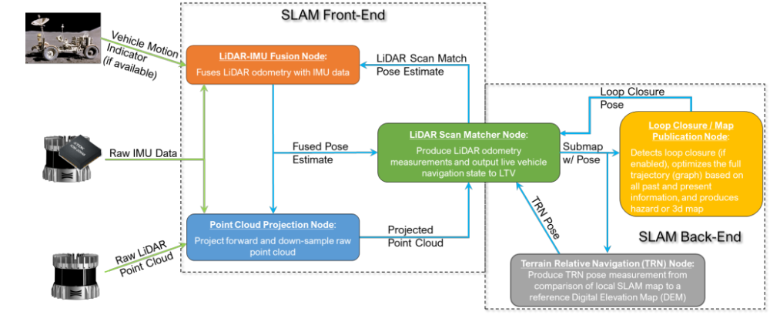
Figure 1 KNaCK-SLAM High Level Flow Chart
Like most graph-based SLAM algorithms, KNaCK-SLAM can be divided into a front-end and a back-end, shown in Figure 1 above. The front-end is primarily responsible for ingesting the raw IMU and LiDAR point cloud data and producing smooth scan-to-scan delta-pose “odometry” pseudo-measurements. The front-end chains these delta-pose measurements together to build a smooth trajectory. However, error accumulates along the trajectory due to each delta-pose measurement having imperfections. Over time, this accumulated error will exceed a 10-meter localization requirement. The back-end is primarily responsible with providing periodic, infrequent updates to the trajectory to constrain the absolute navigation accuracy. It also optimizes the full trajectory using a factor graph in support of scientific and hazard mapping requirements.
Figure 1 shows the major subroutines present inside KNaCK-SLAM. The front-end is comprised of the Point Cloud Projection Node, LiDAR Scan Matcher Node, and the LiDAR-IMU Fusion Node. The back-end is comprised of the Loop Closure/ Mapping Node and the Terrain Relative Navigation (TRN) Node, but interfaces with the front-end via the LiDAR Scan Matcher Node. A description of the high-level purpose of each subroutine follows.
The Point Cloud Projection Node is responsible for “de-skewing” the LiDAR point cloud, performing checks on the validity of each point, and performing preliminary down sampling on the cloud. “De-skewing” of the point cloud is necessary because each point in the raw LiDAR point cloud was taken at a different time. To perform scan-to-scan registration in a downstream subroutine, the algorithm must have access to a coherent point cloud that represents the geometry of the environment at a single point in time. Using the IMU data, each scene can be projected to a common time. An example of this is shown in Figure 2 below. Down sampling in this node reduces computational burden on downstream subroutines operating on the point cloud.

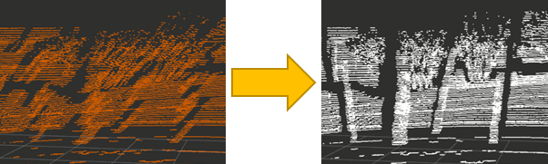
Figure 2. Example of a raw LiDAR point cloud (left) and de-skewed point cloud (right)
The LiDAR Scan Matcher Node is responsible for scan-to-scan registration, registering each subsequent LiDAR scan to the previous one to provide a delta-pose pseudo-measurement. The algorithm used to achieve this is a Generalized Iterative Closest Point (GICP) approach.
The final front-end node, the LiDAR-IMU Fusion Node, combines the projected nav state based on the IMU data with the delta-pose estimate from the LiDAR Scan Matcher Node to derive an optimal estimate of the navigation state. The product of this step is commonly referred to as LiDAR Inertial Odometry (LIO). The approach currently used in KNaCK-SLAM to combine IMU and delta-pose measurements is a factor graph. Prior to the measurement fusion, the variance of the IMU prediction of the navigation state should be compared with the delta-pose measurement to detect instabilities in the scan-to-scan registration. This will be a critical step in ensuring the safety of this approach for critical application, such as a lunar traverse.
The Loop Closure/ Mapping Node is responsible for compiling and saving a local 3D point cloud map, detecting hazards inside the local map, optimizing the trajectory based on front-end and back-end measurements, and detecting loop closures. First, a local 3D map is needed for detecting hazards and loop closures. Hazards are currently detected based on a maximum allowable slope over a given area. Loop closure detection is based on comparing our current local map to previous map segments, “closing the loop” to provide a relative navigation measurement. A factor graph is used to fuse front-end LIO measurements with back-end loop closure and TRN measurements. This node produces the best estimate absolute trajectory for the payload, and on the ground will produce scientific map products.
The Terrain Relative Navigation (TRN) Node is responsible for constraining the navigation error growth in the SLAM front-end. It takes the local SLAM map, sometimes of lengths greater than 75 meters, and compares them in low resolution to reference Digital Elevation Maps (DEMs) to derive a terrain relative location. For the Lunar case, these DEMs will be provided by Lunar Reconnaissance Orbiter (LRO) or similar spacecraft. For a real-world example of this operation in a terrestrial environment, see Figure 3 below.
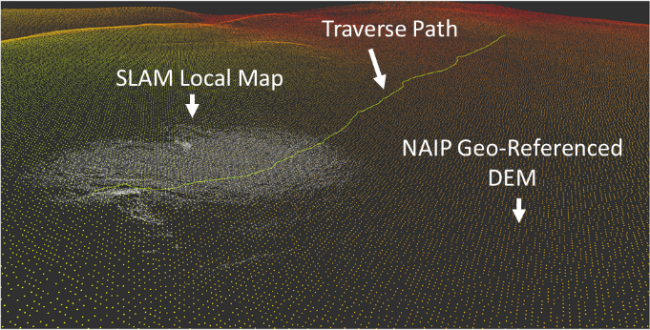
Figure 3. An example TRN match between the Local SLAM map (white) and a NAIP DEM (green and orange) in Arizona
By overlaying the local SLAM map on top of the DEMs as shown in Figure 3, an absolute location can be derived. The success of this node is the most critical for meeting the 10-meter localization requirement.
These are several challenges with the SLAM implementation. LiDAR inertial odometry (LIO) accuracy is currently degraded in dynamic environments where jerk and angular acceleration are high, such as on a drone or occasionally on a backpack. Implementing an approach that accounts for jerk and angular acceleration, such as the one presented in [1], could make KNaCK-SLAM more robust to these dynamic environments. Secondly, the possibility of false positives in loop closure can lead to erroneous navigation estimates. This is a commonly observed phenomena when dealing with highly unstructured and/or natural environments, such as in the desert, caves, or on the Moon. Robust measurement rejection should be implemented for KNaCK-SLAM. Lastly, Terrain Relative Navigation (TRN) is accurate if there is sufficient undulation in topography which can be correlated in the traversed terrain over the swath of the field of regard of the sensor. However, when a patch of ground which is completely flat is traversed, especially one with small-scale objects that are not contained in the baseline DEM, the TRN system can give erroneous results. Robust measurement rejection should be implemented for KNaCK-SLAM..
Solution 2: Radiometric Triangulation and TrIlateration
The second approach to be discussed is the deployment of a local network of radiometric reference stations that can be used to provide measurements. An example of this currently in testing is called the Lunar Harpoon. A technology demonstrator in its current form, it leverages existing commercial-off-the-shelf (COTS) components for radio frequency (RF) communication, navigation, computation, and power. A custom printed circuit board (PCB) handles power regulation, telemetry, I/O, and computation with an integrated Raspberry Pi Compute Module 4. Digi Xbee 2.4GHz radios are used for back-end communications and telemetry but are not used for navigation. For RF navigation, four custom ultra-wideband I/O boards utilizing the DWM3000 UWB module are mounted along an adjustable track on the outside of the box. Additionally, the Harpoon utilizes a UbloxZED9FP GPS receiver with real time kinematics (RTK) capability for outdoor field-testing performance comparisons. The electronic components are contained within an extruded metal case, and antenna/cable ports are accessed along the short ends. It can operate on internal or external power at 12 - 30 volts DC. Figure 4 below shows a single Lunar Harpoon.

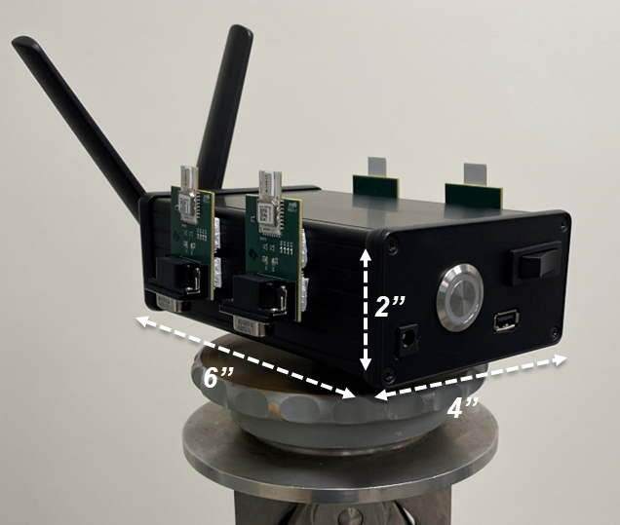
Figure 4. Lunar Harpoon
While the components utilized to date are consumer-grade COTS, some systems like power, communication, and packaging can be easily modified for use in space using existing technologies – likely resulting in a slight but expected mass penalty. The processor would need to be replaced with one more robust to space environments, such as a GR740 Processor [cite] or Modular Unified Space Technology Avionics for Next Generation (MUSTANG) [cite]. The ultra-wideband radios are the largest technology gap, with the main concern being exposure to thermal-vacuum, radiation environments, and the lack of space-ready COTS options in this area. While there is currently no commercial market for space-ready UWB radios, there has been some recent interest in this technology for use in space for relative navigation, one being Jet Propulsion Laboratory’s CADRE (Cooperative Autonomous Distributed Robotic Exploration) mission [cite], among others (CITE LUNA-10 proposals that used UWB).
Lunar Harpoon utilizes multiple navigation algorithms to meet mission objectives, and implementation varies depending on use case – summarized below in Table 1. Note the Phase Difference of Arrival (PDOA) results have not yet been validated in laboratory testing, and the positioning accuracy is highly dependent on the configuration of the deployed system.

Table 1. Comparison of Harpoon Navigation Algorithms.
Algorithm | Provides | Accuracy
Auto-Survey | Initial Anchor Positions | < 1 m
Two Way Ranging (2WR) | Range, Tag Positioning | <10 cm, <20 cm
Time Difference of Arrival (TDOA) | Range, Tag Positioning | <20 cm, <40 cm
Phase Difference of Arrival (PDOA) | Bearing | < 5 deg

Harpoon can provide pseudo range observations within the mesh for a tightly coupled approach or a 3DOF/2DOF position solution for a loosely coupled approach. Field testing, both indoor and outdoor, is done frequently on the harpoon for validation of new algorithms and use cases. For indoor testing, harpoons are deployed indoors, and a laser tracker is used as a truth reference, which is accurate to the micrometer level. Range and position observations are compared back to truth for error computations. Testing indoors has demonstrated accuracies of the harpoons to within the noise floor of the radio, utilizing anchor locations surveyed in with the laser tracker. Figure 5 below shows a visual representation of indoor two-way-ranging and time-difference-of-arrival localization.
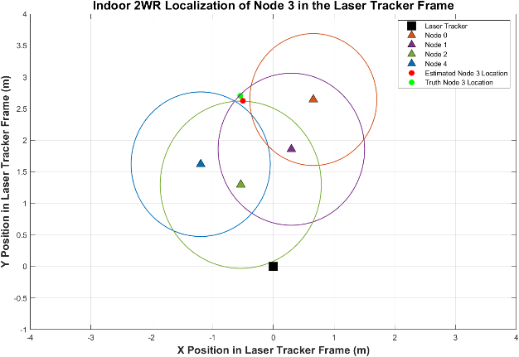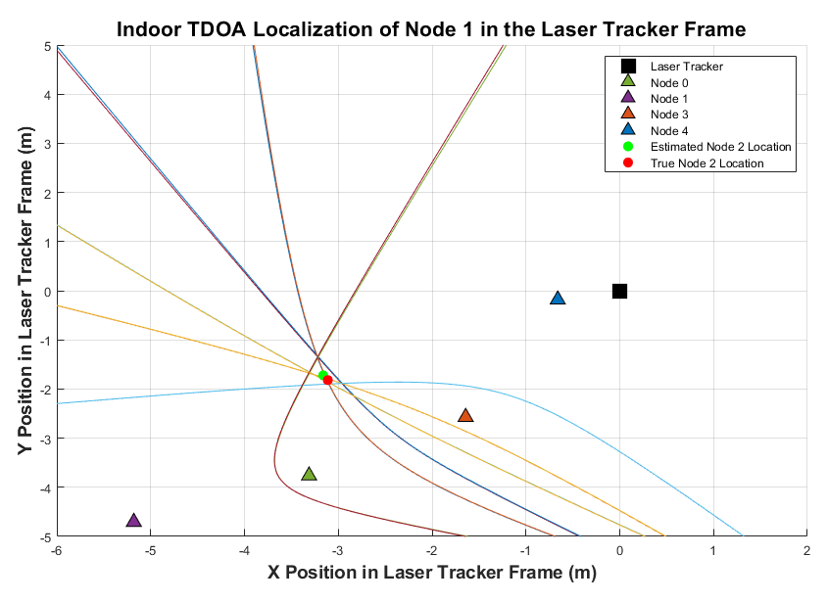
Figure 5. Indoor Harpoon Testing

In a similar fashion, the antenna delays are also calibrated indoors using this process in reverse – i.e., using known ranges among harpoons on a stable granite block, back out error in time of flight (TOF) based on internal delays. Figure 6 below shows this test setup and results.

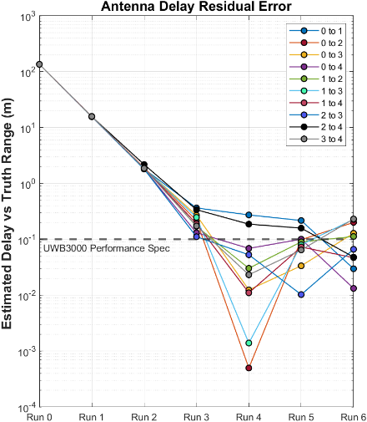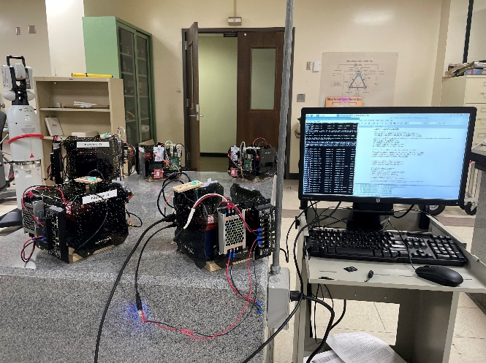
Figure 6. Harpoon Antenna Calibration

Indoor testing at higher power levels yields multipath interference, which is expected and can be mitigated by outdoor use at longer range. Outdoor testing has been conducted using GPS-RTK as a truth reference, yielding accuracies sub- one meter. This is shown below in Figure 7.

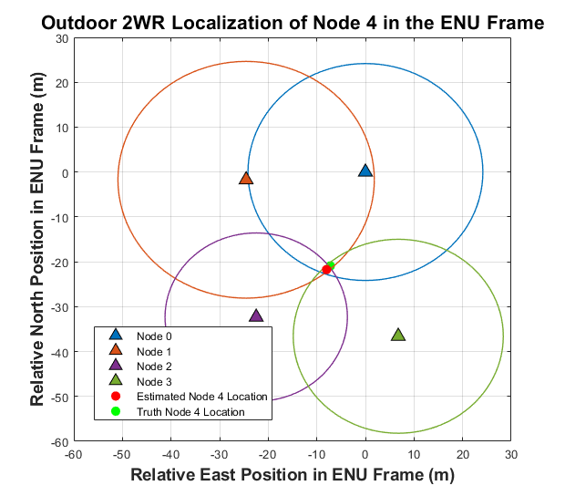
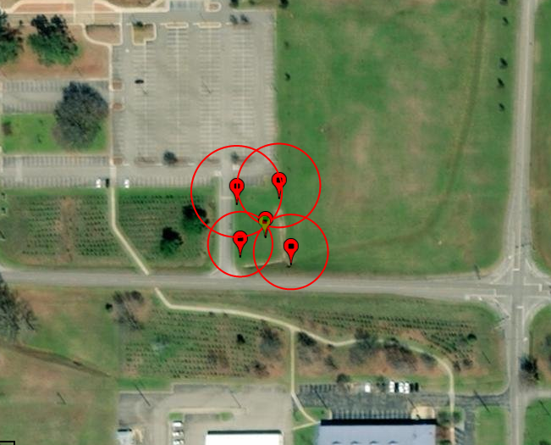

Figure 7. Outdoor Harpoon Testing
Outdoors, over longer ranges, vertical direction resolution degrades and starts to impact solution accuracy. This can be mitigated by deploying harpoons at fixed heights above the surface or eliminating the vertical axis all together in the solution. Additionally, the floor of RTK performance over a short survey-in period used in these tests is larger than the noise floor of the radios, contributing more to the observed error outdoors. Several challenges exist based on the current testing of Harpoon. First, in all use cases, a correlation between relative orientation and range accuracy was observed, likely driven by non-uniformities in the antenna pattern. This issue can be mitigated with more sophisticated radios. Additionally in all use cases, using auto survey for the anchor location determination drives performance error in its current form, however there are algorithm improvements that can be implemented to increase accuracy, in addition to allowing more time for observations. Lastly, while the current range of harpoon is 40 meters line-of-sight limiting its capability, work is ongoing to upgrade the COTS radio components to higher performance options to enable ranges 3-5X higher.
Solution 3: Visual Inertial Odometry and Monocular SLAM
The next approach utilizes a combination of visual and inertial observation to help reduce the growth of errors while using dead reckoning on a traverse. The primary approaches used are Visual Odometry and Visual Inertial Odometry. The delta between the two is the use of inertial observations to aid in the processing between observation. For both techniques, computer vision techniques are used to identify a common set of features in two subsequent images and by tracking the features across both, determine a direction of travel. This information can then be used as part of an inertial navigation filter as a measurement to provide corrections for any integrated errors. While complex these systems have continued to gain attraction and application in the fields of robotics and aerospace. Key applications of note are the use of Visual Odometry on the Mars Rovers. In this use case, observations of direction of motion and total motion observed help to provide an independent measurement to provide insight into local slip conditions via comparison with wheel odometry. Using this technique, results have shown the ability to maintain errors to a much-improved degree. Another high-profile aerospace use case is the Visual Odometry application is the Mars helicopter Ingenuity. In this case, downward facing imagery is used to compute observations of lateral motion to augment onboard IMU and altimetry data to enable precision traverses.
For the testing currently ongoing, the team is using a platform with a common computational heritage to the Ingenuity application, the VOXL-CAM developed by Modal AI. This platform is shown in Figure 8 and consists of multiple sensors operating together: a time-of-flight sensor, a stereo image pair, a wide-angle tracking camera, and two MEMS IMUs. Together, the sensor’s algorithms compute an integration solution using an onboard filter to provide the relative orientation and location of the sensor relative to starting conditions.
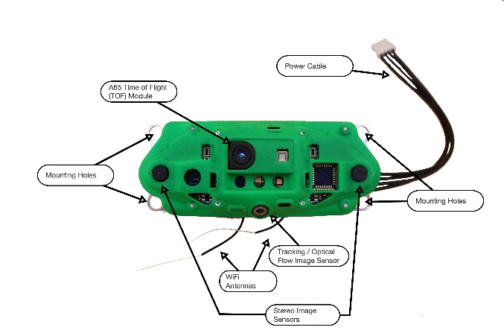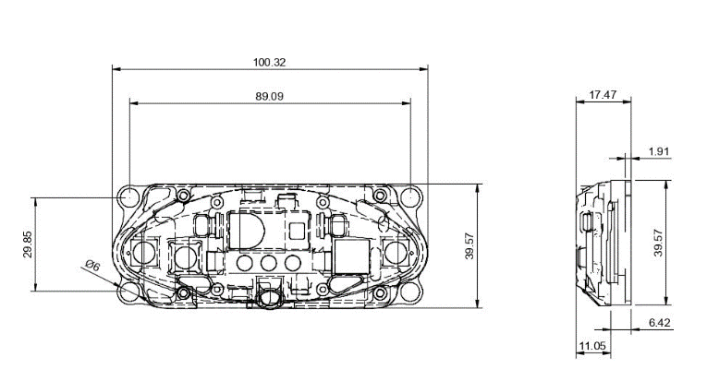
Figure 8. VOXL-CAM (ModalAI): Sensors (Top) and Dimensions (Bottom)
This hardware platform’s primary application is for GPS-denied navigation for drones. When flying near to the ground, it allows the vehicle to maintain a relative state of its translation motion while integrating with n altimeter or other sensor to provide tracking in the vertical direction. Typical mounting has the sensor attached on the underside of the drone with the cameras pointed toward the ground. For the scenarios being evaluated, the sensor would instead be chest mounted. In this application, the multi-sensor system plays a key role. In a test case when the sensor was worn on a chest mount, it was able to track specific features on the ground and not the motion of the user itself, as seen in Figure 8. Note that in this use case, the test subject’s arms and legs come into and out of the frame, but the sensor maintains an integrated solution.
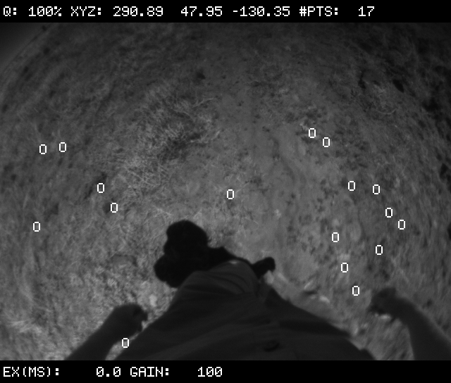
Figure 9 Tracking from Chest Perspective
The sensor is also very dependent on its mounting orientation and knowing this rotation relative to its mounting. In a case of pedestrian-based navigation, this involves three unique frames: the VIO frame defined by the hardware itself (internal calibrations rotate the individual measurements into this common frame for output), a mounting reference, and the global navigation frame. A summary of the three coordinate systems is given below in Figure 10. As can be seen, two primary rotations are of interest, one to go from the VOXL-CAM’s VIO frame to the mounting and the heading relative to the local frame. For field testing, the sensor is typically mounted using a Go-Pro-compatible chest mount, with the Z-axis pointing out of the chest, as seen in the figure. The other two axis are more difficult to calibrate (essentially the pitch and row of the sensor) due to limited onboard sensor data. The pitch is of high importance when conducting these traverses, due to any unknown pitch errors correlating directly into traverse distance.
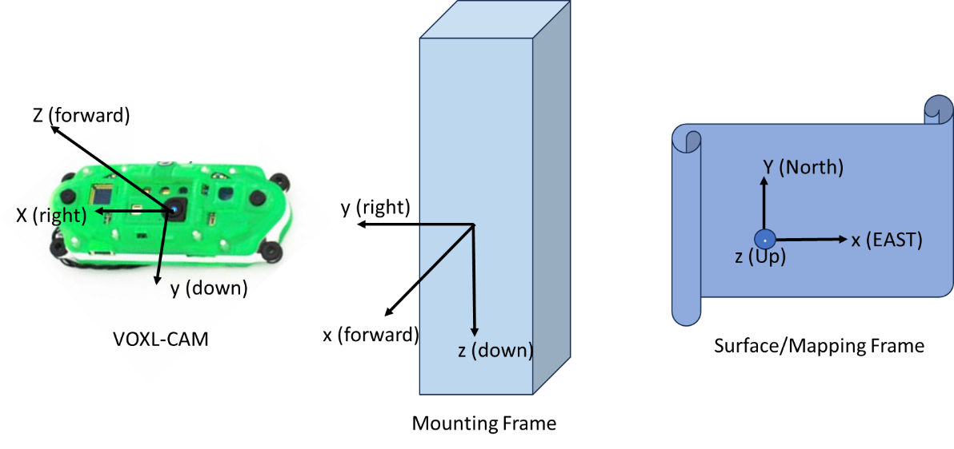
Figure 10 Visual Odometry Reference Frames
In addition to the mounting uncertainty, it is also important to track the orientation of the user at initialization to a global heading. Upon power-up (or loss of a VIO solution, such as when no features are tracked), the sensor initializes its attitude and position to all zeros, and further tracks all motion relative to that starting condition by observing motion in the tracking camera frame. As such the sensor has no awareness of local down (though it can potentially use the raw IMU to determine a coarse measurement of gravity) or local heading. The lack of local heading is directly applicable to a lunar application, where external observations (angle relative to Sun, Earth, or a fixed surface asset) is needed to initialize any heading in a local ENU-type frame. An analog to this is the initialization of the Apollo Lunar Roving Vehicle via a solar compass to define initial heading. This will be necessary for any astronaut application in order to provide a solution easily comparable to products such as maps or procedures. This sensitivity is true for all of the relative navigation solutions listed here.
To gain experience with its performance, the sensor has also been tested in multiple field conditions in order to track motion and observations. For this paper, results taken at JETT-7 field testing at NNSS in November of 2024 will be discussed. In this scenario, GPS data was recorded using a GoPro HERO 11 mounted on the test subject using a standard head strap along a pre-planned traverse. Similarly, the VOXL-CAM was mounted on the same subject using a chest mount. The GPS data shown was processed into a local ENU frame with its original at the starting position. Similarly, the VOXL-CAM VIO solution was first rotated into a body fixed frame and then corrections applied to initialize heading and mounting pitch. For this scenario, these corrections were computed by hand to align the two data groups. Forward work is to refine this process through improved mounting design and alignment procedures.
The results are shown in Figure 9 below. As can be seen the two tracks compare reasonably well as the traverse begins (for the first 30 minutes). The overall traverse shown here is roughly 2 hours in duration at a walking pace. Each corner indicated simulated a science station, and the pattern in the tracks involved looking for surface features around the primary location. The tracks initially are in good agreement, and even the shape of the initial search at the bottom are well-matched. In terms of overall distance measured, the sensors also did a fairly good job as the track’s geometry appears consistent, though with an angular offset applied.
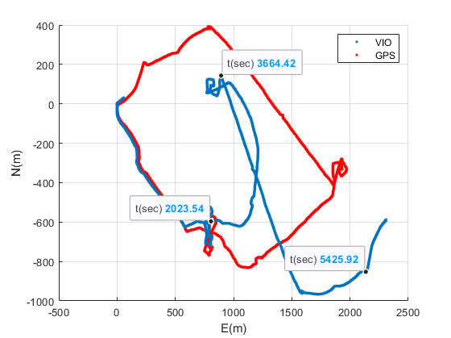
Figure 11 JETT7 Test Traverse
By the end of the traverse the yaw solution at the end of the search activity is clearly degraded by almost 45 degrees. This error continues to grow over the course of the traverse to almost 180 degrees near the end. This is likely due to the quick back and forth motion during the stop where the test subject was looking down at a physical pad that may have blocked the sensor, causing a loss in accuracy. While the sensor never reported any full outages, it is possible that fewer points were tracked, resulting in degraded accuracy. The number of features tracked can be seen in (FIGURE) below. The time is consistent with the data points given in the figure above to inform tracking accuracy vs error growth. For this type of solution, it is important to understand that the visual odometry algorithms do not maintain awareness of features more than one frame back (as opposed to a SLAM-like algorithm, which is building a map and can use loop closures to reduce navigation errors), only providing insight to motion measured on a frame-by-frame basis.
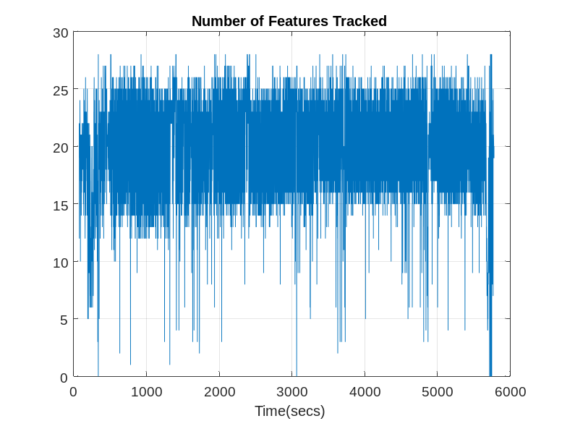
Figure 12 Features Tracking during Traverse
.
As seen, the sensor alone (as any dead reckoning solution) has an error that grows as a function of distance traveled. These measurement type provides an approach to bound error but not completely remove it. While the performance here is not as good as in other implementations, part of this is fundamentally due to the heavily dynamic nature of a moving person, shocks induced by feet hitting the ground, rotation of the body to look around while walking, bounce in a step, etc. As such, proper isolation and mounting are key to this application. Other data was collected for vehicular traverse (i.e., on an ATV) as well as multiple pedestrian traverse that continues to be analyzed.
The other key aspect of the sensor performance is the sensitivity to the local lighting and terrain features in order to facilitate identification and tracking. In addition to onboard algorithms needed for propagating state when the VIO solution gets reset, proper diffuse lighting is also needed to help support operations. To provide insight to this, the sensor has been tested in a range of environment conditions, such as high arctic desert, volcanic plains, desert, and grass fields. This helps to provide insight to range of the scenarios for operations. Screenshots from the sensor operating can be given below under very different conditions in Figure 10 and Figure 11 below.
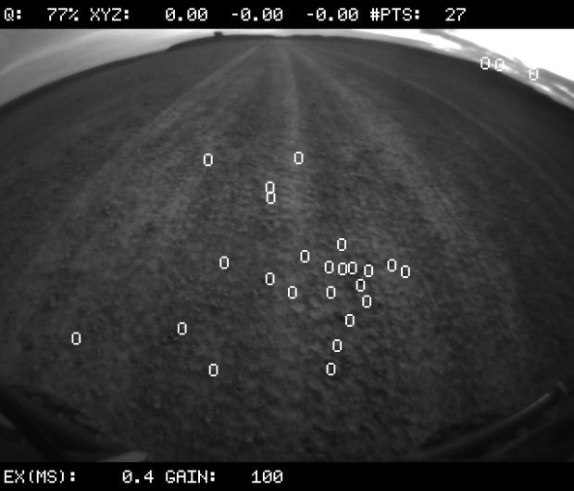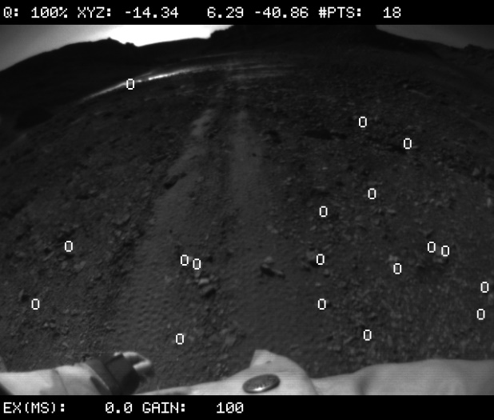
Figure 13. Well-tracked Environments with multiple rocks or surface features

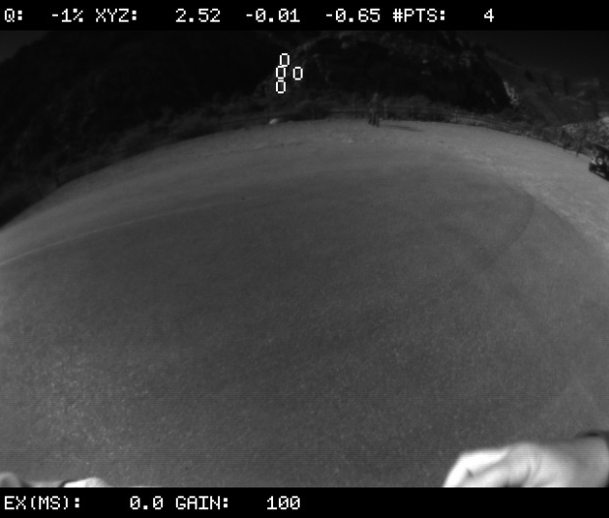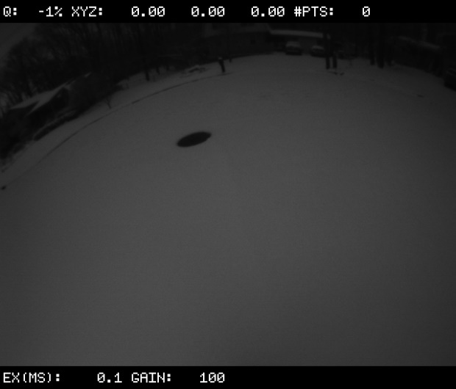
Figure 14 Challenging Environments for Tracking: Asphalt Road (L) and Fresh Snow(R)
As seen in the first set of images, small rocks and other surface features provided adequate contrast against the broader background to help support tracking during these traverses. For context, the left image was taken as the sensor was mounted to front of an all-terrain-vehicle and the right was a chest mount. Both images were taken during field testing Devon Island in the fall of 2023. It is worth noting that even in the left images, the sensor had drop-outs and was not able to maintain the solution. The bottom images highlight some of the worst-case scenarios that the system could face. The left is an asphalt road on the path to a trail in Red Rock Canyon. The sensor is able to detect a far field feature and use that to track (though not enough points to capture a full solution). Similar behavior was identified in the regolith field at MSFC, where the sensor primarily tracked the edges of the field and background objects rather than the field itself. The right images represent using the sensor while traversing in undisturbed snow. For all of these, the lack of highly defined features (with respect to the lower resolution tracking camera) proved difficult. This sensitivity is seen in other optical processing techniques as will be discussed in the next section.

Solution 4: Photogrammetry
The fourth solution to be discussed within this paper is the use of photogrammetry, defined here as techniques for processing a set of imagery of a common object or area and then using computer vision techniques to form a 3-dimensional reconstruction of said object. While not intended to be something that operates in real-time, it has demonstrated it’s potential to generate reconstructions and has a place in post-processing and data recovery for any surface traverse. The technique has been applied to both capture reconstructions of lunar hardware, generated broad surfaces to inform local terrain, provide context for science and focused reconstruction of specific surface boulders . The process typically uses algorithms such as Structure from Motion or processing using known features (i.e., markers, physical objects, or horizon lines) in order to provide a calibration from the focal plane into third dimension. This process is heavily dependent on a few key features: unique and diverse textures of the surrounding (i.e., going up and down a non-descript hallway or flat surface can confuse the algorithms), overlapping images to enable feature tracking between frames, images at multiple unique points of view of an object, high resolution, and steady lighting.
These techniques have advanced to the point where a typical cell phone can perform the image capture (and often with aiding inertial measurement unit or GPS data) and upload to a cloud service for processing of this data set into a 3D model. In fact, the algorithms are also capable of recommending observations angles or increasing diversity of image collection prior to attempting to a reconstruction. Several examples of these software packages include Pix4D, Spectacular, and Polycam (to name a few). Similar, desktop user capabilities have also advanced, enabling high capability processing and scene generation with built-in mesh and texture generation and editing. Key platforms with wide usage include Meshroom, 3DF Zephyr, and Agisoft Metashape. These platforms are widely used in terrestrial applications such as mapping, surveying, modeling, including the usage of anchor points to calibrate the resulting model to generate a properly scaled model (or blueprint).
Given this expansive software environment, the remaining need is the selection of an image source to process the data. These algorithms are sensitive to camera intrinsic calibrations across the imagers focal plane as well as the light sensitivity and resolution. With the Artemis programs, it is expected that there will be a breadth of options for capturing imagery, from a high performance handheld SLR to high definition (or better) imagery from suit worn-cameras that is streamed in real-time to the mission control in addition to other situational awareness cameras across the individual assets (including landers, rovers, suits, infrastructure, etc.). With the combination of the data sets and the ground software tools, these approaches are well-positioned to provide key insight to as-executed traverse and provide additional data to inform scientific observations of the surface.
An alternate approach to using this same imagery set is the use of monocular SLAM algorithms, such as ORB-SLAM⁵, that can be used in real-time to provide state measurements to reduce error growth over time and as sites are revisited enable loop closures to reduce errors. These are the same types of algorithms and processing as used in the KNACK-SLAM approach mentioned previously, but instead of using LIDAR point clouds, this approach uses similar approaches to photogrammetry to perform feature tracking and extraction in the image frames to infer motion, similar to visual inertial odometry. All of these approaches require a combination of inertial measurement unit and camera system to track a user’s state. These methods typically find wide usage in applications such as pedestrian dead reckoning and inside-out tracking for virtual reality where cameras and IMUS within the headset are used to help track a user’s orientation and location within a room. Implementations such as ORB-SLAM enable monocular SLAM techniques where one camera can be used to perform these updates.
In order to support validation of this approach, the team has been utilizing body-mounted GoPro Hero 11 action cameras. These were originally used for capturing data sets to support monocular SLAM techniques and backup truth observations (timestamped GPS) in field testing. But the same data can also be used in photogrammetry-based reconstruction and analysis. As such, the team has been exploring both options to assess performance of both real-time (SLAM) and post-processing regeneration approaches. Their ability to capture UHD as well as HD footage with either 30 or 60 frames per second with frame correlated accelerometer, gyroscope, and GPS observations presents it as a powerful platform for testing. These sensors have been used in other testing scenarios in a similar manner and served to help inspire the traverse reconstruction aspects shown here.
While details of the field-testing scenarios are below, 3 example scenarios are provided here to provide insight to the systems capabilities and representative results across multiple tools based on the results at hand. The first scenario shows the capability to generate a model of an object in the field. For this case, the Pix4DCatch mobile application was used to capture images of a tree in Red Rock Canyon near Las Vegas, NV. The object was chosen due to its complex shape, fine details, and large size. Figure 8 below shows one of the generated images, and two views of the generated model. The generation process used software defaults and 192 images. The tool did a fairly good job of reconstruction, but the narrow spines on the plant did cause some difficulty, resulting in them primarily being added on a texture, rather than as unique parts of the overall mesh. Other results (Apollo-3d boulders) show similar results using existing footage from the lunar surface. This shows general promise in the capability to regenerate unique structures or objects in the field.
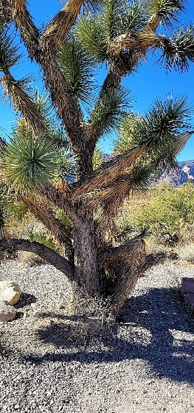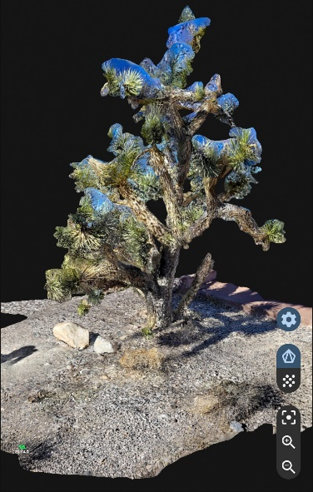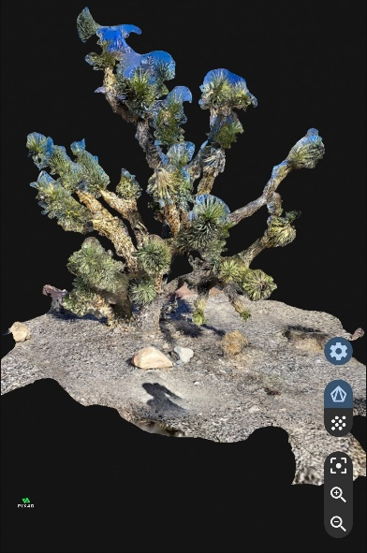
Figure 15. Views of Yucca Tree (L) Example Photo, (M-R) Views of Reconstructed Model
The next test case shows a regeneration of a path from field testing that process low resolution grayscale imagery from the tracking camera on the VOXL-CAM sensor. The resolution of these images is only 640x480 pixels. Figure 9 below shows a representative image and provides a view of the generated terrain model (not shown is a separate view that includes placement of each image within the global model). As can be seen in the figure, the lower resolution of the images limits the generated model. This is mostly seen in the bushes and small structures along the path. The rocks and the path at the center of the frame though, are well captured provide details to their size, location, and distribution.
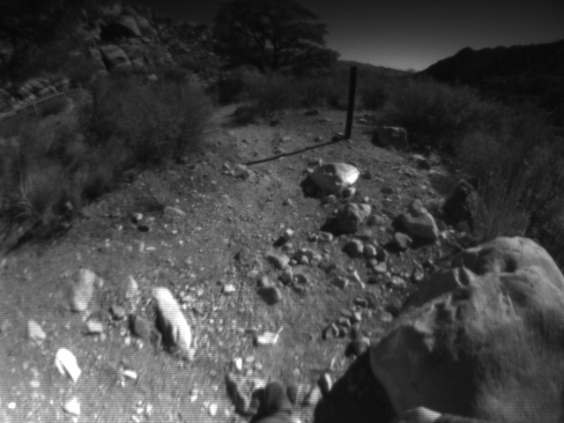
Figure 16 Representative Image from VOXL-CAM Tracking Sensor
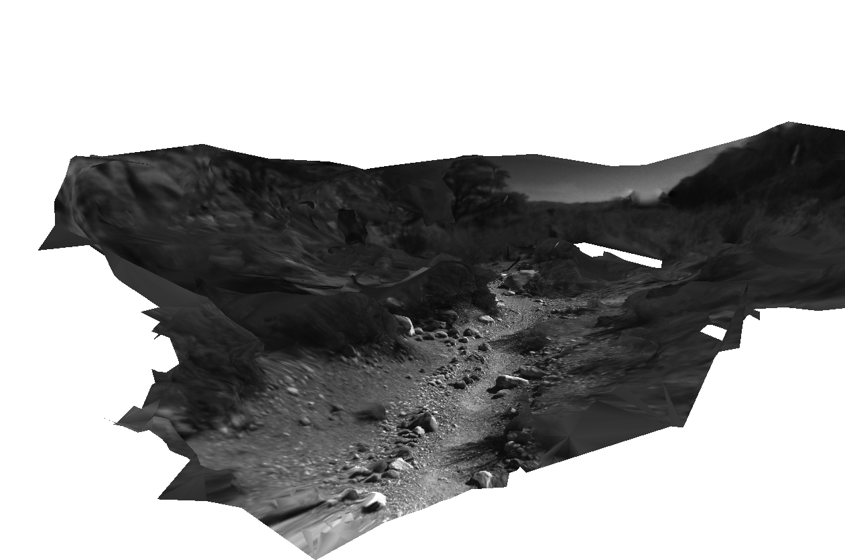
Figure 17 Regenerated Path from Portion of Traverse
These models also highlight some of the challenges with photogrammetry techniques. For example, this reconstruction (482 images at a ~30 frames per second; for a total traverse of 16 seconds) is a focused subset of the overall dataset (18K images). Construction of the entire traverse at once proved challenging due to two suspected issues. The process is set up by default to treat each image as independent, so although it does track features images to image, it does this on a larger scale and compares all images to each other. While for modeling a single object, this is very useful, it can prove challenging for terrain with repeated or limited features. When processing the entire traverse, the results were inadequate. Similar issues were seen when attempting to reconstruct a traverse up and down a stairway. Due to the lack of unique features and solid textures, the algorithms assumed that each flight of stairs was the same flight, so while it was able to generate the proper up and down motion, it neglected to model the individual steps. This points to similar risks with using this approach in areas with limited texture, such as a potential regolith field that may have limited rocks. Or the pattern is chaotic enough that it all looks similar to each other. The test case was limited by the use of a grayscale camera with reduced resolution.
In order to address this gap, an additional data set will be discussed. For this scenario, a GoPro recording at 1080P at 30 FPS was mounted in a location similar to that in an xEMU mockup during field testing near Flagstaff, Arizona in May of 2024 as part of JETT-5. For the case shown, the data was taken from 1080P data at 10 FPS resulting in 1968 frames covering roughly 3.5 minutes of traversing. Figure 11 below provides a frame from the middle at the beginning and near the middle of the traverse section.
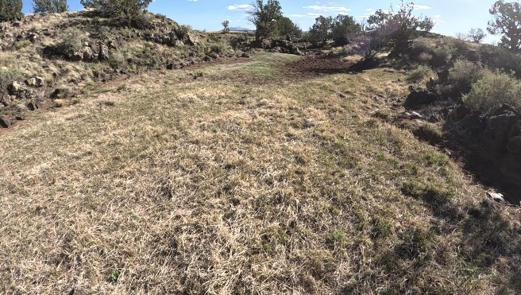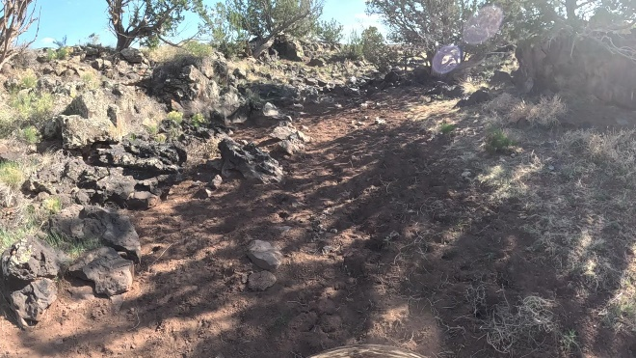
Figure 18 Two frames from start (L) and middle (R) of traverse
This data was then processed in 3DF Zephyr to perform reconstruction and textured mesh generation. The results are shown in the following figures. Figure 12 shows a close-up view of the rock formation near the right edge of the traverse. The rocks and ground features themselves are well-captured in the model, but similar to the other approaches, the process had difficulty with regeneration of thin brush (as shown in the bottom right) where the vegetation shows up more as a texture on a blob than as a well-defined shape. An interesting aspect to this picture is also that the direction of view for the screenshot is perpendicular to the direction of motion. This shows the power of the tools to reconstruct the path, even though the test subject primarily looked forward during the traverse. Figure 13 provides an overview of the entire traverse section. The results show fairly good representation of the primary walking path, though still struggling with large vegetation.
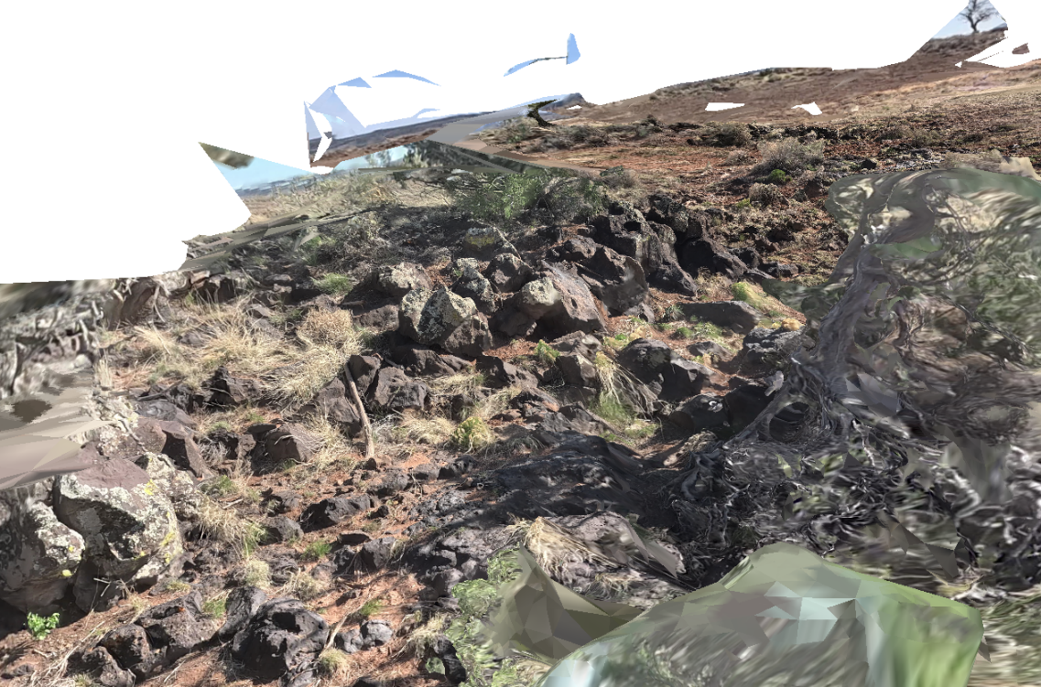
Figure 19 Close-up View of+ Rock Formation in Reconstruction
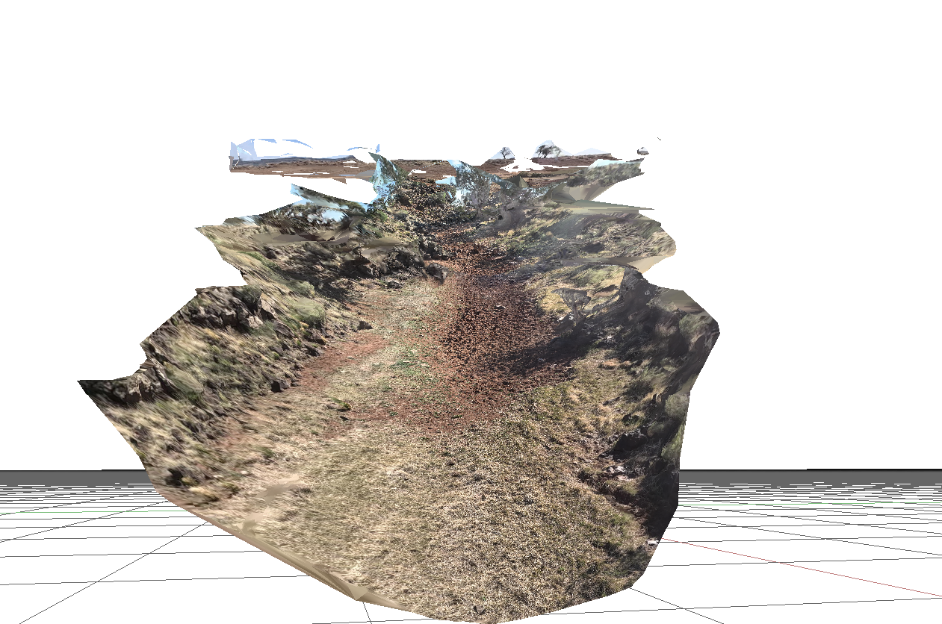
Figure 20 Reconstructed Traverse

Though these results do well match to the observed environment, more work is needed to optimize the application of this approach. As mentioned, the path reconstructions that were successful were limited in scope (several minutes or less of traversing). This was partially due to available computation resources and partially to test out the algorithms. More advanced techniques are possible as part of these packages to include state anchoring and adding markers to the real-world to help aid in the reconstruction process. The results also highlight the dependence on the terrain being mapped, due to the need for complex texture and structures, as well as steady lighting conditions. For example, in a starkly lit environment, the algorithms are as likely to trace shadows as other surface features. This can work for fixed shadows, but a dynamic shadow in the field of view, such as from an astronaut, can create challenges for reconstructions. As such, it will be necessary to take advantage of complex masking algorithms or other techniques to aid in reconstruction. Lastly, testing is needed to continue to evaluate the performance across varied terrain conditions that can mimic the types of features and patterns expected to see on the lunar South Pole.
Summary of Field Testing
In order to provide a comparison of the capability of each solution, they have been evaluated in field testing to capture their performance and capability. While an integrated test of all four solutions has not yet been executed, there have been tests involving subsets of them. This section will provide a brief overview of the testing sites, conditions, and which sensors have been tested.
Due to need to deploy a field infrastructure and limited susceptibility to surface terrain conditions (as compared to the visual approaches), it has been primary evaluated in field conditions on-site at MSFC. Recently, field testing was completed with harpoons stand-alone as well as in-the-loop with autonomous rovers at multiple locations at Marshall Space Flight Center including most recently at the Lunar Regolith Terrain (LRT) field in Summer of 2024. Representative images from the test series are given below in Figure 21. The left image shows a deployed harpoon with autonomous rover, whereas the image on the right shows the overall deployed network on the regolith with other notional terrain and surfacer elements deployed. Capabilities were demonstrated using four anchors ranging ~40 meters apart and two or more tags within the mesh. In the case utilizing autonomous systems, the network provided high accuracy state information to rovers in the network mitigating the need for computationally expensive lidar for rovers executing simple tasks (like terrain leveling).
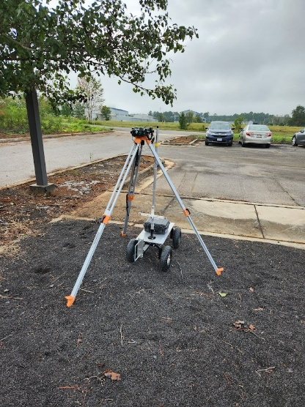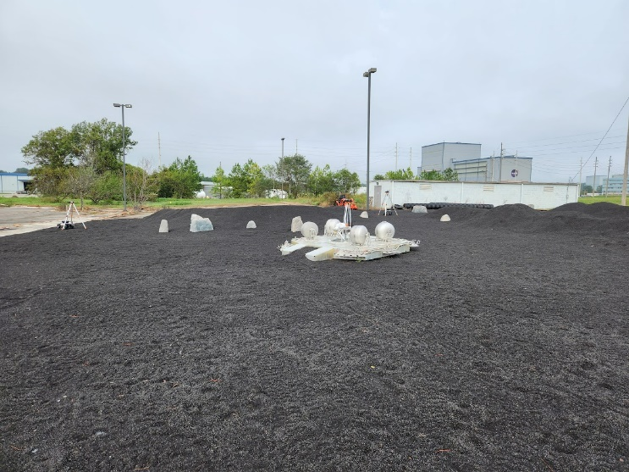
Figure 21. Autonomous Rover w/ Harpoon (L) and Regolith Field Setup (R)
Like the test case above, the other techniques identified here have been tested on the regolith field. Extensive testing of the KNacK components, both mounted to pedestrian and drone, have been conducted on-site. The visual odometry techniques have only been used in quick tests to evaluate the ability to detect visual features in the field as mentioned above. Due to size and isolated nature of on-site fields and test facilities, the teams continue to evaluate future testing capabilities and move towards more integrated testing comparisons of all techniques, on both pedestrian and vehicular navigation (such as on an ATV-type vehicle operating at speeds expected on the lunar surface). The team continues to plan and conduct these tests.
In addition to testing at MSFC, the non-radiometric solutions have been tested as part of multiple field-testing campaigns. Of note is that the KNaCK supports other scientific objectives in addition to navigation and has been used in multiple test campaigns to support planetary science objectives. This includes crater and terrain mapping of sand dunes, impact craters, lava tube or caves systems, etc. Table 2 provides a quick summary of the more-exploration focused test campaigns. The dune tracking is listed here to provide context for an environment where the LIDAR has proven successful, where a system like Visual Odometry will struggle. The hardware systems were included in multiple NASA testing campaigns, include pre-mapping and technology demonstration activities. This hardware was often used for overlapping test objectives. For example, JETT (Joint EVA and Human Surface Mobility Test Team)-7 focused on several orienteering aiding technologies, and thus conducted 20+ traverses with 1-2 test subjects, test conductor, and data gatherers. For each test, the primary subjects utilized chest or head-mounted GoPro’s to provide backup GPS tracking, voice recording, situational awareness, as well as a data source for evaluation of photogrammetry and monocular SLAM techniques.
Table 2. Summary of Test Conditions
Test Campaign  (Location and Time) | Type of Environment | KNaCK/  LIDAR | VOXL-CAM/VIO | GoPro | Harpoon
MSFC Regolith Field (2023-2024, ongoing) | Lunar simulant field | x | x |  | x
Devon Island (September 2023) | Haughton Mars Project, High arctic desert |  | x | x
Iceland testing? | Volcanic Desert | x
Merritt Island Dune Tracking (2023, annual/ongoing) | (South Atlantic) sand dunes | x
Lava Tubes? | Lava tubes? | x
JETT-5 (May 2024) | Arizona desert/San Francisco Volcanic Field | x | x | x
JETT-7 (July/mapping and November 2024) | Desert flats (Yucca Flat) | x | x | x
Field Training Exercises (2024, on-going) | Flat marshland and fields (Challenger Park, Houston, TX, on-site JSC) |  | x | x

These test campaigns have resulted in a large amount of data capturing performance, sensitivities, and operational lessons learned in a variety of environments. For example, JETT7 alone generated ~700 gigabytes of video footage with time synchronized onboard IMU and video data that can be used to assess a variety of applications in addition to those described in the previous section, such as pedestrian dead reckoning among others. The results continue to be processed to build up increased insight and performance metrics of the given technologies.
Comparison of Key Applications
Each of the approaches discussed present a unique capability that can be used to navigate on the lunar surface. Depending on the use case, a particular technology may be more beneficial. Referencing the earlier discussion on mission objectives, several key scenarios can be defined. These are included in Table 2 below. In addition to an identifier and description, each scenario includes limited information on when these types of activities may be an active part of a lunar surface mission. These expectations align with the current understanding of the proposed Artemis missions, including what elements are introduced to the architecture, and presents a conversative expectation of initial mission needs. The timeline is broken into board categories where Early represents the first lunar sorties, “Mid” represents near-term missions, including traverses utilizing mobile assets, and “Late” represents longer-term missions such as those utilizing multiple surface elements and In-situ Resource Utilization and manufacturing. These timelines are considered notional and not the official plans of the individual missions, but instead an informed guess based on existing information and historical approaches. Each of these use cases will be discussed below in terms of the applicability and unique challenges of each navigation approach.
Table 3. Focused Example Use Cases
Use Case | Description | Coarse Initial Timeline
Near-field Exploration (100s of meters) | Ability for the crew to understand their location (absolute or relative) and being able to return to a host vehicle or asset. This could include operations such as traversing from a mobile vehicle, inspection of a lander, science investigations near a lander. The focus is on returning to the host vehicle and reaching a site of scientific interest. | Early (Artemis III+)
Absolute Localization | Ability to correlate a sensor or other scientific observation (including imagery) to an absolute location on the lunar surface. As missions continue this is desired to shift from a post-processing to real-time capability. | Early to Mid (Artemis IV+)
Far-field Navigation (km’s) | Ability for the crew to conduct an expanded traverse around a fixed surface element (i.e., HLS) to both reach scientific areas of interest safely return to the host vehicle. This focuses on a longer duration traverse around a lander to conduct science at a landing site. | Mid (Artemis V)
Multi-asset Autonomous Operations | Ability for multiple assets to understand precision relative states to support data cross correlation and coordinated scenarios such as multiple rovers exploring or working in a common area. | Late (beyond Artemis VI?)
Large Permanently Shadowed Region | Ability for the crew or a vehicle to traverse independently into a large, shadowed area where line of sight to other surface elements and the sun is not available. This focuses on the need to both capture scientific observations and successfully return to a sunlit area. | Late (beyond Artemis VI)

Near-field Surface Navigation
As summarized, this use case begins with the expected initial lunar surface missions. In these scenarios, the crew would conduct surface traverses with increasing distance from the landed surface element from 100s of meters to a few kilometers. Other constraints such as communication range or line of sight to the host vehicle may be the primarily limiting factor. For initial Artemis missions, this would mimic the operational approach taken across the Apollo program, as each traverse allowed for gaining increased operational experience. Over time, the crew traversed increasing distances from the lander. It is expected that the Artemis program will utilize a similar approach. As such, this use case is defined to capture the applicability to early missions, where limited infrastructure is available and other operational constraints may limit exploration range. (TABLE X) below provides a comparison between the selected approaches and what each can provide to support the operational scenario.

Table 4 Near-Field Navigation Use Case
Approach | Expected Navigation Capability | Rationale
LIDAR-based Navigation | High | Can maintain dead reckoning inertial solution to within 10’s of meters or <10 m accuracy to absolute based on by using a priori mapping products, provides excess capability to ensure safe return from notional distances
Local Radiometric Network | Medium | With a full network (3+) deployed in general vicinity, user can determine location to cm’s. For early missions, expectation may only be able to deploy one or two nodes on a limited baseline. Can support user return to host asset, but not high-fidelity absolute location.
Visual Inertial Odometry | Medium | System provides controlled error growth over time. Due to limited distances and durations, error growth expected to be within allowable levels to ensure safe return to host vehicle. Potential higher performance when coupled with other systems.
Monocular SLAM Techniques | Medium | Algorithms capability of controlling error growth to similar levels as Visual inertial methods at cost of additional computing due to mapping aspects.
Photogrammetry | Low | Due to need for cross-comparisons of images to generate a 3d model, photogrammetric techniques offer limited capability for real-time operation.

Absolute Localization
A second use case for discussion is the need to provide an absolute location of a sample or measurement taken during a traverse. This is needed in order to place any captured results within the larger breadth of scientific observations. Compared to the resolution of orbital measurement, it is desired for greater precision than these observations (below 100 m) to provide increased insight to local surface distributions to lunar science and to enable context to global observations. While the preference for this capability is for real-time operations to ensure sampling or observations at pre-determined locations, the ability to post-process results can still enable tactical changes between traverses. The comparison of the individual technologies is given below in Table 4.
Table 5 Absolute Localization Use Case
Approach | Expected Navigation Capability | Rationale
LIDAR-based Navigation | Medium | With TRN approach can allow for real-time location to high accuracy < 10 m
Local Radiometric Network | High | With a full network (3+) deployed in general vicinity, user can determine location to cm’s by anchoring one or two of these nodes to surface coordinates.
Visual Inertial Odometry | Low | System provides a relative navigation solution relative to system initialization. Reliant on other sensors to align to absolute frame.
Monocular SLAM Techniques | Low | System provides a relative navigation solution relative to system initialization. Reliant on other sensors to align to absolute frame.
Photogrammetry | High | While system may not be able to support real-time localization, post-processing of video data likely to provide high accuracy relative position relative to terrain.

Far-field Navigation
Similar to the growth in operations (range and duration) between individual Apollo missions, it is expected that Artemis will follow a similar process as additional capabilities are deployed in each mission. As part of this, it is expected for surface crews to conduct extended traverse over greater distances. This could be as high as single kilometers on foot or tens of kilometers with the aid of vehicular platforms such as the Lunar Terrain Vehicle. As the crew travels farther from a hosting asset, the error growth of relative sensors may continue to increase to a level that results in decreased operational efficiency. In these scenarios, being able to maintain a higher accuracy solution over longer durations would be of high value. A summary discussion of each approach in this use case is given below in Table 5.
Table 6 Far-Field Navigation
Approach | Expected Navigation Capability | Rationale
LIDAR-based Navigation | High | Can provide 10s of meter accuracy for relative or <10 m accuracy to absolute based on implementation, provides excess capability to ensure safe return from notional distances
Local Radiometric Network | Low. | Based on need for multiple assets in view at once, will require large distributed network to support wide operational area (existing COTS systems work at a maximum of 500m range).
Visual Inertial Odometry | Medium | System provides controlled error growth over time. Over extended traverses, errors expected to grow where augmentation or resets will be required during across a traverse.
Monocular SLAM Techniques | Medium | Algorithms capability of controlling error growth to similar levels as Visual inertial methods at cost of additional computing due to mapping aspects. Over extended traverses, errors expected to grow where augmentation or resets will be required during across a traverse.
Photogrammetry | Low | Due to need for cross-comparisons of images to generate a 3d model, photogrammetric techniques offer limited capability for real-time operation.

Multi-asset Autonomous Operations
As the architecture continues to evolve, it is expected to include an increasing number of assets and work towards long-term sustainable exploration. For example, any deployed vehicular asset is being developed to perform year-round operations with or without human crew present. In either situation, this could include cooperative traverse or sceneries in which precise relative location between two assets is needed to conduct a traverse or correlative observations across the two vehicles. This is also being used on early robotic mission such as CADRE¹ where the individual rovers work together to conduct a scientific survey. And to support long-term exploration, similar capabilities will be needed to support in-situ resource utilization and manufacturing and other assets. Another unique aspect of this type of operation is the locale aspect of such operations, with individual units operating within a relatively small area (much less than the expanded exploration ranges discussed above). A comparison of this use case is given in Table 6.
Table 7 Multi-Asset Autonomous Operations
Approach | Expected Navigation Capability | Rationale
LIDAR-based Navigation | Medium | Algorithms focused on determining users’ location to meter level accuracy to local DEM. May not be accurate enough to support autonomous operation on its own. But also, sensor may be used in alternate manner to support higher accuracy inter-vehicle operations.
Local Radiometric Network | High | With a full network (3+) deployed in general vicinity, user can determine location to cm’s. For operations within a local area, a minimum number of assets can be used. Similarly, sensors on each asset can enable high precision relative position data between individual elements.
Visual Inertial Odometry | Low | System focused on minimizing inertial error growth, limited support of relative navigation scenarios.
Monocular SLAM Techniques | Low | System focused on minimizing inertial error growth, limited support of relative navigation scenarios, unless a shared map or feature set is used among all assets.
Photogrammetry | Low | Due to need for cross-comparisons of images to generate a 3d model, photogrammetric techniques offer limited capability for real-time operation.

Large Permanently Shadowed Region
As mentioned in the prior case, as the Artemis missions continue to evolve in complexity, eventually there will be a desire to do an extended traverse (either robotically or via crew) into a large permanently shadowed region. These types of regions are of high scientific value due to the potential for volatiles on or near the lunar surface and may be of key interested in the types of resource utilization scenarios outlined above requiring multi-asset autonomous operations. For this scenario, the key constraint will be operating within a region without any sunlight. While the crew may be able to see their surroundings via earthshine along, it is expected they will make heavy usage of support lighting. These can cause challenges with visual navigation techniques due to either moving shadows or non-uniformly lit terrain. The comparison of these scenarios is provided in Table 7 below.

Table 8 Large Permanently Shadowed Region
Approach | Expected Navigation Capability | Rationale
LIDAR-based Navigation | High | Can provide 10s of meter accuracy for relative or <10 m accuracy to absolute based on implementation, provides excess capability to ensure safe return from notional distances. System operates independently of lighting conditions. For TRN approach, does require DEM map of area, which may or may not be available.
Local Radiometric Network | Medium | With a full network (3+) deployed in general vicinity, user can determine location to cm’s. For early missions, expectation may only be able to deploy one or two nodes on a limited baseline. Can support user return to host asset, but not high-fidelity absolute location within a large PSR
Visual Inertial Odometry | Medium | High sensitivity to lighting conditions. Possible that under earthshine conditions could still track features, but at risk.
Monocular SLAM Techniques | Low | High sensitivity to lighting conditions. Possible that under earthshine conditions could still track features, but at risk. Use of user-mounted lighting would also impact local shadows to a high degree complicating scene registration.
Photogrammetry | Low | Due to need for cross-comparisons of images to generate a 3d model, photogrammetric techniques offer limited capability for real-time operation.

Summary Comparison and Takeaways
As the previous sections have described, no one solution is optimal across all defined use cases. A summary of the results is provided below in Table 8. As shown, each solution has use cases and applications where it excels or provides a unique benefit or has general capability. For example, the use of LIDAR performs well across use cases but may not provide the heightened level of accuracy needed for nearby operations. For the local radiometric solution, it excels in smaller areas, but may not scale as well to larger regions. Visual inertial odometry, represents a good balance for the exploration scenarios to head bound state error growth, though not performing as well as more complex TRN or SLAM algorithms. Monocular SLAM techniques may perform similarly to LIDAR solutions at the cost of more complex computation and increased reliance on local lighting, for example, shifting shadows in the field of view caused by a user’s light may cause false features to be tracked. Lastly, photogrammetric techniques, while powerful, may not be field deployable for real-time operations due to their computations approach, but could be run in parallel on videos or images downlinked in real-time to the ground or between traverses.
LOOKING AT THIS TABLE BELOW. I think I need to make a distinction between pedestrian and monocular slam calling out the ability to run in real-time. LIDAR SLAM should be equivalent to Mono-SLAM. Processing probably about equal as well as performance though in limited lighting they would definitely diverge. For near-field assets operating in the same area, call out that sharing a map may make thing work better for LIDAR or SLAM techniques by supporting loop closures since in a common area?
Table 9. Summary of Applicability to Notional Use Cases
Approach | Near-field Exploration | Absolute Localization | Far-field Navigation | Multi-asset Autonomous Operations | Large Permanently Shadowed Region
LIDAR-based Navigation | High | High | High | Medium | High
Local Radiometric Network | Medium | High | Low | High | Medium
Visual Inertial Odometry | Medium | Medium | Medium | Low | Medium
Monocular SLAM Techniques | Low | High | Medium | Low | Low
Photogrammetry | Low | High | Low | Low | Low

Following this, Table 9 provides a high-level summary of each of the solutions in more detail. This table summarizes the prior results as well as providing insight to key design challenges or operational constraints that may limit the implementation of each solution. Again, as seen above, each solution brings a unique capability to the lunar surface operations, and the implementation and usage may be focused on specific objectives.
NOTE: add primary recommended use case for each?
Table 10. Qualitative High-level Summary of Each Technology
Approach | Key Advantage | Limiting Constraint
LIDAR-based Navigation | Environment-independent solution that can provide an absolute or relative solution | TRN solution dependent on local terrain (i.e., flat areas are challenging), and large power, computing, and storage requirements.
Local Radiometric Network | Multiple techniques including AoA and trilateration to determine high precision of user location within network | Primarily supports smaller areas and requires multiple in view to achieve high accuracy.
Visual Inertial Odometry | Can utilize smaller cameras and inertial sensors to help mitigate inertial measurement drift | Sensitive to local features, medium processing burden in tracking motion.
Monocular SLAM Techniques | Can provide higher accuracy state estimates and build up a common map using smaller sensor than LIDAR. Helps reduce inertial drift by tracking to a built map (similar to LIDAR) | Increased computational burden, very sensitive to surface textures (i.e., user lighting or moving shadows will impact), only provides relative solution
Photogrammetry | Can provide a high-resolution map of the executed traverse and localization of user at each point during. Allows 3D mapping from 2D images at higher fidelity than SLAM techniques. | Very high computational burden, not expected to be conducted in field.

Long-term Use Cases and Alignment with Architecture objectives
Each of these solutions can play a part in the larger lunar surface navigation approach and provide augmenting capability. For example, NASA has also invested in and deploying lunar navigation services to provide a broad regional capability. This can be used to help anchor of these relative solutions to an absolute location on the lunar surface. Similarly, these methods will be of key needs for time when the full service is not available. For example, the initial procurement only includes real-time capability for 40% of an Earth day. Even with the potential use of other LunaNet-compatible navigation constellations,, systems such as these will still be needed for providing support capability during other operational periods.
Similarly, while some approaches have been proposed for enhancing the performance while using these services, the approaches outlined in this paper will still be needed for scenarios requiring greater accuracy over a more limited area. Similarly, post-processing and other mapping techniques will rely on surface users to provide the reference data used to generate those products (which LIDAR scanning and photogrammetry techniques can provide). This integration is well shown for the user of local radiometric tracking solutions. For example, Lunar Harpoons deployed to well-surveyed anchor locations such as within a lunar habitat or landing site can act as a permanent mesh network, allowing the harpoons to reach their full performance potential.
Next steps
For many of these solutions, key forward work is the area of space-rating both the hardware and the algorithms being used to implement the navigation approaches. This includes the porting of algorithms from consumer platforms such as desktop-based processors to more radiation insensitive platforms such as embedded processes and field programable gate arrays for use in flight platforms. Similar, the individual sensors will need to be rated to operate in the challenging thermal vacuum environment of the lunar south pole region, primarily pushing a burden on heat rejection of the platforms. For areas using ground-based processing, data pipeline needs to be put into place to ensure day-of operations are ready, including early field testing.
These solutions have primarily been field tested in pedestrian or small rover platforms independently. While several of these have been used at recent testing campaigns, continued evaluation of the solutions is needed to evaluate further improvements and comparative analysis. For example, many of the terrain and imagery-based approaches are sensitive to the local textures and environments. As such, characterizing them across as wide variety of scenarios is important to capture and assess these sensitivities. The teams continue to conduct field testing and evaluation across multiple use cases.
Additional forward work is the implementation of additional techniques for comparison and integration of techniques used in pedestrian navigation such as Pedestrian Dead Reckoning. Similarly, the team is evaluating upgrades to the Harpoon platform to utilize pseudolite signals based on planned lunar infrastructure defined by the LunaNet Interoperability Standards. This involves integration of capabilities being developed as part of future potential lunar payloads, such as integration of the Lunar Node platform².
CoNclusions
As shown in this paper, terrestrial technologies that have been developed for the fields of autonomous robotics, GPS-denied navigation, and pedestrian navigation have the promise to heavily influence and aid our ability to safely explore the surface of a planetary body. These techniques take advantage of advancements in electronics (sensors, processors, wireless) and algorithms to enable a great degree of capability in localization and mapping. The continued miniaturization and performance improvements of mobile processor platforms provides the foundation for implementation and usage of these algorithms. While the hardware itself must now be adapted to the space environment (primarily concerns regarding thermal-vacuum and radiation impacts), these can still be adapted to provide some initial capability on existing platforms.
In addition to environmental adaptation, key work must also be done to support integration and operation. Pedestrian mounting (particularly within a spacesuit) is an extremely challenging integration problem. This use case has strict constraints in terms of mass, power, and volume to ensure meeting traverse operational (such as duration) and human interface (such as viewing data, integration with suit) constraints that must be balanced. This includes processing algorithms, data capture and storage, telemetry, and development of heads up displays or other real-time operational support.
These all represent standard engineering development, though very challenging, and can be solved. With implementation, several of these techniques can aid, augment, and support a variety of lunar surface user needs. The examples shown herein show applicability to vehicles as well as pedestrians. These techniques can provide the user high performance navigation that can be used to augment and support other infrastructure. This will be necessary to support a multi-layered robust lunar navigation architecture that can ensure safe exploration and ensure high value scientific return.
AcknowledgeMents
The authors would like to acknowledge the multiple funding avenues across NASA (with key support of the Early Career Initiative Program) that have supported the development of these hardware platforms. The team is grateful to the continued support of our management at MSFC in field testing, evaluation, and hardware development. The team is grateful to expansive test teams would have supported and enabled our field demonstration. The authors would like to acknowledge the support of all of the interns who have helped to support this work. Lastly, the team would like to express our appreciation for the staff across NASA who continue to support the spirit of exploration and technology development through the usage of hands-on field testing and evaluation to gain experience and guide our next steps ever forward.

Navigation SME, NASA/Marshall Space Flight Center/EV42,35801.
Aerospace Engineer, NASA/Marshall Space Flight Center/EV42, 35801.
Aerospace Engineer, NASA/Marshall Space Flight Center/EV42, 35801.
Research Scientist, NASA/Marshall Space Flight Center/ST13, 35812.
Aerospace Engineer, NASA/Marshall Space Flight Center/ES31, 35801.
https://www.modalai.com/products/voxl-cam
https://3d.si.edu/collections/neilarmstrong
https://www.nasa.gov/history/alsj/a11/a11Photogrammetry.html
https://www.nasa.gov/humans-in-space/nasa-signs-agreement-with-nikon-to-develop-lunar-artemis-camera/
https://www.nasa.gov/mission/haughton-mars-project-hmp/
https://www.nasa.gov/humans-in-space/nasa-tests-technology-practices-artemis-moonwalks-in-arizona-desert/
https://nnss.gov/the-nevada-space-proving-grounds-nspg/
https://tempo.gsfc.nasa.gov/projects/LCRNS
https://www.nasa.gov/directorates/somd/space-communications-navigation-program/lunanet-interoperability-specification/
de la Croix, Jean-Pierre, et al. "Multi-Agent Autonomy for Space Exploration on the CADRE Lunar Technology Demonstration." 2024 IEEE Aerospace Conference. IEEE, 2024.
Barbieri, Andrea J., et al. "Development and flight performance of CCSDS Proximity-1 on Odyssey and the Mars exploration rovers." 2005 IEEE Aerospace Conference. IEEE, 2005.
Anzalone, Evan J., Statham, Tamara L., "Lunar Node – 1: Initial Flight Results and the Role of Surface Pseudolites in Lunar Navigation," Proceedings of the 37th International Technical Meeting of the Satellite Division of The Institute of Navigation (ION GNSS+ 2024), Baltimore, Maryland, September 2024, pp. 3193-3215. https://doi.org/10.33012/2024.19672
Anderson, Joshua L., et al. "Ingenuity, one year of flying on mars." 2023 IEEE Aerospace Conference. IEEE, 2023.
Campos, Carlos, et al. "Orb-slam3: An accurate open-source library for visual, visual–inertial, and multimap slam." IEEE Transactions on Robotics 37.6 (2021): 1874-1890.
Mur-Artal, Raul, Jose Maria Martinez Montiel, and Juan D. Tardos. "ORB-SLAM: a versatile and accurate monocular SLAM system." IEEE transactions on robotics 31.5 (2015): 1147-1163.
Tavani, Stefano, et al. "Terrestrial SfM-MVS photogrammetry from smartphone sensors." Geomorphology 367 (2020): 107318.
McGill, Mark, Jan Gugenheimer, and Euan Freeman. "A quest for co-located mixed reality: Aligning and assessing slam tracking for same-space multi-user experiences." Proceedings of the 26th ACM Symposium on Virtual Reality Software and Technology. 2020.
Smith, Earnest C., and William C. Mastin. Lunar roving vehicle navigation system performance review. No. NASA-TN-D-7469. 1973.
Chen, Kenny, Ryan Nemiroff, and Brett T. Lopez. "Direct lidar-inertial odometry: Lightweight lio with continuous-time motion correction." 2023 IEEE international conference on robotics and automation (ICRA). IEEE, 2023.
Koide, Kenji, et al. "Voxelized GICP for fast and accurate 3D point cloud registration." 2021 IEEE International Conference on Robotics and Automation (ICRA). IEEE, 2021.
Shan, Tixiao, et al. "Lio-sam: Tightly-coupled lidar inertial odometry via smoothing and mapping." 2020 IEEE/RSJ international conference on intelligent robots and systems (IROS). IEEE, 2020.
Anzalone, Evan, Fritzinger, Mike, and Tamara Statham. ”Application and Use of Lunar Node-derived Beacons for Lunar Surface Navigation.” 2023 American Astronautical Society Guidance Navigation and Control Conference. February 2023. AAS-23-026.
Aqel, Mohammad OA, et al. "Review of visual odometry: types, approaches, challenges, and applications." SpringerPlus 5 (2016): 1-26.
Zhang, Zichao, and Davide Scaramuzza. "A tutorial on quantitative trajectory evaluation for visual (-inertial) odometry." 2018 IEEE/RSJ International Conference on Intelligent Robots and Systems (IROS). IEEE, 2018.
Maimone, Mark, Yang Cheng, and Larry Matthies. "Two years of visual odometry on the mars exploration rovers." Journal of Field Robotics 24.3 (2007): 169-186.
Le Mouélic, Stéphane, et al. "Photogrammetric 3D reconstruction of Apollo 17 Station 6: From boulders to lunar rock samples integrated into virtual reality." Planetary and Space Science 240 (2024): 105813.
Jimenez, Antonio R., et al. "A comparison of pedestrian dead-reckoning algorithms using a low-cost MEMS IMU." 2009 IEEE International Symposium on Intelligent Signal Processing. IEEE, 2009.
Morse, Z.R et al, “RISE2 Lunar Analog Field Tests of Photography and Photogrammetry with the Artemis 3 Baseline Handheld Camera and Suit Camera Analogs”. NASA Exploration Science Form 2024, St. Louis, MO.
Evans, C. A., et al. "Planetary Science Training for Artemis Missions." 55th Lunar and Planetary Science Conference (LPSC). 2024.
Summers, Alex, and Michael Zanetti. "Marshall Space Flight Center: Lunar Regolith Terrain (LRT)." 54th Lunar and Planetary Science Conference-(LPSC). 2023.
Krig, David. “Apollo Travers and Summary of Science Disocverse”. Lunar Exploration Initiative Presentation 2006. https://www.lpi.usra.edu/science/kring/lunar_exploration/briefings/apollo_traverses.pdf
Vondrak, Richard, et al. "Lunar Reconnaissance Orbiter (LRO): Observations for lunar exploration and science." Space science reviews 150 (2010): 7-22.
Glenar, David A., et al. "Earthshine as an illumination source at the Moon." Icarus 321 (2019): 841-856.
Giordano, Pietro, et al. "Lunanet position, navigation, and timing services and signals, enabling the future of lunar exploration." Proceedings of the 36th International Technical Meeting of the Satellite Division of The Institute of Navigation (ION GNSS+ 2023). 2023.
Giordano, Pietro, et al. "The Lunar Pathfinder PNT experiment and Moonlight navigation service: The future of lunar position, navigation and timing." Proceedings of the 2022 International Technical Meeting of The Institute of Navigation. 2022.
Murata, Masaya, et al. "Lunar navigation satellite system: Mission, system overview, and demonstration." 39th International Communications Satellite Systems Conference (ICSSC 2022). Vol. 2022. IET, 2022.
Akiyama, Kyohei, Murata, Masaya, Kogure, Satoshi, "Differential Positioning Performance on Lunar South Pole Region Using Lunar Navigation Satellite System," Proceedings of the 35th International Technical Meeting of the Satellite Division of The Institute of Navigation (ION GNSS+ 2022), Denver, Colorado, September 2022, pp. 628-638. https://doi.org/10.33012/2022.18370

