11th Annual Space Traffic Management Conference 2025

04-05 March 2025, Austin, TX, USA

IAA-STM-25-24-005
NASA CONJUNCTION ASSESSMENT RISK ANALYSIS (CARA) GROUND SYSTEMS, SOFTWARE AND OPERATIONS INFRASTRUCTURE CLOUD IMPLEMENTATION
Alexander Durkin⁽¹⁾, Alinda Mashiku⁽²⁾, Alan Christopher⁽³⁾, Curtis Lacy⁽⁴⁾, Hunter Borwick⁽⁵⁾, Steven Magnusen⁽⁶⁾, and Michael Tata⁽⁷⁾
⁽¹⁾⁽²⁾ NASA Goddard Space Flight Center, 8800 Greenbelt Road, Greenbelt, MD 20771, alexander.e.durkin@nasa.gov, alinda.k.mashiku@nasa.gov
⁽³⁾ The Aerospace Corporation, 14745 Lee Road, Chantilly, VA 20151, alan.d.christopher@nasa.gov
⁽⁵⁾⁽⁷⁾ Omitron, Inc., 7051 Muirkirk Meadows Dr., Suite A, Beltsville, MD 20705, ⁠hunter.borwick@omitron.com, michael.tata@omitron.com
⁽⁴⁾⁽⁶⁾ a.i.solutions, 4500 Forbes Boulevard
Suite 300, Lanham, MD 20706, curtis.m.lacy@nasa.gov, steven.l.magnusen@nasa.gov

The growing number of large-scale constellations and the improvements made in the tracking and detection of resident space objects have contributed to the increase of satellite conjunction events. As a result of the increase of objects in Earth orbit, the timeline for risk analysis computations for satellite collision avoidance is more urgent when conjunctions occur. It is imperative NASA maintains a space environment safety functionality for the agency that allows CARA remote access to the ground system while maintaining redundancy. CARA’s On-premises (On-prem) ground system would no longer be able to meet these access and redundancy requirements, hence the investigation and eventual implementation of a Cloud-based ground station infrastructure as a viable solution. This paper will provide an overview of the principal parts of the Conjunction Assessment (CA) risk analysis process used at CARA, summarize the key drivers towards the Cloud solution, and share key lessons learned that are significant for any operational entity considering a cloud solution for real-time satellite operations to ensure a sustainable space traffic environment for all.

Keywords: Cloud Computing, Conjunction Assessment, Space Traffic, Sustainability

1. Introduction
The NASA Conjunction Assessment Risk Analysis (CARA) program is an Agency-level resource that assesses the risk level of on-orbit close approaches and provides collision avoidance support to all NASA uncrewed missions. CARA protects the orbital environment from collision between the NASA uncrewed missions and other tracked on-orbit objects [1]. CARA currently supports approximately 80 spacecraft in orbit using the institutional three-step conjunction risk assessment process, described as follows: first, the team routinely collects predicted orbital information from NASA space flight projects, passes it on to the CARA Orbital Safety Analysts (OSA) at the 18th Space Defense Squadron (SDS) for screening; second, CARA operators analyze the screening results to determine the risk posed by predicted close approaches; and third, the CARA team works with NASA space flight projects to determine an appropriate mitigation strategy for the close approach risk [1,2]. A number of recent developments in Space Situational Awareness (SSA) and space operations conduct have not only begun to challenge standard collision risk approaches and calculations [2] but have also stressed existing ground systems hardware capacities to handle the ongoing growth of conjunction events.
The space environment is also experiencing a growing number of resident space objects. Globally, a number of organizations have launched and plan to launch thousands of payloads into the space environment. Approximately 7,272 Starlink payloads reside within the Satellite Catalogue (SatCat) maintained by the Space Force’s 18th Space Defense Squadron (18th SDS) at Vandenberg Space Force Base (VSFB) [3]. Similarly, Eutelsat’s OneWeb constellation accounts for approximately 656 payloads within the SatCat [3]. In the coming years, the industry expects Amazon Kuiper to launch and operate approximately 3,000 payloads [4]. Further bolstering the number of payloads on orbit, China’s Qianfan mega constellation aims for nearly 14,000 payloads [5].
The number of total objects on orbit correlates to the number of conjunctions identified. NASA CARA regularly publishes Conjunction Event Growth data and has tracked the number of total conjunctions as well as the total number of conjunctions involving large constellations [6]. Notably, non-payload objects outnumber payload objects and exacerbate the growing number of conjunctions. These non-payload objects may include debris, inactive satellites and rocket bodies from nominal launches, breakups, and collisions. Figure 1 illustrates the correlation between the number of catalogued objects, total conjunction events, total debris conjunction events, and the total large constellation conjunction events.

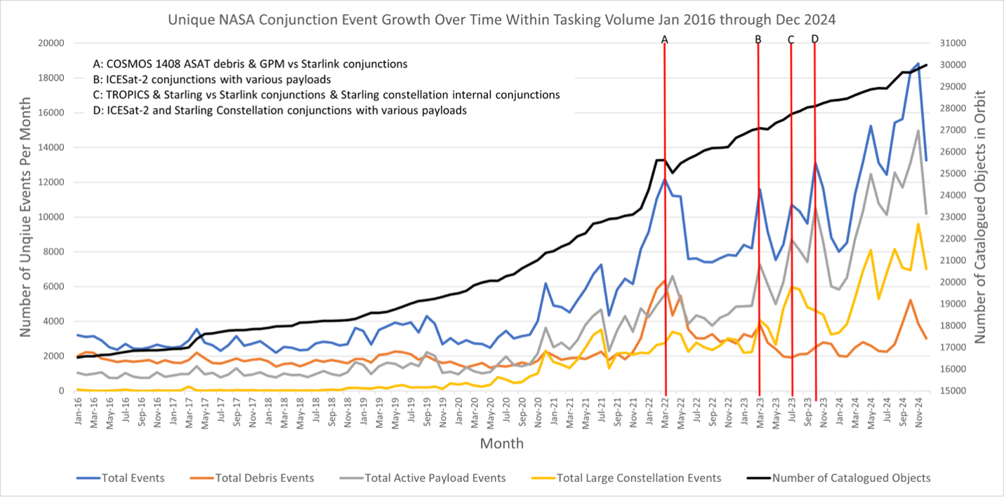
Figure 1: Unique NASA Conjunction Event Growth Over Time Within Tasking Volume Jan. 2016 through Dec. 2024 [6]
Within Dec. 2024, approximately 30,000 conjunctions were identified and catalogued by the 18 SDS and analyzed by the NASA CARA team. Of the 30,0000 conjunctions, approximately 20,500 involved large constellation payloads. In comparison, two years prior during Oct. 2022, approximately 17,300 conjunctions involve large constellation payloads.
With the increase in the number of satellites on orbit and subsequent increase in total conjunctions, the need for available, reliable, and scalable satellite ground systems is paramount. Utilization of cloud infrastructures has allowed satellite operators and support organizations, such as NASA CARA, to scale with the growing computational demands that accompany the large influx of identified conjunctions in the space environment.
To meet these challenges, CARA pursued a multi-year endeavor to evaluate computational solutions to augment various automated processes and services available using Cloud-based platforms and services. The evaluation process ensured the main drivers of shifting to the cloud-based services were clear and understood to adequately define the requirements for a cloud-based operational architecture, as described in the subsequent sections in this paper.
This paper provides the approach CARA took to transition to the cloud, as well as respective lessons learned. Key evaluation factors include cost, security, reliability, and performance of the system. In this paper, we will also summarize the various key-aspects an operational entity should consider when embarking on a multi-accessed cloud-based solution with large sets of operational data for critical safety decision making. The CARA team worked closely with various cloud platform service providers until the team converged in securing the best fit. The team had to deftly learn and understand the differences and similarities in operating and accessing cloud services and the security controls required to ensure the created cloud environments were always protected and secure [7].
CARA processes conjunction assessment data and computing risk analysis data products and disseminates them to the NASA and partner missions three times a day, every day, thus the impetus for a reliable and scalable system. Since 2022, the cloud platform has been an immense conservator in handling the unexpected influx of conjunction data caused by the various unexpected debris-generating events, with the ability to spin-up and spin-down cloud instances for increased computation power on demand. This ensures that NASA can continue protecting its assets as well as ensuring the continual protection of the space environment for all spacefarers.

2. Motivations for a Cloud-Based Solution
CARA was originally set up using a suite of individual tools to run on operator workstations to provide analysis and products to support a handful of missions. As the number of supported missions grew, so too did the number of objects and events being monitored. CARA identified the following risks of continuing to use an On-prem (On premises) system that would need to be addressed:
- Processing speed for operational data began to degrade as the number of missions supported and events identified increased and the current configuration of the On-prem system was not prepared to support the increasing length of processing time.
- Upgrading CARA servers and workstations to meet the growing number of resident space objects was a significant up-front cost.
- On-prem systems had limited scalability that was only possible through purchasing additional hardware and writing additional complex software algorithms to utilize hardware nuances.
- CARA operational support needed geographically redundant systems instead of locally managed physical servers that were subject to more frequent outages to ensure availability under diverse circumstances.
- On-prem systems required CARA to purchase warranties for the hardware and licenses for the software, both of which involved cost and time to manage.

Challenges with On-prem Processing Speed
CARA observed that systems can experience inconsistent utilization if you’re processing real-time data, especially if that data is received in batches. In addition, given that CARA operations are a 24 hours a day 7 days a week endeavor, including holidays, the result is a complicated schedule for workstations. On-prem systems addressing resource scarcity require provisioning additional hardware and licenses, which is both a costly and time-intensive process involving ordering, installation, testing, and maintenance. Another observed challenge was that On-prem infrastructure is difficult to expand beyond a physical location being a single point of failure. This setup made the system vulnerable to power or internet outages, a major concern that further highlighted the limitations of the existing infrastructure.
Altogether, these inefficiencies, high costs, and operational risks underscored the opportunity for a more scalable, reliable, and cost-effective solution presented by transitioning to a cloud-based approach.

On-prem Infrastructure vs. Lift-and-shift vs. Cloud-Native Cost Comparison
The costs of On-prem architecture can be hard to quantify on a monthly basis. As opposed to cloud costs, which tend to be an all-inclusive, monthly bill (with the exception of instance reservations and other longer-duration costs, which can still be amortized over a known period), On-prem infrastructure tends to have a large up-front cost, and indefinite period of usage (for example: a server purchased rather than leased, may be kept on site and functional for ten years or more, and its lifetime cannot necessarily be specified at acquisition). In addition, On-prem infrastructures have more hidden costs, such as power, climate control, maintenance and repair staffing, and physical security measures. The portion of these costs may be allocated to the facility, and the impact to them of the On-prem infrastructure may be difficult or impossible to tease out.

CARA knew that a lift-and-shift of dedicated servers to the cloud would be best served by Elastic Container Services (ECS), which allows multiple identically configured servers to be run in the cloud for predictable cost. This also allowed the number of services to be downscaled in the period between deliveries, though they could never all be shut down completely as at least one server needed to be always running to service ad-hoc requests from system operators. Cloud infrastructure costs more to run per cycle than an On-prem system, and if you have a lifted-and-shifted system then you can expect to pay several times what you were paying to run those servers On-prem, since the lift-and-shift setup is not intended to run efficiently on the cloud and would require rearchitecting to take advantage of the cloud-based services and setup for cost savings.

AWS Lambda supports starting serverless processes on a completely on-demand basis with effectively unlimited parallelism. This means that no server needs to be persistently running, waiting for requests to service (and incurring costs) - they are started immediately upon issuance of a request that requires servicing. The result is a dramatic decrease in compute costs. Volatility in the CPU consumption rationalizes the cost savings achieved with Lambdas. Figure 2 shows the expected Max CPU consumption during nominal conjunction processing.

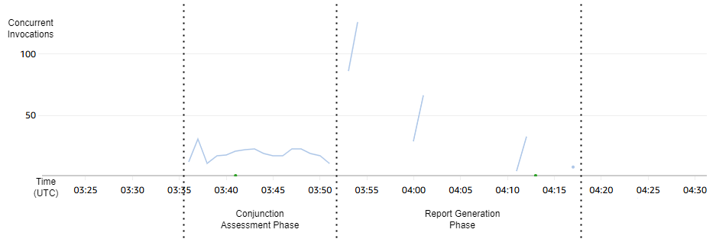
Figure 2: Expected Max CPU Consumption during nominal conjunction processing with Lambdas

Nominal Conjunction Processing can be viewed as having two major phases: The Conjunction Assessment Phase, which currently launches a set of longer-lived processes (up to 100 seconds) for calculation; and the Report Generation Phase, which launches a high number of very short-lived processes (under 6s) and spends the majority of its time in a single (legacy), unparallelized coordination process. Thus, when estimating the On-prem infrastructure needed to replicate processing capacity of the current cloud architecture, it makes sense to estimate using only the CPU consumption of the first phase. In that phase we generally see peak utilization of 26 Lambda Invocations, or 32 CPUs.

As a point of comparison, suppose that CARA decided to provision 32 CPUs of workstations in 2015. The Dell Precision T7910 workstations used by CARA at the time had a cost per CPU Core of $1197. Acquiring 32 CPUs at this price would have been an up-front cost of approximately $38k. With the non-cloud-native infrastructure costing $12k/year, this yields a break-even duration (for equivalent performance) of more than three years. With a cloud native architecture reducing annual compute costs to $800, this break-even duration is lengthened to a much more impressive 47.5 years, well past the duration that commercial hardware is generally expected to stay in service.

Scalability of Dedicated (On-prem or ECS) Servers vs. Cloud-Native Lambda

While the ECS architecture of Application Engine provides some ability to scale, the autoscaling strategy used is relatively simplistic, scaling up to 16 services when a delivery is received, and back down to 1 service for the lower-utilization periods between deliveries. The result is a relatively direct correlation between the size of a delivery (measured in conjunction events processed) and the total duration, as shown in Figure 3: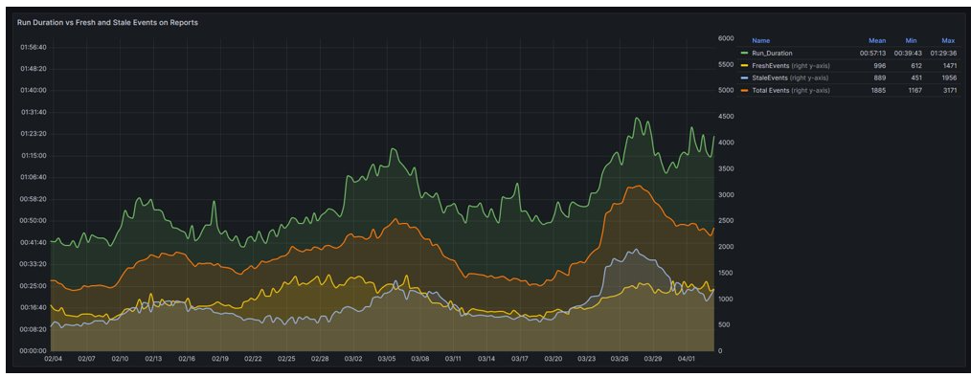
Figure 3: Direct correlation between run duration (Green) and number of events processed function similarly between On-prem and ECS even when scaled

This performance is almost identical to the behavior of the On-prem architecture. The time to process a delivery, scales linearly with the number of events in the delivery, the difference is the size of the scaling factor – additional services can be more easily launched in ECS to accommodate larger deliveries than in the On-prem infrastructure. While ECS allows unlimited horizontal scaling, such scaling needs to be either manual or automatic based on your system conditions such as available memory and CPU consumption. The problem is that both approaches tend to be slow at responding, which results in idle CPU cycles which inflate costs, making large scaling cost prohibitive.

Lambda Functions again provide us a solution. Rather than launching many services to await requests, we can launch a single Lambda invocation explicitly for each request, which terminates as soon as the request is fulfilled. Theoretically, if you’re able to fully optimize it, you can have instances with no charge for unused CPU cycles and scale horizontally.

Lambdas Further Optimize Scaling Saving Time and Cost

A balance must be struck between the time it takes to start up a new service and the time it takes to complete processing. Many libraries on AWS impose relatively large time penalties on startup. The AWS Lambda Service attempts to mitigate this behavior with the use of “warm-starts”, where a Lambda Function execution environment is reused if called again within a short period of time after completion.

Consider two Lambda Functions both given a dataset containing 487 events, and we vary the concurrency – the number of concurrent invocations used to process the dataset. Since AWS bills for Lambda functions by the millisecond on CPU consumed, we plot the total cost to process the dataset against the total time it takes, and an interesting pattern emerges seen in Figure 4:

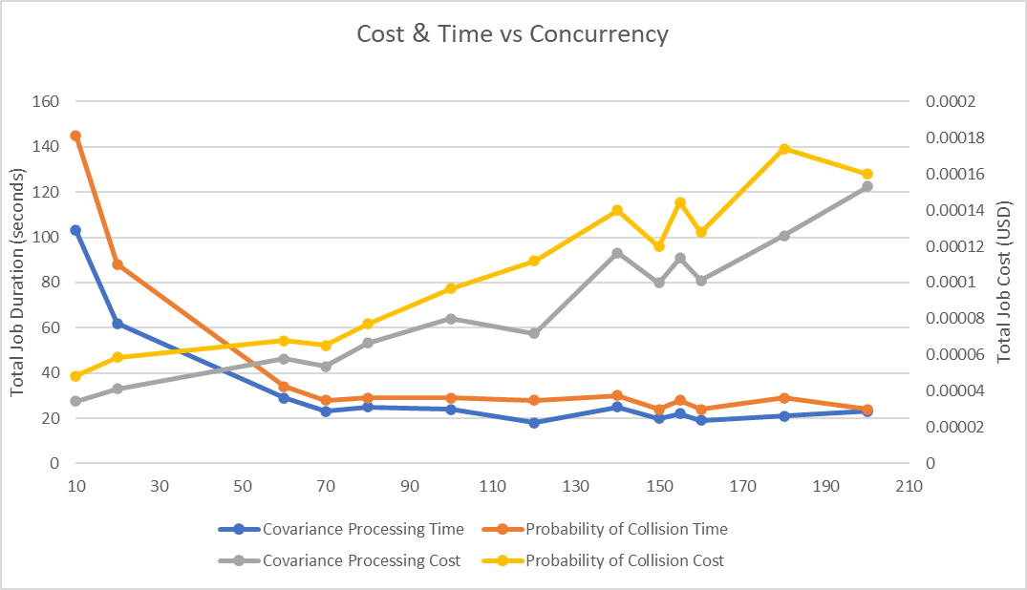
Figure 4: Cost & Time vs. Concurrent Invocations (x axis)

While the AWS cost of the processing increases linearly, there is an inflection point at around 70 parallel invocations past which the duration of the job does not decrease significantly as concurrency increases. This appears to be a balancing point where the cost to cold-start new Lambda executions begins to impact our total runtime – indicating we're better off reusing existing lambda execution environments for the remaining 417 events in our workload than we are to spend time launching more parallel workers. Any application brings with it practical limitations to its concurrency, and while AWS’s Lambda makes available effectively unlimited scaling capacity, its real strength comes in the ability to also manage its concurrent invocations efficiently.

AWS Datacenter Redundancies

On-prem systems can be at risk of outages similar to being limited to one AWS Data Center. Cloud services may be spread across different datacenters to provide geographic redundancy against power losses, network failures, and software bugs that have not rolled out fully. Even when using one AWS datacenter you achieve the following redundancy:
- The hardware infrastructure of a commercial datacenter will be more robust and redundant than a local lab environment can hope to deliver, from switching infrastructure to backup power generation to Heating, Ventilation, and Cooling (HVAC).
- The virtualization abstractions that computations run on top of are backed by a very large compute pool with significant open capacity, allowing workloads to be rescheduled immediately in the event of a hardware failure. That is, the virtual machines (VMs) and containers that most CARA workloads run inside of create redundancy between the physical servers that they run on.
- The Infrastructure as Code (IaC) and immutable infrastructure that CARA has adopted in support of its cloud migration, together with the strong isolation between AWS accounts, enable redundancy in deployed versions.
  - CARA maintains a development and a test deployment in addition to its production deployment, supporting for rapid development and thorough pre-release testing, respectively. Both environments can be de- and re-activated easily to save money, although in practice both are on most of the time.
  - During a deployment to production, blue-green deployed components, such as via rolling update of a container service, allow for zero-downtime updates.

Warranties and Licenses

CARA's on-prem deployment required hardware warranties of various sorts. This concern does not exist in the cloud.

Operating system licenses are handled by the platform and rolled into the hourly price of the VM or container which requires the OS. This simplifies management, but still must be considered when evaluating cost; the license surcharges can be quite significant. Also, many software companies have not updated their licensing to match the demands of running in the cloud and can introduce challenges running in the cloud.

One of the software licenses CARA uses requires permits be tied to a particular MAC address, which makes a lot less sense on the cloud. CARA found a satisfactory solution in creating a stable logical networking component representing a virtual network card called Elastic Network Interfaces (ENIs), binding licenses to those ENIs, then attaching the ENIs to the VMs which require access to the software.

Another challenge of licensing on the cloud is when your software needs to scale ENIs but you need a permit for each one. Juggling ENIs in an auto-scaled system is complex, and the provisioning of licenses for a many-worker system is expensive. MATLAB is one such situation. To avoid these problems, CARA deploys compiled MATLAB applications to its analysis pipeline, which run royalty free. To generate the compiled MATLAB, CARA maintains a dedicated builder box with a static ENI-bound license.

3. Important factors to consider for a 24x7 Operational platform

Implementation of a satellite ground system into a cloud environment presents several benefits as well as some drawbacks. All factors should be considered when evaluating the efficacy. These factors should include performance, reliability, security, and cost. In a broad sense, these factors should be considered for any well-architected system, however, the following were evaluated from the perspective of NASA CARA.
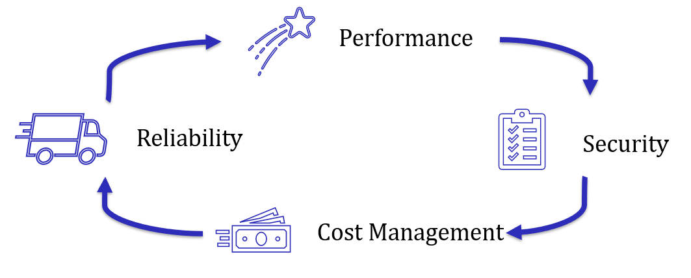
System performance was the focal point when evaluating cloud infrastructure for CARA’s use case. Given the available services by cloud providers such as Amazon Web Services, Microsoft Azure, Google Cloud Platform, and others, computational resource would not present itself as the system bottleneck. Each cloud provider allows users to scale resources on demand. CARA receives conjunction screening data in bulk at least three times in a 24-hour period. For each screening delivery, resources are scaled to meet demand and produce products for CARA’s customers in a timely fashion. Prior to implementing the ground system in the cloud, data processing timelines were on the order of hours. With the current cloud implementation, CARA can provide data products to customers within minutes.
Reliability is perhaps equally as important as system performance when operating a 24-hour service such as CARA. Cloud providers boast superior reliability that exceed standard ground system requirements and have configured their systems to handle hardware failures and keep customer workloads. In the case of CARA using on-prem hardware, a hardware failure could occur and there would be no additional pathway to continue processing data. As a result, additional risk is introduced to the space environment as situational awareness is lost temporarily. The option to purchase redundant hardware systems is available but may not be economically feasible. Outside the realm of hardware failures, cloud providers give users access to many geographical regions to operate their workloads. Programs can reduce mission risk further by becoming geographically redundant. As an example for CARA, if local infrastructure (power, internet, etc.) around NASA Goddard Space Flight Center (GSFC) becomes unavailable, CARA’s services will continue to be provided using the configured cloud infrastructure.
Data security is vital for any organization, government or not. CARA’s position as a conjunction assessment service provider for many missions that spans multiple facets across the globe, only heightens the importance of data integrity and security. Although many in the space traffic community likely are behind some level of VPN, cloud providers usually have both commercial and government cloud capabilities to help compartmentalize further and maintain compliance. Cloud providers are also responsible for maintaining security compliance for their infrastructure, while cloud users like CARA are responsible for the security of the applications created and executed on the cloud infrastructure. The cloud provides a more clearcut picture of the security assets that need protecting than most on-prem systems, however the number of assets to track will increase faster than they did On-prem [9].

Technical Approach for Cloud Solution

Phase 1 “Lift and Shift”

CARA knew the quickest way to get on the cloud would be a relatively straightforward transfer of resources from On-prem resources to AWS resources. Most physical resources have direct counterparts in the cloud; Windows and Linux servers were moved to Amazon Elastic Compute Cloud (EC2) instances, as were operator workstations. Databases were exported and deployed to Amazon Relational Database Service (RDS) clusters. Differences in the deployment methods between On-prem resources and Cloud resources resulted in a change to the way DevOps tasks were performed. Instead of replacing the software packages installed on a physical workstation, new machine images (AMIs) are created containing the intended state of the system, and these used to launch new instances at release.

CARA learned while working with NASA security that they would also need an environment for more sensitive information in AWS’s GovCloud data centers, for governance and compliance reasons. This required the introduction of a VPN tunnel connecting the Commercial Cloud and GovCloud environments, which was not required in the On-prem environment.

In addition, operators needed to adjust behavior with the move to the cloud. An idle On-prem workstation is relatively cheap to ignore, but cloud workstations can rack up substantial costs when left running unnecessarily. To address this, CARA needed to create tools and dashboards to monitor the state of operator workstations, allowing operators to start them when needed, shut them down when finished, and automatically pausing them when idle.

Phase 2 “Convert to Cloud Native”

Significant cost savings cannot be realized simply by converting On-prem resources into equivalent cloud resources. Workstations and servers must still be powered, maintained, cooled, and repaired. In addition, profits must be paid to the cloud providers. The real cost savings in cloud architecture comes from paying only for what you use and not maintaining excess resources. To accomplish this, we must embrace so-called “cloud native” paradigms.

A straightforward first step in this direction for CARA was to move the services from persistent applications running on otherwise underused but dedicated operator workstations to the AWS ECS. ECS lets you rapidly deploy and scale applications to the cloud infrastructure by running them as a service within Docker Containers. The services then monitor a message queue and request additional services as needed. This architecture automatically scales as needed, as the CARA computational workload tends towards short bursts of high demand - that is, a large amount of processing needs to be done quickly, in several large batches each day, but with few requests needed in between deliveries. Operators still have a need to perform ad-hoc analysis between routine deliveries, so CARA leaves at least one Application Engine running at all times to service these requests, incurring costs while idle.

A technique to remedy this is to convert the Application Engine services into AWS Lambda Functions. Rather than existing as a persistent service that watches a queue or other structure for requests, Lambda provisions hardware and executes the functions on demand, billing only for CPU cycles and memory consumed (within millisecond resolution). We can effectively scale these functions horizontally without limit – that is, we can execute as many in parallel at a time as we need. This architecture has its limitations, such as a 15-minute runtime limit before the service forcibly terminates the invocations, but the cost savings from not paying for idle CPUs have been substantial in CARA’s workloads, and Lambdas provide additional mechanisms to work around those limitations.

5. Lessons Learned

CARA recorded many lessons learned from the challenging experience of moving to the cloud to the cloud native modernization effort. CARA hopes to share these lessons learned with the community, as the health of the space environment benefits everyone.

Before You Begin Your Journey to the Cloud

Clearly define the goals for using the cloud. Decide if the cloud is to be used for the whole system, for parts of the system, or just to have a strong fail-over plan. Determine if it will be for data storage, moving data, and/or processing data. Moving to the cloud presented many opportunities for improvement including speed, reliability, cost savings, and security. Many plans were made throughout the cloud effort to try to reach different goals. This delayed the effort significantly, and when only one priority was focused on (to move operations to the cloud) we quickly got over the hurdle and met our first milestone. Too many competing priorities can cause significant delays. And, of course, be sure of your decision to move to the cloud.

Make sure your database schema matches the architecture you decide on for the cloud solution. CARA determined that microservices would work better for its architecture than a monolithic structure and we found we were able to use the benefits of the cloud more easily the more decoupled the subsystems were.

Determine if you want to lift-and-shift your software to the cloud or rebuild it to be Cloud Native from the start. While it worked out for CARA in the long run, it’s a major time commitment and many Cloud Users may just want to right to being Cloud Native if they have the opportunity.

Selecting Your Cloud Provider

When evaluating cloud providers, you need to consider whether the permissions and control they give you will suit your situation. Many will offer to perform a lift-and-shift for you, but unless you have sufficient cloud knowledge on your team you should find a cloud provider solution that retains experts who can help maintain your software or convert it to the necessary Cloud Native solution.
Building Your Team
Have at least one cloud expert on your team. This is key to your transition onto the cloud. Whether that expert is from your cloud provider, or someone you bring on internally, you will need their help and it’s best to bring in from the start. Experts provide critical perspectives that drive your architectural plan, such as how many accounts you will want, whether to lift-and-shift or modernize, and can help write a modernization plan. Make sure to include them in the necessary meetings.

Involve Your Security Team Early and Often

A strong documented agreement (SLA) between cloud provider and user is key to a smooth transition. CARA was fortunate to have a good relationship with their cloud provider. Many issues that could have caused security concerns or project delays were able to be agreed upon and documented. This was paramount to CARA’s success in providing space traffic safety support.

Review architecture and networking with security early on. Security has grown in difficulty over the years, and many cloud development teams don’t have security experts of their own. Cloud providers take on some of the security responsibilities but defer security of the applications to the cloud users. You will want to come up with new Service Level Agreements (SLAs), review Incident Response (IR) plans (most Cloud Providers have one), and come up with new plans for monitoring and logging [9].

Protected Data and Software Systems

EAR/ITAR/CUI data hosting can add complications, and it becomes even more complicated if you work with external users. Having both commercial and government accounts complicated the architecture and finances. If you must have both, work very early on a plan to minimize either the commercial or the government side.

Considerations of On-Prem vs. Cloud Native Infrastructure

Beware working on the cloud if you have Command Line Interfaces (CLIs), or localized GUIs on workstations that users need. The more compatible you are with automated processes or remote control, the better. Ideally, users should be able to interface more via a web API than having to manage logins to workstations.

While there is a risk to using them, AWS managed services have been worth the cost. We found the costs to be comparable with in-house services, and they have saved us a lot of engineering time. The downside is that you are less in control of the service and it tends to couple you to a specific cloud solution. CARA has learned the control isn’t much of a concern and has accepted the risk of having to change cloud solutions.

Software with microservices work better on the cloud if they are cloud native. Many services are charged per cycle used, and so you want smart software that is only running when being used.

Technology like message buses, direct socket connections, and other things that were reliable on-prem may make certain assumptions that break on the cloud. The main one to beware of is the assumption of one subsystem that another subsystem will always be running. Another risky assumption rests in how subsystems communicate and handle ENIs. Also consider if the system is ready to handle multiple copies of geographically redundant systems.

Avoid workstations if possible. The cost and compatibility with most cloud requirements have been an issue. And Linux systems seem to work better and cheaper than Windows ones.

Avoid software with licenses incompatible with the cloud. These licenses typically charge per instance, limiting your ability to horizontally scale your infrastructure.

Team Management

Go with a more direct approach for management while moving to the cloud. CARA was historically developed by contractors, while civil servants performed only indirect management. Managers worked with contractors on requirements and attended milestone reviews and were reported tests but were not involved in daily decisions. CARA managers and CARA engineers worked in an Agile environment, and frequent communication in Agile software development is key. There is certainly a fine line between being too direct and not direct enough, and every case is different, but being indirect led to communication issues, misunderstandings of priorities, and rework/delays.

When touching anything externally facing, communication is key. Make sure to communicate dates of work and deployments (even without expected downtime) and be clear. While oversharing works well for those scenarios, there are other scenarios where you’ll want delicate handling to manage perception. Feedback, troubleshooting, and feature requests are best dealt with on an individual basis. While this is more of a general project management lesson, the cloud angle is that you should design the interface with the customer in a way that customers can be ignorant of your cloud architecture and not too involved.

Expectations of Operating on the Cloud

The cloud could be a more expensive solution for any project working with legacy software, at least for the first couple years. While On-prem software requires higher expenses up front, cloud managed services and the engineers that you hire to maintain them tend to be more expensive to run. Legacy software tends not to be written as a serverless architecture with an on-demand approach. If you’re going to use the cloud but want to save money, you should identify the parts of the system that would work better if they were serverless. Costs for working with AWS are clearly reported, both used and planned, so you can end up having a pretty accurate financial plan for your cloud resources. While you may not save money, you may end up in better control of it. With enough time and money spent towards utilizing the cloud, CARA found that eventually you will start to see cost savings.

Expect things to break a lot at first. CARA has a little bit of everything in the system, automated components, workstations, Secure File Transfer Protocol (SFTP), web servers, Windows systems, Linux Systems, message buses, large databases, small databases, cross-cloud VPN communications, and so forth, and each one of those experienced their own series of problems working on the cloud. While smaller systems may experience fewer errors, they should still expect several bumps along the way. This is why documentation and testing should be as formal as possible, and if not possible, have support staff closely on standby. Communication between stakeholders is key.

6. Conclusion (and/or) Benefits to Space Safety, Sustainability and Security

The switch to a cloud-based architecture has provided significant benefits to the CARA program. When compared to the demands of maintaining and expanding an On-prem architecture to support CARA operations, the following benefits were identified:
- Cost savings: While the up-front cost for moving to a cloud architecture was high, the overall lower operating costs will result in a cost savings over time (if and only if you use cloud native processing). Saving money on infrastructure respects taxpayer money and allows you to spend money on improving your capabilities.
- Improved Parallel Processing: The ability to use multiple cloud instances simultaneously has helped CARA process data for an ever-increasing number of conjunctions without a significant increase to run times. This has led to us getting results back to satellite Owners/Operators improving their window to respond to an event.
- Long-Term Scalability: As the space environment becomes increasingly crowded, the cloud architecture can be easily scaled to meet the increased computing demands at a lower cost. There’s a risk of increasing objects over the next 5-10 years that could lead to untenable response times.
- Short-Term Scalability: In the cloud architecture, Application Engines can be shut down when not in use, helping CARA reduce costs.
- Redundancy: The cloud architecture is not dependent on physical machines in one particular location, significantly decreasing the risk of a loss of CARA services due to emergencies. Maintaining a constant and reliable delivery cycle is paramount to coordination with the space traffic community and sustained trust by the stakeholders.
- Upgradability: Upgrades can be accomplished without procuring and integrating costly new hardware, on a much shorter timeline, and with fewer costs due to licenses and warranties. With upgrades we can save time, money, or take advantage of new features, including improved security compliance and avoiding using end of life infrastructure that poses significant risks to conjunction assessment.
- Availability: The cloud architecture has an expected availability of around 99.5%, which is a significant improvement on the previous On-prem architecture. CARA has yet to encounter system downtime due to a cloud architecture failure.
- Security: The cloud provider is responsible for the security of the cloud infrastructure, while CARA retains responsibility for the software being run on the cloud. Amazon has a strong track record for security of their datacenters and provides many avenues to implement managed services with baked-in security.
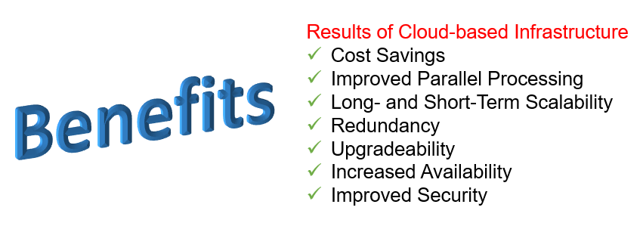

Improved cost tracking, processing capabilities, scalability, redundancy, upgradeability, availability, and security have made CARA’s move from an On-prem architecture to a cloud architecture a clear success.

Acknowledgements

The authors would like to thank Kareem S. Branch, Casimiro N. Ortiz, Daniel L. Rooney, John F. Smigo, and Jason Upchurch from the NASA Goddard CARA team.

References

[1] NASA Procedural Requirements (NPR) 8079.1 “NASA Spacecraft Conjunction Analysis and Collision Avoidance for Space Environment Protection”, Office of the Chief Engineer, Effective June 27th, 2023.
[2] L.K. Newman, A.K. Mashiku, M.D. Hejduk, M.R. Johnson and J.D. Rosa, “NASA Conjunction Assessment Risk Analysis Updated Requirements Architecture,” AAS 19-668, 2019 AAS/AIAA Astrodynamics Specialist Conference, Portland, ME, August, 2019
[3] U.S. Space Command, “Satellite Catalogue,” space-track.org, Available: https://www.space-track.org/. [Accessed: Nov. 22, 2024]
[4] Amazon, “Project Kuiper,” AboutAmazon.com. Available: https://www.aboutamazon.com/what-we-do/devices-services/project-kuiper/. [Accessed: Dec. 2, 2024]
[5] A. Jones, “Can China Challenge SpaceX’s Starlink?” spectrum.ieee.org, Available: https://spectrum.ieee.org/satellite-internet. [Accessed: Dec. 2, 2024]
[6] NASA Conjunction Assessment & Risk Analysis, “Unique NASA Conjunction Event Growth Over Time Within Tasking Volume Jan. 2016 through Oct. 2024,” nasa.gov, Available: https://www.nasa.gov/wp-content/uploads/2022/02/cara-monthly-conjunction-events-plot-oct-2024.jpg. [Accessed: Nov. 22, 2024]
[7] Institute of Standards and Technology “Security and Privacy Controls for Information Systems and Organizations”, In: NIST Special Publication 800-53, Rev.5, https://doi.org/10.6028/NIST.SP.800-53r5
[8] Amazon, “How moving onto the cloud reduces carbon emissions”, AboutAmazon.com. Available: https://sustainability.aboutamazon.com/carbon-reduction-aws.pdf [Accessed: Dec. 26, 2024]
[9] K. Knerler, I. Parker, C. Zimmerman, “11 Strategies of a World-Class Cybersecurity Operations Center”, MITRE Corporation, 2022, Available: https://www.mitre.org/sites/default/files/2022-04/11-strategies-of-a-world-class-cybersecurity-operations-center.pdf [Accessed: January 10th, 2025]

