The Design of a Flexible, Interoperable Navigation Signal for Future Lunar Missions

P. A. Dafesh, N. Wong, G. K. Khadge, G. Djuknic, The Aerospace Corporation; J. Crenshaw, B. C. Peters, C. Gramling, The National Aeronautics and Space Administration (NASA); F. Melman, C. Stallo, R. Swinden, The European Space Agency (ESA); M. Murata, Japan Aerospace Exploration Agency (JAXA)

Biographies
Philip A. Dafesh is a Distinguished Engineer at the Aerospace Corporation. He supports the development of GPS and space systems. He has contributed to the development of the modernized GPS signal structure and associated receiver processing for GPS L1, L2C and M-code signals. Phil hold B.S. degrees in electrical engineering and physics form Cal Poly Pomona and has received his Ph.D. degree in electrical engineering from UCLA. He has published 64 technical papers and holds 21 patents involving GNSS modulation, signal combining, interference mitigation and related technologies.

Gourav K Khadge is a Senior Member of Technical Staff in the Digital Communication Implementation Department of The Aerospace Corporation. He received his M.S. in Electrical Engineering in 2018 from the University of California, Los Angeles specializing in signals and systems. His current work is in research, analysis, testing, and development in wireless communications signals and systems, software defined radio, GPS and GNSS technologies. He has published four papers in IEEE, ION, and The International Symposium on Information Theory and holds one patent in GNSS receiver signal processing technology.

Nathan S. Wong is a Senior Member of Technical Staff in the Digital Communication Implementation Department at the Aerospace Corporation, specializing in software-defined radios and communication waveform design and validation. Previous work of his includes circuit design, machine learning, and system integration for aviation platforms. He received his M.S. in Electrical Engineering in 2018 from the University of California, Los Angeles, with a research focus on information theory, error correction, and channel modeling. He has published 2 technical papers.

Goran Djuknic is a member of the Performance & Analysis group at the Aerospace Corporation, specializing in wireless communications, digital signal processing, analytical methods, and navigation signal design. His contributions to GNSS included jamming mitigation algorithms, snapshot positioning, and GPS signal generation. In Raytheon Technologies, he developed methods for wireless communication in airline cabins, cargo spaces, and jet engines. He researched and developed methods for modeling, simulation, and measurement of signal propagation in airliner cabins and elevator shafts. He published 10 technical papers and was awarded 14 patents.

Juan Crenshaw is a Navigation Engineer at NASA’s Goddard Space Flight Center since 2020. He has over 15 years of prior experience with communications networks and spacecraft navigation, holding telecommunications engineering degrees from UPM and UAX (Spain). Juan is involved in technology development for lunar position, navigation, and timing, and is dedicated to promoting interoperable solutions, including the development of standards such as LunaNet. Additionally, Juan is involved in international organizations, including International Committee on GNSS (ICG), Interagency Advisory Group (IOAG), and the Consultative Committee for Space Data Systems (CCSDS).

Cheryl Gramling has over 40 years of experience leading trajectory design and navigation for NASA missions in LEO, GEO, HEO, lunar, and libration points, including relay systems and distributed system missions, such as the Magnetospheric Multiscale. With expertise in NASA Communication Networks, PNT systems, and operations, her focal areas are ground-based and autonomous orbit estimation, extrapolating existing capabilities in the networks and onboard sensors to cost-effectively achieve mission objectives. She now serves as the Lunar PNT and Standards Lead and is a Goddard Senior Fellow.

Brian C. Peters is pursuing his Ph.D. in Electrical Engineering and Computer Science at Ohio University within the Avionics Engineering Center. His research interests include GNSS interoperability, GNSS interference monitoring, weak-signal GNSS, pulsar-based navigation/timing, and lunar navigation systems. He has previously worked on Ohio University's Bobcat-1 CubeSat mission, and he was a navigation systems engineer for NASA's CAPSTONE mission. He is currently a Pathways intern at NASA Goddard Space Flight Center where he supports the LCRNS project.
Floor Thomas Melman got his MSc in Aerospace Engineering at the Delft University of Technology in 2018. He is currently a radio navigation engineer in the radio navigation systems and techniques section within ESA/ESTEC in the Netherlands. He is coordinating the GNSS receiver experiment that will fly on the Lunar Pathfinder mission and supports the ESA Moonlight program that will provide lunar communication and navigation services. Furthermore, he is the ESA lead within the LunaNet PNT working group that will define standards and protocols enabling interoperable lunar PNT systems.

Richard Swinden is a Navigation System Engineer in the RF Systems Division at the European Space Agency. His main current responsibilities involve providing System and Navigation Engineering support to lunar and Mars-related projects including Moonlight, Argonaut and LightShip-MARCONI. He holds a first-class Master of Electronic Engineering degree from the University of Nottingham and has more than 15 years of experience in the GNSS and space domains.

Cosimo Stallo got a PhD in Microelectronics and Telecommunications at the University of Rome Tor Vergata. He has experienced several years working on GNSS with University of Tor Vergata, RadioLabs, Italian Space Agency as senior researcher and technical manager of ESA and EUSPA projects. He joined Thales Alenia Space Italy in December 2019 as Senior System Navigation Engineer. In 2023 was appointed Head of Unit on E2E system design within Navigation Systems Department, Domain of Observation and Navigation Italy. In June 2024 he joined ESA as LCNS/Moonlight Principal Navigation System.

Masaya Murata joined the Japan Aerospace Exploration Agency (JAXA) in 2017 and he is currently the lunar PNT lead for Japan lunar PNT system called Lunar Navigation Satellite System (LNSS). He has a ten-year private-company experience prior to joining the JAXA and earned his Ph.D. from the University of Tokyo in 2017. From October 2021 to September 2022, he served as a visiting scholar at the Aalto university in Finland and the University of Texas at Austin in U.S., respectively. He is now actively participating in the International Committee on GNSS (ICG) and the Interagency Operations Advisory Group (IOAG) to facilitate the international collaboration for the lunar PNT.

Abstract
The LunaNet Interoperability Specification (LNIS) is a set of standards currently under development by NASA, ESA, and JAXA, which define a common, interoperable set of services and interfaces for lunar communication and navigation. The LNIS includes specifications for the GNSS-like Augmented Forward Signal (AFS). The LANS (Lunar Augmented Navigation Service) will be comprised of Multiple LunaNet Service Provider (LNSP) nodes broadcasting the AFS, such as NASA’s LCRNS (Lunar Communications Relay and Navigation Systems), ESA’s Moonlight LCNS (Lunar Communication and Navigation Services) and the Japan LNSS (Lunar Navigation Satellite System). The LANS will provide a GNSS-like capability enabling orbiting and surface users in lunar space (such as Artemis) to estimate their position, velocity and time as described in Giordano et al., (2023). Initial capabilities will focus on providing service to the lunar South pole region. The specification of AFS defines two orthogonal signal components on a single carrier, with the in-phase component (AFS-I) being a lower-chip-rate data channel tailored for applications where low SWaP is critical (e.g., IoT devices or search and rescue), and the quadrature component (AFS-Q) being a high-chip-rate data-less pilot signal for high-precision, robust lunar navigation and positioning applications. An initial description of AFS was provided in the LNIS, (2023), and initial analysis results were shown in Dafesh, et al., (2024). In this work, we provide rationale for updates to the LNIS that define key aspects of the signal including the primary spreading code designs for the data and pilot channels, and a three-tiered overlay code approach for the pilot channel that provides flexible signal acquisition alternatives, rapid time dissemination and robust frame Sync. The paper also describes a robust data Sync word that is designed to enable frame Sync for low-SWaP receivers that only use the I channel, as well as a low-density parity check code (LDPC) data message encoding design and interleaving definition. The work further describes the impact of the updated AFS design in terms of improved acquisition performance, interference resistance, navigation message capabilities and rapid absolute time dissemination for users able to access clock and ephemeris data over an external network. The cross-correlation and synchronization performance of the AFS design is also compared to potential alternatives, further providing rationale for the final signal design configuration.

Introduction
In support of future lunar exploration, LunaNet is being developed as a set of cooperating networks designed to provide robust and interoperable lunar communications and position, navigation, and timing (PNT) services. In the spirit of the Artemis accords, NASA, ESA, and JAXA are collaborating to define the LunaNet Interoperability Specification (LNIS), which sets standards for the development of the associated lunar infrastructure. These standards are critical for ensuring that various lunar services, providers, and technologies can work together effectively. Establishing these international interoperability standards facilitates a more distributed approach to the buildup of critical lunar infrastructure, allowing various service providers to deliver specific services, coverage, and capabilities as demand grows.

The goal is to enable any potential LunaNet Service Providers (LNSP) to implement selected services as defined in the LNIS and achieve seamless integration with the greater LunaNet ecosystem. Among the first service providers to instantiate LunaNet will be NASA’s Lunar Communications Relay and Navigation Systems (LCRNS), ESA’s Moonlight Lunar Communication and Navigation System (LCNS), and Japan’s Lunar Navigation Satellite System (LNSS). This paper describes the S-band Augmented Forward Signal (AFS) as described in release version 5 of the LNIS and the accompanying Applicable Document #1 Volume A (2025).

The Lunar Augmented Navigation Service (LANS) is a key component of LunaNet as described in the LNIS that defines a Radionavigation Satellite Service (RNSS) via AFS. An individual LNSP with multiple nodes can sufficiently deliver services for a mission. However, in contrast to Earth’s GNSS, LANS as a unified service aims to improve individual capabilities by integrating LNSP asset sources from multiple parties. This concept is illustrated in Figure 1, where different LNSPs work together to enhance coverage, improve geometry and performance.

To achieve LANS interoperability, the LunaNet specifications must consider the challenges associated with different contributing networks operating in the lunar regime. This involves differing orbital designs, with an LNSP possibly using Elliptical Frozen Lunar Orbits to enhance services at the lunar South Pole, while others might opt for circular orbits. Unlike Earth GNSS, this leads to a significant dynamic range amongst received powers on the surface, affecting co-channel interference. The following sections describe the AFS design and how it provides an interoperable solution that meets the needs of future lunar and cislunar users subject to these constraints.

Radio navigation systems rely on accurate, precise, and continuous time as a reference source for their transmitted signals and messages. GNSS in orbit around Earth act as sources of the Coordinated Universal Time (UTC) timescale reference to Earth’s surface of equipotential, the geoid. Even though each system may include an identified offset to UTC, they have consistent clock rates as a fundamental aspect for interoperability. LNSPs providing LANS (thus adhering to LunaNet) will disseminate LunaNet Reference time (LRT) which serves as a reference for the AFS signal. LRT will be linked to the proposed Coordinated Lunar Time (LTC) that is referenced to the lunar geoid as described in Ashby et al., (2024). The link between LRT and Lunar Coordinated Time will be defined in future versions of the LunaNet interoperability specification.

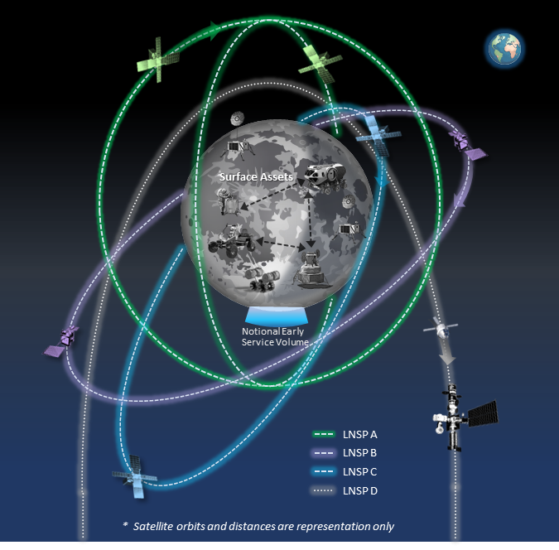
Figure 1: Depiction of Lunar navigation and timing services jointly provided by international LNSPs. The initial service volume is expected at the south pole of the Moon, gradually evolving to service broader regions of the lunar and cislunar regime. Credit: NASA
The remainder of the paper is organized as follows:

- Signal Overview
- I channel ranging code and performance
- Q channel ranging and overlay codes and performance
- Tertiary Overlay code and performance
- AFS Data channel and performance
- Summary and conclusions
Note that performance comparisons described throughout neglect receiver front end implementation loss for all signals, which is dependent on receiver quantization and bandwidth as described in Hegarty and Cerruti (2010).

The Augmented Forward Signal
Following recommendation of the Space Frequency Coordination Group (SFCG 2023), LunaNet established the AFS to be broadcast with a center frequency of 2492.028 MHz derived from 2436 times 1.023 MHz, a frequency common to legacy GNSS systems. The frequency choice poses challenges regarding interference with neighboring wireless and 3rd Generation Partnership Project (3GPP) channels also envisioned for use in the lunar environment (see Figure 2).

Overview
The AFS specification defines a lower accuracy 1.023 MCPS ranging code channel, which is designed for applications where low SWaP is critical (e.g., IoT or search and rescue). The AFS also includes a higher accuracy and more robust 5.115 MCPS ranging code channel similar to the L5 safety of life signal for use in precision landings and surface navigation. The recommendation considers ITU-R RA.479-5 as described in ITU (2023), which establishes protection of frequencies for radioastronomical measurements in the shielded zone of the Moon. All ranging codes used in AFS are Binary Phase Shift Keying (BPSK) modulated as opposed to binary offset carrier (BOC). This selection enhances robustness to adjacent band interference and by centering more energy away from adjacent band 3GPP cellular and Wireless (Wi-Fi) signals anticipated for use on the surface of the moon.

The 1.023 MCPS ranging code is modulated with BPSK data on the I channel. A 5.115 MCPS ranging code without data (pilot) is in phase quadrature, on the Q channel, to enable more robust precision navigation.
$s_{AFS}\left(t\right)=I_{AFS}\left(t\right)\cos{(2πf_{c}t)-Q_{AFS}\left(t\right)\sin{(2πf_{c}t)}}$ (1)
where $I_{AFS}\left(t\right)=\sqrt{\frac{P_{I}}{2}}C_{AFS-I}\left(t\right)D_{AFS-I}(t)$ (2)
and

$Q_{AFS}\left(t\right)=\sqrt{\frac{P_{Q}}{2}}C_{AFS-Q}$. (3)
$D_{AFS-I}$ is the I channel data sequence which has a symbol rate of 500 symbols per second (Sym/sec). $P_{I}$ and $P_{Q}$are the received power levels for the I and Q channels respectively.

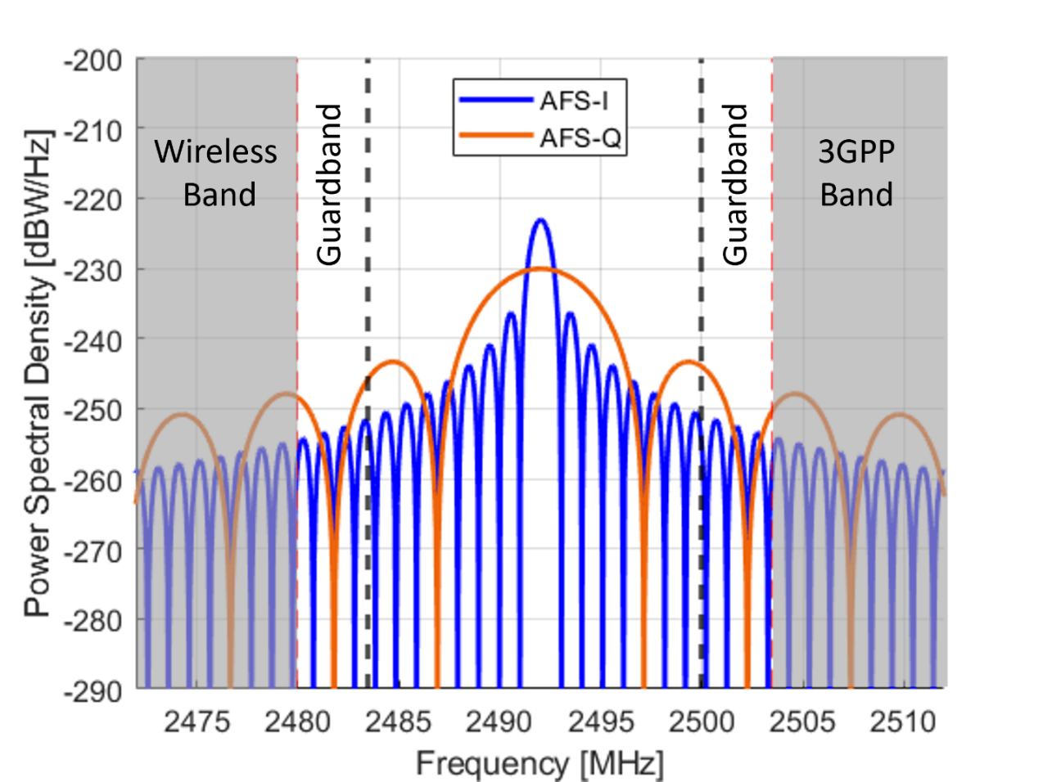
Figure 2: The AFS spectrum allocation sits between the vertical black dashed lines, centered between wireless and 3GPP allocations on either side. Guard bands shown are under study by SFCG.
The 500 sym/s AFS data rate and 6000-symbol message block size enable rapid transmission of Clock and Ephemeris data (CED) and provide margin for additional data contents, beyond what is required for PNT.
The quadrature phase (Q channel) signal uses a 5.115 MCPS spreading code, $C_{AFS-Q}$, denoted by BPSK(5), which is limited in chip rate due to the available 16 MHz bandwidth.

Ranging Codes
The I and Q channel spreading codes were selected to maximize flexibility for both low complexity and high performance user receivers while minimizing co-channel interference within the constraints of the received signal power levels and data symbol rate.
The overall spreading and data frame structure is shown in Figure 3. It includes a 2046-chip I channel spreading code, modulated with a 68-symbol Sync word and 5932-symbol data block. The dataless Q channel spreading code is comprised of a 10230-chip primary spreading code, C_{p}, modulated by a 4 chip secondary overlay code to form a 40920-chip intermediate code, C_{Int}, which is further modulated by a 1500-symbol Tertiary spreading code. The details of the I and Q channel spreading codes are further explained in the subsequent sections of this paper.

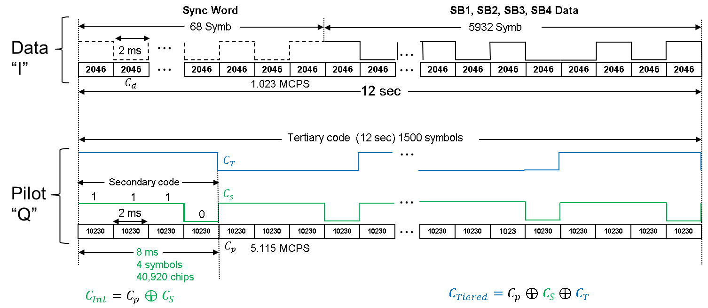
Figure 3: Combined AFS signal structure illustrating I channel Sync word, data modulation and three-tiered ranging codes.

I Channel spreading code
The I channel spreading code period matches the data symbol period and employs a 2 ms long, 2046-chip short cycled 2047-length Gold code. This provides immediate bit Sync and results in an acquisition implementation only twice as complex than for the C/A code. As in GPS, 210 spreading codes were selected based on the best auto-and cross-correlation properties from the set of $2^{11}+1=2048$ possible Gold codes.

The AFS Gold codes are designed from the preferred pair of maximal length sequences based on the following generator polynomials as described in LNIS (2025).

$g_{1}\left(x\right)=x^{11}+x^{2}+1$ and $g_{2}\left(x\right)=x^{11}+ x^{8}+x^{5}+x^{2}+1$, (4)
where the polynomials are initialized to 11111111111 and codes are selected in a manner analogous to the C/A code generation described in ICD-GPS-200.

Table 1 compares the use of a 1023-chip C/A code for the AFS-I channel vs the selected 2046-chip gold code. For a 1023-chip C/A code, cross-correlation is assumed to be over 1 ms during acquisition and 2 ms during track, due to the ambiguity between data symbols and spreading code prior to synchronization. The cross-correlation for the 2046-chip AFS Gold code is always over 2 ms since the data symbols are aligned with the code period. The cross-correlation results assume an equal probability of even and odd cross-correlations for the LDPC coded and interleaved AFS data symbols between satellites.
The results assume an equal probability of even and odd cross-correlations since the data symbols between satellites are assumed to be approximately uncorrelated.

A 2046-chip AFS I channel spreading code was found to provide a 3 dB improvement 99.9 % of the time during acquisition, compared to the GPS L1 C/A spreading code and over 1 dB while tracking, assuming random data symbols. A 2046-chip short cycled 2053-length Weil sequence was found to have comparable performance, but a Gold code was selected to simplify implementation.
Table 1: Cross correlation statistics for current GNSS primary codes, as well as the proposed LunaNet data channel spreading code comparison.

Note that the improvement over C/A code is 3 dB for acquisition (RMS) and 2 dB during track. For this reason, the longer 2046 AFS Gold code was selected instead of the 1023 chip C/A code. The first 50 AFS gold codes are observed to have comparable performance to Beidou’s 37 Gold of the same length for RMS, 99th percent and 99.9th percentile and 1 dB better performance in the max for the first 50 codes.

Q Channel Spreading and Overlay Codes
The Q channel pilot signal uses a 10230-chip pilot channel code as its primary spreading code. L1C primary codes are being considered due to their superior properties, lack of intellectual property rights and since 210 high performance codes have been designed. Fifty E5b sequences were also analyzed in this three-tiered structure shown in Figure 3. Additional details are provided in section 2.5.

A secondary overlay code (4 chip Barker code) used in the Galileo E5b-I signal (HEX letter “E” or 1110 in Binary) was leveraged to produce a tiered intermediate code, $C_{Int}$, of length 8 ms consisting of the modulo-2 sum of a repeating 4 chip secondary code and a 2-ms 10230 chip repeating primary code.

Initial correlation results assumed the same secondary spreading code for all satellites, but it was found that by performing three circular shifts of the 1110 secondary overlay, the overall code correlation properties of the tiered codes were dramatically improved. The circularly shifted codes shown in Table 2 are perfectly orthogonal, making this set of codes optimal for a length-4 overlay sequence. These sequences are derived from the family of possible 4 chip Barker codes, known to have very low autocorrelation sidelobes Barker, (1953).

Table 2: AFS secondary codes in Binary and NRZ format.
 | Binary Representation |  |  |  | NRZ Representation
 | B₄ | B₃ | B₂ | B₀ | N₄ | N₃ | N₂ | N₁
S₀ | 1 | 1 | 1 | 0 | -1 | -1 | -1 | 1
S₁ | 0 | 1 | 1 | 1 | 1 | -1 | -1 | -1
S₂ | 1 | 0 | 1 | 1 | -1 | 1 | -1 | -1
S₃ | 1 | 1 | 0 | 1 | -1 | -1 | 1 | -1

The intermediate code provides an alternate option for acquiring AFS-Q when large time uncertainties exist, providing higher processing gain than utilizing the primary code alone. This intermediate code works in conjunction with the tertiary code to provide a means of robustly determining absolute time, while allowing flexibility to trade complexity with the acquisition sensitivity (processing gain) associated with the longer intermediate code. The Tertiary code may also be used to transmit integrity or health messages in the future.

As described in Dafesh et. al., (2024), the acquisition search complexity of a repeating code scales roughly with the product of the chip rate times the code length. More generally, the complexity of an acquisition circuit is given by Dafesh and Holmes (2000) as

$C_{OPS}=N_{corr,t}\left[2R_{c}+\frac{N_{FFT}}{2Ti}{Log}_{2}(N_{FFT})\right]N_{SB}$, (5)

Where $N_{corr,t}$ is the number of complex time correlators, $R_{c}$ is the chip rate, and the factor of 2 in the second term in brackets accounts for zero padding to reduce loss. $N_{SB}$ is the number of sidebands (=1 for BPSK and 2 for BOC).

If the entire code is searched in parallel,

$C_{OPS}=2L\left[2R_{c}+\frac{N_{FFT}}{2Ti}{Log}_{2}(N_{FFT})\right]N_{SB}$, (6)

Where L is the length of the spreading code in chips, and it is assumed that the receiver searches the entire code in half-chip increments.

As observed from the terms in square brackets from Equation (6), the increase in frequency search due to the use of a longer code (second term) is generally small compared to the first term. For example, consider the case of AFS at 2.046 MCPS and an FFT search with 32 frequency bins with a 1 ms coherent integration over a 1.023 MCPS code vs a 2 ms coherent integration over a 2 ms code with 64 frequency bins (to cover the same frequence search range). The values of $C_{OPS}$ for both cases are provided in Table 3. As observed, the second term in the square brackets is negligible compared to the first term. As a result, it is a very good approximation to state that the acquisition complexity is simply proportional to the product of the code length, L, and the code rate $R_{c}$. The increased frequency search is negligible by comparison.

Table 3: Complexity normalized to code length.
$$N_{FFT}$$ | 32 | 64
$$T_{i}$$ | 0.001 | 0.002
$$R_{c}$$ | 2,046,000 | 2,040,600
$${2R}_{c}$$ | 4,092,000 | 4,092,000
$$C_{OPS}/(2L)$$ | 4,092,001 | 4,092,004

State of the art acquisition circuitry today can search the 10230 chips, 10.23 MCPS L5 code directly as described by Turetsky and McBurney (2020a); Turetsky (2020b) and Cozzens (2021). The AFS pilot primary code is roughly ½ the complexity of an L5 acquisition search implementation, while having comparable processing gain. The tiered intermediate code with 40,920 chips can be searched with an acquisition engine having twice the complexity of L5 only receivers, though resulting in a processing gain (proportional to coherent integration period $×$ chip rate) that is 6 dB greater. The AFS’s multi-tiered acquisition structure therefore provides exceptional receiver acquisition sensitivity in interference environments, while also providing a tertiary code for absolute time.

Q Channel Tertiary Overlay Code
This family of AFS spreading codes is based on Weil sequences whose generation is described by Rushanan (2007). The AFS tertiary overlay sequences are derived from the length-1499 Legendre sequence, which is generated by the quadratic residue approach from Hardy and Wright (1979) but may also be generated in a recursive manner to simplify implementation, as described by Rao and Reddy (1986). In the Legendre sequence, $L=(L_{0},L_{1},L,⋯,L_{1498})$, element values are

$L_{i}=\left\{\begin{matrix}+1, \text{if} i∈\{{LS}_{n}\} \\ -1, \text{if} i∉\{{LS}_{n}\}\end{matrix}, 1≤i≤1498\right.$ (7)
Element $L_{0}$ is always -1, and

${LS}_{n}=\left({LS}_{n-1}+2n-1\right) \text{mod} 1499, 2≤n≤749$ (8)
where ${LS}_{1}=1$. The set of 749, length-1499 Weil sequences is then obtained as

$W=\left\{L⨁TL, L⨁T^{2}L, ⋯, L⨁T^{749}L\right\}$. (9)
$T^{k}$ operator represents the cyclic shift of the sequence for $k$ places, and $⨁$ is the modulo-2 operation. Each Weil sequence is a component-wise exclusive-OR of the Legendre sequence and its circular shift. The value of the shift is the index of Weil sequences, which are also of length-1499. The length-1500 set of augmented Weil sequences is obtained by appending $-1$ to each sequence in the set $W$. A search was conducted to produce 210 Weil-based overlay codes with the best autocorrelation properties (lowest sidelobes) and low mutual cross-correlations, using minimum RMS cross-correlation (sidelobe) values as the criterion.

The code also serves as a source of absolute time for receivers with knowledge of time to within 12 seconds (i.e., exploiting the fact that the tertiary code is aligned to the 12 second data frame). Synchronization to the tertiary code normally occurs after acquisition and tracking of the AFS intermediate code $C_{Int}$. The tertiary code phase is determined by performing a maximum likelihood search by dwelling over some number of tertiary code symbols for each possible code phase offset. Figure 4 shows the 99% $C/N_{0}$ threshold as a function of dwell period. A minimum of 22 symbols must be integrated to achieve synchronization performance comparable to the I channel Sync word threshold (25.2 dB-Hz). Up to 50 symbols are needed to achieve $C/N_{0}$ performance that is well below the data threshold. Absolute time synchronization to within one AFS-Q chip may be determined by correlating 50 successive 8-ms symbols against 1500 possible $C_{Int}$ code-phase offsets, which takes less than one second in software.

Figure 4: Dwell period required to search tertiary code as a function of $C/N_{0}$.

Q channel Tiered Code Cross-Correlation Performance
An initial assessment of the tiered code performance is shown below for sets of primary, secondary, and tertiary sequences that were each combined into a tiered code (C_{tiered} in Figure 3) using different primary code sequences. Results are shown in Table 4 for the L1C primary code sequences described in IS-GPS-800 (2023) versus the Galileo E5b primary code sequence described in European Union (2021).

The cross-correlation results were computed over every possible start time of an integration period in a frame. Integrations of 2 ms were considered over any of 6000 possible starting points in the frame. Integrations of 8 ms or longer were considered to be aligned to secondary code symbols, with 1500 possible starting points for each PRN being tracked. For each of the N PRNs being tracked, one of the remaining N-1 PRNs were considered as the interfering signal, for a total of N*(N-1) pairings. Time differences of arrival between the tracked PRN and the interfering PRN consisting of integer primary chip periods between +/- 20 ms were considered, or 204,600 different time differences of arrival for each pairing of PRNs and each possible starting point. The family of four 4 chip secondary Barker sequences were assigned sequentially to each PRN such that PRNs 1,5,9,... were assigned the first Barker sequence, PRNs 2,6,10,... were assigned the second Barker sequence, and so on. It was found that the overall statistics are not substantially affected by the code assignments between primary, secondary and tertiary codes.
The results are illustrated vs coherent integration periods corresponding to acquisition of the 2-ms primary sequence, acquisition of the tiered 8-ms secondary sequence, or tracking with 100-ms or 200-ms coherent integration periods upon synchronization with the secondary and tertiary overlay sequences. The results compare the cross-correlation performance with the 50 E5a sequences, first 50 L1C sequences, and 210 L1C sequences. Note that we compare the first 50 sequences for each code type in Table 4 since only 50 E5aQ codes have been defined for Galileo in European Union (2021).

As observed by the results, for 99th percentile and 99.9th percentile, the cross-correlation performance with L1C as the primary code exceeds that of E5aQ in most of the cases for 2 ms, 8 ms, 100 ms and 200 ms coherent integration periods (illustrated by the blue coloring in the table). In all cases, the Max cross-correlation with L1Cp as the primary code is superior. Moreover, the rms performance of L1C is practically unchanged (within .05 dB) between 50 and 210 codes defined for L1C. Finally, the rights to the L1C patent No. US 7,511,637 B have been given up in a terminal disclaimer (since June 24, 2010) and are therefore available for use royalty free. All other codes in the AFS signal design have been designed in this work are publicly available (Barker sequences) and are provided royalty free without intention of future patenting.

Table 4: Q-channel tiered code correlation results .

AFS Data Channel
The AFS data channel consists of a symbol stream that commences with a 68-symbol word that provides high reliability frame synchronization for low SWaP receivers that only use the I channel. This is followed by four subframe blocks (SBs) including SB1, containing the time of interval (TOI) and a frame identifier (FID) that provides flexibility to change the data frame structure in future revisions. SB2 contains the CED, while SB3 and SB4 will include almanac data, alerts, network access information, and optional information that can be implemented by service providers. The frame structure for frame identifier #0 is depicted in Figure 5.

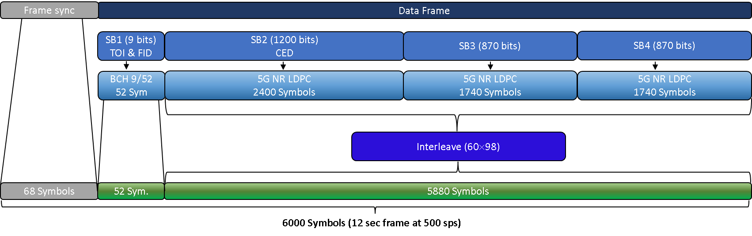
Figure 5: AFS Data message frame for the FID=0.

AFS Data Frame Structure
The design of the AFS data frame entailed several competing objectives:
- Exploit high performance low density parity check (LDPC) forward error control (FEC) coding from available standards.
- Provide an FID field that is independent of the LDPC coding and interleaving.
- Provide a high reliability Sync word to enable frame Sync for low SWaP users that do not track the Q channel.
- Provide a data rate and frame size that permits frequent navigation message updates and ample message flexibility.
- Select message and Sync word sizes that provide useful interleaver factorizations.

Achieving all these objectives required several design iterations conducted in parallel. Iterations involved changes in Sync word size, SB2-SB4 message lengths, encoding and interleaving, as well as SB1 bit allocations and encoding. The resulting frame structure baselined for initial operation is represented in Figure 6.

Design of the LunaNet I Channel Data Frame Synchronization Word
Unencoded or convolutionally coded data messages used in C/A code or the Galileo open service, allow for Sync words to be placed throughout the data message, and frame Sync can occur after data decoding. Because the frame Sync can occur over multiple Sync words in this manner, arbitrarily high reliability may be achieved at the expense of time to achieve frame Sync by having multiple looks at the same Sync word. Frame Sync in modern block encoding approaches such as LDPC must occur prior to decoding the message and therefore frame Sync must be very reliable with just one Sync word.

To select a proper Sync word length, words of various lengths were considered and analyzed focusing on their rate of false alarms per hypothesis while maintaining a 99% detection probability. Each Sync word was chosen from sequences with minimum peak sidelobe levels after autocorrelation from the work of Kocabas and Atalar (2023) in order to reduce the rate of false alarms. Synchronization words of lengths 52, 64, 68, and 128 were analyzed. The plot of results for false alarm rate per hypothesis vs C/N₀ is shown Figure 6 below.

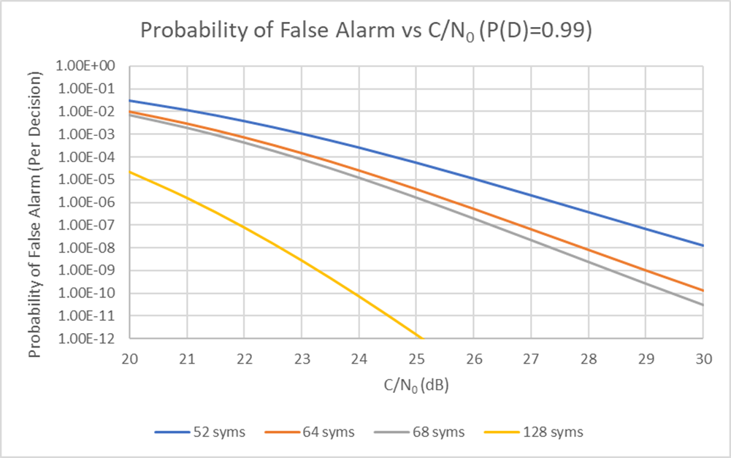
Figure 7: False alarm probability vs C/N₀ and Sync word size.
For each of these Sync words, we found the minimum C/N₀ such that the false alarm rate per hypothesis was below 1E-06. The minimum C/N₀ for each Sync word to achieve the desired performance is shown in Table 5.
Table 5: Synchronization Word Performance vs Length
Sync Word Length (Symbols) | Sync Word Length (ms) | Minimum C/N0  (dB-Hz)
52 | 104 | 27.41
64 | 128 | 25.69
68 | 136 | 25.23
128 | 256 | 21.16
The Sync word design was conducted in parallel with forward error control design to ensure that a single Sync word could operate down to the level of the BCH code and CED C/N₀ threshold levels, while still permitting reasonable factoring of the data blocks for subsequent interleaving. A 68-bit Sync word was identified as having more than adequate performance and capable of operating below the threshold for CED data demodulation, having reliable detection at $C/N_{0}=25.2$dB, for a detection probability of 99 %, and a false alarm rate of 10⁻⁶ per hypothesis, which is below that of the data message threshold. While carrier tracking performance may be limited to $C/N_{0}≥25.2$dB for user receivers that only process the I channel, higher reliability frame Sync may be achieved by tracking the Q channel pilot and searching the tertiary code as described previously in section 2.4.

SB1 Data message decoding
The rate (52, 9) extended BCH code used in GPS L1C was selected for use in AFS since it has a sufficiently low Message Error Rate (MER) at much lower $C/N_{0}$levels than AFS’s LDPC code Betz et al., (2006); Dafesh et al., (2007); Dafesh et al., (2024). This selection permits detection of CED at lower $C/N_{0}$ levels, as described below using CED combining (called code combining in Betz et al., (2006). To support reliable FID decoding, the BCH(52,9) code is re-purposed to provide both a 7-bit TOI and 2-bit FID that are independent from the remaining data.
The AFS TOI increments with every 12-second transmitted frame until it reaches a value of 100, representing a block interval (BI) of 20 minutes, and then resets to zero. The curve fit interval 100over which the CED is valid is expected to be uniquely defined for each service provider. When the curve fit interval is a multiple of the 20-minute BI, the SB2 CED data stays constant over several subsequent frames within the BI. CED combining across frames can then be performed to enhance decoding sensitivity using linear block FEC like LDPC. This intermediate step takes the soft decisions of multiple codewords and adds them symbol-wise to produce a final set of values as shown in Figure 8. Figure 9 shows that with just two combined SB2 blocks, the receiver can read data at 3 dB lower $C/N_{0}$, at a performance close to that of SB1.

SB2-SB4 Data message decoding
To exploit commercially available standards and provide a flexible encoding scheme for varying frame sizes and rates, a set of rate-½ LDPC FEC codes were constructed using the 5G-NR technical specification for SB2-SB4, which consist of 5880 interleaved FEC coded symbols 3GPP (2020); LNIS (2025), Dafesh (2024). The raw, CRC-protected information bits contained in SB2-SB4 are separately encoded and then interleaved together. These decisions stem from multiple trade studies resulting in the design of a high-performance data message structure that meets the above design constraints.

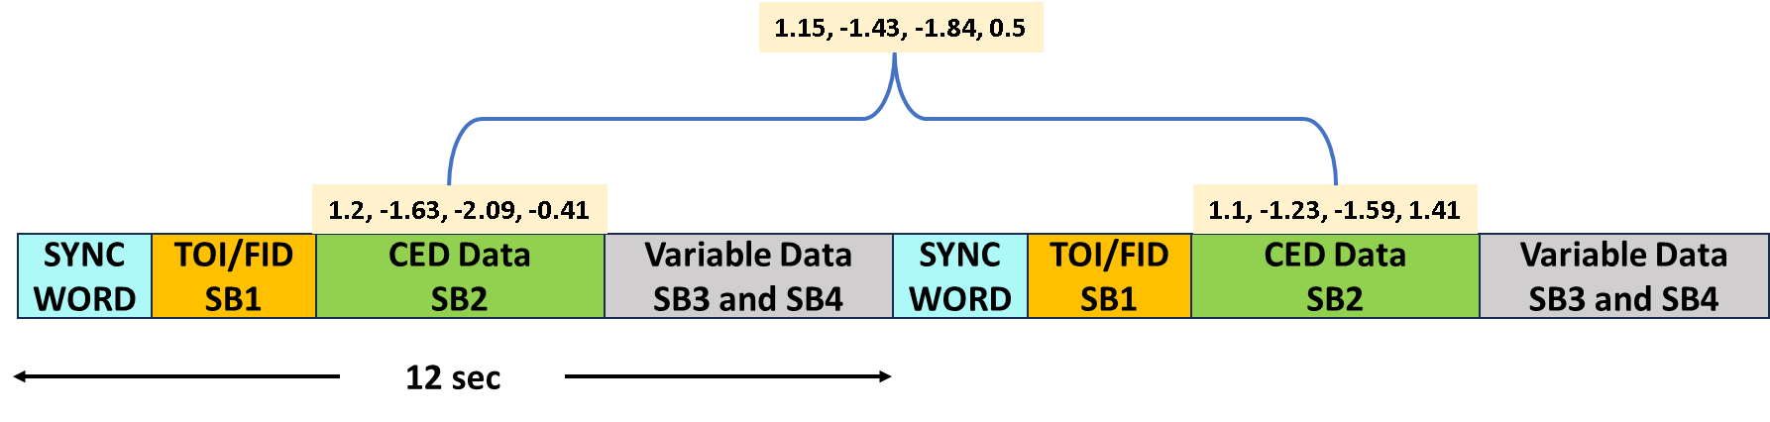
Figure 8: Illustration of CED combining to improve data detection by 3 dB.
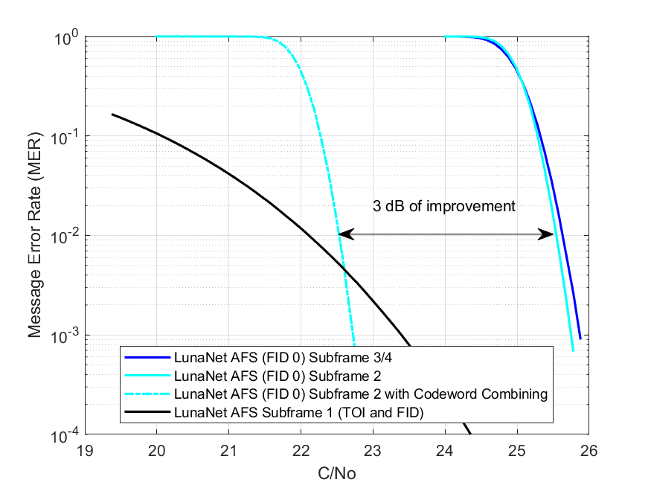
Figure 9: Application of CED combining to enhance sensitivity of SB2 CED data demodulation.
The performance of these codes is shown in Figure 9 to surpass all other currently utilized GNSS codes in terms of bit error rate performance vs $E_{b}/N_{0}$. If needed for other FIDs, the documented 5G-NR design process can be repeated to achieve a unified AFS approach using accessible standards described in 3GPP (2020) and in LNIS (2025).
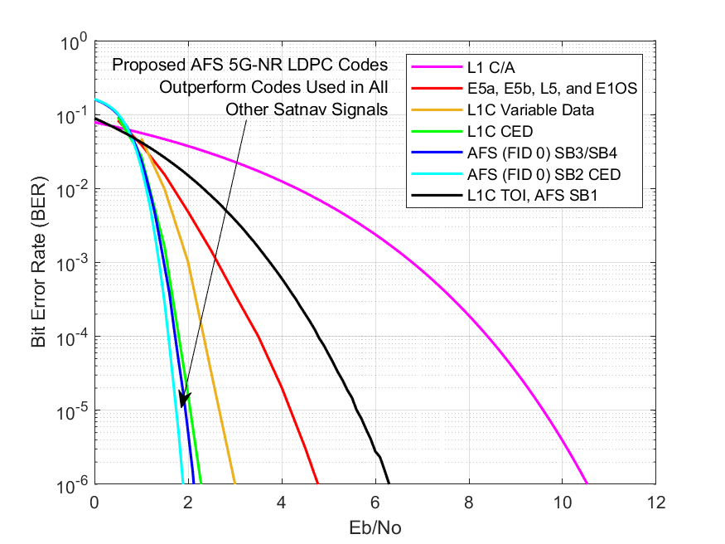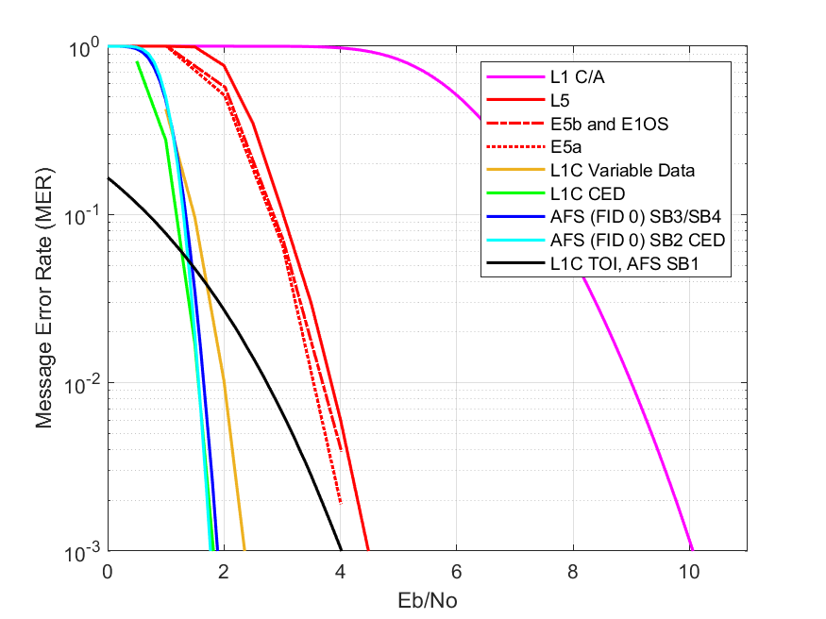
Figure 10: Comparison of LunaNet AFS FEC to GNSS alternatives. The left plot provides a BER comparison, while the right plot provides a MER comparison based on actual frame sizes. The curves for E5a, E5b and E1OS were based on Anghileri (2013).
A navigation user is primarily interested in the likelihood of successfully demodulating CED. This quantity may be computed from $P_{s1}=1-P_{M}$, where $P_{M}$ is the MER. In this case, a message is successfully decoded when all bits in the message are correct and so $P_{M}=0.01$. This corresponds to the case when at least one bit is incorrect in one out of 100 messages.
For signals that use block encoding of CED using a single message, a reasonable message error rate of 10⁻² allows for a success rate of 99%. For legacy signals, requiring multiple independent messages to decode CED, the success rate is determined as the product of the success rates needed for each message. For example, with L5 and C/A code signals, three messages are needed for CED. Under the assumption that the noise induced errors in each message are independent, for a 99 % success rate, the probability of successfully decoding three messages is

$P_{s3}={(1-P_{M})}^{3}=0.99$. (10)

Similarly, the probability of successfully decoding N messages is given by

$P_{sN}={(1-P_{M})}^{N}$. (11)

As described in Anghileri (2013); and RTCA DDO-229G (2020), one typically requires a receiver to acquire and obtain a fix with a 95 % confidence interval. Let $P_{Acq}^{4}$ be the probability of acquiring 4 satellites needed for a fix. The probability of acquiring 4 satellites needed for a fix (assuming independent measurements from 4 satellites), and successfully demodulating CED using $N$ messages for each of 4 satellites with a joint 95 % confidence is given by $P_{Acq}^{4}$ $P_{sN}^{4}=0.95$. or $P_{Acq}^{4}{(1-P_{M})}^{4N}=0.95.$

If we assume that acquisition and data decoding are designed to have the same reliability, $P_{Acq}=P_{sN}$, the MER required for 95 % confidence is given by
${(1-P_{M})}^{8N}=0.95$. (12)

This can be solved for the required MER, resulting in $P_{M}=1-{0.95}^{\frac{1}{8N}}$. The MER for a message of size $M$ bits may also be determined from the Bit Error Rate (BER) by

$P_{M}=1-{\left(1-P_{b}\right)}^{M}≅MP_{b}$, (13)
where $1-P_{b}$ is the probability that a bit is correct. Therefore, ${\left(1-P_{b}\right)}^{M}$ is the probability that all bits in a message are correct, assuming data bits errors are independent and random. Therefore, solving for $P_{b}$and combining the equations above results in
$P_{b}=1-{\left(1-P_{M}\right)}^{\frac{1}{M}}=1-{\left(1-\left(1-{0.95}^{\frac{1}{8N}}\right)\right)}^{\frac{1}{M}}$. (14)

The 95 % confidence metric provides a fairer comparison of the data demodulation performance than using a fixed BER or MER criterion or fixing the data message block length to compare different data modulation and encoding approaches as described in Anghileri (2013). The required BERs and MERs for a Time to First fix ( TTFF ) with 95 % confidence are given in Table 6 for GPS, Galileo and AFS. Note that the TTFF requirements for a given application will vary.

Table 6: Required $E_{b}/N_{0}$ and $C/N_{0}$, for 95 % confidence in TTFF, accounting for equal probability of detection and CED decoding success for each of 4 satellites.
* Including power split and 1 dB implementation loss.

The resulting error rates are very close to the previously used criterion of BER = 1×10⁻⁵ for GPS and MER = 1 % assumed in previous works Betz et al., (2006) and Dafesh, et. al. (2006).
As observed, even though the AFS message size is the largest of any in satellite navigation signals, it can be detected at lower $E_{b}/N_{0}$ than any previous GNSS message. Accounting for power split, and 1 dB of implementation loss, the minimum $C/N_{0}$ to detect data at 250 BPS is about 2 dB higher than GPS L1 C/A code at 50 BPS and is comparable to Galileo E1B(OS), even with a higher data rate. Due to the possibility of CED combining of two short (12 second) messages (3 dB improvement), AFS data can be demodulated at 1 dB lower $C/N_{0}$ levels than the C/A code signal and about 3 dB lower $C/N_{0}$ than the Galileo E1B signal.
To mitigate fading, the encoded subframes 2, 3, and 4 are followed by a block interleaver. The block interleaver can be visualized as a two-dimensional array with 60 rows and 98 columns. The usage of interleaving allows the noise to be distributed across all the LDPC encoded subframes, improving the individual decoding process for each subframe as demonstrated by Dafesh et al (2007).

Summary and Conclusions
LunaNet’s AFS was designed to provide an interoperable standard for future PNT services currently under development by NASA, ESA, and JAXA. The signal services both high performance and low-SWaP users in and around the lunar realm, while accommodating a range of use cases and operational modes. Analogous to C/A code, AFS-I channel is compatible with low SWaP implementations, while providing high performance LDPC coding and frame Sync without need for an overlay sequence to perform frame Sync. This is achieved by using a high integrity 68-symbol Sync word on the I channel that enables frame Sync near the detection threshold of the rate-½ 5G-NR-based LDPC FEC.

The AFS-I channel also employs a 2046 chips, 1.023 MCPS, short-cycled Gold code spreading sequence that provides a cross-correlation improvement of 3 dB for acquisition and 1 dB for tracking when compared to GPS C/A, at the expense of only a factor of 2 in complexity. The data bit rate for the AFS is five times that of legacy GPS C/A code and twice that of the Galileo E1-B signal enabling enhanced flexibility for future lunar integrity and safety of life messages and to support a wide range of lunar satellite Ephemeris representations. The cross-correlation performance of this code was shown to be comparable to other length 2046 sequences when practical statistics are considered.
A high performance 5G-NR LDPC FEC was used to enable rapid development using a widely used standard and robust data decoding, exceeding the performance of E1OS and C/A code even when transmitted at higher data rates.

The AFS-Q channel design provides a pilot channel for use in precision navigation and robust time dissemination. It features a chip rate of 5.115 MCPS using a BPSK modulation to reduce adjacent band interference compared to wider band BOC signals, while providing accuracy performance within a factor of 2 of the L5 and E5 signals. A three tiered code approach was employed to facilitate flexibility in receiver acquisition, data synchronization, absolute time synchronization and precision signal tracking. The code uses a family of 210 GPS L1Cp spreading codes for the primary code, a family of 4 chip Barker codes for the secondary code and a set of 210 new Weil Tertiary codes. The overall cross-correlation performance of the three tiered code is shown to be superior when paired with L1C as compared to E5aQ.

The final AFS design provides the following enhancements compared to current navigation signals:

- Employs 5G-NR Forward Error Control coding with the best decoding performance of any GNSS signal;
- Three-tiered ranging codes permit receivers to trade acquisition complexity with sensitivity;
- Tertiary overlay code that enables rapid time dissemination, high integrity code acquisition, frame Sync and potential for robust transmission of integrity messages;
- A high integrity data Sync word is provided to enable low-SWaP single-channel users to perform frame Sync at levels commensurate with the LDPC encoding without requiring a pilot overlay;
- The signal structure also supports future changes through the robust BCH encoding of the FID field without sacrificing the ability to improve data message performance using CED combining.

ACKNOWLEDGMENTS
A portion of this work was funded by the National Aeronautics and Space Administration’s (NASA) Lunar Communications Relay and Navigation Systems (LCRNS) project to inform the LunaNet Interoperability Specifications, with Aerospace funded under contract 80GSFC19D0011.

REFERENCES
- 3rd Generation Partnership Project (3GPP) (Jul. 2020). Technical Specification Group Radio Access Network; NR; Multiplexing and Channel Coding, Release 16, V16.2.0, 3GPP Standard TS 38.212.
- Anghileri, M., Paonni, M. et al. (2013). Assessing GNSS Data message performance, Inside GNSS, March-April.
- Ashby, N.& Patla, B. (2024). A Relativistic Framework to Estimate Clock Rates on the Moon, The Astronomical Journal, Vol 168, No 3, https://dx.doi.org/10.3847/1538-3881/ad643a
- Barker, R. H. (1952), "Group Synchronizing of Binary Digital Systems". Communication Theory, 1953 London: Butterworth. pp. 273–287.
- BeiDou (2013). Navigation Satellite System Signal In Space Interface Control Document Open Service Signal Version 2 .0.
- Betz, J.W., Blanco, M.A., Cahn, C.R., Dafesh, P.A., et al. (2006). "Description of the L1C Signal," ION International Technical Meeting of the Satellite Division, p. 2080.
- Cozzens, T (2021). OneNav Unveils L5-Only mobile GNSS, https://www.gpsworld.com/onenav-unveils-l5-only-mobile-gnss-receiver/.
- Dafesh P. A. & Holmes, J. K. (2000). Practical and Theoretical Tradeoffs of Active Parallel Correlator and Passive Matched Filter Acquisition Implementations, Proceedings of the IAIN World Congress in association with the U.S. ION Annual Meeting, San Diego, CA.
- Dafesh, P. A., Khadge, G. K., Wong, N. S. & Djuknic, G. (2024), "Flexible Data and Frame Synchronization Structure for the LunaNet PNT Signal," Proceedings of the ION Pacific PNT Meeting (pp. 844 - 866).
- Dafesh, P. A., Vallés E. L. , Hsu J. , Sklar, D. J., Zapanta L. F. & Cahn, C. R. (2007), Data Message Performance for the Future L1C GPS Signal, Proceedings of the ION International Technical Meeting.
- European Union (2021). GNSS (Galileo) Open Service Signal-In-Space Interface Control Document (ICD). Issue 2.0.
- Giordano, P., Swinden, R. , European Space Agency (ESA), Gramling C., Crenshaw J., National Aeronautics and Space Administration (NASA) & J. Ventura-Traveset, (ESA) (2023). LunaNet Position, Navigation, and Timing Services and Signals, Enabling the Future of Lunar Exploration, ION GNSS+ 2023.
- Hardy G.H. & Wright E.M. (1979). An Introduction to the Theory of Numbers, 5th ed., Clarendon Press, Oxford, pp. 67-71.
- Hegarty, C. J. & Cerruti (2010). A. P. , “Results from an Analytical Model for GNSS Receiver Implementation Losses, ION GNSS.
- International Telecommunication Union (ITU) (2023) – Radiocommunication. “Protection of frequencies for radioastronomical measurements in the shielded zone of the Moon,” Recommendation ITU-R RA.479-5.
- IS-GPS-800 (2013). Navstar GPS Space Segment/User Segment L1C Interface.
- LunaNet Signal-In-Space Recommended Standard - Augmented Forward Signal (LSIS) (2023), Draft Version 5.
- LunaNet Signal-In-Space Recommended Standard (LNIS) (2025). Augmented Forward Signal (Noted as Applicable Document 1 [AD1 Vol-A] in LNIS V5).
- Rao, K.V., & V.U. Reddy (1986). “Biphase Sequence Generation with Low Sidelobe Autocorrelation Function,” IEEE Tran. Aerospace & Electronics Systems, Vol. AE-22, No. 2, pp. 128-133.
- RTCA DO-229F (2020). Minimum Operational Performance Standards (MOPS) for Global Positioning System /Satellite Based Augmentation System Airborne Equipment.
- Rushanan J.J. (2007). The Spreading and Overlay Codes for the L1C Signal, Navigation, Vol. 5, No. 1.
- Space Frequency Coordination Group (SFCG) (2023). Communication and Positioning, Navigation, and Timing Frequency Allocations and Sharing in the Lunar Region", Recommendation SFCG 32-2R5.
- Sükrü Ekin Kocabas S., E. & Atalar, A. (2023) “Binary Sequences with Low Aperiodic Autocorrelation for Synchronization Purposes,” IEEE Communications Letters, vol.7, no.1.
- Turetzky G. & McBurney, P. (2020a). A Pure L5 Mobile Receiver, Inside GNSS, https://insidegnss.com/a-pure-l5-mobile-receiver/.
- Turetzky G. (2020b). L5-only receiver designed for mobile phones, GPS World,
https://www.gpsworld.com/l5-only-receiver-designed-for-mobile-phones/.

