ATTITUDE GROUND sYSTEM: RECENT EXPERIENCES IN attitude Sensor Calibration AND UPCOMING MISSION SUPPORT for momentum unloading
(Preprint) AAS XX-XXX
Philip C. Calhoun, Jonathan Glickman, Richard Harman, Joseph Sedlak,
A key component of the mission ground system used for supporting NASA Goddard Space Flight Center space missions, known as the Attitude Ground System (AGS), is used to perform operational and analytical support for the spacecraft attitude control system (ACS). The AGS is comprised of a real-time attitude analysis and monitoring system, and a tool for performing offline analysis of the ACS system using key sensor telemetry collected and stored onboard and transmitted to the mission operations center. The AGS performs numerous functions, including independent ground attitude determination, attitude slew planning and commanding, attitude sensor calibration, and real-time monitoring of the health and safety of the ACS. The AGS is developed in MATLAB using a core library of utility functions called the Multi-Mission Three-Axis Satellite System (MTASS). The MTASS library has been used to support mission operations for over thirty NASA missions starting in the late 1990s. It is customized for each mission to meet specific mission requirements. In this paper we describe recent operational experience using the AGS to support the launch and early orbit (L&EO) phase of the Plankton, Aerosol, Cloud Ocean Ecosystem (PACE) and Joint Polar Satellite System (JPSS) missions. Our summary of L&EO support for PACE and JPSS includes ACS sensor calibration of the alignment and scale factors for the Star Trackers, Inertial Reference Unit, and Three-Axis Magnetometers. We will also describe new capabilities for planning and executing reaction wheel momentum unloading for the Roman Space Telescope (RST) During the spacecraft early orbit phase, the AGS is operated in the mission operations center by a team of subject matter experts that also develop and configure the AGS software. This unique approach, integrating system development and operation in a single engineering team, provides valuable expertise for quick assessment of ACS performance and safety; critical to anomaly resolution and mission success.
Introduction
The NASA Goddard Space Flight Center(GSFC) builds and operates a range of scientific satellites for the space science community to support the Astrophysics, Earth Science, and Heliophysics disciplines. A key component of the mission ground system used for supporting these space missions, known as the Attitude Ground System (AGS), is used to perform operational and analytical support for the spacecraft attitude control system (ACS). The AGS is comprised of three components, 1) a real-time attitude analysis and monitoring system, known as the Real-Time Attitude Determination System (RTADS), 2) a tool for performing offline analysis of the ACS system using key sensor telemetry collected and stored onboard and transmitted to the mission operations center, known as the Attitude Determination System (ADS), and 3) a library of utilities called the Multi-mission Three-axis Stabilized Spacecraft (MTASS) system, comprising the core set of analytical functions of the RTADS and ADS modules. The AGS performs numerous functions, including independent ground attitude determination, attitude slew planning and commanding, attitude sensor calibration, and real-time monitoring of the health and safety of the ACS. The AGS is developed in MATLAB using a core library of utility functions called the Multi-Mission Three-Axis Satellite System (MTASS). The MTASS library has been used to support mission operations for over thirty NASA missions starting in the late 1990s. It is customized for each mission to meet specific mission requirements.
The attitude determination utilities include several methods for processing available sensor data to estimate the three-axis attitude, these include TRIAD¹, Quaternion Estimation (QUEST)^{2,3}, Extended Kalman Filter (EKF)⁴, and a Smoother Estimator⁴. The QUEST method provides a single frame estimate using attitude vectors measured at a particular time. Inertial Measured Unit (IRU) data can be used to propagate the vector measurements to a common epoch. Alternatively, the vectors measured at different times (within a specified time tolerance) may be assumed to be at a common epoch. The EKF algorithm is an implementation a standard 6-state Multiplicative Extended Kalman Filter (MEKF)⁵ used for attitude estimation with quaternion measurements. The Smoother algorithm processes the measurements forward and then backward in time to provide a reduced variance estimate using future as well as past data. This is only used in offline attitude determination using stored telemetry data, as by definition future data is not available in real-time.
In this paper we describe recent operational experience using the AGS to support the launch and early orbit (L&EO) mission phase, with examples of sensor calibrations for the Plankton, Aerosol, Cloud Ocean Ecosystem (PACE) and Joint Polar Satellite System (JPSS) missions. ACS sensor calibration of the alignment and scale factors for the Star Trackers, Inertial Reference Unit, and Three-Axis Magnetometers, and independent attitude determination and validation are included in the following sections. We also describe a new capability for planning and executing reaction wheel momentum unloading for the Roman Space Telescope (RST). During the spacecraft early orbit phase, the AGS is operated in the mission operations center by a team of subject matter experts that also develop and configure the AGS software. This unique approach, integrating system development and operation in a single engineering team, provides valuable expertise for quick assessment of ACS performance and safety; critical to anomaly resolution and mission success.
The AGS system includes utilities to perform calibration of various attitude sensors typically employed on orbiting spacecraft. These include: 1) Relative alignment of the star trackers, 2) Alignment, scale factors, and bias for the Inertial Reference Unit (IRU), and 3) Alignment, bias, and magnetic torquer bar contamination for the Three-Axis Magnetometer (TAM). Least squares methodologies are used to provide optimal solution for these calibration parameters, as described in the following sections.
STAR TRACKER CALIBRATION: PACE FLIGHT EXPERIENCE
The relative alignments between the two PACE bus-mounted star trackers (STs) were estimated using the ALIQUEST⁶ alignment calibration technique. For star tracker relative alignment calibration, a continuous high-frequency data set consisting of 15 integral orbits was used (i.e., the same span of data used for TAM calibration). The alignment calibration run was executed using a set of data from DOY 043-044 (February 12-13) of 2024. The start and stop times in Greenwich Mean Time (GMT) spanned from DOY 043 at 00:16:30 to DOY 044 at 17:04:30, which is exactly 15 integral orbits (assuming an orbital period of 98.3 minutes). The Flight Operations Team (FOT) was able to collect this long data span in two sets of telemetry files, each approximately 12 hours long. This required one “add-batch” TP run to concatenate the two data sets together in the AGS. This method worked well, and the data was very clean with no gaps or significant outliers.
The first step in the ALIQUEST process was to generate the “reference” attitude with the AGS Smoother estimator and using both star trackers weighted equally. In this way, both trackers
would be aligned to the “average” attitude of the two trackers, as opposed to aligning one tracker to the other. The entire 15-orbit span was used to generate the reference attitude.
Figures 2-7 and 2-8 show the pre-calibration Smoother estimator to ST-1 and ST-2 residuals, respectively for the “reference” attitude run. From these pre-calibration values, it is clear that there is more misalignment to remove from ST-1 then there is from ST-2. The reason for this asymmetry is that the nominal alignments onboard are different from the nominal alignments on the ground. The onboard alignments determine the nominal attitude of the spacecraft, which the AGS is accurately measuring. Thus, even though the residuals between the trackers are symmetric onboard (i.e., same magnitudes but opposite signs), the different ground nominal alignments remove this symmetry. These figures show large transient spikes at an orbit period cadence, occurring near the terminator due to solar array drive articulation, as well as ST noise prominent about the tracker boresight. Non-zero mean levels, to be removed by calibration, are evident in these plots as well.
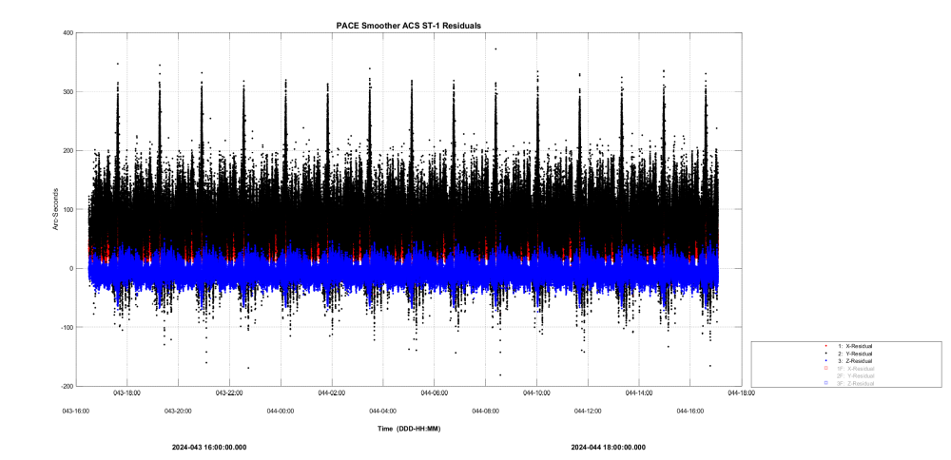
Figure 2-7 Pre-Calibration: Smoother to ST-1 Residuals

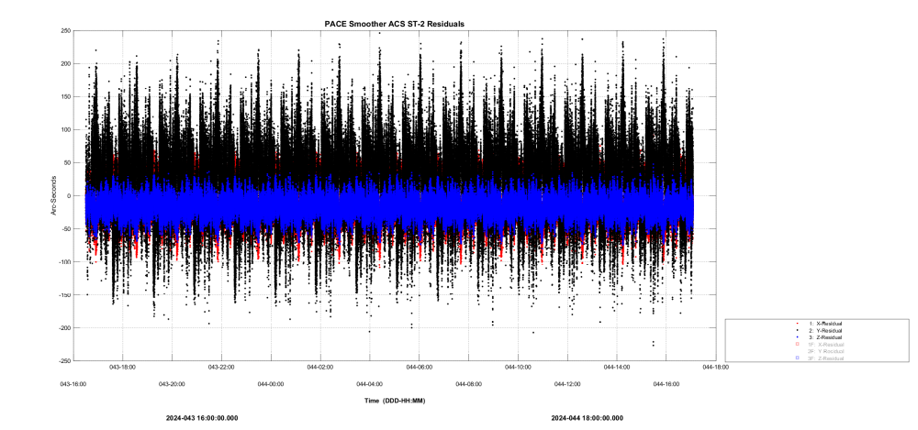
Figure 2-8 Pre-Calibration: Smoother to ST-2 Residuals

Figure 2-9 shows the Smoother attitude solution as Euler angles relative to a Geodetic Orbital Frame (GDS), whose +Z-axis points towards geodetic nadir and whose +Y-axis points towards negative orbit normal. Note that none of the axes (roll, pitch, or yaw) are exactly zero. As mentioned above, this is because the spacecraft onboard control system is zeroing out the roll, pitch, and yaw onboard based on a different set of nominal ST alignments.
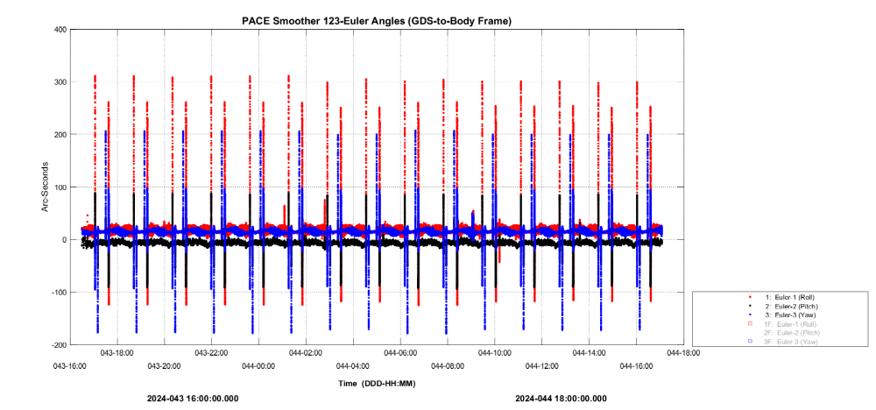
Figure 2-9 Smoother Pre-Calibration Attitude Solution as Euler Angles

ALIQUEST Results
The Smoother reference attitude is used in the ALIQUEST run. Since both trackers were used in the reference run, ALIQUEST will find the relative alignments that correspond to the “average” attitude of the two trackers. Figure 2-13 shows the ALIQUEST post-calibration residuals for ST-1. Note that the means on all axes are now exactly zero, which ALIQUEST forces to happen. Figures 2-14 and 2-15 show the post-calibration residuals for ST-2, respectively. ALIQUEST has found the alignment that forces the mean residuals to exactly zero.
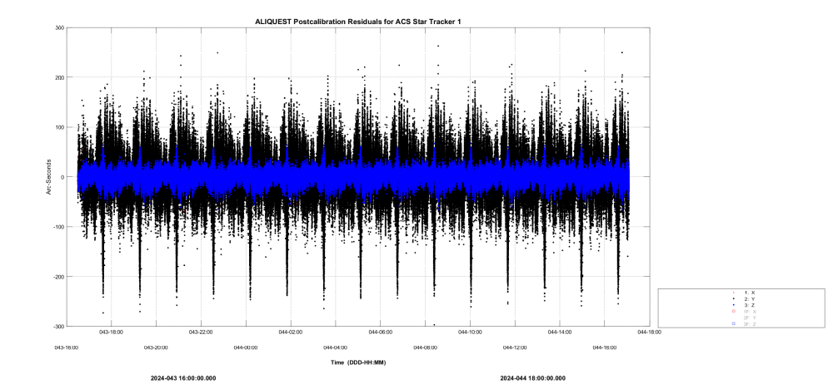
Figure 2-13 ALIQUEST Post-Calibration ST-1 Residuals

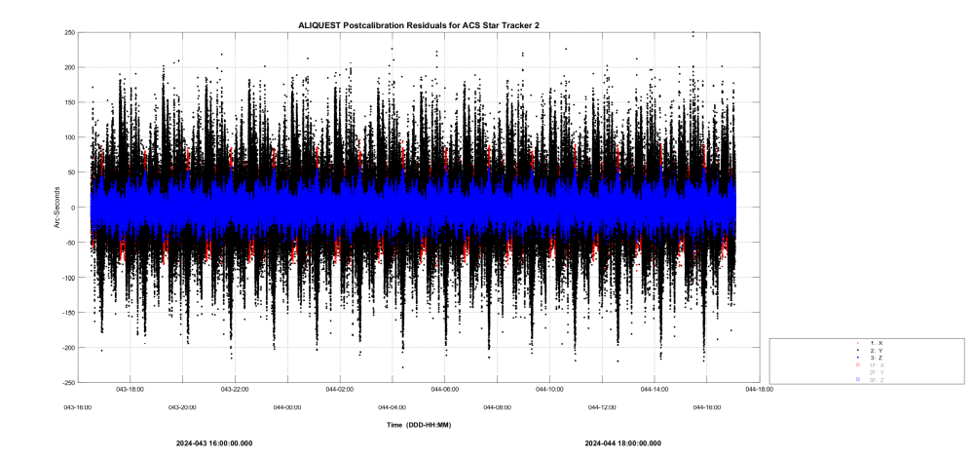
Figure 2-15 ALIQUEST Post-Calibration ST-2 Residuals

The original and post-calibration misalignment matrices for ST-1 are shown in Table 1. Table 2 shows that significant mean ST1 residuals on the order of an arc-min have been removed by the calibration. Tables 3 and 4 show similar values for ST2.

Original Alignment Matrix |  |  | Calibrated Alignment Matrix
0.9364538 | 0.00345457 | 0.35077392 | 0.93643194 | 0.00382169 | 0.35082847
-0.33934462 | -0.2444342 | 0.90834852 | -0.33930026 | -0.24458259 | 0.90832514
0.08887898 | -0.9696595 | -0.22772874 | 0.08927776 | -0.9696207 | -0.22773795
Table 1: ST-1 Alignment Matrices: Original and Post-Calibration

Original Mean Residuals (arc-sec) |  |  | Calibrated Mean Residuals (arc-sec)
Roll | Pitch | Yaw | Roll | Pitch | Yaw
-31.59192 | -76.38858 | 6.765803 | -1.06088E-08 | -1.38758E-08 | -6.11719E-08
Table 2: ST-1 Alignment Residuals: Original and Post-Calibration

Original Alignment Matrix |  |  | Calibrated Alignment Matrix
-0.93241385 | -0.00917356 | -0.36127588 | -0.93239159 | -0.00929610 | -0.36133020
-0.35272612 | 0.24071149 | 0.90423566 | -0.35281189 | 0.24064699 | 0.90421937
0.07866808 | 0.97055313 | -0.22767818 | 0.07854719 | 0.97056796 | -0.22765670
Table 3: ST-2 Alignment Matrices: Original and Post-Calibration

Original Mean Residuals (arc-sec) |  |  | Calibrated Mean Residuals (arc-sec)
Roll | Pitch | Yaw | Roll | Pitch | Yaw
13.53695 | -21.62006 | 17.83296 | 1.899614e-08 | 2.469333e-08 | 7.243196e-08
Table 4: ST-2 Alignment Residuals: Original and Post-Calibration

IRU CALIBRATION: PACE AND JPSS-1 FLIGHT EXPERIENCE
The Inertial Reference Unit (IRU) calibration for three-axis stabilized spacecraft consists of determining a set of parameters that includes a bias and scale factor corrections for each IRU channel (i.e., each gyro sensitive axis) and the directions of those sensitive axes in the spacecraft body reference frame. Thus, the calibration parameter set includes independent values of bias, scale factor, and sensitive axis unit vector direction for each gyro. It is assumed a series of attitude maneuvers are performed comprising of one or more slews about all three spacecraft body axes to provide observability of these gyro parameters.
In this paper, the words gyroscope and inertial reference unit (IRU) are used interchangeably, along with the shortened form “gyro.” Many IRUs also include accelerometers, but that data is not considered here.
The AGS includes several methods for gyro calibration. This paper will compare two of these: the Batch IRU Calibration (BICAL)⁷ utility and the Gyro Calibration (GCAL)⁸ utility. BICAL was devised as a user-friendly method that would be simpler to use than other AGS IRU calibration methods. BICAL has been used for fourteen different missions. The GCAL method was devised to simplify calibrations for spacecraft having more than three active gyro channels for which the BICAL method is much more cumbersome. At this time, GCAL has been used only for the PACE mission, but it has been tested using archived data from several other missions. Here is a brief overview of these methods:
- GCAL – Compares spacecraft body rotation rates as observed on each gyro channel with expected rates. The expected rates are computed by projecting reference rotation rate vectors onto the channel sensitive axes and adjusting them using the current calibration parameter estimates; this can be applied to any number of sensitive axes. GCAL solves for the calibration parameters using an iterated Gauss-Newton least-squares method to minimize the residuals (differences between observed and expected rates on each axis). The constraint that the sensitive axes be unit vectors is imposed using a Lagrange multiplier. The reference rate vectors are determined using an extended Kalman filter (EKF) or optimal smoother by processing data from the gyros and attitude sensors. (The attitude sensors typically are star cameras but may include Sun sensors, Earth sensors, magnetometers, etc.) The reference rate vectors are recomputed using the updated gyro parameter estimates, and the process is iterated.
- BICAL – Determines the calibration parameters along with the attitude as part of an augmented state vector in a batch least-squares estimator. Input data consists of gyro rates and attitude sensor observations. The batch least-squares attitude estimator in the AGS normally solves only for attitude and gyro bias at an epoch time. The BICAL utility augments this state vector with the scale factors and misalignments for three sensitive axes. For IRUs having four sensitive axes, the BICAL utility is invoked four times for the four combinations of three channels at a time. A separate small utility was written to take appropriate averages of those results to obtain a 4-axis IRU calibration. (The complexity of that procedure motivated the creation of the GCAL utility for future missions.)
The BICAL and GCAL algorithms both allow for more than one bias estimate per channel if the input data is divided into multiple time spans, each with its own bias estimate. This multiple-bias option is useful, for example, if the input data comes from attitude maneuvers performed on different days. The biases may change over the course of the calibration due to mechanical or electronic drift or due to spacecraft temperature differences.
The GCAL method has several clear advantages over the other AGS gyro calibration methods that have been used for mission support at NASA GSFC. For example, GCAL:
- Accounts for an arbitrary number of gyro channels in a natural way, without having to average over multiple runs having subsets of three channels.
- Includes gyro model process noise when computing the reference rates and the observation weights. The process noise includes noise sources for both angle random walk and drift rate random walk.
- Outputs a more realistic covariance matrix for the gyro parameter estimates than does BICAL. This improvement is largely due to the inclusion of the gyro model process noise and the use of the covariance matrix from the EKF or optimal smoother. These noise sources are combined to obtain the GCAL observation weights.
- Has a much simpler operational procedure for the 4-channel case, so the chance of user error is significantly reduced.
GCAL Mathematical Background
This section presents a summary of the GCAL mathematical background⁸. Additional tests and derivation details are given in ref 8. The GCAL utility defines the rotation rate model by projecting the true rotation rate vector onto each true sensitive axis,
$ω_{i}={\hat{U}}_{true}^{T}\vec{Ω}\left(x_{true},t_{i}\right)+ν_{i}$ , (1)
where t_{i} is the time tag for the i^{th} gyro data point, ν_{i} is the gyro sensor noise at that time, assumed to be zero-mean, white, and Gaussian-distributed, and where the subscript true indicates the true but unknown state vector. Vector ${\hat{U}}_{true}^{T}$ is the sensitive axis unit vector direction in the body frame for the k^{th}-channel (where the hat indicates unit vector), and $\vec{Ω}$ is the computed reference rotation rate vector in the body frame.
Let the state estimate be written as the prior estimate plus a correction, $∆x≡[{∆b}_{k,1…J}, ∆S, ∆U^{T}]^{T}$,
$\tilde{x}=x_{p}+∆x$ , (2)
where the current estimate is indicated by a tilde and the prior estimate is denoted, x_{p}, which may be an a priori guess or the GCAL state estimate from the previous iteration. The bias $b_{k,j}$ is the bias for the k^{th}-channel and time interval j (allowing for different biases in J different time spans), S is the scale factor, and $\hat{U}$ is the sensitive axis alignment unit vector. The channel subscript k has been dropped elsewhere since the estimation equations are the same for all channels.
The rate model can be written
$ω_{i}=f\left(∆x, x_{p},t_{i}\right)+e_{i}≡\left(1+∆S\right){\left(\hat{U_{p}+∆U}\right)}^{T}\vec{Ω}\left(x_{p},t_{i}\right)+∆b_{j}+e_{i}$ , (3)
where f is the model function, and where e_{i} is an error term that includes the sensor noise ν_{i} plus any model error. Eq. 3 shows that the model for each channel equals the reference rate dotted into the sensitive axis, multiplied by a scale factor, shifted by a bias, plus noise.
The matrix H_{i}, called the sensitivity matrix, is a row vector having J + 4 elements,
$H_{i}≡\frac{∂f\left(0, x_{p},t_{i}\right)}{∂∆x} =\left[\begin{matrix}…, \begin{matrix}1, & …, & 0\end{matrix}, & {\hat{U}}_{p}^{T}{\vec{Ω}}_{i} , & {\vec{Ω}}_{i}^{T}\end{matrix}\right]$ , (4)
where the first J columns are all zero except for the one appearing in the j^{th} column for time interval-j (that is, if t_{i} is in time interval j, then the j^{th} column is one).
The observation residual at each time step is the difference between the actual observed rate and the expected model rate for this channel,
$R_{i}≡ω_{i}-{\tilde{ω}}_{i}=R_{p,i}-H_{i}∆x$ , (5)
where
$R_{p,i}≡ω_{i}-{\hat{U}}_{p}^{T}{\vec{Ω}}_{i}$ (6)
is the residual at time t_{i} using the prior state estimate. The variance of R_{p,i} is given by $E[e_{i}^{2}]≡σ_{i}^{2}$. The inverse of $σ_{i}^{2}$ will be used as a weighting factor for this observation in the state estimator.
The purpose for these definitions is to set up expressions enabling one to minimize the residuals R_{i} as a function of the state correction term $∆x$. To that end, one can stack the H_{i}, R_{i}, and R_{p,i} matrices for all rotation rate observations,
$H=\left[\begin{matrix}H_{1} \\ H_{2} \\ ⋮\end{matrix}\right]$ , $R=\left[\begin{matrix}R_{1} \\ R_{2} \\ ⋮\end{matrix}\right]$ , $R_{p}=\left[\begin{matrix}R_{p,1} \\ R_{p,2} \\ ⋮\end{matrix}\right]$ . (7)
The weights for all the observations are also stacked into a diagonal matrix,
$W=\left[\begin{matrix}\frac{1}{σ_{1}^{2}} & 0 & … \\ 0 & \frac{1}{σ_{2}^{2}} & … \\ ⋮ & ⋮ & ⋱\end{matrix}\right]$ , (8)
where $σ_{i}$ is the uncertainty for the i^{th} observation residual, with units of radians/second. These residual uncertainties have two parts: one from the inherent gyro sensor noise and the other from the computed reference rotation rate error.
First, a term representing apriori knowledge of the state vector, x_{A}, can be included in the loss function. (for example, ref 1, Eq. 13-29.) This term has the desirable property that it discourages the estimator from wandering too far from the region of state space where the optimal solution is expected to be found.
Second, a Lagrange multiplier can be introduced to impose unitization of the sensitive axes. That is, $\hat{U}={\hat{U}}_{p}+∆\vec{U}$ needs to be unitized, and this can be ensured to first order by enforcing the constraint that
$0={\hat{U}}_{p}^{T}∆\vec{U}$
$=\left[\begin{matrix}0,… & 0, & {\hat{U}}_{p}^{T}\end{matrix}\right]∆x$
$≡\overline{H}∆x$ , (9)
where $\overline{H}≡\left[\begin{matrix}0,… & 0, & {\hat{U}}_{p}^{T}\end{matrix}\right]$.
With these additions, the function to be minimized can be written as
$L=\frac{1}{2}{\left(R_{p}-H∆x\right)}^{T}W\left(R_{p}-H∆x\right)+\frac{1}{2}{\left(x-x_{A}\right)}^{T}W_{A}\left(x-x_{A}\right)-λ\overline{H}∆x$ , (10)
where λ is the Lagrange multiplier, x_{A} is the a priori guess for the state vector, and W_{A} is a diagonal weight matrix for that guess, composed of the inverses of the squares of the initial state element uncertainties.
One first solves for the unconstrained solution (indicated with an overbar) where the λ-term has been dropped,
$\overline{∆x}≡{\left(W_{A}+H^{T}WH\right)}^{-1}\left[H^{T}WR_{p}+W_{A}\left(x_{A}-x_{p}\right)\right]$ . (11)
With that result, minimizing the full L yields the actual state correction estimate
$∆x=\left(I-K\overline{H}\right)\overline{∆x}$ , (12)
where I is the identity matrix and K is
$K={\left(W_{A}+H^{T}WH\right)}^{-1}{\overline{H}}^{T}{\left[\overline{H}{\left(W_{A}+H^{T}WH\right)}^{-1}{\overline{H}}^{T}\right]}^{-1}$ . (13)
The state error covariance for the unconstrained state then can be shown to be^{1,4}
$\overline{P}={\left(W_{A}+H^{T}WH\right)}^{-1}$ . (14)
This result leads to the full state error covariance, which reduces to
$P=\left(I-K\overline{H}\right)\overline{P}$ . (15)
Gyroscope Calibration Test Results
This section presents test results using both simulated and flight data. Additional tests can be found in Ref 8. In all examples, the spacecraft will have performed several attitude maneuvers to vary the rates on all body axes to provide observability for all of the gyro calibration parameters. The simulations derive their telemetry from actual archival flight data to ensure that the gyro random noise is realistic. The data then is corrupted by imposing known systematic errors to be estimated by GCAL and BICAL.
PACE Simulated 3-Axis IRU
In this example, GCAL and BICAL results are compared using simulated telemetry for the Plankton, Aerosol, Cloud, ocean Ecosystem (PACE) spacecraft. The simulation includes data from two star cameras and a 3-axis IRU while the spacecraft executes three attitude maneuvers. Figure 1 shows the attitude maneuvers as Euler angles in a 1,2,3-sequence, referenced to a geodetic nadir-pointing frame. Each maneuver consists of a slew about a body axis, a hold period of about ten minutes, a larger slew in the opposite direction, another ten-minute hold, and a slew back to nadir pointing.
To test the option for estimating multiple biases, a separate bias is determined for each of the three maneuver time spans. However, the simulated bias errors were the same for all three time spans, so the three bias estimates should all be nearly the same.
Figure 1. PACE Attitude During the Calibration Maneuvers, Showing Roll (red), Pitch (black), and Yaw (blue) Euler Angles in the Geodetic Nadir-Pointing Reference Frame.
Table 1 presents the GCAL and BICAL calibration results. Both utilities generated very good estimates of the gyro parameters. The estimated biases for the three intervals are all close to the simulated bias error. The GCAL estimates of the sensitive axes are accurate to better than one arc-second where the initial corruptions were over 60 arc-seconds.
Table 1. Comparison of GCAL and BICAL Methods Using PACE Simulated 3-Axis IRU Data and Solving for Three Separate Biases for the Three Time Intervals
Parameter | Parameter Corruption | GCAL Parameter Estimate | BICAL Parameter Estimate
Bias-1 (arcsec/sec) | -0.9 | -0.892, -0.891, -0.886 | -0.890, -0.887, -0.882
Bias-2 (arcsec/sec) | 0.8 | 0.802, 0.797, 0.792 | 0.800, 0.795, 0.789
Bias-3 (arcsec/sec) | 0.7 | 0.699, 0.698, 0.691 | 0.702, 0.702, 0.696
Scale Factor-1 Correction | 0.000100 | 0.000086 | 0.000073
Scale Factor-2 Correction | -0.000200 | -0.000202 | -0.000210
Scale Factor-3 Correction | 0.000300 | 0.000295 | 0.000312
Axis-1 | 60 arcsec (angle between true and corrupted axes) | 0.9 arcsec  (angle between true and estimated axes) | 4.3 arcsec  (angle between true and estimated axes)
Axis-2 | 70 arcsec | 0.2 arcsec | 3.7 arcsec
Axis-3 | 80 arcsec | 0.6 arcsec | 0.9 arcsec

It is very useful operationally to have a graphical representation of the calibration performance. For this purpose, the GCAL utility provides pre- and post-calibration plots of the observation residuals. These residuals are defined to be the differences between the observed rates and the expected rates on each gyro channel. The act of calibration should significantly reduce these residuals.
Figure 2 shows the pre-calibration residuals. In this figure, the pre-calibration parameters have been used to adjust the telemetry data. The offsets of the three curves from zero are due to the gyro bias errors. The variations of the lines from horizontal are caused by the alignment and scale factor errors at the times when the maneuvers occur.
Figure 2. PACE Pre-Calibration Residuals (Observed Rates Minus Expected Rates),
Showing the X-, Y-, and Z-Axes as Red, Black, and Blue Lines.
Figure 3 shows the post-calibration residuals for the X-axis (Y- and Z-axes are similar). Note that the vertical scale ranges only from -0.1 to +0.08 arcsec/sec. The post-calibration residuals have near-zero mean, indicating that the biases have been removed. In addition, the plot shows almost none of the structure seen in Figure 2, indicating that the alignment and scale factor corruptions are very well compensated.
Figure 3. PACE Post-Calibration Residuals (Observed Rates Minus Expected Rates),
Showing Only the X-Axis (Y- and Z-Axes Are Similar).
Tests Using Flight Data for Several Missions
When performing calibration validation tests using actual flight data, the true IRU parameter corruptions are unknown, so a metric for the quality of the calibration must be defined. For these cases, the gyro rates can be integrated and compared to reference attitude estimates determined before and after the slews. The integrations are done using both pre-calibration and post-calibration gyro data to show the improvement. The reference attitudes are generated using an optimal smoother with star camera and gyro data for time spans during constant rate periods before and after the slews. The gyro and star camera inherent sensor noise will contribute random error, but there will be no systematic error from the IRU since all systematic error will be corrected by the bias estimate in the optimal smoother as long as the rates are constant.
Table 2 shows the results for these test calibrations for JPSS-1, Aura, the Rossi X-ray Timing Explorer (RXTE), and PACE. The errors in the integrated rates given in Table 2 are the root-sum-squares (RSS) of the X-, Y-, and Z-axis attitude residuals, averaged over three separate slews. These residuals are the attitude differences between the integrated rates and the smoother estimates at the ends of the selected slews.
Table 2. Errors in Integrated Rates Using Flight Data from Several Missions.
Mission | Pre-calibration Attitude Error  (arcsec) | Post-calibration Attitude Error  GCAL Method  (arcsec) | Post-calibration Attitude Error  BICAL Method  (arcsec)
JPSS-1 (4-axis IRU) | 64.6 | 20.9 | 24.5
Aura (3-axis IRU) | 356.3 | 18.7 | 22.7
RXTE (3-axis IRU) | 38.4 | 10.7 | 10.8
PACE (3-axis IRU) | 695.3 | 15.1 | 9.1

The results presented in Table 2 show that gyroscope calibration can significantly reduce the systematic error in the attitude obtained when integrating gyro data. The GCAL and BICAL methods both yielded good results, with the GCAL method being the simplest to use and the most versatile.

MAGNETOMETER: JPSS-2 FLIGHT EXPERIENCE
Shortly after the launch of Joint Polar Satellite System (JPSS)-2, the Attitude Ground System (AGS) launch team performed a Three-Axis Magnetometer (TAM) calibration for both TAM-1 and TAM-2. In both cases the following calibration parameters were solved for: biases, scale factors, and misalignments. The torquer coupling matrices were not solved for but were adjusted for the solved-for misalignments. The TAM calibration algorithm used for JPSS-2 was the attitude-dependent algorithm contained within the Multi-mission Three-Axis-Stabilized Spacecraft (MTASS) system, known as TAMCAL (ref). The attitude source used in the calibration was the onboard quaternion solution telemetered down to the AGS and processed as the onboard computer (OBC) attitude. For both TAMs, a continuous data set consisting of 14 integral orbits was used so that a broad number of longitudes could be sampled (both ascending and descending). The final TAM calibration run was executed using a set of data from DOY 049 (February 18) of 2023. The start and stop times in Greenwich Mean Time (GMT) spanned from DOY 049 at 00:15:00 to DOY 049 at 23:49:00, which is exactly 14 integral orbits (assuming an orbital period of 101 minutes).
Although the improvements in TAM accuracy from calibration are of little importance during nominal, star-tracker-based attitude determination (where the TAMs are only used for momentum management onboard), the improved TAM accuracy can be important for non-nominal scenarios, such as when the spacecraft might transition to a safehold mode, where the TAMs become more important. More generally, if the star trackers are unavailable, the TAMs become primary attitude sensors (in conjunction with the gyros and the coarse Sun sensors). As primary sensors, improved TAM accuracy (via calibration) can directly improve overall attitude knowledge and pointing accuracies onboard (assuming the calibration results are uplinked) as well as improve attitude accuracies in ground processing. In fact, as shown later in this section, the TAM calibrations can result in JPSS-2 attitude accuracy improvements of 1-2 degrees when the TAMs become primary sensors for attitude determination.
Figure 2-1 shows the TAM calibration results for TAM-1. This TAMCAL output plot displays the pre-calibration and post-calibration residuals for each axis as well as for the magnitude (blue = pre; magenta = post). One can readily see that all large biases are removed (the post-calibration mean values go to zero), but some systematic deviations remain (i.e., the post-calibration lines are not perfectly flat).
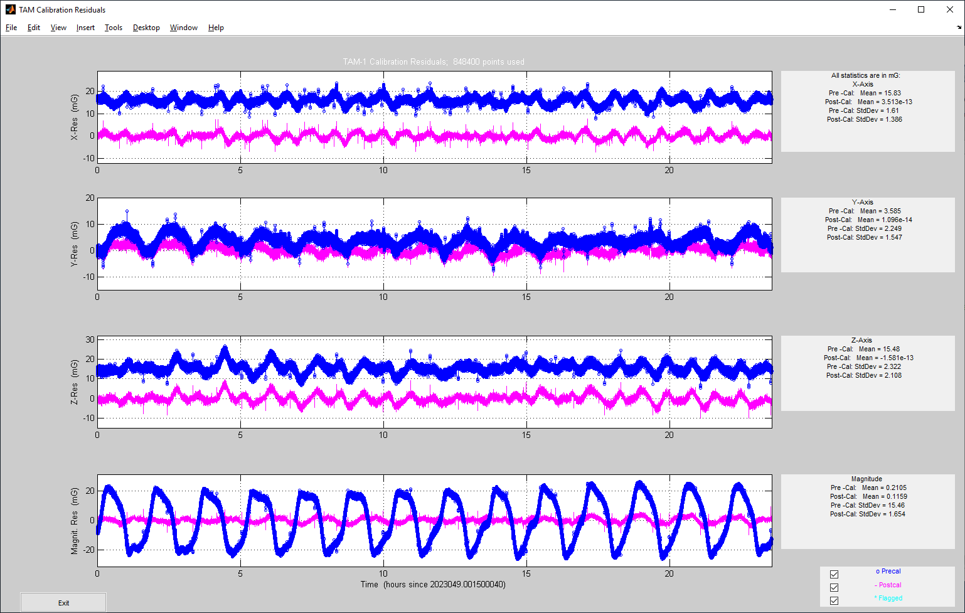
Figure 2-1. TAM-1 Pre vs. Post Calibration Residuals
To validate the TAM-1 calibration an independent set of data was chosen which was not included in the calibration data set itself. In fact, the validation data set (DOY 051) was two days after the calibration data set (DOY 049). A one-orbit time span was selected, and the AGS EKF Smoother was run using star tracker and gyro data with TAM-1 data weighted extremely low. The Smoother was run twice; once with the pre-calibration TAM-1 adjustment parameters and once with the post-calibration parameters. The TAM-1 results are presented in Table 2-1. Note the significant improvement in the root sum square (RSS) Mean residual—an improvement of about 20.5 milligauss (mG). At JPSS-2’s altitude, 1 degree is equivalent to approximately 5 mG; thus, one could expect an improvement in the attitude accuracy, if/when TAM-1 is used as a primary sensor, of up to 4 degrees, at least by this measure.
Table 2-1. TAM-1 Validation Results
Smoother Residual Statistics | Pre-Calibration Residuals (milliGauss) | Post-Calibration Residuals (milliGauss)
Mean-X | 15.68 | -0.25
Mean-Y | 1.97 | -1.78
Mean-Z | 15.82 | 0.49
Std-X | 1.31 | 0.88
Std-Y | 2.73 | 2.00
Std-Z | 1.44 | 1.31
RSS-Mean | 22.36 | 1.86
RSS-Std | 3.35 | 2.55

Figure 2-2 shows the Smoother TAM-1 residuals for the validation run using pre-calibration TAM-1 adjustment parameters (all three axes). Figure 2-3 shows the same plot for the post-calibration case. Note the significant improvement. Also note that the statistics shown in Table 2-1 are derived from the residual data plotted in these two figures.
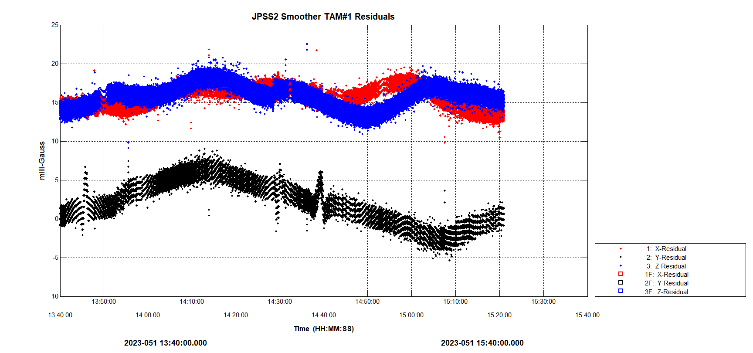
Figure 2-2. TAM-1 Pre-Calibration Smoother Residuals
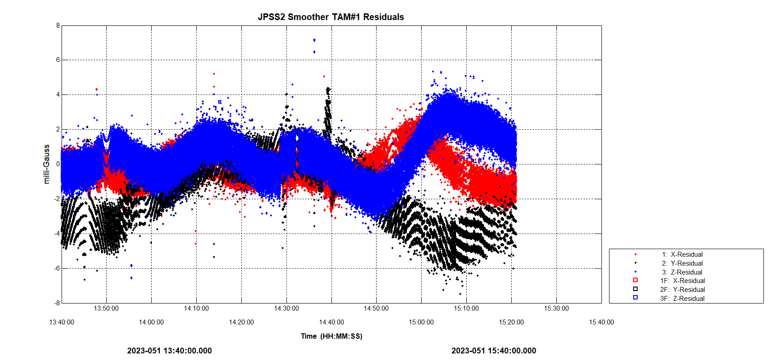
Figure 2-3. TAM-1 Post-Calibration Smoother Residuals
The next set of plots further illustrate the TAM-1 validation results and the improvements gained via the TAM calibration. Going back to the 14-orbit TAMCAL data, Figure 2-4 shows the attitude-independent differences between the magnitudes of the observed and reference magnetic fields using pre-calibration TAM-1 adjustment parameters. Figure 2-5 shows the same plot for the post-calibration case. Note the significant improvement.
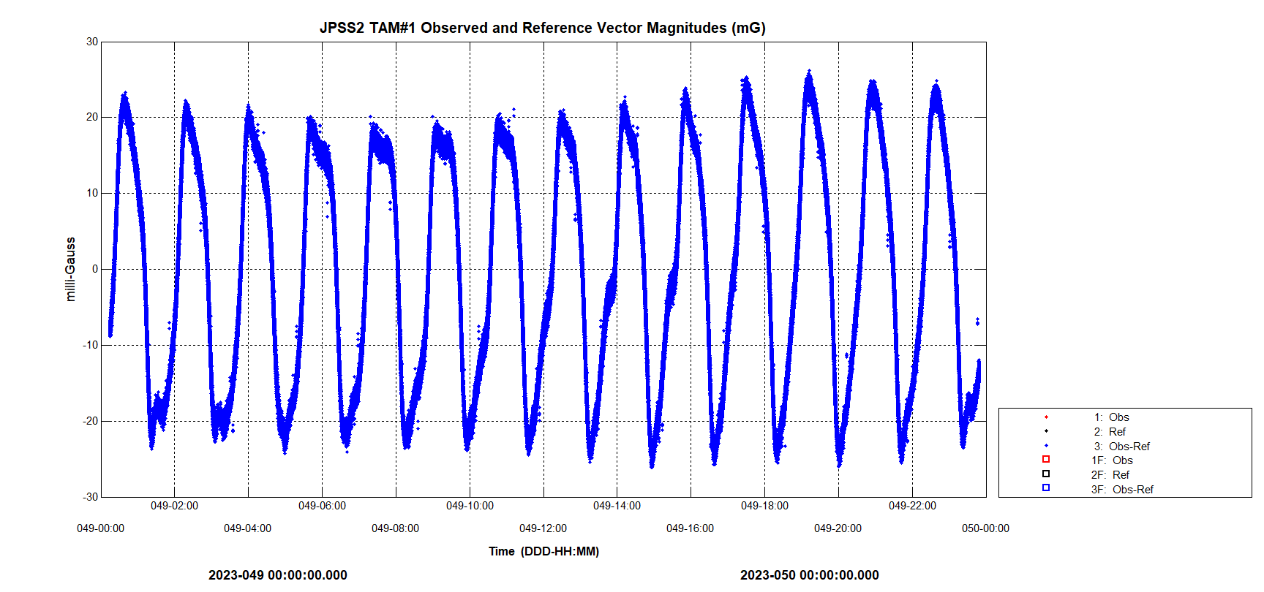
Figure 2-4. TAM-1 Pre-Calibration Observed/Reference Magnitude Differences
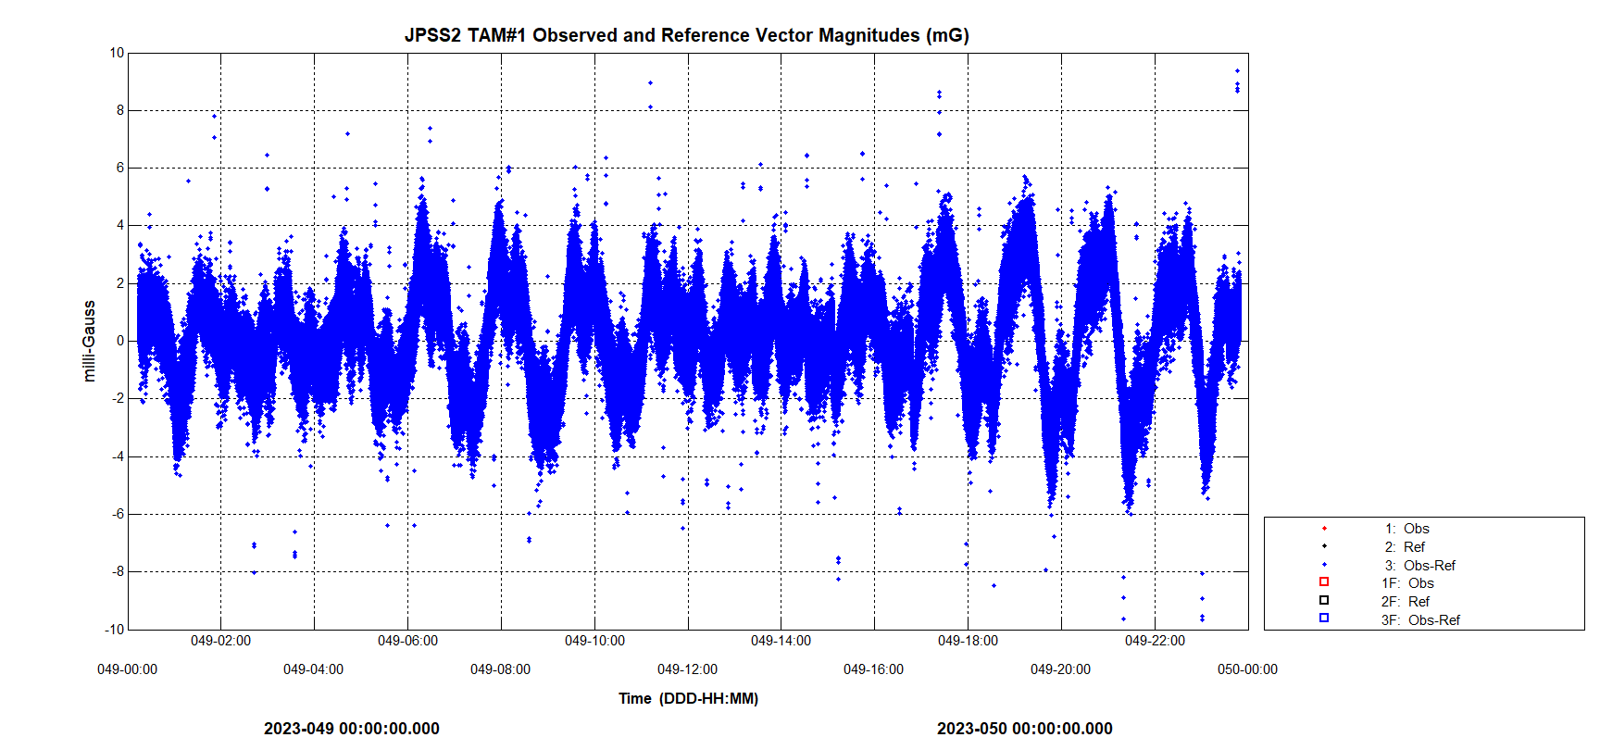
Figure 2-5. TAM-1 Post-Calibration Observed/Reference Magnitude Differences
The TAMCAL results were run through the AGS TAM calibration “post processor” utility to convert the results from MTASS ground conventions to onboard conventions. The conversion formulas for JPSS-2 were non-standard due to the intricate temperature-dependent nature of the onboard algorithm. This required a separate analysis to be performed to reconcile the standard MTASS TAMCAL processing with the non-standard onboard processing. The JPSS-2 TAM post processor code was then implemented using the formulas obtained in the analysis.
The AGS TAM calibration results were uplinked to the spacecraft on March 16, 2023 (DOY 075) at approximately 19:42:24 GMT. Figure 2-11 shows the AGS Real-Time Attitude Determination System (RTADS) TAM-1 residuals plots, respectively, depicting the exact moment of uplink. In these plots, the onboard-processed TAM measurements are being used in the RTADS, so the uplink of TAM sensor processing parameters immediately affects the data in the plot. The estimator used in this plot is the RTADS Single Frame (SF) estimator, which runs the well-known Quaternion Estimation (QUEST) algorithm. With the star tracker present, the QUEST solution can be considered “truth,” and the QUEST TAM residuals are a very good gauge of the accuracy of the TAM processed measurements. The plots show a dramatic improvement in the TAM sensor residuals at the exact time of uplink.
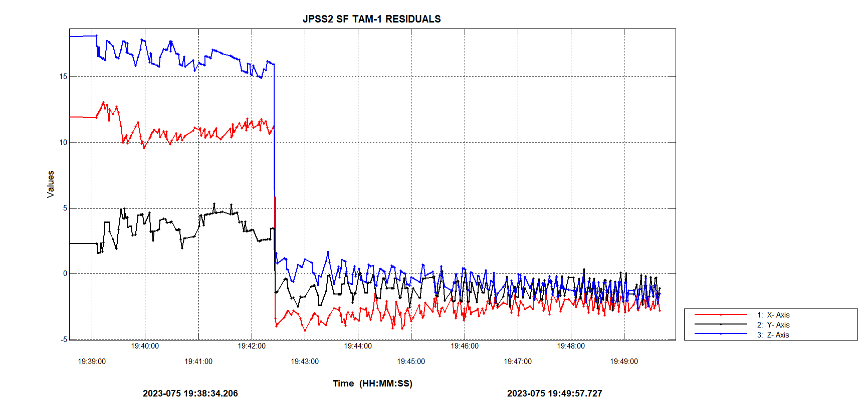
Figure 2-11. OBC TAM-1 RTADS QUEST Residuals (Pre and Post Uplink)

The TAM calibration uplink was further assessed using pre-uplink and post-uplink playback data. The following methodology was employed: the onboard-processed TAM measurements, star tracker data, and gyro data were ingested and processed through the AGS Smoother estimator. The TAM data was weighted extremely low as to not affect the tracker-based Smoother attitude solution. One full orbit was processed for each of the pre- and post-uplink runs. More specifically, the pre-uplink timespan was on March 14, 2023, from 00:00 to 01:41 GMT and the post-uplink timespan was on March 17, 2023, from 06:00 to 07:41 GMT. Tables 2-3 and 2-4 show the dramatic improvement in the pre vs. post uplink residuals for TAM-1 and TAM-2, respectively.
Table 2-3. TAM-1 Pre vs. Post Uplink Residual Statistics
 | X-Axis Mean Residual (mG) | Y-Axis Mean Residual (mG) | Z-Axis Mean Residual (mG) | RSS Mean Residual (mG)
Pre-Uplink | 15.56 | 3.22 | 14.66 | 21.62
Post-Uplink | -0.15 | -1.12 | 0.19 | 1.14

The statistics in the above tables were derived from the following plots (see Figures 2-13 through 2-14).
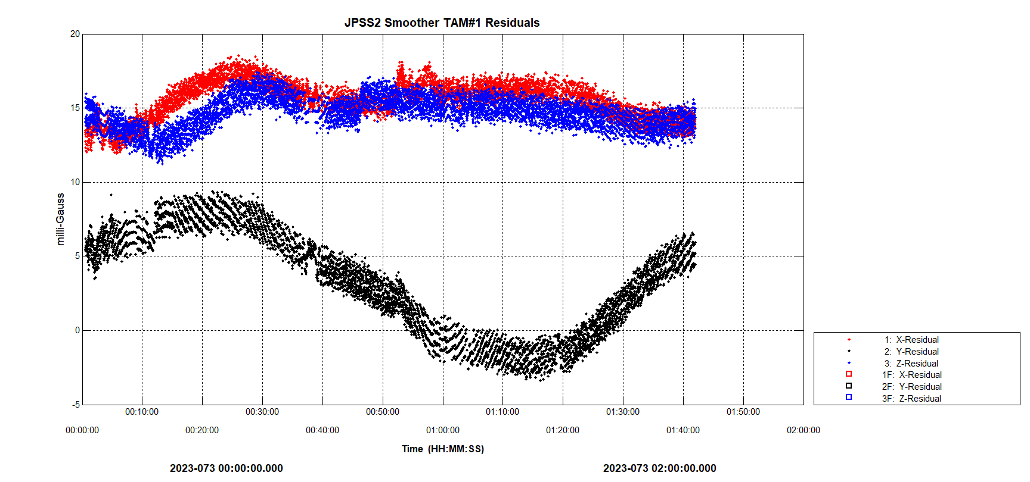
Figure 2-13. OBC TAM-1 Pre-Uplink Residuals Plot
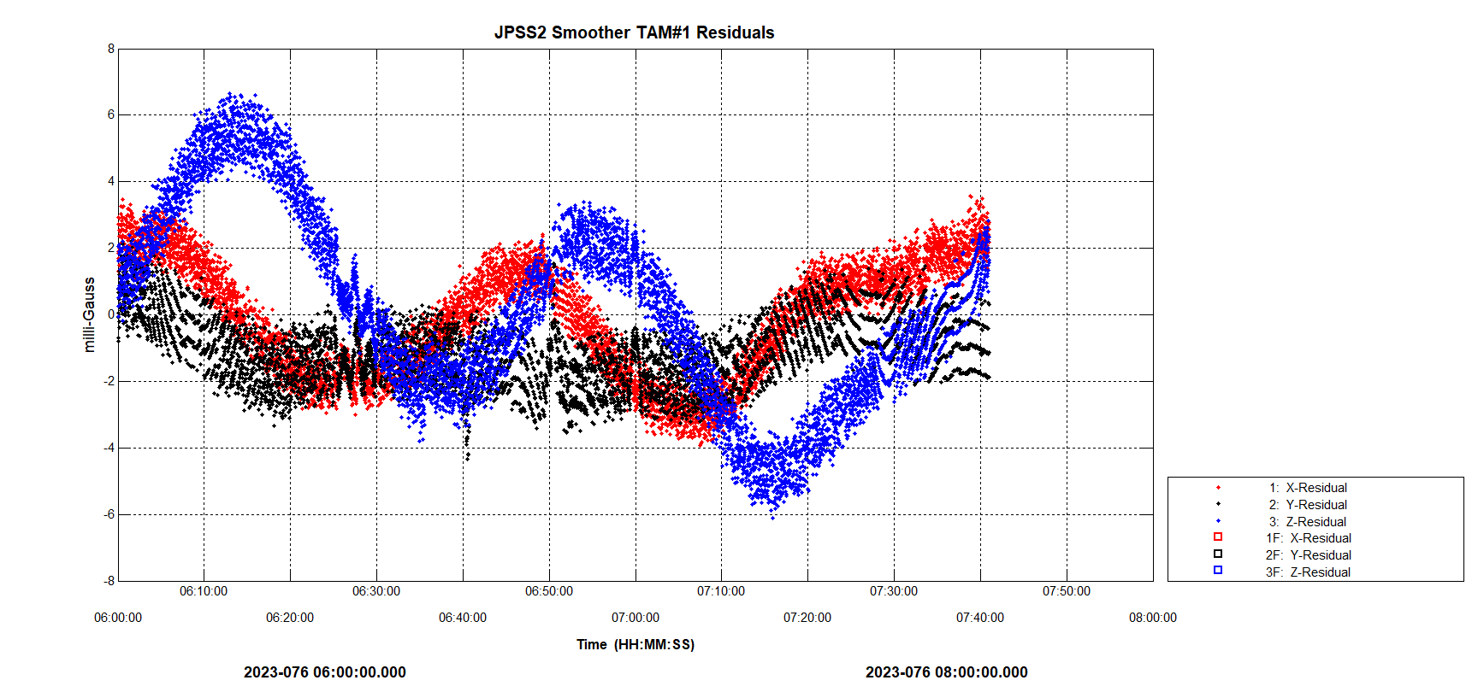
Figure 2-14. OBC TAM-1 Post-Uplink Residuals Plot

To further assess the uplink, the pre-uplink Coarse Attitude Determination (CAD) vs. Fine Attitude Determination (FAD) differences were compared to the post-uplink CAD vs. FAD differences. The onboard CAD solutions use the TAMs as the primary attitude sensor, whereas the onboard FAD solutions use the star trackers and can be considered “truth” for our current purposes. Table 2-5 shows the maximum differences between the CAD and FAD solutions for the pre- and post-uplink cases. These maximum differences constitute another good gauge of the attitude accuracy gained by applying the AGS TAM calibration results to the onboard processing (when the TAMs are used as primary attitude sensors). As seen in the table, the RSS maximums improve from 1.836 degrees (pre-calibration) to 0.483 degrees (post-calibration) resulting in an accuracy improvement of 1.353 degrees. The plots from which these statistics arise are shown in Figures 2-17 and 2-18 (the pre-uplink CAD vs. FAD and post-uplink CAD vs. FAD, respectively).
Table 2-5. CAD vs. FAD: Maximum Differences over One Orbit
 | X-Axis Max Difference (Deg) | Y-Axis Max Difference (Deg) | Z-Axis Max Difference (Deg) | RSS Max  Difference (Deg)
Pre-Uplink | 0.859 | 1.447 | 0.734 | 1.836
Post-Uplink | 0.181 | 0.321 | 0.312 | 0.483

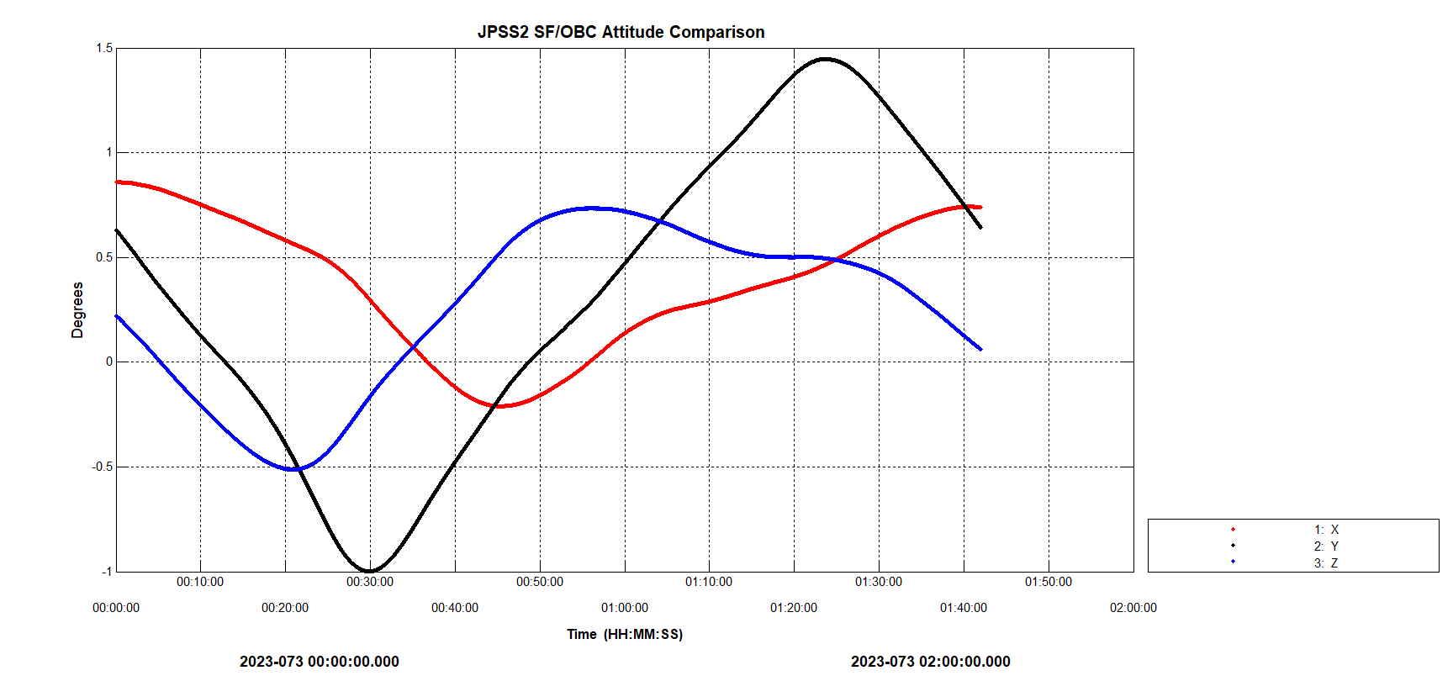
Figure 2-17. CAD vs. FAD Comparisons (Pre-Uplink)
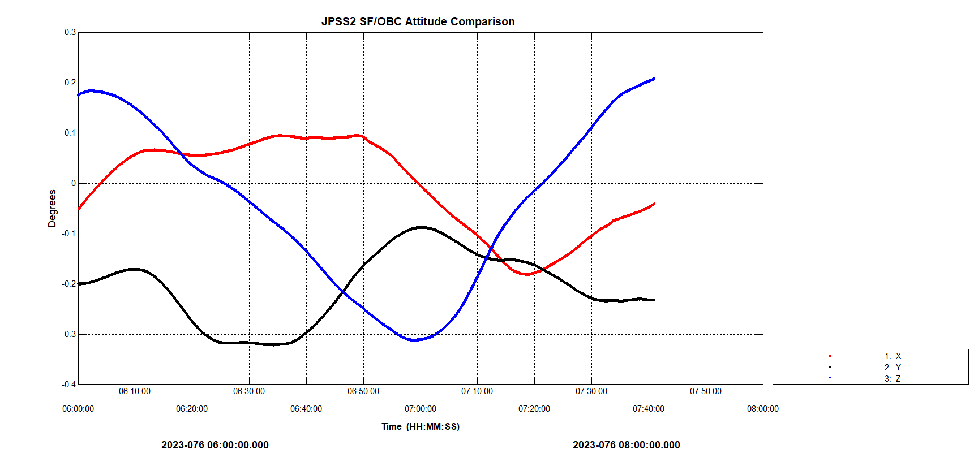
Figure 2-18. CAD vs. FAD Comparisons (Post-Uplink)
The AGS launch team performed TAM calibrations for the two TAMs flying on the JPSS-2 spacecraft. The calibration significantly improved the accuracy of the TAM measurements. Using ground-processed TAM measurements, the AGS calibration improved the TAM RSS mean residuals from 22.36 mG to 1.86 mG for TAM-1 and from 15.91 mG to 1.89 mG for TAM-2. By examining the onboard-processed TAM measurements from both before and after uplink of the AGS calibration parameters, it was shown that the calibration improved the onboard TAM RSS mean residuals from 21.62 mG to 1.14 mG for TAM-1 and from 15.31 mG to 1.14 mG for TAM-2. In terms of attitude accuracy improvement, the onboard maximum RSS CAD (TAM-based) attitude was shown to improve from 1.836 degrees to 0.483 degrees, or an overall attitude accuracy improvement of 1.353 degrees.
Reaction Wheel Momentum UNLOading: Roman AGS Design
For spacecraft such as PACE that are in low-Earth orbit, the dominant attitude perturbations are torques on the spacecraft body from aerodynamic drag and from the gravity gradient. At the Lagrange point (L2) where the Nancy Grace Roman Space Telescope (RST) will reside, the dominant attitude perturbation will be torque from solar radiation pressure (SRP). The RST has fixed solar panels that will always be oriented near the Sun vector. With the Sun on that side of the spacecraft, the RST center of radiation pressure is located roughly 2.4 m away from the center of mass, toward the front of the spacecraft. This offset means the SRP will apply a significant torque. Angular momentum will accumulate roughly 60 N-m-s per day (the actual expected accumulation rate is variable by roughly a factor of two, depending on the spacecraft attitude).
This section of the paper discusses the angular momentum accumulation prediction and management for RST. A new AGS subsystem has been developed called the Momentum Prediction and Calibration (MPAC) utility. This utility uses new code written with extensive use of the MTASS library. MPAC has been tested successfully in early RST mission rehearsals.
During science operations, the RST attitude will change frequently by small amounts, followed by larger slews to other astronomical targets, always keeping the normal to the solar panels within 36 deg of the Sun vector. There are six reaction wheels that will store the accumulated angular momentum. The reaction wheel speed limits will depend on which science instrument is active at any given time. To reduce vibrations, these wheel limits are relatively tight, leading to a need to use thrusters to unload angular momentum frequently. Depending on which science instrument is active, these unloads will be needed anywhere from more than once per day up to once every four days.
The MPAC utility reads a file listing the planned attitude slews, computes the SRP torques, and integrates the torques to find the total angular momentum versus time for a 4-week planning period. Depending on which science instrument is active, MPAC will check either the maximum wheel speed or verify that the angular momentum components are within allowed limits in the body frame.
The RST body is modeled with 1306 triangles, each with defined reflectivity coefficients. The smallest triangles are discarded, reducing this number to 735 triangles. Figure 1 shows the RST model. The different colors represent materials with different reflectivities.
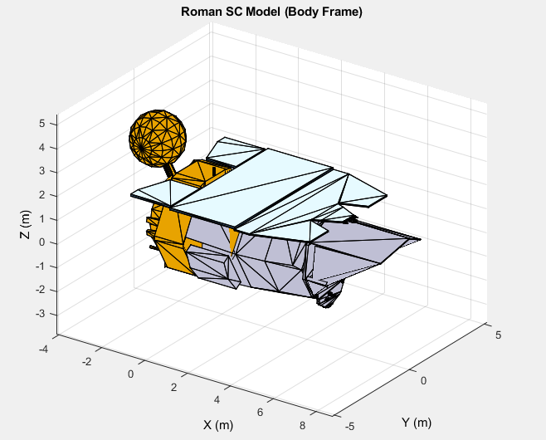
Figure 1. Roman Space Telescope Model Used for SRP Torque Computation.
The SRP torque is computed using a type of ray-tracing method. The spacecraft attitude is expressed in a “box frame” where the Z-axis is oriented toward the Sun, and the X-axis is minimally rotated from the body X-axis direction (for RST, the X-axis is the telescope field of view direction). For typical MPAC operations, a 100×200 grid of Sun-pointing rays is defined in the box frame, and their intersections with the model triangles are determined, as shown in Fig. 2. The array arithmetic in the MATLAB programming environment allows for efficient processing of these ray intersections to determine which triangles are shadowed and which are visible to rays from the Sun (internal reflections are ignored).
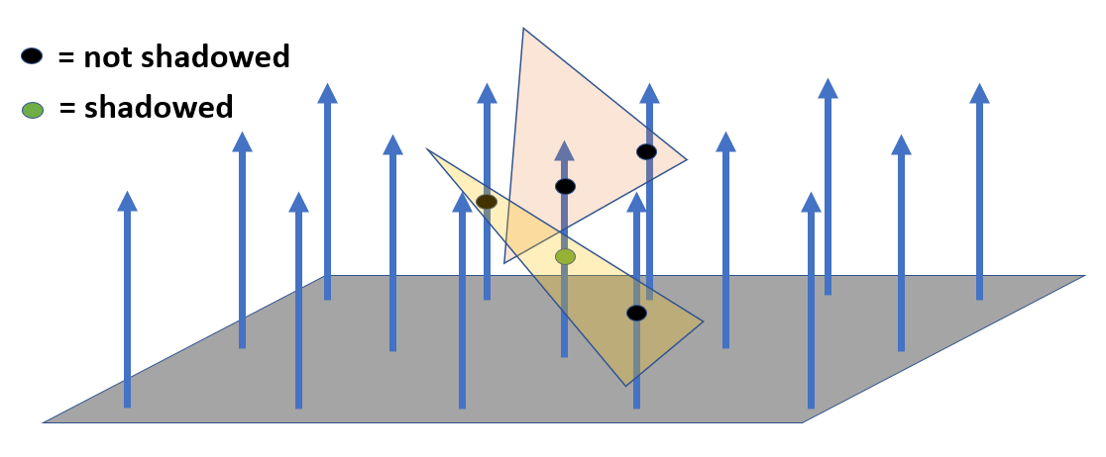
Figure 2. Box Frame and Grid of Sun-Pointing Rays.
The force corresponding to each ray is computed using the reflectivity coefficients. (See Ref. 1, Sec. 17.2.2). The SRP force on an element of area, dA, at time step t_{i} is
$d{\vec{f}}_{i}=-P\cos{ϑ_{i}}\left[\left(1-C_{spec}\right){\hat{S}}_{i}+2C_{spec}\cos{ϑ_{i}}\hat{N}+\frac{2}{3}C_{diff}\hat{N}\right]dA$ , (1)
where P is the solar constant divided by the speed of light, ϑ_{i} is the angle between the spacecraft-to-Sun unit vector, ${\hat{S}}_{i}$, and the unit normal to the area element, $\hat{N}$. The factors C_{spec} and C_{diff} are the coefficients of specular and diffuse reflection for the element of area, respectively. At one astronomical unit (AU), the factor P is approximately 1361 Watts/m^2 (or equivalently, N-m/(s-m^2)) divided by the speed of light and falls off as the inverse of the distance from the Sun squared. At 1 AU, this factor is 4.54×10⁻⁶ N/m^2.
The torques are obtained by summing the cross-products of the intersection locations relative to the center of mass with these individual forces given in Eq. 1. The center of mass is determined from a look-up table dependent on current fuel usage.
The attitudes are taken to be constant between time steps (that is, the slews are assumed to be instantaneous). For this reason, MPAC uses a simple midpoint integration method where the SRP torques are computed at the integration midpoints. Also, since the attitudes are constant while the reaction wheels accumulate the angular momentum, the equation to be integrated is simply kinematic and not dynamic. That is,
$\frac{d\vec{H}}{dt}=\vec{N}$ , (2)
where $\vec{H}$ is the angular momentum and $\vec{N}$ is the SRP torque. This equation holds in either the body frame or the inertial frame since the body rotation rate is assumed to be zero between slews.
At each time step, MPAC checks the wheel limits appropriate for the active science instrument and determines whether a momentum unload is needed. Optionally, a time offset may be applied to move the unload earlier in time to allow more flexibility in the actual final unload scheduling. At each momentum unload, MPAC resets the predicted body frame angular momentum to a target value, which is also dependent on the currently active science instrument.
As an example, Fig. 3 shows the body frame angular momentum as it accumulates predominantly about the body Y-axis. This angular momentum is then repeatedly unloaded as reaction wheel limits are reached. In this example, the active science instrument changes to one with tighter wheel limits on day ten. At that time, the frequency of unloads increases and the target angular momentum is reduced. The attitude is constant in this test case. In more realistic cases, the body frame angular momentum will change with every attitude change. These changes can lead to more momentum unloads than would be expected from SRP torque by itself since the wheel limits are different on different body axes.
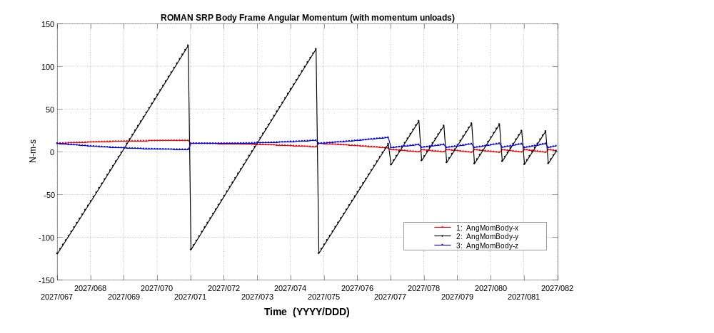
Figure 3. Angular Momentum in Body Frame Showing Momentum Unloads.
MPAC will generate a weekly output report giving the unload times, unload numbers, target angular momenta, and additional comments. Momentum unloads are also scheduled to be performed along with each orbit maneuver (delta-V). The MPAC report provides a four-week look-ahead, where the predicted unloads in the first two weeks will have already been approved by the operations team, and the unloads in weeks three and four are the new AGS recommendations.
The second part of MPAC is to perform a calibration on the computed SRP torque. This calibration is designed to decrease the error in the predicted angular momentum accumulation. The MPAC calibration will be executed periodically as data becomes available during the first several months of the mission. MPAC will compare previous predictions with actual reaction wheel telemetry and will perform a least-squares optimization. The calibration loss function is
$L =\frac{1}{2}\sum_{j}{{\left[{∆\vec{H}}_{obs,j}^{GCI}-K_{j}\vec{R}\right]}^{T}W_{j}\left[{∆\vec{H}}_{obs,j}^{GCI}-K_{j}\vec{R}\right]}$ , (3)
where ${∆\vec{H}}_{obs,j}^{GCI}$ is the angular momentum residual for the j-th time span, $K_{j}$ is a matrix summarizing the geometric and reflectivity properties for that time span as computed and saved during the torque integration, and $\vec{R}$ is the state vector to be estimated.
The state $\vec{R}$ is the product of an unknown element of area and an unknown moment arm; only the product needs to be estimated. That is, the estimator determines a fictitious extra reflective area and moment arm to add to the actual spacecraft triangle model in order to minimize the residuals between the MPAC predictions and the telemetered wheel speeds. This fictitious area is assigned mean reflectivity coefficients that are determined as averages over the known illuminated area elements from a typical set of attitudes and time span.

CONCLUSION
We have developed a trajectory optimization method to simultaneously minimize fuel consumption and landing site contamination. The compromise between contamination reduction and additional fuel usage can be adjusted by changing the respective weighting coefficients in the fitness function. Prescribing a small value for the contamination weight requires a small fraction of additional fuel to perform the hop when compared to the ballistic reference, perturbing the descent trajectory to reduce landing site contamination. As the contamination weight is increased a Double Hop” maneuver further reduces contamination reduction with a modest increase in fuel.
No substantial difference is found in the contamination reduction for 2D-restrive cases versus 3D case when a restrictive VTVL ground constraint is imposed on the vehicle final descent. However, Out-of-plane maneuvers in the 3D cases were found to be more effective in reducing landing site contamination for the same additional fuel usage when a more relaxed VTVL ground constraints is imposed at the landing. A factor of 3 reduction in contamination was found for a modest increase in fuel usage. This is accomplished by vectoring the thrust out-of-plane while more closely maintaining the fuel optimal ballistic trajectory in the pitch plane. Our results show that feasible trajectories can be obtained with realistic constraints on vehicle parameters when some extra fuel is available and contamination minimization is paramount. Typically, these higher contamination weights produce more complex descent trajectories including trajectory inflections and target flyovers, but at the expense of more fuel usage without substantial further reduction in contamination.
The trajectories explored in this work can also be applied to optimize a variety of other surface interactions that might be of interest for a mission. This would require modifying the state equations by either replacing the contamination mass rate or adding new equations to represent other modes of plume surface interaction.

REFERENCES
[1] Wertz, J.R. (ed.), Spacecraft Attitude Determination and Control, D. Reidel Publishing Company, Dordrecht, The Netherlands, 1978.
[2] Shuster, M. D. & Oh, S. D., “Three-Axis Attitude Determination from Vector Observations,” Journal of Guidance and Control, Vol.4, No.1,1981, pp.70–77.
[3] Cheng, Y., and Shuster, M.D., “Improvement to the Implementation of the QUEST Algorithm,” Journal of Guidance, Control, and Dynamics, Vol. 37, No. 1, 2014, pp. 301-305.
[4] Gelb, A. (ed.), Applied Optimal Estimation, MIT Press, Cambridge, MA, 1974.
[5] Lefferts, E., Markley, F., and Shuster, M., “Kalman Filtering for Spacecraft Attitude,” Journal of Guidance, Control and Dynamics, Vol. 5, No. 5, 1982, pp. 417–429.
[6] Hashmall, J. A. and Sedlak, J. E., “New Attitude Sensor Alignment Calibration Algorithms,” 53rd Int. Astronautical Congress, IAC-02-A.4.07, IAF, Houston, TX, Oct. 2002.
[7] Hashmall, J. A., Radomski, M., and Sedlak, J., “On-Orbit Calibration of Satellite Gyroscopes,” AIAA/AAS Astrodynamics Specialist Conference, AIAA-2000-4244, Denver, Colorado, Aug. 2000.
[8] Sedlak, J., “Multi-Axis Gyroscope Calibration Utility,” Internal report, a.i. solutions, Inc., 2024
[9] Challa, M. and Harman, R., A New Magnetometer Calibration Algorithm and Applications Proceedings of the AIAA Guidance, Navigation, and Control Conference, Boston, MA, August 10-12, 1998, pp. 697-707.
Acknowledgments
This work was supported by the NASA/Goddard Space Flight Center, Greenbelt, MD, USA, Contract 80GSFC19C0072.

Aerospace Engineer, Attitude Control Systems Branch, NASA GSFC, Greenbelt, MD 20771
Aerospace Engineer, a.i. Solutions, Inc., Lanham, MD 20771
Aerospace Engineer, a.i. Solutions, Inc., Lanham, MD 20771
Aerospace Engineer, a.i. Solutions, Inc., Lanham, MD 20771

