SSC25-X-03

Rideshare On NASA Missions:

Realities and Triumphs

Alicia Mendoza-Hill
NASA Headquarters
300 E St SW, Washington, DC 20546; 202 358 1139
alicia.mendoza-hill@nasa.gov

William Atkinson, Shaun Daly
NASA Launch Services Program
John F. Kennedy Space Center, FL 32899
william.c.atkinson@nasa.gov; shaun.m.daly@nasa.gov

Katherine Nelson
Booz Allen Hamilton
300 E St SW, Washington, DC 20546
katherine.e.nelson@nasa.gov; hq-smd-rideshare@mail.nasa.gov

ABSTRACT
Small spacecraft technology advancements have transformed the way NASA’s Science Mission Directorate (SMD) strategically executes science investigations. In support of this new approach, SMD established the Rideshare Office in 2020 to implement and define the SMD-wide rideshare strategy. The objective of the office is to maximize science, exploration, and technology return on investment by enabling rideshare or accommodation opportunities for small spacecraft on SMD primary mission launches, and VADR launch procurements which are managed by the NASA Launch Services Program (LSP). The SRO also enables opportunities for NASA small sats on other government agency and international space agency partner launches. The SMD Rideshare Office (SRO) serves as the single point of contact across NASA SMD for coordinating rideshare opportunities between compatible payloads and government launch opportunities. The SRO holds a leadership role across SMD and the rideshare community, which allows it to provide and manage consolidated resources for guidance for potential spacecraft teams and other stakeholders. Such resources include the NASA Rideshare Users Guide (RUG) and do-no harm management strategy, and the SMD Secondary Payload Rideshare Programmatic Framework (SPD-32).
Rideshare as a method of access to space is extremely popular amongst both the government, and especially commercial industry. The practice of integrating multiple missions on a single launch service is complex and an extremely relevant topic of discussion for the small sat community. This presentation will provide SMD’s and LSP’s unique perspective and discussion on NASA’s approach to rideshare and will provide an overview of rideshare realities and processes. It will describe technical and programmatic lessons learned from implementing different rideshare configurations and do-no-harm management approaches.

INTRODUCTION
NASA’s Science Mission Directorate’s (SMD) strategic embrace of rideshare has significantly maximized scientific return on investment by enabling cost savings, fostering enhanced collaboration, and increasing access to space for a diverse portfolio of small satellite missions. We will showcase key triumphs through illustrative examples, while also openly discussing the challenges encountered and the valuable lessons learned that continue to inform NASA's evolving approach to rideshare in a dynamic launch landscape.

BACKGROUND

Historical Context: NASA SMD Rideshare Policy
NASA’s rideshare philosophy is straightforward: utilize the lift capability of an available space transportation service to the maximum extent practicable (as defined by NASA Policy Directive (NPD) 8610.12H). In 2018 SMD developed a policy and process to implement this agency-wide philosophy, resulting in SMD Policy Directive 32 (SPD-32). SPD-32 specifically established the SMD policy for utilizing the excess ascent performance and other mission resources on SMD missions by supporting the integration of secondary payloads onto Evolved Expendable Launch Vehicle (EELV) Secondary Payload Adapter (ESPA) rings. Since 2018 the rideshare landscape has changed greatly, however the original tenants of the policy laid the groundwork for the ability of the Agency to adapt to changes and innovation brought on by the commercial sector.
Current Rideshare Process for SMD Primary NLS-II Launches
The initial SPD-32 refers to the process of adding rideshare on NASA Launch Service Contract II (NLS-II) contracted launches for SMD primary missions. SMD policy enables rideshare and launch opportunities for SMD secondary payloads by encouraging the integration of Secondary Payload Adapters into primary mission launch services. Once a primary mission/payload is selected and its launch requirements are identified, the Launch Services Program (LSP) identifies any excess capacity. If excess performance is available, SMD will use this capacity to launch SMD-sponsored secondary payloads, whether competed or directed, provided that the secondary meets the science, technology and exploration goals required.
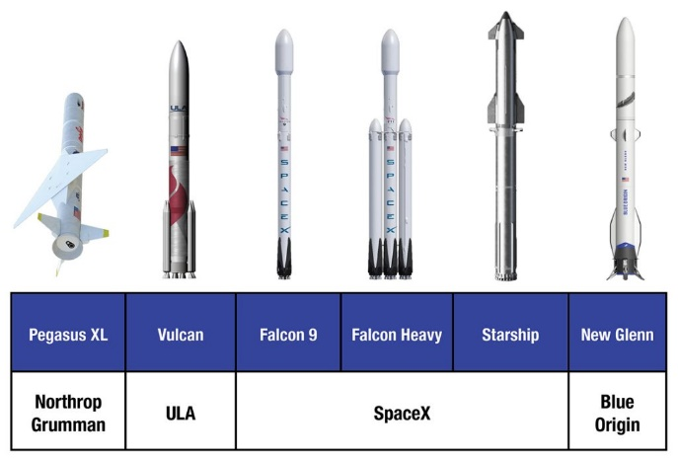
Figure 1: Current LSP fleet of launch vehicles on the NLS II contract. NASA
Any remaining excess capacity can be offered to other NASA mission directorates (MDs), Other US Government Agencies (OGAs) or International Space Agency Partners, consistent with international agreements for collaborative science, technology and exploration efforts.
A guiding principle for SMD’s rideshare process is to prioritize "Do No Harm" (DNH) to the primary payload. This means that every mission on a shared launch must satisfy requirements that prevent detrimental effects on the others' instruments and observatories. In the context of SMD missions using the LSP NLS-II contract, the primary mission is the top priority for launch, and all rideshare missions are obligated to ensure they do no harm to the primary or their launch vehicle. The SMD division responsible for funding the primary mission has the final authority on all matters of spacecraft payload compatibility and DNH compliance.
SMD Rideshare Lead
The establishment of this policy warranted the creation of a single point of contact to manage SMD rideshare efforts. In 2020 SMD created the SMD Rideshare Lead position to act as a central point of contact for coordinating all compatible launch and access to space opportunities. Beyond this, the Rideshare Lead acts as the single point of contact for all SMD rideshare-related inquiries regarding both internal NASA and external launch or collaboration opportunities. The lead is responsible for maintaining comprehensive knowledge and tracking of all rideshare activities for SMD missions, ensuring the optimal utilization of excess launch vehicle performance to maximize scientific returns on investments for SMD.
The mission of the rideshare lead is to enable coordination between primary spacecraft, secondary spacecraft, and launch vehicles to support dynamic partnerships across NASA, government agencies, international partners, and commercial vendors.
The rideshare lead supports all NASA SMD Divisions and works with NASA Center Rideshare POCs to standardize the NASA/SMD rideshare message and process. Additionally, they provide essential information and training to principal investigators (PIs) and program offices on their roles in the rideshare process.
Adapting to a Changing Rideshare Landscape
NASA's initial rideshare framework from 2018, along with the creation of a new centralized approach, laid essential groundwork. This foundation has significantly improved SMDs ability to adapt to the dynamic rideshare market. This evolution is evident in the development of new procurement mechanisms like the Venture-Class Acquisition of Dedicated and Rideshare (VADR) launch service contract. The SMD rideshare lead and LSP are constantly at the forefront of rideshare discussions, diligently collecting lessons learned. This vital feedback directly informs the ongoing updates and expansions of their documentation and contracts, showcasing NASA's highly proactive and adaptive approach to both new opportunities and challenges in the rideshare landscape. The subsequent discussion elaborates on these topics.
The Rideshare Lead is working on incorporating all access to space rideshare options within the SMD Secondary Payload Rideshare Programmatic Framework (an update to SPD-32). This update will include expanded guidance on SMDs rideshare approach for their payloads on all other currently available options for access to space, both government and commercial.
BENEFITS OF NASA RIDESHARE: MAXIMIZING SCIENCE RETURN ON INVESTMENT
NASAs rideshare strategy produces significant cost savings for SMD, enhanced science enabling capabilities, and the ultimate maximization of taxpayer dollars as demonstrated by the following examples.

Implementation Example 1: IMAP and SPHEREx Rideshare Experiences – Two NLS-II Successes
NASA selected the Interstellar Mapping and Acceleration Probe (IMAP) and Spectro-Photometer for the History of the Universe, Epoch of Reionization, and Ices Explorer (SPHEREx) missions in 2018 and 2019, respectively.
- IMAP will help researchers better understand the boundary of the heliosphere, a sort of magnetic bubble surrounding and protecting our solar system.
- SPHEREx, which launched in March of 2025, will provide an all-sky spectral survey. Over a two-year planned mission, the observatory, a NASA medium-class exploration (MIDEX) mission, will collect data on more than 450 million galaxies along with more than 100 million stars in the Milky Way in order to explore the origins of the universe.
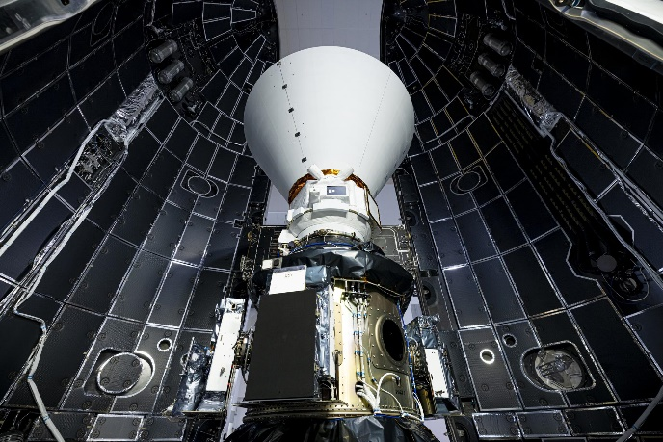
Figure 2: SPHEREx and PUNCH enclosed in a payload fairing at Vandenberg Space Force Base on March 2. NASA/BAE Systems/Benjamin Fry
These two NASA SMD missions will provide decadal-level science contributions within the Heliophysics and Astrophysics communities. Their inherent design, as relatively smaller primary spacecraft opened up substantial excess capacity for rideshare.
NASA procured higher level mission assurance launch vehicles, through the NLS-II contract, for these critical missions and strategically filled excess capacity with additional rideshare missions (e.g., PUNCH for SPHEREx; SWFO-L1 and Carruthers for IMAP). Below are descriptions of the additional science observations made possible by the use of rideshare:
- Polarimeter to Unify the Corona and Heliosphere (PUNCH) is an SMD Heliophysics Mission made up of a constellation of four small satellites in low Earth orbit that will make global, 3D observations of the entire inner heliosphere to learn how the Sun's corona becomes the solar wind.
- The Space Weather Follow-on (SWFO)-L1 project is a NOAA mission that will use a suite of instruments to make real time measurements of the solar wind, thermal plasma, and the magnetic field. In addition, SWFO-L1 will have a Compact Coronagraph (CCOR) instrument to detect coronal mass ejections.
- Carruthers Geocorona Observatory, another Heliophysics mission, will capture light from Earth’s geocorona, the part of the outer atmosphere that emits ultraviolet light.
By only using two launch vehicles, NASA will have successfully launched a total of seven spacecraft, significantly increasing scientific output for a limited price. If rideshare wasn't utilized, each of the three secondary missions would have required a separate, costly individual launch, demonstrating immense savings and enabling more science.
Rideshare additionally offers SMD a valuable pathway to unique or infrequent orbital destinations, notably Lagrange Point 1 (L1). Without rideshare, a dedicated launch to these locations would likely be cost prohibitive for smaller payloads/missions.
Implementation Example 2: VADR Contract and NASAs Access to Commercial Rideshare
The Venture-Class Acquisition of Dedicated and Rideshare (VADR) launch services contract was created by LSP to fulfill NASA’s need for lower cost launch services for higher risk tolerant missions. VADR incorporates lessons learned from previous LSP contracts such as NASA Launch Service (NLS), Venture Class Launch Service (VCLS), CAPSTONE, TROPICS, and various CubeSat, as well as feedback received from commercial partners.
The VADR launch services provide a Federal Aviation Administration (FAA) licensed launch service for payloads with a risk tolerance of Class D (per NPR 8705.4, Risk Classification for NASA Payloads), or higher risk tolerance. VADR is not applicable for Class A, B, C, and some D payloads who require a higher level of mission assurance and oversight. The launch services contracted under VADR are intended to align with standard commercial practices while still retaining an appropriate level of Government oversight commensurate with a Class D mission and a FAA licensed launch.
The VADR contract has Standard Launch Services (CLIN 1) and Streamlined CubeSat Launch Services (CLIN 2) which include dedicated, primary (or anchor) payload on rideshare, or traditional rideshare launch options.
The VADR contract has allowed SMD to provide rideshare opportunities on commercial rideshare launches where NASA does not own the excess performance. This reduces NASAs launch costs by allowing the launch vehicle providers to sell any additional space to their customers.
Below is a highlight of just a few of the missions benefitting from VADR:
- Tandem Reconnection and Cusp Electrodynamics Reconnaissance Satellites (TRACERS) will help understand magnetic reconnection and its effects in Earth’s atmosphere. Magnetic reconnection occurs when activity from the Sun interacts with Earth’s magnetic field. By understanding this process, scientists will be able to better understand and prepare for impacts of solar activity on earth. TRACERS is riding to sun-synchronous orbit (SSO) on SpaceX in Fall of 2025.
- Aspera is an Astrophysics Pioneers program small sat that will study galaxy evolution. Through observations in ultraviolet light, it will examine hot gas in the space between galaxies, called the intergalactic medium, that is thought to contribute to the birth of stars and planets. The intergalactic medium is a major component of the universe but is poorly measured; Aspera would close this gap. The spacecraft is flying to SSO on Rocket Lab’s Electron.
- QuickSounder will support NOAA’s next generation satellite architecture for its future low Earth orbit (LEO) program, which will provide mission-critical data for the agency’s National Weather Service, the nation’s weather industry, and other users worldwide. Quicksounder is flying to LEO on a Firefly Aerospace launch vehicle.
The VADR contract achieves lower launch costs through FAA licensed commercial launches. Providers may propose rocket configurations with no prior demonstrated flight history after they complete extensive NASA certification processes. Through VADR, NASA is fostering growth in the US commercial launch market and enabling greater access to space for science and technology missions at a more affordable price.
Implementation Example 3: OGA and International Collaboration on Rideshare
NASA has partnered with other government agencies to launch secondary payloads including the National Oceanic and Atmospheric Administration (NOAA), and the US Space Force’s Multi Manifest Office and Space Test Program. SMD has collaborated with OGAs to launch a variety of SMD and Cube Sat Launch Initiative (CSLI) cubesats, and small sat missions. Collaborative efforts include NASA Space Technology Mission Directorate (STMD) LOFTID on NOAAs JPSS-2 (NOAA Primary Mission launched on SMD procured NLS-II launch), and SunRISE (SMD secondary payload that will rideshare on a USSF launch). A highlight of the science achieved through collaboration on these launches is detailed below.
- The Sun Radio Interferometer Space Experiment (SunRISE) is an array of six CubeSats that will work together to study solar activity, observing low radio frequency emissions so scientists can understand better how the Sun is able to generate intense space weather storms – known as solar particle storms – that can be hazardous to spacecraft and astronauts.
- The Low-Earth Orbit Flight Test of an Inflatable Decelerator (LOFTID) demonstrated a cross-cutting aeroshell – a type of heat shield – for atmospheric re-entry. This technology enables a variety of proposed NASA missions to enter the atmospheres of destinations such as Mars, Venus, Titan, and Earth.
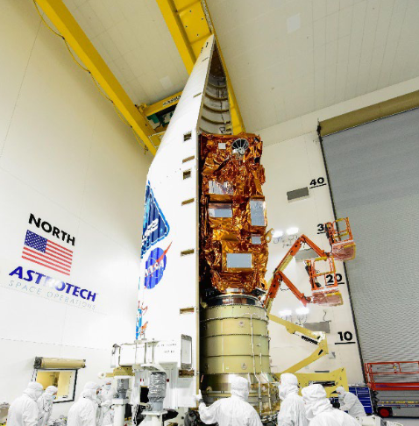
Figure 3: NOAA JPSS-2 with NASA STMD LOFTID underneath. NASA
NASA has also successfully collaborated with international space agency partners, such as ESA, who launched NASA SMD’s CubeSat Radio Interferometry Experiment (CURIE) mission on the maiden launch of Ariane 6.
Beyond the demonstrated cost savings and return on science investment to the government and taxpayer achieved through these collaborative launches, the benefits of information and process sharing between agencies and international partners are paramount. These collaborations improve overall efficiency in government-executed rideshare and strengthen relationships between agencies and nations, leading to more robust space ecosystems.
These illustrative and diverse examples of NASAs execution of rideshare demonstrate that rideshare provides a significant return on investment both budgetarily, and scientifically, for SMD and the agency, and government as a whole.
CHALLENGES AND LESSONS LEARNED: REFINING NASA’S RIDESHARE APPROACH
Big-picture, NASA’s rideshare efforts have been successful and meaningful. Launching satellites is inherently a complex endeavor and therefore multiple spacecraft launching together increases complexity. There have been numerous lessons learned and adaptions made to NASAs rideshare process. NASA has actively tracked and implemented necessary changes to accommodate market development of NASA science needs and commercial rideshare development. Some key lessons and changes are detailed in the following section.
The Uniqueness of NASA Rideshare
NASA’s rideshare approach can not entirely mimic commercial practices and approaches to rideshare (e.g. SpaceX Transporter missions). Due to the unique nature of NASA’s science missions (sensitive instruments, unique orbital locations, mission assurance requirements etc.) and the inherent requirement for a government agency to ensure value and accountability with taxpayer dollars, NASA necessitates a distinct and rigorous approach to rideshare.
Realities and Lessons from NLS-II
Through its experience adding rideshare payloads to NLS-II primary launches, NASA has identified several challenges and gathered important lessons learned. The SMD and LSP have since analyzed these lessons, synthesized the best solutions, and implemented updates to documentation and processes to foster a more efficient and modern approach. Some key challenges encountered, and NASA's corresponding responses, are detailed below.
Compatibility Issues: Our approach to pairing secondary missions with SMD primary payloads involves accommodating a wide range of mission types, including complex missions with significant interface requirements. These complex missions can only be added as rideshares if their intricate requirements do not directly conflict with the primary payload. Secondary payloads are subordinate to all of the primary mission’s parameters (schedule, mission assurance, contamination, launch environments, launch day power-on requirements etc.). This subordinate position can make it difficult for higher classified or complex missions to be secondary payloads. These missions may not be considered for secondary payload opportunities.
Launch Site Considerations: Combining multiple payloads on the same launch vehicle is a complex task. NASA’s experiences in the lead up to rideshare launches have brought to light various realities that small sats must plan for.
Small sat missions need to appropriately design their spacecraft architectures for maximum independence and flexibility, thereby minimizing the support needed from launch site resources. By having fewer requirements, these missions can significantly reduce potential conflicts in schedule and overall launch site operations. These missions should plan for minimal battery charging, magnetic sensitivities, and cleanliness sampling requirements.
Smaller missions are inherently low cost with reduced personnel and resources. However, as secondary payloads they need to plan appropriate resources to support 24/7 launch vehicle integration operations at the launch site, and plan additional support for any potential launch delays.
All lessons learned are incorporated into relevant documentation, such as the NASA SMD Rideshare Users Guide (RUG). This document is available on the NASA Small Spacecraft Systems Virtual Institute (S3VI) website.
Mitigating Coupled Loads: NASA is proactively addressing a critical challenge that has continued to come up in our rideshare missions - the potential for dynamic coupling between rideshare payloads and the primary spacecraft. This coupling can significantly increase loads on the primary mission, potentially violating "do no harm" requirements and extending evaluation timelines for both primary and rideshare payloads. This risk is particularly elevated when primary and secondary payloads are similar in size or mass.
Given that NASA's unique science and technology payloads often have fundamental frequencies in the 0-100 Hz band, they are more susceptible to coupling with rideshares and launch vehicles. To combat this, NASA is actively developing and implementing solutions. These include creating conservative maximum predicted environments that encompass all potential launch vehicles and developing methods to "stiffen" key spacecraft components. These strategies aim to reduce the likelihood of low-frequency coupling between rideshares, the primary spacecraft, and the launch vehicle, ultimately ensuring mission compatibility and success. Results and updates are being incorporated into the SMD RUG.
Realities and Lessons from VADR
Due to their inherently distinct design and sensitivity to launch environments, NASA's science instruments often require mission specific launch requirements. Additionally, the unique orbital destinations required for their scientific measurements frequently differ from the typical targets of commercial launches.
As VADR expectations are communicated and understood by programs, customers, launch service contractors, and within the LSP, missions are becoming more efficient to process. The LSP has applied lessons learned to ensure consistency regarding requirements in the interface requirement documentation in support of the procurement process.
LSP's application of lessons learned makes the VADR mission integration cycle more efficient. By generating VADR level expectations for analysis deliverables, especially for new launch service providers, LSP simplifies and reduces review cycles.
Despite the inherent mission-specific requirements of its science projects, NASA has demonstrated its capacity to adapt to new commercial launch practices and processes while concurrently upholding essential mission assurance through appropriate and streamlined levels of LSP insight.
CONCLUSION: KEY TAKEAWAYS AND FUTURE TRAJECTORY
As the agency continues to push the boundaries of scientific exploration, rideshare will undoubtedly remain a critical tool. Based on the preceding information, the following key takeaways can be identified:
Reinforced Cost Savings: Rideshare has fundamentally altered the economics of space access for NASA, enabling the agency to embrace small satellite missions and to reap the cost benefits of launching multiple payloads on a single launch vehicle. This approach has not only reduced the cost of individual missions but has also allowed NASA to maximize the use of taxpayer dollars and foster greater collaboration with other government agencies and increase U.S. assets in space.
Sustained Science Enablement: NASA's rideshare efforts have demonstrably enabled more science to reach orbit and fostered the increased utilization of small satellite platforms for groundbreaking research.
Significant Return on Investment: The combined effects of cost savings and science enablement represent a substantial return on investment for SMD and for NASA as an Agency.
The Evolving Landscape and NASA's Adaptability: The rideshare landscape continues to evolve rapidly, driven by technological advancements and the growth of the commercial space sector. NASA has demonstrated a remarkable ability to adapt to these changes, continuously refining its strategies and processes, and updating contractual mechanisms, to leverage new opportunities while addressing emerging challenges. By embracing innovation and learning from experience, NASA is well-positioned to continue maximizing the benefits of rideshare for its scientific missions, ensuring a future of groundbreaking discoveries and continued leadership in space exploration.
