(Preprint) AAS 25-116

Enhancing Fast Transfer Launch Availability to the NRHO Using a Phasing Loop Approach
William W. Benson,* Benjamin Asher,† and Sarah Reese‡
Artemis missions will require the launch of multiple Visiting Vehicles (VVs) to a Near Rectilinear Halo Orbit (NRHO) around the Moon and subsequent rendezvous with the Gateway space station. Launch availability is limited by the Delta-V (∆V) available on each VV, subject to the constraints of reaching the NRHO and conducting Rendezvous Proximity and Docking (RPOD) operations with the Gateway. A fast lunar transfer requires a launch that places the VV in a Trans-Lunar Injection (TLI) orbit that passes over the Lunar North Pole, followed by a gravity-assisted rotation of the VV’s orbit into the same plane as the NRHO. As the VV passes over the Lunar North Pole, it must execute a maneuver so that it will arrive in the NRHO at close enough proximity to the Gateway for RPOD to begin (References 1 and 2). The ∆V required for the VV varies significantly depending on the true anomaly of the Gateway within the NRHO at TLI. To minimize VV ∆V requirements, a phasing loop approach is proposed that will allow the VV to enter the NRHO orbit plane efficiently while also allowing a rendezvous with the Gateway that is insensitive to launch date. This paper will discuss the different types of phasing loops and how they vary with the position of the Gateway at VV mission start. As a motivating example, an analysis of the ∆V requirements for a Logistics Module (LM) mission spanning the 2028 launch year will also be discussed.
Introduction
The purpose of this analysis is to study and understand the LM launch availability to Gateway in support of Artemis Campaigns. Moon2Mars (M2M) (Reference 3) will need data on all vehicles participating in an Artemis Campaign to inform manifest decisions and cargo procurement. This analysis provides mission design data to support the preliminary design of a methodology to maximize the LM’s launch availability in support of a notional Artemis IV date. Future work will use this data in conjunction with the analysis products from other engineering disciplines to formulate an overall methodology that will encompass annual availability to support any future Artemis Campaign.
The large swath of available lunar transits to Gateway’s Near-Rectilinear Halo Orbit (NRHO) have been simplified to two general categories: fast and slow transits. “Fast” transits are defined as any transit less than 30 days as measured between launch and hard-capture at Gateway while "slow” transits are anything greater than 30 days. Only the Fast transit will be assessed. The analysis documented in this paper was conducted in three phases.
- Phase 1 established a baseline by considering the launch availability for a single notional target Artemis Campaign date using straightforward approaches such as direct insertion from a fast transit. The notional campaign date will be based on an SLS/Orion launch date of February 9, 2028. As is detailed later, this corresponds to a deadline for hard-capture with Gateway NLT January 26, 2028 (e.g. SLS/Orion L-2 weeks).
- Phase 2 evaluates alternative approaches, such as phasing loops, assessing different operational strategies for the same Artemis Campaign as in Phase 1.
- Phase 3 generalized the results from Phases 1 and 2 to apply to any target Artemis Campaigns over a three-month interval to validate the methodology and characterize the required vehicle capability.

Fast vs. Slow Transits to the NRHO

As was mentioned previously, Fast transits are defined as any transit less than 30 days as measured between liftoff and hard-capture at Gateway. This definition is used to limit the scope of the study but more importantly has operational considerations such as allowing more flexibility for Artemis (M2M) in cargo manifesting, coordination between the various elements supporting a given Artemis Campaign, and latest possible load of cargo or experiments that may have a shorter lifespan. Slow transit missions could include options such as low-thrust transits or Ballistic Lunar Transfers (BLT’s) requiring launches 1-2 months earlier compared to the fast transits. Previous work has shown 100% launch availability for BLTs and will not be considered in this study (see Reference 4).

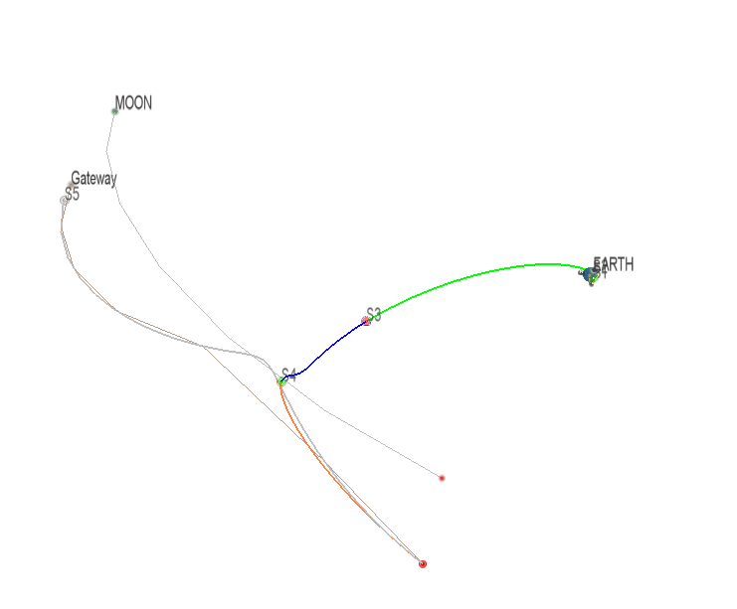
Figure 1. Fast Transfer (Direct) to Gateway in J2000 Frame
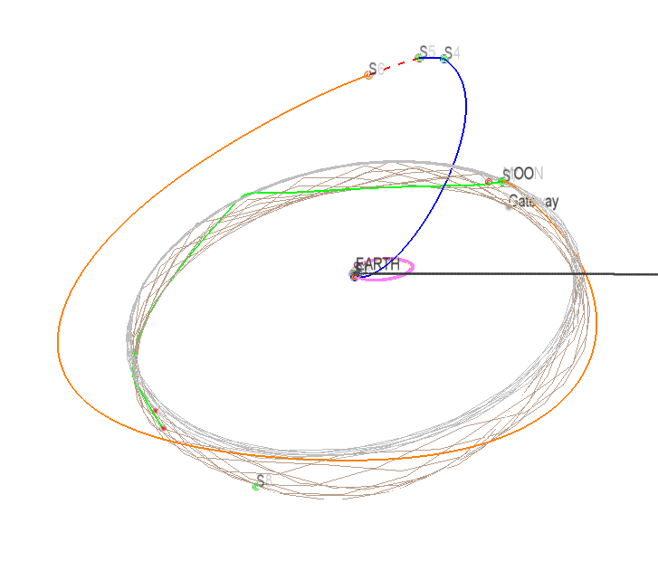
Figure 2. Slow Transfer (BLT) to Gateway in J2000 Frame

Ground Rules and Assumptions
This analysis is meant to encompass any generic LM travelling to Gateway. The force models are chosen to be consistent with mission design stakeholders across Artemis (M2M) (Gateway, HLS, Orion, and SLS) (Reference 5). All LM maneuvers are modelled impulsively, and the combination of these deterministic maneuvers forms the cost function for mission design. The trans-lunar injection (TLI) maneuver is assumed to be performed by the Launch Vehicle (LV) after an initial park orbit coast that is also an impulsive burn in the inertial velocity direction. This TLI maneuver does not contribute to the overall cost function. For this study, a single park orbit state was assumed in Earth-Centered-Earth-Fixed (ECEF) coordinates based loosely on a launch from NASA’s Kennedy Space Center (KSC) as the initial condition for all trajectories and is listed in Table 1.
Table 1. Initial Low Earth Orbit Park Orbit ECEF State
Parameter | Value
RX (km) | 2740.693
RY (km) | -5132.381
RZ (km) | 3036.901
VX (km/s) | 6.661
VY (km/s) | 3.034
VZ (km/s) | -0.883
- Docking with Gateway cannot occur below a lunar altitude of 10,000 km.
- DE430 planetary ephemerides
- “receding_horiz_3189_1burnApo_DiffCorr_15yr.bsp” Gateway ephemeris (Reference 5)
- Gravity: Sun point mass, Earth 4x4, Moon 16x16
- Other forces: No Solar Radiation Pressure (SRP), drag, or lift modeling for the spacecraft. Future work to consider SRP effects.
- A launch opportunity will be considered valid when the sum of all deterministic maneuvers is less than 440 m/s
- The minimum flyby altitude of the Moon is 100 km.
- Assume one day between NRI and hard-capture to Gateway.
- Assume launch occurs five minutes prior to park orbit insertion
- The LM shall be hard-docked with the Gateway No Earlier Than (NET) six-weeks and No Later Than (NLT) two-weeks prior to the launch of the Orion/SLS.
The Gateway NRHO

The Gateway orbit is an NRHO with an orbit period selected for a 9:2 Lunar Synodic Resonance and phased to avoid eclipses by the Earth. The selection of this specific orbit was based on several criteria. An L2 family NRHO was initially selected because of better visibility to the lunar far side for communications. A southern family NRHO was selected because this offers lower ∆V and propellant requirements for Orion returning from the NRHO. This is due to the geometry of returning to a splashdown in Earth’s northern hemisphere. The southern family also has the advantage of very good communications coverage to the surface for sites near the lunar south. An NRHO with a Lunar Synodic Resonant (LSR) period was deemed desirable as it offered the possibility of avoiding eclipses, particularly eclipses by the Earth, which can have durations well in excess of current hardware limits for the Gateway and Orion spacecraft. The 9:2 LSR NRHO was ultimately selected because it offered a relatively low perilune radius, which is advantageous for surface access. (see Reference 5).

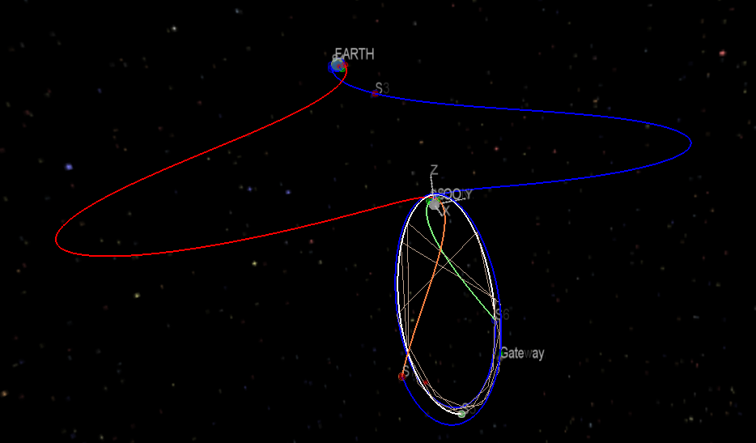
Figure 3. Gateway NRHO
Launch Opportunity vs. Launch Window

For the purposes of this paper, Launch Opportunity is defined as the span of days over which the LM may be launched that supports a particular Orion/SLS launch date. Each launch date in the launch opportunity must satisfy the constraints on the earliest/latest arrival at Gateway as specified in Groundrule 10.

The Launch Window is defined as the interval on a specific day in the Launch Opportunity where a mission may be launched. A launch window may consist of one or more instantaneous launch times or a finite period of time where a launch may occur. Instantaneous launch windows are discrete launch times that satisfy a precise ascending node orbital requirement. Finite launch windows occur over a continuous period lasting minutes or hours where either the LV conducts out-of-plane steering to satisfy requirements on a precise ascending node target or the orbit target tolerances are wide enough to allow for some variation in the ascending node.

Phase 1
In Phase 1 of this analysis, a baseline was established using a direct approach to the NRHO. This was separated into two types, the first type was a “Short TLI Coast” where the total mission duration from liftoff to hard dock at the Gateway was constrained to be within a single Rev of the Gateway and a “Variable TLI Coast” where the coast phase from TLI to perilune was allowed to vary such that the total mission duration could exceed a single Rev of the NRHO.
Direct Approach Trajectory Model Description

The direct approach is illustrated below in Figure 4 in the Earth-Moon Rotating Frame (EMRF) and was modeled in Copernicus version 4.4 (see Reference 6). The trajectory model was broken down into five segments as listed in Table 2. The Park Orbit segment starts at the ECEF state listed in Table 1 with the initial time, S1-T0 and coast duration, S1-Dt used as Optimization Variables (OV’s) to satisfy the Trans-Lunar Injection (TLI) Argument of Perigee (AoP) and Right Ascension of the Ascending Node (RAAN). The Launch Vehicle (LV) TLI Outbound phase starts at the end of the Park Orbit segment with the TLI burn assumed to be aligned with the inertial velocity vector and the magnitude of the impulsive maneuver as an OV. This segment is propagated forward by a duration S2-Dt that is also an OV. The Perilune approach phase is backpropagated from at or near the perilune condition with all six states, S3-X0, and the initial time, S3-T0, used as OVs. The Perilune Approach segment has constraints such that the final state, S3-XF, is equal to the LV TLI Outbound final condition, S2-XF. The Direct Approach has two deterministic maneuvers that occur at the beginning and end of the NRHO Approach and Gateway Rendezvous segment. The maneuver at the start of this phase is called the Powered Lunar Flyby (PLF) with both the magnitude and direction of the impulsive maneuver used as OVs. The maneuver at the end of this phase is called the NRHO-Insertion (NRI) maneuver where both the magnitude and direction are OV’s also. The delta-V necessary for proximity operations and docking are not considered in this analysis. The last segment is simply the Gateway ephemeris starting at S1-T0 with the final time, S5-TF as an OV. The back propagation in the Perilune Approach segment allows the optimizer to solve a more tractable problem since the initial guesses for the perilune state are similar across multiple launch dates in the EMRF. At the end of the NRI maneuver, where Segments 4 and 5 should match in terms of state and time, the LM is considered to have rendezvoused with the Gateway.

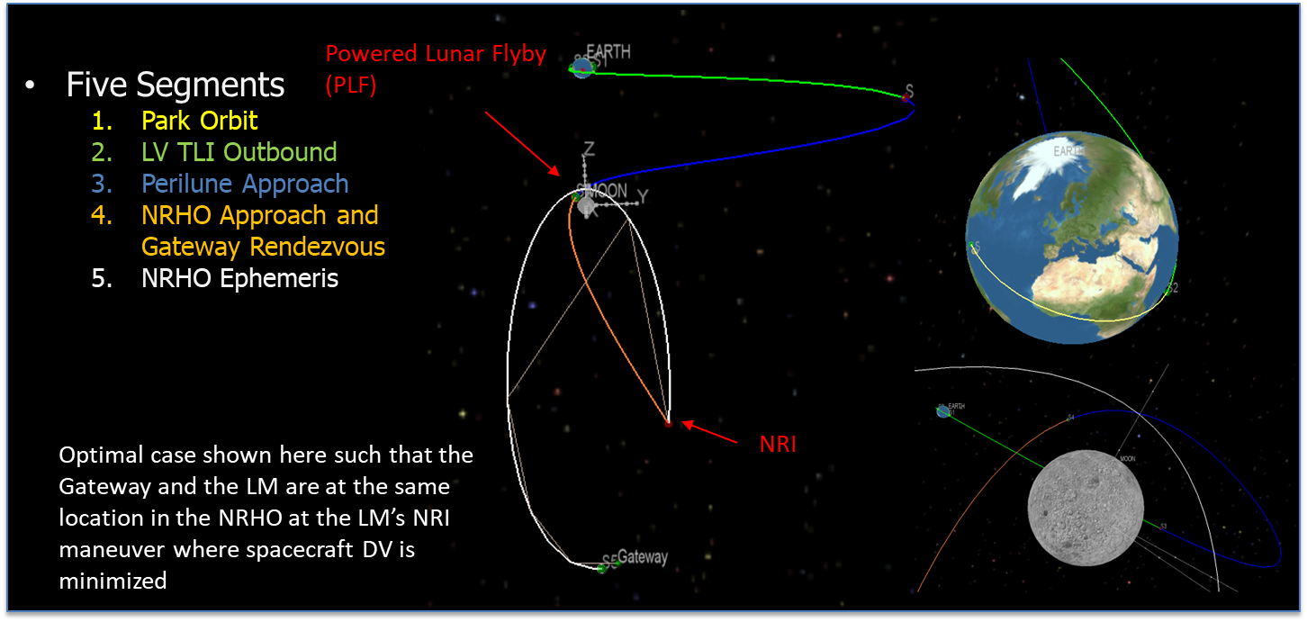

Figure 4. Direct Transfer from TLI to the NRHO

Table 2 Direct Transfer Trajectory Controls/Constraints

SegNum | Segment Description | Start Event | End Event | Initial State Inheritance | Controls | Constraints | Propagate
1 | Park Orbit | LV ECEF Park Orbit | TLI | None | S1 T0 (POI),  S1 DT (PO DT) | T0 occurs on UTC-L | Forward
2 | LV TLI Outbound | TLI | IP | S1 XF  S1 TF | S2 DT,  S2 DVM0 (TLI DV) | S2 XF/TF=  S3 XF/TF | Forward
3 | Perilune Approach | Perilune | IP | None | S3,X0  S3 T0,  S3 DT |  | Backward
4 | NRHO Approach and Gateway Rendezvous | Perilune | NRI | S3 X0 and S3 T0 | S4 DT  S4 DVM0$  S4 DV0ALP  S4 DV0BET  S4 DVMF$  S4 DVFALP  S4 DVFBET | S4 XF/TF =  S5 XF/TF | Forward
5 | NRHO Ephemeris | LD-UTC | NRHOI | S1 T0 | S5 TF | S5 TF < 7 days** | Forward
$ Indicates a component of the overall optimal cost function
** Short TLI Coast only
Short TLI Coast Direct Results
The results of this approach are shown in Figure 5 and Figure 6. Note that as the launch date increases relative to the ideal, the spacecraft ∆V increases due to the less favorable geometry of the interception between the LM and Gateway. This cycle repeats with every Rev of the NRHO, resulting in a pair of back-to-back launch dates every 4-5 days. Note that the interval between LM liftoff and arrival at Gateway remains generally constant such that a one-day change in launch date also corresponds to a one-day change in arrival at Gateway. This results in a limited LM launch opportunity of only 5 days for the example Orion launch date as shown in Figure 7. As will be shown later in this paper, while this minimizes total mission duration, it is not necessarily the most optimal approach from the standpoint of minimizing LM ∆V.
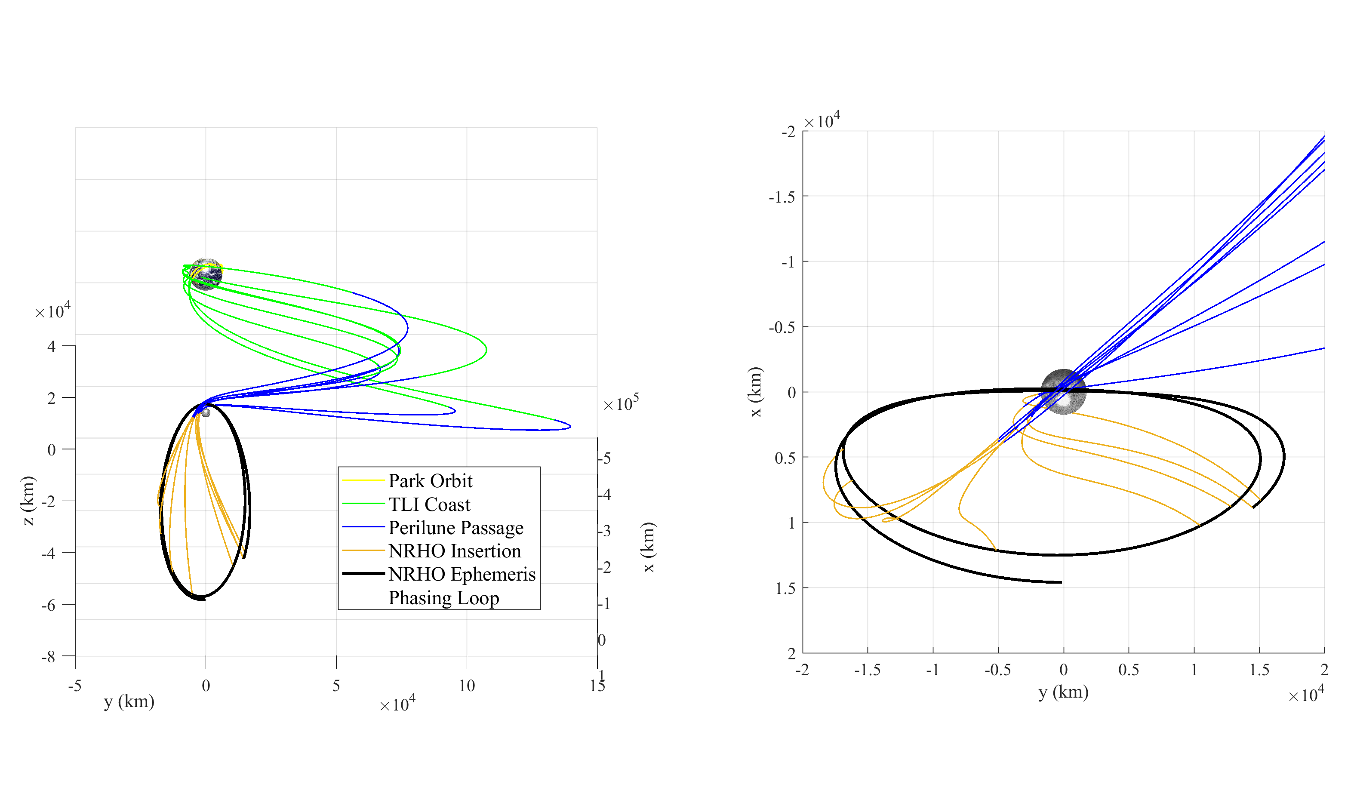
Figure 5. Short TLI Coast Trajectories in the EMRF for Launch Dates Distributed over a Single NRHO Rev
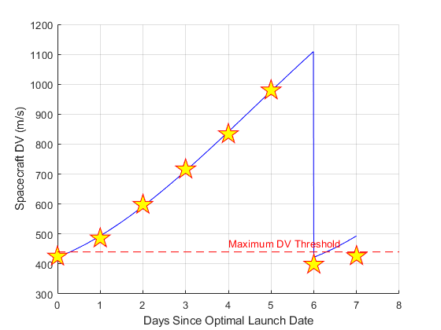
Figure 6. Short TLI Coast Spacecraft Deterministic ∆V Maneuver Budget for Launch Dates Distributed over a Single NRHO Rev

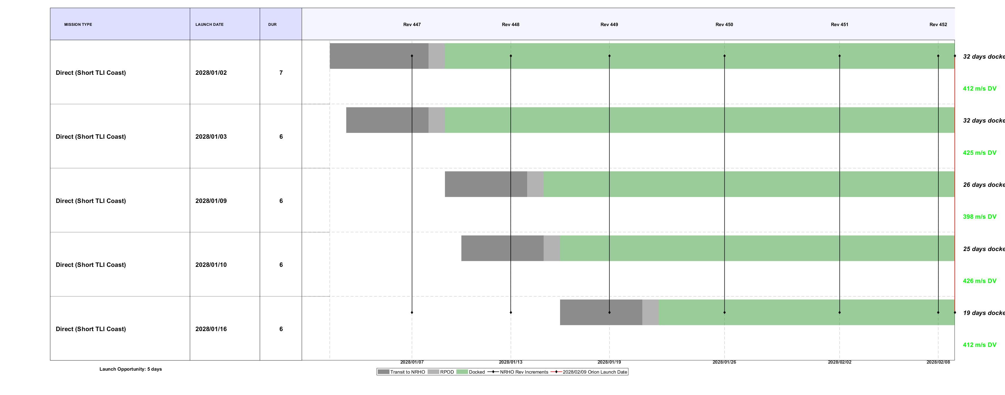
Figure 7. Example Launch Opportunity with Short TLI Coast Direct Transfer for the 2/9/2028 Orion Launch Date

Variable Coast Direct Inject Results
For this approach, the constraint on overall mission duration is lifted. This allows the coast duration from TLI to Perilune to be varied so that the LM arrives at the NRHO while intercepting the Gateway. These results are shown in Figure 8. Note that with the variable TLI coast, the ideal Day 0 NRHO insertion geometry is maintained for all 8 cases. Figure 9 shows that the LM ∆V is significantly reduced from the Short TLI case for Days 2 through 5. This cycle repeats with every Rev of the NRHO, resulting in a series of 5 - 6 launch concurrent launch dates separated by 2 - 3 days of marginal capability. Unlike the Short TLI Coast, the arrival dates at the Gateway all occur shortly after perilune for all launch dates that occur 3 - 9 days prior to the start of a particular NRHO Rev. This provides an 11-day LM launch opportunity for the example Orion launch date as shown in Figure 10.

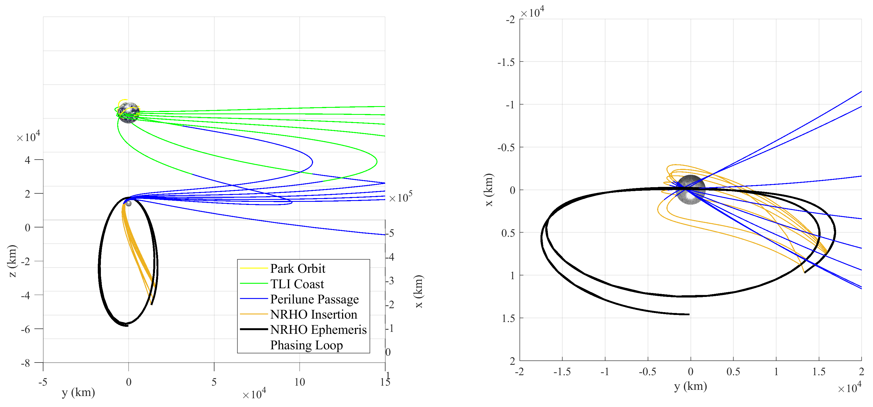
Figure 8. Variable TLI Coast Trajectories in the EMRF for Launch Dates over a Single NRHO Rev
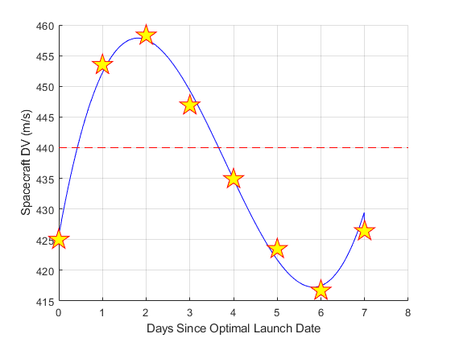
Figure 9. Variable TLI Coast Spacecraft Deterministic ∆V Maneuver Budget for Launch Dates Distributed over a Single NRHO Rev

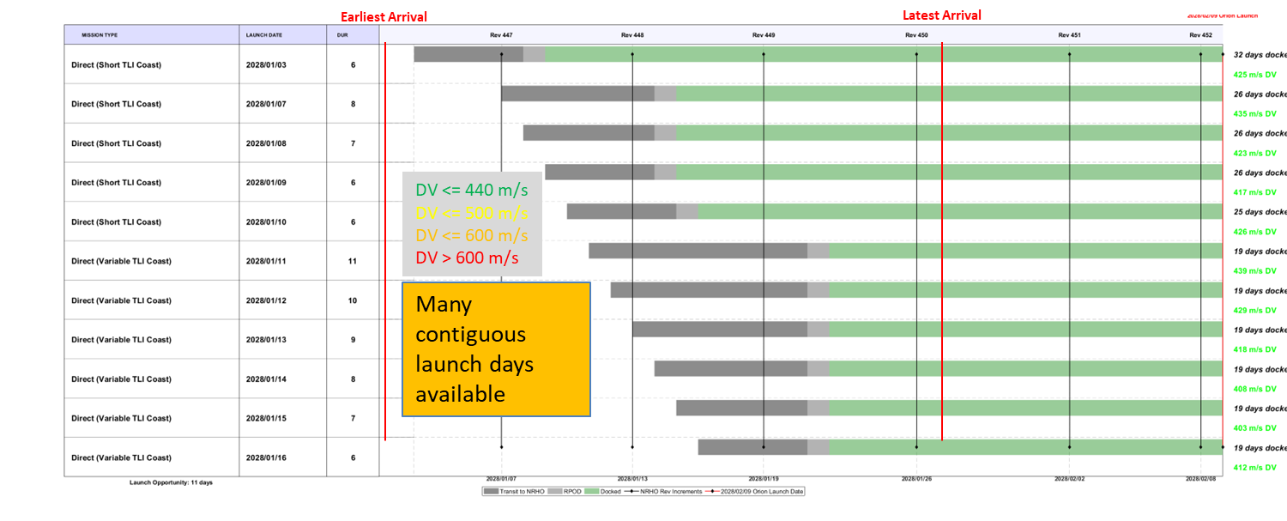
Figure 10. Example Launch Opportunity with Variable TLI Coast Direct Transfer for the 2/9/2028 Orion Launch Date

Phase 2
In Phase 2 of this analysis, a phasing loop approach was taken where an additional deterministic maneuver at NRHO Insertion is added followed by a phasing loop segment prior to rendezvous with the Gateway. This phasing loop segment allows the ideal Day 0 NRHO insertion geometry to be preserved for all launch dates while providing an additional control to ensure that the LM reaches the NRHO orbit at the same time as the Gateway.

Phasing Loop Approach Trajectory Model Description

The phasing loop approach is illustrated below in Figure 11 in the Earth-Moon Rotating Frame (EMRF). This approach is similar to the Direct Approach but has a third deterministic maneuver and another trajectory segment for the phasing loop. The magnitude and direction of the impulsive maneuver at the end of the phasing loop are used as OVs. The maneuver at the end of the phasing loop segment is now the NRI maneuver and the maneuver at the end of the NRHO approach segment is the Phasing Loop Insertion (PLI). At the end of the NRI maneuver, where Segments 5 and 6 should match in terms of state and time, the LM is considered to have rendezvoused with the Gateway.

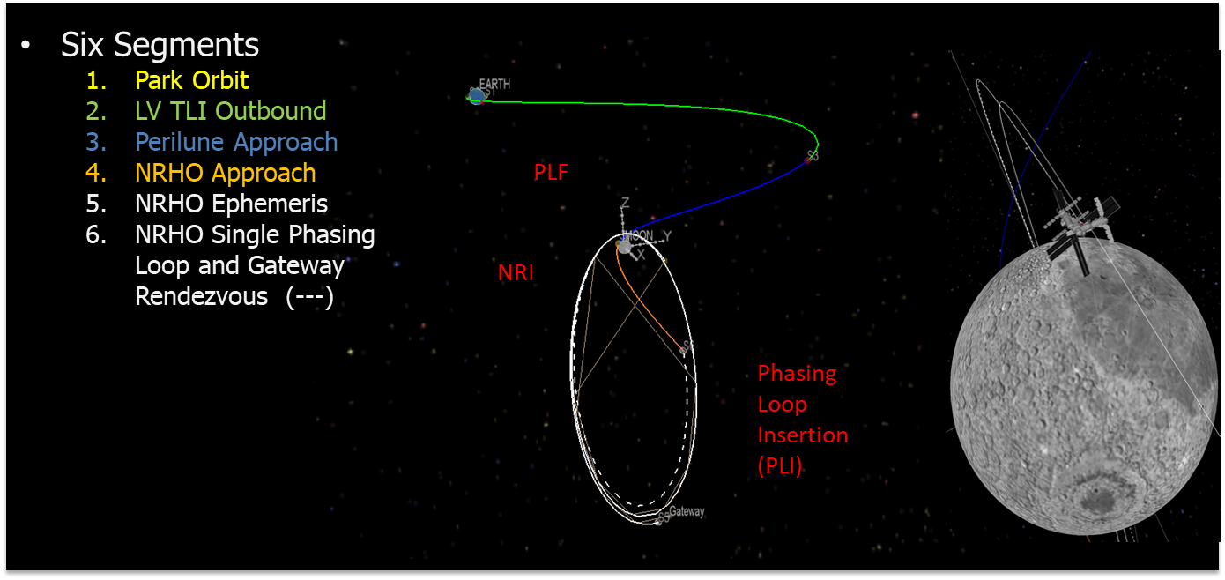
Figure 11. Phasing Loop Transfer from TLI to the NRHO

Table 3. Phasing Loop Trajectory Controls/Constraints

SegNum | Segment Description | Start Event | End Event | Initial State Inheritance | Controls | Constraints | Propagate
1 | Park Orbit | LV ECEF Park Orbit | TLI | None | S1 T0 (POI),  S1 DT (PO DT) | T0 occurs on UTC L | Forward
2 | LV TLI Outbound | TLI | IP | S1 XF  S1 TF | S2 DT,  S2 DVM0 (TLI DV) | S2 XF/TF=  S3 XF/TF | Forward
3 | Perilune Approach | Perilune | IP | None | S3 X0  S3 T0  S3 DT |  | Backward
4 | NRHO Approach and Gateway Rendezvous | Perilune | Phasing Loop Insertion | S3 X0 and S3 T0 | S4 DT  S4 DVM0$  S4 DV0ALP  S4 DV0BET  S4 DVMF$  S4 DVFALP  S4 DVFBET | S4 XF/TF =  S6 XF/TF | Forward
5 | NRHO Ephemeris | LD-UTC | NRHOI | None | S5 TF | None | Forward
6 | Phasing Loop | NRHOI | Phasing Loop Insertion | S5 XF and S5 TF | S6 DT  S6 DVM0$  S6 DV0ALP  S6 DV0BET | None | Backward
$ Indicates a component of the overall optimal cost function

Single Phasing Loop Results

For this approach the phasing loop segment varies such that the orbital period can be adjusted to that the LM crosses the NRHO at the same time as the Gateway intercept as shown in Figure 12. Note that the deterministic LM ∆V’s that result from this approach (see Figure 13) are similar to those from the Short TLI coast in Figure 6. That is because the semi-major axis of the single phasing loop gets smaller relative to that of the NRHO as the launch date gets farther from the Day 0 optimal opportunity. Therefore, a larger magnitude PLI maneuver is required, increasing ∆V costs. The Gateway arrival times follow the same trend as that for the Variable TLI Coast case in where multiple launch dates of the LM result in similar arrival dates at the Gateway. The single phasing loop approach provides a 10-day LM launch opportunity for the example Orion launch date as shown in Figure 14.
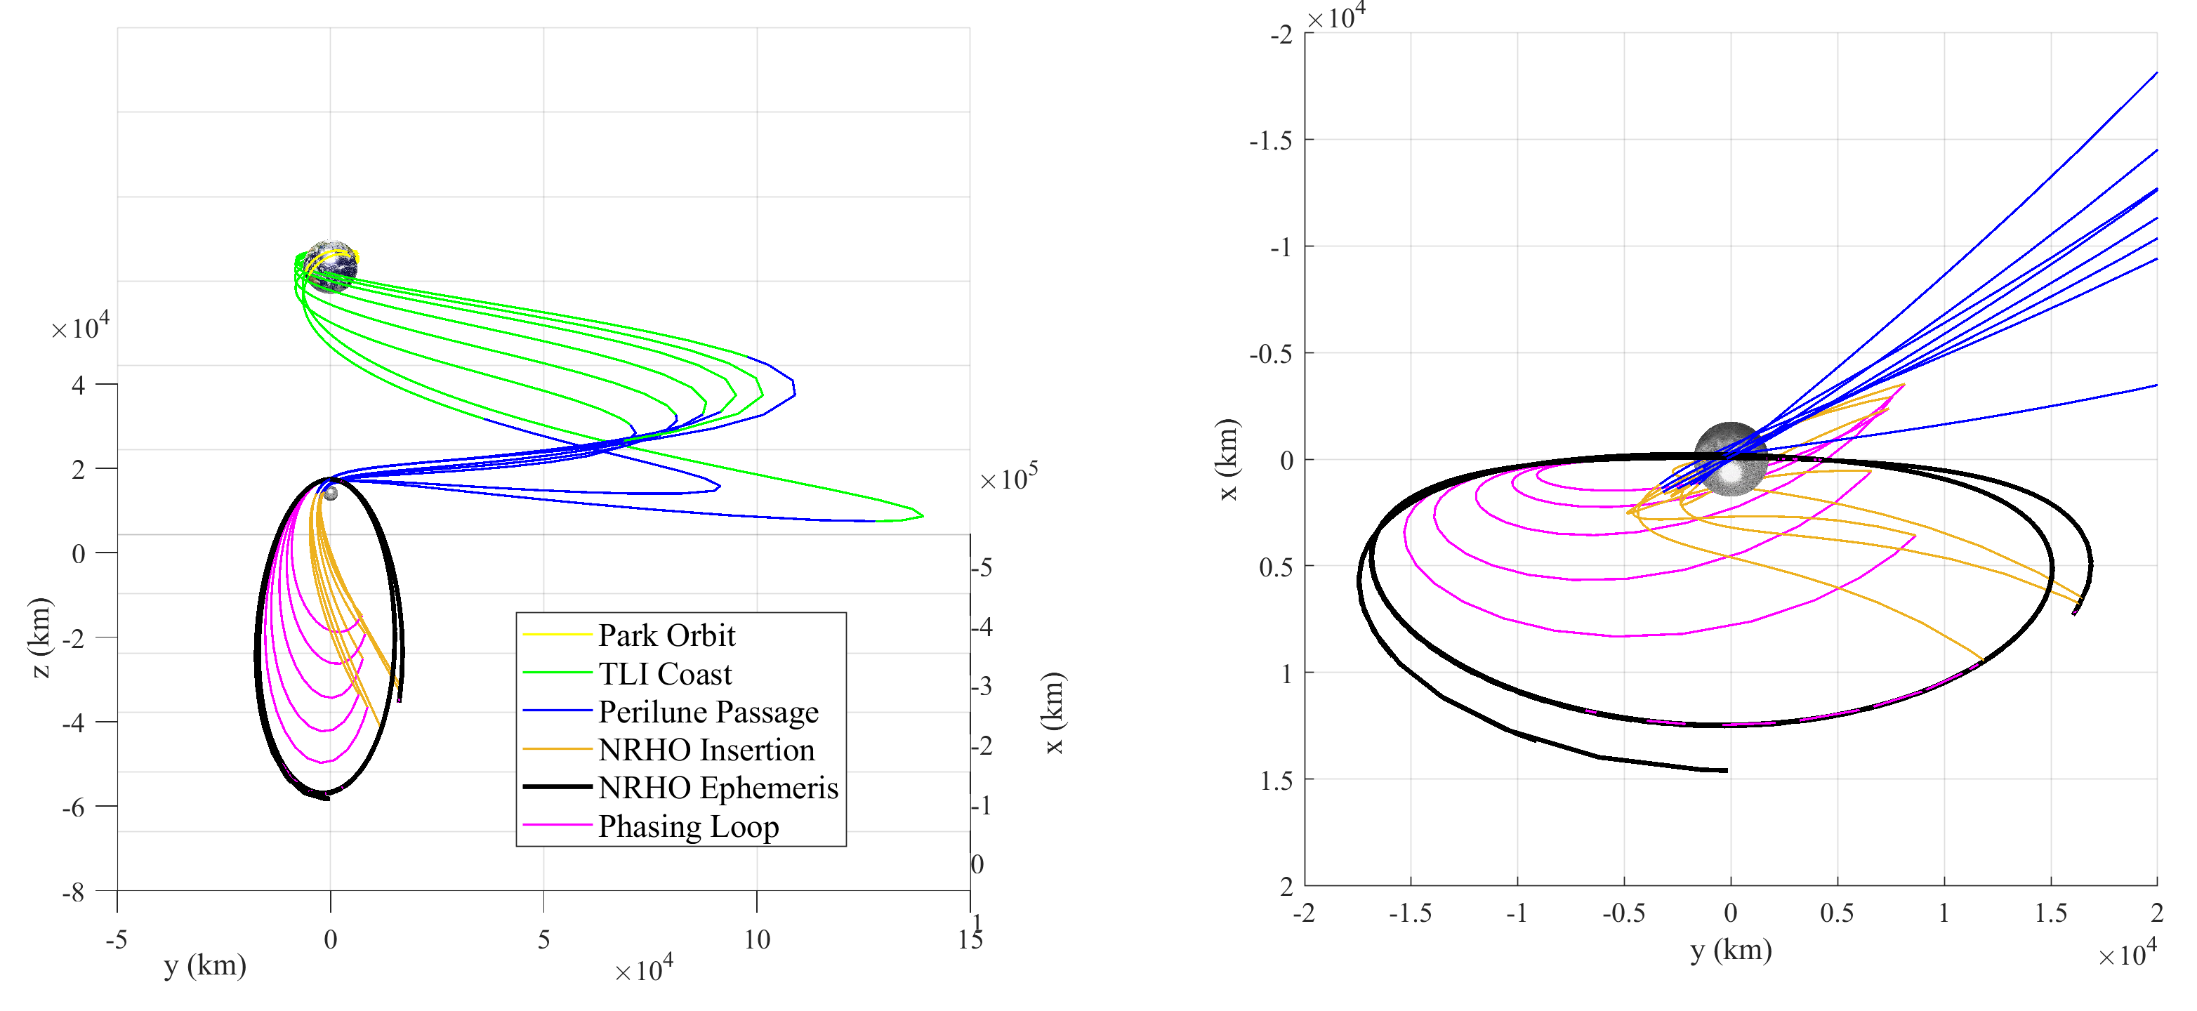
Figure 12. Single Phasing Loop Transfer Trajectories in the EMRF for Launch Dates over a Single NRHO Rev
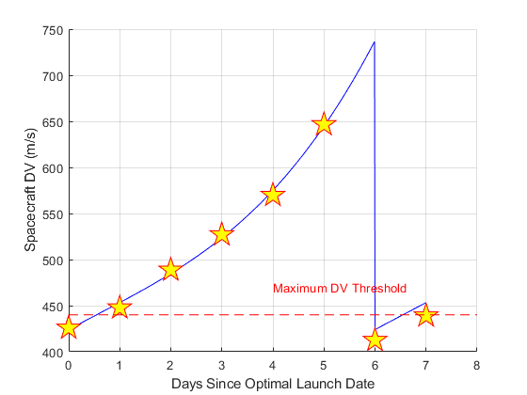
Figure 13. Single Phasing Loop Spacecraft Deterministic ∆V Maneuver Budget for Launch Dates Distributed over a Single NRHO Rev

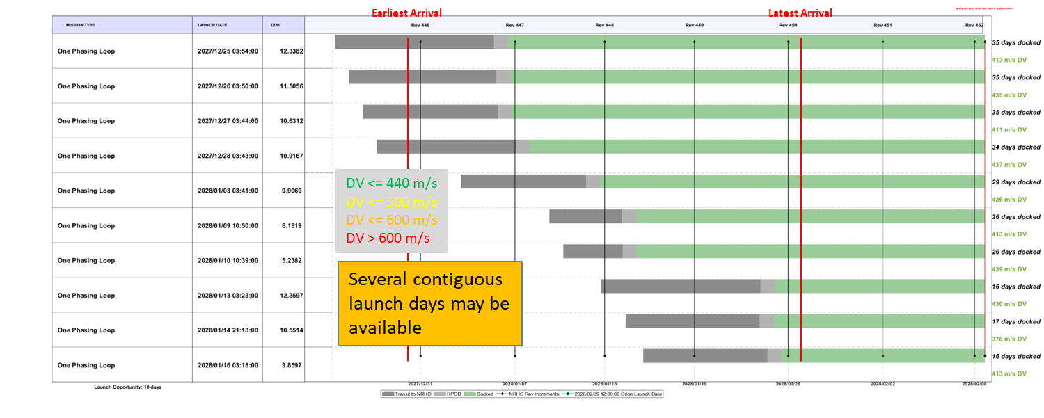
Figure 14. Example Launch Opportunity with Single Phasing Loop Transfer for the 2/9/2028 Orion Launch Date

Double Phasing Loop

For this approach the phasing loop segment is extended to allow a second lunar flyby as shown in Figure 15. This takes advantage of using the Moon’s gravity to rotate the LM’s orbit into the NRHO plane prior to the NRI maneuver. As shown in Figure 16, the ideal Day 0 NRHO insertion geometry is maintained for all 8 cases. Figure 17 shows that the LM ∆V stays below the 440 m/s maximum ∆V threshold for 6 of 8 cases. Note that the two cases where the ∆V threshold is violated (Days 5 and 6) are different than the violation days for the Variable TLI Coast approach (Days 1, 2 and 3). Similar to the Variable TLI Coast and Single Phasing Loop approaches, the Gateway arrival dates cluster near perilune with all launch dates having a common arrival time with a total mission duration ranging from 11 to 17 days and double phasing loop approach provides a 16-day LM launch opportunity for the example Orion launch date as shown in Figure 18.

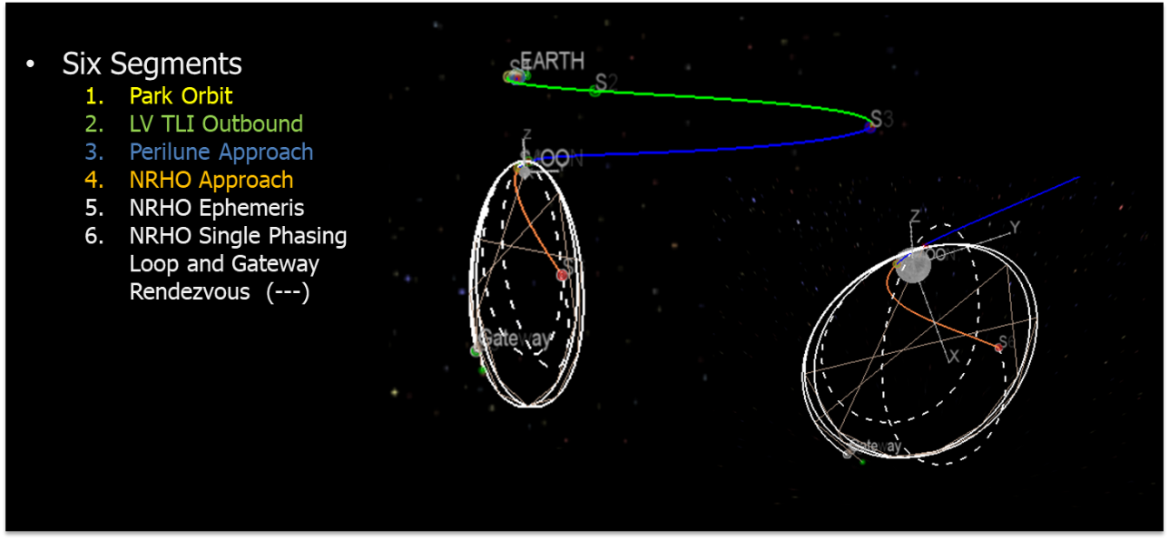
Figure 15. Double Phasing Loop Transfer
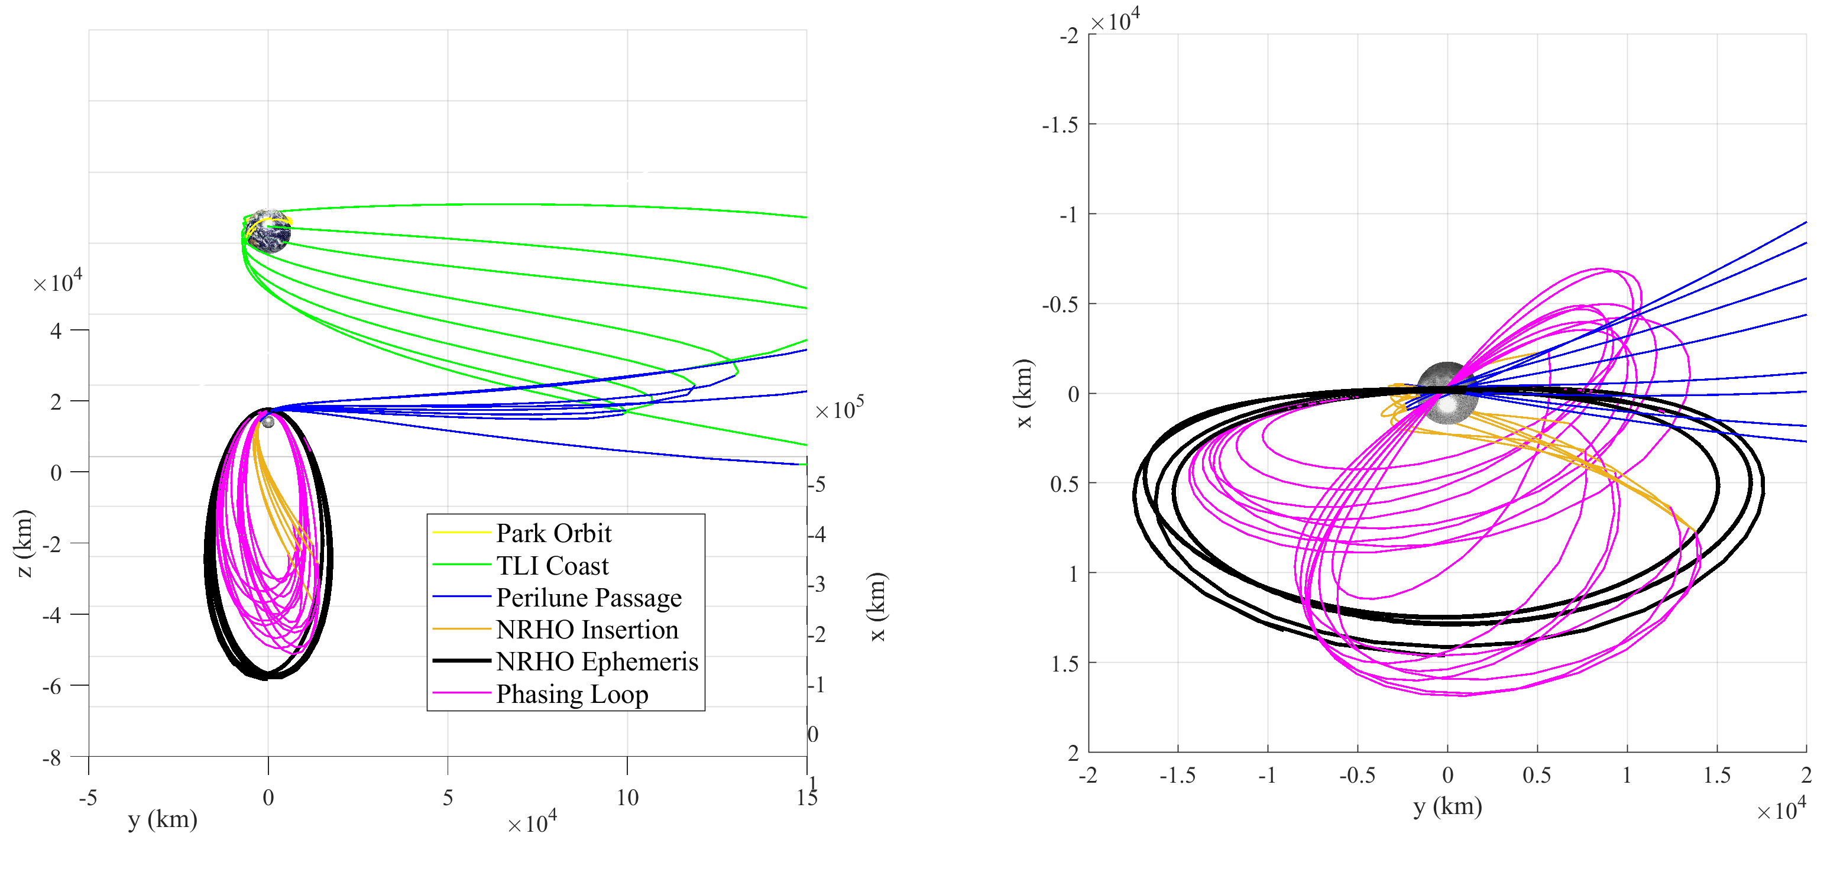
Figure 16. Double Phasing Loop Transfer Trajectories in the EMRF for Launch Dates Distributed over a Single NRHO Rev
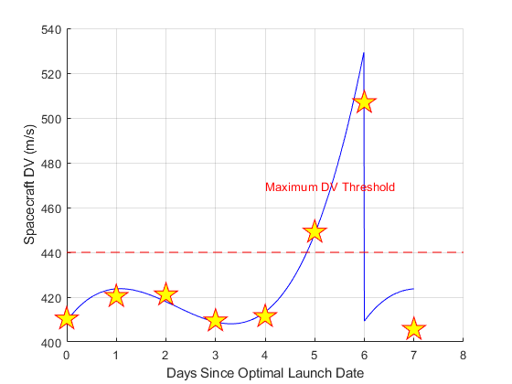
Figure 17. Double Phasing Loop Spacecraft Deterministic ∆V Maneuver Budget for Launch Dates Distributed over a Single NRHO Rev

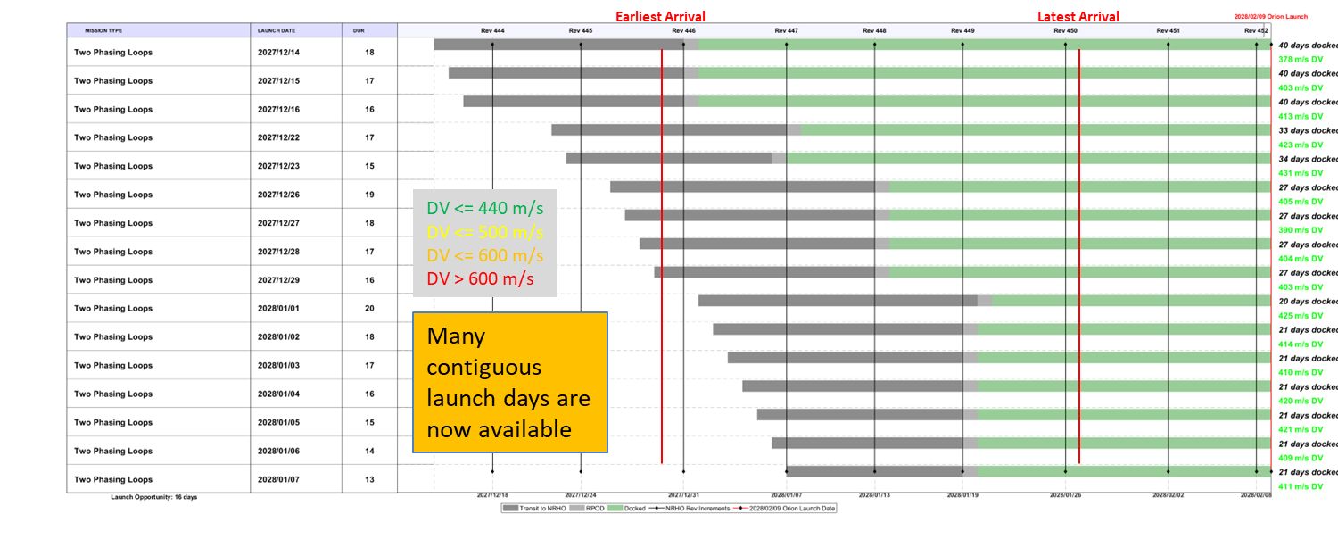
Figure 18. Example Launch Opportunity with a Double Phasing Loop Transfer for the 2/9/2028 Orion Launch Date
Phase 3
In Phase 3 of this analysis the results from Phases 1 and 2 were generalized to apply to any Artemis Campaigns over a three-month interval to validate the methodology and characterize the required vehicle capability. The launch opportunities available using each of the four methods discussed in the preceding pages are shown in Figure 19 through Figure 22. The two methods that provide the greatest capability are the Variable TLI Coast Direct and the Double Phasing Loop. As shown in Figure 25, the LV performance should not be significantly affected since the TLI C3 required is close to the typical value of -1.8 km²/sec² for all runs. When all of these methods are combined as shown in Figure 23 for the example 2/9/2028 launch date and in Figure 24 for a 3-month span of potential Orion launch dates, it can be shown that there is at least a 20-day LM launch opportunity that supports any and all of those dates. This should allow the launch probability to meet or exceed what is generally considered acceptable for interplanetary missions with launch opportunities separated by months or years.

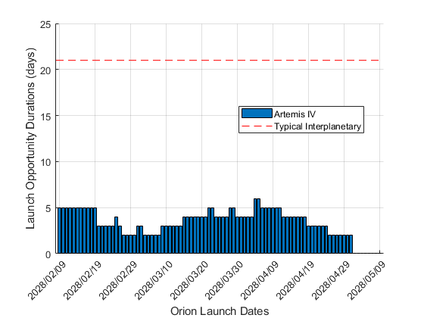
Figure 19: Launch Opportunities over a 3-Month Interval of Orion Launch Dates with Short TLI Coast Direct Transfers
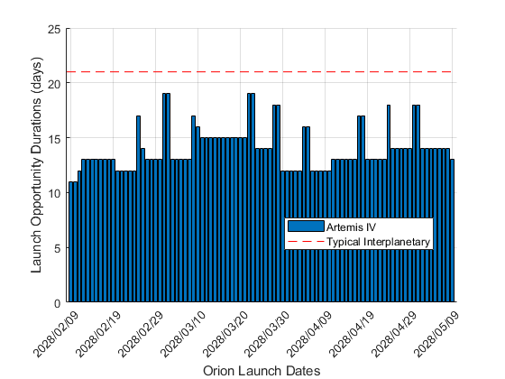
Figure 20. Launch Opportunities over a 3-Month Interval of Orion Launch Dates with Variable TLI Coast Direct Transfers

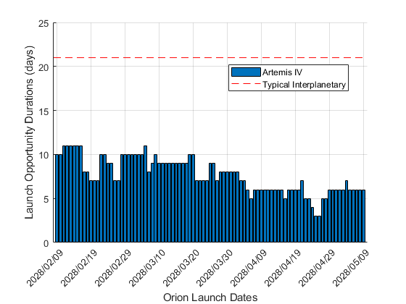
Figure 21. Launch Opportunities over a 3-Month Interval of Orion Launch Dates with Single Phasing Loop Transfers
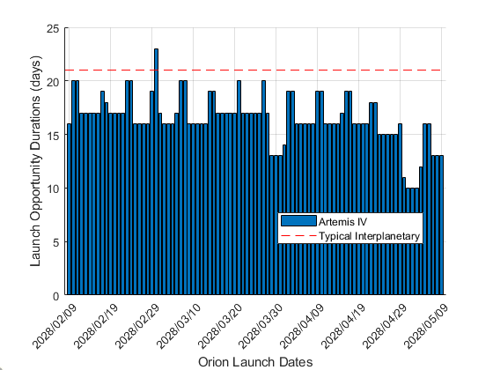
Figure 22. Launch Opportunities over a 3-Month Interval of Orion Launch Dates with Double Phasing Loop Transfers

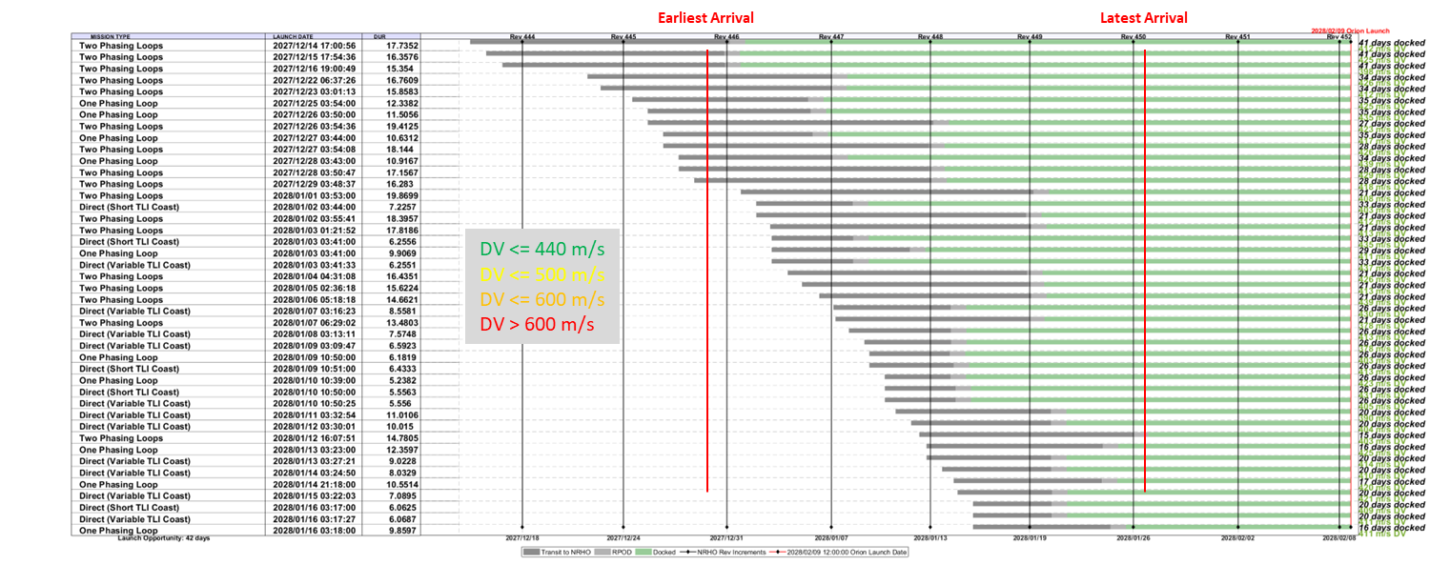
Figure 23. Example Launch Opportunity for the 2/9/2028 Orion Launch Date with all Four Methods Combined
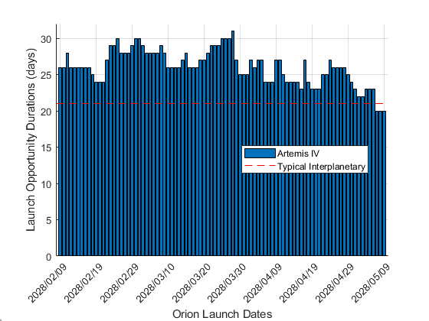
Figure 24. Launch Opportunity for All Four Methods Combined
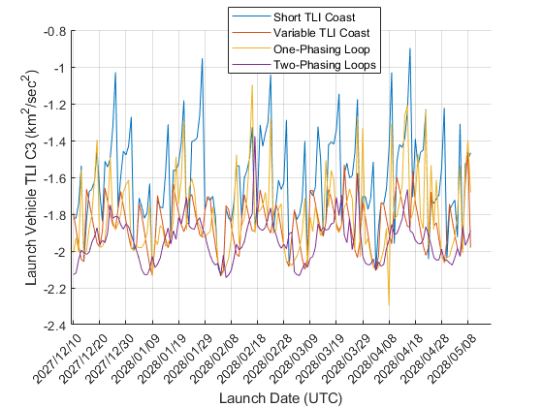
Figure 25. Comparison of Launch Vehicle TLI C3 for all Methods

conclusions and future work

A method of rapidly developing LV targets to support future Artemis campaigns has been developed that combines several methodologies that results in a minimum 20-day launch opportunity for any Orion launch date over a 3-month interval. LV targets are not the limiting factor to launch availability due to the relative insensitivity observed in the TLI C3 target for each LM launch. Rather, it is spacecraft ∆V capability that constrains the available launch and Gateway arrival times for each potential Artemis campaign.

Future work will focus on refining the methodology for the LM mission design and LV target generation. This will include examining the feasibility of multiple instantaneous windows for a given launch date, expanding the 1-Rev analysis over 8-Revs to better understand relationship to 9:2 NRHO:Lunar Synodic Period resonance, and combining two-phasing loop method with variable TLI coasts to achieve a single approach that satisfies all possible launch dates. It will also be necessary to understand the implications of these mission design approaches to other disciplines such as power, thermal, communications, radiation environments, etc. Finally, after the abstract to this paper was submitted for this conference, a similar paper was published at the recent International Astronautical Union (IAU) conference in Milan, Italy that discussed a more DV-efficient phasing loop approach than that discussed in this paper. However, this approach comes at the expense of longer mission durations (nearly 30 days in some cases) and increased complexity. The DSL flight analysis group will incorporate this methodology into their target generation process to provide additional options for the LM mission design (see Reference 7).

Acknowledgments
The authors would like to thank the Deep Space Logistics program for funding this analysis.

NOTATION
BLT Ballistic Lunar Transfer
DSL Deep Space Logistics
DT​ Segment duration (days)​
DV0ALP/DVFALP​ ∆V Angle of Attack w.r.t. inertial velocity vector at start/end of segment​
DV0BET/DVFBET​ ∆V Angle of Sideslip w.r.t. inertial velocity vector at start/end of segment​
DVM0/DVMF​ ∆V Maneuver at Start/End of Segment​
ECEF Earth-Centered-Earth-Fixed
HLS Human Landing System
IP​ Interface Point between TLI and Perilune​
KSC Kennedy Space Center
LD-UTC​ Launch Date at UTC Noon​
LM Logistics Module
LV Launch Vehicle
M2M Moon-to-Mars
NET No Earlier Than
NLT No Later Than
NRHO​ Near-Rectilinear Halo Orbit​
NRI Near-Rectilinear Halo Orbit Insertion​
OV Optimization Variable
PLB​ Phasing Loop Burn​
PLF​ Powered Lunar Flyby​
PO​ Park Orbit​
RPOD Rendezvous Proximity Operations and Docking
SLS Space Launch System
Sn​ Segment “n”, for example, Segment 1 = S1​
SRP Solar Radiation Pressure
T0​ Initial time relative to UTC noon of a given launch date (days)​
TEI Trans-Earth Injection
TLI​ Translunar Injection​
UTC​ Coordinated Universal Time​
VV Visiting Vehicle
X0​ Initial segment state​
XF​ Final segment state​
References

- R. Whitley and R. Martinez, “Options for Staging Orbits in Cislunar Space,” IEEE Annual Aerospace Conference, IEEE, Big Sky, Montana, March 2015
- J. Williams, D. E. Lee, R. L. Whitley, K. A. Bokelmann, D. C. Davis, and C. F. Berry, “Targeting Cislunar Near Rectilinear Halo Orbits for Human Space Exploration,” 27th AAS/AIAA Space Flight Mechanics Meeting, AAS/AIAA San Antonio, Texas, February 2017.
- A. Donaldson, "New Program Office Leads NASA’s Path Forward for Moon, Mars." National Aeronautics and Space Administration, [accessed January 10, 2025], https://www.nasa.gov/news-release/new-program-office-leads-nasas-path-forward-for-moon-mars/
- J. Parker, “Monthly Variations of Low-Energy Ballistic Transfers to Lunar Halo Orbits,” AAIA/AAS Astrodynamics Specialist Conference, Aug. 2010.
- E. M. Zimovan-Spreen, D. C. Davis, and B. P. Mc-Carthy, “Modeling and Phasing Considerations for Near Rectilinear Halo Orbit Baselines,” in 2024AAS/AIAA Astrodynamics Specialist Conference,Aug. 2024.
“Gateway Destination Orbit Model: A Continuous 15 Year NRHO Reference Trajectory”, NASA White Paper, August 20, 2019. https://ntrs.nasa.gov/api/citations/20190030294/downloads/20190030294.pdf
- Williams, J., Copernicus Version 4.4 User Guide, NASA Johnson Space Center, Aeroscience and Flight Mechanics Division Flight Mechanics and Trajectory Design Branch (EG5), October 1, 2016
- C J, Kikuchi., N, Murakami., Y, Matsumoto., and S, Ueda.: “Trajectory Design of NRHO Transfer with Continuous Launch Window for Logistics Resupply Mission to Gateway”, IAF 75th International Astronautical Congress, Milan, Italy, C1.IP.33, 2024.

