NASA Conjunction Assessment Risk Analysis (CARA) Compendium for Artificial Intelligence and Machine Learning for Satellite Collision Avoidance
Dr. Alinda K. Mashiku* and Lauri K. Newman#
*NASA Goddard Space Flight Center, 8800 Greenbelt Rd, Greenbelt, MD 20771, alinda.k.mashiku@nasa.gov
#NASA Headquarters, 300 Hidden Figures Way SW, Washington, DC 20546, lauri.k.newman@nasa.gov
To ensure a sustainable use of low earth orbit and for Earth orbiting missions in general, reliable and effective collision prediction between space objects is key. Space Situational Awareness (SSA) for commercial and government missions is now facing the rapidly growing amount of a variety of operating satellite capabilities, ranging from small and potentially less agile satellites to multitudes of large maneuverable satellites with varying propulsion capabilities. In addition, the space object catalog is expected to increase tremendously in size in the very near future. The most accurate way to perform a conjunction assessment between two spacecraft is through a Monte Carlo simulation of the state space of the two objects of interest. However, even when employing parallel computing and simplified prediction models, Monte Carlo simulation is not feasible for routine scans of the space catalog for conjunction assessment due to the long run times and computational burden. As a result, other risk assessment statistical parameters that use a projection of the uncertainty volume into relative space are employed, such as the probability of collision (Pc) calculation. Those computations can be performed reasonably fast; however, the associated 2-dimensional assumptions may result in inaccuracies (though very rarely) in the realm of low relative velocity encounters, in which the objects move more slowly through each other’s uncertainty volume. NASA Conjunction Assessment Risk Analysis (CARA) program has begun research to determine whether the capabilities of artificial intelligence and machine learning could be applicable to identify new computations that may aid decision makers in faster and more accurate decisions or determine mitigation solutions using artificial intelligence/Machine Learning (ai/ML) on the large available dataset of close approaches. This paper documents the results of the studies that CARA has undertaken and shows that the ai/ML solutions undertaken to date have not shown promise for applicability in risk assessment.
The two main questions we sought to answer via our studies are as follows: 1) Can we perform risk assessment with increased certainty using conjunction data available early in the event? 2) Can we perform rapid/early decision making (for collision avoidance) using early conjunction data available? In conjunction assessment, operators analyze events looking at the Pc threshold as an early indicator but also investigate other parameters such as the miss-distance, tracking history of the secondary object, orbit determination quality etc. It is also known that any tracking updates in the future can and do change the level of the risk at the last minute. It would help answer both questions above if this information can be incorporated a priori qualitatively or quantitatively through the use of ai/ML.
When it comes to ML, quality data is imperative. One must have a clear goal of the outcome required, but even more importantly in risk assessment, the outcome achieved must also be explainable for an operational implementation. Training Neural networks for conjunction risk assessment requires access to “truth” data (i.e. data sets with collisions). Unfortunately (or fortunately), there is no truth data set that exists that contains collisions, let alone a large enough training set to train a neural network model. The current available data set of conjunction data contains a large set of very close encounters that were mitigated (if the S/C was maneuverable). The data set poses some analysis challenges, however, as there are multiple non-deterministic factors involved given that each conjunction is unique with the only factor in common being miss distance that would result in a collision. Therefore, one must simulate or redefine the risk posture to enable the analysis and model training.
In this paper, we present the approaches investigated, based on the latest capabilities in machine learning (neural networks) to determine the potential for fast and accurate close approach risk assessments. We considered the study of statistical and information theory parameters to determine the feasibility of reliably predicting and giving confidence intervals for collisions by generating augmented statistical parameters to the classical probability of collision computation using the set of Conjunction Data Messages (CDMs) available in the CARA archives. We compared the inference for an impending close approach with weighted assignments of the parameters using several models of the Fuzzy Inference System. The Fuzzy Inference system generates weights based on the defined thresholds of each parameter to assess the outcome of each conjunction event. The values for these weights are incorporated using unsupervised machine learning clustering techniques to aid in inferring a close approach risk assessment. We also investigated the use of Deep Neural Networks to fully characterize the known nature of the evolving CDMs due to the stochastic nature of the conjunction event. In addition, given the fact that the CDMs are time-varying as the risk assessment evolves towards the Time of Closest Approach (TCA), we wanted to ensure that the models we generate can be built from the available CDM data set regardless of the number of CDMs in the set. We therefore investigated the Long-Short Term Memory Neural Network because of its potential to predict values using data in a time-series approach.
In Figure 1, we show the varying range of available CDMs per conjunction event, with most events having fewer than 10 CDMs available. This scarcity is partly due to the fact that the earliest moment a conjunction can be identified is 7 days prior to TCA as data older than that must be propagated for so long to TCA that it becomes too inaccurate. The other reason is because it is not uncommon to have a late conjunction identification (within 8 hours of TCA) due to unexpected changes in atmospheric drag due to solar storms.
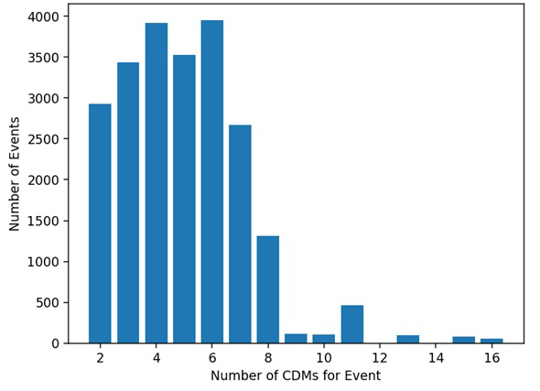
Figure 1. +200,000 CDMs from 2015-2018. Most events have less than 10 CDMs. When the event is restricted to 5km radial distance, most events have less than 4 CDMs.
From the above summarized approaches, we endeavor to qualify what set of parameters are associated with high-risk events to aid in event prioritization for the operator. The paper will show the results of each of the studies undertaken and explain how they contribute to the possible future solutions. The paper also lists potential future studies that could be a good fit for ai/ML that are not necessarily within the CARA purview but would help to improve the state of conjunction assessment processes in the future.

References:
[1] Robertson, B.I., and Mashiku, A., "Early Information Parameter-Set Analysis for Satellite Close Approaches using Machine Learning,"31st AAS/AIAA Astrodynamics Specialist Conference, 2021.
[2] Mashiku, A., Frueh, C., Memarsadeghi, N., Gizzi, E., Zielinski, M., Burton, A., "Predicting Satellite Close Approaches Using Statistical Parameters in the Context of Artificial Intelligence," 29th AAS/AIAA Astrodynamics Specialist Conference, 2019.
[3] Newman, L. K., Frigm, R., and McKinley, D., "It’s Not a Big Sky After All: Justification for a Close Approach Prediction and Risk Assessment Process," AAS/AIAA Astrodynamics Specialist Conference, 2009.
[4] A. Burton, M. Zielinski, C. Frueh, A. Mashiku and N. Memarsadeghi, “Assessing measures to reliably predict collisions in the presence of uncertainty”, 28th AAS/AIAA Astrodynamics Specialist Conference, August 19-23rd 2018, Snowbird, UT
[5] Hochreiter, S. and Schmidhuber, J., "Long Short-Term Memory," Neural Computation, Vol. 9, No. 8, pp. 1735-178-, 1997.
[6] Gilpin, S., Qian, B., Davidson, I., "Efficient hierarchical clustering of large high dimensional datasets," Proceedings of the 22nd ACM international conference on Information & Knowledge Management, pp. 1371-1380, 2013. DOI: 10.1145/2505515.2505527
[7] Steinbach, M., Karypis, G., Kumar, V., "A Comparison of Document Clustering Techniques," University of Minnesota, Technical Report #00-034, 2000.

