SpaceOps-2025, ID #403

Opportunities for Greater Autonomy for OSIRIS-APEX Spacecraft Operations at Apophis

Michael C. Moreauª*, Coralie D. Adam^{b}, Nayessda Castroª, Kenneth M. Getzandannerª,
Dathon R. Golish^{c}, Frank Jaen^{d}, Michael C. Nolan^{c}, Christopher D. Norman^{d}, Anjani T. Polit^{c},
Daniella N. DellaGiustina^{c}

ª NASA GSFC, 8800 Greenbelt Rd, Greenbelt, MD 20771, USA, michael.c.moreau@nasa.gov
^{b} KinetX, Inc. Space Navigation and Flight Dynamics Practice, 7921 Southpark Plaza, Suite 108, Littleton, CO 80120, USA
^{c} Lunar and Planetary Laboratory, University of Arizona, Tucson, AZ 85721, USA
^{d} Lockheed Martin Space, 12257 S. Wadsworth Blvd, Littleton, CO 80125, USA
* Corresponding Author

Abstract

After the successful return of samples from asteroid Bennu in September 2023, the OSIRIS-REx spacecraft executed a divert maneuver to initiate a new mission: OSIRIS–Apophis Explorer (APEX). The APEX mission will re-purpose the OSIRIS-REx flight system to rendezvous with and survey the near-Earth asteroid Apophis just after that asteroid’s rare, close approach to Earth in April 2029. This paper will describe some of the unique challenges for the OSIRIS-REx mission operations team at Bennu and present some of the ground and flight updates that are being studied to increase autonomy and reduce the burden on the operations team at Apophis. Mission operations around Bennu were extremely challenging in large part due to its very small size of ~500 meters diameter, the smallest planetary body ever to be orbited by a spacecraft. Close orbits and flybys of Bennu required execution of propulsive maneuvers ranging in velocity from tens of centimeters per second to as little as 0.01 millimeters per second. This, in turn, required extremely precise modeling of small forces acting on the spacecraft and frequent ground-in-the-loop navigation updates, in which optical navigation images were downlinked, used to update a navigation solution in combination with radiometric tracking by the ground team, and subsequently used to update products that were sent up to the spacecraft, all within a 24-hour period. These 24-hour late-update cycles entailed two-shift operations that frequently required personnel to work evenings and weekends, pushing the envelope of what would be sustainable and affordable for a second asteroid encounter. Nevertheless, the APEX mission will characterize Apophis — which with an estimated mean diameter of 340 meters is even smaller than Bennu — at centimeter scales, similar to the dataset collected at Bennu. Given budgetary constraints for the APEX mission and lessons learned from Bennu operations, the team is studying several opportunities to implement more autonomous operations at Apophis. One example includes an expansion of the autonomous onboard navigation process that was utilized during the four-hour sample collection event at Bennu to enable autonomous targeting of most science observations at Apophis, dramatically reducing the number of 24-hour ground updates necessary. Several potential improvements to ground processes and tools are also being considered. The OSIRIS-APEX mission promises to expand scientific knowledge of the solar system by enabling close study of the tidal effects on Apophis from its close encounter with Earth, while demonstrating more autonomous deep space operations techniques that could apply to future missions.

Keywords: asteroid, autonomous navigation, Apophis, small body, deep space operations

Acronyms/Abbreviations
astronomical units (au)
deep space maneuver (DSM)
Deep Space Network (DSN)
Earth gravity assist (EGA)
Natural Feature Tracking (NFT)
Origins, Spectral Interpretation, Resource Identification, and Security–Regolith Explorer (OSIRIS-REx)
OSIRIS–Apophis Explorer (APEX)
optical navigation (OpNav)
Touch and Go (TAG)
trajectory correction maneuver (TCM)
Variable Phase Orbit (VPO)

Introduction

In September 2023, the OSIRIS-REx mission (Origins, Spectral Interpretation, Resource Identification, and Security–Regolith Explorer) successfully completed its primary objective, to collect a sample of carbonaceous regolith from of the small (~500 m diameter) rubble-pile asteroid (101955) Bennu and return it to Earth for analysis [,]. Following the release of the OSIRIS-REx sample return capsule on September 24, 2023, the spacecraft’s subsequent flyby of Earth placed it on a trajectory with a perihelion distance of only 0.5 astronomical units (au); this is half the distance between the Sun and Earth, whereas the spacecraft was only designed and tested for thermal environments greater than 0.77 au solar distance. The spacecraft was originally not expected to survive the close perihelion passage, precluding the possibility of a subsequent mission in spite of the fact that the instrument suite remained nearly fully capable and the spacecraft had substantial fuel reserves (change in velocity (∆V) capability of over 500 m/s).

Subsequent analysis by members of the OSIRIS-REx flight team resulted in the development of a special solar array and spacecraft attitude configuration that would make it possible to maintain all critical components below qualification temperature limits (and most components below operational temperature limits) even during the 0.5 au perihelion passages. This opened the possibility of another mission. Meanwhile, the asteroid (99942) Apophis is headed for a rare, extremely close approach to Earth in April 2029. Like Bennu, Apophis is small (340 m diameter) and likely a rubble pile, but its composition is stony (S-complex) rather than carbonaceous (C-complex). The OREx spacecraft’s heliocentric orbit affords the opportunity for Earth gravity assists (EGAs) in 2025 and 2027 that set up an opportunity to rendezvous with Apophis in 2029, close on the heels of Apophis’ close flyby of Earth. APEX will allow the precise mapping of an S-type asteroid at centimeter-level scales as was done at Bennu; these data will also enable scientists to understand how Apophis’ surface is changed by its close encounter with Earth.

In 2022, NASA approved a proposal to repurpose the OSIRIS-REx spacecraft to rendezvous with Apophis. This new mission, known as NASA’s Apophis Explorer (OSIRIS-APEX, or APEX for short), will take advantage of the fortuitous opportunity of the Apophis close encounter with Earth to apply a state-of-the-art small-body mapping payload to a second, compositionally distinct asteroid — shortly after it experiences active tidal forces from a close encounter with a major planet []. The capabilities of the spacecraft and instrument suite make it uniquely suited for close proximity operations and detailed mapping of Apophis. Additionally, the capability to navigate the spacecraft down to the surface of the asteroid will be utilized to conduct surface disturbance experiments using the spacecraft thrusters, to gain insights into the surface composition, cohesion, and density. Since the release of the OSIRIS-REx sample return capsule in 2023, the APEX spacecraft has been progressing on a 5-year journey through the inner solar system to rendezvous with Apophis in 2029.

During OSIRIS-REx operations, the spacecraft team routinely demonstrated the ability to conduct close proximity operations and survey Bennu at distances ranging from a few kilometers to a few hundred meters from its surface []. These operations required extremely precise modeling of small forces acting on the spacecraft, precise prediction of the spacecraft trajectory relative to the asteroid, and execution of propulsive maneuvers as small as 0.1 mm/s. In some respects, Apophis is an even more challenging target body than Bennu. Moreover, budgetary constraints necessitate that the encounter phase of the mission be executed for about two-thirds the budget that was available for the equivalent operations at Bennu. These challenges and limitations have required the mission team to look for ways to simplify the planned operations at Apophis where possible, as well as look for areas to increase autonomy and reduce the burden on the operations team. Here we present some of the challenges that drove mission operations complexity for OSIRIS-REx at Bennu, and opportunities APEX is pursuing to implement more autonomy and maximize science return in spite of the challenges presented by Apophis.

Challenges Presented by OSIRIS-REx Operations at Bennu

Navigation Challenges

Bennu was the smallest planetary body to be orbited by a spacecraft; its small size and correspondingly small gravity drove some of the most significant navigation challenges for the mission. OSIRIS-REx mission objectives necessitated that the spacecraft must operate in very close proximity to Bennu in order to survey the entire surface at centimeter scales to collect the data necessary to select a suitable site for collection of a sample, and then ultimately descend to the surface to collect the sample. The microgravity environment meant that the first orbital phase of the mission had an orbit radius of only about 2 km and orbital velocity of 4.5-6 cm/s relative to Bennu. The smallest orbit of the mission varied between 1.5 and 2.1 km radius with orbital velocities of 6-8 cm/s. Hyperbolic flybys used to conduct survey phases of the mission involved flyby velocities of 10-20 cm/s. The extremely low orbital velocities necessitated the capability to conduct extremely precise velocity change maneuvers with the spacecraft propulsion system. Maneuvers conducted during proximity operations ranged between 2 and 20 cm/s, with the smallest maneuver executed over the course of the mission being 0.09 mm/s.

Bennu’s small size and corresponding gravity meant that the navigation team was required to predict the trajectory of the spacecraft precisely over a time period from 24 to 72 hours following each navigation update [, ]. For context, a 50-m trajectory error at Bennu is equivalent to 20% of the body radius. Seemingly small trajectory errors scaled to large angular errors in the relative position of the spacecraft to the body. Thus, the trajectory had to be represented precisely onboard the spacecraft, within tens of meters and sub-millimeters-per-second, in order to successfully observe the surface with narrow field-of-view science instruments and to execute propulsive maneuvers with sufficient precision.
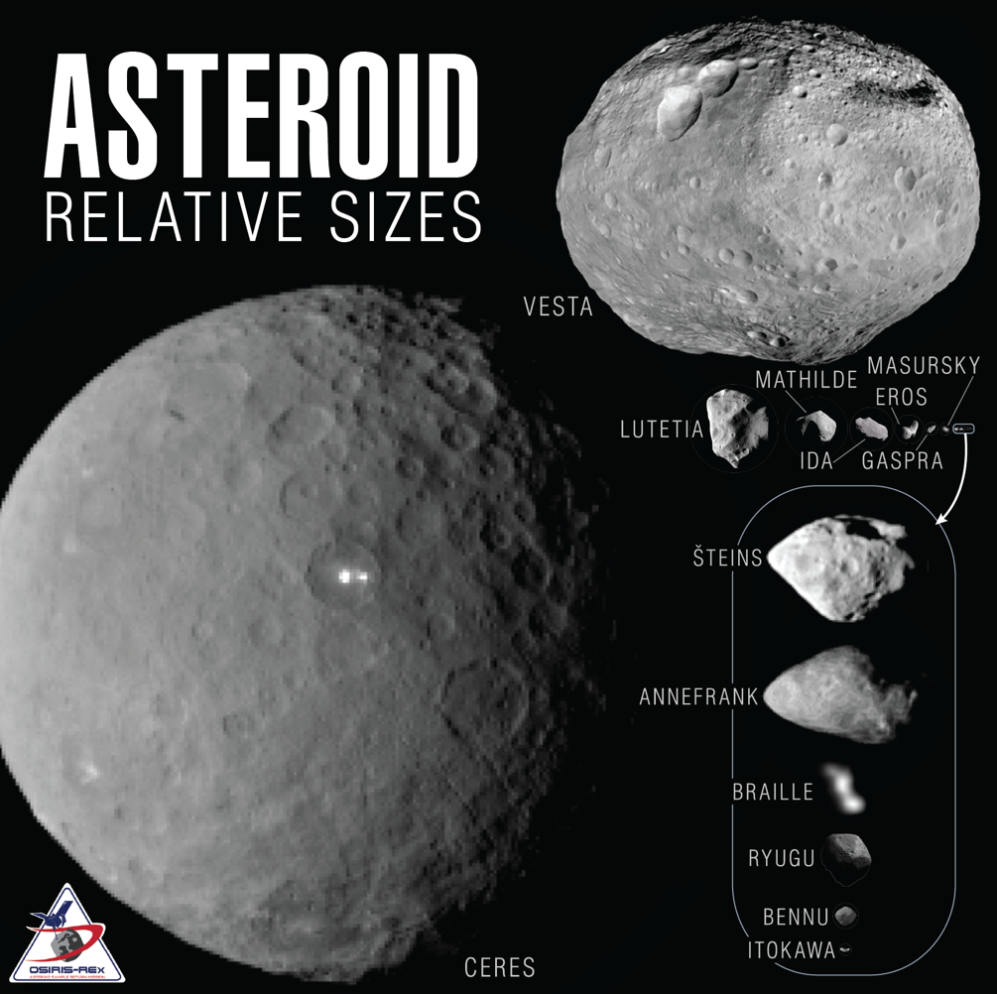
Figure 1 Relative size of Bennu compared to other asteroids.
Small perturbations and force mismodeling greatly impacted trajectory prediction performance. This necessitated significant work on the part of the navigation team to model solar radiation pressure and thermal re-radiation effects on the spacecraft []. Even tertiary forces such as antenna pressure/thrust as well as Bennu’s albedo and infrared radiation had radial acceleration components greater than the estimated uncertainty in GM throughout all orbital phases and required modeling efforts. Strong correlations were present between many of these accelerations which required extensive characterization efforts spanning different orbital phases of the mission to refine modeling and reduce residual errors. Orbit determination also relied extensively on optical navigation (OpNav) measurements recorded by the spacecraft and radioed to the ground during daily Deep Space Network (DSN) downlink sessions. OpNav measurement processing required extensive efforts to characterize and model aspects of the imaging payload and spacecraft, as well as the development of precise models of Bennu’s physical parameters and topography [].

OSIRIS-REx navigation and maneuver designs were implemented using a rapid turn-around, ground-in-the-loop process termed a “late update”; however, the accuracies required for successful operations were at the limits of what was possible through such ground-based operations. Late updates were executed over a 24-hour period, bracketed by two communications sessions with the spacecraft via the DSN. The process began with the downlink of OpNav images and ended with the uplink of revised trajectory or maneuver design parameters, approximately 24 hours later. The process placed significant demands on support from the DSN to provide daily communications sessions that fell within a specified window.

The challenges articulated above were overcome through close teamwork within the navigation team and across other mission elements to characterize the systems to the highest fidelity possible and implement a ground-based process for performing navigation and maneuver updates reliably on a 24-hour cadence. However, it required members of the team to work two shifts, 6 days a week for a large fraction of the 2-year proximity operations campaign at Bennu.

Sample Collection Challenges

The sample collection system on the spacecraft was designed around a “Touch and Go” (TAG) maneuver that would bring the spacecraft into contact with the surface of Bennu for just a few moments. The spacecraft was originally designed to target the selected TAG location within 25 m accuracy, meaning a suitable TAG location was an area roughly 50 m in diameter that was determined from observational data to be safe for the spacecraft to contact and confirmed to have the presence of fine-grained material with particulate sizes 2 cm or less that can be ingested into the sample collection mechanism. Bennu was expected from Earth observations to be relatively uniform in shape and composition and covered with fine-grained material. However, when OSIRIS-REx arrived at Bennu, the team was shocked to see a rough surface covered with boulders of comparable sizes to cars and even multi-story buildings. After an extensive site-selection campaign, the best site identified for sample collection was approximately 8 m in diameter, located in a crater in the northern hemisphere [4]. Even within this region, there were boulders several meters in size that could be hazardous to the spacecraft. Figure 2 illustrates the size of the sample collection site, dubbed Nightingale, compared to the requirement to which the navigation system on the spacecraft had been designed.

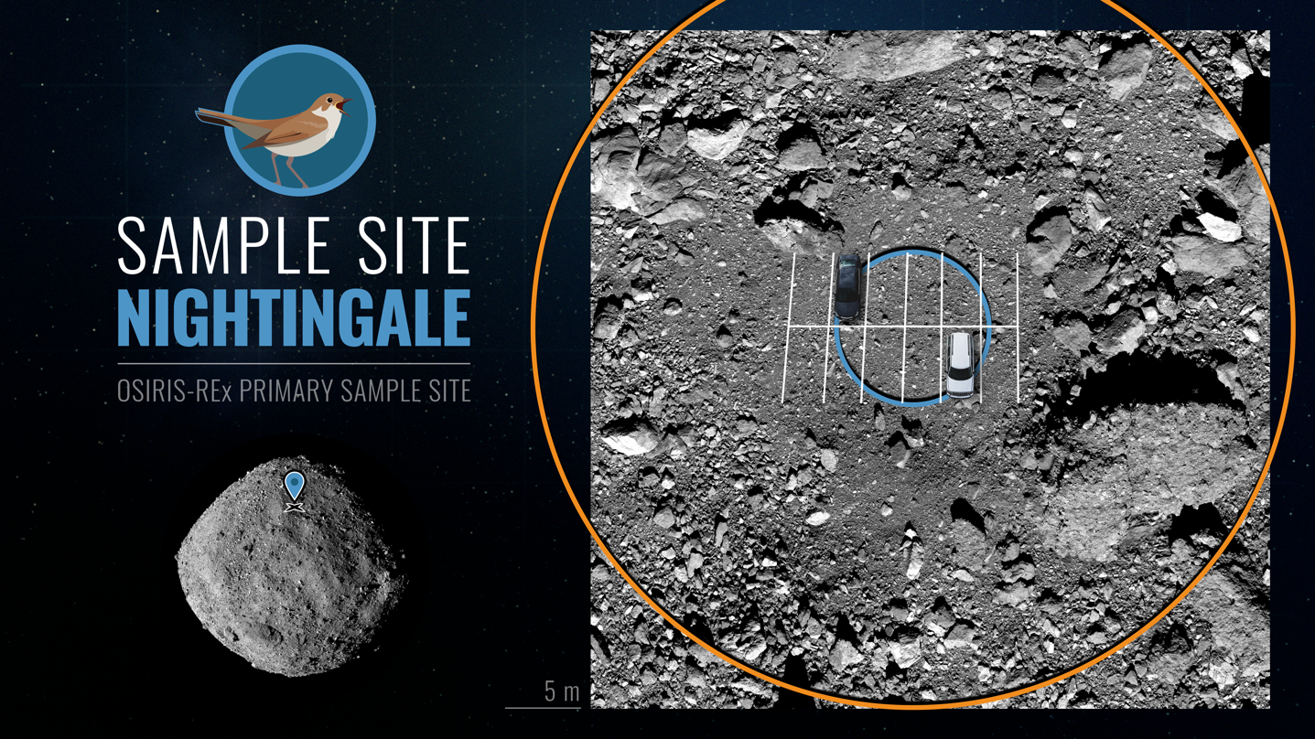
Figure 2 – Comparison of the size of the primary sample collection site at Bennu (Nightingale, blue) to the landing area the spacecraft was designed to target (orange). Cars in a parking lot are overlaid for scale.
The baseline navigation and guidance system for TAG relied on range measurements made by a flash LiDAR instrument [, , ] to observe errors in the descent trajectory for TAG and determine corrections that would re-target the spacecraft to the desired touchdown location and velocity. In light of Bennu’s surprising rocky surface and the dearth of potential safe sample sites, it was clear that touching the surface anywhere within 25 m of the targeted sample collection site would not be safe for the spacecraft and would be unlikely to yield a successful sample collection. However, the simple LiDAR-based navigation updates originally planned for TAG could not perform much better. Fortunately, during OSIRIS-REx development, an OpNav-based onboard navigation system was developed and implemented as a backup method. The Natural Feature Tracking (NFT) system processed OpNav images from one of two navigation cameras onboard the spacecraft and used these images to estimate the spacecraft position and retarget the TAG location autonomously. The NFT system was considerably more operationally complex than LiDAR; it

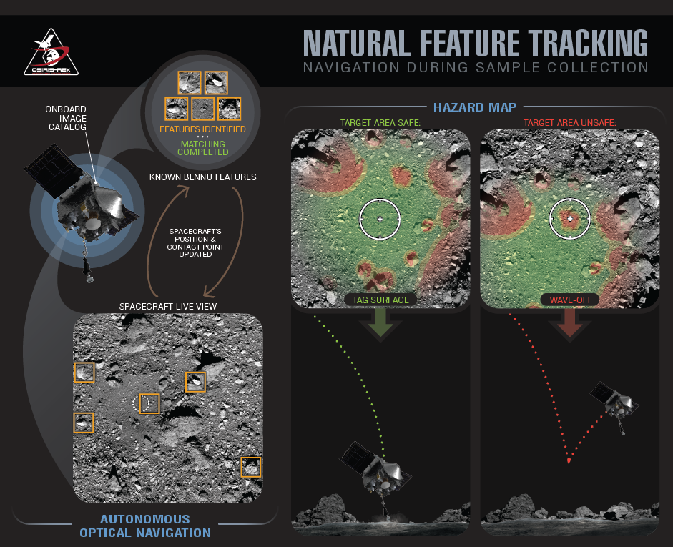
Figure 3 – The NFT system (left) is an onboard implementation of the OpNav process used by the ground navigation team to correlate known landmarks with features identified in OpNav images. The hazard map capability (right) was a new flight software capability developed after arrival at Bennu to protect the spacecraft from hazards present in the vicinity of the targeted sample collection location.

required the development of high-fidelity topographic maps of the surface, and the development of a “feature catalog” of the natural features or landmarks used by the onboard algorithm to correlate against images recorded during the descent []. But the trajectory solutions from NFT were estimated to be accurate to a few meters, leading to an order of magnitude better delivery performance than the LiDAR-based technique. Additionally, because the Nightingale site still had some large boulders that could be hazardous to the spacecraft, a “hazard map” abort capability was developed in flight software. Using the same high-fidelity topographic maps used to generate the landmarks for OpNav, it was possible to map out the regions of the Nightingale site that would be hazardous for the spacecraft to contact. These coordinates were programmed into a map of grid locations that were uploaded to the spacecraft, and using the estimated contact location from NFT, the hazard map software would determine if the predicted location was safe or hazardous, and trigger an abort of the TAG descent as appropriate. Figure 3 illustrates the concept of the NFT autonomous OpNav system (left) and the hazard map (right). The NFT system performed phenomenally during the sample collection event, with the spacecraft contacting the surface less than a meter from the targeted location [, ].

- Unique Challenges of a Rendezvous Mission to Apophis and Comparison to OSIRIS-REx

Apophis is arguably a more challenging target for a rendezvous mission than was Bennu. Apophis is estimated to be smaller than Bennu with a predicted mean diameter of 340 m compared to 490 m for Bennu. The likelihood of a smaller mass amplifies all of the navigation challenges faced at Bennu.

Apophis is understood to be in a low-amplitude non-principal-axis (NPA) rotation state, characterized by a rotation about its shortest (Z) axis at a period $P_{ϕ}$ and that axis wobbling around the angular momentum vector with an average period $P_{ψ}$. The main period derived from observational data of 30.56 hours is a linear combination of the periods $P_{ϕ}$ and $P_{ψ}$; however, existing data does not lead to a unique solution for these rates nor the deviation of the pole direction, and thus there remains a large uncertainty as to the precise parameters of the rotation state, which will not be resolved before Apophis encounters Earth in 2029 [, ]. Furthermore, the close flyby of Earth is expected to significantly perturb the current rotation state leading to even greater uncertainty as to the rotation characteristics during the encounter phase of the APEX mission.

In spite of this uncertainty, it is clear that the nominal Apophis rotation period of approximately 30 hours will require a very different observational approach than implemented for Bennu to accomplish scientific observations that achieve global coverage of the body. Bennu had a short rotational period of 4.3 hours with no NPA rotation, which meant that for any given “observation station,” it was only necessary to observe Bennu for less than 5 hours to accomplish global coverage of the body from that observational geometry. For example, this allowed the Detailed Survey phase of the OSIRIS-REx mission [4] to be accomplished by flying the spacecraft through each desired observation station once. The stations were queued up on a weekly cadence, which allowed the spacecraft and navigation teams to perfect spacecraft maneuvers and precisely estimate the trajectory and pointing of the spacecraft for the 5-hour observation window of interest. At other times, navigation requirements could be significantly relaxed.

The slow rotation period and NPA rotation of Apophis necessitate observation during short, recurring intervals to gradually and continuously build up coverage of the surface at the desired observational conditions over time. So rather than one or two 5-hour science observation periods per week, Apophis will require a regular cadence of short observations to be executed on a repeat cadence of perhaps 2 to 4 hours (depending on the rotation characteristics). The primary complication of this approach is that requirements for precise instrument targeting (and precise prediction of the spacecraft trajectory) must be met nearly all the time, not just for a 5-hour period once or twice a week. The challenges of navigating a spacecraft about a small body (see Section 2) mean that it is infeasible to support such an operational concept exclusively with ground in-the-loop processes as was done at Bennu. Furthermore, the budget allocated for the APEX mission necessitates a smaller operations team. These factors motivate the pursuit of more autonomy in the execution of recurring trajectory updates for APEX, as will be discussed in section 4.

Based on Goldstone and Arecibo radar images taken in 2012–2013, Brozović et al. [] estimated that Apophis is an elongated object 450 × 170 m in size, and that it is bilobed (possibly a contact binary) with a surface albedo of 0.35 ± 0.10, about an order of magnitude brighter than Bennu. The possibility of a bilobed shape combined with Apophis’ complex rotation means it could be challenging to obtain imaging of areas on the surface of Apophis that may be periodically shadowed. Even if sufficient imaging could be accomplished, these regions could also be unreliable for landmark-based OpNav because of the difficulty in predicting when they will be properly illuminated for OpNav imaging. On the other hand, it will be challenging to image the high-albedo surface at low solar phase without saturation with the suite of instruments tuned for an asteroid with an order-of-magnitude lower albedo. Furthermore, the irregular shape will cause more significant gravitational dynamics than experienced at Bennu.

Not all aspects of operations at Apophis are more challenging than at Bennu. Apophis’ orbit about the Sun will be significantly changed by the 2029 close flyby of Earth. The resulting orbit will have a perihelion distance of 0.89 au and aphelion of 1.31 au. This range of solar distances is enveloped by the variation in solar range experienced at Bennu (perihelion of 0.897 au and aphelion at 1.36 au), though science observations around perihelion at 0.89 au solar distance can be constrained due to spacecraft thermal limitations. During the nominal encounter with Apophis (through December 2030) the spacecraft-to-Earth range will never exceed 1.0 au, and will be less than 0.5 au for a substantial portion of the encounter, allowing the use of the highest downlink data rate available on the spacecraft of 1375 kbps. Generally this means data downlink bandwidth is substantially less constrained than for OREx operations with the exception of the period between April and July 2029 when the Sun-probe-Earth angle exceeds 90 degrees, communications through the high gain antenna are precluded.

APEX operations at Apophis will need to incorporate more autonomy in the flight system and ground-based mission operations processes to be successful. Due to a constrained budget, the mission operations team will be substantially smaller than the team from OSIRIS-REx operations at Bennu. Furthermore, Apophis’ slow rotation period and complex rotation dynamics require a much higher observational cadence, which is infeasible to support solely with the ground in-the-loop late-update process employed on OSIRIS-REx. These factors drove APEX mission planners to examine ways to make mission operations more autonomous and reduce the mission operations staffing requirements during the encounter with Apophis. There has also been a general emphasis on simplifying mission operations activities wherever possible.

- Autonomy and Other Operations Changes for Apophis

This section describes some of the concepts being pursued for the mission that have the potential to substantially improve efficiency and corresponding scientific data return, simplify requirements on the mission operations team, and demonstrate techniques that could be utilized on future small body missions.

Autonomous Updates to Pointing of Science Observations via Autonomous Onboard Navigation

Pointing of the spacecraft for science observations at Bennu was driven by a Bennu-relative spacecraft trajectory file generated by the navigation team and uploaded to the spacecraft 2-3 times per week. Each trajectory update involved a ground in-the-loop orbit determination process that was typically executed within a 24-hour period. Each late update commenced with a daily DSN downlink session to receive the OpNav images recorded by the spacecraft during the previous 24-hour period. OpNav images were processed in conjunction with DSN radiometric tracking data and used to estimate the spacecraft trajectory over the data arc. The latest trajectory and spacecraft models were then used to predict the spacecraft trajectory multiple days into the future. Various models were refined through this process over time to improve the predictive performance of the solutions as fidelity of models of small forces was improved. The navigation team then delivered the updated trajectory to the spacecraft team, where it was built into an ephemeris file that could be uploaded to the spacecraft at the next uplink session. This late-update process typically commenced around 8-9 am and was completed by 9 pm local time, thus spanning two shifts.

This process is roughly illustrated in Figure 4a. A propulsive maneuver is calculated by the operations team and executed onboard the spacecraft; an ephemeris file is built assuming the maneuver is executed perfectly and uploaded to the spacecraft with the maneuver parameters. OpNav images are collected at a regular cadence (perhaps every 2-3 hours) following the maneuver and downlinked as part of a daily DSN pass. Over a 24-hour period the operations team executes another late-update process and uplinks an updated trajectory to the spacecraft, which reconstructs the post-maneuver trajectory. The new ephemeris file becomes effective 24 hours following the downlink of OpNav images and 48 hours following the maneuver. The effective age of the predicted spacecraft trajectory is already 24 hours when the new file becomes active on the spacecraft, and the age of data reaches 3-4 days before the next new ephemeris file is uplinked. The soonest following a propulsive maneuver that a trajectory update could be active onboard the spacecraft would be 48 hours, due to the daily cadence for downlink of OpNav images used as part of navigation updates.

(a)
(b)
Figure 4 – Illustration of (a) the ground-based late-update process utilized on OSIRIS-REx and (b) how trajectory updates might be made autonomously onboard the spacecraft for APEX.
An obvious improvement over the ground-based late-update process is to provide the spacecraft with the capability to update the onboard knowledge of its position relative to Apophis autonomously, this removing some of the steps that require ground intervention and corresponding latencies. Figure 4b illustrates the concept for such onboard navigation updates. OpNav images are still recorded by the spacecraft at some nominal cadence but are immediately processed in flight software onboard the spacecraft to produce a revised estimate of the trajectory. The trajectory update frequency can be at whatever imaging cadence can be supported by the spacecraft, but every 2-3 hours is reasonable in most circumstances based on current plans for Apophis proximity operations. Because the age of the latest trajectory update is typically a few hours (as compared to 24-72 hours), the effective trajectory and relative pointing errors are much smaller than what is possible through the ground-based process, even considering the fact that navigation models implemented onboard the spacecraft must be at a lower fidelity than that of the ground. An update to the onboard trajectory following a propulsive maneuver can be accomplished in hours, following a few OpNav measurement epochs, rather than the 48-hour delay necessary for the ground-based process so that science observations can resume more immediately.

Autonomous Onboard Navigation Implementation Details

The existing Natural Feature Tracking (NFT) system utilized for the TAG maneuver described in section 2.2 provides much of the functionality that would be necessary to autonomously update the onboard ephemeris otherwise provided from the ground. The APEX team has studied flight software changes that would be required to utilize the NFT system to autonomously update the current trajectory state of the spacecraft and predict this for short periods into the future. Many of the algorithms used in the NFT system can be utilized as is, but some changes are necessary. These include some flight software development providing an interface to allow NFT to inform the spacecraft attitude control system and update fault protection to guarantee the safety of the spacecraft if the software encounters a fault or experiences an outage associated with one of the cameras.

The software development and modifications are necessary because NFT was designed for the very specific TAG use case. During TAG, the system was used to predict the spacecraft state for the maneuvers that targeted the sample collection site. Once the maneuvers were executed it estimated the TAG location and time. At Apophis, NFT will need to be able to predict the trajectory state at measurement times and provide updates to keep the narrower field-of-view science instruments pointed at the surface. These changes will result in NFT providing inputs to the attitude control system enabling science while also making it difficult for the team to analyse spacecraft safety prior to running the activities. The team is considering ideas to simplify spacecraft safety analysis as well as possible fault protection changes.

At Bennu, the NFT system was operated over ranges to the surface of one kilometer or less. It is expected the existing NFT algorithms can be operated with a landmark catalog of the same resolution as that used for ground-based OpNav processing for orbital phases within a few kilometers of Apophis. However, to be utilized over the full proximity operations campaign at Apophis it must operate at distances up to 10-15 km from Apophis. These flight regimes necessitate a different strategy for using NFT. The larger distances require an alternate technique using a single feature of the shape rather than surface features. The single feature when rendered by NFT will be used to correlate to the illuminated full body in the images, analogous to a centroiding technique. The change to using the single-feature method is primarily an operation change for NFT. The catalog will consist of a single whole-body feature, possibly defined at multiple resolutions, that will be selected based on range. Along with these parameters, matching thresholds and match validation will need to be updated.

The onboard navigation capability greatly reduces the demand on DSN resources and will greatly relax the cadence of operations for the ground team, but it does not completely replace the functions of the navigation team. OpNav images are still downlinked from the spacecraft, but on a more relaxed schedule. Trajectory updates from the navigation team are still necessary to precisely reconstruct the trajectory of the spacecraft for science data processing, to design spacecraft maneuvers, and to precisely model the flight dynamics and geophysical parameters of the asteroid, informing subsequent mission phases. It is also assumed that the onboard system will still utilize a ground-based trajectory file as a backup ephemeris and in support of fault detection; however, the ground-based ephemeris will only need to be updated on a weekly cadence, a much more relaxed schedule than what was required at Bennu.

Direct Benefits of the Autonomous Navigation System for Science Observation Pointing

The most significant benefit from an onboard system to update the spacecraft target ephemeris is that the effective pointing errors are maintained at a level much smaller than is possible with ground in-the-loop late updates, even if these ground-based updates could be performed every day. Some APEX science phases (i.e. Starfish Survey, Variable Phase Orbit (VPO)) require pointing errors to be maintained below 1 degree (on the order of 50 m in trajectory error at 3 km range to the surface) in order to meet observation objectives. With an onboard navigation update, the effective target ephemeris errors during science and OpNav imaging would be maintained at levels typical of a ground ephemeris with an age of data of 24 hours or less. This level of performance would be extremely challenging to meet with only the ground-based late-update process.

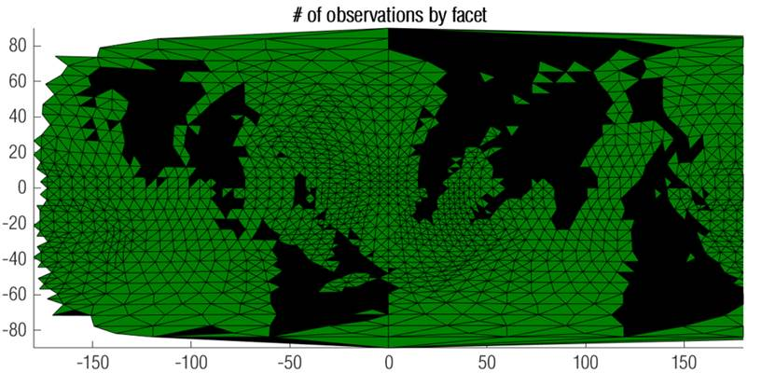
(a)
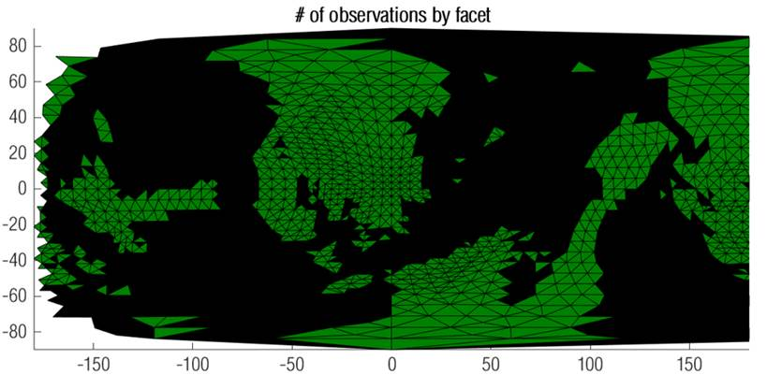
(b)
Figure 5 – Image mosaic basemap coverage during VPO at Apophis assuming (a) onboard ephemeris estimation (82% coverage) vs. (b) ground-based ephemeris updates performed twice per week (42% coverage).
To illustrate how ephemeris errors impact scientific observations, an analysis was performed of the science observations planned for the VPO mission phase. An objective of VPO is to produce an image mosaic basemap of Apophis that resolves features 0.5 m and larger over at least 70% of the object. The analysis assumed a nominal rotation state for Apophis and the current nominal duration planned for the VPO phase. Science instrument pointing errors were simulated for two cases: consistent with a target ephemeris autonomously updated onboard, vs. ephemeris errors typical of a ground-based ephemeris with an age of data between 24 and 96 hours, the best that would be possible given two ground-based late updates per week. Larger pointing errors resulting from the ground in-the-loop process result in approximately half the coverage of the autonomous method. The analysis further demonstrates that even with three ground-based uplinks per week, which would require ground team members to support ephemeris late-update activities 6 days per week, the duration of the VPO phase would need to be extended two to three times to meet the 70% coverage requirement.

Beyond the bottom line that the improved onboard ephemeris accuracy can dramatically improve the surface coverage achievable, there are numerous operational improvements that flow from this capability. Smaller pointing errors associated with instrument observation of Apophis greatly simplifies the task of science planners and mission operations team members. The possibility of large errors in the pointing means that over-scanning must be incorporated into each desired observation to guarantee success of the observation objective. This complicates the design of each observation and increases the time necessary to execute each observation. Over-scanning also results in a significant increase in the volume of data that must be stored and then downlinked from the spacecraft, which is a limited resource due to limitations on the support possible from the DSN. The process of performing 2-3 ground-based late updates per week required 4-6 DSN passes at specific times each day to support the 24-hour late-update turn-around cycle. With the onboard ephemeris update capability, the mission can be operated with 1-2 DSN uplink sessions per week, and the timing of these uplink sessions will be much more flexible, providing significant relaxation of the support requirements of the highly constrained DSN resources.

Automation of Ground-Based Ephemeris Updates

Even with the adoption of the capability to update the onboard ephemeris autonomously in flight software, it is still necessary for the ground team to periodically upload an ephemeris to the spacecraft as a backup to the onboard system. On OSIRIS-REx, the generation of the ephemeris uplink process, validation of the products, and uplink to the spacecraft were all performed through a manual process that spanned two shifts considering the work of the navigation team to generate the updated trajectory estimate and the flight team to build and uplink the products. For APEX, an automated process will be implemented to build, test, and radiate the products to the spacecraft at the next available uplink session, implementing capabilities previously demonstrated for the MAVEN mission.

Simplification of Proximity Operations Maneuver Design Process

OSIRIS-REx performed 107 maneuver late updates to execute the proximity operations at Bennu []. The trajectory flown by the spacecraft between December 2018 and May 2021 is illustrated in Figure 6. The weak gravity environment of Bennu meant that the spacecraft trajectory was inherently difficult to model multiple days and weeks into the future, which led to the development of the late-update process for performing trajectory updates and computing the final parameters for propulsive maneuvers. As part of these late updates, final maneuver parameters were computed by the navigation team and uplinked to the spacecraft within a 24-hour period from downlink of the latest OpNav images to uplink of the final burn parameters. Because the final burn parameters, including the spacecraft attitude that the burn must be executed from, are uncertain until just a few hours before the burn, it was a challenge to ensure that all possible required burn attitudes would be safe for the spacecraft and instrument, a validation normally performed by the mission ops team on the ground. If during the preliminary design phase of the maneuver there was a statistical possibly that the spacecraft attitude required for the burn could put the instrument deck into a Sun exclusion zone, a more complicated two-component burn must be planned.

For APEX, the operations team is investigating utilizing a “vector burn” capability of the spacecraft, in which a desired velocity change and direction can be accomplished by firing each set of three orthogonal thrusters in succession. The vector burn mode was used successfully during the TAG activity for the Checkpoint and Matchpoint burns that targeted the spacecraft for contact with the surface. Utilizing vector burns allows one or more fixed burn attitudes to be analysed in advance, and then regardless of the final burn design, only the magnitudes of the thruster firings in each axis need to be changed to accomplish the required ∆V. This method will result in a small degradation in maneuver accuracy, but it significantly simplifies the ground process for each maneuver final design, representing a major simplification of effort when applied over 100 or more maneuvers during the proximity operations campaign. The APEX team is investigating the performance possible from vector burns to validate that the concept can be utilized widely during the APEX encounter with Apophis.

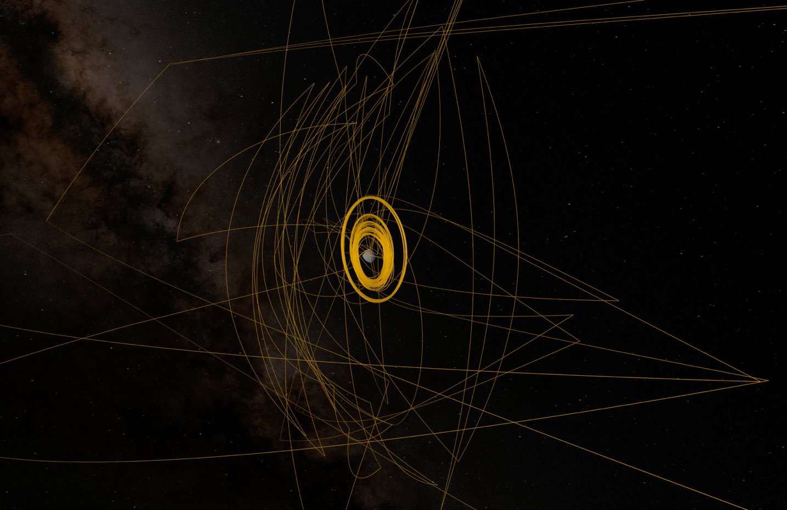
Figure 6 – Trajectory path flown by the OSIRIS-REx spacecraft about Bennu between December 2018 and May 2021; each inflection point in the trajectory represents a propulsive maneuver designed via the ground in-the-loop late-update process.

Simplification of Safe-Mode Response

A spacecraft safe-mode event typically imparts a small, nondeterministic velocity change due to thruster firings to damp out residual attitude rates. For OSIRIS-REx velocity changes from such events could be at a level of 1-2 cm/s in worst-case situations. Normally such a small velocity change would not be a concern, but in the case of OSIRIS-REx it would be sufficient to change the orbit of the spacecraft significantly, and applied in the worst-case direction, could result in impact of the spacecraft with Bennu within 12 hours or less. The actual velocity change imparted and whether the spacecraft was actually on an unsafe trajectory might take 24 hours or more to determine based on routine operations processes. Although the likelihood of a safe-mode entry that could put the spacecraft on an unsafe trajectory was extremely small (less than 1% over the duration of the proximity operations campaign) this was nevertheless a potentially mission-ending failure, so steps were taken to ensure spacecraft safety in such events.

The mission design for OSIRIS-REx ensured that the spacecraft would never travel behind Bennu relative to the Sun, thus to ensure the safety of the spacecraft, if fault protection software detected a fault that would trigger a safe-mode entry, the spacecraft was programmed to execute a pre-planned burn in the sunward direction, that would setup a slow drift of the spacecraft away from Bennu. While this ensured the spacecraft would never impact Bennu in response to safe mode, it created a significant amount of work for mission planners on the navigation team. At any point in the mission, the spacecraft could execute a burn that would cause it to leave the vicinity of Bennu. This meant that for every mission phase, the mission design team had to develop trajectory designs that would return the spacecraft to Bennu and setup for a re-insertion into orbit, or to resume the next series of hyperbolic flybys.

Given the low likelihood of an unsafe safe-mode entry (only one occurrence of safe mode for the OSIRIS-REx/APEX flight system since launch in 2016) and a general philosophy of accepting more risk on a mission of opportunity, the APEX team adopted a ground-rule when formulating the proposal that a sunward burn response would not be part of safe mode. For negligible risk to the APEX mission, this allows for a significant simplification for the contingency planning work necessary for the Apophis encounter.

- Mission status and Outlook

APEX has been traversing the inner solar system on its journey to rendezvous with Apophis in 2029 (Figure 7). The spacecraft has successfully completed two of six close perihelion passages, that take the spacecraft within 0.5 au of the Sun, a much more stressing thermal environment than the spacecraft was designed to withstand. All instruments on the spacecraft with the exception of the student-contributed Regolith X-ray Imaging Spectrometer (REXIS) are functional. The mission team is in the process of developing detailed trajectory and observational plans for the historic encounter with Apophis in 2029. When Apophis flies by Earth at an altitude of only 31,000 km, below the altitude of geostationary satellites, at 21:39 UTC on April 13th, 2029, the APEX spacecraft will be close on its heels, conducting an EGA just one hour behind Apophis. The spacecraft will observe Apophis as a point source in the days leading up to is close approach to Earth and immediately following. The spacecraft will also search for dust plumes and particles liberated from the surface of Apophis due to tidal forces from the Earth encounter and characterize the trajectories of these particles. The APEX EGA will align the orbit planes of APEX and Apophis, setting up a slow approach and rendezvous over the next two months. APEX provides a front-row seat to observe the historic close-flyby of Apophis by Earth in 2029, and its unique capabilities to study a small planetary body from only hundreds of meters distance will yield an unprecedented understanding of this close planetary neighbor of Earth.

Figure 7 – Cruise timeline and trajectory for APEX’s journey to Apophis. The Sun (gold) is shown at the center. DSM, deep space maneuver. TCM, trajectory correction maneuver.

Conclusions
In planning for the encounter with Apophis, the APEX mission benefits from substantial experience gained and lessons learned from the OSIRIS-REx exploration of Bennu. Budgetary constraints dictate that the operations at Apophis must be conducted with a smaller operations team than OSIRIS-REx had, in spite of the fact Apophis is arguably a more challenging target and the complexity of some orbital operations will be higher.

The mission team has considered a number of possibilities to operate the APEX mission more efficiently, chief among them the implementation of flight software changes that leverage existing onboard navigation capabilities demonstrated on OSIRIS-REx, to apply them much more widely on APEX. The autonomous navigation capability allows near-continuous science data collection, rather than just a couple days per week, and furthermore allows for a smaller mission operations team, fundamentally enabling the planned science observations at Apophis.

Acknowledgements
The authors acknowledge the efforts of the entire OSIRIS-REx and OSIRIS-APEX teams for contributions made to the work described in this paper. This material is based upon work supported by NASA under Contracts NNM10AA11C, NNG13FC02C, and NNG12FD66C. OSIRIS-APEX is a new NASA mission utilizing the OSIRIS-REx spacecraft after the successful completion of the sample return portion of that mission. Daniella N. DellaGiustina of the University of Arizona, Tucson, is the principal investigator, and the University of Arizona also leads the science team and the science observation planning and data processing. Lockheed Martin Space Systems in Denver built the spacecraft and is providing flight operations. Goddard Space Flight Center and KinetX Aerospace are responsible for navigating the mission.

References

Lauretta, D.S., et al., OSIRIS-REx: Sample Return from Asteroid (101955) Bennu, Space Science Reviews, 212: 925–984, 2017.
Lauretta, D.S. & Connolly, H. C., et al., Asteroid (101955) Bennu in the laboratory: Properties of the sample collected by OSIRIS-REx, Meteoritics & Planetary Science, 59:2453–2486, 2024.
DellaGiustina, D.N., et al., OSIRIS-APEX: An OSIRIS-REx Extended Mission to Asteroid Apophis, The Planetary Science Journal, 4:198, 2023. doi:10.3847/PSJ/acf75e.
Lauretta, D.S., Enos, H.L., Polit, A.T., Roper, H.L., & Wolner, C.W.V. 2021, in Sample Return Missions, ed. Longobardo, A. (Amsterdam, Elsevier), 163–194. doi:10.1016/B978-0-12-818330-4.00008-2.
Antreasian, P.G., et al., Comparing Pre-Launch Assumptions to In-Flight Navigation Performance of OSIRIS-REx, Proceedings of the 44th Annual Guidance and Control Conference, AAS 22-167, 2022.
Leonard, J.M., et al., Navigation Prediction Performance During OSIRIS-REx Proximity Operations at (101955) Bennu, AIAA Sci Tech Forum, 2022. doi:10.2514/6.2022-2389.
Geeraert, J.L., et al., OSIRIS-REx Navigation Small Force Models, 2019 AAS/AIAA Astrodynamics Specialist Conference, AAS 19-717, 2019.
Adam, C.D., et al., Stereophotoclinometry for OSIRIS-REx Spacecraft Navigation, The Planetary Science Journal, 4:167, 2022. doi:10.3847/PSJ/ace31d.
Berry, K.E, et al., OSIRIS-REx Touch-And-Go (TAG) Navigation Performance, Proceedings of the 38th Annual Guidance and Control Conference, AAS 15-125, 2015.
Church, E., Flash Lidar On-Orbit Performance at Asteroid Bennu, Proceedings of the 43rd Annual Guidance and Control Conference, AAS 20-148, 2020.
Leonard, J., et al., Cross-Calibration of GNC and OLA LIDAR Systems Onboard OSIRIS-REx, Proceedings of the 44th Annual Guidance and Control Conference, AAS 22-166, 2022.
Olds, R.D., et al., The Use of Digital Terrain Models for Natural Feature Tracking at Asteroid Bennu, The Planetary Science Journal, 3:100, 2022. doi:10.3847/PSJ/ac5184.
Berry, K.E., et al., Contact with Bennu! Flight Performance Versus Prediction of OSIRIS-REx TAG Sample Collection, AIAA SCITECH 2022 Forum, 2022. doi:10.2514/6.2022-2521.
Norman, C.D., et al., Autonomous Navigation Performance Using Natural Feature Tracking during the OSIRIS-REx Touch-and-Go Sample Collection Event, The Planetary Science Journal, 3:101, 2022. doi:10.3847/PSJ/ac5183.
Pravec, P., et al., The Tumbling Spin State of (99942) Apophis, Icarus 233:48 (2014). doi: 10.1016/j.icarus.2014.01.026.
Ďurech, J., et al., Spin State and Shape of (99942) Apophis Reconstructed from its Light Curves, Apophis T-7 Conference (2024). https://ui.adsabs.harvard.edu/abs/2024LPICo3006.2012D.
Brozović, M., et al., Goldstone and Arecibo radar observations of (99942) Apophis in 2012-2013, Icarus, 300:115–128, 2018. doi:10.1016/j.icarus.2017.08.032.
Antreasian, P.G., et al., OSIRIS-REx Proximity Operations and Navigation Performance at (101955) Bennu, The 32nd AIAA/AAS Space Flight Mechanics Meeting, San Diego, CA, 2022.

