SpaceOps-2025
Maneuvering Spacewalkers via Ground Control: A New Paradigm for Space Exploration

Laura Lucierª*, Kayse Chen^{b}, Angela Bauer^{c}

a Flight Operations Directorate, NASA Johnson Space Center, 2101 NASA Parkway, Houston, Texas, USA 77058, laura.m.lucier@nasa.gov
b Robotics Operations Branch, NASA Johnson Space Center, 2101 NASA Parkway, Houston, Texas, USA 77058, kayse.m.chen@nasa.gov
c Robotics Operations Branch, NASA Johnson Space Center, 2101 NASA Parkway, Houston, Texas, USA 77058, angela.l.bauer@nasa.gov
* Corresponding Author
Abstract
Since 2001 the National Aeronautics and Space Administration’s (NASA’s) International Space Station (ISS) Program has relied on the Canadarm2 robotic manipulator to perform a variety of high-risk, mission-critical tasks. Chief among these is the maneuvering of spacewalking astronauts to and from worksites and serving as an astronaut stabilization and positioning platform. These operations are referred to as arm-supported Extravehicular Activity (EVA) and must be carefully choreographed and executed as they present high risk to the crew and the vehicle. Historically, command and control of Canadarm2 during arm-supported EVA has been performed by astronauts operating inside the ISS. Recognizing the need to protect for times of reduced onboard crew complement and the need to explore novel operating concepts in support of NASA’s Artemis and Moon To Mars efforts, NASA’s Robotics Operations branch has developed novel techniques for operating Canadarm2 from the ground during arm-supported EVA. These techniques build on the branch’s long legacy of safe and efficient ground-controlled, telerobotic operations, which is briefly discussed. Also presented are considerations and lessons learned in the development, training, and execution of ground-controlled robotic support for EVA. Special attention is paid to associated risks, mitigation strategies, and considerations for future missions.
Keywords: telerobotic, ground control, extravehicular activity, robotics operations

Acronyms/Abbreviations
APFR | Articulating Portable Foot Restraint | NASA | National Aeronautics and Space Administration
CCE | Critical Contingency EVA | OCAS | Operator Commanded Auto Sequence
CSA | Canadian Space Agency | SPDM | Special Purpose Dexterous Manipulator (Dextre)
EVA | Extravehicular Activity | SRMS | Shuttle Remote Manipulator System (Canadarm)
GCA | Ground Control Approach | SSRMS | Space Station Remote Manipulator System (Canadarm2)
ISS | International Space Station |  | Space Station Remote Manipulator System (Canadarm2)
MCC | Mission Control Center | USOS | United States Onboard Segment
MSS | Mobile Servicing System

- Introduction
This section provides a brief introduction to the history of and rationale for arm-supported EVA. Also discussed are various risks associated with maneuvering spacewalking astronauts using robotic arms, and today’s means of mitigating those risks. Telerobotic command and control of the ISS’s Space Station Remote Manipulator System (SSRMS) by NASA’s ground-based flight control team is introduced, followed by rationale for demonstrating ground-controlled, arm-supported EVA.

  - Space Shuttle Era Arm-supported Extravehicular Activity
In the early days of Space Shuttle program formulation it was evident there was a need for Shuttle Remote Manipulator System (SRMS) robotic arm support of EVA for in- or out-of-payload bay tasks requiring either transfer of modules exceeding 100 lbs., or multiple transfer of modules of any mass with high precision positioning requirements. Interestingly, use of the SRMS as a maneuvering or operational platform for spacewalking astronauts was not initially valued, as evidenced by a 1974 report recommendation that “further consideration of this mode for shuttle and payload support should be discontinued” [1]. This conclusion was based on overly optimistic forecasted use of the Manned Maneuvering Unit and safety concerns related to maneuvering both the robot and the crewmember within the tight confines of the shuttle’s payload bay. Another challenge was the intended use of a large and complex platform to serve as the crew/robot interface, as shown on the left side of Figure 1. Though it offered a variety of capabilities such as direct robot control and stowage of spare parts, the platform’s mass and volume, as well as the time required to deploy and stow it at the start and end of EVA operations, made it impractical for real-world use.
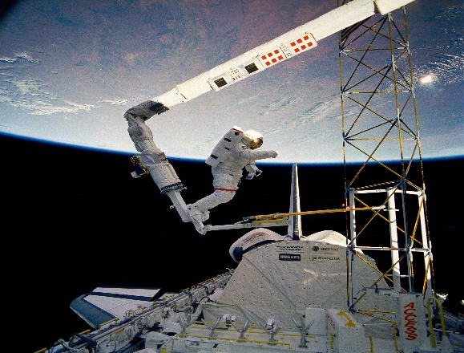
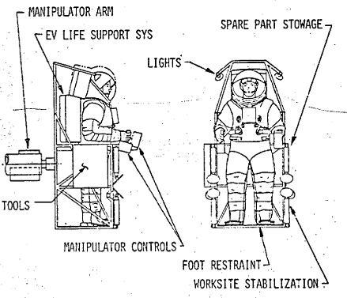
Figure 1 - Early SRMS EVA Interfaces. Left illustration from [1], right photo courtesy NASA.
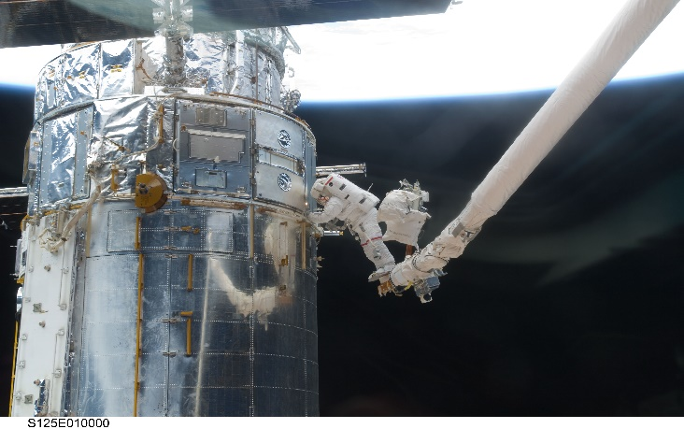
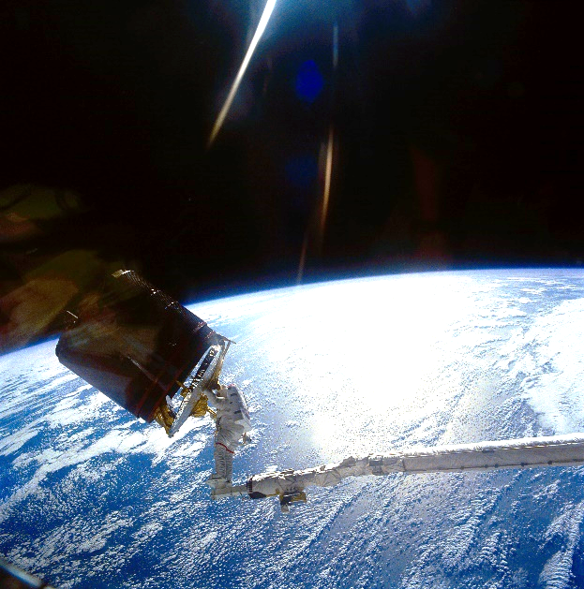
Despite this initial forecast, the SRMS was first used as a crew work platform during the STS-41B mission (NASA’s ninth), in 1984 [2]. This mission demonstrated use of the SRMS Manipulator Foot Restraint, which allowed the crew to “ride” the Canadarm via a significantly simpler and more streamlined interface as shown on the right side of Figure 1. Crewmembers inside the Space Shuttle commanded the arm using hand controllers (joysticks), buttons, and switches on the aft flight deck while relying on verbal cues from the spacewalking crew and views from windows as well as payload bay- and SRMS-mounted cameras to monitor clearances. Over the course of the Space Shuttle program, use of the SRMS to maneuver and position spacewalking crew proved invaluable, enabling critical tasks such as the Hubble Space Telescope repair missions and the capture and deployment of various satellites, as shown in Figure 2.
Figure 2 - SRMS Use for EVA Satellite Repair and Capture. Photos courtesy NASA.

  - International Space Station Arm-supported Extravehicular Activity
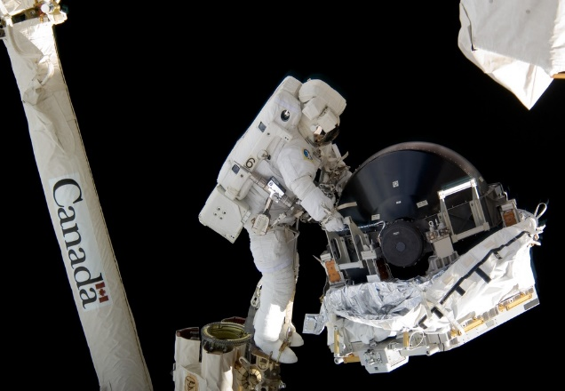
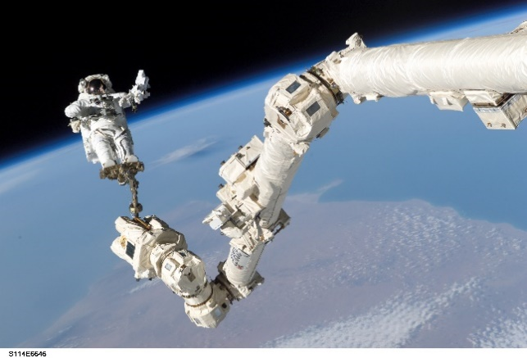
Having proven its value early in the Space Shuttle-era, arm-supported EVA was designated a baseline capability for the ISS program. A streamlined Articulating Portable Foot Restraint (APFR) was designed for use as the interface between spacewalking crew and the Canadarm2, as shown on the left side of Figure 3.
Figure 3 – SSRMS-supported EVA. Photos courtesy NASA.
The relatively small volume and reconfigurability of the APFR, combined with the maneuverability of the SSRMS allows the Canadarm2 to position spacewalking crew in the vicinity of nearly all critical external components on the ISS’s United States Onboard Segment (USOS.) This capability lessens crew fatigue by reducing or eliminating long traverses between the airlock and EVA worksites and by allowing crewmembers to transport and position large, bulky components where needed, as shown on the right side of Figure 3. When serving as a work platform, the SSRMS provides crewmembers flexibility in body positioning, which increases reach and leverage for tasks requiring brute strength. The SSRMS can also increase crewmember stability and visibility for tasks requiring delicate component manipulation.
Although arm-supported EVA is regularly performed on the ISS, many of the risks identified during the Space Shuttle era persist. Chief among these is the risk of collision between the arm or crewmember and surrounding ISS structure. This risk is mitigated through several means:
- Fail-safe system design – For select motion modes, the SSRMS is capable of autonomously monitoring and arresting its motion in the event of a “runaway” (rapid surge in motion) or deviation from the pre-programmed trajectory.
- Vetted trajectory design – All SSRMS trajectories and positions are pre-planned and verified by multiple, certified robotics flight controllers prior to execution. High-fidelity computer models of the ISS and the arm are used to predict and verify motion and to measure clearances between the crew, the arm, and ISS structure throughout the planned motion. SSRMS trajectories and positions are refined as necessary pre-flight to minimize risk of collision. Particular attention is paid to arm positions and clearance envelopes in the vicinity of EVA worksites, where crewmembers may request Ground Control Approach (GCA), or ad hoc changes in position in real-time to improve worksite access.
- Communication protocols – Strict, clear, and concise communication protocols are used between the arm operator and the EVA crewmember. Standard phraseology is used to request, describe, and confirm intended robot motion (e.g. “30 cm starboard,” “20 cm body forward,” “good motion”) as are read-backs of all requests. “Stop motion” and “all-stop” communication protocols are used to rapidly communicate and respond to undesired motion.
- Onboard monitoring of motion – Robot motion is commanded by an onboard operator via hand controllers, switches, and computer commands. The operator follows written procedures, which detail every command to be sent to the robot and what motion is expected to result from each command. The operator uses a combination of system telemetry, video camera views, and dynamic graphic computer modeling of the robot and ISS environment to confirm expected system response.
- Multiple operators – Nominally, two onboard crewmembers work together to command the SSRMS during arm-supported EVA. The first, designated M1, is charged with commanding the robot, while the second, designated M2, conveys procedural instructions, communicates with the ground, pans & tilts cameras to monitor clearances & motion, verifies M1’s actions, and serves as a second set of eyes to ensure all is proceeding as intended.
- Ground monitoring – Certified robotics flight controllers monitor crew-commanded SSRMS operations using the various tools available to the onboard M1 and M2. The ground team additionally has access to significantly more detailed system telemetry and more accurate computer models of the ISS workspace and SSRMS behavior. If unexpected system response is observed, the ground team participates in the communication protocols described earlier to call for a “stop motion” or “all-stop” response, dependent on the severity and immediacy of the situation. The ground team is also able to command the robot directly, effectively pre-empting onboard crew actions.
Another significant risk introduced by arm-supported EVA is the potential to trap a crewmember on the tip of the SSRMS beyond reach of ISS structure, or for the positioning of the robot to otherwise prevent a crewmember from returning to the airlock. This can occur in the event of an ISS or SSRMS failure that stops the robot in an inopportune position. Timely resolution of either scenario is critical for the safety of the crew, particularly in the event of a next-worst failure such as a suit malfunction or medical emergency requiring rapid return to the ISS’s pressurized environment. The need to mitigate this risk became particularly evident following ISS EVA 23, during which a buildup of water in a crewmember’s helmet drove a rapid termination of the EVA [3]. This incident resulted in changes to how arm-supported EVA is planned and trained. Today, the risk of trapping an EVA crewmember is mitigated through:
- Redundant system design – The SSRMS is designed with redundant joint motors, power strings, communication channels, and computer systems, and can be controlled through either of two identical onboard robotics workstations as well as by ground operators. Prior to commencing arm-supported EVA the system is configured to enable timely switching to redundant systems.
- EVA joint drive – EVA crewmembers can use the Pistol Grip Tool (a powered wrench) to manually drive the SSRMS’s shoulder joints one-by-one. This may permit the tip of the arm to be moved towards or away from structure as needed in the event of a total loss of electrical joint drive capability. However, it must be noted that this capability has limited effectiveness as only the shoulder joints can be repositioned, a mechanical jam cannot be overcome, and executing this procedure takes considerable time.
- Limiting time and distance away from structure – When a crewmember is on the arm, robotics trajectories are designed to limit the crewmember’s time and distance away from ISS structure. Arm maneuvering time or distance may be increased in exchange for the ability to return the crew more rapidly or easily to structure. Following ISS EVA 23 a requirement to return the crew to structure and egress the SSRMS within fifteen minutes was imposed. This is based on an averaged minimum of seven minutes to perform return maneuvering and another eight minutes to egress the SSRMS with GCA. In cases where this requirement cannot be met, the crewmember may manually translate across ISS structure as opposed to “riding” the arm.
- Pre-prepared rescue plans – Another requirement that resulted from the ISS EVA 23 incident is for robotics flight controllers to provide the crew with a pre-prepared rescue plan for each arm-supported EVA. This product informs the arm operator how to most efficiently maneuver the arm to return the crew to structure. Specific instructions are given for every arm position and every maneuver planned for the arm-supported EVA. This removes uncertainty in or second-guessing of what action to take, reduces risk of inadvertently making the situation worse, ensures the ground and onboard crew are in sync, and reduces communication traffic during the emergency.
- Crew procedures to shinny down the arm – In the event of an inability to reconfigure the SSRMS, the crewmember may egress the APFR and shinny (climb) from the tip to the base of the arm, returning themselves to structure.
As described above, arm-supported EVA risks are mitigated through smart system design, comprehensive pre-activity planning, use of multiple operators, and attentive real-time execution. These mitigations are tested and trained both generically and for specific spacewalks through integrated simulations. In the event of Critical Contingency EVA (CCE, or quick response spacewalks to recover critical ISS systems), limited time may be available to perform activities such as vetted trajectory design, refinement of positions and maneuvers to minimize time and distance from structure, and development of pre-prepared rescue plans. However, the importance of these mitigations does not diminish. In such situations, the Robotics Operations branch surges their support as necessary to perform these tasks and ensure the safety of the EVA crew. One exceptional risk is the occurrence of CCE during periods of indirect crew handover, or instances where there are insufficient USOS crewmembers to both perform the spacewalk and serve as M1 and M2 (four total USOS crewmembers required.) In a scenario where only three USOS crewmembers are onboard, two would perform the spacewalk while the third would operate the SSRMS as M1. The lack of an M2 is mitigated in one or more of the following ways:
- A ground-based robotics flight controller or astronaut may serve as M2, communicating directly with the onboard M1 from the Mission Control Center (MCC.) The “Ground M2” can use MCC tools to command cameras, relay procedure information, and perform the various verifications and consultations typically performed by an onboard M2.
- An onboard Russian segment crewmember may serve as a robotics assistant, trained to perform a subset of M2 functions.
- Ground-based flight controllers may perform a subset of robotics system commanding to reduce the workload on the onboard M1.
Ground M2 has been exercised many times for ISS arm-supported EVA. It is successful in large part due to the high level of trust that exists between the robotics flight control team and the onboard crew. This trust is the result of decades of training and operating together, as well as years of safe and successful ground-based command and control of the ISS’s robotics systems, which are briefly described in the following subsection.

  - International Space Station Evolutions in Robotics Ground Control
The SSRMS and other external robotic components that comprise the ISS’s Mobile Servicing System (MSS) were originally envisioned to be operated solely by onboard crewmembers. However, demand for crew time is high, both pre-flight and on orbit. Early in the SSRMS’s life, considerable robotics operations time was needed for system characterization, trending, trouble-shooting, and maintenance analysis [4, 5]. To offload the crew, a ground control capability was added in early 2005 to the MSS that permits ground-based robotics flight controllers to command and control all system components and functions with minimal exceptions. When initially introduced, ground control operations were subject to the following limitations [4]:
- The arm could not be “loaded” or carrying a payload (human or otherwise.)
- If maneuvering in joint automatic modes, only one joint could be moved at a time.
- The maximum maneuvering distance for auto-sequence modes was 5 ft.
- A pre-motion survey of the entire operating space was required to be performed no more than 24 hours prior to the operation and a configuration check performed every orbit during operations execution.
- Continuous telemetry coverage was required for the duration of operations when maneuvering greater than 5 ft from structure, and continuous telemetry and video coverage was required when maneuvering less than 5 ft from structure.
On February 24, 2005, the SSRMS was maneuvered via ground control for the first time [4]. In succeeding months the Robotics Operations branch incrementally expanded the envelope of allowable operations. As experience and confidence accrued, the efficiency of ground-controlled operations was increased through removal of the restriction on maneuvering distance and cessation of the requirement to move only one joint at a time when maneuvering in automatic modes. The ground team additionally demonstrated ability to “walk-off” or relocate the SSRMS between operating bases, which required ground-controlled operation of the arm’s end effectors and maneuvering in close vicinity of ISS structure.
A significant turning point in the ground control concept came in 2008 with the arrival of the Special Purpose Dexterous Manipulator (SPDM) [6]. Like the SSRMS, the SPDM was originally designed to be operated via human-in-the-loop control by on-orbit astronauts. However, the SPDM represents a significant increase in ISS robotic operations complexity. The robot itself is substantially more complicated than the SSRMS, as are the operations it is used to perform (see [6] for a more detailed description of both SPDM systems and operations.) As a result, the SPDM operations concept was revised shortly after delivery such that the robot is operated solely from the ground. This change in philosophy reduced operating cost by eliminating SPDM crew training and onboard operator interfaces. This change additionally increased NASA’s confidence in ground-controlled robotic manipulation and maneuvering of payloads in the vicinity of ISS structure, a critical capability in the path towards ground-controlled maneuvering of crewmembers on SSRMS.

  - The Next Evolution: Ground-controlled Robotics for Extravehicular Activity
As described above, ISS arm-supported EVA is a high-risk activity nominally requiring participation of four highly-trained onboard crewmembers. At various times and for various reasons, the USOS crew compliment has not been or may not be this large. This was particularly the case prior to the Commercial Crew Program’s Crew-1 mission in 2020.
Leading up to this time, arm-supported EVA was restricted to intervals when Soyuz missions carrying multiple USOS crewmembers overlapped or, until 2011, when Space Shuttle crew were present at the ISS. Alternately, Russian cosmonauts were employed to operate the SSRMS as M1, M2, and/or as an onboard robotics assistant. In the years shortly before the Crew-1 mission the ISS Program grew increasingly concerned that a CCE event could occur with insufficient USOS crew onboard to respond. This concern peaked in 2018/2019 and resulted in NASA’s Robotics Operations and EVA Operations branches being directed to develop techniques and plans for performing arm-supported EVA via robotics ground control.
Since 2020 the risk of not having sufficient USOS crew onboard to perform arm-supported EVA has decreased. This risk will decrease further when two commercial crew transportation providers reach operational status. However, there continue to be scenarios that could lead to reduced USOS crew compliment. There also continues to be a desire to build on past success and further expand the ground-controlled robotics operations envelope.
The following section describes operations concepts for ground-controlled, arm-supported EVA and the work done to prepare for a demonstration of this capability during an upcoming ISS spacewalk.

- Ground-control of SSRMS for Arm-supported Extravehicular Activity
This section presents NASA’s operational concepts and plans for performing ISS arm-supported EVA via ground-controlled robotics. The term “Ground M1” is used to describe the operations in general and is also used as the title of a flight control position (see Section 2.1.3.) Key operational concerns are discussed, along with the approaches taken to address them. Findings from simulations used to develop, refine, and validate Ground M1 operational concepts are presented. The section concludes with a summary of open work and NASA’s plans to demonstrate the Ground M1 capability during real-time ISS operations.

2.1 Operations Techniques and Risks Unique to Ground M1 Operations
The prevailing approach of the project was to maintain, to the greatest extent possible, continuity with existing practices for performing ISS arm-supported EVA via an onboard SSRMS operator. This approach reduces risk and increases efficiency, for example by allowing the team to leverage proven techniques and existing training materials, real-time procedures, and system tools.
The team began by interrogating the roles and responsibilities of M1 and M2 with an eye towards how each of these positions’ functions could be performed by one or more ground operators in lieu of the onboard crew. For some functions (such as video system management and commanding of large maneuvers to reconfigure the SSRMS), the team determined that minimal, if any, changes in operations techniques would be needed. Conversely, several functions associated with GCA maneuvering were identified as requiring notable changes in operations techniques either due to system limitations or due to potential for increased risk when performed by ground-based operators.
This subsection discusses various operations techniques and considerations unique to Ground M1 operations. Also discussed are Ground M1-unique implications to arm-supported EVA risks and how these are being mitigated.

    - Ground Operator Interfaces and Robot Control Modes
Ground-based ISS operators experience longer command, telemetry, and video latency than onboard operators and must work around interruptions in connectivity to the vehicle. In the case of the SSRMS this limits available operator interfaces, which in turn limits available robot maneuvering modes.
M1 controls the SSRMS from within the ISS’s pressurized environment using hand controllers, switches, and computer commands. In the context of arm-supported EVA, the hand controllers are used to command ad hoc, “manual mode” SSRMS maneuvering, typically in response to GCA positioning requests from the crewmember “riding” the arm. For example, the crewmember may ask to be maneuvered 30 cm in the ISS Starboard direction or yawed to the left 10 degrees to better reach a bolt or fluid connector. The onboard M1 commands such motion by deflecting the appropriate hand controller in the direction corresponding to the desired motion and maintaining the hand controller deflection until the desired SSRMS/crewmember position is achieved. The hand controllers work by converting the operator-induced deflection of the hand controller into continuously variable strength voltage signals, which the robotics software translates into nearly continuously variable and nearly immediate robot motion. To produce smooth, responsive robot response, this mode requires extremely low latency from operator input through the system’s various control loops as well as continuous hand controller connectivity. Ground operation of the SSRMS via hand controllers is therefore impractical, resulting in an inability to perform manual mode maneuvering from the ground.
In fact, ground operators are limited to just two SSRMS maneuvering modes. The first, called Joint Operator Commanded Auto Sequence (Joint OCAS) is used to maneuver the SSRMS to a target destination defined by each joint’s rotational position at that destination. This permits the operator to drive a single joint or any number of joints simultaneously. When commanding a change in position of multiple joints, all joints start and stop their motion at the same time; joints with smaller position deltas will be commanded at slower rates than the joint with the greatest delta. The maneuver’s duration is dictated by operator-selected maximum joint maneuvering rates applied to the joint with the largest delta between initial and final position. This results in predictable, non-linear motion of the tip of the SSRMS and the crewmember “riding” the robot.
The second SSRMS maneuvering mode available to ground operators is called Frame-of-Reference OCAS (FOR OCAS). This mode is used to maneuver the crewmember on the end of the SSRMS to a target destination defined by a position in three-dimensional space. To command this mode the operator inputs coordinates (X, Y, Z, pitch, yaw, roll) corresponding to the desired position and orientation of the crewmember. To ensure motion is predictable, one of the SSRMS’s shoulder joints is locked (prevented from moving), turning the SSRMS into a six-degree-of-freedom manipulator, as is done when an onboard operator engages manual mode. FOR OCAS mode motion is linear at the operator-selected FOR origin, typically located at the end of the arm or at the chest of the crewmember “riding” the arm. This behavior can be leveraged to mimic manual mode maneuvers and overcome ground operator inability to use manual mode as it allows for straight-line motion along one or more axis and pure rotations in the crewmember’s FOR (i.e. it allows the ground operator to comply with crewmember GCA requests to “move me 30 cm Starboard” or “yaw me 10 degrees left.”)
Although FOR OCAS mode can be used to mimic manual mode, FOR OCAS maneuvers take longer to command than manual maneuvers. This is a concern during arm-supported EVA where time is of the essence and becomes cumbersome during GCA maneuvering, which is often iterative. The choreography of a typical GCA sequence involving onboard M1/M2 SSRMS operators is as follows:
- The onboard crewmember charged with providing verbal EVA task guidance to the spacewalking crewmember hands over radio communications to M2.
- M1 commands the robot to manual mode and M2 informs the crewmember “riding” the SSRMS that M1 is ready to support GCA.
- The crewmember “riding” the SSRMS specifies direction and distance of desired motion. Motion is typically requested along a single translational or rotational axis and distance is typically 50 cm or less (GCA maneuvers are performed near ISS structure. Motion is therefore requested and commanded one axis at a time and in small distances to reduce collision risk by keeping maneuvers small, simple, and predictable.)
- M1 maneuvers the SSRMS/crewmember to the requested position, confirms that SSRMS motion has ceased, and M2 informs the crewmember that motion is complete.
- Steps 3 and 4 may be repeated multiple times until the crewmember “riding” the SSRMS is positioned satisfactorily at the EVA worksite.
- Once positioned at the worksite, the crewmember “riding” SSRMS declares “GCA complete.” In response M1 exits manual mode to protect against inadvertent arm motion and M2 hands radio communications back to the onboard crewmember providing verbal task guidance to the spacewalking crewmembers.
With near zero onboard latency, continuous connectivity to the robot’s systems, and continuous communications between crewmembers, the M1 can use hand-controllers to quickly perform Steps 3 through 5 and can always respond to “stop motion” and “all stop” requests. Conversely, ground operators must perform the same functions without the intuitive input method of hand controllers and in the presence of higher latency and occasional interruptions in connectivity to the system and communications with the crew.
SSRMS operators typically use Joint OCAS mode to perform gross reconfigurations of the robot between EVA worksites and FOR OCAS mode to maneuver the SSRMS/crewmember into proximity of ISS structure in preparation for GCA maneuvering. FOR OCAS mode is also typically used to maneuver the SSRMS/crewmember away from ISS structure once EVA worksite tasks are complete. The methods of commanding Joint OCAS and FOR OCAS mode motion are essentially the same regardless of whether the arm is being operated by an onboard M1 or a Ground M1, though ground operators can command maneuver sequences more efficiently than onboard operators by using scripts that automatically queue up maneuver sequences and corresponding system commands.
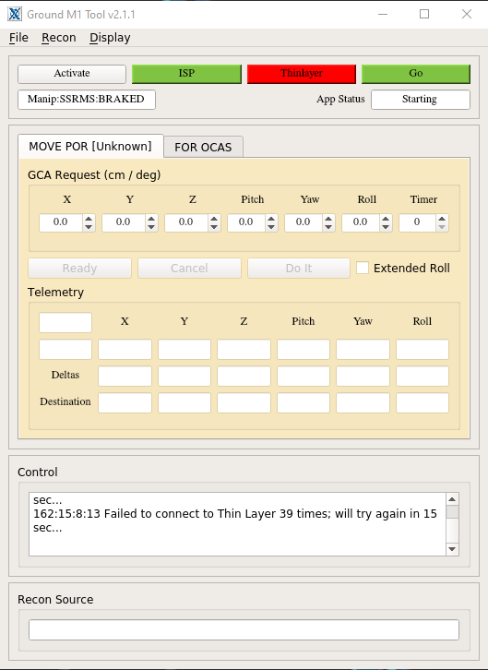
The ad hoc nature of GCA maneuvering, however, precludes the use of scripts and although FOR OCAS mode can be used to mimic manual mode, a series of operator commands are needed for every FOR OCAS maneuver. To mitigate this reduction in efficiency a new application was created for use during Ground M1 operations. Aptly named the “M1 Tool,” the application allows for faster and more intuitive inputting of FOR OCAS destinations than legacy SSRMS ground commanding tools. This is primarily achieved by allowing the Ground operator to command FOR OCAS maneuvers by entering the delta direction and distance to be traveled (e.g. +30 cm in the X axis or -10 degrees in yaw) rather than by requiring that the operator calculate and input the full set of X, Y, Z, pitch, yaw, roll values of the FOR at the destination. The M1 Tool additionally enables faster second-operator verification that the destination entered is correct. Figure 4 illustrates the M1 Tool’s graphical user interface.
Figure 4 - M1 Tool User Interface

    - Collision Risk Implications and Mitigations
As discussed in Section 1.2, arm-supported EVA operations are high risk as they require maneuvering of the SSRMS and crewmember in close vicinity of ISS structure. Various mitigations (also discussed in Section 1.2) are employed to reduce risk of collision. All these will be leveraged when performing Ground M1 operations, though Onboard Monitoring of Motion will be limited to what the spacewalking crewmembers can observe, and the general situation awareness of all onboard crewmembers informed by monitoring radio communications. Four new, additional mitigations are being introduced in support of Ground M1 to account for the increased risk of collision that results from the latency and potential for interrupted vehicle connectivity experienced by ground operators:
- Functionality was added to the ground operator’s dynamic, graphical computer models of the ISS and SSRMS such that when the operator enters an FOR OCAS or GCA destination using the M1 Tool described in Section 2.1.1, the graphical models display the SSRMS/crewmember configuration that will result. This allows the ground operator to confirm prior to commencing motion that the direction of motion will be as requested and that there is no risk of collision at the destination. This capability additionally enables the ground operator to suggest alternate or improved destinations to the crewmember “riding” the arm.
- Maximum allowable SSRMS maneuvering speed will be set lower than that allowable when motion is commanded by an onboard M1. This increases the time available for ground operators to identify and react to motion errors in the presence of increased latency. This also accounts for the fact that during FOR OCAS mode maneuvers, the robot’s control system commands to maximum speed, whereas when onboard crew perform manual mode GCA maneuvers they often don’t fully deflect the hand controller and thus often don’t achieve maximum maneuvering speed. Finally, reducing maneuvering speed reduces impact loads in the event of collision.
- Operators and crewmembers will be advised to perform multiple small GCA maneuvers rather than fewer large maneuvers. Although each maneuver carries risk of operator error causing motion in the wrong direction, its felt that this approach mitigates the larger risk of collision due to overestimating maneuver distance and/or loss of ground connectivity to the SSRMS resulting in inability to respond to a “stop motion” or “all stop” call.
- An onboard crewmember will monitor radio communications during the Ground M1 activity and be available to safe the SSRMS in the event of delayed ground response to an “all stop” call.

    - Trapped Crewmember Risk Implications and Mitigations
The second major risk discussed in Section 1.2 was the potential to trap a crewmember on the tip of the SSRMS beyond reach of ISS structure, or for the positioning of the robot to otherwise prevent a crewmember from returning to the airlock. When performing Ground M1 operations this risk can be uniquely triggered by loss of the ground team’s ability to command to the SSRMS, which relies on the nominal performance of various ISS, communications satellite, and ground segment systems.
Related to the risk of trapping a crewmember is the requirement for crewmembers “riding” the SSRMS to be returned to structure and egressed from the APFR within fifteen minutes. Clearly, any loss of the Ground M1 team’s ability to command to the SSRMS would result in inability to meet this requirement. The development team also noted that several of the operations techniques introduced to mitigate collision risk (Section 2.1.2) have the effect of slowing SSRMS maneuvering, putting the requirement at risk.
To address these hazards, the Ground M1 operations concept leverages the mitigations presented in Section 1.2 as well the following:
- Enhanced vehicle connectivity – The ISS Program secures enhanced communications satellite services when performing high-risk activities such as spacewalks. This reduces the frequency and duration of vehicle loss of signal events. Prior to commencing the spacewalk, the team verifies the health of all ISS, MSS, and ground segment components in the critical path of Ground M1 commanding. Wherever possible, redundant systems and components are configured for rapid switch-over.
- Smart EVA task and maneuver scheduling – Nominal vehicle loss of signal events are predictable. The Ground M1 team confirms sufficient communications coverage is forecasted to complete the full maneuver sequence prior to commencing maneuver sequences that, if interrupted, could trap a crewmember.
- Smart SSRMS maneuver and configuration planning – To the greatest extent possible, SSRMS maneuvers and configurations are designed to permit the crewmember to egress the APFR with little or no SSRMS reconfiguration. This is termed “self-return.”
- Pre-planned EVA crewmember response – The EVA crewmembers will return to the airlock in the event of an unexpected loss of communications with the ground lasting more than 15 minutes. This may require intervention by an onboard SSRMS operator to configure the arm for APFR egress.
- Intervention by an onboard SSRMS operator – Although the scenario driving Ground M1 is lack of an onboard crewmember trained or available to perform M1 functions (see Section 1.4), the concept relies on a minimally trained onboard operator to assist with the rescue of a trapped crewmember, particularly in the event that the ground team is unable to perform this function. This onboard role and the operations associated with it have been termed “M-Rescue.” In the days leading up to CCE execution the M-Rescue operator would be identified and would receive basic training on SSRMS operations sufficient to follow an M-Rescue procedure. The procedure provides step-by-step instructions for maneuvering crew to ISS structure and egressing the APFR. Recognizing that the procedure will be executed by someone with minimal training and with little or no ground team support, it may depart from M1/M2 procedure standards where necessary to better guide an inexperienced operator towards independent success.

    - Ground Operator Cognitive Loading
Ground-based SSRMS operators are subject to several distractions not present for M1 and M2. Perhaps the most intrusive of these is the amount of communications traffic the ground team must monitor and participate in. In the case of M1/M2, all communications with the ground team are funneled through the CAPCOM console position. Message content is carefully curated by CAPCOM to be concise and not distract from the task at hand. The M1/M2 also communicates with the spacewalking crewmembers. To further encourage focus, M1 and M2 are co-located. M2 will typically be prime for communications while M1 is prime for SSRMS commanding.
Conversely, members of the robotics ground team are not co-located, instead relying on communications loops to converse with each other. They may also be engaged in discussion by or with their engineering support counterparts or other members of the larger ISS flight control team. Ground-based SSRMS operators are also expected to monitor communications with the crew, provide regular status to and receive direction from the Flight Director, and monitor communications between other ISS system operators to maintain awareness of happenings that could affect the robotics operations.
Ground operators additionally have access to and are expected to continuously monitor extensive health and performance data for the SSRMS, supporting robotics systems, and various ISS systems that could impact robot performance. Ground operators are expected to investigate in real-time (and potentially troubleshoot) off-nominal indications and impacts of unplanned conditions. Ground operators are additionally expected to monitor the day’s highly choreographed sequence of events and to re-plan activities and maneuvers in real-time as required.
Finally, ground operator interfaces to the SSRMS and its supporting systems are many and vary in their level of user friendliness. Creation of the M1 Tool presented in Section 2.1.1 helps mitigate this challenge but is only one of many command and control applications used simultaneously.
For these reasons, operator cognitive loading was identified as a potential barrier to safe and efficient ground-controlled arm-supported EVA. Early Ground M1 operations concept development simulations experimented to determine optimal team size and distribution of tasks. The result is a team of five certified flight controllers tasked as follows:
- Ground M1 – Communicates with other members of the flight control team, the Flight Director, and the onboard crew (bypassing CAPCOM), particularly during GCA maneuvering. Ground M1 additionally directs the Ground M1 Operator and is responsible for navigating the SSRMS procedure and ensuring the Ground M1 Operator is commanding the SSRMS consistent with the procedure and the crew’s GCA requests.
- Ground M1 Operator – Primary operator of the SSRMS. Performs SSRMS commanding as detailed in the SSRMS procedure and as required to maneuver the SSRMS/crewmember between EVA worksites and in response to GCA maneuver requests. Ground M1 Operator is co-located with Ground M1.
- ROBO – Provides Ground M2 support by verifying procedure call outs, camera views, and commands. Prime for coordinating failure impacts and responses across the larger flight control team.
- MSS Systems – Provides Ground M2 support by performing ISS camera commanding. Prime for monitoring MSS and ISS system performance, investigating off-nominal conditions, and developing and performing troubleshooting activities.
- MSS Task – Provides Ground M2 support by performing MSS camera commanding. Prime for monitoring timeline and schedule, maintaining awareness of EVA task progression, and for real-time re-planning of SSRMS configurations and maneuvers.
The above represents a notable increase in team size when compared to the teams of three flight controllers (ROBO, MSS Systems, and MSS Task) used to perform standard ground-controlled SSRMS and SPDM operations. The Ground M1 development team was careful to consider risks associated with the larger team size including increased opportunities for distraction, miscommunication, and role confusion. The development team also noted that the above arrangement distributes functions performed by the onboard M2 across multiple ground operators. This was found to be necessary to account for the relative complexity of ground commanding applications and protocols and to ensure each position can perform both their traditional functions and additional Ground M1-associated functions within a reasonable cognitive loading.
Of note is the Ground M1’s responsibility to communicate directly with the onboard crew. This represents a significant departure from traditional arm-supported EVA, during which all communications with the spacewalking crew are funneled through a “Ground IV” officer charged with relaying to them EVA information and task instructions. In the case of Ground M1, however, it was found to be most efficient and least risky to permit direct communication between the Ground M1 team and the crewmember “riding” the SSRMS when executing GCA maneuvers. Due to the high-risk nature of such maneuvers the Ground IV abstains from talking to the crew while coordination and execution of GCA maneuvering is taking place.
During traditional arm-supported EVA operations the onboard M1 additionally alerts the spacewalking crew to the start and completion of non-GCA SSRMS maneuvers. In the case of Ground M1 these alerts are communicated by Ground IV as they are less safety critical and to minimize interruptions in Ground IV’s ongoing flow of information and instructions to the crew.

  - Ground M1 Concept Development and Validation
As previously described, arm-supported EVA is a high-risk activity. Changes in operations concepts that could increase risk to the crew, the vehicle, or mission success must be carefully considered and, in most cases, would not be tolerated. Recall, however, that Ground M1 is intended only to be undertaken in CCE scenarios where a) timely recovery of extravehicular systems is required for continued ISS operations and b) there is no onboard M1 operator available. In such contingency situations the ISS Program typically accepts increased risk. However, it remains prudent to refine operations concepts to mitigate risk and encourage mission success to the greatest extent possible.
Several arm-supported EVA and Ground M1 risks, hazards, and mitigations have been discussed throughout this paper. Two operator performance-related factors either directly or indirectly affect these either through causing the hazard, affecting the likelihood of the hazard, and/or affecting the effectiveness of the mitigation. These factors are:
- Incorrect commanding – Commanding incorrect SSRMS motion (e.g. incorrect direction or distance) may result in collision with ISS structure. Non-motion-related commanding errors result operations inefficiency as the operator must issue corrective commands, which slows operations.
- Operations inefficiency – Inefficient commanding and hazard controls such as reduced maneuvering rates (see Section 2.1.2) may delay or slow operations. This increases risk of trapping a crewmember and inability to complete spacewalk objectives. Inefficiency is a particular concern in contingencies requiring rapid return of the crewmember to the airlock.
The Ground M1 development team therefore selected commanding accuracy and operations efficiency as two key figures of merit for use when developing, refining, and validating Ground M1 operations concepts, techniques, and tools. The goal was to achieve a commanding accuracy rate as good or better than onboard M1/M2 operator performance and to minimize, to the greatest extent possible, operations inefficiencies resulting from transfer of tasks from onboard M1/M2 to the Ground M1 team.
The development phase began with discussions internal to NASA’s Robotics Operations branch. Flight controllers experienced in the execution of both ground-controlled robotics operations and arm-supported EVA assessed existing operations concepts, techniques, and tools for each and identified risks and challenges associated with merging the two. Particular attention was given to the figures of merit discussed above. As concepts were matured, flight controllers from NASA’s EVA Operations branch were engaged to consult on impacts to EVA task choreography, task completion, and activities such as rapid APFR egress and crewmember return to the airlock. The crew perspective was provided by members of NASA’s astronaut cadre and by robotics and EVA instructors.
Operating procedures and rules were then drafted. These were first tested in tabletop simulations during which the multi-disciplinary (robotics, EVA, and crew) team talked through execution of an end-to-end Ground M1 arm-supported EVA. As the team progressed through each activity of the simulated EVA, they rehearsed conceptual communications protocols and off-nominal scenario responses. Through tabletop simulations the team was able to experiment with various operations concepts and adjust in real-time at relatively low cost.
The team also leveraged NASA’s high-fidelity ISS simulator to validate operations concepts, techniques, and tools. This facility provides a highly accurate, dynamic model of ISS, MSS, and ground system behavior. Operators can command to the simulated ISS using flight-equivalent ground tools and observe flight-equivalent vehicle response. Flight-equivalent latency is modeled, as are computer-generated flight-equivalent camera views. The high fidelity of the facility allowed the development team to assess various, evolving operations concepts against the figures of merit.
The team commenced high-fidelity simulations in March of 2023. Three sessions were completed by early April, 2023. These events were supported by members of the Robotics Operations and EVA Operations branches and focused on comparison of candidate concepts developed during the discussion and tabletop simulation phases of the project. Effects on command accuracy and operations efficiency were measured for various Ground M1 team sizes and allocations of roles and responsibilities across team members. The team also assessed how choice of command applications affected the figures of merit.
In July of 2023 the team demonstrated Ground M1 during an “integrated” simulation. Integrated simulations also make use of NASA’s high-fidelity ISS simulator but involve all members of a standard flight control team as well as a proxy ISS crew. This introduces the various distractions a flight control team faces during real-time operations including increased communications traffic and a requirement to pay attention to the health and status of non-robotics systems. Integrated simulations also emphasize operations efficiency and provide an opportunity to stress-test the operations concepts across a wider variety of nominal and off-nominal conditions including significant GCA maneuvering, extended loss of communications with the vehicle, and M-Rescue scenarios.
Findings from the first round of high-fidelity and integrated simulations suggested that commanding accuracy was on par with onboard crew performance (Figure 5) but there was significant operator cognitive loading, which negatively impacted operations efficiency.

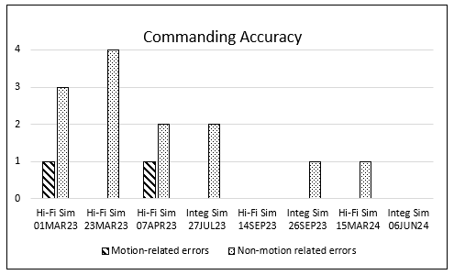
Figure 5 - Commanding Accuracy
Following the July 2023 integrated simulation the team developed the M1 Tool, which was effective in eliminating motion-related errors and helped decrease operator cognitive loading (see Sections 2.1.1 and 2.1.4). They also continued to evolve team composition and task allocations, which was effective in further reducing operator cognitive loading and in increasing operations efficiency. These were assessed during high-fidelity and integrated simulations in September 2023. The result of this round of development was the team composition and tasking described in Section 2.1.4 as well as a mature concept for training and execution of M-Rescue.
A demonstration of Ground M1 during an ISS spacewalk was planned for November 2023 (see Section 2.3.) As the demonstration was repeatedly delayed, the Ground M1 team conducted a high-fidelity simulation in March 2024 and an integrated simulation in June 2024 to maintain their skills. No significant changes to Ground M1 operations concepts resulted from these simulations.

  - Next Steps
The high fidelity of NASA’s ISS simulator provides high confidence in the Ground M1 operations concepts that have been developed. However, despite this and despite the risks introduced by Ground M1, there remains a desire to demonstrate and further validate it during a nominal ISS spacewalk rather than have its first use occur during a high-stakes CCE event. History has shown that even the highest fidelity simulations cannot fully model the rigors of human spaceflight and there are always lessons learned from executing operations in real-time. Human nature and the high workload of the organizations and individuals working the project also suggests some aspects of Ground M1 may not have or will not be given the same level of scrutiny that will be applied when actual execution of Ground M1 is scheduled.
To this end, the ISS Program and NASA’s Flight Operations Directorate identified repair of the Port 1 Lower Outboard camera as a candidate EVA task for the demonstration. Originally scheduled for completion in the fall of 2023, this task would provide an opportunity to demonstrate all nominal aspects of Ground M1 operations including GCA maneuvering. To reduce timeline and technical risk, the operations would be observed by an onboard M1 prepared to take over from the Ground M1 team at any time. Unfortunately, in the weeks leading up to the spacewalk the camera repair was deferred in favor of a higher priority task. In the two years since, the camera repair has yet to be re-assigned to an EVA. Until the task is re-scheduled or an alternate suitable task is identified for a demonstration, the team has paused further work on the Ground M1 project.

- Organizational Considerations
The Robotics Operations branch worked through several organizational considerations throughout the project. Some of the most significant are addressed below.

  - Robotics Operations Branch Workload and Real-Time Execution Plan
Because Ground M1 is expected to be a rarely (if ever) executed contingency ISS capability, and because the Robotics Operations branch is funded and staffed at minimal levels, it is impractical to always maintain a cadre of personnel trained and ready to perform the function. For this reason, and to keep development costs low, the Ground M1 operations concept leverages existing, familiar ground-controlled robotics and arm-supported EVA techniques, tools, and products such that any certified robotics flight controller should be able to support Ground M1 with minimal additional training. As of March, 2025, Ground M1 is ready to execute if or when needed, and further work on the project has been paused.
Future work will be performed on an as-needed, just-in-time basis. For example, work would resume upon identification of either a) an opportunity to demonstrate the concept (see Section 2.3) or b) an increase in likelihood of the need to exercise it (e.g. ISS going into a period of reduced USOS crew compliment due limited consumables, crew transport vehicle issue, etc.) In either event, the Robotics Operations branch would assign a small team of flight controllers and a robotics instructor to execute one or more high-fidelity simulations to familiarize themselves with all aspects of Ground M1. The team would also develop spacewalk task-specific procedures and a crewmember-specific M-Rescue training curriculum. In the one-to-two weeks prior to spacewalk execution, the Ground M1 team would participate in one or more integrated simulations to familiarize the larger flight control team with Ground M1 concepts and associated space-to-ground communications choreography. The Ground M1 team would also deliver the M-Rescue curriculum to the appropriate onboard crewmember and participate in various conferences with the onboard crew to discuss anticipated GCA maneuvers, crewmember positioning at EVA worksites, and communications protocols.

  - Robotics Operations Branch Culture
The Robotics Operations branch was excited to take on the Ground M1 project as it allowed them to continue to expand the operating envelope for ground-controlled robotics and an opportunity to develop and demonstrate their expertise in new ways. Through Ground M1, the team was able to explore alternate operating techniques and to develop improved ground applications, which can be used outside the Ground M1 context. The instructor cadre also enjoyed solving the problem of how to most efficiently remotely train an unexperienced crewmember to perform the critical M-rescue function under just-in-time pressures. These experiences align with and nurture the branch’s culture of continuous improvement, relentless drive to efficiency, and creative innovation.

  - Stakeholder Approval – Crew Office
High levels of trust and synchronization are needed between the SSRMS operator and the spacewalking crewmembers during an arm-supported EVA. Trust is necessary because the arm operator’s performance can directly affect the safety and success of the spacewalking crew while synchronization is critical to maximizing operations efficiency. A high level of trust exists between NASA’s robotics flight controllers and the crew. This has been built over decades spent working and training together. Since 2005, the Crew Office has watched the Robotics Operations branch methodically expand the ground-controlled robotics operations envelope. By taking a measured approach, the branch has demonstrated their commitment to safety and unwillingness leap too far, too fast. Therefore, when the branch asserts that they are confident and comfortable with the Ground M1 concept, their judgement is trusted.
Representatives from the Crew Office were involved in the Ground M1 development process from the outset. This ensured the crew perspective was always kept at the forefront and ensured that crew concerns were identified quickly and addressed thoroughly. One area of particular concern to the Crew Office was how the problem of safe and efficient GCA maneuvering in the absence of hand controllers would be solved. Confidence in the solution was built by having the robotics flight control team demonstrate their ground control tools and techniques to several members of the Crew Office.
Concerns regarding synchronization were addressed during high-fidelity and integrated simulations, in which the development team worked closely with members of the Crew Office to develop spacewalker-to-Ground M1 communications protocols and Ground M1-to-Ground IV and Ground M1-to-CAPCOM communications protocols. In the event of Ground M1 execution onboard ISS, synchronization between the Ground M1 team, spacewalking crew, and M-Rescue operator will be assured by having all three participate in a series of pre-spacewalk conferences to review the choreography of the spacewalk, roles and responsibilities, communications protocols & preferences, SSRMS maneuvers, crewmember body positioning, and contingency procedures.

  - Stakeholder Approval – Flight Director Office
The NASA flight director is responsible for leading the combined NASA and International Partner flight control team towards coordinated mission safety and success. A significant enabler of this is clear, concise communications and clearly established roles, responsibilities, and limits of authority when operating in Mission Control. Clear and concise operational products and techniques are also key. In the context of Ground M1 and taking this into consideration, the Flight Director Office’s primary concern was the introduction of additional members to the robotics flight control team (see Section 2.1.4) and Mission Control Center environment as this could result in confusion and/or increased cognitive loading for other members of the flight control team. The Flight Director Office was also concerned about permitting the Ground M1 operator to speak directly to the onboard crew, particularly during spacewalks, during which communications traffic is typically fast and congested.
Flight Director Office buy-in was achieved primarily through integrated simulation refinement and demonstration of Ground M1 communications protocols and console position roles and responsibilities. During the simulations the Flight Director and other members of the larger flight control team were able to assess impacts and implications to their work due to the Ground M1 operations.
  - Stakeholder Approval – International Space Station Program & Partners
Considerable coordination occurred between the Ground M1 development team and the ISS Program’s Safety and Mission Assurance office, and with NASA’s independent Safety Office. Known hazards related to EVA and robotics operations were reviewed in detail to determine the effect of Ground M1 on the likelihood and severity of those hazards. New hazards were also brainstormed and considered. All Ground M1 operations concepts were assessed against existing and new operational hazard controls and adjusted as needed to protect crew and vehicle safety.
The Robotics Operations branch also coordinated closely with the Canadian Space Agency (CSA) throughout the development process as the MSS is a Canadian ISS asset. Consultations were held with CSA program management and with the combined NASA/CSA engineering teams to assess Ground M1 concepts against agreed operating philosophies and limitations.
This proactive coordination with affected stakeholders resulted in a relatively easy approval of the Ground M1 concept by the Space Station Program Control Board. Less easy, however, was agreement to perform a demonstration of the concept during a nominal spacewalk as there were differences in opinion regarding risk-versus-reward. Ultimately, as discussed in Section 2.3, the community agreed to proceed with a demonstration, though as of March 2025, it has yet to be performed. A contributing factor to the decision to proceed was an Artemis Program desire to demonstrate proof-of-concept in support of future human spaceflight vehicle and operations concept design. Parallels between Ground M1 and future human spaceflight operations are discussed in the following section.

- Future Applications and Growth
As previously discussed, the Ground M1 operations concept was primarily developed to meet an ISS need. However, several aspects of the concept may inform plans and designs for future human spaceflight vehicles and operating domains. Some of these are discussed below.

  - Novel Operator Interfaces
Perhaps the greatest technical challenge that needed to be solved when developing the Ground M1 operations concept was working around the ground’s inability to command the SSRMS via hand controllers and manual maneuvering mode (see Section 2.1.1.) This problem is of interest to developers of future arm-equipped vehicles as hand controllers are relatively bulky and heavy. Replacing this hardware saves valuable mass and volume and reduces complexity in an end-to-end robotics system. Evidence of this trend is seen in the SpaceX Dragon crew capsule, which relies on touchscreen, rather than hardware, crew interfaces to vehicle systems [7].
The Ground M1 project was successful in demonstrating a safe, efficient workaround using an alternate robot maneuvering mode (FOR OCAS) and novel ground operator interface (the M1 Tool.) The team considered a variety of operator interfaces for commanding GCA maneuvering including slider bars and graphical positioning of the arm at the estimated ending configuration in a reverse feedback loop. While the team ultimately chose to implement a solution wherein the operator specifies arm/crewmember destination by inputting distance and direction of motion as this proved to be the safest and most accurate choice, several of the other methods investigated are used by members of the Robotics Operations branch while performing non-real-time mission design. This is allowing the team to continue to develop and gain confidence in such operator interfaces.

  - Increased Trust and Confidence in Remote Operating Partners
With a latency of under 3 seconds between the Earth and our moon, Earth-based telerobotic control of rovers and robotic systems is likely to occur in both the cis-lunar and lunar surface domains. This may be driven by a desire to decrease crewmember training and tasking, and/or in response to practicalities surrounding the visions of the various commercial and international partners slated to provide these systems. Also likely is operation of lunar surface systems by personnel located in lunar orbit or in the relative safety of habitats far from the system being operated [8]. Such activities were recently demonstrated via an experiment wherein a crewmember onboard the ISS commanded a rover operating in a simulated lunar environment at the Ames Research Center [9].
It is noted that Ground M1 represents an increased distancing between the arm operator (previously located onboard the ISS) and the spacewalking crew. A natural extension of Ground M1 would include the remote operation of rovers and robotic systems nearby or in direct collaboration with crewmembers located on the lunar surface or in cis-lunar orbit. In such cases, hazards such as crew injury due to incorrect robot motion run parallel to the hazards addressed during the Ground M1 project. As was also done during the Ground M1 project, consideration will need to be given to topics such as synchronization with the crew and communications protocols. In this way, the Ground M1 project is a pathfinder towards increasing NASA’s trust and confidence in increasingly remote operating partners that may be an enabler of safe and successful lunar exploration.

  - Increased Trust and Confidence in Autonomous Operating Partners
Advancing the concepts discussed in Section 4.2 one step further and recognizing today’s rapid advancement in automated and autonomous vehicle and system control, there is a need for NASA to increase its trust and confidence in autonomous operating partners. One can easily envision a crewmember on the lunar or Martian surface working collaboratively with an autonomously-operating robotic or rover-type system or relying on such a system to autonomously transport an incapacitated crewmember to safety. The Ground M1 team considered exploring this further by developing an autonomous M-Rescue function wherein a single command to the system would result in the MSS autonomously determining the position of the SSRMS and then autonomously selecting and executing an appropriate series of commands and maneuvers to deliver the crewmember to the airlock. Ultimately, this solution was not pursued due to cost, complexity, and safety concerns, but a foundation was laid to mature such operations in the future.

- Conclusion
Through the Ground M1 project, NASA’s Robotics Operations branch successfully solved the problem of how to perform ISS arm-supported EVA in the absence of an onboard robotics operator. To reduce risk and cost, the solution leverages concepts and tools proven through the organization’s decades of safe and successful ground-controlled robotics operations experience. The solution additionally represents a logical next step in the team’s purposeful expansion of their ground-controlled robotics envelope. Ground M1 operations concepts were validated using NASA’s high-fidelity ISS simulator and endorsed by a variety of stakeholders and there remains a desire to demonstrate the capability during a nominal ISS spacewalk.
Particular attention was paid during the project to concerns including latency, operator interfaces, communications protocols, operator cognitive loading, and trust and confidence in an increasingly remote operator. These concerns are relevant in the contexts of telerobotic and autonomous operation of robots and rovers in the lunar and Martian domains. Drawing on their proven track record of excellence and a desire to test novel operations concepts, NASA’s Robotics Operations branch continues to innovate and improve the efficiency of robotic operations for space applications as they expand the limits of human exploration towards the Moon, Mars, and beyond.

References

[1] | Essex Corporation for NASA, "Study of Roles of Remote Manipulator Systems and EVA for Shuttle Mission Support (NASA-CR-140364)," 1974.
[2] | Government of Canada, "Flight History of Canadarm," 31 March 2021. [Online]. Available: https://www.asc-csa.gc.ca/eng/canadarm/flight.asp. [Accessed 22 February 2025].
[3] | C. Hansen, "Mishap Investigation Board Summary of Extravehicular Activity 23: Lessons Learned from a Spacewalk Close Call," Journal of Space Safety Engineering, vol. 1, pp. 32-39, 2014.
[4] | P. Greene, "Enhancing MSS Software to Meet the Evolving Needs of the ISS," in 56th International Astronautical Congress of the International Astronautical Federation, Fukuoka, Japan, 2005.
[5] | R. Rembala and S. Aziz, "Increasing the Utilization of the ISS Mobile Servicing System Through Ground Control," Acta Astroanutica, vol. 61, pp. 691-698, 2007.
[6] | S. Aziz, "Development and Verification of Ground-based Tele-robotics Operations Concept for Dextre," Acta Astronautica, vol. 86, pp. 1-9, 2013.
[7] | A. G. Seidel, "Designing a Console for Future Space Operations," in Space Operations, Cham, Switzerland, Springer Aerospace Technology, 2022, pp. 187-198.
[8] | M. Bualat, W. Carey, T. Fong, K. Nergaard, C. Provencher, A. Schiele, P. Schoonejans and E. Smith, "Preparing for Crew-Control of Surface Robots from Orbit," in Space Exploration Conference, Washington, DC, 2019.
[9] | M. Bualat, D. Schreckenghost, E. Pacis, T. Fong, D. Kalar and B. Beutter, "Results from Testing Crew-Controlled Surface Telerobotics on the International Space Station," in iSAIRAS - International Symposium on Artificial Intelligence, Robotics, and Automation in Space, Montreal, Quebec, 2014.

