SpaceOps-2025, ID #241
Artemis Payload and Science Utilization: Building From 20+ Years of Experience Maximizing Science on ISS
Spenser Kockler
Payload and Mission Operations Division, Gateway Project Lead, NASA Marshall Space Flight Center, Huntsville, Alabama, USA william.s.kockler@nasa.gov
Abstract
The National Aeronautics and Space Administration (NASA) Moon to Mars (M2M) Program plans to return humans to the Lunar Surface for the first time in more than 50 years, and then will send astronauts to Mars for the first time ever. A major priority of these missions will be to have crews collect surface samples during Extravehicular Activities and return them to Earth. Additionally, a game-changing benefit of these exploration missions is the ability to perform novel scientific operations with and without crews. These scientific operations may occur on the Lunar or Martian surfaces, within the pressurized volume of a surface element, externally attached to a surface element, or in near-rectilinear halo orbit around the Moon. These scientific objectives may consist of studies that aim to make scientific discoveries within the fields of heliophysics, materials science, human and biological sciences, planetary science, surface characterization, as well as many other areas of research that will provide significant benefits to humanity.
The Payload and Mission Operations Division (PMOD), within the Human Exploration Development and Operations Office, at NASA’s Marshall Space Flight Center will leverage more than twenty years of International Space Station scientific operations experience along with the background of supporting other historic scientific programs to aid the success of NASA’s exploration scientific objectives. PMOD will use modern infrastructure and proven capabilities to execute necessary components of Artemis scientific operations that include, but are not limited to, integrated planning product development, crew and ground procedure development, command and data handling, telemetry monitoring, anomaly recognition and resolution, and safety verifications. PMOD will also be utilizing autonomous systems and will continue to incorporate state of the art techniques to maximize science opportunities and data return, including phases when crewmembers are not present. This paper will discuss the capabilities and processes that PMOD will utilize to maximize scientific return during Artemis Missions. This includes crewed and uncrewed surface and lunar orbit missions.

Keywords: Science Operations, Artemis, Payloads, Integration, MSFC, Moon to Mars, Utilization

- Introduction
Since its initial launch in 1998, the International Space Station (ISS) has evolved into an international research facility unlike any other. The ISS is the birthplace of scientific discoveries which would not have been possible on Earth’s surface. These discoveries have been achieved in experiments relating to drug development, muscle atrophy and bone loss, states of matter, 3-Dimensional (3D) printing, human research, and many others. Without the ISS, these scientific breakthroughs would not have been possible.
Along with scientific breakthroughs, the ISS has been an incubator for the growth of space commercialization. Over the years, there has been a significant rise in the number and type of commercial companies supporting the ISS. These companies provide widely different support such as payload development, resupply vehicles, crew vehicles, private astronaut missions, and many other areas. The rise in ISS commercial partnership has led to an increase of space commercialization in general. Commercial providers will be at the forefront of the crewed spaceflight transition to exploration beyond low-Earth-orbit (LEO).
At the center of ISS payload, and scientific operations is the Payload and Mission Operations Division (PMOD) located at NASA’s Marshall Space Flight Center (MSFC) in Huntsville, Alabama. For more than 20 years, the Huntsville Operations Support Center (HOSC) along with the Payload Operations Integration Center (POIC), within PMOD, have performed operations integration for ISS payloads [1]. As part of these operations, the POIC has worked with various International Space Agencies as well as commercial partners.
The future of crewed space exploration will be vastly different from what we have witnessed with the ISS. We will see many new international agencies, commercial providers, and other partners begin participating in scientific research beyond LEO, to include the Lunar surface and even Mars. In order to remain successful in space exploration and continue scientific advancement, it’s imperative that we maintain the base of knowledge and utilize the experience we have from ISS to influence the future of space exploration, specifically scientific operations.
- History and ISS Operational Support
Operators, scientists, and engineers within the HOSC have supported space research and NASA missions for more than 50 years. Supported programs from the HOSC include Saturn V, Sky Lab, and the Space Shuttle, along with many more uncrewed missions. The HOSC continues to provide support to NASA’s Commercial Crew Program and Commercial Resupply Services missions. However, over the past 20+ years, the largest mission the HOSC has support is the ISS. Flight Controllers and other personnel have been providing 24x7 real-time support to the scientific operations performed on the ISS since 2001.
Early on during the ISS Program, the majority of the crew time was focused on assembling the vehicle. During this time, the HOSC developed a distributed architecture model, which allowed operators and scientists the ability to support real-time space research from anywhere in the world. Researchers and scientists had the ability to access voice loops, commanding, and telemetry services from their home laboratories [1]. With the transition from assembly to utilization, the scientific operations increased from 0-25 crew hours per week, to averaging between 55 and 80 hours of crew time per week, with multiple weeks reaching record highs of 110 hours or higher [2]. Along with the crew time hours dedicated to scientific operations, numerous other payloads continued to collect science without any crew interaction – both internal and external to the vehicle. This was all made possible by the distributed architecture model which has allowed more than 4000 remote users, supporting from more than 14 different countries, the ability to perform space research onboard the ISS [2].
Operating since 2000, the Telescience Resource Kit (TReK) is a PMOD developed, and managed, suite of software applications and libraries that provide generic data systems services. This suite of tools provides payload developers and other users the ability to monitor and control their ISS payloads from anywhere with access to the internet. By utilizing this software, scientists and engineers can easily monitor their scientific data, perform necessary command operations, and transfer files between their ground and onboard hardware. This software has allowed the science community the ability to perform their onboard operations in a more streamlined, easier, and cheaper method.
Figure 1: TReK Lifecycle Support for ISS
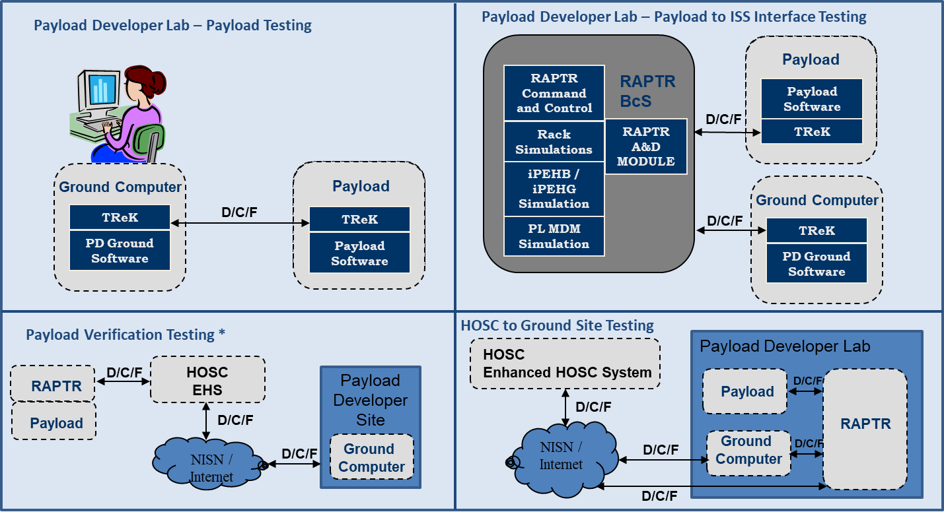
Since the ISS transition from assembly phases to utilization, the payload compliment and crew time hours dedicated to science operations significantly increased. Because of this, the POIC flight control team (FCT) had to evolve and adapt with the increase in operations. This led to the development of the Higher Ops Tempo (HOT) Concept which included doubling up multiple real-time operator positions in order to support multiple science operations happening simultaenously, as well as creating efficiencies by pre-determining real-time decisions, and responses, that required approval from the Payload Operations Director.
With the HOT Concept, the POIC real-time flight control team grew to be more than 10 operators on a regular basis, this number does not include the various payload developers supporting their science experiments on board. With that in mind, the number of operators, scientists, and engineers that could be supporting real-time ISS science operations, could be higher than 50 people at a given time. With the consistent tempo of operations, and the ever-evolving culture that NASA operates in, efficiencies were found, operational products were streamlined, and the number of real-time operators required was able to be driven down. Because of these concepts, PMOD was able to support weeks with more than 100 hours of crew tended payload operations, getting as high as 136 hours in a single week, without any issues.
The ISS real-time planning process is an iterative process that begins six months prior to a crewed mission, an increment as referred to in the ISS Program. The planning begins by assigning activities to each day throughout the increment. These activities are assigned based on programmatic requirements, crew time, science requirements, and other factors such as resource availability – this product is referred to as the On-orbit Operations Summary (OOS), which accounts for about 6 months worth of planning inputs. The preliminary OOS is finalized four months prior to an increment, and is then revisited and finalized one month prior to the increment. After finalization, the OOS is utilized to develop the Weekly Lookahead Plan (WLP), starting two weeks prior to execution. The WLP evolves into the Short Term Plan at one week prior to execution, which is then finalized and handed over to the real-time team six days prior to execution. These plans are updated daily as the planners work through the flow.
With the increase in the number of crew hours available to perform science operations, changes were needed for the payload planning process as well. In additional to the increase in crew hours, other resources became more constrained – available space aboard ISS, power availability, data rates, video downlinks, etc. Through lessons learned, planning teams determined the OOS would need to be updated a month and a half into the increment. Along with this update, payload planning teams reorganized how their subject matter experts would be staffed to maximize timeline development. Roles seemingly remained unchanged; however, extra planners were added to the team to counteract the increased workload. Additionally, new support rooms were created to focus specifically on the science data flow planning, on-orbit payload inventory management, as well as visiting vehicle support.
- Future Science Operations beyond LEO
The Artemis Campaigns will be a part of NASA’s Moon to Mars Program and consists of multiple sub-programs:
- Space Launch System (SLS)
- Orion Crew Spacecraft
- Gateway
- Human Landing System (HLS)
- EVA and Human Surface Mobility Program (EHP)
- Exploration Ground Systems (EGS)
The Moon to Mars strategy asks “Why Go?” The answer to this question stands on three pillars – Science, National Posture, and Inspiration. Each of these pillars is immensely important; however, the focus of this paper is science. These highly complex missions are conducted with the pursuit of knowledge as a driving factor. To explore and understand the universe is a key goal of each Artemis mission. Crewed exploration beyond low-Earth orbit, especially on planetary bodies, allows for humans to expand their knowledge on a multitude of topics [4]:
- Lunar/planetary sciences
- Heliophysics
- Human and biological science
- Physics and physical science
- Applied science
The first crewed mission, Artemis II, will bring astronauts to lunar orbit for the first time in over 50 years. The next mission, Artemis III, will deliver astronauts to the lunar surface for the first time since 1972.
Beginning with Artemis 4, each crewed mission will consist of each one of the programs mentioned above. The crew will be launched within the Orion capsule onboard an SLS rocket. Once in orbit, Orion will separate from SLS and deliver astronauts to Gateway, a lunar orbiting outpost. From there, the crew will be able to transfer to HLS vehicles which will then deliver them to the lunar surface. Each of these crewed missions will consist of astronauts performing science and payload operations during all phases – Orion transit to near-rectilinear halo orbit (NRHO), within the Gateway orbiting laboratory, as well as on the lunar surface – both within the HLS vehicles or during space walks on the lunar surface.
Later Artemis missions have plans for additional elements, such as rovers and surface habitats, that will maintain the capability to perform crewed science operations. In addition to these capabilities, each Artemis element allows uncrewed payload operations.
Operations will not be performed within a single element or vehicle. The majority of scientific operations will be performed during uncrewed time periods from spacecraft that either remain in lunar orbit or on the surface. The communication structure may be different, and ground operations could experience periods of signal loss that last multiple hours. PMOD has extensive experience supporting science and payload operations; however, due to the nature and diversity of the potential scientific and payload operations within an Artemis mission, PMOD has had to find new ways to leverage their previous knowledge and expertise to develop creative and efficient approaches to mitigate any potential risks to science return.
Due to the Artemis architecture with science operations occurring on multiple elements simultaneously, PMOD plans to implement an integrated flight control team. Based on experience and lessons learned from ISS, PMOD determined functions and capabilities that are required to support crewed science and payload operations. From there, PMOD strategically determined how to allocate functions into the on console controllers that would support pre-missions and real-time operations.
The PMOD Flight Control Team will provide the following operations integration functions:
- Payload and Crew Operations Integration role, fulfilled by PMOD teams that will work closely with PDs to become knowledgeable of their science objectives and requirements and help guide them through the milestones necessary to develop their crew procedures and operations products. Throughout this process, inputs from crew preferences and requirements will be provided for optimal efficiency in final execution of the science products from the crew’s perspective. Teams will assess and provide guidance to PD teams on appearance and function of payload displays that the crew will interface with. Teams will adhere to Flight Data File (FDF) standards and Operations Nomenclature (OpNom) in all procedures and products, as well as assist in development of payload specific Payload Regulations and Flight Rules. Teams will help to determine the need for crew payload training and then assist in developing, scheduling, instructing, and facilitating crew training. Teams will develop and provide payload cadre training to prepare FCT before real-time operations while also helping to coordinate resources and any additional equipment needed for operations. At times these teams will also coordinate and develop operations products for the transfer of powered payload hardware between vehicles.
- Payload Planning and Logistics, fulfilled by the Artemis Timeline and Logistics Administration Specialist (ATLAS) position, coordinates with stakeholders to develop operational planning and logistics products for utilization payloads. This role ensures the smooth integration and operation of these payloads throughout the mission lifecycle.
- Payload Safety, primarily fulfilled by Payload Operations Integration Center (POIC) Safety, represents POIC contributions to the identification, development, implementation, and tracking of payload hazardous operational controls. The Payload Safety role reviews Safety Data Packages (SDP) and Hazard Reports for operational concepts, safety requirements, and implementable operational controls via various Artemis safety panels. This role also ensures approved operations and operational controls are properly implemented and tracked in crew procedures, Flight Rules, Ground Commanding Procedures, and Crew Training. POIC Safety is an ad hoc member to the safety panels and provides an Independent Safety Verification Review on flight products.
- System and Payload Resource Integration and Coordination, fulfilled by the System and PAyload Resource Coordinator (SPARC) and Video and Data Resource officer (VADR) positions, provides technical feasibility assessments for payloads related to power, thermal, communication, network, video, data management, and environmental systems. This role reviews and refines payload operations concepts and is responsible for inputs to planning products related to these systems. This role participates in payload testing to ensure successful command capability and systems integration.
- Huntsville Operations Support Center (HOSC) Customer Service role assists PDs and other HOSC customers with operational concept development and verify interfaces between the HOSC and remote users.
- Increment Lead Payload Operations Management, filled by the Increment Lead Payload Operations Director (ILPOD), serves as the PMOD increment lead and is responsible for managing and integrating utilization payload operations during an Artemis Increment. The ILPOD ensures that all utilization payload deliverables and scheduling milestones are met, i.e., Certification of Flight Readiness, procedures, Flight Rules, Operations Interface Procedures (OIPs), etc. As the primary point of contact for PMOD within the M2M Program, ILPOD is responsible for reporting status to relevant counterparts during the Artemis Increment and will conduct post-campaign evaluations to capture, address, status, and incorporate lessons learned.
Each of these functions has an on and off console correlation. The vast majority of the off console functionality happens in the pre-mission preparation phases; however, there will be on console real-time support required for each of these functions. The on-console positions are as follows:
- ATLAS – ATLAS serves as the POIC Subject Matter Expert (SME) for Flight Plan and logistics development for NASA utilization payloads. ATLAS supports real-time execution, cargo-related activities, plan reviews, and leads downstream timeline assessments and resource integration for slip scenarios and/or preapproved payload priority calls generated during timeline replanning.
- Marshall Artemis Ground Integration Controller (MAGIC) – MAGIC is responsible for coordinating and integrating with all local and remote HOSC Artemis users for all topics related to HOSC mission systems. MAGIC coordinates video and audio restrictions and represents the HOSC ground operations team as a flight operations discipline.
- Payload, Human Operations, and ENgineering Integration eXpert (PHOENIX) – PHOENIX maintains knowledge of the overall campaign’s planned activities and how the payload specific planned activities integrate into the mission. PHOENIX maintains an overall awareness of payload objectives and required resources. PHOENIX will support on console for real-time crew tended payload operations. PHOENIX is responsible for real-time payload coordination, real-time payload safety, air to ground (A/G) communication, and interfacing with external counterparts.
- Payload Operations Director (POD) – POD serves as the leader of the POIC Flight Control Team and the focal point for coordination amongst other real-time control centers. POD is responsible for ensuring payloads are in a safe configuration, reporting off-nominal signatures, and coordinating anomaly resolution with respective stakeholders. POD has approval authority for payload troubleshooting, recovery, and resource changes across the Artemis campaign as documented in [OIP TBR]. POD makes decisions based on pre-defined payload priorities, coordinating deviations from payload priorities with the appropriate stakeholders. POD maintains decision authority for POIC during real-time operations. POD is also the backup crew communicator for payloads and leads cross center integration and execution for payloads.
- SPARC – SPARC is the POIC SME for electrical, thermal, and environmental systems. They are responsible for ensuring payloads are receiving necessary resources and coordinate changes in resource availability or configuration changes and the impacts with individual PDs as required. SPARC is prime for enabling all users that require commanding through the HOSC as dictated by the timeline and/or approved by POD. SPARC is responsible for performing and/or coordinating payload safety related commanding to ensure payloads are in a safe configuration. SPARC is also responsible for inputs to operations products related to power/thermal/environmental systems and for coordinating any related configuration changes, anomalies and impacts with all stakeholders.
- VADR – VADR is the POIC SME for communication, network, video, and data management systems. They are responsible for real-time commanding of network and data systems, coordinating with commercial partners to support payload operations, and for coordinating any related configuration changes, anomalies and impacts with all stakeholders. VADR is also responsible for inputs to operations products related to data and/or video systems in support of payload operations.
In addition to these roles, there will be a few off-console support roles that support real-time operations as well.
- HOSC Ground Support role provides generic support for all HOSC ground mission systems including telemetry, commanding, audio, video, and time sync. Additionally, HOSC ground support will maintain POIC tools and facilities that support real-time operations. HOSC ground support ensures data connectivity to PDs, IPs, Commercial Providers, and NASA partner centers, and provides a help-desk function for HOSC users. The HOSC Ground Support role supports MAGIC. This role is primarily comprised of the HOSC Data Operations Control Room (DOCR) team, but also consists of any ground personnel required to support mission operations.
- Flight Data File (FDF) Integration role provides real-time Configuration Management (CM) for payload procedures that reside in the Procedure Viewer Executer and/or electronic Procedure libraries. Maintains procedure libraries for NASA payload procedures from development phase through baseline, while ensuring procedures are compliant with FDF Standards. Performs procedure links verification prior to delivery to Payloads Flight Library.
- POIC Safety serves as an on-call position that provides real-time payload safety responses to console. POIC Safety will enforce a payload’s scope of operations from the Safety Data Package and operational hazard controls. POIC Safety coordinates with the Mission Evaluation Room (MER) Safety and any other relevant safety organizations, analyzes real-time safety responses, and communicates any necessary actions to the POIC FCT. POIC Safety may support console as needed for high-risk payload operations or per POD request. POIC Safety reviews payload anomalies for safety of flight impacts.
When compared to ISS, PMOD’s plans for Artemis science and payload operations support is significantly decreased. By combining functions into single positions, PMOD is able to support pre-mission and real-time operations for Artemis missions more efficiently.
Figure 2: Integrated Artemis Flight Control Team
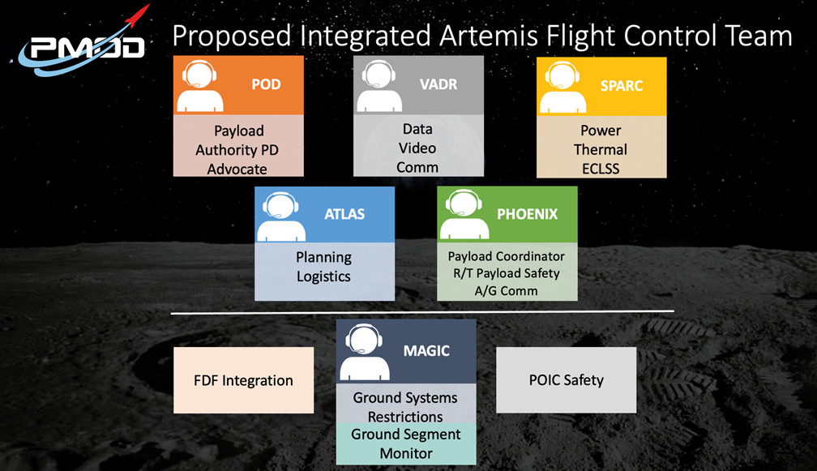
- Innovation

In addition to the streamlined operations support, PMOD has also been identifying innovative ideas that would aid in creating even more efficiencies and allowing the flight control team to provide the same level of quality, with an even more streamlined approach.
In and effort to support NASA’s Program goals more effectively, PMOD has identified transitions to server-based applications and web-based displays as key architectural changes require. These changes allow for a higher level of automative support from real-time operators supporting science and payload operations.
Dynamic displays allow an operator to more effectively utilize their console to monitor multiple systems, from multiple elements, simultaneously without having to manually swap screens. This functionality will utilize on screen indicators to alert the operator to changing or anomalous conditions. The functionality will also be configurable to automatically pop out specific displays when certain limits are reached. This capability is a vast improvement from what is currently utilized to support ISS, and will allow flight controllers to more efficiently monitor and respond to real-time anomalies.
Figure 3: Basic design layout for dynamic displays
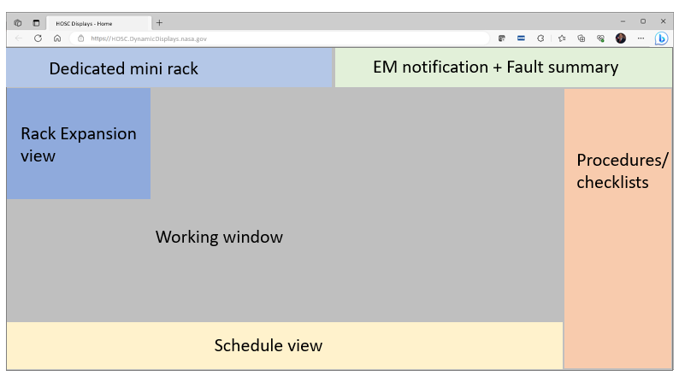
Early on in Artemis mission planning, it was identified that payload operations are not being bookkept very effectively. The Artemis mission planning process begins as early as 4 years prior to launch, and it’s very difficult to provide payload planning inputs this early (many of which have specific timing constraints relative to science viability), as payloads are still in development and have multiple iterations through the years, especially as they get close to launch. PMOD developed the concept of Smart Placeholders, which allows for mission planners to better bookkeep payload operations within the early stages of the mission timeline development. PMOD is able to take payload concepts, and utilize their experience with similar payloads to develop Smart Placeholders to provide timeline inputs as early as payload concept development. These placeholders will continue to evolve over time; however, the closer to launch, the more defined the timeline inputs become.
PMOD also plans to deploy a “lights out” concept. This is a concept that would allow for ground operators to receive remote notifications if there are any conditions that require ground operator response. These notifications would be configurable based on the payload need. Once received, operators could contact scientists and engineers to determine if immediate response is required, and would then be able to report to console, or login remotely to perform any necessary corrective action.
- Conclusions and Continued Evolution of Science Operations Beyond LEO
Science and payload operations within the Artemis Campaigns will continue to grow and expand into more complex operations – just like we saw on ISS. However, like ISS, operations will need to remain efficient and continue to innovate with the expanding landscape. In contrast to positions splitting into multiple positions as we saw on ISS, positions will need to combine to allow for streamlined ground support.
As with ISS, international partnerships will continue to be made as more and more Space Agencies begin their pursuit of space science beyond LEO. Along with additional agencies, we’ll see an increase in commercial organizations supporting these operations. Because of this, the possibilities for scientific discoveries, and international collaborations, are endless.
PMOD has been and will remain at the forefront of crewed spaceflight science and payload operations. PMOD has built on their decades of experience from the Space Shuttle to the ISS, and previous missions, to develop concepts to enhance crewed science and payload operations beyond low-Earth orbit. PMOD will continue to evolve and build on the support plans that have been outlined within this paper as well as collaborate with, and provide knowledge to, all of the agencies and organizations who contribute to the betterment of the human race through spaceflight science operations. Creating these good habits at the beginning of the Artemis Missions will lead to an easier transition to crewed payload operations on the Martian surface.

Acknowledgements

References
[1] C. Cruzen, R. Gibbs, S. Dyer, J. Cech, “Expanding Remote Science Operation Capabilities Onboard the International Space Station,” IEEE Aerospace Conference, March 2005.
[2] I. Howley, J. Johnson, “Science Off the Earth: An Integrated Approach to Science Operations in the Artemis Era and Beyond,” International Conference on Space Operations, March 2023
[3] H. Stetson, D. Deitsch, C. Cruzen, A. Haddock, “Autonomous Payload Operations Onboard the International Space Station,” IEEE Aerospace Conference, March 2007.
[4] NASA’s Moon to Mars Strategy and Objectives Development

