Modal Testing of the NASA VIPER Spacecraft Using Acoustic Excitation
Dale Schick and Daniel Hayes
Acoustic Research Systems
Shepherdstown, WV
Kevin Napolitano, Dr. Peter Kerrian, and Dr. Mike Yang
ATA Engineering, Inc.
San Diego, CA
Vince Fogt and Matthew Goit
NASA Johnson Space Center
Houston, TX

Abstract
The environmental testing phase of the NASA Volatiles Investigating Polar Exploration Rover (VIPER) spacecraft presented a unique opportunity to compare traditional and newer modal testing methods. This paper provides a background for the method of acoustic excitation, including special considerations that were made in preparation for the modal measurements. The modal extraction method for the acoustic excitation method is explored. The results are compared to a modal test of the VIPER structure using the fixed base correction technique to validate the approach. Finally, conclusions are made regarding acceptable use cases and considerations for such a test.
KEYWORDS: modal testing, acoustic testing, spacecraft

Nomenclature
ATA | ATA Engineering, Inc.
CMIF | complex mode indicator function
DFAN | direct-field acoustic noise
DOF | degree of freedom
FBC | fixed base corrected
FBCM | fixed base correction method
FRF | frequency response function
IMAT™ | Interface between MATLAB, Analysis, and Test
MIMO | multi-input/multi-output
NASA | National Aeronautics and Space Administration
PSD | power spectral density
VIPER | Volatiles Investigating Polar Exploration Rover

Introduction
When integrating a spacecraft, manufacturing facilities must weigh schedule, risk, and cost in delicate balance to create the best possible outcome for the mission. The study in this paper is a test of opportunity to explore a process which extracts additional information from required tests, thereby increasing the value of those tests. For instance, a direct-field acoustic noise (DFAN) test or fixed-shaker random vibration test may be used, out of convenience, to also perform modal surveys that would otherwise require costly independent tests with large isolation masses or multi-input/multi-output (MIMO) modal frames.
Performing as many tests as possible at the same location will improve the efficiency of testing while reducing cost and risk. With this in mind, this paper will compare traditional modal excitation methods with an acoustic excitation method to examine what additional preparations, if any, are required to utilize acoustic testing to obtain useful modal data.

NASA VIPER Program
VIPER, shown in Figure 1, is a lunar volatiles detection and measurement mission designed to launch to the lunar South Pole to characterize the nature of the volatiles in the area and extrapolate this data to create global lunar water resource maps. VIPER consists of a science payload suite of instruments integrated into a rover platform with power and thermal systems to form the surface segment. The surface segment will be integrated with the landing system provided by the lunar lander’s service partner, which will deliver it to the pre-selected landing site. Once at the landing site, the communication systems are designed to receive commands from Earth via direct-to-Earth transmissions to perform science operations.
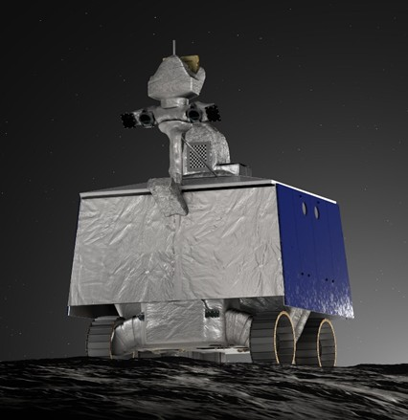
Figure 1. Illustration of the NASA VIPER.

TRADITIONAL Modal Test
A fixed-base-corrected (FBC), impact-hammer excited modal test was performed by ATA Engineering, Inc., (ATA) at the NASA Johnson Space Center on July 10, 2024. VIPER was affixed to a shaker head expander attached to an environmental shaker in the vertical configuration. The instrumentation on VIPER was an accelerometer set which was optimized for vibration and was relatively sparse as a result. Additional seismic triaxial accelerometers were installed on the base plate and head expander to capture the base dynamics. These accelerometers on the base plate and head expander are needed to perform fixed-base correction.
Because the accelerometer models were primarily selected for vibration testing, higher force impacts on the head expander were required to record a coherent signal above the accelerometer noise floor. Radial, torsional, and vertical impacts were made using a standard 2-inch modal hammer at the four cardinal points of the head expander. Programmatic decisions restricted impact excitation of VIPER, reducing the ability of the modal test to directly excite modes with low effective mass. Figure 2 shows an image of the test display model with the instrumented degrees of freedom (DOF) shown with red arrows as well as a photo of VIPER in the test configuration.
The fixed base correction method (FBCM) was developed to transform flexible or dynamically active boundary conditions into fixed boundaries by using acceleration data or constraints shapes as references when calculating frequency response functions (FRFs).References at the of the document describe the theory and successful application of the method. For the VIPER test, the rigid body dynamics of the head expander on the shaker suspension were characterized with the seismic accelerometers and used as references to calculate fixed base FRFs. Figure 3 shows the complex mode indicator function (CMIF) of the uncorrected and corrected FRFs with vertical dashed lines corresponding to the prominent fixed base mode frequencies. Figure 4 contains a summary of the modal parameters extracted for VIPER along with plots of the primary modes.
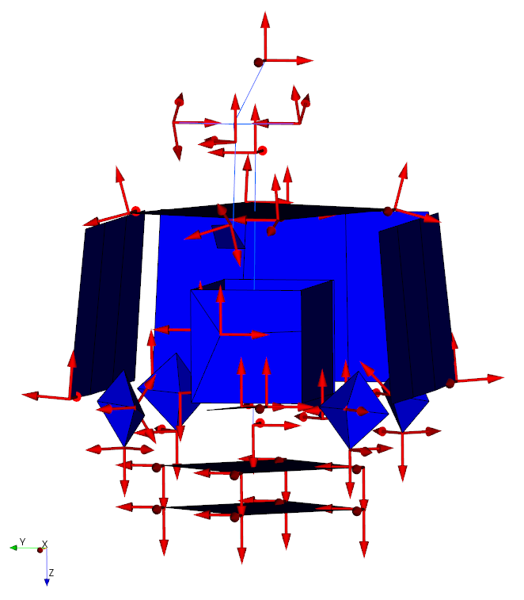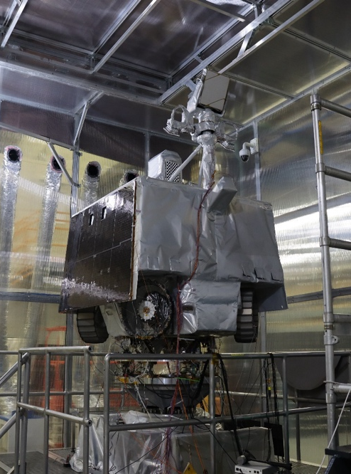
Figure 2. NASA VIPER impact hammer modal test with instrumented accelerometer DOF shown on the left.
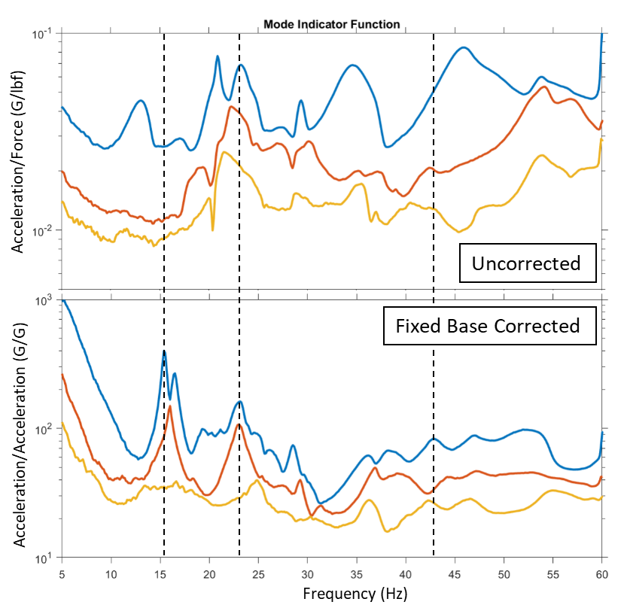
Figure 3. CMIF of uncorrected and corrected FRFs from the VIPER modal survey test.
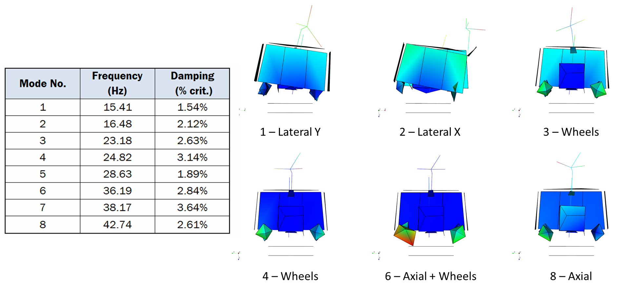
Figure 4. Extracted natural frequencies, damping, and mode shapes for VIPER fixed base modal survey test.

Acoustic Test
VIPER required acoustic testing for launch vehicle qualification as part of the suite of environmental testing. Acoustic Research Systems (ARS) was contracted to perform the test, which was conducted on July 21, 2024. This test, shown in Figure 5, like the traditional FBCM test, was also performed at the NASA JSC campus, but in an ISO 8 cleanroom. A stiff acoustic test frame was used, raising the spacecraft height roughly one meter above the cleanroom floor.
An adaptor fixture was available from a recent force-limited vibration test and consisted of six Kistler 9367C triaxial load cells. The force in the vertical direction was capable of ±60 kN (±13.49 klbf) per unit. This instrumentation would prove to be useful in the acoustic modal test due to its adjustable measurement range via configurable Kistler 5165A charge-amplifiers.
The launch vehicle DFAN test required a level of 138.2 dB OASPL, which was delivered by 24 ‍Neutron acoustic devices configured in six stacks of four devices per stack. The VIPER spacecraft program limited exposure pertaining to sound levels in terms of duration and amplitude, so it was important to operate the modal test at a level significantly lower than that of the DFAN test. The program agreed to a flat spectrum 110 dB OASPL test ranging from 20 to 10,000 Hz for a duration of ten minutes. To characterize any nonlinearities, a −6 dB run and a −3 dB run were also performed in succession prior to the 0 dB run. The subsequent data processing is from the 0 dB (110 dB OASPL) portion, as no significant nonlinearities were noted.
The Neutron acoustic devices do not rely on constructive interference to create the noise field, so they were ideal to operate as acoustic modal exciters as each device, or group of devices, can act as incoherent sources. Multiple incoherent sources controlled simultaneously can help to extract closely spaced modes when processed using multiple references.
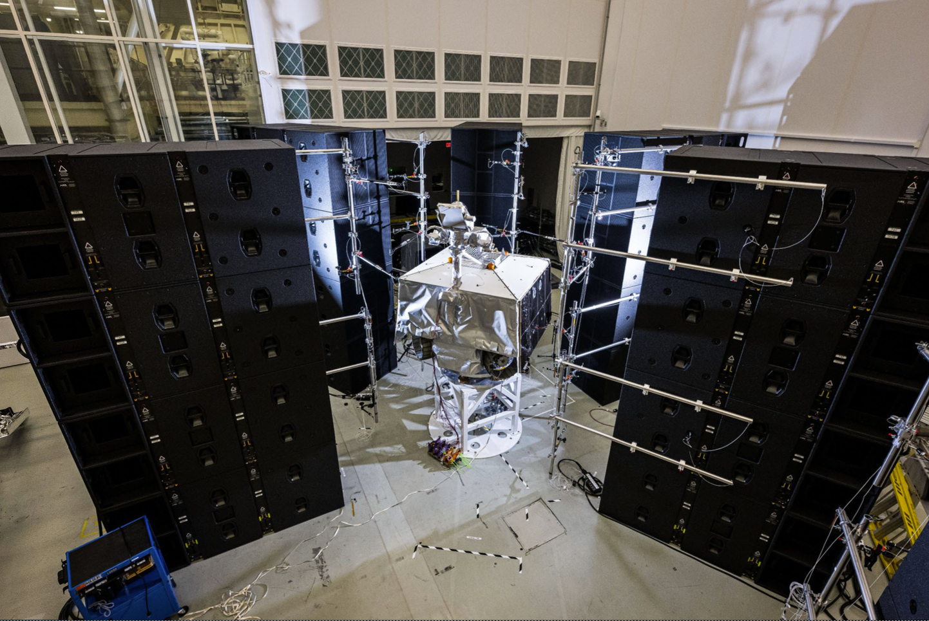
Figure 5. NASA VIPER DFAN test using ARS Neutron.
Each of the 24 acoustic devices were independently controlled by a corresponding control microphone. These 24 control mics were mounted to a support structure which is affixed to the Neutrons.. In this way, no floor stands are needed for the bulk of the instrumentation. For the modal test, groups of two Neutrons shared a drive voltage and the average of the two microphones controlled the amplitude. This pairing was performed to reduce the number of references, thereby allowing for data to be collected over a shorter time period. For the twelve drives, each one used the odd-numbered microphone pressures as references when calculating FRF. Accelerometer locations were mostly similar between the acoustic test and the FBC modal survey test.

Acoustic Modes – Modal Extraction Process
Being a test of opportunity, schedule demands during the test campaign dictated that there was no time to experiment with excitation levels (or methods) to determine what most adequately excited the structure. As such, the data was processed in several ways to produce the best possible results within the various frequency bands.
For frequencies where the acoustic devices are most active (typically from 20 to 10,080 Hz), FRF was processed using the microphones as a reference. Doing so leads to cleaner data to process, but there is a risk at higher frequencies of “zeros” in the microphone auto spectrum matrix due to destructive interference between the Neutrons, which would result in fictitious structural modes. These fictitious modes can be identified by observing the singular values of the microphone cross-spectrum matrix. A fictitious mode would have a near-zero singular value.
FRF-synthesized cross-spectrum data was generated to account for the phase lag. This was done by assuming that the input cross-spectrum matrix, $\left[S_{xx}\right],$ is equal to the identity matrix, which is a typical assumption in operational modal analysis. Operational modal analysis tools were then used to extract modes from the FRF-synthesized output cross-spectrum matrix,$\left[S_{yy}\right].$
$$\left[S_{yy}\right]=\left[H_{yx}\right]\left[S_{xx}\right]{\left[H_{yx}\right]}^{H}= \left[H_{yx}\right]{\left[H_{yx}\right]}^{H}$$
It was observed during the acoustically excited modal test that frequencies below the active output of the acoustic devices were present in the test-measured cross-spectrum matrix. Therefore, at these lower frequencies, the test-measured cross-spectrum matrix operational modal analysis was used to extract shapes even though they were somewhat noisy.
To validate this method, ATA processed the combined FRF-synthesized and test-measured cross-spectrum data using the ATA-developed IMAT™ modal analysis software packages, particularly the OPoly modal estimation software. When using cross-spectrum data, OPoly calculates all four poles for each extracted mode even though only two are commonly used in traditional modal parameter estimation of FRFs. The additional two poles, shown in Figure 6, with negative damping are needed to account for the Hermitian part of the FRF matrix, ${\left[H_{yx}\right]}^{H},$ associated with cross-spectrum matrices.
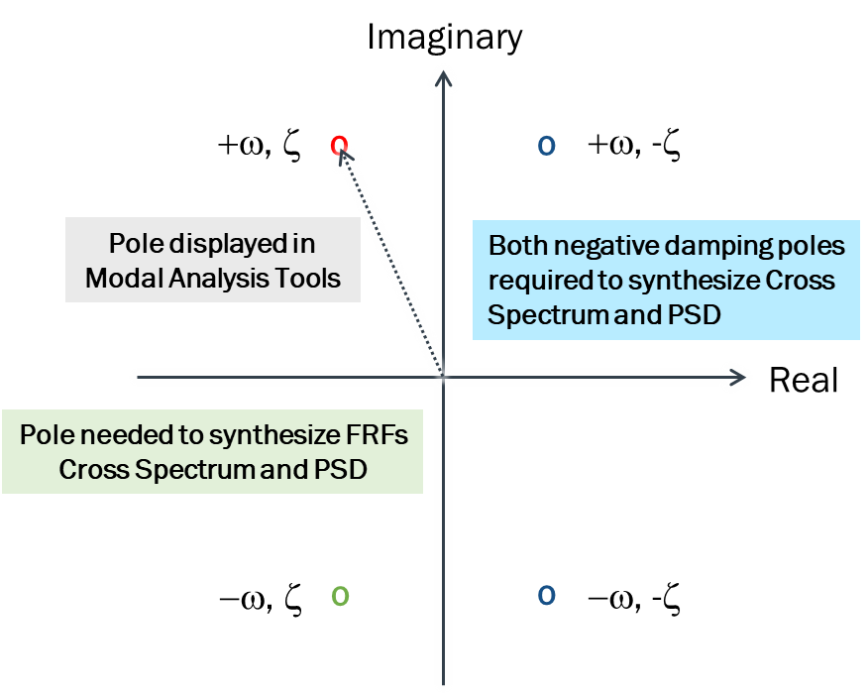
Figure 6. Four-pole solution for cross-spectrum data.

Acoustic Modal Results
The data obtained from this test were primarily from in situ instrumentation such as accelerometers used for the DFAN and vibration test campaigns. Since this was a test of opportunity, it was somewhat understood that the resulting data would be less than ideal. Some value and, it can be said, an opportunity to improve on future tests is presented with such datasets. As mentioned before, the value of incorporating the force sensors into the dataset was unknown at the time of setup but ultimately provided valuable insight.
The power spectral density (PSD) of the summed force data in Figure 7 is the result of the −3 dB and 0 dB portions of the DFAN test, not from the acoustic modal test. Force summation was calculated in the time domain for accuracy and are included to indicate the magnitude of the reaction forces on the structure during acoustic tests of various levels. The force sensor charge-amplifiers were scaled to +/- ‍400 lbf to ensure noise-free measurements during the 110 dB OASPL acoustic modal test.
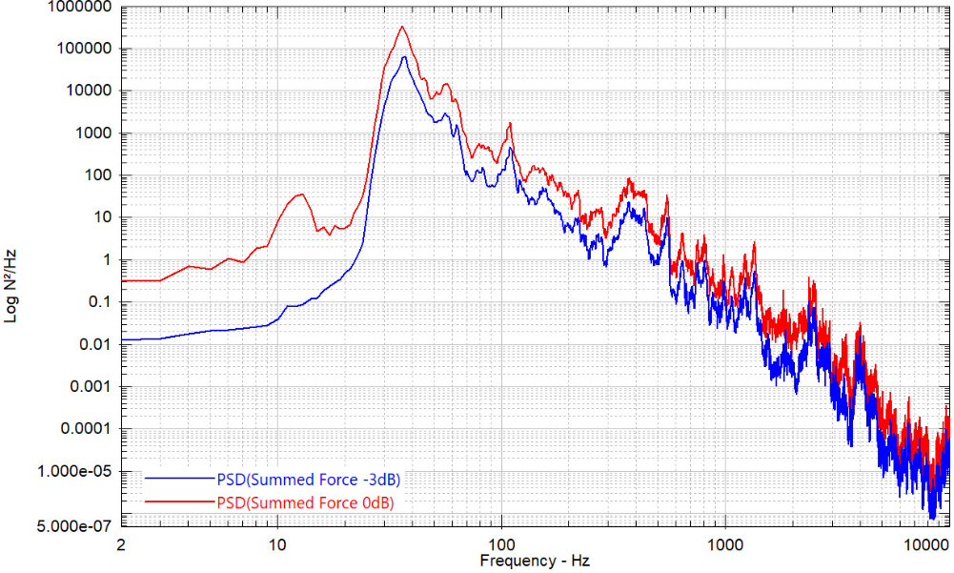
Figure 7. Summed force PSD from DFAN test (−3 dB, 0 dB).
The resulting auto spectra from processing the acoustic modal run produced the cleanest data of all the instrumentation, due to its ability to range well above the noise floor. This force data also revealed modes well below the lower excitation frequency of 20 Hz. In Figure 8, the low-frequency modes are clear and were used in further processing of the acceleration data, where possible.
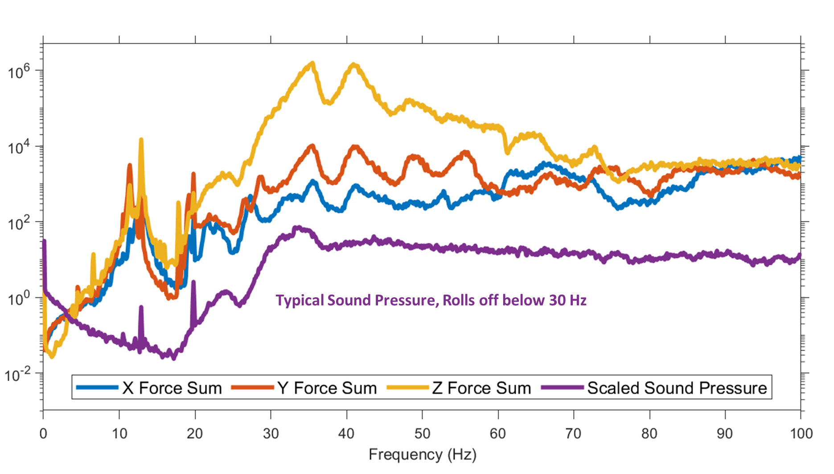
Figure 8. Auto spectrum data from force sensors.
The instrumentation set of accelerometers, as mentioned previously, was optimized for DFAN and vibration testing and was, as such, not ideal for low-level modal testing. An examination of the auto spectra for the entire measurement set reveals an interesting facet of the accelerometer’s capabilities in terms of discernable data above the noise floor. Five triaxial accelerometers were able to measure the lateral bending modes of the structure as well as some modes below 30 Hz where the acoustic input begins to roll-off. The five accelerometers consisted of PCB model 356A33 and Kistler model 8763B500BT units. The rest of the accelerometers were Dytran brand model 3133D1T and were only able to capture useful data above 30 Hz. The primary difference between the models is the internal amplifier. In Figure 9, the auto spectrum of the accelerometers is shown for those models with a low noise floor (blue) and higher noise floor (red). If a nominal set of instrumentation is considered for future tests to be inclusive of data from vibration, DFAN, and modal testing, it may be wise to consider the ultimate measurement capability of the sensor in terms of not only frequency but also total range within the bandwidth of frequencies of measure.
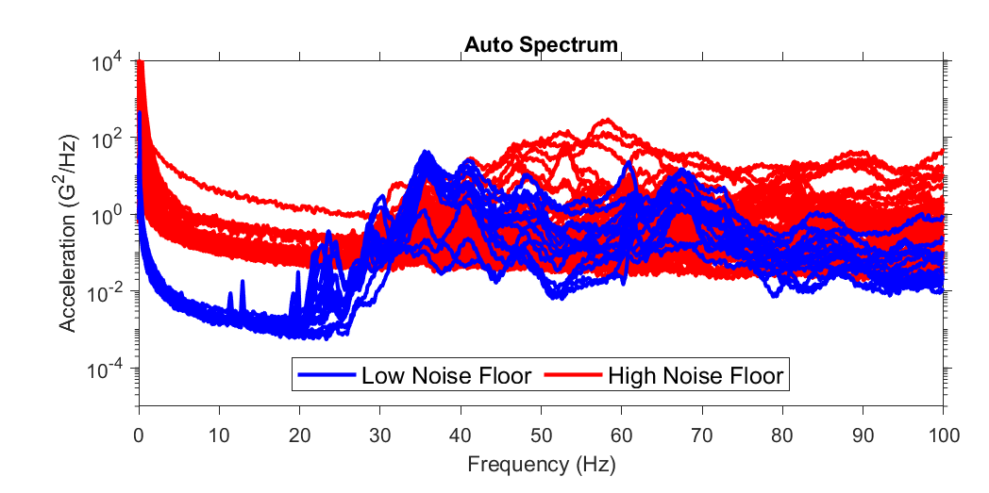
Figure 9. Auto spectrum of accelerometers used in VIPER acoustic test showing difference in accelerometer noise floor.

Modes Obtained from Cross Spectra
Since the acoustic excitation generated ranged, generally, from the 20 Hz octave band to the 10,000 ‍Hz octave band, it was of special interest to attempt to characterize the modes discovered below this frequency range. The predicted true fixed base natural frequencies for the first two modes was below 20 Hz, and it was expected that compliance in the test stand would reduce the frequencies even further.
The FRF-synthesized and test-measured cross spectra were partitioned to rows associated with the accelerometers and load cells, and columns associated with the force sensors.
The top of Figure 10 compares PSD responses from those measured during the test (i.e. processed from directly measured test data) with the PSD responses synthesized from a single mode. These plots show good agreement in the PSD responses. The bottom of Figure 10 shows the extracted mode shapes, natural frequencies, and damping.

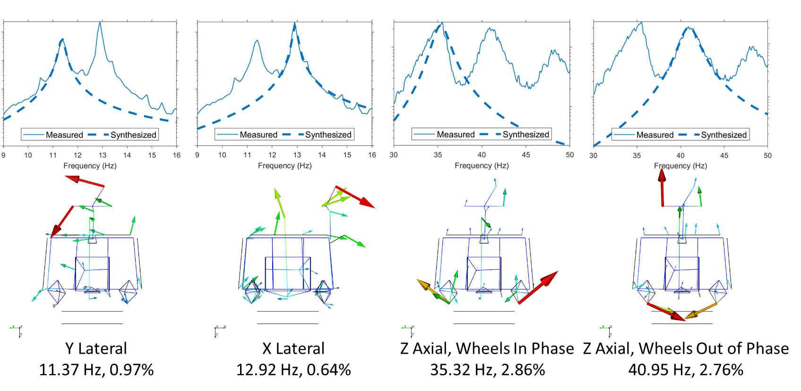
Figure 10. Comparison of measured and synthesized PSDs (top). Modes obtained from test-measured cross spectra (bottom).

Modes Obtained from Acceleration and Pressure
The lower frequency modes (below 30 Hz) are not observable if we use the singular values from the acceleration/pressure FRFs (Figure 11). However, by using the singular values from the FRF-synthesized cross spectrum matrix (which includes the loads cells, see above), the lower frequency modes can be extracted (Figure 12).

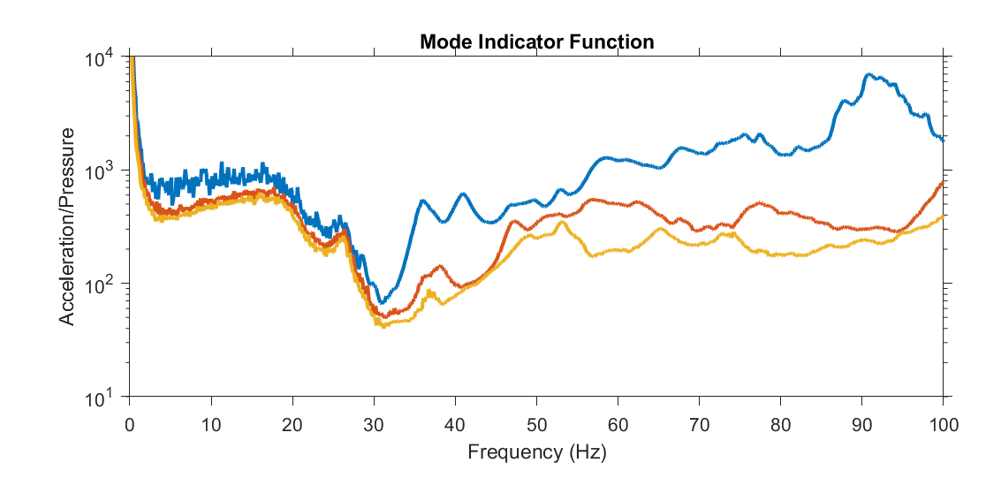
Figure 11. Singular values of acceleration/pressure FRFs.
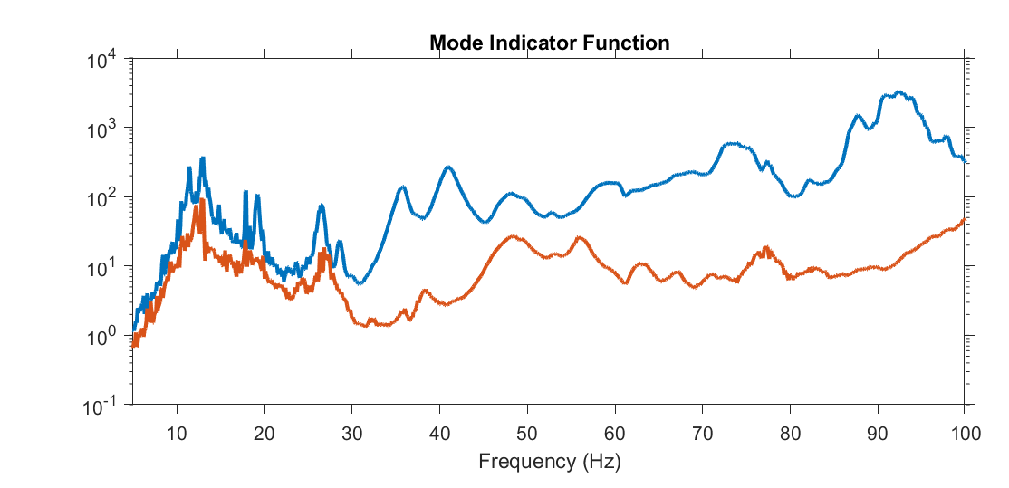
Figure 12. Singular values of FRFs synthesized cross-spectrum matrix used for modal analysis, which includes the load cells.
The modes extracted using the FRF-synthesized method are shown in Figure 13. Their natural frequencies agree well with the test-measured cross-spectral density results as shown in Figure 14.
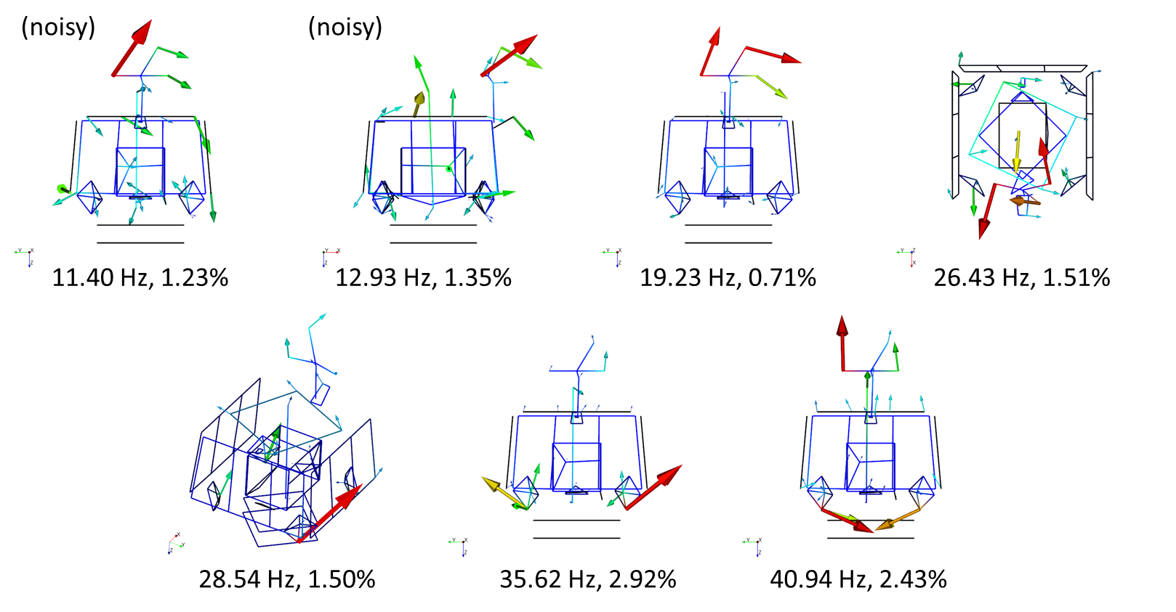
Figure 13. Modes from FRF-Synthesized data
Figure 14 provides a comparison of extracted natural frequencies and damping between the traditional modal testing approach (“FBC Correction”) and the acoustic modal testing approach. Significant differences in natural frequencies are shown for modes 1-3, but these differences do not appear for modes 4-8. This is an indication that the first three modes are sensitive to the different boundary conditions used for the two tests, and the higher frequency modes are less sensitive to the boundary conditions.
These differences could be removed by applying FBC to the acoustic modal testing process. This approach will be a part of future work.
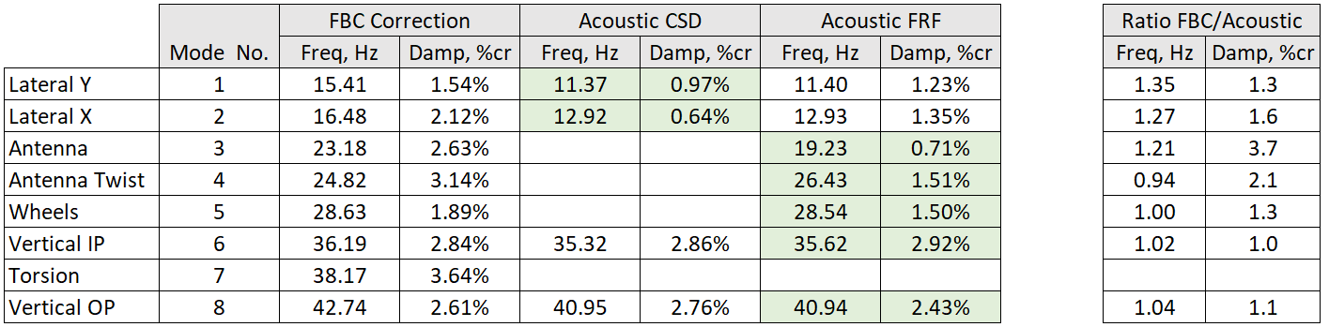
Figure 14. Comparison of excitation methods.
While it may not be feasible to extract observable mode shapes at all frequencies, the data indicates that modes could be extracted at higher frequencies, as shown in Figure 15. This extraction could help with the correlation of acoustic analysis models.
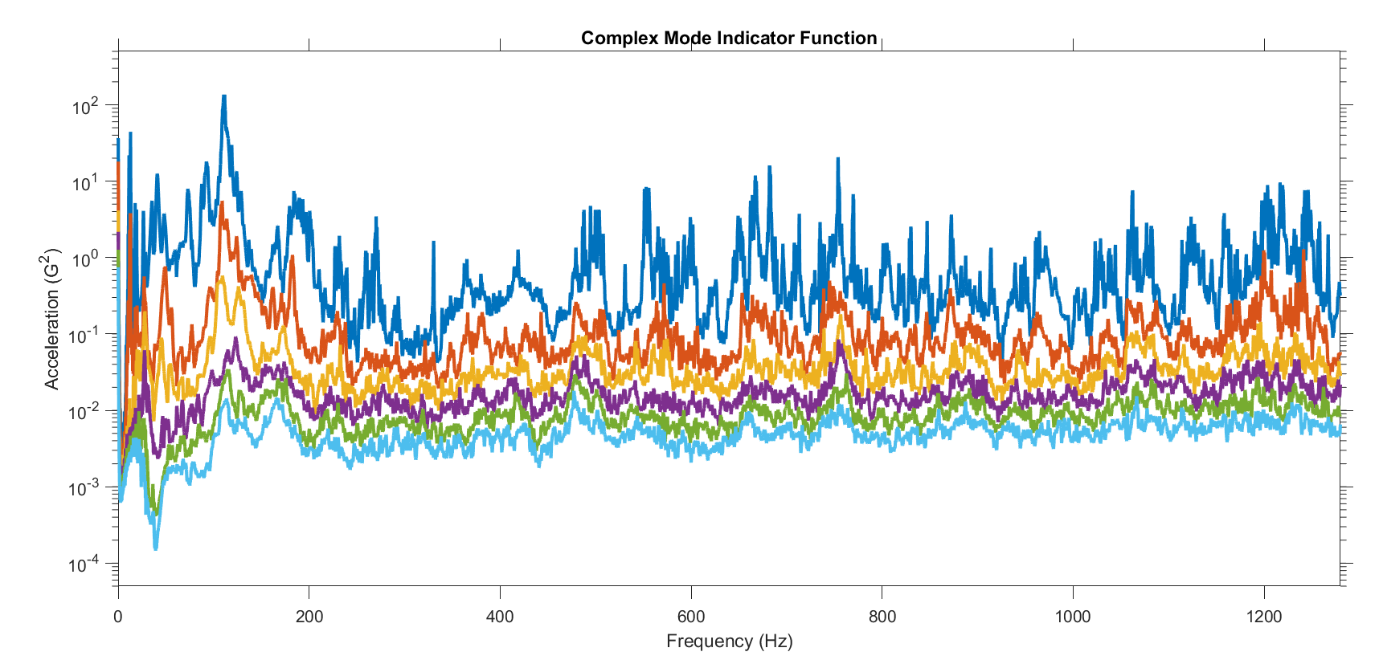
Figure 15. Singular values of FRF matrix up to 1.25 kHz.

Conclusion
The primary takeaway from this test of opportunity is that modal parameters were extracted to a high quality from acoustic testing to as low as 15 Hz. Although some results differed from a traditional modal testing approach, these differences only applied to certain modes which were sensitive the difference in the boundary conditions between the traditional and acoustic tests. Furthermore, simple improvements to the testing conditions, such as accelerometer selection and test duration, as well as the addition of processing techniques like FBCM, can significantly improve the quality of data acquired and the resulting model extraction.
It was found that longer test runs, even at a lower test level, can allow for cleaner data, smaller frequency spacing, and better definition of peaks for modal extraction. Additionally, the same features of the acoustic devices that allow them to achieve high test levels without constructive-interference, as systems that use separate bandpass boxes do, also made them well-suited to assume the use of the identity matrix for the input cross-spectrum [S_{xx}], which is a necessary assumption for operational modal analysis.
Acoustic modal testing provides the ability to maximize the value of an acoustic qualification test by allowing for the testing and extraction of modal parameters without moving the test article. The use of acoustic exciters has the additional benefit of being a non-contact method for mirror arrays or other sensitive optical equipment.
Future work will explore the use of fixed-base correction methods with acoustic modal testing more directly. Such opportunities deserve to be further explored, and the authors of this paper look forward to continuing research on these methods.
The authors would like to thank NASA for the extraordinary opportunity to attempt these methods on a working spacecraft, as it may be the first test of its kind on such a device that is shareable to the broader community.

References
Imregun, M. R. (1987). Structural Modification and Coupling Dynamic Analysis Using Measured FRF Data. 5th International Modal Analysis Conference.
Kerrian, P. N. (2023). A Portable Fixed Base Support for Modal Survey Tests. 41st International Modal Analysis Conference.
Kerrian, P. N. (2023). Techniques for Increasing the Upper Frequency of a Fixed Base Modal Survey Test. 33rd Aerospace Testing Seminar.
Mayes, R. a. (2009). Extracting Fixed Base Modal Models from Vibration Tests on Flexible Tables. 27th International Modal Analysis Conference.
Napolitano, K. (2019). Fixing Degrees of Freedom of an Aluminum Beam by Using Accelerometers as References. 38th International Modal Analysis Conference.
Napolitano, K. a. (2012). Fixed Base FRF Using Boundary Measurements as References – Analytical Derivation. 30th International Modal Analysis Conference.
Napolitano, K. a. (2013). Extraction of Fixed-Base Modes of a Structure Mounted on a Shake Table. 31st International Modal Analysis Conference.
Schick, Hoffmann, Friedlander, & Kinsella. (2021). Verifying a Novel Approach to Acoustic Testing: Acoustic Devices & Control Systems. 32nd Aerospace Testing Seminar. Virtual.
Staab, L. W. (2016). Fixed Base Modal Testing Using the Mechanical Vibration Facility 3-Axis Base Shake System. 34th International Modal Analysis Conference.
Winkel, J. A. (2018). Modal Survey of the MPCV Orion European Service Module Structural Test Article Using a Multi-Axis Shake Table. 37th International Modal Analysis Conference.

Biographies
Dale Schick is Director of Applications for Acoustic Research Systems. He has experience in environmental testing as applied to Aerospace and over 18 years of practical experience in the industry related to vibration, acoustic, shock, and thermal testing technologies.
Daniel Hayes is the Director of Testing and Operation at Acoustic Research Systems. Prior to working at ARS, Daniel was a Certified Test Conductor (CTC) on the NASA Orion Program for Lockheed Martin. Daniel has a bachelor's degree in Acoustical Engineering from Purdue University.
Kevin Napolitano is the Technical Director of the test group at ATA Engineering, Inc. He earned his bachelor’s degree in structural engineering from the University of California San Diego and his master’s degree in aeronautics and astronautics from Stanford University. His area of expertise is implementing innovative methods of performing modal survey tests of aerospace vehicles.
Dr. Peter Kerrian is a Senior Project Engineer at ATA Engineering, Inc. After earning his bachelor’s degree in mechanical engineering from the University of Notre Dame, Dr. Kerrian completed his master’s degree and Ph.D. in acoustics at Pennsylvania State University. His area of expertise is modal and acoustic testing of aerospace structures as well as structural dynamic and acoustic analysis. Presently, Dr. Kerrian is pursuing a Master of Business Administration from The Wharton School at the University of Pennsylvania.
Dr. Michael Yang is the Technical Director of the acoustics group at ATA Engineering, Inc. After earning his bachelor’s degree in mechanical engineering from Purdue University, Dr. Yang completed his master’s degree and Ph.D. in mechanical engineering at Pennsylvania State University. His expertise is in the definition of fluctuating pressure loads, vibroacoustic analysis, and interpretation of random analysis results for aerospace systems.
Vince Fogt is the senior discipline expert for high frequency dynamics at the NASA Johnson Space Center. He has worked in the Loads and Structural Dynamics branch for 34 years supporting high and low frequency dynamics for all NASA crewed spaceflight programs. His current expertise is focused on vibration, acoustic and shock testing and analysis issues. He has a bachelor’s degree in Aeronautical and Astronautical Engineering from the University of Illinois at Urbana Champaign and a Master of Civil Engineering degree from Rice University.
Matthew Goit is a structural dynamics engineer with NASA at the Johnson Space Center. Prior to NASA he worked for Boeing at various sites across the enterprise. He has 20 years of experience working spacecraft, satellites, commercial and military aircraft. He completed a bachelor’s degree in mechanical engineering from Brigham Young University and a master’s degree in mechanical engineering from Kansas State University.

