Satellite-based Analysis of CO₂ Emissions in Global Cities:
Regional, Economic, and Demographic Attributes
Doyeon Ahn^{1,2,3*}, Daniel L. Goldberg³, Fei Liu^{1,2}, Daniel C. Anderson^{2,4}, Toby Coombes⁵, Chris P. Loughner⁶, Matthaeus Kiel⁷, Abhishek Chatterjee⁷
¹Goddard Earth Sciences Technology and Research (GESTAR) II, Morgan State University; Baltimore, MD, USA.
²Atmospheric Chemistry and Dynamics Laboratory, NASA Goddard Space Flight Center; Greenbelt, MD, US.
³Milken School of Public Health, George Washington University; Washington DC, USA.
⁴Goddard Earth Sciences Technology and Research (GESTAR) II, University of Maryland Baltimore County; Baltimore, MD, USA.
⁵C40 Cities Climate Leadership Group Inc.; New York, NY, USA.
⁶Air Resources Laboratory, National Oceanic and Atmospheric Administration; College Park, MD, USA.
⁷Jet Propulsion Laboratory, California Institute of Technology; Pasadena, CA, USA.
Corresponding author: Doyeon Ahn (doyeon.ahn@nasa.gov)

Key Points:
- We use spaceborne observations of CO₂ and NO₂ to estimate CO₂ emissions for 54 global cities
- Satellite-based estimates show regional discrepancies to two bottom-up datasets, even though they agree within 7% at the global scale.
- Satellite dataset reveal wealthier cities emit less CO₂ per dollar economic activity, and residents in larger cities tend to emit less CO₂.

Abstract
Cities play a crucial role in reducing global greenhouse gas emissions. While activity-based (“bottom up”) emission estimates are widely used for global cities, they often lack independent verification. In this study, we use remotely-sensed CO₂ observations from the Orbiting Carbon Observatory-3 (OCO-3) to “top-down” estimate CO₂ emissions for 54 global cities. This global-scale analysis is enabled by a computationally efficient, low latency Cross-Sectional Flux (CSF) approach, which constrains urban plume shape using NO₂ observations from TROPOMI and trajectory simulations from HYSPLIT. Our satellite-based emission estimates for 54 global cities agrees within 7% to two widely used bottom-up datasets but reveal regional discrepancies. Bottom-up estimates tend to overestimate emissions for cities in Central East Asia and South and West Asia, while underestimating emissions in Africa, East and Southeast Asia & Oceania, Europe, and North America. Additionally, our satellite-based socioeconomic analysis shows that 1) high-income cities tend to have less carbon-intensive economies: North American cities emit 0.1 kg CO₂ per USD of economic output, while African cities emit 0.5 kg CO₂ per USD, and 2) per capita emissions decrease with increasing population size, from 7.7 tCO₂/person for cities under 5 million residents to 1.8 tCO₂/person for cities over 20 million residents. This study highlights the potential of satellite data to bridge gaps between top-down and bottom-up emission estimates, enhancing the robustness and transparency of emissions monitoring. Our findings emphasize the growing role of satellite data in verifying urban CO₂ emissions and supporting efforts to mitigate emissions for global cities.
Plain Language Summary
Cities can play a key role in reducing greenhouse gas emissions, but current estimates of their CO₂ emissions often rely on tracking fuel sales and making assumptions on where those fuels are burned. In this study, we use satellite observations from NASA’s OCO-3 instrument to directly estimate CO₂ emissions for 54 global cities. Our satellite-based estimates match fuel-usage-based datasets within 7% globally, but we find regional differences in cities in North America, Europe, Asia, and Africa. We also explore the link between emissions, economies, and populations. Our findings show that wealthier cities tend to have cleaner economies—North American cities emit 0.1 kg of CO₂ per dollar of economic output, while African cities emit 0.5 kg of CO₂ per dollar. Additionally, we found that larger cities produce less CO₂ per person—cities under 5 million people emit 7.7 tons per person, whereas cities over 20 million emit just 1.8 tons per person. Our study shows how satellite data can help improve emission tracking, making global monitoring more accurate and transparent. These insights can help cities better track and eventually reduce their CO₂ emissions.

1 Introduction
Cities contribute about 75% of global CO₂ emissions (Lwasa et al., 2022). With the global urban population projected to grow from 55% in 2018 to 70% in 2050, cities play a crucial role in reducing global Greenhouse Gas (GHG) emissions (Roberts & Mukim, 2023). More than 1,100 cities have signed the United Nations’ Race to Zero campaign, which aims to halve GHG emissions by 2030 and reach net zero by 2050 (UNFCCC, 2023). As cities increasingly commit to reduce emissions, robust and transparent monitoring of urban emissions have become critical. At the 2024 United Nations Climate Change Conference (COP29), delegates of state and governments emphasized the pivotal role of satellite-based Earth observations on cross-verifying GHG emission inventories (Climate TRACE, 2024; Friedlingstein et al., 2024).
The C40 Cities Climate Leadership Group (C40 Cities) is a network of 97 cities representing 20% of global Gross Domestic Product (GDP) and working collaboratively to influence global climate policy and reduce urban GHG emissions (C40, 2023). Most C40 cities have pledged to reach net zero emissions by 2050 (UNFCCC, 2023). To track their progress, cities compile emissions inventories by collecting activity data (e.g., gasoline sales) and corresponding emission factors. This bottom-up dataset is called the Global Protocol for Community-Scale Greenhouse Gas Emission Inventories (GPC) (WRI et al., 2014). Additionally, there are two well-established bottom-up emission datasets―the Emission Database for Global Atmospheric Research (EDGAR) and the Open-Source Data Inventory for Anthropogenic CO₂ (ODIAC). These bottom-up datasets provide up-to-date CO₂ emissions over global latitudinal/longitudinal grid cells, offering another opportunity for tracking cities’ emission (Crippa et al., 2021; Oda et al., 2018).
However, studies have identified inconsistencies between GPC and the two bottom-up gridded emission datasets (Ahn et al., 2023; Gurney et al., 2021; Seto et al., 2014). These studies found regional variations in the differences between these datasets. For example, African, Latin American, and South & West Asian cities tend to show larger variability in emission estimates than other regions (Ahn et al., 2023). These discrepancies can be attributed to outdated emission factors used by cities in non-Annex I nations (particularly Africa) and spatial disaggregation errors in EDGAR and ODIAC, which tend to be larger for smaller cities. This raises a critical question: Can we use the unique vantage point of space-based atmospheric CO₂ observations to provide an independent check on bottom-up urban CO₂ emission estimates at a global scale?
A major challenge in estimating urban CO₂ emissions using satellite observations has been the lack of high-density atmospheric CO₂ observations capable of resolving fine-scale CO₂ features over cities (Kort et al., 2012; Wu et al., 2020; Ye et al., 2020). Since 2019, NASA has been operating the Orbiting Carbon Observatory-3 (OCO-3) mission onboard the International Space Station (ISS). OCO-3 features a Pointing Mirror Assembly (PMA) that enables the instrument to “stare” at a target area (Eldering et al., 2019). The “staring” capability, referred to as Snapshot Area Mapping (SAM) mode, collects multi-swath atmospheric total column CO₂ (XCO₂) measurements over an target area with a precision of < 1 ppm at ~3 km² resolution (Taylor et al., 2023). While its predecessor, the Orbiting-Carbon-Observatory (OCO-2) mission, has provided valuable insights into the natural carbon cycle and long-term carbon-climate interactions (Byrne et al., 2023; Chatterjee et al., 2017; J. Liu et al., 2017; Sun et al., 2017), OCO-3 provides an unprecedented opportunity to constrain the anthropogenic carbon cycle with its broader spatial coverage, high-density SAM mode, and ability to resolve fine-scale XCO₂ features over cities.
An additional challenge is that traditional satellite-based urban CO₂ emissions estimates have relied on complex Bayesian inversion frameworks and/or high-resolution transport models, which optimize prior emission inventories by aligning modeled and observed CO₂ enhancements downwind of cities (Hedelius et al., 2018; Roten et al., 2023; Wu et al., 2018; Ye et al., 2020). However, application of this method has been limited to a small set of cities (< 5) due to the need for high-resolution meteorological fields and corresponding computational expense for running the model simulations (Hedelius et al., 2018; Lei et al., 2022; Reuter et al., 2019; Roten et al., 2023).
In this study, we present a computationally efficient approach for estimating global cities’ CO₂ emissions using OCO-3 XCO₂ observations. Our top-down approach applies the Cross-Sectional Flux (CSF) method to OCO-3 SAM data, incorporating TROPOMI NO₂ measurements and Hybrid Singe-Particle Lagrangian Integrated Trajectory (HYSPLIT) modeling for plume identification (Stein et al., 2015). The benefits of incorporating satellite observations of NO₂ as a tracer for anthropogenic sources of atmospheric CO₂ have been demonstrated in previous studies (Fuentes Andrade et al., 2024; Goldberg et al., 2019; Kiel et al., 2021; Lei et al., 2022; F. Liu et al., 2020; Reuter et al., 2019; Yang et al., 2023, 2023).
Our computationally efficient CSF approach enables CO₂ emission estimates for 54 global C40 cities using 4.2 years of satellite data. Having emission estimates for multiple cities across the globe us to conduct two unique analyses. First, we compare our satellite-based CO₂ emission estimates to two bottom-up emission datasets ―EDGAR and ODIAC. This comparison reveals regional variations in agreements between top-down and bottom-up approaches (Section 3.1). Second, we assess CO₂ emissions across global cities, in relation to their socioeconomic factors (Section 3.2). This analysis demonstrates the value of satellite-based observations for urban climate policy assessment and planning. Finally, we discuss the limitations and potential of our satellite-based approach, and their implication for urban policy stakeholders.

2 Data and Methods

2.1. OCO-3 SAMs
Since September 2019, OCO-3 has been collecting SAMs over 66 of the 97 C40 cities. We downloaded L2 bias-corrected XCO₂ data (version 11r, B11072Ar) for these 66 cities from the NASA Goddard Earth Sciences Data and Information Services Center (GES DISC) website for the period between September 2019 and November 2023 (4.2 years). Note that OCO-3 was put into storage on November 2023 to allow another payload on the ISS complete its nominal mission. OCO-3 was reinstalled in July 2024 and resumed science data collection, but in this study, we limit the scope of our analysis to the first phase of OCO-3 operations, i.e., from September 2019 to November 2023. Only good quality soundings, as indicated by the binary flag in the NetCDF file (xco2_quality_flag = 0), were used in this study.
During the first 4.2 years of its mission, OCO-3 collected 4,050 SAMs (each containing at least one good XCO₂ sounding) over the 66 C40 cities spanning 32 countries―an average of 19 SAMs per city per year. Of these 66 cities, the following 12 cities’ emissions are not estimated due to a lack of SAMs that passed the quality-filtering process required for our emission estimation method (see Section 2.4. for details). These cities include Beijing, Bogota, Guangzhou, Ho Chi Minh City, Lagos, Nanjing, New Orleans, Singapore, Shanghai, Warsaw, Jakarta, and Hong Kong. Two common factors causing SAM data failing the quality-filtering processes were: 1) large XCO₂ or NO₂ plumes from nearby sources that confound observations taken over the city and 2) the city is surrounded by water bodies where XCO₂ retrievals become challenging or may generate estimates with large biases. Information from cities near water bodies is available only if the majority of a plume remains over land.
After applying the quality-filtering process, emissions were successfully estimated for 54 cities (out of 66 cities for which SAMs were available) across 27 countries, spanning seven global regions designated by C40 Cities: 4 in Africa, 8 in South & West Asia, 7 in Latin America, 5 in Central East Asia, 5 in East, Southeast Asia & Oceania, 10 in Europe, and 15 in North America. On average, eight OCO-3 SAMs per city were used to estimate citywide CO₂ emissions― 11 % of all SAMs collected between September 2019 and November 2023. As the OCO-3 SAM data record continues to grow, we expect an increasing number of useable SAMs over individual cities, providing more robust emission estimates.

2.2. TROPOMI NO₂
We downloaded TROPOMI Level 2 NO₂ data (S5P_OFFL_L2_NO2 and S5P_RPRO_L2_NO2) for the 66 C40 cities with OCO-3 SAM observations using the OData interface of the Data Hub (DHuSget v0.3.8). The processor version ranges from v1.03.02 to v2.05. As recommended by the user guide, we excluded TROPOMI NO₂ data with qa_value < 0.5.
TROPOMI acquires column NO₂ measurements in the early afternoon, around 13:30 local time. For temporal colocation, we used TROPOMI NO₂ measurements taken within 2.5 hours of the OCO-3 SAMs overpass time, based on the findings from Wu et al. (2022). This means that OCO-3 SAMs collected between 11:00 and 16:00 local time were used for emission estimations. We also tested alternative temporal windows of 1.5 hours, 2 hours, and 3 hours (Table S1). The 1.5-hour window resulted in greater variability in emission estimates due to a reduced number of available SAMs (–35%), which limited the averaging of random errors and decreased temporal representation of urban emissions. The 3.5-hour window also led to increased variability in emission estimates due to larger changes in wind velocities during the extended time window.

2.3. C40 Cities
Our emission estimation algorithm requires a city’s geographical boundary information as one of its input parameters. We consider two types of city boundaries: 1) the Urban Centre (UC) boundary from the publicly available GHS-SMOD (1 km resolution, year 2020, (Schiavina et al., 2023)) and 2) a cities’ administrative boundary. GHS-SMOD defines the Urban Centre (UC) as a cluster of contiguous 1 km² grid cells with a population density of at least 1,500 inhabitants per km² and a collective minimum population of 50,000 inhabitants, with occasional inclusion of grid cells containing more than 50% built-up area (Commission & Eurostat, 2021). Administrative boundaries indicate the geographical area under the jurisdiction of a city government, where urban climate policies, such as GHG mitigation efforts, are implemented and monitored. We select either the UC boundary or the administrative boundary based on the one that better matches the spatial coverage of OCO-3 SAM for each city. For example, a UC boundary from GHS-SMOD for the Los Angeles area covers 5,093 km², including nearby cities such as Anaheim and Irvine. Meanwhile, OCO-3 SAM specifically targets the city of Los Angeles, which aligns well with its administrative boundary area of 1,361 km². Therefore, we choose the Los Angeles administrative boundary over the UC boundary. For the following 12 cities, we select administrative boundaries over UC boundaries: Seoul, New York, Los Angeles, Chicago, Tokyo, New Delhi, Houston, Mexico City, Kolkata, Sao Paulo, Rome, Toronto. Section 2.4 describes how cities’ geographical boundary information is used to identify urban plumes from TROPOMI NO₂ and OCO-3 XCO₂ measurements. The GHS-SMOD is publicly available for download from the open Global Human Settlement Layer (GHSL) data. The shapefiles of administrative boundaries for the C40 cities are provided as supplemental data.

2.4. Cross-Sectional Flux (CSF) method
In this study, we adopt and refine the CSF method, previously applied to OCO-2’s single-swath XCO₂ data (Reuter et al., 2019; Zheng et al., 2020), to optimize utilization of OCO-3 SAM’s multi-swatch XCO₂ data for estimating urban CO₂ emissions.

2.4.1. HYSPLIT Trajectories
First, we define the cross-sections of a city’s NO₂ and CO₂ plumes by computing two separate trajectories using the Hybrid Singe-Particle Lagrangian Integrated Trajectory (HYSPLIT) model (Stein et al., 2015). A six-hour forward trajectory, starting 2 hours before TROPOMI (or OCO-3) overpass time from the city’s geographical center (i.e., UC or administrative boundary), is computed using ECMWF Reanalysis v5 (ERA5) meteorology (Hersbach et al., 2020).
The trajectory’s starting time―two hours ahead of satellite overpass― is determined based on a sensitivity study evaluating the impact of varying start times ranging from three hours before to exact overpass time (Table S2). The Copernicus Data Service (CDS) API is used to automatically retrieve ERA5 spatiotemporal subset for OCO3/TROPOMI overpasses over C40 cities.
Once the two trajectories are computed, cross-sections of a city’s NO₂ and CO₂ plumes are defined by drawing orthogonal cross-sectional lines along at 15-minute intervals (dashed lines in Figure 1). NO₂ and XCO₂ measurements within ± 0.08° and ± 0.03° of these lines, respectively, are sampled for Gaussian-curve fitting (grey circles in Figure 1).
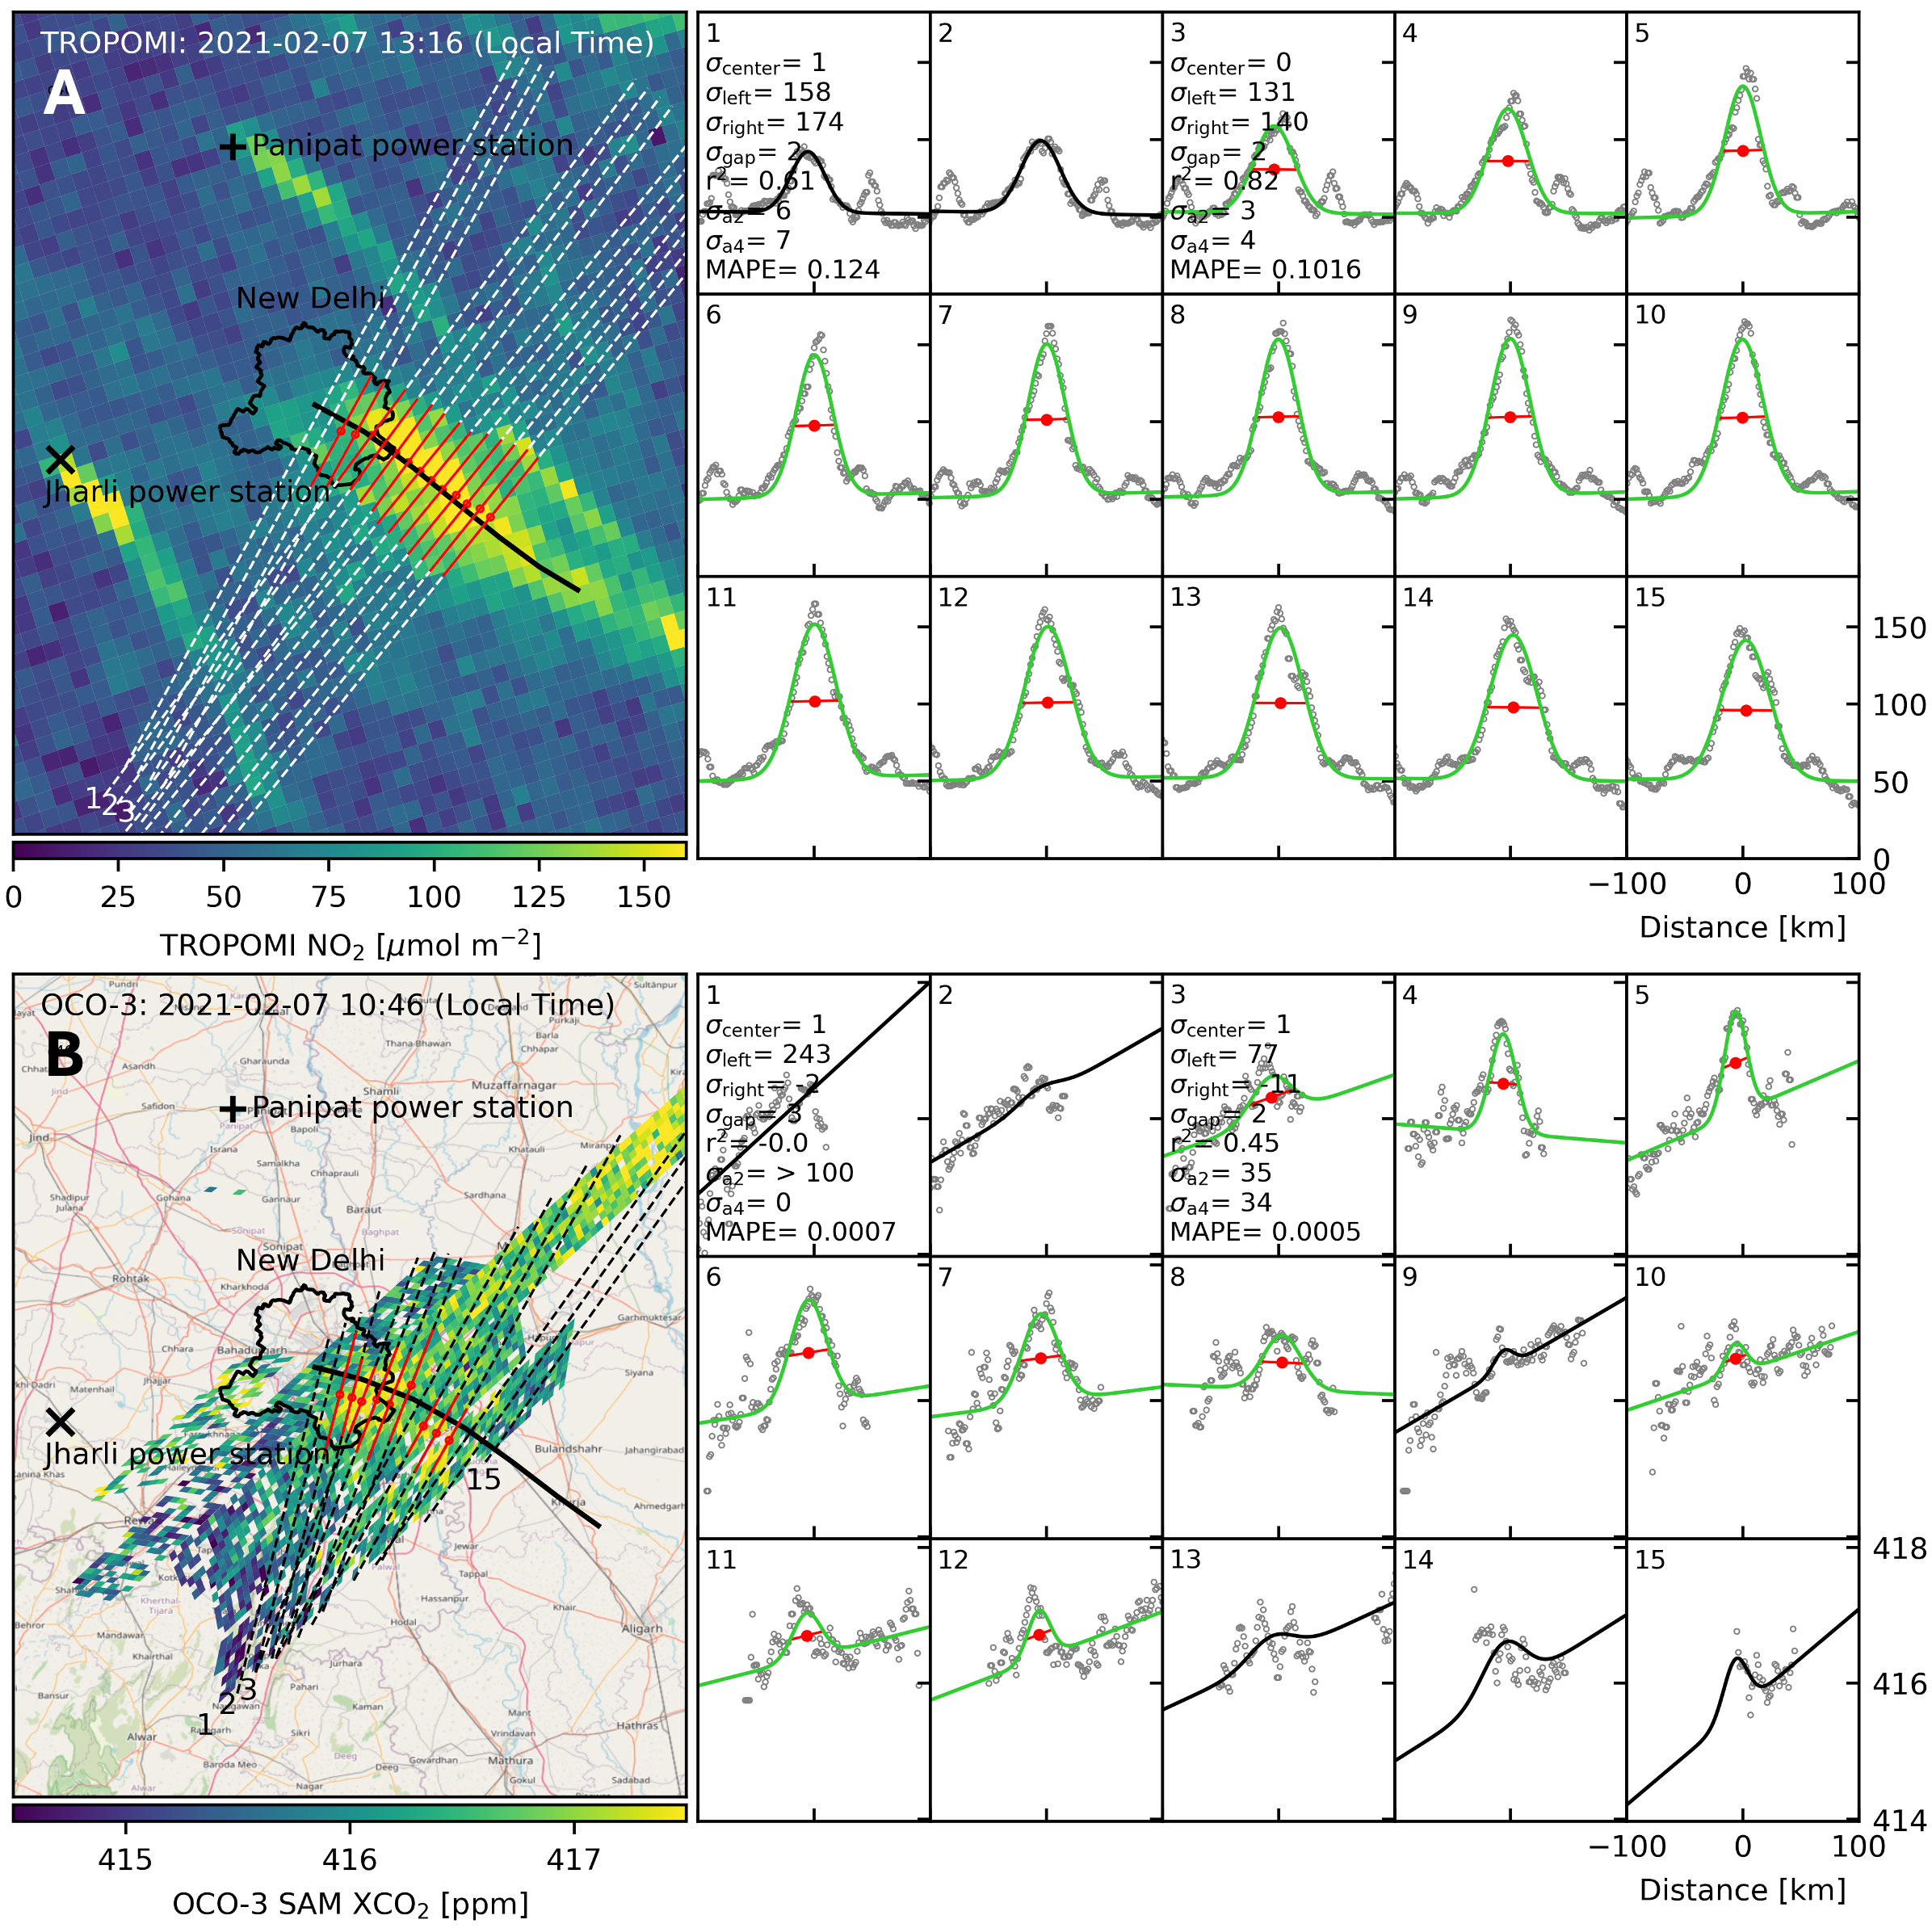
Figure 1. Overview of the cross-sectional flux method. (A) TROPOMI tropospheric column NO₂ measurements over New Delhi on February 7th, 2021. The black line is the HYSPLIT trajectory, while dotted lines are orthogonal lines used for calculating cross-sectional fluxes, defined at 15-minute intervals along the trajectory. Red lines are the full width at half-maximum (a₄ in Equation 1). The right panels show NO₂ measurements sampled along the orthogonal lines as a function of distance from the line’s center (circles). Gaussian curves fitted to the sampled NO₂ measurements are shown in green if they passed the goodness-of-fit test and in black if they failed. Eight goodness-of-fit parameters used for the threshold filtering are shown for two Gaussian curves. (B) OCO-3 SAM XCO₂ measurements from the same day, 2.5 hours before the TROPOMI overpass.

2.4.2. Gaussian Curve Fitting
For Gaussian-curve fitting of the cross-sectional NO₂ and XCO₂ measurements, we adopt the CSF method from Reuter et al. (2019) (R2019). The following two equations are used to fit Gaussian curves to TROPOMI’s NO₂ and OCO-3’s XCO₂ cross-sections sampled downwind of the city:
${NO}_{2} =a_{0}+a_{1}x+a_{2}e^{-4\ln\left(2\right) {\left(x-a_{3}\right)}^{2} a_{4}^{-2}}$ (1)
${XCO}_{2}=b_{0}+b_{1}x+b_{2}e^{-4\ln\left(2\right) {(x-b_{3})}^{2} b_{4}^{-2}}$
$$where \left\{\begin{aligned} 0<a_{0}<500 \\ -50<a_{1}<50 \\ 0<a_{2}<1000 \\ -1D<a_{3}<1D \\ 0.5D<a_{4}<2D\end{aligned} and \left\{\begin{aligned} 400<b_{0}<440 \\ -0.03<b_{1}<0.03 \\ 0<b_{2}<5 \\ {-1.1 a}_{3, max}<b_{3}<{1.1 a}_{3, max} \\ 0.5 a_{4}<b_{4}<a_{4}\end{aligned}\right.\right.$$
$$D: City’s diameter$$
where a₀ and a₁ is the background with spatial variation, and a₂ is the amplitude, a₃ is the shift, a₄ is the full width at half-maximum (FWHM) of the Gaussian curve fitted to TROPOMI NO₂ measurements. Similarly, b₀ to b₄ are equivalent parameters for OCO-3 XCO₂ measurements.
First, we estimate a₀-a₄ by applying a non-linear least squares method to cross-sectional NO₂ measurements, using upper and lower bounds for each parameter as defined in Equation 1. These bounds help prevent the algorithm from fitting curves to noise in NO₂ or XCO₂ measurements while also improving computational efficiency. Notably, the shift of a Gaussian curve, a_{3,} is allowed to deviate from the center of the trajectory by up to the city’s diameter to account for potential errors in ERA5 wind direction. The fitted a₃ value is subsequently used to correct bias in emission estimates caused by errors in HYSPLIT/ERA5 trajectories (see Text S1). In contrast to our approach, R2019 set a₃ to zero after manually adjusting the model wind direction to subjectively align with the observed NO₂ plume.
Gaussian curve fitting for OCO-3 XCO₂ measurements follows a similar approach to NO₂ measurements, with key differences in parameters: b₃ (shift) and b₄ (FWHM). The CO₂ plume shift (b₃) is constrained within 110% of the maximum shift of the NO₂ plume (a₃) over the 6-hour trajectory span. The CO₂ plume width (b₄) is bounded by the NO₂ plume width (a₄), with an upper limit equal to a₄ and a lower limit set at half of a₄. This allows the model to correct the potential overestimation of urban plume width caused by TROPOMI’s larger pixel size (up to 7 km × 7 km) as compared to OCO-3’s finer pixel resolution (2.25 km × 1.6 km). If the Gaussian curve fitted to the co-located NO₂ measurements fails the goodness-of-fit test (r² > 0.8), Gaussian fitting for the corresponding OCO-3 SAM is not conducted.
To ensure the quality of Gaussian fits for CO₂ plumes, we apply a goodness-of-fit test based on twelve mutually inclusive goodness-of-fit metrics (Figure S1). A detailed description of the test is provided in Text S2. As a result, 2,381 Gaussian curves pass the goodness-of-fit test, representing 7% of all Gaussian curves fitted to XCO₂ measurements. Figure 1 illustrates examples of Gaussian curves that passed (green lines) and failed (black lines) the goodness-of-fit test.

2.4.3. Emission Estimation
Once the quality assurance of the Gaussian curves is complete, we calculate the city’s CO₂ emissions using the following equation, adapted from R2019:
$E_{CO2}= \frac{1}{2}\sqrt{\frac{π}{\ln\left(2\right)}} \frac{M_{CO2}}{N_{A}} n_{e} b_{2} b_{4}ws$ (2)
where ECO₂ is the CO₂ emissions in million tons of CO₂ (MtCO₂) per year, M_{CO2} is the molar mass of CO₂ (44.01 g mol⁻¹), N_{A} is the Avogadro constant (6.022 × 10²³ mol⁻¹), n_{e} is the number of dry air particles in the atmospheric column (m⁻²), b₂ is the amplitude (ppm), b₄ is the FWHM (km), and ws is the wind speed orthogonal to the cross section (m/s). The n_{e} is calculated using OCO-3 surface pressure retrieval (P_{surf}) assuming hydrostatic pressure in the standard atmosphere.
To calculate annual emissions, we combine hourly emission estimates from SAMs using diurnal and weekly scaling factors from Temporal Improvements for Modeling Emissions by Scaling (TIMES, global 0.25° grids) (Nassar et al., 2013), and monthly scaling factors derived from ODIAC’s monthly emissions for each city (T. Oda et al., 2018). For scaling from hourly to daily emissions, the diurnal scaling factor is inversely weighted by the 1σ uncertainty of E_{CO2}. (i.e., larger weights are given to emission estimates with smaller uncertainties). For scaling from daily to monthly and monthly to annual emissions, ODIAC scaling factors are weighted by the number of high-quality Gaussian curves fitted for each OCO-3 SAM (i.e., larger weights are assigned to daily/monthly emission estimates that are derived from a larger number of Gaussian curves).
We calculate the 1σ uncertainty for the satellite-based CO₂ emission estimates by propagating six sources of uncertainty: (1, 2) one standard deviation error of the Gaussian curve amplitude and FWHM (σ_{b2} and σ_{b4}), (3) orthogonal wind speed (σ_{ws}), (4) diurnal scaling factor from TIMES (σ_{diurnal}), (5, 6) weekly and monthly scaling factors from ODIAC (σ_{weekly} and σ_{monthly}). The σ_{b2} and σ_{b4} are calculated using the Python SciPy package’s curve_fit algorithm. We assign conservative ±30% uncertainties for wind speed (σ_{ws}) and temporal scaling factors (σ_{diurnal}, σ_{weekly}, σ_{monthly}).
We also tested the sensitivity of our satellite-based CO₂ emission estimates calculated without incorporating TROPOMI NO₂ measurements and/or HYSPLIT trajectories (see Text S3). Our results show that including TROPOMI NO₂ measurements and HYSPLIT trajectories improves the emission estimates―incorporating TROPOMI NO₂ enhances the quality of Gaussian curves, while incorporating HYSPLIT trajectories increases the likelihood of detecting urban plumes from satellite pixels (Table S3).

2.5. EDGAR and ODIAC
We use EDGAR v8 (European Commission et al., 2023) and ODIAC2023 (Oda & Maksyutov, 2015) to calculate annual CO₂ emissions for 54 C40 cities. We select the year 2022 for both EDGAR and ODIAC, as the mean decimal year of the OCO-3 SAMs used for emission calculations is 2022.1. Emissions are calculated by summing the values from EDGAR/ODIAC grid cells within the minimum and maximum longitude/latitude of a city’s boundary (i.e., rectangular area enclosing a city’ boundary shape). Detailed description on city’s boundary is provided in Section 2.1.
To determine the 1σ uncertainty of EDGAR and ODIAC emission estimates, we consider potential spatial misalignment between the geographical coverage of OCO-3 SAM and the boundaries used to sample EDGAR and ODIAC grid cells. Two additional emissions are estimated from EDGAR and ODIAC by sampling grid cells in the following shapes: 1) a square area enclosing a city’s boundary shape (i.e., larger than the rectangular area) and 2) the city’s geographical boundary shape (i.e., smaller than the rectangular area). The 1σ uncertainties for EDGAR (or ODIAC) are calculated as one standard deviation of the three emission estimates― rectangular area (base), square area, and city’s boundary.

2.6. Socioeconomic Analysis
We use cities’ GDP and population data from the C40 Cities website, which provides city-specific GDP values from the Oxford Economics’ Global Cities Dataset. To align the spatial coverage of OCO-3 SAM (i.e., emission estimates) with the C40 cities’ administrative boundaries (i.e., GDP), we scale the GDP values by the population ratio between the two areas. Specifically, we calculate the population in the OCO-3 SAM’s geographical coverage area (i.e., the rectangular area enclosed by the UC or administrative boundaries) relative to the population in the C40 city administrative boundaries. The population count in the OCO-3 SAM’s coverage area is derived from the Gridded Population of the World (GPWv4, Revision 11, 2020, (Center for International Earth Science Information Network - CIESIN - Columbia University, 2018)).

3 Results

3.1. Satellite-based CO₂ Emission Estimates for Global Cities

Figure 2 shows annual CO₂ emissions for 54 C40 cities, estimated using OCO-3 SAMs XCO₂ retrievals collected between September 2019 and November 2023. The emission estimates are calculated using 2,381 Gaussian curves derived from OCO-3 434 SAMs. The average number of SAMs used per city varies by region: 9 for Africa, 8 for South and West Asia, 13 for Latin America, 3 for Central East Asia, 4 for East and Southeast Asia & Oceania, 9 for Europe, and 8 for North America.
Among these cities, Tokyo, Japan shows the highest emissions at 83 million metric tons of CO₂ (MtCO₂) (population 21.6 million), while Rotterdam, Netherlands shows the lowest at 11 MtCO₂ (population: 2.3 million). Istanbul, Türkiye, and Dubai, UAE, show the median values with emissions of 28 MtCO₂ and 32 MtCO₂, respectively. The combined emissions of these cities total 1,735 MtCO₂, which falls between annual emissions of Russia (1,909 MtCO₂) and Japan (1,083 MtCO₂)— the fourth- and fifth-largest emitting countries, respectively, according to EDGAR. The 1σ uncertainty in our satellite-based emission estimates range from 15% for Madrid, Spain to 181% for San Francisco, USA, with median uncertainties of 31% for Washington D.C., USA and 33% for Boston, USA. A full list of 1σ uncertainties for all 54 cities is shown in Figure 2.
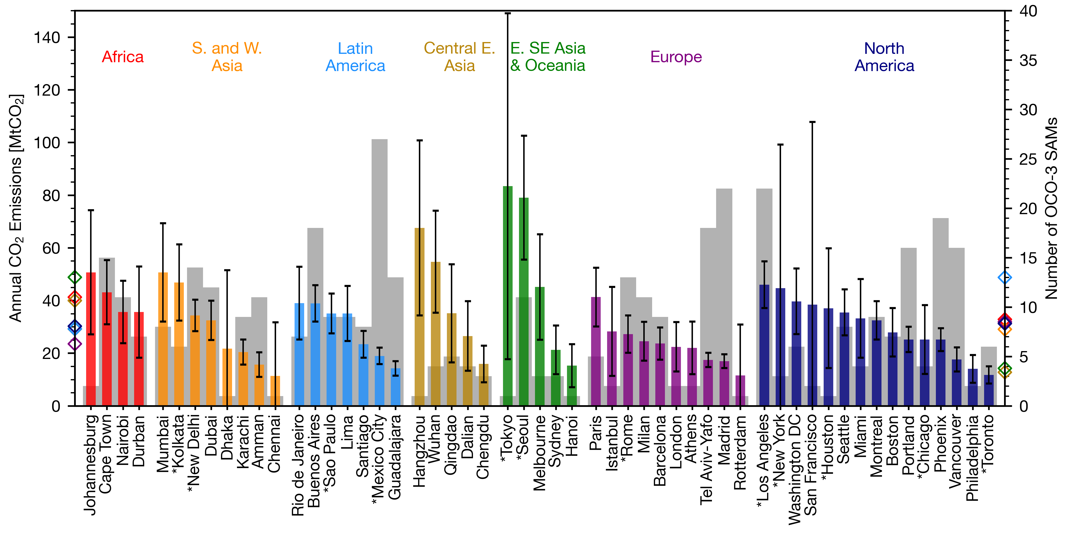
Figure 2. Fifty-four C40 cities’ annual CO₂ emissions estimated from the satellite-based cross-sectional flux method (colored bars) and the number of OCO-3 SAMs used to calculate emissions. Error bars show 1σ uncertainty. Colored diamond symbols on y-axis show the average numbers for seven global regions designated by C40 Cities. An asterisk symbol next to the city name indicates that the city’s administrative boundary was used for the emission estimation. Other cities used the Urban Centre (UC) defined in the GHS-SMOD dataset.

3.2. Global Comparison of Bottom-up and Satellite-based Urban Emission Estimates
Figure 3 compares our satellite-based CO₂ emission estimates for 54 C40 cities to two bottom-up gridded emission datasets– EDGAR and ODIAC. It is important to note that EDGAR includes both fossil and biofuel sectors, while ODIAC only covers fossil-fuel sectors. A previous study found that EDGAR can artificially underestimate citywide emissions by 13% for cities smaller than 1,000 km² due to the smoothing effect of urban emission hotspot grid cells (Ahn et al., 2023). Our study includes 29 cities smaller than 1,000 km². For these cities, EDGAR emissions are 8% smaller than our satellite-based estimates, which is consistent with previous findings reported in Ahn et al. (2023).
Globally, both EDGAR and ODIAC show great agreement with our satellite-based emission estimates: the mean percentage error (MPE) for the 54 cities’ emission estimates is −7% for EDGAR vs. OCO-3 and 1% for ODIAC vs. OCO-3. However, this agreement results from the cancellation of large errors in opposite directions at the individual city level. The mean absolute percentage error (MAPE), which accounts for errors of both signs, is 45% for EDGAR vs. OCO-3 and 50% for ODIAC vs. OCO-3. Among the 54 cities, EDGAR estimates fall within the 1σ uncertainty range of our OCO-3 estimates for 25 cities, and ODIAC estimates fall within this 1σ range for 22 cities. In summary, while individual city estimates should be interpreted with caution, there is less uncertainty when emissions are analyzed for groups of cities, particularly when aggregated at regional or global scales.
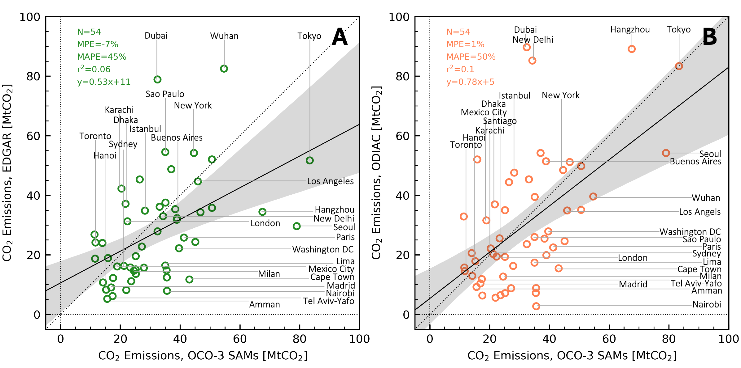
Figure 3. Comparison of annual CO₂ emission estimates for 54 global C40 cities between bottom-up datasets—EDGAR (A) and ODIAC (B)— and satellite-based estimates. The mean percentage error ((BottomUp−OCO3)/OCO3×100), mean absolute percentage error, and the linear least-squares regression model are shown. The grey area represents the 95% confidence interval of the regression model. Only half of the cities are labeled, with the remaining city names shown in Figure S2. Note that EDGAR includes emissions from both fossil and biofuel sectors, while ODIAC only covers fossil-fuel emissions.

3.3. Regional Comparison of Bottom-up and Satellite-based Urban Emission Estimates
When cities are grouped into seven global regions, the two bottom-up emission datasets reveal distinct regional characteristics (Figure 4). Figure 4 includes two additional variables from Figure 3: EDGAR’s fossil-only emissions and the sum of ODIAC’s fossil- and EDGAR’s biofuel emissions. For the 54 cities, ODIAC fossil emissions are 55% larger than EDGAR’s fossil emissions and 14% larger than EDGAR’s total emissions.
We found the best agreement between bottom-up and satellite-based emission estimates for cities in North America, with MPE ranging from −15 ± 41% for EDGAR fossil to −3 ± 46% for ODIAC total emissions. Overall, EDGAR and ODIAC underestimates emissions, though the standard deviation of MPE includes zero, indicating reasonable agreement with satellite-based estimates.
A similar pattern was observed for European cities, though the underestimation by bottom-up datasets was more pronounced than in North America, with MPE range from −29 ± 43% for EDGAR fossil to −20 ± 44% for ODIAC total emissions. Notably, EDGAR and ODIAC fossil emissions showed stronger agreement in North America and Europe than in other regions, suggesting a more robust census capability in these areas. This finding supports the assumption in Solazzo et al. (2021), which assigned a lower uncertainty to fossil fuel combustion activity in industrialized countries (±5%) compared to developing countries (±10%). Additionally, Ahn et al. (2023) reported that cities in North America and Europe tend to use more recent and local-specific emission factors in their inventories, further supporting these results.
For cities in East and Southeast Asia & Oceania, ODIAC showed great agreement with satellite-based emission estimates, comparable to cities in North America, with MPE of −13 ± 23% for ODIAC fossil and 2 ± 29% for ODIAC total emissions. In contrast, EDGAR estimated significantly lower CO₂ emissions in this region than both ODIAC and the satellite-based estimates, with MPE values of −58 ± 13% for EDGAR fossil and −43 ± 13% for EDGAR total.
For cities in Africa, both EDGAR and ODIAC significantly underestimated emissions compared to satellite-based estimates. Among the seven global regions, Africa is the only region where satellite-based estimates fall outside the 1 sigma range of all four bottom-up emission estimates, with MPE ranging from −73 ±19% for EDGAR fossil to −47 ± 35% for ODIAC total emissions.
In contrast, for cities in Central East Asia, both EDGAR and ODIAC overestimated emissions compared to satellite-based estimates— the opposite pattern observed in Africa. This is one of two regions where all four bottom-up estimates showed positive MPE values against satellite-based estimates, ranging from 13 ± 42% for EDGAR fossil to 70 ± 93% for ODIAC total emissions. Previous studies have suggested that China’s emission inventories may be overestimated due to factors such as inflated emission factors and imprecise spatial disaggregation (Feng et al., 2024; Liu et al., 2015; Zhang et al., 2023). While our study does not include an in-depth analysis of bottom-up datasets (e.g., emission factors, spatial proxies used for disaggregation), our results align with these earlier findings.
Similarly, for cities in South and West Asia, both EDGAR and ODIAC overestimated emissions compared to satellite-based estimates. Overall, EDGAR showed better agreements than ODIAC, with MPE ranging from 1 ± 75% for EDGAR fossil to 111 ± 90% for ODIAC total emissions. Notably, fossil emissions from EDGAR and ODIAC agreed with satellite-based estimates at a level similar to that of Central East Asia. However, in this region, EDGAR biofuel emissions accounted for 33% of the total emissions, significantly higher than Central East Asia’s 7%. This led to significantly larger MPE values for EDGAR and ODIAC total emissions compared to cities in Central East Asia.
For cities in Latin America, EDGAR total and ODIAC fossil emissions showed great agreements with satellite-based estimates, at a level similar to North America, with MPE of −15 ± 31% and −4 ± 40%, respectively. Meanwhile, EDGAR estimated relatively high biofuel CO₂ emissions in this region, accounting for 37% of total emissions. This led to a significantly lower MPE for EDGAR fossil emissions and a higher MPE for ODIAC total emissions. The implications of such large biofuel emissions are further discussed in Section 4.1.

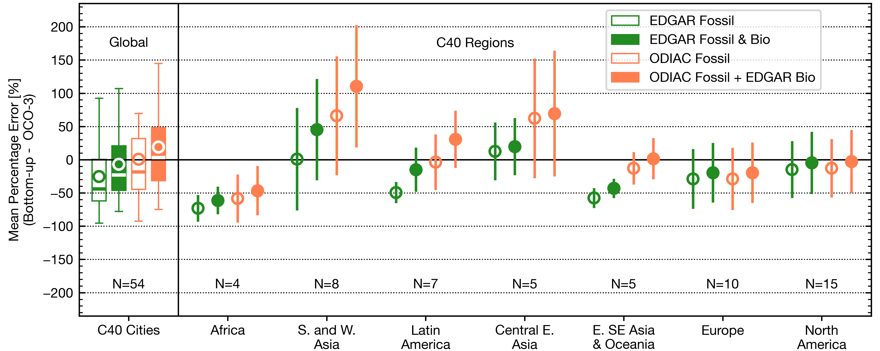
Figure 4. Regional comparison of urban CO₂ emission estimates between the bottom-up datasets—EDGAR and ODIAC— and satellite-based estimates. Empty symbols show the mean percentage error (MPE) for fossil-fuel emissions of the bottom-up datasets, while filled symbols indicate MPE for the total emissions (i.e., fossil-fuel + biofuel). The box plot shows the lower (q1) and upper (q3) quartiles, median, and the whisker ranges from the q3+1.5(q3–q1) to q1–1.5(q3–q1). The circle and line represent the mean and standard deviation, respectively.

3.4. Satellite-based Socioeconomic Analysis of Global Cities’ CO₂ emissions
Given the large population range across the 54 global cities —from 1.9 million in Portland, USA to 29.6 million in Dhaka, Bangladesh— a more policy-relevant comparison of urban emissions can be achieved using the Kaya Identity, which accounts for both population and GDP. Previous studies applying the Kaya Identity have focused on a single country (Dogan & Turkekul, 2016; Gudipudi et al., 2016; Katircioğlu & Katircioğlu, 2018; Ribeiro et al., 2019; Shahbaz et al., 2016) or a region (Al-mulali et al., 2013; Gudipudi et al., 2019; Salahuddin et al., 2019), limited by the availability of spatiotemporally consistent bottom-up emission inventories. In this study, we apply a modified Kaya Identity to decompose our satellite-based emission estimates for the 54 C40 cities: CO₂ = CO₂/GDP × GDP/Population × Population (Kaya & Yokobori, 1997).
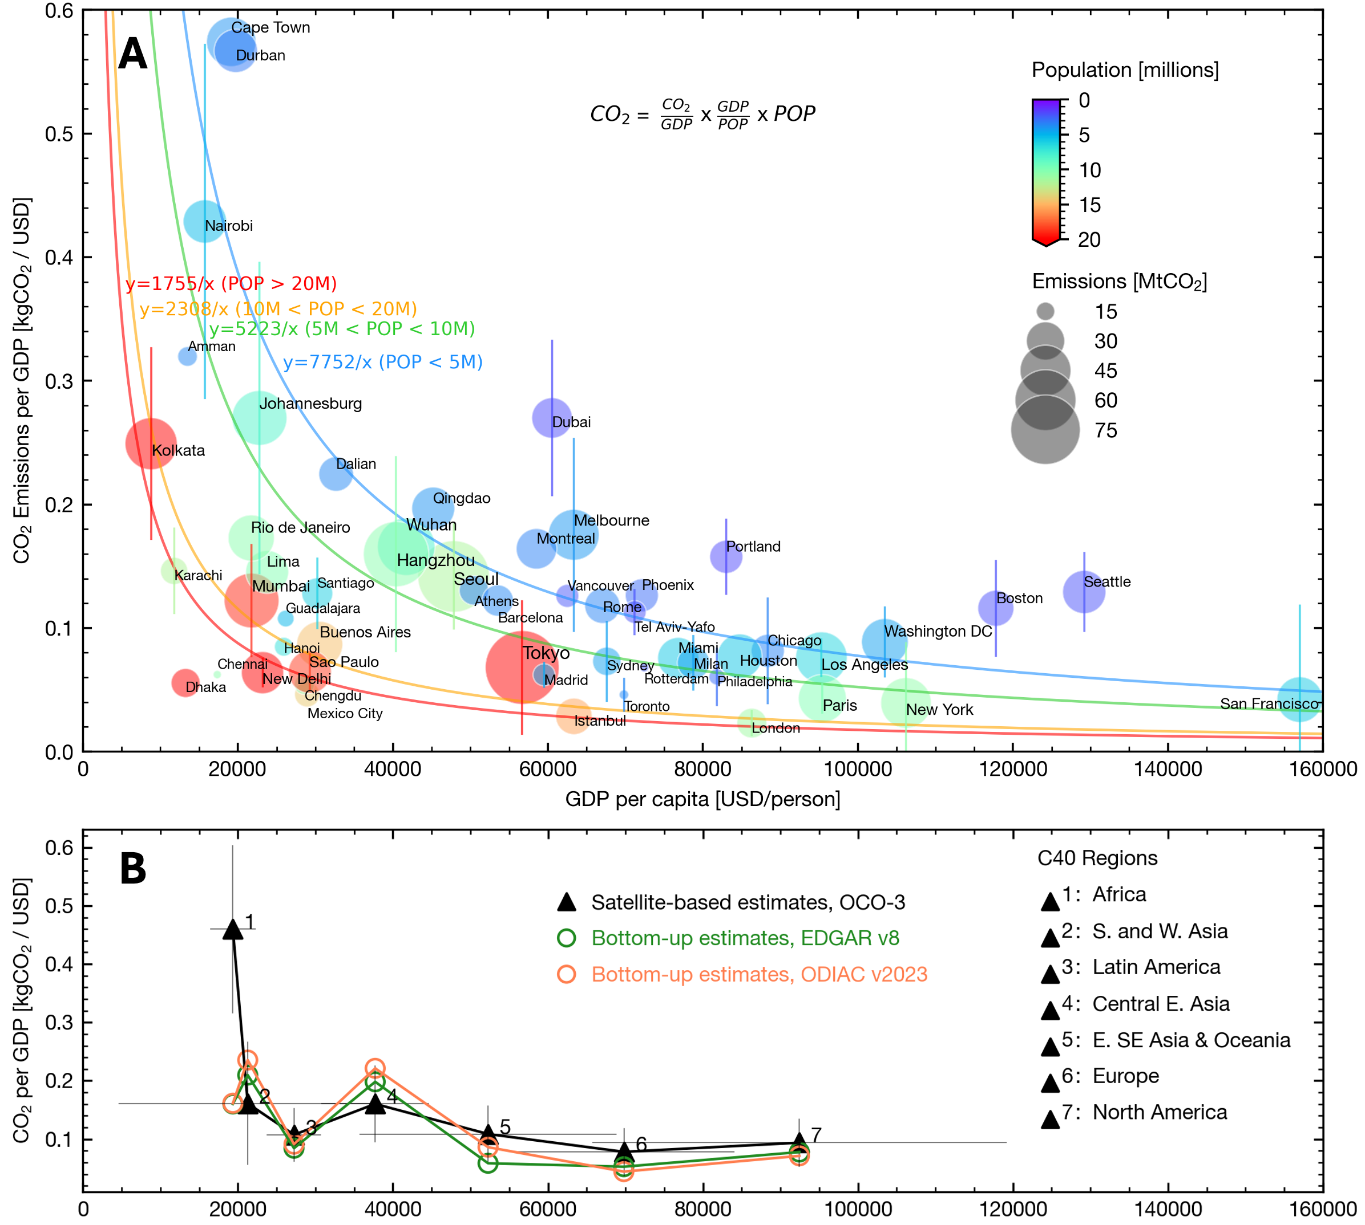
Figure 5. Satellite-based Kaya Identity analysis for (A) 54 C40 cities and (B) those cities grouped into seven global regions. (A) Satellite-based CO₂ emissions for individual cities are plotted against three components of the Kaya Identity: 1) CO₂ Emissions per GDP, 2) GDP per capita, and 3) population. The colored line shows a non-linear least squares fit to the function $y=k/x$ ($k$: CO₂ emissions per-capita) for population bins of 5, 10, and 20 million. (B) Regional satellite-based estimates (black triangle and error bars, the mean and the standard deviation) are compared with bottom-up based estimates (green and orange circles).
Our analysis of satellite-based urban CO₂ emissions reveals an inverse relationship between CO₂ emissions per unit of GDP (i.e., the carbon intensity of a city’s economy) and GDP per capita (i.e., economic output per person), indicating that high-income cities tend to have less carbon-intensive economies. A notable example is San Francisco, USA (positioned in the lower right corner of Figure 5A), where the economy is largely service-based (e.g., IT, Finance, Education), following a decline in the manufacturing sector since the 1980s (Hoerter & Wiseman, 1988). In contrast, Durban and Cape Town, both in South Africa, (upper left corner of Figure 5A) consists of larger industrial sectors. Durban is home to the largest container port in Africa, while the port of Cape Town is the second busiest port in South Africa (Naicker & Allopi, 2015). According to Durban’s GPC emission inventory, the industry sector accounts for 70% of the city’s total GHG emissions (C40 Cities, 2022), with the sugar industry being the province’s largest employer (Rambakus et al., 2020). Additionally, household fuel burning, particularly in low-income settlement area, have been identified as a significant contributor to local air pollution and co-emitted CO₂ emissions (Baborska-Narozny et al., 2020; Buthelezi et al., 2019; City of Cape Town, 2024).
A similar inverse relationship ―the decoupling of CO₂ emissions from economic growth― is observed when cities are grouped into global regions. Three regions ―North America, Europe, East and Southeast Asia & Oceania― are positioned in the lower right corner in Figure 5B, representing high-output, low-carbon-intensity economies. In contrast, Africa is positioned in the upper left corner in Figure 5B, indicating low-output, high-carbon-intensity economy. Notably, despite having higher GDP per capita, Central East Asia shows higher carbon intensity than Latin America. Colored lines in Figure 5B indicate the same analysis conducted using two bottom-up emission inventories. Regionally, bottom-up estimates tend to be larger (smaller) than satellite-based estimates for cities in Central East Asia and South & West Asia (Africa, East and Southeast Asia & Oceania, Europe, and North America). However, on a global scale, bottom-up emission inventories show similar inverse relationships to those observed in satellite-based estimates.
Additionally, our analysis shows that satellite-based per-capita CO₂ emissions decrease as urban population size increases― an inverse relationship illustrated by the colored lines in Figure 5A. This trend has been previously reported in bottom-up emission studies and OCO-2 based analysis (Gately et al., 2015; Luqman et al., 2023; Ribeiro et al., 2019; Wilmot et al., 2024; Wu et al., 2020). For example, studies have reported that transportation energy consumption decrease exponentially with increasing urban population density (Gately et al., 2015; Newman & Kenworthy, 1989). Our-satellite based estimates find that per-capita CO₂ emissions for cities with population size under 5 million average 7.7 tCO₂. This declines to 5.2 tCO₂ (−33%) for cities with population between 5 million and 10 million, 2.3 tCO₂ (−70%) for cities between 10 million and 20 million, and 1.8 tCO₂ (−77%) for cities exceeding 20 million residents.

4 Discussion

4.1. Source Sector Attribution from Space
The major limitation of the CSF approach presented in this study is its inability to attribute emissions to specific source sectors. Our satellite-based emission estimates agree within < 7% to either EDGAR’s total CO₂ emissions or ODIAC’s fossil fuel CO₂ emissions at the global scale (Figure 3). However, EDGAR’s urban fossil fuel CO₂ emissions tend to be too low (MPE = −25%) and ODIAC’s urban total CO₂ emissions tend to be too high (MPE = 19%) compared to our satellite-based estimates (Figure 4). Two bounding hypotheses to explain the discrepancy are 1) EDGAR’s fossil fuel and biofuel emission estimates are accurate and well-captured by our satellite-based approach, while ODIAC overestimates fossil fuel emissions, 2) ODIAC accurately estimates fossil fuel emissions, and our satellite-based method captures the fossil fuel CO₂ signal only: i.e., CO₂ plume distinguished using TROPOMI NO₂ measurements and HYSPLIT trajectories only reflect the fossil fuel signal due to the lack of spatial variability in XCO₂ or NO₂ from biofuel combustions― a limitation of using XCO₂ and NO₂ together. In this second scenario, EDGAR underestimates fossil-fuel CO₂ emissions for global cities. The “true” state likely falls between these two bounding hypotheses, where our satellite method captures fossil fuel CO₂ signal and parts of the biofuel CO₂ signal, and both EDGAR and ODIAC possess errors in their fossil fuel (and also biofuel for EDGAR) emission estimates. According to EDGAR, cities in North America, Europe, and Central East Asia are less sensitive to these hypotheses since biofuel contributions are relatively small (< 15%). In contrast, biofuel emissions account for a larger share (~37%) of total emissions for cities in Latin America and Africa, making these regions more sensitive to the hypotheses.
To better distinguish fossil fuel and biofuel CO₂ emissions surrounding urban areas, future efforts should incorporate atmospheric observations of other trace gases, such as carbon monoxide (CO), black carbon (BC), or primary organic aerosols (POA) as an indicator of biomass burning (Andreae, 2019). For targeted cities, analyzing satellite observations via a Bayesian inversion and high-resolution transport modeling can help refine our understanding of urban CO₂ sources (Hedelius et al., 2018; Roten et al., 2023; Wu et al., 2022; Ye et al., 2020). For example, Wu et al. (2022) estimated combustion efficiencies (i.e., CO-to-CO₂ ratio) at sub-city scales for Baotou, Zibo, Shanghai, and Los Angeles using the X-STILT, OCO-3 XCO₂, and TROPOMI CO data. Roten et al. (2023) demonstrated the potential to constrain sector-specific CO₂ emissions from Los Angeles by interpreting OCO-3 SAMs with a Bayesian inversion technique, sector-specific a priori CO₂ flux map (VULCAN), X-STILT, and 3-km resolution meteorological data.
Moving forward, a collective effort is needed to catalogue and integrate various urban emission datasets―including satellite-derived emission datasets at the global scale (this study), high-resolution inversion modeling for targeted cities, gridded emission datasets (i.e., EDGAR and ODIAC), and local emissions inventory (e.g., GPC)― to support global cities in achieving their net-zero pledges efficiently and effectively.

4.2. In-boundary vs. Out-of-boundary Emissions
Satellite-based CO₂ emission estimates cover emissions within a city’ geographical domain, commonly referred to as Scope 1 emissions. In contrast, the GPC emissions inventory―the standard emission tracking method for C40 Cities― also covers emissions occurring outside of the city’s geographical domain (Scope 2+3). Such out-of-boundary emissions include grid-supplied energy consumption (Scope 2) and out-of-boundary waste & water emissions (Scope 3). To enable a direct comparison between satellite-based emission datasets and GPC inventories, a translation between Scope 1 and Scope 1+2+3 is necessary. Since satellite sensors cannot track out-of-boundary emissions (e.g., grid-supplied energy), a more practical approach is to scale down GPC inventories (Scope 1+2+3) to Scope 1 emissions.
Figure 6 shows the percentage of Scope 1 CO₂ emissions relative to total GHG emissions (seven GHGs across Scope 1+2+3) reported by C40 cities. On average, Latin American cities have the highest Scope 1 CO₂ percentage (78%), followed by North America (72%), Europe (62%), South & West Asia (annual CO₂ emissions %), Africa (48%), East, Southeast Asia & Oceania (32%), with a global mean of 61%. This suggests that about two-thirds of cities’ total GHG emissions occur within their boundaries and can be monitored using CO₂-observing satellite instruments. Additionally, future study can use satellite-based Scope 1 CO₂ emission datasets to assess the air quality co-benefits of urban climate actions, as CO₂ is emitted concurrently with other air pollutants, such as NO_{x} (Kleiman et al., 2022; West et al., 2013).
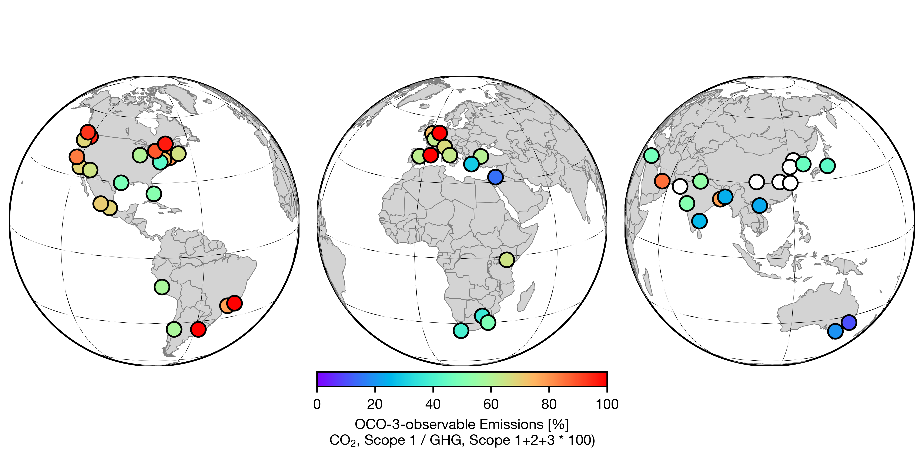
Figure 6. The percentage of urban GHG emissions that can be monitored using satellite for 54 C40 cities. The color scale shows the percentage of Scope 1 (i.e., territorial) CO₂ emissions of the total GHG emissions (All GHGs, Scope 1+2+3) according to self-reported inventories (GPC). The white circles are where the GPC inventory is not available.

4 Conclusions
In this study, we presented a computationally-efficient cross-sectional flux (CSF) approach for estimating CO₂ emissions across 54 global cities using OCO-3 SAMs measurement data. We showed that the accuracy of the CSF approach can be enhanced by incorporating TROPOMI NO₂ and HYSPLIT trajectory in the urban plume detection process.
By comparing our satellite-based emissions estimates with two of the most widely used bottom-up datasets ―EDGAR and ODIAC― we found that: 1) bottom-up datasets show relatively good agreement with the satellite-based estimates on a global scale (within 7%), and 2) this agreement is largely due to regional discrepancies of opposite signs that cancel each other out. We find that bottom-up datasets tend to overestimate CO₂ emissions for cities in Central East Asia and South and West Asia, while underestimating for cities in Africa, East and Southeast Asia & Oceania, Europe, and North America. These findings suggest that satellite-based emission estimates can help identify regions with larger discrepancies, such as cities in Africa and South and West Asia, for region-specific improvements to bottom-up datasets.
Moreover, the application of the Kaya Identity reveals socioeconomic patterns in global cities’ CO₂ emissions. Our satellite-based analysis highlights the decoupling of economic growth and carbon-intensive sectors across global cities. Also, the satellite analysis captured that per capita CO₂ emissions tend to decrease as a city’s population size grows.
While the CSF approach enables consistent and scalable emission estimation for a large number of cities, it lacks the ability to attribute source sector or track Scope 2 or 3 emissions. Therefore, it is crucial to integrate various emission datasets, including high-resolution inversion model estimates, local inventories, along with the bottom-up datasets and satellite-based estimates presented in this study, to more effectively support global cities in their emission mitigation efforts and achieve their net-zero goals.
(2020)
Acknowledgments
We thank C40 Cities for providing their cities’ geographical boundary shapefiles that allowed us to compute satellite-based urban CO₂ emissions. The authors appreciate the helpful comments provided by Victoria Gonsior and Stephen Davis at C40 Cities, Bryan Duncan at NASA GSFC, and Argyro Kavvada at the U.S. Greenhouse Gas Center. This work was funded by NASA Health and Air Quality Applied Sciences Team grant 80NSSC21K0511, Wellcome Trust grant 216075/Z/19/Z, NASA OCO-3 project and NASA Carbon Monitoring System (CMS 2023) program. Part of the work was carried out at the Jet Propulsion Laboratory, California Institute of Technology, under a contract with the National Aeronautics and Space Administration (80NM0018D0004).
Data Availability Statement
OCO-3 Level 2 bias corrected XCO₂ data files (OCO3_L2_Lite_FP v10.4r) for the C40/SAMs cities are downloaded from the NASA's Goddard Earth Sciences Data and Information Services Center (GES DISC) website. TROPOMI L2 NO₂ data (S5P_OFFL_L2_NO2) are downloaded using the OData interface of the Data Hub (DHuSget v0.3.8). CDS (Copernicus Data Service) API was used to automatically retrieve a spatiotemporal subset data of ERA5 for OCO3/TROPOMI overpasses over C40 cities. The C40 GHG Dashboard data (versions 03.2021, 02.2022, and 05.2022) are obtained from the C40 Greenhouse Gas Emissions Interactive Dashboard webpage. We obtained geographical boundary shapefiles via communication with C40, and the shapefiles in a public repository (Data S1). Annual sector-specific EDGARv8.0 are obtained from the JRC EDGAR website (https://edgar.jrc.ec.europa.eu/dataset_ghg80). The version of the ODIAC data product (ODIAC2023) is available from the Global Environmental Database website hosted by the Center for Global Environmental Research (CGER), National Institute for Environmental Studies (NIES), Japan (http://db.cger.nies.go.jp/dataset/ODIAC/). The GHS-SMOD is publicly available for download from the open Global Human Settlement Layer (GHSL) data tools (https://human-settlement.emergency.copernicus.eu/index.php). The shapefiles of administrative boundaries for the C40 cities are provided as supplemental data.
References
Ahn, D. Y., Hansford, J. R., Howe, S. T., Ren, X. R., Salawitch, R. J., Zeng, N., et al. (2020). Fluxes of Atmospheric Greenhouse-Gases in Maryland (FLAGG-MD): Emissions of Carbon Dioxide in the Baltimore, MD-Washington, D.C. Area. Journal of Geophysical Research: Atmospheres, 125(9), e2019JD032004. https://doi.org/10.1029/2019JD032004
Ahn, D. Y., Goldberg, D. L., Coombes, T., Kleiman, G., & Anenberg, S. C. (2023). CO2 emissions from C40 cities: citywide emission inventories and comparisons with global gridded emission datasets. Environmental Research Letters, 18(3), 034032. https://doi.org/10.1088/1748-9326/acbb91
Al-mulali, U., Fereidouni, H. G., Lee, J. Y. M., & Sab, C. N. B. C. (2013). Exploring the relationship between urbanization, energy consumption, and CO2 emission in MENA countries. Renewable and Sustainable Energy Reviews, 23, 107–112. https://doi.org/10.1016/j.rser.2013.02.041
Andreae, M. O. (2019). Emission of trace gases and aerosols from biomass burning – an updated assessment. Atmospheric Chemistry and Physics, 19(13), 8523–8546. https://doi.org/10.5194/acp-19-8523-2019
Baborska-Narozny, M., Szulgowska-Zgrzywa, M., Mokrzecka, M., Chmielewska, A., Fidorow-Kaprawy, N., Stefanowicz, E., et al. (2020). Climate justice: air quality and transitions from solid fuel heating. Buildings and Cities. https://doi.org/10.5334/bc.23
Buthelezi, S. A., Kapwata, T., Wernecke, B., Webster, C., Mathee, A., & Wright, C. Y. (2019). Household Fuel Use for Heating and Cooking and Respiratory Health in a Low-Income, South African Coastal Community. International Journal of Environmental Research and Public Health, 16(4). https://doi.org/10.3390/ijerph16040550
Byrne, B., Baker, D. F., Basu, S., Bertolacci, M., Bowman, K. W., Carroll, D., et al. (2023). National CO₂ budgets (2015–2020) inferred from atmospheric CO₂ observations in support of the global stocktake. Earth System Science Data, 15(2), 963–1004. https://doi.org/10.5194/essd-15-963-2023
C40. (2023). C40 Annual Report 2022. C40. Retrieved from https://www.c40.org/wp-content/uploads/2023/03/C40-Cities-Annual-Report-2022_Published-Online-31-Mar-2023.pdf
C40 Cities. (2022). Benefits of Urban Climate Action | C40 Cities Technical Assistance Report: Durban. Retrieved from https://www.c40.org/wp-content/uploads/2022/02/Durban-–-Regulating-Industrial-Emissions.pdf
Center for International Earth Science Information Network - CIESIN - Columbia University. (2018). Gridded Population of the World, Version 4 (GPWv4): Land and Water Area, Revision 11 [Data set]. Palisades, New York: NASA Socioeconomic Data and Applications Center (SEDAC). Retrieved from https://doi.org/10.7927/H4Z60M4Z
Chatterjee, A., Gierach, M. M., Sutton, A. J., Feely, R. A., Crisp, D., Eldering, A., et al. (2017). Influence of El Nino on atmospheric CO₂ over the tropical Pacific Ocean: Findings from NASA’s OCO-2 mission. Science, 358(6360), eaam5776. https://doi.org/10.1126/science.aam5776
City of Cape Town. (2024). AIR QUALITY MANAGEMENT PLAN 2024. 2024. Retrieved from https://resource.capetown.gov.za/documentcentre/Documents/City%20strategies,%20plans%20and%20frameworks/Air_Quality_Management_Plan_2024.pdf
Climate TRACE. (2024). Climate TRACE data reveal high-impact opportunities for cutting greenhouse gas emissions. Retrieved from https://climatetrace.org/news/climate-trace-data-reveal-high-impact-opportunities-for
Commission, E. & Eurostat. (2021). Applying the degree of urbanisation – A methodological manual to define cities, towns and rural areas for international comparisons – 2021 edition. Publications Office of the European Union. https://doi.org/doi/10.2785/706535
Crippa, M., Guizzardi, D., Pisoni, E., Solazzo, E., Guion, A., Muntean, M., et al. (2021). Global anthropogenic emissions in urban areas: patterns, trends, and challenges. Environmental Research Letters, 16(7), 074033. https://doi.org/10.1088/1748-9326/ac00e2
Dogan, E., & Turkekul, B. (2016). CO2 emissions, real output, energy consumption, trade, urbanization and financial development: testing the EKC hypothesis for the USA. Environmental Science and Pollution Research, 23(2), 1203–1213. https://doi.org/10.1007/s11356-015-5323-8
Eldering, A., Taylor, T. E., O’Dell, C. W., & Pavlick, R. (2019). The OCO-3 mission: measurement objectives and expected performance based on 1 year of simulated data. Atmospheric Measurement Techniques, 12(4), 2341–2370. https://doi.org/10.5194/amt-12-2341-2019
European Commission, Joint Research Centre, Crippa, M., Guizzardi, D., Schaaf, E., Monforti-Ferrario, F., et al. (2023). GHG emissions of all world countries – 2023. Publications Office of the European Union. https://doi.org/10.2760/953322
Feng, S., Jiang, F., Wang, H., Liu, Y., He, W., Wang, H., et al. (2024). China’s Fossil Fuel CO2 Emissions Estimated Using Surface Observations of Coemitted NO2. Environmental Science & Technology, 58(19), 8299–8312. https://doi.org/10.1021/acs.est.3c07756
Friedlingstein, P., O’Sullivan, M., Jones, M. W., Andrew, R. M., Hauck, J., Landschützer, P., et al. (2024). Global Carbon Budget 2024. Earth System Science Data Discussions, 2024, 1–133. https://doi.org/10.5194/essd-2024-519
Fuentes Andrade, B., Buchwitz, M., Reuter, M., Bovensmann, H., Richter, A., Boesch, H., & Burrows, J. P. (2024). A method for estimating localized CO₂ emissions from co-located satellite XCO₂ and NO₂ images. Atmospheric Measurement Techniques, 17(3), 1145–1173. https://doi.org/10.5194/amt-17-1145-2024
Gately, C. K., Hutyra, L. R., & Sue Wing, I. (2015). Cities, traffic, and CO2: A multidecadal assessment of trends, drivers, and scaling relationships. Proceedings of the National Academy of Sciences, 112(16), 4999–5004. https://doi.org/10.1073/pnas.1421723112
Goldberg, D. L., Lu, Z., Oda, T., Lamsal, L. N., Liu, F., Griffin, D., et al. (2019). Exploiting OMI NO2 satellite observations to infer fossil-fuel CO2 emissions from U.S. megacities. Science of The Total Environment, 695, 133805. https://doi.org/10.1016/j.scitotenv.2019.133805
Gudipudi, R., Fluschnik, T., Ros, A. G. C., Walther, C., & Kropp, J. P. (2016). City density and CO2 efficiency. Energy Policy, 91, 352–361. https://doi.org/10.1016/j.enpol.2016.01.015
Gudipudi, R., Rybski, D., Lüdeke, M. K. B., Zhou, B., Liu, Z., & Kropp, J. P. (2019). The efficient, the intensive, and the productive: Insights from urban Kaya scaling. Applied Energy, 236, 155–162. https://doi.org/10.1016/j.apenergy.2018.11.054
Gurney, K. R., Liang, J., Roest, G., Song, Y., Mueller, K., & Lauvaux, T. (2021). Under-reporting of greenhouse gas emissions in U.S. cities. Nature Communications, 12(1), 553. https://doi.org/10.1038/s41467-020-20871-0
Hedelius, J. K., Liu, J., Oda, T., Maksyutov, S., Roehl, C. M., Iraci, L. T., et al. (2018). Southern California megacity \chemCO_2, \chemCH_4, and CO flux estimates using ground- and space-based remote sensing and a Lagrangian model. Atmospheric Chemistry and Physics, 18(22), 16271–16291. https://doi.org/10.5194/acp-18-16271-2018
Hersbach, H., Bell, B., Berrisford, P., Hirahara, S., Horányi, A., Muñoz-Sabater, J., et al. (2020). The ERA5 global reanalysis. Quarterly Journal of the Royal Meteorological Society, 146(730), 1999–2049. https://doi.org/10.1002/qj.3803
Hoerter, D., & Wiseman, M. (1988). Metropolitan development in the San Francisco Bay Area. The Annals of Regional Science, 22(3), 11–33. https://doi.org/10.1007/BF01283650
Katircioğlu, S., & Katircioğlu, S. (2018). Testing the role of urban development in the conventional Environmental Kuznets Curve: evidence from Turkey. Applied Economics Letters, 25(11), 741–746. https://doi.org/10.1080/13504851.2017.1361004
Kaya, Y., & Yokobori, K. (1997). Environment, energy, and economy: strategies for sustainability (Vol. 4). United Nations University Press Tokyo.
Kiel, M., Eldering, A., Roten, D. D., Lin, J. C., Feng, S., Lei, R., et al. (2021). Urban-focused satellite CO2 observations from the Orbiting Carbon Observatory-3: A first look at the Los Angeles megacity. Remote Sensing of Environment, 258, 112314. https://doi.org/10.1016/j.rse.2021.112314
Kleiman, G., Anenberg, S. C., Chafe, Z. A., Appiah, D. C., Assefa, T., Bizberg, A., et al. (2022). Enhanced Integration of Health, Climate, and Air Quality Management Planning at the Urban Scale. Frontiers in Sustainable Cities, 4. https://doi.org/10.3389/frsc.2022.934672
Kort, E. A., Frankenberg, C., Miller, C. E., & Oda, T. (2012). Space-based observations of megacity carbon dioxide. Geophysical Research Letters, 39(17). https://doi.org/10.1029/2012GL052738
Lei, R., Feng, S., Xu, Y., Tran, S., Ramonet, M., Grutter, M., et al. (2022). Reconciliation of asynchronous satellite-based NO2 and XCO2 enhancements with mesoscale modeling over two urban landscapes. Remote Sensing of Environment, 281, 113241. https://doi.org/10.1016/j.rse.2022.113241
Liu, F., Duncan, B. N., Krotkov, N. A., Lamsal, L. N., Beirle, S., Griffin, D., et al. (2020). A methodology to constrain carbon dioxide emissions from coal-fired power plants using satellite observations of co-emitted nitrogen dioxide. Atmospheric Chemistry and Physics, 20(1), 99–116. https://doi.org/10.5194/acp-20-99-2020
Liu, J., Bowman, K. W., Schimel, D. S., Parazoo, N. C., Jiang, Z., Lee, M., et al. (2017). Contrasting carbon cycle responses of the tropical continents to the 2015–2016 El Niño. Science, 358(6360), eaam5690. https://doi.org/10.1126/science.aam5690
Liu, Z., Guan, D., Wei, W., Davis, S. J., Ciais, P., Bai, J., et al. (2015). Reduced carbon emission estimates from fossil fuel combustion and cement production in China. Nature, 524(7565), 335–338. https://doi.org/10.1038/nature14677
Luqman, M., Rayner, P. J., & Gurney, K. R. (2023). On the impact of urbanisation on CO2 emissions. Npj Urban Sustainability, 3(1), 6. https://doi.org/10.1038/s42949-023-00084-2
Lwasa, S., Seto, K., Bai, X., Blanco, H., Gurney, K., Kılkış, Ş., et al. (2022). Urban systems and other settlements. In IPCC, 2022: Climate Change 2022: Mitigation of Climate Change. Contribution of Working Group III to the Sixth Assessment Report of the Intergovernmental Panel on Climate Change[P.R. Shukla, J. Skea, R. Slade, A. Al Khourdajie, R. van Diemen, D. McCollum, M. Pathak, S. Some, P. Vyas, R. Fradera, M. Belkacemi, A. Hasija, G. Lisboa, S. Luz, J. Malley, (eds.)]. Cambridge University Press, Cambridge, UK and New York, NY, USA, 861–952. https://doi.org/10.1017/9781009157926.010
Naicker, R., & Allopi, D. (2015). The Need for Expansion of the Durban Container Terminal. International Journal of Constructive Research in Civil Engineering, 1(2) : 33-38. https://www.arcjournals.org/international-journal-of-constructive-research-in-civil-engineering/volume-1-issue-2/5
Nassar, R., Napier-Linton, L., Gurney, K. R., Andres, R. J., Oda, T., Vogel, F. R., & Deng, F. (2013). Improving the temporal and spatial distribution of CO2 emissions from global fossil fuel emission data sets. Journal of Geophysical Research: Atmospheres, 118(2), 917–933. https://doi.org/10.1029/2012JD018196
Newman, P., 1945-, & Kenworthy, J. R., 1955-. (1989). Cities and automobile dependence : a sourcebook. Aldershot, Hants., England: Gower Technical.
Oda, T., Maksyutov, S., & Andres, R. J. (2018). The Open-source Data Inventory for Anthropogenic CO₂, version 2016 (ODIAC2016): a global monthly fossil fuel CO₂ gridded emissions data product for tracer transport simulations and surface flux inversions. Earth System Science Data, 10(1), 87–107. https://doi.org/10.5194/essd-10-87-2018
Oda, Tomohiro, & Maksyutov, S. (2015). ODIAC Fossil Fuel CO2 Emissions Dataset (ODIAC2022). Center for Global Environmental Research, National Institute for Environmental Studies. https://doi.org/10.17595/20170411.001
Rambakus, Z., Hoque, M., & Gerwel Proches, C. N. (2020). Evaluating the extent of intrapreneurship in a sugar producing company in KwaZulu-Natal, South Africa. Cogent Business & Management, 7(1), 1736848. https://doi.org/10.1080/23311975.2020.1736848
Reuter, M., Buchwitz, M., Schneising, O., Krautwurst, S., O’Dell, C. W., Richter, A., et al. (2019). Towards monitoring localized CO2 emissions from space: co-located regional CO2 and NO2 enhancements observed by the OCO-2 and S5P satellites. Atmospheric Chemistry and Physics, 19(14), 9371–9383. https://doi.org/10.5194/acp-19-9371-2019
Ribeiro, H. V., Rybski, D., & Kropp, J. P. (2019). Effects of changing population or density on urban carbon dioxide emissions. Nature Communications, 10(1), 3204. https://doi.org/10.1038/s41467-019-11184-y
Roberts, M., & Mukim, M. (2023). Thriving: Making Cities Green, Resilient, and Inclusive in a Changing Climate. World Bank Publications.
Roten, D., Lin, J. C., Das, S., & Kort, E. A. (2023). Constraining Sector-Specific CO2 Fluxes Using Space-Based XCO2 Observations Over the Los Angeles Basin. Geophysical Research Letters, 50(21), e2023GL104376. https://doi.org/10.1029/2023GL104376
Salahuddin, M., Ali, Md. I., Vink, N., & Gow, J. (2019). The effects of urbanization and globalization on CO2 emissions: evidence from the Sub-Saharan Africa (SSA) countries. Environmental Science and Pollution Research, 26(3), 2699–2709. https://doi.org/10.1007/s11356-018-3790-4
Schiavina, M., Melchiorri, M., & Pesaresi, M. (2023). GHS-SMOD R2023A - GHS settlement layers, application of the Degree of Urbanisation methodology (stage I) to GHS-POP R2023A and GHS-BUILT-S R2023A, multitemporal (1975-2030). European Commission, Joint Research Centre (JRC). https://doi.org/10.2905/A0DF7A6F-49DE-46EA-9BDE-563437A6E2BA
Seto, K. C., Dhakal, S., Bigio, A., Blanco, H., Carlo Delgado, G., Dewar, D., et al. (2014). Human settlements, infrastructure, and spatial planning.
Shahbaz, M., Loganathan, N., Muzaffar, A. T., Ahmed, K., & Jabran, M. A. (2016). How urbanization affects CO2 emissions in Malaysia? The application of STIRPAT model. Renewable and Sustainable Energy Reviews, 57, 83–93. https://doi.org/10.1016/j.rser.2015.12.096
Solazzo, E., Crippa, M., Guizzardi, D., Muntean, M., Choulga, M., & Janssens-Maenhout, G. (2021). Uncertainties in the Emissions Database for Global Atmospheric Research (EDGAR) emission inventory of greenhouse gases. Atmospheric Chemistry and Physics, 21(7), 5655–5683. https://doi.org/10.5194/acp-21-5655-2021
Stein, A. F., Draxler, R. R., Rolph, G. D., Stunder, B. J. B., Cohen, M. D., & Ngan, F. (2015). NOAA’s HYSPLIT Atmospheric Transport and Dispersion Modeling System. Bulletin of the American Meteorological Society, 96(12), 2059–2077. https://doi.org/10.1175/BAMS-D-14-00110.1
Sun, Y., Frankenberg, C., Wood, J. D., Schimel, D. S., Jung, M., Guanter, L., et al. (2017). OCO-2 advances photosynthesis observation from space via solar-induced chlorophyll fluorescence. Science, 358(6360), eaam5747. https://doi.org/10.1126/science.aam5747
Taylor, T. E., O’Dell, C. W., Baker, D., Bruegge, C., Chang, A., Chapsky, L., et al. (2023). Evaluating the consistency between OCO-2 and OCO-3 XCO₂ estimates derived from the NASA ACOS version 10 retrieval algorithm. Atmospheric Measurement Techniques, 16(12), 3173–3209. https://doi.org/10.5194/amt-16-3173-2023
UNFCCC. (2023). Race to Zero 2023 Progress Report. Retrieved from https://racetozero.unfccc.int/system/race-to-zero/
West, J. J., Smith, S. J., Silva, R. A., Naik, V., Zhang, Y., Adelman, Z., et al. (2013). Co-benefits of mitigating global greenhouse gas emissions for future air quality and human health. Nature Climate Change, 3(10), 885–889. https://doi.org/10.1038/nclimate2009
Wilmot, T. Y., Lin, J. C., Wu, D., Oda, T., & Kort, E. A. (2024). Toward a satellite-based monitoring system for urban CO2 emissions in support of global collective climate mitigation actions. Environmental Research Letters, 19(8), 084029. https://doi.org/10.1088/1748-9326/ad6017
WRI, C40 Cities, & ICLEI. (2014). Global protocol for community-scale greenhouse gas emission inventories: an accounting and reporting standard for cities. Retrieved from www. ghgprotocol.org/sites/default/files/ghgp/standards/GHGP_ GPC_0.pdf
Wu, D., Lin, J. C., Fasoli, B., Oda, T., Ye, X., Lauvaux, T., et al. (2018). A Lagrangian approach towards extracting signals of urban \chemCO_2 emissions from satellite observations of atmospheric column \chemCO_2 (\chemXCO_2): X-Stochastic Time-Inverted Lagrangian Transport model (“X-STILT v1”). Geoscientific Model Development, 11(12), 4843–4871. https://doi.org/10.5194/gmd-11-4843-2018
Wu, D., Liu, J., Wennberg, P. O., Palmer, P. I., Nelson, R. R., Kiel, M., & Eldering, A. (2022). Towards sector-based attribution using intra-city variations in satellite-based emission ratios between CO₂ and CO. Atmospheric Chemistry and Physics, 22(22), 14547–14570. https://doi.org/10.5194/acp-22-14547-2022
Wu, Dien, Lin, J. C., Oda, T., & Kort, E. A. (2020). Space-based quantification of per capita CO2 emissions from cities. Environmental Research Letters, 15(3), 035004. https://doi.org/10.1088/1748-9326/ab68eb
Yang, E. G., Kort, E. A., Ott, L. E., Oda, T., & Lin, J. C. (2023). Using Space-Based CO2 and NO2 Observations to Estimate Urban CO2 Emissions. Journal of Geophysical Research: Atmospheres, 128(6), e2022JD037736. https://doi.org/10.1029/2022JD037736
Ye, X., Lauvaux, T., Kort, E. A., Oda, T., Feng, S., Lin, J. C., et al. (2020). Constraining Fossil Fuel CO2 Emissions From Urban Area Using OCO-2 Observations of Total Column CO2. Journal of Geophysical Research: Atmospheres, 125(8), e2019JD030528. https://doi.org/10.1029/2019JD030528
Zhang, D., Huang, X.-D., Zhong, J.-T., Guo, L.-F., Guo, S.-Y., Wang, D.-Y., et al. (2023). A representative CO2 emissions pathway for China toward carbon neutrality under the Paris Agreement’s 2 °C target. Advances in Climate Change Research, 14(6), 941–951. https://doi.org/10.1016/j.accre.2023.11.004
Zheng, B., Chevallier, F., Ciais, P., Broquet, G., Wang, Y., Lian, J., & Zhao, Y. (2020). Observing carbon dioxide emissions over China’s cities and industrial areas with the Orbiting Carbon Observatory-2. Atmospheric Chemistry and Physics, 20(14), 8501–8510. https://doi.org/10.5194/acp-20-8501-2020

