SpaceOps-2025, ID # 539

Synchronizing Watches between Earth and Moon Development, Implementation, and Challenges of Artemis Integrated Timing Architecture

Evan Anzaloneª*, Edward (Ted) Kenny^{b}, Cheryl Gramling^{c}, Robert Hirsh^{d}, Laurie Mann^{e}, Louis Nicoli^{f}

ª Marshall Space Flight Center, National Aeronautics and Space Administration, United States of America, evan.j.anzalone@nasa.gov
^{b} Johnson Space Center, National Aeronautics and Space Administration, United States of America, ted.kenny-1@nasa.gov
^{c} National Aeronautics and Space Administration Headquarters, United States of America, cheryl.j.gramling@nasa.gov
^{d} Johnson Space Center, National Aeronautics and Space Administration, United States of America, robert.l.hirsh@nasa.gov
^{e} Goddard Space Flight Center, National Aeronautics and Space Administration, United States of America, laurie.m.mann@nasa,gov
^{f} Kennedy Space Center, National Aeronautics and Space Administration, United States of America, louis.p.nicoli@nasa.gov

* Corresponding Author

Abstract

The development of a common, consolidated, and consistent time distribution architecture for the Artemis enterprise is documented within this paper with a focus on the implementation challenges and concerns specific to lunar-centric timing systems. A summary of the short-term and long-term needs is presented to provide context for the sensitivity to time knowledge accuracy. Coordinating time across mission operation centers separated by large distances and under the influence of different gravitational fields adds complexity to the clock synchronization process, yet is necessary to achieve the navigation accuracy and meet Moon to Mars objectives. While initial missions are expected to have limited sensitivity to time knowledge uncertainty, long-term use cases and infrastructure become increasingly reliant on tight timing synchronization. To address this, the Artemis missions are projecting to initially use mathematical representations of lunar time for surface system operations by the second lunar surface mission. As communication and position, navigation, and time (PNT) infrastructures are deployed, they form the basis for broad time dissemination and synchronization, shifting the burden from the lunar user and the dependence away from terrestrial operators. The use of a consistent lunar time scale through a unified distribution network will enable the long-term exploration goals laid out for lunar science and exploration. As on Earth, a realizable uniform time scale will lower the barrier to entry to encourage a lunar ecosystem.
Keywords: navigation, time distribution, Lunar PNT, surface exploration, clock synchronization

Acronyms/Abbreviations
3GPP: Third Generation Partnership Program
AFS: Augmented Forward Signal
GNSS: Global Navigation Satellite System
HLS: Human Landing System
LANS: Lunar Augmented Navigation System
LCRNS: Lunar Communication Relay and Navigation Services
LTV: Lunar Terrain Vehicle
MET: Mission Elapsed Time
NTP: Network Time Protocol
OWLT: One-Way Light Time
PET: Phase Elapsed Time
PPS: Pulse Per Second
PTP: Precise Time Protocol
RDD: Return Data Delay
TWR: Two-Way Ranging
TWSTT: Two-Way Spacecraft Time Transfer
UTC: Coordinated Universal Time
VLBI: Very Long Baseline Interferometry
XEVAS: Exploration Extravehicular Activity Services

1. Introduction
Artemis , a NASA-championed international program focused on lunar exploration, has a challenge: What is the current time on the Moon ?
Fundamental to designing and executing a human spaceflight mission, is tracking all activities to a common time epoch and standard. This is especially important for navigation applications which may rely on different sources for radio frequency-based measurements, such as pseudo-range, where timing error translates to location errors at the speed of light, and similarly for carrier phase, where frequency error translates to velocity errors. For Artemis, this becomes much more complicated than any earlier Apollo mission as there will be multiple sources of time in use simultaneously as well as multiple coordinate systems (internal to a vehicle, between vehicles, and to support the human crews mission objectives). Additionally, Artemis misisons are planned to enable longer duration missions with extended human and robotic presence acros the Lunar South Pole, where direct with earth line of sigh tis not guarantted. Long-term objectives such as precise geophysics, radio astronomy, and in-situ resource utilzaiton will require high precision timing and position knowledge. Each incremental mission involves multiple types of crewed and robotic assets from a host of government, commercial, and international providers, each with different development and operations phasing. In addition, broader efforts are underway that involve major government and international agencies to define lunar time scales and associated lunar reference systems. From an Artemis perspective, early mission contracts, designs, and operational concepts are already in place (ahead of these broader implementations), yet these early missions need some require initial estimates and defined approaches to enable alignment with longer-term international coordination..
This paper provides an overview of the planned implementation and distribution of time across Artemis. This includes a high-level technical overview of key approaches to timekeeping in or on the Moon. This also covers approaches to implementing time-focused requirements across systems, interfaces, and software for both NASA-owned vehicles as well as NASA-procured services. While this paper is focused on the early missions which are predominantly domestic, over time an increasing number of international elements will be integrated, requiring further expanding and coordination of the time dissemination and coordioant. The challenges captured include both the implementation and verification of systems enabling time synchronization and their accuracy. Discussion of accuracy needs as well as operation within the broader architecture will be addressed. Lastly, the current planning for the time management technical baseline and its proposed evolution over time will be described to provide insight into the approach to meet the needs of a broad, multi-element, multi-vendor, sustainable lunar exploration architecture.
This paper includes evaluation of the above through the lens of stressing use cases that provide unique challenges to timing integration. For example, Artemis III performs critical rendezvous, proximity, and docking operations in a Earth-Moon Lagrange 2 near-rectilinear halo orbit (NRHO). To achieve a successful docking, participating vehicles will require timing synchronized to high accuracy to ensure the integration and utilization of cross-vehicle navigation measurements for near- and far-field operations. A second example is the necessity for the timing baseline to support a complex interconnected network of lunar surface? assets including suits, vehicles, and landers to enable integrated/synchronized operations. By Artemis V, multiple lunar space vehicles broadcasting reference PNT signals are expected to be available. These PNT signals serve as a reference timing source and distributing time with the intent to provide relevant lunar time that traces to Earth-based time and thereby shifts time management from Earth-managed time to lunar time for in-situ operations.

2. Timing Definitions and Usage
When discussing time and time management, several operational definitions help provide insight to the function and accuracy of a given approach. The main distinction to draw is between time correlation and time synchronization.
The former is the ability to associate the time between two clocks without administering changes to either clock. For example, this is typically used for spacecraft operating in deep space using the Return Data Delay (RDD) technique, which will be described.. For mostof these missions, a free-running clock onboard ticks forward from a power-on event. Operators on the ground use a combination of the One-Way Light Time (OWLT) [1] from the line-of-sight range derived from the estimated orbit,the Earth-receive timestamp of downlink telemetry packets, and the packet timestamps from the onboard clock, to calculate the onboard clock offset with repsect to the Earth-based reference for the received packets. Such measurements taken over different periods inform the clock drift. The combined bias and drift terms provide an estimated calculation of the absolute time at the spacecraft (i.e. a delta between the onboard free-running clock and a timescale such as Time Barycentric Dynamical (TBD)). The accuracy of this correlation function is limited by both the accuracy of the orbit determination solution as well as the uncertainty between the spacecraft timestamp generation, radio transmission of the same packet, and the Earth-received timestamping uncertainty. Applying the estimated correction, ground mission operators can determine command times for various spacecraft events, such as propulsive maneuvers or pointing commands in terms of both the ephemeris time and the onboard clock. An example of this implementation is provided online in the timing kernels format, as defined within the Spacecraft, Planet, Instrument, C-matrix, Events (SPICE) library [2,3]. This data allows for correlation between observations timestamped with onboard time and an absolute time.
As opposed to passive offline time correlation, time synchronization can be considered a more active approach. In this case, two separated clocks are tuned such that they both report the same time. In this scenario, not only are the offsets to a time epoch kept aligned (through repeating precision time correlation approaches), but also, at least one clock is tuned to ensure that both clocks oscillate at the same rate. For example, in this scenario a spacecraft clock system’s reported time is set to match the ground mission operations time, and the onboard frequency reference that informs spacecraft time is adjusted, generally through a voltage command, to ensure the spacecraft clock oscillates at the same rate as the reference ground clock. A common example is the use of a Global Navigation Satellite System (GNSS) receiver to discipline a spacecraft’s clock system. In this scenario, the GNSS receiver provides both an absolute time offset and a 1 Pulse Per Second output that can be used in phase and digital lock loops to enable the onboard clock to tick at the same rate as the master GNSS reference (i.e. UTC). Other implementation such as a direct two-way time transfer (or TWTT), use similar means to accomplish time synchronization between two clocks.
The two time management methods share some common elements, principally the ability to directly associate an onboard clock to a common reference epoch. For spacecraft, the ability to perform this function is sensitive to the orbit determination accuracy as well as the ability to calibrate delays in timestamp generation on the respective transmission. As vehicles conduct travel farther from Earth or in orbit around other large bodies, modeling the gravitational forces on the spacecraft and its velocity are needed to understand the general and special relativistic impacts of two clocks operating in differing local conditions.

3. Artemis Timing Operational Needs
Prior to defining the implementation of the timing architecture, it is important to first identify the key driving use cases that have a dependency on clock accuracy and synchronization. Figure 1 provides an overview of the use case needs and potential approaches to meet the timing needs. Boxes identified in blue represent implemetnaitons would involve or integrate local timing synchronization within lunar orbit by lunar assets (i.e time synchronization between two assets in orbit), while the green boxes identify direct observation and usage of terrestrial timing siganls, for example week signal GNSS receivers or encyrptoion methods that depend solely on Earth time. The bottom half identifies the key needs to support surface and orbital operations. For surface exploration involving crew with or without mobile assets, the timing accuracy is fairly loose on the order of tens of milliseconds to one second and is tied to the relative velocity of the operational elements. The primary driver is to coordinate activities through sharing navigation states; the sensitivity to timing accuracy is directly correlated with the magnitude of the relative dynamics. For example a surface user tracking a spacecraft is more sensitive to the time accuracy due to the large km/sec relative velocity difference. For early missions, the needs for tighter accuracy are primarily to enable advanced communications-based functions such as 3rd Generation Partnership Program (3GPP) cellular networks and encryption. Similarly, to process lunar orbital navigation signals in limited observation scenarios (i..e scenairos requiring tightly coupled navigation filters with limited satellites in view), tight timing accuracy is needed to process the observation (range). In this scenario, the burden is on the user to maintain accurate timing to be able to differentitae between local timestamping errors and measurement errors. When adequate signals are in view simultenaously with adequate observation geometry, lunar navigation relay systems are designed to provide both position and time information. In the longer term, precision activities such as Very Long Baseline Interferometry (VLBI) will require tight timing synchronization across surface elements.

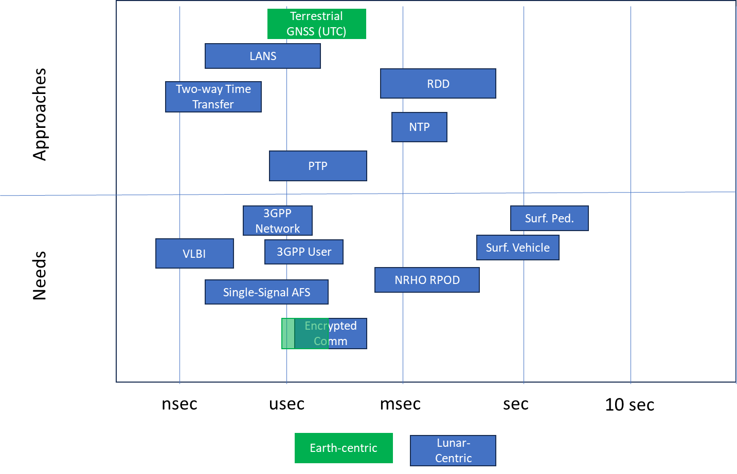
Figure 1 Moon to Mars Timing Needs and Associated Approaches

The top part of the diagram provides insight into typical methods that can be used for time synchronization across space missions as well as network systems (such as Precise Time Protocol and Network Time Protocol). These methods can provide accuracies greater than 1 second but all depend on having an estimate of the space asset’s location and onboard delays. Methods such as RDD can typically achieve msec-level performance. To achieve greater accuracy and precision, more advanced methods are needed, that often require fine timing distribution across the network. For example, Precision Time Protocol (PTP) relies on the hardware timing clock on an ethernet MAC, in addition to firmware. Meaning, not all ethernet devices can achieve high accuracy without additional logic circuits on the ethernet hardware. Firmware-level timing data is needed to enable reliable, repeatable, and accurate timestamping of data shared between two elements, minimizing uncertainty between two-way time of flight measurements. Additional techniques that utilize lunar-focused GNSS-like signals (e.g. LunaNet LANS[4]) and two-way coherent methods enable greater accuracy on the time transfer. A central tenet of these techniques is reliance on very tight synchronization and modeling of the reference signal to a controlled time standard, such as the tie between Global Positioning System (GPS) time and UTC.
In addition to the timing accuracy and use of common time definitions, another key aspect is the mechanism for sharing timing knowledge among vehicles. This includes the timestamping of any data exchanged between elements. Some example data types are science observations, space weather alerts, or, of particular importance, the current navigation state of an asset (position, velocity, and attitude at a given time). In order to standardize this information, two efforts are currently underway focusing on interactions between and with surface elements. One aspect of this is a proposed surface-wide implementation of the Consultative Committee for Space Data Systems (CCSDS) Space Packet [5] for data exchange, which already includes explicit timestamps as part of the standard. The use of this format is being included in an Artemis-wide cross-surface system interfae control document to both mandate application of the standard as well as the explicit time scale to be used. While initial missions may utilize UTC, by necessity introduced by the burgeoning mission set, this will shift to employ the developed lunar time standard. Similarly, work is ongoing to define a navigation data exchange messages that will indicate the reference coordinate system, reference frame, and reference time scale of the transmitted data . These interfaces are mandatory to ensure awareness and coordination among users to plan coordinated activities, rescues, and safe execution of traverses.

4. Timing Demanded by New Operations Paradigm
Managing clocks on the lunar surface for sustained operations poses novel challenges from those encountered when correlating time between a terrestrial ground station and spacecraft traveling in deep space and the associated operational delays factored in to the space-borne mission. Artemis introduces missions with coordinated operations in real time across compound elements. With limited or no line-of-sight to Earth, the navigation must also be performed through in-situ systems. Commonly used radionavigation systems ensure accurate and safe navigation through shared PNT broadcast services. As on Earth, the time reference for these PNT services must relate to the predominant forces influencing time: gravity and velocity. Thus, the primary factor for upcoming lunar operations is the influence of relativity from the lunar gravity field and the lunar velocity with respect to Earth. These relativistic effects influence time observed from free-running clocks on or around the Moon. Several recently published papers [6][7] provide a greater level of insight into the unique impacts of synchronizing clocks between the Earth and Moon considering these impacts. As identified in the literature, a clock on the Moon observed from Earth will appear to tick at a different rate from a clock on the Earth. This impact is driven by the relative mass, orientations, positions, and velocity of the Earth and the Moon, as well as other mass bodies in the solar system. The differences include both a linear term and periodic variations due to the dynamic aspects of the Earth-Moon system. The theory and mathematical formulation are expected to form the basis for transforming time between a clock on the surface of the Earth and one on the Moon for observer on each body. Of critical importance, introducing a lunar time scale maintains the International System of Units (SI) definition of a second, from which the meter and kilogram derive.
These impacts will need to be captured when converting between a UTC time scale and a lunar-centric time scale. For example, two clocks set to the same time will appear to drift apart from each other if the relativistic effects are improperly applied. While the effect may seem small (tens of microseconds per day), longer duration missions will start to see larger impacts. The error can be corrected by re-synching the two clocks, but may become very frequent to meet user needs. Given the current implementation of this process, high fidelity modeling of the interplanetary dynamics, line of sigh to Earth, adequate onboard timestamping, and complex relativistic relationships all pose challenges to the ability to maintain a tight time synchronization. This may not be a feasible approach for more constrained systems that plan to operate for extended duration across the moon.Additoinally, this does not provide any reuduction in error growth, primarily reduces the error to the uncertainty within the synchronization itself., at which point the two will continue to drift apart. The relationship between the Earth and lunar time scales becomes particularly important when generating and following mission-specific timescales, such as mission elapsed time. These relative timelines will be important when coordinating long-term activities and enabling common usage of procedures or other integrated timelines. While the drift over the course of a surface exploration of several days may seem small, the Moon provides an opportunity to demonstrate how these factors will be addressed in further exploration activities, such as Mars or Venus, where the longer OWLT and relativistic impacts will need to be accounted for in real-time operations.

5. Deployment and Usage of Lunar-Centric Time
As the international standards community works to agree on a formal definition for lunar time scales, the individual elements and operational integration of the Artemis architecture are expected to evolve to align with these common definitions. This is important due to long-term high accuracy needs, where the drive will be to have synchronized time represented on the lunar surface to a commonly agreed time scale. It is expected that early missions to the Moon will utilize a sanctioned mathematical model of lunar time with respect to UTC for conversions between the two time scales. For early missions, it is likely that use of lunar time will primarily be implemented as a calculated offset applied to UTC at the time of an groud-commanded update. For example, the processes will likely mimic the existing approaches used in RDD comparing the user clock to UTC, but whe the time update is pushed to the user for their usage it will be in a Lunar Time scale with the correct offset applied. Another example is the use of NTP on the lunar surface networks. In this case, when the ground commands a time update to the lander, instead of pushing a UTC-relative time, the Lunar time epoch will be used with the correct relative corrections for one-way light travel time. As such, the time distributed by the local network will be relative to the lunar time scale rather than UTC. This is especially important as all of the local clocks will be operating within the same gravitational fields. Given the user needs in these initial short duration traverses, it is expected the accuracy of this method will meet the accuracy needs.
With the deployment of LunaNet-compatible service providers into lunar orbit, such as NASA’s Lunar Communication Relay and Navigation Services (LCRNS) [8], it will be possible to synchronize all users within view to a common scale, similar to the GPS distribution of UTC. Until surface tiing references are deployed, this may initially be implemented as a mathematical model capturing the static and dynamic offset to UTC. This is due to the user of terrestrial systems coordinating and correcting each relay’s clocks via time transfer techniques between the relays and Earth and potential usage of terrestrial GNSS signals. With the advent of these services, it will be possible for service users to tightly synchronize to the relay’s time scale through the use of the Augmented Forward Signal (AFS). As users receive AFS to enable their navigation on the surface, they can also achieve synchronization with the LunaNet-distributed lunar time; such synchronization can be achieved within minutes of receipt when at least four AFS are in view. To ensure synchronization across the surface, each user will require either a LANS receivers or access to local communiatoin networks that are deploying the local time scale (these hosts also with receiver capabilities and synchronized with the relays). Additionally, this availabltiy of this capability is coupled with the number of assets in orbit and their relative orbits.

6. Operational Aspects of Time
While the above sections provide an overview of the potential development and deployment of a Lunar Time standard to users operating in lunar space, how it is integrated with mission operations should also be considered. Figure 2 provides an overview of the various timing scales that may be used operationally. The plot captures the absolute timescales such as UTC, GPS time (same scale as UTC, with an offset epoch), or lunar time, that each may have their own unique epoch, and the relative observed drift rates among them. The relationship between observer and user is very impiortnat in this context as identified above. For example, two clocks snapped to a common start time will drift apart based on the obsever location. The plots below all are referenced to what a user on Earth would measure. As can be a seen the observation of lunar clocks would exhibit some drift versus a local clock, aligned with the UTC timescale. In addition to those absolute time scales, multiple relative time scales are likely to be used that measure time past some operational epoch. Per normal space vehicle operations, various mission or phase elapsed times (MET or PET) will be in use. These are typically identified based on launch times or the state of activities in order to trace to activities within a timeline or events that occur relative to an specific start time. When tracing to an executed sequence of activities. These mission-relative time systems can help to understand such metrics as remaining time of consumables or time until other critical events.

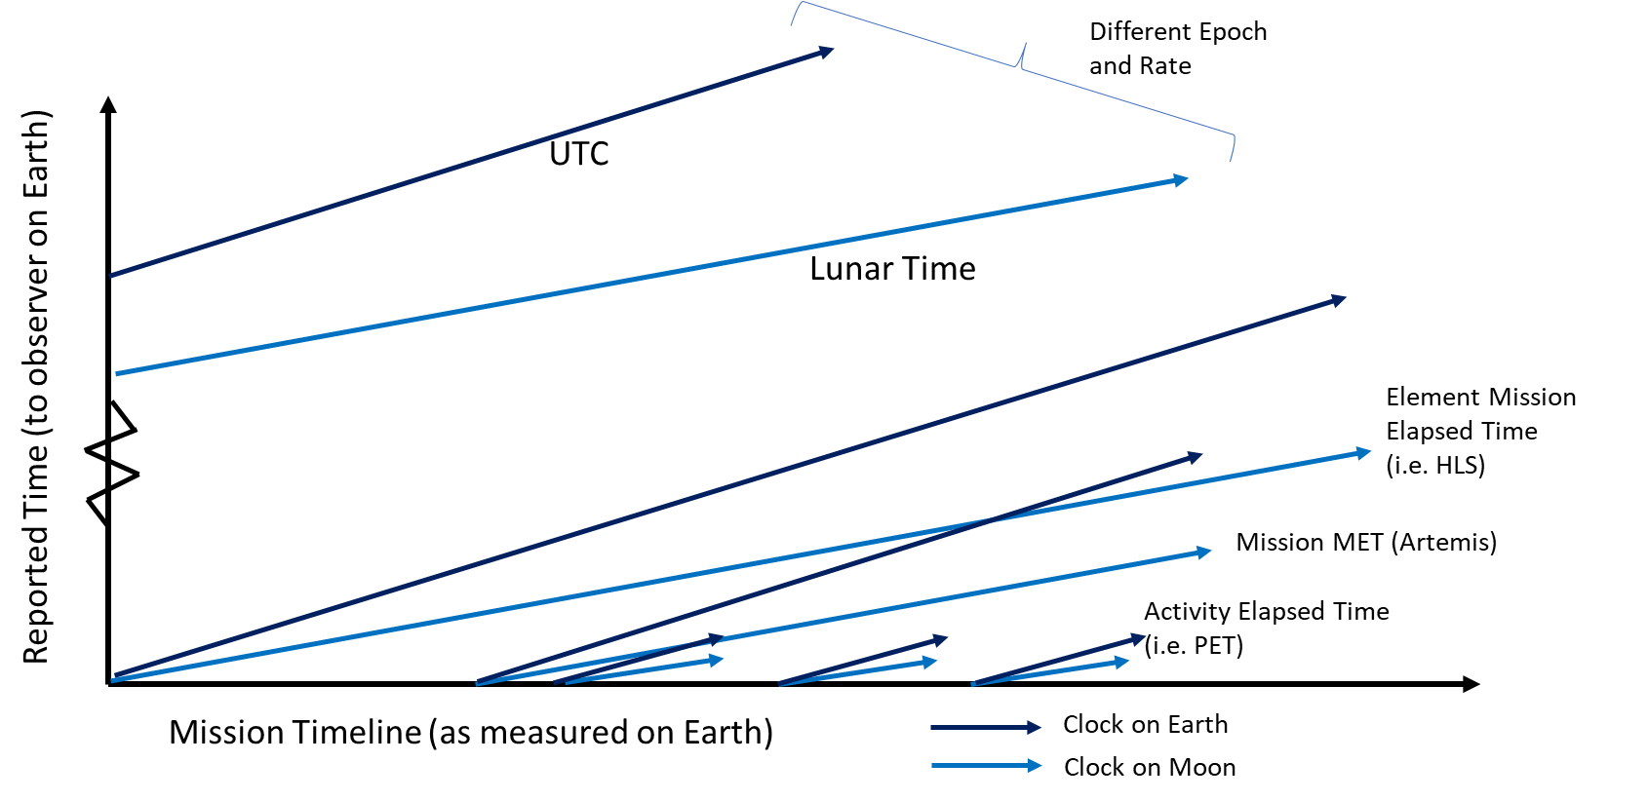
Figure 2. Comparison Between Time Scales (Note: Lunar Time Periodic terms not shown)

Each of these mission-relative time scales will be sensitive to the observed differences in clock rates based on the observer location. As such, the correlations between absolute and relative timescales will not only need to correct for the delta in absolute epoch but the drift incurred since synchronization.
To track all of these time scales, it will be important for any mission control center to maintain knowledge of both UTC used by the Earth operator and lunar time as functionally observed by users at the Moons. Multiple times must be modeled and accounted for in order to execute activities accurately and efficiently. The correlation between the multiple time scales will also be needed to ensure alignment of any timestamped telemetry and synchronization to procedure timelines and operation schedules.

7. Time Distribution and Management at Artemis III
For the initial lunar mission back to the lunar surface, in-situ time accuracy requirements are likely to be relaxed due to the focus on initial operations and checkout of new surface systems. This mission also provides an initial proving ground for demonstrating the critical timing function that will be become more important over subsequent missions. Maintaining a common time is needed early on to support such complex operations as proximity operations and docking in lunar orbit as well as initial surface operations. These implementations will validate operations approaches that will be expanded upon and increasingly relied upon in further missions.
This scenario is the docking of HLS and Orion [9] in lunar orbit to facilitate crew and final material transfer to the vehicle prior to landing on the lunar surface. As these vehicles perform far-field approach outside of the range of near-field visual or lidar systems, the vehicles will be dependent on exchanging state information back and forth via ground operation centers and eventually sharing data directly when vehicles over radio links as they begin to make two-way ranging measurements. In this scenario, understanding the time dependency of the provided ephemeris is of key value when comparing state due to the relative dynamics and latency of the observation. For example, when providing a state relative to the Moon, uncertainties in lunar position, orientation, Earth position, as well as unknown latency and timing error will all drive errors in the provided state knowledge of each vehicle. This scenario represents an early implementation ahead of many infrastructure elements or deployed master clocks. As such, each vehicle will be required to synchronize their own onboard time to ground-based elements to enable a safe and accurate approach via approaches such as one-way light time. As the vehicles enter into range for two-way radiometric tracking, this will also impact the accuracy of one vehicle to process ranging measurements made by the other vehicle. For example, in a relative navigation scenario, if Orion is providing a timestamped two-way range to HLS, any mismatch between their clocks will result in state uncertainty scaled to the relative velocity, essentially being latent to other onboard solutions. As the vehicles become closer, this sensitivity is dismissed as the vehicles relative velocities decrease over the course of proximity operations. Over later missions, as multiple vehicles begin to congregate near Gateway, it will assume a role of master clock in lunar orbit for visiting vehicles and support local time coordination over radio and hardline connections.

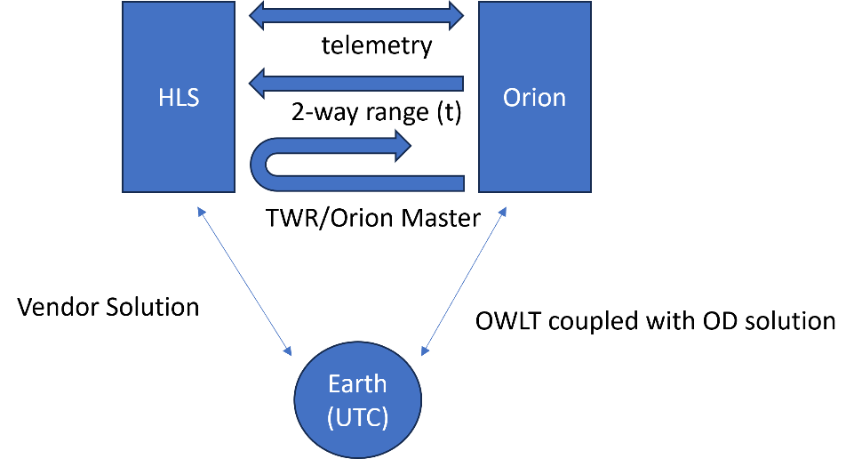
Figure 3. Timing Links at Artemis III during Orion-HLS Docking

For the initial deployment to the lunar surface, HLS will essentially act as the master clock within the architecture. It is expected for all initial and deployed payloads, as well as crew to synchronize their clocks over approaches such as NTP to the master network time maintained by the service provider. This distribution will allow a coarse level of synchronization among the initial exploration elements. Other systems may also operate, such as the handheld camera, which will require a manual time input command. For the initial missions, loose time synchronization requirements are acceptable due to the limited scope of operations, with a focus on initial exploration, utilization, inspection, and traverse activities. Given these objectives, a coarse level of time knowledge is adequate for coordination with the MCC and among the various assets. The overall time architecture is given in the figure below, showing the time distribution among surface elements and ties back to Earth-managed time (UTC).

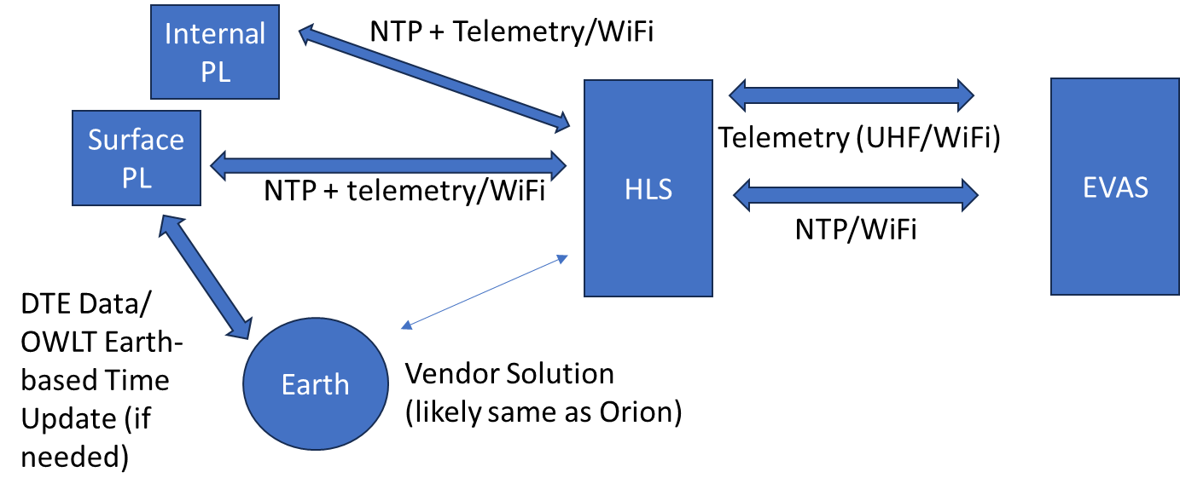
Figure 4. Surface Timing Architecture at Artemis III

8. Time Distribution and Management at Artemis IV
The unique aspects of Artemis IV are the inclusion of operations onboard Gateway [10] and its onboard timing network. The vehicle itself will maintain an onboard UTC-synchronized timing reference that will be used to distribute time cross the element s of gateway and to support any docking or approaching vehicles. This will allow any vehicles on approach to Gateway to interpret gateway-generated ranging measurements and telemetry needed to support approach and docking operations. Gateway is utilizing technology such as time-triggered ethernet in addition to standard techniques such as NTP to allow distribution among the permanent individual elements as well as temporarily docked vehicles.

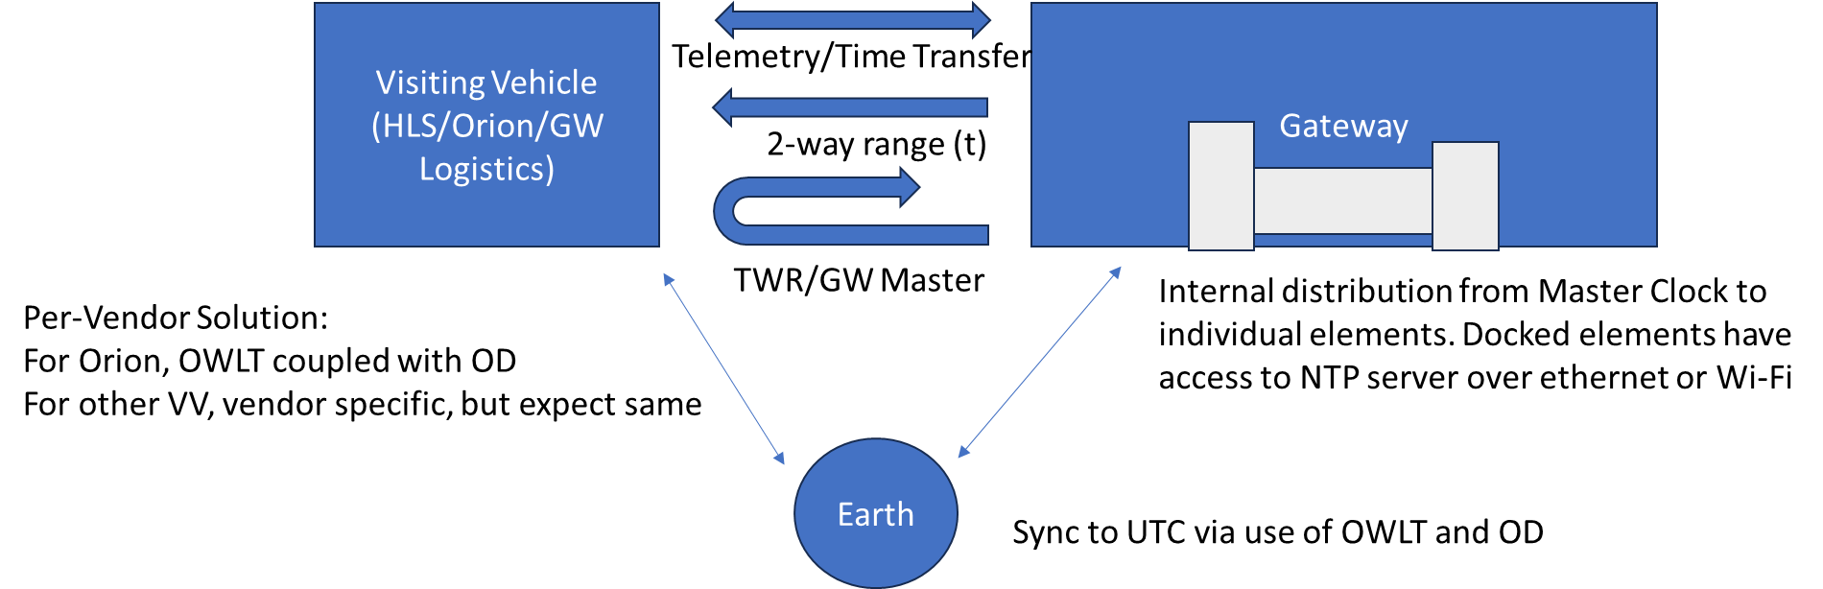
Figure 5. In-space Time Transfers for Gateway Operations

9. Time Distribution and Management at Artemis V
As opposed to how Gateway is expected to operate as a timing host for vehicles operating in NRHO, various ground elements will have unique timing solutions and approaches on a vehicle-to-vehicle basis. This multi-asset and multi-network concept of operations is given in Figure 6 and provides an overview of the multiple connections ongoing during this mission. This use case features a large of surface elements with unique responsibilities: HLS to land and return crew from surface as well as be safe haven, EVAS to support crew exploration on lunar surface, LTV for extended vehicular surface traverses, science and technology payloads (PL) across the various elements and deployed to the surface, and the support infrastructure of Earth and Lunar assets. Similarly, the complexity of networks can be shown with a mix of direct to earth, Earth via Relay, and element to element connections over multiple standards (principally Wi-Fi, though UHF is currently slated for supporting crew voice).
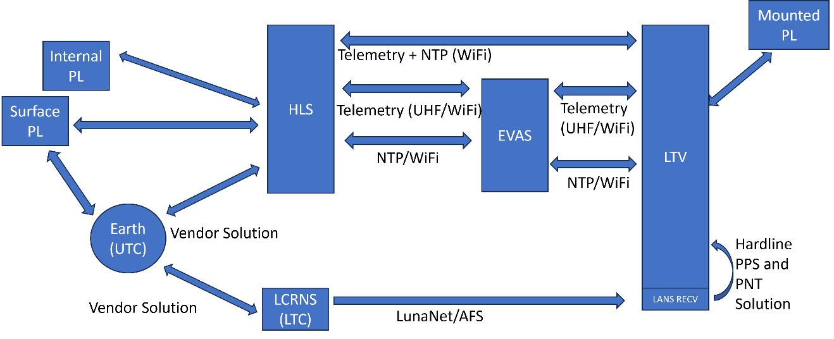
Figure 6. Surface Timing and Data Interfaces at Artemis V
Each vehicle and piece of hardware in this concept of operations is being provided as a Service, and as such functions like time synchronization are the responsibility of the individual vendor. As such, LTV, HLS, and EVAS all will likely have unique hardware and algorithmic implementations to support their local onboard time, through a mix of hosting or using time servicers such as Network Time Protocol (NTP) or doing time transfers directly to other assets. For this scenario, though, the sensitivity on absolute timing synchronization across the elements is reduced. This is primarily a function of the lower relative speeds between assets as well as limited number of mobile assets at a time. For non-science objectives, this primarily focuses on protecting individual assets and maintaining keep-out zones around crew to reduce risk of any collisions. Multiple operational constraints and approaches can further be used to limit this sensitivity.
Timing sensitivity is more important for the utilization of Lunar orbital LunaNet Augmented Forward Signals-type observations to determine a high precision navigation state. Similar to GNSS, the accuracy of this solution on the user side requires an accurate timestamp in order to accurate process relay ephemeris to determine a state solution from the observed psuedoranges. With four satellites in view with adequate observation geometry, the user is expected to be able to maintain an accurate time synchronization with the network. This serves as a primary method of deploying a consistent time across the individual architectural elements. This will help reduce the reliance on vehicle-specific Earth-based synchronization, enabling all assets to be work to a common reference in-situ. As mentioned above, while there is reduced sensitivity to this for early missions, long-term scenarios including high value astrophysics observations [11], broad geophysical observations [12], and multi-vehicle coordinated operations., this time synchronization will become ever important.
At the heart of this architecture is the ability to synchronize all surface to a common time as deployed by LunaNet-compatible references, such as LCRNS. This is intended to be the primary approach to timing synchronization across surface users. This approach is designed to mimic the same approaches utilized by GNSS systems enabling world-wide correlation to a shared terrestrial time basis. The primary limiting factor for early lunar implementation is the lack of local clocks on the lunar surface that capture time at the lunar geoid itself. This will be necessary to validate the mathematical models identified above and provide a local master clock for tracking and aligning the lunar infrastructure. Initial deployments will require the relays to at least maintain a consistent time to ensure that the navigation measurements are tied to a common epoch (whether this is an internal time epoch, UTC, or a mathematical implementation of lunar time) and can be integrated to form a solution. This is one error term of many as called out within the LCRNS SRD for the Signal in Space Error requirement. It is expected that all surface users (or at least the distributors of time to other assets on the surface) be synchronized to this timeframe as well with the ability to transmit and provide correction terms to enable users to transform between the lunar time standard and other operational timeframes, i.e. UTC. Similar to GNSS systems, two approaches are expected to be utilized for this, both solving for a 4D Position and Time solution when 4 relays are in view with adequate geometry for real-time corrections as well as use of a limited satellites but with the application of constraints such as being fixed on the surface to allow for tying any measurement errors directly to clock errors.
As shown in the diagram above, as more assets are included into the network, there becomes a greater potential for misalignment between timing hosts, and hence the need for synchronization to the common distributed lunar time. For Artemis V and following missions, the ground architecture will continue to introduce more disparate elements, such as the pressurized rover, surface habitat, and others [13]. Each asset will operate as a timing master and a source of timing data for any connected vehicles. In these cases, it is necessary that all of the surface elements hosting time all operate to a common standard to minimize any time jumps when reporting data back to Earth or between elements. And similarly, it will be important to understand the accuracy of timekeeping on each asset as well as how well it is tied to the overall lunar time to provide insight into coordinated operations and timing uncertainty.

10. Long-Term Timing Needs Evolution
As the surface architecture continues to grow and evolve through the inclusion of more elements and increased capabilities, there is both the opportunity for improved time knowledge as well as the operational dependence on such timing references. Over time, it is expected that high stability timing references will be deployed to the lunar surface. One such example is the Argo-NET payload as proposed by ESA [14]. This suite of sensors is intended to provide a reference station that can provide a realization of lunar time on the surface. The stability of the clocks is important in order to maintain a local high-fidelity reference in a manner similar to the realization of UTC on the Earth. With a local clock ensemble (and other onboard sensors), it will be possible to observe, track, and monitor the observed time on the Moon and perform high accuracy correlations to terrestrial timing references via radiometric techniques such as Two-way Spacecraft Time Transfer [15]. The first step of distributing an actualized lunar time is this observation of lunar time. Once timing experts can begin to correlate and observe the relativistic shifts, the fundamental models can be verified and validated to enhance understanding of the local effects.
With this, the local clock ensemble becomes a trusted time source with known and well understood uncertainty and can then be integrated with the orbital infrastructure to begin to augment the orbital relay clocks. This closes the loop to enable a fully implemented terrestrial-independent analog to terrestrial GNSS systems that uses local infrastructure and timing references. This reference could then be integrated as the first element of a lunar-based ground segment providing corrections to the orbital relay clocks and ephemeris, and either provider steering terms back to the satellites themselves or provide digital corrections to other surface and orbital users over existing communication links. This enables not just increased accuracy, but also begins to lay out the capabilities to ensure safety of navigation through monitoring and inter-architecture coordination, mimicking approaches used heavily on Earth.
These improvements in localization and timing will be necessary to enable the long-term sustainable architecture elements needed for lunar exploration. In addition to the systems already mentioned that require tight timing synchronization (such as radio astronomy techniques), the evolution of broad communication infrastructure will also be dependent on having this timing capability. As identified previously in this paper, the usage of modern cellular specifications, such as 3GPP 5G NR, have inherent dependency on this. While a single network requires tight synchronization among its users, it doesn’t necessarily have to be tied to a specific time standards. The synchronization within the network is more important than the alignment with an external standard. To enable a network of networks implementation, meanwhile, requires that all of the deployed networks all be synchronized together to be able to manage functions such as user handovers. Similarly, advanced utilization of these networks to enable network-level localization and navigation augmentation require the signals to not only be synced together, but also synced to a common timeframe in alignment with external navigation, such as the AFS generated by LunaNet Service Providers. These capabilities will only be able to be utilized once all users on the surface are tightly synchronized to a common and local time basis. Once enabled, these services provide the jumps in capability and performance for surface network to meet the increasing user demand, both in terms of overall bandwidth and number of simultaneous users across an ever-growing exploration footprint.

11. Discussion and Conclusion
Over time, it is expected that operations on the lunar surface will continue to include an increasing number of assets: crew and cargo landers, suited crew members, crewed vehicles, teleoperated vehicles, autonomous rovers, as well as fixed infrastructure. Per the Artemis Accords approach being undertaken, these elements are being developed and provided by a vast array of international governments through a both in-house agency development as well as external commercial investments. In order for these systems to be interoperable and cohesively operate, strict development and interface to interface standards is needed for sharing data and providing a means of situational awareness among elements. In addition to this, common frameworks such as LunaNet are needed to capture recommendations and guidance for the use of reference and timing standards as developed by international bodies and the definition of common signals for communication and navigation. The timing architecture for the Artemis missions must take this all into account and integrate a set of disparate programs and implementations to ensure the distribution of a common baseline.
This will be enabled by defining and requiring the use of common timescales across the lunar surface for all assets. For example, where a vehicle or asset is providing timing services to surface users (whether a crew, deployed payload, or robotic vehicle), this shall be synced to a Lunar Time reference. While the implementation and approach of this is left up to the individual vendors, it is recommended that users take advantage of LunaNet-compatible signals such as the AFS for ensuring synchronization in-situ to a common standard. While the early missions may have limited sensitivity to the drift between Earth and Lunar clocks due to their limited duration and operational requirements, long-term applications and in-situ use of limited navigation signals will mandate tighter accuracy to local time. Ensuring implementation and adherence to these standards will require detailed verification activities utilizing emulators and end to end testing.
The primary challenge will be the transition from UTC time basis to Lunar Time standards, due to their existing maturity. Due to the long lead terms in vehicle implementation and requirement design, the programs must lean forward to have placeholders in software for the defined epoch and modelling for time transfers between time frames. Another key aspect will be the alignment between surface missions and the deployment of in-situ orbital infrastructure. As the schedules for each move in and out of sync, there are challenges as well as opportunities to advance timing synchronization capability. Similarly, initial missions are likely to rely on mathematical modeling techniques ahead of the formal realization of lunar time through the deployment of stable clocks to the surface. This will require coordination and consistency among vendors to ensure a consolidated timing architecture.
In summary, this paper has provided an overview of the approaches and considerations being taken for the deployment and usage of time synchronization across the Artemis elements. As each mission is executed, the architecture will become increasingly complex due to the number of potential host elements and potential users. With the availability of LunaNet services, it will be possible to coordinate user time to a common in-situ standard to reflect the local time as observed on the lunar surface, laying the groundwork to enable the long-term exploration and science goals of the international community.

Acknowledgements
The authors would like to acknowledge the support and assistance from the NASA community involved in the development, tracking, and implementing of timing standards. The team would specifically like to acknowledge those supporting the timing architecture design task and the scientists whose work is laying the groundwork for the definition of lunar time. Lastly, the team would like to show their appreciation for all of those involved in the development and implementation of the LunaNet standards, which are laying the operational foundation for a powerful time distribution capability.

References
[1] Gifford, A., Nelson, R. A., Orr, R. S., Oria, A. J., Brodsky, B. L., Miller, J. J., & Adde, B., Time dissemination alternatives for future NASA applications, 38th Annual Precise Time and Time Interval Systems and Applications Meeting, 2006, December.
[2] Acton, C.H.; "Ancillary Data Services of NASA's Navigation and Ancillary Information Facility;" Planetary and Space Science, Vol. 44, No. 1, pp. 65-70, 1996. DOI 10.1016/0032-0633(95)00107-7
[3] Acton, C., Bachman, N., Semenov, B., Wright, E., A look toward the future in the handling of space science mission geometry; Planetary and Space Science, 2017, DOI 10.1016/j.pss.2017.02.013
[4] Dafesh, P. A., Wong, N., Khadge, G. K., Djuknic, G., Crenshaw, J., Peters, B. C., Gramling, C., Melman, F., Stallo, C., Swinden, R., Murata, M., The Design of a Flexible, Interoperable Navigation Signal for Future Lunar Missions, Proceedings of the 2025 International Technical Meeting of The Institute of Navigation, Long Beach, California, January 2025, pp. 712-731. https://doi.org/10.33012/2025.1996
[5] Consultative Committee for Space Data Standards, Space Packet Protocol, CCSDS 133.0-B-2, June 2020.
[6] Ashby, N., Patla, B. R., A relativistic framework to estimate clock rates on the Moon, The Astronomical Journal 168, no. 3 (2024): 112.
[7] Kopeikin, S. M., Kaplan, G. H., Lunar time in general relativity, Physical Review D 110, no. 8 (2024): 084047.
[8] Gramling, C.J., Plans for NASA Contributions to Position, Navigation, and Timing at the Moon, Institute of Navigation Joint Navigation Conference, 2022.
[9] Bhasin, K., Hayden, J., Sartwell, T., Miller, R., Hudiburg, J., Integrated Network Architecture for NASA's Orion Missions, SpaceOps 2008 Conference, p. 3587. 2008.
[10] Muri, P., Hanson, S., & Sonnier, M., Gateway Avionics Concept of Operations for Command and Data andling Architecture, 2021 IEEE Aerospace Conference (50100), pp. 1-7, 2021.
[11] Bandyopadhyay, S., et al., Conceptual ideas for radio telescope on the far side of the Moon, 2018 IEEE Aerospace Conference. IEEE, 2018.
[12] Weber, R. C., et al., The lunar geophysical network mission, 2020. Society of Exploration Geophysicists, 2020. 3530-3533.
[13] National Aeronautics and Space Administration, NASA’s Moon to Mars Architecture: Architecture Definition Document, Washington, DC, 2024. ESDMD-001 Rev B. https://www.nasa.gov/Moontomarsarchitecture/
[14] Ventura-Traveset, J., Swinden, R., Melman, F., Audet, Y., Psychas, D., NOVAMOON- Lunar Local Differential PNT and Selenodetic Reference Station, Joint ICG-IAOG Multilateral Cislunar PNT Workshop, Vienna, Austria, February 2025.
[15] DeYoung, J., Two-Way Satellite Time Transfer (TWSTT): USNO Operations and Calibration Services, Proceedings of the 30th Annual Precise Time and Time Interval Systems and Applications Meeting, pp. 315-328. 1998.

