mISSION DESIGN AND Flight dynamics OPERATIONS for the Starling swarm technology demonstration
(Preprint) AAS XX-XXX
Nahum Alem, Jose L. Alvarellos, Theodore G. Hendriks, Paul G. Levinson-Muth, and Andres Dono
The NASA Starling mission, launched in July 2023, represents a significant advancement in demonstrating the capabilities of small satellite swarms to operate autonomously in low Earth orbit (LEO). Starling, which consists of four 6U CubeSats, has validated critical technologies necessary for future multi-satellite missions, including autonomous formation flying and optical-based navigation. The mission successfully maintained precise formations using GPS-based orbit determination and the Starling Flight Dynamics System (FDS) to manage maneuvers and ensure operational success. This abstract provides a comprehensive overview of the Starling’s flight dynamics, covering formation requirements, orbit determination, maneuver planning, and operational tools.
Introduction
The Starling mission consists of four spacecraft designed to validate key technologies for autonomous satellite swarms in LEO. These included autonomous onboard decision-making, optical-based navigation, autonomous maneuver planning and execution, and mobile ad-hoc networking¹. These technologies were rigorously tested within the context of a CubeSat swarm that operated as a coordinated unit, maintaining precise formations and performing complex operations with minimal ground-based intervention. The mission’s success marked a crucial step toward enabling robust and scalable satellite swarming capabilities, which are essential for future space exploration, Earth observation, and other space-based activities. Starling’s success demonstrates the potential for reducing the need for ground-based control, enabling future missions to be more autonomous, flexible, and capable of adapting to unforeseen challenges in real-time.
Spacecraft deployment and commissioning
The deployment of the Starling CubeSats was a critical phase that set the stage for the mission’s operational success. The CubeSats were deployed from the Rocket Lab Electron launch vehicle, as part of the “Baby Come Back” rideshare mission in July 2023, as a secondary payload in a controlled sequence to achieve the initial conditions required for their subsequent formation. The deployment strategy was carefully designed to minimize the relative velocities between the CubeSats and ensure they entered their initial orbits without requiring immediate corrective maneuvers. However, an anomaly occurred when a propulsion leak was detected on Spacecraft 1 (SV1) shortly after deployment², complicating the initial drift control strategy.
The propulsion leak in SV1 necessitated a modification to the mission’s original drift control maneuver strategy. Instead of executing the planned maneuver to position the satellites into their intended in-train formation, the flight dynamics team had to devise an alternative approach that would allow the remaining CubeSats to compensate for SV1’s reduced maneuverability and large drift rate with respect to the other spacecraft. This adjustment ensured that the swarm could still achieve the desired inter-satellite distance (ISD) and begin mission operations effectively, albeit with some adjustments to the formation maintenance strategy to account for the reduced capability of SV1.
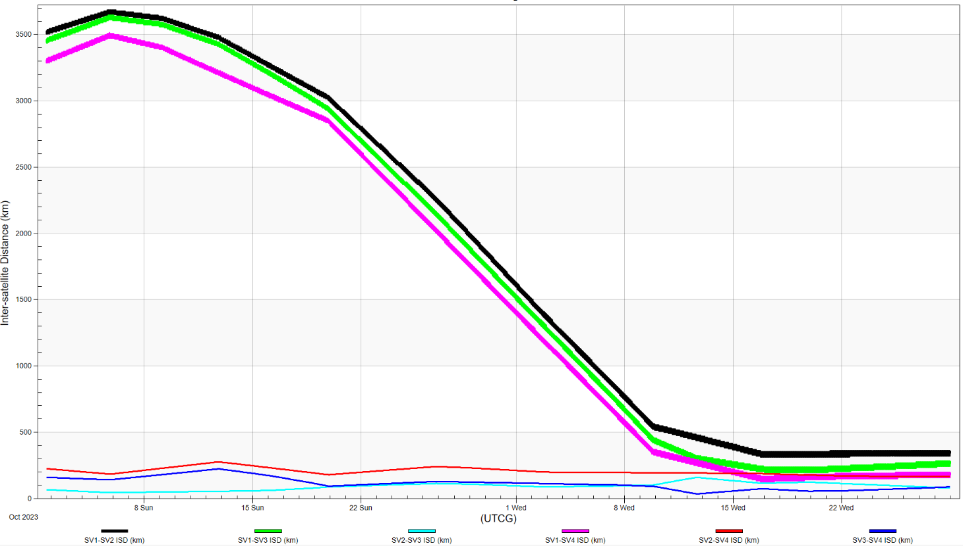
Figure 1 – Inter-satellite distances (ISD) between each of the Starling spacecraft from the Drift Control Maneuver (DCM) in early October 2023 through the Swarm Phasing Maneuver (SPM) in mid-November 2023.
Despite the challenges presented by the propulsion anomaly, the commissioning phase successfully positioned the CubeSats within the required parameters, allowing the mission to proceed with planned operational phases. The experience highlighted the importance of flexibility in mission planning and the ability to adapt quickly to in-orbit anomalies.
formation requirements
Maintaining stable and precise formation was a core requirement for the Starling mission, and it involved operating the CubeSats in two main formation configurations: the in-train formation and the Passively Safe Ellipse (PSE) formation. The in-train formation involved the CubeSats flying in a linear sequence with controlled ISDs, allowing for effective crosslink communication and coordinated autonomous operations. This phase was essential for testing the swarm’s ability to maintain precise alignment and spacing without extensive ground control.
The PSE formation introduced a more complex elliptical relative motion that ensured safe separation of the satellites, minimizing the risk of collision even under off-nominal conditions³. This formation required control of the satellites’ relative eccentricity and inclination vectors to ensure that any deviations from the desired trajectory were promptly corrected. These formations were maintained through propulsive maneuvers, designed to counteract perturbations such as differential drag, which was treated as a disturbance requiring correction rather than as a control mechanism.
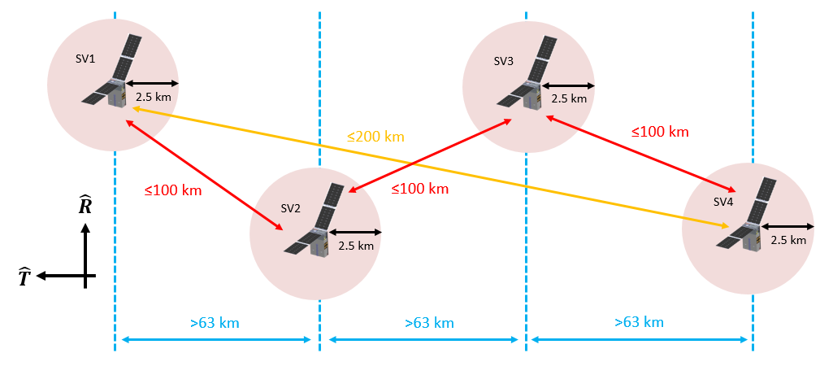
Figure 2 – Experiment and spacecraft operational requirements provide primary drivers behind Starling formation design. For the coordinate system, R represents the radial direction, and T represents the in-track direction, assuming a circular orbit.
orbit determination
Accurate orbit determination was fundamental to the success of the Starling mission. The CubeSats relied solely on GPS tracking for orbit determination during the baseline operations. Each CubeSat was equipped with a GPS receiver that provided data for precise orbit determination. The flight dynamics team used a Kalman filter and Rauch-Tung-Stribel sequential smoother within the Starling FDS to process the GPS data and continuously update the satellites’ state estimates. This approach ensured that the formation was maintained with the required precision, facilitating effective maneuver planning and execution.
The GPS data-driven orbit determination allowed the team to maintain the CubeSats in their intended formations with high reliability. The GPS-based system provided a robust solution for maintaining accurate orbit determination, which was crucial for the overall success of the mission.
maneuver planning
Maneuver planning was a critical aspect of the Starling mission, executed by the flight dynamics team on the ground. The CubeSats were equipped with the Hamlet cold gas propulsion system², which provided the necessary delta-V for maintaining and adjusting the formation. The maneuvers were planned to achieve the desired formation configurations, correct for disturbances such as differential drag, and ensure compliance with the mission’s operational constraints.
The flight dynamics team employed a rigorous maneuver planning process supported by the Starling FDS. This system integrated orbit determination data and allowed the team to generate precise maneuver plans that were executed to maintain the desired formations. The maneuvers were carried out with a focus on efficiency, ensuring minimal fuel consumption while achieving the necessary adjustments to the CubeSats’ orbits. The maneuver planning cadence was aligned with the mission’s operational timeline, ensuring timely and accurate execution of all maneuvers.
The process involved several critical steps, including downlinking GPS data, generating and reviewing maneuver plans, conducting CARA (Conjunction Assessment Risk Analysis) screenings, and coordinating with the Mission Operations Center (MOS) for final approval and execution of the maneuvers. This structured approach ensured that all maneuvers were planned and executed with the highest degree of precision, contributing to the mission’s success.
OPERATIONAL TOOLS
The Starling FDS played a central role in the Starling mission, providing the necessary tools for managing the complex flight dynamics operations. The Starling FDS, developed by L3Harris, supports key functions, including orbit determination, maneuver planning, and the generation of flight dynamics products such as ephemeris files, eclipse reports, and maneuver plans.
The Starling FDS integrated various software tools, including AGI’s STK and ODTK, to facilitate the automation of routine tasks such as data preprocessing, orbit determination, and product generation. These tools enabled the flight dynamics team to handle the mission’s demanding operational tempo efficiently. The Starling FDS also featured capabilities for maneuver reconstruction, allowing the team to analyze the performance of executed maneuvers and make necessary adjustments to future plans.
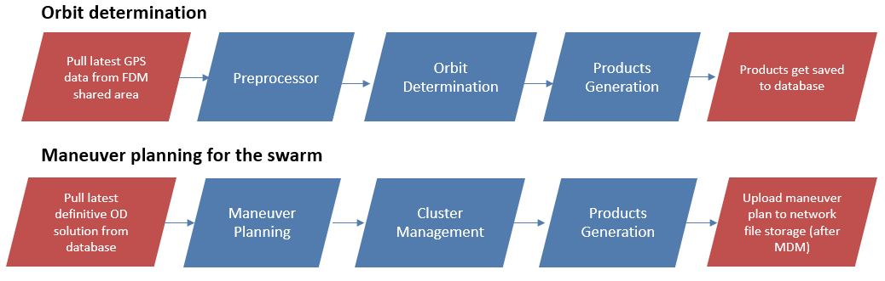
Figure 3 – Orbit determination and maneuver planning workflows supported by the Starling FDS.
The Starling FDS was designed to provide a flexible and robust framework for managing the mission’s flight dynamics, ensuring that the CubeSats operated cohesively as a swarm. Its advanced capabilities allowed the flight dynamics team to maintain the necessary precision and reliability in orbit determination and maneuver planning, which were critical for the mission’s overall success.
conclusion
The NASA Starling mission marks a significant milestone in the advancement of autonomous satellite swarm technologies. Through the successful demonstration of formation flying, precise GPS-based orbit determination, and ground-based maneuver planning, Starling achieved its primary mission objectives. Now in its extended mission phase, Starling continues to lay the groundwork for future missions requiring coordinated multi-spacecraft operations. The mission’s flight dynamics, supported by the robust and versatile Starling FDS, provides valuable insights into the challenges and opportunities of satellite swarms, setting the stage for more complex and scalable space exploration missions in the future.
References
1 Miller, S., Adams, C., Alem, N., Cannon, H., Grashuis, R., Hendriks, T., Hwang, S., Iatauro, M. and Pires, C., 2024. Starling CubeSat Swarm Technology Demonstration Flight Results. In: 38th Annual Small Satellite Conference. Logan, UT. Paper No. SSC24-I-06.
2 Stevenson, T., 2024. Flight Results and Lessons Learned from the Starling Propulsion System. In: 38th Annual Small Satellite Conference. Logan, UT. Paper No. SSC24-VII-01.
3 D’Amico, S. and Montenbruck, O., 2006. Proximity operations of formation-flying spacecraft using an eccentricity/inclination vector separation. Journal of Guidance, Control, and Dynamics, 29(3), pp.554-563.

Starling Flight Dynamics Lead, NASA Ames Research Center, 94035.
Starling Flight Dynamics Engineer, ASRC Federal, NASA Ames Research Center, 94035.
Starling Flight Dynamics Engineer, Metis Technology Solutions, NASA Ames Research Center, 94035.
Flight Systems Engineer, NASA Ames Research Center, 94035.
NASA Ames Flight Dynamics Lead, Axient, NASA Ames Research Center, 94035.

