Planetary Analog Drill Automation Tests at Haughton Crater. B. Glass¹, S. Boelter², V. Vendiola³, C. Fortuin³, T. Stucky¹ and C. Stoker¹. ¹NASA Ames Research Center, Moffett Field, CA 94035, USA, brian.glass@nasa.gov. ²University of Minnesota, Minneapolis, MN 55455, USA. ³Honeybee Robotics, Altadena, CA 91001, USA. Contact: brian.glass@nasa.gov.

Summary: A TRIDENT planetary-prototype 1m-class planetary prototype drill was tested under field conditions at an Arctic planetary-analog site (Haughton Impact Crater). Field tests successfully demonstrated automated drilling, fault detection and recovery, and clean acquisition of subsurface samples for later study.
Introduction: Drilling on Earth relies heavily on human involvement. Conducting similar activities on other planets presents additional challenges due to the absence of preliminary field surveys of the drilling sites, making it necessary to drill into unknown rock formations. Planetary drills must function without muds or lubricants, with minimal downward force, and often rely on solar power with limited energy. Drills that exceed shallow depths risk becoming stuck, so a 1m- or greater class drill must be operated with automation [1].
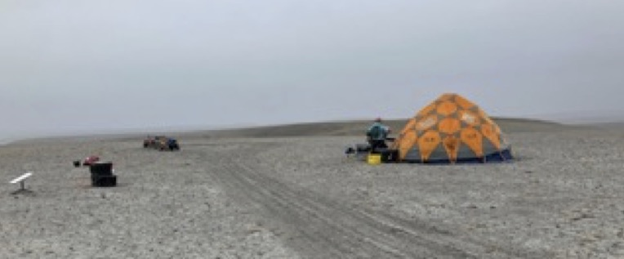
Fig. 1. Haughton Crater test site, Devon Island, with ~600m. permafrost layer and ice layer depths at 0.5 to 0.6 m [9,10].
The Regolith and Ice Drill for Exploration of New Terrains (TRIDENT), developed by Honeybee Robotics), is a rotary-percussive drill designed to begin to address these challenges [2]. A TRIDENT flew on the recent IM-2 (PRIME-1) lunar mission [3]. No general automation approach currently exists to give a complex planetary drilling agent (such as for TRIDENT) adequate situational awareness to recognize potential or incipient faults. However during prior Atacama rover-drilling tests automated drill control and fault recovery software enabled limited autonomous operation of a TRIDENT from a rover [4,5]
Approach: Objectives of the August 2024 Haughton field deployment were to validate the electromechanical performance of a TRIDENT drill in icy impact breccia as well as also test automated drill control software (including its planning and fault recovery capabilities) and to demonstrate acquiring clean subsurface samples (for further study and in astrobiology instrument development). We demonstrated permafrost operations with a TRIDENT drill at two Mars-analog sites at Haughton Crater, and drilled both regolith-like impact breccia and less-altered materials exhibiting frost polygons, totaling nearly 11m with 4m into ice-cemented materials.
Discussion: Drilling tests at Haughton Crater with a TRIDENT were conducted August 6-11, 2024. Two sites were studied: (a) inside the crater (Fig. 1) at the Drill Hill breccia deposit (75.4297N, 89.8348W) (b) on the NW crater rim (Haynes Ridge, 75.4292N, 89.8348W). Fig. 2 shows an example from Hole 24-4 of the automation software detecting and responding to both a hard material fault (flat blue line midway) and subsequent corkscrewing (red line dip) upon retraction.
The thawed depth was observed to be at ~53cm at Drill Hill. Automation software observed and detected icy-regolith fault detection and pertinent to four known major fault modes, and a previously unidentified fault mode was observed.
References: [1] Glass, B. et al. (2008) Astrobiology. [2] Zacny et al. (2021) 52nd LPSC #2548. [3] Quinn et al. (2023) SRR XXIII. [4] Glass et al. (2023) Astrobiology 23(12). [5] Stucky et al. (2018) ASCE Earth & Space 348-358.
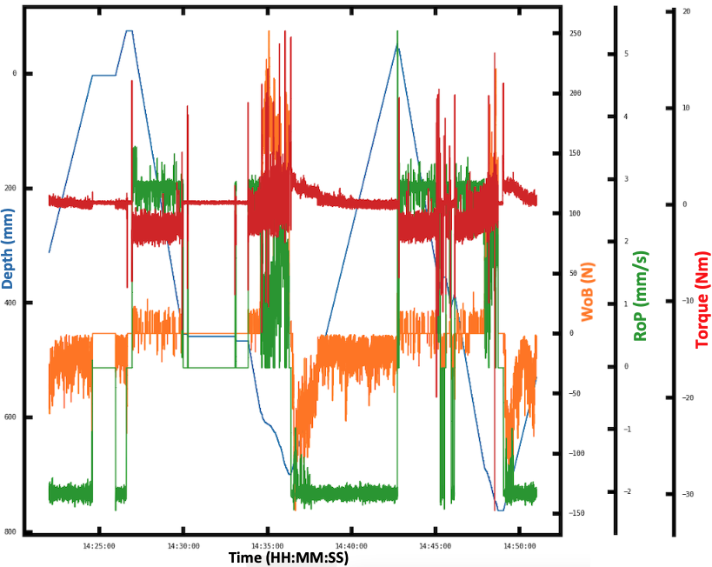
Fig. 2. Automated detection and response to hard material and corkscrewing drilling faults.

