DRAFT


National Aeronautics and
Space Administration
Goddard Space Flight Center
Greenbelt, Maryland

Adaptive Processing System (APS)
System Description

Draft 2: 2025-05-08

Terrestrial Information Systems Laboratory
Curt Tilmes
Navid Golpayegani
Table of Contents
1 Introduction 4
1.1 Purpose 4
1.2 Scope and Precedence 4
2 Science Data Processing 5
2.1 ESDTs and PGEs 5
Product Name 5
2.2 Granularity and Granularity Identifiers 6
2.3 Group 6
2.4 Object Store 7
2.5 Object Identifiers and Object Identifier Resolution 7
2.6 Science Data Transfer Protocol (SDTP) 8
2.7 Software Configuration Management System 9
2.8 PGE Container Images 10
2.9 Container Image Registry 10
2.10 PGE Versions 10
2.11 Job Description Files and Job Priority Identifier 10
2.12 Collections and Reprocessing 11
2.13 Distributed Active Archive Centers 12
2.14 Metadata and CMR 13
2.15 Kubernetes and Kueue 13
3 System Overview 14
3.1 APS Dashboard 14
3.2 APS Client and APSLib 14
3.3 APS Orchestra 15
3.4 Metadata Extract and Access Database (MEAD) and Production Rules 16
3.5 Container Resource Allocation Manager (CRAM) 17
Appendix A Abbreviations and Acronyms 19

List of Figures
Figure 2-1 PGE & ESDT Example 6
Figure 2-2 Object Identifier Resolution 8
Figure 2-3 Federated Object Identifier Resolution 8
Figure 2-4: SDTP Communication overview 10
Figure 2-5 Logical to Physical Identifier Mapping 13
Figure 2-6 Replacing File mapped to a Granule Identifier 13
Figure 3-1 Science Data System Overview 15
Figure 3-2 MEAD Overview 17
Figure 4-1: SDS Context Overview 19
Figure 4-2 SDS Data Transfer and Processing Overview 22

List of Tables
Table 1-1: Applicable Documents to this ConOp 4
Table 1-2: Documents Referenced in this ConOp 5

Introduction

Purpose
This Adaptive Processing System (APS) System Description describes a processing system developed by the Goddard Space Flight Center Terrestrial Information Systems Laboratory (TISL) for performing science data processing for a number of remote sensing missions.
Essentially, APS receives data from external data providers, processes the data using algorithms provided by science team algorithm developers, stores the data as appropriate and sends the processed data out to external data consumers, typically a NASA Distributed Active Archive Center (DAAC) for long term archive and distribution.

Scope and Precedence
This document describes the system generically, and not a specific instance of the system that has been or will be deployed. Each mission will have an Open Science and Data Management Plan (OSDMP) that describes the particular science data processing algorithms, production rules, and general data flow for that mission. Each mission will also have a Concept of Operation (ConOp) describing the context of APS within the overall mission, interfaces with other mission entities and operational plans for that mission.
The mission specific ConOp and OSDMP describe implementation details that override and take precedence over any information presented here.

Science Data Processing
This section describes some background information, terminology, and the general APS approach to science data processing.

ESDTs and PGEs
Each type of data file will be identified by an Earth Science Data Type (ESDT) identifier. The ESDT distinguishes the type of data within the file and the format of those data. Each integrated algorithm will read from files associated with some ESDTs, and produce files associated with other ESDTs. The integrated algorithms will be identified with a Product Generation Executive (PGE) identifier.

The terms ESDT and PGE are more specific than the very general “algorithm family”. A science PI may be associated with a general algorithm that produces a science product, but that product may actually be realized with multiple ESDTs and PGEs. For example, consider the MODIS Surface Reflectance product. It is realized in multiple ESDTs and PGEs for the different instruments and resolutions in time and space, shown in Table 1.

Table 1 Example Surface Reflectance Products from MODIS
Product Name | Terra ESDT | Aqua ESDT
Surface Reflectance 5-minute L2 Swath | MOD09 | MYD09
Surface Reflectance Daily L2G Global 250m | MOD09GQ | MYD09GQ
Surface Reflectance Daily L2G Global 1km and 500m | MOD09GA | MYD09GA
Surface Reflectance 8-Day L3 Global 250m | MOD09Q1 | MYD09Q1
Surface Reflectance 8-Day L3 Global 500m | MOD09A1 | MYD09A1
Surface Reflectance Daily L3 Global 0.05Deg CMG | MOD09CMG | MYD09CMG
Aerosol Optical Thickness Daily L3 Global 0.05Deg CMA | MOD09CMA | MYD09CMA

While this document will continue to use ESDTs and PGEs very generically, the specific ESDTs and PGEs used by any mission and how they relate to one another will be captured in that mission’s OSDMP.

Each PGE will have inputs from 1 or more ESDTs, and outputs to 1 or more ESDTs as depicted in Figure 2-1, which shows an example PGEX that has inputs from ESDT1 and ESDT2 and outputs to ESDT3 and ESDT4.

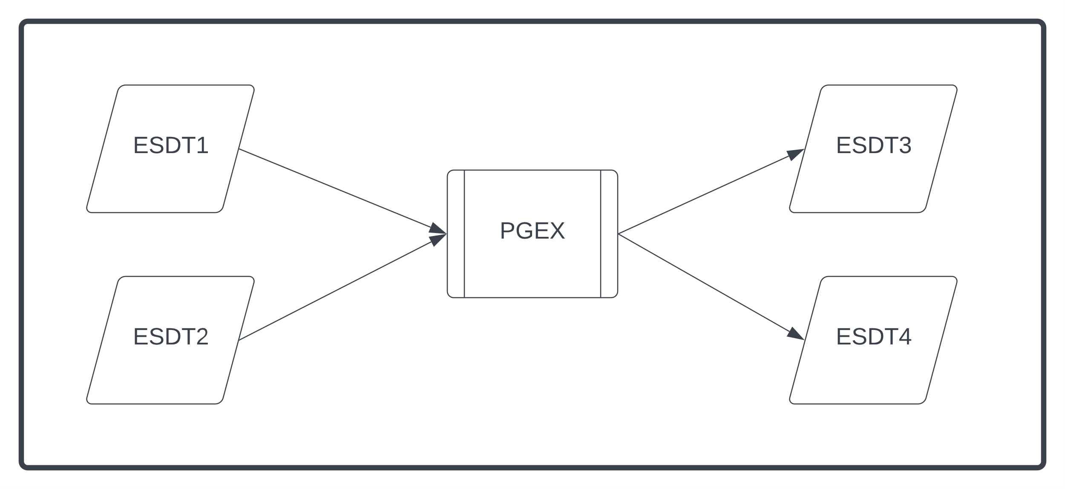
Figure 2-1 PGE & ESDT Example

Granularity and Granularity Identifiers
Data are grouped into “chunks” called Granules. The scheme by which the data are divided is called the Granularity. A Granularity Identifier (GID) uniquely refers to a chunk of data within the scheme.

For example, if the data granularity were defined as “Daily” (i.e. all the data that fall within a given calendar day), the GID might be defined as the ISO 8601 representation of that calendar day, e.g. 2023-05-11. If the data granularity were defined as “Orbital” (i.e. all the data within a given orbit from one ascending equator crossing to the next), the GID might be defined as a six digit, 0-prepended orbit number, e.g. 000426.

Granularity is defined by the Science Team such that the amount of data within a given granule is neither too large, nor too small. Note that the granularity associated with the PGE that produces a product and the ESDT produced by that PGE could match (e.g. an orbital PGE makes data for an orbital ESDT), they are required to, and could easily be different (e.g. a PGE runs once a day and has a Daily granularity, but produces data separated into orbits with an Orbital granularity).

The particular Granularity chosen for each ESDT and PGE will be described and captured in the OSDMP.

Group
The system is designed to support multiple virtual tenant systems simultaneously. As such, each independent tenant is designated with a Group identifier. Each mission will have a unique group for operational data processing. Individual scientists performing research or analysis production within the system will not use the primary operational production group, rather they will be assigned distinct groups for that work.

Group is intended to be globally unique within the overall domain of the system. For NASA, we specifically use the NASA Identity AUID as the group for individuals so they are guaranteed to be unique across the system domain.

Object Store
APS stores data files as objects in an Object Store. Conceptually the Object Store provides a very simple interface that allows complete files to be stored or retrieved. APS supports several implementations of Object Stores, and could easily be extended to others in the future. On premises, this could be Ceph. In the Amazon Web Services (AWS) Cloud, this is typically Amazon S3.

Data can be distributed among multiple data storage locations (e.g. some on premises, some in the cloud, or for some objects, possibly both). We still refer to the broad collection of all the relevant buckets as the “Object Store.”

Object Identifiers and Object Identifier Resolution
Within the broad “Object Store,” files can always be identified by the following logical Object Identifier: { Group, Path, Filename } (Sometimes shortened to just GPF.)

Even if the physical bits of the file are moved or duplicated to different physical portions of the overall “Object Store,” the identifier remains the same and can always be resolved into a specific address (or addresses if the data are duplicated) for a given file. The Path is simply a group specific namespace used to organize a set of individual files within an overall Group. For example, under a mission group, there may be paths assigned for each test such that even if the Filenames for two different test are the same, they will be segregated by their Path (e.g. “test1”, “test2” etc.).

A system component called “Pinpoint” is used for object identifier resolution. By passing an Object Identifier to Pinpoint, its local configuration will be used to track down the requested logical object which may be in a variety of physical locations as depicted in Figure 2-2.
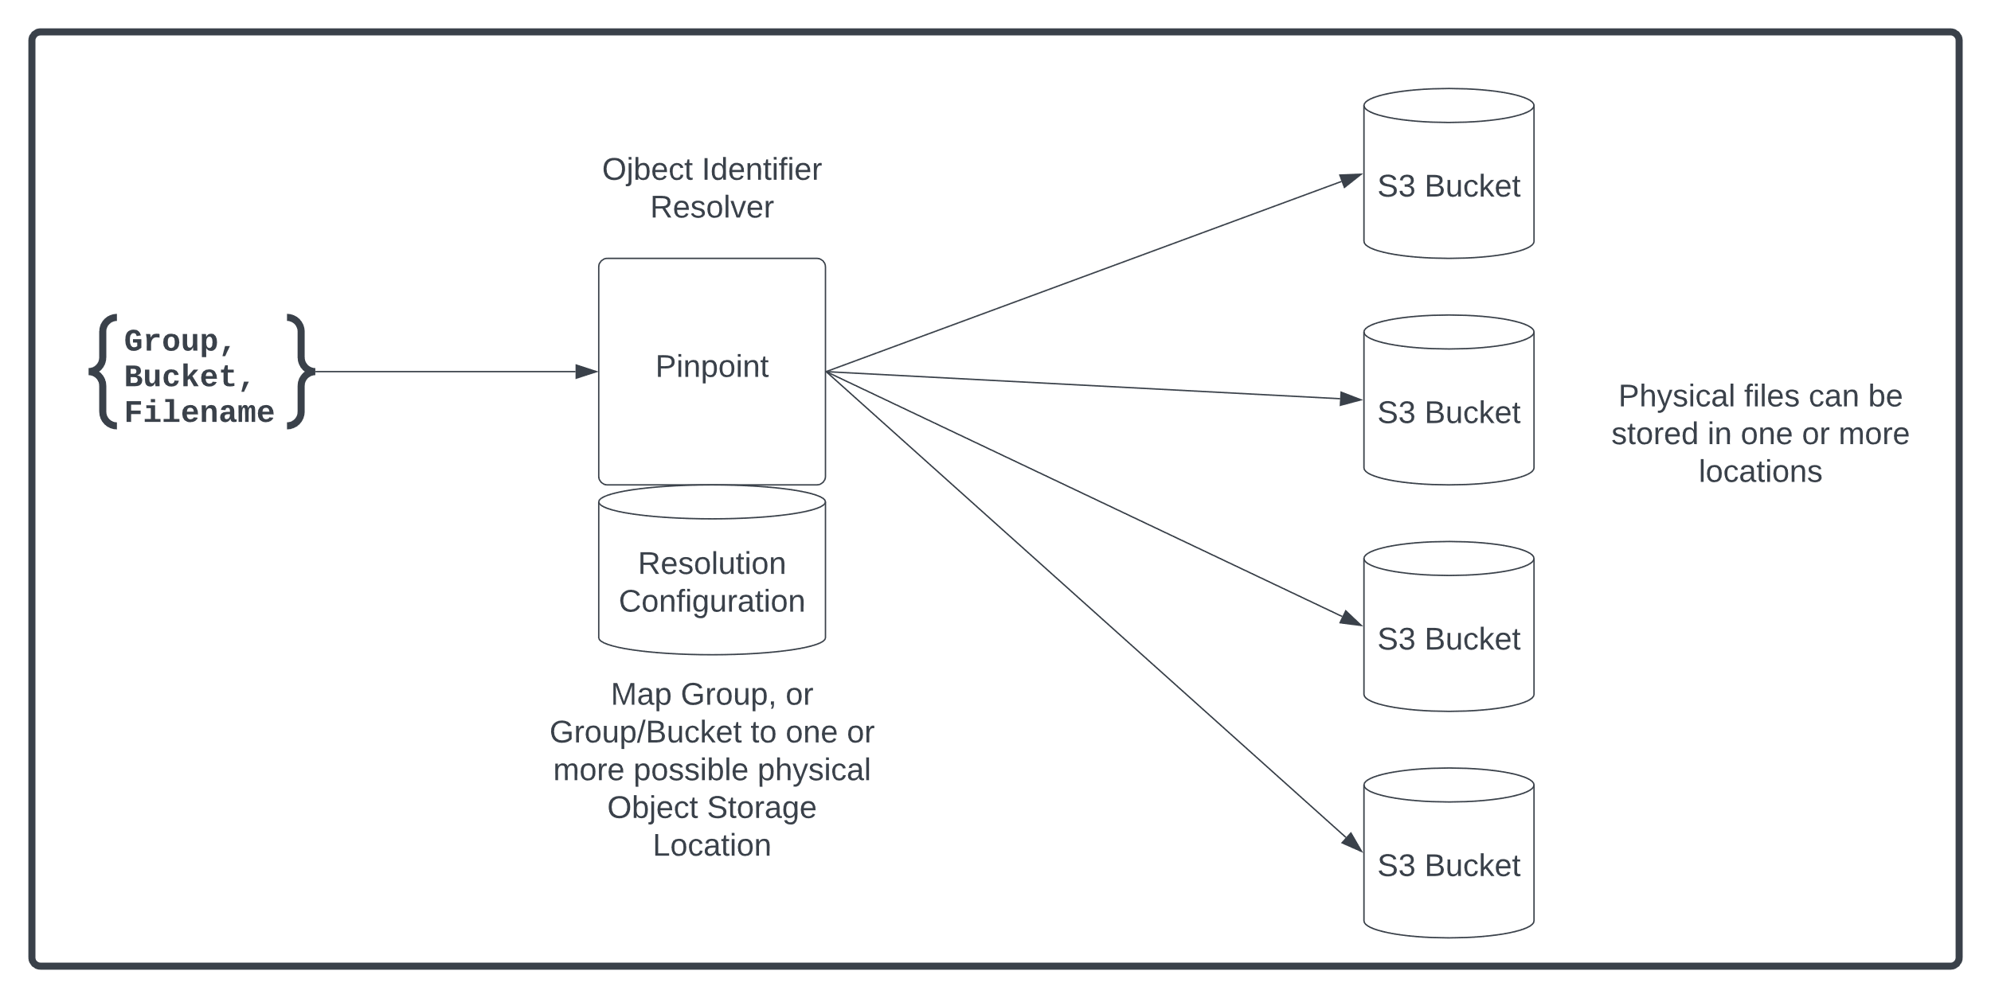
Figure 2-2 Object Identifier Resolution
Multiple Pinpoint instances can cooperate in a hierarchical federation across organizational boundaries to resolve logical identifiers to specific physical locations as depicted in Figure 2-3, but the interface to users of Pinpoint remains the same.

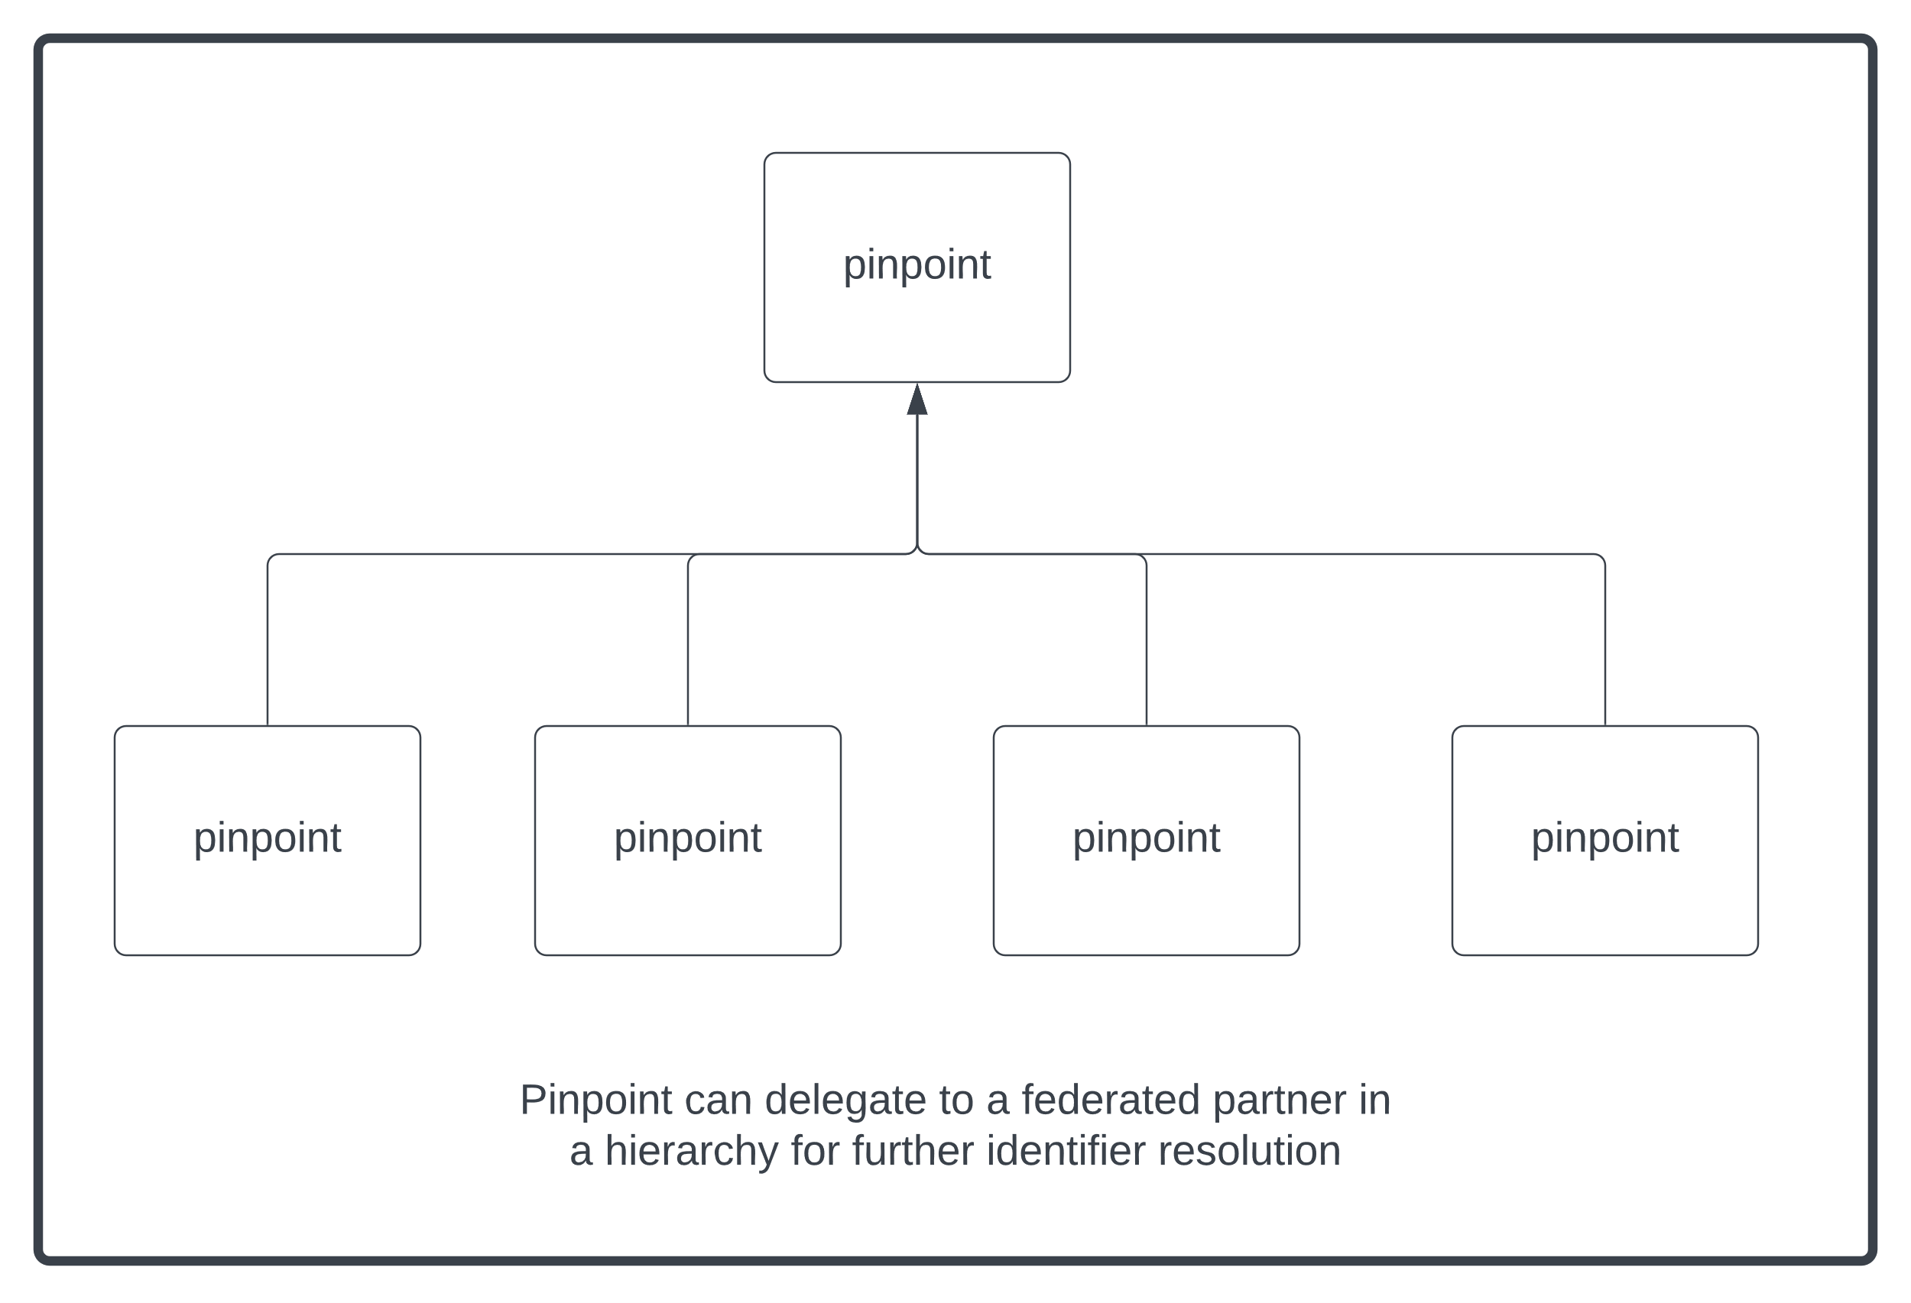
Figure 2-3 Federated Object Identifier Resolution

Science Data Transfer Protocol (SDTP)
A number of the interfaces between the SDS and other external entities make use of the Science Data Transfer Protocol (SDTP). The SDTP is defined by the Science Data Transfer Protocol (SDTP) Interface Control Document (ICD), and details of the communication may be found in that document. An overview of the protocol is included as Figure 2-4.

Essentially, an “SDTP Server” maintains a list of available files. As files are produced by Providers, they are placed in the Object Store and ‘registered’ with the SDTP Server. The server can either serve the content of the files directly or use an HTTP redirect to specify the location of the physical file content. The redirects can be useful to optimize data transfer. Each Subscriber will have a subscription registered SDTP server associating the type of files they are interested in. The Subscriber either continuously or periodically runs an “SDTP Client” that retrieves the list of available files associated with the subscriber. For each file, the SDTP Client retrieves and verifies successful transfer of the file. After the files are successfully retrieved from the server, the Client will acknowledge them, and they will be removed from the client subscription list. After all subscribers have acknowledged files, they may also be eligible to be removed from the Object Store by the Provider as appropriate.

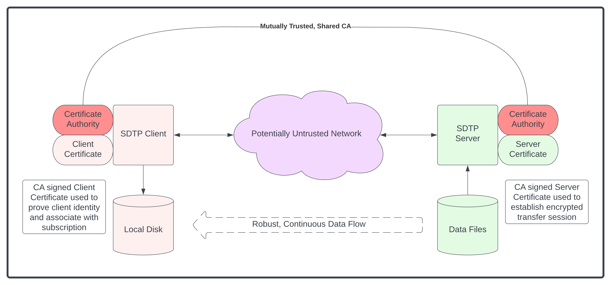
Figure 2-4: SDTP Communication overview

Software Configuration Management System
A Software Configuration Management System (SCMS) in the form of a deployment of a Gitlab instance supports software development for APS. Science Team and Instrument Team developers, including international partners or other affiliates all use this system to host software development and ultimately integrate and unit test the software and deliver integrated PGE Container Images to the Container Image Registry.

Each Software Configuration Item (SCI) will have a CM managed operational “production” repository within the SCMS, including the PGEs themselves, but also separately developed and managed shared libraries that might be used in multiple PGEs and other miscellaneous analysis and research tools.

Each software developer will be able to establish forked versions of the repositories or additional “sandboxes” for research and development where they can use industry standard software development practices including branching, tagging, etc. as well as marking certain versions for delivery to production.

Each PGE will include automated scripts for building, unit testing, and packaging into PGE Container Images.

PGE Container Images
Each PGE will include one or more executables that are packaged with their required dependencies and environment, including operating system components, into a Container Image which will be constructed within the Software Configuration Management System (SCMS), then delivered into the Container Image Registry. APS Containers will follow the Open Containers Initiative (OCI) standard. To execute the PGE, a container will be constructed such that the input files will be mapped or copied from the Object Store so that they are accessible from within the container, and an empty directory for outputs will be available. The PGE container will then be executed which starts the initial command within the container. From there, the initial command can execute additional executables or scripts as required. The PGE must then create any output files into the output directory and exit with either a 0 indicating success or non-0 indicating failure. In the case of successful execution, the output files will be stored in the Object Store. Failures are temporarily stored as well for analysis and debugging as needed.

Container Image Registry
The Container Image Registry (CIR) is an off-the-shelf component for storing Container Images. Though logically considered a single component, it may be physically implemented with multiple independent units. Fundamentally the CIR simply supports two very basic functions, storing a newly created Container Image into the Registry and retrieving a Container Image by the Container Identifier { Group, Name, Version }.

PGE Versions

[put something here]

Job Description Files and Job Priority Identifier
A Job Description File (JDF) completely describes a specific PGE container run. This includes a reference to the specific Container Image to use and the list of Input Files needed for the run. The JDF can also include information about the resources needed to run the Container, and specific arguments used by the PGE for the run. For properly constructed PGEs, the JDF should define the PGE run or Job sufficiently to guarantee scientific reproducibility. If the exact same JDF is resubmitted, results that are “scientifically equivalent” (i.e. they support the same scientific research or results) should be produced.

In addition to the JDF, each Job will be accompanied with information about the Job run called the Job Priority Identifier (JPI). This includes information about how the Job should be run, including priority, group, processing labels, etc.

The difference the two is that the JDF contains enough information to run the job. It can be transferred elsewhere, and another system could repeat the identical run, even just running the container on the command line. The JPI adds additional information to describe how to run the job in this system at this particular moment.

Collections and Reprocessing
Collections are consistent sets of data produced with common characteristics such that it is scientifically useful to study the data together. For example, during the first processing, data will be associated with “Collection 1.” After some time Reprocessing may take place in another collection. This could involve updating calibration and other software inputs as well as the version of the software itself. It could also involve data format changes that might break the interfaces and data flows between PGEs. Reproducing the data from the beginning of the mission with the whole set of changes will result in the production of “Collection 2.”

Since collections distinguish different instances of the same data, additional collections could be created for specific purposes to segregate data for testing, running in different modes, etc.

A complete logical reference to a single granule within the system will require all four (4) parts:
{ Group, Collection, ESDT, GID }.

Those parts make up a unique Granule Identifier that will then map a virtual reference to the logical Object Identifier referring to the actual granule file:

{ Group, Path, Filename }.

This logical identifier can be resolved (see Pinpoint above) to a physical file (or files) in the overall Object Store referenced by a physical address such as an AWS S3 URL (or URLs if there are more than one copy of the files).

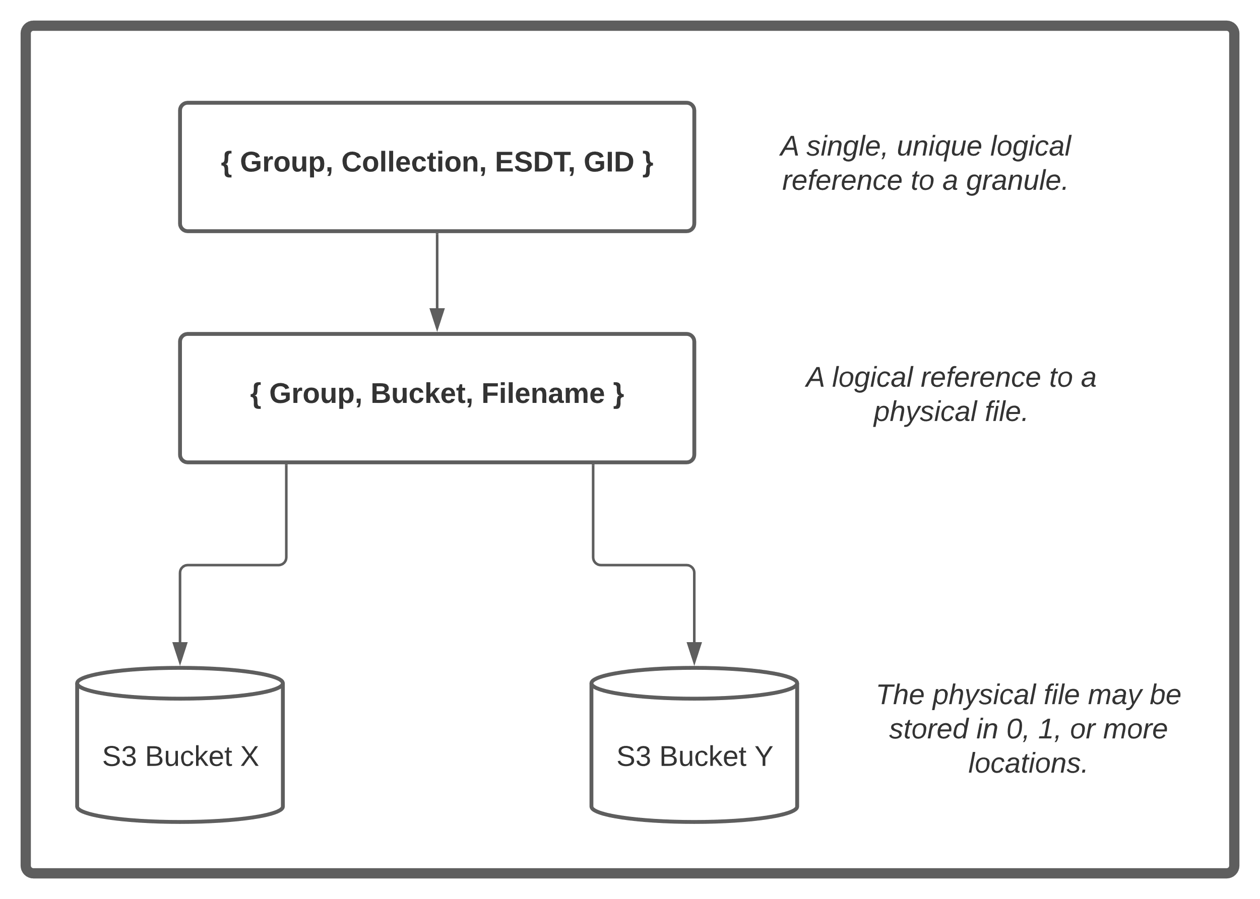
Figure 2-5 Logical to Physical Identifier Mapping

If the system creates a new file with the same Granule Identifier using the same four (4) parts, it will remove the previous instance of the granule from the Collection, replacing it with the new one. Only a single granule can ever be mapped to a unique 4-part identifier.

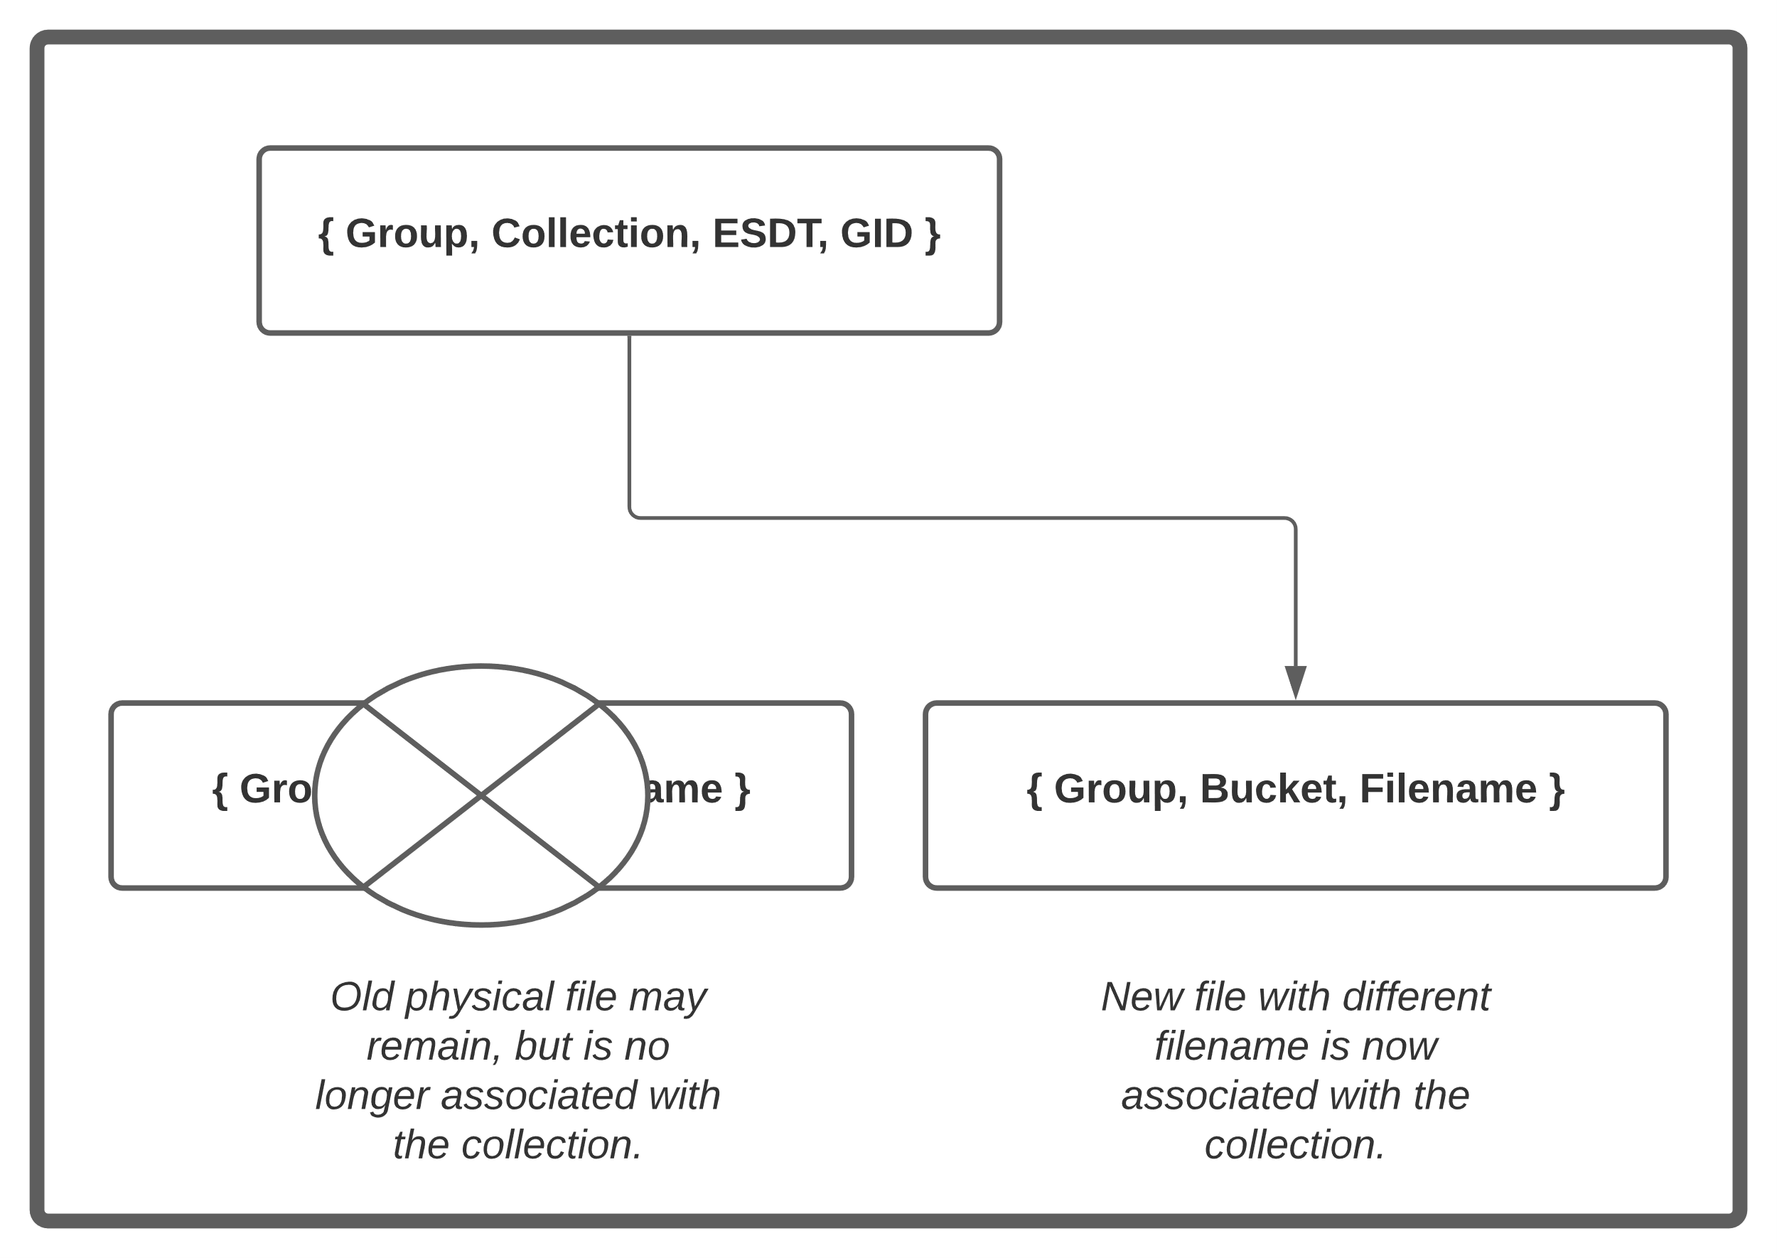
Figure 2-6 Replacing File mapped to a Granule Identifier

Distributed Active Archive Centers
For each mission, one or more DAACs will be assigned the responsibility for long term archive and distribution by NASA HQ and the ESDIS project. The DAACs include an Object Store that will hold that data.

All data required for processing will be delivered to the DAACs or retrieved from external data providers as appropriate. A complete list of data and which PGEs require them for each mission will be detailed in the mission OSDMP. Those data will be pulled directly from the DAAC Object Store as they are needed for processing. For optimization, some data files may be cached in the Compute Cluster for later reuse.

Metadata and CMR
When a granule is created, information about the granule beyond the science data of the granule itself are packaged with the granule. This Metadata includes information about how the granule was created, where the geophysical parameters reside in space and time, etc. When the granule is archived, that metadata can be used to locate and use the science data.

Within the APS, some subsets of the total metadata are used within the processing system to locate a granule needed for further processing (See MEAD in Section 3.4). Once the granule is passed to the DAAC for long term archive, the processing system retains sufficient metadata to find the granule again. Other Metadata fields may be relevant for the DAAC’s long term curation, but are not needed for processing. They will be registered by the DAAC into the Common Metadata Repository (CMR) along with all the rest of NASA’s Earth Science data holdings and used to support DAAC functions such as Earthdata Search.

In particular, the ESDT and the GID are primary metadata that can always be searched within a given Group and Collection to find a specific granule.

Kubernetes and Kueue
Kubernetes is an open-source system for automating deployment, scaling, and management of containerized applications.

Each of the components of the system, including the framework and the science software itself are packaged into containers for management by Kubernetes, and organized into Pods.

Kubernetes can deploy multiple instances of some components for performance scaling, or move instances to different physical hardware for robustness as needed. Those details will not be discussed in detail here, with each component typically being discussed as a whole.

In addition to the Containers (Pods) deployed within Kubernetes for the framework system itself, the science PGEs themselves are also run within the Kubernetes cluster. Kueue, an open-source batch service scheduler works with the standard kube-scheduler, cluster-autoscaler and the rest of the Kubernetes ecosystem to provision resources and execute the PGEs on behalf of APS.

System Overview

Figure 3-1 depicts a high-level overview of the Adaptive Processing System (APS). The major components and internal interfaces will be described below.

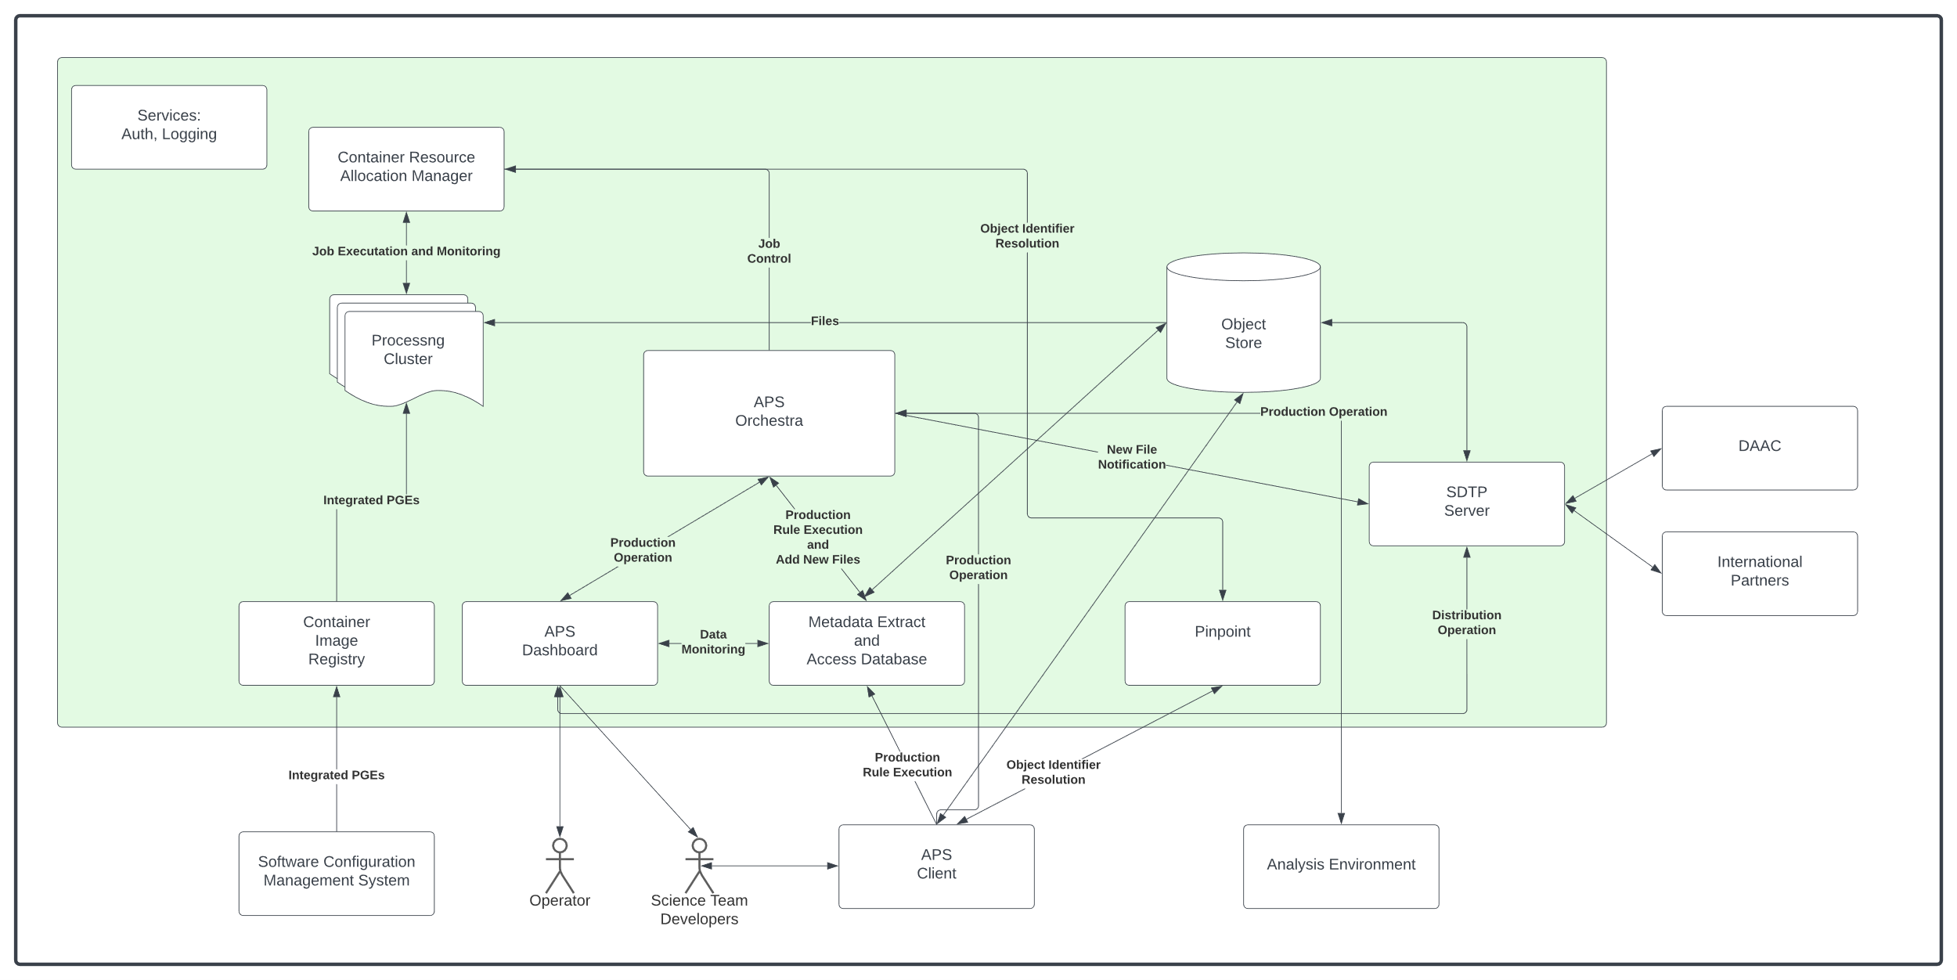
Figure 3-1 APS Overview

APS Dashboard
The APS Dashboard is a web based application providing operators, scientists and developers user friendly access to all of the functionality of APS. It is used to submit new production plans, monitor PGE execution, data production, etc.

APS Client and APSLib
The APS Client or aps is a command line interface to much of the functionality of APS. For example, the Dashboard provides an HTML form on a web browser to describe and submit a production plan, while the Client takes a YAML or JSON description of the plan from a file. Each of them ultimately submit the plan through the same RESTful API to the APS Orchestra, they just offer different mechanisms to access that API.

Most of the common APS interaction use cases are wrapped into the Python library, APSLib, that is available for other clients to use as well. It can be used to automate APS interactions in general.

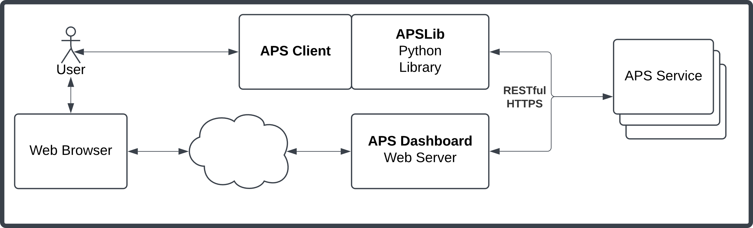
Figure 3-2 APS Client API Interactions

APS Orchestra
The APS Orchestra is the heart of APS and performs overall orchestration of data processing. New Production Plans can be submitted (as noted, either through the Dashboard, or through the Client, or even directly via the RESTful API if desired).

The Orchestra breaks down Plans depending on the nature of the process requests described in the plan into a set of Jobs. A simple example to understand this is a request to execute a daily PGE for each day in the month of January. This will result in the creation of 31 Jobs, one for each day of the month. Plans will include information about how the jobs will execute and they will be passed on into each Job as appropriate.

For each new Job, Orchestra will use MEAD to execute the production rules to determine any runtime parameters or input files required to execute the Job.

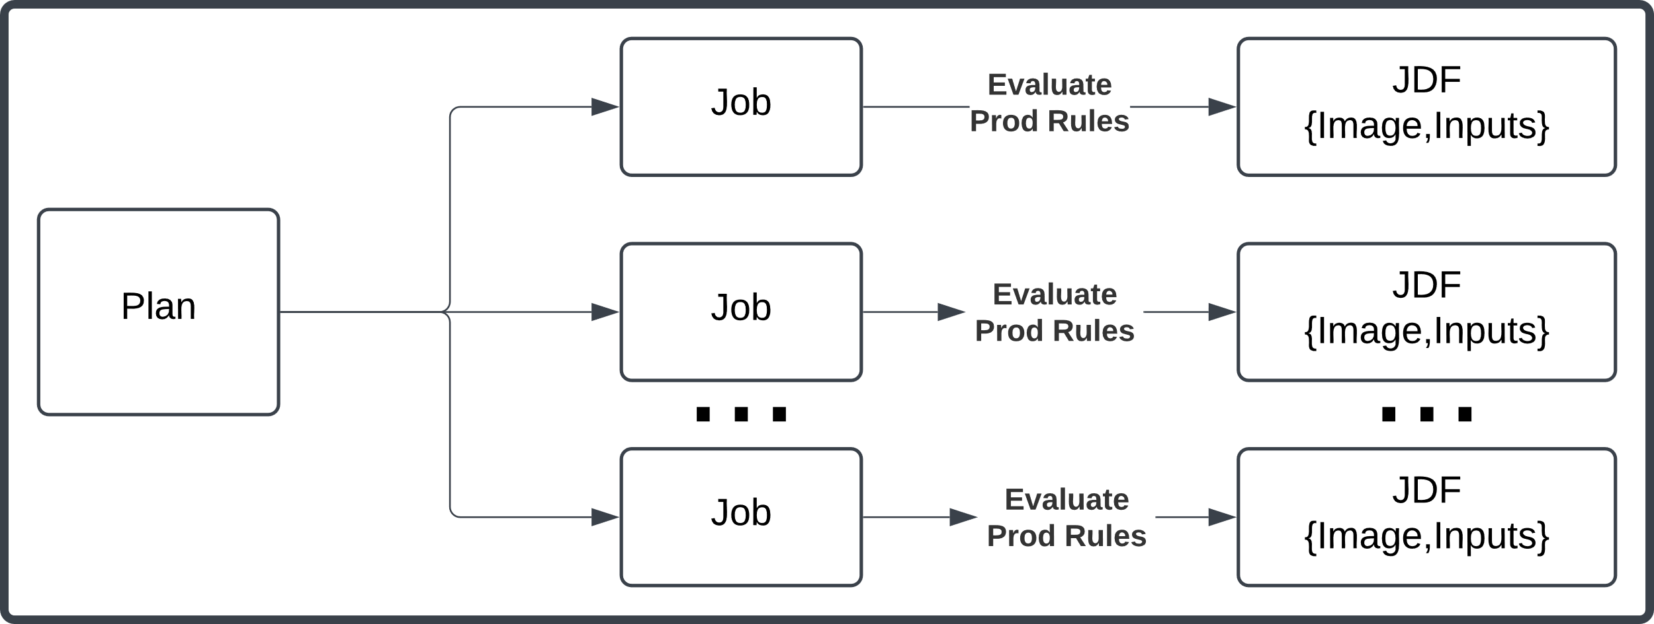
Figure 3-3 Plan Breakdown into Jobs
Once the Job production rules execute successfully, they are used to construct the Job Description File. Other information from the original plan are used to construct the Job Priority Identifier. The JDF and JPI pair are passed to the Container Resource Allocation Manager (CRAM) for execution.

When the Job has successfully executed, Orchestra sends notifications to any external consumers of the data via the SDTP Server. It also inserts newly created files into MEAD.

Metadata Extract and Access Database (MEAD) and Production Rules
As new files enter the system, a portion of their metadata may be needed to find the specific file for future processing. The files are inserted (their identifier, not their content) into the Metadata Extract and Access Database (MEAD). MEAD itself doesn’t know anything about the files or metadata, it is a very generic structure for supporting the interface and grouping a collection of Plugins that can handle each different type of metadata and query. One or more plugins can handle each type of file, and store relevant metadata about the file within local databases.

After a file is registered into MEAD, it can support queries using a very simple Question/Answer protocol to support various Production Rules. The specific plugins, the metadata they store, and the production rules they support will not be discussed here, but the specific production rules used by each PGE will be documented in the SDMP.

For a very simple (but important) example, MEAD can support the basic production rule for finding the { Group, Path, Filename } mapped to a { Group, Collection, ESDT, GID }. As files are inserted into MEAD, a plugin will store that mapping in a database, then a production rule querying for { Group, Collection, ESDT, GID } will result in an answer of the correct { Group, Path, Filename }.

Plugins can be very flexible, connecting to external services such as the NASA CMR, or even another instance of MEAD to support federated hierarchical queries. (Rather than duplicating information about another mission’s data, one mission’s MEAD can simply pass on a query to another mission’s MEAD.)

It is important to note that plugins can be developed for any sort of production rules, even looking up information other than simply finding a file. For example, a table of orbit numbers and their equator crossing times might be inserted to support a production rule for finding the time for a given orbit number (or finding the orbit number for a given time).

Sets of production rules can be grouped using a simple language for expressing concepts including optional and alternative inputs, or timing delays, with MEAD resolving the whole set of production rules at once.

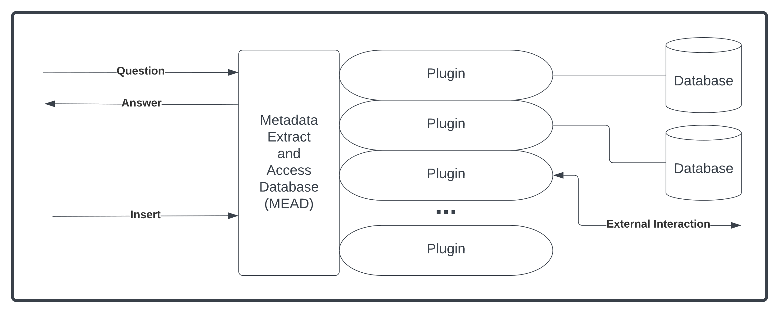
Figure 3-4 MEAD Overview

Container Resource Allocation Manager (CRAM)
The Container Resource Allocation Manager (CRAM) takes JDF/JPIs describing a Job and uses Group and Priority information to order jobs allocates resources for them to run on the Processing Cluster. The specific Container Image for the Job will be accessed from the Container Image Registry, and all of the required input files will be access from the Object Store.
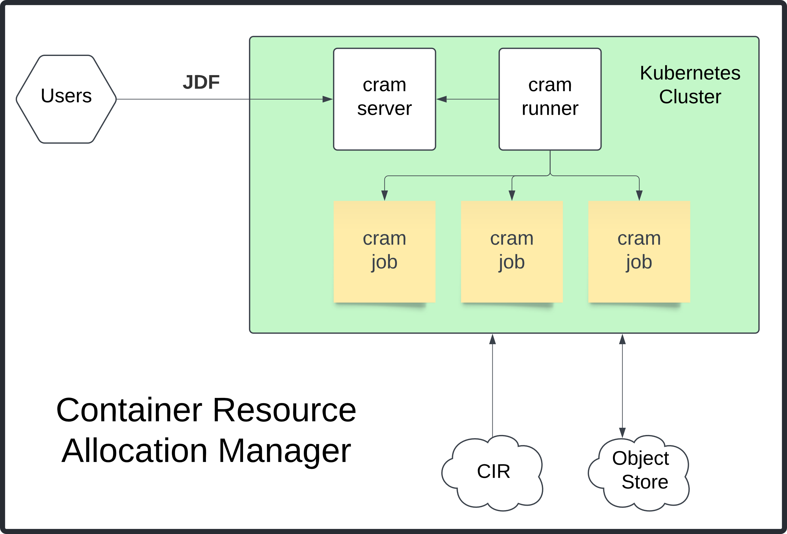
Figure 3-5 CRAM architecture

If a Job fails (Container exits with non-zero), the failed job will be packaged for anomaly analysis and stored back to the Object Store. If the Job succeeds, each of the newly created files will be sent back to the appropriate place in the Object Store.

Users interact with a “cram server” which in turn allocates jobs to “cram runners” to perform the actual processing. Notably, a single cram server can allocate jobs to multiple cram runners in different Kubernetes CPU clusters. This could be used, for example, to run some jobs on-premises and some in a cloud environment.

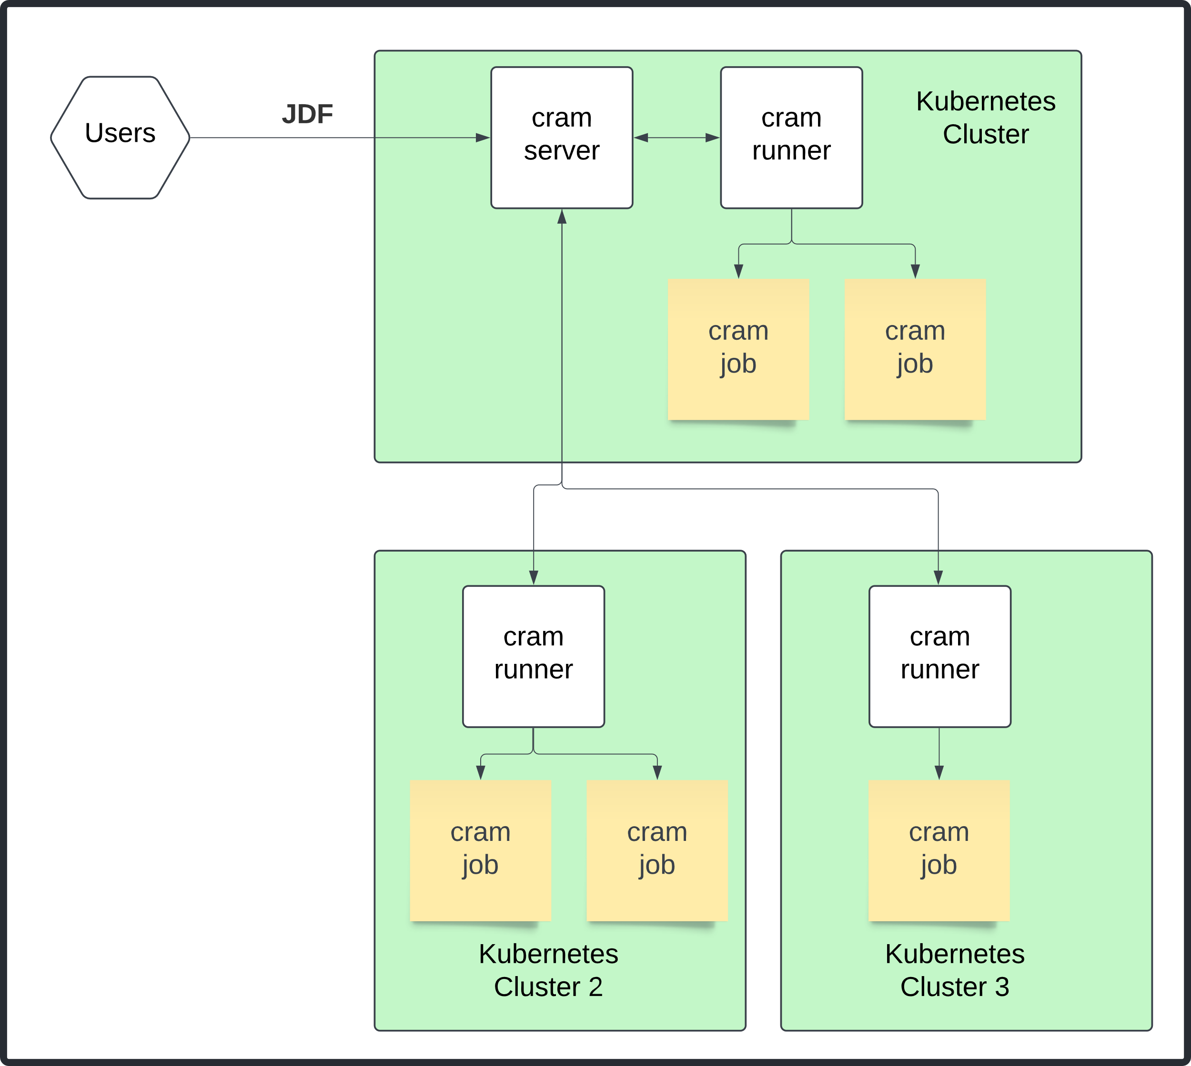
Figure 3-6 CRAM allocating jobs to multiple Kubernetes CPU Clusters

Orchestra continuously monitors Job progress by CRAM and updates status for each Job and the Plan they are associated with.

Abbreviations and Acronyms

Abbreviations/ Acronyms | Definition
AOS | Atmosphere Observing System
CCB | Configuration Control Board
CCSDS | Consultative Committee for Space Data Systems
CIR | Container Image Registry
ConOp | Concept of Operation
EOSDIS | Earth Observing System Data and Information System
ESDT | Earth Science Data Type
ESO | Earth System Observatory
DAAC | Distributed Active Archive Center
GEDI | Global Ecosystem Dynamics Investigation
GID | Granularity Identifier
GMAO | Global Modeling and Assimilation Office
GSFC  ICD  IMERG | Goddard Space Flight Center  Interface Control Document  Integrated Multi-satellitE Retrievals for GPM
ITAR  JDF  JPI  MOC  MRD  OCI  NRT  PGE  PoR | International Trade in Arms Regulation  Job Description File  Job Priority Identifier  Mission Operations Center  Mission Requirements Document  Open Containers Initiative  Near real time  Product Generation Executive  Program of Record
SBU  SCMS  SDS  SDMP  SDTP  SIPC | Sensitive But Unclassified  Software Configuration Management System  Science Data System  Science Data Management Plan  Science Data Transfer Protocol  SIPS-in-the-Cloud Concept of Operations
TBD | To be determined
TBR | To be revised
TBS | To be scheduled

Though we reuse the legacy term ESDT from the EOSDIS, our use varies from the complete EOSDIS Core System meaning.
Similarly, our reuse of the legacy term PGE from EOSDIS shouldn’t be assumed to match the definition of the term there.
https://modis-land.gsfc.nasa.gov/surfrad.html
https://id.nasa.gov/
https://ceph.io/
https://aws.amazon.com/s3/
https://gitlab.com
https://opencontainers.org
https://search.earthdata.nasa.gov/
https://kubernetes.io
https://kubernetes.io/docs/concepts/workloads/pods/
https://kueue.sigs.k8s.io/

