Guidelines for In-Space Cryogenic Propellant Transfer (ISCPT)
Thomas M. Perrin¹
Amentum Space Exploration Division, NASA/Marshall Space Flight Center, AL 35824
David E. Eddleman² and Robert J. Kenny³
Jacob D. Keplinger⁴ and Jonathan R. Stephens⁵
NASA/Marshall Space Flight Center, Huntsville, AL 35824

and

Jason W. Hartwig⁶
NASA/Glenn Research Center, Cleveland, OH 44135

The ability to perform in-space cryogenic propellant transfer is critical to the success of the Artemis campaign. The Human Lander System (HLS) for the Artemis Program includes two vehicles – the SpaceX “Starship” and the Blue Origin “Blue Moon Mark II”. The concept of operations for both spacecraft requires the transfer of cryogenic propellants in space.
The transfer of cryogenic propellants between independent spacecraft has never been demonstrated. But progress is being made. Under the provisions of a NASA Space Technology Missions Directorate (STMD) 2020 Tipping Point Contract, SpaceX demonstrated a tank-to-tank transfer of liquid oxygen during its March 2024 Starship flight.
In 2024, the Cryogenic Fluid Management Portfolio Project Office (CFMPP) at NASA’s Marshall Space Flight Center tasked a group of engineers to write a high-level guidelines document for In-Space Cryogenic Propellant Transfer (ISCPT). The document is not prescriptive in nature but is intended to assist NASA and Commercial Projects in developing architectures and ConOps for systems under development. The document includes several different sections. First, the document “sets the stage” by making some initial assumptions. Then the document discusses procedures for settled propellant transfer, unsettled propellant transfer, cryocoupler construction, and safety considerations.
- Nomenclature

CHV Charge-Hold-Vent (a method for propellant tank chilldown)
NVF No vent fill (filling a pre-chilled propellant tank without venting)
PMD Propellant management device
RCS Reaction Control System
RFMG Radio Frequency Mass Gauging (a technique for unsettled mass gauging)
VC/NVF Vented Chill/No Vent Fill
_____________________
1 Project Integration Engineer, Science & Technology Office/ST23, NASA/MSFC, AIAA Senior Member.
2 Branch Manager, Propulsion Systems Department/ER14, NASA/MSFC, AIAA Member.
3 Project Manager, Science & Technology Office/ST01, NASA/MSFC, AIAA Lifetime Member.
⁴ Safety & Mission Assurance Engineer, Science & Space Systems Assurance Branch/QD22, NASA/MSFC
5 Mechanical Engineer, Propulsion Systems Department/ER64, NASA/MSFC, AIAA Member.
6 Research Aerospace Engineer, Fluids & Cryogenics Branch/LTF0, NASA/GRC, AIAA Associate Fellow.
- Introduction

NASA’s Artemis Program is more complex than the Apollo Program of 50 years ago. While the Apollo Program relied on the mighty Saturn V rocket and very basic mission objectives, the Artemis Program has much more ambitious objectives and many more elements – a suite of precursor robotic missions, the Space Launch System (SLS) heavy rocket, the Orion crew capsule, a Gateway outpost that will orbit the Moon, and the Human Lander System (HLS) which will take astronauts back and forth from the Gateway outpost to the lunar surface.
The Human Lander System (HLS) includes two vehicles – the SpaceX “Starship” spacecraft and the Blue Origin “Blue Moon Mk. II”. The concept of operations (ConOps) for both spacecraft requires the transfer of cryogenic propellants in space – liquid oxygen (LO2) and liquid methane (LCH4) for Starship and LO2 and liquid hydrogen (LH2) for the Blue Moon lander.
The storage and transfer of cryogenic propellants in space has never been demonstrated to any scale, and no one has ever transferred cryogenic propellants between two spacecraft. But progress is being made. Under the provisions of a NASA Space Technology Missions Directorate (STMD) 2020 Tipping Point Contract, SpaceX demonstrated a tank-to-tank transfer of liquid oxygen during its March 2024 Starship flight. (The Apollo-era command module, service module, and lunar lander used non-cryogenic hypergolic hydrazine and did not perform propellant transfers.)
The ConOps for the two HLS landers has given greater visibility to the ongoing research by NASA into the storage and transfer of cryogenic propellants. This research is managed by the Cryogenic Fluid Management Portfolio Project Office (CFMPP) located at NASA’s Marshall Space Flight Center (MSFC) in Huntsville, Alabama, with research ongoing at Marshall Space Flight Center, NASA’s Glenn Research Center (GRC) in Cleveland, Ohio, and numerous other locations around the United States.
The CFMPP oversees work in four “portfolios” – CFM technologies, CFM subsystems, CFM demonstrations (including flight demonstrations), and CFM modeling. Each portfolio includes several “activities” – separate research efforts, each with its own funding, management, and schedule.
Over the last calendar year, the CFMPP tasked a group of engineers to write a high-level document CFM-DOC-008 Guidelines for In-Space Cryogenic Propellant Transfer (ISCPT). The document is not prescriptive in nature but is intended to assist NASA and Commercial Projects in developing architectures and ConOps for systems under development. The document includes several different sections. The organization of the document is shown in Fig. 1. First, the document “sets the stage” by making some initial assumptions – among them that two spacecraft (termed the “propellant supplier spacecraft” and the “propellant receiving spacecraft”) are docked together, and the act of docking the two spacecraft accomplishes the mating of cryogenic fluid coupling devices (termed “cryocouplers”). Then the document discusses procedures for settled propellant transfer, unsettled propellant transfer, cryocoupler construction, and safety.

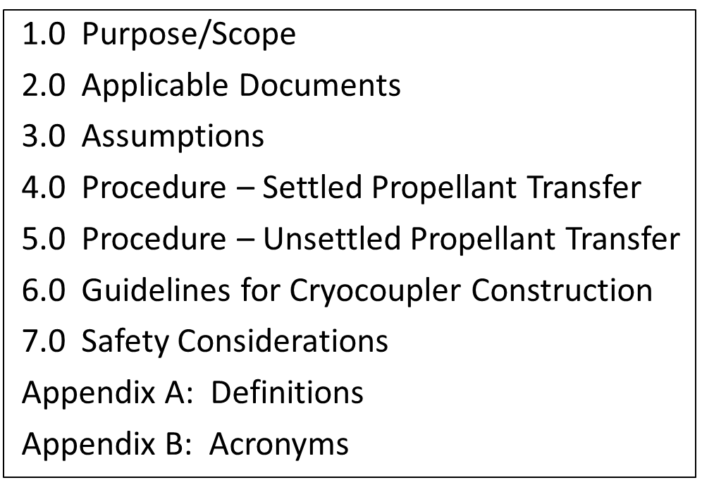

Figure 1. ISCPT Document Organization.
- Settled Propellant Transfer

Settled Propellant Transfer is a simplified operation relative to unsettled transfer in that the position of the propellant within the tank is known. Propellant acquisition, tank pressurization, and mass gauging can all be accomplished with more conventional methods. Trades should be conducted to include mass, risk, feasibility, complexity, and cost when determining whether or not to settle prior to a transfer operation for a given application.
If a settled propellant transfer is planned, then micro-acceleration(s) of the docked space vehicles to settle propellants prior to initiating transfer operations is needed. Micro-accelerations may also be needed during transfer operations to maintain settled conditions. Settling can be accomplished via RCS, Settling Motors, or Propulsive Venting, all of which require propellant (mass). Steps in settled prop transfer are described in Fig. 2. Numbers within the blocks of the figure correspond to sections within the document.

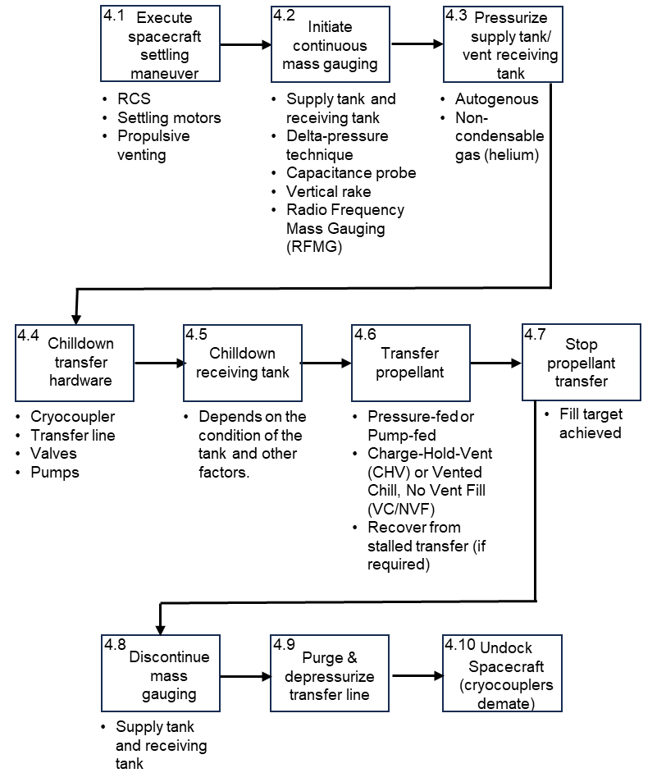

Figure 2. Steps in Settled Propellant Transfer.
- Unsettled Propellant Transfer

Unsettled prop transfer is more difficult than settled prop transfer. In a microgravity environment where the fluid inside the tank is in an unsettled condition, one of the main risks is venting liquid overboard and inability to maintain liquid at the outlet port via liquid acquisition systems. This is due to the unsettled nature of the fluid in the tank as well as the positive pressure gradient across the receiving tank vent valve.
The easiest way to achieve a successful fill is to prechill the receiving system below a “target” temperature, defined as the maximum wall temperature that permits a continuous non-vented fill. This can be determined experimentally and predicted using analytical or numerical techniques based on the thermal energy stored in the receiving tank.
Unsettled prop transfer described in Fig. 3. While the steps appear to be sequential, much depends on the initial state of the receiving propellant tank and transfer line. Chilldown of the receiving tank and the transfer line might occur simultaneously. Mass gauging might be needed continuously for both the supply tank and the receiving tank.
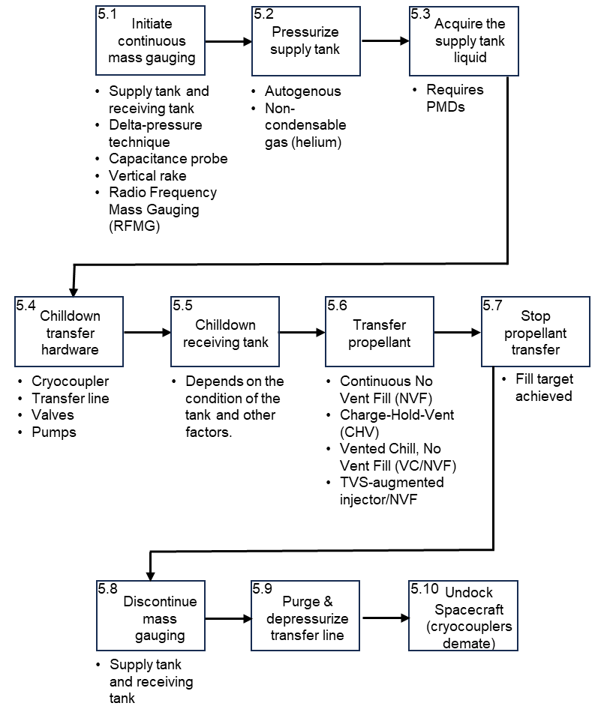

Figure 3. Steps in Unsettled Propellant Transfer.
- Cryocoupler Construction

All cryocouplers fall into one of two categories: actively controlled or passively controlled, and they may be completely active, completely passive, or a combination where one half is actively controlled and the other is passive. A cryocoupler may be a unidirectional or bi-directional flow mechanism designed for operation at cryogenic temperatures, consisting of a male and female half. When joined, the cryocoupler allows for the safe transfer of propellant or oxidizer from one spacecraft to another.
Propellant transfer operations and vehicle architecture requirements will influence the cryocoupler design. System requirements for positive indication of mate or demate and initiation or completion of propellant transfer may drive requirements for position indicators or interstitial purges. Leak detection capability may be required for health monitoring.
All cryocouplers should undergo qualification testing to confirm their ability to endure environments and meet performance requirements with margin. Qualification programs should incorporate tests aimed at verifying design compliance to performance requirements, typically consisting of burst, lifecycle, leakage, operation in thermal or vibrations environments, and flow capacity in both fill and drain directions. Testing should be performed with the expected working fluid to assess soft good friction and sealing performance at the operating temperature.
Performance requirements typical of those for components found on rockets will apply to cryocouplers. The pressure and temperature ranges that the cryocoupler could experience should be defined by the system.
Each cryocoupler component and soft goods must undergo a comprehensive material compatibility assessment to evaluate the effects of propellants, including issues like hydrogen embrittlement and oxygen impact hazards. General compatibility with the transferred propellant must also be verified. A computer aided design (CAD) rendering of a cryocoupler is shown in Fig. 4 below:

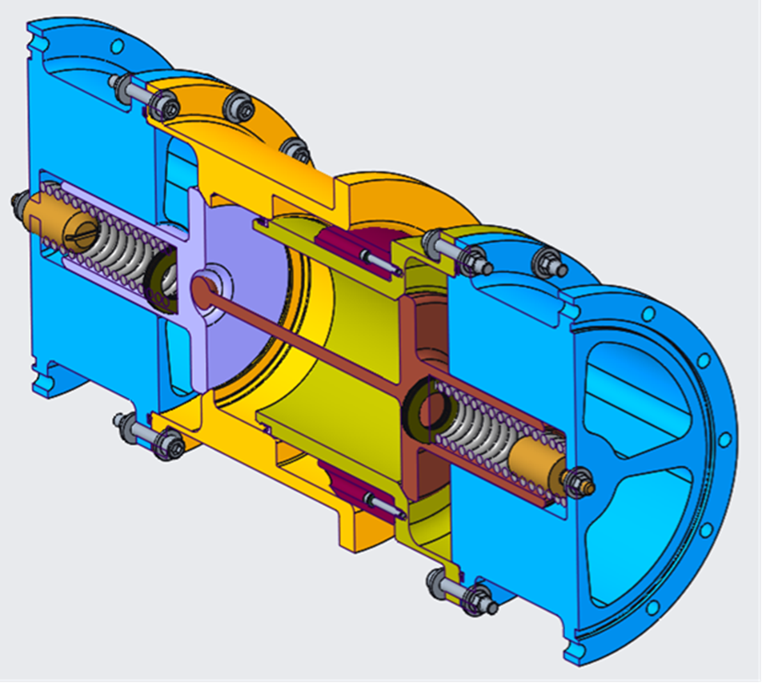

Figure 4. CAD rendering of a cryocoupler.
- Safety Considerations

Safety is paramount when working with cryogenic propellants. Planning for in-space cryogenic propellant transfer must include hazard identification and mitigation. Some potential hazards include:
Propellant leakage. Cryogenic propellant, particularly liquid hydrogen, is prone to leakage due to the tight tolerances required to maintain a seal in connecting interfaces. The propellant transfer lines will likely be the most susceptible to propellant leakage.
Uncontained Propellant or Propellant Vapors. ISCPT operations could result in a release of propellant vapor through intended (venting) or unintended (leakage) events. If these vapors are trapped in or concentrated near the vehicle, they may increase the risk of fire or explosion.
Electrostatic discharge. Electrostatic discharge is a known hazard for docking spacecraft, and all currently conceivable methods of ISCPT will involve some form of docking. Electrostatic discharge can damage vital components, including electrical components, and could initiate combustion or explosion in energetic materials, such as propellant.
Foreign object debris (FOD). Debris may be trapped in the system during manufacture or integration or generated through other vehicle operations. Significant debris can pose hazards by damaging vehicle hardware, interfering with instrument function, forming blockages in fluid lines or valves, or posing an ignition risk (especially in liquid oxygen environments).
Unintended propulsive venting. Venting propellant tanks can place unwanted accelerations on the spacecraft. This should be considered in the design and orientation of vents and when planning transfer operations.
Changes in flight dynamics. After docking, the supply spacecraft and the receiving spacecraft become one “ body”. The transfer of a significant mass and volume of propellant from one location in the body to another could cause the body to roll or otherwise become unstable. The design and concept of operations for spacecraft engaging in cryogenic propellant transfer should consider the impact of changes in flight dynamics to prevent the exceedance of spacecraft design margins or established mission parameters.

- Summary

The ability to perform in-space cryogenic propellant transfer is critical to the success of the Artemis Program. In 2024, NASA ranked cryogenic propellant transfer number 21 of 187 technology shortfalls within the agency. The document described in this paper has been written to provide high-level guidelines to assist aerospace engineers in developing ConOps for cryogenic propellant transfer for systems under development.

