Space weathering effects in Bennu asteroid samples

L. P. Keller¹, M. S. Thompson², L. B. Seifert¹, L. E. Melendez², K. L. Thomas-Keprta³, L. Le⁴, C. J. Snead¹, K. C. Welten⁵, K. Nishiizumi⁵, M. W. Caffee⁶, J. Masarik⁷, H. Busemann⁸, D. Krietsch⁸, C. Maden⁸, Z. Rahman⁴, C. A. Dukes⁹, E. A. Cloutis¹⁰, Z. Gainsforth⁵, S. A. Sandford¹¹, D. N. DellaGuistina¹², H. C. Connolly Jr.^{13,14,15} & D. S. Lauretta¹²

¹NASA Johnson Space Center, Houston, TX, USA.
²Department of Earth, Atmospheric, and Planetary Sciences, Purdue University, West Lafayette, IN, USA.
³Barrios/Jacobs, NASA Johnson Space Center, Houston, TX, USA.
⁴Jacobs, NASA Johnson Space Center, Houston, TX, USA.
⁵Space Sciences Laboratory, University of California, Berkeley, CA, USA.
⁶Department of Physics and Astronomy, Purdue University, West Lafayette, IN, USA.
⁷Department of Nuclear Physics and Biophysics, Comenius University, Bratislava, Slovakia.
⁸Institute of Geochemistry and Petrology, ETH Zurich, Switzerland.
⁹Laboratory for Astrophysics and Surface Physics, Department of Materials Science and Engineering, University of Virginia, Charlottesville, VA, USA.
¹⁰Department of Geography, University of Winnipeg, Winnipeg, Manitoba, Canada.
¹¹NASA Ames Research Center, Moffett Field, CA, USA.
¹²Lunar and Planetary Laboratory, University of Arizona, Tucson, AZ, USA.
¹³Department of Geology, Rowan University, Glassboro, NJ, USA.
¹⁴Department of Earth and Planetary Sciences, American Museum of Natural History, New York, NY, USA.

The OSIRIS-REx mission deployed contact pad samplers to collect regolith from the uppermost surface of the asteroid Bennu that was exposed to the space environment. Space weathering processes, dominated by micrometeoroid impacts and solar irradiation, modify the mineralogy and chemistry of exposed surfaces to produce solar wind amorphized layers on clays, metallic whiskers associated with high temperature melts, and Fe-nitride created by the reaction of indigenous N-bearing gases with space-weathered surfaces. Cosmogenic noble gases and radionuclides suggest that the upper meter of Bennu’s regolith has been exposed to cosmic rays for 2–7 million years, consistent with remote sensing observations indicating that the asteroid’s surface is dynamic and regularly modified by mass movement. Solar energetic particle track and microcrater densities constrain the space weathering spectral changes observed in Hokioi crater to <50,000 years. These spectral changes are driven largely by the accumulation of impact melt deposits on particle surfaces, although compositional or grain size effects may also have an effect. Comparison of Bennu samples to those collected from the asteroids Ryugu and Itokawa suggest micrometeoroid impacts might play a more active and rapid role in the space weathering of asteroidal surfaces than was initially suggested, particularly for carbonaceous bodies.

NASA’s OSIRIS-REx spacecraft returned centimeter-scale and smaller regolith particles from Hokioi crater on (101955) Bennu, a relatively rare, spectrally blue (B-type) carbonaceous asteroid [1,2]. The spacecraft’s Touch-and-Go Sample Acquisition Mechanism (TAGSAM) [3] captured the “bulk” ~122 g sample, which consists of mixed material from the surface and potentially from up to ~0.5 m in depth [4]. In addition, the TAGSAM included 24 contact pads consisting of stainless-steel Velcro, each ~17 mm in diameter and arranged symmetrically around the circumference of the TAGSAM base (Fig. ED1) [3]. Their purpose was to sample Bennu’s uppermost regolith to explore the mineralogical, chemical, and spectroscopic changes resulting from exposure to space weathering.
Spacecraft data provided our first insights into the extent of space weathering effects across Bennu’s surface. Reflectance spectra showed that small craters on Bennu, especially Hokioi, are redder in the visible wavelengths than the global average; these craters were inferred to be the youngest on Bennu, with a surface exposure age estimated to be <10⁵ years [2]. Post-sampling observations of Hokioi crater confirmed that freshly exposed materials are spectrally redder and darker in the visible wavelengths than the more space-weathered, spectrally blue material exposed across most of Bennu’s surface [2,4]. However, spectra from an aliquot of the returned sample are even more red-sloped and darker than spectra collected by the spacecraft [1], suggesting that despite its inferred young exposure age, material at the surface of Hokoi crater has already undergone considerable space weathering.

Upon examination of the TAGSAM, we found that all contact pads contained adhering material, including particles captured in the Velcro loops, smaller particles in the base weave, and dust particles coating much of the surface area (Fig. ED1) comprising << 100 mg. Scanning electron microscopy (SEM) analysis shows that contact pad particles are mineralogically similar to the bulk sample [1], including fine-grained phyllosilicates, magnetite framboids and plaquettes, Fe- and Fe-Ni-sulfides, carbonates, phosphates, and many other minor and trace minerals [5]. SEM analyses also show that all four particles extracted thus far from contact pad OREX-452000-0, as well as tens of particles from the bulk sample show evidence for space weathering on their surfaces, including vesicular impact melt deposits and micrometeoroid impact craters (<10 µm in diameter; Fig. 1; ED Table 1).

Impact Melt Deposits

The quenched impact melt deposits (hereafter “melts”) are present on ~10–20% of the tens of particles analyzed from the bulk sample to date and all four particles extracted from the contact pad. One contact pad particle (OREX-452001-0) exhibits ~180 individual melt deposits over ~0.6 mm² (Fig.1). The melts range in size and coverage, from splashes only a few micrometers wide to coatings covering >200 µm² of the particle surface. We extracted focused ion beam (FIB) sections to investigate the microstructure and chemistry of space weathering features in the transmission electron microscope (TEM).

The bulk compositions of the melts (Tab. S2) are approximately solar for most major elements (e.g., Mg, Si, Fe), except S, which is depleted from the melts owing to its volatility, resulting in the formation of Fe metal grains in some melts. The melts also contain abundant nano- and micro-phase inclusions of Fe-Ni-S phases and can also include larger immiscible Fe-Ni-S melts, either as discrete deposits or as irregular swirls (schlieren) in the host silicate melts.

In addition to micro- and nanophase inclusions, there are widespread vesicles throughout the melts (~500 nm in diameter) and also concentrated at the melt interface with the phyllosilicate-rich matrix (~50 nm in diameter). The large vesicles resemble those in melts produced by IR laser irradiation of hydrated carbonaceous chondrites—where the vesicles form from evolved volatiles (mainly H₂O) [6]. This H₂O likely contributes to the broadening of the 2.7 µm water feature observed in the spacecraft spectra [7]. The smaller vesicles resemble those observed in solar wind–irradiated surfaces of particles returned from Itokawa [8] and laboratory experiments [9, 10].

In contrast to the silicate melts described above, the Fe-Ni-S melt deposits are crystalline and dominated by fine-grained mixtures of pyrrhotite, pentlandite, FeNi metal, and minor magnetite. On one such melt deposit (OREX-501017-101), we observed a polycrystalline ~10 nm Fe-nitride layer (Fig. 2) that consists of an intergrowth of siderazot (Fe₃N_{1.3}) and roaldite (Fe₄N). The Fe-nitride minerals likely formed through a gas-phase reaction of the Fe metal layer with a N-bearing volatile phase, most likely indigenous ammonia [11]. The discovery of nitrides in Ryugu [12] and Bennu samples suggests an unexpected but possibly common process involving interactions between ammonia and the space-weathered regolith particles on carbonaceous asteroids.

A sulfide melt on particle OREX-803164-100 lacks an Fe-nitride layer; however, on that deposit we observe the formation of multiple FeNi-rich metal whiskers protruding up to ~100 nm from the surface (Fig. 3), like those observed on sulfides in samples from Itokawa [12] and the Moon [13] (see Supplemental section).

Solar Wind Irradiation

Evidence for solar wind irradiation was identified in particles that exhibit other characteristics consistent with surface exposure on Bennu (e.g., microcraters and melts). In addition, we examined areas immediately underlying melts superimposed on previously solar wind-exposed surfaces.

On particle OREX-501017-102, we observe a less porous, compact surface layer, ranging in thickness from 60 to 150 nm, consistent with the expected implantation depths for solar wind H⁺ and He⁺ in silicate materials estimated by Monte Carlo atomic collision modeling [9, 15]. This compact layer exhibits heterogeneous crystallinity, with a predominantly amorphous surface transitioning to poorly crystalline, and ultimately long-range crystalline order at the base (Fig. ED2). The compact surface layer is also chemically processed, with a10 nm-thick rim enriched in Mg and depleted in Si, overlying a similar layer depleted in Mg and enriched in Si. This chemical signature is commonly observed in other solar wind–irradiated returned samples and analogs [9,10,16] (See Supplemental section).

We directly measured solar wind–derived He in particles that showed evidence for surface exposure (OREX-501017-102 and OREX-501017-100). Electron energy loss spectroscopy (EELS) measurements revealed heterogeneously distributed He in the compact surface layer of particle OREX-501017-102 (Fig. 4). We also identified He in OREX-501017-100 in small vesicles concentrated at the melt-matrix interface. These observations support the inferred relationship between interface vesicles and the implantation of solar wind gases.

Olivine and pyroxene grains exposed to the space environment are rare in Bennu samples [1,5]. We extracted a FIB section from a forsterite grain on the surface of a contact pad particle (OREX-452001-0) and observed a nanocrystalline solar wind–damaged rim ~100 nm wide and solar energetic particle (SEP) tracks with a density of ~1.4 × 10⁹ cm^{–2} (Fig. 5). The rim microstructure is similar to solar wind–damaged rims in olivine grains from Itokawa and the Moon with similar SEP track densities [17].

Micrometeoroid Impact Craters

We used SEM imaging to identify micrometeoroid impact craters based on their circular morphology, raised rims, and the presence of vesicular melt deposits lining the crater floors (Fig. 1b). Micrometer-sized impact craters are commonly observed on contact pad particles and on some particles from the bulk sample. On the surface of contact pad particle OREX-452001-0, we observe ~40 microcraters with diameters typically 1 to 2 μm. In contrast, the largest crater we have identified is in a particle from bulk sample OREX-803109-0 and is ~10 μm in diameter with radial fractures extending outward (Fig. 6).

Exposure Ages

We use solar energetic particle tracks and microcrater densities to constrain recent direct exposure at Bennu’s surface (< mm depths). At greater depths (upper few m) we use the production of the radioactive cosmogenic nuclides (hereafter “radionuclides”) ¹⁰Be and ²⁶Al as well as the stable noble gas nuclide ²¹Ne by exposure to galactic cosmic rays (GCR). Whereas cosmogenic noble gases record the total cosmic ray exposure (CRE) history of the samples, radionuclides record the CRE history of the past 5–10 Myr.

Solar energetic particles leave tracks of ionization damage in anhydrous silicate crystals, and their density can be used as a chronometer for exposure in the uppermost millimeters of the regolith [18]. The SEP track density in the forsterite exposed on OREX-452001-0 (~1.4 × 10⁹ cm^{–2}) is consistent with an exposure age of ~45,000 years (Methods).

Microcrater densities also constrain the surface exposure age of particles. While contact pad particle OREX-452001-0 has the highest microcrater density, this estimate represents a minimum density for this particle because we did not count micrometer-sized pits without melt as microcraters. We use this density to estimate the exposure age by comparison with the cumulative microcrater production rate observed for lunar rocks and soils [19], giving a range in exposure ages of ~20,000–85,000 years (Methods).

Bennu particles (Methods), like those returned from Ryugu [20], contain abundant primordially trapped noble gas components that mostly overprint the much less abundant cosmogenic noble gases [21]. Some particles that were exposed at Bennu’s surface also contain abundant trapped solar wind, evident in He and Ne. Because the trapped components are so dominant, any resolvable excesses of cosmogenic ²¹Ne are minimal if present at all. Otherwise, upper limits were determined (see data in [21] s. Where resolvable, the concentration of cosmogenic ²¹Ne in the Bennu particles (2.8 and 4.2 × 10^{–9} cm³ STP/g; STP is standard temperature and pressure) suggests a CRE age of 2–7 Myr depending mostly on the depth where the exposure to GCRs occurred.

We measured the concentrations of the cosmogenic radionuclides, ¹⁰Be (half-life =1.36 Myr [22]), ²⁶Al (half-life = 0.705 Myr [23]) and ³⁶Cl (half-life = 0.301 Myr [24]) in aggregate sample, OREX-803047-0. (Table S3). The cosmogenic ¹⁰Be and ²⁶Al concentrations correspond to irradiation depths of 170-180 and 100-110 g/cm², respectively [25]. Since the collected sample is likely a mixture of materials from the surface and deeper in the crater [26], scenarios where individual particles were exposed at different depths and for different durations may explain the cosmogenic nuclide record of the sample. Regardless of the different histories of individual particles, the cosmogenic radionuclide results indicate a minimum CRE age of >3 Myr for the sample, which is consistent with the ages >2 Myr derived from cosmogenic ²¹Ne here. Nevertheless, some caution is needed as noble gas measurements were performed on different samples than those used for radionuclide measurements.

If the 2–7 Myr CRE age of the samples we examined is representative of Bennu’s average surface, then the exposure time of the top few meters of regolith is less than the asteroid’s oldest estimated age (~1 Gyr) by more than two orders of magnitude [27]. This indicates that the uppermost few meters of Bennu are frequently replenished with material from depths >5–10 m, likely by a combination of impact gardening and downslope mass movements. This is consistent with spacecraft observations indicating a dynamic surface, including particle ejection events [e.g., 28], mass movement within the past few hundreds of thousands of years [27, 29], and a crater size frequency distribution indicating the upper ~10 m of Bennu is resurfaced on a timescale of 10–65 Myr [30]. Finally, our initial results for Bennu materials indicate a CRE age of approximately 5 million years, similar to the age determined for Ryugu [20], suggesting that these two asteroids have experienced comparable surface evolution histories.

Connecting Returned Samples to Spacecraft Observations

With the analysis of samples from Bennu, we can compare weathering timescales from a remote versus laboratory perspective, while also linking spectral characteristics to their microstructural and chemical sources. The younger SEP exposure age we find from a particle collected at the surface (~10⁴ years) suggests that space weathering changes occurred on a more rapid timescale than was estimated from spacecraft data (10⁵ years).

Spacecraft measurements also suggest that surface material on Bennu becomes brighter and bluer with continued exposure to the space environment, in contrast with lunar and ordinary chondritic materials [2,3,31]. Compositionally, Bennu samples contain hydrated amorphous Mg, Na-phosphate [1,32]; a similar phase in Ryugu samples displays a blue slope across visible wavelengths [33], suggesting that such material may be contributing to Bennu and Ryugu reflectance spectra. In laboratory studies with analog materials, the bluing trend has been attributed to a variety of optically opaque minerals, including carbonaceous materials, sulfides, or magnetite [6, 34]. The melt deposits on the surfaces of Bennu particles contain abundant nanophase and microphase inclusions of FeNi metal and FeNi-sulfides. Spectral modeling of troilite (FeS) inclusions in silicate hosts indicate that particles >40 nm in diameter cause bluing of reflectance spectra across visible–near-infrared wavelengths [34]. This link between nanophase sulfides, which we observe in the samples, and increasingly blue spectral characteristics offers a fresh paradigm for space weathering on airless carbonaceous bodies where nano- and microscale sulfide inclusions influence the evolution of spectral properties observed through remote sensing, rather than the nanophase Fe-metal. These observations provide context for space weathering processes across the Solar System and may have implications for rocky bodies enriched in sulfur, such as Mercury.

An Evolving Model for Space Weathering in the Inner Solar System

Space weathering is a ubiquitous process affecting airless bodies across the Solar System, and understanding the relative contributions of its constituent processes and their timescales is critical for interpreting the mineralogy and evolution of these planetary surfaces. The canonical model for space weathering constructed from lunar observations suggested that solar wind modifies airless surfaces on short timescales (10⁴–10⁶ years), whereas impacts operate on longer timescales (10⁸–10⁹ years) [35, 36]. This was reinforced by observations from Itokawa samples, where solar wind appeared to be the dominant space weathering agent, acting to alter spectral characteristics more efficiently and on shorter timescales than impacts [8, 36].

However, we can now compare space weathering characteristics in returned samples across all our asteroidal collections (Itokawa, Ryugu, and Bennu). Melt deposits occur in <0.5% of Itokawa samples [37], 2% of the Ryugu particles [16], and 20% of Bennu particles (although analyses of additional material may improve these statistics). In contrast, Ryugu samples have the lowest SEP track density ages (6000 years), compared to those from Bennu (45,000 years) and Itokawa (50,000 years) [8, 16]. Together, these results suggest micrometeoroid impacts play a more important role in the space weathering of asteroidal surfaces than was suggested from early observations of asteroidal returned samples.

Comparing space weathering characteristics between only Ryugu and Bennu samples reveals a common suite of products, including vesiculated melts with nano- and micro-phase FeNi sulfide inclusions, solar wind–damaged rims, microcraters, and the unusual metal whiskers and nitride layers described above [12,13,16,17]. This is unsurprising given their mineralogical and compositional similarity and their exposure to the near-Earth space environment. However, the observed SEP track and microcrater densities indicate that Bennu samples have an order-of-magnitude longer surface exposure than Ryugu samples. In addition, there are apparent differences in the spectral slopes, colors, and strength of the 2.7-µm hydration feature between Ryugu and Bennu in spacecraft data [31].

The spectral slope differences between Ryugu and Bennu [31] were attributed to different space weathering trends operating on the bodies, but the asteroids’ similar chemical and microstructural characteristics and the age relationship we infer from the samples indicates that the space weathering trend is a single path with spectral slopes evolving from red to blue over time. Ryugu sits at an earlier stage of this pathway, and we predict that it will eventually develop a bluer, Bennu-like spectral slope. Other factors such as particle size, minor mineralogical differences, or rock surface textures may also contribute to differences between the asteroids.

The space weathering characteristics of Bennu and Ryugu revealed by remote sensing and sample analysis suggest that space weathering is fundamentally different for primitive carbonaceous bodies compared to the Moon and S-complex asteroids in four ways:
- Micrometeoroid impacts are more efficiently driving rapid spectral changes relative to solar wind effects on hydrated carbonaceous asteroids, which also contrasts with existing models for inner Solar System weathering timescales [e.g., 36].
- Observations from Bennu samples have demonstrated that impacts not only alter the surfaces of C-complex asteroids more substantially but do so on a far shorter timescale than hypothesized based on lunar surfaces (10⁴ years compared to >10⁸ years).
- The effects of micrometeoroid impacts are known to be magnified by the low mechanical strength [38], higher volatile content, and more efficient melting of carbonaceous surfaces versus their anhydrous lunar and asteroidal counterparts. These properties result in the wide dispersion of melt ejecta by shocked volatiles [39].
- Spectral slopes are driven towards bluing with continued exposure, rather than reddening, a reversal of lunar-style space weathering spectral trends. Differences in surface exposure timescales between Ryugu (shorter) and Bennu (longer) support the hypothesis that carbonaceous asteroids experience a pathway of weathering driven by early reddening, followed by eventual bluing [2]. Bennu and Ryugu are snapshots of asteroids at two different stages of this pathway, with Ryugu exhibiting a redder spectral slope, lower crater density, and younger surface exposure ages, and Bennu showing a bluer slope, higher crater densities, and longer surface exposure ages. These observations provide another metric by which relative surface ages could be determined for carbonaceous asteroids in the main belt.

Recent crater distribution and retention age analyses [40] confirm that rubble-pile asteroids can experience exceptionally rapid regolith mixing and resurfacing, with turnover timescales on Ryugu of 10³–10⁵ years. This rapid cycling suppresses long-term spectral bluing and promotes the exposure of fresh material, especially on Ryugu, where younger surface ages result in a redder spectral slope. Bennu, having experienced fewer resurfacing events, has transitioned further along the spectral weathering pathway toward bluer slopes. These processes, driven by impact gardening and surface flows, appear to dominate space weathering on carbonaceous asteroids, fundamentally distinguishing them from those on the Moon and S-type asteroids.

Acknowledgments
This material is based upon work supported by NASA under Award NNH09ZDA007O and Contract NNM10AA11C issued through the New Frontiers Program. We acknowledge the entire OSIRIS-REx team for making the return and analysis of samples from Bennu possible. We thank the Astromaterials Acquisition and Curation Office, part of the Astromaterials Research and Exploration Science (ARES) Division at Johnson Space Center, for their efforts in recovery, preliminary examination, and long-term curation of the Bennu samples. We also greatly appreciate support from the OSIRIS-REx Sample Analysis Micro-Information System (SAMIS) Team. Sample analyses and sample preparation at NASA Johnson Space Center was supported by the Electron Beam Analysis Laboratories. C.W.V. Wolner is thanked for her constructive inputs on early versions of this manuscript.

Author contributions
L.P.K, M.S.T., L.B.S., L.E.M., K.L.T-K., L.L., K.C.W., K.N., M.W.C., J.M., H.B., D.K., C.M., and Z.R contributed to samples analysis. All authors contributed to the final text, the ideas, and direction of this work.

Author information
These authors contributed equally: L. P. Keller and M. S. Thompson.

Competing Interests
The authors declare no competing interests.

Figure Captions

Figure 1. Space weathering effects in a contact pad particle. a, SEM image of particle OREX-452001-0 with microcraters indicated by yellow squares. Typical microcraters and melt deposits on the surface of OREX-452001-0 are indicated with red arrows in panels b and c, respectively.

Figure 2. An iron nitride layer on the surface of a Fe-N-S melt. a, TEM image of a FIB section of particle OREX-501017-101, with the iron nitride layer indicated by yellow arrows. b, Higher-magnification image of the polycrystalline layer. c, Fe-N-S (RGB) composite chemical map of the area shown in panel b. d,e, High-resolution TEM image showing that the Fe-nitride is crystalline, with an inset (red box) fast-Fourier transform (FFT) pattern consistent with the mineral roaldite.

Figure 3. FeNi metal whiskers that have developed on sulfide-rich melt deposits. a, SEM image of particle OREX-803164-0 containing a sulfide-rich melt droplet (labeled “S-rich ‘splat’”). The yellow dashed line indicates the boundary between the sulfide melt and the silicate melt. The green box indicates a magnified area shown in the subsequent panels. The red and yellow arrows indicate a Ni-poor whisker and a Ni-rich whisker, respectively. b, Yellow arrows point toward Ni-rich whiskers, more of which can be seen in this magnified view, and the red arrow points toward the Ni-poor whisker. The corresponding Ni (c) and S (d) maps show that the whiskers are Ni-rich and S-depleted. Arrows pointing toward Ni-rich whiskers in panel d are colored black for clarity.

Figure 4. TEM data showing evidence for solar wind irradiation. a and b, HAADF images of the samples analyzed with EELS, with measurement locations identified by colored boxes. c and d, Interface between melt deposits and the underlying matrix in particle OREX-501017-100. e, HAADF image of the solar wind–irradiated rim in particle OREX-501017-102. f, HAADF image of the matrix, below the implantation depth for solar wind, in particle OREX-501017-102 (not shown in a and b). g, EELS spectra (arbitrarily offset in intensity only for clarity) showing the presence of He, with spectrum colors corresponding to the boxes in panels c to f. The peak positions for the He K-edge shifts to higher energies (between 22-23 eV, as indicated by the dashed grey lines) with higher concentration detected [36].

Figure 5. Track-rich forsterite grain on the surface of particle OREX-452001-0. a, SEM image with the forsterite grain in the center with a dashed line indicating the orientation of the FIB section. b, TEM image of the FIB cross section of the forsterite. c, Expanded TEM image from the red outlined area in b., showing the solar wind damage on the rim and SEP tracks (linear features) in the grain.

Figure 6. Micrometeoroid impact crater in particle OREX-803109-0. a, SEM image of the particle showing the crater (dark area) and the radial fractures surrounding it (yellow arrows). b, The crater entrance is lined with vesiculated melt. c, The crater as exposed in the FIB trench before extracting a section for TEM analysis. The red box indicates the area shown in panel d. d, Fe-Si-S (RGB) composite chemical map of the crater path through matrix material, including a platy pyrrhotite grain (magenta).

References
[1] Lauretta, D. S., H. C. Connolly Jr., J. E. Aebersold, C. M. O. D. Alexander, R-L. Ballouz, J. J. Barnes, H. C. Bates, C. A. Bennett, L. Blanche, E. H. Blumenfeld, S. J. Clemett, G. D. Cody, D. N. DellaGiustina, J. P. Dworkin, S. Eckley, D. I. Foustoukos, I. A. Franchi, D. P. Glavin, R. C. Greenwood, P. Haenecour, V. E. Hamilton, D. H. Hill, T. Hiroi, K. Ishimaru, F. Jourdan, H. H. Kaplan, L. Keller, A. J. King, P/ Koefoed, M. K. Kontogiannis, L. Le, R. J. Macke, T. J. McCoy, R. E. Milliken, J. Najorka, A. N. Nguyen, M. Pajola, A. T. Polit, H. L. Roper, S. S. Russell, A. J. Ryan, S. A. Sandford, P. F. Schofield, C. D. Schultz, L. B. Seifert, S. Tachibana, K. L. Thomas-Keprta, M. S. Thompson, V. Tu, F. Tusberti, K. Wang, T. J. Zega, C. W. V. Wolner & OSIRIS-REx Sample Analysis Team. Asteroid (101955) Bennu in the laboratory: Properties of the sample collected by OSIRIS-REx, Meteoritics and Planetary Science, DOI: 10.1111/maps.14227 (2024).
[2] DellaGiustina, D. N., Burke, K. N., Walsh, K. J., Smith, P. H., Golish, D. R., Bierhaus, E. B., Ballouz, R. -L., Becker, T. L., Campins, H., Tatsumi, E., Yumoto, K., Sugita, S., Deshapriya, J. D. Prasanna, Cloutis, E. A., Clark, B. E., Hendrix, A. R., Sen, A., Al Asad, M. M., Daly, M. G., Applin, D. M., Avdellidou, C., Barucci, M. A., Becker, K. J., Bennett, C. A., Bottke, W. F., Brodbeck, J. I., Connolly, H. C., Delbo, M., de Leon, J., Drouet d'Aubigny, C. Y., Edmundson, K. L., Fornasier, S., Hamilton, V. E., Hasselmann, P. H., Hergenrother, C. W., Howell, E. S., Jawin, E. R., Kaplan, H. H., Le Corre, L., Lim, L. F., Li, J. Y., Michel, P., Molaro, J. L., Nolan, M. C., Nolau, J., Pajola, M., Parkinson, A., Popescu, M., Porter, N. A., Rizk, B., Rizos, J. L., Ryan, A. J., Rozitis, B., Shultz, N. K., Simon, A. A., Trang, D., Van Auken, R. B., Wolner, C. W. V. & Lauretta, D. S. Variations in color and reflectance on the surface of asteroid (101955) Bennu. Science 370(6517), p.eabc3660 (2020).
[3] Bierhaus, E. B., Clark, B. C., Harris, J. W., Payne, K. S., Dubisher, R. D., Wurts, D. W., Hund, R. A., Kuhns, R. M., Linn, T. M., Wood, J. L., May, A. J., Dworkin, J. P., Beshore, E. & Lauretta, D. S. The OSIRIS-REx Spacecraft and the Touch-and-Go Sample Acquisition Mechanism (TAGSAM). Space Sci. Rev. 214, 107 (2018).
[4] Lauretta, D. S., Adam, C. D., Allen, A. J., Ballouz, R.-L., Barnouin, O. S., Becker, K. J., Becker, T., Bennett, C. A., Bierhaus, E. B., Bos, B. J., Burns, R. D., Campins, H., Cho, Y., Christensen, P. R., Church, E. C. A., Clark, B. E., Connolly Jr., H. C., Daly, M. G., DellaGiustina, D. N., Drouet d’Aubigny, C. Y., Emery, J. P., Enos, H. L., Freund Kasper, S., Garvin, J. B., Getzandanner, K., Golish, D. R., Hamilton, V. E., Hergenrother, C. W., Kaplan, H. H., Keller, L. P., Lessac-Chenen, E. J., Liounis, A. J., Ma, H., McCarthy, L. K., Miller, B. D., Moreau, M. C., Morota, T., Nelson,D. S., Nolau, J. O., Olds, R., Pajola, M., Pelgrift, J. Y., Polit, A. T., Ravine, M. A., Reuter, D. C., Rizk, B., Rozitis, B., Ryan, A. J., Sahr, E. M., Sakatani, N., Seabrook, J. A., Selznick, S. H., Skeen, M. A., Simon, A. A., Sugita, S., Walsh, K. J., Westermann, M. M., Wolner, C. W. V. & Yumoto, K. Spacecraft sample collections and subsurface excavation of asteroid (101955) Bennu. Science 377, 285-291. doi/10.1126/science.abm1018 (2022).
[5] Zega, T. J. et al., this special package, Nature Geoscience (in revision).
[6] Thompson, M. S., Loeffler, M. J., Morris, R. V., Keller, L. P., and Christoffersen, R. Spectral and chemical effects of simulated space weathering of the Murchison CM2 carbonaceous chondrite. Icarus, 319, 499-511 (2019).
[7] Hamilton, V. E. Simon, A. A., Christensen, P. R., Reuter, D. C., Clark, B. E., Barucci, M. A., Bowles, N. E., Boynton, W. V., Brucato, J. R., Cloutis, E. A., Connolly, H. C., Donaldson Hanna, K. L., Emery, J. P., Enos, H. L., Fornasier, S., Haberle, C. W., Hanna, R. D., Howell, E. S., Kaplan, H. H., Keller, L. P., Lantz, C., Li, J.-Y., Lim, L. F., McCoy, T. J., Merlin, F., Nolan, M. C., Praet, A., Rozitis, B., Sandford, S. A., Schrader, D. L., Thomas, C. A., Zou, X.-D., Lauretta, D. S. & OSIRIS-REx Team. Evidence for widespread hydrated minerals on asteroid (101955) Bennu. Nature Astronomy, doi: 10.1038/s41550-019-0722-2 (2019).
[8] Noguchi, T., Nakamura, T., Kimura, M., Zolensky, M.E., Tanaka, M., Hashimoto, T., Konno, M., Nakato, A., Ogami, T., Fujimura, A. and Abe, M. Incipient space weathering observed on the surface of Itokawa dust particles. Science, 333(6046), 1121-1125 (2011).
[9] Laczniak, D.L., Thompson, M.S., Christoffersen, R., Dukes, C.A., Clemett, S.J., Morris, R.V. & Keller, L.P. Characterizing the spectral, microstructural, and chemical effects of solar wind irradiation on the Murchison carbonaceous chondrite through coordinated analyses. Icarus, 364, 114479. (2021).
[10] Laczniak, D.L., Thompson, M.S., Christoffersen, R., Dukes, C.A., Morris, R.V. & Keller, L.P. Investigating the role of incident ion flux in solar wind space weathering of carbon-rich asteroidal regolith via H+ and He+ irradiation of the Murchison meteorite. Icarus, 410, p.115883 (2024).
[11] Glavin, D.P., Dworkin, J.P., Alexander, C.M.O.D., Aponte, J.C., Baczynski, A.A., Barnes, J.J., Bechtel, H.A., Berger, E.L., Burton, A.S., Caselli, P. and Chung, A.H. Abundant ammonia and nitrogen-rich soluble organic matter in samples from asteroid (101955) Bennu. Nature Astronomy, 9, 199–210 (2025).
[12] Matsumoto, T. et al. Influx of nitrogen-rich material from the outer Solar System indicated by iron nitride in Ryugu samples, Nature Astronomy, 8, 207-215 (2024).
[13] Matsumoto, T., Harries, D., Langenhorst, F., Miyake, A. & Noguchi, T. Iron whiskers on asteroid Itokawa indicate sulfide destruction by space weathering. Nature communications, 11(1), 1117 (2020).
[14] Matsumoto, T., Noguchi, T., Tobimatsu, Y., Harries, D., Langenhorst, F., Miyake, A. & Hidaka, H. Space weathering of iron sulfides in the lunar surface environment. Geochimica et Cosmochimica Acta, 299, 69-84 (2021).
[15] Ziegler, J.F., Ziegler, M.D. & Biersack, J.P. SRIM–The stopping and range of ions in matter Nuclear Instruments and Methods in Physics Research Section B: Beam Interactions with Materials and Atoms, 268, 1818-1823. (2010).
[16] Noguchi, T., Matsumoto, T., Miyake, A., Igami, Y., Haruta, M., Saito, H., Hata, S., Seto, Y., Miyahara, M., Tomioka, N. & Ishii, H.A. A dehydrated space-weathered skin cloaking the hydrated interior of Ryugu. Nature Astronomy, 7, 170-181 (2023).
[17] Keller, L. P. & Berger, E. L. A transmission electron microscope study of Itokawa regolith grains, Earth Planets Space, 66, 71-80 (2014).
[18] Keller, L. P., Berger, E. L., Zhang, S. & Christoffersen, R. Solar energetic particle tracks in lunar samples: A transmission electron microscope calibration and implications for lunar space weathering. Meteoritics and Planetary Science, 56, 1685-1707. doi: 10.1111/maps.13732 (2021).
[19] Morrison, D. A. & Clanton, U. S. Properties of microcraters and cosmic dust of less than 1000 Å dimensions. Proceedings of the Tenth Lunar and Planetary Science Conference, Volume 2, 1649-1663 (1979).
[20] Okazaki, R. et al. Noble gases and nitrogen in samples of asteroid Ryugu record its volatile sources and recent surface evolution. Science, 10.1126/science.abo0431 (2022).
[21] Barnes, J., Nguyen, A. N. et al., this special package, Nature Astronomy (in revision).
[22] Nishiizumi, K., Imamura, M., Caffee, M.W., Southon, J.R., Finkel, R.C. & McAninch, J. Absolute calibration of 10Be AMS standards. Nuclear Instruments and Methods in Physics Research B258, 403-413 (2007).
[23] Nishiizumi, K. Preparation of 26Al AMS standards. Nuclear Instruments and Methods in Physics Research B223-224, 388-392 (2004).
[24] Sharma, P., Kubik, P.W., Fehn, U., Gove, G.E., Nishiizumi, K. & Elmore, D. Development of 36Cl standards for AMS. Nuclear Instruments and Methods in Physics Research B52, 410-415 (1990).
[25] Leya, I., Neumann, S., Wieler, R. & Michel, R. 2001. The production of cosmogenic nuclides by galactic cosmic ray particles for 2π exposure geometries. Meteoritics & Planetary Science 36, 1547-1561.
[26] Barnouin, O. S., Jawin, E. R., Daly, R. T., Ballouz, R. -L., Daly, M. G., Seabrook, J. A., Michel, P., Zhang, Y., Johnson, C. L., Walsh, K. J., Al Asad, M. M., Gaskell, R., Weirich, J., Palmer, E., Bierhaus, E. B., Nolan, M. C., Wolner, C. W. V., and Lauretta, D. S. Geologic context of the OSIRIS-REx sample site from high-resolution topography and imaging. Planetary Science Journal 3, 75 DOI: 10.3847/PSJ/ac5597 (2022).
[27] Walsh, K. W. et al. Craters, boulders and regolith of (101955) Bennu indicative of an old and dynamic surface. Nature Geoscience, 12, 242-246 (2019).
[28] Bottke, W. F., Moorhead, A. V., Connolly Jr, H. C., Hergenrother, C. W., Molaro, J. L., Michel, P., Nolan, M. C., Schwartz, S. R., Vokrouhlický, D., Walsh, K. J. & Lauretta, D. S. Meteoroid impacts as a source of Bennu's particle ejection events. JGR-Planets 125, e2019JE006282 (2020).
[29] Jawin, E. R., Ballouz, R-L., Ryan, A. J., Kaplan, H. H., Al Asad, M. M., Molaro, J. L., Rozitis, B. and Keller, L. P. (2023) Boulder diversity in the Nightingale region of asteroid (101955) Bennu and predictions for physical properties of the OSIRIS-REx sample. Journal of Geophysical Research – Planets 128, doi.org/10.1029/2023JE008019.
[30] Bierhaus, E. B., Trang, D., Daly, R. T. et al. Crater population on asteroid (101955) Bennu indicates impact armouring and a young surface. Nat. Geosci. 15, 440–446 (2022). https://doi.org/10.1038/s41561-022-00914-5
[31] Yumoto, K., Tatsumi, E., Kouyama, T., Golish, D. R., Cho, Y., Morota, T., Kameda, S., Sato, H., Rizk, B., DellaGiustina, D. N., Yokota, Y., Suzuki, H., de León, J., Campins, H., Licandro, J., Popescu, M., Rizos, J. L., Honda, R., Yamada, M., Sakatani, N., Honda, C., Matsuoka, M., Hayakawa, M., Sawada, H., Ogawa, K., Yamamoto, Y., Lauretta, D. S. & Sugita, S. Comparison of optical spectra between asteroids Ryugu and Bennu: II. High-precision analysis for space weathering trends. Icarus, 116204 (2024); doi:10.1016/j.icarus.2024.116204 (2024).
[32] McCoy, T. J., Russell, S. S., Zega, T. J., Thomas-Keprta, K. L., Singerling, S. A., Brenker, F. E., Timms, N. E., Rickard, W. D. A., Barnes, J. J., Libourel, G., Ray, S., Corrigan, C. M., Haenecour, P., Gainsforth, Z., Dominguez, G., King, A. J., Keller, L. P., Thompson, M. S., Sandford, S. A., Jones, R. H., Yurimoto, H., Righter, K., Eckley, S. A., Bland, P. A., Marcus, M. A., DellaGiustina, D. N., Ireland, T. R., Almeida, N. V., Harrison, C. S., Bates, H. C., Schofield, P. F., Seifert, L. B., Sakamoto, N., Kawasaki, N., Jourdan, F., Reddy, S. M., Saxey, D. W., Ong, I. J., Prince, B. S., Ishimaru, K., Smith, L. R., Benner, M. C., Kerrison, N. A., Portail, M., Guigoz, V., Zanetta, P.-M., Wardell, L. R., Gooding, T., Rose, T. R., Salge, T., Le, L., Tu, V. M., Zeszut, Z., Mayers, C., Sun, X., Hill, D. H., Lunning, N. G., Hamilton, V. E., Glavin, D. P., Dworkin, J. P., Kaplan, H. H., Franchi, I. A., Tait, K. T., Tachibana, S., Connolly, H. C. Jr. & Lauretta, D. S. An ancient evaporite sequence in Bennu samples related to modern brines on Ceres, Europa, and Enceladus. Nature, 637, 1072-1077 (2024).
[33] Pilorget, C., Baklouti, D., Bibring, J.P., Brunetto, R., Ito, M., Franchi, I., Tomioka, N., Uesugi, M., Yamaguchi, A., Greenwood, R. and Okada, T. Phosphorus-rich grains in Ryugu samples with major biochemical potential. Nature Astronomy, 81, 529-1535 (2024).
[34] Thompson, M.S., Morris, R.V., Clemett, S.J., Loeffler, M.J., Trang, D., Keller, L.P., Christoffersen, R. & Agresti, D.G. The effect of progressive space weathering on the organic and inorganic components of a carbonaceous chondrite. Icarus, 346, p.113775 (2020).
[35] Sasaki, S., Nakamura, K., Hamabe, Y., Kurahashi, E., & Hiroi, T. Production of iron nanoparticles by laser irradiation in a simulation of lunar-like space weathering. Nature 410, 555-557 (2001).
[36] Vernazza, P., Binzel, R. P., Rossi, A., Fulchignoni, M., and Birlan, M. Solar wind as the origin of rapid reddening of asteroid surfaces. Nature, 458, 993-995 (2009).
[37] Noguchi, T., Kimura, M., Hashimoto, T., Konno, M., Nakamura, T., Zolensky, M.E., Okazaki, R., Tanaka, M., Tsuchiyama, A., Nakato, A. and Ogami, T. Space weathered rims found on the surfaces of the Itokawa dust particles. Meteoritics & Planetary Science, 49, 188-214 (2014).
[38] Rozitis, B., Ryan, A.J., Emery, J.P., Christensen, P.R., Hamilton, V.E., Simon, A.A., Reuter, D.C., Al Asad, M., Ballouz, R.L., Bandfield, J.L. and Barnouin, O.S. Asteroid (101955) Bennu’s weak boulders and thermally anomalous equator. Science Advances, 6, eabc3699 (2020).
[39] Kieffer, S. W. & Simonds, C. H. The role of volatiles and lithology in the impact cratering process. Reviews of Geophysics and Space Physics, 18, 143-181 (1980).
[40] Takaki, N., Cho, Y., Morota, T., Tatsumi, E., Honda, R., Kameda, S., Yokota, Y., Sakatani, N., Kouyama, T., Hayakawa, M., Matsuoka, M., Yamada, M., Honda, C., Suzuki, H., Yoshioka, K., Ogawa, K., Sawada, H., Michel, P. & Sugita, S. Resurfacing processes constrained by crater distribution on Ryugu. Icarus 377, 114911 (2022).

Methods

Evidence for space weathering on particle surfaces (e.g., vesicular melt deposits with embedded nanoparticles) was identified using SEM of particles extracted from contact pad OREX-452000-0 and from aggregate samples OREX-501017-0, OREX-803081-0, and OREX-803164-0 (where “aggregate” signifies a sample consisting of unsorted particles). We used a JEOL 7900F SEM at NASA Johnson Space Center (JSC) operated in low vacuum mode to image the contact pad particles without a conductive coating. For other aggregate samples, we used JEOL 7600F field emission SEM also at JSC. To prepare the samples by FIB milling, we used a FEI Quanta3D at JSC and the FEI Helios Nanolab 660 G³ in the University of Arizona’s Kuiper-Arizona Laboratory for Astromaterials Analysis (K-ALFAA). TEM analysis of the microstructural and chemical characteristics of space weathering was performed using the JEOL 2500SE TEM at JSC, the aberration-corrected Hitachi HF5000 in K-ALFAA, and the aberration-corrected, monochromated Thermo Themis Z at Purdue. Each TEM is equipped with a silicon drift detector for energy-dispersive X-ray spectroscopy (EDS) and a Gatan EELS for chemical analyses.

The complete noble gas data set, obtained at ETH Zurich with a custom-built sector-field mass spectrometer (all isotopes of He-Xe) is presented in the companion paper [21]. The cosmogenic ²¹Ne concentrations used here were derived by two component decomposition of the measured Ne composition between the trapped endmember and cosmogenic Ne typical for material of CI chemical composition. Samples were transported to ETH from the NHM London in N2 atmosphere. They were subsequently handled in a N₂-filled glove box, weighed using a Mettler Toledo UMX2 ultra-microbalance in hermetically sealed micro-weighing containers, and loaded into an IR laser cell without any exposure to air. Three particles OREX-800032-102, -103 and -104 were placed individually into the laser chamber and pumped down to 10^{–10} mbar. Each particle was melted completely in two steps using a Nd:Yag laser working at 1064 nm wavelength. Gases released upon exposure to the IR laser were purified, cryogenically separated into He-Ne, Ar, and Kr-Xe, and analyzed according to standard procedures [41].

We received ~12 mg of an aggregate sample, OREX-803014-0 of loose, unsorted material <1 mm in size for analysis of cosmogenic radionuclides by accelerator mass spectrometry (AMS). The sample was split into 5 mm-sized particles and a bulk sample, OREX-803047-0, of 9.85 mg. We dissolved the bulk sample along with Be and Cl carriers in a HF/HNO₃ mixture. After dissolution we separated Cl as AgCl for analysis of cosmogenic ³⁶Cl by AMS. A small aliquot of the dissolved sample was split for chemical analysis by inductively coupled plasma optical emission spectrometry (ICP-OES). The chemical composition of the sample (Table S3) is consistent with that of a similar aggregate sample, OREX-803015-0, measured previously by others [1]. We then added 1.5 mg of Al carrier and separated Be and Al from the remaining solution for analysis of cosmogenic ¹⁰Be and ²⁶Al by AMS. The AMS measurements of the ¹⁰Be/Be, ²⁶Al/Al and ³⁶Cl/Cl ratios were performed at Purdue’s PRIME Laboratory [42]. The measured ratios were normalized to those of well-known AMS standards [22-24]. From the normalized ratios, the amount of Be, Al and Cl carrier, and the sample mass, we calculated the ¹⁰Be, ²⁶Al, and ³⁶Cl concentrations of the sample. Concentrations (in atoms/g) are then converted to disintegrations per minute per kg (dpm/kg) and reported in Table S3. The measured concentrations of ¹⁰Be and ²⁶Al are compared with production rates for 2pi irradiation from model calculations [25], adopting the bulk composition of Bennu aggregate samples [1]. If the measured concentrations represent saturation values during steady-state exposure conditions, they provide a direct measure of the irradiation depth of the sample.

We determined a SEP track exposure age from the track measurements in OREX-452001-0 by using the 1 AU track production rate calibration of [43] and an r^{−1.7} model [44] for the heliocentric decay of the SEP flux to account for the parts of Bennu’s elliptical orbit beyond 1 AU. The measurements were made on a FIB section prepared using the JSC FIB and images using the JEOL 2500SE STEM at JSC.

The microcrater exposure age for OREX-4520001-0 was determined by measuring the number of definite craters in the measured area (~40 craters in 0.6 mm² of surface area) and using the crater production rates from [19]: ~0.3 craters/cm²/year for 2 μm diameter craters and 0.08 craters/cm²/year for 1 μm craters (for a 2π exposure), giving exposure ages ranging between ~20,000 and 85,000 years. However, this estimate represents the minimum crater density for this particle because we did not count micrometer-sized pits or other circular features without melt as microcraters.

Data Availability Statement
Instrument data supporting the experimental results from the samples analyzed in this study will be available via Astromat (astromat.org) at the DOIs listed in Table S1 and/or are available within the manuscript or its supplementary material.
Methods-only references:
[41] Riebe M.E.I., Welten, K. C., Meier, M. M. M., Wieler, R., Barth, M. I. F., Ward, D., Laubenstein, M., Bischoff, A., Caffee, M. W., Nishiizumi, K. & Busemann, H. Cosmic-ray exposure ages of six chondritic Almahata Sitta fragments. Meteoritics & Planetary Science: 52: 2353-2374 (2017).

[42] Sharma, P., Bourgeois, M., Elmore, D., Granger, D., Lipschutz, M.E., Ma, X., Miller, T., Mueller, K., Rickey, F., Simms, P. & Vogt, S. PRIME lab AMS performance, upgrades and research applications. Nuclear Instruments and Methods in Physics Research B172, 112-123 (2000).

[43] Keller, L. P., Berger, E. L., Zhang, S. & Christoffersen, R. Solar energetic particle tracks in lunar samples: A transmission electron microscope calibration and implications for lunar space weathering. Meteoritics and Planetary Science, 56, 1685-1707. doi: 10.1111/maps.13732 (2021).

[44] He, H.-Q., Zhou, G. & Wan, W. Propagation of solar energetic particles in three-dimensional
interplanetary magnetic fields: radial dependence of peak intensities. Astrophys. J. 842, 71 (2017).

Corresponding author
Lindsay P. Keller; lindsay.p.keller@nasa.gov

Figures and Figure Captions:

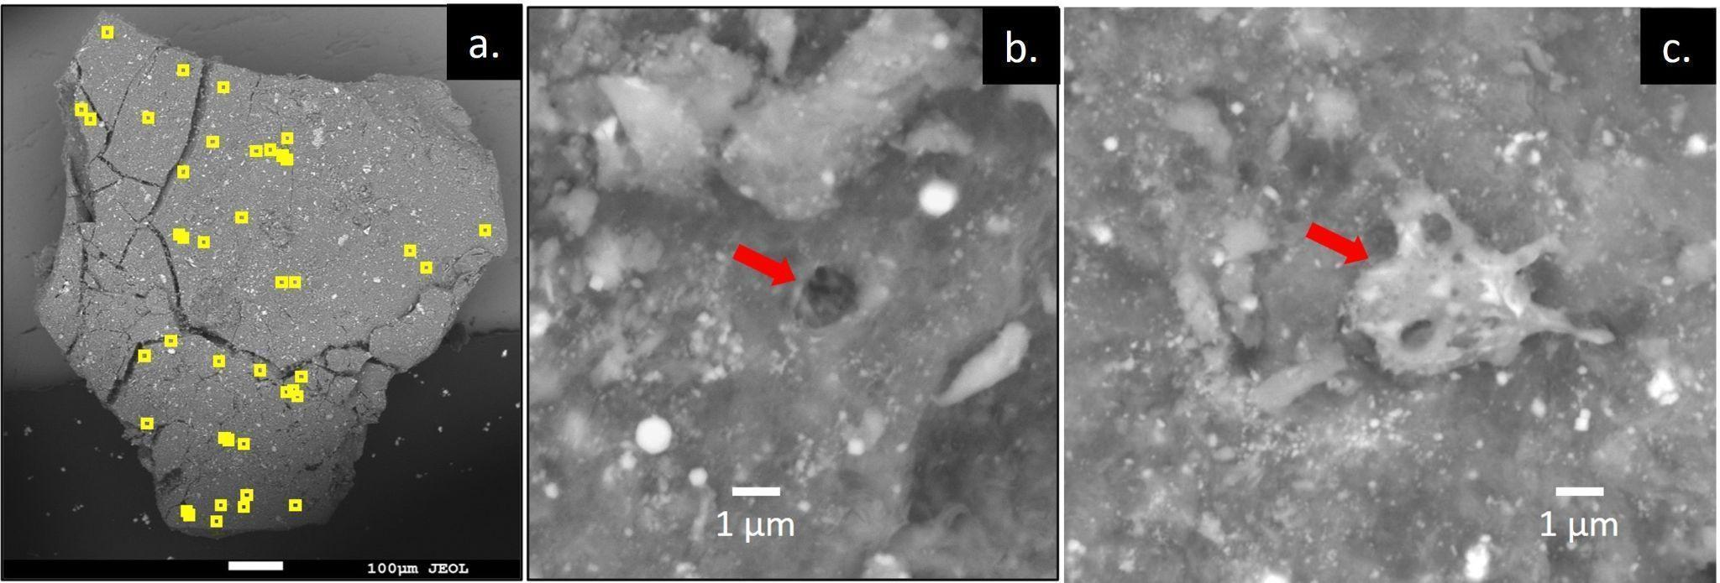
Figure 1. Space weathering effects in a contact pad particle. a, SEM image of particle OREX-452001-0 with microcraters indicated by yellow squares. Typical microcraters and melt deposits on the surface of OREX-452001-0 are indicated with red arrows in panels b and c, respectively.

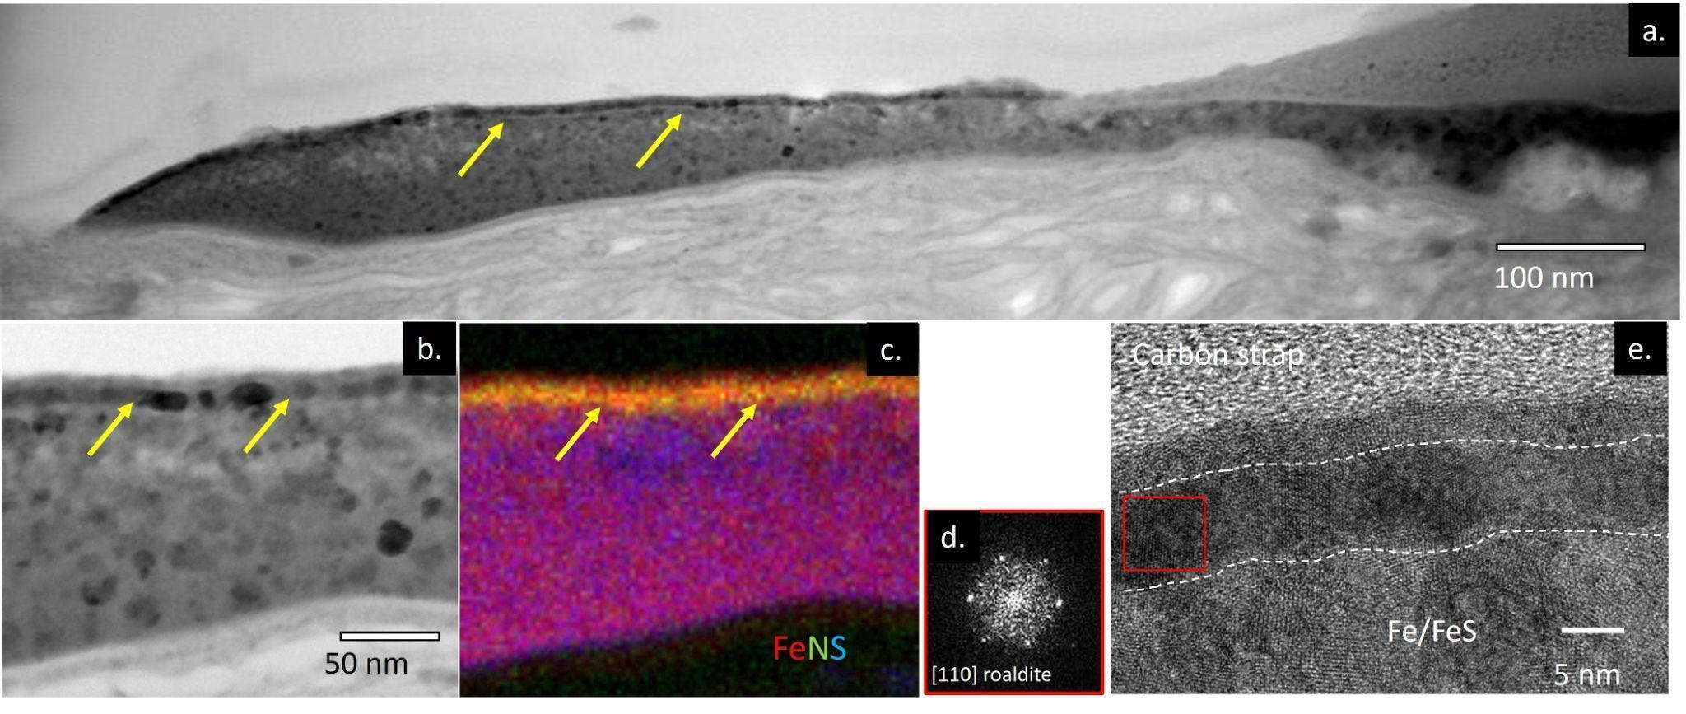
Figure 2. An iron nitride layer on the surface of a Fe-N-S melt. a, TEM image of a FIB section of particle OREX-501017-101, with the iron nitride layer indicated by yellow arrows. b, Higher-magnification image of the polycrystalline layer. c, Fe-N-S (RGB) composite chemical map of the area shown in panel b. d,e, High-resolution TEM image showing that the Fe-nitride is crystalline, with an inset (red box) fast-Fourier transform (FFT) pattern consistent with the mineral roaldite.

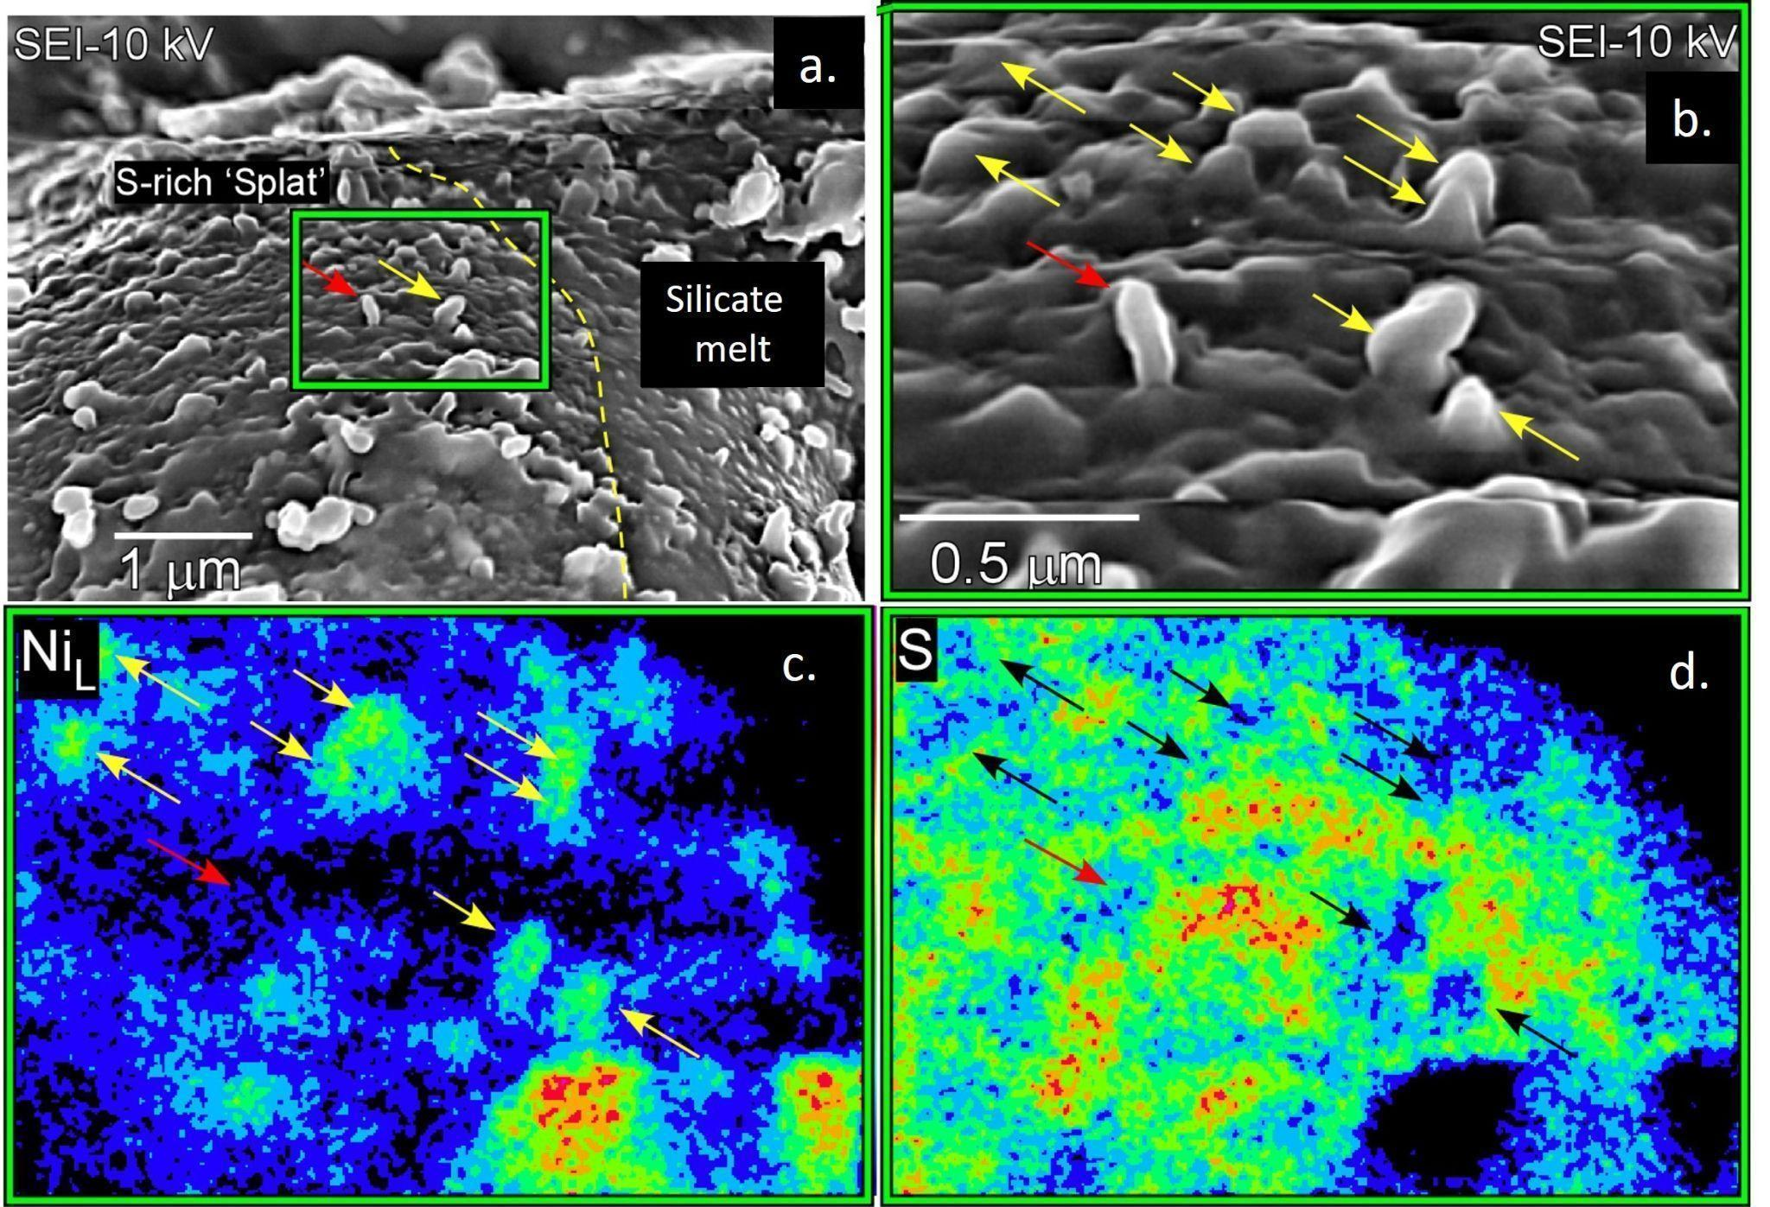
Figure 3. FeNi metal whiskers that have developed on sulfide-rich melt deposits. a, SEM image of particle OREX-803164-0 containing a sulfide-rich melt droplet (labeled “S-rich ‘splat’”). The yellow dashed line indicates the boundary between the sulfide melt and the silicate melt. The green box indicates a magnified area shown in the subsequent panels. The red and yellow arrows indicate a Ni-poor whisker and a Ni-rich whisker, respectively. b, Yellow arrows point toward Ni-rich whiskers, more of which can be seen in this magnified view, and the red arrow points toward the Ni-poor whisker. The corresponding Ni (c) and S (d) maps show that the whiskers are Ni-rich and S-depleted. Arrows pointing toward Ni-rich whiskers in panel d are colored black for clarity.

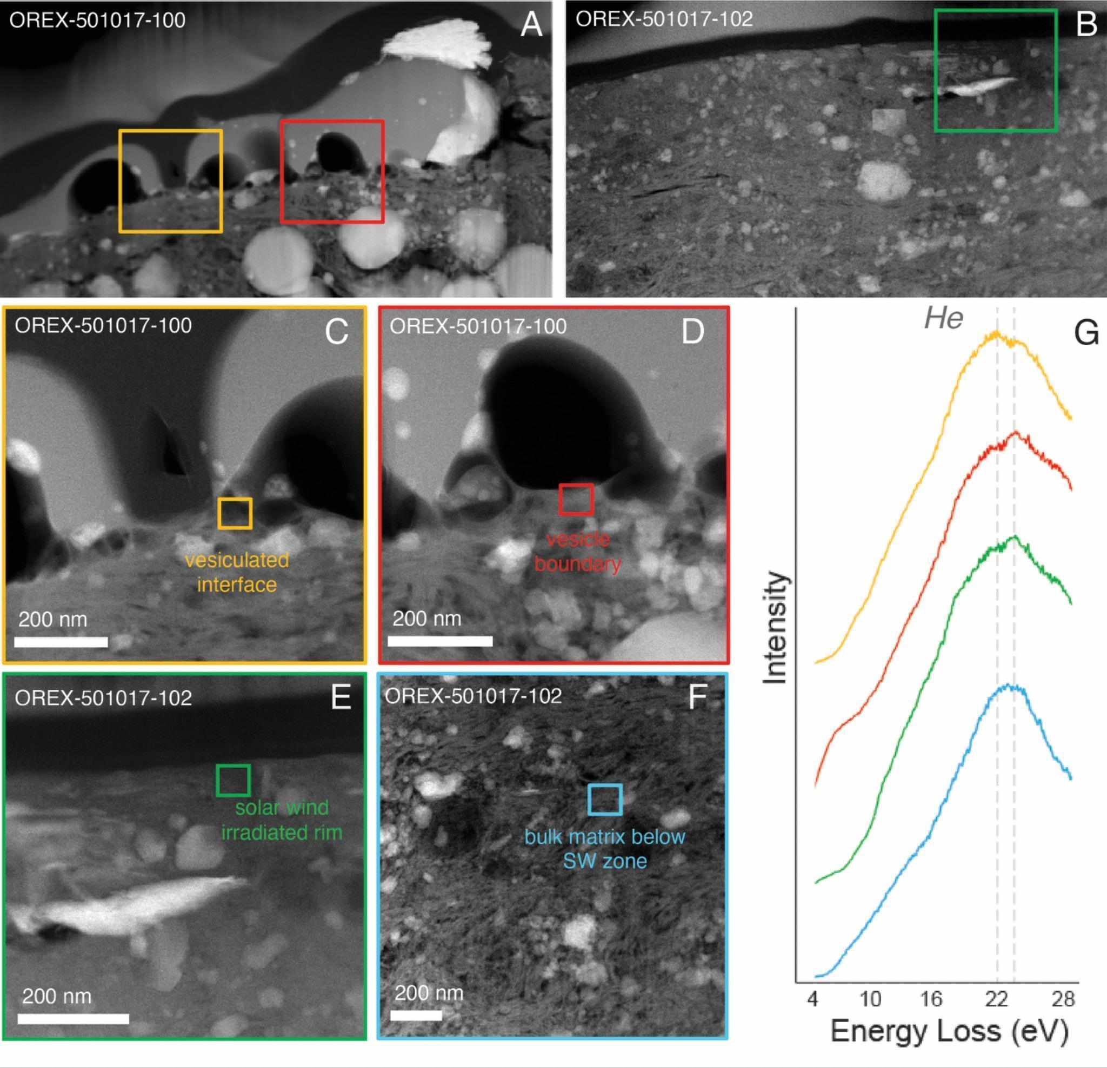
Figure 4. TEM data showing evidence for solar wind irradiation. a and b, HAADF images of the samples analyzed with EELS, with measurement locations identified by colored boxes. c and d, Interface between melt deposits and the underlying matrix in particle OREX-501017-100. e, HAADF image of the solar wind–irradiated rim in particle OREX-501017-102. f, HAADF image of the matrix, below the implantation depth for solar wind, in particle OREX-501017-102 (not shown in a and b). g, EELS spectra (arbitrarily offset in intensity only for clarity) showing the presence of He, with spectrum colors corresponding to the boxes in panels c to f. The peak positions for the He K-edge shifts to higher energies (between 22-23 eV, as indicated by the dashed grey lines) with higher concentration detected [36].

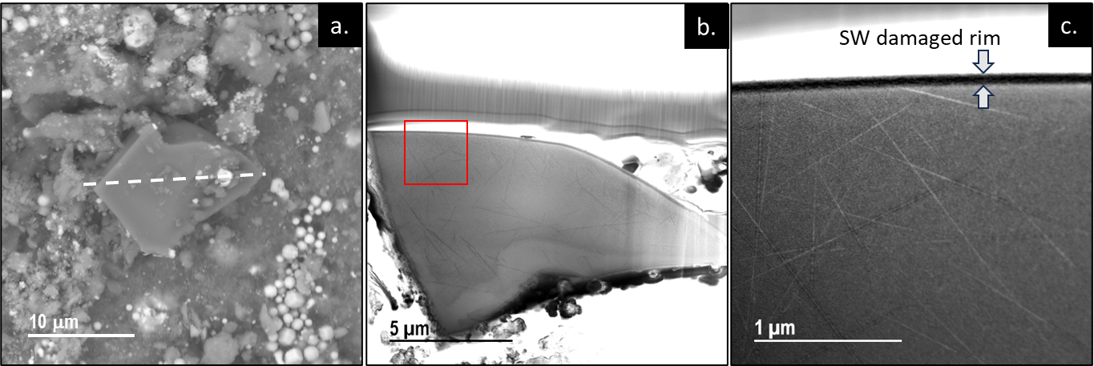
Figure 5. Track-rich forsterite grain on the surface of particle OREX-452001-0. a, SEM image with the forsterite grain in the center with a dashed line indicating the orientation of the FIB section. b, TEM image of the FIB cross section of the forsterite. c, Expanded TEM image from the red outlined area in b., showing the solar wind damage on the rim and SEP tracks (linear features) in the grain.

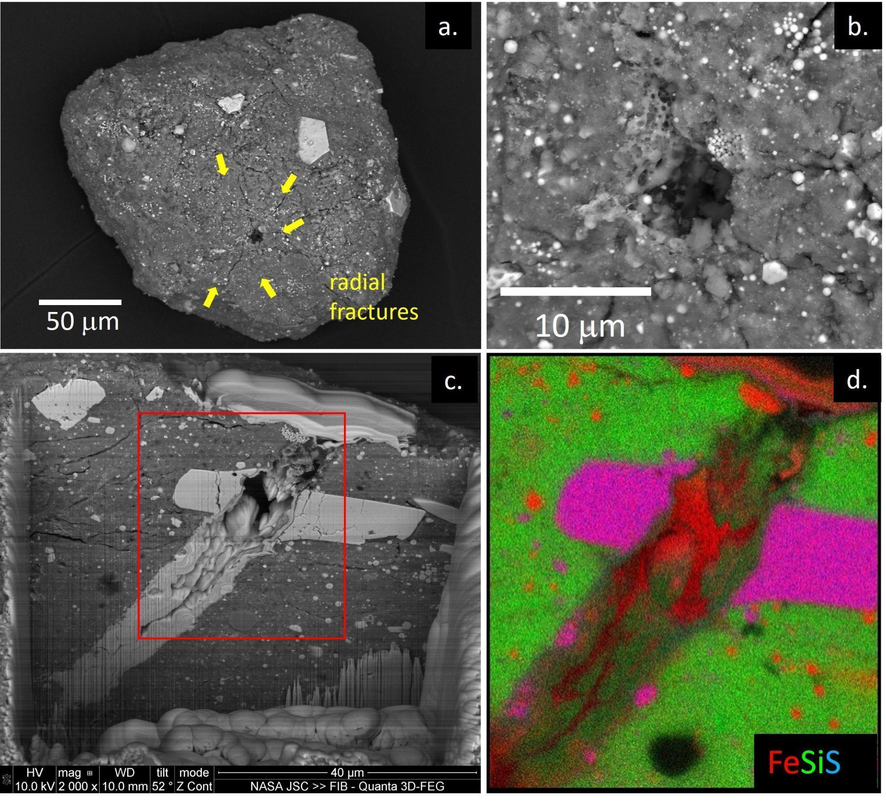
Figure 6. Micrometeoroid impact crater in particle OREX-803109-0. a, SEM image of the particle showing the crater (dark area) and the radial fractures surrounding it (yellow arrows). b, The crater entrance is lined with vesiculated melt. c, The crater as exposed in the FIB trench before extracting a section for TEM analysis. The red box indicates the area shown in panel d. d, Fe-Si-S (RGB) composite chemical map of the crater path through matrix material, including a platy pyrrhotite grain (magenta).

Extended Data Figures

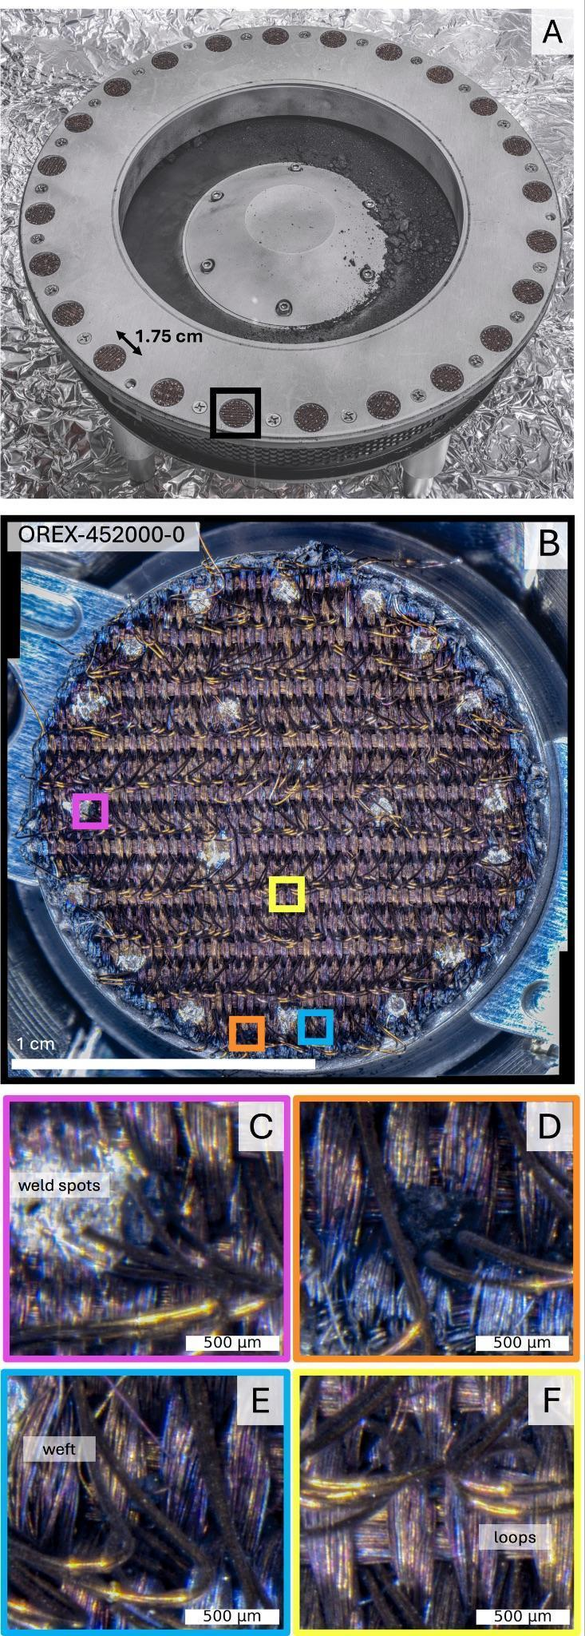
Figure ED1. TAGSAM contact pads and associated particles. a, The array of contact pads arranged around the circumference of the TAGSAM base, with some of the bulk sample that can be seen in the center. b, Contact pad OREX-452000-0 (location on the TAGSAM indicated by the black box in panel a) with larger trapped particles indicated by the pink, orange, blue, and yellow boxes with higher-magnification images in panels c-f.

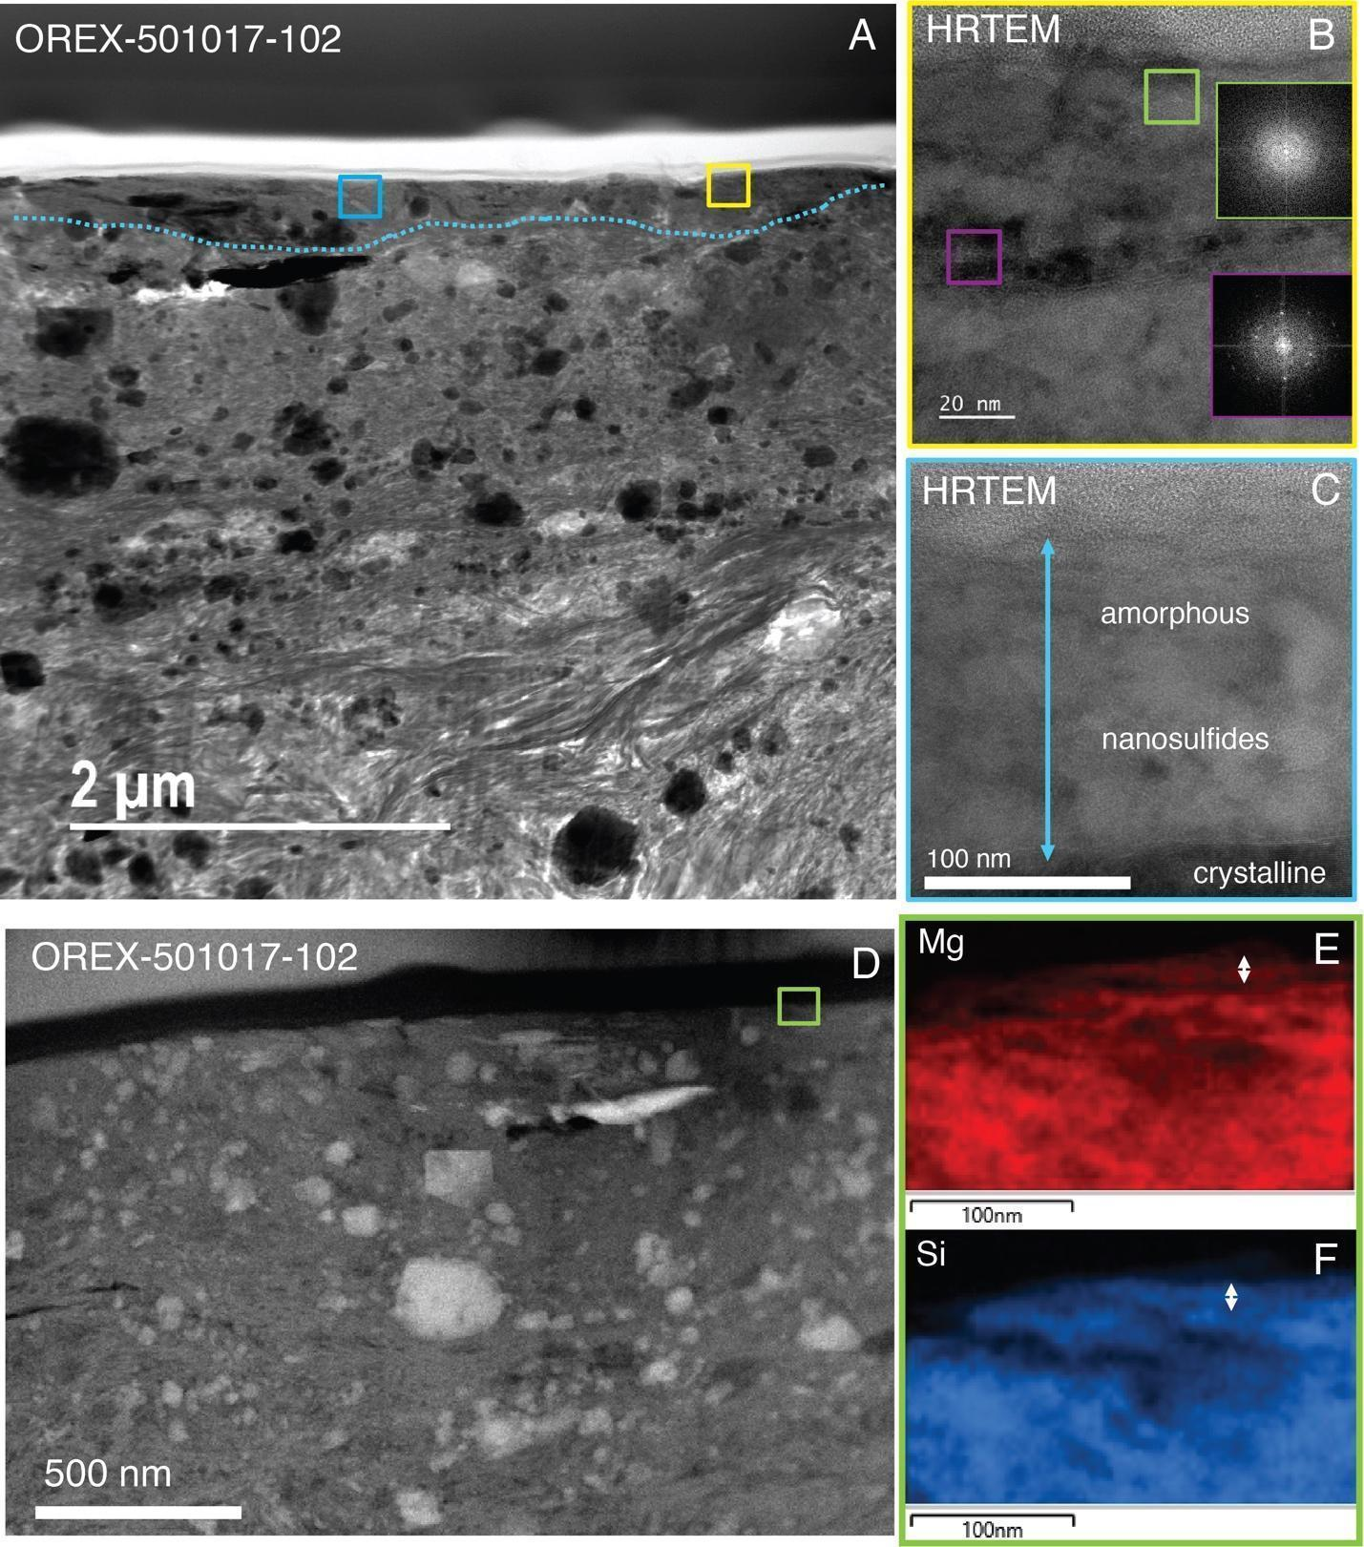

Figure ED2: TEM evidence for solar wind irradiation. a, Bright-field scanning transmission electron microscope (BF STEM) image of particle OREX-501017-102 showing a porous phyllosilicate matrix with a contact surface layer outlined by the blue dashed line. The yellow and blue boxes indicate the areas shown in panels b and c, respectively. b, High-resolution TEM (HRTEM) image showing the amorphous texture of the rim (green FFT inset) which transitions to nanocrystalline (purple FFT inset). c, HRTEM image showing an area of the rim that is completely amorphous and >100 nm thick. d, HAADF image of particle OREX-501017-102. Bright phases are sulfides and magnetite. The green box shows the location of EDS maps (insets) showing chemical segregation in the solar wind–irradiated rim, with an enrichment in (e) Mg and a depletion in (f) Si in the uppermost 10 nm of the rim, with the respective layers shown by the white arrows.

Extended Data Tables

Table ED1: Sample descriptions, analytical techniques, and outcomes.
Sample ID | Nature of Sample | Method(s) of Analysis | Findings
OREX-452000-0 | Entire contact pad | Optical Imaging | Identification of contact pad particles
OREX-452001-0 | Particle associated with contact pad OREX-452000-0 | SEM, TEM | Evidence for micrometeoroid bombardment including microcraters and melt deposits
OREX-501017-0 | Particle extracted from quick-look allocation [1] | SEM | Evidence for micrometeoroid bombardment including microcraters and melt deposits
OREX-501017-100 | FIB section extracted from melt deposit on particle OREX-501017-0 | TEM | Evidence for micrometeoroid bombardment, including nanophase particles
OREX-501017-101 | FIB section extracted from 2nd melt deposit on particle OREX-501017-0 | TEM | Evidence for micrometeoroid bombardment, including nanophase particles
OREX-501017-102 | FIB section extracted from space weathered surface on particle OREX-501017-0 | TEM | Evidence for solar wind exposure, including presence of He
OREX-501018-0 | Particles from quick-look allocation pressed into Au | SEM, TEM | SEP track analysis
OREX-800032-102 | Aggregate sample for cosmogenic measurements | Noble gas analysis | Exposure age >2 Myr
OREX-800032-103 | Aggregate sample for cosmogenic measurements | Noble gas analysis | Exposure age >2 Myr
OREX-800032-104 | Aggregate sample for cosmogenic measurements | Noble gas analysis | Exposure age >2 Myr
OREX-803047-0 | Aggregate sample | Cosmogenic radionuclide analysis | ¹⁰Be, ²⁶Al, and ³⁶Cl analysis, indicate a minimum CRE age of >3 Myr for the Bennu sample overall
OREX-803081-0 | Particle extracted from a bulk sample allocation | SEM | Evidence for micrometeoroid bombardment including microcraters and melt deposits
OREX-803109-0 | Particle extracted from a bulk sample allocation | SEM | Largest micrometeoroid impact crater
OREX-803164-0 | Particle extracted from a bulk sample allocation | SEM | Evidence for micrometeoroid bombardment including microcraters and melt deposits
OREX-803164-100 | FIB section extracted from particle OREX-803164-0 | TEM | Sulfide melt deposit

