SSC25-II-09

Hitching a Ride on History: NASA’s Space Launch System Artemis II CubeSats

Russell Lane, David Beaman, Courtney Ryals
NASA Space Launch System Program
Marshall Space Flight Center XP04, Huntsville, AL, 35812 USA; 256.544.0847
russell.lane@nasa.gov

David Hitt
Amentum Space Exploration Division
Marshall Space Flight Center XP04, Huntsville, AL, 35812 USA; 256.544.7081
david.hitt@nasa.gov

ABSTRACT
In early 2026, NASA will launch the Artemis II mission, the second flight of its Orion spacecraft and Space Launch System (SLS) rocket. Artemis II will be the first crewed flight of the systems and will see four astronauts venture around the Moon as a key step toward establishing a long-term human presence in deep space. The 10-day flight will demonstrate NASA's foundational human deep space exploration capabilities. Launching along with Orion on SLS will be four 12U CubeSats developed through partnerships with space agencies around the world that are signatories of the Artemis Accords. The CubeSats will deploy in a highly elliptical Earth orbit and will perform scientific research and technology demonstrations in space at a range of distances from Earth. This paper will provide an overview of the Artemis II mission and CubeSat payloads, as well as additional information about SLS secondary payloads.

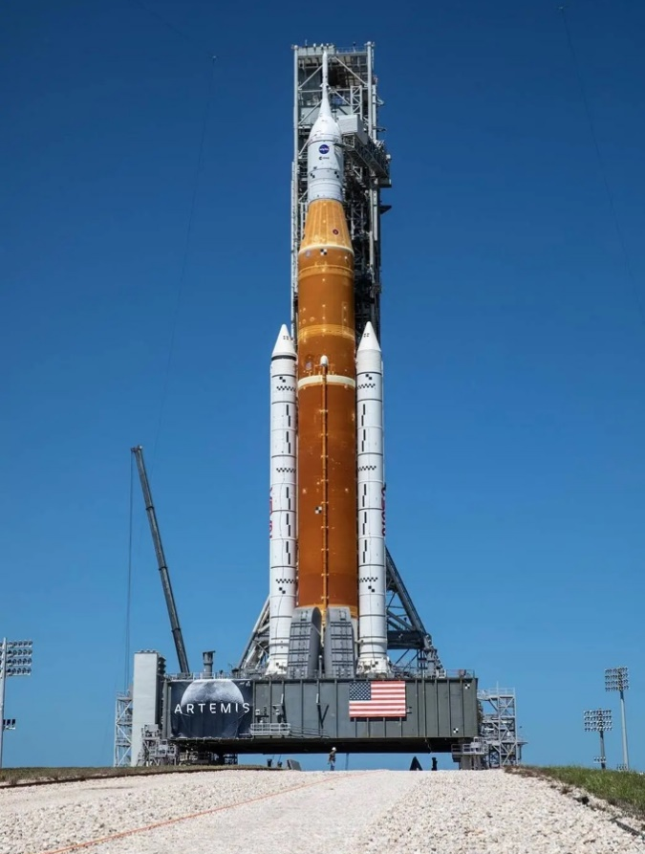
SLS OVERVIEW
SLS is a key part of NASA’s efforts to return astronauts to the Moon and establish a sustained human presence in deep space. The launch vehicle produces more maximum thrust than any previous NASA rocket – including the mighty Saturn V – and can send 27 metric tons (t) of payload to translunar injection (TLI) in its initial Block 1 crew configuration. SLS is the only rocket capable of launching that much payload to the Moon in a single launch. (Figure 1)
The rocket features a core stage powered by four RS-25 liquid hydrogen/liquid oxygen engines and two five-segment solid rocket boosters. The rocket stands 322 ft. (98 m) tall and weighs 5.74 million pounds (2.6 million kg) in the Block 1 crew configuration at liftoff. The interim cryogenic propulsion stage (ICPS), a derivative of the highly successful United Launch Alliance (ULA) Delta Cryogenic Second Stage (DCSS), is the upper stage on Block 1. A Launch Vehicle Stage Adapter (LVSA) narrows the vehicle’s diameter from 8.4 m to 5 m and partially encloses the ICPS on the Block 1 crew vehicle. Another adapter, the Orion Stage Adapter (OSA), connects SLS to the Orion spacecraft and provides accommodations for CubeSats.

Figure 1: Space Launch System
The SLS Program is managed at NASA’s Marshall Space Flight Center in Huntsville, Alabama, as part of the agency’s Moon to Mars Office.

Artemis II MISSION
On the historic Artemis II mission, the first crewed flight of SLS and Orion will send four astronauts on a free-return lunar trajectory, the first time human beings will have visited the Moon since Apollo 17 in 1972. (Figure 2) The mission will also carry four 12U CubeSats as secondary payloads.

Figure 2: The crew of Artemis II. Clockwise from left: Christina Koch, Victor Glover, Canadian Space Agency astronaut Jeremy Hansen, and Commander Reid Wiseman
In order to reduce risk for Artemis II and future missions, the ICPS will perform multiple burns after launch to place the Orion spacecraft and ICPS in a high Earth orbit with an orbital period of approximately 23.5 hours. Apogee will approach 40,000 nautical miles (74,000 km). In this high Earth orbit, the four astronauts will perform checkouts of Orion’s systems.¹
Orion will separate from the ICPS, and begin an approximately 70-minute proximity operations demonstration during which the crew will command Orion through a series of moves using the detached ICPS, simulating maneuvers that could be conducted on future missions that will see Orion dock with a human landing system to carry crew to the lunar surface.
Once the proximity operations demonstration is complete, Orion will move away from the ICPS and continue its journey toward the Moon. Orion will then perform an apogee-raise burn that will place it into an 8-day free-return trajectory around the Moon.
After Orion has moved away from the ICPS, the upper stage will begin the work of deactivating itself and entering a disposal trajectory toward the Pacific Ocean.
The SLS secondary payload system is housed within the vehicle’s Orion Stage Adapter, which will be permanently attached to the SLS upper stage and will mate it with the Orion spacecraft. The CubeSats are housed in Canistered Satellite Dispensers procured from Rocket Lab. Brackets are mounted to the wall of the OSA, which attach the dispensers to the vehicle, canted at an angle to clear the adapter aperture. (Figure 3) Between the dispensers and brackets are vibration isolation units, buffering the CubeSats from launch vibrations. In addition to the four dispensers, the secondary payload system also includes an avionics unit responsible for deployment of the CubeSats.
Before the ICPS powers down, it will send a signal to the avionics unit, starting a timer for payload deployment. The four CubeSats will be deployed at one-minute intervals, roughly six hours before the stage reaches apogee. At the time of the deployment, they will be following the disposal path of the ICPS and have roughly one day before returning to Earth. Three of the four payloads include propulsion systems designed to raise their perigee and insert into a stable elliptical orbit; the fourth will remain on the disposal path and conduct its full mission prior to reentry. Those CubeSats using propulsion systems will have approximately an 8-hour window in which to change their trajectories.
For those CubeSats that choose to insert into a stable orbit, that orbit will have an apogee roughly double the altitude of geosynchronous satellites and a perigee within low Earth orbit. This will allow them to collect data at a range of distances from Earth during their mission operations.

Artemis II Payloads
Four 12U CubeSats, developed by international partner space agencies, will fly on Artemis II. The CubeSats were selected from proposals submitted by the agencies in nations that are signatories of the Artemis Accords, based on a review of technical feasibility and compatibility with SLS accommodations and the Artemis II mission profile. The selected CubeSats are as follows.
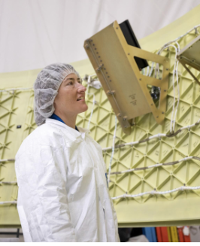
Figure 3: Artemis II astronaut Christina Koch inspects a portion of the secondary payload deployment system on the Orion Stage Adapter. Beside her is a bracket to which the secondary-payload avionics unit is mounted.

ATENEA
Argentina’s space agency, the Comisión Nacional de Actividades Espaciales (CONAE), is developing a CubeSat named ATENEA, which will collect data on radiation doses across various shielding methods, measure the radiation spectrum around Earth, collect GPS data to help optimize future mission design, and validate a long-range communications link.²

K-RadCube
The Korea AeroSpace Administration (KASA) is developing a spacecraft named K-RadCube. The South Korean CubeSat will use a dosimeter made of material designed to mimic human tissue to measure space radiation and assess biological effects at various altitudes across the Van Allen radiation belts, a critical area of research for human presence at the Moon and Mars.^{3,4} (Figure 4)

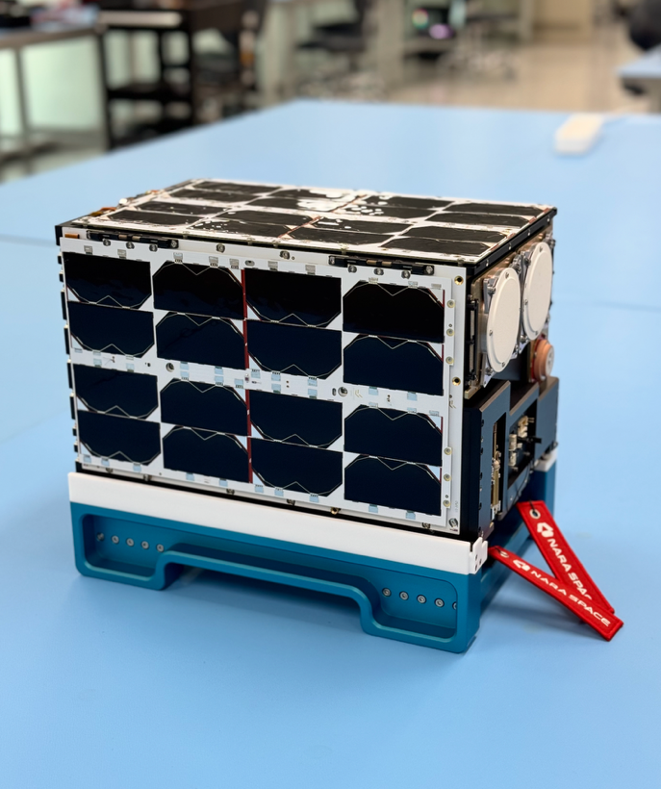Figure 4: K-RadCube during development.

Space Weather CubeSat-1
The Saudi Space Agency is developing Space Weather CubeSat-1 (SWC-1), which will measure aspects of space weather at a range of distances from Earth. As a testament to the role partnerships like the Artemis II CubeSats play in international relationships, the agreement to fly SWC-1 on Artemis II was announced by U.S. President Donald J. Trump, alongside His Royal Highness Crown Prince Mohammed bin Salman, in Riyadh as part of the former’s visit to Saudi Arabia.⁵

TACHELES
The German space agency DLR signed an agreement with NASA to launch the CubeSat TACHELES, which will collect measurements on the effects of the space environment on electrical components to inform technologies for lunar vehicles. According to DLR, TACHELES is being developed by Berlin-based company NEUROSPACE GmbH, which is building the spacecraft as a technology demonstrator for systems intended for a future lunar rover.^{6,7}

ARTEMIS I
Artemis II will mark the second time CubeSat secondary payloads fly on SLS. On November 16, 2022, NASA’s first SLS rocket successfully launched, starting the Artemis I mission and marking a significant milestone in the Artemis program of returning humans to the Moon.
Orion made a 5-day outbound trip to the Moon, flying about 80 miles above the surface at closest approach before using the Moon’s gravitational force and another engine burn to propel into a distant retrograde orbit about 40,000 miles past the Moon. This is 30,000 miles farther than Apollo travelled during Apollo 13 and the farthest in space any spacecraft built for humans has ever flown. Orion spent a total of over 25 days in space, reentering Earth’s atmosphere at Mach 32 and splashing down into the Pacific Ocean on December 11.⁸
Data from the mission showed that the SLS vehicle performed exceptionally well. The Earth orbit insertion velocity, for example, was within 0.026 percent of prelaunch predictions, and orbital insertion apogee was just 0.25 percent from the target. The upper stage burn set a duration record for RL10 engines, at 18 minutes.⁹
In addition to SLS beginning Orion’s journey toward the Moon, 10 6U CubeSats launched in the OSA. (Figure 5)
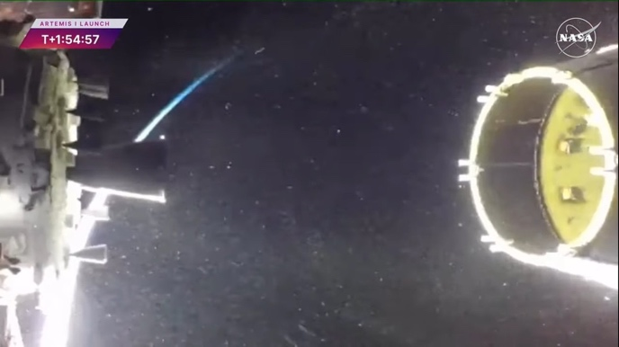
Figure 5: Secondary payloads are visible within the Orion Stage Adapter following Orion separation during the Artemis I mission.
The CubeSats – developed by NASA, large businesses, small businesses, educational institutions, and international partners – all had different mission objectives that supported NASA’s future exploration goals. These ranged from studying the lunar surface for water and minerals, landing on the Moon, studying deep space radiation and the Sun, studying Earth-Moon LaGrange Point 2, and characterizing a near-Earth asteroid, to name a few.
The payloads were integrated into their dispensers and onto the OSA before it was stacked onto the SLS, prior to Orion stacking. Between integration onto the SLS stack and launch, those payloads that met pre-defined requirements, if they so desired, had their batteries charged to ensure the charge was maintained at levels necessary for mission success. The same service will be provided for payloads on Artemis II on an as-needed basis.
For Artemis I, the SLS ICPS performed the translunar injection burn that propelled Orion toward the Moon. Orion then separated from the upper stage, and the ICPS performed a disposal burn that placed it in heliocentric orbit. Once the stage had shut itself down, deployment signals were sent to all CubeSats, between approximately four to eight hours after launch.
Because the ICPS had ended its mission and was not capable of relaying CubeSat deployment status to Earth, teams on the ground relied on receiving a signal from CubeSats for confirmation of deployment. During the mission, ground teams received signals from eight of the 10 deployed CubeSats. Of those eight CubeSats, five achieved either partial or complete mission success, a figure in keeping with mission success ratios for CubeSats in general. (Figure 6) At the time of this writing, the Artemis I CubeSat BioSentinel is still in operation, two and a half years after deployment, having traveled 2.5 billion miles since deployment.¹⁰
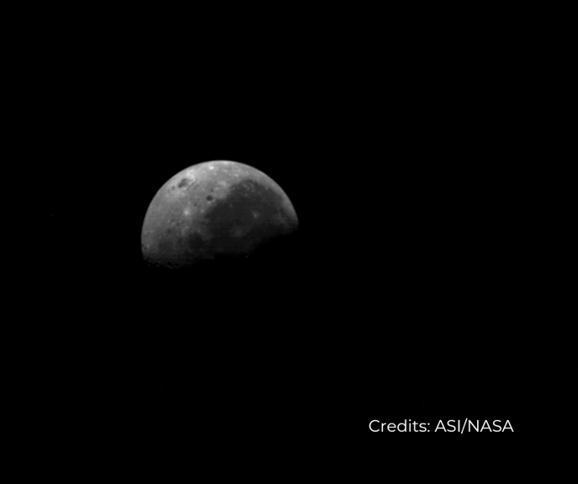
Figure 6: Image of the Moon captured by ArgoMoon, an Artemis I CubeSat developed through partnership with the Italian Space Agency.

ARTEMIS III
The third flight of SLS, Artemis III, is scheduled to return humans to the surface of the Moon, no earlier than mid-2027. The SLS flight path will be similar to the Artemis I flight path. Mission analysis is still ongoing, and at the time of this writing no SLS secondary payloads have yet been manifest. Similar to Artemis I, any secondary payloads on Artemis III would have their first opportunity for deployment once Orion departs the upper stage vicinity and the ICPS has completed its disposal operations into heliocentric orbit.

CONCLUSION
Scheduled for launch in early 2026, NASA’s Artemis II mission will make history as it launches four astronauts who will become the first human beings to fly around the Moon since Apollo, marking a major milestone in humanity’s return to deep-space and toward the establishment of a sustained presence on other worlds. Taking part in this historic mission will be four 12U CubeSats, developed by international partner space agency from signatory nations of the Artemis Accord. These spacecraft will collect data and gather knowledge that will promote greater understanding of the space environment and help inform future exploration of deep space.

References
- Kraft, R.H. “Key Test Drive of Orion on NASA’s Artemis II to Aid Future Missions,” NASA. March 2024. https://www.nasa.gov/humans-in-space/key-test-drive-of-orion-on-nasas-artemis-ii-to-aid-future-missions/
- Kraft, R.H. “NASA Signs Agreement with Argentina’s Space Agency for Artemis II CubeSat,” NASA. May 2025. https://www.nasa.gov/blogs/missions/2025/05/20/nasa-signs-agreement-with-argentinas-space-agency-for-artemis-ii-cubesat/
- Kraft, R.H. “NASA Set to Fly South Korean CubeSat on Artemis II Test Flight,” NASA. May 2025. https://www.nasa.gov/blogs/missions/2025/05/02/nasa-set-to-fly-south-korean-cubesat-on-artemis-ii-test-flight/
- Yoon, J.Y. “Artemis 2 to Carry CubeSat Testing Samsung’s Next-Gen Space Chips,” News1. May 2025. https://en.news1.kr/economy/5610577
- Kraft, R.H. “NASA to Fly Saudi Arabia CubeSat Aboard Artemis II Test Flight,” NASA. May 2025. https://www.nasa.gov/blogs/missions/2025/05/13/nasa-to-fly-saudi-arabia-cubesat-aboard-artemis-ii-test-flight/
- Kraft, R.H. “NASA to Fly International CubeSats Aboard Artemis II Test Flight,” NASA. September 2024. https://www.nasa.gov/blogs/missions/2024/09/20/nasa-to-fly-international-cubesats-aboard-artemis-ii-test-flight/
- Hecker-Twrsnick, G.; Wolf, T. and Kaczmarczyk, A. “Artemis II – small German satellite to fly to the Moon,” German Aerospace Center. September 2024. https://www.nasa.gov/blogs/missions/2024/09/20/nasa-to-fly-international-cubesats-aboard-artemis-ii-test-flight/
- NASA. “Artemis I,” NASA. March 2025. https://www.nasa.gov/reference/artemis-i-2/
- Honeycut, J.; Blevins, J.; Cobb, S. and Bryan, W. “NASA’s Space Launch System: Artemis I Results and Path Forward,” SciTech 2024. January 2024. https://ntrs.nasa.gov/api/citations/20230017105/downloads/Final%20-%20SciTech%202024%20-%20SLS%20Update.pdf
- Tabor, A. “What is Biosentinel?,” NASA. November 2024. https://www.nasa.gov/centers-and-facilities/ames/what-is-biosentinel/

