Cost-Benefit Analysis of Debris Risk Reduction Portfolios

Akhil Rao, Jericho Locke, Thomas J. Colvin

NASA

Executive Summary
Cost-Benefit Analysis of Debris Risk Reduction Portfolios

Purpose
Orbital debris is defined as all human-made, nonfunctional objects, including fragments and other elements, that are in Earth’s orbit or are reentering the atmosphere. These debris increase the costs of space operations by requiring efforts to shield against or maneuver around debris, threaten the safety of astronauts and satellites, hinder the launch of new spacecraft, and may eventually make entire orbits unusable.
A wide range of actions have been proposed to address risks from orbital debris, from mitigating their creation to removing existing objects. The effectiveness of these actions has typically been assessed in isolation. This includes previous work by the authors— referred to here as Phase 1 (Colvin, Karcz and Wusk 2023) and Phase 2 (Locke, et al. 2024)—to assess the costs and benefits of performing debris remediation, mitigation, and tracking on operationally relevant timescales. In reality, no risk-reducing action will be applied by itself, as operational norms naturally evolve, or policymakers consider parallel interventions. Ignoring interdependencies is a key gap in our objective to build a capability that can (1) complete rigorous calculations of the net present value of each action, (2) identify an economically efficient portfolio of actions to reduce risk, and (3) quantitatively analyze policies related to space sustainability.
This work assesses the effectiveness of different portfolios of risk-reducing actions, accounting for the interdependencies among actions. The analysis uses the models developed in Phase 1 and Phase 2 to analyze combinations of remediation, mitigation, and tracking actions and identify economically efficient portfolios of actions. We demonstrate that our approach of measuring risks in dollars facilitates identification of complementarities and substitution potential between actions. These, in turn, generate novel results about technology development priorities given budget and other constraints.

Key Findings
First, the interaction between different risk-reducing actions matters. In all assessments, the marginal value of adding an individual action to the portfolio does not equal the individual value of that action. For example, the benefit of implementing both active debris removal (ADR) and just in time collision avoidance (JCA) is two-thirds of the sum of their individual benefits. Making decisions solely based on individual assessments risks making investments that strongly substitute or missing complementarities between options.
Second, the most efficient set of actions as predicted by the model depended greatly on initial assumptions of the space environment. While both models identify the same portfolios as efficient—and, consequently, the budgets required are identical—the estimated NPV of the efficient space sustainability portfolio differs across models by an order of magnitude. This is likely mainly due to differences in the underlying flux submodels. Model 1 is based on NASA’s Orbital Debris Engineering Model (ORDEM), which predicts much higher small debris fluxes than ESA’s Meteoroid and Space Debris Terrestrial Environment Reference (MASTER), on which Model 2 is based. This results in Model 1 predicting greater damages if no risk is addressed and consequently greater benefits from addressing risk.
Table E-1: Efficient portfolios with no constraints on which actions are chosen.
Model 1 |  | Model 2
Ranking of portfolio actions | - Shield against 5mm debris  - Laser ranging and 2 new Space Fences  - Laser JCA  - 0-year PMD  - Passivation  - Laser removal of cm debris | Ranking of portfolio actions | - Laser ranging and 2 new Space Fences  - Laser removal of cm debris  - Laser JCA  - Shield against 5mm debris  - 0-year PMD  - Passivation
NPV | $2.97 T | NPV | $281 B
Up-front cost | $2.51 B | Up-front cost | $2.51 B
Running cost | $150 M/year | Running cost | $150 M/year

Finally, the best combination of three actions can achieve at least 95% of the value of the most efficient portfolio. In other words, a minority of actions can address the majority of the risk. Additionally, despite each action having positive individual net benefits, all assessments exhibited diminishing marginal returns to spending on more sustainability actions. This means that the most efficient portfolios excluded other potential actions. This implies that a “peanut butter spread” to investing in space sustainability capabilities may be counterproductive. For a rational actor with a fixed budget, it may be more efficient to pick a portfolio of a few capabilities and allocate greater budget share to them. This study suggests that as few as 1–3 capabilities may be sufficient, and that efficient actions with low substitution should be prioritized.

Table of Contents
Executive Summary i
Purpose i
Key Findings i
Table of Contents iii
Purpose and Scope 5
Methodology 7
Calculating the value of a portfolio 7
Landscape of actions 8
Calculating the benefits of space sustainability actions 12
Up-front costs, running costs, and time-to-value 14
Discounting and the timing of costs and benefits 17
Results 20
Net benefits of individual actions 20
Interactions from combining two actions 22
Efficient space sustainability portfolios 25
Robustness to delays 29
Summary and Conclusions 34
Potential next steps 35
Higher fidelity on up-front costs, recurring costs, and times-to-value 36
Modeling cost and schedule complementarities between actions 36
More exploration of the action space 36
Better understanding of discounting and appropriate rate structures 36
Assessment of non-financial metrics 37
Inclusion of adaptive behavior 37
Inclusion of active-active interactions 38
Inclusion of stochastic effects and different space environment scenarios 38
Inclusion of policy constraints 38
Inclusion of solar cycles 38
Appendix A: Cost Estimation Methodology 39
Mitigation actions 41
Remediation actions 43
Tracking actions 47
Appendix B: Simulation Framework 49
Constructing the set of admissible portfolios 49
Appendix C: Acronyms 51
References 52

Purpose and Scope
This report is an update the previous work to estimate the costs and benefits of actions that reduce the risks that orbital debris pose to space operators. The current analysis demonstrates how to use the risk model from (Locke, et al. 2024) to identify desirable combinations – “efficient portfolios” – of risk-reducing actions. The risk-reducing actions considered are a subset of those analyzed in (Locke, et al. 2024). The efficient portfolios identified are groups of actions which, if invested in, will provide maximal net benefit to the global community of space operators over our analysis horizon (60 years), conditional on the assumptions and limitations of this study. This analysis also provides an assessment of the budget outlays necessary to support these actions, and the prioritization of actions in the event that only a subset of an efficient portfolio can be pursued.
The simulation framework used in this analysis is the same as in (Locke, et al. 2024). We provide a brief overview here; interested readers are referred to that study for a detailed discussion of the simulation methodology. Briefly, this study simulated the evolution of space debris 1 millimeter and larger – including debris generation through shedding, accidental explosions, and collisions, as well as the effects of atmospheric drag that will deorbit debris – over a period of 60 years. We simulated this evolution using an ensemble of models, reflecting different assessments made by NASA and the European Space Agency (ESA). We combined these models with estimates of the financial consequences of interacting with debris to estimate the risks to all spacecraft operators in dollar units. Our risk modeling allowed us to simulate how investing in combinations of actions to mitigate, track, and remediate debris changes the risk to spacecraft operators. The benefit of an action or combination of actions is the risk it reduces, while the cost of an action or combination of actions is the budget outlay required to implement it.
In our previous work ( (Colvin, Karcz and Wusk 2023), (Locke, et al. 2024)) we assessed the benefits of individual actions through “cost effectiveness” metrics like the ratio of benefits to costs or by directly plotting the accumulation of net benefits (benefits minus costs) over time. For the analysis in the current report, we maintained the emphasis on dollar-denominated risk to calculate benefits and budget outlays to calculate costs but focused instead on the Net Present Value (NPV) of portfolios of actions. The NPV is calculated by summing the benefits and subtracting the costs associated with the action, with the benefits and costs weighted based on the year in which they occur. This weighting, known as “discounting”, ensures that the timing of when benefits and costs are accrued is accounted for. The weighting is done using a percentage rate, called the “discount rate”, which measures the rate at which society is willing to give up money today in exchange for benefits received in the future. The use of discounting in assessing US government investments and regulatory policy is prescribed by the Office of Management and Budget (OMB), which maintains a schedule of discount rates to use for this purpose. If the NPV of an investment exceeds 0, it generates benefits in excess of its costs – including the opportunity cost of forgoing alternate investments. We simulated the evolution of the space environment under a large number of possible portfolios of risk-reducing actions and ranked the portfolios by their NPV. The portfolios with the highest NPV were assessed as “efficient” given the relevant assumptions or constraints imposed.
This study has several limitations. Like (Colvin, Karcz and Wusk 2023) and (Locke, et al. 2024), we considered spacecraft in low-Earth orbit (LEO) only. Space sustainability in the geostationary belt (GEO) is a serious and understudied issue. Given the significant differences between the orbital dynamics of spacecraft in LEO and GEO, our model of the evolution of the space environment is not suitable for use in GEO.
A second limitation is that we continue to omit policy and implementation concerns regarding the risk-reducing actions we study. However, if policy or implementation concerns preclude pursuing an action that contributes significantly to the NPV of an attractive portfolio, our portfolio-assessment methodology will allow decision-makers to identify alternative portfolios that do not have similar concerns. Our methodology will also support assessment of the opportunity costs of those policy or implementation concerns.
A third limitation is that the costs associated with the development and operation of the mitigation, tracking, and remediation actions are rough estimates based on particular concepts of operations (CONOPS). We relied on the estimates used in the Phase 1 and Phase 2 reports to construct estimates of the budgetary outlays required to implement these actions over our period of simulation. The scope of this study did not allow for assessment of the technology readiness level or the advancement degree of difficulty of these systems. While the Phase 1 and Phase 2 reports used ranges of costs and efficacies to mitigate optimism or pessimism associated with individual actions, the effects of combining actions make the determination of whether a particular assumption is optimistic or pessimistic with respect to a particular portfolio challenging. Computational constraints limited our ability to simulate every possible combination of assumptions. We therefore rely on the most individually optimistic estimates found in the Phase 1 and 2 reports (i.e., low cost and high efficacy) to calculate the portfolio NPVs. The NPVs can then be used to assess the degree of additional cost of achieving our stated efficacies that would overturn our conclusions here, though we did not pursue this effort in this analysis. Overall, this study does not attempt to provide definitive or high-fidelity estimates of costs or benefits of particular actions, nor does it attempt to make a definitive determination of the desirability of combining specific actions. This study is a strategic analysis to identify groups of actions that may have high promise when combined.
This study updates and expands on the findings of (Locke, et al. 2024). It represents a snapshot of our progress towards the capability to (1) quantitatively analyze policies and funding decisions related to space sustainability, (2) assess interactions between active spacecraft and the effects of actions to coordinate space traffic, and (3) quantitatively analyze the effects of space sustainability actions on the incentives spacecraft operators face to pursue particular technologies, behaviors, or orbital regimes.

Methodology
For the purposes of this analysis, a portfolio is a combination of space sustainability actions. An efficient portfolio is one which maximizes the NPV of the operating in the space environment, given the analytical assumptions and any investment constraints (e.g., a requirement to use a particular technology). This notion of efficiency is related to financial portfolio management, where “efficient portfolios” are collections of securities that maximize the mean portfolio return given a certain variance in returns (Markowitz 1952).
We constructed portfolios to assess from combinations of a relatively small number of actions to reduce risk to spacecraft. Each individual action had been assessed in the Phase 1 or Phase 2 reports. We focused here on actions that had (1) shown promise in either report, or (2) might be expected to display promise when combined with other actions considered.

Calculating the value of a portfolio
We calculate the value of investing in a portfolio of space sustainability actions as the net present value of the net benefits it generates, i.e., the discounted sum of annual benefits minus total annual costs. More formally, in year , a portfolio generates benefits , incurs running costs , and annualized up-front costs . The discount rate for year is . We calculate the NPV of a portfolio as:

Figure 1 shows an example using Model 2 of how the annual benefits of a portfolio consisting of only the PMD 0-year action are calculated from the difference in encounter risks under the portfolio and under the baseline “business-as-usual” case with no actions. The top-left panel (panel A) shows the annual encounter risks in the baseline scenario with no space sustainability actions and the annual encounter costs in the scenario when the PMD 0-year action is taken. The top-right panel (panel B) shows how the benefits of the PMD 0-year action are calculated from the encounter costs: the dashed line shows the undiscounted annual benefits (the difference between the baseline and PMD 0-year lines); the solid line shows the discounted annual benefits using the discount rate schedule given in Table 4 (the kink at year 56 is due to shifting to a lower rate); and the shaded area shows the present value of annual benefits. In the NPV formula, the undiscounted benefits line corresponds to , the discounted benefits line corresponds to , and the present value of annual benefits corresponds to . The bottom-left panel (panel C) shows the annual portfolio costs associated with implementing the PMD 0-year action: the dashed line shows the undiscounted up-front costs (incurred between years 0 through 9, i.e., during the TTV period) and running costs (incurred after year 9, i.e., after the TTV period); the solid line shows the discounted up-front and running costs; and the shaded area shows the present value of annual costs. In the NPV formula, the undiscounted benefits line corresponds to , the discounted benefits line corresponds to , and the present value of annual costs corresponds to . The NPV, shown in the bottom-right panel (panel D), is the difference between the present value of annual benefits (blue shaded area) and the present value of annual costs (orange shaded area).

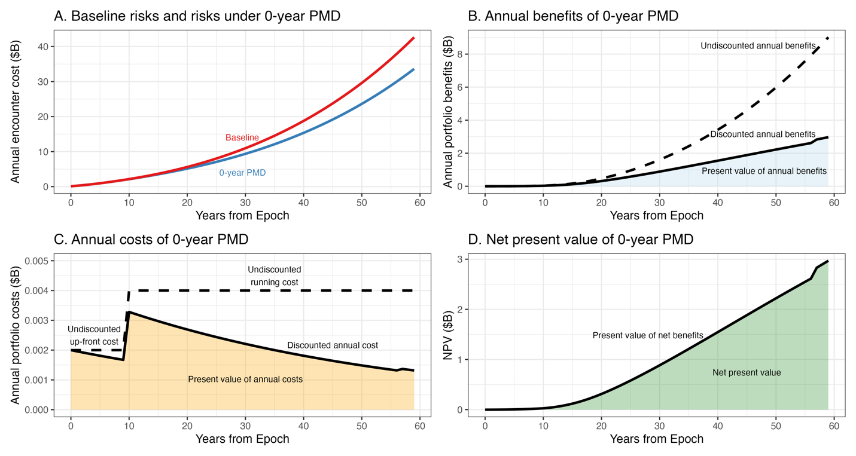
Figure 1: Examples of steps in calculating the NPV of a portfolio.

Landscape of actions
Table 1 lists the actions used to construct portfolios in this report.

Table 1: List of actions used to construct portfolios.
Action | Category | Short name | What the action does | What happens if the action isn’t done
Shielding against 0.005m debris | Mitigation | 5mm shielding | All spacecraft are given shielding against strikes from debris 5mm or smaller | All spacecraft are only shielded against strikes from debris 1mm or smaller
5-year propulsive post-mission disposal | Mitigation | 5-year PMD | 90% of spacecraft with propulsion systems (~78%) move to the highest circular orbit with a 5-year decay timeline (550 km) | 90% of spacecraft with propulsion systems move to the highest circular orbit with a 25-year decay timeline (550 km)
0-year propulsive post-mission disposal | Mitigation | 0-year PMD | Same as above but highest circular orbit with a 0-year decay timeline (300 km) | 90% of spacecraft with propulsion systems move to the highest circular orbit with a 25-year decay timeline (550 km)
Passivation of electrical and propellant | Mitigation | Passivation | Conventional satellite batteries are replaced with those more robust to thermal runaway, and pyrotechnic valves vent pressurized propellant | No changes to batteries or valves, explosion risk is not reduced
Improved tracking of large objects | Tracking | Laser ranging | A network of 5 satellite laser ranging stations to maintain total custody and reduce false positive conjunction predictions with tracked objects by 100x | No changes to current tracking uncertainties
Improved tracking of large objects and tracking cm debris | Tracking | Laser ranging and 2 new Space Fences | Same laser ranging network paired with 2 new Space Fence-like systems | Objects smaller than 10 cm are not tracked and cannot be maneuvered around
Laser nudging for just-in-time collision avoidance | Remediation | Laser JCA | A ground-based tracking and laser system “pings” large debris before predicted high-risk conjunctions with enough to alter their orbits and reduce risk to a tolerable level | The only way to avoid predicted conjunctions with large objects is for active satellites to maneuver
Uncontrolled reentry of large objects | Remediation | ADR | One servicer removes 5 large objects per year in the Phase 1 Orbit Fab CONOPS | Large objects are not removed
Dust deployment to remove mm debris | Remediation | Small debris removal (dust, mm) | One-time deployment that removes all debris with mass-to-area ratios <5 from orbits of 1100 km and lower. | Debris with mass-to-area ratios <5 are not removed from orbits of 1100 km and lower
Ground-based lasers to remove cm debris | Remediation | Small debris removal (laser, cm) | Uses same system as Laser JCA to deorbit cm-sized debris | Cm-sized debris deorbits as it normally would
We implement each action as in the Phase 2 report with minor changes, many of which are to reduce computational burden given the combinatorial nature of this study. We briefly describe the changes below:
- The Phase 2 report considered 25-year post-mission disposal with 90% success as a distinct action. In this report, we assume the 25-year rule as a baseline: that 90% of spacecraft with propulsion capability successfully use that propulsion system to safely maneuver to the highest orbit consistent with 25-year disposal at the end of their mission as part of the baseline.
  - Note that as in the Phase 2 report, we apply propulsive PMD only to spacecraft that already have propulsion systems (about 78% of spacecraft). The rest are assumed to fail in place.
- The Phase 2 report analyzed post-mission disposal actions using propulsion and drag sails. We only consider one of those actions, propulsive post-mission disposal. This is not an assessment of the merit of either approach; given time and computational resources we had to reduce the number of actions analyzed and selected a single PMD action.
  - The Phase 2 report bounded the costs of propulsive PMD assuming all spacecraft had electric propulsion (low cost) or all spacecraft had monoprop (high cost). The truth is somewhere in between. We use the low-cost estimate here.
- We only consider PMD for 0-year and 5-year rules. This is both for computational tractability and relevance: 5-year PMD is currently being assessed by the FCC and 0-year PMD is listed as the preferred option under NASA’s Orbital Debris Mitigation Standard Practices. Recall that the baseline option we compare these against is a uniform 25-year requirement.
  - As in the Phase 2 report, we assume 90% success rate for both the 0-year and 5-year PMD actions considered here.
- The Phase 2 report considered laser ranging to produce between a 10-100x reduction in false positives. We fix this at 100x to assess the upper bound of benefits the action may generate.
- The Phase 2 report considered laser ranging and radar-based tracking of centimeter-sized debris as separate options, finding that radar-based tracking of centimeter sized debris (using 2 new Space Fence-like systems) on its own did not produce positive net benefits. While there are differences in the approaches used in that study and this one, we felt it reasonable given our computational constraints to only assess laser ranging and the combination of laser ranging with radar-based tracking as distinct options, omitting separate assessment of radar-based tracking.
- The Phase 2 report simulated the full 30-year analytical horizon in a single stretch and did not account for higher-order effects occurring within that horizon. An example of a first-order effect (accounted for in the Phase 2 report) would be the encounter costs caused by fragments generated from a collision in year 2. But if those fragments from a collision in year 2 caused a collision in year 5, the encounter costs due to the fragments from that year 5 collision would be considered higher-order effects and not accounted for. This was done for computational tractability and because the probabilities decrease with higher orders. We now run the simulation in 1-year increments, which allows us to capture higher-order effects on timescales greater than 1 year (e.g., our framework would account for the costs in the example above, but would not capture encounter costs due to cascades of collisions occurring within a single year).
- The Phase 1 and Phase 2 reports assumed that all debris removal happened at once initially and then generated benefits over time. Given the focus on first-order effects, lack of discounting, and the individual comparison of actions, this was an analytically convenient assumption without any effect on the results. Such invariance does not hold in this report. We therefore make the following assumptions about the timing of debris removal:
  - The dust in the “Small debris removal (dust, mm)” action is dispersed only once over the 60-year horizon and removes all millimeter-sized debris.
  - The ground-based laser systems in the “Small debris removal (laser, cm)” action can eliminate up to 50,000 small debris pieces per year. In years with more than 50,000 such pieces, 50,000 pieces are removed uniformly.
  - Uncontrolled reentry in the “ADR (uncontrolled)” action removes up to 5 large objects per year. The objects removed are statistically similar to the McKnight Top 50 objects, implying removal of the McKnight Top 50 in 10 years from TTV. In years with more than 5 such objects, 5 pieces are removed uniformly.

Calculating the benefits of space sustainability actions
This study uses the same methodology as the Phase 2 report to assess the number and value of encounters between space objects. We provide a brief overview of the methodology here; a detailed description can be found in the Phase 2 report.
The space community currently tracks debris larger than 10 centimeters so that spacecraft operators can be warned of close approaches and maneuver to reduce the probability of a collision. Interactions with debris – strikes and close approaches that generate warnings or maneuvers – create negative financial consequences for spacecraft operators. Operators may have to pay to assess warnings; may have to pay workers to conduct the maneuver; and in the event of a mission-ending collision (MEC), must pay to replace the lost satellite. Debris smaller than 10 centimeters is currently untracked and so does not generate warnings or maneuvers but may still result in MECs if they strike vulnerable critical components. This study measured risk as the sum of the expected encounters – warnings, maneuvers, and MECs – multiplied by their respective financial consequences. The benefit of any action or combination of actions is calculated as the amount of risk it reduces.
As in the Phase 2 report, we used multiple submodels to estimate the current number of debris and the number of warnings, maneuvers, and MECs these debris cause. For computational tractability we restricted our attention to two of the submodels used in the Phase 2 report which were shown to produce substantially different conclusions. The most significant difference between the encounter models is the estimated number of debris in space and the size of those debris. The debris counts (i.e., fluxes) in Model 1 are based on NASA’s Orbital Debris Engineering Model (ORDEM) while the debris counts in Model 2 are based on the European Space Agency’s Meteoroid and Space Debris Terrestrial Environment Reference (MASTER). ORDEM predicts much higher fluxes of 1-millimeter debris than MASTER. In addition, the altitude distributions of debris under each flux model also differ. By using these two submodels, we can assess what the benefits of different actions and efficient portfolios may be from the perspective of each Agency. The models are described in Table 2. The encounter costs, encounter frequencies, and risks in the first year are identical to those used in the Phase 2 report.

Table 2: Summary of the two encounter models used in this study.
Encounter model | Description | Flux source
Model 1 | Developed by the Phase 2 study team and calculates the number of encounters using fluxes from ORDEM. | ORDEM
Model 2 | Uses the COMSPOC Volumetric Encounter Model (VEM), from which the COMSPOC Number of Encounters Assessment Tool (NEAT) is derived. | MASTER

Figure 2 shows the growth of the cumulative number of >10 cm debris included in this study under both models. While the evolutions are different, the trends are similar and consistent with those identified elsewhere, e.g., the European Space Agency’s prediction that the number of large debris (which is most similar to what Model 2 shows) will approximately double in the next 30 years. As in the Phase 2 report, we instantiate the debris environment at a state representing the 2023 environment.

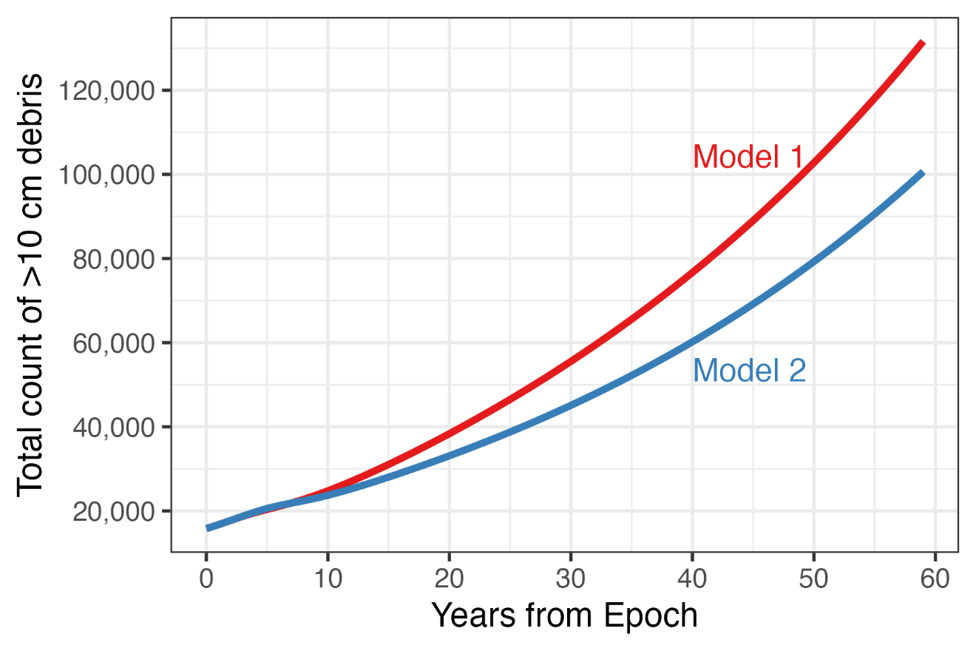
Figure 2: Evolution of counts of debris larger than 10 cm under each model with no actions taken.

Up-front costs, running costs, and time-to-value
In this report, we distinguish between the up-front costs and running costs, and in doing so also account for the time-to-value (TTV). The TTV of an action is the time taken for the action to begin delivering benefits. The up-front costs of an action are the costs incurred over the TTV, before the action begins delivering benefits. The running costs of an action are the costs incurred after the TTV, once the action has started delivering benefits.
We utilize the cost estimates from Phase 1 and Phase 2 to construct up-front and running costs in this report. The Phase 1 and Phase 2 reports used low- and high-cost estimates to assess the relative value of actions. Here, we use a single up-front cost estimate and a single running cost estimate – the low costs from the Phase 1 and 2 reports – to limit the computational burden of running many combinations. Since we use NPV – discussed in detail in the following sections – as the final metric, the robustness of any portfolio’s value to cost assumptions in any given action can be read in units of year 0 dollars directly from the portfolio’s NPV. For example, suppose portfolio A contains actions 1, 2, and 3 and has an NPV of $100 while portfolio B contains actions 1 and 3 and has an NPV of $80. It is immediately clear that action 2 can have up to $20 more in cost, measured in year 0 dollars, without affecting the rankings of portfolios A and B. The additional cost can be incurred in any year so long as the present value in year 0 is less than $20. Thus, the NPV provides an indication of how much a different CONOPS from those we have considered would have to cost in order to change its ranking.
In Phases 1 and 2, actions were assumed to begin taking effect immediately. For example, using a 60-year analysis horizon, an action assumed to require $100 in up-front costs before the action began delivering benefits and $10 in recurring unit, operations, and maintenance costs while delivering benefits would have been modeled as $100 in the first year and $10 over the full 60 years ($100 + $10/year * 60 years, so $700 total). The time taken for the action to begin delivering benefits was ignored, so even if it would have taken 10 years to build and deploy the relevant systems the benefits and costs were assumed to begin accruing immediately.
In this report we would classify the $100 as up-front costs, the $10 as running costs, and the 10 years as the time-to-value. The $100 would be incurred over the first 10 years before benefits begin to accrue, and the $10 would be incurred every year over the remaining 50 years while the benefits accrue. The sequence of cost flows would therefore be $100 in the first 10 years and $10 in every year after. The inclusion of TTV changes the total costs ($10/year * 10 years + $10/year * 50 years, so $600 total). Further, as will be discussed in the following section, the use of discounting makes the timing of costs relevant in assessing the value of each action or combination of actions. The inclusion of TTV also changes the benefits of each action compared to Phase 2 (which assumed a TTV of 0 years), as a longer TTV means a lower present value of benefits overall.
TTV for new systems is difficult to estimate, so we bound the likely benefits by calculating NPVs between a 0- and 10-year TTV. The Apollo program was initiated in 1961 with the goal of landing humans on the Moon, which it accomplished seven years later in 1969. Considering that the Apollo program was more complex than any of the space sustainability actions we have analyzed, we assume that any of them can be accomplished in 10 years of dedicated effort. So the 10-year TTV assumption gives us a reasonable upper bound. To estimate the sensitivity of the efficient portfolio’s NPV estimates to the TTV, we reduce the TTV of each action to 0 years (since “immediately” is the fastest any action could begin delivering benefits) and recalculate the value of the portfolio. This allows us to estimate the sensitivity of the efficient portfolio to decreases in TTV for any individual action, at least within the range of 0-10 years.
Table 3 summarizes the development cost, time-to-value, operational cost, and operational lifetime assumptions for all actions considered. All values are rounded up to the nearest million dollars.

Table 3: Costs and performance characteristics of actions analyzed.
Action | Category | Up-front cost  [$M] | Running cost  [$M/year] | Performance
Shielding 5mm | Mitigation | 8 | 2 | Shields against all collisions with debris 5mm and smaller
Passivation | Mitigation | 275 | 55 | Removes risk of battery or propellant-related explosions while spacecraft is on orbit
5-year PMD | Mitigation | 8 | 2 | Around 70% of spacecraft move to 550 km at end of mission
0-year PMD | Mitigation | 20 | 4 | Around 70% of spacecraft move to 300 km at end of mission
ADR | Remediation | 1395 | 45 | Removing 5 9,000kg objects per year, implies cost per kg removed as low as $81,000/kg.
Laser JCA | Remediation | 654 | 11 | All large objects
Laser cm debris removal | Remediation | 654 | 11 | Up to 50,000 debris objects >1 cm are removed annually
Dust mm debris removal | Remediation | 1618 | 0 | All debris with mass-to-area ratios <5 from orbits of 1100 km and lower
Laser ranging | Tracking | 140 | 7 | 100x reduction in false positive conjunction predictions involving tracked objects
Laser ranging and 2 new Space Fences | Tracking | 840 | 62 | All debris >1 cm is tracked and 100x reduction in false positive conjunction predictions involving tracked objects

Discounting and the timing of costs and benefits
This report accounts for the timing of the costs and benefits from different actions by discounting benefits received or costs incurred in any given year back to the first year of analysis (“year 0”). Discounting is a widely used method to account for a basic economic principle: dollars spent or received in one year are not the same as dollars spent or received in another. As with any investment, investing in space sustainability comes at the cost of not investing in something else.
The discount rate measures the rate at which society is willing to give up benefits that would be received today in exchange for benefits that are received in the future (OMB 2023). Applied in this analysis, the discount rate represents the rate at which society is willing to give up funds that could be spent on things today in exchange for investments in space sustainability that bear fruit in the future. Mechanically, if the discount rate is a constant, a dollar value of benefits or costs received in year is discounted to year 0 dollars by multiplying the dollar value by . The discounted dollar value is referred to as a “present value”.
The present value of a stream of benefits , discounted at time-varying rate , is:

An example may help clarify mechanics and interpretation. Suppose in year 0 a group of space operators invested $1M in a portfolio of space sustainability actions that unfolded over 30 years, rather than risk-free Treasury securities with a 2% rate of return. At year 30, suppose the space sustainability portfolio produced $1.81M in benefits to the space operators – for simplicity, suppose these benefits were received only in year 30, with no benefits at all in the intervening years. The space operators could have invested the $1M in the Treasury securities and earned the same $1.81M over the 30-year period. While a simple comparison of undiscounted benefits to costs would suggest the space operators earned $0.81M in net benefits, they could have earned the same return by purchasing risk-free Treasury securities and waiting. Discounting the benefits produced by the sustainability portfolio reflects this: the present value of the benefits is $ M = $1M, and the net present value of net benefits is $0. This portfolio is therefore no better a use of funds than simply investing in risk-free Treasury securities and waiting.
Figure 3 illustrates how discounting would affect benefits received in different years. The solid line shows the hypothetical growth of an undiscounted stream of benefits from an arbitrary action, the dotted line shows the growth of the same stream of benefits using a 2% discount rate, and the dashed line shows the growth of the same stream of benefits using a 1.5% discount rate.

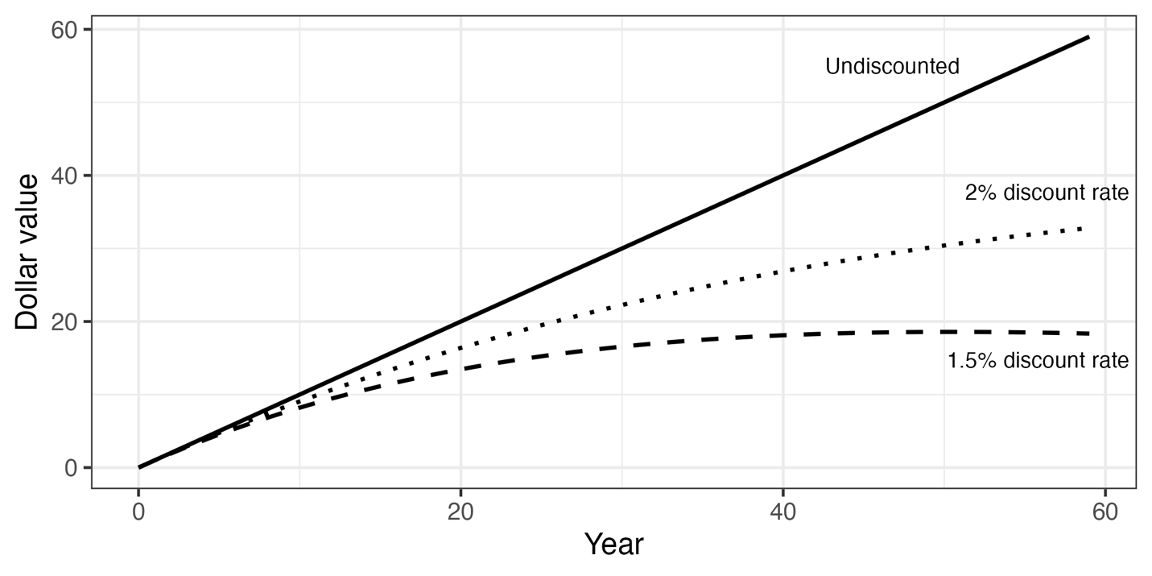
Figure 3: Examples of the effects of discounting at different rates.
The fact that space sustainability actions taken now can have very long-term effects introduces additional considerations to discounting future benefits and costs. For benefits and costs accruing over “short” time horizons (i.e., up to 30 years) OMB recommends discounting using the interest rates on 30-year Treasury bonds. These rates reflect the willingness of the US government and its counterparties (i.e., the buyers of the bonds) to trade funds available today for funds available in the future. But for extremely long periods of time, e.g., several decades or centuries, there are no markets from which to infer these intertemporal preferences. To address this issue, OMB provides a discount rate schedule for use in long-term analysis. The use of the OMB discount rates (shown in Table 4 below) therefore approximates the rate at which the US government is willing to give up funds available today in exchange for the benefits from space sustainability investments over long time horizons. See OMB Circular No. A-4 for more details.

Table 4: Discounting schedule used in this study.
Years | Discount rate ()
2023-2079 | 2%
2080-2094 | 1.9%

Results
Space sustainability actions are not typically analyzed in NPV terms, nor are they typically combined, nor are their effects typically analyzed in an ensemble of models. We therefore build the reader’s intuition about the NPV effects of combining actions by first presenting the NPVs of individual actions under each model, then presenting the pairwise interactions between individual actions under each model. With these elements in hand, we analyze the efficient space sustainability portfolios under each model and assess the effects of reducing the TTV on the actions in the efficient portfolio.

Net benefits of individual actions
Figure 4 shows the NPV of net benefits from individual actions under Models 1 and 2. In general, the ranking of NPVs matches the ranking of actions identified in the Phase 2 report. Note that the estimated NPV magnitudes are accumulated over the entire 60-year analysis horizon. To put the estimated magnitudes in terms of annual flows, one can divide the values by 60 to approximate the equivalent annual flow of benefits implied by these NPVs. Thus, shielding against 5mm debris under Model 1 is expected to generate around $38B/year in net benefits due to reduced risk from interacting with small debris (i.e., 5mm or smaller). Similarly, 0-year PMD under Model 2 is expected to generate around $1B/year in net benefits due to reduced risk from interacting with large debris. Since ORDEM predicts a much higher level of small debris flux and shedding than MASTER, the benefits of all actions are higher under Model 1 than under Model 2 – simply put, having more encounters with small debris means there are greater benefits to taking actions that reduce small debris shedding directly or indirectly. The implication of this difference is roughly an order of magnitude in the estimated benefits. For context, the Satellite Industry Association estimated that the global commercial satellite industry generated revenues of around $400B in 2023 (Satellite Industry Association 2024).

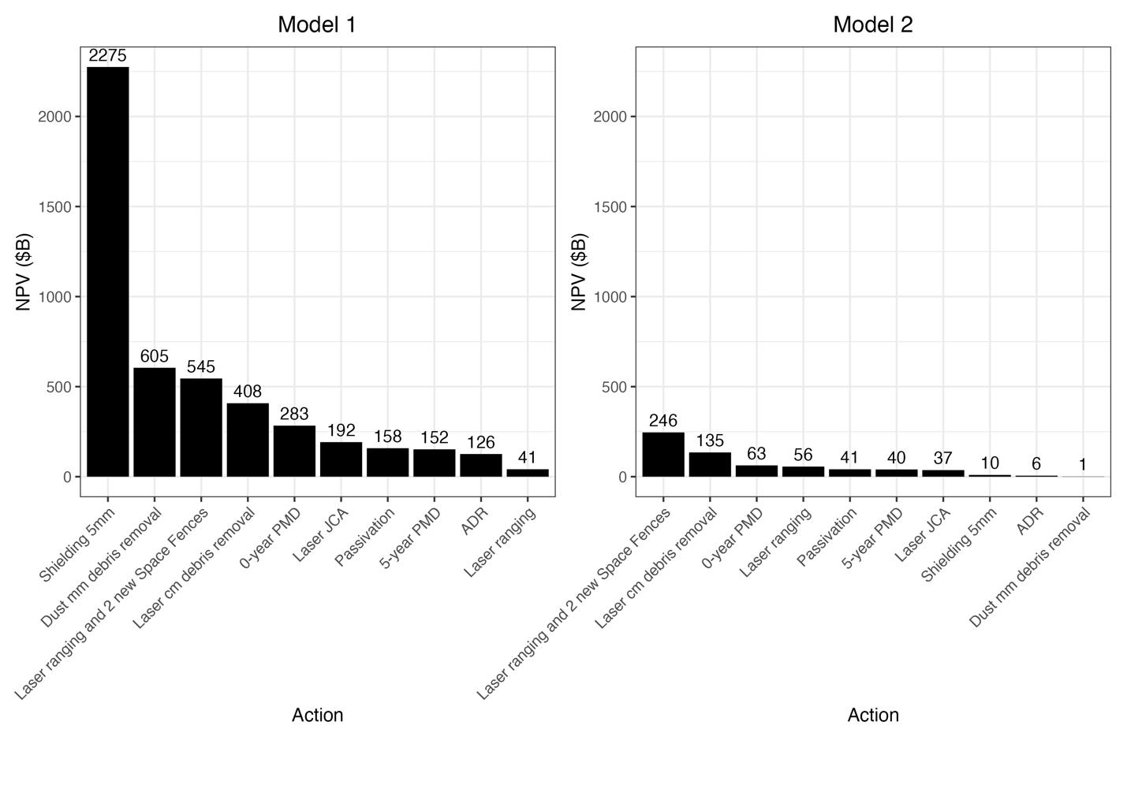
Figure 4: NPV of actions under each model when applied individually.
The difference in small debris flux environments between models also implies very different ranks for actions that address millimeter-sized debris. Under Model 1, shielding against 5mm debris and the one-off use of dust to clear millimeter-sized debris from the space environment are the two most valuable single actions analyzed. Under Model 2, both actions are among the least valuable single actions analyzed. This makes sense, since both actions directly address risk from the small debris flux, and the models disagree over both the quantity of small debris flux and the rate at which it is produced through shedding.
These differences aside, the models agree on several other points. The top three actions that do not directly address millimeter-sized debris (i.e., ranks 3-6 under Model 1 and 1-3 under Model 2) are the same – a suite of tracking (reducing first-order risk from large objects), small debris removal (reducing first-order and higher-order risk from currently-untracked objects), and immediate post-mission disposal (reducing first-order and higher-order risk from large objects). Laser JCA, identified as a highly valuable action in the Phase 1 and 2 reports (based on a cost-benefit ratio), is not among the top 5 most valuable single actions under either model here (based on NPV). As in the Phase 1 and 2 reports, uncontrolled large debris removal is one of the lowest-ranked actions.
The Phase 2 report identified significant benefits from rapid deorbiting of large objects at the end of their missions. We reaffirm this finding, though given our focus on NPV rather than a benefit-cost ratio we find that 0-year PMD strictly dominates 5-year PMD under both models (both at roughly 70% overall adoption, since only 78% of spacecraft are assumed to comply and only 90% of attempted disposals are assumed to succeed). Since 25-year PMD is incorporated in the baseline, the NPVs of all actions are incremental to doing 25-year PMD.

Interactions from combining two actions
One of the major differences between considering actions in isolation and actions as part of a portfolio is the ability to identify the interactions between different actions. For instance, investing in both shielding against millimeter debris and using dust to remove millimeter debris would seem to be counterproductive. If you’ve removed the source of the risk, why protect against it? Conversely, if you’re protected against the risk, why spend scarce dollars on removing it? Such interactions are a critical aspect in assessing portfolios of actions.
Qualitatively, there are two types of interactions to consider in assembling a space sustainability portfolio. Substitution occurs when two or more actions address the same sources of risk such that their combined effect is less than the sum of their individual parts. For example, grabbing and removing large debris and nudging large debris away from collisions might be expected to be substitutes. Complementarity occurs when two or more actions address different sources of risk such that their combined effect is greater than the sum of their parts. For example, nudging large debris away from collisions and removing cm size debris might be expected to be complements. The nature and magnitude of interactions between actions will depend on their characteristics as well as the details of the encounter model.
Figure 5 below illustrates examples with different degrees of substitution under Model 1. Three actions are used: 5-year PMD, ADR, and Laser JCA. Since 5-year PMD and ADR address different sources of risk – the former targets now and future active spacecraft at the end of their missions, the latter targets legacy derelict spacecraft – one might expect them to have largely independent effects. This intuition is supported in the analysis, as the NPV of the portfolio containing only those actions is virtually identical to the sum of the NPVs of the actions individually. On the other hand, one might expect Laser JCA and ADR to have some interactions, since both address risk from overlapping populations of derelict spacecraft. This intuition is also supported in the analysis, as the NPV of the portfolio containing only those actions is less than the sum of the NPVs of the actions individually.

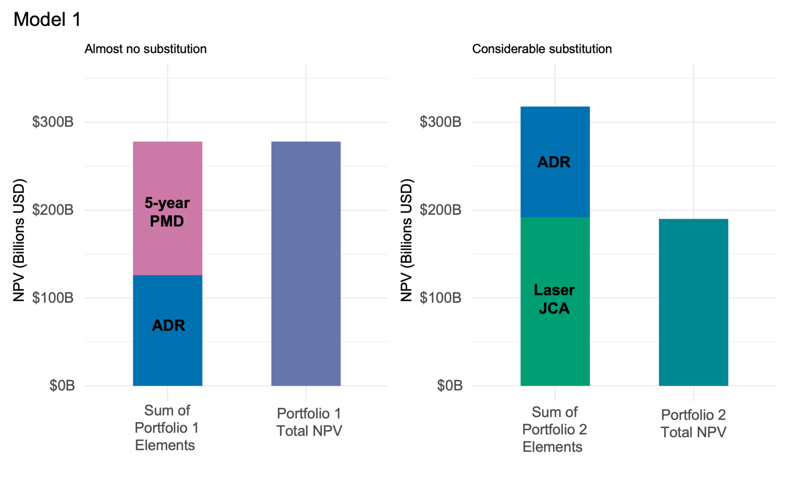
Figure 5: Examples of different degrees of substitution between actions that may be combined in a portfolio.
Figure 6 displays pairwise interactions between all actions in a heatmap. The strength of the interactions is expressed as the ratio of the value of the portfolio to the sum of the values of each action separately. For example, a value of 100% (e.g., between Small debris removal (laser) and Laser ranging under both models) means the NPV of the portfolio containing those two actions is equal to 100% of the sum of their NPVs individually – these actions are independent. A value of 67% (e.g., between Small debris removal (laser) and Laser ranging and 2 new Space Fences under Model 2) means the NPV of the portfolio containing those two actions is equal to 67% of the sum of their NPVs individually – these actions are substitutes. A value of 111% (e.g., between Small debris removal (dust) and PMD 0-year under Model 1) means the NPV of the portfolio containing those two actions is equal to 111% of the sum of their NPVs individually – those actions are complements.
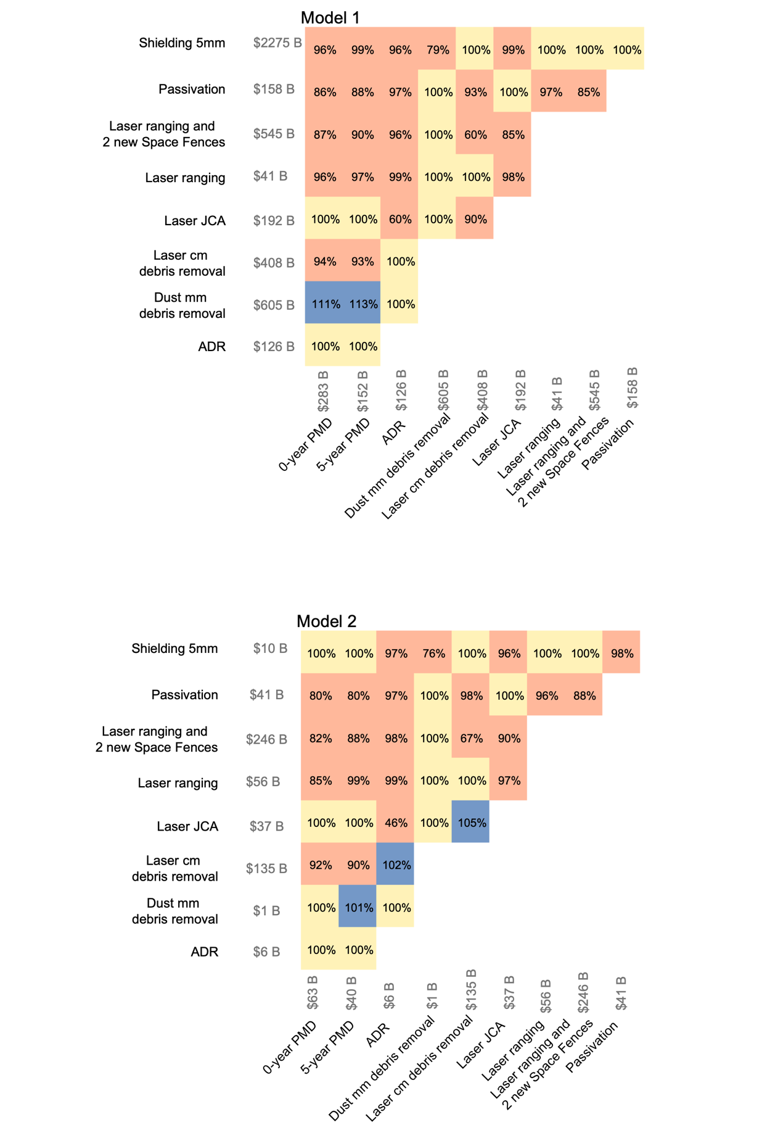
Figure 6: Pairwise interactions between all combinations of actions analyzed. Blue indicates complementarity, orange indicates substitution, yellow indicates independence (no interaction).

Efficient space sustainability portfolios
Having analyzed individual actions and the set of pairwise interactions between actions, we now move on to analysis of portfolios of sustainability actions. We use our simulation framework to identify a large set of portfolios and calculate the portfolio with the largest NPV among that set under each model. These are the “efficient” portfolios for those models. Since we do not impose any constraints on specific actions they must contain, we refer to these as the “unconstrained” efficient portfolios. Recall that in our baseline case, presented here, we hold all TTVs at 10 years. Table 5 lists the unconstrained efficient portfolios along with the recommended priority of each action. The ranking is a prioritization, not a temporal sequencing: it does not say the rank 2 action should be pursued only after the rank 1 action. Instead, it says if you had to pick only 1 action to do it should be the rank 1 action; if you had to pick only 3 actions to do, it should be the actions ranked 1, 2, and 3. We round all values up to the nearest 10 million dollars.
While both models identify the same portfolios as efficient – and, consequently, the budgets required are identical – the estimated NPV of the efficient space sustainability portfolio differs across models by an order of magnitude. This is likely mainly due to differences in the underlying flux submodels. Model 1 is based on ORDEM, which predicts much higher small debris fluxes than MASTER, which Model 2 is based on. This results in Model 1 predicting greater damages if no risk is addressed and consequently greater benefits from addressing risk.
The efficient portfolios do not simply include the highest-NPV single actions, and do not even rank those actions by their NPVs when conducted in isolation. For example, under both models substitution effects are identified between “Dust mm debris removal” and “Shielding 5mm” and only the latter is included in the efficient portfolios. Under Model 1, “Laser cm debris removal” is ranked 4 in terms of individual NPV (ahead of “Laser JCA”) but ranked 6 in terms of its contribution to the portfolio’s NPV (behind “Laser JCA”). Similarly, under Model 2 “Laser JCA” is ranked behind “Passivation” in terms of its individual benefits, but ahead of “Passivation” in terms of its contribution to the portfolio’s NPV.
That the efficient portfolios do not contain all potential actions combined with the general prevalence of substitution effects in Figure 6 suggests that there are diminishing marginal returns to adding actions (at least, presuming actions are being chosen efficiently). To investigate how overall portfolio NPV scales with the number of actions, we plot the share of maximum NPV achieved by the best portfolio with a fixed number of actions in Figure 7. The plot confirms the presence of diminishing and eventually negative marginal returns to adding actions.

Table 5: Efficient portfolios with no constraints on which actions are chosen.
Model 1 |  | Model 2
Ranking of portfolio actions | - Shield against 5mm debris  - Laser ranging and 2 new Space Fences  - Laser JCA  - 0-year PMD  - Passivation  - Laser removal of cm debris | Ranking of portfolio actions | - Laser ranging and 2 new Space Fences  - Laser removal of cm debris  - Laser JCA  - Shield against 5mm debris  - 0-year PMD  - Passivation
NPV | $2.97 T | NPV | $281 B
Up-front cost | $2.51 B | Up-front cost | $2.51 B
Running cost | $150 M/year | Running cost | $150 M/year

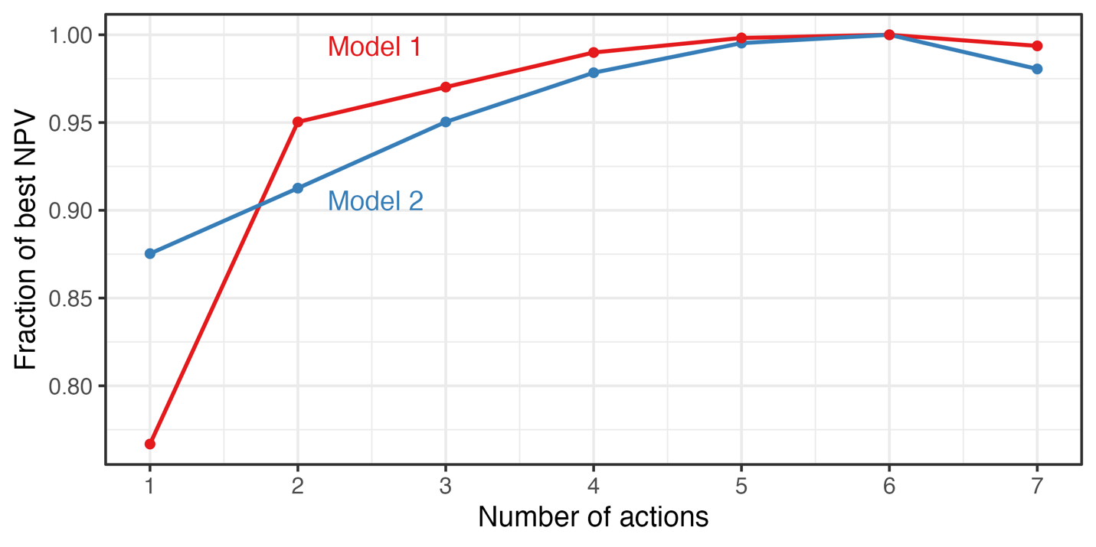
Figure 7: Scaling of overall portfolio NPV as actions are added in unconstrained efficient rank orders (shown in Table 5). The red line shows scaling under Model 1, the blue line shows scaling under Model 2. Portfolio NPVs are expressed as fractions of the NPV of the efficient portfolios for the given model.
Next, we assess efficient portfolios under constraints to include particular actions. While this could in principle be done with any actions, we focus on ADR. Since it was not selected in the unconstrained efficient portfolios, it provides insight into the best outcomes that can be achieved while deviating from the unconstrained optimum.
When constraining the portfolio to include ADR, both models support a strategy of choosing a larger set of actions than when unconstrained. On the one hand, this can result in NPV nearly identical to the unconstrained maximum. This suggests that constraining the solution to include a particular set of technologies need not result in very poor outcomes. On the other hand, this net benefit comes at substantially higher up-front and running costs. The implication – supported by Figure 8 – is that the ADR CONOPS considered adds low value. Indeed, while the Laser JCA CONOPS considered is among the lowest priority actions in this portfolio, the fact that it is included at all indicates that it provides value in addressing risk from large objects – indicating that ADR at the scale considered here does not sufficiently address risk from large objects. Note that the inclusion of Laser JCA in this portfolio is a statement about the assumed efficacy of the ADR action, not the assumed costs associated with the ADR CONOPS considered. Were ADR to remove more than 5 large objects per year – roughly 45,000 kg removed per year – the models may not find it efficient to include Laser JCA in this portfolio.

Table 6: Efficient portfolios with the constraint that ADR must be included.
Model 1 |  | Model 2
Ranking of portfolio actions | ADR  - Shield against 5mm debris  - Laser ranging and 2 new Space Fences  - 0-year PMD  - Laser removal of cm debris  - Passivation  - Laser JCA | Ranking of portfolio actions | ADR  - Laser ranging and 2 new Space Fences  - Laser removal of cm debris  - Shield against 5mm debris  - 0-year PMD  - Laser JCA  - Passivation
NPV | $2.95 T | NPV | $276 B
Up-front cost | $3.85 B | Up-front cost | $3.85 B
Running cost | $190 M/year | Running cost | $190 M/year
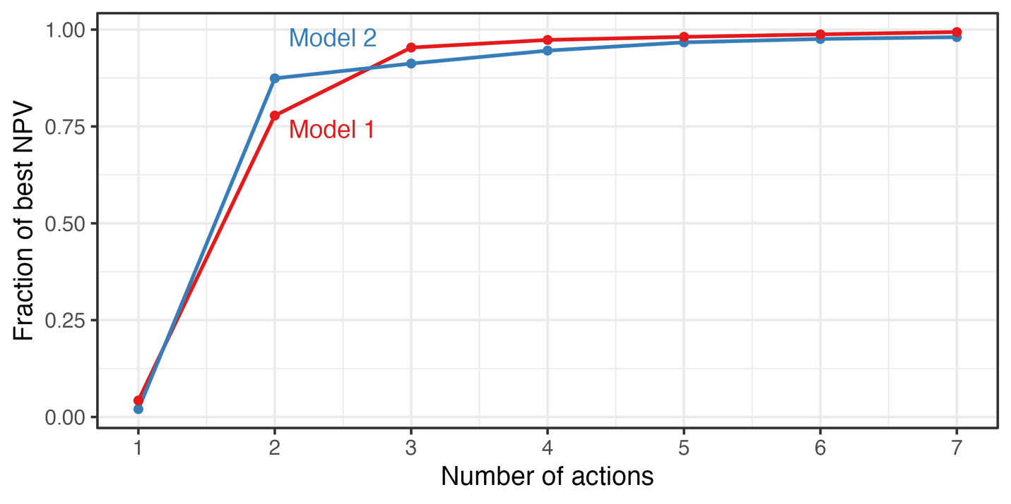
Figure 8: Scaling of overall portfolio NPV as actions are added in constrained efficient rank orders (shown in Table 6). The red line shows scaling under Model 1, the blue line shows scaling under Model 2. Portfolio NPVs are expressed as fractions of the NPV of the constrained efficient portfolios.

Robustness to delays
As mentioned, we assess the baseline results presented above assuming 10-year time-to-value for all actions. This is likely uniformly conservative, though may be more so for some actions than others. We therefore assess the sensitivity of our conclusions to this assumption by individually varying the time-to-value for each action from 10 to 0 years (i.e., immediate implementation) and measuring the average change in portfolio NPV due to a 1-year reduction in the time-to-value of an individual action.
Reducing the time-to-value affects the value of a portfolio through two channels:
- The benefits begin accruing sooner. This is perhaps the most intuitive effect and will in general result in greater estimated benefits since the risks are reduced sooner. It may however result in lower estimated benefits, if the baseline case has lower risk. That is, since the measurement of benefits is relative to a world where no actions are taken, the benefits of implementing an action will depend on how much risk is reduced.
- The costs are compressed. The up-front costs are incurred over a shorter period, and the running costs begin accruing sooner. Without discounting the former would not matter and the latter would only result in a few extra years of running costs (i.e., over a 25-year analysis period beginning operations 5 years sooner would mean 5 extra years of running costs). With discounting, however, the present value of the up-front costs mechanically increases since they are spread over fewer years. The same effect mechanically increases the present value of the running costs. The net effect is that accelerating the time-to-value will tend to increase the present value of up-front and running costs. This can be seen in Figure 9 below: extending the TTV reduces the area under the curve of the discounted costs.

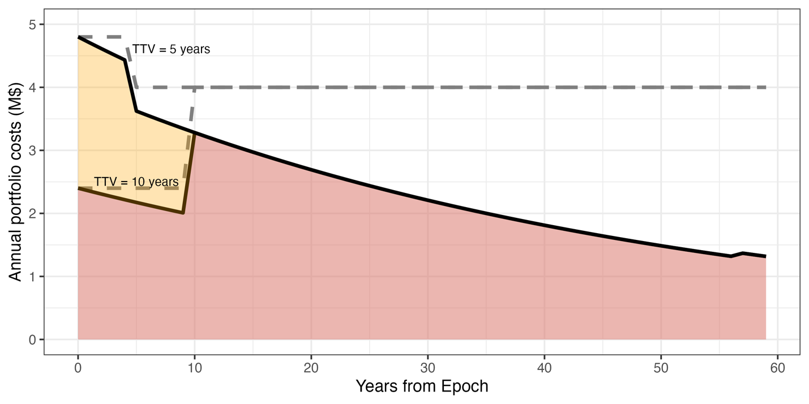
Figure 9: “Cost compression” effects of changing TTV from 10 to 5 years, with and without discounting. The shaded orange area shows the additional present value of cost incurred with a shorter TTV assuming the analysis horizon is fixed at a finite value.
Whether the net effect of reducing the time-to-value is to increase or decrease the NPV of any given action will depend on the nature of the benefits it provides (e.g., whether it addresses risks that are prevalent now or are likely to be prevalent in a few years along a business-as-usual path), the magnitude of the benefits, and the magnitudes of costs involved (e.g., the degree to which it requires up-front investment that would be more convenient to budget for over an extended duration). We therefore calculate the effect of reducing TTV for each action in the efficient portfolio from 10 years to 0 years, and from that effect calculate the average change in overall portfolio NPV and the PV of benefits from a 1-year reduction in TTV. The change in overall portfolio NPV is informative about the combination of both channels described above, while the change in the PV of benefits the portfolio delivers isolates the first channel.
Figure 10 shows the effect of reducing TTV by 1 year, rounded to the nearest $100 M, on the NPV of the unconstrained efficient portfolio. Interestingly, while the largest effects are indeed in the top-ranked actions, in general the ranking of sensitivities to TTV reductions doesn’t match the ranking of actions (either in the unconstrained efficient portfolios or even individually). Model 2 generally predicts lower benefits than Model 1, so it is perhaps not surprising that Model 2 shows some actions having negative NPV changes from a marginal year TTV reduction. Note that the estimated effects are averaged over a 10-year TTV reduction – it is possible that the effects only become negative at some threshold TTV reduction where the gain in terms of PV benefits matches the loss in terms of compressed PV costs.
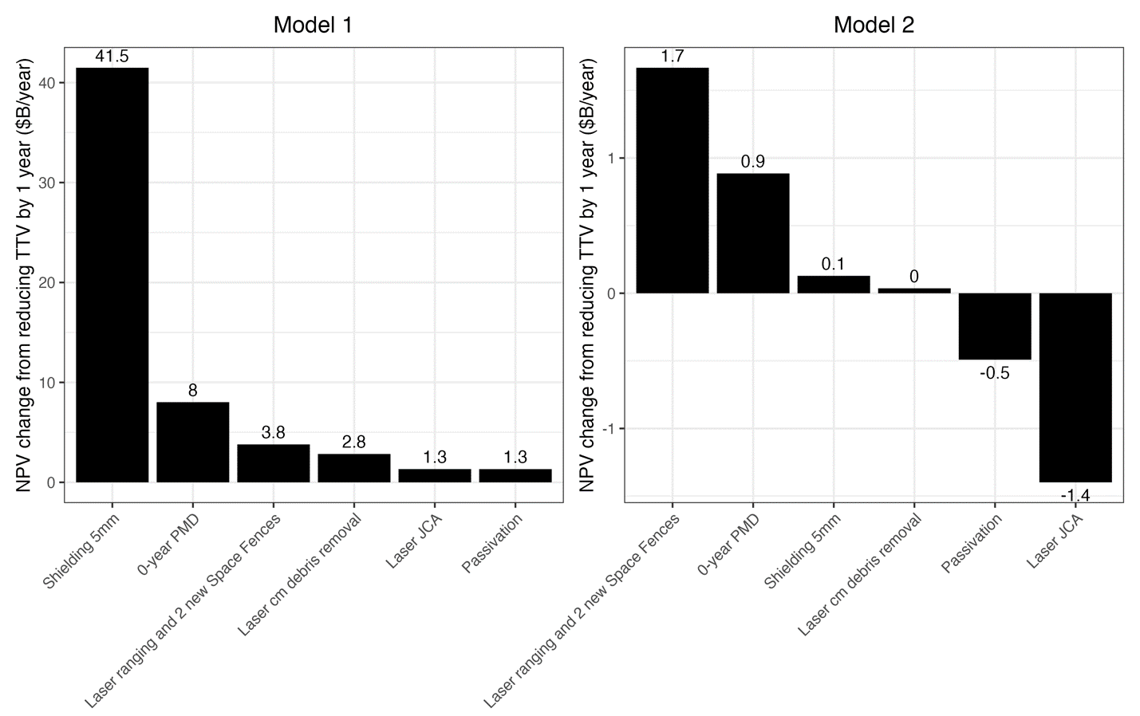
Figure 10: Change in NPV of the unconstrained efficient portfolio (calculated under 10-year TTV) from reducing the TTV of individual actions by 1 year.
Figure 11 plots the sensitivity of the PV benefits to marginal year TTV reductions to assess this. As might be intuitively expected, all of these changes are positive. However, aside from the top-ranked options, the ranking of PV benefits sensitivities differs from the ranking of NPV sensitivities. This makes sense since, as seen in Table 3 and Figure 4, the order of costs does not generally match the ranking of individual benefits or prioritization in the efficient portfolio. This is particularly pronounced under Model 2, where Laser JCA is rank 4 in the magnitude of PV benefits from reducing TTV by a marginal year but last (in fact negative) in the magnitude of NPV from reducing TTV by a marginal year. This is reasonable since Laser JCA has significant up-front costs which would be convenient to spread over a longer duration. Indeed, the comparison between Figures 4, 10, and 11, as well as Table 5, reveal that the amortization period is likely a critical factor in determining the value or even presence of Laser JCA and Passivation in the efficient portfolio.
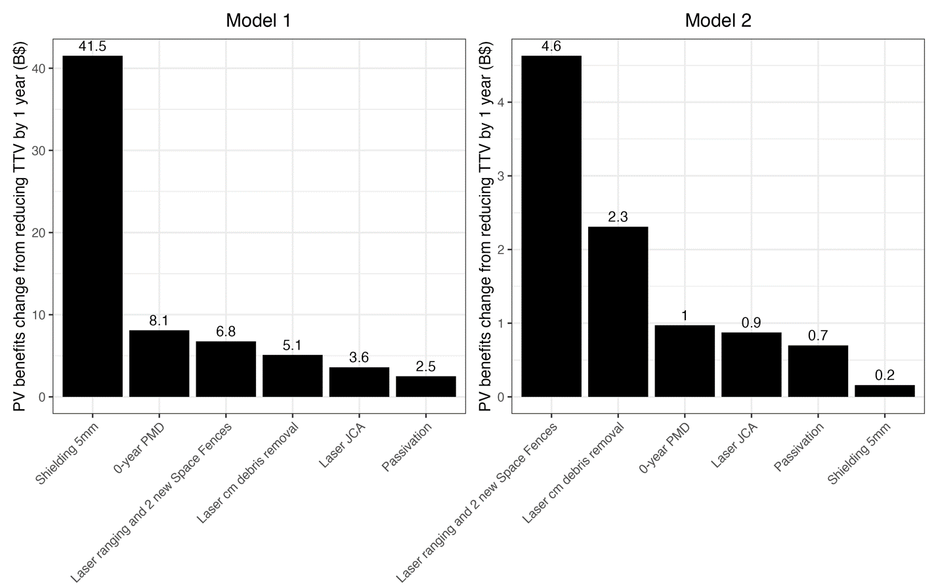
Figure 11: Change in PV of benefits of the unconstrained efficient portfolio (calculated under 10-year TTV) from reducing the TTV of individual actions by 1 year.
Finally, to assess how sensitive the unconstrained efficient portfolio is to acceleration of multiple actions, we compute the unconstrained efficient portfolio assuming all actions begin delivering benefits immediately, i.e., under a 0-year TTV. All values are rounded up to the nearest ten million dollars.
With 0-year TTVs across the board the models no longer agree on the efficient portfolios, though they do still agree on some actions. They also do not agree on the size of the efficient portfolios: Model 1 suggests including more actions, and more expensive actions, than Model 2. Both models continue to agree that millimeter debris is worth protecting against and that 0-year PMD is better than 5-year PMD. However, while they agree that some forms of improved tracking and debris remediation are worth investing in, they disagree on what those forms ought to be. Model 1 suggests investing in a more comprehensive tracking system and using Laser JCA to address risk from large objects. Model 2 suggests simply reducing uncertainty in the orbits of large objects is sufficient and prioritizes removing centimeter-size objects – the same objects Model 1 would prefer to track. Model 1 also suggests additional passivation is a worthwhile investment.

Table 7: Efficient portfolios with no constraints on which actions are chosen assuming 0-year TTV.
Model 1 |  | Model 2
Best portfolio actions | - Shield against 5mm debris  - Laser ranging and 2 new Space Fences  - Laser JCA  - 0-year PMD  - Passivation | Best portfolio actions | - 0-year PMD  - Shield against 5mm debris  - Laser ranging  - Laser removal of cm debris
NPV | $3.48 T | NPV | $289 B
Up-front cost | $1.80 B | Up-front cost | $830 M
Running cost | $140 M/year | Running cost | $24 M/year
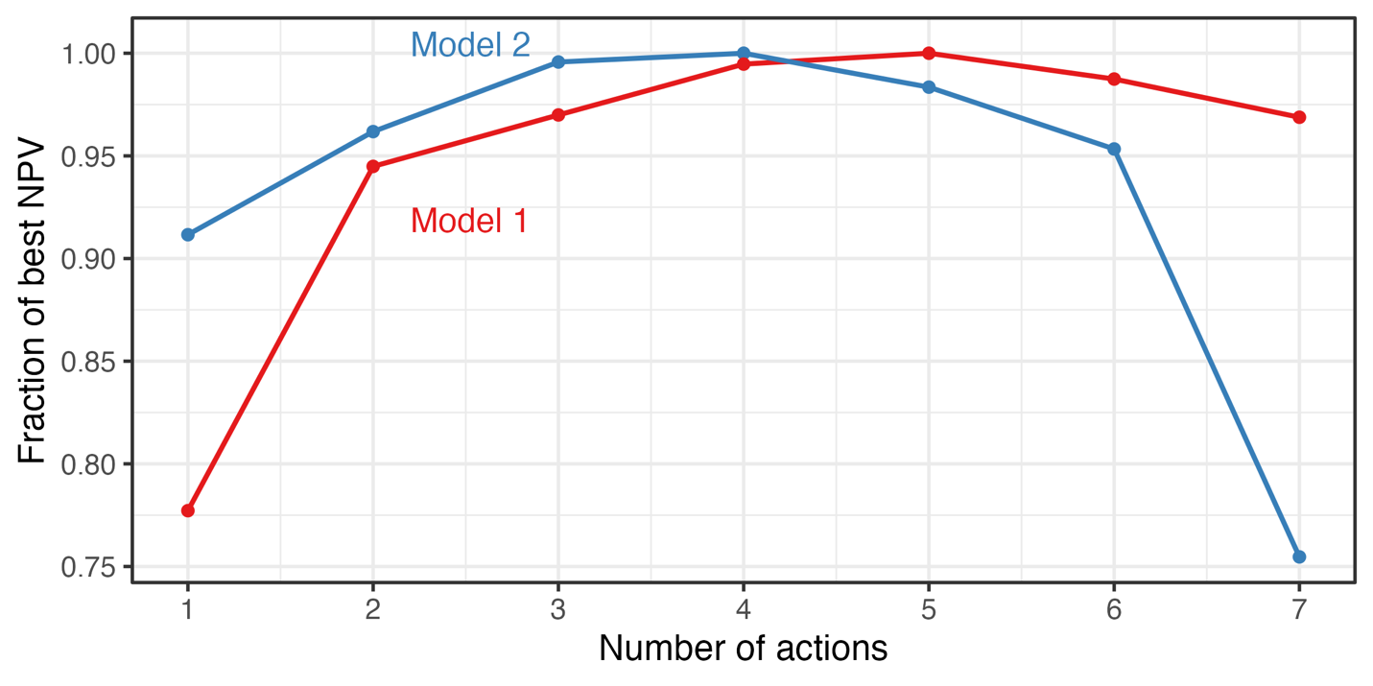
Figure 12: Scaling of overall portfolio NPV as actions are added in unconstrained efficient rank orders (shown in Table 7). The red line shows scaling under Model 1, the blue line shows scaling under Model 2. Portfolio NPVs are expressed as fractions of the NPV of the unconstrained efficient portfolios with 0-year TTV.

Summary and Conclusions
This analysis demonstrated the complementarity and substitution between a variety of space sustainability actions. Using the risk model developed in (Colvin, Karcz and Wusk 2023) and (Locke, et al. 2024), we designed efficient portfolios of space sustainability actions that account for these complementarities and substitutabilities, and showed how different assumptions about the debris environment can lead to different efficient portfolios or different prioritization within the same efficient portfolios. In our main analysis, three features stand out:
- The best combination of 3 actions can achieve at least 95% of the value of the efficient portfolio. The first few actions in general address the bulk of the risk. Under Model 1 those involve shielding against tiny debris, tracking more objects and reducing uncertainty to support better active collision avoidance, and nudging large derelict objects to avert collisions between them (effectively giving them maneuvering capabilities). Under Model 2, those involve tracking more objects and reducing uncertainty, removing small debris objects, and nudging large derelicts. The emphasis on shielding against millimeter-sized debris in Model 1 is consistent with the ORDEM-predicted small debris fluxes used in the model. Model 2 also finds that removing small debris objects is a worthwhile endeavor but given that it predicts lower millimeter-debris flux, it focuses on centimeter-sized debris.
- The efficient portfolio does not contain all actions. This is despite all actions having positive individual benefit. Why? Under both models there are diminishing marginal returns to spending on more sustainability actions. As each action is added to the portfolio, the remaining risks for new actions to address diminish while the costs of implementing the actions remain constant. For example, consider the curve for Model 2. The 7th action added is ADR, by which time the portfolio is already addressing risk from existing large debris through Laser JCA and Passivation, on already addressing the creation of new pieces of large debris through 0-year PMD, and addressing risk from shedded or existing small debris through shielding and Laser cm debris removal. At that point it makes sense that spending upwards of $1 B up-front to bring the ADR capability online and around $45 M/year to maintain it is not a worthwhile investment – much of the risk it would address is already being addressed.
- Interaction effects matter. Both models agree that the marginal value of adding an individual action to a portfolio is not the same as the individual value of that action, consistent with the pairwise interactions in Figure 6. For example, shielding against 5mm debris is included in both portfolios while using dust to remove all millimeter-sized debris is not – even in the case of Model 1, where Dust mm debris removal is the second most valuable individual action and the only action to show significant complementarity with 0-year PMD. This is likely due to its strong substitution with shielding, which suggests that conditional on using shielding to reduce the risk from millimeter-size debris it is not worth spending an additional ~$1.6 B to further reduce that source of risk.
An important implication of point 2 above – that the efficient portfolio does not contain all actions – is that a “peanut butter spread” to investing in space sustainability capabilities may be counterproductive. For a rational actor with a fixed budget, it may be more efficient to pick a portfolio of a few capabilities and allocate greater budget share to them. Point 1 suggests that as few as 1-3 capabilities may be sufficient; point 3 suggests the efficient actions will be those with low substitution between them.
It is also worth noting that 0-year PMD dominates 5-year PMD under both models, individually and as an element of an efficient space sustainability portfolio – the latter under both 10-year and 0-year TTVs. This is consistent with results from the Phase 2 study and suggests that there may be significant net benefits from implementing immediate post-mission disposal, even if only for ~70% of satellites in orbit with the rest allowed to fail in place.

Potential next steps
The results and limitations of this study suggest some next steps for future work. We discuss a few here. These steps would very likely improve the value and prioritization estimates from this or related simulation frameworks.

Higher fidelity on up-front costs, recurring costs, and times-to-value
Our estimates of up-front costs and recurring costs come from the Phase 1 and Phase 2 reports. These estimates were convenient to use for this analysis and facilitated comparison of results with those studies. However, both the underlying values and the constructions of the cost estimates involved strong and potentially distortionary assumptions on the system elements and concepts of operations. It would likely be a substantial effort to add greater fidelity across the board, but likely of correspondingly high value.

Modeling cost and schedule complementarities between actions
Our up-front and running cost estimates do not include the possibility of sharing elements or knowledge across systems development. For example, the Phase 1 report noted that the same system that conducts laser JCA could also conduct laser cm-sized debris removal. This suggests that even if two distinct facilities are used for each action, development of one may reduce concurrent or subsequent up-front costs of the other. Neglecting these effects likely biases our up-front cost estimates upwards in cases where actions with common elements are combined. Similarly, our TTV assumptions do not incorporate the potential to temporally sequence actions so as to increase net benefits.
We also ignore any trade secrets or similar barriers to adoption. As with TTV, we assume that once an action has been developed its costs do not need to be re-incurred by any other actors. This likely biases our up-front costs downwards for actions which will be implemented by distinct entities with competitive commercial or geopolitical incentives.

More exploration of the action space
We chose a very small set of actions for tractability given limited computing resources. This forced us to impose admittedly arbitrary and somewhat artificial constraints on the concepts of operations for some actions. For example, one might reasonably argue that 5mm is not the right size of debris to shield against, or that our assumed debris removal efficacy is insufficient. A fuller exploration of the space of plausible actions to consider would be valuable in identifying high-value concepts of operations from the perspective of combining in a portfolio. This effort would likely require additional work on simulation algorithms to reduce computational burden or else significant compute allocation. It would be highly complementary to efforts to attain greater fidelity on costs and TTVs as well as to efforts to better model cost and schedule complementarities between actions.

Better understanding of discounting and appropriate rate structures
We used a particular discount rate structure, recommended by OMB in Circular No. A-4, to understand the trade-offs between spending dollars now and receiving benefits in the future. These trade-offs reflect the particular financial constraints and value judgements of the US government. It would be useful to extend this work to use (a) no discounting, and (b) discount rate structures reflecting the constraints and judgements of other actors. The case with no discounting would help in understand the degree to which substitution and complementarity between actions – rather than differences in the timing of benefits – drive the results obtained here. Cases with different discount structures would facilitate understanding of how different types of actors, e.g., a profit-oriented large constellation operator, would prefer to invest in space sustainability actions.

Assessment of non-financial metrics
We used financial risk as a convenient unit to compare a wide range of consequences and actions. It would be useful to use different metrics to assess the space sustainability actions. Of particular interest are metrics that appear understudied in the literature and likely of greater importance as the commercial space industry develops, such as human casualty risk on orbit or on the ground.

Inclusion of adaptive behavior
The Phase 2 report assumed that the spacecraft population currently in orbit was maintained, with satellites that were lost due to natural end of life or collisions being immediately replaced. We maintain the same assumption in this report. The launch traffic and active spacecraft population are thus identical in every year and do not respond to the state of the orbital environment. In the baseline scenario, we assume all maneuverable spacecraft in orbit attempt to comply with a 25-year deorbit timeline.
There are ongoing research efforts to develop methods to predict the evolution of launch traffic and responsiveness of orbital-use patterns to the state of the orbital environment (e.g., (Rao, Burgess and Kaffine, Orbital-use fees could more than quadruple the value of the space industry 2020), (Nozawa, et al. 2023), (Rao, Moretto, et al. 2023)). Incorporating these methods would add significant complexity to the analysis here. While using a steady-state population and constant launch traffic allows us to estimate the monetary value of the physical effects of sustainability actions, including behavioral responses – e.g., changes in the orbits that operators launch to or types of satellites launched – may provide qualitatively or quantitatively different insights. Such modeling capabilities would be particularly valuable at longer time horizons, as operators have more time to adapt.

Inclusion of active-active interactions
As in the Phase 1 and Phase 2 reports, we assumed away interactions between active spacecraft. This assumption is likely innocuous in the short run, but may be significantly distortionary in the long run as the number of active spacecraft grows. Of particular interest would be ways to include such interactions that facilitate assessment of space traffic coordination actions.

Inclusion of stochastic effects and different space environment scenarios
Our simulation framework is “mean-field” in the sense that actions are modeled as their expectation values. This substantially simplifies the computation of outcomes, at the cost of uncertainty quantification and understanding the value of outcomes that mitigate tail risks. We also initialize our model from the state of the environment in 2023. However, the state of the environment will differentially affect the benefits of actions. For example, dust may be more valuable immediately after a collision has occurred. Similarly, shielding may receive lower priority in an environment dominated by large derelict objects that are likely to collide. A stochastic simulation framework with multiple space environment scenarios could address these limitations.

Inclusion of policy constraints
We assume all actions are adopted by all space operators at the same time and begin delivering their full benefits immediately after the time-to-value period. This likely overstates the value of actions which will see staggered adoption. We also ignore any limits to how actions can be applied based on policy or legal constraints. This likely overstates the value of actions with significant dependence on policy or laws. This is at least partially mitigated by using the conservative assumption that the TTV is uniformly 10 years. Incorporating realistic policy and legal constraints and realistic timelines under which they could be relaxed would likely improve the prioritization of actions.

Inclusion of solar cycles
We did not model the solar cycle in this analysis. The solar cycle would generate variation over time in the rate at which debris deorbit, and may have additional effects on the costs of stationkeeping and post-mission disposal. Over short horizons it is unlikely such effects would affect the relative net benefits of different actions. This may change as the simulation time horizon increases.

Appendix A: Cost Estimation Methodology
This section provides details on the specific elements used to construct our cost estimates. Our estimates are constructed from the Phase 1 and Phase 2 reports, albeit categorized differently. We express all running costs in millions of dollars per year, and all up-front costs in millions of dollars.
“Up-front costs” for an action are those costs incurred before the action begins delivering benefits, i.e., during the time-to-value period. We classify them into two categories:
- The non-recurring engineering expenses associated with a new action, including testing and validation.
- The cost of building the first operational unit.
For simplicity, we assume that the up-front costs are incurred uniformly over the TTV period. For example, if an action has a development cost of $10M then in the 10-year TTV case we accrue $1M of development cost per year beginning in year 0 until year 10. These costs are discounted in the calculation of NPV but are reported in undiscounted dollars.
“Running costs” are those costs incurred while the action is active. They include:
- The unit costs of building and (re-)deploying the system that implements the action, incurred at an action-specific refresh frequency. For simplicity, we assume the entity implementing the action budgets for these costs annually. A $100 unit cost incurred every 5 years is therefore converted to a $20 annually recurring cost.
- The operations and maintenance cost associated with running the action, incurred annually as long as the action is active.
Whatever actions are taken over the next 60 years, many will involve systems that need to be re-deployed. This was not an issue in the Phase 1 and 2 reports since actions were assumed to occur only once and evaluated over relatively short time horizons. In this report, we incorporate the costs of constructing replacement hardware and facilities into the annual operational cost flow. This is necessary since we are interested in the relative values of different portfolios of actions with different up-front and running costs. For consistency, we make the following assumptions:
- Facilities and related fixed infrastructure for actions like laser JCA and radar tracking have 20-year lifespans.
- Spacecraft operational lifetimes are held constant from the Phase 2 report. The average lifetime, weighted by prevalence of different spacecraft, is 4.8 years, and the median is 5 years. For simplicity we use 5 years for cost accrual.
- Running costs are pre-funded. That is, budget for replacement, operations, and maintenance costs associated with an action must be accumulated before the expenses are incurred. For example, if a replacement spacecraft costs $5M in year 5 and operations and maintenance is another $5M over years 5-10, the $10M over years 5-10 will be budgeted for prior to year 5.
The Phase 1 and Phase 2 reports provided estimates of running costs as defined in this report. We construct the running costs here from the estimated costs in those reports.
Up-front costs for new systems are often subject to significant uncertainty. We assume that the first operational unit has the same cost as subsequent units. Estimating the NRE is more challenging. Where possible, we use analogies to systems known to be similar to those we are assessing. Where such systems do not exist, we use an “iterative design” heuristic and assume that the NRE is twice the cost of the hardware involved in the operational system. This heuristic will likely overstate the development cost for systems that have relatively fewer new elements or require fewer test iterations and understate the development cost for systems that have relatively more new elements or require more test iterations. Further research on estimating the development cost of new systems relevant to space sustainability actions would be helpful.
In the baseline case with 10-year TTV for all actions, the up-front cost is divided by 10 to obtain the annual budgetary impact. We also assume that all expenses are pre-funded. This means that the cost of the first operational unit is accounted for in the up-front costs, and system replacement costs are accounted for in the running costs before replacement occurs. The replacement costs are annualized on a straight-line basis. All budgetary costs are presented in undiscounted dollar values; while the investment analysis must account for the opportunity cost of funds, the undiscounted values are relevant for budgeting and planning purposes.
The mitigation and tracking actions all involve systems or improvements that exist or are in use today. We therefore assign no NRE cost to those actions. In those cases, the up-front cost is simply the cost of the first operational system or tranche of improvements. The remediation actions do involve novel systems and so get NRE attributed. We use the “iterative design” heuristic described in the main text to calculate these costs as 2x the hardware cost. In these cases, the up-front costs are the sum of the NRE cost and the cost of the first operational system.

Mitigation actions
The Phase 2 report provides the basis of our estimates of the cost of mitigation actions. We focus on four types of actions that are technologically feasible today (“Shielding 5mm”, “Passivation”, “5-year PMD”, and “0-year PMD”).
Shielding against 5mm debris strikes is assumed to require an additional 1.5-3.1 kg/m² of areal mass. As in the Phase 2 report, we assume that spacecraft are already shielded against 1mm debris strikes from medium density debris, e.g., aluminum debris, and we assume that all debris are medium density to simplify this analysis.
Complete or hard passivation to mitigate explosions is estimated using the implementation of a segmented battery system that is more robust to thermal runaway during and after operations and adding pyrotechnic valves to vent propellant after operations. The battery system is assumed to double the spacecraft battery mass and the addition of valves (including materials, testing, and launch) is assumed to add between $10K-$150K to the total spacecraft cost.
5-year and 0-year PMD both involve spacecraft moving from their initial orbit to a circular orbit at the highest altitude such that they will naturally deorbit in 5 or 0 years (where “0 years” is taken to mean “less than 1 year”). We continue to radically simplify the complex operations needed to choose a disposal altitude by assuming disposal altitudes are 550 km and 300 km, respectively. The maneuvers are assumed to involve two Hohmann transfers using an electrical propulsion system with specific impulse of 1,500 seconds. The cost of the maneuvers is calculated as the cost of additional propellant required to conduct them. This ignores other potential costs like potentially increasing the size of the propulsion system. All spacecraft attempt to be compliant (i.e., pay for compliance) but we assume only 90% of PMD attempts are successful. If a satellite is already operating at or below the relevant disposal altitude (i.e., naturally compliant), it is allowed to fail in place with no cost. Spacecraft without a propulsion system fail in place.
Further details on the CONOPS and assumed efficacies of these actions are described in Appendix C of the Phase 2 report (Locke, et al. 2024). All of these actions would be applied to active spacecraft. The up-front costs are therefore calculated as the cost of applying the relevant subsystems (e.g., additional shielding mass, battery mass to eliminate explosion risk) to the entire active spacecraft population. As in the Phase 2 report, we assume that spacecraft are immediately replaced. We do not track when a satellite was launched, so we hold uncertain how long each spacecraft has been operating. That means each year, there is a 1 / lifetime probability that each spacecraft has reached its end of life and must be replaced (e.g., a satellite with a 5-year lifetime has a 20% probability of being replaced in any given year). The average lifetime across the population is roughly 5 years. We therefore construct the running costs as the total cost divided by the average lifetime, since that reflects the average fraction of spacecraft being replaced and incurring the incremental costs associated with these actions. Table 8 describes the cost elements and estimates for all risk mitigation actions considered. All costs are rounded up to the nearest million dollars.

Table 8: Costs for risk mitigation actions
Action | Line item | Subtotal | Total | Unit
 | Weighted average spacecraft lifetime |  | 5 | years
Shielding 5mm
 | Cost of applying to population turning over in one year | 2 |  | M$/year
 | Running cost |  | 2 | M$/year
 | Cost of applying to entire population | 8 |  | M$
 | Up-front cost |  | 8 | M$
Passivation
 | Cost of applying to population turning over in one year | 55 |  | M$/year
 | Running cost |  | 55 | M$/year
 | Cost of applying to entire population | 275 |  | M$
 | Up-front cost |  | 275 | M$
5-year PMD
 | Cost of applying to population turning over in one year | 2 |  | M$/year
 | Running cost |  | 2 | M$/year
 | Cost of applying to entire population | 8 |  | M$
 | Up-front cost |  | 8 | M$
0-year PMD
 | Cost of applying to population turning over in one year | 4 |  | M$/year
 | Running cost |  | 4 | M$/year
 | Cost of applying to entire population | 20 |  | M$
 | Up-front cost |  | 20 | M$

Remediation actions
The Phase 1 and Phase 2 reports provide the basis of our estimates of the cost of remediation actions. We focus on four types of actions (“Dust mm debris removal”, “ADR”, “Laser JCA”, “Laser cm debris removal”). While Laser JCA and Laser cm debris removal are both assumed to use the same type of system and could in principle be conducted from the same facility (economizing on total cost), we treat them as distinct entities for constructing portfolio costs.
Dust deployment is assumed to involve the release of 20 tons of 60-micron tungsten particles at an altitude of 1,100 km, which would impact millimeter-size debris and lower their orbit. As the dust’s orbit decays, it acts as a “sweeper” and removes the millimeter-size debris it encounters. As mentioned in the main text, the dust is assumed to be deployed only once during the analysis horizon, and so has no running costs.
ADR is based on the OrbitFab-inspired architecture studied in Phase 1. It is assumed to involve a tug that grabs large objects and brings them down to an altitude of 350 km, from where they re-enter without further control. The tug then returns to a depot where it refuels and prepares to execute another mission. We assume a single tug can remove up to 5 large debris objects per year, and that the tug has a 15-year life. We also assume that the depot is capable of storing 15 years’ worth of fuel on orbit. The original architecture considered in Phase 1 involved 7 tugs; we have scaled the relevant items to reflect a single tug.
Laser cm debris removal and Laser JCA both involve facilities with an acquisition system to acquire a target, a laser generator to produce the pulsed laser beam, and a telescope to focus the laser and strike the target. The telescope may require advanced adaptive optics to correct for atmospheric distortions. For small debris removal, the system would target debris that may pose a significant risk to spacecraft or human spaceflight or else go after targets of opportunity. Once a target was selected and handover from acquisition to telescope was complete, the laser would impart enough energy to ablate a small amount of material on the target, which would generate thrust that reduces the target’s orbital lifetime. As mentioned in the main text, we assume the laser system can remove up to 50,000 pieces of cm-sized debris per year. For JCA, the system would target debris involved in a predicted conjunction or could continuously tend the orbits of a prioritized subset of debris. Once a target is identified and uncertainty in the object’s orbit has been minimized (e.g., through use of the same laser system at lower power levels) the laser would impart enough energy to cause ablation, altering the object’s orbit and averting a collision.
Further details on the CONOPS and assumed efficacy of the dust action is described in Appendix B of the Phase 2 report (Locke, et al. 2024). Further details on the CONOPS and assumed efficacy of the Laser cm debris removal action is described in Appendix B of the Phase 1 report, and of the Laser JCA and ADR actions in Appendix C of the Phase 1 report.
Table 9 describes the cost elements and estimates for the dust deployment system, Table 10 describes the cost elements and estimates for the ADR system, and Table 11 describes the cost elements and estimates for the laser system used for JCA or small debris removal. All costs are rounded up to the nearest million dollars.

Table 9: Costs for a dust deployment system
Line item | Element | Subtotal | Total | Unit
Spacecraft cost | 194 |  |  | M$/spacecraft
Dust shield cost | 2 |  |  | M$
Operations cost | 10 |  |  | M$
Spacecraft launch cost | 67 |  |  | M$/launch
Number of spacecraft | 2 |  |  | spacecraft
Number of launches | 2 |  |  | launches
Total system cost |  | 546 |  | M$
Replacement cadence |  | 0 |  | systems/year
Running cost |  |  | 0 | M$/year
NRE |  | 1072 |  | M$
First operational system |  | 546 |  | M$
Up-front cost |  |  | 1618 | M$

Table 10: Costs for an uncontrolled grab-and-remove (ADR) system
Line item | Element | Subtotal | Total | Unit | Notes
Spacecraft cost | 115 |  |  | M$/tug
Spacecraft launch cost | 21 |  |  | M$/tug
Spacecraft lifetime | 15 |  |  | years
Spacecraft replacement cost |  | 9 |  | M$/year
Removal operations cost |  | 3 |  | M$/year | Table 35 of Phase 1, annualized
Fuel mass delivered during refueling | 17907 |  |  | kg/delivery | Table 35 of Phase 1, scaled from 7 tugs to 1
Launch cost per kg of fuel delivery | 15000 |  |  | $/kg
Total cost to put fuel on orbit | 269 |  |  | M$/delivery
Depot fuel storage capacity | 15 |  |  | years/delivery
Annualized cost of fuel delivery |  | 18 |  | M$/year
OrbitFab architecture cost | 225 |  |  | M$ | Table 35 of Phase 1, scaled from 7 tugs to 1
Annualized architecture cost |  | 15 |  | M$/year
Running cost |  |  | 45 | M$/year
NRE |  | 722 |  | M$
First operational system |  | 673 |  | M$
Up-front cost |  |  | 1395 | M$

Table 11: Costs for a laser system used for JCA or small debris removal.
Line item | Element | Subtotal | Total | Unit
Facility cost | 218 |  |  | M$
Facility lifetime | 20 |  |  | years
Facility replacement cost |  | 11 |  | M$/year
Running cost |  |  | 11 | M$/year
NRE |  | 436 |  | M$
First operational system |  | 218 |  | M$
Up-front cost |  |  | 654 | M$

Tracking actions
The Phase 2 report provides the basis of our estimates of the cost of tracking actions. We focus on two systems that are used to define two actions (“Laser ranging” and “Laser ranging and 2 new Space Fences”).
The first system is a global network of 5 ground-based satellite laser ranging (SLR) stations (“Laser ranging”) that would be used to provide on-demand laser ranging of objects larger than 10 cm. This is assumed to reduce the rate of false positive conjunction alerts generated by 100x. The second system is a global network of 2 ground-based radars (“2 new Space Fences”) that would be used to track and maintain custody of centimeter-size debris and support conjunction assessments involving them. Further details on the CONOPS and assumed efficacies of both types of systems are described in Appendix D of the Phase 2 report (Locke, et al. 2024). It is worth mentioning that when we combine the two systems in the “Laser ranging and 2 new Space Fences” action, the 100x reduction in false positive conjunction alert rate is applied to all debris larger than 1 cm.
Table 12 describes the cost elements and estimates for the network of 5 new SLR stations, and Table 13 describes the cost elements and estimates for the network of 2 new radars. All costs are rounded up to the nearest million dollars.

Table 12: Costs for a ground-based laser ranging network
Line item | Element | Subtotal | Total | Unit
Station unit cost | 8 |  |  | M$/station
Number of stations | 5 |  |  | stations/network
Lifetime | 20 |  |  | years/station
Total network replacement cost |  | 40 |  | M$/ network
Station unit operating cost | 1 |  |  | M$/station/year
Total network operating cost |  | 5 |  | M$/year
Running cost |  |  | 7 | M$/year
NRE |  | 0 |  | M$
First operational network |  | 140 |  | M$
Up-front cost |  |  | 140 | M$

Table 13: Costs for radar network to track small debris
Line item | Element | Subtotal | Total | Unit
Station unit cost | 350 |  |  | M$/station
Number of stations | 2 |  |  | stations/network
Lifetime | 20 |  |  | years/station
Total network replacement cost |  | 700 |  | M$/network
Station unit operating cost | 10 |  |  | M$/station/year
Total network operating cost |  | 20 |  | M$/year
Running cost |  |  | 55 | M$/year
NRE |  | 0 |  | M$
First operational network |  | 700 |  | M$
Up-front cost |  |  | 700 | M$

Appendix B: Simulation Framework
As described in the main text, the simulation modeling here is built on the code used in the Phase 2 report. Interested readers are referred to (Locke, et al. 2024) for technical details. The only major change is that we loop over individual years rather than simulate multiple years at once, allowing us to capture higher-order effects as repeated applications of first-order effects. Here we describe the mechanics of constructing portfolios of actions. While the final set of actions used is relatively small, the portfolio construction methodology described below can scale to much larger sets of actions if compute time is available to run them.
We decompose the problem of finding the efficient portfolio of space sustainability actions into two stages. In stage 2, we use the framework developed in the Phase 2 report to measure the benefits (i.e., changes in financial consequences to space operators due to close approaches, maneuvers to reduce risks, and mission-ending collisions with currently untracked debris) of a single portfolio of space sustainability actions. Actions in the portfolio are deployed per their assumed development and deployment time. This generates a time series of benefits to space operators from the analyzed portfolio. We repeat this step for each portfolio under consideration. In stage 1, we discount the benefits of each portfolio back to time 0, apply the discounted development and running costs, and construct the NPVs of each portfolio. Identifying the efficient portfolio is then simply a matter of ranking portfolios by their NPVs and selecting the one with the largest value. The stage 2 process is pleasingly parallel and where the bulk of compute time occurs. The stage 1 process could similarly be parallelized but is reasonably quick to run in serial when the total number of portfolios to analyze is not “too large”.

Constructing the set of admissible portfolios
To identify portfolios for analysis, we constructed a taxonomy of actions that could be combined. The taxonomy classifies actions at three levels:
- The category, which is one of “mitigation”, “remediation”, and “tracking”. This level is useful for analyst interpretation but does not mechanically affect the portfolio construction.
- The approach, which includes high-level approaches like “post-mission disposal”, “grab and remove”, “improved characterization”. At this level, all actions are distinct and can be considered separately or in tandem.
- The type, which specifies details like “propulsive post-mission disposal within 5 years of the end of mission”, “grab and remove 50 largest objects with controlled re-entry”, “deployment of radar systems to track debris 1 cm and larger”. At this level, actions may have overlap or be mutually exclusive. For example, “propulsive post-mission disposal within 5 years of the end of mission” and “propulsive post-mission disposal within 10 years of the end of mission” are both types of post-mission disposal, but one encompasses the other. Similarly, “grab and remove 50 largest objects with controlled re-entry” and “grab and remove 50 largest objects with uncontrolled re-entry” are mutually exclusive.
Where actions can be applied to a set of satellites, they are applied to all satellites in that set uniformly. Actions like post-mission disposal are therefore applied to all satellites, and actions like grab and remove are applied to the same satellites.
Actions are combined across the approach level, but not across the type level. So, it is possible to construct a portfolio that combines “propulsive post-mission disposal within 5 years of the end of mission” and “deployment of radar systems to track debris 1 cm and larger”, but not a portfolio that combines “propulsive post-mission disposal within 5 years of the end of mission” and “propulsive post-mission disposal within 10 years of the end of mission”. This modeling choice is a logical consequence of uniformly applying actions to satellites. It sacrifices fidelity for tractability: while it is possible that there are worthwhile combinations of actions at the type level (e.g., “grab and remove these 22 satellites with controlled re-entry and those 28 satellites with uncontrolled re-entry” may dominate using solely controlled or uncontrolled re-entry for all 50), considering portfolios of actions at the individual satellite level explodes the search space for the stage 2 calculation. However, it is technically feasible to consider such optimization over architecture design provided compute time is available. Since we did not have such resources for this analysis, we focused on a more limited set of actions.

Appendix C: Acronyms
Acronym | Definition
NASA | National Aeronautics and Space Administration
ESA | European Space Agency
OMB | Office of Management and Budget
OTPS | Office of Technology Policy, and Strategy
PV | Present Value
NPV | Net Present Value
PMD | Post-Mission Disposal
JCA | Just-in-time Collision Avoidance

References
[1] | T. J. Colvin, J. Karcz and G. Wusk, "Cost and Benefit Analysis of Orbital Debris Remediation," NASA OTPS, Washington, DC, 2023.
[2] | J. Locke, T. J. Colvin, L. Ratliff, A. Abdul-Hamid and C. Samples, "Cost and Benefit Analysis of Mitigating, Tracking, and Remediating Orbital Debris," NASA OTPS, Washington, DC, 2024.
[3] | H. Markowitz, "Portfolio Selection," The Journal of Finance, vol. 7, no. 1, pp. 77-91, 1952.
[4] | OMB, "Circular No. A-4," 9 November 2023. [Online]. Available: https://www.whitehouse.gov/wp-content/uploads/2023/11/CircularA-4.pdf. [Accessed 3 January 2025].
[5] | Satellite Industry Association, "COMMERCIAL SATELLITE INDUSTRY CONTINUES HISTORIC GROWTH WHILE DOMINATING GLOBAL SPACE BUSINESS – SIA RELEASES 27TH ANNUAL STATE OF THE SATELLITE INDUSTRY REPORT," Satellite Industry Association, 13 June 2024. [Online]. Available: https://sia.org/commercial-satellite-industry-continues-historic-growth-dominating-global-space-business-27th-annual-state-of-the-satellite-industry-report/. [Accessed 4 January 2025].
[6] | A. Rao, M. G. Burgess and D. Kaffine, "Orbital-use fees could more than quadruple the value of the space industry," Proceedings of the National Academy of Sciences, vol. 117, no. 23, pp. 12756-12762, 2020.
[7] | W. Nozawa, K. Kurita, T. Tamaki and S. Managi, "To What Extent Will Space Debris Impact the Economy?," Space Policy, vol. 66, p. 101580, 2023.
[8] | A. Rao, M. Moretto, M. Holzinger, D. Kaffine and B. Weeden, "OPUS: An Integrated Assessment Model for Satellites and Orbital Debris," vol. https://arxiv.org/abs/2309.10252v1, 2023.
[9] | National Aeronautics and Space Administration, "NASA Correspondence Management and Communications Standards and Style," 2006. [Online].
[10] | H. Levy and M. Sarnat, "International Diversification of Investment Portfolios," The American Economic Review, vol. 60, no. 4, pp. 668-675, 1970.

“Up-front” and “running” costs are related to but distinct from “development” and “operations” costs. The up-front costs include both NRE and first-unit costs, while development costs typically include only the former. The running costs include operations and maintenance costs as well as replacement costs. We use the terms “up-front” and “running” to avoid confusion.
Unless otherwise stated, we adopt the convention that series indices begin at 0.
In general, if the NPV of an investment is greater than zero the investment is judged a better use of funds than whatever the alternative is. In the case of the US government, the standard alternative is risk-free Treasury bonds.
This is only an approximation for quick mental comparisons. A proper calculation of the equivalent annual flow of benefits would involve calculating the annuity with present value equal to the NPV. Since the discount rates used here are low, this “0 discount rate” approximation is a reasonable one.
Recall that these benefits include benefits from reductions in higher-order interactions, e.g., reductions in interactions with debris generated in collisions with fragments from collisions with large objects that were disposed of immediately.
In financial settings, correlations between asset returns implies efficient portfolios ought to be diversified across less-correlated assets (Markowitz 1952, Levy and Sarnat 1970). We obtain analogous diversification across actions due to the correlations between the specific risk reductions delivered by different actions. Allowing for the possibility that actions may have correlated likelihoods of success (e.g., all laser-related actions may have similar failure modes) would also generate diversification across actions. We do not incorporate such possibilities in this analysis.
Interestingly, each of these efficient portfolios involves taking the next-smaller efficient portfolio and adding one more action. This “efficient nesting property” obtains when the interactions between actions in the portfolio and the new action being evaluated is not “too large” relative to the direct gain from adding the action.
Discounting amplifies this effect since earlier costs are weighted higher than later costs but is not the reason it exists. Fundamentally, amortizing the up-front cost over a longer period while holding the analysis horizon fixed crowds out the same number of running cost years, changing the total cost paid. Over an infinite-time analysis horizon with no discounting this effect would not exist; but over an infinite horizon with no discounting the costs would diverge to infinity. Regardless, it is a basic point of financial analysis that all else equal it is better to pay a given amount over a longer period than a shorter one.
For example, Figure 7 shows that under Model 2 Laser JCA adds around 7.5% to the NPV of the efficient portfolio as the third action added. Combined with Table 5, that implies a marginal value of Laser JCA in the efficient portfolio of roughly $21 B. A 10-year TTV reduction would reduce the marginal NPV added by around $14 B. On the other hand, the PV of benefits increases by about $9 B from the same 10-year the TTV reduction, suggesting that there may be TTV reductions that generate PV benefits without imposing excess budgetary strain.
Interestingly, uniform 0-year TTVs breaks the “efficient nesting” property identified for the “10-year TTV unconstrained efficient portfolio” in Table 5 for Model 2: with a 0-year TTV, the efficient portfolio constrained to 3 or fewer actions involves the more comprehensive tracking system (Laser ranging and 2 new Space Fences), while at 4 actions the inclusion of Laser cm debris removal obviates the need for the 2 new Space Fences that would track centimeter debris. The ranking in the Model 2 efficient portfolio in Table 7 reflects the ranking conditional on excluding “Laser ranging and 2 new Space Fences”.
There is also the challenge that many behavioral parameters that govern responses to environmental or economic changes, e.g., greater congestion in some orbits or changes in launch prices, are not yet well-quantified.
The time profile over which up-front costs are accrued varies substantially by technology. For actions that involve new technologies, there is also considerable uncertainty over the shape of the profile.
“Unit” here should be understood inclusively. For actions like shielding, the first unit is the first wave of shielding applied to all eligible spacecraft in the fleet. For actions like grab and remove, the first unit is the first full architecture that implements the action. For actions like laser JCA, the first unit is the first facility.

