Intercomparison of low-energy electron transport calculations by different Monte Carlo track-structure simulation codes

Ioanna Kyriakou¹, Alexis Papadopoulos¹, Ioannis Polopetrakis¹, Christina Kotroumbelou¹, Ianik Plante², Yusuke Matsuya^{3,4}, Takeshi Kai⁴, Rui Qiu⁵, Junli Li⁵, Pavel Kundrát⁶, Giorgio Baiocco⁶, Chia-Wei Huang^{6,7}, Jan Lillhok⁸, Robert Billnert-Maróti⁹, Salvatore Di Maria¹⁰, Hoang Tran¹¹, Yann Perrot¹², Carmen Villagrasa¹², Michael Dingfelder¹³, Hans Rabus¹⁴, Weibo Li¹⁵, Sebastien Incerti¹¹, Dimitris Emfietzoglou^{1,*}

¹ Medical Physics Laboratory, Department of Medicine, University of Ioannina, 45110 Ioannina, Greece
² KBR, 2400 NASA Parkway, Houston, TX 77058, USA
³ Faculty of Health Sciences, Hokkaido University, Kita-12 Nishi-5, Kita-ku, Sapporo, Hokkaido, 060-0812, Japan
⁴ Nuclear Science and Engineering Center, Research Group for Radiation Transport Analysis, Japan Atomic Energy Agency (JAEA), 2-4 Shirakata, Tokai, Ibaraki, 319-1195, Japan
⁵ Department of Engineering Physics, Tsinghua University, Beijing 100084, China
⁶ Department of Radiation Dosimetry, Nuclear Physics Institute of the CAS, Na Truhlářce 39/64, 180 00 Praha, Czech Republic
⁷ Faculty of Nuclear Science and Physical Engineering, Czech Technical University, Břehová 7, 11519 Praha, Czech Republic
⁸ Swedish Radiation Safety Authority, SE-171 16 Stockholm, Sweden
⁹ Vattenfall AB, 169 92 Stockholm, Sweden
¹⁰ Centro de Ciências e Tecnologias Nucleares, Instituto Superior Técnico, Universidade de Lisboa, Estrada Nacional 10, 2695-066 Bobadela LRS, Portugal
¹¹ Université de Bordeaux, CNRS, LP2I, UMR 5797, F-33170 Gradignan, France
¹² Autorité de sûreté nucléaire et de radioprotection (ASNR), PSE-SANTE/SDOS/LDRI, F-92260, Fontenay aux Roses, France
¹³ Department of Physics, East Carolina University, Mailstop 563, Greenville, NC 27858, USA
¹⁴ Physikalisch-Technische Bundesanstalt (PTB), Abbestrasse 2-12, 10587 Berlin, Germany
¹⁵ Federal Office for Radiation Protection (BfS), Ingolstädter Landstraße 1, 85764 Oberschleißheim, Germany

* Corresponding author: demfietz@uoi.gr (D.E.)

Abstract
Objective. To evaluate the uncertainty of physical features of low-energy electron transport in liquid water due to the use of different Monte Carlo track-structure (MCTS) codes.
Approach. Several MCTS codes developed specifically for liquid water, namely, Geant4-DNA, PHITS-TS, RITRACKS, NASIC, and PARTRAC are used to calculate the electronic stopping power, the pathlength and absorption ranges, the dose-point-kernel, and the frequency-mean (${\overline{y}}_{F}$) and dose-mean (${\overline{y}}_{D}$) lineal energy for electron energies from 20 eV to 100 keV. Results from MCNP6’s single-event mode, which correspond to unit-density scaled water vapor, are also included for comparison. All the examined codes adopt similar electron transport methodologies but different cross section models and datasets. Data from ICRU Report 90 were used to benchmark the medium- to high-energy performance of the codes. The uncertainty of each calculated quantity was evaluated by the relative standard deviation ($RSD$) and the maximum relative difference ($MRD$).
Main Results. For energies above ~1 keV, the $RSD$ and $MRD$ among the MCTS codes for liquid water are, on average, between 5‒25% and 20‒100%, respectively. At lower energies, and especially below 100 eV, the differences are significantly higher with the $RSD$ reaching up to ~70% and the $MRD$ up to ~700%. The MCNP6 results are comparable to those of the liquid water codes, except for energies below 0.1‒1 keV and/or nanometer targets where differences may reach (or exceed) ~100%. Fairly good agreement with the ICRU data is found with the average deviation between 1‒16% and the maximum deviation between 3‒20%, with the exact values depending on the particular code.
Significance: Due to the lack of experimental data, our understanding of electron transport in liquid water is practically limited by the dispersion of the results of MCTS codes. The present results reveal significant differences among MCTS codes at low energies, especially below ~100 eV, potentially compromising the accuracy of DNA damage simulations where such electrons play a key role. The present work highlights the need for further development of the physics models used in MCTS codes to reduce the uncertainties associated with low-energy electron transport calculations in liquid water.

1. Introduction
It is well recognized that the biological effects of ionizing radiation are initiated by its action in micro- to nano-meter-sized targets, corresponding to sensitive (sub) cellular structures, such as chromosomes, nucleosomes, and the DNA double helix (ICRU 1983, ICRU 2023). At this spatial scale, the effects of radiation depend upon the stochastic aspects of its interaction with matter. Therefore, Monte Carlo (MC) codes for liquid water medium, which perform stochastic simulation of radiation transport, are currently the workhorse of theoretical micro- and nano-dosimetrty and radiobiology (Dingfelder 2006, Nikjoo et al 2016, Chatzipapas et al 2020 Baiocco et al 2022).
Essentially all types of ionizing radiation, including photons, protons, alpha particles and heavier ions, deposit energy and induce biological effects largely via interactions of secondary electrons, especially low-energy ones (NCRP 2018). The simulation of electron transport using the MC method is generally classified as either condensed history (CH) or track structure (TS). TS simulations employ interaction cross sections for the most important physical processes (i.e., electronic excitations and ionizations) to enable the transport of electrons collision-by-collision down to eV energies. The TS approach offers spatial resolution at the atomic or molecular level and, therefore, is well-suited for quantifying radiation action from the micro- down to the nano-meter scale (Nikjoo et al 1998, Dingfelder 2012). However, due to the large number of interactions that must be simulated for each radiation track, TS simulations are generally computationally intensive and are mostly limited to electron transport at low to medium energies (approximately up to ~10‒100 keV). Several MCTS codes for liquid water have been developed worldwide over the last 40 years (ICRU 2023). In particular, PARTRAC (Friedland et al 2011a), RITRACKS (Plante and Cucinotta 2011), and NASIC (Li et al 2015) are three MCTS codes that extend to both the chemical and biological stage of radiation action (Friedland et al 2011, Friedland and Kundrat 2013, Friedland et al 2017, Plante et al 2019, Plante et al 2024, Li et al 2015). In general, all MCTS codes share very similar transport algorithms but may greatly differ in the interaction cross sections. Due to the huge effort required for the development of suitable cross section datasets and their strong material-dependence (especially at low energies), most TS codes for radiobiological applications are commonly developed for a single medium, namely, liquid water, which is commonly used as a surrogate for biological media. Important contributions of TS simulations to our understanding of radiation action in cells include the quantification of the complexity of DNA damage for different radiation qualities at a level of detail which is well beyond current experimental capabilities (Goodhead 1994, Nikjoo et al 1999, 2001, Friedland et al 2011b, Plante et al 2024, Goodhead and Weinfeld 2024), and the recognition of electron “track-ends” as a high-LET (linear-energy-transfer) component, which is present in any radiation field (Nikjoo and Goodhead 1991, Michael and O’Neill 2000, Hill 2018, Goodhead 2021).
CH simulations, on the other hand, transport electrons along artificial steps whereby the overall effect of a large number of interactions contained within the step is treated via multiple-scattering models. The latter have a weak material dependence, so their application to different media is straightforward. Another crucial advantage of this approach is that the number of simulation steps per radiation track is much reduced, which shortens the simulation time, thus facilitating the simulation of radiation transport to higher energies and macroscopic volumes. The shortcoming of the CH approach is that multiple-scattering models have a low energy limit of application at ~1 keV, which renders this approach unsuitable for mechanistic radiobiological studies at the DNA level. The important role of TS simulations to radiobiological modeling, along with the fact that TS codes are not publicly available, has led some CH codes, like Geant4 (Agostinelli et al 2003, Allison et al 2006, Apostolakis et al 2009, Allison et al 2016), PHITS (Sato et al 2024), and MCNP (Hughes 2014), to extend their functionality to the microscopic domain by enabling TS simulations of electron transport down to eV energies. Thus, by switching between CH and TS simulations, both macro- and micro-scopic calculations can be performed seamlessly. In particular, the TS versions of Geant4 and PHITS, namely, Geant4-DNA (Incerti et al 2010a, Incerti et al 2010b, Incerti et al 2018, Bernal et al 2015 Kyriakou et al 2022) and PHITS-ETS (Matsuya et al 2022), contain interaction cross section developed specifically for liquid water while also including functionalities for simulating radiation damage at the (sub) cellular and DNA level (Tang et al 2019, Sakata et al 2020, Sakata et al 2021, Matsuya et al 2022, Sato et al 2024). On the other hand, MCNP’s single-event mode, namely, MCNP6 (Rising et al 2023, Kulesza et al 2022), allows micro- and nano-dosimetry calculations in unit-density scaled water vapor (Di Maria et al 2017, Lillhök et al 2022). Because of their availability, popularity, and wide range of applications, Geant4-DNA, PHITS-ETS, and MCNP6 are also included in the present study.
A well-known problem in the development of TS codes for liquid water is the lack of direct experimental data for the interaction cross sections. Thus, TS codes for liquid water mainly depend on (semi) theoretical cross section models. This is in sharp contrast to gas-phase media (including water vapor) where experimental measurements of interaction cross sections are generally available over a broad energy range, thus facilitating the development of empirical or semi-empirical cross section models down to the eV scale. This is the reason why, historically, TS simulations for liquid water were based on unit-density scaled water-vapor cross sections (Uehara et al 1999). This practice is nowadays largely abandoned owing, firstly, to the recognition that the effects of the condensed-phase on the interaction cross sections are non-linear, especially at low energies which are of most interest in MCTS studies and, secondly, to the availability of experimental data for the dielectric function (DF), or the energy loss function (ELF), of liquid water, which may be used to calculate inelastic cross sections from first-principles within the PWBA (Fano 1963, Inokuti 1971). Presently, calculations of inelastic cross sections for condensed media, like liquid water, using optical-data models of the DF (or ELF) are considered the state-of-the-art (Fernandez-Varea 1998, Dingfelder et al 1998, Emfietzoglou et al 2005, Fernandez-Varea et al 2005, Salvat et al 2009, Wiklund et al. 2011, Tanuma et al 2011, Dingfelder 2014, Nikjoo et al 2016, Garcia-Molina et al 2017, De Vera and Garcia-Molina 2019, De Vera et al 2021). However, the extension of these calculations down to ~10 eV is particularly challenging given the general restrictions of the PWBA and the additional approximations in the optical-data models. In fact, it has been consistently reported in the literature that, although differences among calculated inelastic cross sections for liquid water developed by different optical-data models remain moderate (~10-30%) down to about a few hundred eV, they increase rapidly at lower energies, especially below ~100 eV (Emfietzoglou and Nikjoo 2005, 2007, Dingfelder et al 2008, Emfietzoglou et al 2012, Emfietzoglou et al 2017b). Despite their promise, more elaborate models of the DF or ELF of liquid water or ab-initio calculation of cross sections, have so far limited application to MCTS studies (Champion et al 2011, Emfietzoglou et al 2013, 2017a, Nguyen-Truong 2015, 2018, Koval et al 2022).
The aim of this study is to evaluate the uncertainty of electron transport calculations in liquid water in the energy range from 20 eV to 100 keV, due to the use of different MCTS codes. To that end, we present a systematic comparison of several state-of-the-art MCTS codes, namely, Geant4-DNA, PHITS-ETS, RITRACKS, NASIC, PARTRAC, and MCNP6 in terms of the electronic stopping power, the pathlength and absorption ranges, the dose point kernel (DPK), and the microdosimetric quantities frequency-mean and dose-mean lineal energy. Apart from the MCNP6 code, which corresponds to unit-density scaled water vapor due to its atomic cross sections, the other MCTS codes employ inelastic cross section models and datasets developed specifically for liquid water. The dispersion of the physical quantities calculated was evaluated in terms of the relative standard deviation ($RSD$) and the maximum relative difference ($MRD$).

2. Materials and Methods
2.1. Cross sections for electron transport
In contrast to CH codes, which differ (sometimes crucially) in their transport methodology, MCTS codes adopt almost identical methodologies for simulating electron transport. This methodology is essentially based on the random sampling of interaction variables, such as the distance-to-the-next-interaction (collision-free path), the scattering angle, and the energy loss (if any), from the differential and integrated cross sections for elastic and inelastic scattering. So, the essential difference among MCTS codes is not the transport methodology, but the various interaction cross sections which, in general, may be empirical, semi-empirical, or (semi) theoretical and calculated analytically or by interpolation from look-up tables. In addition, for TS applications, it is necessary to simulate, along with the primary electron, the transport of all generations of secondary electrons. Thus, cross sections for all the individual inelastic channels (i.e., excitation levels and ionization shells) must also be provided. In Table 1, we present the different cross section inputs of the MCTS codes used in this work.

Table 1. Key cross section features of the codes included in this study (for more details about each code, see the cited references in the main text).
Cross section  Code | Ionization | Electronic excitation | Elastic | Comments
GEANT4-DNA (option 4, recommended) | - Extended-Drude DF model based on Heller’s optical data  - K-shell from BEAX  - PWBA cross sections with Mott style exchange  - Non-PWBA Coulomb low-energy corrections | - Similar to ionizations but w/o exchange | - Screened Rutherford cross section formula with screening parameter based on water vapor data | - Condensed-phase effects included via DF  - Modelled DF with 5 ionization shells and 5 excitation levels (no plasmon)  - DF adjusted to sum-rules  - No condensed-phase effects in elastic cross sections
PHITS-ETS | - Ashley’s ELF model based on Heller’s optical data  - PWBA cross sections with Mott style exchange | - Similar to ionizations but w/o exchange | - Screened Rutherford cross section formula with Molliere’s screening parameter | - Condensed-phase effects included via ELF  - Modelled ELF with 5 ionization shells and 5 excitation levels (no plasmon)  - ELF adjusted to sum-rules  - No condensed-phase effects in elastic cross sections
RITRACKS | - For energies <50 keV: Rudd’s cross section formula with parameters for liquid water  - For energies >50 keV: Seltzer’s cross section formula with parameters for water vapor | - Kutcher-Green formula | - For energies <200 eV: experimental data for water vapor  - For energies >200 eV: Screened Rutherford cross section formula | - Condensed-phase effects included via Rudd’s parametrization  - 5 ionization shells, 2 excitation levels, and Plasmon  - No condensed-phase effects in elastic cross sections
PARTRAC | - Extended-Drude DF model based on Heller’s optical data and early Hayashi data  - K-shell from hydrogenic model  - For energies <5 keV: PWBA cross sections with Mott style exchange  - For energies >5 keV: BDA cross sections with Møller style exchange  - Empirical non-PWBA low-energy corrections | - Same as ionizations but w/o exchange | - Atomic phase-shift calculations <1 keV  - NIST atomic data >1 keV | - Condensed-phase effects included via DF  - Modelled DF with 5 ionization shells and 5 excitation levels (no plasmon)  - Used sum rules and other physical quantities to adjust DF  - No condensed-phase effects in elastic cross sections
NASIC
MCNP6.3  (Single event mode) | - ACE cross section data Tables with specific reference to ERPDATA14 | - Not explicitly modeled  - Energy loss included via stopping power (total minus ionizations) | - ACE elastic data Tables | - 5 ionization shells, no discrete excitation levels  - Accuracy at low energies is limited by ACE data  - No condensed-phase effects
DF: Dielectric Function; ELF: Energy Loss Function; PWBA: Plane Wave Born Approximation; BEAX: Binary Encounter Approximation with Exchange; BEB: Binary Encounter Bethe; BDA: Bethe Dipole Approximation

2.2. Stopping power
The stopping power ($S$) of the medium for a charged particle of kinetic energy $T$ quantifies the average energy loss ($dT$) per unit path length ($dl$) and consists of three contributions, namely, the energy loss to ionizations and electronic excitations (electronic stopping power, $S_{el}$), the energy loss to bremsstrahlung photons (radiative stopping power, $S_{rad}$), and the energy loss in elastic scattering by the nucleus (nuclear stopping power, $S_{nucl}$). For electrons, $S_{nucl}$ is negligible (regardless of the medium), and $S_{rad}$ becomes sizeable only at high energies (practically above ~1 MeV) in liquid water (ICRU 2014). So, for the energy range of interest in the present work (10 eV – 100 keV), only $S_{el}$ is important. The connection between $S_{el}$ and the inelastic cross sections used in a MCTS code takes one of the following forms, Eq. (1a) or (1b), depending on whether the energy transfer in electronic excitations is sampled from the differential excitation cross section (similar to ionizations) or takes a fixed-value for each particular transition, respectively:

$$S_{el}\left(T\right)=-\frac{dT}{dl}=N\sum_{j}^{ioniz.}{\int_{E_{min,j}}^{E_{max,j}}{E\frac{{dσ}_{ioniz.}^{\left(j\right)}\left(E;T\right)}{dE}dE}}+N\sum_{k}^{excit.}{\int_{E_{min,k}}^{E_{max,k}}{E\frac{{dσ}_{excit.}^{\left(k\right)}\left(E;T\right)}{dE}dE}} (1a)$$
or
$$S_{el}\left(T\right)=-\frac{dT}{dl}=N\sum_{j}^{ioniz.}{\int_{E_{min,j}}^{E_{max,j}}{E\frac{{dσ}_{ioniz.}^{\left(j\right)}\left(E;T\right)}{dE}dE}}+N\sum_{k}^{excit.}{E_{k}σ_{excit.}^{\left(k\right)}\left(T\right) \left(1b\right)}$$

where $N$ is the density of targets (here water molecules), $E_{k}$ is the electronic excitation energy of the $k$-th transition, $E_{min}$ and $E_{max}$ are the minimum and maximum energy transfer in an inelastic interaction (which are generally different for each channel), respectively, and $\frac{dσ}{dE}$ is the single differential cross section (per water molecule and energy interval). As indicated in Table 1, the cross sections in Eq. (1) may be either calculated directly by a particular cross section formula (as in RITRACKS) or obtained by suitable integrations of the DF (as in Geant4-DNA, NASIC, and PARTRAC) or the ELF (as in PITS-ETS). Neglecting possible systematic uncertainties in the transport algorithm, the expectation value of $S_{el}$ deduced from MCTS simulations is equivalent to the value calculated by Eq. (1) using the same set of electronic excitation and ionization cross sections used in the simulation. Note that $S_{el}$ is independent of the elastic scattering cross section. Also, since $S_{el}$ relates to the energy loss of the primary particle (of a given energy), secondary electrons do not need to be transported when $S_{el}$ is determined by MCTS simulations.
The calculation of $S_{el}$ by the PHITS-ETS code is made analytically since Ashley’s ELF model yields an analytic expression for Eq. (1a). In the other MCTS codes (including MCNP6), $S_{el}$is determined according to one of the following approaches. In what may be called the “track-segment” approach, the primary particles are allowed to travel a fixed path length ($Δl=const.$) and the energy loss ($ΔT$) due to ionizations and electronic excitations is recorded. From the defining relation: $S_{el}=- \frac{dT}{dl}=-\lim_{Δl→0}{\frac{\overline{ΔT}}{Δl}}$ follows that, as long as $Δl$ is short enough so the condition $\overline{ΔT}≪T$ is satisfied, the electronic stopping power ($S_{el}$) may be computed from:

$$S_{el}\left(T\right)≈-\frac{1}{n}\sum_{i=1}^{n}{{\left.\frac{{ΔT}_{i}}{Δl}\right|}_{{ΔT}_{i}≪T}}={\left.\frac{\overline{ΔT}}{Δl}\right|}_{\overline{ΔT}≪T} (2)$$

where ${ΔT}_{i}$ is the energy loss of the $i$-th primary particle due to ionizations and electronic excitations along $Δl$, and $n$ is the total number of simulated primary particles. At high electron energies (MeV), $Δl$ may be several times the inelastic mean free path (IMFP), and still satisfy the condition $\overline{ΔT}≪T$. However, at low electron energies (sub-keV), owing to the rapid variation of the IMFP with $T$, it becomes difficult to satisfy the condition $\overline{ΔT}≪T$ for a fixed $Δl$. Importantly, at energies below ~100‒300 eV, the energy loss at a single inelastic interaction may be comparable to $T$, so $Δl$ should be small enough to ensure that no more than one collision takes place (i.e., $Δl$ should be of the order of IMFP). So, at low electron energies, the track-segment approach is both inconvenient (too many zeros are scored due to small $Δl$) and error-prone (the condition $\overline{ΔT}≪T$ may be violated). Τhe track-segment approach is used by the MCNP6 code.
In the “frozen-velocity” approach, the primary particle is allowed to travel with fixed velocity ($T=const.$) along a finite path length ($l$) that is long enough so that a large number of ionizations and electronic excitations take place. Then, the electronic stopping power is simply computed from:

$$S_{el}\left(T\right)≈\sum_{i=1}^{m}{{\left.\frac{E_{i}}{l}\right|}_{T=const.}}={\left.\frac{E_{total}}{l}\right|}_{T=const.} (3)$$

where $E_{i}$ is the energy transfer in the $i$-th inelastic interaction (ionization or electronic excitation), $m$ is the total number of inelastic interactions along $l$, and $E_{total}$ is the total energy transfer along $l$. The advantage of the frozen-velocity approach, Eq. (3), over the track-segment approach, Eq. (2), is that it is equally efficient for both high and low electron energies, owing to the condition of constant $T$ along the simulated path length. Note that the statistical uncertainty in this approach depends on the total number of simulated inelastic interactions ($m$). Τhe frozen velocity approach, Eq. (3), is used by the Geant4-DNA code (via its spower example). An alternative implementation is to reduce the simulated path length $l$ (and, as a corollary, the number of collisions $m$) but simulate a larger number (>1) of primary particles. In this case, Eq. (3) must be averaged over the number of primary particles. This implementation has the advantage that the simulation of primary particles can be done in parallel, thus reducing the computational time. This implementation is used by the RITRACKS code.
In the “first-collision” approach, the primary particles are killed after their first (inelastic) collision. Then, the electronic stopping power is computed from:

$$S_{el}\left(T\right)≈\frac{\sum_{i=1}^{n}{{E_{1,i}}/n}}{\sum_{i=1}^{n}{{l_{1,i}}/n}}=\frac{\overline{E}}{IMFP} (4)$$

where $E_{1,i}$ is the energy transfer in the first inelastic collision by $i$-th primary particle, $l_{1,i}$ is the path length travelled by the $i$-th primary particle until its first inelastic collision, $n$ is the total number of simulated primary particles, $\overline{E}$ is the average energy transfer in a single inelastic collision, and the IMFP corresponds to the average path length traveled by the primary particle until its first inelastic collision (both $\overline{E}$ and IMFP depend on $T$). The “first-collision” approach is used by the PARTRAC code.

2.3. Pathlength range
The pathlength range ($R_{path}$) is defined as the average (curvilinear) distance travelled in the medium by a primary particle of initial kinetic energy $T_{0}$until its energy falls below the transport cutoff energy $T_{cut}$ (unless otherwise stated, $T_{cut}=10 eV$). The calculation of $R_{path}$ by MCTS simulation is based on the following expression:

$$R_{path}\left({T_{0}→T}_{cut}\right)=\frac{1}{n}\sum_{i=1}^{n}{\sum_{j=1}^{m_{i}}{\left|{\vec{r}}_{j}\right|}} (5)$$

where ${\vec{r}}_{j}$ is the vector that connects two successive interactions with Cartesian coordinates $\left(x_{j-1},y_{j-1},z_{j-1}\right)$ and $\left(x_{j},y_{j},z_{j}\right)$, $m_{i}$ is the total number of interactions experienced by the $i$-th primary particle until its energy falls below the transport cutoff energy ($T_{cut}$), and $n$ is the total number of simulated primary particle tracks. For electrons, the calculation of $R_{path}$ by MCTS simulation is independent of the elastic scattering cross sections used in the simulation (similar to the electronic stopping power).
A closely related quantity to $R_{path}$, is the continuous-slowing-down-approximation (csda) range ($R_{csda}$) defined by:

$$R_{csda}\left(T_{0}→T_{f}\right)=\int_{T_{f}}^{T_{0}}{\frac{1}{S_{el}\left(T\right)}dT} (6)$$

where $T_{0}$ and $T_{f}$ are the initial and final energies, respectively, of the primary electron. Contrary to $R_{path}$, which can only be determined via MCTS simulation (and it is the quantity calculated in the present work), $R_{csda}$ can be calculated from $S_{el}$ via Eq. (6). Assuming that the $S_{el}$ entering Eq. (6) is determined from exactly the same set of inelastic cross sections used in the simulation, the calculated $R_{csda}$ (via Eq. (6)) becomes equal to the simulated $R_{path}$, if energy-loss straggling is neglected and $T_{f}=T_{cut}$ (see Eqs (5) and (6)). It should be noted that, since MCTS simulations include (by default) energy-loss straggling, $R_{path}$ may be somewhat different than $R_{csda}$; however, in practice, this difference is only noticeable at very low electron energies. ICRU (ICRU 1984, 2014)] tabulates $R_{csda}$ values determined by Eq. (6) with $S_{el}$ calculated from Bethe’s formula. However, due to the limitations of Bethe’s formula below 1 keV, ICRU sets $T_{f}=1 keV$ in Eq. (6), and the residual range (from $T_{f}=1 keV$ down to $T=0$) is estimated very roughly by using a linear interpolation between $S_{Bethe}^{-1}(T=1 keV$) to $S_{Bethe}^{-1}(T=0$), assuming that $S_{Bethe}^{-1}\left(T=0\right)=0$. Thus, the following expression is used by ICRU (ICRU 1984, 2016):

$$R_{ICRU}\left(T_{0}→0\right)=\int_{1 keV}^{T_{0}}{\frac{1}{S_{Bethe}\left(T\right)}dT}+\frac{1}{2}\frac{1 keV}{S_{Bethe}(T=1 keV)} (7)$$

2.4. Absorption range
Due to their relatively low mass, electrons exhibit highly tortuous trajectories within matter. The elastic scattering of electrons by the atomic nuclei of the medium is the main cause of their tortuous path as the angular deflections by inelastic collisions have, overall, a much smaller effect. As noted above, $R_{path}$ and $R_{csda}$ are not influenced by elastic scattering and depend solely upon the electronic stopping power, i.e., the ionization and electronic excitation cross sections. A related quantity, which is sensitive to the elastic scattering cross section, is the absorption range ($R_{abs}$) (also called penetration range), which is defined as the average (rectilinear) distance between the initial and final points of the primary electron’s trajectory:

$$R_{abs}\left({T_{0}→T}_{cut}\right)=\frac{1}{n}\sum_{i=1}^{n}{{\left|{\vec{r}}_{f}-{\vec{r}}_{0}\right|}_{i}} (8)$$

where ${\vec{r}}_{0}$, ${\vec{r}}_{f}$ are the initial and final point vectors, respectively, and $n$ is the total number of simulated primary particle tracks. The final point corresponds to the last inelastic interaction, which causes the energy of the primary electron to fall below the transport cutoff energy ($T_{cut}$).

2.5. Dose-Point-Kernel
A useful dosimetric concept is the dose-point-kernel (DPK), which is defined as the distribution of absorbed dose around an isotropic point source in an infinite and homogeneous medium (ICRU 2021). Then, the DPK is radially symmetric and varies only as a function of distance ($r$) from the source. Depending on the application, there exist several different (almost equivalent) mathematical descriptions of the DPK. In the present work, the DPK, $K(r)$, is expressed in the same units used for the stopping power:

$K\left(r\right)=\frac{δE\left(r\right)}{δr} (9)$

where $δE(r)$ is the average energy (per primary electron) that is imparted in an infinitesimally thin spherical shell of thickness $δr$ at a radius $r$ from the initial point of the primary’s electron trajectory. In MCTS simulations, the calculation of $K\left(r\right)$ by Eq. (9) is approximated by a histogram over discrete radial bins corresponding to radial shell with inner radius $r_{j}$ and outer radius $r_{j}+Δr$ ($j=1,2,…m$):

$$K\left(r_{j};T_{0}\right)≈\frac{1}{n}\sum_{i=1}^{n}{{\left(\frac{ΔE\left(r_{j}\right)}{Δr}\right)}_{i}}=\frac{\overline{ΔE\left(r_{j}\right)}}{Δr} (10)$$

where ${\left(ΔE(r_{j})\right)}_{i}$ is the energy imparted in the $j$-th spherical shell due to ionizations and electronic excitations (including residual energy of sub-cutoff electrons) by the $i$-th primary electron, and $n$ is the total number of simulated primary electron tracks. The $K\left(r\right)$ distribution is characterized by a (Bragg-type) peak, the height of which is denoted as $K_{max}$ and its radial distance is referred to as the peak depth, $d_{peak}$. Contrary to all the previous quantities ($S_{el}$, $R_{path}$, $R_{csda}$, $R_{abs}$), the evaluation of $K\left(r\right)$ by MCTS simulation requires that both the primary and all secondary electrons are included in the simulation.

2.6. Lineal energy
In microdosimetry, radiation quality is often described via the stochastic quantity lineal energy, $y$ (ICRU 2023). By definition, $y$ refers to a single primary particle track for which at least one inelastic interaction occurs inside the target volume and is obtained as follows:

$$y=\sum_{j=1}^{m}{\frac{ε_{j}}{\overline{l}}}=\frac{ε}{\overline{l}} (11)$$

where $ε_{j}$ is the energy imparted by the $j$-th inelastic interaction in the considered target volume of mean chord length $\overline{l}$, $m$ is the total number of inelastic interactions that take place inside the target volume, and $ε$ is the energy imparted to the target by the primary particle track. $y$ shares the same dimensions with LET (linear energy transfer) and is often interpreted as its stochastic analogue. Assuming that the target volume is a sphere and considering chords from straight lines intersecting the sphere originate from uniformly distributed random points in space and isotropically distributed directions (μ-randomness), then, $\overline{l}=2d/3$ with $d$ being the sphere’s diameter (ICRU 2023). Similar to $K\left(r\right)$, the evaluation of $y$ by MCTS simulation requires that both the primary and all secondary electrons are included in the simulation.
In practice, radiation quality is commonly linked to the frequency-mean (${\overline{y}}_{F}$) and the dose-mean (${\overline{y}}_{F}$) lineal energy, defined as follows (ICRU 2023):

${\overline{y}}_{F}=\int{yf\left(y\right)dy} (12)$

${\overline{y}}_{D}=\frac{1}{y_{F}}\int{y^{2}f\left(y\right)dy} (13)$

where $f\left(y\right)$ is the probability density function, i.e., $f\left(y\right)dy$ is the probability of finding $y$ in the interval $[y,y+dy]$.
The evaluation of $f(y)$ by MCTS simulations is commonly based on two approaches. In the uniform sampling approach, an irradiated volume is defined, large enough to enclose the entire particle track (i.e., all the inelastic interactions of both the primary electron and all secondary electrons, until the energies of all electrons fall below $T_{cut}=10 eV$), and the target sphere is uniformly and randomly placed inside that larger volume. Then, the lineal energy for the $i$-th particle track ($y_{i}$) as well as the ${\overline{y}}_{F}$ and ${\overline{y}}_{D}$ are calculated by:

$$y_{i}=\sum_{j=1}^{m_{i}}{\frac{ε_{j,i}}{\overline{l}}}=\frac{ε_{i}}{\overline{l}} (14)$$
$${\overline{y}}_{F}=\sum_{i=1}^{n}{y_{i}/n} (15)$$
$${\overline{y}}_{D}=\frac{1}{{\overline{y}}_{F}}\sum_{i=1}^{n}{{\left(y_{i}\right)}^{2}} (16)$$

where $ε_{j}$, $\overline{l}$ are as defined in Eq. (11), $m_{i}$ is the number of inelastic interactions inside the target volume from the $i$-th primary particle track, and $n$ is the total number of simulated primary particle tracks. A drawback of the uniform sampling approach is that it is computationally inefficient because, too often, the target sphere may not contain any inelastic interaction, i.e., $ε_{i}=0$ in Eq. (14), and should be discarded. In other words, the sampling efficiency defined as the ratio of successes (spheres sampled with $ε_{i}≠0$) to the total number of spheres sampled may be significantly less than one, especially for small targets and/or high particle energies. The uniform sampling approach is used by the PHITS-ETS and MCNP6 codes.
An alternative approach is the weighted sampling approach, whereby an inelastic interaction point from the entire particle track is randomly selected, and the target sphere is placed randomly within a distance smaller or equal to $d/2$. The advantage of the weighted sampling approach is that the sampling efficiency is exactly one, since every sphere sampled will contain at least one inelastic interaction, i.e., $ε_{i}≠0$ always. In this approach, ${\overline{y}}_{F}$ and ${\overline{y}}_{D}$ are calculated using the following expressions:

$${\overline{y}}_{F}=\sum_{i=1}^{n}{f_{i}y_{i}} (17)$$

$${\overline{y}}_{D}=\sum_{i=1}^{n}{d_{i}y_{i}}=\sum_{i=1}^{n}{\left(\frac{f_{i}y_{i}}{\sum_{i=1}^{n}{f_{i}y_{i}}}\right)y_{i}}=\frac{1}{{\overline{y}}_{F}}\sum_{i=1}^{n}{\left(f_{i}y_{i}^{2}\right)} (18)$$

where $y_{i}$ is given by Eq. (14), $n$ is the total number of simulated primary particle tracks, and $f_{i}$ is the weighted probability distribution function defined by:

$$f_{i}=\frac{w_{i}}{\sum_{i=1}^{n}{w_{i}}} (19)$$

where the weighting factor for the $i$th track is defined as $w_{i}$=${\left(\frac{k_{total}}{k_{target}}\right)}_{i}$ with $k_{total}$ being the total number of inelastic interaction points in the track and $k_{target}$ being the number of inelastic interaction points inside the target. As noted, this approach ensures that, for all $i$, $k_{target,i}≠0⇒ε_{total,i}≠0$. The weighted sampling approach is used by the Geant4-DNA (via its microyz example), RITRACKS, and PARTRAC codes.

2.7. Data analysis
In the analysis of the results, we distinguish between the five MCTS codes which use inelastic cross sections developed specifically for liquid water (i.e., Geant4-DNA, PHITS-ETS, RITRACKS, NASIC, and PARTRAC) and the MCNP6 code which uses atomic cross sections that pertain to water vapor (scaled to unit-density in this study).
The dispersion of the electron transport quantities calculated by the five MCTS codes of liquid water is evaluated in terms of the relative standard deviation ($RSD$) and the maximum relative difference ($MRD$). The $RSD$ is defined as:

$RSD\left(\%\right)=\frac{100}{\overline{x_{MCTS}}}\sqrt{\frac{\sum_{i=1}^{5}{{\left(x_{i}-\overline{x_{MCTS}}\right)}^{2}}}{5}} (20)$

where $x_{i}$ is the value of the quantity $x$ determined by the $i$th code, and $\overline{x_{MCTS}}=\frac{\sum_{i=1}^{5}{x_{i}}}{5}$ is the average value of the quantity $x$ determined by the five MCTS codes. The $RSD$ calculated by Eq. (20) is a measure of the relative uncertainty (in %) of the quantity $x$ due to the use of different MCTS code. The $MRD$ is defined as:

$MRD\left(\%\right)=100\frac{x_{max}-x_{min}}{x_{min}} (21)$

where $x_{max}=MAX\left\{x_{i}; i=1,2,…5\right\}$ and $x_{min}=MIN\left\{x_{i}; i=1,2,…5\right\}$ with $x_{i}$ being the value of the physical quantity $x$ determined by the $i$th MCTS code. The $MRD$ calculated by Eq. (21) is a measure of the maximum difference (in %) of the quantity $x$ that may be observed between the five MCTS codes. Since all the quantities studied vary with electron energy (i.e., $x_{i}≡x_{i}(T)$), so do the $RSD$ and the $MRD$.
Ιn order to assess the performance of the MCNP6 code as a MCTS code for liquid water, the absolute difference between MCNP6 and the “average” result of the five MCTS codes of liquid water was also evaluated for each quantity $x$ according to:

$MCNP6 vs. \overline{MCTS}=100\left|\frac{x_{MCNP6}-\overline{x_{MCTS}}}{\overline{x_{MCTS}}}\right|$ (22)

3. Results
3.1. Stopping power data
In the upper panel of Figure 1, we present simulated values for the electronic stopping power ($S_{el}$) of liquid water for electrons with energies from 20 eV to 100 keV for the five MCTS codes for liquid water (i.e., Geant4-DNA, PHITS-ETS, RITRACKS, NASIC, and PARTRAC) and the MCNP6, which corresponds to unit-density water vapor. The calculation of $S_{el}$ by the different codes is described in section 2.3. The dispersion of the $S_{el}$ values (bottom panel) from the five MCTS codes is presented in the form of $RSD$ and $MRD$, along with the relative absolute difference between MCNP6 and the average $S_{el}$ of the five MCTS codes.

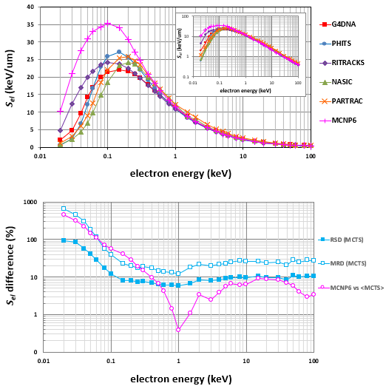

Figure 1. Upper panel: The electronic stopping power ($S_{el}$) of liquid water for electrons in the energy range from 20 eV to 100 keV evaluated by five MCTS codes for liquid water, namely, Geant4-DNA (red boxes), PHITS-ETS (blue dots), RITRACKS (purple diamonds), NASIC (green triangles), and PARTRAC (orange crosses) as well as by the MCNP6 code (magenta pluses), which corresponds to unit-density water vapor. See the main text (section 2.2) for details on the method of evaluation of $S_{el}$. The inset depicts the same data in a log-log plot. Bottom panel: The relative standard deviation ($RSD$) and the maximum relative difference ($MRD$) of the $S_{el}$ values of the five MCTS codes, as well as the relative absolute difference between MCNP6 and the average value of the five MCTS codes.

3.2. Pathlength range data
In the upper panel of Figure 2, we present simulated values of the pathlength range ($R_{path}$) of electrons in liquid water, for initial electron energies ($T_{0}$) from 20 eV to 100 keV, calculated by the five MCTS codes for liquid water (i.e., Geant4-DNA, PHITS-ETS, RITRACKS, NASIC, and PARTRAC) and the MCNP6 code, which corresponds to unit-density water vapor. The calculations of $R_{path}$ are based on Eq. (5) with $T_{cut}=10 eV$. In the bottom panel of Figure 2, the dispersion of the $R_{path}$ values from the five MCTS codes is presented in the form of $RSD$ and $MRD$, along with the relative absolute difference between MCNP6 and the average $R_{path}$ of the five MCTS codes. The reason for the steep fall (from 300% to 10%) of the MCNP6 vs. <MCTS> at 50 eV (bottom panel in Figure 2) is not clear and corresponds to the change of slope of MCNP6’s $R_{path}$ curve (upper panel in Figure 2) in the 50‒60 eV interval. In general, the $R_{path}$ results of MCNP6 below about 100 eV were particularly unstable.

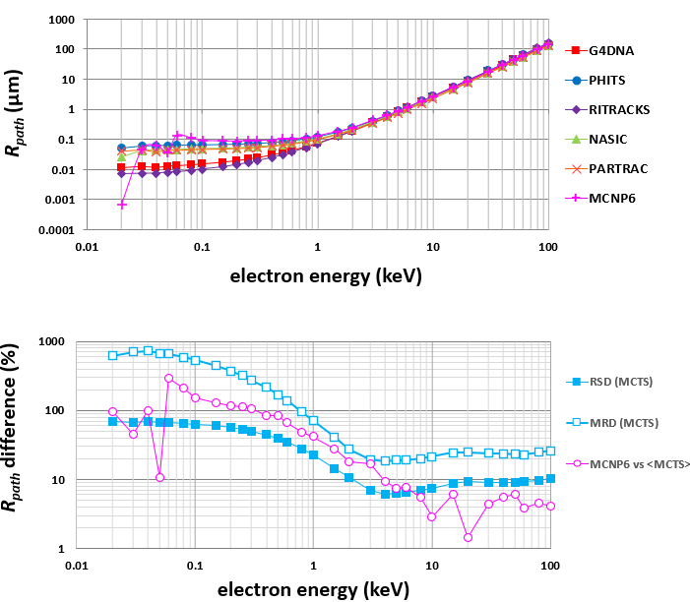

Figure 2. Upper panel: The pathlength range ($R_{path}$) of electrons in liquid water in the energy range from 20 eV to 100 keV evaluated by five MCTS codes for liquid water, namely, Geant4-DNA (red boxes), PHITS-ETS (blue dots), RITRACKS (purple diamonds), NASIC (green triangles), and PARTRAC (orange crosses) as well as by the MCNP6 code (magenta pluses), which corresponds to unit-density water vapor. See the main text (section 2.3) for details on the method of evaluation of $R_{path}$. Bottom panel: The relative standard deviation ($RSD$) and the maximum relative difference ($MRD$) of the $R_{path}$ values of the five MCTS codes, as well as the relative absolute difference between MCNP6 and the average value of the five MCTS codes.

3.3. Absorption range data
In the upper panel of Figure 3, we present simulated values of the electron absorption range ($R_{abs}$) in liquid water for initial electron energies ($T_{0}$) from 20 eV to 100 keV, calculated by the five MCTS codes for liquid water (i.e., Geant4-DNA, PHITS-ETS, RITRACKS, NASIC, and PARTRAC), and the MCNP6 code, which corresponds to unit-density water vapor. The calculations of $R_{abs}$are based on Eq. (8) with $T_{cut}=10 eV$. In the bottom panel of Figure 3, the dispersion of the $R_{abs}$ values from the five MCTS codes is presented in the form of $RSD$ and $MRD$, along with the relative difference between MCNP6 and the average $R_{abs}$ of the five MCTS codes. Similar to Figure 2, there is a steep fall (from 2000% to 400%) of the MCNP6 vs. <MCTS> at 50 eV (bottom panel in Figure 3), which corresponds to the change of slope of MCNP6’s $R_{abs}$ curve (upper panel in Figure 3) in the 50‒60 eV interval. The instability of MCNP6 for $R_{path}$ below about 100 eV (see above), has also been noticed for $R_{abs}$.

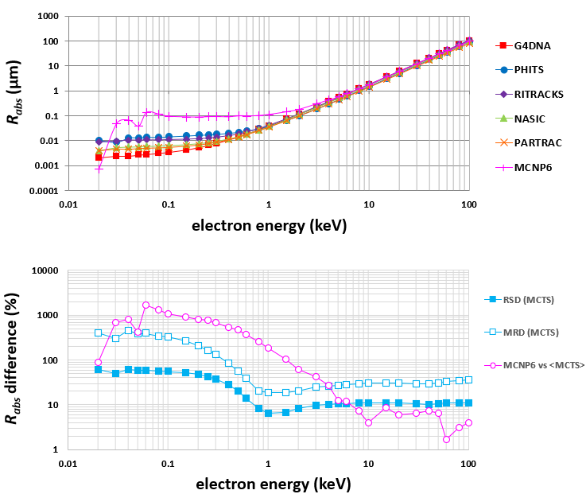

Figure 3. Upper panel: The absorption range ($R_{abs}$) of electrons in liquid water in the energy range from 20 eV to 100 keV evaluated by five MCTS codes for liquid water, namely, Geant4-DNA (red boxes), PHITS-ETS (blue dots), RITRACKS (purple diamonds), NASIC (green triangles), and PARTRAC (orange crosses) as well as by the MCNP6 code (magenta pluses), which corresponds to unit-density water vapor. See the main text (section 2.4) for details on the method of evaluation of $R_{abs}$. Bottom panel: The relative standard deviation ($RSD$) and the maximum relative difference ($MRD$) of the $R_{abs}$ values of the five MCTS codes, as well as the relative absolute difference between MCNP6 and the average value of the five MCTS codes.

3.4. Dose-Point-Kernel data
The DPK distribution as a function of radial distance, $K(r)$, is presented in Figure 4 for different initial electron energies (0.1, 0.5, 1, 10, 100 keV). The calculations of $K(r)$ are based on Eq. (10) with $T_{cut}=10 eV$ for both the primary and all secondary electrons (except for MCNP6’s 100 keV data, which were obtained with $T_{cut}=15 eV$ for increased computing efficiency). Results are presented for five MCTS codes for liquid water (i.e., Geant4-DNA, PHITS-ETS, RITRACKS, NASIC, and PARTRAC) and the MCNP6 code, which corresponds to unit-density water vapor. Although the shape of the DPK profile is similar for all codes, the peak height ($K_{max}$) and peak depth ($d_{peak}$) vary among the codes. Note that the PHITS-ETS results at 100 keV are underneath the NASIC and MCNP6 curves, so they are not visible.

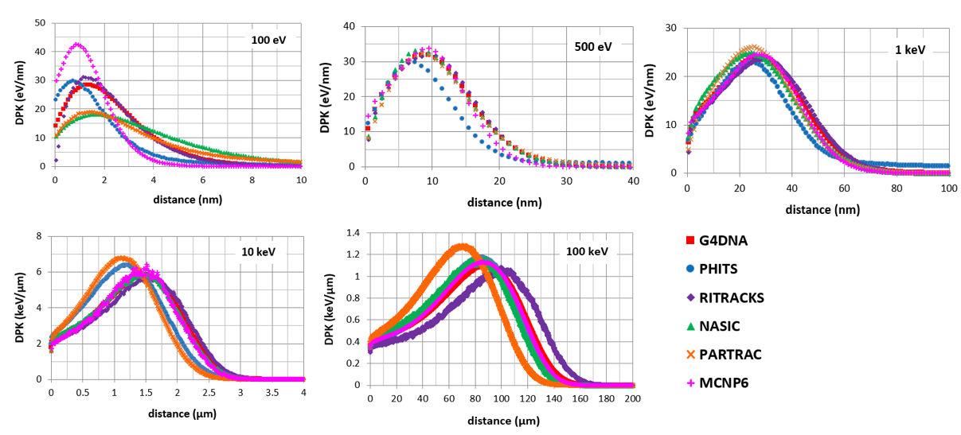

Figure 4. Dose-point-kernel (DPK) distributions, $K(r)$, for electrons in liquid water for different initial electron energies (0.1, 0.5, 1, 10, 100 keV) evaluated by five MCTS codes for liquid water, namely, Geant4-DNA (red boxes), PHITS-ETS (blue dots), RITRACKS (purple diamonds), NASIC (green triangles), and PARTRAC (orange crosses) as well as by the MCNP6 code (magenta pluses), which corresponds to unit-density water vapor. See the main text (section 2.5) for details on the method of evaluation of $K(r)$.
In Figure 5, the dispersion of the $K_{max}$ (upper panel) and $d_{peak}$ (bottom panel) values from the five MCTS codes is presented in the form of $RSD$ and $MRD$, along with the relative absolute differences between MCNP6 and the average $K_{max}$ and $d_{peak}$ of the five MCTS codes.
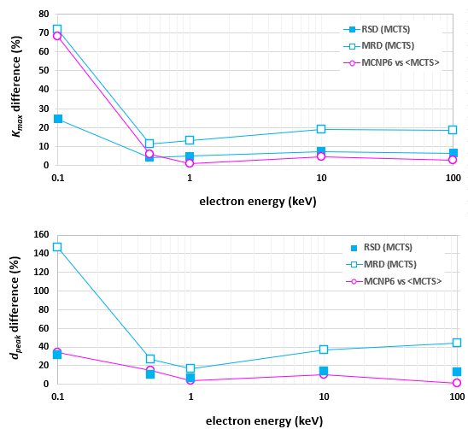

Figure 5. Upper panel: The relative standard deviation ($RSD$) and the maximum relative difference ($MRD$) of DPK’s peak-height ($K_{max}$) values of the five MCTS liquid water codes (Geant4-DNA, PHITS-ETS, RITRACKS, NASIC, PARTRAC) as well as the relative absolute difference between MCNP6 (corresponding to unit-density water vapor) and the average value of the five MCTS liquid water codes. Bottom panel: Same as upper panel but for DPK’s peak-depth ($d_{peak}$).

3.5. Lineal energy data
The microdosimetric quantities ${\overline{y}}_{F}$​ and ${\overline{y}}_{D}$ for initial electron energies ($T_{0}$) from 20 eV to 100 keV, calculated by the five MCTS codes for liquid water (i.e., Geant4-DNA, PHITS-ETS, RITRACKS, NASIC, and PARTRAC) and the MCNP6 code, which corresponds to unit-density water vapor, are presented in Figures 6 and 7, respectively. The calculations of ${\overline{y}}_{F}$​ and ${\overline{y}}_{D}$ are based on either the uniform sampling approach, Eqs (14)-(16), or the weighted sampling approach, Eqs (17)-(19) as indicated in section 2.6. Results are shown for spherical water targets of 2, 10, 100, and 1000 nm diameter. Note that MCNP6 results for the 2 nm sphere are limited up to 2 keV, for the 10 nm up to 5 keV, for the 100 nm up to 20 keV, and for the 1000 nm up to 50 keV. This is because the MCNP6 data are obtained with uniform sampling that becomes very time-consuming for small targets and high energies. The simulation efficiency had to be improved by increasing the electron transport cut-off from 10 eV to 15 eV, although the ${\overline{y}}_{F}$ and ${\overline{y}}_{D}$ increase somewhat due to this. Still, data for higher energies were not possible to obtain within a reasonable time.
In Figure 8, the dispersion of the ${\overline{y}}_{F}$​ (upper panel) and ${\overline{y}}_{D}$ (bottom panel) values from the five MCTS codes is depicted in the form of $RSD$ and $MRD$, along with the relative absolute difference between MCNP6 and the average ${\overline{y}}_{F}$​ and ${\overline{y}}_{D}$​ of the five MCTS codes. The steep increase from 150 to 350% in the $MRD$ of ${\overline{y}}_{F}$​ for the 10 nm sphere between 0.1-1 keV (upper panel in Figure 8) is caused by the difference between the NASIC and PARTRAC codes (left bottom panel in Figure 6).

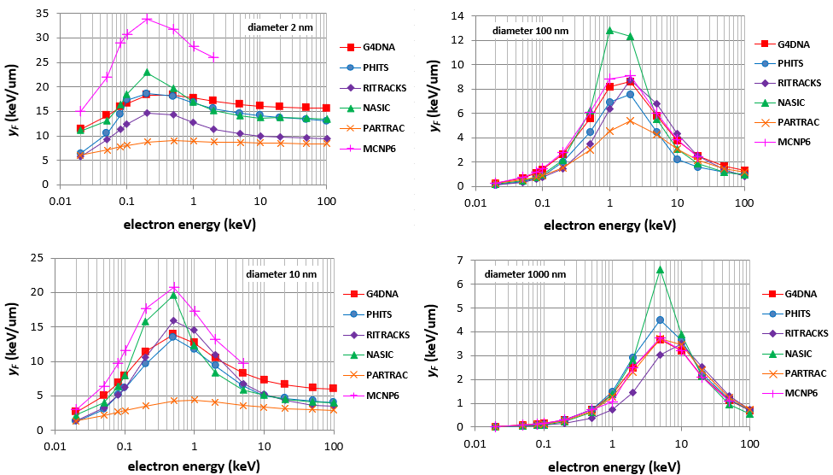

Figure 6. The frequency-mean lineal energy (${\overline{y}}_{F}$) of electrons in liquid water spheres of different diameter (2, 10, 100, 1000 nm) in the energy range from 20 eV to 100 keV evaluated by five MCTS codes for liquid water, namely, Geant4-DNA (red boxes), PHITS-ETS (blue dots), RITRACKS (purple diamonds), NASIC (green triangles), and PARTRAC (orange crosses) as well as by the MCNP6 code (magenta pluses), which corresponds to unit-density water vapor. See the main text (section 2.6) for details on the method of evaluation of ${\overline{y}}_{F}$. Note that the MCNP6 results cover a limited energy range and are obtained with a 15 eV (instead of 10 eV) electron transport cutoff.

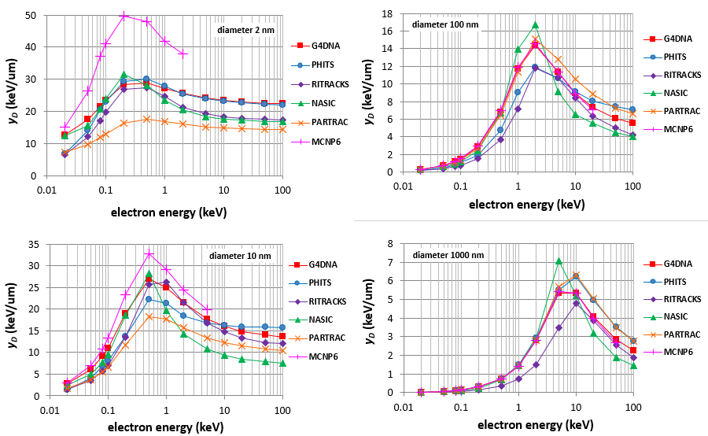

Figure 7. Same as in Fig. 6 for the dose-mean lineal energy (${\overline{y}}_{D}$).

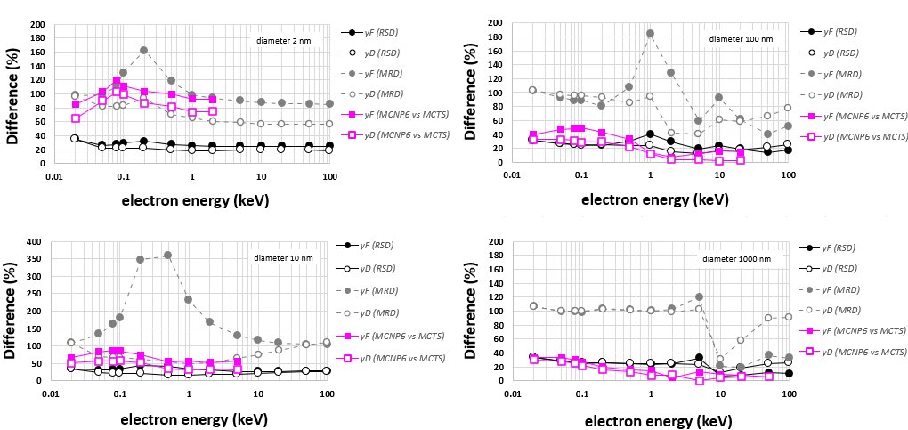

Figure 8. The relative standard deviation ($RSD$) and the maximum relative difference ($MRD$) of the ${\overline{y}}_{F}$ and ${\overline{y}}_{D}$ values of the five MCTS codes for liquid water (Geant4-DNA, PHITS-ETS, RITRACKS, NASIC, PARTRAC) as well as the relative absolute difference between MCNP6 (corresponding to unit-density water vapor) and the average values of the five MCTS codes. Note that the MCNP6 vs. MCTS comparison covers a limited energy range (see text).

3.6. Summary of results
The results depicted in Figures 1‒8 are summarized in Figure 9 (MCNP6 excluded) which presents, for each examined quantity ($S_{el}$, $R_{path}$, $R_{abs}$, $K_{max}$, $d_{peak}$,${\overline{y}}_{F}$​, ${\overline{y}}_{D}$​), the average $RSD$ (upper panel) and the average $MRD$ (bottom panel) over the electron energy intervals (in keV): (0.01, 0.1], (0.1, 1], (1, 10], and (10, 100]. This representation reveals more clearly the energy regime(s) where the dispersion (or uncertainty) in the calculated quantities is higher (or lower). Note that, due to the averaging procedure (within each energy interval), it is expected that for particular electron energies the $RSD$ and/or $MRD$ may be larger than depicted in Figure 9, as can be confirmed by observing Figures 1‒8.

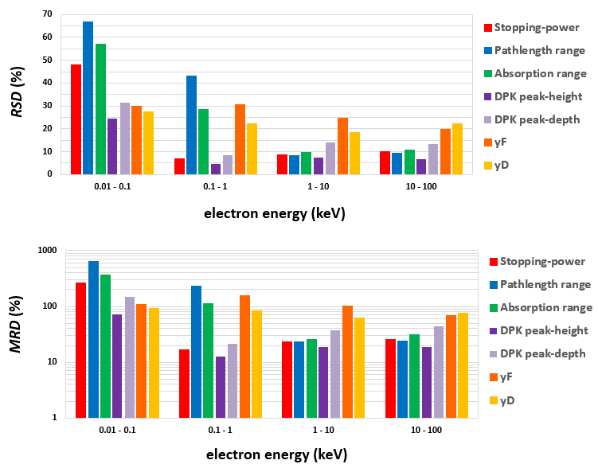

Figure 9. Upper panel: The relative standard deviation ($RSD$) of the examined quantities, namely, the electronic stopping power ($S_{el}$), pathlength range ($R_{path}$), absorption range ($R_{abs}$), DPK peak-height ($K_{max}$), DPK peak-depth ($d_{peak}$), frequency-mean lineal energy (${\overline{y}}_{F}$), and dose-mean lineal energy (${\overline{y}}_{D}$), evaluated by the five MCTS codes for liquid water (Geant4-DNA, PHITS-ETS, RITRACKS, NASIC, PARTRAC) are averaged over the energy intervals (in keV): (0.01, 0.1], (0.1-1], (1, 10], (10, 100]. Bottom panel: Same as upper panel but for the maximum relative difference ($MRD$).

3.7. Comparison with ICRU
A commonly used benchmark for the electronic stopping-power ($S_{el}$) is provided by Bethe’s stopping-power formula. The latter underlines the recommended values published in various ICRU Reports (ICRU 1984,1992,1997,2014). The important outcome of Bethe’s theory is that, for sufficiently high-energy electrons (above ~1‒10 keV), $S_{el}$ can be calculated analytically without explicit knowledge of the ionization and electronic excitation cross sections entering Eq. (1). In Figure 10, the results for $S_{el}$ of the five MCTS codes for liquid water (i.e., Geant4-DNA, PHITS-ETS, RITRACKS, NASIC, and PARTRAC) and the MCNP6 code, which corresponds to unit-density water vapor, are compared against ICRU’s most recent values (ICRU 2014). The comparison is limited to the 1‒100 keV energy range, since ICRU does not provide $S_{el}$ values for electrons below 1 keV due to the inherent limitations of the Bethe formula. According to ICRU Report 90 (ICRU 2014), for low-Z materials, the $S_{el}$ values calculated by the Bethe formula have an uncertainty of 1.5‒5% for $1≤T≤10 keV$, 1‒1.5% for $10≤T≤100 keV$, and 0.5‒1% for $T>100 keV$.
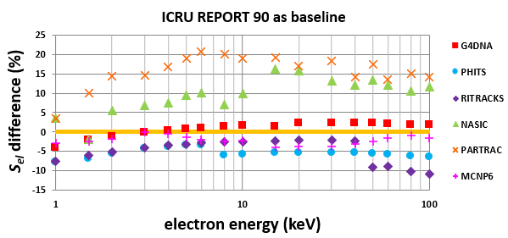
Figure 10. Percentage difference of the electronic stopping power ($S_{el}$) of liquid water for electrons evaluated by the five MCTS codes for liquid water (Geant4-DNA, PHITS-ETS, RITRACKS, NASIC, PARTRAC) and the MCNP6 code, which corresponds to unit-density water vapor, against ICRU’s recommended values (ICRU 2014). See the main text (section 2.2) for details on the methods of evaluation of $S_{el}$.

Similarly, the pathlength ($R_{path}$) is commonly benchmarked against the continuous-slowing-down-approximation range ($R_{csda}$) evaluated by Eq. (6). ICRU provides $R_{csda}$ data calculated by Eq. (7) for electron energies above 1 keV (ICRU 2014). Due to the low-energy interpolation of $S_{Bethe}^{-1}$ (from 1 keV down to 0 eV) in Eq. (7), the accuracy of ICRU’s $R_{csda}$ calculations deteriorates when the residual $R_{csda}$ at 1 keV is a significant fraction of the total $R_{csda}$ (see section 2.3). Thus, ICRU’s $R_{csda}$ values for electron energies below a few keV should be considered qualitative. For this reason, the comparison of Figure 11 is limited to energies above 10 keV, where ICRU’s $R_{csda}$ value may be considered reliable with an uncertainty similar to $S_{el}$, i.e., at the 1‒5% level.
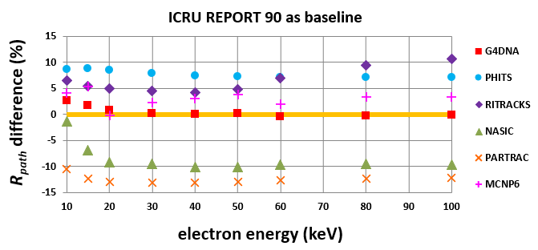
Figure 11. Percentage difference of the pathlength range ($R_{path}$) of electrons in liquid water evaluated by the five MCTS codes for liquid water (Geant4-DNA, PHITS-ETS, RITRACKS, NASIC, PARTRAC) and the MCNP6 code, which corresponds to unit-density water vapor, against ICRU’s values for the continuous-slowing-down-approximation range ($R_{csda}$) (ICRU 2014). See the main text (section 2.3) for details on the methods of evaluation of $R_{path}$ and $R_{csda}$.

4. Discussion
The comparison of the electronic stopping power ($S_{el}$) and pathlength range ($R_{path}$) in Figures 1 and 2 reflects differences in the inelastic cross sections (for ionization and electronic excitation) used by the codes, since elastic collisions do not influence the calculation of either $S_{el}$ or $R_{path}$. The dispersion of the $S_{el}$ and $R_{path}$ values (quantified by the $RSD$ and $MRD$) of the five MCTS codes for liquid water is rather constant above 1‒10 keV but increases rapidly at lower energies. Specifically, the $RSD$ is about 5‒10% for energies above a few keV and reaches ~100% at sub-100 eV energies. As expected, the $MRD$ is larger than the $RSD$; however, it exhibits a similar trend, i.e., it is almost constant at about 20‒30% above a few keV but increases up to ~700% at sub-100 eV energies. The results regarding the absorption range, $R_{abs}$ (see Figure 3), share similar trends to the results of $R_{path}$, despite the fact that $R_{abs}$ depends also on the elastic cross sections. It is evident from the above results that our understanding of some of the most fundamental electron transport quantities, like $S_{el}$, $R_{path}$, and $R_{abs}$, are particularly uncertain (by ~100% or more) at low energies, especially below 100 eV. In regards to $S_{el}$, $R_{path}$, and $R_{abs}$, the difference between MCNP6, which corresponds to unit-density water vapor, and the average prediction of the five MCTS codes for liquid water is up to 10% above 1‒10 keV but increases up to ~1000% at sub-100 eV energies. These very large differences at low energies could be attributed to phase-effects (liquid versus gaseous water at same density) in the interaction cross sections used by MCNP6 and the liquid water codes. However, for the $S_{el}$ in particular, the MCNP6 calculations are based on the track-segment approach which may also introduce some systematic uncertainties at low energies (see section 2.2).
Contrary to the above quantities ($S_{el}$, $R_{path}$, and $R_{abs}$) which depend upon the transport of the primary electron, the DPK distribution, $K(r)$, depends also on the secondary electron spectra. Although the shape of the DPK profiles is very similar among all the codes examined (see Figure 4), differences in both the peak height ($K_{max}$) and the peak depth ($d_{peak}$) are evident. A quantification of these differences (see Figures 5) reveals that, overall, the dispersion of $K_{max}$ and $d_{peak}$ values among the five MCTS codes are rather moderate between 0.5‒100 keV with the $RSD$ being up to 15% and the $MRD$ up to 40%. However, for the 100 eV electron energy, the $RSD$ increases to 25% ($K_{max}$) and 30% ($d_{peak}$), and the $MRD$ to 70% ($K_{max}$) and 150% ($d_{peak}$). Similarly, the difference between MCNP6 and the average $K_{max}$ and $d_{peak}$ of the five MCTS codes is only up to 15% between 0.5‒100 keV, but increases to 70% ($K_{max}$) and 35% ($d_{peak}$) for the 100 eV electron energy.
Concerning the microdosimetric quantities (${\overline{y}}_{F}$ and ${\overline{y}}_{D}$​) (see Figures 6 and 7), significant differences are observed among the five MCTS codes for liquid water with the $RSD$ being up to 40% and the $MRD$ up to 100‒400% (see Figure 8). In general, the dispersion of ${\overline{y}}_{D}$ is smaller than for ${\overline{y}}_{F}$. Interestingly, and perhaps contrary to expectation, the dispersion of ${\overline{y}}_{F}$ and ${\overline{y}}_{D}$ shows a weak dependence on sphere diameter. On the other hand, the difference between the MCNP6 code and the average values of the five MCTS codes exhibits a strong dependence on sphere size (see Figure 8). For example, for the larger spheres (i.e., 100 and 1000 nm), the ${\overline{y}}_{F}$ and ${\overline{y}}_{D}$ values of the MCNP6 code are comparable to those of the five MCTS codes, with the difference being similar to the corresponding $RSD$, whereas for the smaller spheres (i.e., 2 and 10 nm), MCNP6 overestimates the predictions of the five MCTS codes, with the difference being now comparable to the corresponding $MRD$. The influence of the different electron transport cut-off used in the MCNP6 calculations (15 eV instead of 10 eV) can of course not be neglected, although not quantified in this work.
The $RSD$ and $MRD$ for each of the examined quantities (i.e., $S_{el}$, $R_{path}$, $R_{abs}$, $K_{max}$, $d_{peak}$, ${\overline{y}}_{F}$, and ${\overline{y}}_{D}$) averaged over the energy intervals shown in Figure 9, reveal that the dispersion of the results of the five MCTS codes is almost steady for energies above 100 eV but exhibits (for all the examined quantities) an upward shift at the sub-100 eV energy interval where the $RSD$ increases to ~25‒65% and the $MRD$ to ~70‒700%; the exact value depends upon the particular quantity. It is worth noting that, even at the “high” energy interval (10‒100 keV), both the $RSD$ and $MRD$ remain sizeable, i.e., varying between ~5‒20% and ~20‒70%, respectively.
A useful benchmarking for the performance of MCTS codes at moderate-high electron energies (>1 keV) is offered by the ICRU data for the $S_{el}$ and $R_{csda}$. The ICRU data for $S_{el}$ are based on calculations using the Bethe formula and are considered accurate to within 1 to 5%; specifically, the reported uncertainty by ICRU is 1.5‒5% for $1≤T≤10 keV$ and 1‒1.5% for $10≤T≤100 keV$ (ICRU 2014). The ICRU data for $R_{csda}$ are based on calculations using Eq. (6). The uncertainty of ICRU’s $R_{csda}$ values is difficult to estimate but it may be considered similar to ICRU’s $S_{el}$ values, as long as the electron energy is well above 1 keV (see sections 2.3 and 3.8). Based on the results shown in Figure 10, the average (and maximum) deviation of the examined codes from ICRU’s $S_{el}$ values from 1 to 100 keV is: 1.7% (4.0%) for Geant4-DNA, 2.1% (3.8%) for MCNP6, 5.0% (10.7%) for RITRACKS, 5.5% (7.8%) for PHITS-ETS, 9.8% (16.1%) for NASIC, and 15.7% (20.1%) for PARTRAC. The corresponding average deviation from ICRU’s $R_{csda}$ values from 10 to 100 keV is: 0.7% (2.7%) for Geant4-DNA, 3.1% (5.4%) for MCNP6, 6.4% (10.7%) for RITRACKS, 7.8% (8.9%) for PHITS-ETS, 8.4% (10.1%) for NASIC, and 12.4% (13.1%) for PARTRAC (see Figure 11). Thus, all codes are in good agreement with the ICRU data for $S_{el}$ and $R_{csda}$. However, this finding should be interpreted with caution, since the consistency of a code with ICRU data, which cover energies above 1‒10 keV, does not guarantee its good performance at lower energies, especially below 100 eV.

5. Conclusion
Electron transport calculations by five MCTS codes, which have been developed specifically for liquid water (i.e., Geant4-DNA, PHITS-ETS, RITRACKS, NASIC, and PARTRAC), revealed that, for electron energies above 1‒10 keV the dispersion of the results is moderate (on average ~20‒30%) but increases rapidly at sub-100 eV energies where differences between codes may reach ~100‒1000%. This level of uncertainty, due to the use of different MCTS codes, compromises our understanding of radiation-induced effects at the nanometer scale (including radiochemical yields, DNA damage, etc.), where low-energy electrons (mostly below ~100 eV) play a key role. The results by the MCNP6 code, which correspond to unit-density water vapor, are comparable to those of the MCTS liquid water codes, except for energies below 0.1‒1 keV and/or nanometer targets where differences may reach (or exceed) ~100%. The results clearly indicate that efforts to further develop the physics models for liquid water used in MCTS codes and reduce the uncertainties associated with low-energy electron transport calculations in liquid water are still well-justified and should be given due priority.

Acknowledgement
The work of I.K., A.P., I.P., C.K. and D.E. is supported by grants from the H.F.R.I. call “Basic research Funding (Horizontal support of all Sciences)” under the National Recovery and Resilience Plan Greece 2.0 funded by the European Union- NextGenerationEU (H.F.R.I. Project Number: 15283) and the European Space Agency (ESA) via the Open Space Innovation Platform as a Co-Sponsored Research Agreement and carried out under the Discovery program (Grant number 4000147290). The work of I.P. was performed under NASA contract NNJ15HK11B.

References

Agostinelli S, Allison J, Amako K, Apostolakis J, Araujo H, Arce P, Asai M, Axen D, Banerjee S, Barrand G, Behner F, Bellagamba L, Boudreau J, Broglia L, Brunengo A, Burkhardt H, Chauvie S, Chuma J, Chytracek R, Cooperman G, Cosmo G, Degtyarenko P, Dell’Acqua A, Depaola G, Dietrich D, Enami R, Feliciello A, Ferguson C, Fesefeldt H, Folger G, Foppiano F, Forti A, Garelli S, Giani S, Giannitrapani R, Gibin D, Gómez Cadenas J J, González I, Gracia Abril G, Greeniaus G, Greiner W, Grichine V, Grossheim A, Guatelli S, Gumplinger P, Hamatsu R, Hashimoto K, Hasui H, Heikkinen A, Howard A, Ivanchenko V, Johnson A, Jones F W, Kallenbach J, Kanaya N, Kawabata M, Kawabata Y, Kawaguti M, Kelner S, Kent P, Kimura A, Kodama T, Kokoulin R, Kossov M, Kurashige H, Lamanna E, Lampén T, Lara V, Lefebure V, Lei F, Liendl M, Lockman W, Longo F, Magni S, Maire M, Medernach E, Minamimoto K, Mora De Freitas P, Morita Y, Murakami K, Nagamatu M, Nartallo R, Nieminen P, Nishimura T, Ohtsubo K, Okamura M, O’Neale S, Oohata Y, Paech K, Perl J, Pfeiffer A, Pia M G, Ranjard F, Rybin A, Sadilov S, Di Salvo E, Santin G, Sasaki T, et al 2003 Geant4—a simulation toolkit Nuclear Instruments and Methods in Physics Research Section A: Accelerators, Spectrometers, Detectors and Associated Equipment 506 250–303
Allison J, Amako K, Apostolakis J, Araujo H, Arce Dubois P, Asai M, Barrand G, Capra R, Chauvie S, Chytracek R, Cirrone G A P, Cooperman G, Cosmo G, Cuttone G, Daquino G G, Donszelmann M, Dressel M, Folger G, Foppiano F, Generowicz J, Grichine V, Guatelli S, Gumplinger P, Heikkinen A, Hrivnacova I, Howard A, Incerti S, Ivanchenko V, Johnson T, Jones F, Koi T, Kokoulin R, Kossov M, Kurashige H, Lara V, Larsson S, Lei F, Link O, Longo F, Maire M, Mantero A, Mascialino B, McLaren I, Mendez Lorenzo P, Minamimoto K, Murakami K, Nieminen P, Pandola L, Parlati S, Peralta L, Perl J, Pfeiffer A, Pia M G, Ribon A, Rodrigues P, Russo G, Sadilov S, Santin G, Sasaki T, Smith D, Starkov N, Tanaka S, Tcherniaev E, Tome B, Trindade A, Truscott P, Urban L, Verderi M, Walkden A, Wellisch J P, Williams D C, Wright D and Yoshida H 2006 Geant4 developments and applications IEEE Trans. Nucl. Sci. 53 270–8
Allison J, Amako K, Apostolakis J, Arce P, Asai M, Aso T, Bagli E, Bagulya A, Banerjee S, Barrand G, Beck B R, Bogdanov A G, Brandt D, Brown J M C, Burkhardt H, Canal Ph, Cano-Ott D, Chauvie S, Cho K, Cirrone G A P, Cooperman G, Cortés-Giraldo M A, Cosmo G, Cuttone G, Depaola G, Desorgher L, Dong X, Dotti A, Elvira V D, Folger G, Francis Z, Galoyan A, Garnier L, Gayer M, Genser K L, Grichine V M, Guatelli S, Guèye P, Gumplinger P, Howard A S, Hřivnáčová I, Hwang S, Incerti S, Ivanchenko A, Ivanchenko V N, Jones F W, Jun S Y, Kaitaniemi P, Karakatsanis N, Karamitros M, Kelsey M, Kimura A, Koi T, Kurashige H, Lechner A, Lee S B, Longo F, Maire M, Mancusi D, Mantero A, Mendoza E, Morgan B, Murakami K, Nikitina T, Pandola L, Paprocki P, Perl J, Petrović I, Pia M G, Pokorski W, Quesada J M, Raine M, Reis M A, Ribon A, Ristić Fira A, Romano F, Russo G, Santin G, Sasaki T, Sawkey D, Shin J I, Strakovsky I I, Taborda A, Tanaka S, Tomé B, Toshito T, Tran H N, Truscott P R, Urban L, Uzhinsky V, Verbeke J M, Verderi M, Wendt B L, Wenzel H, Wright D H, Wright D M, Yamashita T, Yarba J, et al 2016 Recent developments in Geant4 Nuclear Instruments and Methods in Physics Research Section A: Accelerators, Spectrometers, Detectors and Associated Equipment 835 186–225
Apostolakis J, Asai M, Bogdanov A G, Burkhardt H, Cosmo G, Elles S, Folger G, Grichine V M, Gumplinger P, Heikkinen A, Hrivnacova I, Ivanchenko V N, Jacquemier J, Koi T, Kokoulin R P, Kossov M, Kurashige H, McLaren I, Link O, Maire M, Pokorski W, Sasaki T, Starkov N, Urban L and Wright D H 2009 Geometry and physics of the Geant4 toolkit for high and medium energy applications Radiation Physics and Chemistry 78 859–73
Baiocco G, Bartzsch S, Conte V, Friedrich T, Jakob B, Tartas A., Villagrasa C, Prise K M 2022 A matter of space: how the spatial heterogeneity in energy deposition determines the biological outcome of radiation exposure Radiation and Environmental Biophysics 61 545–559
Bernal M A, Bordage M C, Brown J M C, Davídková M, Delage E, El Bitar Z, Enger S A, Francis Z, Guatelli S, Ivanchenko V N, Karamitros M, Kyriakou I, Maigne L, Meylan S, Murakami K, Okada S, Payno H, Perrot Y, Petrovic I, Pham Q T, Ristic-Fira A, Sasaki T, Štěpán V, Tran H N, Villagrasa C and Incerti S 2015 Track structure modeling in liquid water: A review of the Geant4-DNA very low energy extension of the Geant4 Monte Carlo simulation toolkit Physica Medica 31 861–74
Braby L A, Conte V, Dingfelder M, Goodhead D T, Pinsky L S, Rosenfeld A B, Sato T, Waker A J, Guatelli S, Magrin G, Menzel H-G, Brandan M-E and Olko P 2023 ICRU Report 98, Stochastic Nature of Radiation Interactions: Microdosimetry J. ICRU 23 1–168
Champion C, Le Loirec C, and Stosic B 2011 EPOTRAN: A full-differential Monte Carlo code for electron and positron transport in liquid and gaseous water. International Journal of Radiation Biology 88 54–61.
Chatzipapas K P, Papadimitroulas P, Emfietzoglou D, Kalospyros S A, Hada M, Georgakilas A G and Kagadis G C 2020 Ionizing Radiation and Complex DNA Damage: Quantifying the Radiobiological Damage Using Monte Carlo Simulations Cancers 12 799
De Vera P and Garcia-Molina R 2019 Electron Inelastic Mean Free Paths in Condensed Matter Down to a Few Electronvolts J. Phys. Chem. C 123 2075–83
De Vera P, Abril I, and Garcia-Molina R 2021 Excitation and ionisation cross-sections in condensed-phase biomaterials by electrons down to very low energy: application to liquid water and genetic building blocks Phys. Chem. Chem. Phys. 23, 5079-5095
Di Maria S, Belchior A, Pereira E, Quental L, Oliveira M C, Mendes F, Lavrado J, Paulo A and Vaz P 2017 Dosimetry assessment of DNA damage by Auger-emitting radionuclides: Experimental and Monte Carlo studies Radiation Physics and Chemistry 140 278–82
Dingfelder M 2006 Track structure: time evolution from physics to chemistry Radiation Protection Dosimetry 122 16–21
Dingfelder M 2014 Updated model for dielectric response function of liquid water Applied Radiation and Isotopes 83 142–7
Dingfelder M, Hantke D, Inokuti M and Paretzke H G 1998 Electron inelastic-scattering cross sections in liquid water Radiation Physics and Chemistry 53 1–18
Dingfelder M, Ritchie R H, Turner J E, Friedland W, Paretzke H G and Hamm R N 2008 Comparisons of Calculations with PARTRAC and NOREC: Transport of Electrons in Liquid Water Radiation Research 169 584–94
Dingfelder M, Travia A, McLawhorn R A, Shinpaugh J L and Toburen L H 2008 Electron emission from foils and biological materials after proton impact Radiation Physics and Chemistry 77 1213–7
Emfietzoglou D and Nikjoo H 2005 The Effect of Model Approximations on Single-Collision Distributions of Low-Energy Electrons in Liquid Water Radiation Research 163 98–111
Emfietzoglou D, Cucinotta F A and Nikjoo H 2005 A Complete Dielectric Response Model for Liquid Water: A Solution of the Bethe Ridge Problem Radiation Research 164 202–11
Emfietzoglou D and Nikjoo H 2007 Accurate electron inelastic cross sections and stopping
powers for liquid water over the 0.1-10 keV range based on an improved dielectric
description of the Bethe surface Radiation Research 167 110-120
Emfietzoglou D, Kyriakou I, Abril I, Garcia-Molina R and Nikjoo H 2012 Inelastic scattering of low-energy electrons in liquid water computed from optical-data models of the Bethe surface International Journal of Radiation Biology 88 22–8
Emfietzoglou D, Kyriakou I, Garcia‐Molina R and Abril I 2017a Inelastic mean free path of low‐energy electrons in condensed media: beyond the standard models Surface & Interface Analysis 49 4–10
Emfietzoglou D, Kyriakou I, Garcia-Molina R, Abril I and Nikjoo H 2013 Inelastic Cross Sections for Low-Energy Electrons in Liquid Water: Exchange and Correlation Effects Radiation Research 180 499–513
Emfietzoglou D, Papamichael G and Nikjoo H 2017b Monte Carlo Electron Track Structure Calculations in Liquid Water Using a New Model Dielectric Response Function Radiation Research 188 355–68
Fano U 1963 Penetration of Protons, Alpha Particles, and Mesons Annu. Rev. Nucl. Sci. 13 1–66
Fernández-Varea J M 1998 Monte Carlo simulation of the inelastic scattering of electrons and positrons using optical-data models Radiation Physics and Chemistry 53 235–45
Fernández-Varea J M, Salvat F, Dingfelder M, Liljequist D 2005 A relativistic optical-data model for inelastic scattering of electrons and positrons in condensed matter Nucl Instrum Meth B 229 187-218
Friedland W and Kundrát P 2013 Track structure based modelling of chromosome aberrations after photon and alpha-particle irradiation Mutation Research/Genetic Toxicology and Environmental Mutagenesis 756 213–23
Friedland W, Dingfelder M, Kundrát P and Jacob P 2011a Track structures, DNA targets and radiation effects in the biophysical Monte Carlo simulation code PARTRAC Mutation Research/Fundamental and Molecular Mechanisms of Mutagenesis 711 28–40
Friedland W, Jacob P and Kundrat P 2011b Mechanistic simulation of radiation damage to DNA and its repair: on the track towards systems radiation biology modelling Radiation Protection Dosimetry 143 542–8
Friedland W, Schmitt E, Kundrát P, Dingfelder M, Baiocco G, Barbieri S and Ottolenghi A 2017 Comprehensive track-structure based evaluation of DNA damage by light ions from radiotherapy-relevant energies down to stopping Sci Rep 7 45161
Garcia‐Molina R, Abril I, Kyriakou I and Emfietzoglou D 2017 Inelastic scattering and energy loss of swift electron beams in biologically relevant materials Surface & Interface Analysis 49 11–7
Goodhead D T 1994 Initial Events in the Cellular Effects of Ionizing Radiations: Clustered Damage in DNA International Journal of Radiation Biology 65 7–17
Goodhead D T 2021 Particle Track Structure and Biological Implications. In: Young, L.R., Sutton, J.P. (eds) Handbook of Bioastronautics. Springer, Cham.
Goodhead D T, Weinfeld M 2024 Clustered DNA Damage and its Complexity: Tracking the History Radiat. Res. 202 385-407.
Hill M A 2018 Track to the future: historical perspective on the importance of radiation track structure and DNA as a radiobiological target International Journal of Radiation Biology 94 759-768
Hughes G 2014 Recent developments in low-energy electron/photon transport for MCNP6 Progress in Nuclear Science and Technology 4 454–8
ICRU 1983. International Commission on Radiation Units and Measurement, Microdosimetry, ICRU Report 36, Bethesda, MD
ICRU 1984 ICRU Report 37: Stopping Powers for Electrons and Positrons (Bethesda, MD: International Commission on Radiation Units and Measurements)
ICRU 1992 ICRU Report 42: Use of Computers in External Beam Radiotherapy Procedures with High-Energy Photons and Electrons (Bethesda, MD: International Commission on Radiation Units and Measurements)
ICRU 1997 ICRU Report 56: Dosimetry of External Beta Rays for Radiation Protection (Bethesda, MD: International Commission on Radiation Units and Measurements)
ICRU 2014 ICRU Report 90: Key Data for Ionizing-Radiation Dosimetry (Bethesda, MD: International Commission on Radiation Units and Measurements)
ICRU 2021 ICRU Report 96: Dosimetry – Prescribing, Recording, and Reporting Radiation Therapy (ICRU Report 96) (Bethesda, MD: International Commission on Radiation Units and Measurements)
ICRU 2023 ICRU Report 98: Radiation Dose and Dose Rate Effects: Radiosensitivity of the Human Organism (Bethesda, MD: International Commission on Radiation Units and Measurements)
Incerti S, Baldacchino G, Bernal M, Capra R, Champion C, Francis Z, Guèye P, Mantero A, Mascialino B, Moretto P, Nieminen P, Villagrasa C and Zacharatou C 2010 THE GEANT4-DNA PROJECT Int. J. Model. Simul. Sci. Comput. 01 157–78
Incerti S, Ivanchenko A, Karamitros M, Mantero A, Moretto P, Tran H N, Mascialino B, Champion C, Ivanchenko V N, Bernal M A, Francis Z, Villagrasa C, Baldacchino G, Guèye P, Capra R, Nieminen P and Zacharatou C 2010 Comparison of GEANT4 very low energy cross section models with experimental data in water Medical Physics 37 4692–708
Incerti S, Kyriakou I, Bernal M A, Bordage M C, Francis Z, Guatelli S, Ivanchenko V, Karamitros M, Lampe N, Lee S B, Meylan S, Min C H, Shin W G, Nieminen P, Sakata D, Tang N, Villagrasa C, Tran H N and Brown J M C 2018 Geant4‐DNA example applications for track structure simulations in liquid water: A report from the Geant4‐DNA Project Medical Physics 45 Online: https://aapm.onlinelibrary.wiley.com/doi/10.1002/mp.13048
Inokuti M 1971 Inelastic Collisions of Fast Charged Particles with Atoms and Molecules—The Bethe Theory Revisited Rev. Mod. Phys. 43 297–347
Koval N E, Koval P, Da Pieve F, Kohanoff J, Artacho E and Emfietzoglou D 2022 Inelastic scattering of electrons in water from first principles: cross sections and inelastic mean free path for use in Monte Carlo track-structure simulations of biological damage R. Soc. open sci. 9 212011
Kulesza J, Adams T, Armstrong J, Bolding S, Brown F, Bull J, Burke T, Clark A, Forster Iii R, Giron J, Grieve T, Josey C, Martz R, McKinney G, Pearson E, Rising M, Solomon Jr. C, Swaminarayan S, Trahan T, Wilson S and Zukaitis A 2022 MCNP® Code Version 6.3.0 Theory & User Manual Online: https://www.osti.gov/servlets/purl/1889957/
Kyriakou I, Emfietzoglou D and Incerti S 2022 Status and Extension of the Geant4-DNA Dielectric Models for Application to Electron Transport Front. Phys. 9 711317
Li J, Li C, Qiu R, Yan C, Xie W, Wu Z, Zeng Z and Tung C 2015 DNA strand breaks induced by electrons simulated with Nanodosimetry Monte Carlo Simulation Code: NASIC Radiat Prot Dosimetry 166 38–43
Lillhök J, Billnert-Maróti R and Anastasiadis A 2022 MCNP 6.2 simulations of energy deposition in low-density volumes corresponding to unit-density volumes on the nanometre level Radiation Measurements 157 106831
Matsuya Y, Kai T, Sato T, Ogawa T, Hirata Y, Yoshii Y, Parisi A and Liamsuwan T 2022 Track-structure modes in particle and heavy ion transport code system (PHITS): application to radiobiological research International Journal of Radiation Biology 98 148–57
Michael B D and O’Neill P 2000 A Sting in the Tail of Electron Tracks Science 287 1603–4
NCRP 2018 Evaluation of the relative effectiveness of low-energy photons and electrons in inducing cancer in humans (Bethesda, Maryland: National Council on Radiation Protection and Measurements)
Nguyen-Truong H T 2015 Penn Algorithm Including Damping for Calculating the Electron Inelastic Mean Free Path J. Phys. Chem. C 119 7883–7
Nguyen-Truong H T 2018 Low-energy electron inelastic mean free paths for liquid water J. Phys.: Condens. Matter 30 155101
Nikjoo H and Goodhead D T 1991 Track structure analysis illustrating the prominent role of low-energy electrons in radiobiological effects of low-LET radiations Phys. Med. Biol. 36 229–38
Nikjoo H, Emfietzoglou D, Liamsuwan T, Taleei R, Liljequist D and Uehara S 2016 Radiation track, DNA damage and response—a review Rep. Prog. Phys. 79 116601
Nikjoo H, O’Neill P, Terrissol M and Goodhead D T 1999 Quantitative modelling of DNA damage using Monte Carlo track structure method Radiation and Environmental Biophysics 38 31–8
Nikjoo H, O’Neill P, Wilson W E and Goodhead D T 2001 Computational Approach for Determining the Spectrum of DNA Damage Induced by Ionizing Radiation Radiation Research 156 577–83
Nikjoo S. Uehara W. E. Wilson M. Ho H 1998 Track structure in radiation biology: theory and applications International Journal of Radiation Biology 73 355–64
Plante I and A. F 2011 Monte-Carlo Simulation of Ionizing Radiation Tracks Applications of Monte Carlo Methods in Biology, Medicine and Other Fields of Science ed C J Mode (InTech) Online: http://www.intechopen.com/books/applications-of-monte-carlo-methods-in-biology-medicine-and-other-fields-of-science/monte-carlo-simulation-of-ionizing-radiation-tracks
Plante I, Slaba T, Shavers Z and Hada M 2019 A Bi-Exponential Repair Algorithm for Radiation-Induced Double-Strand Breaks: Application to Simulation of Chromosome Aberrations Genes (Basel) 10 936
Plante I, West D W, Weeks J and Risca V I 2024 Simulation of Radiation-Induced DNA Damage and Protection by Histones Using the Code RITRACKS BioTech 13 17
Rising M, Armstrong J, Bolding S, Brown F, Bull J, Burke T, Clark A, Dixon D, Forster Iii R, Giron J, Grieve T, Hughes Iii H, Josey C, Kulesza J, Martz R, McCartney A, McKinney G, Mosher S, Pearson E, Solomon Jr. C, Swaminarayan S, Sweezy J, Wilson S and Zukaitis A 2023 MCNP® Code V.6.3.0 Release Notes Online: https://www.osti.gov/servlets/purl/1909545/
Sakata D, Belov O, Bordage M-C, Emfietzoglou D, Guatelli S, Inaniwa T, Ivanchenko V, Karamitros M, Kyriakou I, Lampe N, Petrovic I, Ristic-Fira A, Shin W-G and Incerti S 2020 Fully integrated Monte Carlo simulation for evaluating radiation induced DNA damage and subsequent repair using Geant4-DNA Sci Rep 10 20788
Sakata D, Suzuki M, Hirayama R, Abe Y, Muramatsu M, Sato S, Belov O, Kyriakou I, Emfietzoglou D, Guatelli S, Incerti S and Inaniwa T 2021 Performance Evaluation for Repair of HSGc-C5 Carcinoma Cell Using Geant4-DNA Cancers 13 6046
Salvat F and Fernández-Varea J M 2009 Overview of physical interaction models for photon and electron transport used in Monte Carlo codes Metrologia 46 S112–38
Sato T, Iwamoto Y, Hashimoto S, Ogawa T, Furuta T, Abe S-I, Kai T, Matsuya Y, Matsuda N, Hirata Y, Sekikawa T, Yao L, Tsai P-E, Ratliff H N, Iwase H, Sakaki Y, Sugihara K, Shigyo N, Sihver L and Niita K 2024 Recent improvements of the particle and heavy ion transport code system – PHITS version 3.33 Journal of Nuclear Science and Technology 61 127–35
Tang N, Bueno M, Meylan S, Perrot Y, Tran H N, Freneau A, Dos Santos M, Vaurijoux A, Gruel G, Bernal M A, Bordage M-C, Emfietzoglou D, Francis Z, Guatelli S, Ivanchenko V, Karamitros M, Kyriakou I, Shin W-G, Incerti S and Villagrasa C 2019 Assessment of Radio-Induced Damage in Endothelial Cells Irradiated with 40 kVp, 220 kVp, and 4 MV X-rays by Means of Micro and Nanodosimetric Calculations Int J Mol Sci 20 6204
Tanuma S, Powell C J, Penn D R 2011 Calculation of electron inelastic mean free paths (IMFPs) IX. Data for 41 elemental solids over the 50 eV to 30 keV range Surf Interf Anal 43 689-713
Uehara S, Nikjoo H and Goodhead D T 1999 Comparison and assessment of electron cross sections for Monte Carlo track structure codes Radiat Res 152 202–13

