[SSC25-XX-XX]

TES-11 GOES DCS Demonstration: A Novel LEO-to-GEO Communication System for Nanosatellites

Marcus S. Murbach
Spaceflight Projects Office, NASA Ames Research Center
Moffett Field, CA, USA 94035; (650) 604-3155
marcus.s.murbach@nasa.gov

Beau Backus
JHU APL for NOAA
Silver Springs, MD
beau.backus@noaa.gov

Brett H. Betsill
Microcom Environmental
Hunt Valley, MD
bbetsill@microcomdesign.com

David B. Kunkee, Ph.D.
The Aerospace Corporation
Chantilly, VA
david.b.kunkee@aero.org

Thom Stone, Alejandro Salas, Malachi Mooney-Rivkin, Vasant Chalemcherla
Millennium Engineering and Integration
NASA Ames Research Center
M/S 244-19, Moffett Field, CA, USA 94035

ABSTRACT
A satellite in any low Earth orbit (LEO), with access to various geostationary Earth orbit (GEO) satellites, could have a near constant, low bandwidth, real-time link back to Earth during most of an orbit. These GEO satellites could include the two GOES, steadily refreshed since 1974, the European Space Agency (ESA) Meteosat, and the Japanese Space agencies (JAXA) Himawari satellite. These satellites implement the GOES Data Collection System (DCS), or analog, with applications which include meteorology, oceanography, hydrology, ecology, and remote sensing of Earth resources. The relatively compact DCS ground stations used by thousands of researchers transmit data at 100, 300, and 1200 bps at 402 MHz. A full-time link during much of an orbit, even at low data rate, would be useful for reporting internal spacecraft health, hazard avoidance for a future space traffic control system, and an augmentation of the GEO satellite monitoring capability (by monitoring, for example, polar regions not accessible to the system) including real-time events requiring immediate attention. A joint effort between NOAA and the NASA Ames Research Center began such an effort using the TechEdSat (TES-n) -8, -10 and -11 missions. This required a miniaturization of the basic DCS transmitter such that it could fit within the constrained volume of the cubesat standard (i.e., 100 x 100 mm cross-section). In addition, the transmitted signal needs a different Doppler correction depending on the orbit position or velocity, which represented a significant part of the mission development. The transmitted power levels were varied from 1-10 W_{rf,} to assess the success of the acquired message string. Even at low power, the message success was greater than 40% and found to be adequate for some applications, particularly if the message were repeated. While not a replacement for high data downlink capability, it is an attractive option for long-lived thermosphere sensing, quick command and control of the basic spacecraft avionics, and rapid identification protocols, which has become increasingly important in the crowded 400-600 km altitude band. For geostationary transfer orbits (GTO) and cis-Lunar space including the Lunar surface, the addition of this rapid command and control capability can help assure the success of the mission with the simple addition of an extra communication link. In addition, the system frequency is the same standard for the UHF Mars relay satellites, allowing for future Mars ‘nanosat-class’ ground science stations. – Thus, this process may permit the extension of the basic DCS concept, enabling a significant augmentation of Mars weather predictions for the upcoming series of missions.

Introduction

NASA GOES and DCS System
Since 1974, the National Oceanic and Atmospheric Administration (NOAA) has operated a series of geostationary satellites (Geostationary Operational Environmental Satellites or GOES), two of which are currently in service (GOES-East and GOES-West). To add to the remote sensing capability, environmental monitoring data services onboard the satellites were eventually implemented permitting direct transmission from small earth stations in a system referred to as the Data Collection Service (DCS). The service relays environmental monitoring data and telemetry from approximately 33,000 terrestrial data collection platforms (DCPs) through the two GOES. The NOAA DCPs are all installed in the western hemisphere. The DCPs transmit their data using an uplink near 402 megahertz (MHz) in the Ultra-High-Frequency (UHF) spectrum and a relayed downlink near 1,680 MHz in the L-Band spectrum. Identical services are operated by the European Organization for the Exploitation of Meteorological Satellites (EUMETSAT) on their Meteosat satellites.

NOAA LEO DCS Project
The question was eventually asked, “can the DCS concept be extended to low Earth orbit (LEO) in order to directly monitor attributes of space weather or other unique phenomenon?” From this, the NOAA and NASA (National Aeronautics and Space Administration) at the Ames Research Center engaged in a small series of nano-satellite class missions which would further develop and explore the concept. In order to do so, various challenges needed to be overcome, including a) developing a DCS transmitter that would fit the compact volume of a nano-satellite, b) add sufficient battery capability (while maintaining the rigid safety standards) to power the ~50W_{e} (10W_{rf}) transmitter, and c) can the Doppler effect be efficiently compensated for, and permit the transmitted data to remain in the prescribed channels.

SOAREX and TES-N Experimental Flight Series
To develop and assess the attributes of the DCS in LEO, a rapid flight development team was required in order to attain results within relatively short time periods. The SOAREX (Sub-Orbital Aerodynamic Re-entry Experiments) and the TES-n (Technology Education Satellite) experimental flight series are successful rapid flight test development series designed by a group at the NASA Ames Research Center with a history spanning over 25 years. Starting initially with balloon and sub-orbital (SOAREX) flights, by 2013 the group was able to execute the first cubesat deployment from the ISS (International Space Station). At present, there have been nine SOAREX and thirteen TES-n nano-satellite missions (recent missions are shown in Figure 1) with five more in the planning/execution stages (as of this writing, TES-11 and TES-22 are currently operational in LEO). Active collaboration with other universities, NASA centers, and other government entities is typical. The rich collaborative environment has led to basic advances in the efficient execution of nano-satellites, advanced/cognitive communication, the development of the unique exo-brake (for de-orbit disposal or navigation), the BrainStack (a collaborative Artificial Intelligence set of experiments), a unique Mars atmospheric sounder development, etc. In the process, many dozen early career and even larger number of university interns have been directly involved. At present, the production capabilities include nano-sats from 1U to 24U, as well as a unique ISS ‘smallsat’ of 180U equivalence.
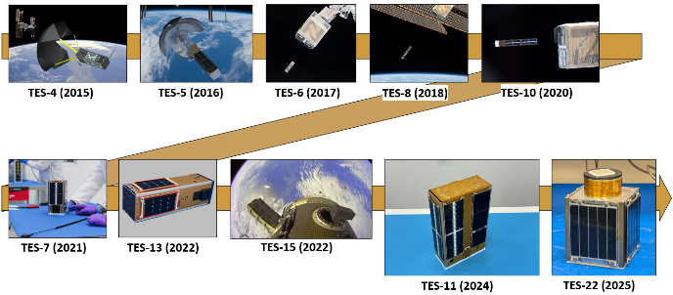
Figure 1: Recent TES Missions Timeline

Evolution of the GOES DCS Radio
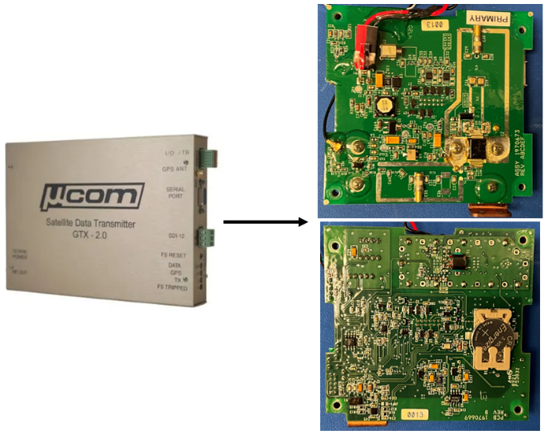
One of the initial challenges to the development of the nano-satellite experiment was the required miniaturization of the ground unit to fit the PC-104 mechanical form-factor (less than 100 mm x 100 mm to fit within the constrained cubesat ‘standard’ volume).
Figure 2: NOAA DCS Radio Board
The GTX 2.0 standard ground unit, produced by Microcom, Inc. and shown in Figure 2, uses 45 W_{e} with a 10 W_{rf} output (100, 300, and 1200 bps at 401-403 Mhz). This system, originally at roughly 20 cm x 20 cm, had to be redesigned into two boards, with careful attention to the heat dissipation. On the latter, both heat straps and L-shaped heat pipes (previously flown on TES-8) were considered. It was found that for the initial experiments and intended duty cycle, a thick copper strap would be adequate.

`Development of the TES-8, 10, and 11 Flight Experiments
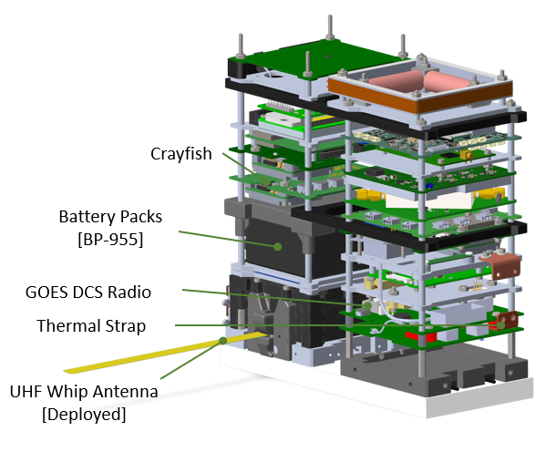
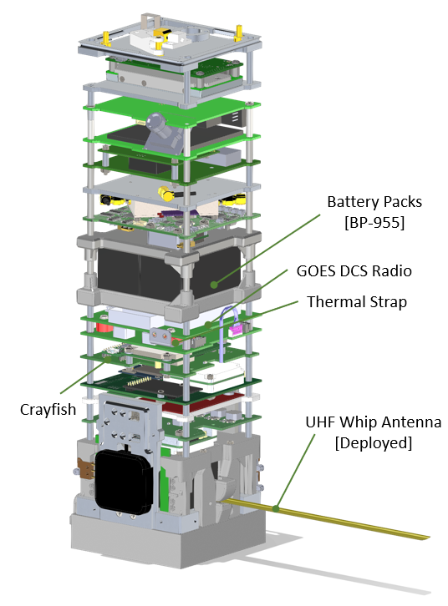
The initial flight opportunities were in unique ‘long’ 6U nano-sats deployed from NRCSD (NanoRacks Cube Sat Deployer) on the ISS. Figure 3 shows the approximate layout of the two 6U experiments (TES-8 and 10), whereby the 100 x 100 cross section ‘skin’ was then mounted over the avionics/electronic stack assembly. The basic power system had to be routed through three inhibits (two-fault tolerant power system, as required by ISS Safety System), which made the final assembly challenging.
Figure 3: TES-8 and 10 Linear 6U Stack Layout
TES-8 provided some encouraging results, though the power amplifier was determined to be non-functional during flight operations. The incremental development afforded TES-10 to be flown in rapid succession, with the knowledge from the previous flight to be applied immediately. For this flight, all the systems worked, and the basic Doppler correction was successfully tested.
The TES-11, this time in a ‘wide’ 6U format shown in Figure 4, was the most recent version in the series. Due to the ‘wide’ format, the challenging cable routing was made easier. As a non-ISS flight, the injected altitude was 520 km in a sun synchronous orbit (Firefly-Alpha launch vehicle). There was a unique safety feature for the 150 Whr power system that permits an easy doubling to 300 Whr for future missions. All three missions in the 6U ‘class’ had 150 Whr power systems with different re-charge times due to experimental high-efficiency solar cells on the latter flights.
Figure 4: TES-11 2x 3U Stack Layout (6U)

Concept of Operation
The TES-n are commanded through a unique and redundant L-band short burst data (SBD) transceiver (two-fault tolerant) using the Iridium constellation. Scheduling commands for the different payloads or experiments are sent typically one day or more in advance.
Of critical consideration is the Doppler correction. Due to the relative difference in velocity (for ‘approaching’ and ‘receding’ orbit segments) with a particular receiving GOES spacecraft, the Doppler shift can be many kHz above or below the assigned frequency. This means that the uncompensated signal can have significant interference issues in one of the other channels used by one of the 33,000 NOAA DCP’s.
To compensate, an algorithm was developed (D. Kunkee, Aerospace Corp.) that would take TLE (Two Line Element) orbit parameters of the intended transmission time and orbit location (and related velocity) and provide the necessary compensation to the transmission frequency. This can also be input as a time-dependent function for longer transmission passes, where the Doppler effect can change.
At present, these Doppler compensatory commands are calculated on the ground, and passed to the operator, who then uploads the full command sequence through the Iridium up-link system. In the future, by knowing the TLE and an accurate timing signal (in this case, from the on-board GPS receiver), a series of commands to change the Doppler correction can be fully automated.

Flight Test Results
As previously noted, the 50 W_{e} of input into the system caused rapid local heating of critical radio components such as the power amplifier. Even though the power amplifier board had a considerable thermal ground, the rapid heating is evidenced in Figure 5. Here, the rapid temperature rise is moderated by the 4 seconds ‘on’/ 5 seconds ‘off’ operation. The maximum temperature for one of the typical test cases was 70ºC, which was still considered moderate with little effect on the system performance.
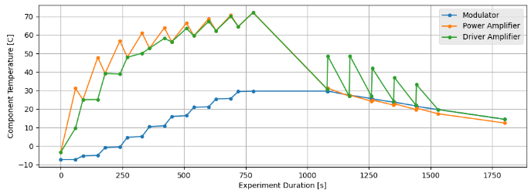
Figure 5: Component Temperatures During Experiments
The different experiment results of transmission power vs. message success rate can be seen in Figure 6. Somewhat surprisingly, the system performance at the 1 W_{rf} (1/10 of the nominal RF power) was only seen to degrade to 80% at the 300 bps rate. This suggests that a more modest battery pack can transmit essential data to the GOES satellites, though at a lower packet success rate.
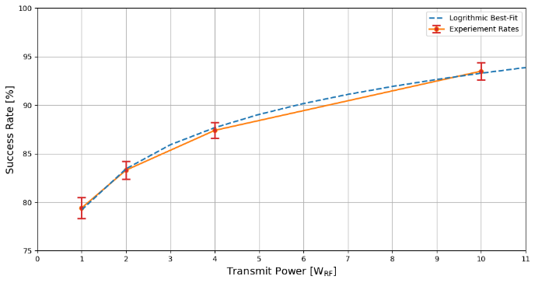
Figure 6: Success Rate Based on Transmit Power

Future Applications
With the current set of flight experiments and opening the parameter space, it is now possible to further contemplate future application and related use-cases. The DCS transmitter can transmit messages at low power (1 W) at 80% completion rate suggests that a smaller power system can be used, if the transmission is repeated until the signal is adequately received. This suggests that the system could be useful in a ‘beacon mode’ for precise tracking and general knowledge of the state of health, and finally to assist in what may be space traffic management (of current concern in the increasingly populated 400-600 km altitude bands).

Cis-Lunar Space
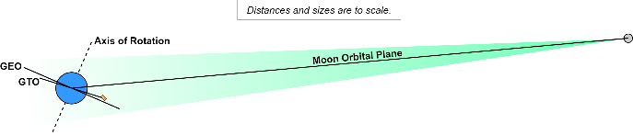
For the lunar surface, it was found that a 12 W_{rf} transmission could adequately close the link with terrestrial NASA NSN (Near Space Network) antennas at 1200 bps. While the data rate is small, the omni-directional antenna pattern is such that the pointing accuracy is not stringent. For a TES-n development design scenario using a small rover (LUNIE), the DCS transmitter in a bi-directional mode would permit the other high data rate assets (e.g., S, X or Ka band) to be positioned adequately for the transmission of large science data sets.
Figure 7: Orbit Planes in Cis-Lunar Space

Mars Surface Science Packages
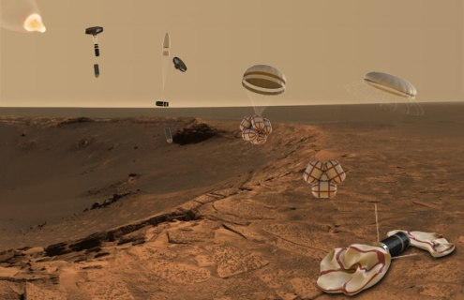
Extending the DCS concept to the Mars surface has also been considered. The current transmitter operates at the same frequency as the UHF relays in Mars orbit (virtually the same up/downlink frequency). It was found that the 2 W was adequate to close the link, and the system is ideal for extended data collection of critical surface conditions.
Figure 8: Science Package Deployment on the Mars Surface

Summary
The UHF frequency DCS system has been a very successful collaboration between NASA Ames and NOAA. Three missions thus far (including TES-11 in current operation) have successfully overcome the initial challenges and demonstrated the performance at different inclinations and up to 520 km altitude. The Doppler correction technique is now well understood, and the system can be applied to a different set of science missions. At low power, the system may be used for smaller missions with repetition of critical data needed. As a space traffic management (STM) beacon, it may help provide critical position/health data to the emerging STM management such as CARA (Conjunction Assessment Risk Analysis). In cis-lunar space or on the lunar surface, the system may act as a convenient back-up to ensure communication as well as proper positioning of higher data rate transmitters. The other interesting case is the extension of the DCS concept to the surface of Mars, where a network of ‘surface nano-sats’ can provide essential pressure and temperature data to understand and predict global weather as input to global circulation models (GCM).

Acknowledgements
The authors would like to express appreciation for the larger team that helped to bring this effort about. These include Matthew Taylor (Microcom), Brian Kopp (Jacksonville University), Nicholas Coyne (EUMETSAT), and Paul Kim (Ames Research Center/The Aerospace Corporation). The authors would also like to thank the members of the team at NOAA that contributed to this effort: William Dronen, Letecia Reeves, Warren Dorsey, and Matt Sullivan. Finally, the authors would like to thank the members of the TES-n team at the Ames Research Center: Thomas Hector, Arwen Dave, Daphne Phuong-Nghi, Carter Edmond, Avery Brock, Kwabena Boateng, and James Adams.

References
- Murbach, M., et al. “Advances in autonomous communications and operations: Tes-n Series,” 38th Annual Small Satellite Conference, Logan, UT, August 2024.
- Backus, B., Murbach, M. S., Stone, T., Kim, P., Kunkee, D., Betsill, B., Coyne, N., “TES-11 GOES DCS Demonstration: A Novel LEO-to-GEO Communication System for Nanosatellites,” Small Satellite Conference, Salt Lake City, Utah, August 13, 2025.
- Backus, B., Murbach, M. S., Betsill, B., Kopp, B., “Space-based environmental monitoring for small sats with the NOAA GOES Data Collection System,” Proceedings of the 2021 International Telemetering Conference, Las Vegas, NV, October 2021.
- Dudokovich, R., Gannon, A., Briones, J., Recker, T., Zhong, P., Deleon, K., Shaulkhauser, L., Schweinberg, E., Danish, E., Salas, A., and Murbach M. S., “TechEdSat-11: Prototyping Autonomous Communications in Orbit,” Small Satellite Conference, Logan, Utah, August, 2024.
- Murbach. M., Salas, A., Lowry, M., Barszcz, E., Briones, J., Schemmel, P., Mercury, M., Taha, T., Priscal, C., Ntone, R., Zuniga, S., Krześniak, S., Boateng, K., Schisler, S., Stone, T., Alena, R., Gannon, A., Dudukovich, R., Downey, J., Doxley, C., Chelmins, D. “TechEdSat-13: On the importance of nano-satellites and the rapid advancement of artificial intelligence and machine learning for space applications”. Proceedings of the 1st Artificial Intelligence in Action Conference, San José State University, San José, CA, USA 95112 and Athens, Greece, 2022.
- Murbach, M., Stone, T., Guarneros-Luna, A., Priscal, C., Salas, A., Kanniainen, H., Ntone, R., Williams, N., Brock, A., Tanner, S., Dono Perez, A. “Topics in Advanced Communication and Design in the TES-n Nanosatellite Flight Series – Use of Iridium® as a Primary Encrypted Command/Control Gateway”. NASA Small Spacecraft Virtual Institute Webinar Series, NASA, 2020.
- Murbach, Marcus S., et al, 2023. “The Doppler Wind and Temperature Sounder (DWTS) Flight Evaluation and Experiments (TES-16,17),” Smallsat Conference, Utah State University, Logan, Utah, August 5, 2023, paper SSC23-WV-06.
- Papadopoulos, P., Murbach, M., “Democratizing the power of AI,” Artificial Intelligence in Action Conference, October 31, 2021.
- Alena, R., Murbach, M., Guarneros-Luna, A., Priscal, C., Tanner, A., Stone, T., Salas, A., Ngo, K., Buntschuh, F., Wheless, J., “Orbital Communication Analysis for Small Satellite Missions Using the Iridium Constellation,” Small Satellite Conference, August 7, 2019.
- Cronin, M., et al. “Cognitive Communication Cubesat Constellation ‒ Preliminary Concept of Operations,” April 2020.
- Omar, S., Bevilacqua, R., “Guidance, navigation, and control solutions for spacecraft reentry point targeting using aerodynamic drag,” Acta Astronautica, Volume 155, Pages 389-405, February 2019.
- Murbach, M., Barszcz, E., Schisler, S., Salas, A., Boateng, K., Marty, G., Mooney-Rivkin, M., Brock, A., Krześniak, S., Zuniga, S., “BRAINSTACK – A Platform for Artificial Intelligence & Machine Learning Collaborative Experiments on a Nano-Satellite” Center Innovation Fund Proposal, 2023.
- Murbach, M., Priscal, C., Salas, A., Ntone-Johansen, R., Kannaiainen, H., Williams, N., “Use of the Iridium Constellation as the Primary Comand/Control Gateway for Nanosatellites,” Small Satellite Virtual Institute (S3VI) Webinar, March 18, 2020.
- Murbach, M., Papadopoulos, P., Guarneros-Luna, A., Priscal, C., Tanner, F., Reyes, E., Rosales, J., Baltazar Cardono, A., Smith, S., Salas, A., Hugues, Z., Dono, A., Ntone-Sike, R., Bowes, A., Omar, S., “The Exo-Brake as an Inexpensive Means of Achieving Sample return from Low Earth Orbit – Recent Flight Tests,” 70th International Astronautical Congress (IAC), Washington, D.C. U.S, October 21, 2019.
- Murbach, M., Guarneros-Luna, A., Tanner, A., Salas, A., Wheless, J., Priscal, C., Ntone Sike, R., Soriano-Gama, B., Hugues, Z., Williams, N., Rosila, J., Mauro, D., Stone, T., “Relevant Work Themes Regarding Interplanetary Nano-satellite Technology at the NASA Ames Research Center: Exo-Brakes, Radios, Power Sources, Incremental Mission Development,” Interplanetary Small Satellite Conference, 2019.

