20XX-01-XXXX

LUNAR LANDER LANDING DYNAMIC MODEL AND APP DEVELOPMENT IN SIMSCAPE®
Wei Wu, Noah Butzman, Grant Arndt
Amentum Space Exploration Division, ESSCA
Jacob Davis
NASA Pathways Intern

Abstract
With the recent renewed interest in manned Lunar exploration, it is critical to revisit the Apollo Moon landings with new analysis tools. Modeling the Moon landings of the past can help guide the development of new landing vehicles for the present and the future. One of the critical subsystems to model is the vehicle’s landing gear. During a landing event, structural loading, energy absorption, and toppling stability are important factors that drive the design of landing gear subsystems. These aspects can be studied using models and simulations in addition to physical testing. This study explores one recent modeling tool for modeling the landing gear and uses the Apollo 11 Moon landing as a use case.
A generic model was built using MATLAB®, Simulink®, and Simscape® Multibody to model the dynamics of a landing event. The landing gear structure comprising the primary strut, secondary struts, footpads, and joints were modeled in Simscape® Multibody. Various energy absorption mechanisms in the struts were modeled based on the relative motions of the inner and outer cylinders of the leg. Touchdown contact forces, when the footpads strike the lunar surface, were modeled considering the soil mechanical properties. Slosh dynamics were modeled using a mechanical pendulum module and tip-over controllers were developed using Simulink®. However, neither were applied in the presented analysis relating to the Apollo lunar module.
After developing the generic landing dynamic model, the Apollo 11 landing was simulated for validation purposes with results closely matching the historical measured data. A MATLAB® Graphical User Interface application (app) also was developed based on this model for usability and better accessibility of the landing simulation by non-experts on landing dynamics. It offered the opportunity for landing stability study with and without control, i.e., the max slope a lander can land without tipping over in 3D realistic landing situations.
Introduction
It is vital for mission success to study the performance of the landing vehicle’s landing gear. Factors such as structural loading, energy absorption, and toppling stability need to be well understood to guide landing gear development. For the Apollo program, the Lunar Module (LM) landing gear touchdown dynamics was both experimentally tested [1] and simulated by computer [2].
Landing legs typically have one primary strut and two secondary struts equipped with an energy absorption mechanism, as with the LM landing gear shown in Figure 1(a) [3]. This landing leg structure can be easily modeled using Simscape® Multibody. The toolbox’s Body Elements, Joints, Frames, and Transforms libraries contain blocks which were graphically connected to model the leg struts, the footpad, the joint connecting the primary strut to the secondary struts, and joints connecting the legs to the vehicle main body. The energy absorption mechanisms in the struts, such as a spring-dashpot damper, were easily modeled using Simulink® and Multibody blocks based on the relative motions of the inner and outer cylinder of the struts. The Multibody toolbox provides a Transform Sensor block which can output translational and rotational motion variables between two frames, which were used to compute the dissipative forces. The General Variable Mass block was used to specify the mass properties of each leg element including mass and moments of inertia. Figure 1(b) shows sample landing leg model developed in Simscape®.
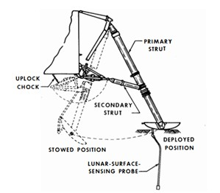
(a)
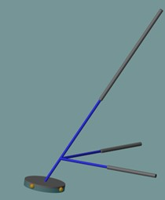
(b)
Figure 1. Apollo LM landing leg (a) and leg model in Simscape® (b)
During a lander touchdown, one or more footpads strike the lunar surface and initiate a dynamic interaction between the landing legs and the lunar soil. It is very important to model the footpad and soil interaction in a landing performance assessment. Thus, the surface was modeled as a plane using the Infinite Plane block. The contact forces were modeled using the Spatial Contact Force block, where the normal force is computed based on the footpad penetration, specified soil stiffness, and damping coefficient. The friction force was computed based on the normal force and the soil friction coefficient. The soil mechanical properties were computed based on the Apollo 11 touchdown data found in Reference [4]. In the simulation, the landing contact normal force was initially modeled using a linear spring-damper method provided within Simscape®. This simple model was not capable of capturing the inelastic deformation of the lunar regolith and increased soil stiffness with increasing footpad penetration. Thus, a custom nonlinear contact normal force model was developed to simulate the landing events with increased accuracy.
Simulation
Having modeled the landing leg structure, energy attenuation, and contact forces, landing dynamics under various landing modes were simulated given the initial vehicle states and local slope at touchdown [5]. The model was instrumented to output key variables such as strut strokes, soil penetration depth, tilt angle, and vehicle body rates, which allowed assessment of the structural integrity and toppling stability for a given landing leg design against the requirements. Figure 2(a) shows the lander stably landing on a 4.6 degrees slope for the passive 2-2-over landing mode [5], where the left two legs impact first, then the right two impact before it settles or tips over. Figure 2(b) shows the primary structure stroke distances.
To successfully land on steeper slopes, hot gas thrusters firing were simulated during touchdown to prevent the vehicle from tipping over via feedback control logic. Because Simscape® is embedded inside Simulink®, it was very easy to model different tip-over control strategies using various Simulink® blocks and toolboxes. Slosh was modeled with a mass pendulum module, but it was not included in the Apollo Lunar Module model, as slosh was not included in the referenced historical analysis [4].
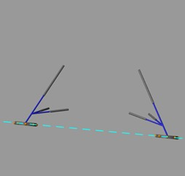
(a)
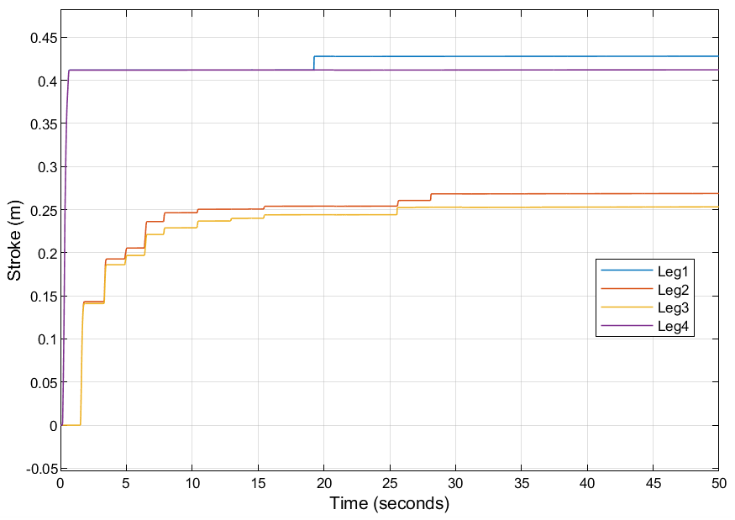
(b)
Figure 2. Stable landing, 2-2-over landing mode (a) and primary structure stroke (b)
Historical Apollo 11 Results from Simulation
To validate the model capabilities, a study was performed to evaluate the touchdown dynamics of a simulated landing of the Lunar Module (LM) with characteristics like what was observed in the Apollo 11 Landing on July 20, 1969. The model measured the body rates of the vehicle using transform sensor blocks, which can be compared to measured rates by the onboard computer of the LM during the landing as shown in Figure 3. The vehicle settled in about 1.5 seconds and saw a maximum rate of about 0.15 rad/s in both pitch and roll with very little change in the vehicle yaw rate. Dr. George Zupp performed a similar simulation analysis to evaluate the performance of the landing gear during the Apollo 11 landing [4]. His report gave an extensive overview of the design and performance conditions of the LM landing gear, details on the touchdown dynamics of the Apollo landings, and reference data recorded from flight computers during each landing. The details given in that report were used to develop the landing model in this study. The model was developed iteratively by changing different components of the dynamics one at a time, measuring the response, and correcting problems and inconsistencies as they arose. The details of the dynamics, process, and results of the modeling effort are described below.
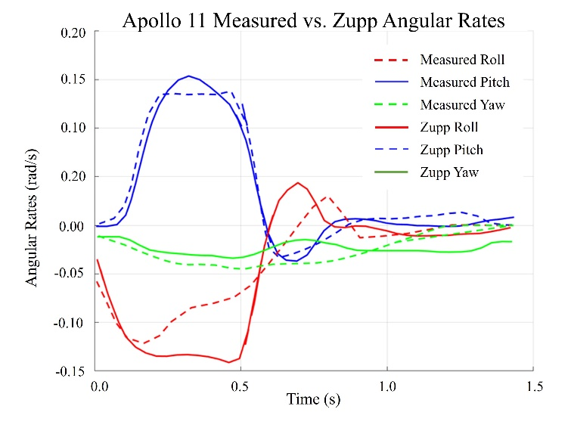
Figure 3. Body rotational rates measured during Apollo 11 Landing compared to predicted rates in the Zupp report
Touchdown Conditions of the Apollo 11 Lunar Module
The geometry and dimensions of the lunar module, obtained from the LM Vehicle Familiarization Manual [8], are shown below in Figure 4(a). These dimensions were used to model the landing legs correctly within the simulation; a picture of the landing legs in the simulation is also shown in Figure 4(b).
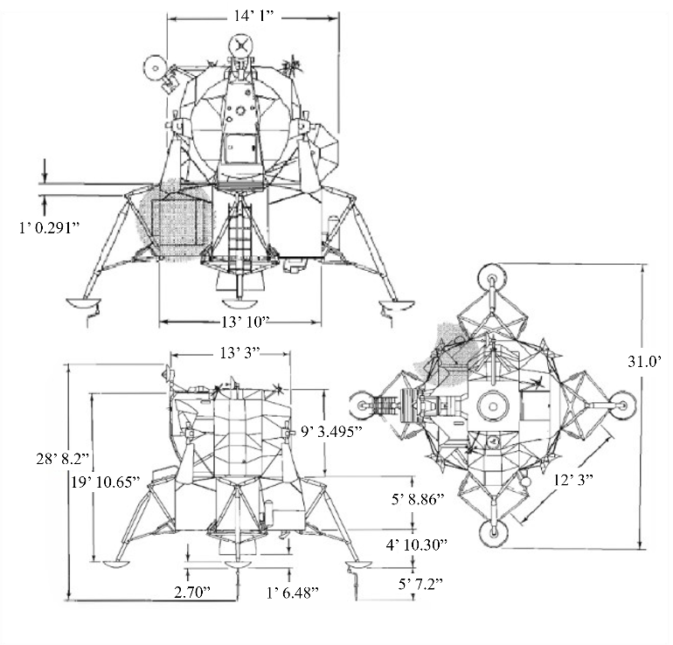
(a)

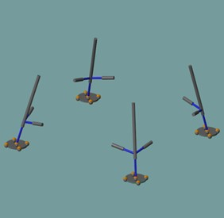
(b)
Figure 4. Overall dimensions of LM (a) and LM landing legs in Simscape® (b)
The body coordinate system, used in Reference [4] to describe the touchdown conditions, was different than the coordinate system used in the simulation. Figure 5 shows the two coordinate systems. While the two share the same +Y axis, the simulation’s +Z axis is the LM’s +X axis. All results presented here were described in the simulation’s coordinate system instead of that reported in Reference [4].
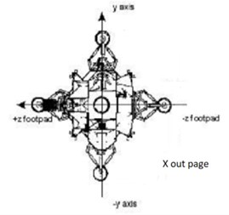
+ y axis
- z axis
+ z axis
-y axis
+ x out of page
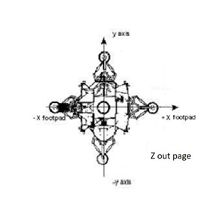
+ y axis
- y axis
+ x axis
- x axis
+ z out of page
Figure 5. Coordinate systems of Zupp report (top); Simulation (bottom); Figure from Reference [4]
Table 1 shows the mass properties at the time of touchdown. It includes the masses of the different components of the landing gear given in reference [2]. The landing gear component mass properties were necessary to give the legs a more accurate mass distribution. Products of Inertia were not given in the reference [2], so they were assumed to have a small impact. For this paper, individual components were considered as rigid bodies with a uniform mass distribution. Effects such as elasticity and interaction with the extreme Lunar thermal environment were not modeled.

Table 1. Mass properties of lunar module and landing gear at touchdown
Total Mass of Vehicle (kg) | 7063.5
Primary Strut Mass (kg) | 43.1
Primary Inner Piston Mass (kg) | 13.6
Secondary Strut Mass (kg) | 5.12
Footpad Mass (kg) | 11
Moment of Inertia about X (I_{xx}) (kg-m²) | 20,808
Moment of Inertia about Y (I_{yy}) (kg-m²) | 17,409
Moment of Inertia about Z (I_{zz}) (kg-m²) | 16,492
Center of Mass height above footpad (m) | 3.62

Table 2 shows the touchdown initial velocity, angular orientation, and body rotation rate vectors. The sequence of orientation in the simulation were given by the rotations about body Y, X, and Z (Pitch, Roll, and Yaw) respectively.
Table 2. Touchdown orientations, rotation rates, and velocities in simulation
Pitch (about Y) (degrees) | 0.8240
Roll (about X) (degrees) | 2.6038
Yaw (about Z) (degrees) | 15.3259
Pitch rate (rad/s) | 0.0100
Roll rate (rad/s) | 0.0280
Yaw rate (rad/s) | -0.0108
V_{z} (m/s) | -0.5486
V_{y} (m/s) | -0.6706
V_{x} (m/s) | 0.0305

Crushable Honeycomb Energy Attenuation System
The braking system used in the LM landing gear were cartridges of aluminum honeycomb material that were designed to fail at a constant load when compression forces were applied, as seen in Figure 6(a). Upon touchdown, an inner sliding piston would crush these honeycomb cartridges, causing them to buckle and absorb the energy from impact while also limiting the structural load applied to the landing gear system. Stacks of different honeycomb meshes that failed at different loads would give the system a load profile that varied with piston stroke [9].

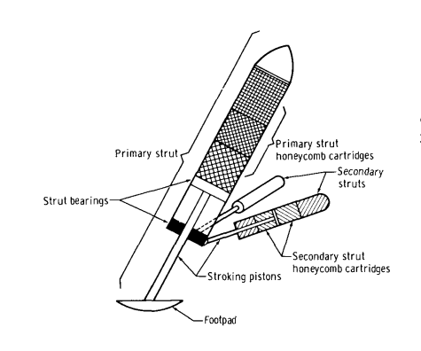
(a)
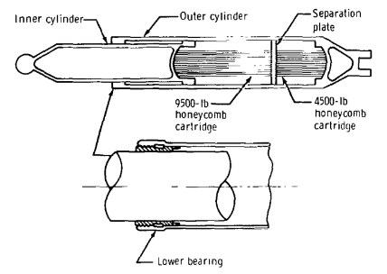
(b)
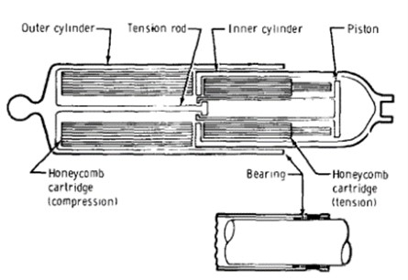
(c)
Figure 6. Landing gear (a), primary strut (b), and secondary strut (c); figures from Reference [3]
The primary strut, shown in Figure 6(b), was capable of compression stroking only with two stages of absorption. Meanwhile, the secondary struts in Figure 6(c) could stroke in both tension and compression, with two stages of absorption in tension and one in compression. The primary strut mainly absorbed vertical forces while the secondaries absorbed most of the lateral loads. Due to horizontal forces on the footpad and the application of the secondary strut loads on the primary strut, constraint forces in the bearing of the primary strut would result in a moment balance making bearing friction an important consideration in the energy attenuation of the primary strut. The bearing friction coefficient was given in the report [9] as 0.23. Figure 7(a) and Figure 7(b) show the load stroke characteristics of the primary and secondary struts.
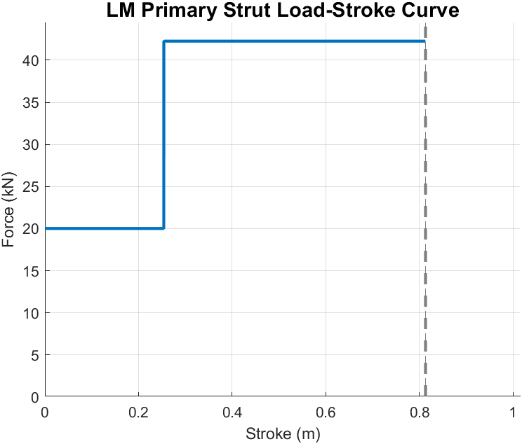
(a)
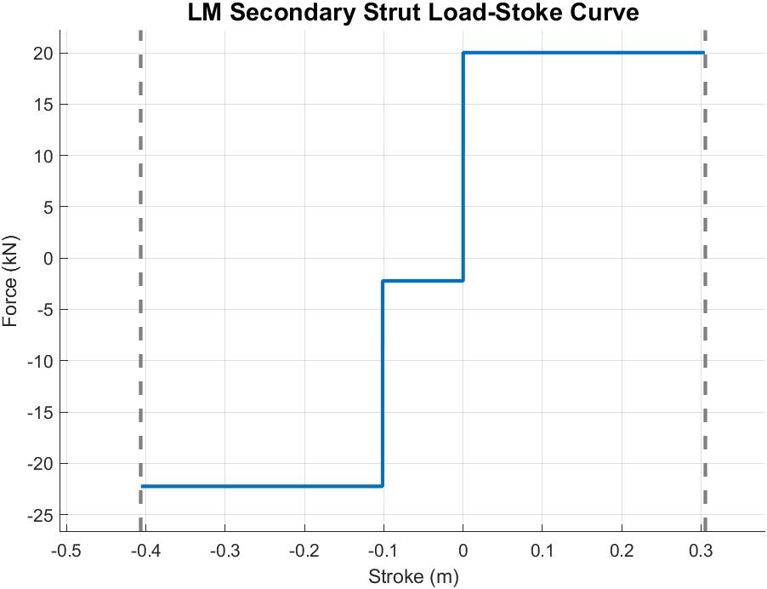
(b)
Figure 7. Load-stroke curves for LM landing gear primary (a) and secondary struts (b)
In the model, the primary strut supplied 20,017 N of resistive force for 0.254 m of compression stroke and 42,258 N of force for another 0.558 m of stroke making the primary strut capable of 0.8128 m of stroke in compression [4]. The secondary strut supplied 20,017 N of resistive force for 0.3048 m of compression stroke [4]. The secondary strut also supplied 2224 N of resistive force for 0.1016 m of tension stroke and 22,241 N for another 0.3048 m of tension stroke making the total tension stroke capabilities of the secondary struts 0.4064 m [4].
The honeycomb energy attenuation system was implemented into the model using joints between the different modeled elements of the landing gear, to measure the amount of stroke undergone by each strut and to supply the appropriate force through an external Simscape® force block. To implement the force-stroke profile, the model considered extra parameters such as the piston’s direction of travel and how much honeycomb material has been crushed. This ensured the legs were correctly attenuating the energy of impact. This implementation is seen in action in Figure 8, showing the honeycomb crush level on the primary strut of the +Y (body axis) landing leg during the Apollo 11 2-2-over landing mode. The joints were capable of providing the constraint forces to account for bearing friction as well, which was implemented by placing external forces on the joints in addition to the load from the honeycomb.

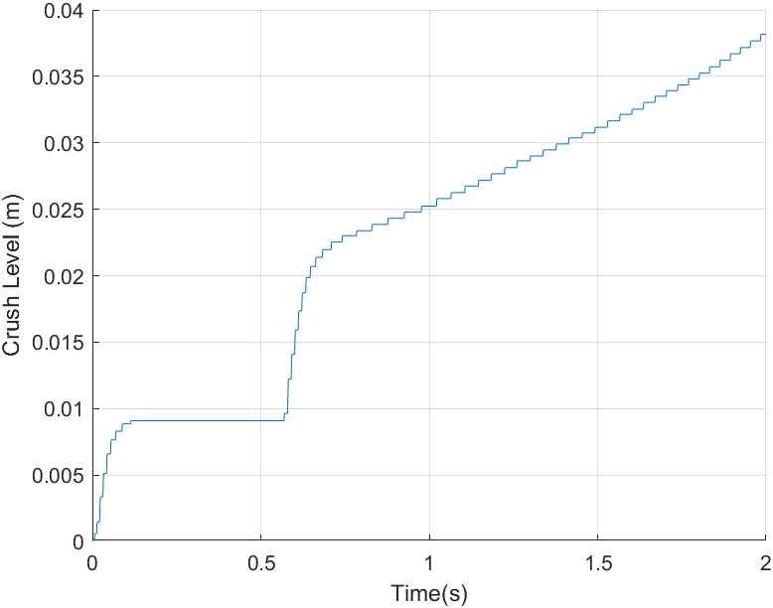

Figure 8. +Y landing leg primary strut honeycomb crush level during Apollo 11 landing event
Provided in the Zupp report [4] were the measured primary and secondary strut stroke of the Apollo 11 Lunar Module. All the secondary struts stroked in tension only. The primary struts saw little to no stroking. In the presented simulation the former was true, however small stroking was seen in the primary struts. This was likely due to the implementation of the load forces as the external forces, which caused the cylinders to bounce away from the joints. An attempt was made to fix this by adding a hysteresis to the loading function where the loading would continue to apply even when disengaged. This helped limit the extra stroke slightly, but a perfect implementation could not be achieved. Further development is underway to improve the honeycomb force modeling.
Soil Model
The soil model from the Zupp report [4] used for the development of this model was simple and consists of vertical and horizontal forces acting on the footpad. The vertical force (or normal force) was calculated by modeling the ground as a spring with a stiffness being the soil’s bearing strength (K_{V}), which was a linear function of the footpad penetration depth (Z_{p}).
$$F_{V}= K_{V}Z_{P}$$
The horizontal force was modeled as the summation of two separate forces: the sliding friction acting on the footpad’s underside and a resistive force resulting from the plowed soil building up in front of its leading edge. The friction force was modeled as a linear function of the vertical force with a coefficient of friction μ, and the plowing force was a linear function of the skid distance (S_{D}) of the footpad and a plowing coefficient (K_{p}).
$$F_{H}= μF_{V}+ K_{P}S_{D}$$
A few assumptions were made to implement this soil model, and the model itself was based on observations made during the Apollo 11 landing. Using the model outside of these assumptions and in conditions not experienced by the Apollo landers would likely result in inaccurate simulations. There are a few key differences between the physical reality of the Apollo lander and the implementation of the landing legs in simulation space. The absence of contact area from the bearing model implies footpad contact area must be constant throughout footpad penetration, even though in reality the LM footpads have curvature. Also, the footpad must be rigid and attached to the ball joint of the primary strut. In the simulation, a ball joint was used to attach each footpad and a point cloud block in Simscape® was used on the footpad to apply the contact forces, which are measured using a spatial contact force block. As such, the soil model for Apollo 11 landing [4] was likely not exactly represented in the simulation due to the underlying assumptions used to build the model. However, due to the low energy landing of Apollo 11, shallow penetration, and small skid distance, the soil model seemed acceptable, and it was important to ensure the simulation matched the model and parameters given in the report. Table 3 lists the mechanical soil properties used in this analysis. The selected values match those used in the Zupp report [4] for the purpose of results comparison.
For simulations using different soil models, the current Apollo 11 soil model was easily replaced by writing a custom soil model code in the MATLAB® function block in the underlying Simulink® model where the current soil model was programmed.
Table 3. Lunar soil mechanical properties
Friction Coefficient (μ) | 0.33
Bearing Strength (K_{v}) (N/m) | 350,254
Plowing Coefficient (K_{P}) (N/m) | 1454
Landing slope (degrees) | 4.5

Descent Engine Thrust Profile
Another characteristic of the Apollo 11 landing was the thrust history of the Lunar Module Descent Engine (LMDE) during the first footpad contact. The LMDE was not shut off when touchdown was initially recorded which means for approximately the first 0.225 seconds of touchdown, there was some deceleration of the lander due to the engine still firing. Figure 9 shows a reconstruction of the thrust history which was used in the simulation for modeling the Apollo 11 touchdown dynamics. The thrust at touchdown was about 9786 N and fell off during shutdown transient. Thrust amplification could have been a factor due to how close the LMDE was to the ground at the time of the engine firing.
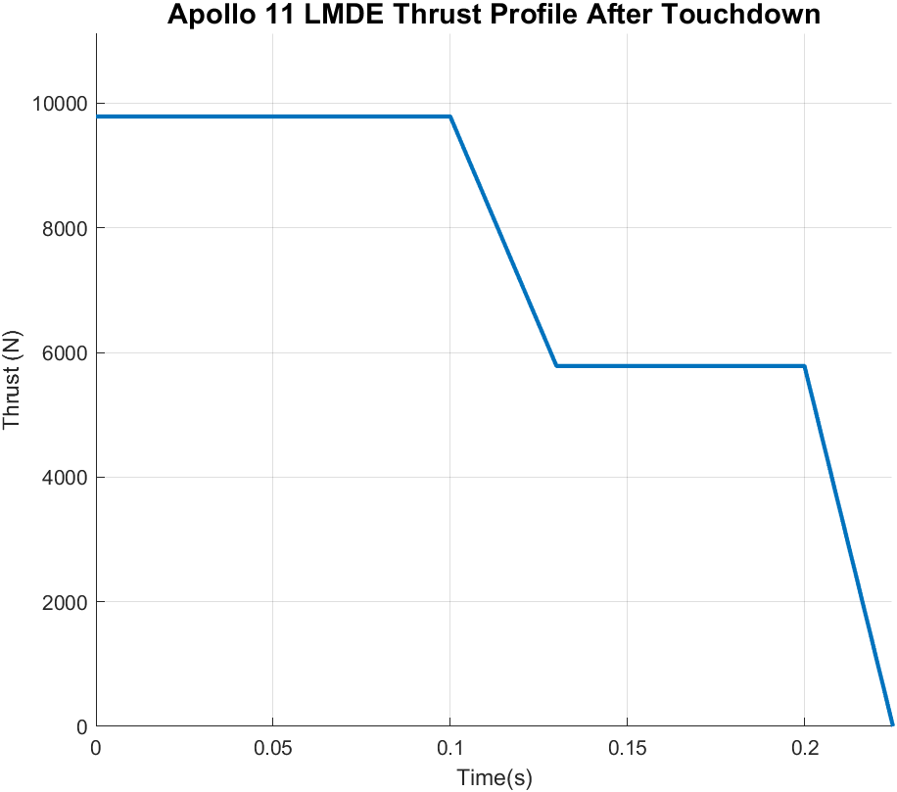
Figure 9. Apollo 11 Lunar Module descent engine thrust time history from touchdown
Simulation Results
Figures 10 and 11 show a comparison of the rotation rate time history of the MATLAB®/Simulink®/Simscape® simulation with Apollo 11 data and the Zupp simulation respectively, after implementing all above dynamics and plotting the measured onboard rate. All these plots begin with footpad contact at time zero.
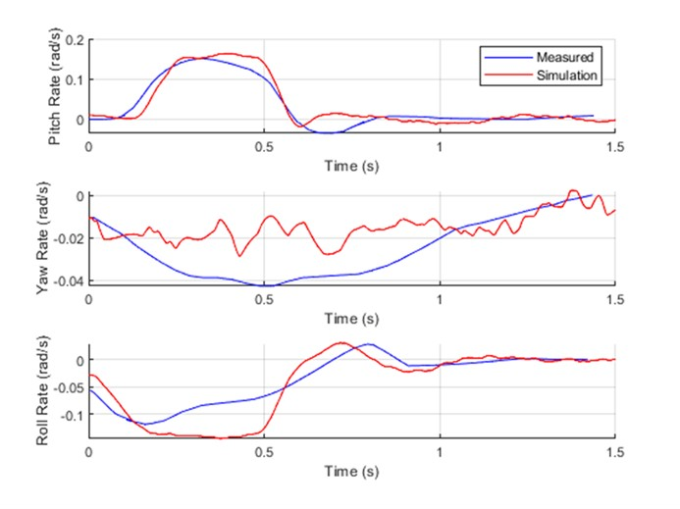
Figure 10. Comparison of simulation and measured rotation rates for Apollo 11 landing
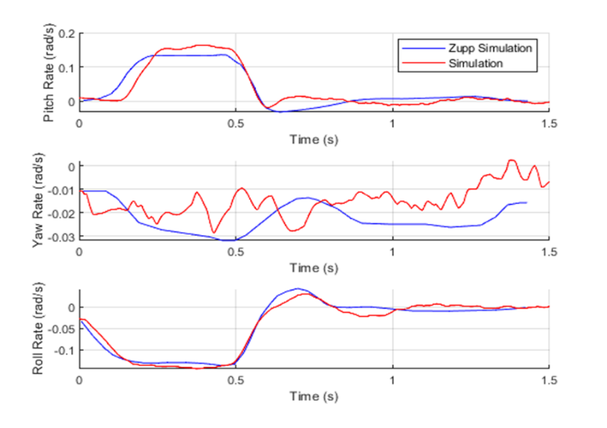
Figure 11. Comparison of simulation and Zupp simulation rotation rates for Apollo 11 landing
The simulation rotation rates mostly matched very well with the measured rates in terms of the shape of the curves and the magnitudes of the rates as a function of time. In Figure 10, the roll rate showed a large second “bounce” in the graph around 0.5s. The pitch rate had a small second bounce that occurs early around 0.6s compared to the measured data that slightly bounces at 0.75s-0.8s. These small differences could be attributed to outside factors or uncertainties in the reported historical parameters such as the mass at touchdown or products of inertia. Rotation rate sensor dynamics could also play a role in what is not being captured. However, the overall touchdown dynamics seem to be modeled accurately, and the results followed the measured rates well enough to verify the capability of the surface contact simulation of the landing model.
Landing App Development
In addition to developing the landing dynamics models and simulation in the MATLAB®/Simulink® environment, the built-in Appdesigner feature was used to improve the usability and expandability of the model. Through Appdesigner, a Graphical User Interface (GUI) application (app) was developed which allows users to easily customize and run the landing simulation to their own specifications and view pertinent outputs for post-run analysis.
Architecture
The landing dynamics simulation is operated at the top level using a MATLAB® app created from Appdesigner. The user can navigate the simulation entirely from this app interface, which includes tabbed sections for file transferring, simulation configuration and running, plotting outputs and statistics, and includes a link to a detailed tutorial guide for navigating the GUI. Figure 12 shows the high-level architecture of the landing app.
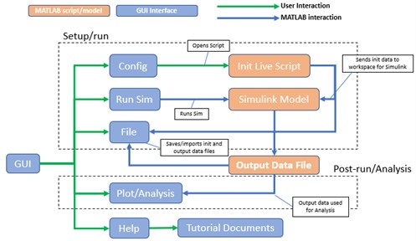
Figure 12. High-level landing app architecture
Underneath the front-facing graphic interface, the app calls and accesses a MATLAB® live script (.mlx) file which is used to manually provide input parameters for the simulation if the user does not have access to an input data file. This live script also includes detailed descriptions and diagrams, if applicable, for each of the input parameters to ensure clarity and proper definition of the inputs. Any modifications to the live script will automatically save the input data to the MATLAB® workspace and does not need to be run manually by the user. The input data is nested within a single data structure, which is sent back and forth from the app and MATLAB® workspaces. If the user does not import an input data file or make modifications before running, the live script will automatically run to populate the simulation workspace with default parameters.
The 6DOF landing dynamics simulation is in a Simulink® model, which is called when the simulation is run within the app. The Simulink® model does not open automatically and remains hidden from the user throughout the whole simulation runtime. Upon run completion or error, the Simulink® model sends its status back to the app interface. When a run completes, the input data file used for the simulation configuration and the output data file from the run are automatically saved in a labelled folder, which can be used to recreate the run or for post-run analysis.
After a run completes, output data from the logged signals is automatically saved within the app and MATLAB® workspaces in addition to the labelled folder as described above. Within the post-processing Plot and Analysis sections, the user can create plots and view statistics from the run data.
User Interface
The Graphical User Interface allows users of varying experience levels to effectively navigate the landing dynamics simulation. The primary sections of the GUI, both the Home and File sections, are shown in Figure 13.

Figure 13. Home and File tabs in landing app
Here, the user is welcomed to the interface and is given options for importing input configuration files, exporting data, and defining paths for sending files. The File Status window at the bottom of the page displays the full path locations where files are sent or pulled from whenever they are exported or imported.
The Config section of the app allows the user to toggle various run options and is primarily used as an entry point for accessing the configuration live script, which opens at the click of a button. The Landing Parameter Initialization script interface is shown in Figure 14.
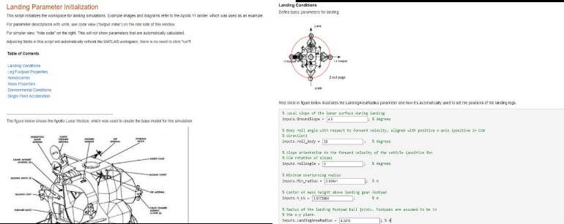
Figure 14. Initialization Live Script interface
The initialization live script in Figure 14 is designed to be intuitive and informative for new users, and especially for users with limited knowledge on landing dynamics or lander spacecraft in general. The inputs are laid out in sections and are given detailed descriptions and unit values to aid in the simulation configuration. As previously mentioned, the user does not need to manually run the script, as all modifications are saved automatically.
The Run section of the app, shown in Figure 15, allows the user to run and stop the simulation at the press of a button. Here, the user is also able to define the simulation run time, which is defaulted to 2 seconds. The Sim Status window will display the end status of the simulation run and will display if the run was completed successfully or if there was any error.
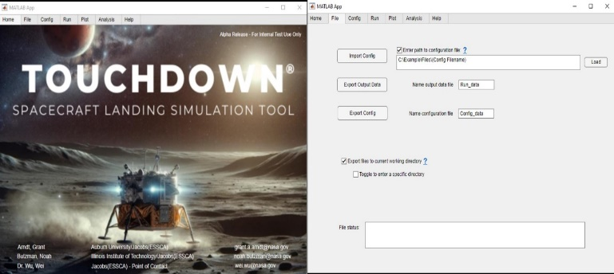
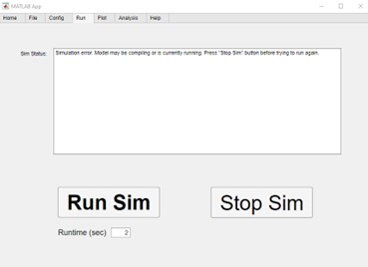
Figure 15. Run Tab in landing app
The Plot and Analysis sections of the app allow for post-processing after a simulation run is complete. The Plot tab is shown in Figure 16. From here, plot figures can be saved to labelled folders or to the user-defined path in the File section. Output data from a previous run may also be uploaded in these tabs to allow for coplotting and comparison. Data statistics may also be saved, if desired.
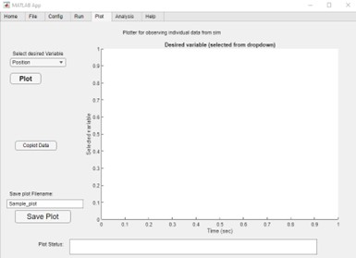
Figure 16. Plot Tab in landing app
Finally, the Help section of the app gives brief descriptions of each of the tabbed sections and provides a link to an in-depth user guide at the click of a button. The guide button opens a slide presentation that gives a full walkthrough of how to set up, run, and post-process a simulation. Within the slide presentation is also a video tutorial that walks through the process for the default Apollo 11 landing simulation.
Functionality
The primary functionality of the landing dynamics app is to quickly test and assess the stability and performance of various landing vehicle designs and conditions. To do this, the app features the ability to customize the landing simulation parameters to fit any vehicle, given that the overall structure of the lander is consistent with the classical four-legged Apollo 11 design. For quick stability and performance analysis, the app also features an animation of the landing maneuver as well as a plotting/coplotting functionality within the interface, which allows for pertinent variables to be assessed.
Within the parameter initialization script, the user can adjust lander component masses, stiffness, and dimensions, as well as environmental and ground conditions, energy attenuation parameters, and various other inputs. Within the Config section of the app, the user is also able to toggle different functionalities and run options on and off.
When a simulation compiles correctly and begins to run, a separate Mechanics Explorer window opens that provides a live animation of the landing simulation shown in Figure 17. The animation features a rudimentary physical model of the landing legs as they contact the ground surface. Here, the user can visually inspect their run as it is running and can look for any anomalies in the physical behavior of the lander. Using view tools in the top banner, the user can adjust the perspective of the animation to whatever frame they desire. Additionally, the landing animation can be replayed at any speed and saved.
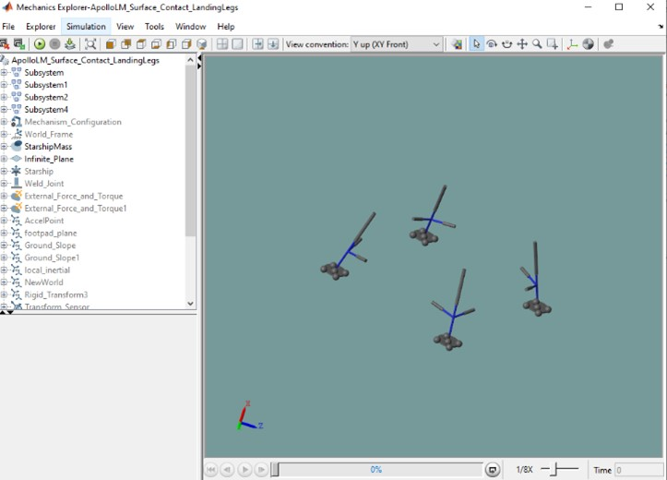
Figure 17. Live animation in Mechanics Explorer window
Within the Simulink® model, a certain collection of signals is logged and outputted to a data file. Once a run completes, the user can post-process this data and compare to previous runs. Available signals include lander positions, attitude angles, and body rates as well as accelerations, footpad loads, strut stokes, and soil sinkage and skidding. Data can be plotted or coplotted and saved off as MATLAB® figures or PNG image files. Similarly, data statistics are also automatically calculated and can be saved.
Future Development
The landing app is currently in an alpha state and is under an internal review within the developing organization. Based on feedback and the overall desire to improve the functionalities of the GUI, there are numerous forward work items.
Primary work items involve expanding the simulation and allowing customization for different lander configurations, layouts, and degrees of freedom that aren’t captured in the classical Apollo 11 LM design and vehicle structure. Additionally, features are being developed that will allow the user to import higher-fidelity models into the simulation, such as flexible body and propellant sloshing dynamics, as well as reaction control system thrusters and arbitrary control laws.
Other work items include improving the status tracking of the simulation by including live plots of desired signals, more detailed error and status messages, and a live animation within the app itself instead of in the separate Mechanics Explorer window. Additionally, Monte-Carlo and parameter sweep options will be added for users to test a wide variety of designs at once or to observe sensitivities to design variations.
Upon completion of ongoing work items, the landing app will be released in a beta state as a standard executable to reach users that do not have access to MATLAB® software or appropriate licenses. It may in the future be released through the NASA Software catalog.
Conclusion
The developed landing dynamics model and simulation was compared with measured Apollo 11 flight data and another simulation (Zupp, [4]). It provided an opportunity to study landing stability, specifically the maximum slope on which a lander can touch down without tipping over in realistic 3D landing scenarios.
The models and simulation were built and used for analyzing landing dynamics with Simscape® Multibody. That allowed for building high fidelity models without having to derive equations of motion. Simscape® Multibody tools were used to build models with modular blocks that represent the system and apply the underlying physics such as gravity, external forces and torques, actuators, and contact modeling. In addition, these tools were used to analyze the dynamics and measure the physical response of the simulation.
A GUI interface to the models and simulations was also developed, and a simulation of the Apollo 11 landing was implemented using these tools and verified against another simulation and against measured Apollo data. However, certain aspects of the dynamics were not considered in this study such as the flexible dynamics of the landing legs, which would require higher-fidelity tools such as Finite-Element Analysis and building more complicated representative models than using the Simscape® Multibody blocks. However, the model of the above simulation does appear to capture the landing dynamics very well for the purposes of analyzing vehicle stability during the preliminary design phase. At later design phases, more complex methods could be applied [12, 13].
References
- Blanchard, U.J., Full-scale Dynamic Landing-Impact Investigation of A Prototype Lunar Module Landing Gear, NASA technical note, NASA TN D-5029, 1969.
- Doiron, H.H., and Zupp, Jr., G.A., “APOLLO lunar module dynamics,” 41st AIAA/ASME/ASCE/AHS/ASC Structures, Structural Dynamics, and Materials conference and Exhibit, April 2000.
- Rogers, W.F., Apollo Experience Report-Lunar Module Landing Gear Subsystem, NASA TN D-6850, 1972.
- Zupp, Jr., G.A., An Analysis and a Historical Review of the Apollo Program Lunar Module Touchdown Dynamics, NASA/SP-2013-605, 2013.
- Walton Jr., W.C., Herr R.W., and Leonard, H.W., “Studies of Touchdown Stability for Lunar Landing Vehicles,” J. Spacecraft, Vol. 1, 1964.
- D. Liang et al., “Landing dynamic analysis for landing leg of lunar lander using abaqus/explicit,” International Conference on Electronic Mechanical Engineering and Information Technology, 2011.
- V. Pham et al., “Landing stability simulation of a 1/6 lunar module with aluminum honeycomb,” International Journal of Aeronautical and Space Sciences, 2013.
- Vehicle Familiarization Manual, Lunar Module, Northrop Grumman, November 1, 1969.
- Zupp, Jr., G.A., and Doiron, H.H., A Mathematical Procedure for Predicting the Touchdown Dynamics of a Soft-Landing Vehicle, NASA TN D-7045, 1971.
- R.W. Herr, “Studies of touchdown stability for lunar landing vehicles,” Journal of Spacecraft and Rockets, vol. 1, issue 5, pp.552-556, 1964, https://doi.org/10.2514/6.2000-1678.
- Z. Tang et al., “Physical and mechanical characteristics of lunar soil at the chang’e-4 landing site,” Advancing Earth and Space Science, 2020, https://doi.org/10.1029/2020GL089499.
- T. Tucker, “Numerical study on modeling the soil footpad interaction of lunar soft landers at touchdown,” Computers and Geotechnics, 171, 2024.
- Z. Wang, C. Chen, et al, “3D Soft-Landing Dynamic Theoretical Model of Legged Lander: Modeling and Analysis,” Aerospace, 2023, 10, 8111.
Software: MATLAB® 2023b, 64-bit, Windows OS

