Tailored refractory W-alloys for fusion-based additive manufacturing
Priyanka Agrawal^{a,b,*}, Amit Kumar Singh^{a,b,c}, Prithvi Dev Awasthi^{a,b,c}, Sarah McDearis^{a,b}, Aishani Sharma^{a,b}, Fredrick N. Michael^{d}, Rajiv S. Mishra^{a,b,*}
ªCenter for Friction Stir Processing, Department of Materials Science and Engineering, University of North Texas, Denton, TX 76207, USA
^{b}Department of Materials Science and Engineering, University of North Texas, Denton, TX 76207, USA
^{c}Center for Agile and Adaptive Additive Manufacturing, University of North Texas, Denton, TX 76207, USA
^{d}Materials & Processes Laboratory, Marshall Space Flight Center, National Aeronautics and Space Administration, Huntsville, AL, USA

*Corresponding author: Priyanka.Agrawal@unt.edu, Rajiv.Mishra@unt.edu

Graphical abstract
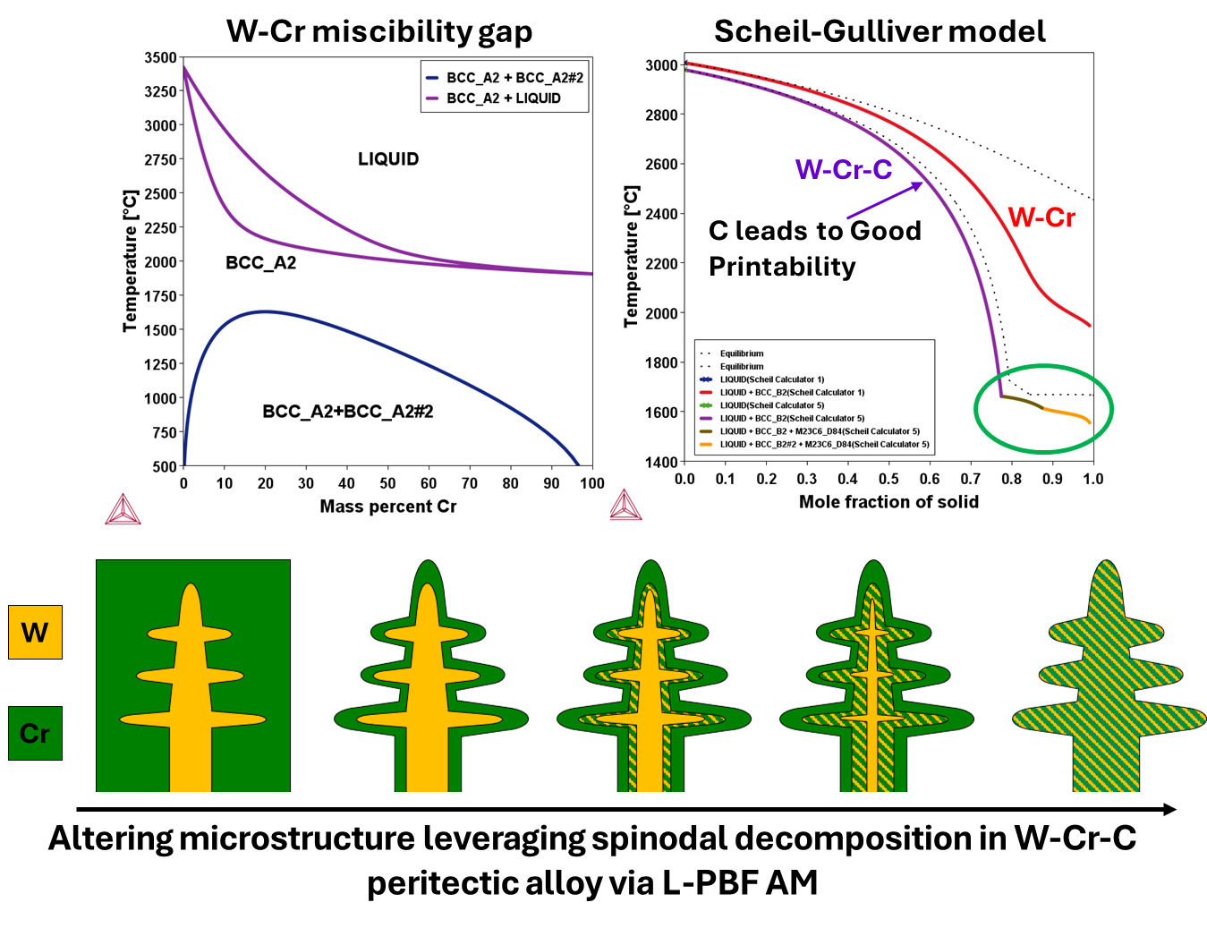

Abstract
Additive manufacturing (AM) of refractory tungsten (W) alloys has been restricted by their high melting point, inherent brittleness, and poor printability. As the demand for refractory metals in high-temperature and extreme environments grows, laser powder bed fusion (L-PBF) AM has emerged as a promising method to fabricate W-based components, provided alloys that can be designed for crack-free, dense printing. To address these challenges, a W-Cr-C alloy was designed and developed for L-PBF AM by CALPHAD and heat transfer–material flow simulations to enhance printability and exhibit superior mechanical properties. L-PBF AM is a highly non-equilibrium process that produces rapidly solidified microstructures. In conventional W-Cr alloys, spinodal decomposition dominates the microstructural evolution. In this study, post-heat treatments were employed to control spinodal features and enhance the strength-ductility synergy of L-PBF AM printed W-alloy. Although the high cooling rates in L-PBF restrict spinodal decomposition to a small fraction, this fraction can be effectively tuned through AM process parameters optimization and post-process heat treatments. By engineering a hierarchical microstructure to enhance strength, while incorporating appropriate alloying elements to improve ductility, the mechanical performance of L-PBF fabricated W-alloys can be significantly enhanced. This approach establishes a pathway for the design of refractory alloys compatible with AM and optimized for application-specific requirements.
Keywords: Tungsten refractory alloy; Laser powder bed fusion additive manufacturing; Spinodal decomposition; Numerical modeling

The need for high-temperature materials has pushed efforts in printing W-alloys, due to their high temperature strength and stability, using fusion-based additive manufacturing (AM) [1–3]. High temperature refractory metals are of interest for many industries, including manufacturing, shipping, automotive, space, and aerospace. The applications include high-wear industrial cutting tools, turbine blades for marine propulsion, corrosion-resistant heat exchangers, hypersonic flight vehicle components, armor penetrators, fusion reactors, Gen IV fission reactors, high-temperature propulsion, and space nuclear propulsion programs [4,5].
Although AM has been shown to save 2-10 times the cost over the traditional route and leads to a faster development cycle, it remains challenging for refractory alloys [2]. A key barrier associated with the fabrication of alloys like W is the large-scale production capabilities due to its very high melting point of 3442 °C and brittle nature [6]. The challenges faced are a) segregation of oxides at the grain boundaries, resulting in cracking due to the high affinity for oxygen in refractory metals, b) high ductile-brittle transition temperature (DBTT) of up to 700 °C reported for W, which leads to processing difficulties, c) dearth of a complete thermodynamic database and literature for refractory metals, resulting in a lack of readiness for AM of refractories. Other issues with AM include undesirable microstructural features, such as columnar grains and the formation of non-equilibrium phases that challenge the qualification of printed components.
Recently, Olson’s process-specific alloy design approach demonstrated increased success in printing material via laser powder bed fusion (L-PBF) AM, which was also adopted for the currently studied W-alloy. W-Re system results in a reduction in DBTT to room temperature, improving the ductility of the alloy [7], whereas W-(Nb,Ta,Mo) system allows for a high service temperature limit of > 2000 °C, exhibiting complete solid solubility across the entire composition range. In contrast, the W-Cr system offers improved corrosion resistance, low neutron activation, and a lighter alloy, but has an immiscibility gap that leads to spinodal decomposition (Figure 1 (a)). The alloying strategy involved incorporating nanoparticles and scavenging the interstitial O atoms from the grain boundaries. Solidification cracking was eliminated by selecting interstitial elements like carbon and boron to create a terminal eutectic/peritectic solidification. The goal was to enhance the strength-ductility synergy of L-PBF AM printed W-alloy, leveraging spinodal decomposition to tailor the microstructure for improved strength, while incorporating suitable alloying elements to enhance ductility.
Building on this, W-9Cr-0.3C (all in wt %) alloy was developed via an integrated computational materials engineering (ICME) approach. It combines material information with processing and performance data, accelerating the development cycle for the alloys designed for and printed via L-PBF AM [8,9]. The alloy was designed using CALPHAD (Figure 1 (a)) and printed a nearly crack-free and pore-free build, with a relative density exceeding 99% [8]. The print demonstrated superior compressive strength of 1344 MPa and hardness in the range of 550 – 750 HV, owing to the good printability and the carbides formed. Initial tests on the as-printed build revealed no spinodal decomposition from the X-Ray Diffraction (XRD) and transmission electron microscopy (TEM) experiments. The hypothesis was that the high cooling rates during L-PBF AM suppressed the kinetics required for spinodal decomposition. The present study delves deeper into spinodal decomposition in the W-Cr-C system by creating a hierarchical microstructure through heat treatments to alter the strength-ductility synergy of the printed W-alloy for targeted applications.
W-9Cr-0.3 C (all in wt %) alloy was printed using L-PBF AM Aconity MIDI, with a raster scan strategy and a laser spot size of ~ 80 µm. The build with ~ 6 mm height was printed using a laser power of 700 W, a laser scanning speed of 400 mm/s, a layer thickness of 50 µm, and a hatch spacing of 0.1 mm. For additional details, please refer to the recent publication [8]. To investigate spinodal decomposition, the alloy was heat-treated at 1000 °C for 1 and 24 hours, followed by water quenching (WQ), as determined from the pseudo-binary W-0.3C-xCr phase diagram (Figure 1 (a)), to achieve resolvable spinodal features in the scanning electron microscope (SEM). Due to the AM process, the as-printed sample exhibits a high dislocation density resulting from the rapid cooling rate [8]. Consequently, the kinetics of nucleation and transformation for spinodal decomposition will be faster during the heat treatments. For heat treatment, the samples were vacuum sealed in a quartz tube to prevent oxidation. After heat treatment, the samples were polished to a mirror finish for microscopy and testing. XRD was performed using a Rigaku Ultima III diffractometer with a Cu-Kα source (wavelength of 1.54 Å) to assess spinodal evolution and the development of phases such as carbides/oxides at an operating voltage of 40 kV and a current of 44 mA. The data was collected over a 2θ range of 20° – 120°. The as-printed and heat-treated samples were imaged using a Thermo Fischer Scientific Apreo 2C SEM equipped with an Octane elect EDAX energy-dispersive X-ray spectroscopy (EDS) detector to investigate elemental partitioning. Imaging was conducted in OptiPlan mode at 10 kV and 3.2/6.4 nA using a concentric backscatter detector (CBS). To obtain the mechanical response with spinodal evolution, FemtoTools FT-NMT04 in-situ nanomechanical testing system with a spherical indentor (~ 2 µm tip radius) in displacement control mode with a maximum depth of 0.5 µm. Nanoindentation was performed on various locations of spinodal decomposition, Cr-rich, and W-rich regions for both as-printed and heat-treated conditions, with an approach speed of 0.25 µm/sec, load ramp time of 2 secs, and unload time of 4 secs. Further process modeling was carried out using the finite volume method to understand thermal cycling and its effect on the spinodal decomposition. Details of the modeling are provided in the previous article on W-Cr-C [8].
Figure 1 (b) shows the SEM-CBS images for as-printed and heat-treated conditions. The as-printed sample shows classic microstructure of peritectic solidification due to the addition of C, where the W-rich dendritic region in bright contrast is surrounded by Cr-rich resultant low temperature phase in dark contrast. A visibly thick W-Cr interface is between the W and Cr-rich region for the as-printed, which transitions to lamellar spinodal morphology with heat treatment. Figure S1 in the supplementary material provides images at different magnifications for all three conditions for the evolution of spinodal decomposition. A typical feature of spinodal decomposition in XRD is the development of sidebands or satellite peaks near the main peak. Figure 1 (c) displays XRD plots for both as-printed and heat-treated conditions. We observe that, with heat treatment, sidebands emerge for the W peaks. Results are presented for 110, 200, 211, and 220 diffraction peaks. Besides the spinodal evolution, precipitation of carbides and oxides is being observed, influencing the strength and ductility of the alloy.
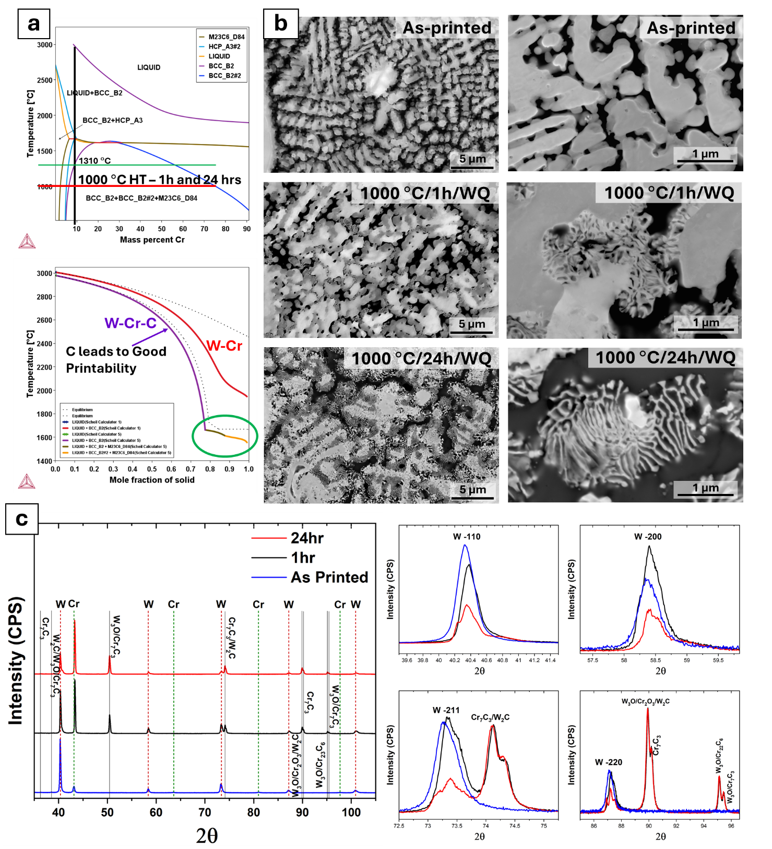
Figure 1: (a) CALPHAD results - Pseudo-binary phase diagram of W-9Cr-0.3 wt% C, highlighting 1000 °C as the selected heat-treatment temperature, along with a Scheil–Gulliver solidification plot illustrating the role of carbon in enhancing printability. Evolution of spinodal with heat treatment, (b) SEM-CBS images at different magnifications for as-printed, 1000 °C/1h/WQ, and 1000 °C/24h/WQ, and (c) XRD results showing side bands suggesting spinodal decomposition and evolution of precipitates with heat treatment.

Figure 2 (a) presents the EDS compositional maps and line scan for the 1000°C/24 hr heat treatment, reaffirming our observations from the SEM-CBS images. Although C seems to be homogenously distributed, with bright spots observed in the C map, suggesting carbides/oxides [8], the line scan shows a preference for C in the W-rich region, whereas O is partitioned with the Cr-rich region, as seen in Figure 2 (b). EDS maps for the as-printed and 1-hour heat-treated samples are provided as supplementary material in Figures S2-S3. From the above results, the evolution of spinodal decomposition is sketched in Figure 2 (c), illustrating how time and temperature can be used to tailor the fraction of spinodal features that affect the mechanical response, as discussed in the upcoming nanoindentation section.
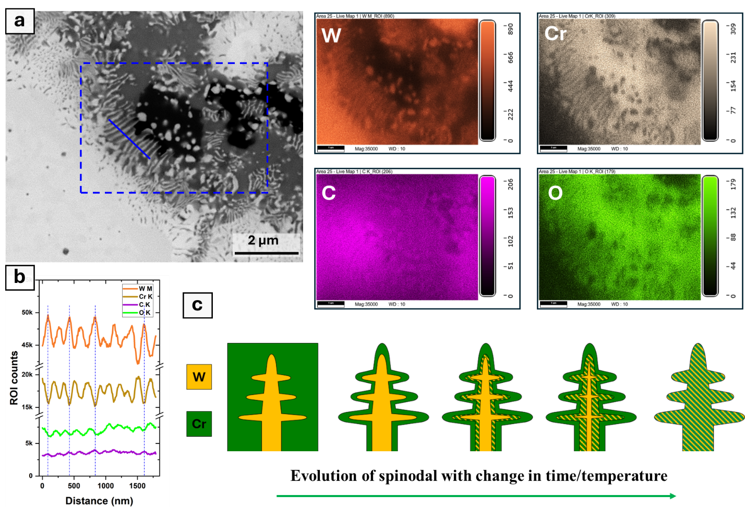Figure 2: SEM-EDS results for 1000 °C/24h/WQ heat-treated sample (a) compositional maps of W, Cr, C, and O, (b) line scan along the spinodal region marked in (a), and (c) schematic of spinodal decomposition leading to tailoring the microstructure.
Figure 3 (a) shows representative nanoindentation load-displacement results for all conditions. The as-printed sample exhibits high hardness ~ 8 GPa (Figure 3 (b)), attributed to the high dislocation density [8] and the minor presence of carbides and oxides, as highlighted in the enlarged XRD plot in Figure S4. After heat treatment at 1000 °C for 1 hour, spinodal features and carbide/oxide peaks are observed in SEM and XRD (Figure 1); however, the hardness decreases by ~50% to about 4 GPa, primarily due to the annealing of the high density of dislocations. Prolonged heat treatment for 24 hours promotes further spinodal decomposition. It maintains a similar fraction of precipitates, resulting in a hardness increase back to ~8 GPa, albeit with greater scatter in the data. Nanoindentation was performed to study the evolution of these features and their influence on mechanical properties with heat treatment. However, as shown in Figure S5, the indents (~ 2 μm) are much larger than the nanoscale features, limiting the interpretation to average hardness values only.
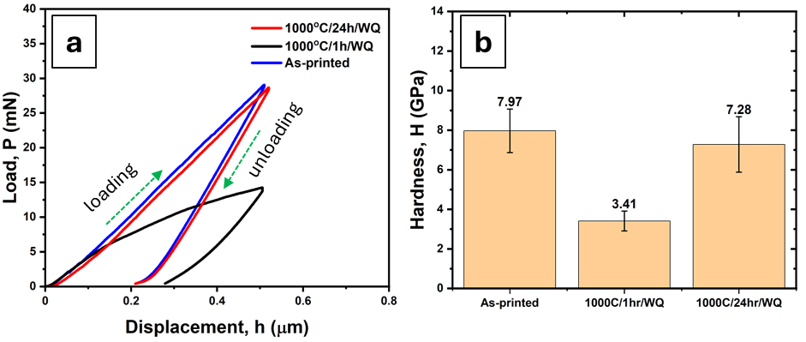
Figure 3: Nanoindentation results of hardness for as-printed, compared with samples heat-treated at 1000 °C for 1 hr and 24 hr.
When imaging from the bottom to the top of the as-printed sample (~ 6 mm in height), along the build direction (Figure S6), the micrographs reveal a typical peritectic microstructure, and spinodal decomposition was not expected in the as-printed condition [8]. However, careful examination reveals evidence of spinodal decomposition in the middle portion of the build. To investigate this further, modeling was performed to understand the thermal cycling that leads to spinodal decomposition in the middle layers, as well as the effect of subsequent heat treatment on the formation of alternating W-rich and Cr-rich lamellae.
Figures 4 (a) and (b) show the temperature distribution and thermal cycles from top to bottom layers, respectively, with each layer having a height of 50 μm. Each profile corresponds to a layer where the first and second melt pools overlap. The peak temperature of the top layer and the liquidus line define the first melt pool (~300 μm from simulations), marked by a red dotted line. From the equilibrium phase diagram (Figure 1 (a)), the spinodal decomposition for this alloy (with 9 wt% Cr) is expected below ~1310 °C. Heat treatment studies indicate that the extent of spinodal decomposition depends on both temperature and hold time. However, L-PBF AM is characterized by very high cooling rates, leaving little hold time at elevated temperatures.
The cooling rates (CR) along the melt pool depth are marked in Figure 4 (c). These high CRs and short hold times prevent the formation of spinodal features in the top melt pools, which is consistent with microscopy observations. In deeper melt pools, the cooling rates decrease, and below ~1310 °C, spinodal decomposition becomes possible. However, this is only within a narrow range, schematically indicated by the shaded blue region, where the temperature is high enough to allow spinodal decomposition and the CRs are moderate enough to provide sufficient hold time as shown in Figure 4 (c). At lower temperatures, longer hold times are required, which are not offered during L-PBF AM processing. Consequently, spinodal features are observed primarily in the middle layers of the build, where the thermal cycles fall within the optimal temperature and cooling rate range for spinodal decomposition in this alloy.
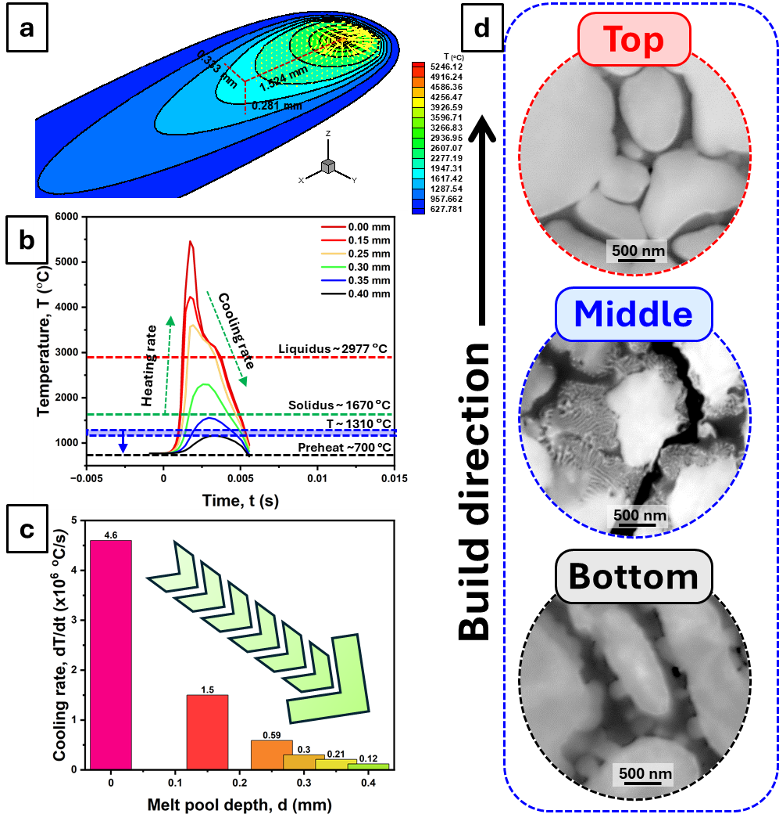
Figure 4: Heat transfer model – thermal cycling along the build direction to track spinodal and then corresponding SEM images from bottom to top of the build. (a) Melt pool simulation [8], (b) thermal cycles with respect to time and the melt pool depth, (c) cooling rate extracted from thermal profiles with respect to melt pool depth, and (d) location-specific SEM micrographs.
From this study, it is clear that adjusting the processing parameters during L-PBF AM of W–Cr alloys enables microstructural tailoring for specific applications. Figure 5 presents a schematic W–Cr time–temperature–transformation diagram illustrating how different processing routes lead to distinct microstructures. The W-tool market is very sizeable, and densimet alloys (W-Fe-Ni) have an upper-temperature limit governed by the low melting temperature of Fe and Ni. New alloys using the W-(Mo,Nb,V,Cr,Ta,Re) system will fulfill currently unmet needs by tuning the composition and microstructure to have a printable W-alloy for targeted applications. Another is armor applications, where W-based alloy [10] can replace depleted uranium (DU) for armor plating and armor-piercing projectiles. DU, a by-product after enrichment of uranium, has various civilian and military applications, due to its high density of 19.1 g/cc. The civilian uses include counterweights in aircraft, stabilizers in maritime vessels, radiation shielding in medical radiation therapy and industrial radiography equipment, and containers for transporting radioactive materials; whereas military uses include armor plating and armor-piercing projectiles. The issue with the use of DU is its long-term health effects due to exposure to toxic uranium, leading to a search for alternatives. The newly developed alloy can be used, which is dense enough to provide a maximum amount of kinetic energy, self-sharpening but not shattering on impact, and be able to replicate at least 90% of DU’s shear properties.
W-alloys are of interest for nuclear reactors due to their high temperature stability, high temperature strength, excellent thermal conductivity, high density, minimal sputtering yield, and hydrogen interaction [5]. Different structural components of a nuclear reactor demand complex geometrical design and rapid prototyping, which can be offered by AM. But spinodal decomposition is known to be detrimental for nuclear applications as it can lead to embrittlement, cracking, and potential failure, concerning the lifetime and sustainability of nuclear reactors. Spinodal is observed for W-15Cr (at.%) during sintering of micron-size powders starting at temperatures above 950 °C [11] and via traditional melting routes in as-cast alloys, due to slow solidification rates. The high solidification rates in AM by optimizing the processing parameters will allow no time for decomposition.
W has been widely used by NASA and recently by DARPA as a fuel cladding, fuel matrix, fuel element, and channel material in nuclear thermal propulsion applications [12,13]. These properties make refractory alloys ideal for use also in space propulsion sub-components, rocket nozzles, wing leading edge heat pipes, nuclear casings, and thrust chambers [14,15].
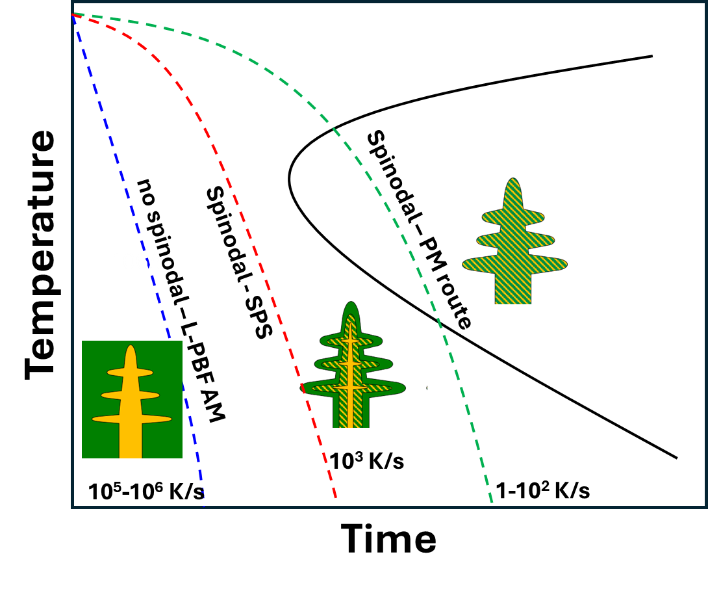
Figure 5: Evolution of spinodal features with different cooling rates attributed to diverse processing routes, including L-PBF AM, spark plasma sintering (SPS), and powder-metallurgy (PM) route.
L-PBF AM is a non-equilibrium process that produces a rapidly solidified microstructure. In this study, it was observed that the high cooling rates inherent to L-PBF result in only a small fraction of spinodal features. However, this fraction can be tuned by adjusting the AM process parameters and applying post-process heat treatments. The strength–ductility synergy of L-PBF-printed W alloy can be optimized by engineering a hierarchical microstructure to enhance strength, while incorporating appropriate alloying elements to improve ductility.

CRediT authorship contribution statement
Priyanka Agrawal: Conceptualization, formal analysis, data curation, microscopy, software, Writing ― original draft. Amit Kumar Singh: Formal analysis, data curation, software, Methodology, Writing ― review and editing. Prithvi Dev Awasthi: Methodology. Sarah McDearis: Methodology. Aishani Sharma: Data curation. Fredrick N. Michael: Resources, Writing ― review and editing. Rajiv S. Mishra: Conceptualization, project administration, resources, supervision, Writing ― review, and editing.

Declaration of competing interest
The authors declare that they have no known competing financial interests or personal relationships that could have appeared to influence the work reported in this paper.

Acknowledgments
This work was supported by NASA under grant number #80NSSC21M0273. The authors acknowledge the infrastructure and support of the Center for Agile & Adaptive and Additive Manufacturing (CAAAM), funded through State of Texas Appropriation #190405-105-805008-220. The authors thank the Materials Research Facility for access to microscopy facilities at the University of North Texas. PA thanks Dr. Rajarshi Banerjee and Dr. Vishal Soni for insightful discussions on heat treatments to track spinodal decomposition in immiscible systems.

References
[1] A.B. Peters, D. Zhang, S. Chen, C. Ott, C. Oses, S. Curtarolo, I. McCue, T.M. Pollock, S. Eswarappa Prameela, Nature Communications 2024 15:1 15 (2024) 1–15.
[2] P. Gradl, O.R. Mireles, C. Katsarelis, T.M. Smith, J. Sowards, A. Park, P. Chen, D.C. Tinker, C. Protz, T. Teasley, D.L. Ellis, C. Kantzos, Acta Astronaut 211 (2023) 483–497.
[3] A. Bose, C.A. Schuh, J.C. Tobia, N. Tuncer, N.M. Mykulowycz, A. Preston, A.C. Barbati, B. Kernan, M.A. Gibson, D. Krause, T. Brzezinski, J. Schroers, R. Fulop, J.S. Myerberg, M. Sowerbutts, Y.M. Chiang, A. John Hart, E.M. Sachs, E.E. Lomeli, A.C. Lund, Int J Refract Metals Hard Mater 73 (2018) 22–28.
[4] A.M. of R.M. for A.A.-N.T.R.S. (NTRS)-https://ntrs.nasa.gov/citations/20210018657, (2021).
[5] M. Rieth, S.L. Dudarev, S.M. Gonzalez De Vicente, J. Aktaa, T. Ahlgren, S. Antusch, D.E.J. Armstrong, M. Balden, N. Baluc, M.F. Barthe, W.W. Basuki, M. Battabyal, C.S. Becquart, D. Blagoeva, H. Boldyryeva, J. Brinkmann, M. Celino, L. Ciupinski, J.B. Correia, A. De Backer, C. Domain, E. Gaganidze, C. García-Rosales, J. Gibson, M.R. Gilbert, S. Giusepponi, B. Gludovatz, H. Greuner, K. Heinola, T. Höschen, A. Hoffmann, N. Holstein, F. Koch, W. Krauss, H. Li, S. Lindig, J. Linke, C. Linsmeier, P. López-Ruiz, H. Maier, J. Matejicek, T.P. Mishra, M. Muhammed, A. Muñoz, M. Muzyk, K. Nordlund, D. Nguyen-Manh, J. Opschoor, N. Ordás, T. Palacios, G. Pintsuk, R. Pippan, J. Reiser, J. Riesch, S.G. Roberts, L. Romaner, M. Rosiński, M. Sanchez, W. Schulmeyer, H. Traxler, A. Ureña, J.G. Van Der Laan, L. Veleva, S. Wahlberg, M. Walter, T. Weber, T. Weitkamp, S. Wurster, M.A. Yar, J.H. You, A. Zivelonghi, Journal of Nuclear Materials 432 (2013) 482–500.
[6] O. Mireles, AIAA Propulsion and Energy Forum, 2021 (2021).
[7] A. Talignani, R. Seede, A. Whitt, S. Zheng, J. Ye, I. Karaman, M.M. Kirka, Y. Katoh, Y.M. Wang, Addit Manuf 58 (2022) 103009.
[8] P.D. Awasthi, P. Agrawal, A.K. Singh, A. Sharma, F.N. Michael, R.S. Mishra, Int J Refract Metals Hard Mater Under Review (2025).
[9] P.D. Awasthi, Additive Manufacturing of Refractory Alloys, University of North Texas, 2024.
[10] A.J. Knowles, T.Y.S. Cheung, K. Ma, R. Dodds, S.A. Humphry-Baker, F.F. Morgado, S.S. Katnagallu, E. Saiz, B. Gault, C.D. Hardie, D. Dye, Appl Mater Today 41 (2024) 102430.
[11] M. Park, C.A. Schuh, Nature Communications 2015 6:1 6 (2015) 1–6.
[12] A. Litnovsky, T. Wegener, F. Klein, C. Linsmeier, M. Rasinski, A. Kreter, B. Unterberg, J.W. Coenen, H. Du, J. Mayer, C. Garcia-Rosales, A. Calvo, N. Ordas, Nuclear Fusion 57 (2017) 066020.
[13] A. Litnovsky, T. Wegener, F. Klein, C. Linsmeier, M. Rasinski, A. Kreter, X. Tan, J. Schmitz, J.W. Coenen, Y. Mao, J. Gonzalez-Julian, M. Bram, Phys Scr 2017 (2017) 014012.
[14] S.K. Borowski, D.R. Mccurdy, L.M. Burke, The Nuclear Thermal Propulsion Stage (NTPS): A Key Space Asset for Human Exploration and Commercial Missions to the Moon, 2014.
[15] J.R.; Johnston, R.A.; Signorelli, J.C. Freche, Performance of Rocket Nozzle Materials with Several Solid Propellants., n.d.
[16] D.T. Queheillalt, Y. Murty, H.N.G. Wadley, Scr Mater 58 (2008) 76–79.
[17] N. Khan, A. Riccio, Progress in Aerospace Sciences 149 (2024) 101021.
[18] H.Z. Zhong, T. Song, C.W. Li, R. Das, J.F. Gu, M. Qian, Scr Mater 228 (2023) 115341.
[19] A.K. Singh, P.D. Awasthi, A. Roy, P. Agrawal, A. Sharma, A. Gumaste, R.S. Haridas, R.S. Mishra, Additive Manufacturing Letters 14 (2025) 100308.

Supplementary Material
Tailored refractory W-alloys for fusion-based additive manufacturing
Priyanka Agrawal^{a,b,*}, Amit Kumar Singh^{a,b,c}, Prithvi Dev Awasthi^{a,b,c}, Sarah McDearisª, Aishani Sharma^{a,b}, Fredrick N. Michael^{d}, Rajiv S. Mishra^{a,b,*}
ªCenter for Friction Stir Processing, Department of Materials Science and Engineering, University of North Texas, Denton, TX 76207, USA
^{b}Department of Materials Science and Engineering, University of North Texas, Denton, TX 76207, USA
^{c}Center for Agile and Adaptive Additive Manufacturing, University of North Texas, Denton, TX 76207, USA
^{d}Materials & Processes Laboratory, Marshall Space Flight Center, National Aeronautics and Space Administration, Huntsville, AL, USA

*Corresponding author: Priyanka.Agrawal@unt.edu, Rajiv.Mishra@unt.edu
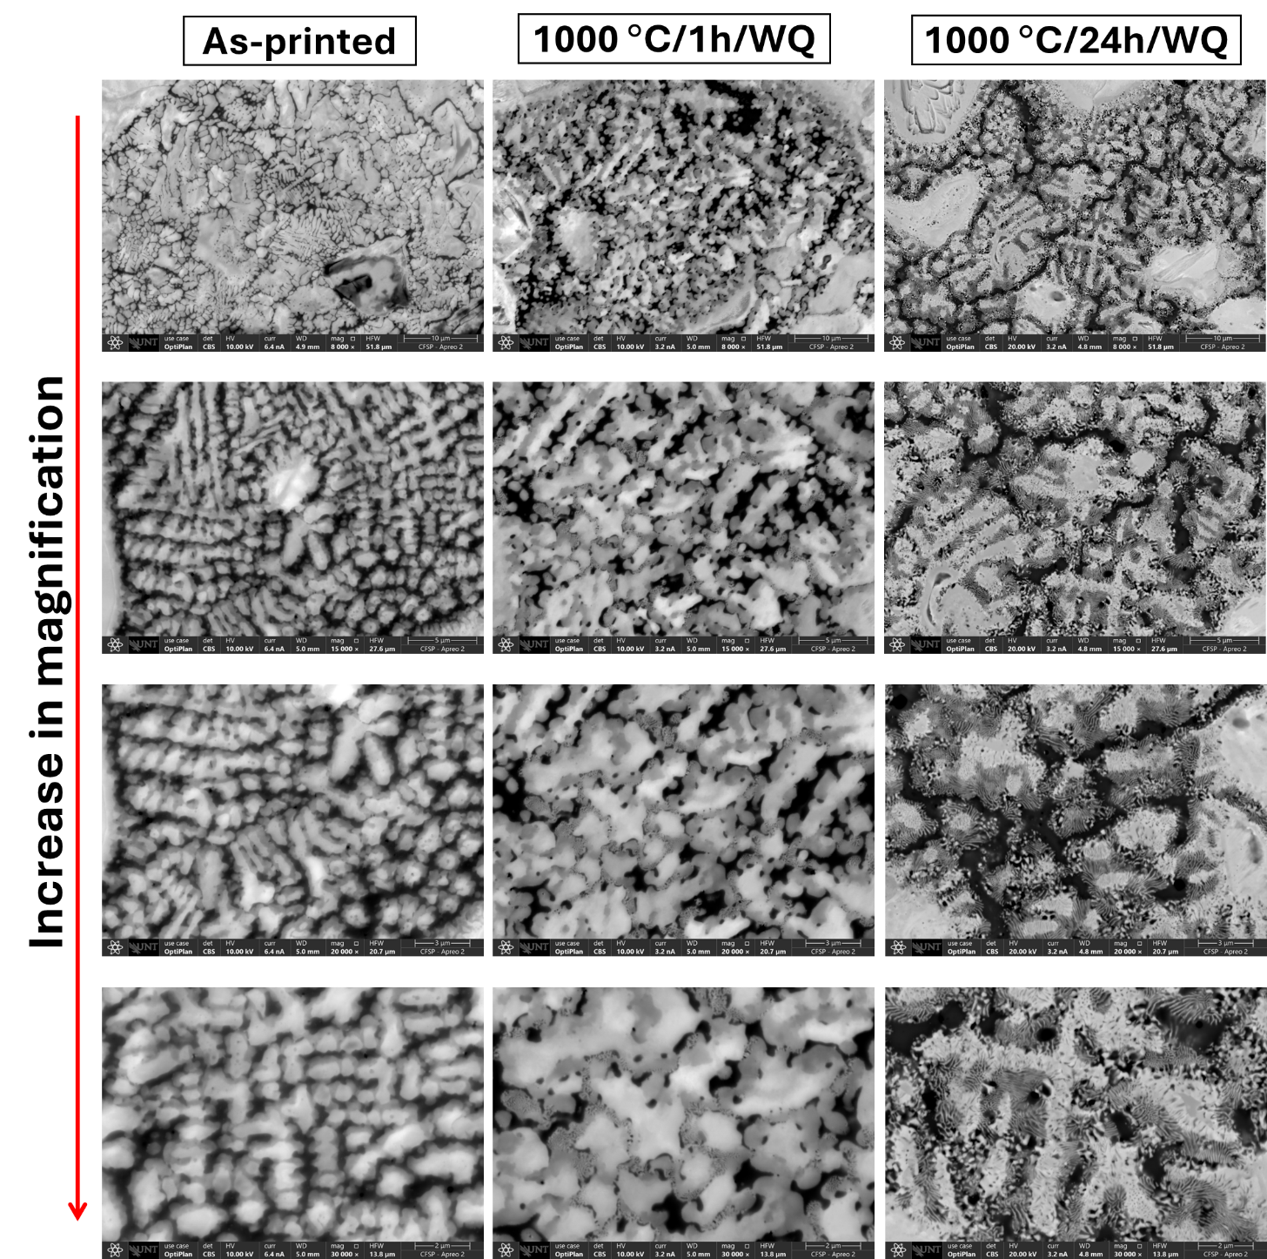
Figure S1: SEM-BSE images for all conditions at different magnifications.
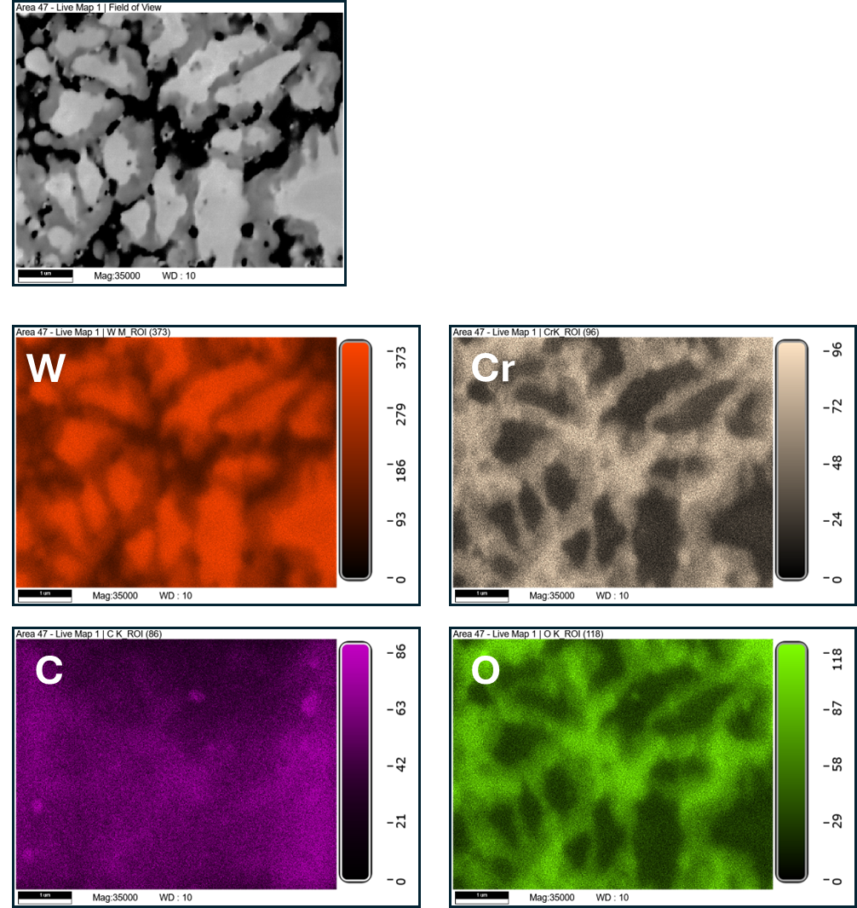
Figure S2: SEM-EDS of as-printed sample.
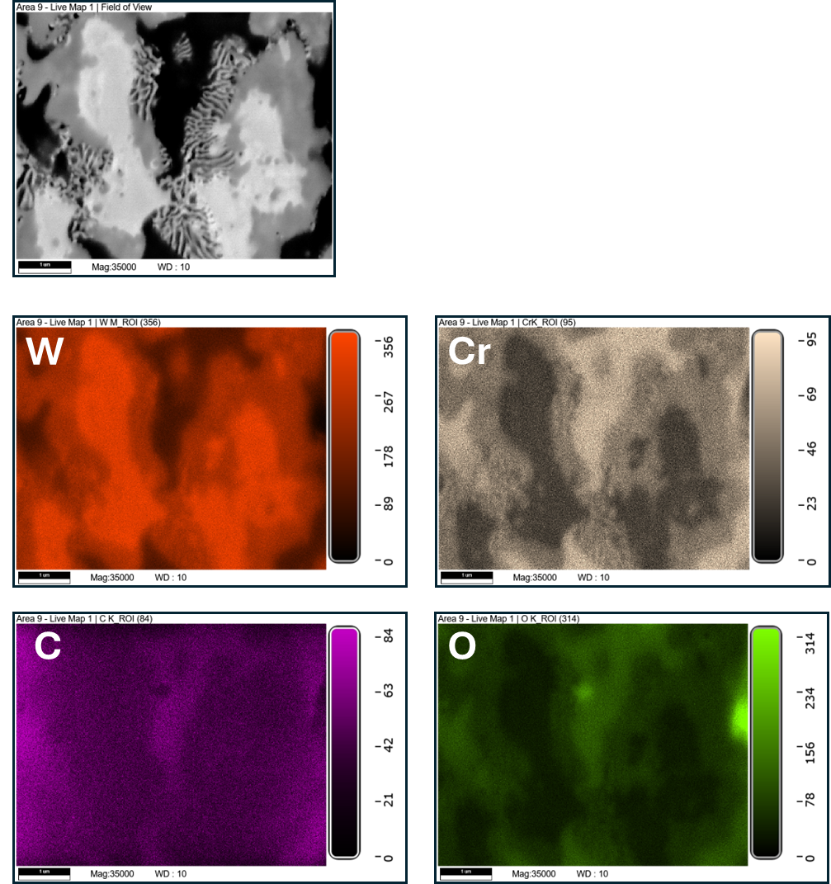
Figure S3: SEM-EDS of heat-treated sample for 1hr, 1000 °C.

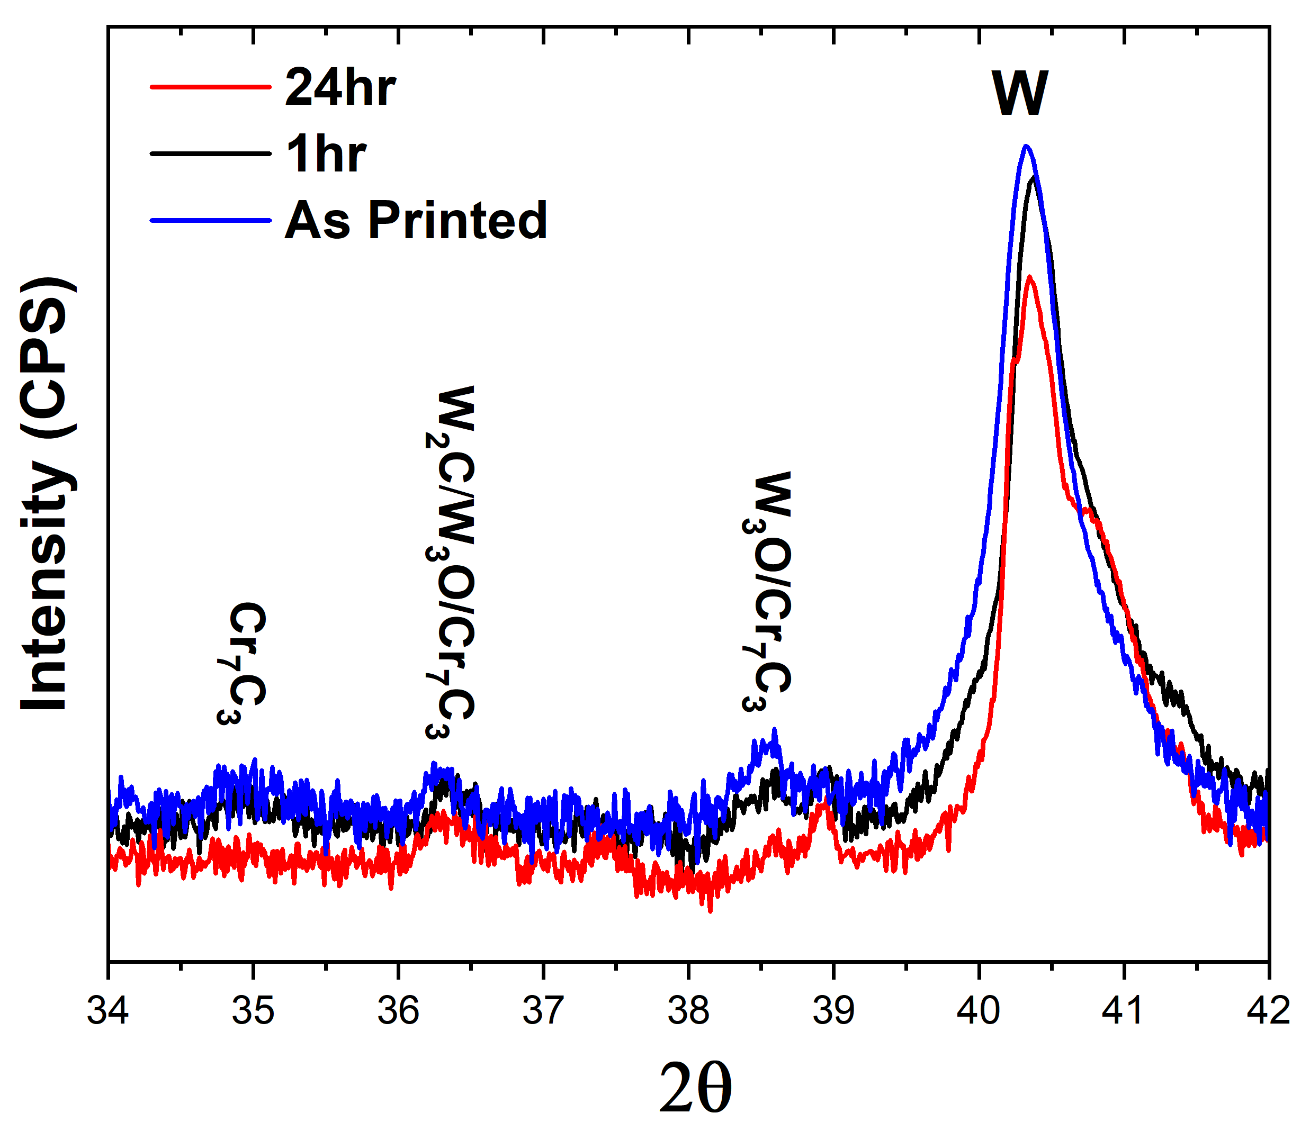
Figure S4: XRD results showing the presence of precipitates even in the as-printed condition.

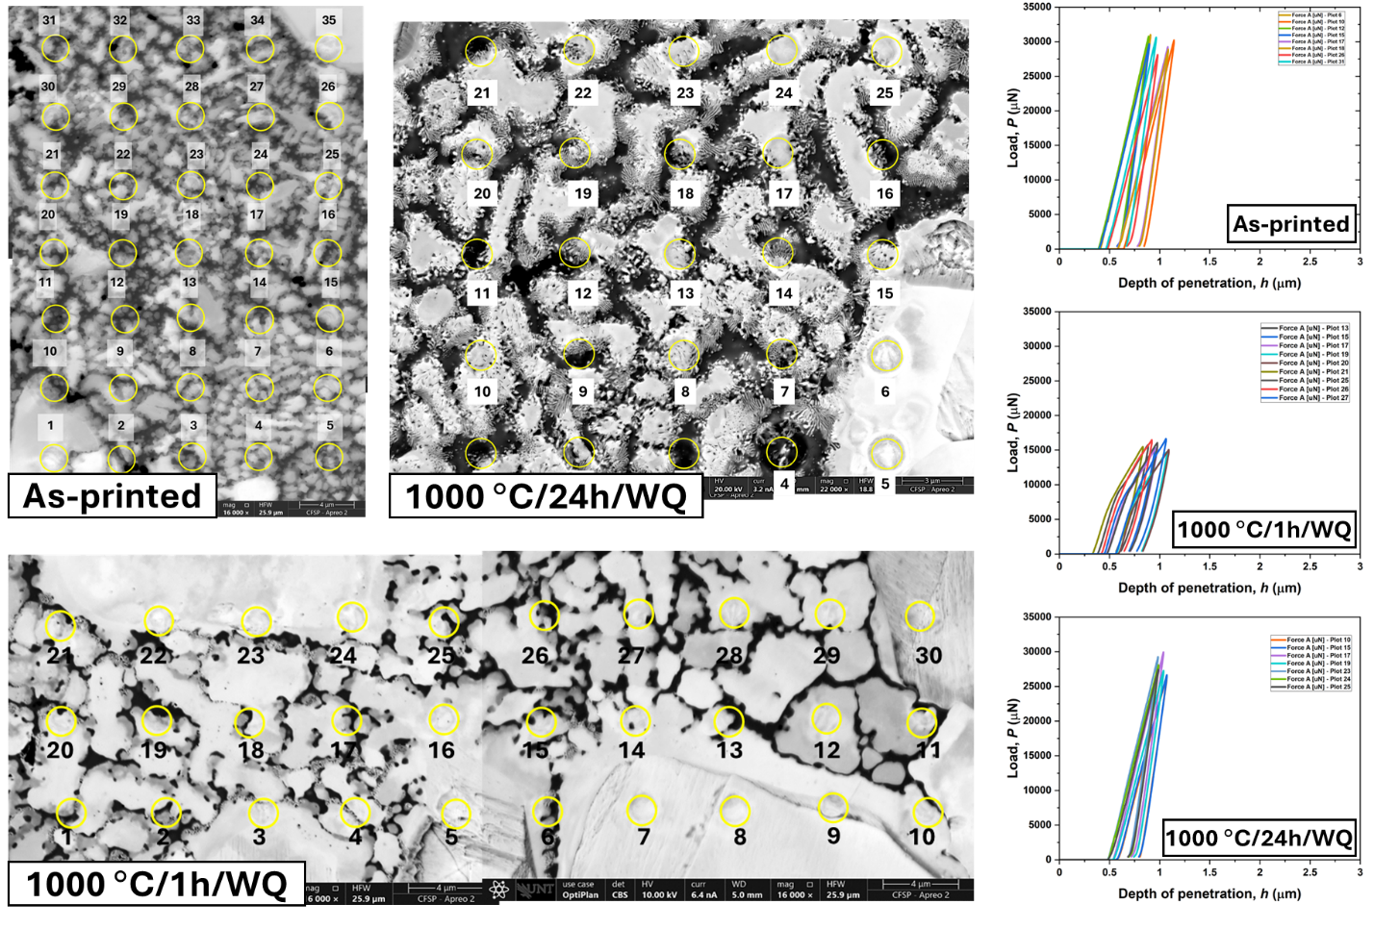
Figure S5: Nanoindentation in correlation with microscopy to reveal the effect of microstructural features on mechanical performance.
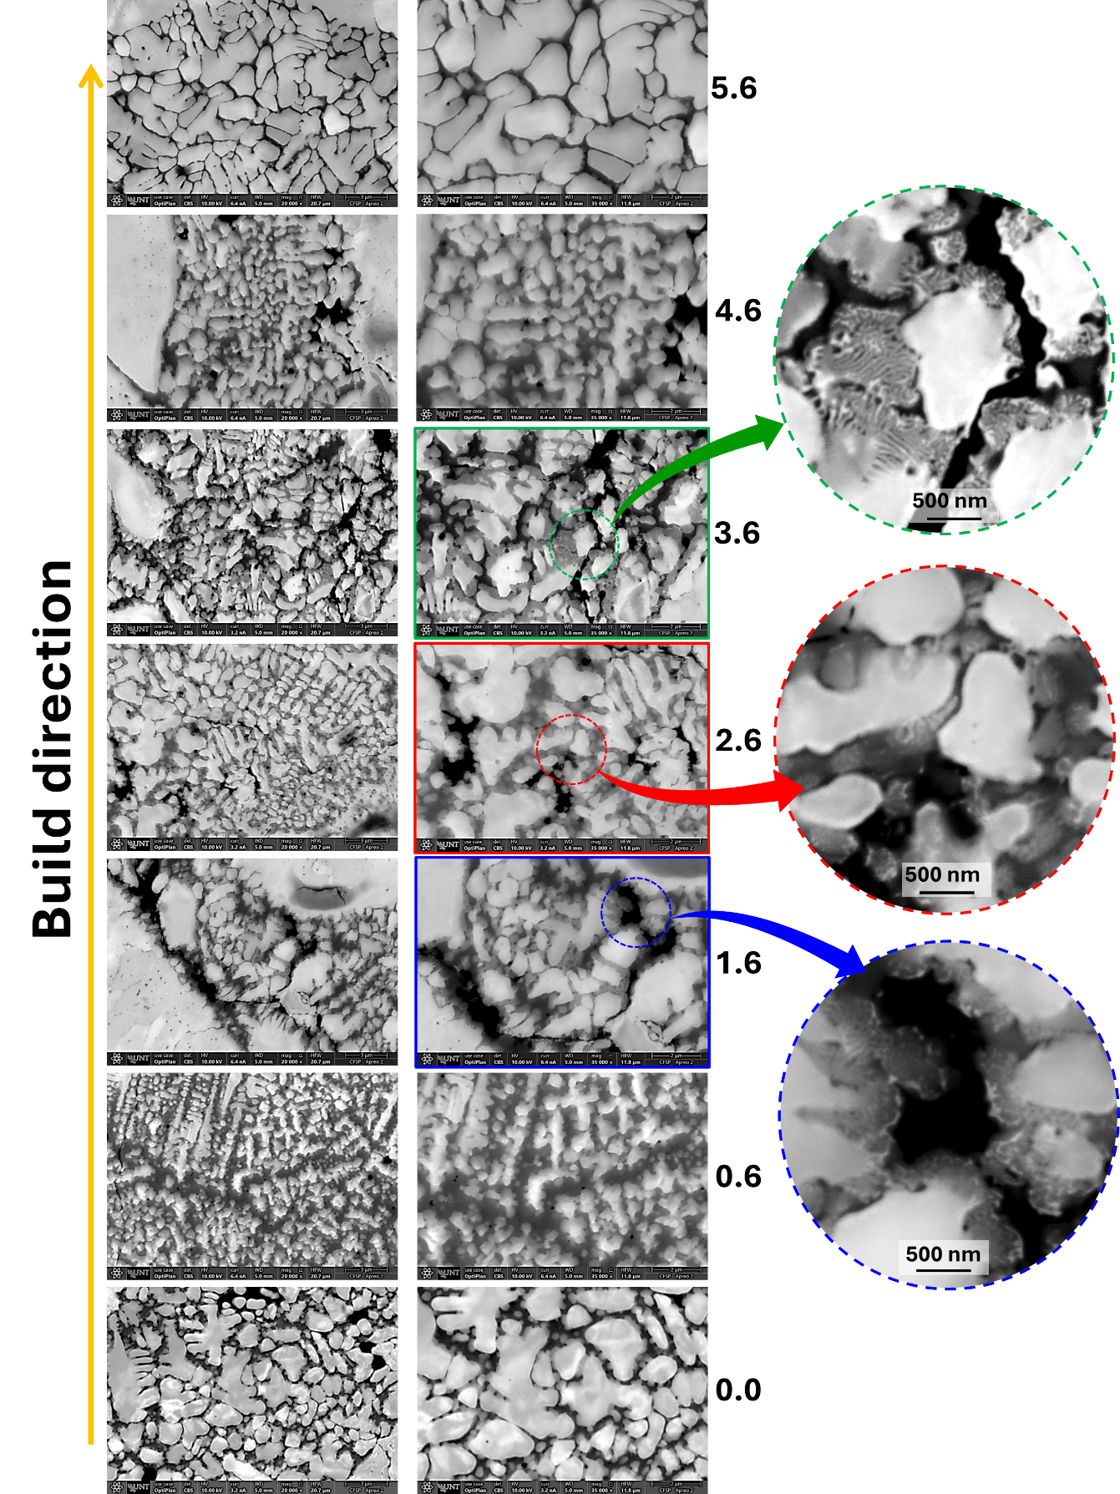
Figure S6: Evolution of microstructural features, mainly spinodal decomposition along the build height ~ 6mm. The left column is the low magnification images, whereas the right column is at higher magnification. The numbers to the right note the distance in mm from bottom to top.

