Evaluation of Electrically Heated Nuclear Reactor Development Units for the Advancement of Propulsion and Power Technologies
Jackson Cho^{1*}, Jacob Ondeck¹, Brian Hoang², Matthew Hitt¹, Tyler Dennis³, Noah Sutton³
¹NASA Marshall Space Flight Center, Propulsion Research and Technology Branch, Huntsville, AL
²Amentum, Space Exploration Division, Huntsville, AL
³Antares Nuclear, Inc., Torrance, CA

ABSTRACT
The national interest in sustainable nuclear power has seen a recent and significant resurgence, with targeted investments creating an enriched environment for the development of more modular and situational nuclear systems. Despite this, logistical and regulatory hurdles risk throttling reactor development efforts, with the potential of disproportionally affecting those technologies at the micro reactor scale. To permit rapid thermal testing of integrated reactor systems earlier in the development cycle, electric heating can be employed to simulate fission heating. The Nuclear Systems Team within Marshall Space Flight Center’s (MSFC) Propulsion Research and Technology Branch has expertise performing such non-nuclear testing to evaluate reactor components, inspect material compatibilities, and characterize thermal system performances. Tests of this type have been critically valuable to advancing space nuclear propulsion in their ability to validate fuel element materials and geometries in a simulated yet thermally representative nuclear thermal propulsion reactor environment. Similarly, this approach has been implemented by the team to the advancement of reactors with applicability to space nuclear propulsion. At Antares Industries, nuclear and system engineers are developing a special-purpose multi-Kilowatt scale micro-reactor for use in first response, and space, and other environments. Reactor architectures of this output scale readily lend themselves to the implementation of electrical demonstration units (EDU). Consequently, Antares and MSFC personnel have collaborated to develop a subscale EDU representative of the Antares R1 reactor system. Herein is a discussion of the design, buildup, and testing of the Antares EDU, alongside potential future work discussions of the advancement of micro-reactor non-nuclear development testing.
Keywords: Space Nuclear Propulsion, Reactor Ground Testing, Nuclear Electric Propulsion, Fission Surface Power

INTRODUCTION
Significant focus in the nuclear power industry has recently been placed on the development of compact power solutions (e.g. micro-reactors) for use in power generation. These reactor units, with outputs generally between 2-40 MW, represent a resilient approach to power generation in a deployable scale [1]. The shared need for electrical power across almost all engineering disciplines points directly to the benefit of a universal, sustainable, efficient, and long-lived energy solution. Nuclear power is uniquely poised to fulfill these requirements. Despite the allure of a common and sustainable energy solution, the process of developing and testing a nuclear reactor system often proves prohibitive for limited scope efforts. Regulatory restrictions and supply chain challenges pose major challenges for development efforts, with the delivery of nuclear material potentially lagging behind the development of a potentially functional thermal system [1]. To combat this, the principle of using electrical heating to simulate the thermal load on a developmental reactor system is commonplace in micro and pico-reactor projects. Employing electrical heating permits testing and analysis of system materials, design and performance without the schedule impacts of nuclear material delivery.
Additionally, electrically driven nuclear simulation alleviates testing restrictions, simplifies instrumentation practices, and improves viability of post-testing breakdown and analysis of hardware, fuel structures, soft goods, etc. Electrical Demonstration Units (EDUs), do not require the certifications and facilities necessary to perform powered nuclear operation. In the realm of instrumentation, the lack of degrading effects when testing an EDU greatly increases survivability of critical devices. Post testing approaches are also greatly simplified, as no nuclear material or radioactive elements are present in the system. These advantages evidence the utility of EDU testing capabilities.
The Propulsion Research and Technology Branch’s Nuclear Systems Team at MSFC has an extensive history of contributions to the testing of fission power system hardware using non-nuclear, electrically heated surrogate approaches. The extent of legacy work here at MSFC includes resistive heating prototypes such as the SAFE-100a EDU, tested as early as 2005 [2]. State of the art test stands at MSFC such as the Nuclear Thermal Rocket Element Environmental Simulator (NTREES) facility [3] and the Compact Fuel Element Environmental Test (CFEET) testbed have expanded the field of electrically driven nuclear environment simulation substantially [4]. These test beds and reactor simulators provide research partners with valuable thermochemical, thermomechanical, and thermohydraulic data for the maturation of associated nuclear reactor technologies, improving the knowledgebase of material and component performance within such systems.
One such partner, Antares Nuclear, seeks to implement a deployable, micro-reactor scale power generation unit in virtually all emergent fields in need of robust power generation. In partnership with the Nuclear Systems Team at MSFC, an EDU design effort to simulate their reactor system is detailed herein. This paper will specifically discuss the design constraints and delivered capability of the EDU, as opposed to partner specific metrics or achievements.

DESIGN
The design of the Antares R1 reactor EDU system served to develop hardware for the full-scale system, identify use case challenges, and further component compatibility. The system was designed as an alkali metal heat pipe reactor. These reactor concepts utilize captured metal to create a naturally stabilized heat transfer system through the evaporation and condensation, as shown in Figure 1.
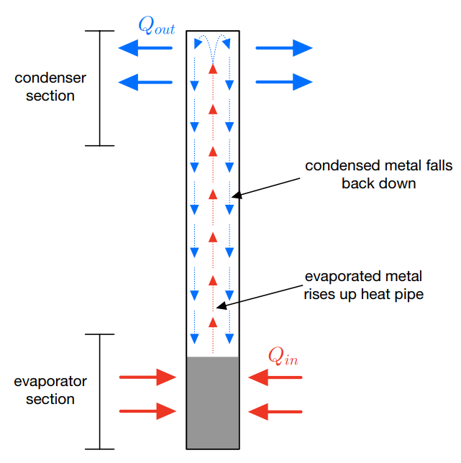
Figure 1. Heat Pipe Diagram

Alkali metal heat pipe reactor systems benefit from negative feedback loop behavior. As heat flux is increased into the heat pipe, the evaporation of captured metal occurs more rapidly. This increases the transfer of heat through the pipe to the evaporator section, and thereby increases cooling experienced by the reactor core. If the heat flux into the evaporator section decreases, the metal evaporates more slowly, and therefore decreases the cooling experienced by the reactor core. For specific heat flux ranges that do not result in evaporation of the captured material, this process ensures passive stability within the heat transfer system of the reactor. This effect is observable in the case of fission or electrical heating. These specific heat pipes utilized a finned upper section to improve heat transfer with the process fluid, and are shown in Figure 2.
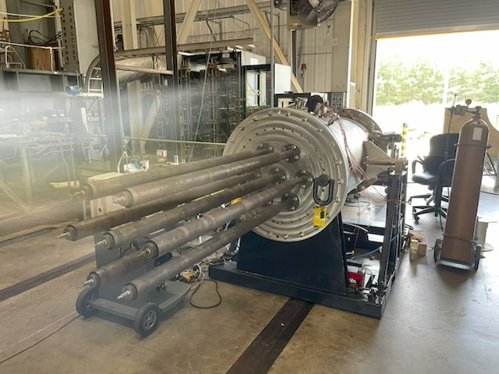
Figure 2. Antares EDU Upper Section Closeup
The core of the reactor utilized graphite hexes for fuel containment. Due to the operational temperature ranges, the graphite would oxidize if left in ambient atmosphere. The reactor was therefore housed in a stainless-steel enclosure, and a nitrogen trickle flow was employed to inert the volume. To account for thermal expansion during heating from ambient conditions, the reactor core was designed to ride on springs, supported by a set of stainless-steel retention plates. The hexes and containment can be seen in Figure 3.
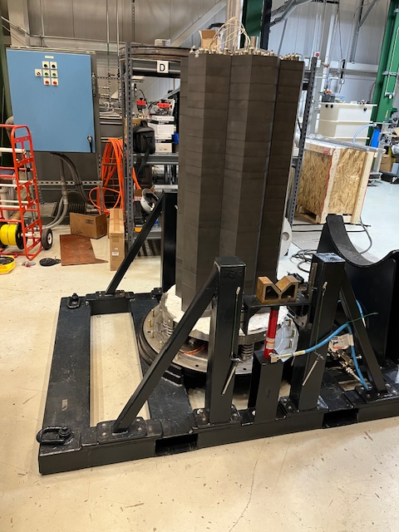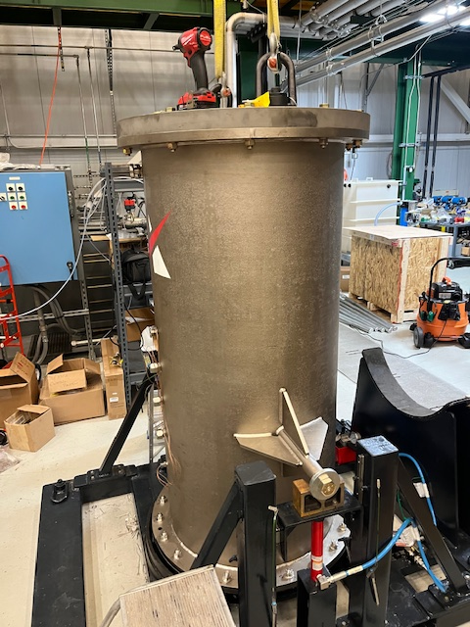
Figure 3. Reactor Simulator (L: Uncovered; R: Enclosed)
For the heat exchanger section, the alkali metal heat pipes were designed to reside in the center of each graphite fuel hex. Then process heat was directed into a primary heat exchanger (PHX) located directly on top of the reactor core assembly. This is shown below in Figure 4.
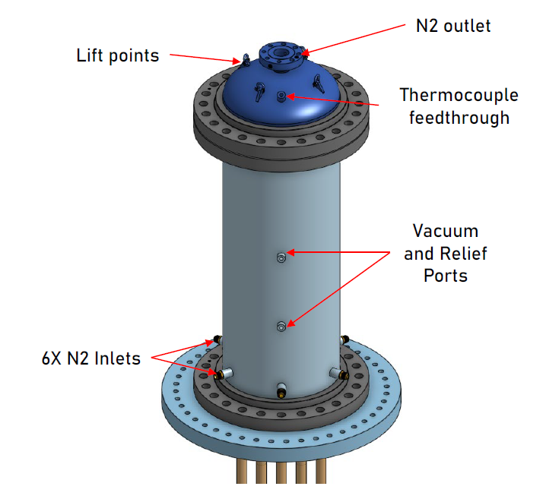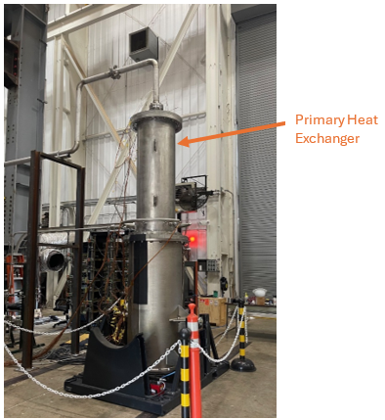
Figure 4. Primary Heat Exchanger (L: CAD Rendering; R: Installed PHX In-Situ)

One of the major benefits to the micro-reactor system concept is transportability. Such systems could be utilized across all industries for deployable robust long term power generation. Antares industries, therefore, specifically designed the R1 reactor system to be portable and field-installation ready. The entire assembly rides on a custom hydraulic transport cradle to facilitate maneuvering. This cradle can be seen in figures 2 and 3.
Once the design had been communicated to the MSFC Nuclear Systems Team, the EDU was modeled after the R1 system. Resistive cartridge heaters simulated the input heat needed for the reactor. The cartridge heaters acquired were fabricated with variable windings to generate variable thermal loading in the reactor core along the axial direction. This aligned more closely with the theoretical nuclear system. The heaters occupied designed voids in the graphite core where nuclear fuel would eventually be housed.
The reactor core was instrumented with a variety of penetrative thermocouples and surface contact thermocouples throughout the graphite hexes. These provided temperature measurements along critical thermal gradients that characterize reactor behavior. Thermocouples were also implemented along the length of the heat pipes to monitor the heat transfer throughout system operation. Hall effect current sensors were deployed along the power transfer circuits feeding the cartridge heaters to ensure representative thermal loading. The trickle gas flow into the reactor core housing and the nitrogen working fluid flow in the primary heat exchanger were instrumented for flow rate and exhaust temperature to capture the heat losses of the system.
One of the critical takeaways from the EDU design effort was the need to increase the instrumentation fidelity on subsequent testing. The thermal loading of the reactor system was complex to the point where significant gradients may not have been completely represented by the discrete points captured in the initial campaign. Residual gas analysis (RGA) on exhausted process gas would’ve been desirable. The capability to implement optical metrology, specifically some kind of Digital Image Correlation (DIC) technique, would have proved useful. This increase in instrumentation would better characterize the heat pipe interactions, cartridge heater performance, and graphite core performance throughout testing. The presence of optical feedthroughs or optometric strain evaluation would also have provided valuable data.

TESTING
Buildup of the EDU occurred at MSFC’s Propulsion Research Laboratory in Building 4205. The Nuclear Systems Team worked on-site with Antares personnel through the course of several months. The ability to use a 15 ton overhead crane in conjunction with forklift access greatly facilitated build up schedule. The facility is currently undergoing updates to improve its future EDU testing capabilities.
Once assembled, the EDU was transported to MSFC Materials Environment Test Complex (METCO) Hot Gas Facility for testing. Custom gas plumbing and power routing allowed for the remote operation of the test article. MSFC and Antares personnel designed a test matrix that would ensure all corners of theoretical reactor behavior were represented, along with some fringe failure cases that would inform design maturation.
The EDU was designed to apply a three-dimensional thermal gradient on the reactor core. The axial gradient direction was driven by the cartridge heater design, and the radial gradient direction driven by variable supply power. To preserve the privacy of the Antares team’s design metrics, plotted values will be normalized against static design parameters. Full analysis of the observed thermal gradients, design values, and achieved performance during test matrix completion are not contained in this paper. This section specifically details the delivered capabilities of the EDU. For the simulation of the reactor core, the bottom, middle, and upper thirds of the graphite fuel containment section were expected to see different temperatures at steady state. This is in keeping with the behavior of the predicted nuclear system. The three regions can be seen plotted normalized in Figure 5.
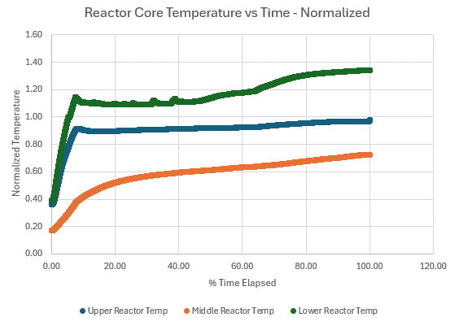
Figure 5. Reactor Core Temperature vs. Time (Normalized)
As can be observed, the design of the cartridge heaters produced discernable heating gradients among the three regions of the reactor core, alongside the cooling effect of the heat pipe system. This experimentation allowed the Antares team to observe the reaction of their hardware and architecture while under a representative design load.
The cartridge heaters were connected to 26 DC power supply units that could be tuned to approximate the thermal loading of the system under nuclear load in the radial direction. The Antares team was able to model the predicted thermal loading of the outer ring of hexes, and the innermost hex. This allowed for horizontal thermal profiling as well as vertical. Once again, the presented values are normalized against a design metric. Figure 6 outlines the Antares inner and outer hex supply distributions:
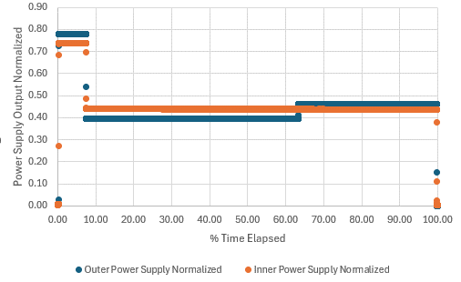
Figure 6. Power Supply Currents vs. Time (Normalized)
This capability allowed for the testing of variable heat fluxes in the radial direction. The achieved thermal gradients allowed the Antares team to contrast thermal modeling against the EDU, and affect the full scale reactor design accordingly.

CONCLUSIONS
In partnership with Antares Nuclear personnel, MSFC Nuclear Systems Team personnel designed, built, and tested an EDU in support of the Antares R1 Reactor system and NASA’s EDU testing capabilities. EDUs offer multiple advantages in schedule and ease of testing in the lifecycle of reactor development. In pursuit of accurate reactor characterization, an EDU with alkali metal heat pipes, graphite core, and nitrogen fed primary heat exchanger was designed to provide three dimensionally variable heat fluxes from cartridge heaters. This effort resulted in valuable experience gained for both teams, as well as meaningful test data for Antares Nuclear. The MSFC Nuclear Systems Team is exploring the implementation of a dedicated, in-house, non-nuclear reactor simulator testbed for further maturation of these concepts.

ACKNOWLEDGMENTS
This paper discusses ongoing work at NASA Marshall Space Flight Center which could not be possible without the support of our team’s Branch, Division, Department, Directive, and Center leadership. Additionally, the Propulsion Research and Technology Branch’s existing lab capabilities are directly attributed to the continual support of NASA’s Space Technology Mission Directorate (STMD) through the Space Nuclear Propulsion (SNP) project. Testing was conducted at METCO, and the efforts of the METCO team are greatly appreciated.
The specific test example discussed within this paper was activity funded under Space Act Agreement SAA8-2440703.1. Special thanks are owed to NASA MSFC Partnerships and Opportunity Development (POD) Office, NASA MSFC Office of Communications, and NASA MSFC Office of the General Counsel.
REFERENCES
- Nuclear Energy Institute, Micro-Reactor Regulatory Issues, White Paper, Washington, DC, USA, Nov. 2019.
- S. M. Bragg-Sitton, “Heat Pipe Reactor Dynamic Response Tests: SAFE-100a Reactor Core Prototype,” in Proceedings of the Space Nuclear Conference 2005, San Diego, CA, USA, Jun. 2005.
- M. P. Schoenfeld, J. O. Ondeck, M. A. Hitt, and J. W. Post, “An Overview of Nuclear Thermal Rocket Element Environmental Simulator (NTREES) Capabilities, Upgrades, and Overlaps in Advanced Material Testing Areas,” NASA MSFC, 2025.
- K. M. Benensky et al., “Operational Characterization and Testing of NASA MSFC’s Compact Fuel Element Environmental Test (CFEET),” in ANS Nuclear and Emerging Technologies for Space (NETS), Las Vegas, NV, USA, Feb.–Mar. 2018.

