Fly me to the moon: Family conferencing with communication delays on lunar missions
Sheena I. Dev¹, Nikole D. Moody², Diana P. Arias², & Suzanne T. Bell³

¹ NASA Behavioral Health and Performance Laboratory, KBR, Inc., Houston, TX, USA
² NASA Behavioral Health and Performance Laboratory, JES Tech, Houston, TX, USA
³ NASA Behavioral Health and Performance Laboratory, NASA Johnson Space Center, Houston, TX, USA

Correspondence:
Sheena I. Dev
Sheena.i.dev@nasa.gov

Abstract
Background: Current astronauts on the International Space Station have scheduled time to connect with their families via virtual audio and video private family conferences (PFCs). However, one-way communication delays expected to range from 4 to 12 seconds during lunar missions represent a significant paradigm shift for PFCs which have thus far operated with real-time communication. The objective of this study was to determine the effect of lunar communication delays on the expected benefits of PFCs in astronaut-like participants and their families. Methods: Thirty-five primary participants were recruited to approximate astronaut demographics at NASA Johnson Space Center in Houston, Texas. They were asked to identify a family member living outside of Houston to join as their study partner. Each study pair participated in six weekly virtual audiovisual PFC sessions conducted under 0, 4, 6, 8, 10, or 12 second one-way delays. Relationship and individual well-being outcomes were assessed before and after each PFC. Communication quality was assessed after each PFC in reference to the delay implemented. Linear mixed models with planned contrasts examined the impact of each PFC on relationship, individual well-being, and communication quality. Results: PFCs improved relationship outcomes relative to baseline regardless of the delay. Compared to PFCs with no delays, greater decrements to relationships and individual well-being were observed after PFCs with 8 second one-way delays or longer. Participants also indicated all delay latencies significantly reduced their communication quality and would impact their relationships if they were required to continue communicating under those conditions for six months. Conclusion: PFCs benefit long distance relationships among astronaut-like families. While participants generally tolerated shorter communication delays in this time limited laboratory setting, our results suggest that PFCs with communication delays, especially 8 seconds or longer, may not be sufficient to maintain family bonds in future long duration lunar missions. These findings underscore the importance of maintaining access to family and friends during spaceflight and provide a foundation from which innovative solutions can be crafted to preserve connections despite obstacles to communication.

Keywords: Astronaut; long duration spaceflight; communication delays, family separation; behavioral health

Introduction
Astronauts living and working in space are separated from their family and friends on Earth for extended periods of time. Communication with family is limited and opportunities for crew members to participate in significant milestones, daily stressors and joys, and important decision making within the family unit is severely constrained. This degree of prolonged family separation can challenge relationships [1], negatively impact individual well-being [1, 2], erode perceived support over time [3], and interfere with reintegration [4, 5]. Therefore, mitigating the negative impacts of family separation by providing opportunities for astronauts to meaningfully connect with their family and friends is critical to support their behavioral health.
Current operations on the International Space Station (ISS) include email and social media communication as well as dedicated time for astronauts and their families to connect via real time virtual audio and video private family conferences (PFCs). Astronauts have described PFCs as critical to maintaining family bonds, a coping mechanism that positively impacts their individual well-being, and distinct from other methods in its ability to facilitate an immediate shared emotional and affective experience with multiple family members at once [6-8]. However, no studies to date have quantified the benefits of PFCs on the relationships between astronaut crew members and their families. Even less is known about the perspective of family members participating in PFCs.
Maintaining family bonds and connection with communities on Earth will become more challenging as future space exploration missions to the Moon and Mars increase in duration and venture further from the luxury of real time communication currently supported within Earth’s low earth orbit [9-11]. Artemis missions to the Moon will rely on digital communication systems, in contrast to Apollo era analog frameworks, and are therefore expected to operate under audio and visual transmission delays currently estimated to range from 4 – 12 seconds (s) one-way [11]. This will demand a significant paradigm shift for PFCs but the transmission latency beyond which PFCs lose their effectiveness is not known. To date, analog studies with transmission delays impacting family communication utilized email or pre-recorded audio/video strategies to overcome delays that range from 1 to 22 minutes one way [3, 12], and were not designed to investigate the impacts of shorter delays on PFCs. There are few records of communication delays under one minute. Apollo astronauts describe a noticeable, albeit tolerable, impact to communications with mission control with approximately 1.5 second one-way delays during lunar operations [13-15]. Kintz and Palinkas [16] examined communication delays by simulating an operational task that required ISS astronauts and mission support on the ground to communicate with no delay and with a 50 second one-way delay. Compared to the no delay condition, ISS astronauts reported more stress and worse communication quality, but no differences in self-reported performance on the task. Thus, there is some evidence of increased frustration without significant impact to performance with one-way communication delays under one minute, but no studies have examined the direct impacts of expected Artemis delays on PFCs.
Taken together, the extant literature provides anecdotal evidence that PFCs support familial relationships and individual well-being among astronaut crew members, but the value of and complications with delayed communication for PFCs on Artemis missions is unknown. In this laboratory study, we implemented PFCs at delays within expected range for Artemis missions to individuals working at NASA Johnson Space Center and their families. Our primary aims were to examine the impact of PFCs on family relationships and to assess the effect of 4 – 12 second one-way communication delays during PFCs on relationships, individual well-being, and the quality of communication. We hypothesized that virtual PFCs would be associated with improved relationship outcomes regardless of the delay (hypothesis 1). Relative to the no delay PFC, we expected that familial relationships (hypothesis 2) and psychological well-being (hypothesis 3) would exhibit some degree of tolerance to shorter delays but ultimately worsen at longer delays. Finally, we predicted decrements in communication quality would be observed as early as the shortest delay (hypothesis 4).

Method

2.1 Participants
Thirty-five study pairs (N = 70) participated in the study. Each study pair consisted of one primary subject and their nominated family member. The primary subjects were recruited at NASA Johnson Space Center (JSC) to approximate astronaut demographics with respect to age (30-65 years), education (advanced degree in a STEM field), and occupational exposure to the aerospace industry (workers at JSC). Recruitment was conducted through NASA's Test Subject Screening program and via center-wide email distributions at NASA JSC. The primary subjects were asked to nominate up to three family members residing outside of Houston with whom they have a close relationship and who was able to participate remotely. Family members were screened for access to a compatible device to facilitate videoconferencing and general familiarity with videoconferencing platforms. Participants were excluded if they reported vision, hearing, or language impairments; no prior experience with virtual conferencing; or an incompatible personal device that prevented communication delay simulation. All participants provided informed consent, and the study was approved by the NASA JSC Institutional Review Board.

2.2 Virtual Private Family Conferences
Study pairs participated in six weekly sessions and were asked to refrain from any other personal communication or in-person meetings with each other for the duration of the study. Each session included a 30-minute virtual Private Family Conference (PFC) conducted under 0, 4, 6, 8, 10, or 12 second one-way audio and video delays. The primary subjects attended sessions in person at NASA JSC using study-dedicated computers facilitated by the study team. Family members joined remotely from personal devices. PFCs were supported by Microsoft Teams software and delays were implemented on both the study and family personal devices using an open-source delay simulation software called Open Broadcaster Software. When necessary, the study team assisted family members with software download and installation prior to the first study session. Delays were randomized across sessions within each study pair. All participants were provided with a brief overview of recommended communication strategies for transmission delays [17]. This included indication when a transmission was complete (i.e., “over”) and appropriate expectations such as how to estimate the full length of the communication delay. Participants were instructed to converse with one another naturally; no predetermined topics were provided.

2.3 Measures
Baseline, pre-PFC, and post-PFC surveys were administered to all participants. Relationship and individual well-being outcomes were assessed before and after each PFC. Communication quality was assessed after each PFC in reference to the delay implemented. Demographics and relationship outcomes were assessed at baseline prior to any PFC session. Baseline surveys also asked participants to indicate if they had previous experience with delayed communication, if they had any expectations of how delays would impact conversations and, if yes, the extent to which they expected delays to be disruptive to their conversation on a 7-point Likert scale ranging from 1 (Not At All) to 7 (To a Very Great Extent). Their general experience using utilizing video conferencing technology was also assessed. Consenting, baseline data collection, and their first PFC were all conducted during the first study session. Because study pairs were randomly assigned to a delay condition, some completed baseline assessments prior to the no delay condition (n= 5) while others completed baseline assessments prior to one of the delay conditions.

2.3.1 Relationship
Relational closeness was assessed using the Inclusion of Other in the Self Scale [18], a 7-point single item pictorial scale that displays interlocking circles to represent degree of closeness between the self and other. Relationship satisfaction was assessed using a scale modified from marriage and family literature [19] using a 7-point Likert scale ranging from 1 (Unsatisfied) to 7 (Satisfied). Similar to other space research that asked participants to rate interpersonal relationships in an imagined future [20, 21], we included a two-item scale to assess participants’ prediction of their relationship if their communication was limited to PFCs with each delay for 6 months. Specifically, items asked the extent to which 6 months of communication with each delay would affect “your relationship with your study partner” and “the ability for your study partner to be there for you the way you need them to be.” Participants responded on a 7-point Likert Scale ranging from 1 (Not at All) to 7 (To a Very Great Extent).

2.3.2 Individual Well-being
Individuals rated their level of perceived stress on a 100-point visual analog scale ranging from 0 (Not Stressed at All) to 100 (Very Stressed). Previous spaceflight studies using this item have reported increased stress during extended isolation and confinement [22] but reduced stress when individuals relied on their crew members for social support [3]. In lieu of longer affective scales, we assessed a range of affective states using single item indicators: annoyed, discouraged, anxious, and cheerful. These items were assessed on a 5-point Likert scale ranging from 0 (Not at All) to 4 (Extremely). We also assessed whether the time between transmissions impacted the individual’s attention to the conversation using a single item indicator “unable to concentrate” on a 5-point Likert scale ranging from 0 (Not at All) to 4 (Extremely).

2.3.3 Communication Quality
After each PFC, participants indicated the extent to which the delay impacted their conversation. Shared understanding was operationalized using a 4-item 7-point Likert modified scale [16] assessing the degree to which the individual understood their partner, felt their partner understood them, enjoyed the conversation, and reported a shared emotional experience. A two-item 7-point Likert scale assessed impacts to the conversation by asking participants to indicate the degree to which the delay influenced the number of topics covered and the depth of conversation. Items assessing shared understanding and conversation impacts, respectively, were averaged due to high item correlations within each construct. Participants were also asked to indicate the degree to which their communication was effortless and disjointed [23], and the degree to which they were frustrated with the PFC’s delay [16]. All scales ranged from 1 (Not at All) to 7 (To a Very Great Extent).

2.4 Statistical Analysis
Descriptive statistics for all outcome variables were generated for baseline (when applicable) and at each PFC session. To test our first hypothesis, we conducted linear mixed models (LMM) with random subject intercepts to assess the main effect of PFC session on relationship closeness and relationship satisfaction. A-priori contrasts specified comparisons between each PFC and baseline ratings. Hypotheses 2-4 were tested with another series of LMM analyses with random subject intercepts assessing the main effect of delay on all relationship, individual well-being, and communication quality outcome variables. A-priori contrasts specified comparisons between the no delay PFC session and each of the delayed PFC sessions (4, 6, 8, 10, and 12 second one-way delays). Models were run in primary and family groups independently. Pre-PFC ratings of relationship and individual well-being (when applicable), session number, previous experience with delayed communication (i.e., yes/no categorical covariate), and expectations related to audiovisual delays were included as fixed effects to control for potential confounds. Residuals from each model were assessed for normality using the Shapiro-Wilk test and robust LMMs were utilized when violations were identified [24]. Dunnett’s test was applied to adjust for multiple comparisons between treatment (delayed PFC) and control (baseline or no delay PFC) conditions. Trimmed models, adjusted p-values, and a modified Cohen’s d that accounts for within subject correlations [25] for each outcome measure are reported in text and tables. To further explore the impacts of delays on relationship outcomes, we calculated the percent of participants whose ratings declined, remained stable, or improved after a short (4 second) and long (10 second) delay when compared to no delay. This provided additional descriptive information characterizing the direction of change independent of the magnitude. Statistical significance was set to α = .05, and all analyses were performed using R 4.2.1.

Results
Demographic characteristics of primary and family groups are summarized in Table 1. The most common type of relationship within the family pair was described as sibling (n = 10) followed by parent-child (n = 8) and stepsibling (n = 8). Sessions occurred an average of 7.6 (SD = 4.75) days apart. Prior experience with communication delays was reported by 46% of the primary participants and 9% of the family participants.
Table 1. Demographic Characteristics of Study Participants
 | n | Age  Mean (SD) | Sex | Education  (% advanced degrees) | Prior Experience with Communication Delay
Primary | 35 | 40.12 (9.95) | 13F | 20M ^ | 100% | 46%
Family | 35 | 48.00 (17.95) | 21F | 14M | 43% | 9%
^Prefer not to answer (n = 2)

3.1 Benefits of Private Family Conferences
Descriptive characteristics of relationship outcomes at each session are presented in Table 2. Hypothesis 1 that all virtual PFC conditions would improve relationship outcomes regardless of delay was tested utilizing LMMs with planned contrasts directly comparing closeness and relationship satisfaction reported after each PFC with baseline ratings taken prior to conducting any PFCs. The models revealed higher ratings of relational closeness after all six PFC conditions compared to baseline in both primary and family groups (β’s range from .70 to 1.26; all p’s < .0001); all effect sizes of the mean differences between each PFC and baseline were small to medium (d’s range from 0.33 to 0.79). Both primary and family groups also reported higher relationship satisfaction after 0 second (β = .28, p = .02, d = 0.41 and β = .34, p = .001, d = 0.37, respectively) and 4 second (β = .28, p = .02, d = 0.43 and β = .32, p = .001, d = .38, respectively) delay PFC conditions compared to baseline. There were no significant differences in relationship satisfaction between baseline and any other PFC condition. See Figure 1 and Supplemental Tables A & B.

Figure 1. Relationship outcomes at Baseline and after each Private Family Conference for both Primary and Family Groups

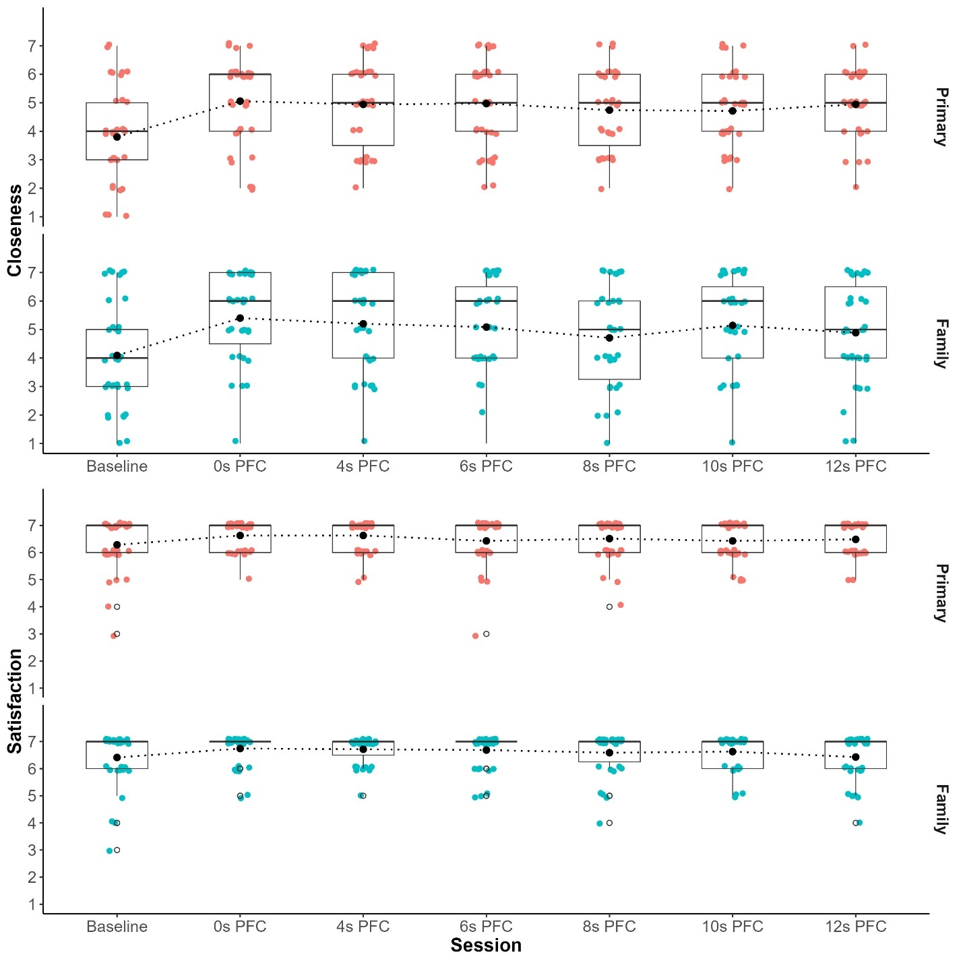

3.2 The Impact of Communication Delays During Private Family Conferences on Familial Relationships
Planned contrasts directly comparing all delayed PFC conditions to the no delay PFC condition revealed partial support of Hypothesis 2 that relationships would only be impacted by communication delays at the longer delay conditions (Figure 1). Relational closeness reported by the primary group decreased after the 10 second delay condition only, though this did not achieve significance after adjusting for multiple comparisons and the effect size was small. No statistically significant differences in ratings of relationship satisfaction were observed across all delay conditions in the primary group. See Supplemental Table C.
Family ratings of closeness significantly reduced after 8 second (β = -.38, p = .003, d = -0.36) and 12 second (β = -.34, p = .01, d = -0.3) delays compared to the no delay condition. Decreased relationship satisfaction after a 12 second delay compared to the no delay condition (β = -.21, p = .02, d = -0.43) was also reported by the family group. See Supplemental Table D.
Further descriptive characterization at short and long delays revealed that 29% of primary participants and 31% of family participants reported lower relational closeness after the 4 second PFC, while 43% of primary and 31% of family participants reported lower ratings in relational closeness after the 10 second PFC relative to no delay PFC. With regard to relationship satisfaction, 11% of primary participants and 6% of family participants reported a lower rating after the 4 second PFC while 17% of primary and 11% of family participants reported a lower rating after the 10 second PFC relative to no delay PFC.
Both groups reported that all delay latencies would significantly impact their relationships if they were required to continue communicating under those conditions for 6 months (Figure 2). Notably among the primary participants, the effect size of these differences increased from medium at 4 second (β = .9, p < .0001, d = 0.48), 6 second (β = 1.14, p < .0001, d = 0.66), and 8 second (β = 1.19, p < .0001, d = 0.65) delays to exceedingly large at 10 second (β = 1.72, p < .0001, d = 1.13), and 12 second (β = 1.95, p < .0001, d = 1.19) delay PFCs. Effect size differences among the family group remained in medium to large range for all delay conditions, including 4 second (β = 1.04, p = .001, d = 0.46), 6 second (β = 1.18, p = .0001, d = 0.54), 8 second (β = 1.76, p < .0001, d = 0.82), 10 second (β = 1.84, p < .0001, d = 0.89), and 12 (β = 1.79, p < .0001, d = 0.81) second delays compared to no delay. See Supplemental Table C and D.

Table 2. Descriptive Characteristics of Relationship Outcomes
by session in Primary and Family Groups
 | Closeness  M (SD) | Satisfaction  M (SD) | Impact to Relationship after 6 months
Primary
Baseline | 3.8 (1.69) | 6.29 (.96) | --
0s PFC | 5.06 (1.47) | 6.63 (.55) | 1.84 (1.59)
4s PFC | 4.94 (1.51) | 6.63 (.6) | 2.56 (1.34)
6s PFC | 4.97 (1.56) | 6.43 (.88) | 2.81 (1.28)
8s PFC | 4.74 (1.4) | 6.51 (.74) | 2.8 (1.32)
10s PFC | 4.71 (1.36) | 6.43 (.7) | 3.43 (1.17)
12s PFC | 4.94 (1.14) | 6.49 (.61) | 3.69 (1.5)
Family
Baseline | 4.09 (1.85) | 6.41 (1.02) | --
0s PFC | 5.4 (1.7) | 6.74 (.56) | 2.06 (1.81)
4s PFC | 5.2 (1.83) | 6.71 (.52) | 2.86 (1.64)
6s PFC | 5.09 (1.74) | 6.69 (.63) | 2.99 (1.63)
8s PFC | 4.71 (1.85) | 6.59 (.78) | 3.6 (1.86)
10s PFC | 5.14 (1.73) | 6.63 (.65) | 3.61 (1.67)
12s PFC | 4.89 (1.76) | 6.43 (.81) | 3.54 (1.87)
Note: All scales range from 1 to 7. Higher scores indicate greater
closeness, satisfaction, or impacts to relationship after 6 months.
M = mean; SD = standard deviation; s = second; PFC = private family conference.

Figure 2. Predicted Impact to Relationship after 6 Months of Restricted Communication under Communication Delays.
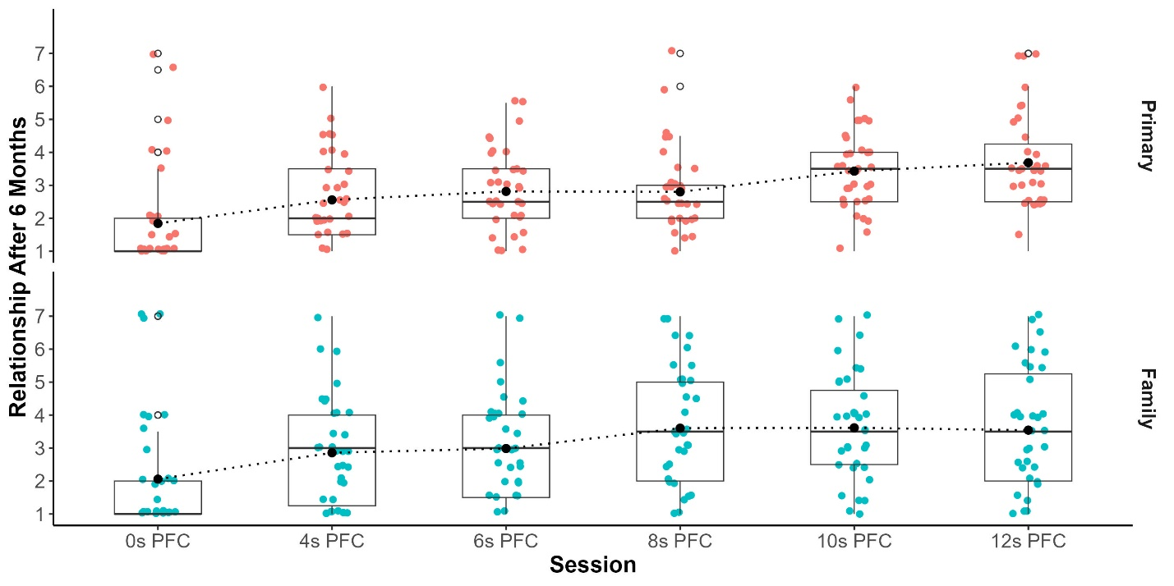

3.3 The Impact of Communication Delays During Private Family Conferences on Individual Well-Being
Descriptive characteristics of individual well-being outcomes at each session are presented in Table 3. Individual well-being was operationalized with single item scales to assess the following states: stress, annoyed, unable to concentrate, discouraged, anxious, and cheerful. Planned contrasts between all delayed PFC conditions and the no delay condition also revealed partial support of Hypothesis 3. Among the primary group, only the longer delays were associated with increased stress and concentration difficulties. Specifically, greater stress was reported after PFCs conducted after 8 second (β = 6.41, p = .02, d = 0.41), 10 second (β = 7.53, p = .003, d = 0.38), and 12 second (β = 6.85, p = .008, d = 0.52) one-way delays compared to the no delay PFC condition (Figure 3). Greater difficulty concentrating was also reported after 10 second (β = .28, p = .02, d = 0.51) and 12 second (β = .3, p = .01, d = 0.53) one-way delay PFC sessions compared to the no delay PFC. See Supplemental Table C.
Among the family group, longer delays were associated with greater ratings of annoyance and decreases in ratings of cheerfulness. Specifically, they were more annoyed after PFCs conducted with 8 second (β = .05, p = .049, d = 0.53), 10 second (β = .08, p < .001, d = 0.41), and 12 second (β = .07, p = .007, d = 0.53) one-way delays compared to the no delay session. Additionally, the family group reported decreases in cheerfulness after the 12 second (β = -.38, p = .005, d = -0.31) one-way delay compared to no delay. Audiovisual delays during PFCs were not associated with changes in ratings on any other items assessing individual well-being. See Supplemental Table D.

Table 3. Descriptive Characteristics of Individual Well-being Outcomes by session in Primary and Family Groups
 | Stress | Annoyed | Unable to Concentrate | Discouraged | Anxious | Cheerful
 | M (SD) | M (SD) | M (SD) | M (SD) | M (SD) | M (SD)
Primary
0s PFC | 16.1 (15.65) | .14 (.36) | .29 (.52) | .14 (.49) | .37 (.69) | 2.83 (.86)
4s PFC | 21.04 (18.29) | .4 (.85) | .4 (.5) | .17 (.51) | .43 (.85) | 2.86 (.81)
6s PFC | 20.51 (16.92) | .26 (.51) | .49 (.74) | .17 (.45) | .31 (.58) | 2.89 (.93)
8s PFC | 23.8 (21.12) | .43 (.7) | .49 (.61) | .26 (.61) | .34 (.59) | 2.69 (.99)
10s PFC | 23.02 (20.24) | .29 (.46) | .63 (.77) | .17 (.38) | .49 (.66) | 2.69 (.99)
12s PFC | 25.49 (19.62) | .31 (.53) | .63 (.73) | .23 (.43) | .54 (.82) | 2.69 (.93)
Family
0s PFC | 14.82 (15.23) | .03 (.17) | .49 (.82) | .2 (.53) | .37 (.69) | 3.11 (.99)
4s PFC | 16.58 (16.29) | .09 (.28) | .43 (.81) | .2 (.47) | .43 (.65) | 2.97 (.86)
6s PFC | 18.14 (16.88) | .23 (.49) | .46 (.7) | .2 (.47) | .46 (.7) | 2.83 (.98)
8s PFC | 16.97 (17.08) | .26 (.62) | .5 (.9) | .24 (.55) | .5 (.75) | 2.94 (.92)
10s PFC | 18.98 (19.1) | .4 (.81) | .37 (.69) | .23 (.6) | .57 (1.01) | 2.94 (.84)
12s PFC | 17.94 (18.14) | .29 (.62) | .63 (.94) | .26 (.51) | .57 (.88) | 2.83 (.82)
Note: Stress scale ranges from 0 to 100 and all others range from 0 to 4. Higher values indicate higher endorsement of described affect. M = mean; SD = standard deviation; s = second; PFC = private family conference.

Figure 3. Ratings of Stress after each Private Family Conference for both Primary and Family Groups
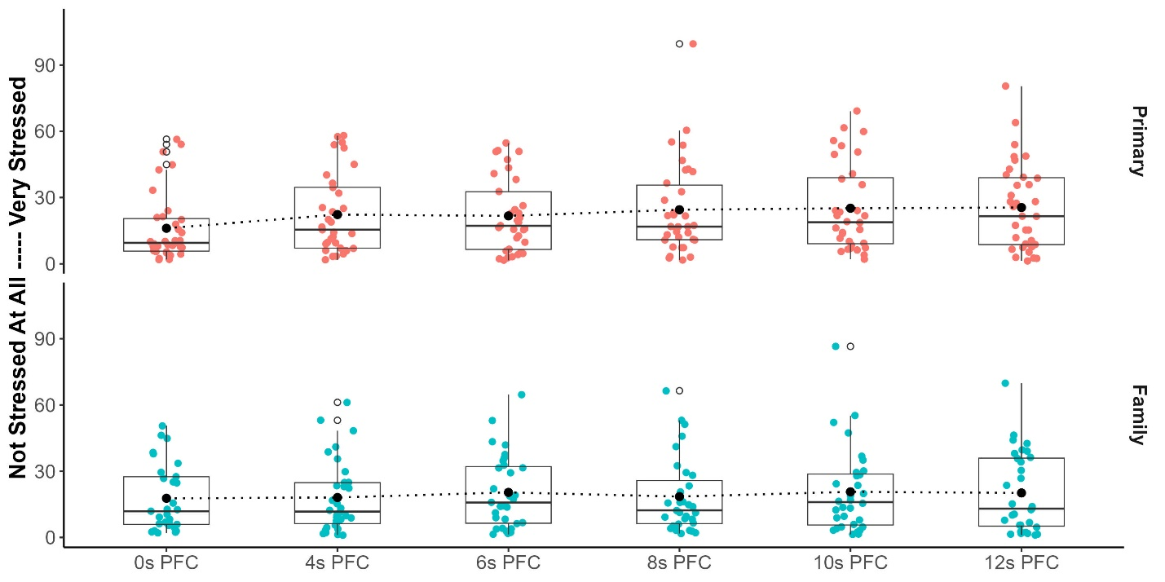

3.4 The Impact of Communication Delays During Family Conferences on Communication Quality
Descriptive characteristics of communication quality outcomes at each session are presented in Table 4. Consistent with Hypothesis 4, LMMs with planned contrasts comparing all delayed PFC sessions with the no delay session revealed worse communication quality under delays as short as 4 seconds one-way in both groups, with effect sizes ranging from small to exceedingly large. Primary participants reported significantly decreased shared understanding (Figure 4) and effortless communication after all delay conditions when compared to the no delay PFC. Specifically, reduced shared understanding was observed after 4 second (β = -.32, p = .03, d = -0.78), 6 second (β = -.33, p = .02, d = -0.86), 8 second (β = -.43, p = .001, d = -0.90), 10 second (β = -.64, p < .0001, d = -1.19), and 12 second (β = -.71, p < .0001, d = -1.20) one-way delays. Ratings of effortless communication also decreased after 4 second (β = -1.46, p < .0001, d = -1.18), 6 second (β = -1.97, p < .0001, d = -1.91), 8 second (β = -2.29, p < .0001, d = -1.90), 10 second (β = -2.77, p < .0001, d = -2.21), and 12 second (β = -2.63, p < .0001, d = -2.02) one-way delays. See Supplemental Table C.
Ratings by the primary group indicated greater influence on conversation content, more disjointed communication, and higher frustration after all delay conditions relative to the no delay PFC. Greater influence on conversation content was reported after 4 second (β = 1.6, p < .0001, d = 0.81), 6 second (β = 2.15, p < .0001, d = 1.15), 8 second (β = 2.51, p < .0001, d = 1.31), 10 second (β = 3.15, p < .0001, d = 1.73), and 12 second (β = 3.38, p < .0001, d = 1.91) one-way delays. Communication was rated as more disjointed after 4 second (β = 1.42, p < .0001, d = 1.13), 6 second (β = 1.6, p < .0001, d = 1.50), 8 second (β = 1.66, p < .0001, d = 1.30), 10 second (β = 2.39, p < .0001, d = 2.17), and 12 second (β = 2.07 , p < .0001, d = 1.68) one-way delays. Greater frustration with the delays was also reported after 4 second (β = 1.35, p < .0001, d = 0.18), 6 second (β = 1.78, p < .0001, d = 0.24), 8 second (β = 2.02, p < .0001, d = 0.21), 10 second (β = 2.43, p < .0001, d = 0.40), and 12 second (β = 2.92, p < .0001, d = 0.44) one-way delays. See Supplemental Table C.
Results in the family group yielded a similar pattern. Family participants reported significantly decreased shared understanding (Figure 4) and effortless communication after all delay conditions when compared to the no delay PFC. Specifically, reduced shared understanding was observed after 4 second (β = -.31, p = .05, d = -0.73), 6 second (β = -.41, p = .004, d = -0.95), 8 second (β = -.42, p = .003, d = -0.82), 10 second (β = -.64, p < .0001, d = -1.33), and 12 second (β = -.78, p < .0001, d = -1.30) one-way delays. Ratings of effortless communication also decreased after 4 second (β = -1.42, p < .0001, d = -0.90), 6 second (β = -1.48, p < .0001, d = -0.99), 8 second (β = -2.03, p < .0001, d = -1.20), 10 second (β = -2.46, p < .0001, d = -1.52), and 12 second (β = -2.59, p < .0001, d = -1.60) one-way delays. See Supplemental Table D.
The family group rated greater influence on conversation content, more disjointed communication, and higher frustration with the delay after all delay conditions relative to the no delay PFC. Greater influence on conversation content was reported after 4 second (β = 1.06, p = .009, d = 0.39), 6 second (β = 1.77, p < .0001, d = 0.73), 8 second (β = 2.6, p < .0001, d = 1.18), 10 second (β = 2.65, p < .0001, d = 1.11), and 12 second (β = 2.91, p < .0001, d = 1.32) one-way delays. Communication was rated as more disjointed after 4 second (β = 1.05, p = .003, d = 0.84), 6 second (β = 1.34 , p < .0001, d = 1.00), 8 second (β = 1.73, p < .0001, d = 1.22), 10 second (β = 1.95, p < .0001, d = 1.37), and 12 second (β = 2.34, p < .0001, d = 1.54) one-way delays. Finally, greater frustration with the delays was also reported by the family group after 4 second (β = 1.54, p < .0001, d = 0.50), 6 second (β = 2.06, p < .0001, d = 0.70), 8 second (β = 2.14, p < .0001, d = 0.59), 10 second (β = 2.83, p < .0001, d = 0.60), and 12 second (β = 3.03, p < .0001, d = 0.60) one-way delays. See Supplemental Table D.
Table 4. Descriptive Characteristics of Communication Quality Outcomes by session in Primary and Family Groups
 | Shared Understanding | Influence on Content | Disjointed | Effortless | Frustration
 | M (SD) | M (SD) | M (SD) | M (SD) | M (SD)
Primary
0s PFC | 6.89 (.19) | 1.81 (1.74) | 1.43 (.7) | 6.63 (.65) | 1.17 (.71)
4s PFC | 6.54 (.59) | 3.07 (1.33) | 2.89 (1.53) | 5.17 (1.54) | 2.51 (1.42)
6s PFC | 6.53 (.55) | 3.6 (1.34) | 3.06 (1.3) | 4.66 (1.28) | 2.91 (1.38)
8s PFC | 6.36 (.8) | 3.93 (1.47) | 3.14 (1.61) | 4.34 (1.57) | 3.14 (1.7)
10s PFC | 6.07 (.98) | 4.56 (1.41) | 3.83 (1.36) | 3.86 (1.65) | 3.63 (1.59)
12s PFC | 5.96 (1.06) | 4.8 (1.37) | 3.63 (1.68) | 4 (1.66) | 4.09 (1.63)
Family
0s PFC | 6.95 (.13) | 2.23 (2.17) | 1.26 (.89) | 6.49 (1.42) | 1.09 (.51)
4s PFC | 6.61 (.56) | 3.01 (1.78) | 2.37 (1.59) | 5.03 (1.77) | 2.63 (1.42)
6s PFC | 6.49 (.61) | 3.63 (1.59) | 2.63 (1.63) | 5.06 (1.47) | 3.14 (1.38)
8s PFC | 6.47 (.76) | 4.54 (1.63) | 3.06 (1.81) | 4.59 (1.69) | 3.21 (1.55)
10s PFC | 6.21 (.8) | 4.4 (1.73) | 3.23 (1.7) | 4.09 (1.7) | 3.91 (1.52)
12s PFC | 6.01 (1) | 4.7 (1.53) | 3.63 (1.9) | 3.94 (1.71) | 4.11 (1.64)
Note: All scales range from 1 to 7. Higher values in Influence on Content, Disjointed, and Frustration indicate worse communication quality. Lower values in Shared Understanding and Effortless indicate worse communication quality. M = mean; SD = standard deviation; s = second; PFC = private family conference.

Figure 4. Ratings of Shared Understanding after each Private Family Conference for both Primary and Family Groups
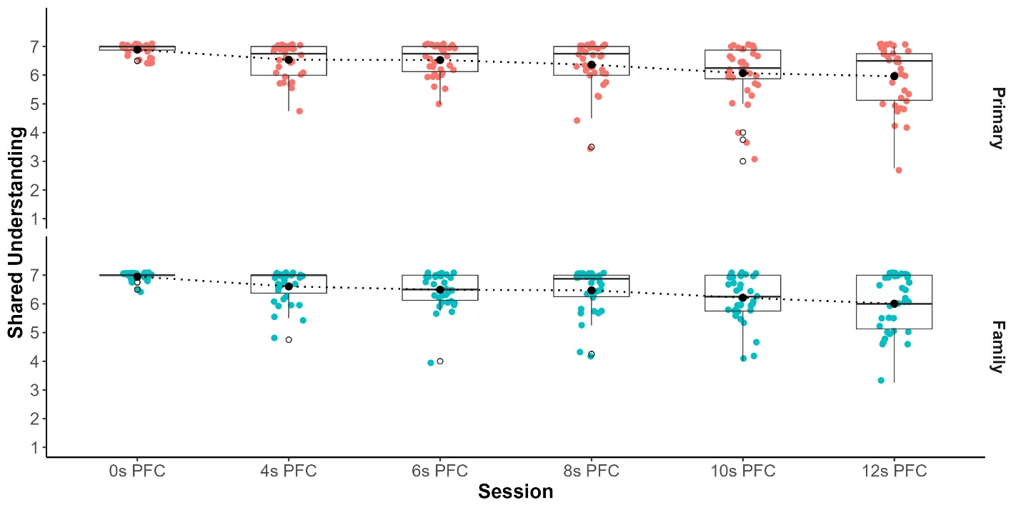

Discussion
The objective of this study was to determine the effect of lunar communication delays ranging from 4 to 12 seconds one-way on the expected benefits of private family conferences in astronaut-like participants and their families. We report that all PFCs, regardless of delay, significantly improved relational closeness relative to baseline. Relationship satisfaction improved relative to baseline after 0 and 4 second delay PFCs. Among our primary group recruited to approximate astronaut demographics, we found no significant differences in current relationship outcomes after any delayed PFC compared to the no delay PFC. In the family group, delays at 8 seconds and longer were associated with reduced relational closeness and 12 second one-way delays were associated with reduced relationship satisfaction. Notably, both groups indicated that delays as short as 4 seconds one-way significantly eroded communication quality and would meaningfully impact their relationships if communication was restricted in such a manner for 6 months. Aspects of individual well-being were not impacted until delays exceeded 8 seconds one-way. See Table 5 for a summary of our findings. This is the first study to investigate behavioral health impacts of communication delays expected in Artemis missions to the Moon and our findings make several critical contributions.
Table 5. Summary of significant group level changes to relationships, individual well-being, and communication quality after each delayed PFC compared to the no delay condition.
 | Current Relationship | Relationship after 6 months | Individual Well-Being | Communication Quality
Primary
4s PFC | ns^ | ↑ Impact to relationship | ns | ↓Shared understanding, effortless conversation  ↑ Influence on content, disjointed conversations, and frustration with delay
6s PFC
8s PFC | ns^ | ↑ Impact to relationship | ↑ Stress
10s PFC | ns^ | ↑ Impact to relationship | ↑ Stress  ↑ Difficulty concentrating
12s PFC | ns^ | ↑ Impact to relationship | ↑ Stress  ↑ Difficulty concentrating
Family
4s PFC | ns† | ↑ Impact to relationship | ns | ↓Shared understanding, effortless conversation  ↑ Influence on content, disjointed conversations, and frustration with delay
6s PFC
8s PFC | ↓ Relational closeness | ↑ Impact to relationship | ↑ Annoyed
10s PFC | ns† | ↑ Impact to relationship | ↑ Annoyed
12s PFC | ↓ Relational closeness  ↓ Relationship satisfaction | ↑ Impact to relationship | ↑ Annoyed  ↓ Cheerful
Note: PFC: Private family conference; s = seconds; ns = non-significant; ↑ increased ratings relative to 0s delay; ↓ decreased ratings relative to 0s delay. ^ Descriptively, 29% and 43% of primary participants reported at least one point decline in relational closeness after 4 and 10 second one-way delays, respectively. †Descriptively, 31% of family participants reported at least one point decline in relational closeness after both 4 and 10 second one-way delays.

First, we present evidence that private family conferences benefit long distance relationships among astronaut-like participants and their families and show that these advantages to baseline relationships remain even after introducing delays. This is consistent with anecdotal reports from astronauts expressing praise for PFCs during their spaceflight missions. Indeed, strong familial relationships are associated with reduced psychological distress, greater sense of self and psychological resilience, and improved mental and physical health outcomes [2, 26-28]. Thus, facilitating connection with family during space exploration missions offers direct benefits to the behavioral health of astronauts [10]. The threat to these bonds posed by family separation can be ameliorated by real time communication [29-31]. Among military families, frequent and varied communication during deployment is associated with better psychological well-being of the service member during both the deployment and post-deployment reintegration phases [32, 33]. This study is the first to systematically assess the benefits of private family conferences similar to those used in spaceflight and provides empirical evidence that opportunities to connect with family in current and future spaceflight missions can maintain or even improve relationships.
Next, our findings suggest that despite impacts to communication quality astronaut-like individuals and their families can generally tolerate shorter communication delays in a time limited laboratory setting, though some variability exists suggesting individualized support may still be necessary to maintain relationships and individual well-being. No statistical differences in relationship and individual well-being outcomes were observed in one-way delays shorter than 8 seconds indicating group level resilience to communication delays. However, 28% of the primary participants rated at least a one-point decrease in relational closeness after a 4 second delay. When translated to a four-person astronaut crew in spaceflight, this suggests that approximately 1 in 4 crew members may experience some disruption to family relationships and individual well-being with delayed PFCs and may require additional resources to obtain the same benefits. Further, once 8 second delays were introduced, the primary and family groups reported unique impacts from longer delay latencies. This underscores the vital role of current family support practices that emphasize distinct expectation management and countermeasure resources for crew members and their families [34]. These findings are also consistent with the large body of literature documenting variability in family adjustment during military deployment. These studies support the presence of subsets of servicemembers and family that report greater dysfunction related to separation [4, 35, 36], the value of individualized resources and coping strategies to manage family separation during deployment [37], and pre-deployment predictors (i.e., family resilience) that may help to identify at risk families and specific strategies to overcome challenges [38, 39]. Nevertheless, our findings suggest that PFCs with one-way delays less than 8 seconds on short duration Artemis missions may still offer reasonable family support, and can be further complemented with individualized support when required.
Finally, results of this study indicate that PFCs with communication delay may not be sufficient to maintain family bonds in future long duration lunar missions, despite the observed benefits relative to baseline and minimal impacts at shorter delay latencies. Participants predicted that all delay latencies would significantly impact their relationships if communication were limited to that type, frequency, and delay for 6 months. It is likely that the significant communication breakdown observed as early as 4 seconds one-way, though tolerable for shorter periods of time, may accumulate to exacerbate disconnection and frustration over extended periods. In other words, several months to years of communication with family that, as indicated by our results, is characterized as effortful and disjointed, altered in breadth and depth of topics covered, and deficient in shared understanding may attenuate relationships and individual well-being over time. Spaceflight hazards and operational stressors in long duration space exploration missions are also likely to exacerbate the decrements that we observed in our controlled laboratory setting.
This study offers two near term solutions to overcome challenges to family relationships exacerbated by lunar communication delays. First, the communication breakdown observed in as early as 4 second one-way delays could be addressed with crew and family training opportunities to facilitate practice PFCs under delays before the start of a mission. Such an activity could include reviewing and practicing communication strategies designed to decrease frustration and support more positive interactions during the mission. For example, strategies like chunking topics or taking notes could reduce the perception of disjointed conversation and facilitate a more meaningful, effortless exchange [17]. Second, advancing alternative asynchronous communication solutions, such as emails, store and send audio recordings, or social media, to support near-term lunar or future long duration exploration missions could be considered to adequately support relational connectedness with loved ones on Earth. These solutions are likely to be supported by current lunar concept of operations and can provide alternative paths for contact with loved ones relative to the PFC alone. These platforms also do not require real time transmission and may be more resistant to the challenges introduced by 4-12 second one-way range, especially when augmented by the PFC, though the combined benefit of these communication modalities is beyond the scope of the current study and warrants further investigation. Indeed, relationship satisfaction is more closely linked to the perception of emotional availability rather than distance or frequency of communication alone [40], and alternative modes of asynchronous communication, such as audio recordings and social media, are associated with positive outcomes in both military families during deployment and civilian long-distance relationships [33, 41, 42]. Creative asynchronous communication solutions assisted by technologies such as artificial intelligence or virtual reality to facilitate meaningful interactions between astronauts and their families should also be explored for future exploration missions regardless of the communication delay.
The limitations of the present investigation offer future high value research targets. Our small laboratory sample did not simulate extended periods of isolation and confinement for individuals separated from their core family unit (i.e., spouse). Primary participants, though recruited to approximate astronaut demographics, were also not in an operational setting where the separated individual is focused on mission critical activities or coping with additional stressors related to the spaceflight environment [43, 44]. We did not characterize the frequency and type of communication study pairs were already implementing prior to the study. Finally, we limited communication between study pairs to PFCs while current and future astronaut crew members for Artemis missions will likely have access to additional communication modalities like email. Future studies of family connectedness in spaceflight should be implemented in conditions of isolation and confinement with a mission realistic suite of countermeasures developed to support family communication during long duration space exploration under communication delays. Investigators could also examine the content and affective tone of conversations to determine if they have an influence on relationships and individual well-being.

Conclusion
This is the first study to investigate communication delays within the range expected on Artemis missions during audiovisual virtual family conferences. We found that family conferences generally improved relationship outcomes regardless of delay, that familial relationships and individual well-being are relatively more tolerant to shorter one-way delays (4-6 seconds) compared to longer (8-12 seconds), and that these outcomes are likely at greater risk under all delay scenarios in future long duration missions. Our findings underscore the challenges to maintaining access to family and friends during spaceflight and provide a foundation from which innovative solutions can be crafted to preserve connections despite obstacles to communication. Indeed, strong interpersonal bonds, shared emotional experiences, and vibrant communities lie at the heart of human nature and enrich the human experience. As humanity ventures ever farther from Earth toward a multiplanetary future, nurturing and even enhancing these relationships will be essential for humans to flourish in these new frontiers.

Acknowledgements
We thank the study participants for their time and dedication to support this research. We also sincerely thank Mercedes N. Jorge for her efforts to set up recruitment and study procedures, Satyajit Upasani, PhD and Joschka Mosonyi for their hands-on software troubleshooting, Lauren B. Landon, PhD and Kritina L. Holden, PhD, for study design consultation, and Millennia Young, PhD for statistical consultation. This research was supported by the NASA Human Research Program study “Communication Delays in Cislunar Space: Behavioral Medicine Risk Characterization of Impacts on Private Family Conferences” directed to Sheena Dev, PhD. Sheena Dev, Nikole Moody, and Diana Arias were supported by KBR’s Human Health and Performance Contract NNJ15HK11B through NASA. The authors of this report are entirely responsible for its content. Any opinions, findings, and conclusions or recommendations expressed in this material are those of the authors and do not necessarily reflect the views of the US Government, NASA, KBR, or JES Tech. The authors have no interests that may be perceived as conflicting with the work described or proposed here.

References
[1] B. Paley, P. Lester, C. Mogil, Family systems and ecological perspectives on the impact of deployment on military families, Clin Child Fam Psychol Rev, 16 (2013) 245-265.
[2] D. Grevenstein, M. Bluemke, J. Schweitzer, C. Aguilar-Raab, Better family relationships––higher well-being: The connection between relationship quality and health related resources, Mental health & prevention, 14 (2019) 200160.
[3] S.T. Bell, S.R. Anderson, P.G. Roma, L.B. Landon, S.I. Dev, Social support from different sources and its relationship with stress in spaceflight analog environments, Frontiers in Psychology, 15 (2025) 1350630.
[4] L.I. Marek, L.E. Moore, Coming home: the experiences and implication of reintegration for military families, Journal of Military, Veteran and Family Health, 1 (2015) 21-31.
[5] D.R. McCreary, J.M. Peach, A.-R. Blais, D. Fikretoglu, Towards a better understanding of post-deployment reintegration, Military deployment and its consequences for families, (2014) 173-191.
[6] J. Stuster, Behavioral issues associated with long-duration space expeditions: review and analysis of astronaut journals: experiment 01-E104 (Journals), National Aeronautics and Space Administration, Johnson Space Center Houston, TX, 2010.
[7] J. Stuster, Behavioral issues associated with long duration space expeditions: Review and analysis of astronaut journals experiment 01-E104 (Journals) phase 2 final report, NASA/TM-2016- 2181603, (2016).
[8] P.J. Johnson, The roles of NASA, U.S. astronauts and their families in long-duration missions, Acta Astronautica, 67 (2010) 561-571.
[9] N. Kanas, Interpersonal issues in space: Shuttle/Mir and beyond, Aviation, Space, and Environmental Medicine, 76 (2005) B126-B134.
[10] S.I. Dev, S.E. Whiting, G.A. Nelson, V. Dotson, A.P. Mulavara, J.M. Schorn, J.S. Williams, Risk of Adverse Cognitive or Behavioral Changes and Psychiatric Disorders Leading to In-Mission Health and Performance and Long-Term Health Effects, in, NASA Human Research Program 2025.
[11] L.B. Landon, J. Karasinski, L. Morissette, K. McTigue, M. Parisi, S. Wu, T. Panontin, Assessment of the State of Communication Delay Research in Preparation for Missions Beyond Low Earth Orbit, NASA Technical Memorandum, (2025).
[12] S. Goemaere, K. Brenning, W. Beyers, A.C. Vermeulen, K. Binsted, M. Vansteenkiste, Do astronauts benefit from autonomy? Investigating perceived autonomy-supportive communication by Mission Support, crew motivation and collaboration during HI-SEAS 1, Acta Astronautica, 157 (2019) 9-16.
[13] R.A. Scheuring, J.A. Jones, J.D. Novak, J.D. Polk, D.B. Gillis, J. Schmid, J.M. Duncan, J.R. Davis, The Apollo Medical Operations Project: Recommendations to improve crew health and performance for future exploration missions and lunar surface operations, Acta Astronautica, 63 (2008) 980-987.
[14] NASA, Apollo Flight Journal, NASA, (2017).
[15] NASA, Apollo Lunar Surface Journal, NASA, (2017).
[16] N.M. Kintz, L.A. Palinkas, Communication Delays Impact Behavior and Performance Aboard the International Space Station, Aerosp Med Hum Perform, 87 (2016) 940-946.
[17] U. Fischer, K. Mosier, Communication protocols to support collaboration in distributed teams under asynchronous conditions, in: Proceedings of the Human Factors and Ergonomics Society Annual Meeting, SAGE Publications Sage CA: Los Angeles, CA, 2015, pp. 1-5.
[18] A. Aron, E.N. Aron, D. Smollan, Inclusion of other in the self scale and the structure of interpersonal closeness, Journal of personality and social psychology, 63 (1992) 596.
[19] S.S. Hendrick, A generic measure of relationship satisfaction, Journal of Marriage and the Family, (1988) 93-98.
[20] L.B. Landon, J.C.W. Miller, S.T. Bell, P.G. Roma, When people start getting real: The Group Living Skills Survey for extreme work environments, Front Psychol, 15 (2024) 1348119.
[21] A. Vinokhodova, V. Gushchin, K. Eskov, M. Khananashvili, Psychological selection and optimization of interpersonal relationships in an experiment with 105-days isolation, Human Physiology, 38 (2012) 677-682.
[22] M. Basner, D.F. Dinges, D.J. Mollicone, I. Savelev, A.J. Ecker, A. Di Antonio, C.W. Jones, E.C. Hyder, K. Kan, B.V. Morukov, J.P. Sutton, Psychological and behavioral changes during confinement in a 520-day simulated interplanetary mission to mars, PLoS One, 9 (2014) e93298-e93298.
[23] U. Fischer, K. Mosier, J. Schmid, A. Smithsimmons, R. Brougham, Braiding–A novel approach to supporting space/ground communication under signal latency, Acta Astronautica, 207 (2023) 411-424.
[24] M. Koller, robustlmm: an R package for robust estimation of linear mixed-effects models, Journal of statistical software, 75 (2016) 1-24.
[25] W.P. Dunlap, J.M. Cortina, J.B. Vaslow, M.J. Burke, Meta-analysis of experiments with matched groups or repeated measures designs, Psychological methods, 1 (1996) 170.
[26] D. Umberson, J. Karas Montez, Social relationships and health: A flashpoint for health policy, Journal of health and social behavior, 51 (2010) S54-S66.
[27] B.N. Uchino, Social support and health: a review of physiological processes potentially underlying links to disease outcomes, Journal of behavioral medicine, 29 (2006) 377-387.
[28] P. Navaneetham, B. Kanth, Effects of Personal relationships on Physical and Mental Health among young Adults-A scoping review, The Open Psychology Journal, 15 (2022).
[29] M. Nishikitani, M. Ariyoshi, Y. Nohara, J. Umihara, Communications Through Contemporary Tools of Information and Communication Technology: Cross-sectional Study Evaluating Health Among Separated Family Members, JMIR Formative Research, 6 (2022) e34949.
[30] K. Tammisalo, A. Rotkirch, Effects of information and communication technology on the quality of family relationships: A systematic review, Journal of Social and Personal Relationships, 39 (2022) 2724-2765.
[31] C. Shen, M.P. Wang, J.T. Chu, A. Wan, K. Viswanath, S.S.C. Chan, T.H. Lam, Sharing family life information through video calls and other information and communication technologies and the association with family well-being: Population-based survey, JMIR mental health, 4 (2017) e8139.
[32] C.W. O’Neal, M. Lucier-Greer, J.M. Duncan, J.K. Mallette, A.L. Arnold, J.A. Mancini, Vulnerability and resilience within military families: Deployment experiences, reintegration, and family functioning, Journal of Child and Family Studies, 27 (2018) 3250-3261.
[33] A. Wood, L. Gray, J. Bowser-Angermann, P. Gibson, M. Fossey, L. Godier-McBard, Social media and Internet-based communication in military families during separation: An international scoping review, new media & society, 25 (2023) 1802-1823.
[34] W.E. Sipes, S.T. Vander Ark, Operational behavioral health and performance resources for International Space Station crews and families, Aviation, space, and environmental medicine, 76 (2005) B36-B41.
[35] T.S. Wells, S.C. Miller, A.B. Adler, C.C. Engel, T.C. Smith, J.A. Fairbank, Mental health impact of the Iraq and Afghanistan conflicts: a review of US research, service provision, and programmatic responses, International Review of Psychiatry, 23 (2011) 144-152.
[36] C.W. Hoge, C.A. Castro, S.C. Messer, D. McGurk, D.I. Cotting, R.L. Koffman, Combat duty in Iraq and Afghanistan, mental health problems, and barriers to care, N Engl J Med, 351 (2004) 13-22.
[37] A.J. Merolla, Relational maintenance during military deployment: Perspectives of wives of deployed US soldiers, Journal of Applied Communication Research, 38 (2010) 4-26.
[38] F. Walsh, Family resilience: A framework for clinical practice, Family process, 42 (2003) 1-18.
[39] T.N. Ray, A.P. Esquivel, V.A. Stander, H.S. McMaster, S.C. Roesch, F. Walsh, M.C.F.S. Team, The development, validity, and reliability of a brief self-report measure of family resilience in military families, Measurement and Evaluation in Counseling and Development, 57 (2024) 299-317.
[40] P.R. Shaver, M. Mikulincer, Attachment-related psychodynamics, Attachment & human development, 4 (2002) 133-161.
[41] J.B. Houston, B. Pfefferbaum, M.D. Sherman, A.G. Melson, M.W. Brand, Family communication across the military deployment experience: Child and spouse report of communication frequency and quality and associated emotions, behaviors, and reactions, Journal of Loss and Trauma, 18 (2013) 103-119.
[42] S. Carter, K. Renshaw, Spousal Communication During Military Deployments: A Review, Journal of Family Issues, 37 (2015) 1-24.
[43] L.K. Knobloch, S.R. Wilson, Communication in military families across the deployment cycle, The SAGE handbook of family communication, (2015) 370-385.
[44] S.W. Durham, In their own words: Staying connected in a combat environment, Military Medicine, 175 (2010) 554-559.

