APOLLO LUNAR ROVING VEHICLE AS TRAVERSED PERFORMANCE METRICS: PREPARING FOR ARTEMIS MOBILE VEHICLE TRAVERSE PLANNING. S. R. Jacob^{1,3*}, P. E. Montalvo^{2,3}, K. S. Gray^{2,3}, A. W. Britton^{2,3}, M. F. Thomas^{2,3}, M. J. Miller^{2,3}, ¹Barrios, Houston, TX, ²Amentum Inc., Houston, TX, ³ARES NASA-JSC, Houston, TX, (*samantha.jacob@nasa.gov).

Introduction: Having mobile assets as part of a planetary exploration mission has proven to significantly increase the scientific return of a mission as evidenced by the Apollo Lunar Roving Vehicle (LRV) and the numerous Mars rovers. This abstract focuses on the characterization of the as-traversed lunar terrain and performance demonstrated of the LRV to inform future traverse planning for Artemis vehicles. This abstract quantifies the speed made good (SMG) for the Apollo 15 and 16 LRV EVAs and compares that to the slope and detrended terrain ruggedness of the landing sites and exploration area experienced along each traverse path. The LRVs were designed to navigate a 20 – 23° slope in “favorable conditions” with a max of 25°. The LRV could theoretically achieve speeds of 9 – 13 km/hr (2.5 – 3.6 m/s). Having these Apollo as demonstrated traverse metrics will be a useful starting point to understand how mobility assets will perform at the lunar south pole.
Methods: SMG was calculated to understand the actual average speed achieved during individual traverses. These values were compared to the average slope and terrain ruggedness for each traverse to explore any potential correlations between SMG and surface characteristics. To quantify the SMG of the Apollo traverses, start/stop times were pulled from the transcripts that are part of the Apollo lunar surface journals [1]. The duration it took to drive between stations is then divided by the actual traverse distance quantified using the vector files provided by the Lunar Reconnaissance Orbiter Camera (LROC) team. Slope and detrended terrain ruggedness index were calculated using the 2 mpp NAC DTM.
Results: The surface characteristics analyzed, and SMG calculated for Apollo 15 and 16 EVAs are summarized in Table 1 and plotted in Figures 1 and 2.

Table 1: Apollo 15 and 16 EVA statistics.
 | Apollo 15 | Apollo 16
Mean Slope (deg) | 5.6 | 4.5
Max Slope (deg) | 22.1 | 24.7
Mean TRI (m) | 1.2 | 0.5
Max TRI (m) | 4.5 | 2.4
Mean SMG (m/s) | 2.0 | 1.7
Max SMG (m/s) | 2.6 | 2.5
Discussion: Overall, the results show that the Apollo 15 and 16 LRVs performed within or near the expected capabilities. The average slope of each traverse was well within the expected limits of LRV capabilities, and the max slopes did not exceed the capabilities. The as-traversed speeds were, on average, lower than expected. However, there are times in the transcripts where the astronauts noted higher speeds than what is evident in the SMG calculations. The Apollo 16 mission report states the LRV achieved speeds up to 14 km/hr (3.8 m/s) [1]. There are several variables that could have contributed to the average LRV speeds being less than the design specifications including the astronauts learning how to operate the LRV on the surface, mechanical problems (the Apollo 15 LRV front steering mechanism was non-functional), and more cautious driving adapted to the physical surface environment. However, comparisons of SMG to the average slope and TRI did not result in any strong correlations.
Future Work and Conclusions: Final steps for this project include performing the SMG calculations for Apollo 17. Looking at the specifics of the as-traversed performance of the Apollo LRV is the best crewed analog to understand how future Artemis mobility assets might perform at the south pole of the Moon. Understanding the time a traverse will take and how a vehicle will perform given the physical surface conditions is critical to planning successful missions that incorporate mobility assets. Currently as part of the Artemis campaign there are three main vehicles being designed, the Lunar Terrain Vehicle, the Pressurized Rover, and the Multi-Purpose Habitat. The Artemis Geospatial Data Team is currently looking at traverseability of the south pole given various design capabilities for future Artemis vehicles.
References: [1] (https://www.nasa.gov/history/alsj/main.html)

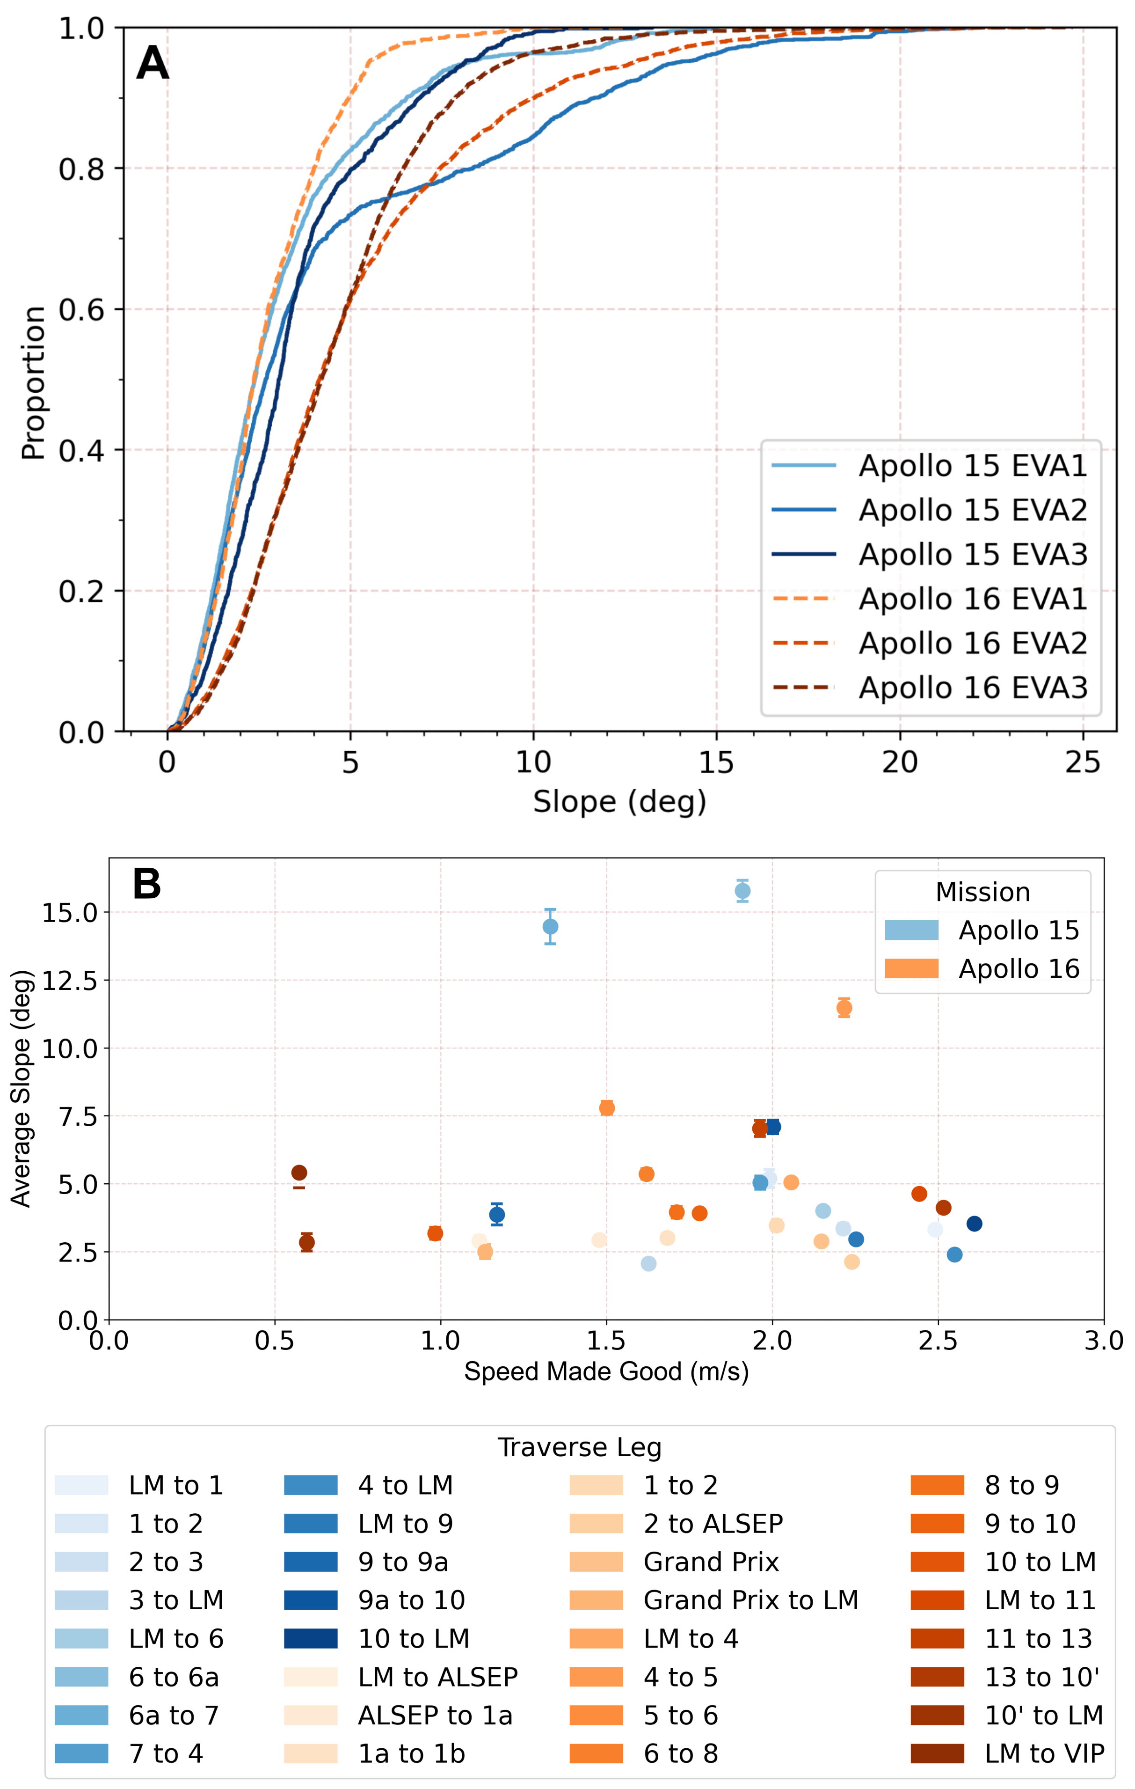
Figure 1: Panel A shows the cumulative distribution of surface slope for each EVA. Panel B shows SMG as a function of surface slope for each traverse during Apollo 15 and 16. Error bars are at 95% confidence interval.
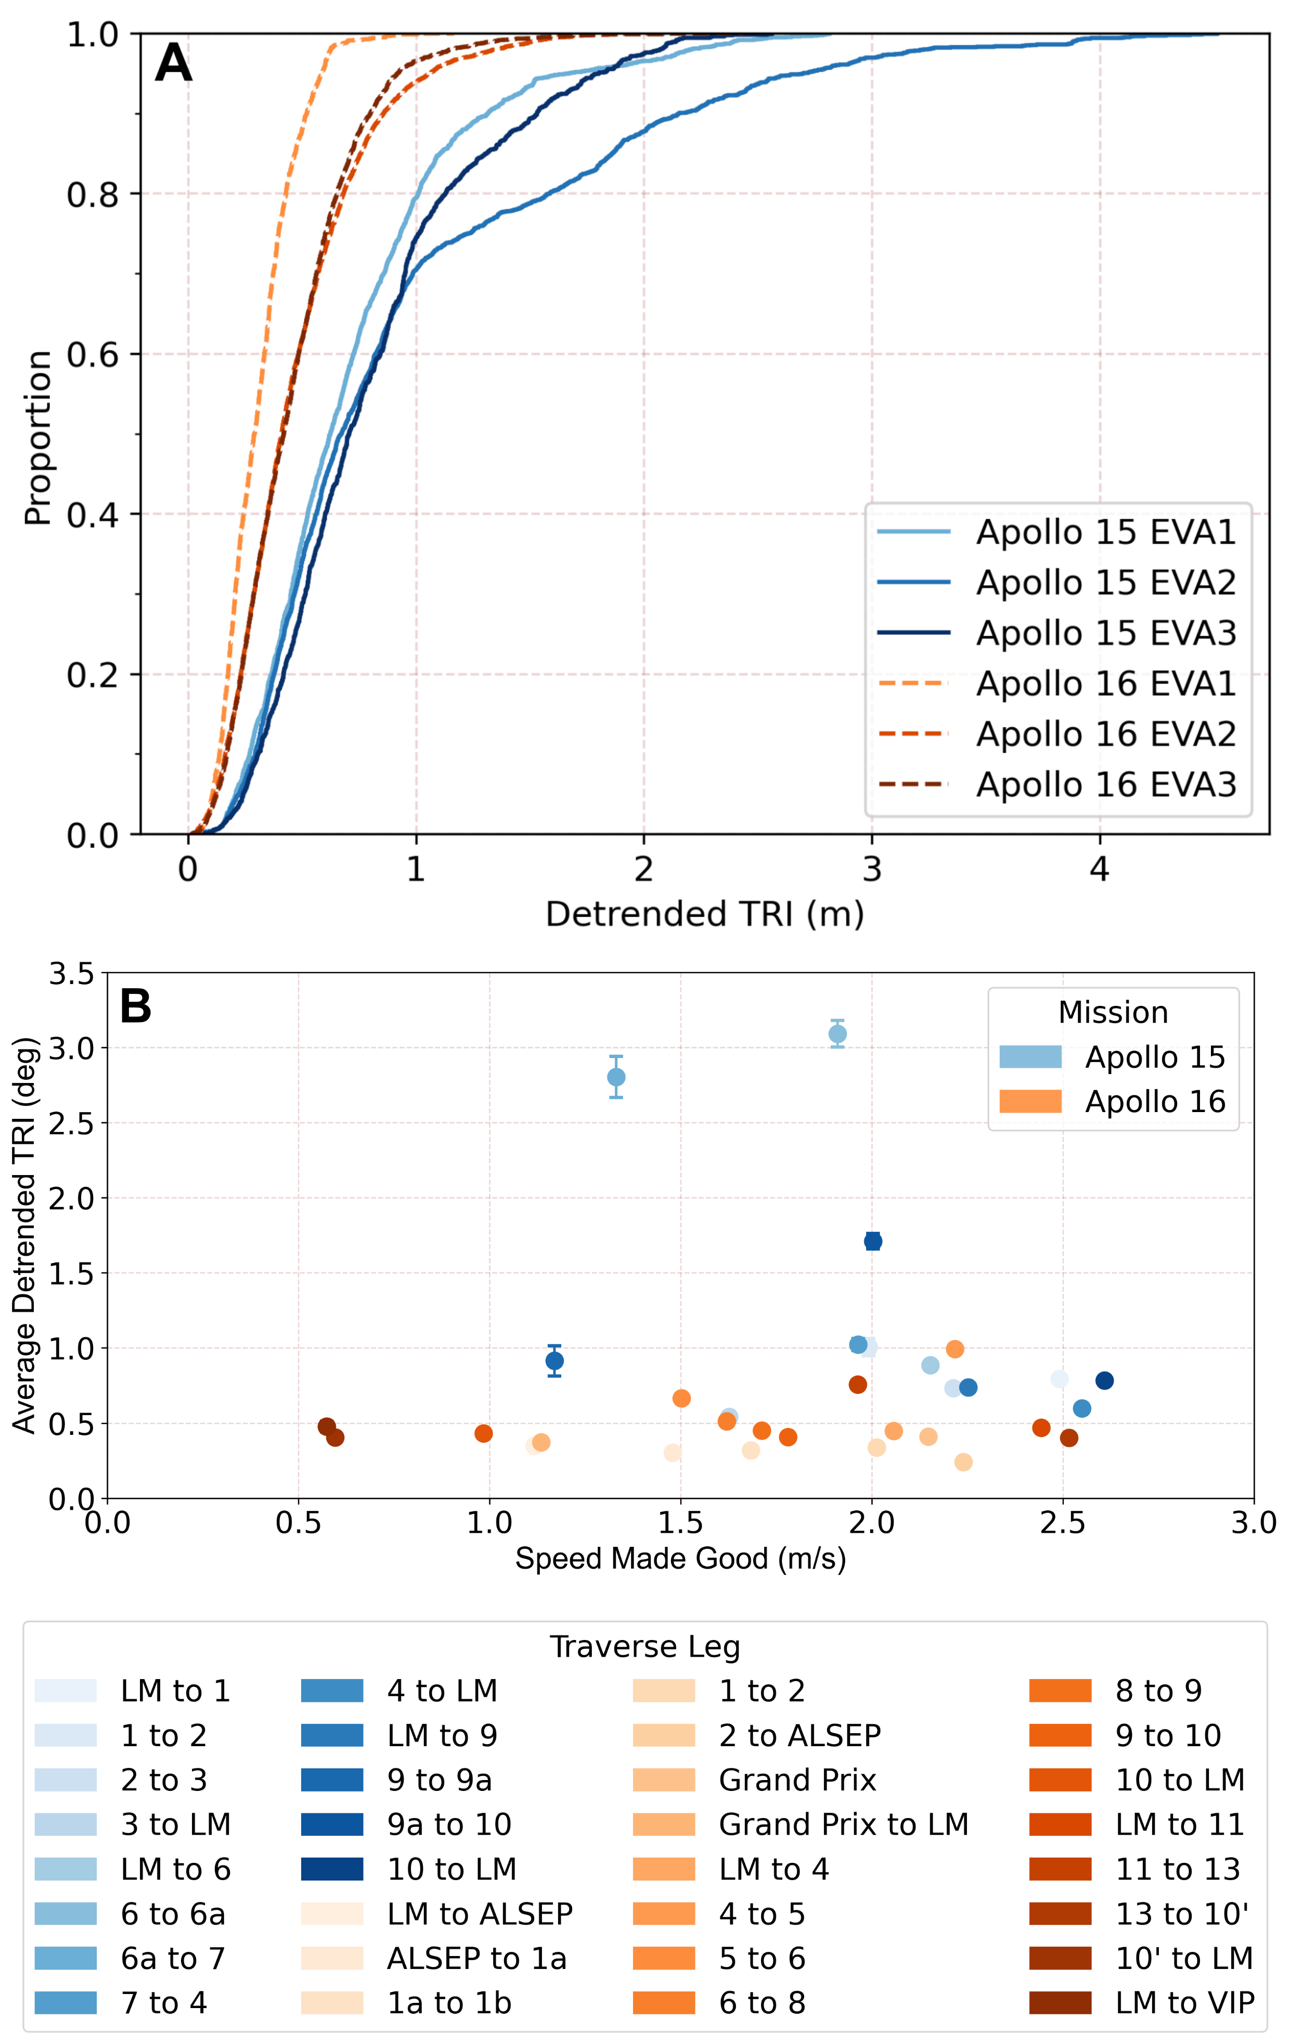
Figure 2: Panel A shows the cumulative distribution of detrended terrain ruggedness for each EVA. Panel B shows SMG as a function of detrended terrain ruggedness for each traverse during Apollo 15 and 16. Error bars are at 95% confidence interval.

