AN Axis SequentiaL REACTION CONTROL SYSTEM design for spacecraft and launch vehicle ATTITUDE CONTROL
AAS 26-188
Wei Wu
This paper describes an axis sequential control strategy for a thruster-based Reaction Control System (RCS) using a phase plane controller. For a four thruster RCS, some RCS commands for three axes attitude control cannot be achieved by firing any combination of thrusters without introducing unwanted perturbation torques on other axes. Assuming weak dynamic couplings among axes, the attitude of each axis can be controlled independently. The individual command torques for each axis can be met by firing a combination of thrusters one axis at a time, instead of torque commands for all axes at the same time. Thus, an axis sequential RCS control is proposed, where the roll, pitch, and yaw axis are controlled in sequence: one axis is controlled by RCS at each controller update instance in a prescribed order. In this way, there is no control interference among axes and the torque commands are always achievable. Simulation results, of this sequential RCS control on a launch vehicle model, are satisfactory provided a fast enough controller update frequency. Stability analysis of the sequential RCS, controller update frequency effects on stability and performance, attitude control performance, and fuel efficiency for the proposed axis sequential RCS are investigated using simulation. This study provides an alternate RCS design when the number of thrusters of RCS is limited due to other vehicle design constraints such as payload.
INTRODUCTION
RCS is commonly used for attitude control in satellites and the upper stages of launch vehicles. For an RCS system to have adequate control authority for each axis of a full three axes attitude control system, an adequate number of thrusters are needed, e.g., 6 or 8 thrusters.
When an extreme payload management requirement poses a strict mass restriction on an RCS system, a smaller number of thrusters may be required to control the spacecraft attitude. In this situation, the design control torque of thrusters for a single axis may not be achieved when three axes’ attitudes are being controlled simultaneously. Consider an RCS configuration with four thrusters. Figure 1 shows the rear view of a vehicle with four canted thrusters arranged around its perimeter. In the figure, the arrowhead of each lines indicates the direction of the thruster force. Beside each arrow, the roll, pitch, and yaw torque produced by the thruster when being fired are also indicated, i.e., +R indicates a positive roll torque. Each thruster generates roll, pitch, and yaw torques. There are three torques commands for each axis, -1, 0, +1. The total possible torque commands for roll, pitch, and yaw control are therefore 27. For the four thrusters in Figure 1, only 15 of 27 combinations can be achieved with the required design torques, while the remaining 12 are unwanted torque combinations. For example, the combination of negative roll torque, negative pitch torque, and zero yaw torque command ([-1 -1 0]) is not achievable, because when thrusters generating desired negative roll and pitch torques are fired, indicated by green arrows in Figure 1, the resultant torques are half of the negative design roll torque, half of the negative design pitch torque, and half of the positive design yaw torque. Thus, the roll and pitch axis only have a half of the commanded control torques and the yaw axis has an unwanted disturbance torque. This demonstrates that the RCS configuration cannot fully utilize the multi-axis torque capacity and generates an unwanted torque for an axis needing no control torque in some control situations.
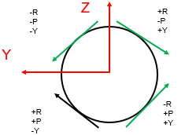
Figure 1. RCS with four thrusters
Although this RCS system may be considered unfeasible for simultaneous three axis attitude control, it can still be used for successful attitude control if the axes are controlled sequentially one axis at a time. There is enough control authority for each single axis. If the RCS control system updates at a fast rate, it is demonstrated via simulation that the full three axes attitude control can be achieved under the thruster hardware limits such as the minimum off time and the minimum on time.

SEQUENTIAL AXIS CONTROL METHOD
As introduced in the previous section, for a four thruster RCS configuration, a sequential axis attitude control method can be applied. The advantage of this method is that there is a full control authority for each axis and the unwanted disturbance torques are avoided. In this method, at each control update time only one axis attitude is corrected, and after three control updates attitudes of all three axis have been controlled and the cycle repeats. Thus , for each axis the effective control period is three times the normal control update time. Figure 2 shows the sequential control timing for each axis. If the control update rate is fast enough, the effective single axis control rate is still high enough for adequate attitude control performance.
Stability Analysis
The stability of the proposed sequential axis RCS control can be analyzed as follows. Following the general approach that models the phase plane with an attitude deadband and an attitude rate limit as a proportional and derivative controller plus a delay element (References 1 and 2) with the effective single axis control rate being three times the control update rate, there are two methods that can be used to analyze the stability of the sequential control.

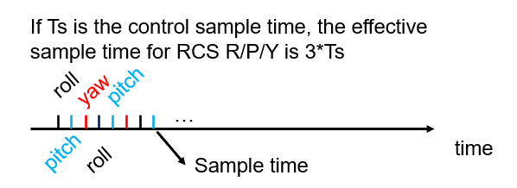
Figure 2. Sequential axis control sample time

Figure 3 shows the phase plane model with the sequential sampling for the stability analysis for one axis. δ is the attitude angle deadband, RL is the attitude rate limit, ϕ is the attitude angle. The extra block for the sequential RCS (SRCS) is the model for the control action over one effective sample period for the sequential method. As shown in Figure 3, there are two ways to model this control action. If the control signal is considered as the result of the pulse width modulation, then the effective control can be assumed to be 1/3. Alternately, the control signal can be modeled as the sum of a unit step and a negative unit step applied after Ts. The effective gain of 1/3 or the transfer function $1-e^{-T_{s}s}$ can then be added to the phase plane model to define the controller behavior for stability analysis as usual using a Describing Function (DF) for the relay element.
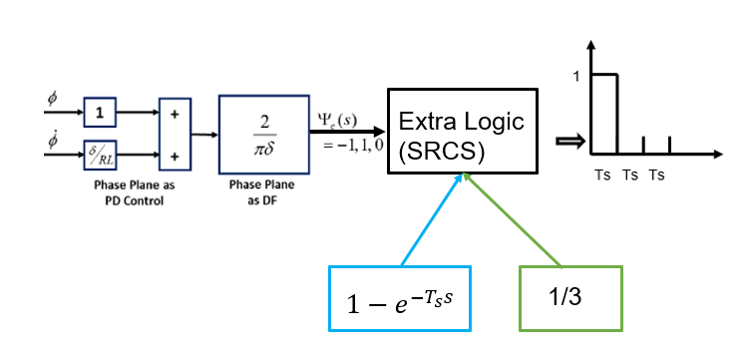
Figure 3. Sequential axis control stability analysis

SIMULATION
In this section, the simulation results are presented for the sequential axis RCS control with four thrusters. The system simulated is a small launch vehicle. The thruster hardware constraints are included in the simulation. They are the minimum off time and the minimum on time. The thrusters are controlled with a phase plane controller. For verifying the stability of the method, the controller sample rates are varied. The fuel usage is also considered to assess the feasibility of the new method for practical applications.
Figure 4 shows the thruster limiting logic. The thrust command signal is turned off after meeting the minimum time on constraint and then turned on after meeting the minimum time off constraint.
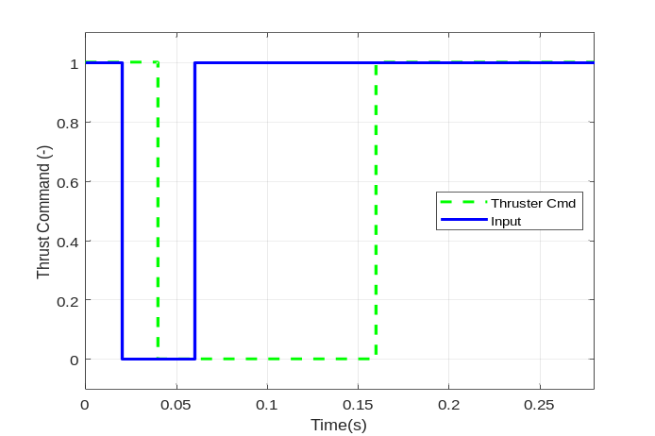
Figure 4. Thrust limiting

In the simulation, about 100 seconds after the launching of the vehicle, the RCS attitude control system is turned on. Figure 5 shows the sequential axis RCS control three axis performance during the flight of the launch vehicle. The initial conditions are 0,0 for the rate and attitude error respectively. The dashed blue lines are the phase plane switching lines. All three axes have satisfactory attitude performance meeting the phase plane control requirements. For the roll axis, the initial rate error slight above 4deg/sec is brought down close to zero almost immediately. For both the pitch and yaw axis, the rate error and the attitude error are brought to zero in about 10 seconds. The blue arrows on the three plots indicate the change of the attitude and rate errors with respect to time.
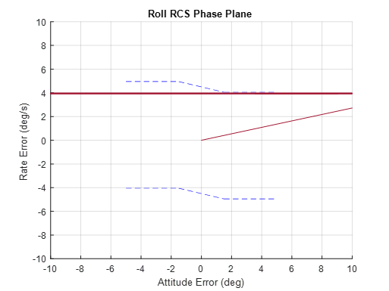
Start
(a)
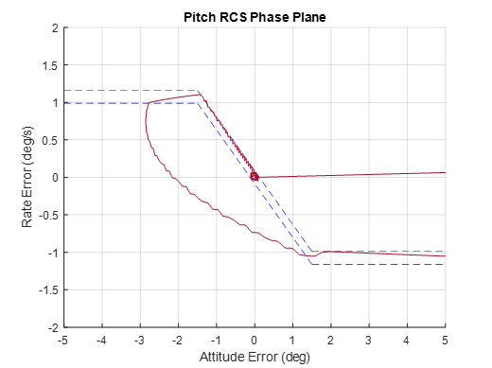
Finish
Start
(b)
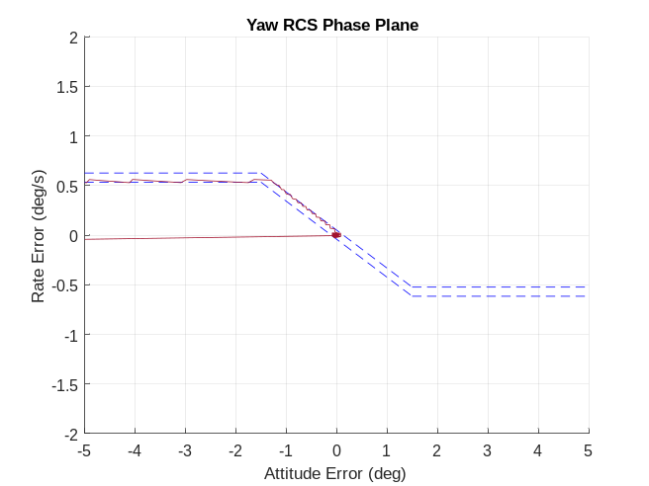
Finish
Start
(c)
Figure 5. Attitude performance at 50Hz sampling rate
Figure 6 shows the pitch axis control performance under various sampling rates. As it is evident, with too large a sample interval, the delay associated with RCS controller eventually degrades the control performance, i.e., a limit cycle. Under normal control sampling rates, such as 50Hz or 20Hz, the sequential axis RCS controller gives a good attitude control performance, Figure 6 (a) and (b).
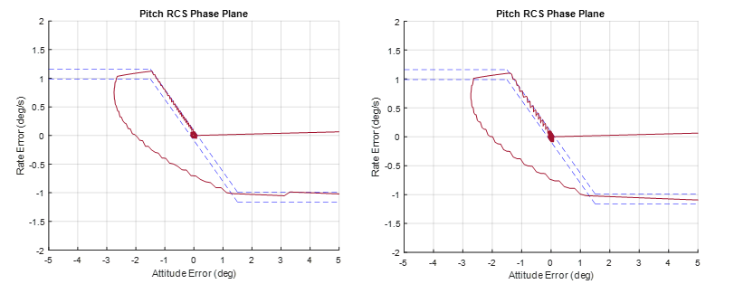
- Ts = 0.02second (b) Ts = 0.05second
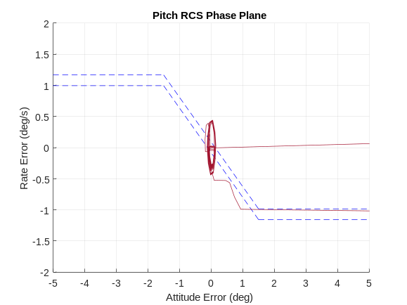
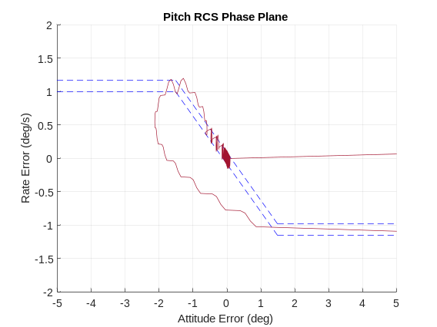

(c)Ts = 0.1 second (d) Ts = 0.2second
Figure 6. Sampling on the pitch axis attitude performance
Finally, the fuel consumption is considered. It is not acceptable for RCS over firing, which leads to excessive fuel usage, since the fuel carried by a spacecraft is limited due to the mass constraint. Figure 7 shows the fuel remaining under various sampling rates. Due to the sequential correction of the attitude, instead of three axis correction simultaneously, the fuel usage is increased if the sampling rates are low. However, under typical RCS control sampling rates of 20Hz to 50Hz, the fuel consumption is considered normal and acceptable.
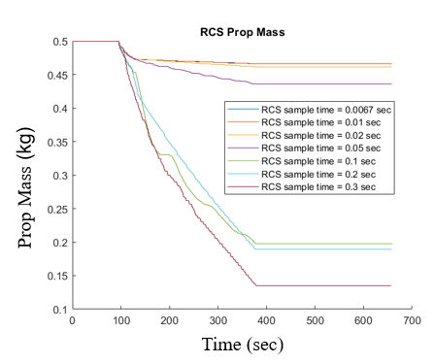
Figure 7. Sampling on the fuel performance

CONCLUSION
When the mass constraint dominates the RCS design, a four thruster RCS system may be used. With a four-thruster configuration RCS, some attitude torque commands cannot provide the designed control torques and introduce unwanted torque disturbances in an axis requiring no control torque. To overcome these drawbacks, instead of controlling three axis all at the same time at each control update time, an axis sequential attitude control has been proposed in this paper. The concept guarantees the full control authority for each axis with an effective control interval being three times the actual control sample period. The stability analysis approaches for this method are described. A launch vehicle simulation demonstrates the control performance and the fuel usage under various sampling rates for this new method. Results show that this method is feasible with a good control performance and an acceptable fuel usage if a normal control sampling rate is used, i.e. 50Hz. Thus, a practical, new, RCS attitude control method has been proposed for the case of a lean RCS configuration with a limited number of thrusters. However, this method can be also applied to RCS systems with more thrusters.

REFERENCES
¹ Hall, R.A., et. al., “Design and Stability of an On-Orbit Attitude Control System Using Reaction Control Thrusters,” GN&C Conference, AIAA SciTech 2016, San Diego, CA, January 2016.
² Jang, J., Plummer, M., Bedrossian, N., Hall, C., Jackson, M., Spanos, P., “Absolute Stability Analysis of a Phase Plane Controller Spacecraft”, 20th AAS/AIAS Space Flight Mechanics Meeting, San Diego, California, February 2010, AAS-10-112.

GNC associate tech. fellow [ESSCA], Amentum Space Exploration Division, NASA MSFC, Huntsville, AL 35812.

