Human-Centered Design of
Next-Generation Telemetry Displays for
NASA’s Moon and Mars Exploration Missions

Anima D. Sabale
Mailstop: CX3, NASA’s Johnson Space Center (KBR Inc), Houston, TX, 77058, USA

Erika E. Gallegos
Colorado State University, Fort Collins, CO, 80523, USA

Abstract
NASA’s upcoming Artemis lunar surface missions will significantly increase telemetry volume and operational demands for Extra-Vehicular Activity (EVA) operations team in NASA’s Mission Control Center (MCC). These missions require telemetry displays that more effectively support real-time monitoring, situational awareness, and decision making than existing International Space Station (ISS) systems, which were not designed for sustained lunar surface operations or the expanded telemetry demands of modern exploration architectures. The objective of this paper is to identify human-centered design requirements for next-generation Artemis EVA telemetry displays that can be implemented within existing mission control constraints. The study integrates human factors principles from high-risk operational domains with qualitative feedback (N=10) from flight controllers, flight instructors and backroom regarding current display strengths, limitations and desired capabilities. Responses were analyzed using thematic analysis to identify recurring usability challenges and operational needs. The results reveal key limitations of current telemetry displays, including dense text-based layouts, limited data correlation, non-intuitive navigation, and high training burden. In response, this paper defines a set of actionable design requirements emphasizing layered information hierarchies, synoptic schematic displays, contextual filtering, multimodal alerting, intuitive navigation, and selective automation. These findings provide practical, near-term guidance for developing Artemis EVA telemetry displays that function as cognitive support tools rather than passive data repositories, reducing controller workload and enhancing situational awareness to support safe and effective lunar surface operations.

Introduction
NASA’s Moon to Mars Exploration missions are a long-term strategy to return humans to the lunar surface through the Artemis program and to use the Moon as a proving ground for eventual crewed missions to Mars [1]. Through Artemis, NASA aims to establish a sustained human presence on the Moon. Artemis III, currently scheduled for Spring 2027, is expected to be the first crewed landing mission in the series. In these missions, Extra-Vehicular Activities (EVA) to support science operations will be a primary focus. Hence, this paper focuses on a new design for EVA telemetry displays.
As with all space missions, telemetry will play a critical role in mission monitoring and decision making. For Artemis EVAs, telemetry will be transmitted from multiple mission elements including the Exploration Extra-Vehicular Activity (xEVA) spacesuits, the Human Landing System (HLS), the Lunar Terrain Vehicle (LTV), the Pressurized Rover (PR), the Multi-Purpose Habitat (MPH), and the Gateway (GW), to NASA’s Artemis Mission Control Center (MCC) on Earth [2]. To support these operations, a new telemetry visualization, monitoring, and commanding system is being developed for use by the EVA Operations team within the Artemis MCC.
To address both the challenges presented by the existing legacy systems and the increased complexity introduced by multiple mission elements, this paper examines the design of telemetry displays for Artemis EVA operations through a human-centered and human factors lens. Specifically, it focuses on understanding the limitations of existing International Space Station (ISS) MCC telemetry displays, the cognitive demands placed on EVA flight controllers, and the implications of increased telemetry volume and system complexity for future lunar missions. By synthesizing prior research in high-risk display design and incorporating insights from flight controller experience, this work seeks to inform the development of next-generation Artemis telemetry displays that better support situational awareness, reduce cognitive workload, and enhance real-time decision-making during EVA operations.
A. EVA Operations and Risk of Information Overload
EVA Operations flight controllers are responsible for monitoring and overseeing EVAs or spacewalk operations on the lunar surface. This role requires sustained attention, rapid decision-making, and continuous situation awareness. Each Artemis EVA will require controllers to manage multiple, concurrent streams of telemetry data. For example, the new xEVA suits alone will generate substantially more telemetry than the legacy Extra-Vehicular Mobility Unit (EMU), which was designed in the 1980s [3]. Advances in sensing, onboard computing, and system complexity will result in a multifold increase in data volume, placing significant strain on existing display paradigms.
Even with EMU data alone, current telemetry displays used for the ISS EVA operations are densely packed, cluttered, and difficult for novice users to interpret, as shown in Figure 1. These displays typically require years of training before flight controllers can reliably extract critical information in real-time. The Artemis program further amplifies this challenge by introducing multiple airlocks across different systems, including the HLS, PR, MPH, and Gateway [2]. Depending on the EVA configuration, flight controllers may need to monitor telemetry from more than one airlock simultaneously, in addition to the xEVA suits, significantly increasing the risk of information overload. Human cognitive capabilities are increasingly outpaced by the volume, complexity, and rate of information in modern high-risk operational environments [23]. When displays are overly dense or poorly structured, critical cues may be missed, decision times may increase, and situational awareness can degrade.

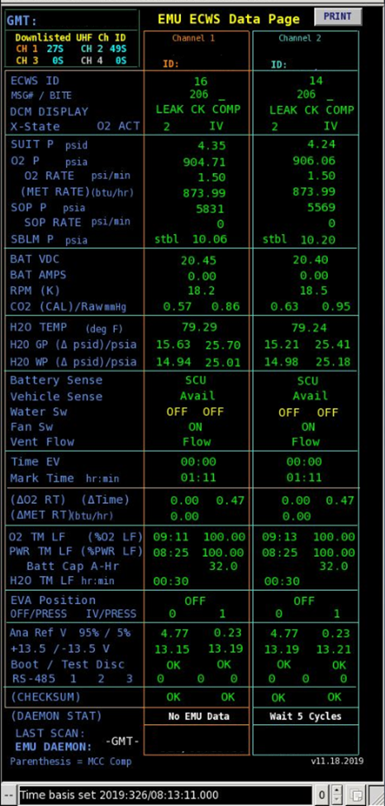 | 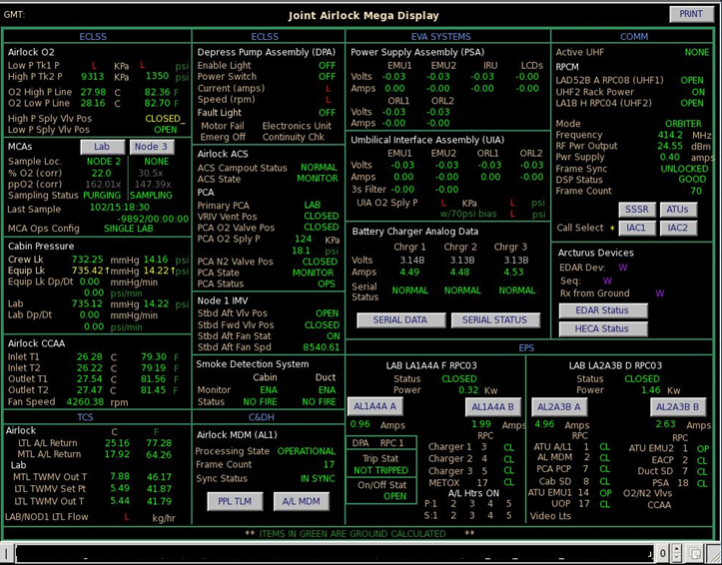
Figure 1. Current ISS displays for EMU suit (left) and joint airlock mega displays (right)
B. Human Factors Challenges in Telemetry Display Design
Research across aviation, healthcare, and nuclear power consistently demonstrates that poorly designed displays contribute to cognitive overload, reduced vigilance, and delayed or incorrect responses [12]. Barnard [5] showed that while integrated displays can enhance awareness, they may also lead to user overreliance and misinterpretation if information transparency is insufficient. In healthcare settings, Korentsides, et al [14] identified alarm fatigue, multitasking demands, high workload, and cluttered interfaces as major contributors to reduced vigilance and missed signals in telemetry monitoring systems. Similar findings have been reported in aviation [8] and nuclear power control rooms [9, 10, 11], where display design directly affects operator performance and safety.
In the ISS MCC, flight controllers must manage telemetry displays alongside numerous flight products, including flight notes, flight procedures, flight rules, timelines and schedules, mission plans, and anomaly reports [4]. Despite the complexity of these tasks, current telemetry systems provide limited decision-support functionality, requiring controllers to memorize thresholds, flight rules, and system behavior. Artemis surface missions introduce additional complexity through new data products such as lunar terrain maps, navigational tools, and geology instruments, further intensifying cognitive demands.
C. Human-Centered Design Principles for Artemis
Understanding how users perceive and interact with information is critical when designing displays, as it enables the development of interfaces that are easier to read, less prone to misinterpretation, and better aligned with user capabilities and limitations. This consideration is especially important for the Artemis program, where crews operate on a distant lunar surface and even small errors can have catastrophic consequences.
Thompson [6] highlights how perceptual design choices, including color, motion, and spatial organization, directly influence how operators process critical data under time pressure. Extending these ideas, Flick [7] and Hugo & St. Germain [13] advocate for modular, adaptive, and context-aware dashboards that align with users’ mental models across domains such as flight decks, control rooms, and space missions. Together, these studies converge on a central insight: telemetry interfaces must not simply present data but actively support cognition through visual salience, contextual filtering, and user-centered adaptability.
Proposed solutions in the literature include visual hierarchies, relevance-grouped data, multimodal alerts, adaptive thresholds, and tiered urgency levels to improve perceptual clarity and reduce fatigue. Safe and effective telemetry displays therefore require human-centered design approaches, workload management strategies, and decision-support tools that respect cognitive limits [14]. These principles are directly applicable to Artemis EVA telemetry displays, where astronaut safety and mission success depend on flight controllers’ ability to manage large volumes of complex, time-critical information. By reducing cognitive workload, and presenting information in perceptually efficient ways, flight controllers will be better equipped to monitor multiple mission elements, detect anomalies more quickly and make confident real time decisions.
One promising approach for addressing these challenges is the use of synoptic displays which are prevalent in the aviation industry and typically present schematic summaries of complex system architectures [24]. Synoptic displays help operators manage system complexity through intuitive symbology, logical organization, minimal clutter, and visual simplicity. Aesthetic considerations and visual minimalism have also been shown to enhance usability by reducing cognitive load [15]. In contrast, current NASA MCC telemetry displays, developed using an in-house custom software system, are dense with alphanumeric data and make limited use of static graphical elements.
For Artemis, synoptic displays offer a meaningful departure from this legacy design paradigm, particularly given the complex architectures of the new xEVA spacesuit and the new airlock systems. Displays based on system schematics could visually associate telemetry values with their corresponding sensors, allowing data to be highlighted directly on the schematic. This approach would provide flight controllers with an at-a-glance summary of the system’s current state, helping to reduce cognitive load while improving situational awareness. Similar challenges (e.g., information overload, cluttered interfaces, and poor support for rapid decision-making) have been observed in other high-risk domains, such as healthcare and nuclear power, where user-centered design approaches grounded in human factors principles have been shown to improve safety, efficiency, and operator experience [16].
ISS telemetry displays often function as comprehensive data repositories, presenting all available information regardless of operational context. However, not all telemetry data is relevant during every phase of EVA operations. For example, battery charging data remains visible on the joint airlock mega display even when astronauts are outside the ISS conducting an EVA, despite this information being primarily relevant only during battery maintenance activities. Continuously displaying such data contributes to visual clutter and distracts flight controllers from more time-critical information.
Barnard [5] emphasizes three key design strategies for addressing this issue: layered information (providing only task-relevant data in time-critical contexts), contextualization (filtering data dynamically to fit operational conditions), and integration (combining graphical and textual data to present a coherent picture). Similarly, Hugo & St. Germain [13] highlight the importance of integrated information displays that prioritize actionable, decision relevant data while filtering out “nice-to-know” information. Designing displays around specific EVA activities, for example an “Execute EVA” display versus a “Battery Maintenance Operations” display, would allow flight controllers to view only the information relevant to the task at hand, while still maintaining access to other displays through simple navigation. This approach reduces clutter, supports cognitive efficiency and mitigates information overload.
Poor visual design can lead to cognitive overload, change blindness, and misinterpretation particularly in complex and time-critical environments. Designing effective telemetry displays therefore requires accounting for the physiological constraints of human vision and leveraging principles from cognitive psychology and perceptual design. Pre-attentive visual attributes such as color, shape, proximity, and motion can be used to support rapid information processing [6]. Minimalist design strategies, including consistent typography, spacing, alignment, and the application of Gestalt principles, further help guide user attention and reduce user fatigue [7,29].
Traditional dashboard systems often fail to incorporate these principles, relying instead on raw data presentation that imposes unnecessary cognitive demands. More effective displays integrate context-specific, pre-processed visualizations that align with users’ mental models and perceptual capabilities. Techniques such as foreground-background differentiation, semantic use of color, intuitive iconography, and interactive visualizations can enhance pattern recognition and reasoning, enabling operators detect both expected and emergent conditions through graphical cues [13]. For Artemis EVA telemetry display development these recommendations provide a clear path for applying cognitive ergonomics to transform raw telemetry data into meaningful, actionable insights.
The NASA Moon to Mars GUI Standards [17] establish high-level guidelines for developing graphical user interfaces (GUIs) across the Artemis program. Their primary aim is to promote consistency among Artemis components, streamline GUI design, and improve development efficiency. While these standards are intentionally broad and do not directly address the specialized requirements of telemetry display design, some general principles remain relevant to Artemis EVA telemetry displays. These include guidance on layout and appearance, color usage, data presentation, graphical elements, schematics, and automation. Applying these standards ensures that EVA telemetry displays maintain visual coherence with other Artemis systems. In this paper, we selectively adopt the most applicable standards from the NASA Moon to Mars framework to complement the human factors analysis and strengthen the design of Artemis EVA telemetry displays.
D. Automation, Anomaly Detection, and Decision Support
The aviation industry has rapidly leveraged automation since the 1980’s when cockpits transitioned from analog gauges to integrated electronic flight decks [18]. In contrast spaceflight systems have adopted automation more cautiously due to limited trust in software to manage complex decision-making in high-risk scenarios [19], particularly in EVA operations where human lives are directly at stake.
Automation in the NASA MCC was first introduced during the Space Shuttle era with the Real Time Data System (RTDS) in 1987 [20] and has continued to evolve. Current systems support threshold-based alerts that trigger visual or auditory cues; however, flight controllers must still memorize threshold limits and corresponding flight rules. Integrating flight products directly into telemetry displays could make these systems more “intelligent” by providing controllers with immediate, contextual access to critical information rather than relying on memory. For Artemis missions, such automation could reduce workload, minimize human error, and enhance decision support, while preserving human authority.
Drawing from a comprehensive investigation that included aviation accident analyses and controlled laboratory studies, Chaparro, Miranda, Grubb [18] identified five foundational principles for integration of automation in displays: information integrity, ease of use, communication style, transparency, and level of control. Incorporating these principles into the design of Artemis EVA telemetry displays can foster greater trust in embedded automation. Beyond reducing cognitive workload, appropriately designed automation can enhance situational awareness for Artemis flight controllers. Importantly, the role of automation in these displays is intended to be supportive; while automation aids decision making, ultimate authority remains with the human operators (i.e. the flight controllers).
For high-risk missions such as human spaceflight, crew safety is always the highest priority. To maintain the integrity of critical systems and safeguard astronauts, robust anomaly detection and fault analysis are essential. In current ISS operations, flight controllers in the ISS MCC monitor system status continuously, 24 hours a day, 365 days a year. For an anomaly detection method to be effective, it must provide flight controllers with sufficient rationale to support confident and timely action [21]. Although emerging fault-detection techniques are being developed for aerospace applications, their adoption on active spacecraft remains limited due to high computational demands and the constraints of existing models [22].
As the number of systems and telemetry streams in Artemis missions continues to grow, automating anomaly detection offers significant potential to support flight controllers by providing real-time decision support, enabling prediction of potential failures, and facilitating proactive intervention. Automation can also allow controllers to focus on higher-level tasks rather than continuously scanning telemetry data for anomalies. Building user trust in such system requires extensive testing and training as well as transparent system behavior. As emphasized by Barnard [5], maintaining an appropriate balance between automation and human control is essential for enhancing cognitive performance and situational awareness in mission-critical environments.
E. Motivation and Research Questions
Human factors engineering and user experience (UX) research together provide a holistic framework for designing telemetry displays that support the cognitive, emotional, and behavioral dimensions of system use. Adopting a human-centered design approach places the user at the center of the design process and directly supports one of the primary goals of Artemis EVA telemetry display development: improving the user experience. Well-designed, usable systems have been shown to enhance productivity, reduce stress, increase accessibility and lower risk of human error and harm [25].
Asbjorn [26] highlights the importance of user involvement and feedback in usability evaluations of systems. Despite extensive research on human factors and display design in high-risk domains, there remains a notable gap in the application of these principles to human spaceflight telemetry displays, particularly for surface EVA operations. Much of the existing literature focuses on aviation, healthcare, or legacy spaceflight systems, with limited empirical work examining how NASA flight controllers interact with current telemetry displays or how their experiences can inform the design of future systems. In addition, few studies explicitly address the implications of increased telemetry volume, system complexity, and constrained legacy software environments for next-generation lunar missions. Although the ISS MCC telemetry system has inherent limitations, it has functioned reliably for decades, with experienced users adapting through learned scan patterns, procedural knowledge, and navigation strategies. The requirement to develop Artemis EVA telemetry displays using the same underlying software platform constrains opportunities for entirely novel designs; however, meaningful improvement in layout, visualization, contextualization, and decision support remain achievable within these constraints. Understanding how flight controllers currently use, and work around, existing displays is therefore essential for informing realistic, implementable design improvements for Artemis.
To address these gaps, this work seeks to answer the following research questions:
- What are the key strengths and limitations of current ISS telemetry displays as perceived by NASA flight controllers?
- What information and features do NASA flight controllers consider most critical for effective decision-making during Artemis missions?
- How do NASA flight controllers perceive the usability and cognitive demands of existing telemetry displays, and what design improvements do they recommend for Artemis systems?
- Which display design features are most likely to reduce cognitive workload and support efficient monitoring during lunar operations?
By grounding telemetry display design in the lived experiences and perspectives of flight controllers, this work aims to translate established human factors principles into actionable design guidance for Artemis MCC EVA telemetry display system. The findings are intended to inform practical display requirements, support near-term design decisions within existing technical constraints, and ultimately contribute to safer and more efficient EVA operations. Rather than proposing speculative interface concepts, this research provides empirically informed insights that can be directly applied to the development and refinement of next-generation Artemis EVA telemetry displays, with clear implications for mission readiness, controller performance, and astronaut safety.

- Method
A survey study was conducted to understand strengths and limitations of the existing ISS EVA telemetry displays and to identify user needs and opportunities for designing new Artemis EVA telemetry displays. Data was collected from NASA telemetry display end users (i.e. flight controllers) to obtain expert feedback on current systems and desired enhancements.
A. ISS EVA Telemetry Displays
For the purpose of this study, and as scoped to study participants, ISS EVA telemetry displays refer to the telemetry data displays used at NASA’s ISS MCC to support EVA ground operations for ISS missions and associated subsystems. These displays consolidate all incoming data into a unified system that enables flight controllers to monitor and supervise ISS systems. The displays consist of multiple screens and menus housing a variety of subsystem information. The primary systems of interest for this study include the EMU suit and the joint airlock.
B. Participants
Participants were recruited from the EVA Operations team at NASA’s Johnson Space Center in Houston, Texas. Ten individuals completed the survey, including six ISS EVA flight controllers and four engineers training to be Artemis EVA flight controllers. The ISS EVA flight controllers were highly experienced having worked console positions within the MCC for approximately 15 to 20 years. The Artemis EVA flight controller trainees are expected to support future Artemis missions and were still in the training phase at the time of the study. Collectively, participants were familiar with flight control operations and mission telemetry, however their experience with real-time telemetry displays ranged from extensive to very limited.

C. Survey
An online survey was administered in February 2025. The survey consisted of ten open-ended questions. Respondents were asked to describe their perceptions of the current ISS telemetry displays, including system capabilities, strengths, weaknesses, and limitations. Additional questions focused on desired capabilities, functionality enhancements, and levels of automation for the new Artemis EVA telemetry displays.
D. Data Analysis
The survey yielded primarily open-ended, text-based responses. This data was analyzed using thematic analysis, a qualitative method commonly recommended for open-ended survey data [27]. Thematic analysis involves identifying, analyzing and reporting patterns within qualitative data, resulting in an organized and detailed representation of response themes [28]. The analysis followed the six-phase approach described by [30]: 1) familiarization with the data; 2) generation of initial codes; 3) theme development; 4) theme review; 5) theme definition and naming; and 6) production of final report.
- Results
A. Strengths of Current ISS EVA Displays
The ISS EVA displays are most valued for their ability to provide clear situational awareness, especially through one-page layouts that consolidate critical consumables and system status for rapid emergency response. Users consistently praised visual cues such as color coding and graphs, which reduce cognitive load and make anomalies immediately noticeable. Customization options including resizing, filtering, and personal “loadouts”, allow controllers to tailor workflows to their individual needs. Pop-up drill-downs and pre-configured views further streamline operations by enabling quick access to subsystem details without adding visual clutter.
At the same time, users identified several gaps, including challenges in balancing readability with high data density, ensuring accessibility beyond color-based cues, expanding predictive trend analysis for consumable depletion, and integrating additional ISS subsystems to provide richer operational context. Overall, the current displays are strong in clarity, customization, and visual hierarchy; however, future designs should prioritize improvements in emergency readiness, predictive analytics, and system integration to fully meet mission-critical demands.
Following the identification of initial codes during thematic analysis of user responses, higher-level themes were developed to characterize the primary strengths of current ISS EVA displays. Table 1 groups representative codes and lists the corresponding themes they support.
Codes | Theme
situational awareness, summary status,  limiting consumables, emergency use | Situational Awareness
one-page view, readable fonts, data-at-once | Information Density with Readability
parameter grouping, system-level views | Logical Grouping & Co-location
color coding, alerts, graphs | Visual Coding & Salience
resize, personal loadouts, custom screens | Customization & Flexibility
plots, trends, rates | Trend Visualization & Temporal Context
pop-ups, ISS data, airlock details | Integrated & Contextual Information
Table 1: Codes and Themes for Display Strength Responses
Figure 2 presents an infographic visualization of these themes and illustrates how they contribute to rapid data interpretation, resulting in enhanced situational awareness, that ultimately leads to effective decision making. Information organization features such as high information density, logical grouping of related parameters, and user customization, enable efficient scanning and system-level comprehension. Visual attention and interpretation features, including color-coded alerts, trend monitoring over time, and integrated EVA/ISS contextual information, further enable rapid data interpretation and anomaly detection. Together, these capabilities support effective EVA decision making, particularly under time-critical and high-workload conditions.
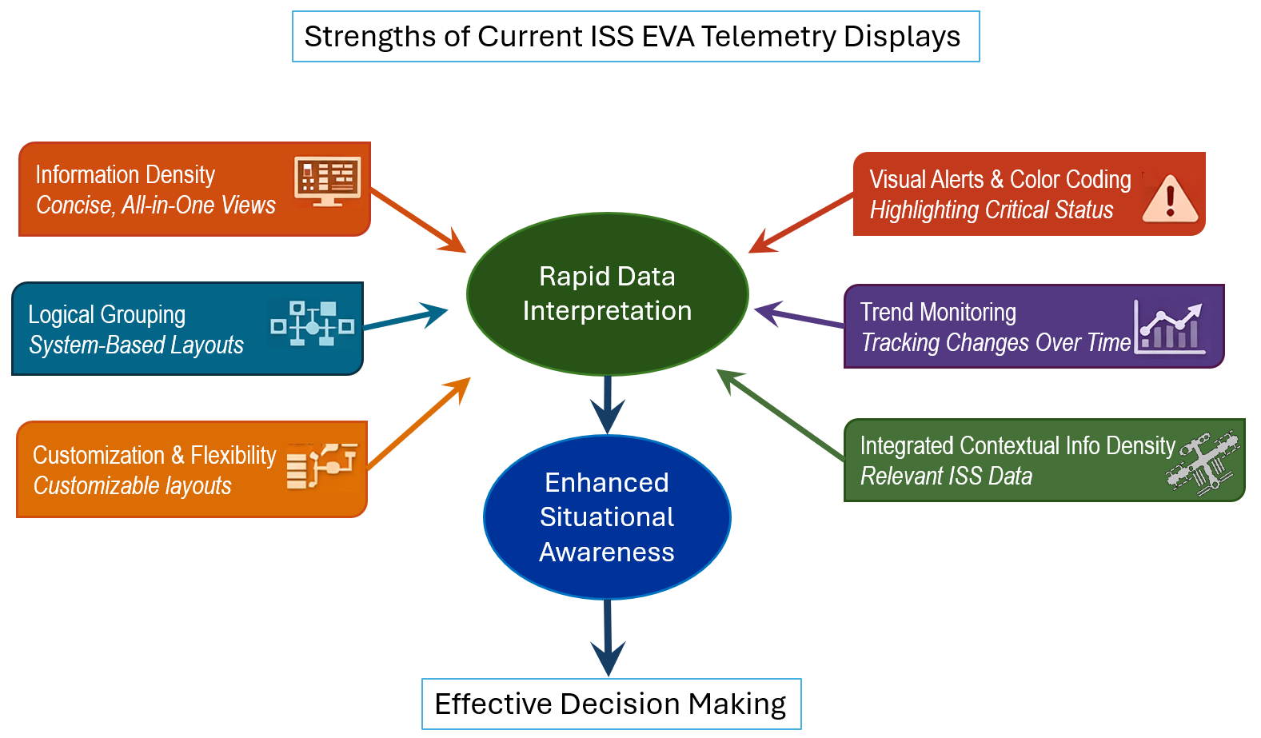
Figure 2: Conceptual Theme Diagram for ISS EVA Display Strengths
The design matrix shown in Table 2 maps user needs to existing ISS EVA display features, highlighting both current benefits and opportunities for improvement. Each row identifies a specific user requirement, the feature that currently supports that requirement, the associated operational benefit, and the corresponding gap or enhancement opportunity. This matrix serves as a diagnostic tool, making it easier to identify where the displays are already effective (i.e., clarity, visual cues, customization) and where future development should focus, including predictive analytics, accessibility, broader system integration. By aligning technical features directly with user priorities, the matric helps guide the prioritization of future design enhancements.

User Need | Current Feature | Benefit | Gap/Opportunity
Quick situational awareness | One-page view for both suits; Consumable summary | Fast scanning, emergency readiness | Balance readability vs. density; ensure critical consumables always visible
Comparative system context | Data for 2 suits displayed side-by-side. ISS data integration | Cross-checking, environmental awareness | Expand integration with ISS subsystems (thermal, comms)
Visual cues for anomalies | Color coding for nominal/off-nominal | Immediate attention to issues | Consider additional shapes/icons for redundancy (color-blind accessibility)
Customization & personalization | Resize, zoom, filter, personal loadouts | Tailored workflows, reduced cognitive load | Standardize critical views while allowing personalization for secondary data
Trend analysis | Telemetry plots over time; dual GMT/Phased Elapsed Time (PET) plots | Detecting patterns, consumable usage | Expand predictive trend overlays (e.g., projected consumable depletion)
Detailed system drill-down | Pop-up windows for additional data | Access deeper info without drilling down into default navigation menu | Add more modular pop-ups for emerging subsystems
Emergency readiness | One-page layout, color alerts | Rapid response in critical scenarios | Ensure redundancy: one-page must remain legible under stress conditions
Table 2: Design Matrix for User Needs vs. Display Features
B. Limitations of Current ISS EVA Display
Users find the EVA displays limited by usability issues, training gaps, and poor information presentation. Navigation pathways are not intuitive, the old user interface feels disorganized, and reliance on text-heavy layouts makes it difficult to correlate data or gain a “feel” for the system. Several users noted that without training, parameters are hard to interpret, reducing situational awareness. Others highlighted that configuration options (like saving layouts) are glitchy or unused, and symbols can be confusing. Layout constraints also restrict scalability as more sensors and computations are added. Overall, the system struggles with readability, correlation of data, and intuitive design, leaving opportunities to improve visual representation, consolidated summaries, accessibility, and predictive analytics while balancing constraints and user workflows. Figure 3 is an infographic that provides a quick, big-picture summary of limitations of the existing displays. There are three distinct themes identified at the top, each of which are based on the initial codes in the bulleted lists below them. Various limitations in displaying data contribute to the common theme of layout constraints. Non-intuitive features coupled with steep learning curve contribute to the theme identified as cognitive load and training. The theme of data correlation and analysis is based on the codes identified as poor graphs, lack of trend captures, and schematics-based data.
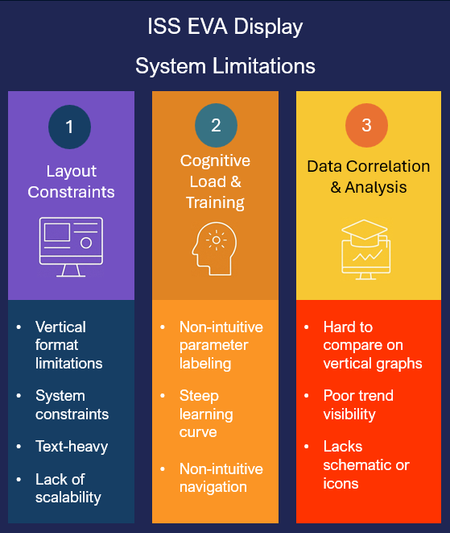
Figure 3. Limitations of current ISS EVA Displays
The design matrix in Table 3 summarizes where user needs clash with current limitations and highlights clear opportunities for design improvement.
User Need | Current Limitation | Impact | Opportunity
Intuitive navigation | Pathways to open displays not user-friendly; old UI disorganized | Slows access, requires training | Redesign navigation flow with user-centric layouts
Training & accessibility | Parameters not labeled intuitively; limited training exposure | Reduces situational awareness for non-specialists | Provide contextual labels, tooltips, and improved onboarding
Visual clarity | Text-heavy, numbers without graphics | Hard to interpret, no physical correlation | Integrate schematics, icons, and graphical overlays
Data correlation & comparison | Difficult to compare trends across graphs | Limits analysis and decision-making | Enable multi-graph correlation and consolidated summary views
Configuration reliability | Save configuration option glitchy, unused | Users avoid customization | Improve reliability and promote personalization features
Scalability & layout constraints | One-page vertical layout at design limits | Future sensors/computations may overwhelm | Explore modular, expandable layouts with adaptive scaling
System representation | Symbols not updated to reflect PUIs | Creates confusion | Standardize symbol updates and align with system naming conventions

Table 3: Design Matrix for User Needs vs. Current Limitations
With these limitations and gaps identified, it is possible to identify features that can be implemented in the short-term and features that can be slated for long term for the new display design. Figure 4 below provides a roadmap that highlights a clear progression from immediate usability fixes to longer-term strategic investments. In the short term, the focus is on enhancing user experience and situational awareness by redesigning navigation flows, improving labeling and accessibility, integrating schematics for better visual clarity, consolidating key parameters into summary views such as a combined Suit and Airlock display, and future-proofing the system through scalable modular layouts that can accommodate additional sensors and computations. These changes deliver quick wins that directly address user frustrations with navigation, readability, and training gaps.
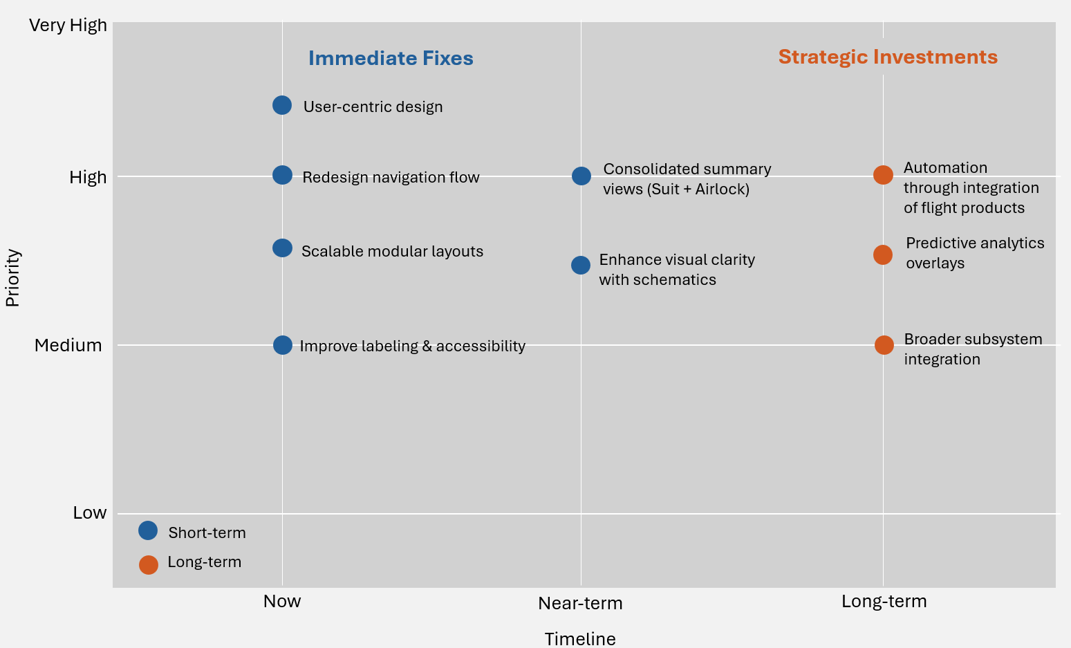
Figure 4: Displays Features Improvement Roadmap
Over the longer term, the roadmap emphasizes predictive analytics overlays to anticipate consumable depletion and system performance, broader subsystem integration for holistic EVA awareness, and integrating flight products within display to allow for in-built automation capabilities. Together, these initiatives balance immediate operational needs with strategic innovation, ensuring the displays remain both intuitive and mission-critical as complexity grows.

C. Needs for New Artemis EVA Telemetry Display
Feedback reveals a strong desire for telemetry displays that are more intuitive, integrated, and user centered. Users consistently emphasize the need for clearer alerting mechanisms - through color coding, fonts, sounds, and pop-ups, to draw attention to off-nominal data without relying solely on scan patterns. They also call for improved visual hierarchy and representation, such as schematic overlays, graphical system views, and dynamic displays that minimize clutter while remaining aesthetically pleasing. Another recurring theme is data integration and accessibility, with requests for combined numeric and plot views, contextual “data tips,” links to anomaly reports, and historic data inclusion. Users want greater flexibility in data handling, including exporting to Excel, trending, and performing calculations, alongside interactive controls like hover/click features and customizable graphics.
Overall, the responses highlight a push toward telemetry systems that balance clarity, functionality, and modern UI research to reduce training needs and enhance situational awareness. Figure 5 provides an infographic overview of the modular breakdown of user-desired features for next-gen telemetry displays. This breakdown is based on the primary themes identified in the user feedback that are then further elaborated upon in the design matrix in Table 4. Six major themes drawn from user feedback are highlighted in the design matrix, each paired with user identified limitations, new design opportunities, and implementation strategies for those design opportunities. For alerting and attention management, users noted that current alerts are too subtle, lack audible cues, and rely heavily on manual scan patterns. This opens opportunities for multi-modal alerts using color, sound, and contextual anomaly links.
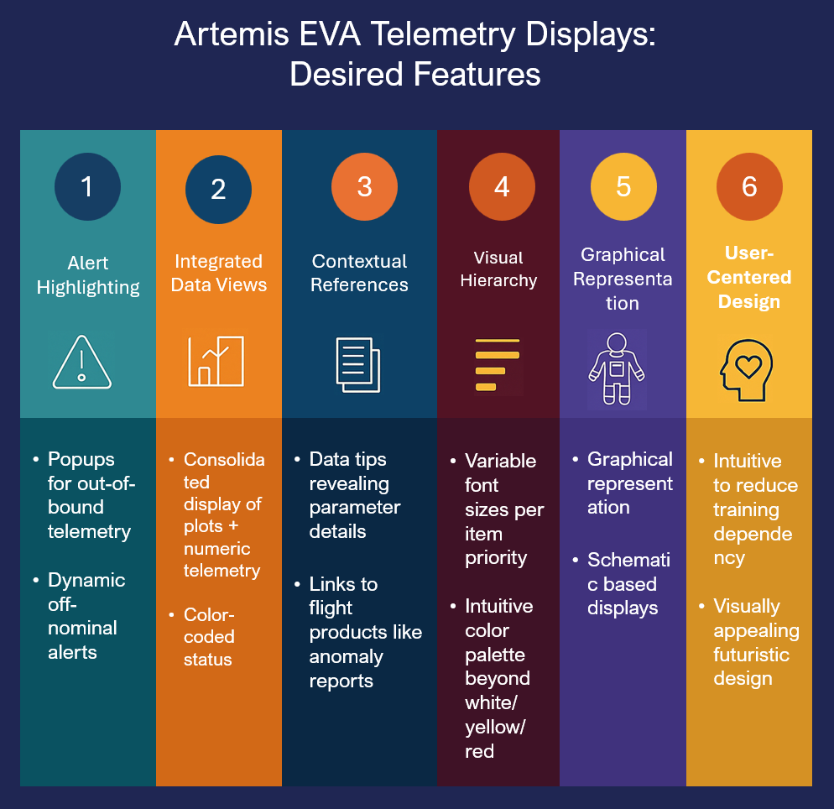
Figure 5: User Desired Features for New Displays
In terms of visual hierarchy and representation, cluttered displays and auto-resizing plots make data hard to scan, suggesting improvements through larger fonts, schematic overlays, and more aesthetically dynamic layouts. Data integration and accessibility is limited by fragmented telemetry and plots, missing historic data, and absent sensor overlays, opening up opportunities
Theme / User Need | Limitations Identified | Design Opportunity | Implementation Strategies
Alerting & Attention Management | - Alerts are subtle (text color changes easily missed)  - No audible notifications tied to limits  - Reliance on manual scan patterns for attention | Ensure critical data stands out and captures user attention | - Multi-modal alerts (color, font, sound, pop-ups)  - Configurable thresholds and escalation levels  - Integration with anomaly reports for context
Visual Hierarchy & Representation | - Displays cluttered and difficult to scan when overloaded  - Hard to zoom in on plots due to auto-resizing with repeating zero values | Improve clarity and reduce cognitive load | - Larger/distinguished fonts for priority data  - Color-coded boards modeled after comm sentry  - Graphical system schematics with sensor overlays  - Dynamic, aesthetically pleasing layouts
Data Integration & Accessibility | - Telemetry and plots separated across panels  - Historic data not incorporated | Provide contextualized, unified views of telemetry | - Combine numeric + plots in single display  - Hover/click “data tips” linking to metadata/schematics  - Overlay telemetry on EMU schematics
User-Centered Design & Research | - Displays require re-learning plot functions  - Current design not informed by user-centered research | Apply modern UI/UX principles to reduce training needs | - Evidence-based UI informed by cognitive psychology  - Minimize clutter with modular layouts  - Intuitive navigation and grouping of subsystems
Contextual References & Data Manipulation & Export | - No easy way to export plots/data for debriefs  - Trend capture and rate calculations are cumbersome  - Historic data missing from system | Enable flexible analysis and reporting | - Links to flight products like anomaly reports  - Data tips for parameter details  - Export plots/data to xls/csv  - Built-in trend capture and rate calculations  - Historic data integration for smarter analysis
Graphical Representation | -Text-based cluttered displays | Empower users with interactive exploration | - Schematics based graphical displays
Table 4: Design Matrix for User Needs vs. Possible Improvements
for unified views with numeric and plot combinations, hover-based data tips, and schematic integration. For user-centered design and research, users struggle with re-learning plot functions and feel current designs lack modern UI principles, which could be addressed by evidence-based layouts that minimize clutter and reduce training needs. Quick accessible contextual references by providing links to flight products within the displays can help with rapid data interpretation. Data manipulation and export is constrained by the inability to easily export plots, cumbersome trend capture, and missing historic datasets, creating opportunities for Excel/CSV export, built-in rate calculations, and smarter historic integration. Finally, graphical representation through the implementation of schematic based synoptic displays provides an at-a-glance comprehension of complex systems and will help reduce the learning curve. Overall, the matrix shows how user-identified limitations directly inform actionable design opportunities, balancing clarity, functionality, and usability.
D. Usability for New Artemis EVA Telemetry Display
User responses reveal several key themes for making telemetry displays more user-friendly. First, intuitive navigation is a priority, with calls for clearly labeled pathways and menu structures that require minimal training, akin to navigating a well-designed website. Graphical system representation also stands out, with users requesting simplified telemetry visualization using schematic diagrams that link sensor data to subsystems and allow drill-down access to more detailed views as needed. Visual design preferences include dark backgrounds with light fonts and consistent color conventions for parameter states, enhancing readability and reducing eye strain. Interactivity is another core need, with suggestions for touchscreens that enable data expansion, collapse, and annotation.
Theme / User Need | Limitations Identified | Design Opportunity | Implementation Strategies
Intuitive Navigation & Labeling | - Pathways to displays are unclear  - Menus require prior training/exposure | Simplify navigation and labeling | - Clear, consistent pathways  - Website-like navigation structure  - Minimal training required
Graphical System Representation | - Parameters not visually tied to system diagrams  - Graphical representation missing | Link telemetry to system graphics | - Associate parameters with simplified diagrams  - Enable drill-down to subsystem detail views  - Use standard colors for parameter states
Visual Design & Readability | - Current displays do not optimize readability  - Inconsistent color conventions | Improve visual clarity and consistency | - Dark background with light font  - Standardized color coding for high/low/static parameters  - High-contrast layouts
Interactive Features | - Displays lack expand/collapse functionality  - Limited ability to annotate or interact with data | Add interactive controls | - Touchscreen expand/collapse features  - Annotation capability  - Click-through to detailed subsystem views
Data Access & Plot Control | - Historical plots not easily accessible  - Time scales difficult to adjust | Enhance data visualization flexibility | - Easy access to historical plots  - Adjustable time scales  - Quick toggle between views
Design Literacy & Team Awareness | - Team lacks understanding of visualization psychology | Build design literacy and awareness | - Training on visualization principles  - Incorporate cognitive psychology into design  - Encourage user-centered design
Table 5: Design Matrix for User Desired User-Friendly Features
Users also emphasize flexible data access, such as the ability to pull up historical plots and adjust time scales easily. Finally, one user highlighted a broader challenge: many team members lack familiarity with visualization principles and design psychology, suggesting a need for increased design literacy to support better collaboration and feedback. Together, these insights point to a design for the future telemetry system that is intuitive, visually clear, interactive, and contextually rich. The design matrix in Table 5 above, organizes user feedback into a structured framework that highlights limitations identified by users, the corresponding design opportunities, and concrete implementation strategies. Each row represents a major theme, such as intuitive navigation, graphical representation, visual design, interactivity, data access, and design literacy.
In the limitation’s column, you see the specific pain points users mentioned, like unclear pathways to displays, fragmented telemetry and plots, cluttered visuals, or difficulty accessing historical data. The design opportunity column reframes those limitations into actionable goals, such as simplifying navigation, linking telemetry to system graphics, improving readability, adding interactive controls, enhancing plot flexibility, and building design literacy. Finally, the implementation strategies column provides practical solutions, ranging from clear labeling and standardized color coding to touch-enabled expand/collapse features, hover-based data tips, and training on visualization principles.
This structure makes the matrix easy to scan, it shows how each user frustration directly informs a design improvement, ensuring that future telemetry displays are intuitive, visually clear, interactive, and contextually rich. It’s essentially a roadmap that connects user pain points to actionable design solutions.
E. Automation & Remote Commanding for New Artemis EVA Telemetry Displays
User responses to questions about automation and remote commanding highlight a strong interest in using remote commanding to reduce crew workload during Artemis EVAs, but with caution about reliability and safety. Participants suggested ground control of life support functions, airlock depress/repress cycles, rover navigation, and camera or lighting systems as ways to free astronauts for science tasks and improve situational awareness. At the same time, they stressed that mission-critical or immediate-response actions should remain manual to preserve crew autonomy and safety. A recurring theme is the balance between efficiency and complexity, with lessons from ISS showing that over-engineered protections can reduce reliability. Finally, automation opportunities were identified in predictive support tasks such as estimating workload, tracking crew speed, and identifying safe return paths, pointing toward selective automation that enhances EVA effectiveness without undermining trust or safety.
The word cloud in Figure 6 highlights dominant themes in user feedback regarding EVA commanding, crew autonomy, and automation for Artemis missions. The most prominent terms, such as commanding, EVA, suit, rover, and ground, reflect a strong focus on how control authority is distributed between flight controllers and crewmembers.
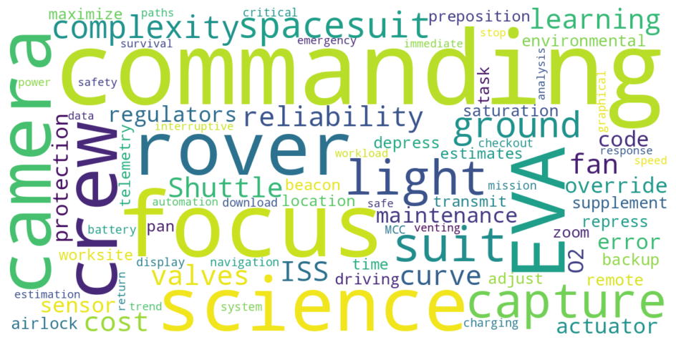
Figure 6: Word Cloud of Dominant Themes
High visibility of words like camera, focus, light, capture, and science underscores broad support for ground-enabled commanding that enhances science return and situational awareness without directly interfering with crew safety. In contrast, terms including safety, survival, emergency, and mission critical emphasize clear boundaries where control should remain with the crewmember, particularly for life-critical suit functions. The presence of complexity, reliability, cost, and learning curve reflects concerns about over-engineering and lessons learned from ISS versus Shuttle commanding architectures. Finally, words such as analysis, workload, estimates, and return paths indicate interest in automating cognitive and planning tasks to reduce crew burden while preserving human-in-the-loop control for time-critical and safety-sensitive actions. This visualization complements the thematic analysis by showing which concepts were most salient across participants
The visual framework chart in Figure 7 maps these dominant themes against crew workload reduction potential and reliability concerns. This chart helps illustrate where different ideas fall:
- Ground commanding of life support functions sits in the high-workload reduction but high-reliability concern quadrant, showing both its potential and its risks.
- Rover commanding & navigation support also offers high workload reduction but with moderate reliability concerns, making it a strong candidate for selective automation.
- Camera & lighting control is relatively low-risk and slightly more than moderately helpful, a clear “quick win.”
- Airlock operations depress/repress environmental commanding and automation of predictive support cluster slightly in the middle, balancing workload savings with
manageable reliability issues.
- Maintenance tasks such as battery charging, suit checkouts fall in the low-risk, high impact for workload reduction quadrant, making it a clear must-have.
- Scope limitations (non-critical tasks only) fall in the low-impact, low-risk quadrant, reinforcing the idea of keeping mission-critical actions manual.

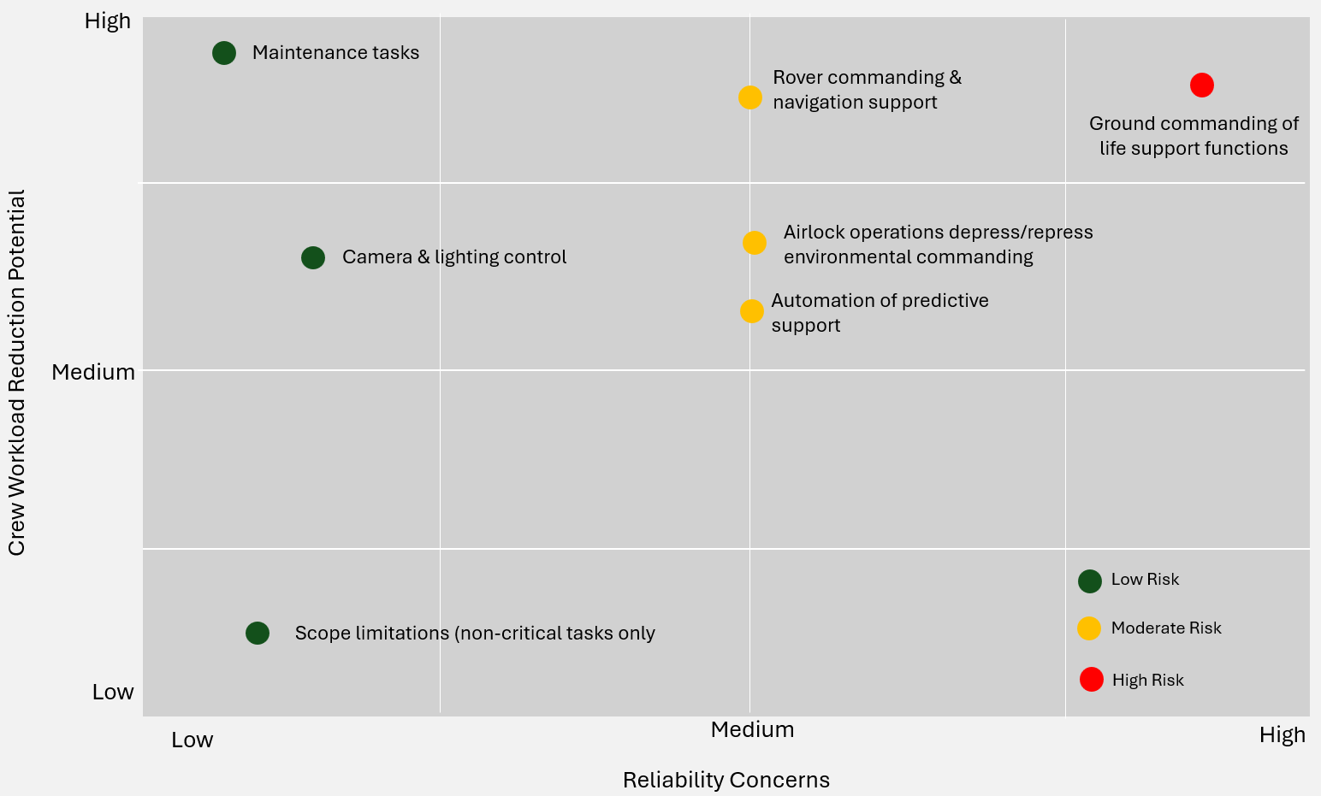Figure 7: EVA Remote Commanding Themes: Workload vs. Reliability
Overall, the chart visually clarifies trade-offs, highlighting which capabilities are best suited for early adoption versus those requiring deeper evaluation.
The Prioritized Telemetry Display Design Matrix in Table 6 organizes all user feedback into six key themes and ranks them by impact and feasibility to guide design decisions. It identifies actionable opportunities for improving telemetry displays based on real user limitations. High-impact, high-feasibility items like Intuitive Navigation & Labeling and Visual Design & Readability are classified as Quick Wins, offering immediate usability improvements through distinct, intuitive labels, website-style navigation, and standardized visual conventions. Medium-feasibility but high-impact themes such as Graphical System Representation, Interactive Features, and Data Access & Plot Control are labeled Strategic Priorities, requiring more development effort but delivering significant gains in situational awareness and user control. Finally, Design Literacy & Team Awareness is categorized as a Long-Term Investment, addressing cultural and educational gaps that affect design feedback and collaboration. This matrix helps prioritize enhancements that balance user needs, technical effort, and mission-critical value.
Theme / User Need | Impact | Feasibility | Priority Level | Notes
Intuitive Navigation & Labeling | High | High | Quick Win | Clear labeling and website-like navigation are straightforward to implement and immediately improve usability.
Graphical System Representation | High | Medium | Strategic Priority | Strong impact on situational awareness but requires design and system integration work (parameter mapping, schematics).
Visual Design & Readability | Medium | High | Quick Win | Dark backgrounds, light fonts, and standardized colors are easy to apply and improve readability quickly.
Interactive Features | Medium | Medium | Strategic Priority | Touchscreens expand/collapse and annotation add flexibility but require hardware/software updates.
Data Access & Plot Control | High | Medium | Strategic Priority | Historical plots and adjustable time scales are critical for analysis but need backend support.
Design Literacy & Team Awareness | Medium | Low | Long-Term Investment | Training and design literacy have lasting value but require cultural change and ongoing effort.
Table 6: Prioritized Telemetry Display Design Matrix
- Discussion
The findings from this study underscore the critical role of human factors and user-centered design in shaping next-generation telemetry and commanding displays for Artemis EVA operations. Across user feedback and comparative industry analysis, a consistent theme emerges; displays must evolve from static repositories of data into dynamic cognitive tools that actively support situational awareness, reduce workload, and enhance decision-making under time pressure. User responses highlight the strengths of current ISS EVA displays, particularly their ability to consolidate consumables and system status into one-page layouts, employ color coding for anomaly detection, and allow customization through resizing and filtering. These features provide clarity and flexibility, enabling controllers to tailor workflows and respond quickly in emergencies. However, limitations in navigation, readability, and data correlation reveal that the legacy system is not well-suited to the expanded telemetry demands of Artemis missions. The cluttered, text-heavy layouts and unintuitive pathways increase training burdens and hinder situational awareness, pointing to the need for a more intuitive, visually coherent design.
The discussion also emphasizes the importance of visual hierarchy and representation. Users consistently requested schematic overlays, graphical system views, and dynamic layouts that minimize clutter while maintaining clarity. These preferences align with human factors research across aviation, healthcare, and nuclear power, which stresses that effective display design must reduce cognitive load and leverage perceptual efficiency. Synoptic displays, widely used in aviation, offer a promising model for Artemis by presenting telemetry data directly on subsystem schematics, enabling at-a-glance comprehension of complex systems.
Another recurring theme is data integration and accessibility. Current ISS displays separate numeric telemetry from plots and lack historic data, limiting contextual understanding. Users envision Artemis EVA displays that unify numeric and graphical data, incorporate historic trends, and link telemetry directly to anomaly reports and schematics. Such integration would not only improve situational awareness but also enable predictive analytics, allowing controllers to anticipate consumable depletion and system performance issues before they become critical. This reflects a broader shift toward displays that are not merely reactive but proactive, providing decision support through contextual filtering and trend analysis.
The role of automation and remote commanding is particularly nuanced. While users see clear benefits in reducing crew workload through ground control of life support functions, airlock operations, rover navigation, and camera systems, they caution against over-engineering and emphasize that mission-critical or immediate-response actions must remain manual. This balance between efficiency and reliability reflects lessons learned from ISS, where complex error-protection logic sometimes reduced reliability. Selective automation focused on predictive support tasks such as workload estimation, crew speed tracking, and safe return path identification, emerges as a promising avenue that enhances EVA effectiveness without undermining crew autonomy or safety.
Finally, the feedback highlights user-friendliness as a multidimensional goal. Intuitive navigation, graphical system representation, consistent visual design, interactive features, and flexible data access are all seen as essential for reducing training burdens and improving usability. Importantly, users also identified a need for increased design literacy among teams, suggesting that successful implementation will require not only technical redesign but also cultural investment in visualization principles and user-centered practices. These insights suggest that Artemis EVA telemetry displays must be designed as integrated, adaptive, and user-centered systems. Short-term improvements should focus on usability fixes like navigation, labeling, visual clarity, while long-term investments should prioritize scalability, predictive analytics, and subsystem integration. By aligning technical features with human factors principles and user-identified priorities, the new displays can evolve into mission-critical tools that enhance safety, efficiency, and situational awareness, ensuring that controllers are equipped to manage the unprecedented complexity of lunar surface operations. Table 6 provides a summary of the display design requirements and aligns each requirement with its rationale and implementation strategy. This list of requirements specifications will help guide the development of the Artemis EVA telemetry displays.
Requirement | Rationale | Implementation Strategy
Layered information hierarchy | Reduces cognitive overload by showing only task-relevant data in time-critical contexts | Create EVA-specific displays with drill-down access; filter out “nice-to-know” data dynamically
Synoptic schematics | Provides at-a-glance comprehension of complex subsystems | Overlay telemetry values directly on suit/airlock/rover diagrams; highlight sensors visually
Minimal clutter & Gestalt grouping | Improves perceptual efficiency and guides user attention | Apply grouping, contrast, and proximity principles; limit redundant data on primary views
Contextual filtering | Prevents distraction from irrelevant telemetry | Dynamically adjust displayed parameters based on EVA phase or operational context
Consistent visual conventions | Enhances readability and reduces training burden | Use dark backgrounds with light fonts; standardized color coding for nominal/off-nominal states
Multi-modal alerts | Ensures anomalies are noticed under stress | Combine color, font changes, sound cues, and pop-ups; configurable thresholds for escalation
Typography standards | Reduces fatigue and misinterpretation | Standardize font weights, spacing, and alignment across all displays
Graphical overlays | Improves clarity compared to text-heavy layouts | Integrate icons, schematics, and trend plots directly into telemetry panels
Intuitive navigation pathways | Minimizes training requirements and speeds access | Website-like or different navigation structures; clear labeling; consistent pathways across subsystems
Interactive controls | Empowers users to explore and annotate data | Touchscreen expand/collapse, hover/click data tips, annotation features
Customizable views with standardized critical panels | Balances personalization with mission consistency | Allow resizing/filtering for secondary data; lock standardized layouts for critical telemetry
Quick toggles between EVA activity displays | Reduces time spent switching contexts | Enable one-click transitions between “Execute EVA,” “Battery Maintenance,” and other activity views
Unified telemetry views | Improves contextual understanding | Combine numeric values and plots in single panels; integrate anomaly links
Historic data inclusion | Supports trend analysis and predictive monitoring | Provide easy access to past EVA telemetry; overlay historic trends on current plots
Predictive overlays | Anticipates consumable depletion and workload issues | Implement trend projections for consumables, crew speed, and workload estimates
Cross-system integration | Provides holistic situational awareness | Consolidate telemetry from suits, airlocks, rovers, and habitats into integrated dashboards
Selective automation | Reduces workload while preserving safety | Automate non-critical tasks (lighting, cameras, rover navigation); keep mission-critical actions manual
Decision support integration | Reduces reliance on memory and flight rules | Embed flight rules and anomaly reports directly into displays
Transparency & override capability | Builds trust in automation | Ensure all automated actions are visible, explainable, and easily overridden
Modular layouts | Future-proofs displays for added sensors and computations | Design expandable panels with adaptive scaling
Design literacy support | Improves collaboration and feedback quality | Provide training on visualization principles and cognitive psychology
Standards compliance | Ensures consistency across Artemis systems | Align with NASA Moon to Mars GUI Standards for layout, colors, and schematics
Table 7: Display Design Requirements Specification
Figure 8 maps these requirements into an Artemis EVA Telemetry Displays Development Roadmap. This roadmap visually organizes the requirements into three distinct phases:
- Short-term (Immediate Usability Fixes): clarity, alerts, navigation, typography, quick toggles.
- Mid-term (Enhancements & Integration): overlays, interactivity, unified telemetry, historic data, cross-system integration.
- Long-term (Strategic Innovation): predictive overlays, selective automation, modular layouts, design literacy, standards compliance.
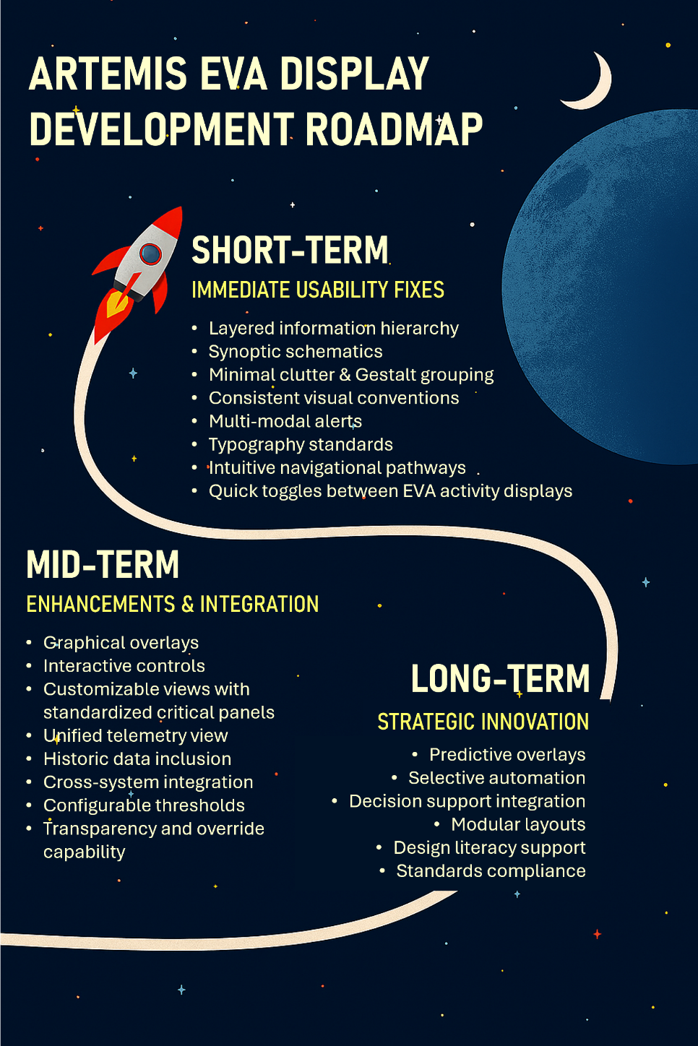
Figure 8: Requirements Mapped to Roadmap

- Conclusion
NASA’s Artemis EVA Flight Operations team requires a new, intuitive, and user-friendly telemetry and commanding display system to support astronauts during lunar surface activities. The research draws on human factors and interface design standards from industries like aviation, nuclear energy, and healthcare, while also incorporating direct feedback from ISS EVA flight controllers, instructors, and engineers. This feedback highlights both the strengths and limitations of current ISS EVA displays and informs requirements for Artemis EVA displays. The goal is to reduce cognitive overload, improve user experience, and strengthen situational awareness and decision-making, ultimately providing a foundation for next-generation displays that will support upcoming Moon and Mars missions.
Taken together, these insights provide a roadmap for developing Artemis EVA telemetry displays that are not merely data monitors but cognitive tools, systems that actively support flight controllers in managing complexity, detecting anomalies, and making rapid, confident decisions during lunar surface operations. By aligning technical features with human-centered design, predictive analytics, and selective automation, the Artemis Extra-Vehicular Activity Operations team can ensure that its displays evolve into mission-critical assets that safeguard astronaut safety, enhance operational efficiency, and enable the success of NASA’s Moon to Mars exploration strategy.
References
[1] NASA, NASA’s Lunar Exploration Program Overview.
https://www.nasa.gov/wp-content/uploads/2020/12/artemis_plan-20200921.pdf, 2020 (accessed 13 October 2025).

[2] Nujoud Merancy, Julie A Grantier, George Nelson, Shatel Bhakta, Paul D Kessler, Patrick R Chai, James J Hill, Tiffany M Nickens, Sally A Cahill, Jacob E Bleacher, Audrey Morris-Eckart, Alexus Cottonham, Nathanael McIntyre, Greg Mercer, Danny Baird, Moon-to-Mars architecture definition document, https://ntrs.nasa.gov/api/citations/20230002706/downloads/M2MADD_ESDMD-001%28TP-20230002706%29.pdf (ntrs.nasa.gov), 2023 (accessed 13 October 2025).

[3] M. Flores-Daley, B. Jones, (2022, July 10-15). NASA advanced space suit Xemu development report--environmental protection garment. 51st International Conference on Environmental Systems, St. Paul, Minnesota. https://ntrs.nasa.gov/api/citations/20210023541/downloads/NASA%20Advanced%20Space%20Suit%20xEMU%20Development%20Report%20-%20Components.docx.

[4] Christie Bertels, Gary Dittemore, (2011, Sept. 27-29). The final countdown: A review of three decades of flight controller training methods for space shuttle mission operations. AIAA SPACE 2011 Conference and Exposition, Long Beach, CA.
https://ntrs.nasa.gov/citations/20110014997

[5] Yvonne Barnard, Human factors in the display and use of aeronautic information from different sources and of different status, in D. De Waard, J. Godthelp, & F. L. Kooi (Eds.), Human factors, security and safety, Shaker Publishing, Netherlands, 2009, pp. 143-158.

[6] J. Thompson, Human factors in data visualization, in NATO SAS-124 Research and Technology Group (RTG) Visualization design for communicating defense investment uncertainty and risk, Institute of Defense Analysis, Virginia, 2023, pp. 3-23.

[7] T. Flick, Best practices for dashboard UI/UX to enhance user experience, https://www.researchgate.net/publication/391574128_Best_Practices_for_Dashboard_UIUX_to_Enhance_User_Experience, 2025 (accessed 18 October 2025).

[8] Z. Zeng, Y. Sun, X. Liu, Y. Jie, Y. Zeng, Visual cognition-based optimised design of primary flight displays in cockpits, The Aeronautical Journal. 129 (2024), pp 1-18. https://doi.org/10.1017/aer.2024.103

[9] IAEA, Human factors engineering in the design of nuclear power plants (IAEA Safety Standards Series No. SSG-61). Vienna, 2019.

[10] S. Yan, X. Liu, X. Zhang, A predictive method for operator workload in nuclear power plant main control rooms considering performance-shaping factors. Cogn Tech Work 27 (2025). https://doi.org/10.1007/s10111-025-00843-4
[11] Stephanie Morrow, Niav Hughes Green, Translating human factors research to regulatory guidance in the nuclear industry in Proceedings of the 69th Human Factors and Ergonomics Society Annual Meeting, Sage, LA, Sage Publications, 2025 pp. 1-5. https://www.nrc.gov/docs/ML2521/ML25213A059.pdf

[12] Racquel Fygenson, Lace Padilla, Enrico Bertini, Cognitive affordances in visualization: Related constructs, design factors, and framework, IEEE Transactions on Visualization and Computer Graphics. 31 (2025) pp. 10624-10639. Doi: https://doi.org/10.1109/TVCG.2025.3610803

[13] Jacques V. Hugo, Shawn St. Germain, Human factors principles in information dashboard design, Proceedings of the 10th International Topical Meeting on Nuclear Plant Instrumentation, Control and Human-Machine Interface Technologies. 2 (2017) pp. 1315-1328.
https://www.osti.gov/servlets/purl/1358407

[14] Jenna Korentsides, Zander N. Miller, Elizabeth H. Lazzara, Rosemarie Fernandez, Joseph R. Keebler, 2025. The perils of modern telemetry: A human factors perspective.
Human Factors in Healthcare. 7, 100102. https://doi.org/10.1016/j.hfh.2025.100102

[15] Jeffrey HH. Chen, Jonathan S. Litt, Exploring synoptic display concepts for hybrid-electric airliner flightdecks https://ntrs.nasa.gov/api/citations/20230015020/downloads/TM-20230015020.pdf, 2023 (accessed 17 October 2025)

[16] Zoe M. Pruitt, Jessica L. Howe, Lucy S. Bocknek, Arianna P. Milicia, Patricia A. Spaar, Seth Krevat, Raj M. Ratwani, Informing visual display design of electronic health records: A human factors cross-industry perspective, Patient Safety. 5(2023) 32–39. https://doi.org/10.33940/001c.77769

[17] NASA Moon to Mars GUI Standards (2024), NASA. (NASA internal)

[18] Alex Chaparro, Andrew Miranda, Jefferson Grubb, Aviation displays: Design for automation and new display formats, Human Factors in Aviation and Aerospace. 3(2023) 341–371.
https://doi.org/10.1016/B978-0-12-420139-2.00014-9

[19] Michael Freed, Pete Bonasso, Michel Ingham, David Kortenkamp, Barney Pell, John Penix, (2005, Jan 30 – Feb 1). Trusted autonomy for spaceflight systems. AIAA 1st Space Exploration Conferenc: Continuing the Voyage of Discvery, Orlando, FL.
https://doi.org/10.2514/6.2005-2521

[20] Troy A. Heindel, Arthur N. Rasmussen, Robert Z. McFarland, Advanced automation in Space Shuttle Mission Control. NASA Conference Publication 3103. 1 (1991) 236-243 https://ntrs.nasa.gov/api/citations/19910011357/downloads/19910011357.pdf

[21] Shota Iino, Hideki Nomoto, Takashi Fukui, Sayaka Ishizawa, Miki Sasaki, Yohei Yagisawa, Takayuki Hirose, Yasutaka Michiura, Hiroharu Shibayama, Systemic symptom detection in telemetry of ISS with explainability using FRAM and SpecTRM, Proceedings of the Asia Pacific Conference of the Prognostics and Health Management Society. 4 (2023). https://doi.org/10.36001/phmap.2023.v4i1.3731

[22] Ashely Carlton, Rachel Morgan, Whitney Lohmeyer, Kerri Cahoy, Telemetry fault-detection algorithms: Applications for spacecraft monitoring and space environment sensing, Journal of Aerospace Information Systems, 15(2018), 307–320. https://doi.org/10.2514/1.I010587

[23] Timothy J. Etherington, Lynda J. Kramer, Lisa R. Le Vie, Mary C. Last, Kellie D. Kennedy, Randall E. Bailey, Vincent Houston, Impact of advanced synoptics and simplified checklists during aircraft systems failures, IEEE/AIAA 37th Digital Avionics Systems Conference (DASC). (2018) 1-9.
https://doi.org/10.1109/DASC.2018.8569559

[24] Sig Mejdal, Michael E. McCauley, Dennis B. Beringer, (2001). Human factors design guidelines for multifunction displays, Office of Aerospace Medicine, Washington D.C., 2001 (accessed 17 October 2025).
https://apps.dtic.mil/sti/tr/pdf/ADA399354.pdf

[25] Richard Harte, Liam Glynn, Alejandro Rodríguez-Molinero, Paul MA Baker, Thomas Scharf, Leo R Quinlan, Gearóid ÓLaighin, 2017. A human-centered design methodology to enhance the usability, human factors, and user experience of connected health systems. JMIR Human Factors, 4(1), e5543
https://doi.org/10.2196/humanfactors.5443

[26] Asbjorn Folstad, Users’ design feedback in usability evaluation: A literature review, Human-Centric Computing and Information Sciences, 7(2017) 1–17. https://doi.org/10.1186/s13673-017-0100-y

[27] Jessie Rouder, Olivia Saucier, Rachel Kinder, and Matt Jans. 2021. What to Do With All Those Open-Ended Responses? Data Visualization Techniques for Survey Researchers, Survey Practice, https://doi.org/10.29115/SP-2021-0008, 2021 (accessed 18 October 2025).

[28] Virginia Braun, Victoria Clarke, Using Thematic Analysis in Psychology, Qualitative Research in Psychology. 3 (2006) 77-101.
https://doi.org/10.1191/1478088706qp063oa

[29] Ruxandra Stanomir, Optimizing Business Analytics: The Role of Gestalt Principles in Dashboard Design, Proceedings of the International Conference on Business Excellence, Bucharest University of Economic Studies.
DOI: 10.24818/BASWP.2025.1. https://www.fabiz.ase.ro/wp-content/uploads/2025/07/12-STANOMIR.pdf. 2025 (accessed 7 November 2025)

[30] CJ Eubanks Flemig, Qualitative methods for the quantitatively inclined. Center for Engaged Learning.
https://www.centerforengagedlearning.org/qualitative-methods-for-the-quantitatively-inclined/, 2023 (accessed 7 November 2025)

