ARTEMIS III SITE SELECTION UPDATE: DOWNSELECTION FROM THIRTEEN TO NINE CANDIDATE REGIONS. T. George¹ , M. A. Rubio^{1,2}, S.J. Lawrence¹, and P. Curell¹. ¹National Aeronautics and Space Administration (NASA), ²Booz Allen Hamilton.

Introduction: In 2022 the National Aeronautics and Space Administration (NASA) publicly announced the 13 candidate Artemis III regions. These locations, near the Moon’s south pole, will host the Agency’s first crewed mission back to the lunar surface in over 50 years [1]. Since then, the Artemis III site-selection effort has continued to mature through additional analysis and refinement of constraints. In October 2024 at the Lunar Exploration Analysis Group (LEAG) meeting at Johnson Space Center, NASA announced an updated set of nine candidate Artemis III landing regions which have been refined from the original 13 [2]. This abstract provides an update to the initial 2022 announcement , documenting the status of the effort. to refine the candidate list and summarizing key considerations which informed the selection.
Updated Candidate Regions: Shown in Image 1 is the updated set of Artemis III candidate landing regions – Peak near Cabeus B, Haworth, Malapert Massif, Mons Mouton Plateau, Mons Mouton, Nobile Rim 1, Nobile Rim 2, de Gerlache Rim 2, and Slater Plain. They represent the outcome of more than two years of continued assessment since the original announcement in 2022. Each region includes multiple landing sites and provides flexibility for further site-specific evaluation.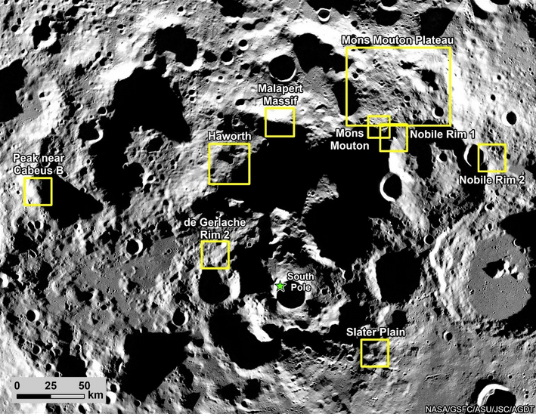
Image 1 The 9 candidate landing regions. Credit: NASA
Analysis Process: During this period, Artemis III mission assumptions evolved, including updates to vehicle performance and trajectory analyses based on the SpaceX human Landing System (HLS) design. Mission-level assessments increasingly emphasized end-to-end mission availability, capturing the combined effects of launch opportunities, transit and rendezvous geometry, communication constraints, landing performance, surface illumination, and terrain safety. These constraints are evaluated simultaneously on a calendar basis, reflecting the operational realties of a crewed lunar mission.
Artemis III in-space operations will be conducted from a Near-Rectilinear Halo Orbit (NRHO), which provides favorable Earth visibility and access to the south pole region but imposes strong temporal and geometric constraints on surface access. Surface stay duration varies approximately 5.75 to 6.25 days depending on mission epoch plus low lunar orbit rev considerations, resulting in time-dependent accessibility that differs by region. As analyses matured, regions demonstrating greater robustness across mission epochs and reduced sensitivity to seasonal effects were favored.
Terrain safety remains a primary consideration, with assessments focused on minimizing the degree of slope variability within a landing ellipse, consistent with various aspects of the integrated architecture. Regions that maintain sufficient low-slope area to accommodate a safe landing were prioritized. In parallel, candidate regions were evaluated for the presence and distribution of hazardous surface features, including impact craters, block populations, and rough or highly variable terrain that could pose risk during descent, landing or early surface operations. Regions offering greater flexibility to mitigate these hazards through site placement were favored during the process
Communication and illumination considerations further differentiate candidate regions. If Artemis III employs a Direct-to-Earth (DTE) communication architecture, regions with greater Earth visibility are preferred. Solar illumination remains a critical requirement for the entire crewed surface stay, with south polar illumination conditions exhibiting strong seasonal variability and shifting approximately 2-3 weeks per year. Regions demonstrating robust illumination across mission windows and reduced sensitivity to timing uncertainties in the context of the integrated architecture are favored.
End-to-end mission availability analyses demonstrate that individual regions typically provide limited viable opportunities when all constraints are simultaneously satisfied. To support acceptable annual mission availability and increase flexibility in launch timing, more than one landing regions must be maintained for Artemis III specifically. This consideration was a key factor in refining the candidate set.
The resulting down selection from thirteen to 9 regions reflects prioritization under current Artemis III constraints and does not imply that removed regions are unsuitable for future exploration. Rather, the 9 regions represent those that continue to balance operational feasibility, terrain safety, and science potential most effectively for the architecture envisioned for the first crewed mission.
Implications for Artemis III and Future Missions: The nine candidate regions identified in this update are specific to Artemis III and its emphases on crew safety and risk mitigation. This refinement does not affect site selection for Artemis IV and later missions, which are expected to expand access to broader portions of the south polar region. This update reflects the continued evolution of Artemis III site-selection efforts and provides a focused foundation for ongoing site-specific assessment, hazard mitigation planning, and mission preparation in advance of the Artemis III crewed lunar landing.
References: [1] Weber, R., Cohen, B. A., Lawrence, S. J., (chairs) (2020) A Bold New Era of Scientific Discovery: Report of the Artemis III Science Definition Team. [2] NASA (2024) NASA Provides Update on Artemis III Moon Landing Regions, NASA News Release, Oct. 28.

