
Global Biogeochemical Cycles

Supporting Information for

Global Model Estimates of Atmospheric Al, Ca, Fe, Si, and Ti from Dust and Non-Dust Aerosols Informed by EMIT Surface Mineralogy and Evaluated Against Observations

Natalie M. Mahowald^{1*}, Longlei Li¹, María Gonçalves Ageitos^{2,3}, Ronald L. Miller⁴, Carlos Pérez García-Pando^{2,5}, Paul Ginoux⁶, Vincenzo Obiso², Philip G. Brodrick⁷, Roger N. Clark⁸, Karine Desboeufs⁹, Robert O. Green⁷, Gregory Okin¹⁰, David R. Thompson⁷, Sagar Rathod¹¹, Esteban Gazel¹, Adrian Hornby¹, Emile Journet¹², Maria Grazia Alaimo¹³, Célia Alves¹⁴, Andres Alastuey¹⁵, Paulo Artaxo¹⁶, Alex R. Baker¹⁷, Francisco Barraza¹⁸, Silvia Becagli¹⁹, Clifton S. Buck²⁰, Giulia Calzolai²¹, Shankararaman Chellam²², Ying Chen²³, Patrick Y. Chuang²⁴, David D. Cohen²⁵, Cristina Colombi²⁶, Evangelia Diapouli²⁷, Gaetano Dongarra¹³, Konstantinos Eleftheriadis²⁷, Johann P. Engelbrecht²⁸, Corinne Galy-Lacaux²⁹, Cassandra Gaston³⁰, Dario Gomez³¹, Yenny González Ramos^{32,33}, Jenny Hand ³⁴, Roy M. Harrison³⁵, Barak Herut^{36,37}, Philip K. Hopke^{38,39}, Zsofia Kertesz⁴⁰, Katriina Kyllönen⁴¹, Fabrice Lambert^{42,43}, Willam M. Landing 44, Remi Losno⁴⁵, Franco Lucarelli^{21,46}, Willy Maenhaut⁴⁷, Christopher Marsay⁴⁸, Hitoshi Matsui ^{49,50}, Randall V. Martin⁵¹, Yasser Morera-Gómez⁵², Adina Paytan⁵³, Joseph Prospero³⁰, Sergio Rodríguez^{54,32}, Geraldine Sarthou⁵⁵, Rachel Shelley¹⁷, Ronald L. Siefert⁵⁶, Patricia Smichowski³¹, Daniela Varrica¹³

¹ Department of Earth and Atmospheric Sciences, Cornell University, Ithaca, NY, United States
² Barcelona Supercomputing Center, Barcelona, Spain
³ Department of Project and Construction Engineering, Universitat Politècnica de Catalunya – BarcelonaTech, Terrassa, Spain
⁴ NASA Goddard Institute for Space Studies, New York, NY, United States
⁵ ICREA, Catalan Institution for Research and Advances Studies, Barcelona, Spain
⁶ NOAA/OAR Geophysical Fluid Dynamics Laboratory, Princeton, New Jersey, United States
⁷ Jet Propulsion Laboratory, California Institute of Technology, Pasadena, CA, United States
⁸ Planetary Science Institute, Tucson, AZ, United States
⁹Université Paris Cité and Univ. Paris Est Creteil, CNRS, LISA, 75013 Paris, France
¹⁰University of California Los Angeles, Los Angeles, CA, USA
¹¹La Follette School of Public Affairs, University of Wisconsin-Madison, Madison, WI, USA.
¹²Univ Paris Est Creteil and Université Paris Cité, CNRS, LISA, 94010 Créteil, France
¹³ Dip. Scienze della Terra e del Mare, University of Palermo, Italy
¹⁴ Centre for Environmental and Marine Studies (CESAM), Department of Environment, University of Aveiro, 3810-193, Aveiro, Portugal
¹⁵ Institute of Environmental Assessment and Water Research (IDAEA-CSIC), 08034, Barcelona, Spain
¹⁶ Instituto de Fisica,Universidade de Sao Paulo, 05508-090, Sao Paulo, SP, Brazil
¹⁷ School of Environmental Sciences, University of East Anglia, Norwich, UK
¹⁸ Saw Science, Invercargill, New Zealand
¹⁹ Department of Chemistry "Ugo Schiff", University of Florence, 50019 Sesto Fiorentino, Italy
²⁰ Skidaway Institute of Oceanography, University of Georgia, Savannah, GA, USA
²¹ National Institute for Nuclear Physics (INFN) - Florence division, Sesto Fiorentino (FI), Italy
²² Department of Civil & Environmental Engineering and Department of Chemical Engineering, Texas A&M University, College Station, TX 77843-3136, USA
²³ Dept. Environ. Sci. Engr. Fudan University Jiangwan Campus 2005 Songhu Road, Shanghai, China
²⁴ Earth & Planetary Sciences Department, University of California Santa Cruz, Santa Cruz, CA, 95064 , USA.
²⁵ Centre for Accelerator Science, Australian Nuclear Science and Technology Organisation, New Illawarra Rd, Lucas Heights, NSW, Australia
²⁶ Environmental Monitoring Sector, Arpa Lombardia, Via Rosellini 17, 20124 Milan, Italy
²⁷ Environmental Radioactivity & Aerosol Technology for Atmospheric & Climate impact Lab, INRaSTES, N.C.S.R. Demokritos, 15341 Ag. Paraskevi, Attiki, Greece
²⁸ Desert Research Institute (DRI), 2215 Raggio Parkway, Reno, Nevada 89512-1095
²⁹ Univ Toulouse, CNRS, IRD, LAERO, Toulouse, France
³⁰ Rosenstiel School of Marine, Atmospheric, and Earth Science, University of Miami, Miami, FL, 33149, US
³¹ Comision Nacional de Energia Atomica, Gerencia Química, Av. Gral Paz 1499, B1650KNA, San Martin, Buenos Aires, Argentina
³² Izaña Atmospheric Research Center (IARC), Agencia Estatal de Meteorología (AEMET), Santa Cruz de Tenerife, Spain
³³ Scientific Department, CIMEL, Paris, France.
³⁴ Cooperative Institute for Research in the Atmosphere, Colorado State University, Fort Collins, CO, USA
³⁵ School of Geography, Earth and Environmental Sciences, University of Birmingham, Edgbaston, Birmingham B15 2TT, United Kingdom
³⁶ Israel Oceanographic & Limnological Research, Tel Shikmona, Haifa, 31080, Israel
³⁷Faculty of Marine Sciences, Ruppin Academic Center, Michmoret, 4025000, Israel.‎
³⁸ Institute for a Sustainable Environment, Clarkson University, Potsdam, NY, USA,
³⁹ Departments of Public Health Sciences and Environmental Medicine, University of Rochester School of Medicine and Dentistry, Rochester, NY, USA,
⁴⁰ HUN-REN Institute for Nuclear Research (ATOMKI), Debrecen, Hungary
⁴¹ Finnish Meteorological Institute, Helsinki, Finland
⁴² Geography Institute, Pontificia Universidad Catolica de Chile, Santiago, 7820436, Chile
⁴³ Center for Climate and Resilience Research, Santiago, Chile
⁴⁴Department of Earth, Ocean, and Atmospheric Science, Florida State University, 1011 Academic Way, Tallahassee, FL 32306-4520
⁴⁵ Institut de Physique du Globe de Paris, Université Paris Cité, CNRS, Paris, France
⁴⁶ Physics and Astronomy Department, University of Florence, Sesto Fiorentino (FI), Italy
⁴⁷ Department of Chemistry, Ghent University, Gent, Belgium
⁴⁸ School of Marine Science and Policy, University of Delaware, Newark, DE, USA
⁴⁹ Graduate School of Environmental Studies, Nagoya University, Furo-cho Chikusa-ku, Nagoya, 464-8601, Japan
⁵⁰ Institute for Space–Earth Environmental Research, Nagoya University, Furo-cho Chikusa-ku, Nagoya, 464-8601, Japan.
⁵¹ Energy, Environmental and Chemical Engineering, Washington University, St. Louis, MO, USA.
⁵² Universidad de Navarra, Instituto de Biodiversidad y Medioambiente BIOMA, Irunlarrea 1, 31008, Pamplona, Spain
⁵³ Earth and Planetary Science, University of California, Santa Cruz, CA, USA
⁵⁴ Consejo Superior de Investigaciones Científicas, IPNA CSIC, Tenerife, Canary Islands, Spain.
⁵⁵ CNRS, Univ Brest, IRD, Ifremer, LEMAR, Plouzané, France
⁵⁶ Chemistry Department, United States Naval Academy, Annapolis, MD 21401
Corresponding author: Natalie Mahowald (mahowald@cornell.edu)

Contents of this file
Figures S1-S22
Tables S1-S10
Introduction
This file includes supplemental figures and tables referenced in the main text.

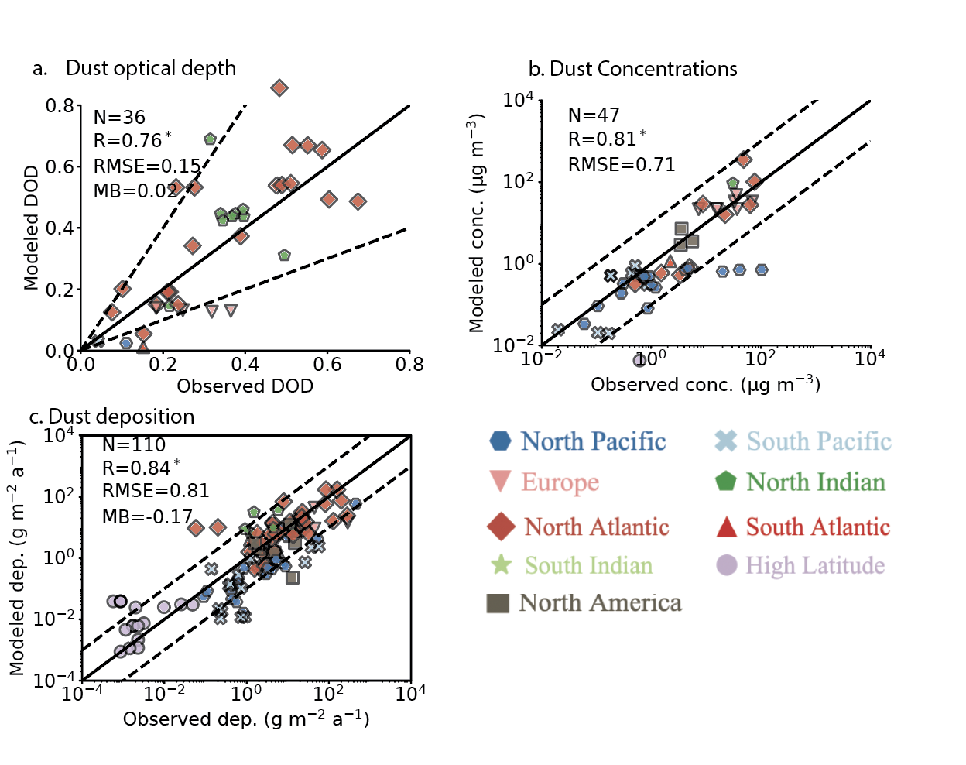

Figure S1: Scatterplot of model (y-axis) versus observations (x-axis) for dust related proxies, similar to Li et al., 2022 for ease of comparison for a. Dust optical depth, b. surface concentrations and c. dust deposition. The only difference between these model simulations and those in Li et al., 2022 is the inclusion of the EMIT composition map. The one-to-one line (solid), and uncertainties (dotted) are shown (from Li et al. 2022).

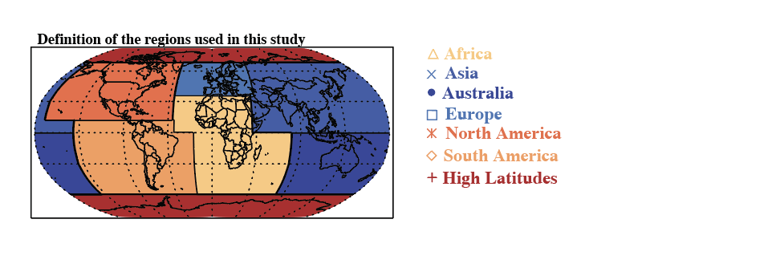

Figure S2: Definition of the different regions used in this study and the color and symbols associated with them.

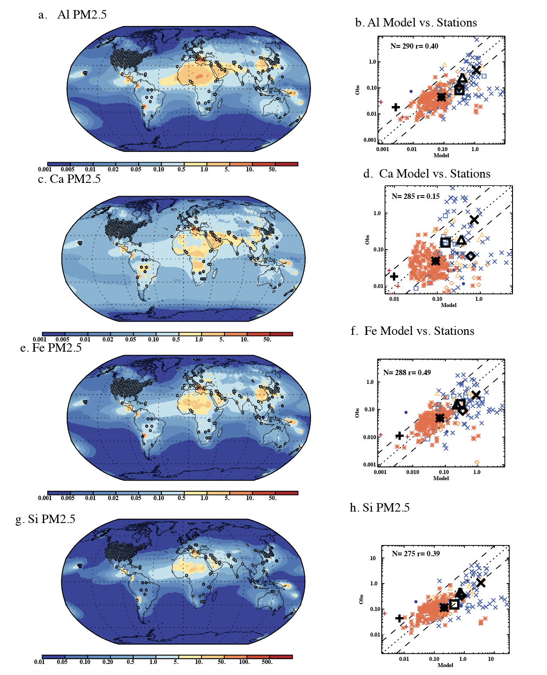
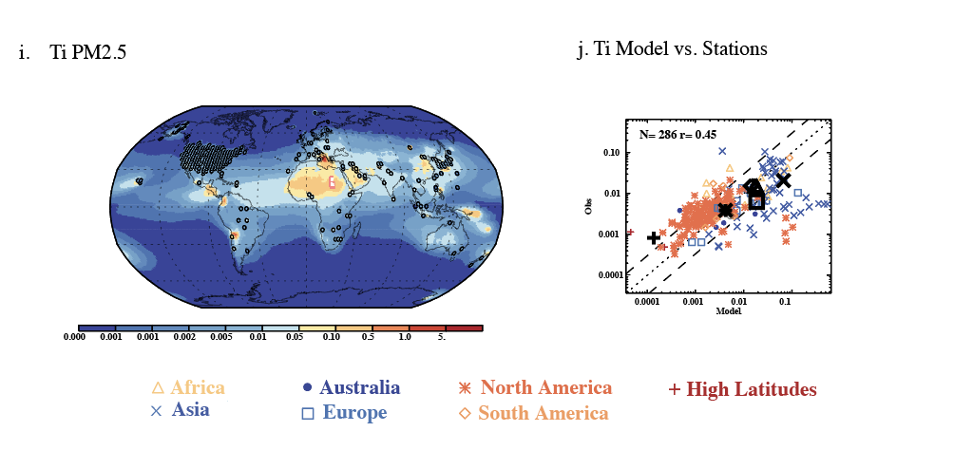
Figure S3: Elemental surface concentrations in the PM_{2.5} size fraction. Modeled values in µg/m³ are shown in the background in a. Al, c. Ca, e. Fe, g. Si and i. Ti while the circles represent the observational measurements from land-based station data using the same color bar. A comparison of the model (x-axis) to the observations (y-axis) is shown for the land-based station data (b. Al, d. Ca, f. Fe, h. Si, and j. Ti). Statistics for these figures are in Table S7.

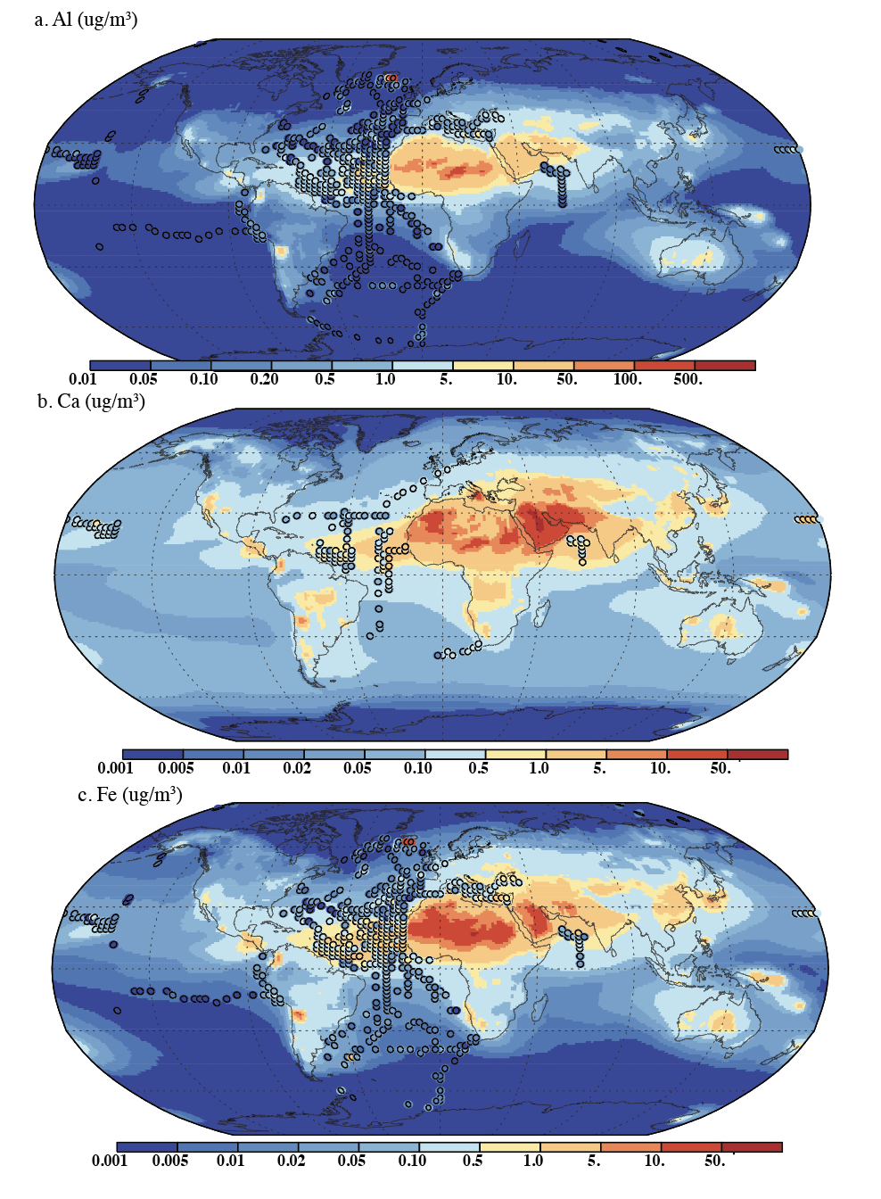
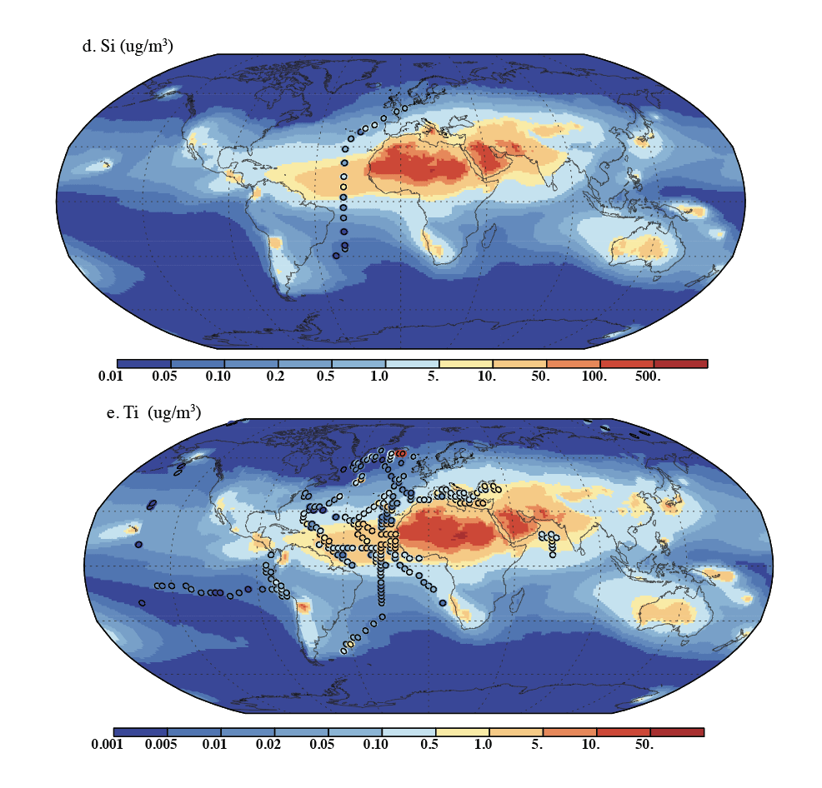Figure S4: Elemental surface concentrations in the PM₁₀ size fraction compared against cruise data. Modeled values in µg/m³ are shown in the background in a. Al, b. Ca, c. Fe, d. Si and . Ti while the circles represent the observational measurements from cruise data using the same ecolor bar. A scatter-plot comparison of the model (x-axis) to the observations (y-axis) is shown in the main paper in Figures 1,3, 5-7 for the different elements. Statistics for these figures are in Table S8.

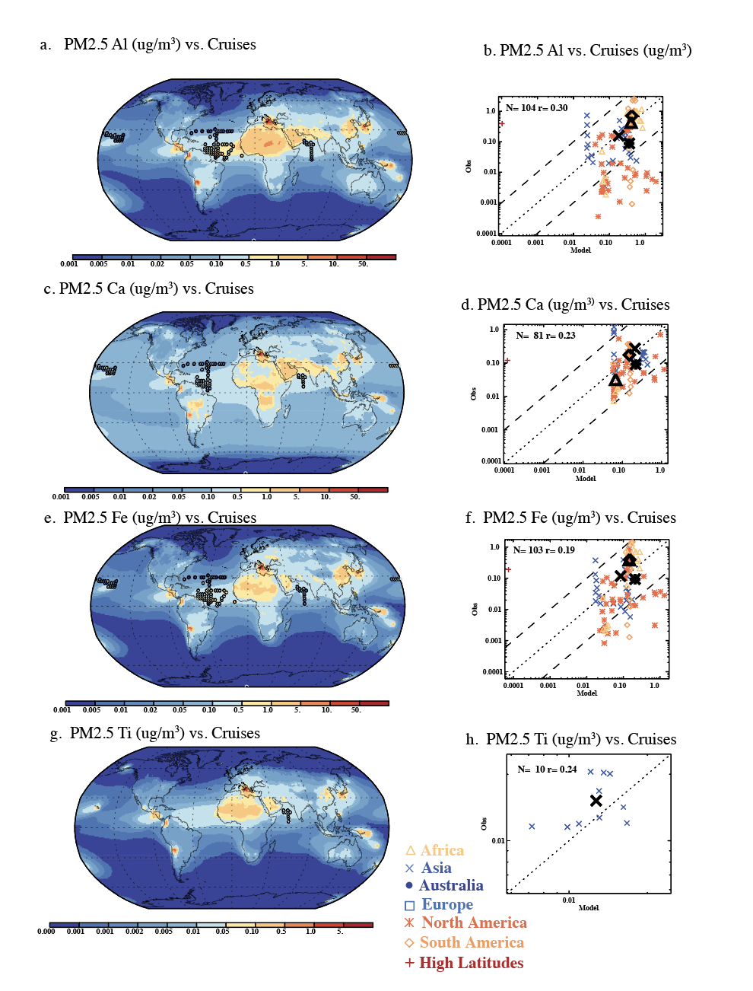
Figure S5: Elemental surface concentrations in the PM_{2.5} size fraction. Modeled values in µg/m³ are shown in the background in a. Al, c. Ca, e. Fe, and g. Ti (there is no Si data) while the circles represent the observational measurements from cruise data using the same color bar. A comparison of the model (x-axis) to the observations (y-axis) is shown for the cruise data (b. Al, d. Ca, f. Fe, and h. Ti). Statistics for these figures are in Table S9.

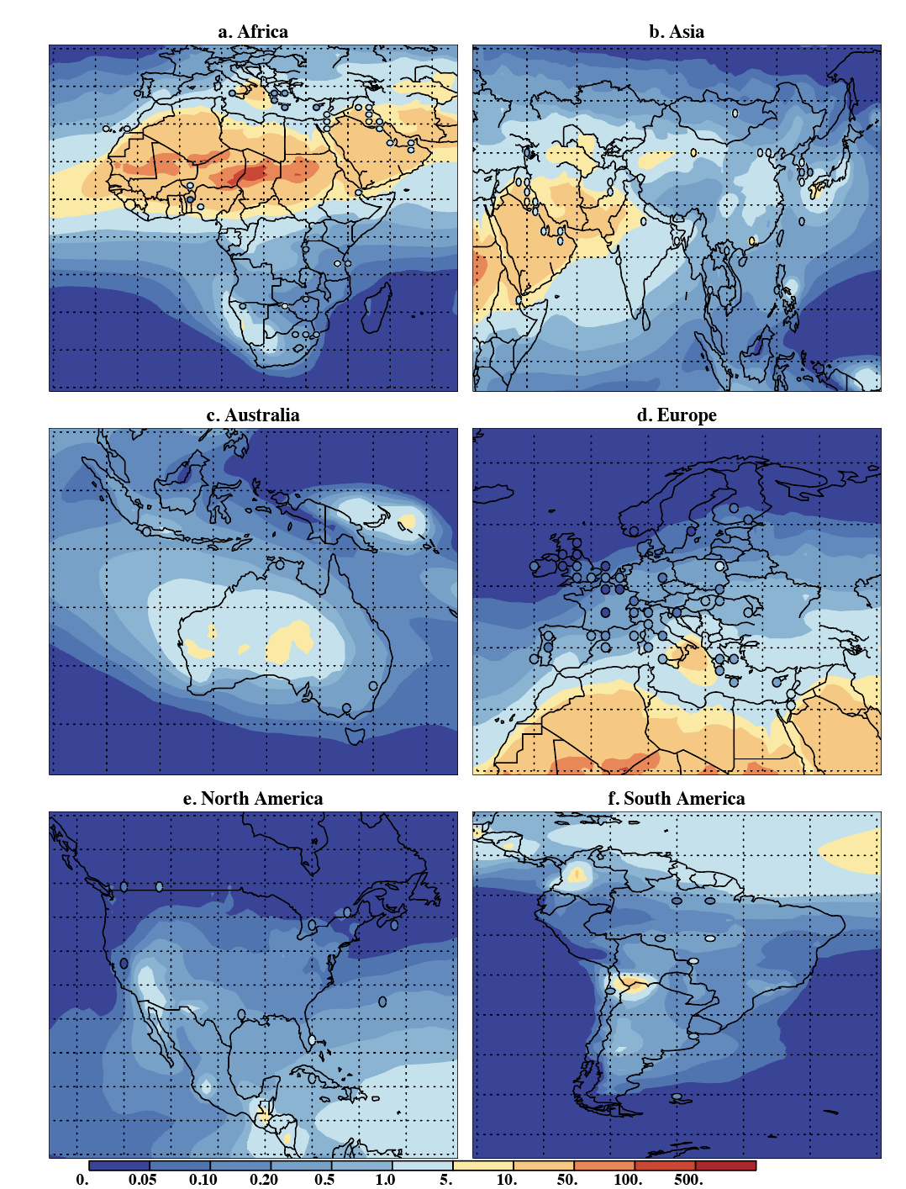
Figure S6: Modeled (background) and observed (circles) Al PM₁₀ annual mean concentrations in µg/m³ for a. Africa, b. Asia, c. Australia, d. Europe, e. N. America and f. S. America. These show the exact same information as in Figure 1a but in subregions.

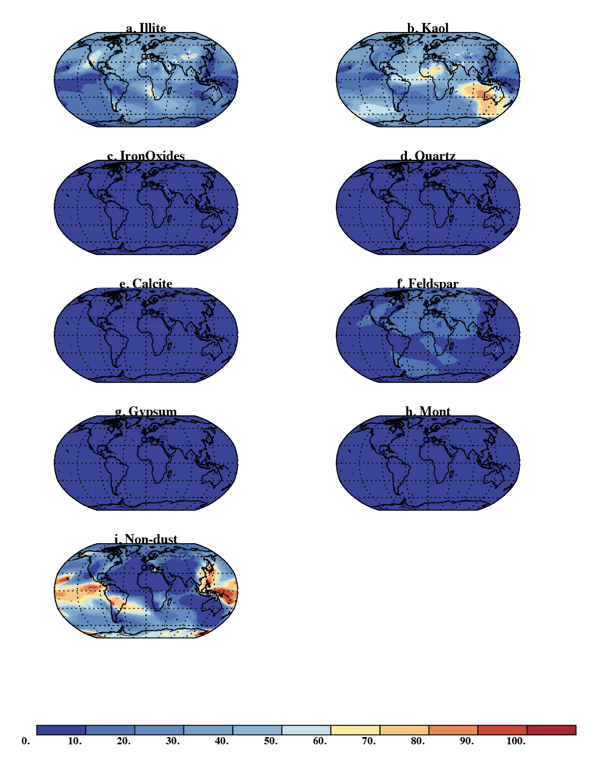
Figure S7: Percentage of deposition from each dust source or PM₁₀ Al for a. Illite, b. Kaolinite, c.Iron Oxides, d. Quartz, e. Calcite, f. Feldspar, g. Gypsum, h. Montmorlite, and i. Non-dust sources.
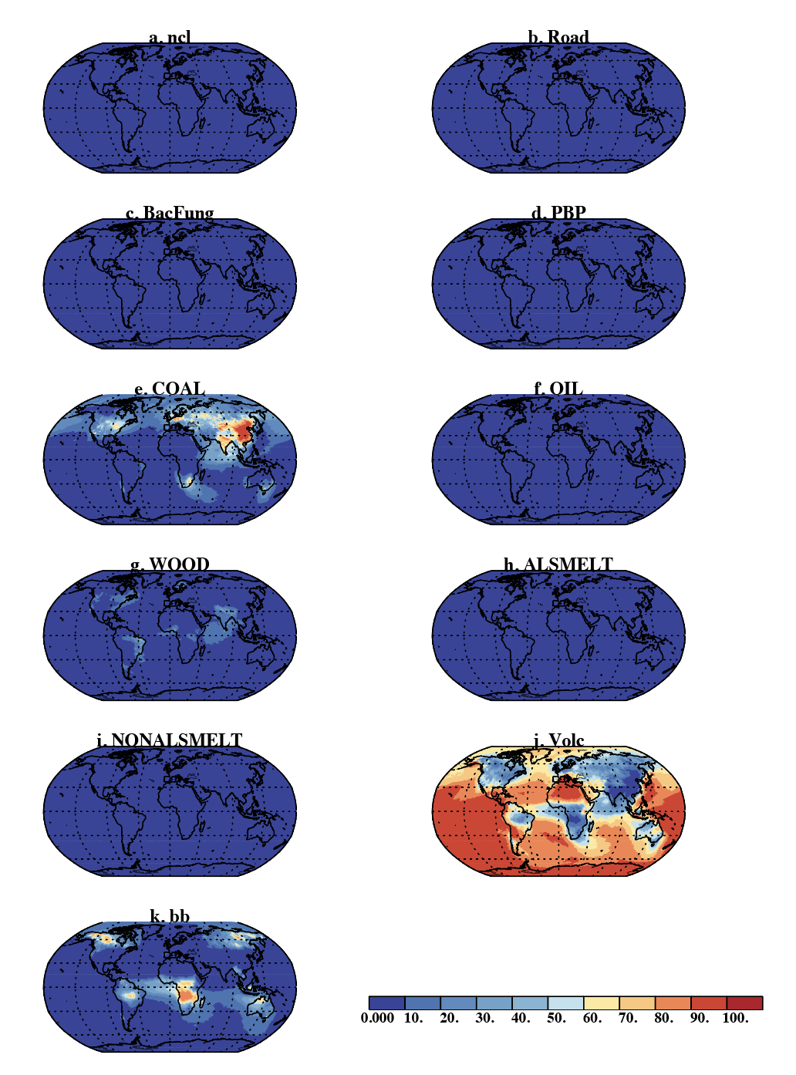
Figure S8: Percentage of the non-dust sources (not the total) for Al PM₁₀ deposition: a. Sea Salts (ncl), b. Road dust, c. bacteria and fungi (BacFung), d. other primary biogenic particles (PBP), e. Coal, f. Oil, g. Wood, h. Al Smelting, i. Non-Al Smelting, i. Volcano, k. Biomass Burning (bb).
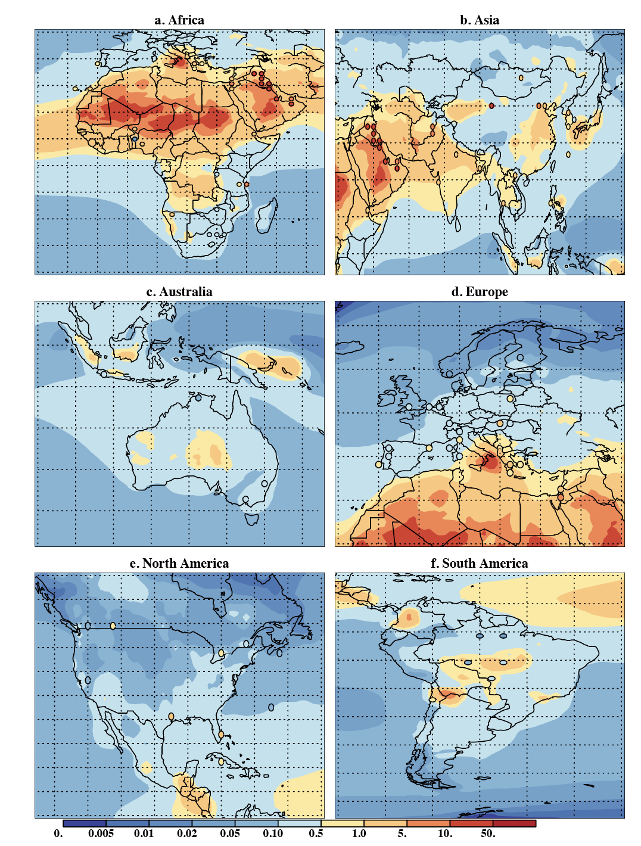

Figure S9: Modeled (background) and observed (circles) Ca PM₁₀ annual mean concentrations in µg/m³ for a. Africa, b. Asia, c. Australia, d. Europe, e. N. America and f. S. America. These show the exact same information as in Figure 3a but in subregions.

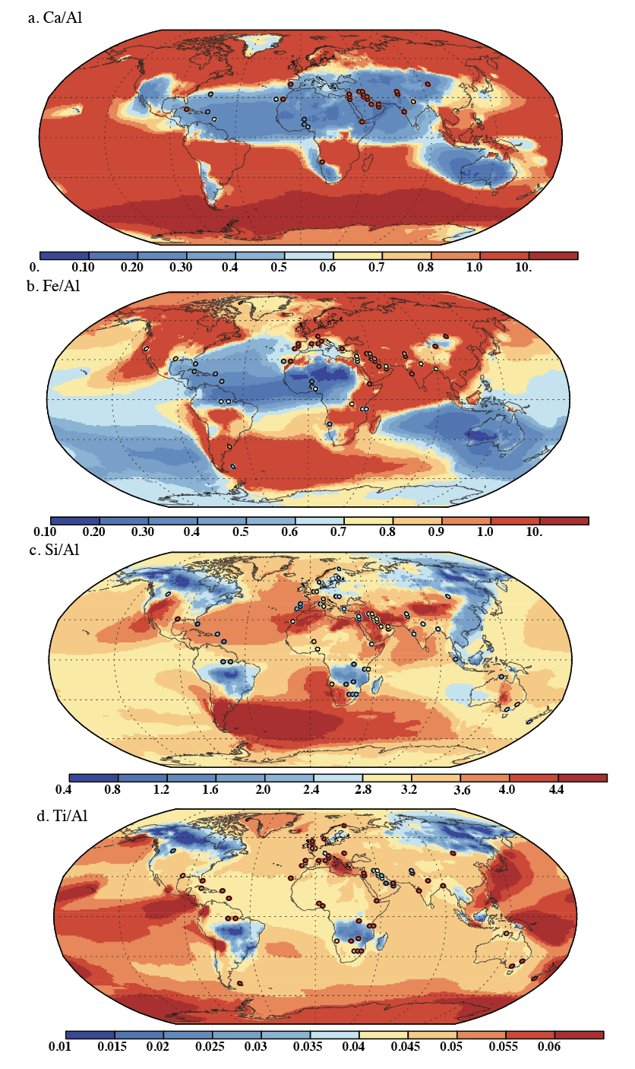
Figure S10. Elemental surface size fraction compared against station data using the ratios of concentrations ((μg/m³ divided by μg/m³ ). Modeled values in are shown in the background for a. Ca/Al, b. Fe/Al, c. Si/Al and d.Ti/Al while the circles represent the observational measurements from station data using the same color bar. A scatter-plot comparison of the model (x-axis) to the observations (y-axis) is shown in the main paper in Figures 4 for the different elements. Statistics for these figures are in Table S8.

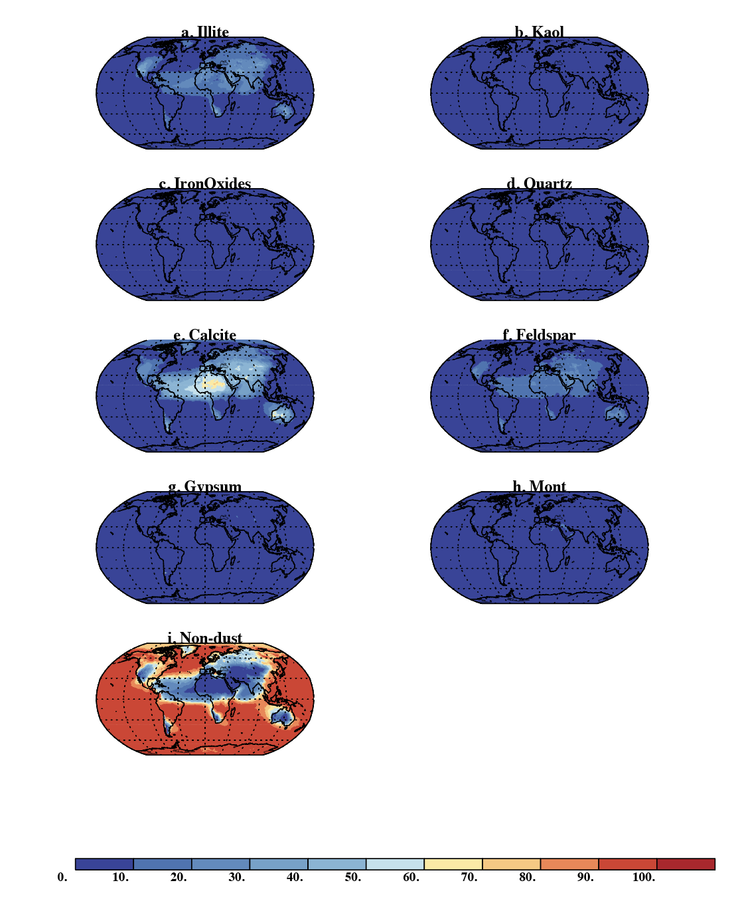
Figure S11: Percentage of deposition from each dust source for PM₁₀ Ca for a. Illite, b. Kaolinite, c.Iron Oxides, d. Quartz, e. Calcite, f. Feldspar, g. Gypsum, h. Montmorlite, and i. Non-dust sources.
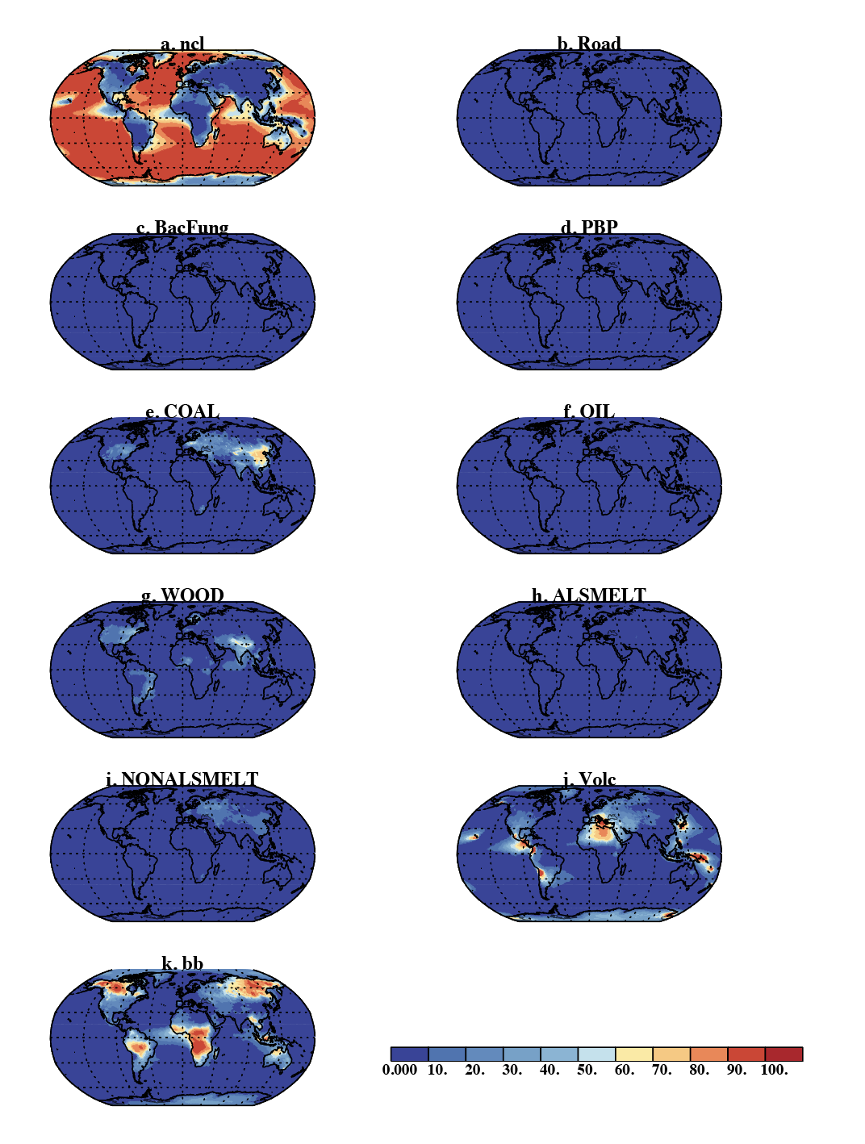 Figure S12: Percentage of the non-dust sources (not the total) for Ca PM₁₀ deposition: a. Sea Salts (ncl), b. Road dust, c. bacteria and fungi (BacFung), d. other primary biogenic particles (PBP), e. Coal, f. Oil, g. Wood, h. Al Smelting, i. Non-Al Smelting, i. Volcano, k. Biomass Burning (bb).
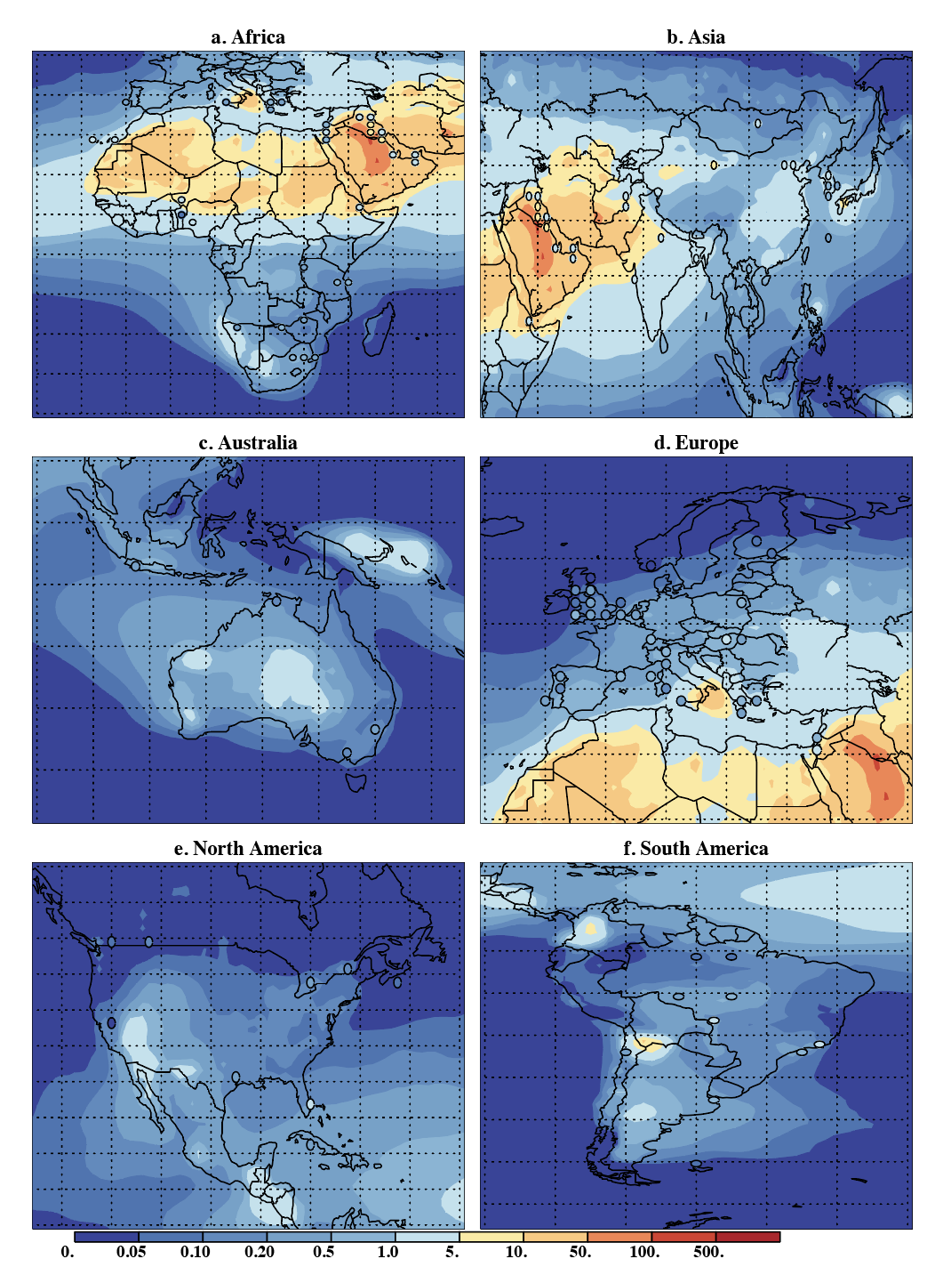

Figure S13: Modeled (background) and observed (circles) Fe PM₁₀ annual mean concentrations in µg/m³ for a. Africa, b. Asia, c. Australia, d. Europe, e. N. America and f. S. America. These show the exact same information as in Figure 5a but in subregions.
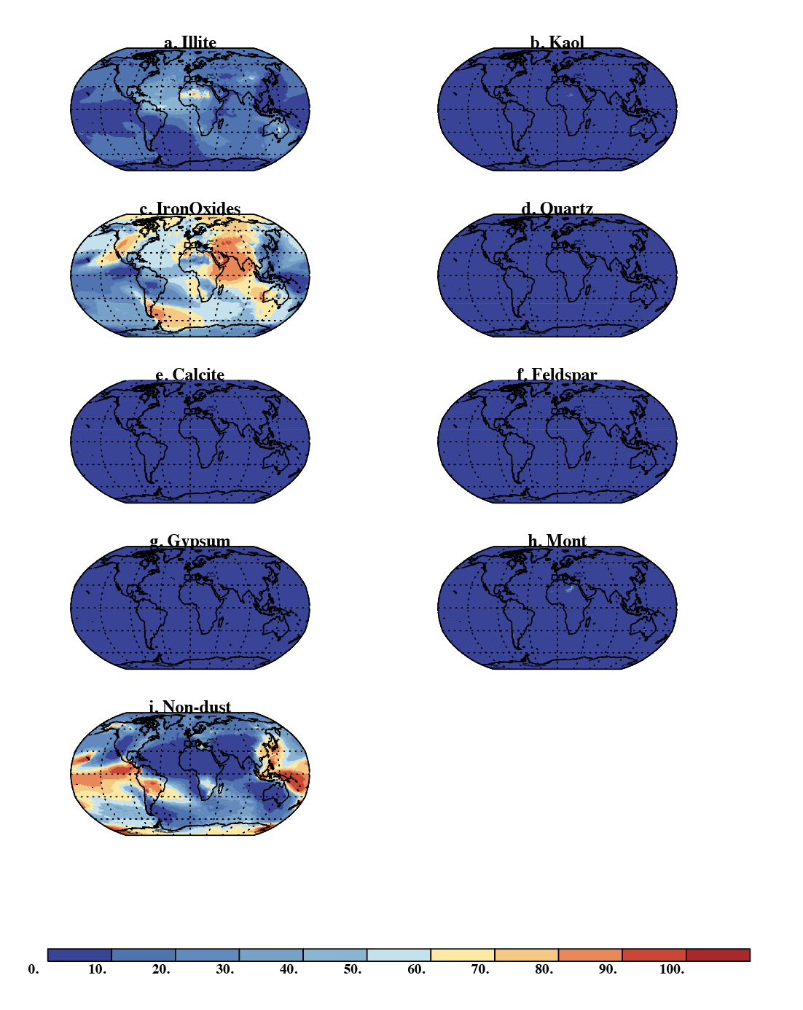
Figure S14: Percentage of deposition from each dust source for PM₁₀ Fe for a. Illite, b. Kaolinite, c.Iron Oxides, d. Quartz, e. Calcite, f. Feldspar, g. Gypsum, h. Montmorlite, and i. Non-dust sources.

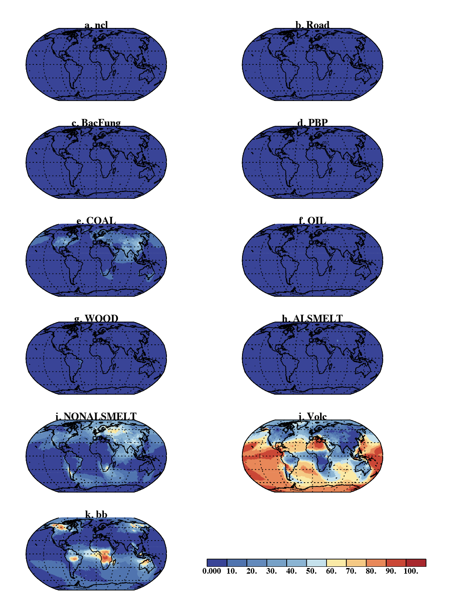 S15: Percentage of the non-dust sources (not the total) for Fe PM₁₀ deposition: a. Sea Salts (ncl), b. Road dust, c. bacteria and fungi (BacFung), d. other primary biogenic particles (PBP), e. Coal, f. Oil, g. Wood, h. Al Smelting, i. Non-Al Smelting, i. Volcano, k. Biomass Burning (bb).

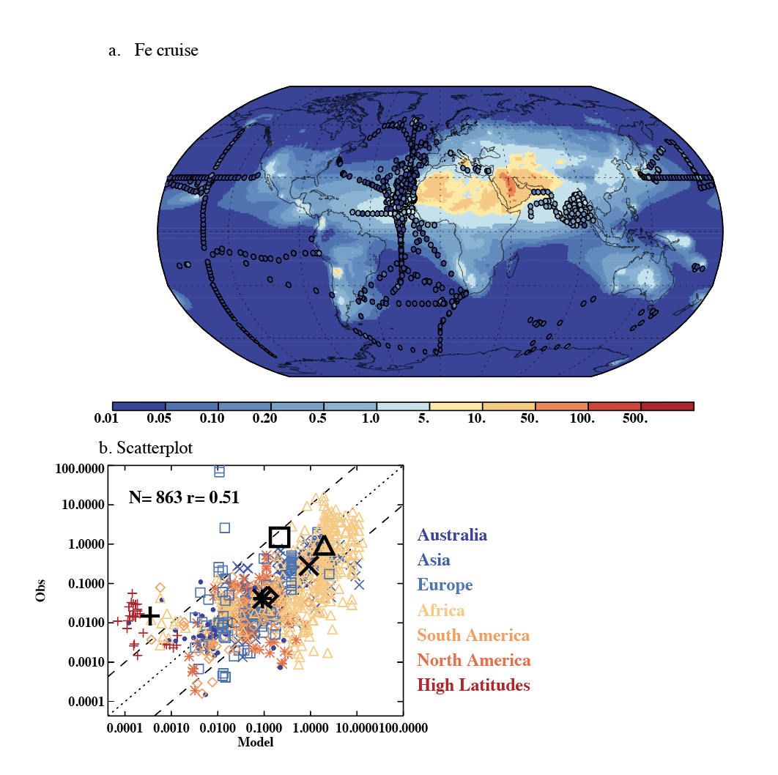
Figure S16. Elemental surface concentrations in the PM₁₀ size fraction compared against cruise data from Myriokefalitakis et al (2018). Modeled values in µg/m³ are shown in the background in a, while circles represent the observational measurements from cruise data using the same color bar. A scatter-plot comparison of the model (x-axis) to the observations (y-axis) is shown in b. The correlation coefficient is 0.51, while the rms value is 0.97 and the mean normalized bias is 0.10, similar to previous versions of this model Myriokefalitakis et al (2018).

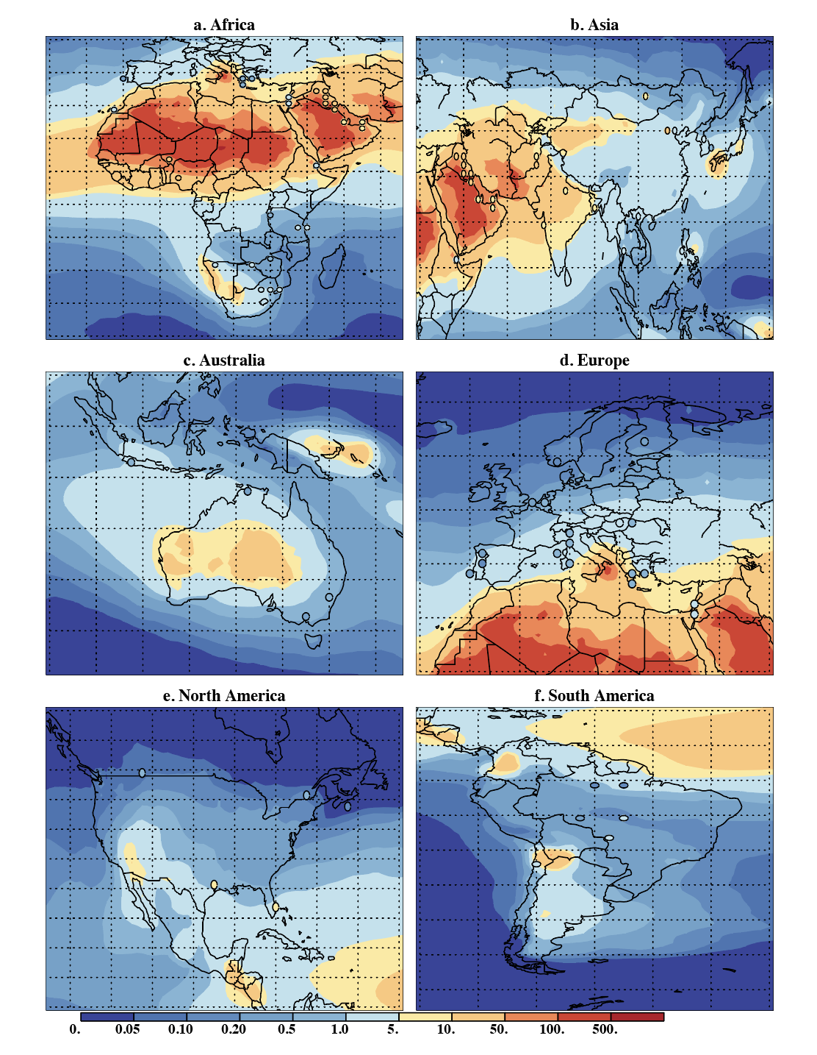
Figure S17: Modeled (background) and observed (circles) Si PM₁₀ annual mean concentrations in µg/m³ for a. Africa, b. Asia, c. Australia, d. Europe, e. N. America and f. S. America. These show the exact same information as in Figure 6a but in subregions.
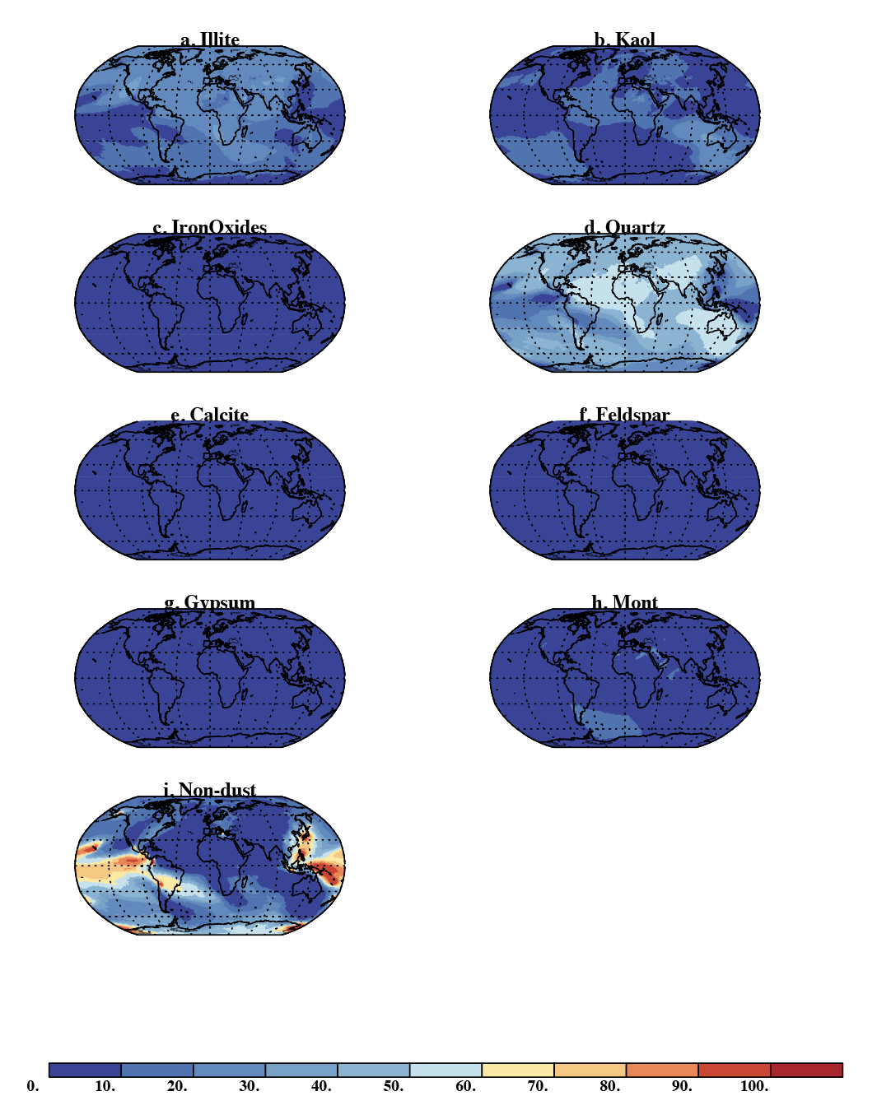

Figure S18: Percentage of deposition from each dust source for PM₁₀ Si for a. Illite, b. Kaolinite, c.Iron Oxides, d. Quartz, e. Calcite, f. Feldspar, g. Gypsum, h. Montmorlite, and i. Non-dust sources.

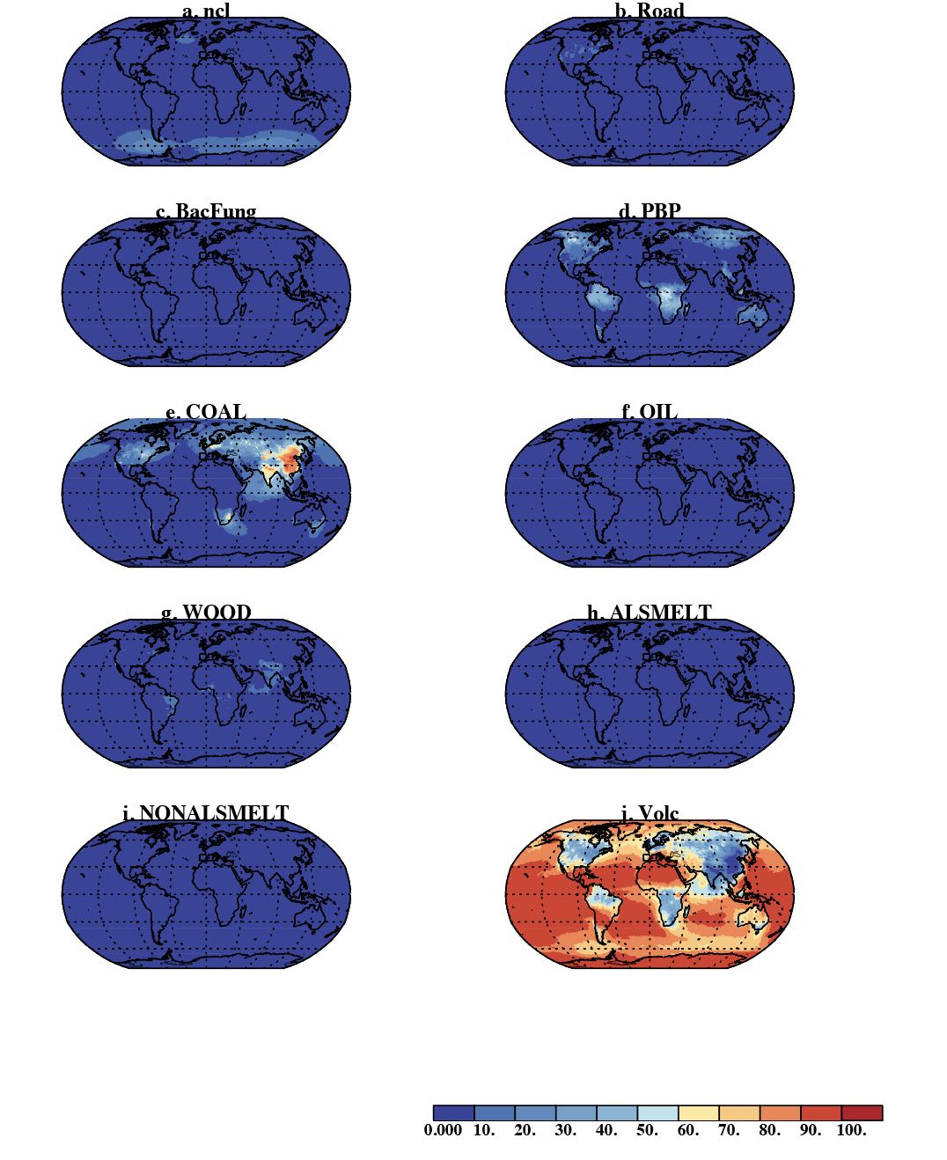
S19: Percentage of the non-dust sources (not the total) for Si PM₁₀ deposition: a. Sea Salts (ncl), b. Road dust, c. bacteria and fungi (BacFung), d. other primary biogenic particles (PBP), e. Coal, f. Oil, g. Wood, h. Al Smelting, i. Non-Al Smelting, i. Volcano. Biomass burning is assumed to be zero and not included.

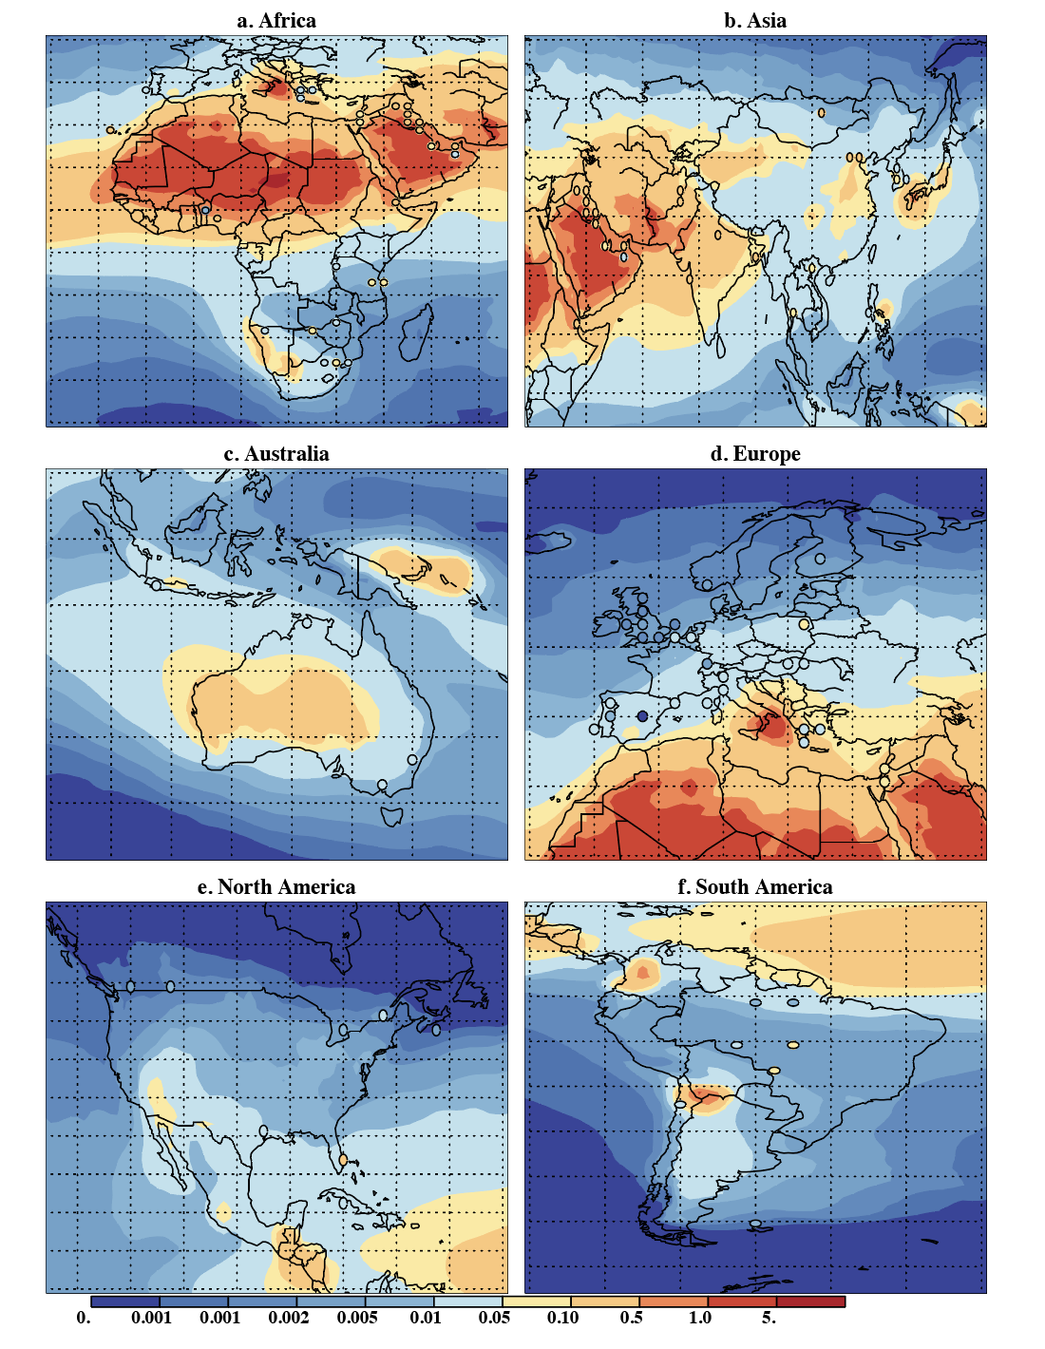
Figure S20: Modeled (background) and observed (circles) Ti PM₁₀ annual mean concentrations in µg/m³ for a. Africa, b. Asia, c. Australia, d. Europe, e. N. America and f. S. America. These show the exact same information as in Figure 7a but in subregions.

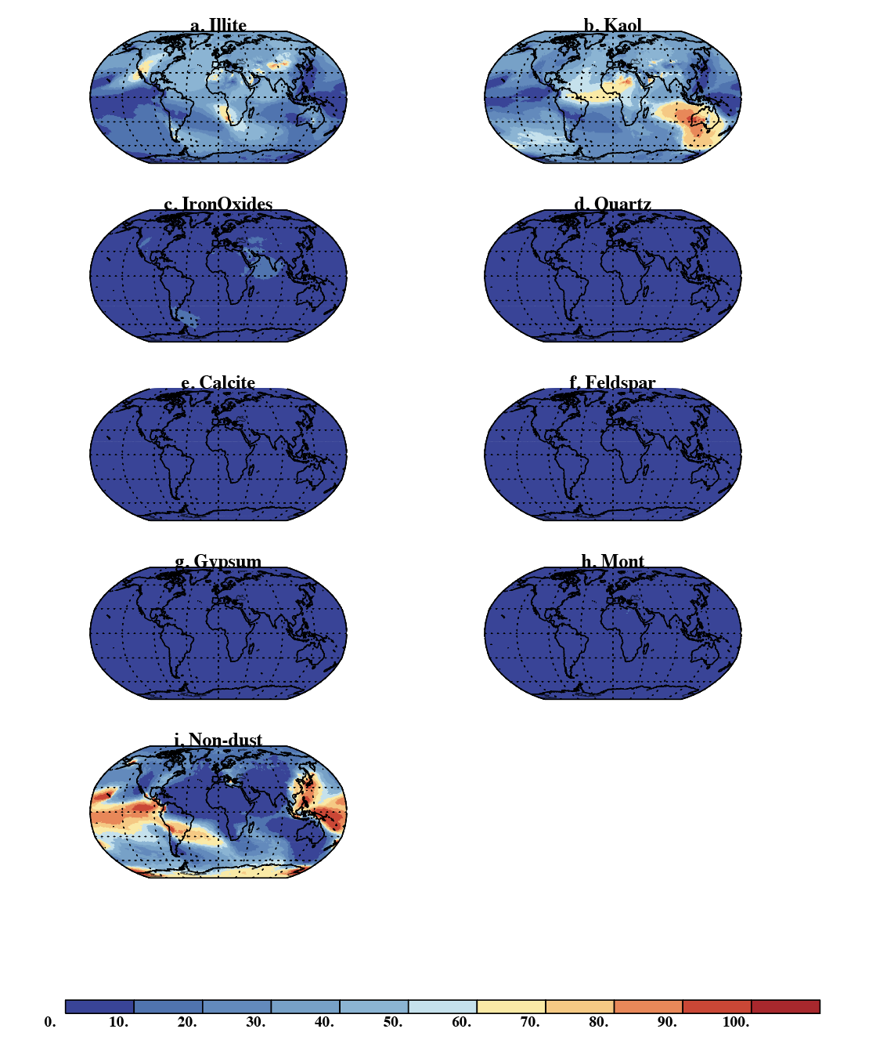
Figure S21: Percentage of deposition from each dust source for PM₁₀ Ti for a. Illite, b. Kaolinite, c.Iron Oxides, d. Quartz, e. Calcite, f. Feldspar, g. Gypsum, h. Montmorlite, and i. Non-dust sources.

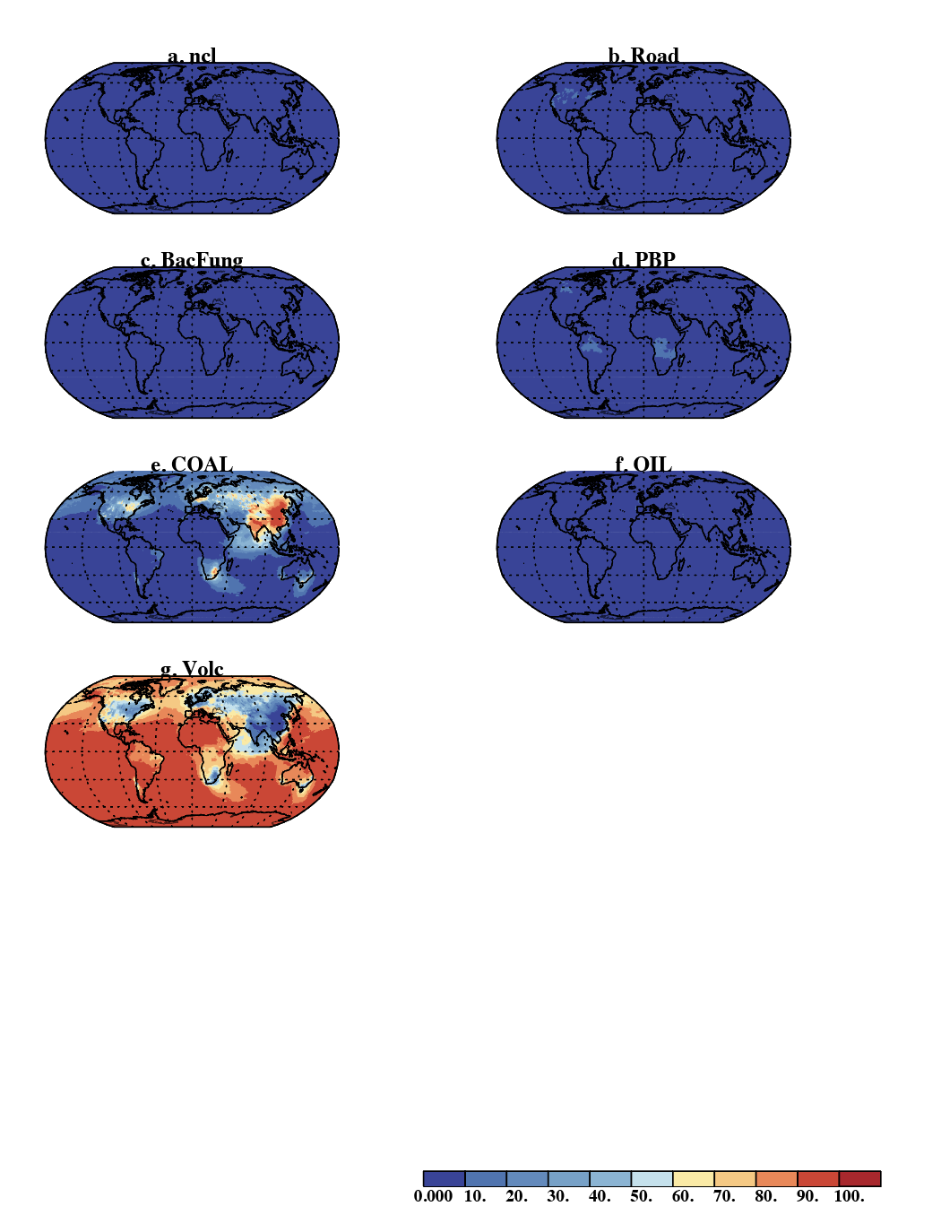
S22: Percentage of the non-dust sources (not the total) for Ti PM₁₀ deposition: a. Sea Salts (ncl), b. Road dust, c. bacteria and fungi (BacFung), d. other primary biogenic particles (PBP), e. Coal, f. Oil, g. Volcano. Wood, Al and Non-Al Smelting and Biomass burning is assumed to be zero and not included.

Table S1. Mass percentage elemental composition of minerals in desert dust based on the measurement and compilations from (Menut et al., 2020).
Mineral | Al | Ca | Fe | Si | Ti
Calcite | 0 | 40 | 0 | 0 | 0
Feldspar | 10.96 | 3.84 | 0.34 | 25.24 | 0.04
Goethite | 0.55 | 0.02 | 62.90 | 0.89 | 0.01
Gypsum | 0 | 23.3 | 0 | 0 | 0
Hematite | 2.67 | 0.12 | 57.48 | 2.11 | 0.22
Illite | 10.47 | 1.45 | 4.01 | 24.11 | 0.52
Kaolinite | 20.42 | 0.03 | 0.24 | 20.27 | 1.00
Quartz | 0 | 0 | 0 | 46.7 | 0
Smectite | 8.57 | 0.91 | 2.55 | 27.44 | 0.07
Vermiculite | 6.84 | 0.98 | 6.7 | 16.09 | 0.65

Table S2. Estimated mass ratio of element/Fe for using the mineralogy-based Fe emissions from combustion and industrial activities (Rathod et al., 2020). Iron emissions are spatially disaggregated using Rathod et al., (2020). Citations for these emission factors are the following: Hard coal: Block and Dams, 1976; Matinez and Tarazona, 1990; Mamane 1986, Meji 1994, Davison 1976, Querol 1995, Smith, 1979; Watson 2001. Oil, light and medium distillates: Linak, 2000; Tsai 1998; Dreher 1997; Huffman 2000; Maman 1986. Smelting: DeSouza 2010; Machado 2006. Wood:
Koukouzas 2007; Steenari 1999; Zhang 2012; Watson 2001; Schmidl 2008; Alves, 2001. Open fires: Hamilton et al., 2022 for Al, Ca, and the same citations as for Wood for Si and Ti.
Fuel | Broad category | Al | Ca | Si | Ti
Hard Coal | Coal | 2 | 1 | 3 | 0.1
Heavy Fuel Oil | Oil | 0.4 | 0.2 | 0.4 | 0.05
Light distillate | Gasoline | 0.4 | 0.2 | 0.4 | -
Middle distillate | Diesel | 0.4 | 0.2 | 0.4 | -
Smelting and misc (Cu and Pb) | Smelting | 0.01 | 0.2 | 0.03 | 0
Other fuels |  | 2 | 1 | 3 | -
Wood | Wood | 3 | 10 | 3.5 | 0
Open Fire |  | 1.5 | 4 | 0 | 0

Table S3: Elemental mass fraction for different sources, how these are calculated and the citation.
Type | Elemental Fraction | Citation
Sea spray/Sea salt
Al | 2.5e-8 | Rauch and Pacyna, 2009
Ca | 1e-2 | Schlesinger, 1997
Fe | 3e-9 | Rauch and Pacyna, 2009
Si | 3e-5 | Kido and Nishimura, 1975
Ti | 5e-9 | Orians et al., 1990
Primary biogenic particles
Al | 166e-6 | Rauch and Pacyna, 2009
Ca | 1e-4 | Ostrowska and Porębska, 2017
Fe | 193e-6 | Rauch and Pacyna, 2009
Si | 1e-2 | Smis et al., 2014
Ti | 33e-6 | Lyu et al., 2017
Road dust
Al | 0.07 | Zhang et al. 2015
Ca | 0.04 | Zhang et al. 2015
Fe | 0.035 | Taylor and McClennan, 1985
Si | 0.3 | Taylor and McClennan, 1985
Ti | 0.006 | Zhang et al. 2015
Biomass burning | Ratio to BC
Fe | 0.3 | Hamilton et al., 2021
Al | 0.2 | Ratios from Table S2
Ca | 1.2 | Ratios from Table S2
Si | 0 | Table S2
Ti | 0 | Table S2

Table S4: Ash weight percentage from different volcanic eruptions of elements estimated from Hornby et al., 2023, contrasted with PM₁₀ observations from individual volcanoes.
Weight % by element | Al | Ca | Fe | Si | Ti | Citation | Notes
Values used here | 8.6 | 4.8 | 5.6 | 20 | 0.70
Ash | 8.6 | 4.8 | 5.6 | 27 | 0.70 | Hornby et al. 2023 | Average of multiple volcanoes
PM10 | 6.7 | 5.9 | 6.8 | 18 | 1.7 | Lopez-Darias et al., 2025 | La Palma eruption (low Si eruption)
PM10 | 10.1 | 6.2 | 6.9 | 25 | 0.5 | Tomacek et al., 2024 | La Soufriere, St. Vincent

Table S5: Global emissions from each of the sources included in this study (Tg/year). We also include the percent of the surface concentrations that are in PM_{2.5}.
Source type | Al | Ca | Fe | Si | Ti | % PM_{2.5}
Illite | 6.74E+01 | 9.33E+00 | 2.58E+01 | 1.55E+02 | 3.35E+00 | 8
Kaolinite | 9.56E+01 | 1.40E-01 | 1.12E+00 | 9.49E+01 | 4.68E+00 | 8
Iron Oxides | 1.52E+00 | 6.82E-02 | 3.27E+01 | 1.20E+00 | 1.25E-01 | 8
Quartz | 0.00E+00 | 0.00E+00 | 0.00E+00 | 3.67E+02 | 0.00E+00 | 4
Calcite | 0.00E+00 | 6.33E+01 | 0.00E+00 | 0.00E+00 | 0.00E+00 | 8
Feldspar | 2.23E+01 | 7.82E+00 | 6.92E-01 | 5.14E+01 | 8.14E-02 | 4
Gypsum | 5.76E-02 | 1.57E-01 | 0.00E+00 | 0.00E+00 | 0.00E+00 | 8
Montmorillite | 0.00E+00 | 1.06E+00 | 2.96E+00 | 3.19E+01 | 8.13E-02 | 8
Road Dust | 3.01E-02 | 1.72E-02 | 1.50E-02 | 1.29E-01 | 2.58E-03 | 79
Coal | 1.53E+00 | 7.67E-01 | 7.67E-01 | 2.30E+00 | 7.67E-02 | 65
Oil | 1.39E-02 | 6.95E-03 | 3.47E-02 | 1.39E-02 | 1.74E-03 | 78
Wood | 2.10E-01 | 7.00E-01 | 7.00E-02 | 2.45E-01 | 0.00E+00 | 92
Al Smelting | 4.47E-04 | 8.94E-03 | 4.47E-02 | 1.34E-03 | 0.00E+00 | 72
Non-Al Smelting | 1.30E-02 | 2.61E-01 | 1.30E+00 | 3.91E-02 | 0.00E+00 | 84
Volcano | 1.10E+01 | 6.24E+00 | 7.34E+00 | 3.52E+01 | 7.34E-01 | 100
Fires | 4.80E-01 | 2.88E+00 | 7.20E-01 | 0.00E+00 | 0.00E+00 | 100
Sea Salts | 6.29E-05 | 2.52E+01 | 7.55E-06 | 7.55E-02 | 1.26E-05 | 28
Bacteria and Fungi | 7.14E-04 | 4.30E-04 | 8.30E-04 | 4.30E-02 | 1.42E-04 | 21
Other Primary Biogenic Particles | 8.95E-03 | 5.39E-03 | 1.04E-02 | 5.39E-01 | 1.78E-03 | 27
Totals | 200 | 118 | 74 | 740 | 9.13
%PM_{2.5} of surface conc. | 13 | 34 | 15 | 9.5 | 15

Table S6: PM₁₀ comparison statistics for model-data comparisons for land stations including correlation coefficient (r), and slope (B) for linear regression with uncertainties (sigma B), root mean square differences (rms), average model during time of the observations (µg/m³) , Fraction of the observations outside of the estimated model-data comparison range (3-fold) and the number of observations (N). Values are given for different composition and different regions (regions shown in Figure S2).

 |  | Kendall Rank | (µg/µg) | (µg/µg) | (µg/µg) | (µg/m³) | (µg/m³)
Composition | Region | Correl. (r) | Slope | Slope Unc. | RMS | Avg. Model | Avg. Obs | Frac. >3× | Num. Obs.
Al | Globe | 0.53 | 1.61 | 1.44E-02 | 4.84E+00 | 2.47E+00 | 1.09E+00 | 0.47 | 124
Al | Africa | 0.29 | 6.06 | 1.59E-01 | 6.91E+00 | 4.28E+00 | 1.32E+00 | 0.63 | 19
Al | Asia | 0.46 | 1.47 | 2.34E-02 | 7.80E+00 | 5.94E+00 | 2.69E+00 | 0.34 | 32
Al | Australia | 0.33 | 1.07 | 2.88E-02 | 1.51E-01 | 2.24E-01 | 2.24E-01 | 0.29 | 7
Al | Europe | 0.6 | 2.18 | 3.03E-02 | 8.58E-01 | 5.58E-01 | 1.94E-01 | 0.44 | 43
Al | High Latitudes | -1 | -0.89 | 1.04E-01 | 1.87E-02 | 5.86E-03 | 2.26E-02 | 0.5 | 2
Al | North America | 0.67 | 0.79 | 1.68E-02 | 9.60E-01 | 4.47E-01 | 6.82E-01 | 0.54 | 13
Al | South America | 0 | 0.2 | 7.54E-03 | 1.05E+00 | 4.34E-01 | 6.59E-01 | 0.75 | 8
Ca | Globe | 0.44 | 0.47 | 4.42E-03 | 4.06E+00 | 9.54E-01 | 2.62E+00 | 0.43 | 91
Ca | Africa | 0.19 | 0.29 | 7.51E-03 | 2.26E+00 | 1.20E+00 | 1.53E+00 | 0.35 | 17
Ca | Asia | 0.6 | 0.25 | 3.98E-03 | 7.06E+00 | 1.81E+00 | 6.80E+00 | 0.54 | 28
Ca | Australia | -0.07 | -0.2 | 1.17E-02 | 2.06E-01 | 2.24E-01 | 2.12E-01 | 0.33 | 6
Ca | Europe | 0.28 | 0.45 | 1.15E-02 | 5.84E-01 | 3.68E-01 | 5.45E-01 | 0.4 | 20
Ca | North America | 0.33 | 0.22 | 1.01E-02 | 7.58E-01 | 1.97E-01 | 6.39E-01 | 0.38 | 13
Ca | South America | 0.33 | 1.85 | 8.80E-02 | 6.69E-01 | 7.41E-01 | 2.01E-01 | 0.67 | 6
Fe | Globe | 0.57 | 1.06 | 1.02E-02 | 1.05E+01 | 3.82E+00 | 1.09E+00 | 0.37 | 108
Fe | Africa | 0.37 | 4.54 | 1.25E-01 | 2.69E+00 | 2.15E+00 | 8.46E-01 | 0.53 | 17
Fe | Asia | 0.6 | 1.62 | 2.68E-02 | 1.99E+01 | 1.18E+01 | 2.70E+00 | 0.4 | 30
Fe | Australia | 0.07 | 1.68 | 1.03E-01 | 1.43E-01 | 1.40E-01 | 2.19E-01 | 0.17 | 6
Fe | Europe | 0.42 | 0.91 | 1.45E-02 | 6.58E-01 | 4.83E-01 | 3.55E-01 | 0.29 | 31
Fe | High Latitudes | 1 | 1.36 | 2.02E-01 | 1.96E-02 | 6.87E-03 | 2.64E-02 | 0.5 | 2
Fe | North America | 0.55 | 0.64 | 1.44E-02 | 5.25E-01 | 2.41E-01 | 4.06E-01 | 0.33 | 12
Fe | South America | 0.24 | 0.23 | 8.92E-03 | 5.84E-01 | 2.80E-01 | 5.41E-01 | 0.4 | 10
Si | Globe | 0.48 | 2.63 | 3.16E-02 | 2.55E+01 | 1.34E+01 | 3.65E+00 | 0.51 | 77
Si | Africa | 0.6 | 5.26 | 1.50E-01 | 2.17E+01 | 1.27E+01 | 3.85E+00 | 0.57 | 14
Si | Asia | 0.58 | 2.42 | 5.22E-02 | 4.07E+01 | 2.97E+01 | 7.28E+00 | 0.42 | 26
Si | Australia | 0.07 | -0.46 | 2.07E-02 | 5.14E-01 | 6.87E-01 | 5.85E-01 | 0.17 | 6
Si | Europe | 0.23 | 4.34 | 1.15E-01 | 4.29E+00 | 3.01E+00 | 6.13E-01 | 0.5 | 16
Si | North America | 0.5 | 2.19 | 9.68E-02 | 3.40E+00 | 2.14E+00 | 2.35E+00 | 0.75 | 8
Si | South America | -0.33 | -0.09 | 6.92E-03 | 2.33E+00 | 1.58E+00 | 9.70E-01 | 0.83 | 6
Ti | Globe | 0.46 | 1.2 | 1.37E-02 | 2.44E-01 | 1.26E-01 | 6.50E-02 | 0.41 | 92
Ti | Africa | 0.14 | 2.85 | 8.12E-02 | 2.01E-01 | 1.23E-01 | 7.33E-02 | 0.5 | 14
Ti | Asia | 0.22 | 1.37 | 3.48E-02 | 4.28E-01 | 3.30E-01 | 1.46E-01 | 0.42 | 26
Ti | Australia | 0.33 | 1.58 | 9.43E-02 | 1.03E-02 | 1.10E-02 | 1.74E-02 | 0.17 | 6
Ti | Europe | 0.45 | 1.4 | 3.37E-02 | 5.34E-02 | 3.07E-02 | 1.36E-02 | 0.31 | 26
Ti | High Latitudes | -1 | -1.99 | 6.32E-01 | 1.10E-03 | 2.82E-04 | 1.34E-03 | 0.5 | 2
Ti | North America | 0.75 | 0.99 | 2.54E-02 | 5.94E-02 | 2.26E-02 | 4.35E-02 | 0.45 | 11
Ti | South America | -0.05 | 8.6 | 5.04E-01 | 5.31E-02 | 2.20E-02 | 3.23E-02 | 0.71 | 7

Table S7: PM_{2.5} comparison statistics for model-data comparisons land stations including correlation coefficient (r), and slope (B) for linear regression with uncertainties (sigma B), root mean square differences (rms), average model during time of the observations (µg/m³) , Fraction of the observations outside of the estimated model-data comparison range (3-fold) and the number of observations (N). Values are given for different composition and different regions (regions shown in Figure S2).

 |  | Kendall Rank | (µg/µg) | (µg/µg) | (µg/µg) | (µg/m³) | (µg/m³)
Composition | Region | Correl. (r) | Slope | Slope Unc. | RMS | Avg. Model | Avg. Obs | Frac. >3× | Num. Obs.
Al | Globe | 0.4 | 1.83 | 1.19E-02 | 9.01E-01 | 3.21E-01 | 1.42E-01 | 0.28 | 290
Al | Africa | 0.49 | 2.51 | 5.96E-02 | 4.37E-01 | 4.02E-01 | 2.51E-01 | 0.2 | 15
Al | Asia | 0.21 | 2.53 | 4.75E-02 | 2.00E+00 | 1.14E+00 | 4.81E-01 | 0.62 | 55
Al | Australia | 0.2 | 5.15 | 2.47E-01 | 1.10E-01 | 1.17E-01 | 4.72E-02 | 0.83 | 6
Al | Europe | 0.37 | 4.03 | 1.12E-01 | 4.73E-01 | 3.20E-01 | 8.18E-02 | 0.41 | 17
Al | High Latitudes | -1 | -0.17 | 9.88E-03 | 1.96E-02 | 2.70E-03 | 1.80E-02 | 0.5 | 2
Al | North America | 0.22 | 1.38 | 1.08E-02 | 1.84E-01 | 8.30E-02 | 4.47E-02 | 0.15 | 187
Al | South America | 0.36 | 25.31 | 1.77E+00 | 4.59E-01 | 3.11E-01 | 1.10E-01 | 0.38 | 8
Ca | Globe | 0.15 | 2.41 | 2.60E-02 | 6.87E-01 | 2.43E-01 | 1.74E-01 | 0.47 | 285
Ca | Africa | -0.22 | -0.51 | 1.24E-02 | 3.90E-01 | 3.62E-01 | 1.88E-01 | 0.73 | 15
Ca | Asia | -0.07 | 0.03 | 1.50E-03 | 1.53E+00 | 7.24E-01 | 6.57E-01 | 0.77 | 53
Ca | Australia | -0.07 | -1.06 | 5.93E-02 | 2.14E-01 | 2.07E-01 | 3.84E-02 | 0.83 | 6
Ca | Europe | 0.49 | 1.12 | 2.96E-02 | 2.03E-01 | 1.55E-01 | 1.55E-01 | 0.29 | 14
Ca | North America | -0.07 | 2.12 | 2.59E-02 | 1.30E-01 | 9.15E-02 | 4.85E-02 | 0.35 | 187
Ca | South America | -0.07 | -0.28 | 2.30E-02 | 7.07E-01 | 6.00E-01 | 6.64E-02 | 0.75 | 8
Fe | Globe | 0.49 | 1.61 | 8.27E-03 | 6.73E-01 | 3.25E-01 | 1.15E-01 | 0.24 | 288
Fe | Africa | 0.43 | 3.27 | 9.80E-02 | 2.56E-01 | 2.97E-01 | 1.55E-01 | 0.33 | 15
Fe | Asia | 0.35 | 3.73 | 4.64E-02 | 1.51E+00 | 1.23E+00 | 3.34E-01 | 0.67 | 54
Fe | Australia | -0.2 | 5.39 | 3.19E-01 | 9.33E-02 | 1.02E-01 | 4.48E-02 | 0.67 | 6
Fe | Europe | 0.38 | 1.6 | 3.38E-02 | 3.29E-01 | 3.01E-01 | 1.55E-01 | 0.25 | 16
Fe | North America | 0.42 | 1.22 | 7.78E-03 | 1.27E-01 | 7.82E-02 | 4.89E-02 | 0.08 | 187
Fe | South America | 0.36 | 2.04 | 6.67E-02 | 3.91E-01 | 3.47E-01 | 9.14E-02 | 0.38 | 8
Si | Globe | 0.39 | 1.61 | 1.24E-02 | 2.61E+00 | 8.59E-01 | 3.07E-01 | 0.22 | 275
Si | Africa | 0.62 | 2.93 | 1.01E-01 | 6.13E-01 | 7.34E-01 | 4.67E-01 | 0.23 | 13
Si | Asia | 0.16 | 1.38 | 2.25E-02 | 6.04E+00 | 3.56E+00 | 1.07E+00 | 0.53 | 49
Si | Australia | -0.33 | 12.13 | 9.41E-01 | 2.87E-01 | 2.38E-01 | 1.09E-01 | 0.5 | 6
Si | Europe | 0.56 | 2.95 | 7.57E-02 | 4.79E-01 | 4.66E-01 | 1.53E-01 | 0.27 | 11
Si | North America | 0.25 | 1.37 | 1.08E-02 | 5.83E-01 | 2.14E-01 | 1.14E-01 | 0.12 | 187
Si | South America | 0.14 | 2.77 | 1.43E-01 | 1.13E+00 | 8.14E-01 | 3.37E-01 | 0.29 | 7
Ti | Globe | 0.45 | 0.85 | 9.24E-03 | 5.41E-02 | 1.78E-02 | 8.02E-03 | 0.27 | 286
Ti | Africa | 0.45 | 2.41 | 7.03E-02 | 1.78E-02 | 1.78E-02 | 1.58E-02 | 0.4 | 15
Ti | Asia | 0.13 | 1.77 | 2.46E-02 | 1.22E-01 | 6.82E-02 | 2.08E-02 | 0.49 | 53
Ti | Australia | -0.2 | 14.79 | 1.59E+00 | 6.02E-03 | 5.32E-03 | 2.85E-03 | 0.33 | 6
Ti | Europe | 0.49 | 1.2 | 2.71E-02 | 3.26E-02 | 1.78E-02 | 5.91E-03 | 0.33 | 15
Ti | North America | 0.42 | 0.68 | 3.70E-03 | 1.21E-02 | 4.24E-03 | 3.88E-03 | 0.19 | 187
Ti | South America | 0.21 | 1.02 | 4.13E-02 | 8.73E-03 | 1.44E-02 | 1.54E-02 | 0.25 | 8

Table S8: PM₁₀ comparison statistics for model-data comparisons using cruise data including correlation coefficient (r), and slope (B) for linear regression with uncertainties (sigma B), root mean square differences (rms), average model during time of the observations (µg/m³) , Fraction of the observations outside of the estimated model-data comparison range (3-fold) and the number of observations (N). Values are given for different composition and different regions (regions shown in Figure S2). If there is no data in a region, the region is skipped.

 |  | Kendall Rank | (µg/µg) | (µg/µg) | (µg/µg) | (µg/m³) | (µg/m³)
Composition | Region | Correl. (r) | Slope | Slope Unc. | RMS | Avg. Model | Avg. Obs | Frac. >3× | Num. Obs.
Al | Globe | 0.5 | 3.55 | 2.34E-02 | 4.74E+00 | 1.74E+00 | 7.26E-01 | 0.62 | 501
Al | Africa | 0.57 | 4.83 | 3.91E-02 | 3.96E+00 | 3.06E+00 | 1.07E+00 | 0.29 | 180
Al | Asia | 0.11 | 4.54 | 9.16E-02 | 2.05E+00 | 1.47E+00 | 3.03E-01 | 0.32 | 25
Al | Australia | 1 | 4.18 | 1.38E+00 | 2.88E-03 | 8.59E-03 | 6.05E-03 | 0 | 2
Al | Europe | 0.33 | 3.49 | 6.62E-02 | 9.40E+00 | 1.44E+00 | 1.19E+00 | 0.24 | 92
Al | High Latitudes | -0.27 | 0 | 5.30E-05 | 3.41E-02 | 6.08E-04 | 2.67E-02 | 0.81 | 16
Al | North America | 0.34 | 5.02 | 7.92E-02 | 9.15E-01 | 7.84E-01 | 2.33E-01 | 0.42 | 76
Al | South America | 0.54 | 2.08 | 2.04E-02 | 1.16E+00 | 8.57E-01 | 3.24E-01 | 0.09 | 110
Ca | Globe | 0.28 | 1.36 | 1.23E-02 | 4.86E-01 | 5.23E-01 | 3.87E-01 | 0.29 | 126
Ca | Africa | 0.42 | 1.14 | 2.19E-02 | 6.43E-01 | 8.41E-01 | 6.07E-01 | 0.08 | 36
Ca | Asia | -0.05 | 1.39 | 3.78E-02 | 6.34E-01 | 3.37E-01 | 5.96E-01 | 0.17 | 18
Ca | Europe | -0.33 | -0.05 | 2.88E-02 | 9.31E-02 | 9.95E-02 | 1.73E-01 | 0 | 6
Ca | North America | 0.13 | 1.4 | 3.21E-02 | 3.31E-01 | 3.28E-01 | 1.66E-01 | 0.06 | 34
Ca | South America | 0.46 | 1.75 | 2.13E-02 | 3.46E-01 | 5.55E-01 | 2.95E-01 | 0.06 | 32
Fe | Globe | 0.51 | 2.27 | 1.22E-02 | 3.67E+00 | 8.60E-01 | 5.51E-01 | 0.52 | 462
Fe | Africa | 0.56 | 3.19 | 2.34E-02 | 1.45E+00 | 1.19E+00 | 6.90E-01 | 0.18 | 169
Fe | Asia | 0 | 0 | 2.12E-03 | 3.58E+00 | 2.22E+00 | 2.29E-01 | 0.5 | 22
Fe | Australia | 1 | 2.8 | 4.85E-01 | 1.94E-03 | 5.44E-03 | 3.74E-03 | 0 | 2
Fe | Europe | 0.4 | 6.77 | 1.26E-01 | 8.09E+00 | 1.10E+00 | 1.17E+00 | 0.22 | 85
Fe | High Latitudes | -0.61 | -0.17 | 3.93E-03 | 1.49E-02 | 8.17E-04 | 1.17E-02 | 0.58 | 12
Fe | North America | 0.46 | 2.58 | 3.74E-02 | 3.31E-01 | 3.43E-01 | 1.58E-01 | 0.31 | 75
Fe | South America | 0.53 | -0.06 | 4.37E-04 | 4.00E-01 | 2.88E-01 | 2.24E-01 | 0.08 | 97
Si | Globe | 0.39 | 3.73 | 1.60E-01 | 6.87E+00 | 3.99E+00 | 9.63E-01 | 0.5 | 18
Si | Africa | 0.2 | 4.45 | 1.54E-01 | 1.19E+01 | 1.12E+01 | 1.94E+00 | 0.33 | 6
Si | Europe | -0.07 | 0.17 | 1.24E-02 | 7.43E-01 | 4.67E-01 | 8.56E-01 | 0.17 | 6
Si | South America | 0.07 | 9.72 | 5.50E-01 | 4.06E-01 | 2.99E-01 | 9.00E-02 | 0 | 6
Ti | Globe | 0.49 | 1.47 | 1.17E-02 | 6.94E-01 | 1.02E-01 | 9.06E-02 | 0.51 | 252
Ti | Africa | 0.39 | 1.26 | 2.13E-02 | 1.81E-01 | 1.75E-01 | 8.62E-02 | 0.29 | 79
Ti | Asia | -0.02 | 2.5 | 4.41E-02 | 7.23E-02 | 9.46E-02 | 3.56E-02 | 0 | 11
Ti | Australia | 1 | 0.22 | 2.19E-02 | 4.19E-04 | 4.84E-04 | 6.11E-04 | 0 | 2
Ti | Europe | 0.32 | 2.13 | 3.98E-02 | 1.46E+00 | 1.41E-01 | 2.54E-01 | 0.3 | 56
Ti | High Latitudes | -0.33 | 0 | 7.22E-04 | 1.44E-03 | 5.43E-05 | 1.13E-03 | 0.5 | 6
Ti | North America | 0.5 | 1.37 | 2.04E-02 | 2.25E-02 | 2.57E-02 | 1.91E-02 | 0.23 | 39
Ti | South America | 0.49 | 0.36 | 8.20E-03 | 5.94E-02 | 3.51E-02 | 1.08E-02 | 0.12 | 59

Table S9: PM_{2.5} comparison statistics for model-data comparisons using cruise data including correlation coefficient (r), and slope for linear regression with uncertainties, root mean square differences (rms), average model during time of the observations (µg/m³) , Fraction of the observations outside of the estimated model-data comparison range (3-fold) and the number of observations (N). Values are given for different composition and different regions (regions shown in Figure S2). If there is no data in a region, the region is skipped.

 |  | Kendall Rank | (µg/µg) | (µg/µg) | (µg/µg) | (µg/m³) | (µg/m³)
Composition | Region | Correl. (r) | Slope | Slope Unc. | RMS | Avg. Model | Avg. Obs | Frac. >3× | Num. Obs.
Al | Globe | 0.3 | -0.06 | 6.73E-04 | 5.06E-01 | 3.37E-01 | 3.21E-01 | 0.46 | 104
Al | Africa | 0.49 | 0.69 | 1.18E-02 | 2.76E-01 | 3.99E-01 | 4.34E-01 | 0.22 | 18
Al | Asia | -0.04 | 1.31 | 2.52E-02 | 2.46E-01 | 1.91E-01 | 1.57E-01 | 0.21 | 24
Al | North America | 0.15 | 0.64 | 1.88E-02 | 5.55E-01 | 3.55E-01 | 8.75E-02 | 0.57 | 35
Al | South America | 0.26 | 0.04 | 4.09E-03 | 7.05E-01 | 4.19E-01 | 7.05E-01 | 0.15 | 26
Ca | Globe | 0.23 | -0.27 | 2.33E-03 | 2.66E-01 | 1.69E-01 | 1.53E-01 | 0.41 | 81
Ca | Africa | 0.2 | -0.06 | 2.12E-02 | 4.99E-02 | 6.26E-02 | 3.22E-02 | 0 | 5
Ca | Asia | -0.03 | -0.02 | 1.53E-03 | 3.80E-01 | 1.19E-01 | 2.73E-01 | 0.17 | 18
Ca | North America | 0.38 | 0.61 | 2.32E-02 | 2.89E-01 | 2.17E-01 | 9.20E-02 | 0.09 | 34
Ca | South America | 0.02 | 0 | 1.02E-02 | 1.05E-01 | 1.67E-01 | 1.76E-01 | 0.04 | 23
Fe | Globe | 0.19 | 0.3 | 3.18E-03 | 4.12E-01 | 1.85E-01 | 2.30E-01 | 0.59 | 103
Fe | Africa | 0.48 | 0.22 | 5.43E-03 | 4.24E-01 | 1.29E-01 | 3.94E-01 | 0.22 | 18
Fe | Asia | -0.2 | 0 | 1.95E-03 | 3.75E-01 | 2.71E-01 | 1.18E-01 | 0.36 | 22
Fe | North America | 0.31 | 0.2 | 6.18E-03 | 3.86E-01 | 2.09E-01 | 9.46E-02 | 0.42 | 36
Fe | South America | 0.21 | 0.01 | 1.97E-03 | 4.72E-01 | 1.25E-01 | 4.00E-01 | 0.19 | 26
Ti | Globe | 0.24 | 0.93 | 9.33E-02 | 4.36E-03 | 1.36E-02 | 1.52E-02 | 0 | 10
Ti | Asia | 0.24 | 0.93 | 9.33E-02 | 4.36E-03 | 1.36E-02 | 1.52E-02 | 0 | 10

Table S10: Comparison of global budgets (Tg/year) here for Al, Ca, Fe, Si and Ti to a previous compilation (Mahowald et al., 2024), indicated by the * or for dust only **(Zhang et al., 2015). There are no available budgets for Ca or Si for non dust elements.

 | Al | Al* | Ca | Ca** | Fe | Fe* | Si | Si** | Ti | Ti*
Dust | 187 | 80 | 82 | 66 | 63 | 50 | 701 | 465 | 8 | 8
Anthropogenic | 2 | 3 | 2 |  | 2 | 0.70 | 3 |  | 0.08 | 0.002
Fire | 0.48 | 2 | 3 |  | 0.72 | 1 | 0 |  | 0
Biogenic | 9.66E-03 | 0.2 | 5.82E-03 |  | 1.12E-02 | 0.2 | 0.58 |  | 1.92E-03
Sea spray | 6.29E-05 | 1. | 25 |  | 7.55E-06 | 0.2 | 7.55E-02 |  | 1.26E-05
Volcanos | 11 | 5 | 6 |  | 7 | 9 | 35 |  | 0.73

