NASA/TM−20260000972



EXTRAVEHICULAR ACTIVITY AND HUMAN SURFACE MOBILITY PROGRAM (EHP) INTEGRATED CONCEPT OF OPERATIONS (CONOPS)

Meganne E. Valerioti
The Aerospace Corporation
Johnson Space Center (JSC) Houston

Since its founding, NASA has been dedicated to the advancement of aeronautics and space science. The NASA scientific and technical information (STI) program plays a key part in helping NASA maintain this important role.  The NASA STI program operates under the auspices of the Agency Chief Information Officer. It collects, organizes, provides for archiving, and disseminates NASA’s STI. The NASA STI program provides access to the NTRS Registered and its public interface, the NASA Technical Reports Server, thus providing one of the largest collections of aeronautical and space science STI in the world. Results are published in both non-NASA channels and by NASA in the NASA STI Report Series, which includes the following report types:  - TECHNICAL PUBLICATION. Reports of completed research or a major significant phase of research that present the results of NASA Programs and include extensive data or theoretical analysis. Includes compilations of significant scientific and technical data and information deemed to be of continuing reference value. NASA counterpart of peer-reviewed formal professional papers but has less stringent limitations on manuscript length and extent of graphic presentations.  - TECHNICAL MEMORANDUM.  Scientific and technical findings that are preliminary or of specialized interest,  e.g., quick release reports, working  papers, and bibliographies that contain minimal annotation. Does not contain extensive analysis.  - CONTRACTOR REPORT. Scientific and technical findings by NASA-sponsored contractors and grantees. | - CONFERENCE PUBLICATION.  Collected papers from scientific and technical conferences, symposia, seminars, or other meetings sponsored or  co-sponsored by NASA.  - SPECIAL PUBLICATION. Scientific, technical, or historical information from NASA programs, projects, and missions, often concerned with subjects having substantial public interest.  - TECHNICAL TRANSLATION.  English-language translations of foreign scientific and technical material pertinent to  NASA’s mission.  Specialized services also include organizing  and publishing research results, distributing specialized research announcements and feeds, providing information desk and personal search support, and enabling data exchange services.  For more information about the NASA STI program, see the following:  - Access the NASA STI program home page at http://www.sti.nasa.gov  .

EHP-10033
Revision D, Admin Chg 1
National Aeronautics and  Space Administration | EFFECtIVE DATE: February 24, 2026
Extravehicular Activity and Human Surface mobility Program (EHP)

integrated Concept of operations (ConOps)
Verify that this is the correct version before use.

REVISION HISTORY PAGE
Revision  No. | Change  No. | Description | Effective  Date
Baseline | EHP-C0036 | Initial Release (N. Mary); approved at the EHPCB on 12/8/2022 as reflected in Directive EHP-D0036 | 12/8/2022
A | EHP-C0601 | Approved at SEICB on 2/14/24 as reflected in Directive EHP-D0601. Summary of changes include:  - 24/42 TBXs closed associated with EHP Analysis Cycles (EHAC): EHAC 1.1 Mass, 1.5 Utilization ConOps  - Deletion of ISS sections  - TBD-EHP-10033-003: Disposal of EVA suits on the surface is not needed.  - TBD-EHP-10033-005: PR is not operating in a PSR.  - TBD-EHP-10033-008: Future landing site prep is not baselined.  - TBD-EHP-10033-010: Gateway needs contamination detection kit for ammonia – remains in ConOps.  - TBD-EHP-10033-011: Landing site details, science objectives to be documented in Mission Definition Baseline (referenced in ConOps)  - TBD-EHP-10033-012: PR will have conditioned sample stowage (EHAC 1.5)  - TBD-EHP-10033-013: Some tools/equipment stowed in HLS.  - TBR-EHP-10033-001: Gloves on Orion as example  - TBR-EHP-10033-004: Lighting section updated in ConOps.  - TBR-EHP-10033-006: EVA suits are left on HLS for disposal.  - TBR-EHP-10033-010: Artemis Level operations and planning teams will analyze each traverse for thermal and power during long shadow.  - TBR-EHP-10033-011: Prebreathe protocol generic  - TBR-EHP-10033-013: Hard mounting suits being analyzed.  - TBR-EHP-10033-014: FOD will later determine whether Gateway EVAs get planned before or after the lunar sortie.  - TBR-EHP-10033-017: ICR will be tested on the ground.  - FWD-EHP-10033-002: Aligning/decomposing M2M ConOps with EHP ConOps is standard SEI.  - FWD-EHP-10033-003: ISS ESOC related.  - FWD-EHP-10033-004: Landing site details, science objectives to be documented in Mission Definition Baseline (referenced in ConOps)  - FWD-EHP-10033-005: ISS stowage related.  - FWD-EHP-10033-006: Gateway EVA tools examples are in logistics masses included in the Artemis Manifest Panel  - FWD-EHP-10033-008: Only one of the two airlocks is nominally used for initial surface sorties.  - FWD-EHP-10033-009: Elevator operations too detailed for EHP level  - FWD-EHP-10033-010: Payload ConOps added.  - FWD-EHP-10033-013: LTV manipulator accuracy too detailed for EHP level  - Addition of EHAC 1.3 Autonomy ConOps | 12/14/2024
B | EHP-C0695 | Approved at EHPCB on 6/20/24 as reflected in Directive EHP-D0695. Summary of changes include:  - TBXs closed out associated with EHACs: EHAC 1.7 Integrated Contingencies, 1.9 LTV/PR Cooperative Exploration ConOps  - Closed TBR-EHP-10033-007, TBR-EHP-10033-016, FWD-EHP-10033-012, FWD-EHP-10033-014, FWD-EHP-10033-015, FWD-EHP-10033-016  - Added Power, Navigation, and MBSE Use Case Appendices  - HLS vendor will provide tools/aids for ingress, repress and doffing.  - The LTV and PR will provide offloading assistance to the healthy crewmember.  - DRMs to align with M2M-30007 nomenclature.  - Addressed disposal of the xEVA System at the end of each Artemis mission  - Crew specific items taken to PR from HLS; 3 days of consumables remain in PR.  - Traverse without having to rely on battery recharge to actual distance w/ratio 1.3:1.  - Began adding power, lighting, navigation, communication specification use cases.  - Crew navigation solution can be sent <TBR-EHP-10033-019> to the LTV display.  - PR may reinitialize its navigation state with the LTV solution.  - At the end of the mission, the crew stows reusable tools (depending on mission parameters, expected life of tools, and EVA science objectives (i.e., avoiding cross contamination))  - Passive payloads will be loaded/unloaded by crew or by an LTV external robotic manipulation capability if within the operational constraints of the crew or robotic loading.  - Added MBSE | 06/20/2024
C | EHP-C0808 | Approval and authorization for release per EHP Directive EHP-D0808.  Summary of Changes include:  - Updated M2M document references  - Inclusion of M2M Increment Development Framework  - Additional detail on uncrewed Rover operations  - Additional Integrated Contingency Content to DRM3+ Suits Only, DRM4+ Polar Sortie with Suits and Gateway and DRM6+ Polar Sortie with Suits, plus LTV+PR including reference to TPR#14167 Inability to Perform a Suited Transfer and ICR Decision Package content  - New Section 4.1.4.14.3 Gateway Robotic Assisted EVAs  - Updated MBSE Activity Diagrams (throughout)  - Latest Approved Capabilities Table Appendix E.1  - Latest Approved E.2 EHP to ESDMD Use Case Mapping E.2  - Updated Cooperative Ops “Circle” diagrams  - New Appendix A.3: Diagram Symbol Definitions  - Closed 17 TBXs:TBD-EHP-10033-006, TBD-EHP-10033-018, TBD-EHP-10033-021, TBR-EHP-10033-002, TBR-EHP-10033-008, TBR-EHP-10033-018, TBR-EHP-10033-019, FWD-EHP-10033-007, FWD-EHP-10033-017, FWD-EHP-10033-018, FWD-EHP-10033-019, FWD-EHP-10033-022, FWD-EHP-10033-023, FWD-EHP-10033-025, FWD-EHP-10033-028, FWD-EHP-10033-029, FWD-EHP-10033-031 | 4/18/2025
C Change 1 | EHP-C0940 | Update per Pressurized Rover Tiger Team results. Added TBD-EHP-10033-023. Approval and authorization for release per EHP Directive EHP-D0940. | 7/22/2025
D | EHP-C1020 | - TBD Closures (EHAC 3.3):TBD-EHP-10033-001, TBD-EHP-10033-002, TBD-EHP-10033-014, TBD-EHP-10033-017, TBD-EHP-10033-019, TBD-EHP-10033-023  - FWD Closures: | 12/16/2025
D Admin Chg 1 |  | Updated marking | 02/24/2026

TABLE OF CONTENTS
section page

1.0 Introduction 11

1.1 Purpose 11

1.2 Scope 11

1.3 Change Authority and Responsibility 12

2.0 Documents 12

2.1 Applicable Documents 12

2.2 Reference Documents 13

3.0 NASA Campaign and Missions Overview 15

3.1 Moon To Mars Overview 17

3.2 Gateway Overview 18

3.3 Lunar Surface Overview 18

4.0 Moon to Mars Terminology and Mission Descriptions 19

4.1 Artemis Lunar Missions 19

4.1.1 DRM 3: Crewed Lunar Surface Landing - Initial Lunar Landing Capability 20

4.1.2 Non-Polar Sortie DRM 34

4.1.3 DRM 4: Initial Gateway Capability 35

4.1.4 DRM 5: Expanded Lunar Exploration - Evolved Gateway & Initial Lunar Mobility with LTV 37

4.1.5 DRM 6: Extended Surface Operations (Pressurized Rover) 57

4.1.6 DRM 7: Initial Pressurized Surface Habitation (ISH) – 4 Crew to Surface for Extended Surface Operations 79

5.0 Integrated Contingencies and Approach Options 86

5.1 DRM 3+: Polar Sortie Suits Only and Non-Polar Sortie DRM Suits Only 90

5.1.1 Suit Failure on EVA from HLS 90

5.1.2 Crew Medical Events 91

5.1.3 Environmental Event: Unexpected Radiation Event while EVA from HLS 92

5.1.4 Loss of Capability 93

5.2 DRM 4+: Polar Sortie with Suits and Gateway 96

5.2.1 Contingency Transfer to Orion/Gateway 96

5.3 DRM 5+: Polar Sortie with Suits + LTV 96

5.3.1 Suit Failure on EVA from HLS (LTV Available) 97

5.3.2 Crew Medical Events 97

5.3.3 Environmental Event: Unexpected Radiation Event while EVA with LTV from HLS 99

5.3.4 Loss of LTV Capability 100

5.3.5 Evolved Gateway (with Airlock Module) 103

5.3.6 Environmental Events: Unexpected Radiation while EVA from Gateway 104

5.3.7 Loss of Capability 104

5.4 DRM 6+: Polar Sortie with Suits + LTV + PR 105

5.4.1 Suit Failure on EVA from PR 106

5.4.2 Crew Medical Events 107

5.4.3 Environmental Events 111

5.4.4 Loss of Capability 112

5.5 DRM7+ Initial Pressurized Surface Habitation – 4 Crew to Surface for Extended Surface Operations 120

5.5.1 Suit Failure 122

5.5.2 Crew Medical Events 122

5.5.3 LTV Failures While Supporting ISH 122

5.5.4 Inability to Support Cargo/Consumables Resupply 123

6.0 Records 125

7.0 Risks 125
Appendix A: Acronyms and Abbreviations and Glossary of Terms 126
Appendix B: Open Work 135
Appendix C: Navigation 137
Appendix D: Power 140
Appendix E: Lunar Dust Mitigation 142
Appendix F: EHP Use Cases and Capabilities 146

Tables
Table 2-1: Applicable Documents 12
Table 2-2 : Reference Documents 13
Table 4-1: DRM 3 Key Parameters 21
Table 4-2: Geology Sample Types 28
Table 4-2: Crewed Lunar Missions with LTV Key Parameters 37
Table 4-3: Crewed Missions with LTV and PR Key Parameters 59
Table 4-3 DRM 6 and 7 Cooperative Exploration with LTV and PR Overview 68
Table 4-6 DRM 6 Cooperative Exploration with LTV and PR Overview 70
Table 4-3: Crewed Missions with Mobility and Surface Habitation Key Parameters 79
Table 5-1: DRM 3 and Non-Polar Sortie DRM Integrated Contingencies 90
Table 5-2: DRM 5 Integrated Contingencies 97
Table 5-3: DRM 6 and 7 Integrated Contingencies 106
Appendix Table B-1: To Be Determined Items 135
Appendix Table B-2: To Be Resolved Issues 135
Appendix Table B-3: Forward Work 136
Appendix Table E-1: EHP Use Case to ESDMD Use Case Allocation 147
Appendix Table E-2 EHP Capabilities Definition Table 152

figures
Figure 3-1 M2M Incremental Development Framework (IDF) (Tailored for EHP) 16
Figure 4-1: DRM 3 Overview 21
Figure 4-2: DRM 3 Initial Docked Operations 22
Figure 4-3: DRM 3 Surface Operations Overview 23
Figure 4-7: Exploration EVA Range From HLS for DRM 3 25
Figure 4-8: DRM 3 EVA 26
Figure 4-9: DRM 3 Science Objectives 26
Figure 4-11: Emplace Surface Payload 29
Figure 4-12: DRM 3 Post EVA 30
Figure 4-13 EVA Navigation Orienteering Tools Prototypes 32
Figure 4-14: DRM 3 Ascent Preparations 34
Figure 4-15: DRM 4 Overview 35
Figure 4-16: DRM 4 Initial Docked Operations 36
Figure 4-17: DRM 5 Overview 37
Figure 4-18: DRM 5 Surface Operations 40
Figure 4-19: DRM 5 Prep for Crew Arrival 41
Figure 4-20. Exploration EVA Range from HLS for DRM 5 42
Figure 4-21: DRM 5 EVA 43
Figure 4-22: DRM 5 EVA with LTV 44
Figure 4-23: LTV-EVA Exploration Site Operations 45
Figure 4-24: DRM 5 Post EVA 46
Figure 4-25: DRM 5 Ascent Preparations 46
Figure 4-26: LTV Delivery to Surface 48
Figure 4-27: DRM 5 Pre-Mission Uncrewed Surface Operations 49
Figure 4-28: LTV Uncrewed Utilization Operations 50
Figure 4-29: Active/Passive Payload Activities 52
Figure 4-30: LTV Manipulator Science Experiments 53
Figure 4-31: LTV Post-Crewed Operations 53
Figure 4-32: DRM 6 Overview 57
Figure 4-33: PR Delivery to Surface 58
Figure 4-34: DRM 6 Surface Operations 58
Figure 4-35: DRM 6 Surface Operations: Post-Outfitting 59
Figure 4-36: DRM 6 Prep for Crew Arrival 61
Figure 4-37: DRM 6 Crew Landing 62
Figure 4-38: Crew Transfer To PR 63
Figure 4-39: DRM 6 PR EVA 64
Figure 4-40: DRM 6 PR Cargo Resupply 65
Figure 4-41: DRM 6 Two Crew Foundational Exploration 66
Figure 4-42: DRM 6 PR Crewed Science Traverse 67
Figure 4-43: Exploration EVA Range from HLS for DRM 6 with LTV-PR Cooperative Operations 69
Figure 4-44: Notional LTV-PR Cooperative Operations 71
Figure 4-45: PR Post EVA During the Mission 76
Figure 4-46: DRM 6 Final Ingress into HLS 76
Figure 4-47: DRM 6 HLS Post EVA 77
Figure 4-48: Potential Pre-Mission Uncrewed Surface Operations 78
Figure 4-49: Exploration EVA Range From PR When LTV With Initial Surface Habitat 82
Figure 4-50: Exploration EVA Range from Initial Surface Habitat When LTV With Initial Surface Habitat 83
Figure 4-51: Exploration EVA Range From Initial Surface Habitat (Four Crew EVA) 84
Figure 4-52: Exploration EVA Range From Initial Surface Habitat When LTV is with PR 85
Figure 5-1: Crew Medical Event Integrated Contigencies 87
Figure 5-2: Environmental Event Integrated Contigencies 88
Figure 5-3: System Failure Event Integrated Contingencies 89
Figure 5-4 ICR Traversing with LTV 98
Figure 5-5 ICR Traversing with PR 109
Figure E-1: EHP Use Cases 146
Figure E-2: EHP Capabilities 152

Introduction
This Extravehicular Activity and Human Surface Mobility Program (EHP) Concept of Operations (ConOps) document captures a high-level definition of the prospective concepts of operations, capabilities, and operational interfaces across the current National Aeronautics and Space Administration (NASA) exploration mission architecture options reflecting stakeholder expectations. EHP operations involve conducting Extravehicular Activities (EVAs) using the Exploration EVA (xEVA) System in both microgravity environments (such as cis-lunar space aboard Gateway) and partial gravity on the lunar surface. These operations also include traversing the lunar terrain using both the unpressurized Lunar Terrain Vehicle (LTV) and the Pressurized Rover (PR). Science activities conducted on these rovers will be opportunistic—meaning they will be supported by basic onboard capabilities, with scientific tasks designed to fit within the vehicles' operational parameters. EHP operations also encompass activities involving a secondary habitable volume, such as the Initial Surface Habitat (ISH), expected to be the Multi-Purpose Habitat (MPH), as well as interactions with the Lunar Surface Cargo Lander. Operations with other pre-formulation projects, will be included in upcoming revisions of this document as will operations during transit to Mars and Mars surface <FWD-EHP-10033-001>.

Purpose
The EHP Integrated ConOps detailed in this document are intended to provide the operational context to inform the development of the xEVA System, LTV, and PR projects. This document describes a bounding set of Design Reference Missions (DRM) to provide scope for interpretation and implementation guidance of the controlled requirements in EHP-10012, Extravehicular Activity and Human Surface Mobility Program (EHP) System Requirements Document. The ConOps are informed by the Moon to Mars (M2M) Program Office, a multitude of exploration studies and are also influenced by various integrated field testing and analog missions. This document decomposes higher level concepts of operations and relays further detail focusing on EVA, LTV, and PR for EHP. Results from pertinent integrated operational tests (analogs) were utilized to provide relevant data for informing concepts, fleshing out capabilities, and evolving systems. For spacesuit and lunar surface rover developers, this document provides the basis of what is operationally expected in a given environment. It will also help to provide context for element pre-formulation integration and eventually Mars operations.

Scope
This document describes concepts of operations, assumptions, and preliminary high-level objectives for EVA operations aboard Gateway in cis-lunar space, and for both EVA and mobility operations during Artemis lunar surface operations, and eventually for surface operations on Mars. Mission descriptions, potential vehicles and assets, and several possible EVA tasks are discussed. It is intended that the information presented in this document be provided in sufficient detail to enable high-level design requirements development, interface development, alignment with architecture definition, and to provide context for requirement verification at the Program level as well as guidance for each project level. The ConOps will continue to evolve and mature as information from testing becomes available and the exploration architecture missions evolve.

Change Authority and Responsibility
The EHP Board Authority for Approval of this product is the EHP Control Board (EHPCB). Board Authority for future revisions of this product is not delegated. Board Authority for changes is the EHPCB.
The administration of future revisions will be managed by the Office of Primary Responsibility (OPR). Proposed changes to this product shall be submitted via Change Management Workflow (CMW). All such requests will adhere to the EHP-20000, Extravehicular Activity and Human Surface Mobility Program (EHP) Configuration and Data Management Plan.
The appropriate NASA OPR identified for this document is the Systems Engineering and Integration (SE&I) Office within EHP.

Documents

Applicable Documents
The following documents include specifications, models, standards, guidelines, handbooks, and other special publications. The documents listed in this paragraph are applicable to the extent specified herein.
Table 2-1: Applicable Documents
Document Number | Document Revision | Document Title
EHP-10009 | Baseline | Extravehicular Activity and Human Surface Mobility Program (EHP) Program Protection Plan
EHP-10012 | B | Extravehicular Activity and Human Surface Mobility Program (EHP) Systems Requirements Document (SRD)
EHP-10038 | A | EHP-10038, Extravehicular Activity and Human Surface Mobility Program (EHP) Safety Review Process Requirements.
EHP-10069 | Baseline | Extravehicular Activity and Human Surface Mobility Program (EHP) Power Specification
EHP-10070 | A | Extravehicular Activity and Human Surface Mobility Program (EHP) Navigation Specification
EHP-10108 | Baseline | Lunar Surface Integration Phase Command and Data Handling C&DH Specification
EHP-20004 | Baseline | Extravehicular Activity and Human Surface Mobility Program (EHP) Architecture Description Document (ADD)
EHP-20057 | Baseline | EHP-20057 EHP Cybersecurity Implementation Plan
M2M-30007 | Baseline | Artemis Integrated Concept of Operations (ConOps)
SMD-LUN-104 | A | Science Mission Directorate (SMD) Artemis End-to-End (E2E) Sampling Concept of Operations (CONOPS)

Reference Documents
The following documents contain supplemental information to guide the user in the application of this document.
Table 2-2 : Reference Documents
Document Number | Document Revision | Document Title
AIST010 | 05/13/2024 | Artemis Internal Science Team (AIST) Adjudication Memo
CAPTEM | 1 September 2010 | Curation and Analysis Planning Team for Extraterrestrial Materials (CAPTEM) Review of Sample Acquisition and Curation During Lunar Surface Activities Report
EHP-10021 | A | Lunar Terrain Vehicle (LTV) System Requirements Document (SRD)
EHP-10025 | Baseline | Extravehicular Vehicle Activity and Human Surface Mobility (HSM) Program (EHP) Planetary Protection Plan
EHP-10028 | A, Chg 1, Admin Chg 1 | Extravehicular Activity and Human Surface Mobility Program (EHP) xEVA System Compatibility Standards
EHP-10031 | A | Artemis Lunar Exploration Crew Handheld Camera Concept of Operations (ConOps)
EHP-10041 | Baseline, Change 2 | Extravehicular Activity and Human Surface Mobility Program (EHP) Pressurized Rover (PR) Concept of Operations (ConOps)
EHP-10044 | B | Extravehicular Activity and Human Surface Mobility Program (EHP) Pressurized Rover (PR) System Requirements Document (SRD)
EHP-10068 | Baseline, Change 1 | Extravehicular Activity and Human Surface Mobility Program (EHP) Communications Specification
EHP-10140 | Baseline | Lunar Surface Integration Phase Operational Ground Rules and Constraints (OGR&Cs)
EHP-20000 | Baseline | Extravehicular Activity and Human Surface Mobility Program (EHP) Configuration and Data Management Plan
ESDMD-409 | Baseline | Strategic Utilization Planning Agreements
EVA-EXP-0042 | D | Extravehicular Activity and Human Surface Mobility Program (EHP) xEVA System Concept of Operations (ConOps)
GP 10027 | B, Change 1 | Gateway Concept of Operations (ConOps)
HLS-CONOP-001 | C | Human Landing System (HLS) Concept of Operations (ConOps) – Initial Phase Mission (Artemis III)
HLS-CONOP-006 | A, Adm Chg 1 | Sustained Phase Human Landing System (HLS) Concept of Operations (ConOps)
HLS-CONOP-007 | A, Admin Chg 1 | Human-Class Delivery Lander (HDL) Concept of Operations (ConOps)
HLS-CONOP-008 | A, Admin Chg 1 | Human Landing System (HLS) Sustaining Phase Radio Frequency (RF) Communications Concept of Operations (ConOps)
HLS-PAP-034 | Baseline | Backup Crew Strategy for Sustained Lunar Missions
LTV-CONOP-001 | B | Lunar Terrain Vehicle (LTV) Concept of Operations (ConOps)
M2M-30044 | Baseline | Moon to Mars (M2M)Lunar Surface Data Book
M2M-30015 | A | Moon to Mars (M2M) Architecture Configurations and Design Constraints (ACDC)
M2M-30038 | C | Moon to Mars (M2M) Utilization Interface Requirements Document
M2M-30072 | Baseline | Moon to Mars (M2M) Artemis Science Sample Management Requirements
M2M-31103 | B | Moon to Mars (M2M) Program Mission Definition Baseline (MDB) for Artemis III
M2M-32105 | A | Moon to Mars (M2M) Medical Operations Requirements Document (MORD)
MPH-CONOP-001 <TBD-EHP-10033-023> | Draft | Multi-Purpose Habitation (MPH) Module Concept of Operations (ConOps)
NASA/SP-20205009602 | N/A | Artemis Science Definition Team Report
NASA-STD-3001 Vol 1 | C | NASA Spaceflight Human-System Standard Volume 1: Crew Health
N/A | April 2023 | NASA’s Moon to Mars Strategy and Objectives Development

NASA Campaign and Missions Overview
EHP provides the capabilities necessary to safely execute missions for the Artemis Campaign in cis-lunar space on Gateway and on the lunar surface for initial and sustained human missions to pave the way for humans to go to Mars. M2M-30007, Artemis Integrated Concept of Operations describe the goals and objectives, operational requisites for exploration missions, and functions of elements needed for each exploration missions ranging from human lunar return to extended duration Lunar missions and ultimately to the Martian surface. M2M-30007 defines the Incremental Development Framework (IDF) to incrementally integrate needed campaign capabilities into the overall Artemis architecture.
Figure 3-1 below is a graphical representation of the framework overlaid with DRMs The Development Increments are defined as a subset of the Artemis architecture that represents a collection of capabilities that needs to be integrated into the overall architecture to incrementally meet the full Artemis architecture requirements. Each Development Increment has an aligned set of Artemis DRMs which will introduce new elements to be utilized within the Artemis architecture.
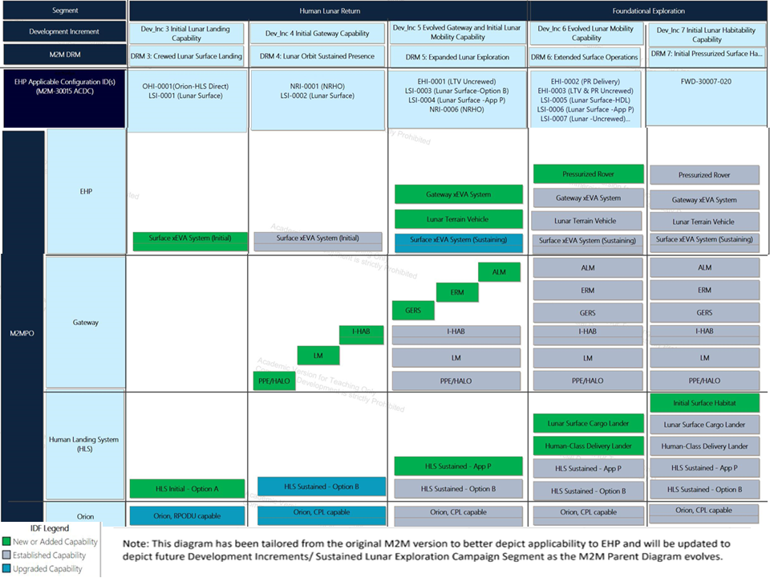
Figure 3-1 M2M Incremental Development Framework (IDF) (Tailored for EHP)

A Development Increment may encompass several missions. The M2M Development Increments are defined as:
- Initial Cislunar
- Crewed Cislunar
- Initial Lunar Landing
- Initial Gateway
- Evolved Gateway & Initial Lunar Mobility
- Evolved Lunar Mobility
- Initial Lunar Habitation
Additional details on use cases and scenarios for each Development Increment can be found in EHP-20004, Extravehicular Activity and Human Surface Mobility Program (EHP) Architecture Description Document (ADD). This architecture baseline and exploration strategy will be decomposed by DRM for the purposes of this ConOps document.
NASA’s Moon to Mars Strategy and Objectives document identifies and describes the NASA science and technology utilization goals and objectives that will be enabled by human missions. These goals and objectives have been defined by the NASA SMD, Space Technology Mission Directorate (STMD), and with the reorganization and split of the Human Exploration and Operations Mission Directorate (HEOMD), now represented by Exploration Systems Development Mission Directorate (ESDMD) and Space Operations Mission Directorate (SOMD).
The goals and objectives will be used to identify the manner in which human missions will support the science and technology communities in conducting fundamental research about our universe and solve the scientific and technological challenges for sustaining and expanding human exploration missions. The utilization goals and objectives are implemented through science and technology activities across the International Space Station (ISS), Commercial Low Earth Orbit (LEO) utilization, the Artemis missions to cis-lunar space and the lunar surface, and the first human crewed missions to Mars.
EHP capabilities are focused on crew transport and exploration, while supportive of long-term science needs to the greatest extent possible. Prioritizing interoperability and flexibility allow for updated science objectives, instrument exchange, and new technologies throughout the Artemis missions.

Moon To Mars Overview
The M2M-30007, Artemis Integrated Concept of Operations (ConOps), lays out the DRMs for the Artemis Architecture. The Artemis architecture implements the Moon to Mars Strategy and Objectives to “blueprint a sustained human presence and exploration throughout the solar system” by providing enabling capabilities in cis-lunar space and on the lunar surface through Gateway station, Human Lander System (HLS), Lunar surface elements, Exploration Ground Systems (EGS), Space Launch System (SLS), and Orion. For Artemis, NASA leads a geographically distributed team of international and commercial partners that provide hardware, software, and operations support. During real-time execution of crewed missions, Mission Control Center – Houston (MCC-H) has mission authority to ensure crew safety and mission success.
The first objective is to leverage the lunar surface and cis-lunar space to conduct experiments to learn more about the universe, our solar system, the Moon, and Earth. The second objective is to demonstrate technologies and space exploration techniques that will ultimately enable a human crewed mission to Mars.

Gateway Overview
EVA capability out of Gateway will be possible once the Gateway airlock arrives. Gateway EVAs are assumed to be performed while there are four crew on Gateway. Gateway EVAs for activities other than expected contingency maintenance are currently being assessed, as any maintenance items would need to be delivered to Gateway prior to the crew arriving. An exception would be a planned EVA to demonstrate functionality of the systems once the airlock is operational. Gateway will have the capability to perform up to two EVAs per mission, if necessary and maintenance items are available. EVA cadence and objectives will be determined in mission operation planning products. Currently, xEVA suits are planned to be delivered to Gateway and are dedicated to Gateway (i.e., lunar EVA suits are not used on Gateway). EVA operations in cis-lunar space from an airlock on Gateway will follow a similar approach to those performed from the ISS airlock. EVAs performed at Gateway will not preclude a lunar surface mission, and time may not be available for EVAs on every Artemis mission.

Lunar Surface Overview
The EHP Projects supporting operations in partial gravity on the lunar surface will begin with the xEVA System, followed by the LTV, and then the PR. Initially, two crewmembers will descend to the Moon and perform EVAs on the surface from HLS. EVAs will be performed by two crewmembers on each EVA (i.e., “buddy system”) at first by walking traverses, and then aided by the LTV to enable longer traverses and provide support to deploy payloads and transport tools, samples and eventually cargo transfer to habitable surface assets. Cargo transfer on the lunar surface will play a major role once the PR arrives, which provides a habitable mobile platform capability. The PR will have the functional capabilities to allow the two crewmembers to stay for longer durations on the lunar surface. Once a second habitation element arrives on the lunar surface, four crew will descend and live on the surface (two in the PR and two in a habitation element).
The NASA Commercial Lunar Payload Services (CLPS) allows for acquisition of lunar delivery service for payloads that could require crew interaction. International Partners will also contribute to the development of assets which could include the PR and the Initial Surface Habitat which will help extend the range that crewmembers can explore on the lunar surface to increase utilization points of interest. The Lunar Surface Cargo Lander consists of the Lunar Descent Element (LDE) and its Passenger (payloads) . ESDMD Strategy and Architecture Office (SAO) studies are ongoing for large lander concepts which include delivery of robotics, habitation, and cargo.
Landing sites and the specific mission objectives are still in work and will be referenced in mission specific Artemis MDB documentation to guide the development of systems and tools to support utilization in those locations.

Moon to Mars Terminology and Mission Descriptions
EHP leverages, and is consistent with, the M2M-developed terminology associated with Artemis which will be distinct from ISS terminology. M2M-30015, Moon to Mars (M2M) Architecture Configurations and Design Constraints (ACDC), defines the Integration Phase configurations which can be applied to the DRMs in the following sections.

Artemis Lunar Missions
Concepts of operations for the lunar surface from DRMs are outlined in M2M-30007, Artemis Integrated Concept of Operations (ConOps). The Exploration Campaign Segments addressed in the Artemis ConOps document are Human Lunar Return, Foundational Exploration, and Sustained Lunar Evolution. DRMs 1 and 2 are not directly applicable to EHP. DRMs are described in M2M-30007 as:
- DRM 3: Crewed Initial Lunar Surface Landing
- Initial Surface Capability
- DRM 4: Lunar Orbit Sustained Presence
  - Initial Gateway Capability
- DRM 5: Expanded Lunar Exploration
- Evolved Gateway w/Airlock & Initial Lunar Mobility – LTV
  - LTV Uncrewed Surface Operations
  - Gateway EVA
- DRM 6: Extended Surface Operations
- Enhanced Lunar Surface Mobility Capability – PR
  - PR Uncrewed Operations
  - Lunar Surface Cargo Lander
- DRM 7: Initial Pressurized Surface Habitat
  - Habitation Capability includes ISH
- Non-Polar Sortie DRM
Lunar missions will allow for continued scientific research of the Moon, along with providing a critical test bed for concepts of systems bound for Mars. These missions will progress with a phased approach, starting with smaller short missions and expanding to a long duration, sustained human presence on the surface. These missions will initially take place in a south polar region (84 to 90 deg south), with occasional sorties to different non-polar landing sites spread across the surface of the Moon (Non-Polar Sortie DRM). xEVA System cargo will be dependent on the number of EVAs and duration, science objectives/tools, and xEVA suit providers for each mission and each DRM. xEVA system mass can vary from a mission-to-mission basis but is constrained in requirements. No EVAs will take place from HLS in Near-Rectilinear Habitation and Logistics Outpost (HALO) Orbit (NRHO).
This ConOps will lay out lunar DRMs with further EHP level detail for crewed Artemis missions as well as uncrewed ConOps for Supporting Mission Excursions. This includes autonomous, semi-autonomous, and remote operations of the LTV and PR.

DRM 3: Crewed Lunar Surface Landing - Initial Lunar Landing Capability
Initial missions to the lunar south polar region will consist of two crewmembers going to the lunar surface for approximately 6 days. The number of EVAs could vary depending on vehicle capability, xEVA suit capability, utilization objectives and crew time; however, the capability to turn around and perform daily EVAs within the given mission parameters will be available. Currently, Artemis III is consistent with the DRM 3 mission profile.
Table 4-1: DRM 3 Key Parameters
Surface System Configuration | HLS, xEVA
Key Objectives | - Demonstrate Surface Landing Capability  - Conduct geological traverses, perform science observations and activities including the collection of a variety of samples to return to Earth for later research
Key Parameters | Surface Crew | 2
Key Parameters | Surface Stay | ~6 Days
Key Parameters | Goal for EVAs per Crewmember | Up to 4 Planned + 1 Unplanned
Key Parameters | EVA Range (from HLS) | < 2 km

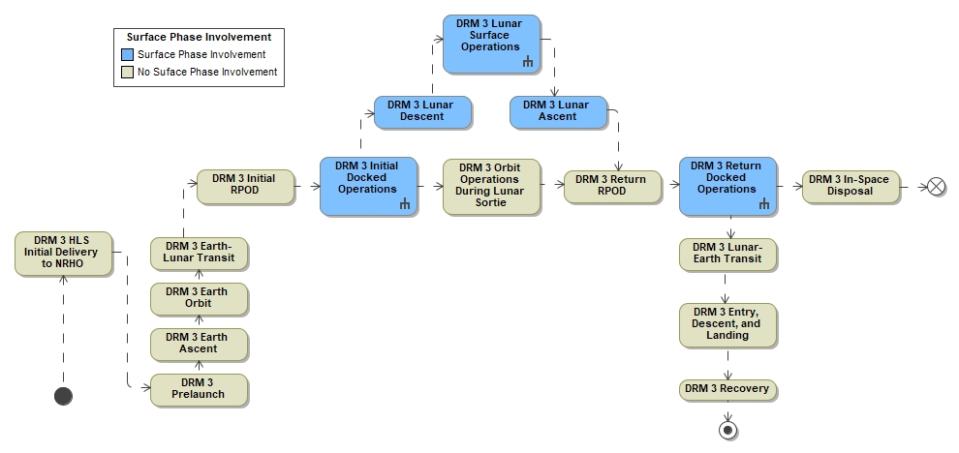
Figure 4-1: DRM 3 Overview
The first DRM 3 mission is a direct dock between HLS and Orion prior to lunar descent. Two crewmembers stay on Orion, while two crewmembers transfer to HLS for the lunar surface sortie.

DRM 3 Initial Docked Operations
Most of the EVA equipment is launched on HLS for the two crew that go to the lunar surface. Some equipment (i.e., EVA prime and backup gloves, cameras, map books, cuff checklists, backup crew swap sizing components, etc.) may be sent with the crew on Orion to ensure proper fit. HLS-PAP-034, Backup Crew Strategy for Sustained Lunar Missions, lays out the HLS Program Backup Crew Strategy for Sustained Lunar Missions. In addition to the primary crew, it is necessary to define a strategy for backup crew members to protect against a pre-launch or post-launch setback that impacts the ability to complete the mission. While a small amount of equipment may be able to launch in Orion, there will be significant mass and volume limitations. Thus, it is expected that only a small amount of EVA equipment will launch on Orion. Backup crewmember items are also sent in HLS and will be swapped out as necessary. As needed, remaining crewmember backup items and launch packaging will be transferred to and left on Orion.
When the crew has completed on-orbit tasks such as xEVA suit assembly and xEVA suit checkouts (i.e., power, audio, telemetry) in the lander airlock, the xEVA suits will then be configured for lunar descent. Prior to descent, the crew don their HLS-provided Intravehicular Activity (IVA) suits, and wear those during the undock, portions of the descent phase, and lunar landing phase to ensure crew safety.
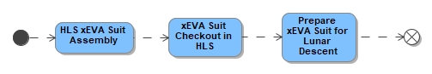
Figure 4-2: DRM 3 Initial Docked Operations

DRM 3 Surface Operations
Immediately following lunar surface touchdown, the HLS and crew, in coordination with MCC, will determine Authority to Proceed (ATP) with the surface mission. Following ATP, the HLS and crew will begin surface stay preparations. This segment includes doffing and stowing their IVA suits, vehicle safing, and cabin reconfiguration. A more complete description of HLS operations can be found in HLS-CONOP-001, Human Landing System (HLS) Concept of Operations (ConOps) – Initial Phase Mission (Artemis III).

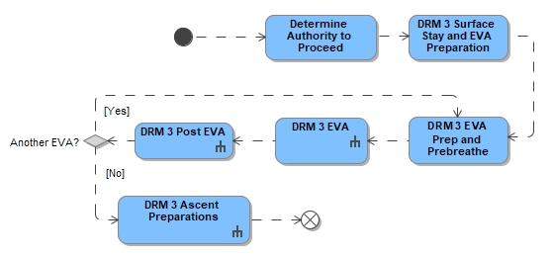
Figure 4-3: DRM 3 Surface Operations Overview
The crew will live in the lander for a surface duration of approximately 6 days during lunar daytime and will perform EVAs from one of two airlocks. Only one of the airlocks will be utilized for nominal EVAs on initial missions.
The xEVA Suit Consumables Recharge and the EVA System Checkout events may need to take place due to the previous on-orbit xEVA suit fit check/checkout in preparation for the first human lunar return EVA. The number of EVAs performed from HLS will be between two and four EVAs (plus one reserved EVA in event of an unplanned or additional EVA need) depending on HLS capabilities and mission science objectives, with each EVA planned to be 4 to 8 hours long (plus one hour of reserved consumables in the event of a contingency). The xEVA suit has reserve consumables to support a one-hour contingency return for most suit failures. This one-hour contingency return includes the following activities: recognition of the failure, alerting Extravehicular (EV) buddy, return to the lander, entering the lander, ingressing the airlock, and repressurizing the airlock.

EVA Technical Objectives
EVA technical objectives are driven by EHP and EVA Providers and include but are not limited to the following:
- Demonstrate xEVA suit systems performance during IVA and EVA activities.
- Demonstrate xEVA suit mobility and outward visibility performance.
- Demonstrate Lunar Surface Navigation and Traverse Techniques
- Demonstrate EVA tool and sample containment functionality.
- Evaluate lunar dust mitigation activities, including dust transfer, across all vehicles and xEVA suit systems
- Collect EVA metabolic rate data during high met rate activities.
- Perform Inspirational Outreach Activities
- Enable crew to deploy science instrumentation packages on lunar surface
- Demonstrate communications range between HLS and EVA suited crewmember on a 3GPP system

DRM 3 Road-to-EVA
EVA operations on the lunar surface include Road-to-EVA, prep and prebreathe, surface operations, post-EVA, and maintenance. The "Road-to-EVA" is a comprehensive list of all the activities that occur before and up to the day prior to the start of a planned series of EVAs. It includes preparing the EVA Suit and vehicle interfaces, the lander/airlock, and the tools and equipment, in addition to the crew preparing themselves.

DRM 3 EVA Preparation and Prebreathe
On the day of the EVA, the crewmembers begin preparation activities, including a Private Medical Conference (PMC) and the prebreathe protocol (as applicable). Once the required prebreathe protocol is complete and the crew are ready to egress HLS, the crew initiate cabin/airlock depressurization. The “EVA” phase elapsed time (PET) begins when the spacesuit is switched from the vehicle-provided power source to internal suit power (i.e., batteries).

DRM 3 EVA
The EVA crew open the hatch and gather any equipment they may bring with them from inside the cabin/airlock to the surface. Crew will conduct a final check of tools and equipment on harnesses attached to their xEVA suit and/or in equipment/tool bags. They will destow any tools and equipment from HLS. This may include dust mitigation tools, sample collection tools and instruments, along with equipment to transport tools and samples. They then descend down to the surface, utilizing a fall protection system if required. Refer to HLS-CONOP-001 for further information.
Once on the surface, the crew will set up the tools and equipment that are needed for their tasks. The crew will transport smaller tools and equipment to the worksite either directly attached to their xEVA suits or with a harness/carrying system. Larger tools and storage boxes will be transported with an equipment transportation system such as a tools caddy (e.g., a wheeled cart). The crew may also setup the EVA Remote Observation Camera (EROC).
In addition to task equipment, the crew will also place the dust mitigation kit where it can be accessed at the end of the EVA. This set of tools will be part of the dust mitigation strategy that the crew will follow during ingress towards the end of the EVA.
One of the first tasks on the first EVA will be collection of an initial sample. This will provide a small science return in the event of any abort. Crew will conduct a multitude of science-focused tasks on the surface, including observations and imagery, acquisition of data, deployment and retrieval of instruments, and acquiring physical samples for return to Earth. Science tasks will also involve deploying handheld instruments, surface deployed instrument packages, and instruments requiring prolonged crewmember interaction. Imagery using the Handheld Universal Lunar Camera (HULC) during lunar surface EVAs helps to accomplish mission science objectives during traverses and for imaging science targets.
Although unlikely for initial Artemis missions, some tasks will require the EVA crew to scramble up and down steep slopes, possibly using a walking aid to avoid scrambling, traverse across regolith, volcanic terrain, traverse down into craters and back up out of them, and work near or inside Permanently Shadowed Region (PSRs). This will be dependent on orienteering tool and lighting capabilities. They will primarily perform geology tasks, characterizing the area and acquiring sample materials. During an EVA, the crew will explore distances up to 2 km away from HLS, once the EVA system has been demonstrated to provide for safe contingency return from this distance.
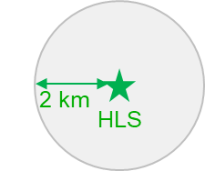
Figure 4-7: Exploration EVA Range From HLS for DRM 3
Nominally, upon completion of an EVA, or having reached predetermined consumables or time limits, the crew will gather their tools, samples, and equipment, and stow them. The crew will pack equipment and science samples into the equipment transportation system and begin traversing back to the lander. Once back at the lander, the crew may then start the dust mitigation procedure to reduce what is brought back into the vehicle. Dust and contamination accumulated on the surface of the xEVA Suit is mitigated prior to ingress of the airlock to limit contamination to the habitable volume and is achieved via both EVA system-provided methods and vehicle-based hardware. These steps will include cleaning the xEVA suits, bags, tools, and hatch in a multi-layer approach. Note that in some contingencies, dust removal may not be possible prior to ingress.
Once this portion of the dust mitigation process is complete, the crew will begin ascent into the lander, utilizing any fall protection that is required. At the hatch, the crew may conduct more dust mitigation steps, and then will work together to move the sample bags inside and stow them according to the science plan. They will restow any tools and equipment that must come inside in the proper stowage location in HLS. After ingress, the crew will connect umbilicals to the xEVA Suits and switch to vehicle power and consumables. The crew will then close the hatch and begin repressing the lander/airlock. The EVA PET clock officially ends after repressurization has initiated.
Each EVA will be planned to end with the vehicle in a launchable configuration. EVAs will allow enough time to ensure all hardware (xEVAS, HLS, and Utilization) is stowed appropriately prior to ingress to leave HLS in a known launch-ready configuration for both contingency and planned launch. The specific configurations for contingency launch (between EVAs in the series) and planned launch (after the final EVA of the series) remain to be defined.
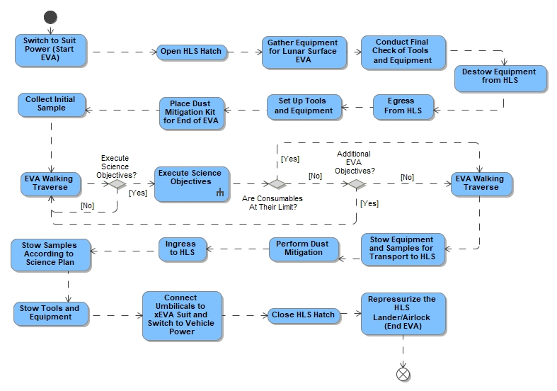
Figure 4-8: DRM 3 EVA
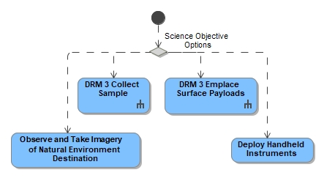
Figure 4-9: DRM 3 Science Objectives

DRM 3 Utilization Operations
Artemis human missions designed to explore new and diverse areas of the lunar surface are necessary to collect critical science data, to address high-priority Artemis science objectives, and to prepare for longer duration Artemis missions in the future. As NASA explores new terrain, the ability of scientifically trained crewmembers to provide detailed geologic descriptions and document their findings will enable a new view of lunar science. The meticulous collection, curation, and return to terrestrial laboratories of lunar samples will unlock a new era of lunar and planetary science. The in-situ use of both handheld instruments during traverses and deployed science payloads at different locations on the Moon will provide crewmembers and science teams with crucial data, both during an exploration mission and post-crew departure. Activities to characterize and understand the geology of the lunar south polar region are the foundation for a utilization plan for resources (e.g., sunlight, water, and other volatiles) that could be used to establish a long-term human presence on the lunar surface. At Regions of Interest (ROIs), the EVA crew will primarily perform geological tasks, characterize the area, and acquire sample materials. They will move and assemble hardware, take measurements of fields or the environments, and deploy utilization instruments. Reference ESDMD-409, Strategic Utilization Planning Agreements for further details on NASA’s science and technology utilization goals and objectives that will be enabled by human missions.
This section will provide potential examples of operational scenarios for the mission. It is not intended to document every possible science/technology objective but to display concepts to drive requirements.

Lunar Sample Collection
On the lunar surface, EVA crew will conduct a multitude of science-focused tasks that trace to landing site specific objectives within the mission Science Traceability Matrix. Once in ROIs, the crew will apply pre-mission geoscience training to explore and characterize an area, conduct initial inspections of the surroundings, record context documentation, and utilize sample markers to identify target samples.
Science operations will include the EVA crew navigating to new or recurring ROIs with tools necessary for sample collection. The EVA crew may utilize navigation systems to confirm their location, allow MCC to track their progress, allow crew to safety return to the lander, and record position data with the necessary accuracy needed by the science team. Several different types of Regolith samples can be taken on the lunar surface, including bulk (scoop) samples, Core samples taken with a Drive Tube, Surface Samples taken with a Contact Sampler, Volatiles, and Trench samples. Geology sample collection will need to be orchestrated such that samples are collected on the side of the suit opposite to the vacuum access port, to ensure that there are no suit exhaust contaminants in the collected samples. There are several different kinds of rock samples that can be retrieved from the Lunar Surface, including float, chip, or rake samples. Samples are weighed either EVA or IVA before going into an IVA sample return pack. Reference EVA-EXP-0042, Extravehicular Activity and Human Surface Mobility Program (EHP) xEVA Systems Concept of Operations (ConOps), for further details on Lunar xEVA Operations and xEVA Tools.
Furthermore, the Artemis Science Definition Team Report (NASA/SP-20205009602) provides a nominal candidate sampling program appropriate for Artemis crewed sortie mission periods to support necessary science investigations. The Lunar Exploration Analysis Group (LEAG) Curation and Analysis Planning Team for Extraterrestrial Materials (CAPTEM) Review of Sample Acquisition and Curation During Lunar Surface Activities report, dated 1 September 2010, provides additional historical data on the Apollo sampling program and lessons learned that can be drawn upon while planning the next lunar sample collection opportunities.
Table 4-2: Geology Sample Types
Type of Geology Sample | Sample Method
Regolith | Bulk  Surface  Core  Volatiles  Trench
Rock | Float  Chip  Rake

Deployed Surface Instruments
Science operations will include deploying science instrumentation packages by the crew on the lunar surface. Instrument examples include geophysical and environmental monitoring, instruments to investigate the effects of long-term exposure of materials to the lunar surface environment, and other surface instruments that will address priority science objectives. Inside HLS prior to the EVA, the crew may assemble, charge batteries, perform a checkout of the science payload hardware, and temporarily stow payloads in a location easily accessible for removal. Payloads may also be accessible from an unpressurized location on HLS and uninstalled from the vehicle for deployment during the EVA.
Once the crew transfers the payload to the lunar surface, the crew then carries, or delivers via cart or carrier, the science instrument to its intended location. The crew will proceed to deploy the payload, which may include orienting antennas, solar panels, or the payload itself, in the correct position or ground installation. Following deployment, the crew may need to power on the payload, perform calibration steps, and verify the payload is in a nominal operational state with confirmation from the ground team. While the crew traverses along the lunar surface completing other tasks, the payload will continue to collect data. Data path to the ground may include multiple options to route data through the lunar assets or could be self-contained. Once the data is received on the ground it then will be distributed to the Payload Developer who confirms the instrument is operating nominally. Science instrumentation and/or non-geological samples (e.g., hard drives, regolith-derived products, biological specimens, etc.) may be collected by the crew following other task completion and taken back inside the crew lander or may be left behind on the lunar surface to continue science collection during uncrewed periods. Deployed surface assets will be impacted by the HLS Plume Field unless protected by terrain or located outside the interaction zone.
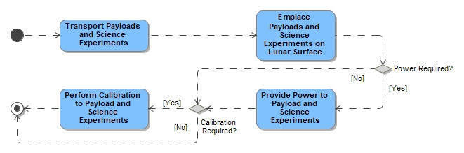
Figure 4-11: Emplace Surface Payload

Portable/Handheld Science Instruments
Portable/Handheld science instruments may aid the crew during their geological tasks and can provide valuable insight to the science team’s determination of sample collection. For example, an X-ray Fluorescence spectrometer could be used to determine the elemental composition of materials in lunar samples. A temperature sensor may also be utilized to provide additional data of the sample environment within shadowed regions. Pre-EVA, the crew would gather the instrument, verify the instrument battery is fully charged, verify the instrument is operational, and temporarily stowed on the xEVA suit, tool cart, carrier, or bag for use during EVA. Once at the ROI, the crew will utilize the instrument to collect data on candidate samples. The data will be transmitted manually or automatically (by the crew or flight controllers) to the ground team for documentation. and the crew will then receive further direction from the science team on samples to be collected. Once complete with data collection, the device would then be hand-carried or stowed on the xEVA suit or Tool Cart for the traverse back to HLS.

DRM 3 Post EVA
Following ingress, the crew will conduct post-EVA activities. Turn-around time is from EVA start of repress and ends at switch to internal xEVA suit power of next EVA. Crew time must be coordinated between EHP systems, host vehicles, and any other systems supporting EVA to enable minimal crew intervention for the system to be turned around within 16 hours. The don/doff aids will provide structure for crew to don/doff the suit unassisted. The HLS Environmental Control and Life Support System (ECLSS) will help to remove any particulates in the atmosphere. Crew may don HLS Personal Protective Equipment (PPE) until dust levels are acceptable. After cleaning, inspection, and xEVA suit recharge is initiated, the required xEVA Suit data is downloaded. Note that most of the data download occurs automatically via Wi-Fi interface; however, some data may need to be downloaded manually.
In addition to post-EVA inspections, the xEVA suits may require maintenance, however, no preventative maintenance is foreseen for Artemis III or IV. Maintenance may include replacement of gloves. A post-EVA PMC is conducted with each EVA crew. Also, a post-EVA conference with MCC and Science Team is conducted to debrief on the EVA.
Note: Post-EVA PMCs may serve as pre-EVA PMCs for subsequent EVAs to assess crew health and readiness.
Reference EVA-EXP-0042, Extravehicular Activity (EVA) Office Exploration EVA Systems Concept of Operations (ConOps), for further details on Road-to-EVA, xEVA Systems Prep, prebreathe, egress and setup, science tasks, cleanup and ingress, maintenance, and post EVA operations.
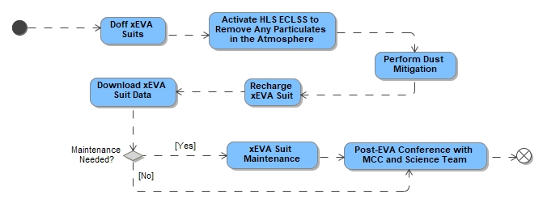
Figure 4-12: DRM 3 Post EVA

DRM 3 Communications, Navigation, and Lighting
DRM 3 xEVA suits provide simultaneous communications between HLS and EVA crewmembers and/or potential lunar surface communication relays by providing video, voice, and suit data communications and crewmember biomedical telemetry. All real-time communication between EVA crewmembers and Earth will be relayed via HLS.
Real-time transmission from xEVA suit is always subject to momentarily loss of data. Since all data recorded during an EVA is likely to be of interest, only having one chance to receive it would be problematic. After an EVA is completed, additional data (that was either not selected broadcast real-time or data that was lost in transmission) may be downloaded from the xEVA Suits and/or EVA equipment/sensors. Once transferred to HLS, the data is subsequently transmitted from HLS to Earth via the same paths listed above.

xEVA suits using Ultra-High Frequency (UHF) (for audio/telemetry) and Wi-Fi (for video/telemetry) may encounter limitations on distance the crew can traverse (<2 km) from HLS. HLS provides the vehicle side of the EVA wireless radio, antennas, and hardline audio and data connections for the xEVA System umbilicals for two-way communications of EVA voice/data as well as downlink of EVA video.
Time synchronization takes place by using Network Time Protocol Version 4 (NTPv4) compatible format such that all systems can synchronize and agree on a time stamp reference.
The crew will stay in communication with the lander according to Flight Rules. They will walk across regolith and around boulders. Depending upon orientation tool and lighting capabilities, the crew may transit up/down slopes of up to 20°, in long shadows, and into PSRs. The crewmembers will likely go into a small, shadowed area (an area smaller than ~5 meters) and collect a sample to be returned in a vacuum sealed container under ambient conditions. These small, shadowed areas are sometimes called micro-PSRs or cold traps; within this document, a “small shadowed area” is an area where the surface temperature remains below the nearby surface temperatures. Reference AIST010 Artemis Internal Science Team (AIST) Adjudication Memo.
Crew will use coarse navigation systems and navigation aids to determine their location and headings to reach the science stations, navigate to waypoints, and return to the lander.
For Artemis III, the crew will have orienteering tools (prototype shown in Figure 4-11), and an in-flight demonstration of a handheld navigation device. Traverses are expected to be planned where crew have visibility of the lander and to avoid PSR or long shadows. The handheld device will be capable of a coarse accuracy of 150 m/10deg in position and heading respectively. Both verbal communication and helmet camera feeds will allow the MCC-H to track the crew location and progress improve the chances of a safe return to the lander both nominally and in a contingency.
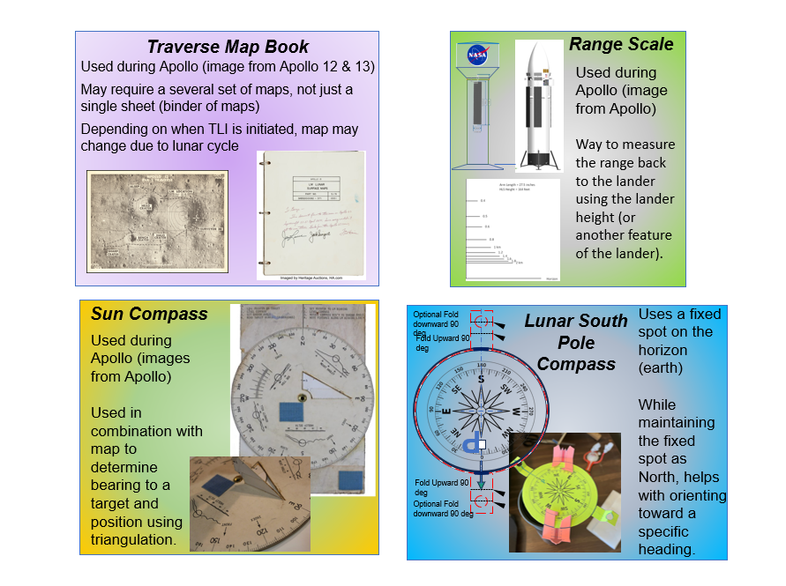
Figure 4-13 EVA Navigation Orienteering Tools Prototypes
The crew will experience constant long shadows near the lunar South Pole, while also looking nearly directly at the Sun. In order to traverse safely and effectively through the partially and fully shadowed terrain, across rough terrain and slopes, and into PSRs, crew will need to have access to supplemental lighting options and countermeasures (e.g., sun visors, reflective material, etc.). Supplemental lighting options could include xEVA suit-mounted (lights that move with the crew's change of field of view), portable lamp stands (handsfree) that can be placed around a task area away from a major surface asset, high intensity spotlights for viewing far away targets, and handheld illumination options that allow the crew flexibility to direct light in specific directions. The integrated surface lighting plan will be unique for each task for each lunar lighting condition and that task's position with respect to other major surface assets. Early Artemis missions may have limited lunar surface EVA task capability because of limited lighting countermeasures and surface assets not yet in place to maintain crew safety. The quantity of lamps, the power allocation, the optics, and positioning are all unique to the tasks and surface conditions. These surface assets require planning for the mission and DRM through human in the loop evaluations, integrated lighting and cameras evaluations, safety assessment and physics-based lighting prediction models and simulations. Traverses and tasks will need to consider the full lighting spectrum, from direct Sun to dark shadows. Thermal ranges in dark shadows will also play into EVA duration in these areas.
Artemis EVA surface operations will experience low angle sunlight that is very slow to change due to the lunar month-long day/night cycle. This low angle sunlight creates extremely long shadows; overhead lighting from the sun is not present. The persistent lack of overhead lighting for general and specific tasks creates a need to provide light at angles that best illuminates the ground and tasks located at “working heights” (waist level). Overhead lighting requires consideration on operational work area, mounting height, glare, power, beam distribution, and quantity of light sources. Lighting systems architectures should be driven by the limitations of the environment and surrounding architectures where the task is located, along with consideration of task performance goals and limitation of the humans and machines required to operate within that environment. The simple assessment of “provide a light and problem is solved” does not take into consideration the challenges associated with human adaptation nor limitations of imaging systems required to operate within that environment. There are many potential tasks the crew could experience, but the following should be accounted for and provisioned accordingly, while considering challenges presented by the lunar lighting environment:
- Inspections of surface support hardware and lander surfaces for damage – Inspections could be direct visual observations by the crew and also include the usage of camera systems for reporting information to the ground. Environmental conditions could be high contrast, so the crew needs to be provisioned with lighting to improve quality of visual inspections of areas that appear to be poorly lit due to shadowing, dark materials, or high contrast due to shadows.
- Translation via walking or jumping– Visual challenge is recognizing hazards to avoid injury. Hazards could be hidden depending on lighting conditions.
- Performance of maintenance and repair tasks – Maintenance and repair will require more illumination than simple translation because of higher visual acuity needs. High-contrast surface lighting conditions could influence lighting countermeasures and operations plans for maintenance activities. Lighting accommodations need to maintain high-quality light source spectrums to maximize color and color contrast for the observer (crew and camera).
- Performance of science inspection tasks – Lighting conditions need to support Science tasks such as rock collection and can require comparable characteristics to those needed for maintenance and repair tasks. Lighting accommodations need to ensure spectral output, maximize color rendition and contrast for observers including crew and camera imagery.

Lunar Walk Back Distance (No Rovers)
The xEVA Suit will enable EVA crew the ability to ambulate (walk) on the lunar surface. This includes being able to support a walking traverse of up to 2 km radial distance away from the lander on the lunar surface, though distance depends on the local terrain and communication ranges. The EVA crew must have the ability to return safely to the interior of a pressurized vehicle within the contingency capabilities provided (a one-hour window per requirements) in the event of specific contingency scenarios, such as a failure of the primary ventilation system, thermal control, or power. The EVA crew must have the ability to return safely to the interior of a pressurized vehicle within a one-hour window in the event of specific contingency scenarios, such as a failure of the primary ventilation system, thermal control, or power. Traverse ranges are based on the xEVA contingency systems providing an hour of contingency capability Determination of traverse range must account for several return traverse factors such as terrain, crew metabolic rate, lighting conditions, navigation, hardware provider design, etc., and consider time for potential contingency identification, and pressurized vehicle ingress. These factors for traverse range may mean the crew needs to walk faster than 2 km/hr. to return to a safe pressurized vehicle or other operational constraints may be necessary. See Integrated Contingencies section for further details.

DRM 3 Ascent Preparations and Orion Docked Operations
Prior to crew departure from the destination, the crew will prepare/stow the xEVA suits and any other tools for ascent. The crew don their IVA suits for HLS ascent and docking to Orion. Once docked to Orion, the crew transfer to Orion any samples for return to Earth, and any launch packaging/hardware previously left on Orion to HLS for disposal. xEVA suits are left on HLS for disposal.
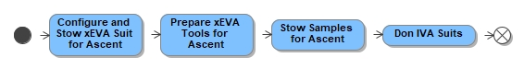
Figure 4-14: DRM 3 Ascent Preparations

Non-Polar Sortie DRM
Non-polar sortie missions will be very similar to Artemis III and IV missions; however, environments and lighting will be different. The surface stay time will be no longer than 6 days but may be shorter (e.g., 2-day threshold) if the mission calls for a longer time in-transit from NRHO or in Low Lunar Orbit (LLO) loiter.

DRM 4: Initial Gateway Capability
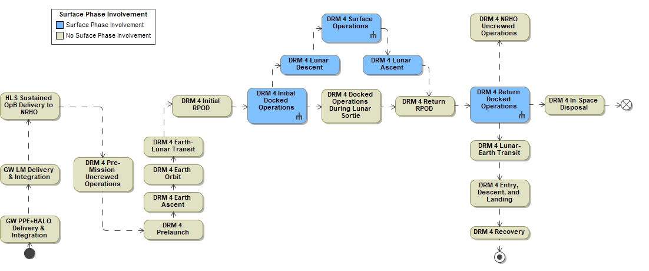
Figure 4-15: DRM 4 Overview
Gateway operations become a part of subsequent Artemis missions involving two crew to stay on Gateway and two crew to descend to the Moon. Gateway provides no capability for Gateway EVA or xEVA suit servicing hardware, such as umbilicals for power, battery recharge stations and other fit check hardware interfaces, prior to arrival of the Airlock. xEVA activities requiring the use of vehicle interface equipment will not take place on Gateway until then.
If lunar cargo is sent to Gateway, crewmembers will unpack and transfer to HLS any equipment needed for lunar descent. Additional cargo items are required in NRHO to allow for the contingency substitution of an HLS crewmember prior to the surface mission. The additional cargo allows for resizing of EVA systems and replacement of personal items prior to HLS departure to the surface. Backup crew equipment does not nominally need to be delivered to the lunar surface but rather can be left at or relocated by the crew to Gateway prior to the crewed HLS mission. If backup crew equipment is utilized, it will replace a similar set of HLS equipment of equivalent mass. HLS-PAP-034 lays out the HLS Program Backup Crew Strategy for Sustained Lunar Missions.
The crew will prepare for descent to the lunar surface, including transfer of necessary equipment to HLS, assembly of xEVA suits and partial xEVA suit checkouts inside the designated HLS airlock. Any packaging will be left behind at Gateway in the Logistics module for disposal.
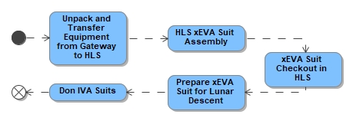
Figure 4-16: DRM 4 Initial Docked Operations
All real-time communication between EVA crewmembers and Earth will be relayed via HLS, as listed below.
- HLS relay with Gateway
- HLS direct with Earth
- HLS relay via Lunar Communications and Navigation Systems Service (LCRNS)

For Artemis IV, the crew will have the certified handheld display and navigation device along with visual indicator(s) that can be deployed during the traverse and/or located on the lander. The orienteering tools will serve as a backup method. This configuration should enable further range from the lander, or more complex traverse paths, as well as a means to quickly return to safety in the event of a contingency.
The remainder of the mission will look much like Artemis III in the sections above with the exception of specific science objectives and return to Gateway after the surface mission is complete.

DRM 5: Expanded Lunar Exploration - Evolved Gateway & Initial Lunar Mobility with LTV
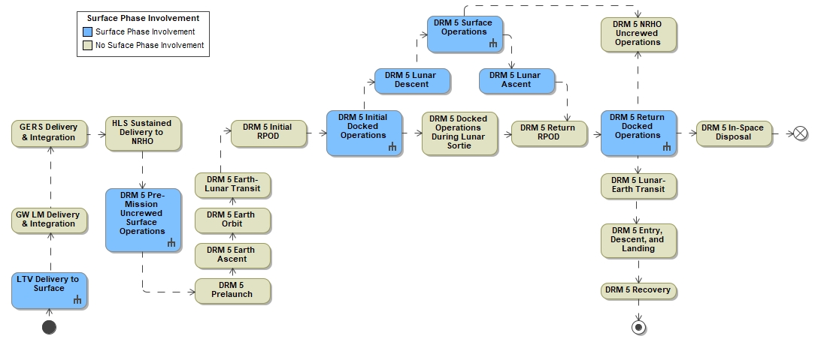
Figure 4-17: DRM 5 Overview
Operations are similar to DRM 3 in duration and will consist of two crewmembers staying on Gateway while two crewmembers descend to the lunar surface. The main difference for lunar surface operations from prior missions will be the availability of the LTV which allows the crew to explore further from the landing site, increasing utilization destinations. The LTV is delivered and deployed by the lander to the lunar surface without assistance from crewmembers. Refer to the LTV-CONOP-001, Lunar Terrain Vehicle (LTV) Concept of Operations (ConOps), for further information on the launch, landing and deployment of the LTV. The LTV will support one crewed mission per year of varying durations, as well as support science activities telerobotically between crewed missions. The LTV may be utilized for surface characterization to help with future landing site selection for both cargo landers and future human landers, as well as utilized in support of addressing key science investigations independent of crewed activities. Preventive maintenance operations are under assessment <FWD-EHP-10033-035>.
The locations of the landing sites are still to be determined. Key parameters for the missions are shown in the table below:
Table 4-2: Crewed Lunar Missions with LTV Key Parameters
Surface System Configuration | HLS Sustained, xEVA, LTV
Key Objectives | - Conduct geological traverses, perform science observations and activities, characterize, and document the regional geology, including small PSRs.  - Collect a variety of samples to return to Earth for later research.  - Perform capability demonstration of advanced traverse capabilities with LTV.  - Deploy technology demonstration packages and instrumentation
Key Parameters | Surface Crew | 2
Key Parameters | Crewed Surface Stay | ~6 Days
Key Parameters | Proposed Number of EVAs per Crewmember | 4 Nominal + 1 Unplanned
Key Parameters | EVA Range with LTV (from HLS) | 10 km radial distance
Key Parameters | Uncrewed NASA Surface Operation Duration | 4-8 months
Key Parameters | Service Life | 10 years

The LTV-CONOP-001 defines the operations on the lunar surface for LTV. The LTV is an unpressurized lunar rover capable of carrying two crewmembers who manually operate it, carrying equipment during crewed lunar surface missions (e.g., payloads, tools caddy, samples and sampling equipment, etc.), and executing uncrewed surface activities via autonomous and teleoperated (or remotely operated) control. Use of the LTV occurs year-round, including during seasonal periods when the vehicle may need to follow the Sun for charging and thermal purposes to arrive at designated sites during peak lunar winter seasons. Industry has indicated the desire to use LTV for commercialization purposes which will be weighed with these seasonal periods and NASA utilization. Prior to the next crewed mission, LTV is responsible for getting within range of that HLS landing site.

Autonomous, Remote, and Manual Operations on Lunar Surface
Starting with DRM 5 and the arrival of the LTV, and through subsequent DRMs, including the arrival of the PR, EHP will enable autonomous, semi-autonomous, and remote capabilities. Autonomous Operations are those where the vehicle is assigned both the authority and responsibility for the decision to execute a behavior. Semi-autonomous operations occur when an operator agent has the decision responsibility to initiate a behavior and the vehicle has only the authority to execute the behavior. Both Autonomous and semi-autonomous operations may include pre-programmed automated sequences depending on the behavior or task. Autonomous and semi-autonomous functionality will be used, where practical, to enhance vehicle operability and safety.
Remote or teleoperations are those in which control input to the vehicle is initiated by an operator not on board the vehicle. Manual operations are those in which an onboard crew operator is controlling the vehicle.
Depending on the task or mission objective, autonomous, semi-autonomous, remote, and manual operations can be executed in combination, where control of individual system behaviors is shared jointly between the vehicle and an operator. For example, an onboard crew or ground operator could be driving the vehicle between waypoints and the vehicle independently initiates an automated response to a fault or hazard, such as a Warning annunciation.
Time-critical behaviors where the time to effect (TTE) exceeds communication latency expected with remote operations or where the behavior is dependent on local vehicle sensor/imaging system data are those generally initiated autonomously by the vehicle. These behaviors may include automated sequences to achieve:
  - Vehicle Safing in the Event of Unexpected Loss of Communications
  - Hazard Detection and Response (including Collision Avoidance)
  - System/Sub-System Fault Detection
  - Communications Signal Acquisition/Re-Acquisition and Relay
  - Monitor and Send Vehicle Data, e.g., sufficient to operate vehicle
  - Caution, Warning, and Advisory Alerting
Autonomous operations may be manually overridden by an operator in instances where the system is exhibiting unexpected or unacceptable behavior.
Remote operations will be employed for command and control of the LTV and PR during uncrewed mission timeframes and during crewed missions to maximize crew efficiency and safety. Remote operations can also take place while the crewmembers are EVA off of the vehicles. A control hierarchy will be in place to prioritize crew manual operation over autonomous, semi-autonomous, or remote operations. Additionally, software maintenance will be enabled by the ability provide remote software updates in accordance with EHP-20057 EHP Cybersecurity Implementation Plan, EHP-10009 EHP Program Protection Plan and EHP-10108 Lunar Surface Integration Phase Command and Data Handling Specification
In order to manage the Earth-to-surface communication latency challenges, with an aim to evolve Mars-forward capabilities, there is a goal for EHP uncrewed rovers to incrementally increase remote and autonomous capabilities over time as confidence is established and more is understood about the landscape in which the rovers will operate. When uncrewed, the vehicle will traverse to a selected waypoint or along a planned closed-loop route. It will navigate in a manner that ensures vehicle safety by avoiding both perceived hazards as well as pre-established keep-out zones (either through operational planning or vehicle capability). If the vehicle cannot find a safe path to the waypoint, or reactive safety checks exceed limits, it will stop and wait for ground or remote operator intervention before continuing.

Crewed Lunar Mobility with LTV Surface Operations
The LTV-CONOP-001 defines the operations on the lunar surface for LTV. The LTV can be used to gather pre-flight data on human landing sites and expected EVA paths, carry equipment, serve as a data gathering tool, serve as a mobility platform for science activities, cargo transport, and/or payload utilization. The LTV is delivered by a commercial lander, deployed without assistance from crew, and checked out prior to the launch of the crewed mission.
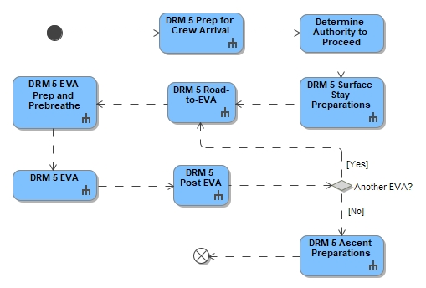
Figure 4-18: DRM 5 Surface Operations

Prep for Crew Arrival
Prior to each crewed landing during the increment, the LTV is commanded to traverse to a location outside of the landing range accuracy and plume impingement of the HLS, yet still to be within range to video the HLS descent and landing <FWD-EHP-10033-011>. The LTV is then nominally teleoperated to a safe distance in order to take video of the EVA crew egressing HLS.
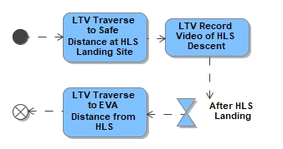
Figure 4-19: DRM 5 Prep for Crew Arrival

DRM 5 EVA
Once crew are on the lunar surface, the LTV will be configured and prepared for crewed operations. The crew will egress HLS for EVA, as in DRMs 3 and 4; refer to HLS-CONOP-001 for further information. During an EVA, the LTV will be used to explore distances up to 10km away from HLS. Typically, the crew will manually drive the LTV, but the LTV can be remotely commanded to support EVA, if needed. The crew will drive the LTV to and between exploration stations/areas of interest and will traverse on foot within a station to complete tasks. The crew will likely remain within close proximity (e.g., within ~500m) of LTV to take advantage of the vehicle’s ability to carry tools, equipment, and samples. The crew may traverse into terrain that the LTV is enabled to enter but is within EVA suit capability (e.g., areas with unfavorable rocks/terrain for LTV but within safe limits of the suit).

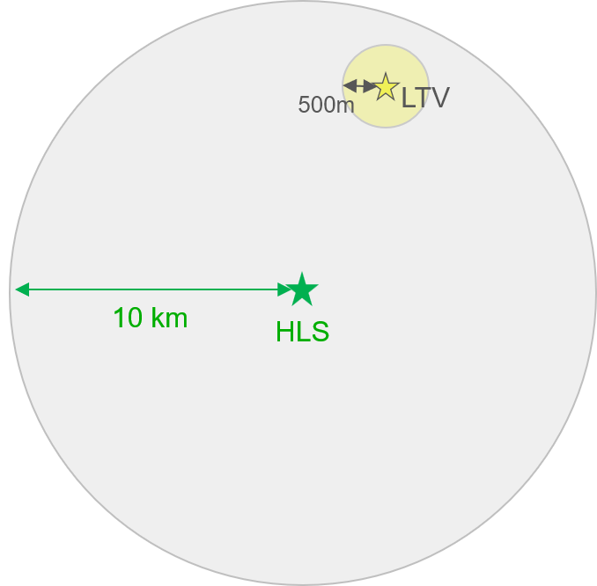
Note: yellow circle can move within grey circle during an EVA

Figure 4-20. Exploration EVA Range from HLS for DRM 5
Crew-to-vehicle separation distance can be up to 500m but crew will likely remain in closer proximity to LTV (e.g., so LTV can support tool carrying, sample stowage, etc.)

The LTV has allocated stowage locations for NASA payloads which could be science-related or mission systems. LTV is not expected to carry an additional transport system to move tools or assist in contingencies. Human exploration will be conducted addressing science and exploration goals. The LTV general operations are as follows:

- Continuous driving before needing to stop for recharge to achieve the actual-path-to-radial-distance ratio of 1.3.
- Operate continuously for an 8-hour EVA (when not operating in a PSR)
- Conduct traverses and/or EVA daily according to science and exploration plans with the following conditions:

  - Park during crew sleep periods to recharge
  - Hibernate during lunar night or extended shadowing events (limited or no traversing and limited payload operations)
  - Perform at least two hours inside of a PSR.

Mobility assets can survive a certain amount of lunar night, however, must go into hibernation during lunar night. Durations during long shadow events are location and date dependent and can also affect EVA and mobility asset operations. System design, operations, and timelines will need to take into consideration that portions of the EVA traverse or vehicle traverse may be performed in shadow.
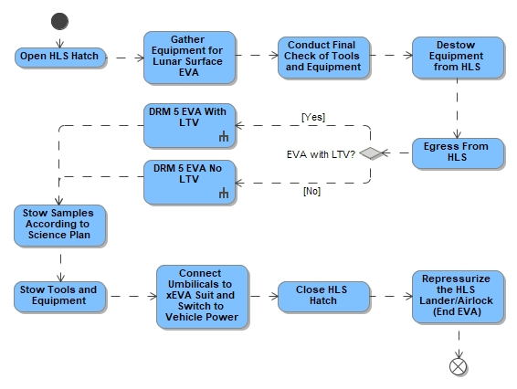
Figure 4-21: DRM 5 EVA
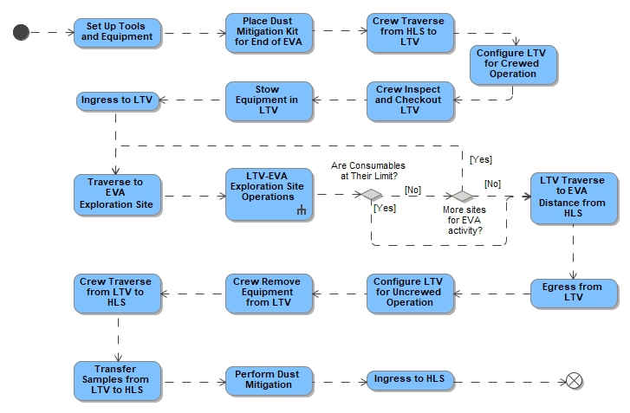
Figure 4-22: DRM 5 EVA with LTV
If samples requiring cold stowage are taken by the crew, they are placed in a passive container on the LTV as the LTV does not provide the power for cold stowage. While the EVA crewmembers are not on the LTV, the LTV may be remotely commanded in order to support the crew during EVA as a communications relay, camera views, lighting, etc. according to operational need. At the end of each EVA, the crew may stow EVA tools, tools caddy, geology samples, and science payloads back onto the LTV prior to the traverse back to HLS.
In general, tools and equipment will be stowed back on the LTV between EVAs This protects the equipment and leaves the tools configured safely in case of an unexpected abort from the surface. Tools required for tasks will be hand-carried by the crew from the LTV to the task location. At the end of the mission, the crew stows reusable tools (depending on mission parameters, expected life of tools, and EVA science objectives, i.e., avoiding cross contamination).

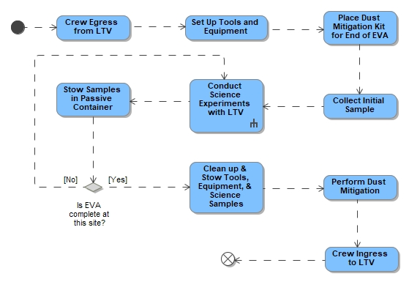
Figure 4-23: LTV-EVA Exploration Site Operations

DRM 5 Post EVA
Once the crew has completed the EVA and ingressed the HLS, the LTV will be remotely driven to a safe distance from HLS to protect for emergency aborts or nominal HLS departure and to take video of descent/ascent.
Figure 4-24: DRM 5 Post EVA
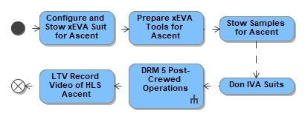
Figure 4-25: DRM 5 Ascent Preparations

Communications and Navigation
Communication paths between LTV and HLS can be established over Wi-Fi or 3GPP, though 3GPP will support longer communication ranges than Wi-Fi. The LTV will host 3GPP user equipment (UE) that can communicate with other Artemis Systems hosting 3GPP Base Transceiver Stations (BTS). The LTV will also host a 3GPP BTS to enable communications with xEVA-hosted 3GPP UE. All real-time communication between surface EVA crewmembers and Earth will be relayed via HLS or LTV which communicates with Gateway, LCRNS or direct to Earth. In addition to real-time communication, recorded data, images, video, and audio may be transmitted at a later time after an EVA is completed. LCRNS assets will provide navigation services to surface elements including EVA crewmembers.
A more robust navigation capability for DRM 5 EVA (compared with DRM 3 EVA) is critical due to the distance that the LTV will take the crew away from the HLS (i.e.., up to 10 km radial distance). Under nominal operations, the LTV will have its own navigation capability with 10-m 3D Rendering RSS Feeds (3-D-RSS) absolute position and 5-deg absolute heading accuracies (e.g., using Lunar Augmented Navigation System (LANS) augmented with optical nav/IMU, pending hardware provider solutions). See contingency section and Navigation Appendix for further use cases.

Power
The following use case categories are scenarios where bi-directional power exchange is required:
Nominally, there could be a use case to include the capability to extend the duration/distance the LTV is able to travel, stay longer at a location, or accommodate science needs for longer. LTV exchanges power with future elements (e.g., PR, Initial Surface Habitat, power generating elements and/or charging stations). Power exchange can occur crewed or uncrewed. Power transfer occurs through an interface that is physically compatible (such that it is small enough for crew to handle) with EVA crewmembers and robotics <TBD-EHP-10033-020>. This smaller interface is carried by each rover. Larger interfaces (e.g., longer cables) that are robotically manipulated to be used for future elements will not be carried by the LTV.
ConOps and use case details for bidirectional power exchange between the LTV and future elements on the lunar surface are still being understood. See contingency section and Power Appendix for further use cases. Refer to EHP-10069, Extravehicular Activity and Human Surface Mobility Program (EHP) Power Specification that decomposes this requirement to the projects and missions and includes details on the power interfaces and power quality.

Lighting
The immediate perimeter of LTV will be illuminated to aid in the crew in the checkout of the vehicle for the mission. After the checkout of the vehicle is complete for either crew or remote operation, the vehicle lights are turned on to illuminate the direction of travel. Arriving at the destination, lights are provided to aid crew in moving around the immediate perimeter of LTV or to accomplish the objectives for the area. Other considerations include Operation of motorized equipment (e.g., robots and rovers) – Whether operating a robot or a rover, the crew will need visuals of sufficient quality and timing to make real-time decisions for control of the robot and rover to both perform the required task and for collision avoidance. Illumination conditions may require additional consideration for illuminating other nearby surfaces rather than just the task surface to increase situational awareness of a moving object.

Contingency operations may require the same or similar task lighting conditions as nominal operations, especially for translation, navigation, and critical inspections. Prior to the mission, evaluations should be performed to determine critical capabilities the crew needs to maintain for their return to a safer point of operation and the duration required for that critical capability. This should establish the minimum contingency power and equipment allocation to maintain the required skill set.

Remote and autonomous operations, particularly those that involve movement (traverse or maneuvering), will require proper surface contrast to maintain optical accuracy of the visual systems involved, to safely achieve the task. Depending on the nature of the task and surrounding ambient lighting conditions, this may drive the need for supplemental lighting sources or task timing constraints pending on the ability to compensate for the high contrast visual environment.

Lunar Walk Back Distance with LTV
For lunar surface operations, there will be a goal to maximize the traverse distance for science exploration to the greatest extent possible. Utilizing rovers will extend the ranges that EVA crew will be able to explore the surface. However, the crew will always stay within a range that allows them to get to a safe haven (lander, habitat, etc.) in the event of a contingency. The distance the crew travels from the lander (or habitat) will change depending on the assets present (e.g., rovers). This will be a combination of the EVA crew staying within appropriate walk back and driving distances. With the addition of LTV, the crew can travel up to a 10km radial distance away from the lander. Duration of an EVA on LTV at the maximum traverse distance will be factored into planning and real-time operations to preserve consumables for traverse back in order to protect for EVA walk back in case of contingency. Traverse planning tools will be utilized to calculate the appropriate distance during any given day. The assumptions for defining EVA ranges are provided below.
- EVA range with lunar surface unpressurized rover – The rover will stay within less than a 5-hour walk back to the lander, which equates to approximately 10 km when walking at a pace of 2 km/hr. This protects for a rover failure that requires the EVA crew to walk back to the lander. This distance must be balanced with suit consumables remaining and does not account for slope or obstacles (e.g., boulders), so distances may decrease due to terrain or operational considerations. This range does not stack system failures. See Integrated Contingencies section for further details.
- During the Apollo missions, the crew traveled 4.74 miles (7.63 km) from the Lunar Module while driving the unpressurized Lunar Rover Vehicle (LRV), which was designed to operate within a 5-mile (~8 km) radius of the Lunar Module.

DRM 5 Uncrewed LTV Mission Excursions
Uncrewed LTV mission excursions begin once the LTV has landed on the lunar surface and has been deployed. Uncrewed missions will mainly be focused on utilization; however, there may be opportunities for LTV to be remotely driven to a safe distance from future elements/vehicles to take video of descent/ascent.
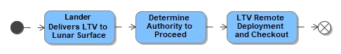
Figure 4-26: LTV Delivery to Surface

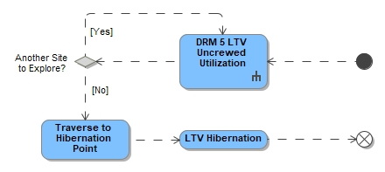
Figure 4-27: DRM 5 Pre-Mission Uncrewed Surface Operations

LTV Uncrewed Utilization Operations
During the uncrewed supporting mission of an increment, the LTV is remotely operated from ground stations. In addition to maintaining and monitoring the vehicle, ground control centers will be capable of further uncrewed science exploration, landing site and future EVA traverse path reconnaissance, payload utilization and deployment, sample collection, and equipment transportation. Ground control centers will work in coordination with LTV hardware provider(s) to direct the LTV to sites of scientific and/or operational interest to collect measurements and other data, collect and stow samples, and deploy scientific instruments to the lunar surface, as applicable to that mission segment's objectives. The LTV is collecting and transmitting data to help the science team determine future crewed and uncrewed utilization work site locations by providing imagery, video, temperature sensor readings, etc., LTV will use an onboard robotic arm to make measurements proximal to the lunar surface, acquire samples, and deploy instruments to the lunar surface. The LTV must also be able to “follow the Sun” to allow for charging prior to periods of extended darkness (PED) and lunar night.
The LTV robotic manipulator enables capabilities such as sample gathering, utilization of science tools, and deployment and retrieval of small payloads.
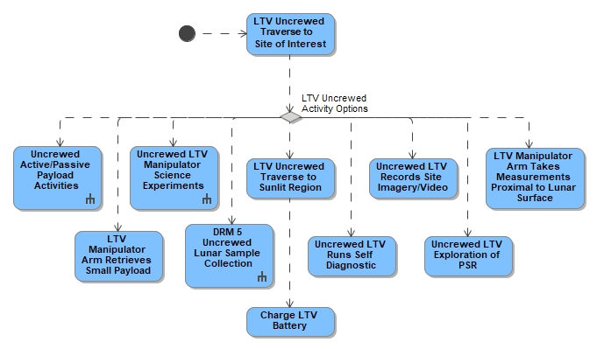
Figure 4-28: LTV Uncrewed Utilization Operations
Prior to each crewed landing during the increment, the LTV is commanded to traverse to a location outside of the landing accuracy range and plume impingement of the HLS, but to be within range to video the HLS descent and landing. Once HLS has landed, the LTV is teleoperated to perform image capture for assessment of the exterior of HLS for the purposes of inspection and hazard identification.

DRM 5 Crewed Utilization Operations
With the availability of the LTV as an unpressurized mobility asset in DRM 5, in addition to the utilization capabilities established in DRM 3, the crew can traverse longer distances, explore new ROIs, and collect samples at new ROIs. The LTV is expected to host active payloads, utilized during crewed and uncrewed operational periods to support mission objectives. The LTV will accommodate at least two payloads for installation prior to launch. Additional payloads delivered on HLS or future cargo landers may be installed by the EVA crew once the LTV is on the lunar surface.

Lunar Sample Collection
At the start of the crewed missions, crew will retrieve cached samples from manipulator operations during uncrewed periods and transfer them to the lander vehicle for return. LTV will be utilized by the crew to carry and transport utilization tools and collected lunar samples. LTV will also provide a passive cold stowage capability, to maintain sample conditioning of bulk or core collected samples before being transferred to active conditioned stowage location in HLS for return. The cold stowage capability allows for the conditioning of volatile samples, likely from long-duration shadowed or PSRs. The end-to-end sampling ConOps is documented in SMD-LUN-104, Artemis End to End (E2E) Sampling Concept of Operations and M2M-30072 M2M Artemis Science Sample Management Requirements
For further details on sampling operations reference EVA-EXP-0042, EHP xEVA Concept of Operations (ConOps).

Active Payloads
The LTV provides power, communications/data, and physical interface attachment to active payloads. Payloads will be expected to provide their own thermal control and vibrational dampening as needed, independent of the vehicle and isolated from the LTV interface structure. The LTV will provide a data interface, and data storage/forward, for each active payload as required. LTV will also provide the communication path for payload data through the LTV communications system. EHP 10044, Extravehicular Activity and Human Surface Mobility Program (EHP) Pressurized Rover (PR) System Requirements Document (SRD) & EHP 10021, Lunar Terrain Vehicle (LTV) System Requirements Document (SRD) gives examples of active payloads hosted on the vehicles.
LTV is anticipated to support certain active payload instruments at specified elevation levels above the lunar surface. These mast-mounted payloads will provide a higher vantage point for potential Light Detection and Ranging (LiDAR), stereo multispectral imaging systems, or other instruments. EVA crew will be able to replace or swap instruments for maintenance or repair, and all interfaces will support interoperability of instruments between LTV and PR. Additional details can be found in EHP-10044, Extravehicular Activity and Human Surface Mobility Program (EHP) Pressurized Rover (PR) System Requirements Document (SRD). Payloads may be emplaced on the Lunar surface. Payload communications will flow through the LTV avionics and communications systems to the lunar architecture and distributed to the payload developer by the ground team.
For further information on active payload interfaces, see M2M-30038, Moon to Mars (M2M) Utilization Interface Requirements Document (IRD).

Passive Payloads
The LTV will be used to transport self-sufficient payloads between locations or may emplace small payloads on the surface. These payloads will be loaded/unloaded by crew or by LTV robotic manipulator if the payload is within the operational capability of the crew or the robotic manipulator. Cargo carriers will be passive cargo on LTV that may need to be loaded/unloaded with mechanical assistance (such as a remotely operated davit, crane, or other transfer systems).

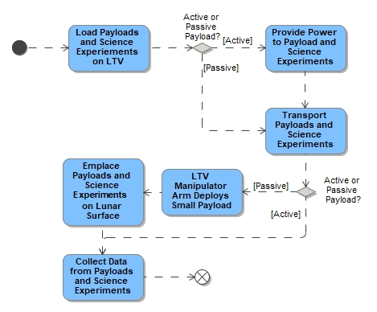
Figure 4-29: Active/Passive Payload Activities

Manipulation Capability
Robotic manipulation on mobile vehicles for utilization operations will provide an enhanced capability to interact with the lunar surface during uncrewed periods. A limited amount of bulk and rock samples will be collected and stored on the vehicle during uncrewed periods for retrieval by the next Artemis crew. Interchangeable manipulator-connected instruments, also known as end-effectors, will be provided by NASA to conduct NASA science investigations, including sample and data collection. End effectors will also be considered active and passive payloads, requiring common interface to the “wrist” portion of the manipulator. Examples of end effector payloads include remote sensing instruments, contact/collection instruments, and cameras. As mentioned above, the manipulator will also have the capability to load and unload passive payloads for emplacement on the lunar surface. Figure 4-30 represents one of many possible use cases for the robotic manipulator, and all activities shown are only potential use cases. Note that several use cases may be accommodated with a single manipulator arm/end effector deployment.
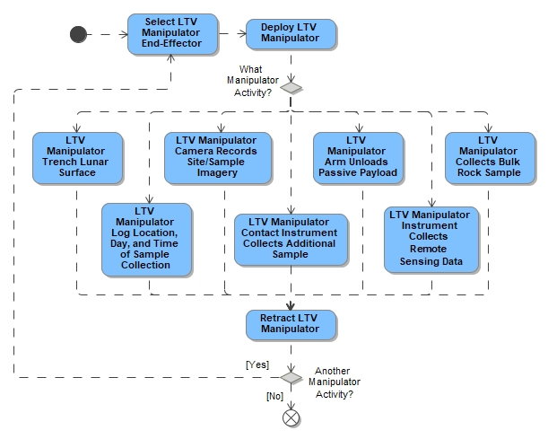
Figure 4-30: LTV Manipulator Science Experiments

LTV Post-Crewed Operations
During the final EVA, the crew leaves the LTV in a configuration appropriate for the uncrewed mission phase and transfers any tools for disposal and samples to HLS. At the end of each crewed mission, the LTV is commanded to traverse to a location outside of the plume impingement area of HLS to record video of the ascent.
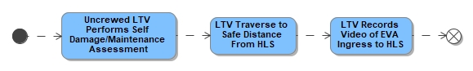
Figure 4-31: LTV Post-Crewed Operations

DRM 5 Gateway EVAs
EVA availability on Gateway begins with the activation of a fully functional, dedicated Airlock element with the xEVA System components dedicated to Gateway. To prevent cross-contamination, mix-up, or lack of availability when needed, xEVA System items such as suits and tooling for IVA activities and pre-planned EVA excursions will not be shared between the Lunar surface and Gateway.
EVA operations on a spacecraft in cis-lunar space will share many similarities with those performed on the Space Shuttle and ISS. Egress and ingress will be performed via a dual-chambered airlock, and many of the same or similar tools will be used to perform tasks - including (but not limited to) safety tethers, waist tethers, Body Restraint Tethers (BRT), equipment tethers, a Modular Mini-Workstation (MMWS) equivalent, various bags (crew lock, maintenance items, trash), drivers (powered and manual wrenches) and associated sockets, torque wrenches, pliers, cutters, wire ties, scissors, cameras, and contamination detection kits . Possible maintenance tasks include (but are not limited to) maintenance item Remove and Replace (R&R), preventative maintenance, adding translation paths, and robotics repair.
Gateway EVAs will utilize xEVA Suits which could be from different hardware providers or include upgrades (utilizing the same vehicle interfaces). Suits and equipment necessary to perform an EVA may be initially launched and delivered in the airlock or sent to Gateway in a logistics module. In the event Gateway Extravehicular Robotics (EVR), the primary means of completing external planned maintenance and contingencies, cannot perform the needed task, EVA may be utilized for planned maintenance and contingencies. EVA will not be utilized as the primary means of Gateway assembly and construction. For consumables and cargo estimates, these missions will allow for up to two 2-crewmember EVAs per mission. Gateway uncrewed periods may be as long as three years; however, xEVA suits are to be designed such that prolonged stowage on gateway does not create a hazard. Gateway EVAs are assumed to be performed while there are four crew on Gateway and an IV crewmember is available to operate the Gateway External Robotic System (GERS) as needed and may assist with don/doff as needed. A more complete description of Gateway operations can be found in GP 10027, Gateway Concept of Operations (ConOps).

Gateway EVA System and Airlock for Microgravity EVA Operations
The Airlock provides EVA capabilities, which include xEVA Suit consumable recharge (e.g., power, oxygen, water), access to vacuum for CO₂ removal, and the ability to reserve suit consumables while connected to the vehicle via umbilical during activities such as prebreathe and suit checkouts. The airlock also provides communication interfaces for voice and data transfer, structural interfaces, and stowage for spare parts and ancillary equipment. Airlock functionality for EVA includes xEVA Suit donning and doffing interfaces, suit servicing and recharge interfaces, communication, prebreathe capability, depressurization and repressurization, egress and ingress, and tools. Initial checkout of the airlock and EVA systems are performed prior to the first EVA.
Servicing and checkout of the suits, performed prior to the first EVA and then between subsequent EVAs, includes consumables recharge (e.g., batteries and thermal system water) using suit servicing vehicle interfaces, and cleaning the suit interior in preparation for the next EVA. Spares and maintenance items will be required for on-orbit suit maintenance (depending on crewed pressurized time). Some spares may be equipment left from previous stages, such as is done on ISS, while others may be launched in logistics modules. General clean-up and stowing of non-EVA equipment are needed to prepare for depressurization and vacuum operations. Any items that cannot withstand vacuum or require special stowage should be moved to other elements of the stack. The equipment lock provides the capability for the EVA crewmembers to ingress in the case of a crew lock contingency. Airlock equipment in the depressurized portion must be designed to function nominally while exposed to or after exposure to vacuum. Equipment stored within the airlock which is not to be used during depressurization/vacuum operations must be designed to operate after exposure to vacuum.
The dual-chambered airlock provides the volume for two crewmembers to perform on-orbit suit maintenance and the EVA prep and post activities, including suit donning/doffing and prebreathe. It is assumed that EVA suits require two donning/doffing fixtures to allow crewmembers to simultaneously self-don and self-doff their suits, if necessary, although an IV crewmember is available to assist.
Gateway EVA wireless radio, antennas, and hardline audio and data for two-way communications of EVA voice/data, as well as downlink of EVA video, are provided by Gateway. This system provides simultaneous communications between Gateway and EVA crewmembers by providing video, voice communications, and EVA suit telemetry and crewmember biomedical telemetry. Wireless communications are available internal to the airlock as well as external. The EVA suit provider furnishes the radio located in or on the suit; Gateway Airlock will provide the radio that is located in the airlock.

Gateway EVA Operations
The "Road-to-EVA" is a comprehensive list of all the activities that must be completed prior to and following an EVA or series of EVAs. It includes tasks such as suit assembly, sizing, on-orbit fit verification, filling and installing drinks bags, tool configuration, etc.
On the day of the EVA, the crewmembers begin final prep activities and the prebreathe protocol. Any necessary inhibits are commanded by MCC-H prior to the EVA. Once the crew performs suit pressure integrity and system checks, they begin their prescribed prebreathe period. Prebreathe protocols decrease the risk of decompression sickness (DCS) and may be different durations depending on suit operational pressure and Nitrogen [N₂] saturation prior to starting an EVA. Gateway is planned to be at 70 kPa (10.2) psia nominally. Gateway may operate at higher pressures up to 101 kPa (14.7 psia) at the start of crewed missions in order to preserve consumables to the extent possible. This may impact DCS prebreathe operations and will need to be considered in Gateway/EHP mission planning.
According to the integrated prebreathe procedures, when the crew are ready to leave the airlock, they initiate cabin/airlock depress; however, prebreathe and airlock depress may occur simultaneously to a lower cabin pressure in support of prebreathe. The EVA crew will depressurize the airlock, switch over to suit systems, egress, and begin their tasks. The “EVA” phase begins when the spacesuit is switched from the vehicle-provided power source to suit batteries, and officially ends after the ingress and initiation of airlock repressurization. See EVA-EXP-0042, Extravehicular Activity (EVA) xEVA Systems Concept of Operations (ConOps), for further details on EVAs on Gateway.

Gateway Robotic Assisted EVAs
Many of the EVA Maintenance Items (MI) on Gateway will require the assistance of the GERS to through EVA crew member positioning, movement or transfer of MIs, and worksite viewing and lighting using GERS assets. The GERS is designed to accommodate crewmember positioning through a foot restraint installed into a Worksite Interface (WIF) and safety tethering through a handrail on the Low-Profile End Effector (LPEE). Each LPEE will have both a handrail and a WIF. While the specific concept of operations for specific MIs will not be fully developed until the MI is required, the GERS will be able to accommodate MI movement or transfer if platform used is compatible with the GERS. The GERS also has cameras and lights that may be utilized for imagery or lighting during the EVA.
From an IVA perspective, the EVA will be supported by an IV crewmember operating the GERS for the arm associated EVA assisted tasks utilizing the Robotics Planning and Control Station (RPCS) next to the Human Interface Panel (HIP). In addition, it is expected that the IV crewmember assisting the EVA crewmembers with the execution of the EVA timeline and procedures would be collocated with the GERS IV operator for ease of communication, coordination and sharing of imagery view assets.
On the day of EVA that will utilize GERS after airlock egress, the GERS will be positioned at a predetermined location to facilitate EVA crewmember setup of the arm. Arm setup will include installation of a foot restraint and crewmember safety tether swap to the LPEE handrail. Once the arm is setup, the crewmember will ingress the foot restraint and the arm will translate to the worksite per the EVA timeline. The free float EVA crewmember will perform EVA setup and translate to the worksite per the EVA timeline.
Once at the worksite the arm-based crewmember and free float crewmember will work to complete the EVA task. The arm-based crewmember will utilize Ground Crew Assist (GCA), a term borrowed from aviation, to verbalize to the crewmember operating the arm directional positioning cues at the worksite. The free float crewmember will perform work, assist the arm-based crewmember, or provide additional monitoring of arm movements as necessary per the EVA timeline to complete the EVA task.
Upon completion of the task requiring use of GERS, the arm will translate the arm-based crewmember back to the egress site where the crewmember will egress the arm and perform a safety tether swap back to the module-based safety tether and begin EVA cleanup, which will include removing the foot restraint from the LPEE, or additional tasks per the EVA timeline. The free float crewmember will perform additional tasks or translate to the airlock to begin EVA cleanup. GERS will then be positioned according to the mission plan. Upon completion of the EVA the crewmembers will ingress per the EVA timeline. Additionally, the GERS is designed to accommodate emergency crew ingress requirements by ensuring arm translation times meeting emergency ingress requirement of 30 minutes.

DRM 6: Extended Surface Operations (Pressurized Rover)
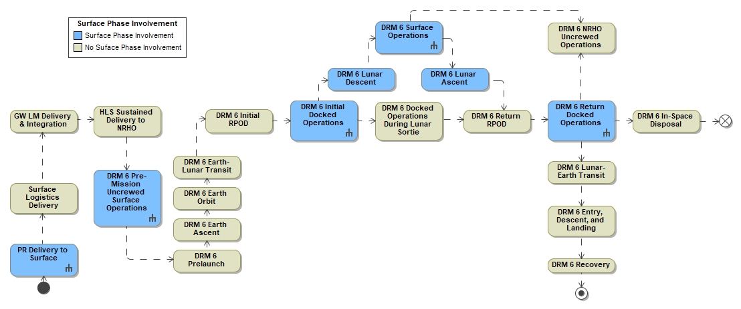
Figure 4-32: DRM 6 Overview
Enhanced lunar surface mobility capability includes the LTV and the PR, as well as lunar cargo delivery. This document will be updated upon formal designations of new programs/projects to include further description of the expected elements and operations associated with them. There is a planned phase of exploration discussed in ESDMD-001, Exploration Systems Development Mission Directorate (ESDMD) Moon to Mars Architecture Definition Document, called the “Foundational Exploration” segment utilizing the LTV and PR to explore regions of the South Pole to include an initial sequence of prioritized landing sites before deciding on the location for habitation. The buildup of Foundational Exploration will provide for expanded lunar surface capability for utilization and demonstration of Mars-forward objectives.
The M2M-30007, Artemis Integrated Concept of Operations (ConOps), describes DRM 6 where one pressurized element, the PR, is on the surface for two crew to perform an EVA from HLS to the PR, and live in the PR cabin for up to 28 days plus 3 days margin, once the PR has been outfitted its to full capability. The PR provides the systems required to maintain crew health. Refer to EHP-10041, Extravehicular Activity and Human Surface Mobility Program (EHP) Pressurized Rover (PR) Concept of Operations (ConOps), for additional details on the PR architecture and operations on the lunar surface. Refer to previous sections in DRM 5 on Autonomous, Remote, and Manual Operations, Active Passive Payloads and Utilization that also apply to DRM 6.

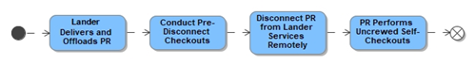
Figure 4-33: PR Delivery to Surface
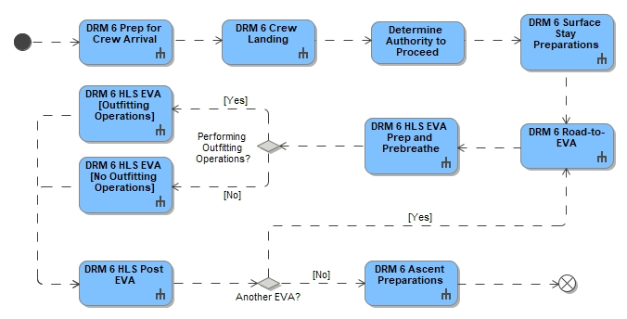
Figure 4-34: DRM 6 Surface Operations
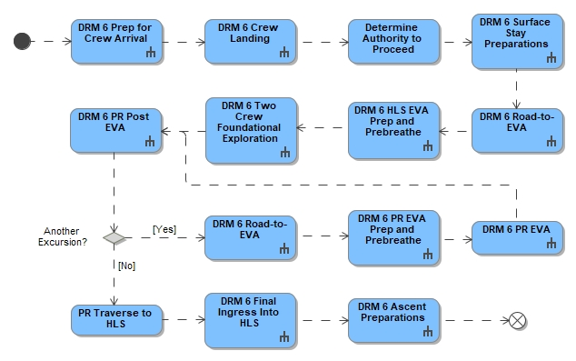
Figure 4-35: DRM 6 Surface Operations: Post-Outfitting
From M2M-30007, the overarching goals of the NASA Foundational Exploration are three-fold:
- to demonstrate elements of a Mars-forward architecture
- to conduct scientific exploration of the Moon synergistically with crew and robotic explorers
- to demonstrate the capabilities needed to work and live on the Moon for long durations.
Table 4-3: Crewed Missions with LTV and PR Key Parameters
Surface System Configuration | HLS Sustained, xEVA, LTV, PR
Key Objectives | - Demonstrate extended surface stay.  - Demonstrate extended NRHO stay.  - Perform capability demonstration of advanced traverse capabilities with PR.  - Demonstrate cooperative exploration with multiple mobility assets.  - Conduct lunar exploration and science on the lunar surface.  - Deploy technology demonstration packages and instrumentation
Key Parameters | Surface Crew | 2
Key Parameters | Proposed Surface Stay | 14 Days*
Key Parameters | Per Crewmember EVA time | Cumulative EVA time per week ≥ 24 hrs.
Key Parameters | EVA Range with PR and LTV (from HLS) | 20 km radial distance
*M2M-30007 M2M Integrated Concept of Operations defines a surface stay of 14 days. It is expected that the crew will spend 1 day in HLS at the start and 1 day at the end of the mission. The PR is designed to support up to 28+3 days of surface operations with the per initial HLS cargo delivery

DRM 6 Prep for Crew Arrival
Delivery of the PR helps extend the distance of lunar South Pole exploration and provides a pressurized cabin in which the crew can live shirt-sleeved while on the surface. The PR will have a 10-year lifetime which increases utilization during crewed and uncrewed missions. The PR cabin has the capability to support 2 crewmembers nominally.

The PR is delivered by the Human-class Delivery Lander (HDL), which is expected to provide the PR with services until it is ready to operate. These services are expected to continue for 48 hours after offloading. Disconnecting from these services will be performed remotely. The deployment method of the PR will be determined by the lander provider and the PR provider and will likely be design specific.

Once the PR has been delivered to the surface prior to crew arrival, it is robotically offloaded by the lander onto the surface and performs teleoperated self-checkouts to ensure it is ready for use. After self-checkouts, the PR will be remotely operated to perform checkouts post first drive and then to perform scientific activities such as observations, scouting of potential EVA traverse and HLS landing sites. Shortly before the next crewed Artemis mission, the PR will be positioned near the HLS landing site to record landing, and then reposition closer to the lander for crew access post-landing. At the beginning of each crewed mission, the PR will have 3 days’ worth of O2/N2 cabin and EVA consumables until crew subsequently replenishes the O2/N2 tanks. Pending onboard utilization capabilities, the PR will be teleoperated to perform scientific activities during the traverse to the landing site area. Until autonomous driving systems (e.g., collision avoidance), are fully checked out, remotely-operated driving speeds may be slower (e.g., approximately 1 km/day) than full-capability remote driving speeds.
Prior to the two crewmembers landing in HLS, all surface assets will be checked out to be sufficiently operational.
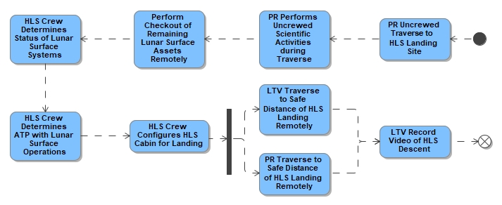
Figure 4-36: DRM 6 Prep for Crew Arrival

DRM 6 Crew Landing Operations
From the HLS-CONOP-006, Sustained Phase HLS Concept of Operations (ConOps), for both sortie and excursion missions, the HLS integrated lander and crew, in coordination with MCC, will determine ATP with the surface operations phase. This includes identifying the health and status of the lunar surface systems and, if necessary, commanding the lunar surface systems transition to operational modes. Following ATP, the HLS integrated lander and crew will begin surface stay preparations. This phase includes vehicle safing and cabin reconfiguration. Both the LTV and the PR are teleoperated to a location outside of the plume impingement and landing accuracy zones to video descent and landing. They will then be commanded closer to the HLS lander to perform remote visual inspections of the lander and landing site, then to traverse to a location within walking distance for the crew to perform an EVA from HLS to the PR. For initial PR missions, mission planning may need to accommodate potentially slower tele-operation speeds to relocate the PR from its HLS-landing staging area to the base of the HLS post landing to meet the crew (and possibly for HLS ascent at the end of the mission).
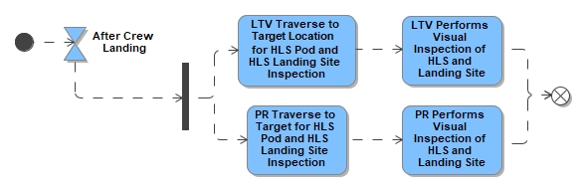
Figure 4-37: DRM 6 Crew Landing

DRM 6 Two Crew Foundational Exploration
Initial crewed operations for PR will include cargo transfer and completion of any outfitting necessary to support crew habitation and EVA capability. If cargo logistics landers are not yet available, outfitting hardware will need to be delivered with the crew on HLS and hand carried to the PR during EVAs. Similarly, limited shelf life/perishable and crew specific items (e.g., EVA spares such as gloves) will need to be delivered with the crew on HLS and hand carried to the PR during EVAs. Once PR is deemed fit for crew habitation and EVA from PR, the crew will transfer from the HLS to the PR for the remainder of the mission.
The amount of cargo that is initially delivered with the PR and with the crew on the HLS will determine the duration that the crew can stay on the surface during initial crewed missions utilizing the PR, unless another means of delivering cargo to the surface (e.g., dedicated cargo lander) is available. All cargo needed for PR missions will be hand carried in (and out) of the vehicle during EVA via Crew Portable Carriers (CPC); the PR will not have the ability to dock with another surface element.
In addition to the operations that are performed prior to any lander-based EVA, the crew will perform activities required to enable the HLS integrated lander to remain uninhabited during the approximately 30-day surface asset-based portion of the mission. When these activities are complete, the two crew members will egress the HLS integrated lander, leaving the hatch in a configuration such that no single failure prevents crew ingress. The crewmembers then transfer from HLS to the PR to conduct the surface mission. The crew will be based from the PR as their habitat for up to 28 days. During the PR portion of the mission, all EVAs will be based out of the PR.
After the ingress volume is depressurized by the crew and/or MCC, the crew ingress the PR hatchway/translation path which is sized to support comfortable ingress and egress for the suited crewmembers (including nominal and contingency, such as fully incapacitated crewmember rescue (ICR) operations) without risking abrasive damage to rover hatch seals and xEVA suits in the process. PR utilizes the “cabin as an airlock” approach to enabling EVAs. After crew donning of xEVA suits, the entire PR cabin depressurizes. Due to flammability and other concerns, the majority of portable hardware on PR is crew-tended, meaning it will be regularly stowed in the appropriate carrier (pressurized or unpressurized, depending on the hardware) and removed from the carrier only when in use. Therefore, pre- and post-EVA cabin reconfiguration time on PR is expected to be minimal. The PR and crew can maximize utilization capability during EVAs by reducing the amount of crew time it takes to configure the EVA System and reconfigure the PR cabin in preparation for EVA. In addition, the PR atmosphere is set to a level that reduces required pre-breathe time.

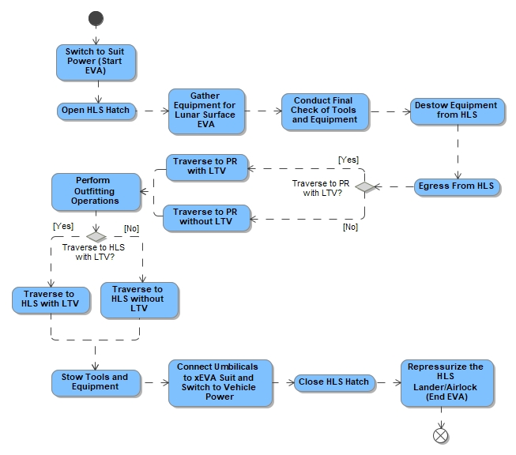
Figure 4-38: Crew Transfer To PR

.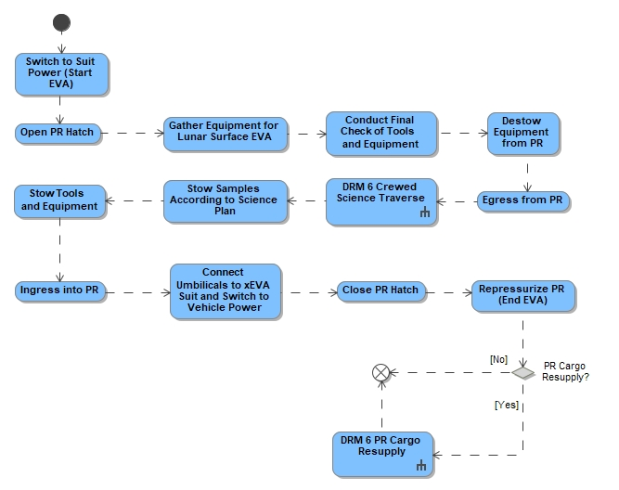
Figure 4-39: DRM 6 PR EVA

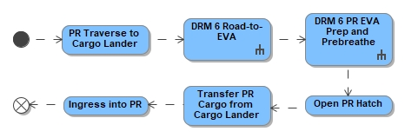
Figure 4-40: DRM 6 PR Cargo Resupply
The PR provides EVA capabilities, which include xEVA Suit consumable recharge (i.e., power, oxygen, and water), access to vacuum for CO₂ removal, and the ability to reserve suit consumables while connected to the vehicle via umbilical during activities such as prebreathe and suit checkouts. The PR also provides interfaces for xEVA System voice and data transfer, structural interfaces, and stowage for spare parts and ancillary equipment. PR functionality for EVA includes xEVA Suit donning and doffing interfaces (allowing parallel don/doff), suit servicing and recharge interfaces allowing suits to be recharged in parallel, communication, prebreathe capability, depressurization and repressurization, egress and ingress, and tools stowage (suit maintenance tools, non-utilization tools, and utilization tools for science).
PR will leverage the CPCs, which can serve as conditioned stowage carriers, to transfer items that cannot be exposed to vacuum (e.g., food, water, EVA spares (bladder material), medicine, human research items, etc.). Equipment in the depressurized portion of a pressurized vehicle will be designed to function nominally during or after exposure to vacuum. Equipment which is not to be used during depressurization/vacuum operations must be designed to operate after exposure to vacuum. The PR will stow and transport at least 14 days of cargo. During a nominal 14-day lunar surface mission, an initial supply of the PR will occur early in the mission. At the end of the mission, trash and waste will be offloaded from the PR, and some supplies may be loaded for the next mission. Each supply event will require at least one full EVA.
Once the PR is checked out by the crew, and if determined necessary by the logistics needs of the mission, a cargo resupply EVA may be necessary. In this case, the PR will drive to the cargo lander and conduct EVAs as necessary to transfer cargo, including solid and liquid consumables, payloads, and other equipment contained in hand-carried Crew CPCs. Gaseous consumables, such as oxygen and nitrogen, will be transferred via crew-carried tanks. Cargo transfer to PR will be conducted via crew hand carry only. Neither telerobotic resupply, nor surface docking resupply methods are supported by PR.

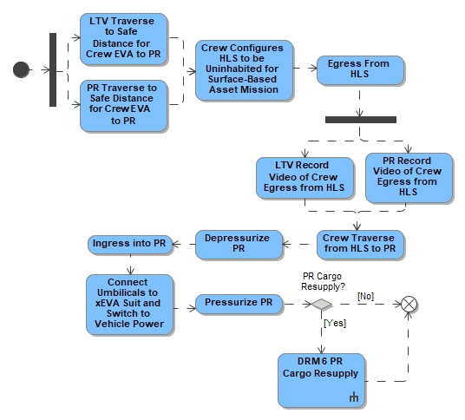
Figure 4-41: DRM 6 Two Crew Foundational Exploration

DRM 6 PR Crewed Science Traverse
To meet exploration objectives, the PR is driven by the crew to the first exploration site of the mission. Human exploration will be conducted to address science and exploration goals. Daily, the PR will conduct traverses and/or allow crewmembers to perform EVAs according to science and exploration plans, in general:
- Observing crew duty-day and work week requirements per M2M-32105, Moon to Mars (M2M) Medical Operations Requirements Document (MORD)
- Crew perform a minimum of 24 hr/week of EVA operations from the PR;
- EVAs from PR are conducted only during lunar daytime to avoid thermal constraints.
- During PED, the crewed PR may experience some limits on operation including driving restrictions and limited power loads.
- Nominal EVAs from the PR will be conducted by two crewmembers; a nominal EVA will never involve one crewmember inside the pressurized cabin with the other crewmember outside performing an EVA.
During EVA, when the EVA crewmembers are not on the PR, the PR may be remotely commanded to support the EVA crewmembers. This support includes, but is not limited to serving as a communications relay, providing supplementary camera views, or providing supplementary lighting. Lighting will be provided by the PR to support driving the vehicle (that align with the vehicle's direction of travel) and vehicle-mounted lighting (and provide illumination for area tasks on the PR, instrumentation, other areas on the vehicle the crew may access, for safely walking around the immediate perimeter of PR). After each EVA, tools are stowed in the appropriate stowage area and geological samples are placed in external conditioned or ambient stowage as appropriate for the type of geological sample.

At the end of the mission, the crew drives the PR to the landing site and configures it for the upcoming uncrewed period. The PR will be left with three days of non-perishable cargo to be used by the next crew. The crew then performs an EVA to transfer to the HLS, taking with them any samples collected during the surface mission and any crew-specific items that will be needed on the return (e.g., personal medical kit). The PR and LTV will be teleoperated to a safe distance away from the HLS launch area to take video of ascent.
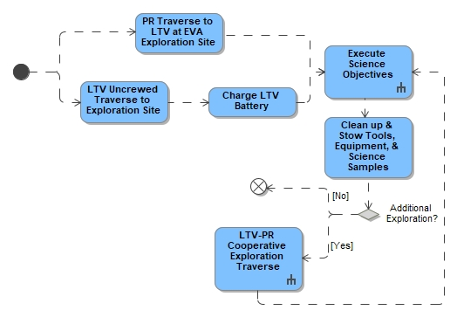
Figure 4-42: DRM 6 PR Crewed Science Traverse

DRM 6 LTV-PR Cooperative Exploration Overview
The PR and LTV can be utilized together to perform cooperative exploration to extend and enhance exploration capabilities in the field. Cooperative rover exploration can occur during both DRM 6 two-crew-to-the-surface missions (i.e., two crew living out of the PR with the LTV accompanying) and DRM 7 (see section 4.1.6) four-crew-to-the-surface missions (i.e., two crew living out of the PR and two crew living out of the Initial Surface Habitat, with the LTV supporting either the PR crew or the Initial Surface Habitat crew).
For missions with only two crew on the surface, it is expected that both the LTV and PR will be dedicated to that crew pair for the duration of the mission.
Table 4-3 DRM 6 and 7 Cooperative Exploration with LTV and PR Overview
DRM | LTV | PR | Initial Surface Habitat
DRM 6 | Accompanies PR Crew: 20km radial range from HLS | 2 Crew | N/A
DRM 7 | Accompanies PR Crew: 20km radial range from HLS  Or accompanies the Initial Surface Habitat Crew: Both crew pairs constrained to HLS walk back distance | 2 Crew | 2 Crew
Dual rover cooperative exploration will enhance scientific exploration (e.g., by providing a second platform for housing camera and science instruments, artificial lighting, communication relay support, etc.) <FWD-EHP-10033-034>. It also provides a second rover (namely, the LTV) to the PR crew could enable additional contingency support in the event of an unexpected rover mobility failure. If the PR crew have a dedicated LTV supporting them (i.e., DRM 6 mission only, or DRM 7 mission when the LTV is “assigned” to the PR crew and not supporting the Initial Surface Habitat crew), exploration range can extend out to 20 km radial distance since, in the event that one rover fails, the other can be used to drive the PR crew back to the HLS.
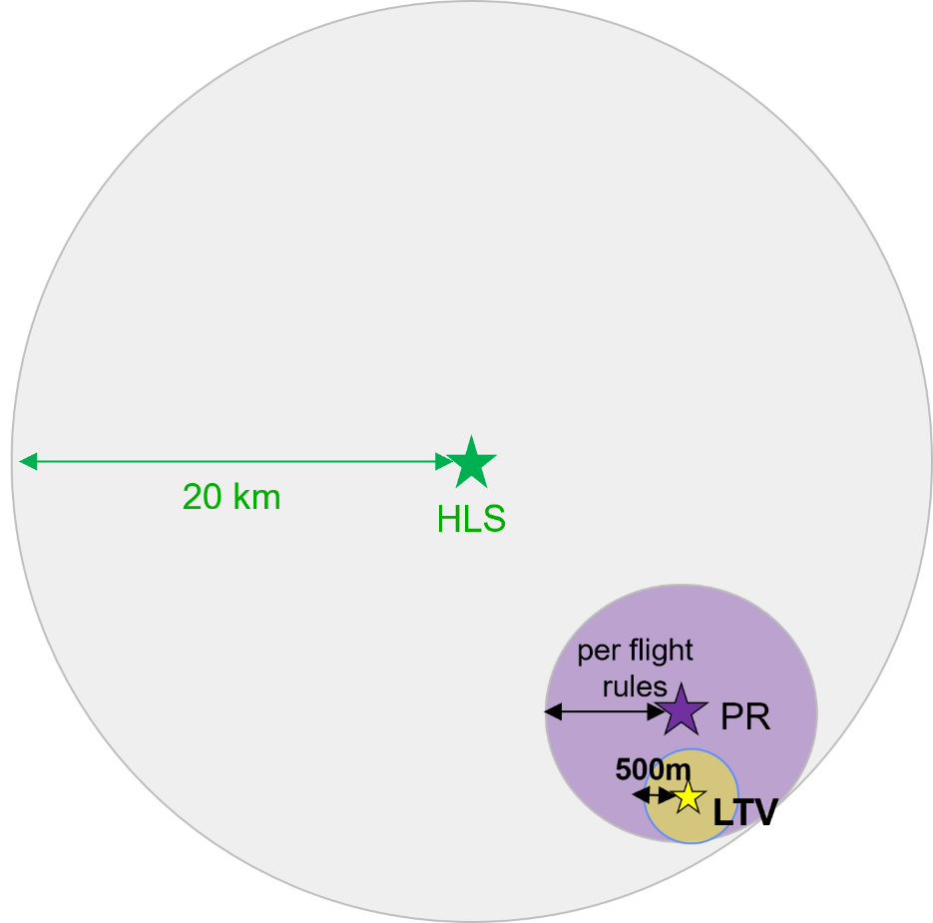
Note: Purple circle can move within grey circle during an EVA.
Yellow circle can also move within purple circle

Figure 4-43: Exploration EVA Range from HLS for DRM 6 with LTV-PR Cooperative Operations
The relative distance between LTV and PR will be specified in flight rules based on conditions such as terrain, natural lighting, science objectives, etc.
Crew-to-vehicle separation distance can be up to 500 m but crew will likely remain in closer proximity to LTV.

For DRM 7, when 2 crew are living in the PR and 2 crew are living in an alternate surface habitat, the LTV may be nominally dedicated to a specific crew pair, or shared between the crew pairs: e.g., there may be mission phases where the LTV is solely dedicated to the PR crew, solely dedicated to the Initial Surface Habitat crew, or shared during a 4-crew cooperative exploration phase (e.g., during a 4-crew EVA), pending mission priorities, the distance between the Initial Surface Habitat and HLS, or exploration worksites, etc.
If the LTV is assigned to the Initial Surface Habitat crew, the Initial Surface Habitat crew would be constrained to operating within 10 km of Initial Surface Habitat using the LTV and the PR crew would be constrained to operating within walk back distances of the HLS. If all 4 crew conduct an EVA together, both crew pair would be constrained to operating within walk back distances of either HLS or Initial Surface Habitat as the PR would be dedicated to the PR crew and the LTV dedicated to the Initial Surface Habitat crew. Ground control and other capabilities needed to support parallel operations (including parallel EVA) for PR and Initial Surface Habitat crew will need to be considered.
During crewed missions, either the LTV or the PR may be teleoperated at different times to facilitate cooperative exploration. A teleoperated rover will likely traverse slower than a manually operated one due to general remote operator caution, limited fields of view and perspectives (pending rover design details and remote operator capabilities), and Earth-Moon-Earth latency in commanding. This difference in speeds will need to be considered when planning nominal dual rover traverses so that contingency protection can be provided.
Contingency protection does not necessarily mean that the cooperative exploration rovers need to be always travelling side-by-side or in tandem. This may not be practical due to the environment (e.g., terrain, shadows) or vehicle recharge requirements. However, flight rules will govern separation distances and/or times required to be maintained between cooperatively operating vehicles so that mission objectives are balanced with crew safety, which are then balanced with the overall risk posture acceptance for the mission; different considerations will be made when rovers are operating within walk back range of the HLS verses outside of walk back range, and flight rules will be informed through analyses and testing. Specific integrated contingencies related to DRM 6 missions are described in the Integrated Contingencies Section at the end of this document.

DRM 6 LTV-PR Cooperative Exploration and Crew Contingency Protection
The process of deriving how the LTV and PR can be used cooperatively to extend crewed exploration distances includes analysis based on EHP Ground Rules and Assumptions (GRA)s, analog field data, and rover simulation data. When the LTV is dedicated to the PR crew and the PR crew are within walk back distance of the HLS, there is no constraint on the relative distance between the LTV and PR. In other words, both vehicles can operate as needed to support mission objectives (e.g., cooperative, or separate driving to science exploration sites, communication relay support, EVA support, etc.). Once the PR crew travel beyond walk back distance of the HLS, the vehicles will need to perform cooperative exploration and the LTV will remain within distances defined within mission planning and per flight rules of the PR so that the LTV can respond to a PR crew contingency event within a reasonable amount of time.
Table 4-6 DRM 6 Cooperative Exploration with LTV and PR Overview
Configuration | LTV | PR | HLS | LTV-PR Relative Distance
DRM 6 | Accompanies PR Crew | 2 Crew | Within walk back distance | No Constraint
DRM 6 | Accompanies PR Crew | 2 Crew | Not within walk back distance | Constrained per flight rules

To support M2M Program objectives that include the ability to explore out to 20 km radial distance from the HLS with both vehicles, each rover must be capable of actual path continuous driving (e.g., without stopping for recharge) that supports nominal operations as well contingency return to HLS within the life support capabilities of the LTV and PR. The vehicles will likely need to travel longer actual-path distances to reach their destination due to terrain and shadow navigation, communication architecture, onboard artificial lighting capabilities, etc. on the outbound (and inbound) traverse. Based on internal NASA SMD analyses specific to rover operations, an average actual-path-to-radial-distance ratio of 1.3:1 is assumed. While this ratio may not cover the exploration within the entire 20-km radius circle surrounding the HLS, it provides sufficient options to extend exploration opportunities beyond single rover operations. While it is advantageous for the LTV to drive at least 26 km ( $20 km×1.3=26$km) and the PR to drive a minimum actual path distance of 18 km (13.8 km x 1.3 = 17.9 km)on a single charge to expedite nominal and contingency operations, because the PR provides IVA habitation, suit consumables resupply (water, O2, power), and medical treatment for ICR, it is permissible for the PR to stop for recharge overnight during a contingency return traverse to HLS. Specific duration of recharge can vary and will meet the applicable requirements in EHP-10044, EHP Pressurized Rover (PR) System Requirements Document (SRD).
Exploration range will be extended, as bounded by flight rules and any other safety considerations. Caveat: if either vehicle is driving through excessively cold regions (e.g., LTV driving through a PSR) or extended periods of darkness are encountered, the LTV and PR may travel continuous distances that are shorter.
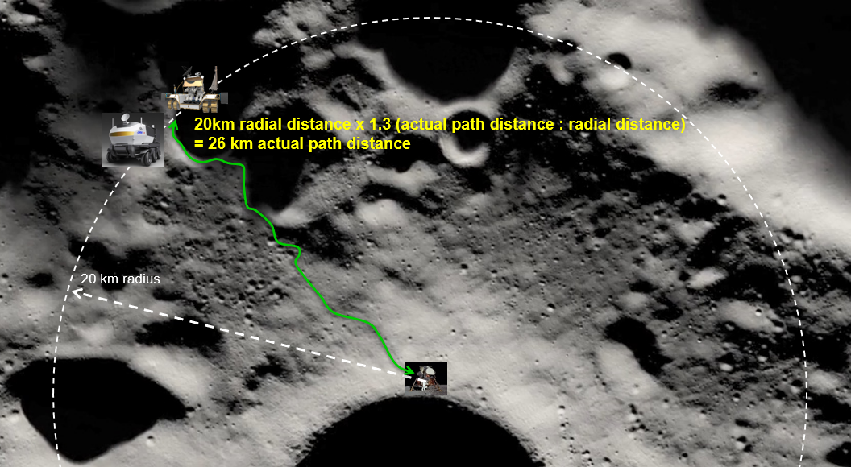
Figure 4-44: Notional LTV-PR Cooperative Operations
The LTV and PR can travel together or separately, as desired to best support mission objectives, out to the walk back distance constraint from the HLS. Once the PR crew reach this threshold, the vehicles will stagger their outbound traversing (assuming manual and teleoperations speeds between the vehicles differ) to meet mission objectives balanced with contingency driveback support.
Depending on recharge needs of the vehicles, the LTV (assuming its teleoperations speed is slower than the manual speed of the PR) may start its traverse before the PR so that it can arrive at the next recharge location and begin recharging itself before the PR continues its traverse farther outbound. This will enable the LTV to have sufficient power to support full contingency return of the PR crew to the HLS if the PR experiences an emergency. Once the PR catches up to the LTV recharge location, it will pause to fully recharge, and the LTV will continue its outbound trek. This process will continue until the crew reach their 20 km radial distance destination (or are close enough to be within vehicle exploration and/or walking exploration range). The number of “steps” to reach this distance will depend on all the factors described above (i.e., manual and teleoperations speeds, vehicle recharge speeds, environmental factors like terrain and natural lighting complexity, risk posture acceptance, etc.). If the manual speed of the PR is comparable to the teleoperations speed of the LTV, it is possible that the vehicles will travel outbound in closer proximity to one another (i.e., less staggering is needed). Risk posture acceptance and PR design considerations that provide redundancy in IVA habitation and suit resupply capabilities may allow for expedited exploration out to 20 km radial distances from HLS: e.g., (1) PR starts fully charged at the 10km walk back distance from HLS, and LTV is fully charged at 20km radial exploration distance, (2) PR drives to LTV and recharges overnight before beginning exploration EVA with both vehicles the next day.

DRM 6 Utilization Operations
Artemis utilization operations for DRM 6 missions include capability of both the LTV and PR. The PR provides a crew habitable environment, enables longer range traverses of the lunar surface, which increase scientific study of additional areas of lunar terrain and IVA utilization objectives. PR will have Active and Passive payload capabilities similar to those mentioned in DRM 5 Although not a NASA-required capability, the PR will also have robotic manipulation capability to support some science objectives.
The PR science activities during the crewed rover traverses may include, but are not limited to:
- Stowage of geological samples collected on the lunar surface during EVA. The PR will be equipped to transport geological samples collected by crewmembers during all crewed excursions. To minimize the amount of lunar material brought inside the vehicle, geological samples will be stored externally in a way that maintains sample integrity.
- Handheld instruments may be carried by PR for utilization use. Items such as HULC, a handheld X-ray fluorescence spectroscopy instrument, and a handheld laser-induced breakdown spectroscopy instrument may be used by the EVA crew and located inside the rover for storage and charging. These items will not need to be carried by PR when the vehicle is uncrewed and may be disposed of.
- Four externally attached payloads may be accommodated by PR may be swapped out by the crew during an EVA. PR provides power, data, and mechanical attachments at these locations.
- Internal Payloads include two payload bank locations, which provide power, data, cold plate cooling, and mechanical attach points. Each bank accommodates a single standard sized payload that can be swapped out according to mission needs. IVA investigations are performed by crew inside the PR. IVA investigations are performed by crew inside the PR.
- Cabin deployed payloads to be utilized for IVA research may be deployed from a stowage location and used within the vehicle. This equipment can then be placed on a workbench and utilize two Portable Equipment Panels for power and communication resources.
- External NASA payloads will be expected to provide their own thermal control and vibrational dampening as needed, independent of the vehicle and isolated from the PR interface structure.
- Geology sample collection will need to be orchestrated such that samples are collected on the side of the PR opposite to the vacuum access port, to ensure that there are no PR exhaust contaminants in the collected samples.

DRM 6 Communications
All real-time communication between EVA crewmembers and Earth will be relayed via HLS, Gateway, LTV, PR, or other major surface elements. In addition to real-time communication, recorded data/images/video may be transmitted at a later time after an EVA is completed. LCRNS Satellites will provide positioning services to mobile surface elements and EVA crewmembers.

DRM 6 Power
The PR will have the ability to externally receive power from other surface elements to support additional mission planning flexibility during a crewed period of extended darkness. PR will not be capable of sending power to the LTV or future surface elements (e.g., Initial Surface Habitat, power generating elements and/or charging stations). PR external power transfer occurs during crewed missions through an interface that is physically compatible (such that it is small enough for crew to handle) with EVA crewmembers.
The PR external power transfer interface does not preclude the use of robotic operations during a crewed mission, but any robotic external power transfer capabilities are to be designed to use the same PR interface provided for the crewmembers or an adapter is provided by the robotic asset. In either case, no additional loading may be imparted onto the PR than what would be imparted by crew contact loads.
Any cabling, including any required interface sizing adapters, needed for external power transfer is not planned to be provided by the PR and thus must be exchanged within existing transportation mass capabilities. However, this capability remains a possibility for other future lunar surface assets.
ConOps and use case details for power exchange between the PR and future elements on the lunar surface are still being understood. See contingency section and Power Appendix for further use cases. Refer to EHP-10069, EHP Power Specification that decomposes this requirement to the projects and missions and includes details on the power interfaces and power quality.

DRM 6 Logistics Transfer Operations (LTO)
Lunar Logistics Transfer Operations (LTO) begin when cargo is unloaded from the first logistics lunar lander and transported to other surface elements (e.g., LTV, PR, etc.), and continue through future missions for the duration of the Artemis Lunar Campaign. This cargo is intended to support the crew on the lunar surface by resupplying/replenishing elements on the surface. Certain cargo, such as EVA system components, food, medicine, etc., cannot be exposed to vacuum or extreme temperatures and, if it is expected that they would be exposed to these environments, they must be delivered in pressurized, thermally controlled containers, such as CPCs. Science payloads may also be transferred using LTO capabilities. Landers are expected to offload cargo. LTO will begin after the PR is delivered to the lunar surface and cargo lander logistics deliveries commence.
Cargo for all crewed missions prior to the first cargo lander are delivered within the HLS and do not require LTO. Once PR is delivered, at least the initial crewed mission is expected to require outfitting of the PR using hardware delivered with the crew on HLS.
For subsequent PR and surface habitation missions, non-crew specific and non-perishable cargo required to support these missions will be pre-delivered to the surface before the crew arrive (crew-specific and short-shelf-life items will continue to accompany the crew on HLS).
Cargo intended for surface habitation elements other than PR may be transported by the LTV from the cargo lander to the surface habitat: the crewmembers in that habitat use the LTV to drive to the cargo lander, load the cargo onto the LTV, and transfer it to their habitat. Rovers are not required to perform self-loading or offloading. There is no expectation that either LTV or PR load/unload payloads or cargo from the other.

Pressurized Cargo and Fluid Transfers
Pressurized cargo is delivered to the surface on cargo landers prior to crew arrival. The lander will provide the necessary payload support (i.e., power and telemetry) until offloading for a limited amount of time. Once cargo is offloaded from the landers (lander function) it is transferred to either the PR or LTV manually by crew.. Cargo resupply, spares stored in the landers, and fluid resupply will be performed by the crew via EVA using small cargo carriers, such as CPCs and pressurized gas resupply tanks.
During and at the end of the mission, trash and waste will be transferred from the PR and habitation for long term storage <FWD-EHP-10033-033>.

Other Cargo/Payload Logistics Operations
Currently other cargo/payload resupply needs have not been identified; however, it is anticipated that cargo including unpressurized material or equipment (e.g., spare parts) or larger pressurized components will be needed over time to support lunar surface operations

Logistics Lander Operations (Common Landing Area, Disposal and/or Recycle)
Repeated logistics lander arrivals are anticipated to require landing site preparation such as regolith compacting, berm construction for plume mitigation, and landing site clearing. Additionally, old landers and waste and trash will need to be removed, disposed, processed and/or recycled. All EHP hardware must be safed for disposal at its end of life such that it does not pose a hazard to the crew, or other lunar surface assets; disposal will be performed per EHP-10025, Extravehicular Vehicle Activity and Human Surface Mobility (HSM) Program (EHP) Planetary Protection Plan. As concepts of operations develop to account for these activities, future revisions will be made to address those.

DRM 6: Lunar Surface Cargo Lander
The Lunar Surface Cargo Lander is not a surface asset. It is a transportation asset. The Lunar Surface Cargo Lander consists of the LDE and a Passenger (payload). The Passenger payload will be determined by the lander provider and would be subject to EHP-10028, Extravehicular Activity and Human Surface Mobility (EHP) Exploration EVA (xEVA) System Compatibility Standards for any Passenger needing EVA crew interaction The lander itself, may deliver surface assets or cargo and is expected to have very little crew interaction, if any.
The LDE is only powered for two days and does not supply power to the Passenger payload, which is responsible for their own power. The LDE will then transition to payload operations and safing.
- The lander is not going to be intentionally EVA compatible, unless levied by a Passenger payload.
- The offloading of the Passenger payload from each lander is a process specific to each Passenger and are coordinated with the cargo lander provider
- Any emissions coming from the lander and its Passenger payload would be pointed away from crew such that Keep Out Zones may not be required

DRM 6 Lunar Walk Back Distance with PR
EVA range with a single rover, PR range: It is assumed that in the case of a mobility failure, there is time available for the crew to rest and recharge their xEVA suits before they walk back to the lander/habitat, providing a maximum walk-back time of 8 hours (nearly a full EVA). However, a more conservative approach would be to use a more nominal EVA length of 6 hours, with an associated walk-back distance of 10 km. If a failure also renders the PR uninhabitable while the crew is EVA, sufficient EVA resources must be retained to support the transition to the appropriate safe haven. This could be via EVA walk back or drive back within the time remaining in the EVA system at the time of the contingency call.

See Integrated Contingencies section for further details.

DRM 6 Drive Back Distance with PR and LTV
EVA range with a PR and LTV: With a set of roving capabilities in close proximity, it is assumed that there is time available for the crew to rest and recharge their suits before they drive back to the lander/habitat. If the PR and LTV are within close proximity, the maximum radial distance can be extended to 20 km. If the PR and LTV are not within close proximity, the distance remains 10 km.

DRM 6 Post EVA
The following figure shows the operations associated with post EVA during the mission in PR.
Figure 4-45: PR Post EVA During the Mission
The final EVA of the mission from PR to HLS is shown in the figure below. Once the crew is inside HLS, the PR is remotely driven to a location outside of the plume impingement area of HLS to record video of the ascent.

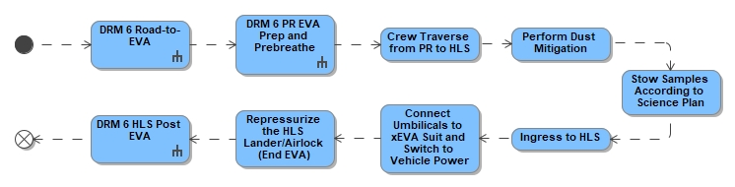
Figure 4-46: DRM 6 Final Ingress into HLS

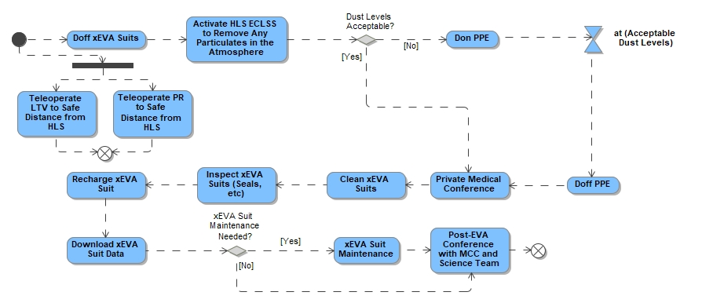
Figure 4-47: DRM 6 HLS Post EVA

DRM 6: Uncrewed PR Mission Excursion Objectives
The PR autonomous or teleoperated activities during the uncrewed PR traverses may include, but are not limited to:
- Command and control of vehicle traverse behaviors
- Maintain and monitor vehicle systems
- Cooperation with other uncrewed lunar surface assets, such as the LTV and landers for exploration and cargo
- Scouting the surface for potential traverse paths and scientific sites of interest for future crewed missions (consider details such as terrain, natural lighting, etc.)
- Body mounted payloads surveying the subsurface to understand the geologic layering and presence of frozen volatile ice using payload instruments such as ground penetrating radar or a neutron spectrometer for investigation of polar volatiles in the top meter of regolith.
  - Measuring surface properties or sample characteristics
    - Geotechnical properties as a function of terrain (i.e., bearing capacity, shear strength), geochemical characterization.
- Elevated external attached payloads to survey lunar environment, such as a laser-induced breakdown spectroscopy instrument, and LiDAR.
- Imagery of potential samples, sampling sites, or other geologic phenomena
- Emplace surface assets such as remote science stations:
  - Geophysical station(s), space environmental monitoring, local exosphere and volatile flux, micrometeorite collection, astrophysical payloads
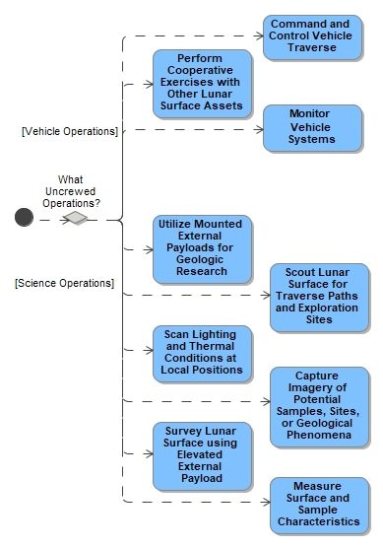
Figure 4-48: Potential Pre-Mission Uncrewed Surface Operations
Between crewed missions, the LTV, and later also the PR, will traverse the lunar surface in order to satisfy three major objectives: (1) survive the lunar winter by relocating between hibernation points as needed; (2) relocate to a new exploration region of interest within the Lunar South Pole area to prepare for the next crewed mission; and (3) accomplish exploration objectives, such as collecting samples, in an opportunistic fashion. These traverses will be planned in advance, taking lunar terrain and shadow conditions into account, to allow the rovers to survive while still arriving at the next landing site in time to rendezvous with the crew. When both rovers are present, they may coincidentally travel broadly similar paths since they will be traversing between the same start and end points. However, in general, the rovers are not expected to remain in close proximity to each other during uncrewed periods, partly because their exploration objectives may differ and partly because the rovers will be at lower risk of collision, shadowing one another, or obstructing one another's paths (for example, if one rover becomes stuck) if they are not being operated in tandem.

DRM 7: Initial Pressurized Surface Habitation (ISH) – 4 Crew to Surface for Extended Surface Operations
HLS provides habitability for four crew for at least five Earth days while on the Lunar surface. Delivery of a second surface habitable asset allows the increase of crew to the surface from two to four for longer durations. After HLS descent, all four crew perform an EVA with two crew transferring to the PR and two crew transferring via LTV to the second habitable volume taking with them any perishable and crew specific items (e.g., EVA spares such as gloves) to their respective volume.
Recurring missions under this DRM include delivery of the PR cargo resupply initially within the HLS and eventually supplemented on a dedicated lander, which may allow mission durations up to 28 day (+3 margin). Nominally the PR design supports up to 2 crew for 28 days (with resupply) allowing for some extra consumables to cover crew ingress and egress activities or off-nominal events.
The PR will stow and transport at least 14 days of cargo. During a nominal 33-day lunar surface mission, an initial supply of the PR will occur early in the mission, followed by a resupply in the middle of the mission. At the end of the mission, trash and waste will be offloaded from the PR, and some supplies may be loaded for the next mission. Each supply event will require at least one full EVA.
Table 4-3: Crewed Missions with Mobility and Surface Habitation Key Parameters
Surface System Configuration | HLS Sustained, xEVA, LTV, PR, Initial Surface Habitat
Key Objectives | - Demonstrate prolonged surface stay.  - Deploy technology demonstration packages and instrumentation
Key Parameters | Surface Crew | 4
Key Parameters | Proposed Surface Stay | Up to 33 Days
Key Parameters | Proposed Number of EVAs per Crewmember | Cumulative EVA time per week ≥ 24 hrs.
Key Parameters | EVA Range with PR and LTV (from Habitat) | 20 km

The Initial Surface Habitat supports EVAs with a dedicated airlock (which will be checked out by the ground prior to crew arrival) eliminating crew time required to reconfigure the habitable cabin and stow items that should not be exposed to vacuum. The airlock will be sized to allow two crew to simultaneously don and doff their suits since EVAs are always performed in pairs (buddy system). The xEVA suits will be stored on the don/doff stands, which can be reconfigured or relocated, when the suits are not being used.
If a suit fit check is required to ensure proper fit prior to going EVA, it will be performed during pre-EVA activities of the next planned EVA. EVA suit fit check may be needed, especially if they are on-orbit or NRHO for extended periods of time and spinal elongation occurs. Additional configuration change and checkout will be performed on the lunar surface as needed.
EVA exploration, tools, equipment, and sample containers will be managed through a combination of storage solutions. While some items may be housed within the ISH airlock, larger or frequently accessed equipment will primarily reside in external containers designed for easy EVA crew access or stowed on the LTV if available. Power tools, however, will necessitate transport into the ISH for charging. Given that the ISH currently lacks external compartments for geology tools, an EVA-accessible staging area will be crucial for efficient tool swapping as needed and for the initial stowage of collected samples. This system allows for the offloading of tools from the LTV when necessary, either to create space for CTBs/CPCs or to remove items not slated for subsequent EVAs, thereby optimizing LTV performance. Furthermore, tools not brought into the ISH will be placed on designated surfaces to mitigate dust contamination, rather than being left on the lunar regolith.
The management of collected samples and the role of the LTV are integral to efficient surface operations. At the conclusion of each EVA, collected samples, such as sample bags and drive tubes, will be removed from the LTV and, at the mission's end, transported to the HLS via the LTV. This practice ensures that once an item has been used and is not planned for re-use, it is removed from the LTV to maintain optimal vehicle performance. Similarly, the LTV may serve as a temporary stowage platform for reusable EVA tools between EVAs, compensating for the absence of dedicated external geology tool compartments on the ISH. Any single-use or end-of-life items will also be removed from the LTV at the end of each EVA for the same performance rationale. Current assumptions are that EVA accessible containers used for stowing tools could be flown separately from the ISH and do not need to be integrated with the structure. Spare equipment and EVA consumables will be stowed in the module for use during the crewed mission. The ISH will have an external platform with stairs to facilitate the crew translating between the module and the lunar surface. Fall protection aids (tether system) may be required depending on the height of the platform. Dust mitigation systems and tools will be housed in the airlock and outside the module to assist the crew in removing dust prior to entering the module after an EVA. A more complete description of ISH operations can be found in MPH-CONOP-001, Multi-Purpose Habitation (MPH) Module Concept of Operations (ConOps).
The amount of cargo delivered for the ISH crew on HLS will determine the duration that the crew can stay on the surface during initial crewed missions until dedicated Mated Carriers (MC) arrive. Until then, cargo needed for missions will be hand carried in (and out) of the ISH airlock during EVA via CPCs. Once MCs are available, the MC docks to the ISH to the hatch opposite of the airlock and the crew transfer cargo shirtsleeve. The MC can mate/demate while crew is not there; however, if crew are in MPH, they may need to isolate in the airlock during mate/demate.
The ISH will support utilization by providing payload accommodations and resources to payloads mounted internally and externally to the module. ISH supports Surface Deployed payloads nearby with data transfer services but not power. The current assumption is that these payloads will be launched separately and delivered to the ISH through logistics transfer processes. The ISH will host six external payloads that are mounted on the outside structure of the ISH within reach of EVA crewmembers, allowing them to be removed and replaced throughout the operational life of the module. External payload interfaces will be designed to be EVA compatible. Considerations for ensuring the safety of the EVA crew (ex. trip hazards) with relation to any power cables will need to be further investigated, as well as considerations for proximity of rover operations to lunar surface deployed payloads.

DRM 7 LTV-PR Cooperative Exploration – 4 Crew to Surface
For missions with four crew on the surface, mission priorities and other factors (e.g., distance of the Initial Surface Habitat from HLS) will determine when the LTV is co-located with the PR crew versus when it is with the Initial Surface Habitat crew. Furthermore, it is possible that over the course of a given mission, the LTV will “switch” support between the PR crew and Initial Surface Habitat crew. It is also possible that all four crew may conduct cooperative exploration together for a period of time (e.g., during a cooperative 4-crew EVA).
When two crewmembers are stationed at the second habitable volume (Initial Surface Habitat), they may have the LTV with them for both science exploration support and contingency purposes. In this case, the crew in the Initial Surface Habitat will be limited to the 10 km walk back radial distance exploration from the Habitat during exploration EVA on the LTV, and the crew in the PR will be limited to the 10 km walk back radial distance exploration from the HLS. Another possibility, depending on relative distances and mission objectives, is that the PR crew and the Initial Surface Habitat crew may exchange habitats halfway through the mission. Such an exchange would necessitate exchange of crew-specific cargo, such as hygiene kits and spare gloves.

DRM 7 EVAs from PR without LTV
For DRM 7 missions, the PR and Initial Surface Habitat may not be co-located. Therefore, if the LTV is providing support to the Initial Surface Habitat crew, the PR crew may conduct their traverses and EVAs without the LTV nearby. EVAs from the PR without the LTV will occur within walk back distances of the HLS.

The crew will drive the PR to and between exploration stations/areas of interest and will traverse on foot within a station to complete tasks. The crew will remain within moderate proximity (e.g., ~500m) of the PR. The PR may be remotely operated during an EVA to maintain a distance from the crew that balances the support for the crew (e.g., carry tools, equipment, samples; provide supplemental lighting; faster contingency response) and be in close proximity of the crew should an emergency arise.

If the PR is remotely operated during an EVA, PR needs to remain at distance from sampling locations to reduce vehicle-induced contamination. The crew may traverse into terrain that the PR is unable to enter but is within xEVA suit capability (e.g., areas with unfavorable rocks/terrain for PR but within safe limits of the xEVA suit).

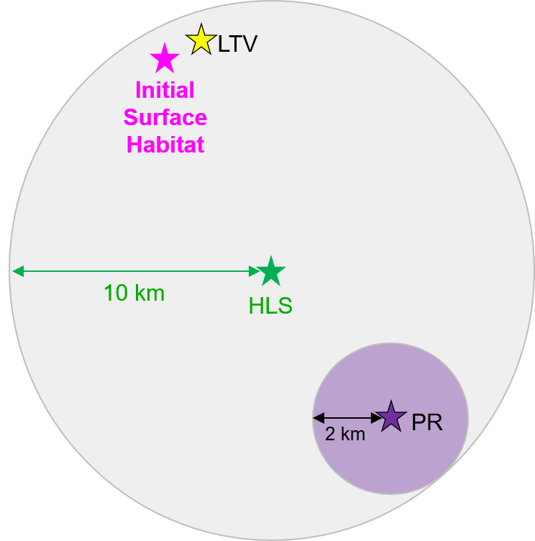
Note: Purple circle can move within grey circle during an EVA.

Figure 4-49: Exploration EVA Range From PR When LTV With Initial Surface Habitat
Crew-to-vehicle separation distance can be up to 2km but crew will likely remain in closer proximity to PR to support tool carrying, sample stowage, etc.

DRM 7 EVAs from PR with LTV
If the LTV is dedicated to the PR crew and not to the Initial Surface Habitat crew, PR-based EVAs will follow the same ConOps as described in DRM 6 (i.e., within 20km range of HLS), assuming the Habitat only nominally supports 2 crew simultaneously.

DRM 7 EVAs from Initial Surface Habitat with LTV
If the LTV is dedicated to the Initial Surface Habitat crew, habitat-based EVAs will follow the same ConOps as described in DRM 5 with the habitat at the center of the 10km radius.
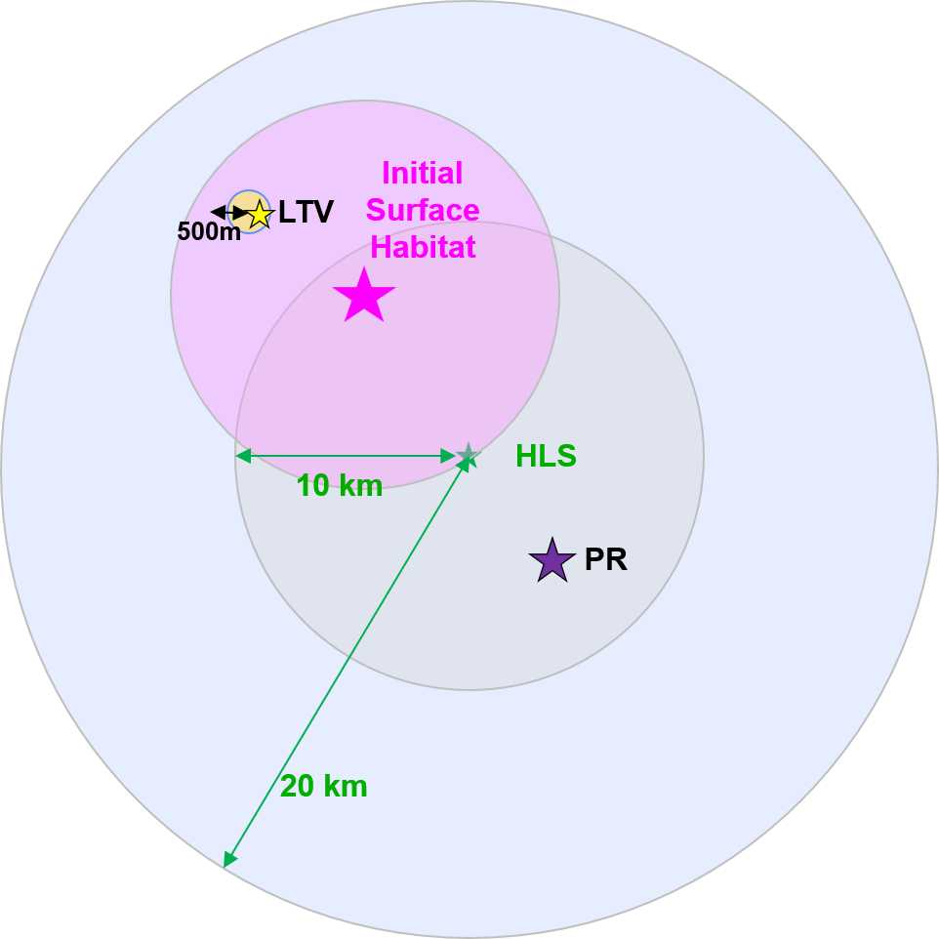
Figure 4-50: Exploration EVA Range from Initial Surface Habitat When LTV With Initial Surface Habitat
Crew-to-vehicle separation distance can be up to 500m but crew will likely remain in closer proximity to LTV.

DRM 7 EVAs with 4 Crew from PR and Initial Surface Habitat with LTV
During DRM 7 missions, all four crewmembers could conduct an EVA together using both the LTV and PR for mobility and support (i.e., with LTV assigned to the Initial Surface Habitat-based crew and PR assigned to the PR-based crew). In this situation, the EVA must remain within walk back distance of the Initial Surface Habitat (as PR only provides habitation support for 2 crewmembers, including during contingencies). To protect for contingencies, the crew will remain within relative proximity of their assigned vehicle, such as LTV or PR, as defined by flight rules.
During the EVA, the rovers will be used to traverse between science sites. The crew will traverse by foot short distances away from rovers to reach science objectives, carrying tools and samples with them. The maximum distance all four crew (while EVA together) can be from HLS at any time is 10 km to protect for contingency return to HLS.
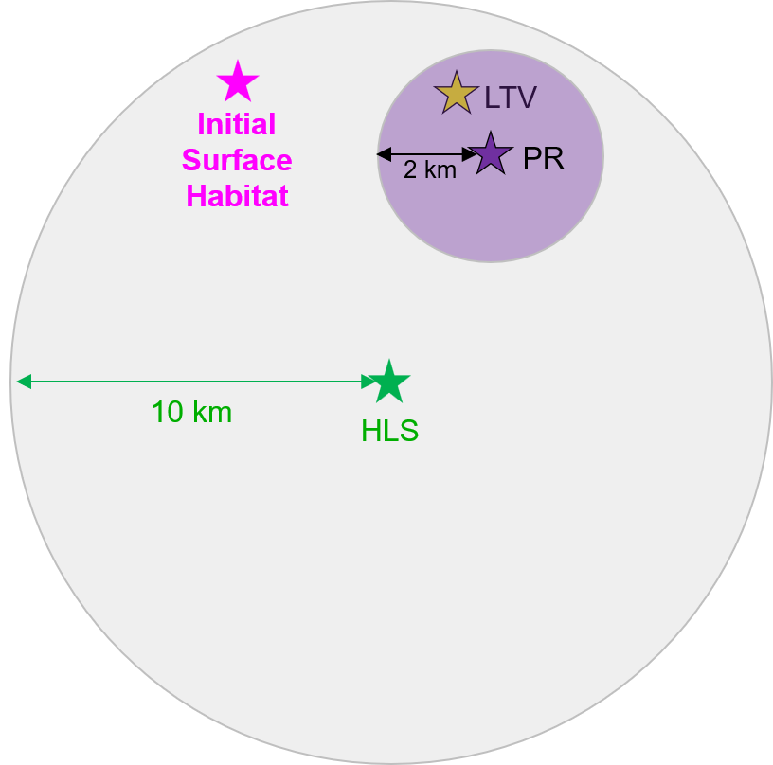
Note: Purple circle can move within grey circle during EVA

Figure 4-51: Exploration EVA Range From Initial Surface Habitat (Four Crew EVA)

DRM 7 EVAs from Initial Surface Habitat without LTV
If the LTV is dedicated to the PR crew, then the Initial Surface Habitat crew do not have a rover available for nominal or contingency use (exception being if the PR is operating in close proximity to the Initial Surface Habitat). It is possible that the LTV or PR could provide emergency assistance to the Initial Surface Habitat crew. In scenarios where the LTV is unavailable, the ISH crew's ability to return to the HLS in an emergency becomes significantly limited, primarily relying on a walk-back contingency covering distances of approximately 2 to 10 kilometers. Consequently, planned
EVAs will not be performed if the LTV is not operational or accessible, ensuring crew safety and preventing situations where they might be stranded far from the HLS without reliable transport. This constraint is critical because the LTV, a key surface asset, might be unavailable due to various nominal or off-nominal circumstances, necessitating a robust contingency plan for crew return.
To mitigate the risks associated with potential LTV unavailability (nominal or off-nominal), specific planning assumptions should be imposed on landing site selection for missions where the crew resides in the ISH and cannot depend on surface assets for contingency transportation. The chosen landing site must be situated outside any blast zone that could impact the ISH and, crucially, must be within a 10-kilometer walk-back range to the HLS. This ensures that, in the event of an LTV malfunction or absence, the ISH crew can still perform an EVA walk-back to the HLS if a contingency arises, safeguarding their ability to reach a safe haven.
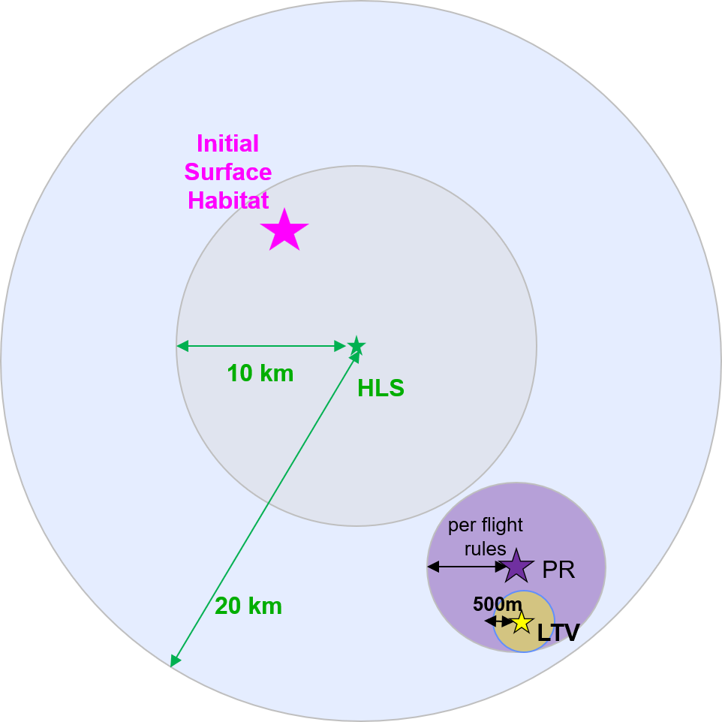
Note: Purple circle can move within blue circle during EVA

Figure 4-52: Exploration EVA Range From Initial Surface Habitat When LTV is with PR
The relative distance between LTV-PR will be specified in flight rules based on conditions such as terrain, science objectives, etc. Crew-to-LTV separation distance can be up to 500m (as supported by the communication architecture) but crew will likely remain in closer proximity to LTV so that it can be utilized to carry tool, samples, support ICR, etc.
If a tool cart transport system is not available to the Initial Surface Habitat crew, it is recommended that nominal exploration EVAs from Initial Surface Habitat are not conducted without LTV/PR, or only limited-distance EVAs are conducted. With hand carrying tools and any contingency aids, distance limitations are expected to be too constraining to accomplish enough science to merit performing an EVA. Limited scope EVAs could allow EVAs in immediate vicinity (hundreds of meters) of Initial Surface Habitat with crew hand-carrying tools. This may or may not provide high science value but could allow for repairs, sample curation, etc.
If a tool cart transport system is available, the Initial Surface Habitat crew can perform EVAs within 2km of Initial Surface Habitat. In this case, the EVAs would look similar to those performed in DRMs 3 and 4.

Integrated Contingencies and Approach Options
All human spaceflight missions entail some level of inherent risk, and hence planning failure mitigations is critical for ensuring as much crew safety and mission success as possible. Artemis elements, including the xEVA System, LTV, and PR, must be ready and able to handle emergencies to preserve crew life and mission objectives. Hardware providers for all Artemis elements will produce hazard reports that identify hazards, causes and controls as well as crew survival methods to be employed when all controls fail. The LTV and PR are required to be at least 1-fault tolerant to catastrophic hazards and all critical hazards must be controlled. The xEVA suit is required to be 2-fault tolerant for catastrophic hazards and 1-fault tolerant for critical hazards. Despite these requirements, contingencies can still occur.
Artemis Lunar Surface Systems are expected to control their hazards primarily through their element design (hardware and software). Due to the nature of lunar surface operations, there may be instances where there is a reliance between elements (ie. rover to suited crewmember) to perform an operational control to a hazard.
Should it be determined that an operational control is essential in controlling a catastrophic hazard, and that it requires transmission of data to surface crew to control that catastrophic hazard, the implementation strategy mandates that these alerts will be sent as audio annunciations to other surface systems. These audio annunciations will be transmitted over the standard audio loop, ensuring direct and unmistakable communication with the surface crew. The receiving element will not be expected to interpret raw data to generate its own tones; rather, it passively receives the originating element's audio transmission over the standard audio loop. This approach streamlines the process, ensuring clarity and minimizing potential for misinterpretation.
This section outlines a list of integrated contingencies between surface assets specific to include suit failures, crew medical events, environmental events, and loss of capabilities (such as loss of communication or rover mobility failures) that the xEVA suit, LTV, and PR are responsible for supporting. The scope of the list is on EHP element integrated contingencies, does not get into element specific failure details, and is not all encompassing. Contingency scenarios are organized by DRM, and some integrated contingencies can apply to all DRMs. Deltas to each scenario are discussed as opposed to repeating information already encompassed in the ConOps. Program integrated contingencies triggers are organized into three categories: Crew Medical Events, Environmental Events, and System Failure Events.
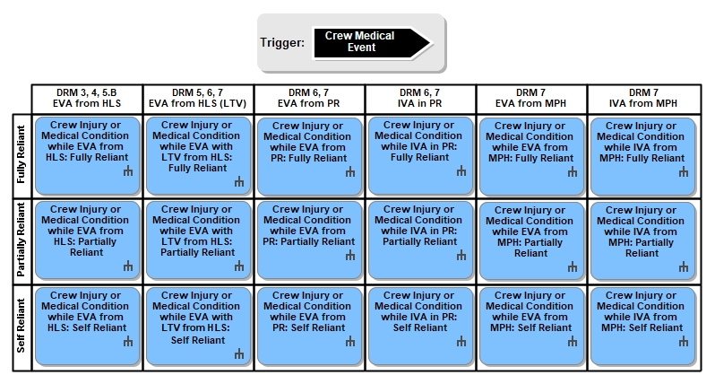
Figure 5-1: Crew Medical Event Integrated Contigencies
Crew Injuries: There exists a wide variety of crew injuries or medical conditions that could occur during Artemis surface mission phases. The point of injury or condition onset could occur at any time and in any location where the crew is present. The corresponding physical and/or cognitive impairment could result in the injured crewmember being fully or partially reliant on their buddy crew for survival. Alternatively, the injury might be minor enough such that the crewmember is able to transfer him or herself back to a safe location without assistance (i.e., a self-reliant). Depending on the nature of the injury/condition and medical aid capabilities available, treatment could range from facilitating a full recovery on the surface (e.g., in the event of DCS) to otherwise stabilizing the crewmember as best as possible and returning the injured crewmember back to Earth as soon as possible for definitive care (e.g., broken bone). For injuries that require return to Earth, continuity of care should be transferred as the crew transitions from one element to the next (e.g., xEVA suit rover HLS Gateway Orion). Importantly, medical care of the injured crewmember must not incur additional risk to the uninjured crewmember. Note that in terms of failure classifications, crew injuries and medical events are not in and of themselves considered failures.
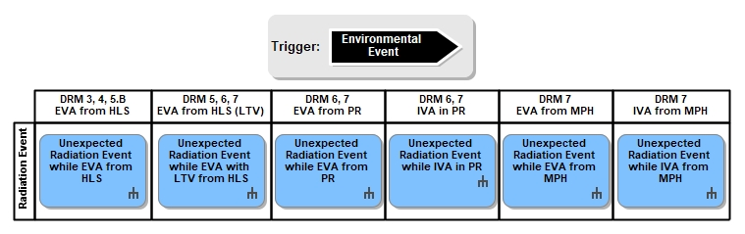
Figure 5-2: Environmental Event Integrated Contigencies
Environmental Events: Unexpected radiation events are covered in each section. Other environmental events such as micrometeoroid debris or contingencies due to terrain can cause both injury and a feed the leak scenario or system failure. Other environmental effects that need to be considered are dust (effecting functionality of suit OR brought back inside a habitable volume and effecting crew health of functionality of the vehicle ECLSS system) and tribocharging where effects can harm the crew in the suit or the suit systems.
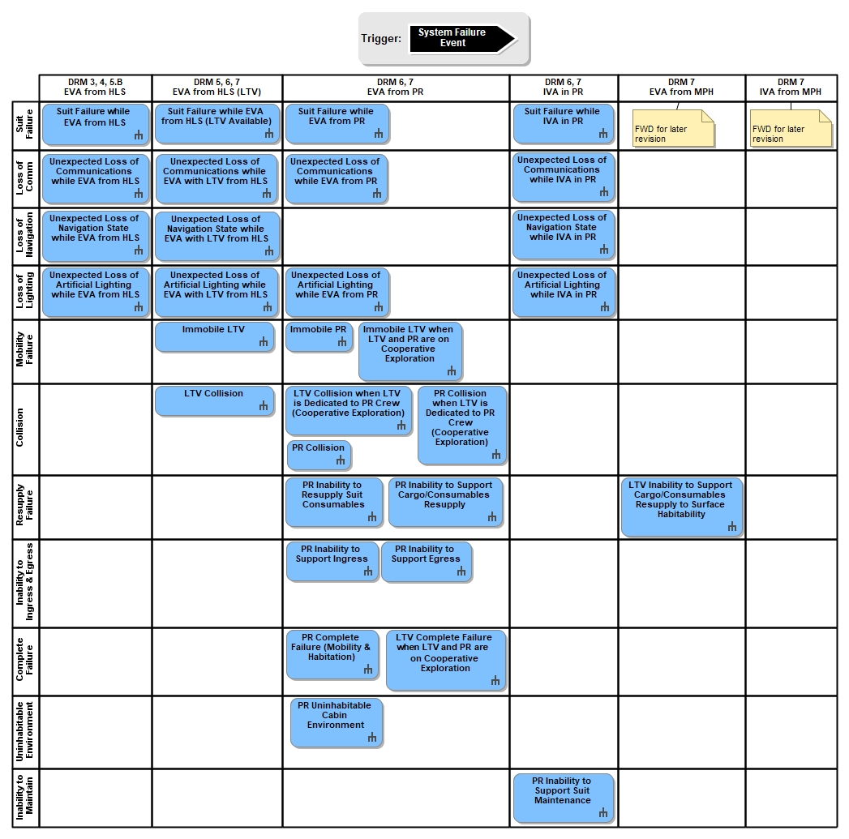
Figure 5-3: System Failure Event Integrated Contingencies
Suit Failures: Suit failures can result from mechanical, power, pressure, data/communication or thermal anomalies. A single failure event can cause other loss of capability on the xEVA suit (e.g., power failure loss of artificial lighting) and can range in severity from catastrophic in nature, to critical, to minor. This document will not identify every potential suit failure that could result in an integrated contingency, as that is the role of the safety review panel process that continues throughout the life of the project including certification for flight. For definitions of hazard severity (e.g., critical vs catastrophic), and details of the safety review panel process, refer to EHP-10038, EHP Safety Review Process Requirements. The focus in this section will be on high-level integrated responses to suit failures.
Lunar Replaceable Units (LRU) or replacement parts will need to be either onboard the vehicle or able to be delivered to the lunar surface on a later mission. LRUs would need to have the capability and compatibility to be removed and replaced by a suited crewmember. Adequate lighting will need to be provided to support the maintenance. All maintenance will need to occur within the nominal bounds of EVA consumables and without requiring excess physical exertion by the crew.

DRM 3+: Polar Sortie Suits Only and Non-Polar Sortie DRM Suits Only
DRM 3 and Non-Polar Sortie integrated contingencies, located at a polar site and non-polar site, respectively, are categorized into four topics: xEVA suit failures, crew medical events, environmental events, and loss of capability. These DRMs assume EVA capability only and no rovers or other surface assets outside of the HLS. This section outlines integrated contingencies that occur while the crew are EVA from the HLS, including suit failure, crew injury or medical condition (responses separated by fully reliant, partially reliant, and self-reliant injuries), environmental events including unexpected radiation event, and loss of capabilities including loss of communication, loss of navigation state, and loss of artificial lighting.
Table 5-1: DRM 3 and Non-Polar Sortie DRM Integrated Contingencies

Suit Failure on EVA from HLS
In the event of a xEVA suit failure while EVA from HLS, mission flight rules will determine (based off hazard reports) which failures require immediate EVA termination and return to HLS versus which failures may allow an EVA to continue, possibly with some in-field troubleshooting and/or altered mission objectives. If the nature of the suit failure requires EVA termination, the affected crewmember will, if needed, switch to emergency Secondary Oxygen Pack (SOP), and then both crewmembers will walk back to HLS together as safely and efficiently as possible. It is possible that the unaffected crewmember will have to guide the affected crewmember depending on which suit capabilities are functioning in an off nominal state; furthermore, mission planning will need to account for additional time needed to return to HLS in an emergency (e.g., to initially communicate the issue between crewmembers and to the ground, navigate and traverse back to HLS in an off nominally functioning suit which might reduce pace and/or require a different traverse path, etc.). Once the crew reach HLS, they will ingress and repress, during which the HLS will provide power, cooling, comm/telemetry, and O2 to both suited crew.
In the event that the suit failure can be either troubleshooted and fixed in the field or the EVA can progress because the contingency does not pose undue risk (as bounded by flight rules, e.g., an isolated, failed helmet camera), it is possible that the EVA can continue, though potentially under reduced capabilities or with altered objectives (e.g., due to lost time to attend to the contingency initially). Throughout a suit failure contingency, the MCC team will assist the crew in following their contingency procedures, and navigating, troubleshooting, etc. as needed.

Crew Medical Events
For all injuries and medical conditions occurring during an EVA, the first step towards resolution is for the healthy crewmember to recognize that an injury or medical event has occurred with his or her buddy. That might include the healthy crewmember first locating the injured crewmember not within immediate line-of-sight; the ground may assist with location support. The healthy crewmember will then assess the situation and determine, in consultation with the injured crewmember (if he or she is able) and the MCC, the level of care needed and subsequent steps to take.
Medical conditions could include, e.g., DCS, which, depending on severity and how quickly it is detected, could render that crewmember anywhere from self-reliant to fully reliant on the EVA buddy. If the injury or medical condition requires the crew to return to the HLS for departure to Earth, vehicle safing and prep for uncrewed operations may need to be conducted by the onboard crew and/or ground, as determined by vendor design specifications.

Crew Decompression Sickness while EVA from HLS
If a crew member suspects they are experiencing DCS, they will increase suit pressure to 56.5 kPa (8.2 psid). They may also consult with the Flight Surgeon if needed, depending on the symptoms. The crew members will then pause the EVA to evaluate the impact of the pressure increase on DCS symptoms before initiating the return to the vehicle. Unless there is an issue with consumables, the walkback duration is not time critical. The crew should return at a speed that does not overexert the physical workload of the crew. If the DCS symptoms become so severe that the crewmember experiencing them is partially or fully reliant on the healthy crewmember, the steps outlined in the following applicable sections will be followed for returning to HLS.
Once both crewmembers physically contact the vehicle on return, , they will start the 30-minute DCS treatment timeline (completion of ingress and at DCS treatment pressure within 30min ). The crewmember with DCS will be at 56.5 kPa (8.2 psid) and the other crew member will remain at nominal suit pressure. The crew will ingress the vehicle and attach their umbilicals. They will then close the hatches and complete any other repress preparations. When that is complete, both crew members will begin repressurization of the vehicle. The crew member with DCS will remain at 56.5 kPa (8.2 psid) for the remainder of the Airlock depressurization. The other crew member will perform nominal repressurization procedures with the plan of doffing the xEVA suit. The healthy crew member will then doff their suit solo or with the help of the DCS afflicted crew member and then complete post-EVA activities while the DCS afflicted crew member remains suited.
The healthy crew member will then perform a neurological exam on the DCS-afflicted crew member. If there are no further issues from the exam, the DCS-afflicted crew member will remain in their suit at 56.5 kPa (8.2 psid) for up to 6 hours, pending the flight surgeon instructions.

Crew injury or medical condition while EVA from HLS: Fully Reliant
In the event of an injury or condition that results in a fully reliant crewmember, he or she will return to HLS utilizing EVA hardware provider provided tools that safely, securely, and efficiently support transport to the base of lander potentially up to 2 km radial distance away, with the support of their healthy crew buddy. Any EVA hardware provider provided tools should be able to support the crewmember on slopes up to 15 deg for full traverses, with portions between 15 and 20 deg for up to 200m. Following safe return to HLS, these xEVA System tools used continually to support ICR are not required to support subsequent EVAs.
It is expected that the xEVA suits will be able to support at least some dragging along the lunar surface, the amount of which will depend on design of the xEVA vendor-provided tools for aiding in the transport a fully reliant crewmember. Once the fully reliant crewmember reaches the base of HLS, HLS vendor-provided tools and aids will provide ingress, repress, and suit doffing accommodations for a fully reliant suited crewmember. In the event that critical clean-up outside of HLS could not be performed due to the ICR prior to HLS ascent, a contingency EVA may need to occur.

Crew injury or medical condition while EVA from HLS: Partially Reliant
In the event of an injury or medical condition that results in a partially reliant crewmember, he or she will return to HLS utilizing vendor provided tools to the base of lander with the support of their healthy crew buddy, as needed based on the nature of the injury or condition. HLS vendor will provide tools and aids for ingress, repress, and xEVA suit doffing accommodations for a partially reliant suited crewmember.

Crew injury or medical condition while EVA from HLS: Self Reliant
An injured crewmember who is considered "self-reliant" can return to HLS under his or her own power. However, the injured crewmember may opt to use vendor provided tools and/or their healthy buddy for support to reach base of lander as an added safety precaution and to reduce risk of further injury, as long as those tools are used in an acceptable manner that is consistent with their design and intent. A self-reliant injured crewmember is not expected to use HLS-provided ingress assistance or alternate doffing accommodations.

Environmental Event: Unexpected Radiation Event while EVA from HLS
An unexpected radiation event (e.g., solar particle event [SPE]) could occur at any time and result in a dangerous environment for the crew and lunar surface assets. Each system in the Artemis architecture will offer an innate level of protection from Galactic Cosmic Radiation (GCR) and SPEs in line with As Low As Reasonably Achievable (ALARA) principles; innate protection levels will drive operational planning and flight rule development for minimizing the risk to crew and mission systems. Space weather forecasting will guide EVA go/no-go decisions, as risk to the crew is highest during an EVA due to exposure levels (including duration of exposure). The xEVA suits will provide active radiation monitoring and alerting to the crew. Mission flight rules will define go/no-go decisions for continuing the EVA based on the current radiation detection level. A low-level event may enable the EVA to continue when in line with ALARA principles. A major event, which could last for multiple hours, will require EVA termination and the crew returning to HLS as quickly as possible.

Loss of Capability
There are multiple causes that could lead to loss of capabilities such as communications, navigation, lighting, integrated contingencies with HLS, etc.; furthermore, a single event could result in loss of multiple capabilities simultaneously (e.g., something that knocks out a power system). In any of these capability loss cases, mission procedures and flight rules will determine the extent of mission and/or crew impacts.

Unexpected Loss of Communications while EVA from HLS
During DRM 3 EVAs, the xEVA suits will have UHF SSCS (space-to-space communication system) to communicate with one another and a direct UHF SSCS and Wi-Fi communication links to HLS, enabling the crew to communicate with MCC. There are multiple events that could lead to an unexpected loss of communication between crewmembers on EVA or between EVA crew and ground, such as communication network failures (including connections between HLS and ground) or EVA suit communication system failures. In the event of an unexpected loss of communication while EVA, mission flight rules will include (1) getting crew to a safe and stable state, if needed (e.g., did the loss of communication result from some other anomaly that needs to be addressed more immediately?); this could include terminating the EVA, and the (2) if/when time and resources allow, attempting to understand the cause of the loss of communication (e.g., communication blockage, suit radio failure, ground relay failure, etc. - this could be achieved by returning to the last known location of communication, swapping to an alternate radio or radio frequency, swapping to an alternate antenna or antenna station, recycling ground communication hardware, etc.) so that it can be recovered. In the event of an HLS or network failure resulting in reduced bandwidth, the data streams between HLS and Earth will be prioritized (e.g., drop to crew voice only, or crew voice and a single helmet camera).

Unexpected Loss of Navigation State while EVA from HLS
The navigation strategy for EVA from HLS during DRM 3 is currently planned to be a standalone navigation system (in-flight demo for Artemis III and certified for Artemis IV) capable of 150-m/10-deg accuracy performance. In the event that the navigation system is not ready or breaks down during the mission and no navigation state is provided to the crew, the crew will use the navigation orienteering tools to support their navigation needs: a map book, sun compass, range scale, and sighting compass are currently prototyped. A sun compass can be used in combination with traverse maps to show bearing to a target and position using triangulation. A range scale provides a means for measuring the range back to the lander using the lander height (or other feature of the lander). A sighting compass can use a fixed spot on the horizon (e.g., the Earth) and while maintaining the fixed spot as base reference, helps with orienteering toward a specific heading.
In the event that the crew becomes lost during an EVA, they will pause to re-establish their current location relative to HLS, their path back to HLS, and/or their worksite (e.g., looking for key local terrain features, following boot prints until regaining line of sight with their target, etc.). Once the crew is able to re-establish navigation, they may continue their EVA, pending resources remaining. Flight rules will ensure that sufficient time for crew to safely walk back to HLS at the end of their EVA tasks.
Additional safety navigational aids such as visual indicators (on HLS or deployed during traverse) are under investigation as a means to reduce cognitive load/time to determine direction back to safety.

Unexpected Loss of Artificial Lighting while EVA from HLS
In the event of an unexpected loss of artificial lighting while crew are EVA from HLS (i.e., xEVA suit helmet light failure which could be caused by a more general power or thermal failure in the suit, as described more generically above), the crew will follow pre-defined procedures (memorized response, relayed from the ground, their crew buddy, and/or a cuff checklist) that prioritize their safety, followed by troubleshooting and completing objectives, as time and resources allow.
The affected crewmember will first complete necessary suit systems checks to determine any other problems that could impact safety (e.g., loss of artificial lighting as the result of a larger failure, such as loss of primary power, malfunction of the thermal management system, or overheating due to dust accumulation, etc., that needs to be addressed with high priority). A decision will then be made regarding which (if any) of the planned tasks can continue without artificial lighting and/or upstream failure mode that caused the lights to fail.
The EVA may be continued, potentially with altered objectives to account for loss of lighting or other impacted system, or it may be terminated, in which case, both crewmembers will return to HLS. It is possible that the affected crewmember may need to be assisted by the non-affected crewmember: for example, in the more extreme case if the affected crewmember loses artificial lighting when operating in a fully shadowed region they might need to first be located by the unaffected crewmember and then guided out of or through the shadows.
Return time may be longer than under nominal circumstances (e.g., due to needing to walk slower or change course if line-of-sight is limited). If alternate artificial lighting, that is designed to provide required light levels for the EVA task, is available (e.g., via vendor provided tools), they may be used as a substitute for suit helmet lights, which might enable more of the EVA tasks to be completed.

Inability of EVA Crew to Ingress HLS
Without the ability to ingress HLS, the result will be Loss of Crew. EHP-10028, xEVA System Compatibility Standards includes a best practice EVABP-29 EVA Secondary Ingress Method if the primary method of ingress/egress should fail due to a mechanical failure (hatch or power issue) or blocked exit, etc.

Inability of EVA Crew to Egress HLS
In the event that the EVA crew is unable to egress HLS whether that be due to a mechanical failure or blocked exit, the crew will follow a procedure to determine the issue with loss of egress capabilities. The planned EVA will be terminated, and no further EVAs will occur until the crew can determine a way to egress. If no solution can be found, there will be a loss of mission objectives.

Inability to Ingress and Repress HLS Airlock
If the crew is unable to ingress and repress the HLS airlock following an EVA, the crew will use a secondary ingress method to enter HLS if available. Without a secondary airlock available or a way to resolve the issue either by fixing the problem or having redundancy, this could lead to loss of mission and loss of crew.

Uninhabitable Environment in HLS Airlock
An incident where the HLS airlock is unhabitable could occur from either a fire, toxins release or loss of atmosphere. In the event this occurs while the crew is unsuited in the HLS Airlock, the crew will don safety equipment, Portable Breathing Apparatus (PBA), and identify the source of the failure. Once the failure source is identified, the failure will need to be mitigated (e.g., fire - extinguish the fire) and the habitable environment will need to be recovered by removing the toxin and cleaning contaminated surfaces.
In the event that the habitable atmosphere cannot be restored, the result is a Loss of Mission, due to the inability to use the airlock.
An uninhabitable environment issue can occur in the HLS Airlock with or without the crew present or while crew is present and suited or partially suited <FWD-EHP-10033-032>. Depending on when this occurs, the response will be different. Regardless of when it occurs, crew will begin cleaning the atmosphere by venting and repressurizing the vehicle as well as cleaning the vehicle itself as soon as it is safe to do so. Crew exposure to the uninhabitable environment is a worst-case Loss of Crew scenario. If the crew is able to resolve the cause of the uninhabitable atmosphere, but the airlock atmosphere is unable to recover, this would result in Loss of Mission due to the inability to use the airlock.

Uninhabitable Environment in HLS Cabin
The HLS Cabin could become uninhabitable during crewed or uncrewed times. If an event that causes an unhabitable environment occurs, such as a fire or a toxin release in the HLS cabin, while uncrewed and the crew is performing an EVA, the HLS response system will notify the crew. The crew will terminate the EVA and return to HLS to assess the situation and follow the below protocol if needed.
If the crew is on HLS, safety protocols, such as powering down hardware or turning off airflow systems that could exacerbate the situation, will be implemented. If these protocols fail, then the crew isolates the area(s) of concern and may begin venting the atmosphere. After threat to the environment is eliminated, the crew begins cleaning the atmosphere by venting and repressurizing the vehicle as well as cleaning the vehicle itself. The crew continues to monitor the vehicle to ensure the fire does not reignite.
If the HLS cabin continues to be uninhabitable, the crew will need to abort to the Crew Staging Vehicle (CSV). This will result in an overall worst-case Loss of Crew scenario, with a Loss of Mission for EVA objectives.

DRM 4+: Polar Sortie with Suits and Gateway
DRM 4 integrated contingencies, located at a polar site are comprised of the same considerations as DRM 3 with the addition of scenarios that could occur on Gateway. These DRMs assume EVA capability only and no rovers or other surface assets outside of the HLS. This section outlines any integrated contingencies not mentioned previously in the DRM 3 section.

Contingency Transfer to Orion/Gateway
In the event of a contingency transfer inside HLS and/or to Orion or Gateway, the xEVA suit will not be used as a mitigation due to its inability to fit through internal hatches. HLS and Orion do not have the capability to support EVA transfer on the vehicles in microgravity.

DRM 5+: Polar Sortie with Suits + LTV
DRM 5 integrated contingencies located at a polar site with EVA capability and LTV capability are categorized into topics similar to those outlined in DRM 3: xEVA suit failures, crew medical events, environmental events, loss of capability, with DRM 5 including vehicle collision. Only deltas from DRM 3 descriptions, i.e., due to the availability of the LTV, are included below. This section outlines additional LTV loss of capabilities while on EVA from HLS (communication, navigation, lighting, immobile LTV, and complete LTV failure) as well as a vehicle collision scenario.
Table 5-2: DRM 5 Integrated Contingencies
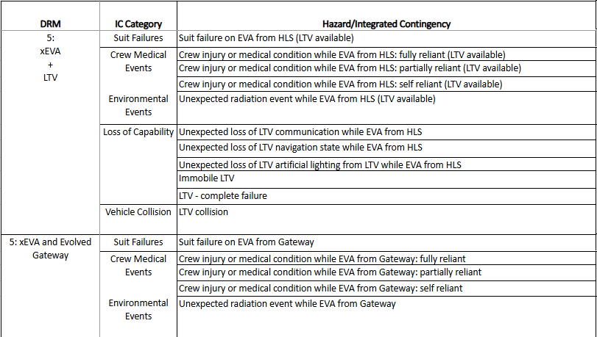

Suit Failure on EVA from HLS (LTV Available)
If a suit failure occurs while EVA from HLS with the LTV that requires EVA termination, the affected crewmember will, if needed, switch to emergency SOP, and then both crew will ingress the LTV and drive back to HLS as safely and quickly as possible. The crew will ingress, connect their suit to HLS umbilicals for consumables, and repress the HLS. In the event that the suit failure can be either troubleshooted and fixed in the field (e.g., if LTV has additional resources onboard that can support the crew) or the EVA can progress because the contingency does not pose undue additional risk, it is possible that the EVA can continue, though potentially under reduced capabilities or with altered objectives (i.e., loss of helmet lights use LTV for lighting support).

Crew Medical Events
In the event of an injury or medical condition during an EVA that requires return to HLS, vendor provided capabilities (EVA and LTV) will support the return of the two crew to the base of the lander. If the injury or medical condition requires the crew to return to the HLS for departure to Earth, vehicle safing and prep for uncrewed operations may need to be conducted by the onboard crew and/or ground, as determined by vendor design specifications.

Crew injury or medical condition while EVA with LTV from HLS: Fully Reliant
In the event of an injury or medical condition during an EVA with the LTV that renders a crewmember fully reliant on their buddy for safe return to HLS, vendor provided capability (xEVAS and LTV) will aid the healthy crewmember in returning his or her injured crewmate back to the base of lander. First, the LTV will be driven as close as practical (either by the healthy crewmember returning to the LTV and manually driving it or the ground teleoperating it) to the injured crewmember and oriented to best support crew loading and ingress. The healthy crewmember will move the incapacitated crewmember to the base of the LTV, likely by dragging or similar solution which necessitates the crew being close to the LTV during the EVA. If the ICR event occurs in terrain that the LTV cannot access directly, EVA tools will be used to aid the healthy crew in transportation of the incapacitated crew from the location of incapacitation. This is only considered feasible for relatively short distances, and hence the crew will remain within close proximity of LTV-traversable terrain, per the flight rules.

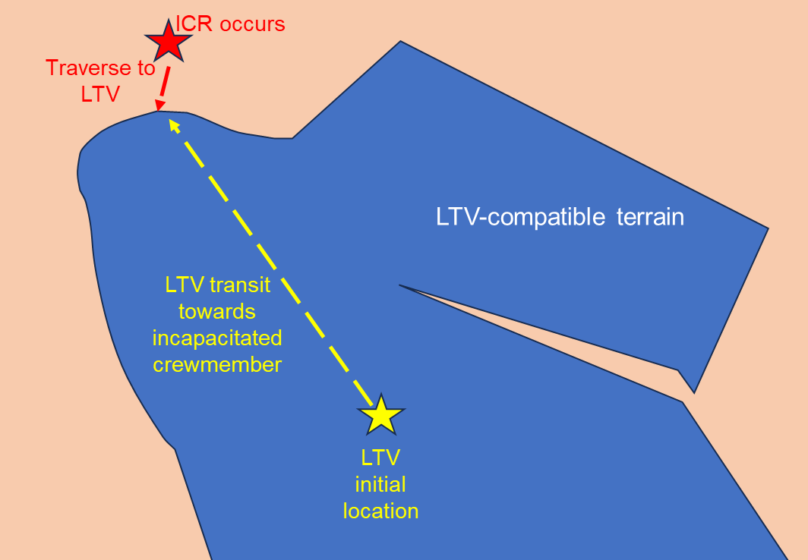
Figure 5-4 ICR Traversing with LTV
The LTV will then aid the healthy crewmember with loading/ingressing the fully incapacitated crewmember into the vehicle. It is expected that the xEVA suits will be able to support at least some dragging along the lunar surface and portions of the LTV (pending design) during the transition from the point of injury to the LTV and during the LTV ingress process.
Once the fully reliant crewmember has ingressed the LTV, they will be positioned and secured in a manner that provides optimal patient comfort, medical stabilization, and reduced likelihood of their conditions worsening or causing additional problems to protect the injured crewmember during the drive back to HLS. Furthermore, the healthy crewmember will need face-to-face visualization of the incapacitated crewmember during transport. This is critical for medical assessment, for example to observe facial expressions, including eyes and mouth, and changes in medical status. Face-to-face visualization does not need to be provided continuously and does not necessarily need to be helmet-to-helmet direct visualization (e.g., a camera, mirror, or other design solution could suffice).
Once the LTV reaches the base of HLS, the rover will be positioned relative to HLS to best support egress of the fully incapacitated crewmember. Depending on vendor designs, EVA tools may be used to help the injured crewmember transition from the base of the LTV to the base of HLS. Once the crew reach the base of HLS, HLS vendor provided tools and aids will provide ingress, repress, and xEVA suit doffing accommodations appropriate for a fully reliant suited crewmember. After crewmembers have ingressed HLS and prior to HLS ascent, LTV will be commanded to traverse to a location outside the HLS plume field. Post ICR event, the LTV must still meet all vehicle requirements following use for ICR.

Crew injury or medical condition while EVA with LTV from HLS: Partially Reliant
A similar process will be followed if the injury or medical condition leads to partially reliant incapacitation of an EVA crewmember: The vehicle will be relocated as close as practical to the incapacitated crewmember, the LTV will provide loading/ingress assistance, transport, and unloading/egress assistance in accordance with best medical practices. EVA tools will support the transition of the partially incapacitated crewmember from the incident location to the base of the LTV, and from the base of the LTV to the base of the HLS, as needed. HLS will provide ingress assistance and alternate suit doffing accommodations appropriate for a partially reliant suited crewmember.

Crew injury or medical condition while EVA with LTV from HLS: Self Reliant
In the event of a self-reliant injury or condition that results in EVA termination, the crew will return to the lander via the LTV. In a self-reliant injury or condition, the crew are not expected to need the EVA tools, LTV ingress/egress assistance accommodations, or HLS ingress assistance and alternate suit doffing accommodations, but the crew and ground may use their discretion and utilize these features as desired to prioritize crew safety and reduce the risk of further injury, provided they are used in their intended manner.

Environmental Event: Unexpected Radiation Event while EVA with LTV from HLS
An unexpected radiation event while EVA from the HLS with the LTV will follow similar protocols to those defined for DRM 3 (i.e., EVA from the HLS without the LTV): flight rules will define go/no-go decisions for continuing the EVA based on the current radiation detection level. A low-level event may enable the EVA to continue when in line with ALARA principles, while a major event will require EVA termination and the crew returning to HLS via the LTV as quickly as practical.

Loss of LTV Capability
In the event of a loss of capability of the LTV (worst case being 10 km radial distance from HLS ora habitable environment), the crew walks back to HLS. Unless there is supplemental communication extending the distance of communication between the EVA System and HLS, the crewmembers must use either a pre-planned traverse back (if no LTV communications at all) or coordinate a traverse back with ground control before departing the LTV vicinity. Loss of communication with the crew occurs once the crew leave the vicinity of the LTV and is acquired once they are within vicinity of HLS.

Unexpected Loss of LTV Communications while EVA with LTV from HLS
Similar to DRM 3, various events or circumstances could lead to unexpected loss of communication between crewmembers or between the crew and ground while EVA from HLS with the LTV. In DRM 5, the LTV could serve as a communication host: communication from xEVA suits can be relayed by the LTV to Earth or relayed by HLS to Earth. Communication paths between LTV and HLS can be established over Wi-Fi or 3GPP, though 3GPP will support longer communication ranges than Wi-Fi. The LTV will host 3GPP user equipment (UE) that can communicate with other Artemis Systems hosting 3GPP (BTS). The LTV will also host a 3GPP BTS to enable communications with xEVA-hosted 3GPP UE. If the LTV loses communication with Earth, it is required to execute all critical functions without communication with Earth. Similar to the discussion above for DRM 3, in the event of an unexpected loss of communication with the LTV present, crew will prioritize getting to a safe and stable state followed by gathering an understanding of and troubleshooting the cause of the loss of comm, as time and resources allow. In the event of a communication failure resulting in reduced bandwidth, data streams between crew and ground (via the LTV or HLS) will be prioritized. If the EVA needs to be terminated, the crew will return to HLS on the LTV. The full definition of the order of operations in an unexpected loss of communication situation will be determined with input from LTV hardware provider details.

Unexpected Loss of LTV Navigation State while EVA with LTV from HLS
A more robust navigation capability for DRM 5 EVA (compared with DRM 3 EVA) is critical due to the distance that the LTV will take the crew away from the HLS (e.g., up to 10 km radial distance). Under nominal operations, the LTV will have its own navigation capability with 10-m 3-D-RSS absolute position and 5-deg absolute heading accuracies (e.g., using LANS augmented with optical nav/IMU, pending vendor solutions).
In the event that the LTV loses its navigation state, the EVA crew will, at a minimum, have capabilities similar to DRM 3 EVAs (150-m / 10-deg). The challenge will be the distance with which the crew are from HLS when the failure occurs, which can be compounded by the specific terrain surrounding the traverse path, natural lighting condition, available features to use as orienteering references (the Earth or other celestial objects, terrain), etc. If by DRM 5 the crew has the same navigation capability as the LTV (e.g., via the suits or a separate handheld device), then this will provide full redundancy. Depending on the navigation solution implemented, the crew position could be sent the LTV display, and the crew could drive based on that information.
In the event that the LTV breaks down at distance from the HLS and the crew needs to return to the HLS on foot, at a minimum, the crew will have capabilities similar to DRM 3 EVAs (150-m/10-deg accuracy). The challenge will once again be the distance with which the crew are from HLS when the failure occurs and how much extra time/resources it will take to walk-back due to coarse navigation. If by DRM 5 the crew has the same navigation capability as the LTV, the crew should be able to navigate back to the lander provided that there are enough resources remaining for a walk-back with bounded-metabolic rates.

Unexpected Loss of LTV Display
<TBD-EHP-10033-022>

Unexpected Loss of LTV Artificial Lighting from LTV while EVA from HLS
Pending vendor designs, artificial lighting onboard the LTV may be an important asset to EVA operations, including LTV surface traverse, EVA tasks performed off of LTV, off LTV vehicle service activities, off LTV payload operations, and off LTV science operations. If artificial lighting is lost due to an LTV contingency event (e.g., power, or thermal failure, terrain impact), the crew will need appropriate capabilities to perform, vehicle support tasks, if any, and return safely to HLS within sufficient time to complete their return within their remaining consumables. These capabilities may come in the form of redundant or additional power systems, artificial lights, reflective materials, etc. Since DRM 5 EVAs may require the crew to travel up to 10-km radial distance away from HLS to achieve science and exploration objectives, if the lighting failure occurs at significant distance from HLS, the crew may need to take an alternate (longer) traverse path home to take advantage of more favorable natural light and/or may need to drive slower. It is not expected that EVA System lights will be sufficient for supporting LTV driving. However, it is possible that if the lighting failure occurs while the rover is in a shadowed area, one crewmember may need to walk alongside the rover and use their helmet lights to scan the terrain immediately in front of the rover to visualize obstacles and determine navigable pathways. This option would be weighed against the expected timeline of return fully on foot from the crew's location. If the lighting failure is part of a larger LTV system failure (e.g., complete power outage), the crew will need to return to HLS on foot within their remaining consumables.

Immobile LTV
In the event of an immobile LTV, e.g., due to getting stuck in terrain or following a system failure rendering the vehicle immobile, the crew will need to get themselves into a safe and stable state (if necessary) and acknowledge their remaining EVA consumables. As time and resources allow, they will work with the ground to identify and troubleshoot the failure. Troubleshooting might need to occur over multiple EVAs, pending the exact nature of the failure, vehicle design and onboard capabilities, resources needed and where they are located, and where the incident occurs in relation to the HLS.
If the LTV is stuck in terrain and requires crew involvement to become unstuck, the vehicle will need to be freed without requiring excess physical exertion by the suited crewmembers. The crew will also need to be able to access and transport (if needed) the necessary resources (e.g., tools, lights) to assist with vehicle freeing. All of this must be done within the bounds of nominal EVA consumables, accounting for time to walk out to the LTV (if multiple EVAs are needed) and walk back to the HLS at the end of the EVA. Alternatively, it is possible that vendors may provide completely autonomous or tele-operable solutions for freeing a stuck vehicle (e.g., to meet the multi-year life requirement during which uncrewed traversing will occur with the potential for getting stuck) that can also be applied during crewed mission phases.
If an LTV system failure renders the LTV immobile, then the crew will work with the ground to identify the cause and resolve so that the vehicle remains viable for future missions.
The inability of LTV to remain mobile, will preclude the ability to charge its batteries. This will result in the loss of energy storage capability. This risk can be mitigated by having a vehicle with the ability to receive power, resulting in recharging batteries via an external source.

Complete LTV Failure
In the event of a complete LTV failure (i.e., all systems inoperable including mobility, power, thermal control, communication and navigation systems, lighting, etc.), the crew will need to intervene to be part of the solution, as in this instance the vehicle will not be able to send or receive telemetry and data with the ground or conduct autonomous operations. The crew will need to have access to the necessary resources to do the preliminary diagnostics and troubleshooting so that vehicle capability can be restored. Depending on the severity of the failures and nature of the required corrective maintenance, multiple EVAs as well as support from the ground will need to be prioritized to ensure sufficient vehicle function can be restored, if possible.

LTV Collision
An LTV collision event, either with the lunar terrain or with another surface asset, could render damage to the vehicle. The severity of damage would depend on a number of factors including, but not limited to, speed on impact and location on the vehicle where the impact occurred. In general, the likelihood of such an occurrence will be reduced by operator training in realistic environments (for both manual and remote operators), flight rules outlining acceptable operating limits, smart vehicle design (e.g., appropriate Center of Gravity (CG) to minimize chances of rollover events, sufficient tread to minimize ground slippage, mechanical speed limits like governors), terrain limits (e.g., driven only over shallower slopes, limitations on rocky terrain), etc. Furthermore, current analysis and testing in analog environments has indicated that the vehicle will likely travel relatively slowly due to the challenging natural environment inherent to the lunar south pole region, as well as the desire to conduct scientific exploration while traversing (which might require starts/stops and/or slower speeds to use cameras, instruments, and conduct contextual surveys).
Nevertheless, if a collision event does occur, the crew will first need to be assessed for their own safety, and any crew injuries or xEVA suit failures will need to be evaluated and resolved. Once the crew are confirmed in a stable condition, pending remaining suit consumables and other resource needs, the vehicle will need to be assessed for damage. LTV health and status diagnostic information should be accessible by the ground without crew involvement to save on EVA time (e.g., autonomously or via teleoperations); however, pending vehicle damage, the crew may need to intervene to conduct a thorough damage assessment. The crew will then work with the ground to conceive a corrective maintenance plan, which depending on severity might extend over multiple EVAs. Replacement parts will need to be either onboard the vehicle or able to be delivered to the LTV if the LTV is unable to drive to the location due to damage. Lighting (natural and/or artificial) will need to be provided to support the maintenance. All maintenance will need to occur within the nominal bounds of EVA consumables and without requiring excess physical exertion by the crew. In case of a minor collision, yet the LTV is drivable, ground stations will confer for a go/no-go decision for continuing the EVA objectives and/or determining if the crew drive back to HLS. If the vehicle is not operable, the EVA may be terminated, and the crew will need to return to HLS on foot within their remaining consumables.
If collision occurs with a crewmember, they will first need to be assessed for their own safety, and any crew injuries or xEVA suit failures will need to be evaluated. Refer to Crew Injury sections for further detail.

Evolved Gateway (with Airlock Module)
DRM 5 integrated contingencies, located at a polar site are comprised of the same topics as DRM 3. These include: xEVA suit failures, crew medical events, environmental events, and loss of capability. Additional scenarios that could occur with Gateway EVAs, include environmental events such as an unexpected radiation event, and loss of capabilities including loss of communication, loss of navigation state, and loss of artificial lighting.

Suit Failure on EVA from Gateway
If the crew on a Gateway EVA has a suit failure that requires an EVA termination, the crew will need to return to the Gateway Airlock Module. The affected crewmember will, if needed, switch to emergency SOP and then both crew members will translate back to the airlock hatch using the handrails mounted on the external surfaces of the gateway modules.
The crew will ingress, seal the outer airlock hatch and connect the suit umbilicals to the EVA suits. Then, the suits will be switched from xPLSS mode to umbilical mode if possible. Once the airlock is repressurized, the crewmembers can open the inner airlock hatch and exit the airlock. After exiting the airlock, the crew can doff the EVA suits.

Crew Medical Events
Crew medical events that occur on the lunar surface or on EVA from Gateway are both a concern. The first step in handling a crew medical event is making sure the healthy crew member is aware of the injury of medical event. This will be done wither by the healthy crew member noticing, the injured crew member notifying them or ground assisting with this information. Once the healthy crew member is aware of the situation, they will determine a plan for handling this event, with the help of MCC if needed.
Medical events can vary from a minor injury requiring little support to the injured crew member being unable to move or speak and requiring full support. Regardless of if it is a full or partial reliant ICR, the EVA will be terminated or aborted, and the crew will return to the cabin or airlock. The situations below document how different conditions will be handled.

Crew injury or medical condition while EVA from Gateway: Fully Reliant
Crew injuries or medical conditions that lead to the incapacitated crewmember being fully reliant on the healthy crew member will trigger an abort from the EVA on Gateway. The healthy crew member will aid the incapacitated crew member in getting back to Gateway, using vendor-provided tools if necessary. The healthy crew member will also be in contact with MCC for assistance in the incapacitated crew rescue. The healthy crew member will bring the incapacitated crew member into the airlock via the outer airlock hatch and then seal the hatch. In the airlock the healthy crew member will use any Gateway vendor-provided aids for repressing and suit doffing in the airlock.

Crew injury or medical condition while EVA from Gateway: Partially Reliant
For events that lead to a partially incapacitated crew member on an EVA from Gateway, the EVA will be aborted and both crew members will make their way back to the Gateway airlock. If needed, the healthy crew member will use vendor provided tools to aid the partially reliant crew member in returning to the airlock. Once both crew members have ingressed, Gateway vendor provided tools may be needed to provide treatment or help with suit doffing.

Crew injury or medical condition while EVA from Gateway: Self Reliant
If a crew member is injured or experiencing a medical event on an EVA from Gateway but can still return to the airlock without assistance, they are considered self-reliant. In these scenarios, the injured crew member could use support from the healthy crew member to vendor provided tools to return to the airlock safely. Once both crew are in the airlock, a self-reliant injured crewmember will assess their medical situation and perform suit doffing procedures.

Environmental Events: Unexpected Radiation while EVA from Gateway
In the event of an unexpected radiation event (such as a SPE), EVAs from Gateway will be terminated, and the crew will return to the airlock as soon as they are able to. In addition to having a plan for ending EVAs if an unexpected radiation event occurs, Gateway will provide some level of protection from GCR. Space weather will be monitored prior to EVAs and EVAs will be cancelled if there is a risk of weather event. The xEVA suits will also provide active radiation monitoring and will notify the crew if high radiation occurs.

Loss of Capability
Loss of capabilities to Gateway related to EVAs include the loss of communication and inability to ingress or egress the Gateway Airlock. These scenarios cover situations that affect the crew while on EVA

Unexpected Loss of Communications while EVA from Gateway
The crew will utilize UHF SSCS to communicate with one another and a direct UHF SSCS and Wi-Fi communication links to Gateway, enabling the crew to communicate with MCC while on EVA. The crew could lose this capability for a number of reasons while on EVA from Gateway.
A procedure will be available for the crew to follow in the event of an unexpected loss of communications. This includes the loss of communication between EVA crewmembers or between EVA crew and ground.

Inability of EVA Crew to Ingress Gateway Airlock
In the event that the primary method of ingress/egress should fail due to a mechanical failure (hatch or power issue) or blocked exit, etc., the result will be Loss of Crew. In the event that the primary method of sealing the outer hatch should fail due to a mechanical failure (hatch or seal issue, etc.) the result could be Loss of Crew if trouble shooting procedures or alternative ingress capabilities are not successful. The Gateway Airlock will provide at least single failure tolerance to catastrophic events such as failure of the outer hatch primary seal. EHP-10028, xEVA System Compatibility Standards includes a best practice EVABP-29 EVA Secondary Ingress Method in the event that the primary method of ingress/egress should fail due to a mechanical failure (hatch or power issue) or blocked exit, etc.

Inability of EVA Crew to Egress Gateway Airlock.
If the crew is unable to egress the Gateway airlock prior to an EVA, the crew will follow a procedure to determine the issue with loss of egress capabilities. The planned EVA will be terminated, and no further EVAs will occur until the crew can determine a way to egress. If no solution can be found, there will be a loss of mission objectives.

DRM 6+: Polar Sortie with Suits + LTV + PR
DRM 6 integrated contingencies located at a south polar site with xEVA suits, LTV, and PR capabilities include discussions relevant to DRM 6 (2 crew to the surface) and DRM 7 (4 crew to the surface). For DRM 6, the 2 crew have access to both the LTV and PR, as needed, to support science exploration and protection during contingencies. For DRM 7, the LTV may be nominally dedicated to a specific crew pair or shared between the crew pairs pending mission priorities. Using the LTV to support PR contingencies will be determined by availability of the LTV to the PR crew (e.g., is it already dedicated to the Initial Surface Habitat crew?) and proximity to the PR to render aid in time. For this reason, operating constraints are presumed so that in the event of a PR failure without the LTV available, the PR crew will always remain within walk back range of the HLS. Whether or not the LTV is available to the crew in the PR is defined in each section.
Unique to Artemis PR missions is the fact that under the current PR architecture, the crewmembers living out of the PR must perform an EVA from the PR to return to HLS (and hence return home). Contingencies during PR missions that require termination or abort to HLS will require:
(1) If crew are EVA from the PR when the contingency occurs: EVA ingress into PR, followed by an additional PR-HLS transfer EVA
(2) If crew are IVA inside the PR when the contingency occurs: PR-HLS transfer EVA.
Prior to the PR-HLS transfer EVA, crew injuries, xEVA suit failures, and any other off-nominal circumstances will need to be considered so that the crew can safely complete their PR-HLS transfer EVA. Without the ability to complete the PR-HLS transfer, Loss of Crew is at risk. Top program Risk14167: Inability to Perform a Suited Transfer from PR to HLS is defining credible scenarios that could lead to the inability to complete the PR-to-HLS transfer EVA and associated capabilities needed to mitigate those scenarios.
Integrated contingency categories for DRM 6 are the same as above, but with additional loss of capabilities related to PR-specific integrated contingencies (e.g., due to PR providing IVA habitation as well as an EVA exploration platform) and callouts for dependencies on LTV availability. There are multiple integrated contingencies (e.g., suit failure, crew injury, loss of habitation, etc.), that require the ability for crew to remain suited while all of their suit consumables (power, water, O2) are supplied from the PR to the suit.
Table 5-3: DRM 6 and 7 Integrated Contingencies

Suit Failure on EVA from PR
In the event of a xEVA suit failure while EVA from the PR, flight rules will determine (based off of hazard reports) which failures require EVA termination vs. which failures allow the EVA to continue, possibly with some in-field troubleshooting and/or altered mission objectives. If the suit failure can be either troubleshooted and fixed in the field or if the EVA can progress because the contingency does not pose undue risk (as bounded by flight rules, e.g., an isolated, failed helmet camera), it is possible that the EVA can continue, though potentially under reduced capabilities or with altered objectives (e.g., due to lost time to attend to the contingency initially). If the nature of the suit failure requires EVA termination, the affected crewmember will, if needed, switch to emergency SOP, and then both crew will walk back to the safe haven (in this case PR) together as safely and efficiently as possible (or drive back on the LTV if the LTV is available to the crew and deemed more expeditious). It is possible that the unaffected crewmember will have to guide the affected crewmember back to the PR and support them through ingress, repress, and suit doffing, depending on which suit capabilities are malfunctioning. Once the crew are safely inside the PR and have doffed their suits, they will complete suit inspections and perform necessary maintenance; repair tools and spare parts must be inside the PR for the crew to access. Suits will need to be resupplied (power, water, O2), including full resupply of secondary systems that may have been depleted during a contingency, prior to the next EVA.
If the suit remains in an off-nominal state (e.g., due to inability to return it to the nominal state with the existing supplies inside the rover, inability to resupply, etc.), or if the suit is found in a failed state while the crew are IVA inside the rover (e.g., potentially independent from the last EVA), considerations will need to be made with ground input regarding how to return the crew from the PR to the HLS to prevent against Loss of Crew (reference: Top Program Risk 14167: Inability to transfer from PR to HLS). The level of suit maintenance needed to return from PR to HLS in a contingency situation is to protect against catastrophic failures in support of EVA transfer from PR to HLS and to rely on auxiliary equipment in the case of a primary component failure. Examples include getting the suit "as good as possible", feeding the leak, having access to the proper spares, etc.

Crew Medical Events
During PR missions, injuries and medical events could occur when the crew are EVA or IVA. Medical assessment during EVA is exceptionally difficult. Determining the exact medical diagnosis will generally not be possible due to suit limitations, inability to assume ground flight surgeon utilization for real-time diagnostic support, and limited availability of biomedical data; furthermore, medical condition severity is undeterminable while suited (e.g., it is not possible to differentiate a severe ankle sprain vs. open bleeding ankle fracture while suited). The decision to return to and ingress PR vs. HLS will be real-time, and crew driven due to with limited real-time input from the flight control team (e.g., due to communication latency, known and unknown blackout periods).
In most cases, returning to and ingressing PR will be the preferred destination for assessment, stabilization, and treatment of medical conditions that may develop during lunar surface EVA ops. The primary driver for this is time to medical assessment and initiation of medical treatment. Prolonging time between condition onset and initiation of treatment is likely to worsen the ongoing pathologic process, and it is likely that the crew will be in closer proximity to the PR than to the HLS. Furthermore, PR will have a robust medical assessment, stabilization, and treatment capability. The majority of stabilized and treated medical conditions will not prevent suit donning and EVA from PR to HLS (ref: Top program risk 14167: Inability to Perform a Suited Transfer from PR to HLS).
That said, a small number of unlikely medical conditions may drive direct return to HLS, including worst-case herniated disc events (e.g., resulting in paralysis from the level of herniation down, thereby rendering inability to don the suit if doffed), worst-case acute stress response (e.g., incapacitated crew member cannot follow commands or is unresponsive, inability to don suit if doffed) and/or worst-case head injuries (e.g., unconscious, if initially survivable, cannot don suit if doffed).
If the injury or medical condition requires the crew to return to the HLS for departure to Earth, vehicle safing and preparations for uncrewed operations may need to be conducted by the onboard crew and/or ground, as determined by hardware provider design specifications. This would include the PR, e.g., prior to final egress, and LTV if available to the PR crew. In emergency medical situations, it is ideal if vehicle safing and preparation for uncrewed mission phases can be conducted via autonomous operations and/or teleoperations so that the healthy crewmember can prioritize support to their injured crewmate.

Crew injury or medical condition while EVA from PR: Fully Reliant
In the event of an injury or medical condition during an EVA from the PR that renders a crewmember fully reliant on their buddy for safe haven return, hardware provider tools (i.e., from xEVAS and PR, and possibly LTV if it is available to the PR crew or in close proximity) will aid the healthy crewmember in returning his or her injured crewmate from the location of incapacitation back into the PR and/or possibly back into the HLS. If the LTV is available and the injured PR crewmember must return to HLS for treatment and transport back to Earth, the LTV may be used to transport the fully reliant crewmember back to the HLS. This decision might be made to expedite the transport and/or reduce stress on the injury/condition, pending LTV vs. PR design solutions for supporting a fully reliant individual. In this case, the healthy crewmember will need to get their injured buddy to the base of the LTV, load him/her onto the LTV, restrain him/her, drive the LTV back to HLS, unload him/her, and ingress into the HLS.
Following an ICR event, the healthy crewmember must first transfer the fully reliant crewmember from the point of incapacitation into the PR cabin. For incapacitated crew rescues while EVA from the PR without LTV support, the PR will be relocated as close as practical to the incapacitated crewmember and oriented to support crew loading and ingress; this could occur via remote operation or by the healthy crewmember returning to the PR and manually driving it to the incapacitated crewmember. If moving the PR is deemed too costly timewise and/or too complicated, this step can be skipped per the discretion of the crew and MCC.
It is expected that the suits will be able to withstand at least some dragging along the lunar surface and portions of the PR (pending design) during the transition from the point of injury to the PR and during the PR ingress process. If the EVA crewmembers are at distance from the PR with the LTV nearby, the healthy crewmember may use the LTV, similar to operations described in DRM 5, to get the fully reliant crewmember close to the base of the PR. If the ICR event occurs in terrain that is not traversable by the PR and the LTV is not readily available for support, the healthy crewmember will need to relocate the fully reliant crewmember to the base of the PR by dragging or similar solution. Due to the anticipated difficulty completing this task, crewmembers will remain within moderate proximity of PR traversable terrain throughout the EVA, per the flight rules, to protect for ICR.
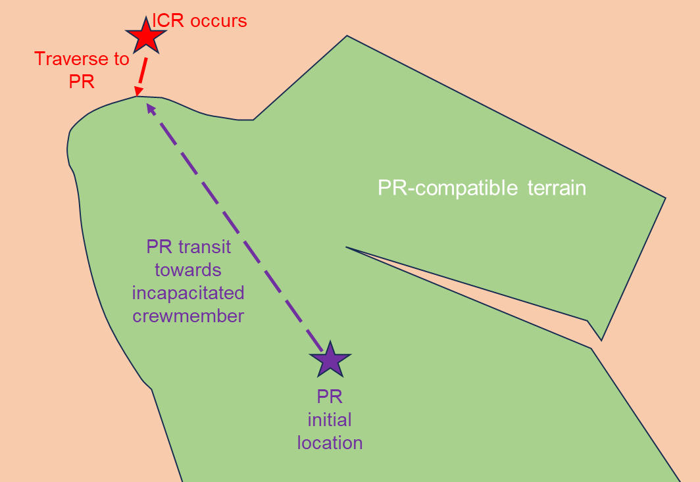
Figure 5-5 ICR Traversing with PR
Similar to DRM 5, the incapacitated crewmember will not be positioned in inverted, prone, or any position obscuring rapid face-to-face visualization by the rescuing crewmember during loading and ingress, transport, or egress and unloading. During transport, he or she will be positioned and secured at a reclined resultant angle between 30 and 60 degrees with outstretched legs.
For some ICR events, it is also permissible to secure a suited crewmember in an upright vertical position during transport. To maintain rapid PR-to-HLS EVA capability, the incapacitated crewmember may need to remain suited; it is medically permissible to transport the suited crewmember in the donning stand to expedite return to HLS. Additionally, some suited medical assessments and treatments (e.g., DCS) are more easily achieved in the vertical orientation if possible. If a crewmember experiences DCS while EVA from the PR, he or she will return to the PR and ingress the cabin, either on their own or aided by their EVA buddy depending on severity of the DCS. The PR cabin atmosphere will be repressed to 56.5 kPA (8.2 psi), and the suited crewmember will be connected to vehicle consumables (power and O2). The xEVA suit will provide 56.5 kPA (8.2 psi), and increased O2 concentration at the appropriate levels and for sufficient duration to fully treat the DCS.
If the fully reliant crewmember needs a more detailed medical assessment and/or treatment inside the PR that requires them to be unsuited, the healthy crewmember will need to conduct suit doffing of both himself/herself as well as the injured buddy. For an unsuited incapacitated crewmember on PR, the crewmember will be able to be secured in a completely supine position for transport to facilitate prolonged, optimized medical management of and recovery from a broad range of medical conditions applicable to lunar surface operations.
If return to HLS is still necessary following stabilization/treatment inside the PR, the PR will either be driven by the healthy crewmember or teleoperated by the ground (e.g., if the healthy crewmember must tend to the injured crewmember), and then the healthy crewmember will need to re-don the suit of the injured buddy in preparation for PR egress and HLS ingress. Upon reaching the HLS, the PR will be positioned relative to the HLS to best support PR egress and final transport for HLS ingress. Depending on hardware provider designs, EVA tools may be used to help the injured crewmember transition from the base of the PR to the base of HLS. HLS hardware provider tools will provide ingress, repress, and suit doffing accommodations appropriate for a fully reliant suited crewmember. After the crew have ingressed the HLS and prior to HLS ascent, the PR will be commanded to traverse to a location outside the HLS plume field. Post ICR event, the PR must still meet all vehicle requirements following use for ICR.

Crew injury or medical condition while EVA from PR: Partially Reliant
The process for supporting a partially reliant crewmember is similar to that described above; however, in this instance, the injured crewmember may be able to assist in their own rescue. The PR will be relocated as close as practical to the incapacitated crewmember, the PR will provide loading/ingress assistance, transport, and unloading/egress assistance in accordance with best medical practices. It is expected that EVA tools, and/or LTV tools pending their availability to the PR crew and proximity, will support the transition of the partially reliant crewmember from the incident location into the PR, and from the PR into the HLS, as needed. HLS hardware provider will provide tools and aids for HLS ingress, repress, and suit doffing accommodations for a partially reliant suited crewmember.

Crew injury or medical condition while EVA from PR: Self Reliant
In the event of a self-reliant injury or condition that results in EVA termination, the crew will return to the PR on foot or via the LTV, if available. In this case, the crew are not expected to need the EVA tools or PR ingress/egress assistance accommodations. However, the crew and MCC may use their discretion and choose to utilize these features to prioritize crew safety and reduce the risk of further injury, provided they are used in their intended manner. A determination will be made regarding treatment in the PR and/or return to HLS. If return to HLS is needed, the self-reliant crewmember will be able to conduct suit donning, PR egress, and HLS ingress on their own without the use of ICR tools provided by the hardware providers or the assistance of their healthy crewmate.

Crew injury or medical condition while IVA in PR: Fully Reliant
The following integrated contingency is a subset of the above Crew Injuries while EVA from the PR. In the event of an injury or medical condition while IVA in the PR that renders a crewmember fully reliant, the healthy crewmember and ground control medical officers will assess whether or not the fully reliant crewmate can be treated inside the PR or needs to be returned to the HLS (see Section 5.4.2.1). If the crew must return to the HLS, the PR will either be driven by the healthy crewmember or teleoperated by the ground (e.g., if the healthy crewmember must tend to the injured crewmember). The PR will be positioned relative to HLS to best support egress of the fully reliant crewmember and ingress into the HLS. Medical team analysis does not recommend attempt to don a suit on a fully incapacitated crew member due physiological difficulties. The likelihood of a crew being incapacitated outside the xEVA Suit, e.g. while IVA, is low. If a return to HLS is needed, the incapacitated crew will remain in their suit. Once the fully reliant crewmember is transported to the base of HLS, HLS hardware provider tools and aids will provide ingress, repress, and suit doffing accommodations for a fully reliant suited crewmember. After crewmembers have ingressed HLS and prior to HLS ascent, PR will be commanded to traverse to a location outside the HLS plume field.

Crew injury or medical condition while IVA in PR: Partially Reliant
The following integrated contingency is a subset of the above Crew Injuries while EVA from the PR. A partially reliant crew injury while IVA in the PR will follow a similar process to that described for a fully reliant injury with the exception that the injured crewmember will be able to assist their healthy buddy in their own rescue (including treatment, suit donning, PR egress, and HLS ingress as needed).

Crew injury or medical condition while IVA in PR: Self Reliant
The following integrated contingency is a subset of the above Crew Injuries while EVA from the PR. A self-reliant crew injury will IVA in the PR will follow a similar process to that described above for a self-reliant injury while EVA from PR: A determination will be made regarding treatment in the PR and/or return to HLS. If return to HLS is needed, the self-reliant crewmember will be able to conduct suit donning, PR egress, and HLS ingress on their own without the use of ICR tools provided by the hardware provider or the assistance of their healthy crewmate.

Environmental Events

Environmental Events: Unexpected Radiation Event while EVA from PR
An unexpected radiation event while EVA from the PR will follow similar protocols to those defined for DRM 3, 4 and 5: flight rules will inform go/no-go decisions for continuing the EVA based on the current radiation detection level. A low-level event may enable the EVA to continue when in line with ALARA principles, while a major event will require EVA termination and the crew returning to the PR. If the LTV is available, it might be used to the return the crew to the PR more expeditiously than walking.

Environmental Events: Unexpected Radiation Event while IVA in PR
The PR will be designed to limit radiation exposure to crewmembers inside the PR cabin per NASA STD 3001, Nasa Spaceflight Human-System Standard Volume 1: Crew Health. Furthermore, the PR will monitor and report radiation levels produced by galactic cosmic rays and solar energetic particles to the crew and the ground. If an unexpected radiation event occurs while the crew are IVA, they will shelter inside the cabin.
Depending on the design of the PR, the crew may need to conduct some cabin reconfiguration to set up a temporary radiation shelter. If the strength and anticipated duration of the radiation event exceeds the sheltering support of the PR, considerations may be made for return the crew to HLS (though the decision will need to be balanced with the need to go EVA to ingress HLS).

Loss of Capability
Loss of capabilities in DRM 6 related to EVAs include integrated contingencies with the xEVA Suits, PR and LTV. The scope of the list is on EHP element integrated contingencies, does not get into element specific failure details, and is not all encompassing.

Unexpected Loss of PR Communications while EVA from PR
Similar to DRMs 3 and 5, various events or circumstances could lead to unexpected loss of communication between crewmembers or between the crew and ground while EVA from the PR, with or without the LTV. For example, communication failures could result from vehicle system or communication network (including Earth station) failures or occur due to terrain blockage. In DRM 6, the PR could serve as a communication host: i.e., communication from EVA crew can be relayed from the PR to Earth, in addition relay from the LTV or HLS to Earth. Direct surface links between PR, LTV and HLS can be established over 3GPP or Wi-Fi, though 3GPP will support longer communication ranges than Wi-Fi. PR and LTV will host 3GPP user equipment (UE) to communicate with other Artemis Systems hosting 3GPP (BTS). LTV and PR will also each host a 3GPP BTS, enabling them to act as both communications users and relays. If the PR loses communication with Earth, it is required to execute all critical functions without communication with Earth.
If an unexpected loss of communication occurs while the crew are EVA from PR, the crew will first get to a safe and stable state (e.g., was the communication failure due to a larger suit failure that needs to be attended to?) and then work with the ground (if accessible) to diagnose and troubleshoot the failure, as time and resources allow. Flight rules will designate when communication losses are acceptable for continuing the EVA vs. when EVA termination is necessary. In the event of a communication failure resulting in reduced bandwidth, data streams between crew and ground (via the PR or LTV or HLS) will be prioritized. If the EVA needs to be terminated, the crew will return to the PR by foot or via the LTV if it is available. The full definition of the order of operations in an unexpected loss of communication situation will be determined with input from PR hardware provider details.

Unexpected Loss of PR Communications while IVA in PR
If the crew lose communication with the ground while they are IVA in the PR, flight rules will bound which circumstances allow for continuation of mission objectives vs. those that require an immediate pause for diagnosing and troubleshooting the failure. E.g., if the crew were traversing through an area of terrain with a high likelihood of communication dropouts, flight rules may allow for continuation of the traverse under a degraded communication state, including LOS (loss of signal), for a specific period. Similar to the contingency description above, crew safety will be prioritized, followed by failure diagnostics and re-establishment of the communication.

Unexpected Loss of PR Navigation State while IVA in PR
Similar to the LTV, the PR will have its own navigation capability via a partner solution with 10-m 3-D RSS absolute position and 5-deg absolute heading accuracies. Furthermore, for DRM 6 missions, the crew navigation capability will be accurate to 10-m position/5-deg heading.
In the event that the PR loses its navigation state and the LTV is available to support the PR crew (i.e., not dedicated to another surface element crew) and is in close proximity to the PR:
1.) If the PR navigation hardware is unaffected, the PR may reinitialize its navigation state from its last known state or with the LTV solution and the relative state between the two vehicles. The LTV will have the same absolute navigation capability as the PR and when in close enough proximity it could estimate the relative state between the vehicles.
2.) If the PR navigation hardware has failed but the vehicle remains operational, the PR crew will either (a) follow a teleoperated LTV to the desired destination, or (b) don their suits and have one crewmember transfer to the LTV for manual driving while the other crewmember drives the PR (with cabin depressed in his or her EVA suit and assuming this does not violate the buddy rule) by following the LTV (i.e., the LTV navigation system will be used to return the crew to the desired traverse path and destination).
3.) If the PR is rendered inoperable, both crewmembers will don their suits and transfer to the LTV to return to safe haven. The maximum exploration range of the PR is limited to be no greater than the driveback distance of the LTV, with time remaining to egress the LTV and ingress HLS. In this case, considerations will need to be made for PR troubleshooting so that the vehicle is not lost.
In the event PR loses its navigation state and the LTV is not available to support the PR crew:
1.) Similar to DRM 5, the crew will use the EVA navigation solution (this may require the crew to be EVA so that one crew member can walk and use his or her crew navigation capability while the other crewmember follows by manually piloting the PR in his or her xEVA suit unless this violates the single crewmember EVA rule). The walking crewmember can transfer their navigation state to the PR. PR may be able to display it for path planning and other functions, depending on navigation state information.

Unexpected Loss of PR Display
<TBD-EHP-10033-022>

Unexpected Loss of PR Artificial Lighting while EVA from PR
Pending hardware provider designs, artificial lighting onboard the PR may be an important asset for both IVA and EVA operations, including but not limited to habitation, utilization, traversing, and maintenance tasks. It is possible that vehicle exterior lighting will be used as the primary light source to support nominal EVA tasks onboard the PR or in close proximity of the PR, including egress/ingress operations, tool setup and stowage, sample organization and stowage, dust mitigation, and vehicle maintenance activities. If exterior vehicle lights fail due to a PR contingency event during an EVA (e.g., power or thermal failure), the crew will need other resources on hand to be able to complete their priority tasks (which may include EVA vehicle contingency diagnostics and troubleshooting) and safely ingress the vehicle.
These capabilities may come in the form of redundant or additional power systems and alternate emergency lighting systems. If the LTV is available to the PR crew, it may be driven close to the PR so that its lights can be used to support the contingency operations. In this type of contingency maneuver, the system illumination designs provided by both the LTV and suit systems need to provide a light field that meets the illumination requirements of the continency task, or otherwise its utilization cannot be used as a control to cover the loss of the lighting system on the other vehicle. Once the crew is safely inside the vehicle, they will work with the ground to identify the failure(s) and plan for corrective maintenance, if needed.
If PR interior lights are also failed, the PR cabin will need additional IVA illumination capabilities so that the crew can see to be able to complete basic IVA habitation and necessary maintenance tasks. If lighting cannot be restored and the vehicle needs to be relocated (e.g., to a cargo logistics lander carrying necessary maintenance supplies or back to the base of the HLS), the crew may need to take an alternate (longer) traverse path to their destination to take advantage of more favorable natural light and/or may need to drive slower. If the vehicle is in a completely shadowed area when the incident occurs, the LTV (if available to the PR crew) and/or the suit helmet lights will need to be used to scan the terrain immediately in front of the PR to visualize obstacles and determine navigable pathways. If the lighting failure is part of a larger PR system failure (e.g., complete power outage), the crew will need to return to the HLS via the LTV (if available to the PR crew), or on foot within their remaining consumables.
If suit helmet lights fail during an EVA, the first line of defense will be for the unaffected crew buddy to be notified and regroup with his affected buddy and ensure crew safety and suit functionality. It is not expected that the PR or LTV be designed to support task lighting for all EVA utilization activities, especially those occurring at distance from the vehicles (some utilization activities may occur away from the rovers to minimizing worksite contamination, e.g., due to the vehicles otherwise thermally heating potential sampling areas). However, in an emergency and based on nominal hardware provider lighting designs, the extent that the vehicles can be positioned and oriented to provide emergency task lighting will be considered as part of the contingency mitigation strategy.
If the LTV is supporting the PR crew during an EVA and its lights fail, a similar procedure to that described for DRM 5 will be employed. However, to the extent that the PR nominal lights can support the contingency, they will be considered.

Unexpected Loss of PR Artificial Lighting while IVA in PR
If PR artificial lighting fails while the crew are IVA, the crew will need to first determine the scope of the failure (lighting hardware failure only? larger power or thermal systems failure? etc.) and ensure their own safety. The crew will need sufficient resources inside the PR to support this contingency (e.g., emergency lighting).
If the vehicle needs to drive without lights, it is likely that the traverse path will need to be longer to employ favorable natural lighting conditions and the rover may need to traverse slower. If the LTV is available to the PR crew, its nominal lights may be used to support the contingency driving and PR crew egress. If the LTV is not available to the PR crew or is available but it's nominal lights are unable to illuminate the traverse path in front of the PR, it is possible that the PR crew will need to don suits and go EVA so that one crewmember can use suit helmet lights to scan the terrain immediately in front of the rover to visualize obstacles and determine navigable pathways. If the lighting failure is part of a larger PR system failure (e.g., complete power outage), the crew will need to return to the HLS via the LTV (if available to the PR crew), or on foot within their remaining consumables.

PR Inability to Support Cargo/Consumables Resupply
The PR will need to support resupply of cargo and consumables to meet its ten year requirement for supporting annual crewed missions. Cargo and consumables are needed to meet crew health and habitation objectives (food, water, O2, IVA science and utilization equipment), as well as enable EVA activities (suit tools and supporting equipment, EVA science and utilization equipment). For nominal PR missions beyond the initial crewed PR outfitting missions that require resupply, the crew will not be committed to the surface until (1) the cargo lander(s) and associated contents are confirmed healthy and ready to support the crewed mission, and (2) the PR is confirmed able to receive these items; this will be conducted via autonomous and/or teleoperations checkouts by ground operators. (Details regarding which specific cargo and consumables are delivered to the lunar surface via uncrewed cargo logistics landers (e.g., non-crew specific items, items with long shelf lives) vs. which come down with the crew on HLS (e.g., crew-specific items, perishables/items with low shelf life) are in work <FWD-EHP-10033-021>.)
Nonetheless, there are two integrated contingency scenarios that could result in an inability to resupply the PR in support of a crewed PR mission:
(1) If the HLS lands outside of the range of the cargo lander (i.e., off-nominal HLS landing location), or
(2) If the PR has a failure that results in an inability to receive cargo (e.g., mechanism for tank swap fails)
If the HLS lands outside of the range of the cargo logistics lander (i.e., outside of the nominal traversing range of the PR or PR + LTV, when LTV is available to support the PR crew), mission objectives will need to be re-worked to consider the new landing location. Considerations for conducting a mission from HLS will need to be worked between EHP and HLS and consider HLS surface capacities and consumables needed to support exploration operations vs. those for mission termination and abort scenarios.
If the PR is unable to receive cargo, e.g., the crew finds damage/contamination to the cargo once it is brought into the PR, or the crew finds an issue with the PR mechanisms necessary for supporting cargo and consumables resupply (e.g., inoperable or incorrect connectors for gas tank swaps), an assessment of the severity of the issue will need to be determined. Pending the diagnosis, a decision will need to be made for mission continuation, potentially of reduced scope or different priorities, vs. mission termination.

PR Inability to Resupply Suit Consumables
To enable EVA from the PR, including the ability of the crew to return to the HLS at the end of a mission, xEVA suits will need to be resupplied with power, water and O2 between all EVAs. If the PR crew return from an EVA and cannot doff their suits (e.g., due to an inability to repress, an uninhabitable cabin atmosphere, etc.), the PR will need to support suit consumable resupply while the crew remain suited while that failure is being addressed. If crew are injured or supporting a medical condition that requires them to drive suited (e.g., injury on EVA that requires return to the HLS), the suits will need to be resupplied while the crew drive to their destination to minimize delay in injury/medical condition resolution (e.g., while waiting for consumables resupply/recharge).
If the PR is unable to resupply suit consumables, the crew will not be able to conduct a nominal EVA, including a nominal PR-HLS transfer EVA (ref: Top program risk 14167: Inability to Perform a Suited Transfer from PR to HLS. If the LTV is available to the PR crew and it has a payload to support xEVA suit emergency resupply, then it can be employed to support the PR crew.

PR Inability to Support Suit Maintenance
The PR will need to be designed to support preventative suit maintenance, including patching or swapping of suit parts due to anticipated wear and tear (e.g., glove changeouts), as well as contingency suit maintenance (e.g., following an unexpected failure). This will include sufficient interior cabin space to support the maintenance and associated suit sizing and fit checks, as well as volume to store the necessary suit tools and spares. Any suit maintenance will be performed within the habitable volume of the PR using the tools and spares provided. Nominal EVAs will no longer be performed if it is determined that the suit cannot be maintained to provide the crewmember the capability per the flight rules.

PR Uninhabitable Cabin Environment
Prevention against an uninhabitable atmosphere and IVA cabin environment begins with design: for example, controlling sources for fire and toxin release, providing early detection capabilities for smoke and leaks, and supplying PPE and suppression equipment for the crew in the event that the cabin environment does inadvertently become uninhabitable. Pending hardware provider design, a variety of causes could lead to failure to support habitation such as fire, toxic atmosphere (e.g., elevated CO2 levels, elevated dust levels, biohazard contamination) or loss of atmosphere (e.g., pressure failure, thermal control system failure). Hardware provider hazard reports will identify potential sources of an uninhabitable cabin environment, and controls and crew survival methods will be considered for mitigation of such events.
If the crew are IVA when a cabin atmosphere or IVA environment warning is detected, the vehicle will immediately be safed. Once in stable terrain the crew will don safety equipment (e.g., PPE, PBA, etc. as needed). Automatic detection systems, to the extent that hardware providers can incorporate them, will save crew valuable time searching for the source of the failure, likely reducing overall damage and facilitating a faster suppression response by the crew and/or ground. Once the failure source is identified, the failure will need to be mitigated (e.g., fire - extinguish the fire) and the habitable environment will need to be recovered by removing the toxins and cleaning contaminated surfaces. If it is necessary to don suits, the crew may do so while recovering the atmosphere/environment. Once the cabin can support habitation, the crew mission may continue.
In the event that the habitable atmosphere cannot be restored, the crew may need to use their suits as a safe haven and don suits as quickly as possible to egress the PR; note however that escape via suits may not be a viable resolution as, pending the exact emergency situation and PR design, the TTE might be less than time to don suits. It is also possible that depending on the timing of the emergency, e.g., immediately following an EVA, the suits may not be fully recharged to support a full EVA, pending suit recharge and resupply capabilities. If the crew do need to conduct a rapid suit don and egress from the PR, any equipment not designed to go to vacuum that is not able to be moved into conditioned stowage would end up damaged or destroyed.
For cabin loss of pressure scenarios, the PR will be designed to "feed the leak" up to a certain hole size and/or leakage rate. In this case, the crew may need to don their suits while the failure is mitigated. If cabin pressure cannot be restored (e.g., through pressure system repair, patching, replacement parts, etc.), the crew will need to drive the PR back to the HLS while suited. In the event that this scenario happens at the end of an EVA (e.g., failed cabin repress), the suited crewmembers will remain in their suits using vehicle provided consumables (in this case the EVA from PR to HLS would be performed using the suit secondary systems).
For all scenarios identified above, if the cabin atmosphere and IVA environment cannot be fully recovered, the crew and ground controllers will consider an alternate mission where the PR crew transfer into the HLS for continuation of exploration surface operations (likely of reduced scope with alternate priorities) and/or consider mission termination and abort scenarios. Depending on the condition of the PR and location of the LTV, the crew may either walk to HLS, drive the PR while suited to HLS, or drive the LTV to HLS.

PR Inability to Support Egress
EHP-10028 xEVA System Compatibility Standards includes a best practice EVABP-29 EVA Secondary Ingress Method in the event that the primary method of ingress/egress should fail due to a mechanical failure (hatch or power issue) or blocked exit, etc. This method applies to egress.

Immobile LTV when LTV and PR are on Cooperative Exploration
If the LTV is dedicated to the PR crew for exploration operations, the PR crew will be able to explore beyond the nominal 10-km walk back distance and out to 20-km radial distance due to the added driveback redundancy provided by the LTV in the event of a PR failure. If, however, the LTV becomes immobile during an excursion (i.e., stuck in terrain or system failure rendering the vehicle immobile), the PR crew will fall back to within walk back range of the HLS. If the LTV failure occurs within walk back range of the HLS, then the crew will work with the ground to identify and troubleshoot the LTV failure and complete LTV corrective maintenance as needed so that vehicle function can be fully restored. If LTV maintenance is required, tools and parts will need to be either onboard the LTV or reachable by the crew and brought back to the incident location (e.g., the crew may need to drive the PR to a cargo lander to retrieve the necessary supplies). If the LTV failure occurs outside of walk back range, the crew and ground will need to consider plans for LTV troubleshooting and maintenance within flight rules for contingency support. The extent by which the LTV can support failure identification and maintenance without crew hands-on engagement will support crew safety if failures occur outside of the walk back range.

Immobile PR (with and without LTV available)
In the event that the PR becomes immobile, i.e., stuck in terrain and/or system failure that leads to PR immobility such as a flat tire or broken chassis, but PR habitation and EVA support are operating nominally, the crew will first get themselves into a safe and stable state (if necessary). If the crew are EVA when the event happens, they may work with the ground to alter their EVA objectives to support diagnosing the failure and troubleshooting, pending remaining EVA consumables and EVA priorities.
Once the failure has been identified, how PR mobility is re-established will depend on the exact nature of the failure, vehicle design and onboard capabilities, resources needed and where they are located (e.g., maintenance tools and parts onboard the PR? or in a cargo lander at some distance away?), and whether or not the LTV is available to the PR crew for support. If the resolution requires crew engagement (e.g., for failure diagnosing and/or corrective maintenance), the crew may need to conduct an EVA (or multiple EVAs).
If the failure happens outside of walk back range (e.g., because the LTV was dedicated to the PR crew and the PR was farther than 10 km from the HLS when the incident occurred), the crew and ground will need to consider plans for PR troubleshooting and maintenance within the flight rules for contingency support when only a single rover (i.e., the LTV) is operating nominally.
If the PR is stuck in terrain and requires crew involvement to become unstuck, the vehicle will need to be freed without requiring excess physical exertion by the crew; this is also true if crew are needed for conducting corrective maintenance on system failures that render the PR immobile. The crew will also need to be able to access and transport (if needed) the necessary resources (e.g., tools, lights) to assist with vehicle freeing. If EVA is required, corrective maintenance must be conducted within the bounds of nominal EVA consumables. Alternatively, it is possible that the PR hardware provider may provide completely autonomous or teleoperable solutions for freeing a stuck vehicle (e.g., to meet the multi-year life requirement during which uncrewed traversing will occur with the potential for getting stuck) that can also be applied during crewed mission phases.
The inability of PR to remain mobile, will preclude the ability to charge its batteries. This will result in the loss of energy storage capability. This risk can be mitigated by having a vehicle with the ability to receive power, resulting in recharging batteries via an external source.

Complete Failure when LTV and PR are on Cooperative Exploration
If the LTV experiences a catastrophic failure such that none of its systems are working while it is dedicated to supporting the PR crew, the PR crew will need to intervene to be part of the diagnostics and resolution. If the failure occurs within walk back distance of the HLS, troubleshooting and corrective maintenance can proceed as described in DRM 5. If the failure occurs outside of walk back distance, the crew and ground will need to consider plans for LTV troubleshooting and maintenance within flight rules for contingency support with a single rover (i.e., the PR) operating nominally.

PR Complete Failure (Mobility & Habitation), (with and without LTV available)
The PR will be designed to be 1-fault tolerant for catastrophic failures. Nevertheless, if the PR experiences a failure such that its habitation systems fail and the vehicle is simultaneously immobile (e.g., significant micrometeoroid hit), the PR crew will need to first get themselves into a safe and stable state, if possible. Pending hardware provider designs, the crew will most likely need to don suits, or stay suited if the incident occurs while the crew are EVA.
Pending remaining suit consumables, if the LTV is available to the PR crew, the crew will use it to drive back to HLS; if the LTV is not available, the crew will need to walk back to the HLS. Once PR crew safety is established, the crew will work with ground controllers to establish the forward plan for failure diagnosis, troubleshooting, and corrective maintenance. Similar to the above descriptions, if crew engagement is required to mitigate the failure, it will need to be conducted within the bounds of nominal EVA consumables and without excess physical exertion by the crew. Furthermore, the crew will need to be able to access and transport (if needed) the necessary resources to assist with the corrective maintenance.

LTV Collision when LTV is Dedicated to PR Crew (Cooperative Exploration)
Similar to the discussion in DRM 5, an LTV collision event, either with the lunar terrain or with another surface asset such as the PR, when the LTV is dedicated to the PR crew could render injury to the crew and damage to the LTV and/or other asset involved in the collision.
Flight rules will govern dual rover manual operations (e.g., if one crewmember needs to drive the LTV while the other drives the PR), as well as rover teleoperations when the PR crew are in the vicinity of the teleoperated rover (either onboard the other rover or EVA). Both the LTV and PR will have automatic hazard detection and annunciation systems (to the crew and to the ground) to identify hazardous terrain and other objects on the surface, including the crew and other rovers.
If an LTV collision event does occur (e.g., due to operator error or onboard system failure), the crew will be assessed for their own safety, and any crew injuries or suit failures will be evaluated and resolved first. If the collision is with the terrain and the crew are inside the PR when the event occurs, the PR crew may drive the PR close to the LTV to better assess the damage and project recovery needs, and/or work with the ground to plan an investigative EVA; considerations will need to be made if the LTV is immobile (or presumed immobile) and the incident occurs outside of walk back distances.
If the crew are EVA when the collision occurs, EVA task priorities may shift to LTV damage assessment, pending remaining consumables and projected stability of the rover for the crew to approach it. Crew assessments will be augmented by detailed health and status reports automatically sent to the ground for additional analyses.
If the LTV collides with the PR while the crew are EVA, both vehicles will need to be evaluated for damage, likely through a combination of crew inspections and detailed automatic health and status reports sent to the crew and ground. If the LTV collides with the PR while the crew are inside, crew health and safety will need to be established first, and then the vehicles will be assessed for system damage.
In all cases, following a thorough damage assessment, the crew and ground will plan for corrective maintenance, as needed. Any necessary replacement spares or tools will need to be either immediately available (e.g., onboard one or both of the vehicles) or able to be retrieved by the crew (e.g., might require driving one of the vehicles to a cargo lander and returning to the incident); risk posture will need to consider a collision event that renders both vehicles immobile, outside of crew walk back distance, and without onboard supplies to fix either rover. Lighting (natural and/or artificial) will need to be provided to support the maintenance. All EVA maintenance will need to occur within the nominal bounds of EVA consumables and without requiring excess physical exertion by the crew.

PR Collision when LTV is Dedicated to PR Crew (Cooperative Exploration)
Similar to the integrated contingency description above, a PR collision event (either with the lunar terrain or with another surface asset such as the LTV) could injure the crew and damage the vehicles. If such an event occurs with the terrain or another asset, crew safety and injury resolution will be prioritized, followed by vehicle damage assessment and maintenance as needed.
If collision occurs with a crewmember, they will first need to be assessed for their own safety, and any crew injuries or xEVA suit failures will need to be evaluated. Refer to Crew Injury sections for further detail.

LTV Collision when LTV is Dedicated to Initial Surface Habitat Crew
Similar to the integrated contingencies description above, the LTV crew will be assessed for their own safety, and any crew injuries or suit failures will be evaluated and resolved first. The PR crew will drive the PR close to the LTV/Initial Surface Habitat crew to better assess the damage and project recovery needs, and/or work with the ground to plan an investigative EVA. If the crew in not injured, they will walk back to the Initial Surface Habitat while the PR crew investigate. If a crewmember is injured, he/she would be swapped with a PR crewmember for assessment.

DRM7+ Initial Pressurized Surface Habitation – 4 Crew to Surface for Extended Surface Operations
Most of the section provided in DRM 6+ apply when the ISH is on the surface as well. To avoid duplication, only the differences will be included in this section. As mentioned in the section prior, for DRM 7, the LTV may be nominally dedicated to a specific crew pair or shared between the crew pairs pending mission priorities. Using the LTV to support ISH contingencies will be determined by availability of the LTV to the ISH crew and proximity of the LTV and/or PR to render aid in time.
Unique to Artemis ISH missions is the fact that under the current ISH architecture, the crewmembers living out of the ISH must perform an EVA from the ISH to return to HLS on the LTV (and hence return home). Contingencies during ISH missions that require termination or abort to HLS will require:
(1) If crew are EVA from the ISH when the contingency occurs: EVA ingress onto LTV, ingress the ISH to remedy the situation, followed by an additional HLS transfer EVA via LTV
(2) If crew are IVA inside the ISH when the contingency occurs: ISH-HLS transfer EVA via LTV.
(3) The PR is also available to support the ISH crew (using existing PR capabilities) in an emergency
(4) If PR is providing HLS-return support to ISH crew, transfer EVA from ISH to PR is < 60 minutes and transfer EVA from PR to HLS is < 60 minutes
Note: PR is expected to only support two crewmembers at one time. The PR-assigned crewmembers may need to return to HLS before the PR is remotely traversed to ISH to support the ISH crewmembers in their emergency.
The ISH is not relocatable and could be up to 10 km away from HLS. Rover mobility (LTV or PR) is available to provide crew transport from ISH to HLS (walkback may be sufficient if the failure is limited to ISH itself). PR and LTV each accommodate two crewmembers. ISH contingencies not affecting EHP projects are further discussed in MPH-CONOP-001, Multi-Purpose Habitation (MPH) Module Concept of Operations (ConOps).
Prior to the HLS transfer from ISH EVA, crew injuries, xEVA suit failures, and any other off-nominal circumstances will need to be considered so that the crew can safely complete their ISH-HLS transfer EVA. Without the ability to complete the ISH-HLS transfer, Loss of Crew is at risk. Top EHP program Risk15009: Inability to Perform a Suited Transfer from MPH to HLS is defining credible scenarios that could lead to the inability to complete the ISH-to-HLS transfer EVA and associated capabilities needed to mitigate those scenarios.
Integrated contingency categories for DRM 7 are the same as above (not repeated here), but with additional loss of capabilities related to ISH-specific integrated contingencies (e.g., due to ISH providing IVA habitation as well as an EVA exploration platform) and callouts for dependencies on LTV availability. Another difference is that in the event that the crew cannot exit through the airlock, the ISH cabin docking port can be used as a secondary egress path. There are multiple integrated contingencies (e.g., suit failure, crew injury, loss of habitation, etc.), that require the ability for crew to remain suited while all of their suit consumables (power, water, O2) are supplied from the ISH to the suit.
Table 5-7: DRM 7 Integrated Contingencies

Suit Failure
If an xEVA suit malfunctions while crew are inside the ISH, both crewmembers may have to remain in the ISH until a repair of the suit is complete. Returning the suit to service would provide a means of returning the ISH crew to HLS. The ISH’s airlock provides the possibility of parts and materials being delivered to aid in repairing a suit. For example, the PR crew could place a spare part in the ISH's airlock for the ISH crew to then utilize. EVA spares prior to MC arrival may be limited; however, it is currently assumed that a full suit is available in the MC <FWD-EHP-10033-035>. Any EVA out of PR to support ISH contingency operations will reduce the available/remaining PR EVAs. Also, PR is expected to carry spare xEVA suit parts for use on PR only. No additional xEVA suit spares for other lunar surface elements are expected in the PR cargo manifest.

Crew Medical Events
If a crewmember experiences DCS while EVA from the ISH, he or she will return to the ISH and ingress the airlock, either on their own or aided by their EVA buddy depending on severity of the DCS. The ISH cabin atmosphere will be repressed to 56.5 kPA (8.2 psi), and the suited crewmember will be connected to vehicle consumables (power and O2). The xEVA suit will provide elevated pressure and increased O2 concentration at the appropriate levels and for sufficient duration to fully treat the DCS. The combination of suit and the ISH airlock atmospheric pressure provides the total hyperbaric oxygen pressure needed to facilitate treatment. The ISH will be capable of providing two DCS treatments for the two crewmembers simultaneously per crewed mission.

LTV Failures While Supporting ISH
If the LTV experiences a catastrophic failure such that none of its systems are working while it is dedicated to supporting the ISH crew, the ISH crew will need to intervene to be part of the diagnostics and resolution. This can include bidirectional power transfer from the ISH to the LTV to diagnose the LTV failure. If the failure occurs within walk back distance of the ISH or HLS, troubleshooting and corrective maintenance can take place and may span multiple EVAs, pending the nature of the failure. If the failure occurs outside of walk back distance, the crew and ground will need to consider plans for LTV troubleshooting and maintenance within flight rules for contingency support with a single rover (i.e., the PR) operating nominally.
The Initial Surface Habitat have the ability to transfer power to LTV in the event of a power loss. LTV has capability to receive power at a nominal voltage of 120Vdc and the Initial Surface Habitat will have the capability to send and receive power at 120Vdc per EHP-PWR-R-3004 as referenced in EHP-10069.

Inability to Support Cargo/Consumables Resupply

LTV Inability to Support Cargo/Consumables Resupply to Surface Habitability
Under nominal operations, the LTV is capable of supporting cargo transfer for Initial Surface Habitat crew. Nominally, the crew would not be committed to the surface without cargo logistics landers in place and the LTV available to support cargo transfer. In the event that the LTV cannot be used to transfer cargo (e.g., mid-mission due to a contingency) and no other mobility assets are available, the crew will perform hand-carry logistics for moving supplies from the LTV to the Initial Surface Habitat. Note that PR is not expected to support cargo transfer for other lunar surface elements in nominal nor contingency conditions. If the cargo is lost (due to contamination, damage, etc..) the mission will be terminated with an early return to the HLS.

ISH Inability to Resupply Suit Consumables
If the ISH is unable to resupply suit consumables, with only auxiliary consumables remaining, the crew will not be able to conduct a nominal EVA and drive the LTV back to HLS, including a nominal ISH-HLS transfer EVA (ref: Top program risk 15009: Inability to Perform a Suited Transfer from ISH to HLS). Should the ISH crew’s EVA suits not recharge, they will either:
- Wait for the PR crew to drive to ISH. Both crew prepare to perform a transfer EVA for ISH crew to trade places with the PR crew. Crews swap vehicles while PR and ISH A/L are both depressed (for both transfers). The ISH crew uses their auxiliary consumables by performing a transfer EVA to PR to recharge their suits in PR, and PR crew, who will be mostly charged, will remain in the ISH until the ISH crew’s suits have been recharged to ensure the ISH crew will be able to perform a nominal EVA back to HLS on the LTV end of mission. Once the ISH crew’s suit recharge is complete, the crews will again trade places and the ISH crew will remain in the ISH without performing EVAs while the PR crew continues to perform mission objectives from the PR. At end of mission, the ISH crew performs a nominal EVA back to HLS on LTV, or
- The PR crew may need to return to HLS early to allow for the PR to be remotely driven (this may not be feasible depending on remote speed and timing) to retrieve the ISH crew who would wait until the PR drops off the PR crew at HLS, arrives at ISH, the ISH crew perform a transfer EVA using their secondary consumables, recharges their suits in the PR, and perform a transfer EVA from PR to HLS or
- MTrade places with the PR crew using their auxiliary consumables to then recharge their suits in PR, and PR crew, who will be fully charged, will return to the HLS in the LTV, or
- Use the LTV if it has a payload to support xEVA suit emergency resupply, that can be employed to support the crew’s traverse to HLS.
- Any PR support to the contingency of ISH's inability to resupply xEVA suit consumables will be limited to the existing PR capabilities. PR is expected to only support two crewmembers at one time, any EVA out of PR or use of PR consumables to support ISH contingency operations will reduce the available/remaining PR EVAs, and the use of other PR cargo (xEVA suit spares, etc.) used to support ISH contingency operations will reduce the remaining mission capabilities conducted out of PR.C

Depending on when the failure occurs during the mission, during the resupply period, distance and consumables remaining in each vehicle are drivers to determining which of these scenarios allows mission objectives to be completed, but more importantly protect the crew’s safety. The ISH crew remains in ISH or PR (depending on the scenario chosen above) until 24 hours prior to launch to avoid having all 4 crew in HLS and depleting HLS consumables. Lunar Surface Integration Phase Operational Ground Rules and Constraints (OGR&Cs) are referenced in EHP-10140.

ISH Uninhabitable Cabin Environment
In the case that the ISH’s air is left unbreathable, the crew will isolate from the affected area and/or don EVA suits, then vent and repress the atmosphere.

For cabin loss of pressure scenarios, the ISH will be designed to "feed the leak" up to a certain hole size and/or leakage rate. In this case, the crew may need to don their suits while the failure is mitigated. If cabin pressure cannot be restored (e.g., through pressure system repair, patching, replacement parts, etc.), the crew will need egress through the airlock and drive the LTV back to the HLS. In the event that this scenario happens at the end of an EVA (e.g., failed cabin repress), the suited crewmembers will remain in their suits using vehicle provided consumables and wait for the PR to arrive (in this case the EVA from PR to HLS would be performed using the suit secondary systems). In the case that the leak is in the MC, the hatch between the MC and the ISH can be closed to maintain constant pressure within the ISH. If the depressurization rate is such that crew corrective actions can’t be taken, the crew will transfer to the identified safe haven and the ground will troubleshoot the leak to see if mitigation is possible. The ISH airlock and xEVA suits can serve as a temporary safe haven until the ISH crew can return to the lunar surface safe haven (HLS).

ISH Inability to Support Ingress/Egress
EHP-10028 xEVA System Compatibility Standards includes a best practice EVABP-29 EVA Secondary Ingress Method in the event that the primary method of ingress/egress should fail due to a mechanical failure (hatch or power issue) or blocked exit, etc. The ISH follows this best practice with the capability provided by the airlock as well as the capability of utilizing the second hatch at the opposite end of the airlock for ingress/egress by depressurizing the habitable volume of the ISH. If the MC is mated to that end, it will have to be commanded to demate from the ISH.
If the airlock is unable to repressurize due to an external hatch failure, depress valve stuck open, or other scenario, the crew will need to connect their umbilicals to recharge the O2 in the suit and receive vehicle services (besides battery recharge), depress the cabin, open the internal hatch, ingress the cabin, close the internal hatch, and repress the cabin. In this case, their suit batteries would be depleted and there are no don/doff stands or consumables recharge capability in the cabin. At this point, the crew would:
- The PR crew may need to return to HLS early to allow for the PR to be remotely driven to retrieve the ISH crew. The PR crew will use the PR to traverse to HLS and disembark the PR. The PR will be remotely driven back to ISH. The ISH crew will perform a transfer EVA using their secondary consumables to enter PR and recharge their suits in the PR. The ISH crew will use the PR to traverse to HLS and will then perform a transfer EVA from PR to HLS, or

- Trade places with the PR crew using their auxiliary consumables to then recharge their suits in PR, and PR crew, who will be fully charged, will return to the HLS in the LTV, or

- Use the LTV if it has a payload to support xEVA suit emergency resupply, that can be employed to support the crew’s traverse to HLS.

Scenarios such as gas introduction (from the xEVA suit or ISH) exceeding the airlock depressurization capability, internal hatch failure, or failure of the nominal depressurization method can lead to the inability to depressurize the airlock. In those cases, upon donning xEVA suits, the crew can utilize a manual valve to bleed down the airlock volume or depressurize the full ISH cabin to support egress/ingress via the ISH hatch at the end of the module opposite of the airlock.
Cases such as an xEVA suit with a valve stuck open could lead to an over pressure condition which also elevates O2 levels. The ISH will incorporate a fault tolerant design feature, such as positive pressure relief valves, to address the risk of over pressurization.

ISH Support to Architectural Contingencies
The ISH may be capable of supporting up to four crewmembers for up to 32 hours in a loss of mission contingency situation that is not related to the crew’s health, such as a failure of another habitat element (i.e., PR) or rover necessitating troubleshooting. In that case, two crewmembers at a time can ingress the ISH. Two xEVA suits will be brought into the habitable portion of the ISH and the other two xEVA suits will remain in the airlock since the ISH airlock only accommodates two suits. The ISH will only service two xEVA suits at a time. The ISH will only service two xEVA suits at a time. If four crew need to return to HLS, the options outlined in section “ISH Inability to Support Ingress/Egress” would also apply here. The ISH is not considered as a safe haven for PR crew. The PR crew will return to HLS in cases related to the crew's health.

Records
Records associated with this document that require retention are held by the EHP Configuration Management Office.

Risks
EHP risks are tracked in the M2M Active Risk Manager (ARM) database. To facilitate integration in the risk management process, and to provide a consistent understanding of risk management information, M2M uses a common database across the division organizations and programs. ARM is the tool used by M2M for risk documentation and communication.

Acronyms and Abbreviations and Glossary of Terms

Acronyms and Abbreviations
Acronym | Definition
3-D-RSS | 3D Rendering RSS Feeds
ACD | Artemis Campaign Development
ACDC | Artemis Architecture Configuration and Design Constraints
ADD | Architecture Description Document
AEGIS | Artemis EVA Geographic Information System
AIST | Artemis Internal Science Team
ALARA | As Low As Reasonably Achievable
ARM | Active Risk Manager
ATP | Authority to Proceed
BRT | Body Restraint Tether
BTS | Base Transceiver Station
CAPTEM | Curation and Analysis Planning Team for Extraterrestrial Materials
CB | Control Board
CG | Center of Gravity
CLPS | Commercial Lunar Payload Services
CMW | Change Management Workflow
CO₂ | Carbon Dioxide
ConOps | Concept of Operations
CPC | Crew Portable Carriers
CSV | Crew Staging Vehicle
DCS | Decompression Sickness
DRM | Design Reference Mission
E2E | End-to-End
ECLSS | Environmental Control and Life Support System
EGS | Exploration Ground Systems
EHAC | EHP Analysis Cycle
EHP | Extravehicular Activity and Human Surface Mobility Program
EHPCB | Extravehicular Activity and Human Surface Mobility Program Control Board
EMSS | EVA Mission Systems Software
EROC | EVA Remote Observation Camera
ESDMD | Exploration Systems Development Mission Directorate
EVA | Extravehicular Activity
EVR | Extravehicular Robotics
FOD | Flight Operations Directorate
FSP | Fission Surface Power
GCA | Ground Crew Assist
GCR | Galactic Cosmic Radiation
GERS | Gateway External Robotic System
GRA | Ground Rules and Assumptions
HALO | Habitation and Logistics Outpost
HDL | Human-Class Delivery Lander
HEOMD | Human Exploration and Operations Mission Directorate
HLS | Human Lander System
HULC | Handheld Universal Lunar Camera
HIP | Human Interface Panel
HSM | Human Surface Mobility
ICR | Incapacitated Crewmember Rescue
IDF | Incremental Development Framework
IRD | Interface Requirements Document
ISRU | In-Situ Resource Utilization
ISH | Initial Surface Habitat
ISS | International Space Station
IV | Intravehicular or Roman Numeral 4
IVA | Intravehicular Activity
Km | Kilometer
kPA | Kilopascal
LANS | Lunar Augmented Navigation System
LCD | Launch Countdown
LCRNS | Lunar Communications and Navigation Systems Service
LDE | Lunar Descent Element
LEAG | Lunar Exploration Analysis Group
LEO | Low Earth Orbit
LiDAR | Light Detection and Ranging
LLO | Low Lunar Orbit
LOS | Loss of Signal
LPEE | Low-Profile End-Effector
LRO | Lunar Reconnaissance Orbiter
LRU | Lunar Replaceable Unit
LRV | Lunar Rover Vehicle
LTO | Logistics Transfer Operations
LTV | Lunar Terrain Vehicle
MC | Mated Carrier
MI | Maintenance Item
M2M | Moon To Mars
MCC | Mission Control Center
MCC-H | Mission Control Center-Houston
MDB | Mission Definition Baseline
MGRS | Military Grid Reference System
MMWS | Modular Mini-Workstation
MORD | Medical Operations Requirements Document
MPH | Multi-Purpose Habitation
N2 | Nitrogen
NASA | National Aeronautics and Space Administration
NRHO | Near-Rectilinear Halo Orbit
NTPv4 | Network Time Protocol Version 4
O2 | Oxygen
OPR | Office of Primary Responsibility
PAO | Public Affairs Office
PBA | Portable Breathing Apparatus
PED | Periods of Extended Darkness
PET | Phase Elapsed Time
PMC | Private Medical Conference
PNT | Position, Navigation, Timing
PPE | Personal Protective Equipment/Power and Propulsion Element
PR | Pressurized Rover
Psia | Pounds per Square Inch Absolute
PSR | Permanently Shadowed Region
RF | Radio Frequency
ROI | Regions of Interest
RPCS | Robotics Planning and Control Station
R&R | Remove and Replace
SAO | Strategy and Architecture Office
SE&I | Systems Engineering and Integration
SH | Surface Habitat
SLS | Space Launch System
SMD | Science Mission Directorate
SOMD | Space Operations Mission Directorate
SOP | Secondary Oxygen Pack
SPE | Solar Particle Event
SSCS | Space-to-Space Communication System
STMD | Space Technology Mission Directorate
TBD | To Be Determined
TBR | To Be Resolved
TTE | Time To Effect
UHF | Ultra-High Frequency
WIF | Worksite Interface
xEVA | Exploration Extravehicular Activity

Glossary of Terms
Term |  | Description
Actor or Agent |  | Any human or system within the work system attempting to achieve work goals.
Artemis Mission | Begins at Launch Countdown (LCD) call to stations and ends with crew extraction to a stable platform with access to medical support and the Crew Module safely secured in the well deck in the recovery ship.
Authority |  | In an Autonomous system, describes which actor/agent is assigned the execution of a function or behavior in an operational sense.​
Automation |  | A pre-programmed sequence of related functions performed by a system that is initiated by vehicle or operator command.
Autonomy |  | The ability of a system to achieve goals in a dynamic environment while operating independently of external control and includes the deliberate allocation of authority and responsibility for specific functions or behaviors to an Actor or Agent, such as a vehicle or a crew/ground operator. Note: during crewed phases, the crew on board the system is considered a part of the system for autonomy.​
Campaign |  | A series of interrelated mission that together achieve Agency goals and objectives
Cargo |  | Cargo typically refers to all removable supplies and equipment (either provided by the vehicle or manifested as cargo or science) that are transported from one location to another for intended use beyond the system providing the transportation. Scientific and exploration-enabling cargo is needed to support mission goals at DRM destinations. A certain quantity of scientific and sample cargo can be returned to Earth in the pressurized volume with the crewmembers.
Contingency |  | An off-nominal situation that is identified in the hazard analysis process and has a preplanned response to mitigate the risks to crew and or vehicle. A contingency does not necessarily represent a system failure
Excursion |  | While on an expedition, a journey from a fixed location or mobile habitable asset in the pursuit of exploration objectives, sample collection, or setting up science experiments or technology demonstrations.
Expedition |  | A dedicated activity within a mission (e.g., two crewmembers will descend to the lunar surface for a ~6-day expedition).
Increment |  | The period between the end of one crew mission (i.e., crew splashdown) and the end of a second crew mission, including the uncrewed activities and operations that commence during this defined timeframe.
Logistics |  | Is the overall process for the process for manifesting and delivering cargo to NRHO and the lunar surface for missions.
Near Rectilinear Halo Orbit (NRHO) |  | Used to refer to the specific stable orbit used for Artemis missions of the NRHO family of orbits with a 9:2 lunar synodic resonance characterized by a period of 6.5 days, a perilune radius of about 3,200 km, and an apolune radius of approximately 71,000 km.
Responsibility |  | In an Autonomous System, describes an Agent that will be held accountable in an organizational and operational sense for a decision outcome.​
Safe Haven | A functional association of capabilities and environments (e.g., lander, habitat, pressurized rover, or EVA suit) that is initiated and activated in the event of a potentially life-threatening anomaly and allows human survival until rescue, the event ends, or repair can be affected. A lunar-surface safe haven is a temporary state that provides an opportunity for re-planning, may or may not provide an immediate path to a return vehicle, and may be limited by remaining consumables.
Scramble |  | A walk up steep terrain involving the use of one’s hands.
Segment |  | Each segment will have a primary goal that addresses the purpose of exploration, as well as specific objectives that NASA wishes to achieve. These are not temporal phases, as one may not end as another begins. Includes: Human  Presence in LEO, Human Lunar Return, Sustained Lunar Presence, Humans to Mars.
Semi-Autonomous |  | Describes a system with multiple automated sequences that can be performed without human input that result in an objective being completed. Supervised autonomy is shared control between operator and Vehicle and assumes that the operator performs some tasks and supervises the automated sequences.
Sortie | A single crewed mission to a lunar surface location for a period of days supported solely by the lunar crewed lander. The main characteristics of the sortie mission are that crew habitation is provided by the crewed lander and the crew can perform all lunar surface activities using self-contained resources – although, pre-deployment of resources is not necessarily precluded during a sortie mission.
Stage |  | The major events occurring on Gateway and timing of crew presence onboard Gateway. The Stage number (X) is incremented according to a major milestone in the Gateway Program, synchronized with the Artemis mission numbering.  Stages are typically broken up by visiting vehicles. Gateway Stage X.0 identifies the preparation or buildup of the Gateway to be ready for crew arrival.  Gateway Stage X.A identifies the presence of crew on the Gateway and an Artemis mission.  Gateway Stage X.1 identifies the post-Artemis (Orion) departure Gateway reconfiguration or cleanup activities.  Gateway multi-stage strategic plans will be developed with the international partnerships and incorporate high-level Artemis enterprise requirements to account for crew and lunar lander launch schedules.
Teleoperate | Refers to the operation of a system or machine at a distance. To control a device or machine remotely.
Uncrewed | Uncrewed mission portions refer to the duration that crew is not on the lunar surface.
Utilization |  | Utilization is the use of the platform and/or mission to conduct science, research, development, test and evaluation, public outreach, education, and commercialization. Utilization is distinct from the carriers designed to sustain the mission and health of the crew (which include launch vehicles, transportation vehicles, orbital modules, and space suits).

Diagram Symbol Definitions
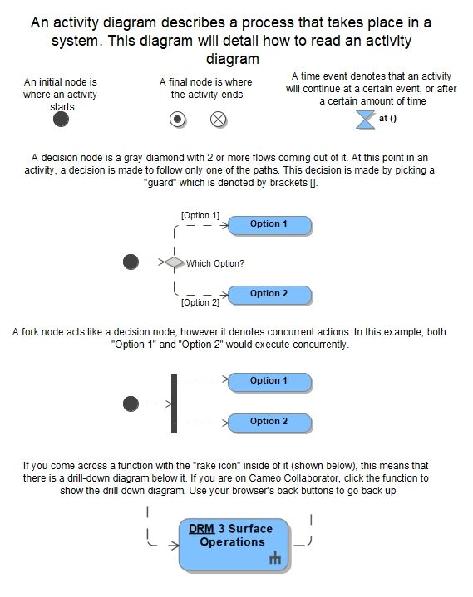

Open Work

To Be Determined
The table To Be Determined Items lists the specific To Be Determined (TBD) items in the document that are not yet known. The TBD is inserted as a placeholder wherever the required data is needed and is formatted in bold type within carets. The TBD item is numbered based on the document number, including the annex, volume, and book number, as applicable (e.g., <TBD-EHP-10033-001> is the first undetermined item assigned in the document). As each TBD is resolved, the updated text is inserted in each place that the TBD appears in the document and the item is removed from this table. As new TBD items are assigned, they will be added to this list in accordance with the above-described numbering scheme. Original TBDs will not be renumbered.
Appendix Table B-1: To Be Determined Items
TBD | Section | Description
TBD-EHP-10033-020 | 4.1.4.7 | Awaiting definition of compatible robotic interface
TBD-EHP-10033-022 | 5.3.4.3, 5.4.4.4 | Definition of contingency plan should loss of rover Navigation display occur.
TBD-EHP-10033-023 | Table 2-2 | Baseline of MPH-CONOP-001

To Be Resolved
The table To Be Resolved Issues lists the specific To Be Resolved (TBR) issues in the document that are not yet known. The TBR is inserted as a placeholder wherever the required data is needed and is formatted in bold type within carets. The TBR issue is numbered based on the document number, including the annex, volume, and book number, as applicable (e.g., <TBR-EHP-10033-001> is the first unresolved issue assigned in the document). As each TBR is resolved, the updated text is inserted in each place that the TBR appears in the document and the issue is removed from this table. As new TBR issues are assigned, they will be added to this list in accordance with the above-described numbering scheme. Original TBRs will not be renumbered.
Appendix Table B-2: To Be Resolved Issues
TBR | Section | Description
Appendix Table B-3: Forward Work

Forward Work
FWD | Section | Description
FWD-EHP-10033-001 | 1.0 | Forward work to include pre-formulation elements, Mars forward demonstrations on the Moon, and placeholder population for Mars operations.
FWD-EHP-10033-011 | 4.1.4.3 | Positioning the LTV in such a way that it will be out of range of plume impingement but also able to image ascent/descent may be difficult. Follow plume impingement work.
FWD-EHP-10033-021 | 5.4.4.6.1 | Determine the details regarding which specific cargo and consumables are delivered to the lunar surface via uncrewed cargo logistics landers (e.g., non-crew specific items, items with long shelf lives) vs. which come down with the crew on HLS (e.g., crew-specific items, perishables/items with low shelf life)
FWD-EHP-10033-032 | 5.1.4.7 | Expand content in 5.1.4.7 to address on an uninhabitable HLS airlock while suited or partially suited in the EVA Suit
FWD-EHP-10033-033 | 4.1.5.9.1 | Update to add details for waste and trash management.
FWD-EHP-10033-034 | 4.1.5.5 | Expand content on EHP cooperative operations concept, constraints and resources.
FWD-EHP-10033-035 | 4.1.4, 5.5.1 | Expand content on preventive maintenance for rovers for DRM5+

Navigation
There are two navigation configurations for DRM-3. For the first configuration Nav-1, the crew is using orienteering with navigation orienteering tools to support their navigation needs (e.g.; a map book, sun compass, range scale and sighting compass are currently prototyped). The second configuration Nav-2, the crew will be able to use a handheld navigation system with an accuracy of at worst 150 m for location and 10 deg for heading. Nav-1 configuration will be a backup for Nav-2 configuration.
The following GRAs apply for the Nav-1 and Nav-2 configuration:
- Crew will stay within voice range with MCC
- Crew will stay within eyesight and/or voice range of each other
- At least one crewmember will stay within eyesight of HLS for awareness of HLS location
- Crew will send real-time helmet video feed when within Wi-Fi range
- Crew will capture a HULC panoramic when instructed by MCC (location estimation post-processing)
- Crew will have a display and MCC will be able to send command to the display to update procedure, return plan or mark crew position estimates
HULC bracketed JPG images will be transferred via Wi-Fi when Wi-Fi is available. High-resolution imagery and video will be stored in HULC memory cards for return to earth and optionally download when back at the lander. Crew will be provided with a display including digital maps.
Additional GRAs apply for Nav-2 configuration only:
- Each crew is provided a handheld navigation system
- Navigation system is compliant with 150 m/10 deg performance requirement
- Navigation system estimate can be displayed on the suit display
- Navigation system data can be sent to MCC when within Wi-Fi range
EVA Walking Traverse within Wi-Fi range
In the case where the crew traverse to a location within Wi-Fi range, crew will be able to send images and real-time video feed to MCC. The crew will communicate their position over voice based on grid nomenclature to MCC. This estimate will either be derived based on orienteering (Nav-1) or based on the handheld navigation system (Nav-2). MCC will track the crew position using Artemis EVA Geographic Information System (AEGIS) functionality. The AEGIS software tool built by the EVA Mission Systems Software (EMSS) Team enables EVA Flight Operations Directorate (FOD) to compose and execute lunar surface operations by seamlessly integrating map data into the EVA product development process to plan, train, fly, explore for Artemis. Note that the navigation system location and heading data is expected to be sent back to MCC as well.
In addition, MCC may be able to process real-time video feed and camera images to improve the crew position estimate. MCC may communicate better estimates to the crew verbally. When in Nav-1 configuration, MCC may also send the crew position best estimates to the EVA suit display so that the crew can visually see the actual traverse path as recorded along with planned path/return path information. Otherwise, Crew will be able to track their position on the EVA display maps.
EVA Walking Traverse within UHF range
In the case where the crew traverse to a location within UHF range only, the crew can exchange navigation information verbally. The crew may choose to indicate the last known location within Wi-Fi range with a visual indicator MCC will not receive any real-time image or video and will rely on the crew verbal information to determine the crew location. However, the video and image information and any handheld navigation system information will be saved and stored and time-stamped for later post-processing.
EVA Walking Traverse: Return to Lander (Nominal)
MCC will monitor crew location and progress during the traverse along with overall health, safety and remaining EVA resources. Based on operational criteria (e.g. required EVA resources for the return, actual traverse progress versus expected progress, EVA science sampling success, overall supporting hardware status, etc.), MCC will instruct the crew to return to the lander. Crew will head in the general direction of the lander if not visible. This may be facilitated by visual indicator(s) deployed during the traverse, a lander visual indicator or using the handheld navigation system information. They will head directly toward the lander unless a terrain obstacle requires a temporary detour. If EVA visual indicators were deployed, crew may retrieve them on their return. Location estimates and range to lander estimates will be exchanged between crew and MCC to evaluate estimated time of return to the lander as well as remaining resources on return.
EVA Walking Traverse: Return to Lander (Suit Contingency)
In case of a suit anomaly, the crew will spend about 5 min troubleshooting and identifying the anomaly and will then proceed with a return to the Lander based on instructions from MCC. No other activities are expected besides walk back with a large portion of the walk-back with the lander visible to the crew. If communication with MCC is lost, crew will rely on awareness of a general direction where lander becomes visible and then follow lander’s direction when visible. This lander direction awareness may be facilitated by traverse visual indicators, a lander visual indicator or the handheld navigation system. Since time is critical in this scenario, orienteering tools may also be used sparingly when in Nav-1 configuration by any unaffected crew member to confirm general heading direction if needed.
Lunar Standards and Data Exchange Across Architecture
Multiple coordinate systems and reference frames are in use across the Artemis Campaign. Users must seek means to integrate across the community to provide Artemis missions a common language for referencing position and orientation of lunar surface assets at the lunar South Pole.
Apollo mission analysis and recent field testing has shown that a grid coordinate system (similar to the Military Grid Reference System (MGRS)) provides an efficient and intuitive method for crew members on the surface to describe their position and orientation effectively to ground teams, at scales bounded by human performance. By contrast, a latitude/longitude (lat-long) system can be disorienting in practice on the surface, due to longitude convergence and cardinal direction ambiguity near the poles.
Many remote sensing platforms, such as the Lunar Reconnaissance Orbiter (LRO), employ lat-long systems to describe locations on the lunar surface. Users analyzing data received from such platforms must be able to easily translate to and from operational reference frames, such as a grid coordinate system, to enable mission planning and integration, and scientific analysis.
Current studies are investigating the deployment of Position, Navigation, Timing (PNT)-enabled services for the Artemis Campaign. Any coordinate system and/or reference frame in use across the community should also integrate with PNT-enabled services, especially if those PNT-enabled services provide navigation data to crew members on the surface.
ACD-50044, Lunar Surface Data Book, can be used as a reference for a common set of data sources and assumptions provides examples of traverses. The data book provides representative traverses and associated terrain details (e.g. slope, boulder rock clearance, etc.) to support scientific exploration, logistics transport, and emergency return expectation. Once landing sites and objectives are known, detailed traverses will be planned by the operations community.
Specifications on navigation concepts shall be found in EHP-10070, Extravehicular Activity and Human Surface Mobility Program (EHP) Navigation Specification for further details on navigation concepts.

Power
Power exchange on the lunar surface is crucial for a variety of reasons. As we venture beyond Earth, establishing a sustainable presence on the Lunar surface and preparing for future Mars missions, reliable electrical power becomes a lifeline. Here’s why:
- Artemis Program and Beyond: NASA’s Artemis program aims to return humans to the Moon and demonstrate technologies essential for Mars missions. A permanent habitat on the lunar surface requires continuous power for life support systems, communication, and scientific research.
- In-Situ Resource Utilization (ISRU): To reduce reliance on Earth, we must extract resources from the Moon. ISRU processes like mining water ice and producing oxygen depend on energy sources. Power exchange enables these critical activities.
- Fission Surface Power (FSP): Nuclear reactors can provide abundant, reliable energy. Establishing a shared power system with long distance power transfer allows us to integrate fission-based systems, ensuring a steady supply of electricity.
- Commercial Lunar Economy: As private companies explore lunar resources, long distance power transmission facilitates their operations. In-space manufacturing, mining, and tourism all require electricity. A shared power system via long distance power transfer enhances efficiency and cost-effectiveness.
- Reliability and Evolvability: A lunar power grid offers flexibility. It allows seamless integration of various sources—solar arrays, batteries, regenerative fuel cells, and even nuclear power. As power demands grow, the grid adapts, ensuring uninterrupted energy supply.
Nominally, there exists a potential use case for extending the operational duration and travel distance of the LTV. This extension could allow the LTV to remain at a specific location for an extended period or accommodate longer scientific missions. The LTV engages in power exchange with other elements and future components (such as ISH), power generators, and charging stations), however the PR will only be capable of receiving power. This power exchange can occur either with crewed or uncrewed operations through an interface compatible with both crew-operated mating connectors and robotically operated mating connectors. Each rover will carry crew-operated power exchange hardware, while hardware requiring robotic manipulation (such as long cables) will be reserved for future elements and not carried by the LTV or PR.
The ability to utilize the power exchange interface for external recharging of power storage devices is crucial for success of lunar exploration and habitation. Let's explore why:
- Sustainability and Longevity
  - Lunar missions, especially those involving long term habitation, require a reliable and sustainable power supply
  - Rechargeable batteries serve as an essential energy reservoir, allowing continuous operation during periods of low or no sunlight (such as lunar nights)
- Mitigating Power Source Failure
  - Primary power sources, like solar arrays, can face unforeseen issues (e.g. dust accumulation, damage, or malfunction)
  - Backup batteries act as a safety net, providing power when primary sources fail. They ensure uninterrupted operations for critical systems.
- Flexibility and Adaptability
  - External rechargeable batteries allow flexible energy management. They can be charged during peak sunlight hours and discharged during Lunar nights.
  - Robotic explorers, habitats, and scientific instruments can rely on these batteries, adapting to varying power demands
- Emergency Situations
  - In emergencies (e.g. equipment malfunction, unexpected events), battery power becomes crucial, not limited to:
    - Full Loss of Power Generation: This situation may arise due to damage to power generation devices, inability to fully retract them, arcing, or other reasons. In such cases, the vehicle loses its power generation capability, rendering it unable to charge batteries or provide power to the vehicle. Power exchange and external recharge become essential for vehicle startup and power transmission.
    - Partial Loss of Power Generation: Partial loss of power generation can occur due to array damage, inability to partially retract solar arrays, shadowing, or other factors. When power generation becomes insufficient, external recharge via the power exchange interface allows successful battery charging.
    - Inability to Recharge from the Vehicle: If the vehicle cannot recharge its batteries using its own power generation devices, external power recharge via the power exchange interface becomes a critical solution. Vehicle to vehicle power exchange can support diagnostics in the case of a system failure.
- ISRU
  - Rechargeable batteries facilitate ISRU activities (e.g. mining water ice, producing oxygen) by providing power during resource extraction and processing
- Lunar Dust and Charging Hazards
  - Lunar regolith dust particles accumulate charge due to electrostatic interactions
  - Battery powered equipment avoids direct contact with charged surfaces, reducing risks associated with Lunar dust
In summary, external battery recharge capability via the power exchange interface ensures reliable, adaptable, sustainable power for lunar missions, supporting scientific research, exploration, and future human presence on the moon.

Lunar Dust Mitigation

Dust Mitigation Overview
The goal of dust mitigation is to limit the amount of regolith liberated from EVA suits and hardware, and other tools when entering a pressurized volume, to prevent the excessive buildup of lunar dust on exterior surfaces, (visors, suits, radiators, solar arrays, etc.) ,to limit operational interference of external systems (cameras, mechanisms, windows, hatch seals, etc.) due to dust, and to maintain control of dust levels within pressurized volumes.
A predetermined amount of acceptable dust per EVA crew member is established by requirements and implemented by design for nominal ingress scenarios. Additional dust contamination is expected from hardware or scientific payloads brought into a habitable volume. The crew will have a limited time allocated to perform dust mitigation activities on hardware returning inside and in off-nominal situations, dust mitigation operations may be reduced or eliminated.
The intent of this section of the Integrated Concept of Operations is to provide an overarching methodology that can be applied to all EHP elements. Lunar surface dust mitigation is an active and evolving aspect of lunar exploration. Historical observations from Apollo, technology development, ground testing, and flight observations will provide a path to develop tools and processes which can minimize the impact of lunar dust on the Artemis elements and missions.
Lessons learned from Apollo, early Artemis missions, data gathered from CLPS missions rigorous ground and technological development testing and modeling, combined with potential design improvements to the EVA suit, offer an opportunity to change the way mitigation is planned, managed, and executed. For early lunar surface missions, emphasis should be placed on ground testing and modeling due to the absence of other data. The dust removal process is intended to minimize the impacts from dust on the Artemis systems in pressurized and unpressurized volumes on the lunar surface as well as in lunar orbit. xEVA System surface operations include multiple strategies for reducing the amount of lunar dust that is brought into and released within the habitable volume. Much of the prevention process can occur through engineering design and operational controls, such as improved suit mobility enabling surface tool operability (minimizing the need for suit/dust interaction), minimized dust capture points on the suit, and eventually limiting the amount that adheres to the suit surface (forward goal).
- In general, possible techniques for controlling lunar dust movement and mitigating the impact of dust will focus on the five methods of dust mitigation: Avoid, Remove, Tolerate, Contain, Dispose (ART-CD)
- Avoid: Mitigation strategy centered around hardware design to prevent intrusion or other collection of dust on surfaces and within components. Avoidance can also apply to an element as a whole. For example, avoiding proximity to dust-generating events, such as surface plumes. Additionally, prevention measures such as having crew don PPE to prevent inhalation of dust
- Remove: generally thought of as dust removal; active and passive dust mitigation, including tools, ECLSS, ConOps, etc. that "remove" dust from volumes and surfaces. Common and heritage examples of dust removal include brushes and wipes.
- Tolerate: design-heavy mitigation effort centered around hardware designed to operate nominally in the presence of lunar dust, such as dust-tolerant connectors or seals that are able to form operate nominally in the presence contamination. Other examples include thermal coatings that can maintain nominal thermal performance in the presence of lunar dust contamination.
- Contain: methods designed to store dust in a non-hazardous area such as vacuum cleaners (both removal and containment) or ECLSS. Additionally, pairing containment (dustpan) with removal (broom) can be utilized.
- Dispose: ejection of dust out of harmful areas, such as designing replaceable ECLSS filters or vacuum bags. Frequently, disposal techniques follow containment (e.g. moving dust that has been swept up into a dustpan to a disposal bag).
While not a method of dust mitigation, it cannot be understated that the quantification of dust loading (areal or volumetric) is a necessity when planning dust mitigation ConOps. If the quantity of dust that is removed from a surface or volume, it is difficult, if not impossible, to determine if hardware will work or that a volume is safe for crew. Currently, this is a knowledge gap with few methods of dust quantification published at mid/high TRL.

Nominal Operations
The outlined concepts of operations in this section may be utilized multiple times during a DRM. At this time, current tools used for dust mitigation have heritage in the Apollo dust mitigation tooling. However, mitigation tool development continues to evolve via technology development and element level development. Therefore, current tools and methods will be denoted with the knowledge that specialized tools may also be applicable at the given mitigation station. An overview of all current and previous lunar exploration element operations planning (HLS, Commercial lunar landers, xEVA suits, and Apollo) using these tools at the various stations that may occur during the operational process have been included in this general summary.

Surface Concept of Operations
IVA, Pre-EVA, EVA Egress
Prior to EVA, crew may prepare the airlock or area nearby the exit hatch for EVA by stowing sensitive hardware or deploying dust covers to protect critical systems. Crew can quantify dust on the suit and remediate as necessary prior to donning the suit. Crew may also collect and pre-position EVA dust mitigation tools into accessible areas near the exit hatch prior to depressurization; it is not anticipated that these tools be returned into the airlock after each EVA. Crew PPE used for off-nominal contingency dust mitigation upon eventual EVA ingress and suit doffing can be verified to reside in the proper stowage locations prior to egress.
Surface System EVA Ingress
Crew will retrieve EVA dust mitigation tools from their stowed location as required. Dust mitigation tools may be specific to the EVA suit and associated EVA tools. Utilization payloads may provide specialized tools to enable cleaning of their surfaces. These tools will be used to clean the suit as well as any utilization systems, science payloads, or sample return canisters recovered during the EVA that are expected to enter the vehicle post EVA. Following EVA dust mitigation activities, the tools may be stowed or disposed of per planetary protection guidance and crew will enter the airlock or vehicle outer door. The crew can clean airlock hatch seals with the provided seal tools. And clean as necessary with the provided seal tools/methods denoting before/after results. Hardware/Payload items transferred into the airlock system may be isolated in a sealed container at this time.
Surface System Post-EVA and IVA
After external door closure, pressurization, and verification of an acceptable door seal has been attained, the operations may allow sufficient time for dust settlement prior to EVA suit doffing. This would be based upon operational instructions established by detailed crew planning and safety procedures or by lunar dust monitor.. Typical measures may use integrated air filtering systems within this pressurized volume to enable sufficient cleanup of the breathable air volume prior to EVA suit doffing. Using this integrated system, the air system can begin to filter the non-settled dust from the volume.. Dust monitoring systems may also be deployed in the pressurized volume to provide an indication of air quality.
The crew will doff EVA suits prior to performing dust operations. Once crew have doffed their EVA suits and an indication of acceptable air quality is attained, the suit exteriors along with any utilization systems, science payloads, or sample return canisters recovered during the EVA and brought into the habitable volume and cleaned for a pre-determined amount of time.. Once clean, objects will be stowed; this operation may include the use of bags or covers to limit additional dust contamination after stowage. After ingress to the habitable volume, crew will continue to perform periodic dust cleaning activities to mitigate the lunar dust. This activity may include vacuum operations, filter cleaning or replacements, or other similar dust mitigation strategies.
If air quality is in question upon EVA suit doffing, previously stowed PPE can be donned to protect the crew while they perform additional cleaning. Self-reporting of crew health, such as ocular pruritus or rhinorrhea may be useful in determining whether crew should don PPE,, PPE will be available in airlock should dust mitigation measures be needed per mission planning...
Upon transition to the habitable volume, the habitation ECLS system will continue use integrated air filter systems to maintain air cleanliness levels related to maintain crew compatibility. Air monitoring hardware, if available, can be implemented to assist in the assessment of air quality and provide data for subsequent evaluation and validation to assure crew health and comfort is maintained.

In-Space/Microgravity ConOps
During a return from the lunar surface, (i.e., upon entering microgravity, dust previously gravity-bound and not captured during dust mitigation efforts) remaining dust could be liberated into the cabin environment, and dust mitigation activities may be necessary prior to lander docking to further minimize the spread of dust into other in-space habitable volumes (e.g., Gateway, Orion). On approach to an orbiting system, the lander will ensure that the dust environment is acceptable and that the hatch can be safely opened. Dust monitoring systems may be available to validate air quality levels. If the dust environment exceeds the tolerance of the orbiting system, crew may perform additional mitigations to reduce dust to acceptable levels. Once the approaching vehicle environment can be tolerated by the orbiting system, the hatch may be opened. Additionally, dust cover removal or other dust remediation may be necessary prior to the transfer of EVA suits, utilization systems, science payloads, or sample return canisters into the orbiting system.

Off-Nominal Operations
For all phases of Lunar Surface and Microgravity/In-Space EVA, dust mitigation operations may be waived or suspended in cases of off-nominal events with the vehicle or crew health in order to address the situation. This includes events that may occur during configuration and setup of dust mitigation measures while IVA, during an EVA or upon return from EVA. Flight rules will need to balance level of risk for each event with the amount of dust risk.

EHP Use Cases and Capabilities

EHP Use Cases
EHP Use Cases are a high-level dataset that categorizes all EHP behavioral responsibilities that are independent of EHP system solutions. The EHP Use Case dataset is currently allocated to the ESDMD Use Case and Functions dataset. In the teamwork cloud version of the EHP ConOps, a user can select any of these Use Cases and be navigated to a table automatically filtered by the selected EHP Use Case to show all EHP Functions associated to that Use Case. This supports a traceability analysis which shows how EHP is meeting its required behavior.
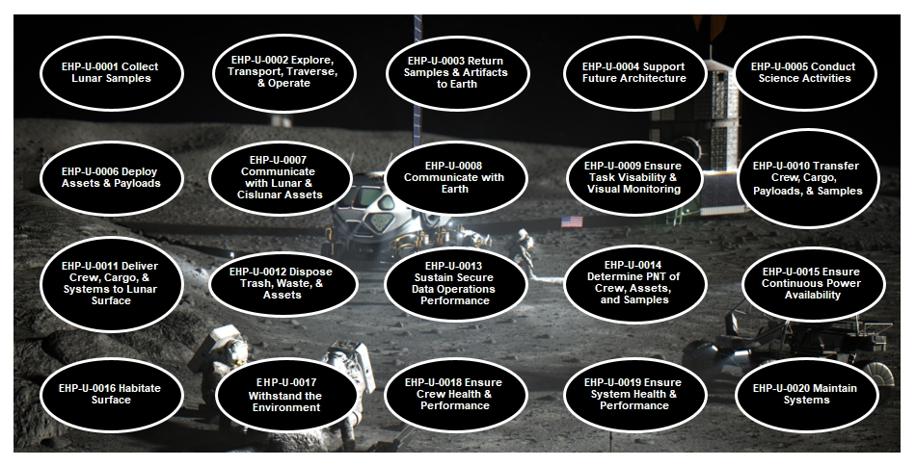
Figure E-1: EHP Use Cases
The following table details the allocation of the EHP Use Cases to the ESDMD Use Cases. This allocation facilitates a parent-child traceability analysis to report and ensure that EHP satisfies the behavioral needs of the agency. This table is also accessible via the teamwork cloud version of the EHP ConOps
Appendix Table E-1: EHP Use Case to ESDMD Use Case Allocation
EHP Use Case | ESDMD Use Case
EHP-U-0001 Collect Lunar Samples | - UC-025-L Crew extravehicular explorations and identification of surface samples  - UC-030-L Collect surface samples from PSRs  - UC-111-L Collect sub-surface samples from PSRs  - UC-117-L Provide tools, including EVA tools, to collect, recover, and package sub-surface samples  - UC-034-L Collect sub-surface samples from non-PSRs and sunlit regions  - UC-026-L Collect surface samples from non-PSRs and sunlit regions  - UC-107-L Document sample details prior to collection on the lunar surface  - UC-019-L Robotically assist crew exploration, site surveying, sample and resource locating, documentation, and sample retrieval
EHP-U-0002 Explore, Transport, Traverse, & Operate | - UC-010-L Crew inhabit assets on the surface for short-durations (days to weeks) on the lunar surface  - UC-083-L Conduct autonomous/semi-autonomous mission operations on the lunar surface  - UC-024-L Crew excursions to locations distributed around landing site  - UC-011-L Support crew extravehicular operations on the lunar surface  - UC-035-L Conduct missions with extended-duration (year+) in microgravity, followed by short-duration (days to weeks) in partial gravity, and then ending with extended-duration (year+) in microgravity prior to return to Earth.  - UC-128-L Crew inhabit assets on the surface for mid-durations (month+) on the lunar surface  - UC-048-L Robotically survey PSRs near potential crewed landing and exploration sites to identify locations of interest  - UC-089-L Crew use of tools to assist in performing extravehicular activities, e.g., sample collection and suit cleaning  - UC-005-L Operate transportation assets(s) from Earth during crew surface missions  - UC-094-L Remotely manage robotic system(s) during surface operation as required  - UC-022-L Crewed mission(s) to distributed landing sites on the lunar surface  - UC-102-L Operate habitation system(s) on the lunar surface while uncrewed  - UC-184-L Remotely manage robotic system(s) during in space operation as required  - UC-105-L Perform lunar surface activities with surface robotic system(s) assistance  - UC-121-L Robotic system(s) support of logistic operations on the lunar surface as required  - UC-023-L Robotically survey potential crewed landing and exploration sites to identify locations of interest"
EHP-U-0003 Return Samples & Artifacts to Earth | - UC-118-L Package sub-surface samples for return  - UC-097-L Return collected surface and sub-surface samples to Earth in sealed conditioned sample containers  - UC-116-L Return physical artifacts from experiments to Earth
EHP-U-0004 Support Future Architecture | - UC-130-L Test, analyze, and evaluate responses to range of communication latency expected of Mars-class missions  - UC-139-L Demonstrate maintenance, modification, and/or upgrades of asset(s)  - UC-143-L Demonstrate autonomous construction techniques, e.g., collection of regolith, processing regolith into feedstock, and regolith construction  - UC-145-L Demonstrate regolith based additive/subtractive manufacturing techniques  - UC-075-L Demonstrate uncrewed relocation of large exploration assets to sites around the lunar south polar region  - UC-093-L Demonstrate in-situ crew command and control of robotic system(s)  - UC-108-L Demonstrate operational techniques for utilizing robotic system(s) to assist crew operations on the lunar surface
EHP-U-0005 Conduct Science Activities | - UC-043-L Conduct intravehicular science and utilization activities on the lunar surface  - UC-077-L Demonstrate operational techniques to recover water from the lunar regolith in the polar regions  - UC-040-L Crew conduct fundamental physics experiments while in habitable volume on the lunar surface  - UC-076-L Demonstrate operational techniques to recover oxygen from lunar regolith  - UC-036-L Crew conduct biological science and human research activities on the lunar surface  - UC-046-L Provide in-situ training to astronauts for science tasks during mission(s)  - UC-150-L Demonstrate operational techniques to recover and refine metals from the lunar regolith
EHP-U-0006 Deploy Assets & Payloads | - "UC-063-L Deploy and set up physics utilization payload(s) on the lunar surface with long term remote operation  - UC-031-L Deploy and set up Heliophysics utilization payload(s) at cislunar asset(s) with long term remote operation  - UC-142-L Deploy and set up autonomous construction demonstration utilization payload(s) on the lunar surface with long-term remote operation  - UC-033-L Deploy and set up Heliophysics utilization payload(s) on the lunar surface with long-term remote operation  - UC-062-L Deploy and set up physics utilization payload(s) at asset(s) in cislunar space with long term remote operation  - UC-171-L Deploy and set up assets to monitor induced environment on the lunar surface  - UC-042-L Deploy and set up fundamental physics utilization payload(s) in cislunar space with long term remote operation  - UC-039-L Deploy and set up astrophysics utilization payload(s) on the far side of the lunar surface with long-term remote operation  - UC-053-L Deploy and set up fundamental physics utilization payload(s) at asset(s) in cislunar space with long term remote operation  - UC-169-L Deploy and set up assets to monitor natural environments on the lunar surface  - UC-057-L Deploy and set up utilization payload(s) at cislunar asset(s) with long term remote operation  - UC-041-L Deploy and set up fundamental physics utilization payload(s) on the lunar surface with long term remote operation  - UC-159-L Deploy and setup of utilization payload(s) related to available resources on the lunar surface with long term remote operation  - UC-124-L Deploy and set up plasma utilization payload(s) on the lunar surface with long term remote operation  - UC-144-L Deploy and set up advanced manufacturing demonstration utilization payload(s) on the lunar surface with long-term remote operation  - UC-134-L Deploy and set up demonstration ISRU utilization payload(s) on the lunar surface with long-term remote operation  - UC-007-L Unload large exploration assets on the lunar surface  - UC-165-L Deploy assets to monitor natural environments in cislunar space  - UC-014-L Deploy and setup utilization payload(s) on the lunar surface with long-term remote operation"
EHP-U-0007 Communicate with Lunar & Cislunar Assets | - UC-173-L Communications and data exchange between assets in cislunar space and the lunar surface  - UC-067-L Communications and data exchange between assets at a variety of exploration locations on the lunar surface
EHP-U-0008 Communicate with Earth | - UC-047-L Allow ground personnel and science team to directly engage with crew on the surface and in cislunar space, augmenting the crew's effectiveness at conducting science and utilization activities  - UC-175-L Communications and data exchange between assets in cislunar space and Earth  - UC-066-L Communications and data exchange from assets at a variety of exploration locations on the lunar surface to Earth  - UC-158-L Transmit data from in-space and surface asset(s) to medical personnel on Earth
EHP-U-0009 Ensure Task Visibility & Visual Monitoring | - UC-011-L Support crew extravehicular operations on the lunar surface
EHP-U-0010 Transfer Crew, Cargo, Payloads, & Samples | - UC-118-L Package sub-surface samples for return
EHP-U-0011 Deliver Crew, Cargo, & Systems to Lunar Surface | - UC-056-L Land exploration missions at sites removed from sites of historic significance  - UC-004-L Transport crew and supporting system(s) between cislunar space and the lunar surface  - UC-133-L Cislunar space to lunar surface transportation supporting short-duration (days to weeks) missions to distributed landing sited on the lunar surface
EHP-U-0012 Dispose Trash, Waste, & Assets | - UC-136-L Manage disposal of hardware and waste products
EHP-U-0013 Sustain Secure Data Operations Performance | - UC-174-L Aggregate and store data in cislunar space until it is able to be transmitted and confirmed received  - UC-176-L Aggregate and store data on the lunar surface until it is able to be transmitted and confirmed received
EHP-U-0014 Determine PNT of Crew, Assets, and Samples | - UC-126-L Position, navigation, and timing for crew and robotic assets at distributed and south polar region locations on the lunar surface  - UC-127-L Position, navigation, and timing for accurate sample tracking  - UC-068-L Position, navigation, and timing for crew and robotic assets in cislunar space
EHP-U-0015 Ensure Continuous Power Availability | - UC-189-L Provide continuous power availability in off-nominal conditions  - UC-P-501 Continuous power provision to assets during mission critical activities.  - UC-P-502 Continuous power provision to assets in off-nominal conditions.  - UC-P-101 Power generation and energy storage at South Pole region on lunar surface.
EHP-U-0016 Habitate Surface | - UC-147-L Habitation capabilities for mid-duration (month+) missions in cislunar space and on the lunar surface  - UC-092-L Reuse habitation system(s) on the lunar surface  - UC-146-L Habitation capabilities for short-duration (days to weeks) missions on the lunar surface
EHP-U-0017 Withstand the Environment | - UC-125-L Limit spread of dust raised by lunar surface operations  - UC-172-L Monitor, characterize, and provide advance warning for induced environmental threats on the lunar surface, e.g., induced radiation level, thermal conditions, high-energy debris, contamination, electrostatic, and acoustics  - UC-170-L Monitor, characterize, and provide advance warning for natural environmental threats on the lunar surface, e.g., high energy debris, natural radiation level, thermal conditions, plasma environments, and electrostatic charges  - UC-115-L Reduce path erosion, dust lofting, and sample contamination
EHP-U-0018 Ensure Crew Health & Performance | - UC-161-L Nutrition monitoring for crew during mission  - UC-138-L Ensure safe and effective interaction between crew and autonomous asset(s)  - UC-163-L Crew health maintenance with countermeasure activities in partial gravity environment  - UC-160-L Crew survival during off-nominal situations  - UC-154-L Crew emergency health care, diagnosis, and treatment on the lunar surface  - UC-152-L Remotely monitor, diagnose, and treat crew health during short-duration (days to weeks) missions on the lunar surface  - UC-018-L Remotely monitor, diagnose, and treat crew health during mid-duration (month+) missions on the lunar surface  UC-104-L In-situ diagnosis and treatment of crew on the lunar surface
EHP-U-0019 Ensure System Health & Performance | - UC-191-L Resupply cargo and manage wastes to/from habitable assets on surface to support repeated crew missions on the lunar surface  - UC-141-L Monitor environmental factors in habitation systems on the lunar surface
EHP-U-0020 Maintain Systems | - UC-122-L Robotic system(s) support of maintenance and repair operations as appropriate  - UC-183-L Crew repair and/or replacement of failed or off-nominal systems

EHP Capabilities
An EHP Capability identifies the categorization of EHP Functions. Where EHP Use Cases describe the problem domain (the behaviors levied onto EHP), the EHP Capabilities outline the solution domain (the Function categorization we need to meet the Use Cases). An EHP Function can be allocated to one or more EHP Capability. Additionally, the EHP Capability dataset is allocated to the M2M Capability dataset to facilitate cross-project collaboration and consistency. In the teamwork cloud version of the EHP ConOps, a user can select any of these capabilities and be navigated to a table automatically filtered by the selected EHP Capability to show all Functions of that Capability. Please see the below table for descriptions of each capability.
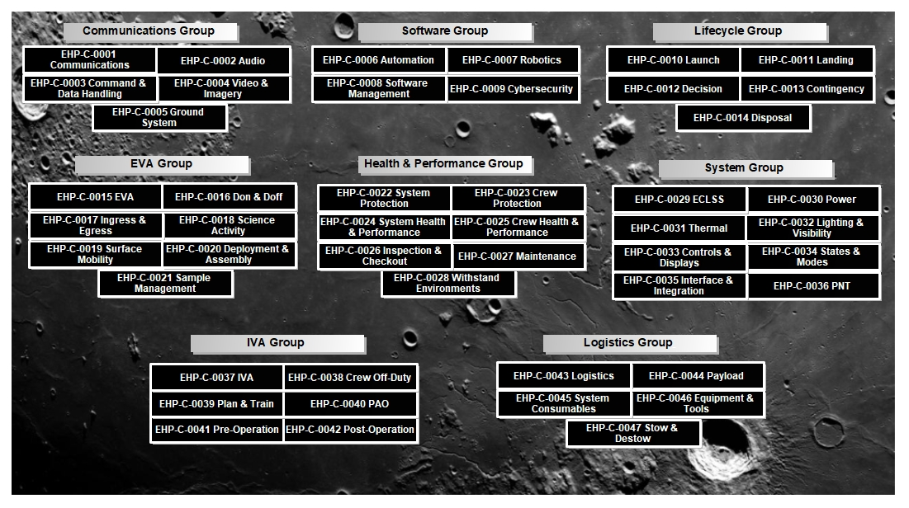
Figure E-2: EHP Capabilities
Appendix Table E-2 EHP Capabilities Definition Table
Name | Description
EHP-C-0001 Communications | The capability to send and receive data to and from an external system.
EHP-C-0002 Audio | The capability to capture, playback, send, and receive audio.
EHP-C-0003 Command & Data Handling | The capability to store, process, and execute commands & data.
EHP-C-0004 Video & Imagery | The capability to capture, store, and communicate video and imagery.
EHP-C-0005 Ground System | The capability to provide terrestrial support of lunar and cis-lunar assets using ground stations, mission control, remote terminals, and ground networks.
EHP-C-0006 Automation | The capability to provide automated and autonomous functionality.  Autonomous: The capability of a system to perform complete objectives under defined conditions without human input or guidance."
EHP-C-0007 Robotics | The capability to robotically perform activities including: manipulate the environment, equipment, and payloads, take measurements, and scout traverse paths.
EHP-C-0008 Software Management | The capability to perform functions via system software.
EHP-C-0009 Cybersecurity | The capability of the system to protect information systems from unauthorized access and usage.
EHP-C-0010 Launch | The capability to support operations related to the launching of a system from earth and the lunar surface.
EHP-C-0011 Landing | The capability to support operations related to the landing of a system on the lunar surface or returned to earth.
EHP-C-0012 Decision | The capability to enable decision making activities such as "go or no-go".
EHP-C-0013 Contingency | The capability to support off-nominal events, including: a crew medical event, environmental event, system failure event, crew abort, termination of an operation, self rescue, incapacitated crew rescue, and walkback scenarios.
EHP-C-0014 Disposal | The capability to support the disposal of the system, equipment, supplies, trash, or waste.
EHP-C-0015 EVA | The capability to perform activities by a pressure-suited crewmember in an unpressurized or space environment.
EHP-C-0016 Don & Doff | The capability to support the don & doff of xEVA or IVA suits.
EHP-C-0017 Ingress & Egress | The capability to provide suited crew access to enter or exit the system.
EHP-C-0018 Science Activity | The capability to perform science activities.
EHP-C-0019 Surface Mobility | The capability to traverse the lunar surface in a vehicle.
EHP-C-0020 Deployment & Assembly | The capability to deploy or assemble a system, equipment, or supplies.
EHP-C-0021 Sample Management | The capability to collect, store, and manage lunar samples.
EHP-C-0022 System Protection | The capability of the system to safeguard itself.
EHP-C-0023 Crew Protection | The capability of the system or equipment to safeguard the crew.
EHP-C-0024 System Health & Performance | The capability to monitor system health, status, and performance; and alert and assist local or remote operators in troubleshooting.
EHP-C-0025 Crew Health & Performance | The capability to monitor and support crew health, including: health management, crew routine, monitor crew vitals, and health treatments.
EHP-C-0026 Inspection & Checkout | The capability to support a system's initial deployment, nominal inspection, and checkout activities.  Note: Inspection may include visual checks from crew and/or instrumentation. Checkout may include verifying system functionality and operability.
EHP-C-0027 Maintenance | The capability to maintain systems and equipment.
EHP-C-0028 Withstand Environments | The capability to withstand natural and induced environments of space.
EHP-C-0029 ECLSS | The capability to provide or control atmospheric parameters (pressure, temperature, humidity, oxygen levels, etc.), fire detection and suppression, waste management and water supply.
EHP-C-0030 Power | The capability to generate, store, exchange, and manage power.
EHP-C-0031 Thermal | The capability of the system to manage thermal loads.
EHP-C-0032 Lighting & Visibility | The capability to illuminate the lunar surface for the crew, exploration, maintenance, and science activities.
EHP-C-0033 Controls & Displays | The capability to provide user input and receive visual information needed to operate a system.
EHP-C-0034 States & Modes | The capability to change a system's configuration (such as changing from On to Off state).
EHP-C-0035 Interface & Integration | The capability to provide exchange (data, material, energy) between hardware, software, and/or environmental elements.
EHP-C-0036 PNT | The capability for systems and crew to determine their position, navigation, and timing.
EHP-C-0037 IVA | The capability to perform activities by a crewmember in a pressurized environment.
EHP-C-0038 Crew Off-Duty | The capability to enable crew personal time.
EHP-C-0039 Plan & Train | The capability to support the planning and training of operations and procedures.
EHP-C-0040 PAO | The capability to support activities of the Public Affairs Office (PAO).
EHP-C-0041 Pre-Operation | The capability to support activities immediately before the start of an operation.
EHP-C-0042 Post-Operation | The capability to support turnaround activities immediately after the end of an operation.
EHP-C-0043 Logistics | The capability to support equipment inventory, flight crew resources, and resupply.
EHP-C-0044 Payload | The capability to support payload operation, deployment, transport, and storage.
EHP-C-0045 System Consumables | The capability to utilize and resupply a system's consumable materials (O2, H2O, propellant, etc.).
EHP-C-0046 Equipment & Tools | The capability to utilize crew equipment & tools for EVA, logistics, maintenance, and supplies.
EHP-C-0047 Stow & Destow | The capability to store, unpack, load, unload.

