

Habitability Assessment of International Space Station (ISS Habitability)
Final Report

Maya Greene, Ph.D. NASA Human Factors Engineering Laboratory (HFEL), Wyle, Inc., Houston, TX, USA
Sherry Thaxton, Ph.D. NASA Human Factors Engineering Laboratory (HFEL), NASA Johnson Space Center, Houston, TX, USA
Jurine Adolf, Ph.D. NASA SA Human Factors Engineering Laboratory (HFEL), Wyle, Inc., Houston, TX, USA

Contents

- List of Figures 5
- List of Tables 6
- Executive Summary 7
- Introduction 8
  - Report Purpose 8
  - Importance of Human Factors and Habitability in Long-Duration Spaceflight 8
  - Specific Needs for Habitability and Human Factors Data Collection Onboard ISS 8
- Background 9
  - Previous Human Factors and Habitability Research 9
    - Analog Research 10
    - Spaceflight Research 11
- Study Objectives 11
- Methods 13
  - Equipment 13
  - Tools 13
    - Tool development 13
    - Tool use during ISS Habitability 13
  - Participants 15
  - Facilities 15
  - Procedures and Timeline 15
    - Overview Video 16
    - Human Factors and Habitability Observations 17
    - Walk-Through Videos 17
    - Narrated Task Videos 17
    - Habitability and Human Factors Questionnaires 18
    - PI Conference 18
  - Data Analysis 18
    - iSHORT-Based Data 18
    - Questionnaires and PI Conferences 20
- Results 20
  - Data Collection Rates 20
  - Habitability and Human Factors Observations 21
  - Narrated Task Videos 21
  - Walk-through Videos 22
  - Combined iSHORT-based data 22
    - Categories and codes used 22
    - Analysis of tone 29
    - Location 33
  - Habitability and Human Factors Questionnaire 34
  - PI Conferences 35
  - Interpretation and General Recommendations 35
    - Increase the use of wireless technology 35
    - Design stowage systems for efficiency and function 37
    - Give additional thought to the placement and design of handrails and restraint systems40
    - Increase the integration of software and hardware for tasks that are expected to be performed regularly 42
    - Provide highly usable interfaces for hardware and software that are intended to be reconfigured to support crewmember use 43
    - Design systems for consistency 44
    - Provide a dedicated volume for hygiene operations that is separate from toilet operations 46
    - Ensure labels are clear, visible, and accessible from multiple viewing angles 47
    - Provide windows as resource for crewmember recreation as well as specific operational tasks 49
    - Provide crewmembers with the ability to control and modify environmental factors 50
    - Ensure the trash management systems sufficiently control odor 52
    - Design packaging to facilitate activities and reduce trash generation 53
    - Ensure surfaces in areas that are likely to get dirty are easily cleanable and accessible ... 54 8.9 Additional uses for the data and tools 57
- Lessons Learned 58
- Conclusion 58
- Acknowledgments 60
- References 61
- Appendix A – NEK Habitability 64
  - Introduction and Specific Aims 64
  - Methods 64
    - Participants 64
    - Procedures 64
    - Tools 65
    - Training 65
    - Data analysis 65
  - Results 65
    - Data collection rates and overview 65
    - Data relevancy 66
    - Categories and codes used 67
    - Analysis of tone 68
    - Data collection types 69
    - Recommendations 69
  - Conclusions and Lessons Learned 72
- Appendix B – PI Conference Questions 74
- Appendix C – ISS Codes and Definitions 75
- Appendix D – Questionnaire Results 77
- Appendix E – NEK Codes and Definitions 81
- Appendix F – Acronyms 84

List of Figures
Figure 1. Current state of data sources, recipients, and products for human factors and habitability data.
...................................................................................................................................................................... 9
Figure 2. Screenshot from iSHORT 14
Figure 3. Screenshot of iQ&A survey 15
Figure 4. Screenshots from study training videos. 17
Figure 5. Major category frequency 23
Figure 6. Individual code frequency 24
Figure 7. Percentage distribution of tone. 29
Figure 8. Distribution of tone by mission quarter 30
Figure 9. NPN by participant and mission quarter. 32
Figure 10. An example of cables aboard ISS 36
Figure 11. Screenshot from a video showing the "lip" over payload containers. In order to access the container a user needs to demate the connections and open the "lip." 39
Figure 12. Crewmembers modified this restraint in the dining area to increase comfort. 40
Figure 13. Improvised foot restraint in the Cupola. The crewmember is demonstrating using the hatch opening for stabilization 41
Figure 14. Two light switches in the same module with inconsistent interfaces. 45
Figure 15. Screenshot from video showing translation path to improvised hygiene area in the PMM 46
Figure 16. Screenshot from video showing the tool box. The red arrow is pointing at a label. 48
Figure 17. A screenshot from a video showing a scratch pane on an ISS window. 49
Figure 18. Surface showing dirt accumulation in dining area. 54
Figure 19. Screenshot from video showing good grill design. These grills are highly visible and easy to access and clean 56
Figure 20. Screenshot from video showing poor grill design. This grill is hard to access for cleaning and requires using tools. 56
Figure 21. NEK major category frequency 67
Figure 22. NEK individual code frequency 68
Figure 23. Percentage distribution of tone for NEK. 69
Figure 24. NEK crewmember showing marks left by the heart rate monitor. 70
Figure 25. Screenshot from video showing broken badge. 71
Figure 26. Screenshot from a video showing the crew's schedule affixed to a wall 72

List of Tables
Table 1. Summary of relevant analog-based human factors and habitability research 10
Table 2. Summary of relevant spaceflight-based human factors and habitability research 11
Table 3. Specific aims and resolutions. 12
Table 4. ISS Habitability activities 16
Table 5. List of primary categories and examples of codes used for analysis. 19
Table 6. Number of data collection sessions completed 20
Table 7. Habitability and human factors Observation media used. Each participant’s preferred method is highlighted in bold 21
Table 8. Frequency of participants' use of prompts. 21
Table 9. Most frequently used codes and major categories. 24
Table 10. Ten most frequently co-occurring codes with interface design 25
Table 11. Ten most frequently co-occurring codes with effectiveness. 26
Table 12.Ten most frequently co-occurring codes with Satisfaction 26
Table 13. Ten most frequently co-occurring codes with Ease of use. 27
Table 14. Ten most frequently co-occurring codes with Convenience. 28
Table 15. Ten most frequently co-occurring codes with Consistency 28
Table 16. Number of Observations about specific locations. 33
Table 17. NEK Habitability activities. 64
Table 18. Expected vs. received data. 66
Table 19. Relevancy of NEK data files. 66
Table 20. Limitations, impacts, and recommendations 72

Executive Summary
Poorly designed habitats and vehicles reduce crew safety, introduce inefficiencies and errors, and reduce satisfaction. It is therefore important to study and characterize habitability and human factors on board the International Space Station (ISS) to improve future vehicle and habitat design.

This report describes the research performed under the directed research project titled Habitability Assessment of International Space Station (ISS Habitability) Human Factors and Behavioral Performance (HFBP). The aim of the study was to address the Risk of an Incompatible Vehicle/Habitat Design, and researchers collected and analyzed data about human factors and habitability on board the ISS and made recommendations for redesign of future vehicles. The participants of the study used two custom iPad applications: they recorded observations about their living and working environment using the Space Habitability Observation Reporting Tool (iSHORT), and they responded to questionnaires on the iQuestion and Answer (iQ&A) application. Six ISS crewmembers participated in the study; one crewmember spent a year on the ISS and the other five crewmembers spent six months on board. Participants collected data throughout their missions: they were asked to capture observations about their environment about once every two weeks; to capture a video as they passed through an area of ISS about once per month; to narrate a task about once per month; to complete a human factors and habitability questionnaire three times during the mission; and to participate in a conference with the investigator’s team after they had filled out each questionnaire. Content analysis was used to categorize the data, draw general conclusions, and make recommendations for future vehicle and habitat designs.

Introduction

Report Purpose
This report documents work completed for the Habitability Assessment of International Space Station (ISS Habitability). This study began in March 2015 and data was analyzed by August 2018. NASA’s Human Research Program (HRP) approved this study as part of the “ISS Habitability” (Master Task List 883) study. NASA’s Institutional Review Board (IRB) approved the protocol as a modification to “ISS Habitability” (Pro1007), and the protocol was subsequently included in International Space Station (ISS) complement of IRB packages. Protocols, which were first tested during Human Exploration Research Analog’s (HERA) Campaign 1 Mission 1, were implemented on board ISS as part of the 1-Year ISS mission, and subsequently during 6-month missions. A second investigation, NEK Habitability, is reported in Appendix A—NEK Habitability.

Importance of Human Factors and Habitability in Long-Duration Spaceflight
The design of space vehicles and space habitats can greatly affect habitability in terms of physical and psychological needs and comfort. Sources of discomfort may include inadequate volume in which to live and work, auditory interference, olfactory distress, frustration over confusing hardware and software interfaces, and other stressors (Beaubien & Baker, 2002). These sources of discomfort become even more important as spaceflight missions extend in duration (Celentano, Amorelli, & Freeman, 1963; Connors, Harrison, & Atkins, 1985; Fraser, 1968; Harrison & Connors, 1990; Keeton, Schmidt, Slack, & Malka, 2012; Stuster, 1996, 2000, 2010; Whitmore, Adolf, & Woolford, 2000; Whitmore, McQuilkin, & Woolford, 1998). Researchers have found that isolation tends to affect several areas of human function such as sleep cycle, immune function, and psychological adaptation to the environment (American Bureau of Shipping, 2001; Lane & Feeback, 2002). These effects can potentially reduce crew safety, introduce inefficiencies and errors, and reduced satisfaction. Therefore, documenting and quantifying details about crew task performance and well-being in a long-duration microgravity environment will provide valuable data for use in research, operations, and design of future vehicles.

4.3 Specific Needs for Habitability and Human Factors Data Collection Onboard ISS
Currently, collection of subjective real-time (or near real-time) data on human factors and habitability during space operations is limited. We define “near real-time data” as observations documented by crewmembers as soon as reasonably possible after an observation is made; the crewmember is not asked to stop a task to document an observation, but the observation is recorded during the mission, ideally while the observation is still fresh on the crewmember’s mind, rather than during debriefs after the mission. ISS crewmembers routinely provide their evaluation of human factors and habitability of the ISS during postflight debrief sessions that occur about a month after they return from a mission. Limited additional data is retrieved from information the crewmembers enter into the crew scheduling tool known as the Operations Planning Timeline Integration System (OPTIMIS); however, crewmembers are not prompted or trained to specifically enter information relevant to human factors or habitability concerns. Many crewmembers consider their reports to the Mission Control Center (MCC) to be a primary method of relaying human factors and habitability concerns. Although critical problems are addressed using this method, complete details of smaller issues or complaints may not reach the human factors and habitability practitioners or designers who need this information to enhance efficiencies and effectiveness and to improve the design of next generation spacecraft. Crewmembers also record video to document observations that could assist hardware and system owners and designers, but recording these observations this is not a requirement. A diagram of current information flow is provided in Figure 1.

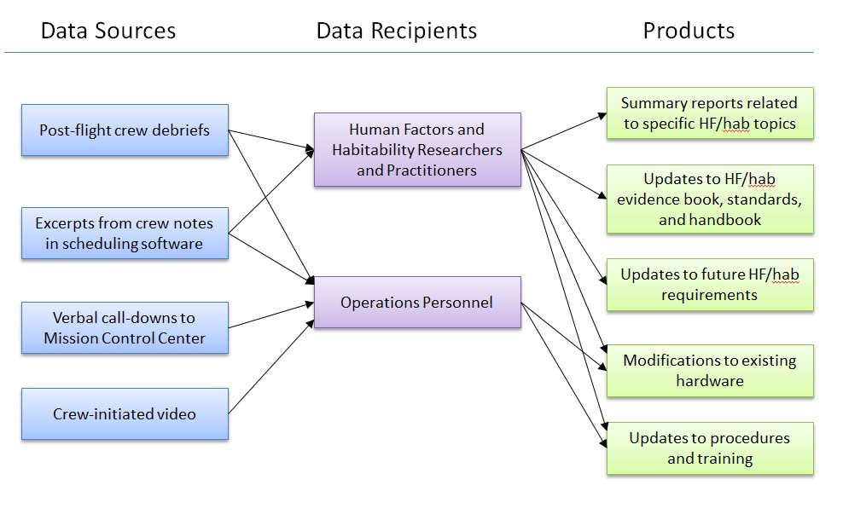
Figure 1. Current state of data sources, recipients, and products for human factors and habitability data.

Background

Previous Human Factors and Habitability Research
Previous NASA research on habitability and human factors provides an existing knowledge base that can be used to direct future research needs. This section provides a high-level summary of previous research on habitability and human factors. Although these studies yielded valuable results, some of which formed the basis of the ISS Habitability study, none of the studies collected data during long-duration spaceflights.

Analog Research
Research performed in spaceflight analogs can provide unique insight into design and operational considerations. Table 1 summarizes of human factors and habitability research that was conducted in various spaceflight analog environments along with a brief description of data collected. This table provides a high level summary and lists references for previous human factors and habitability work.

Table 1. Summary of relevant spaceflight analog-based human factors and habitability research

Project Tektite | Rating of habitat items and use of specially developed scales and questionnaires in an underwater habitat. Crew size: 4; Duration: 13-60 days. (Bellcomm, 1970; Helmreich, 1971; Miller & Koblick, 1984; Miller, VanDerwalker, & Waller, 1971; Nowlis, Wortz, & Watters, 1972; Tektite Underwater Habitat Museum, n.d.)
Skylab Medical Experiments Altitude Test (SMEAT) | Habitability assessments conducted before Skylab missions using cue cards and adequacy ratings. Crew size: 3; Duration: 56 days.  (Bond, 1973)
Lunar-Mars Life Support Test Project (LMLSTP) | Habitability assessments including a habitability questionnaire, crew debriefs, Space Operations Incident Reporting Tool (SOIRT), and video analysis conducted in a vacuum chamber at the Johnson Space Center (JSC). Crew size: 4; Duration: 60-91 days.  (Mount, 2002)
KC-135  assessments | In-flight questionnaires, postflight analysis of video, and crew debriefs regarding glove box evaluations during parabolic flight. Duration: Short intervals of microgravity. (Whitmore & Chmielewski, 1998; Whitmore & Mount, 1995)
NEEMO 5 | Development of non-invasive methods of capturing habitability data in underwater habitat. Crew size: 6; Duration: 14 days.  (Whitmore, Paige, Chung, Gieske, & Blume, 2004)
Desert Research and Technology Studies (DRATS) | Ratings for items and tasks on a numerical scale, open-ended questionnaires, and targeted questionnaires related to various human factors during prototype testing in a desert environment. Crew size: 4; Duration: less than 7 days.  (Abercromby, Gernhardt, & Litaker, 2010; Litaker, Thompson, & Howard, 2009; Romig & Kosmo, 2011)
Antarctic journals | Journal entries documenting observations related specifically to a list of behavioral issues with design and procedural implications for spaceflight, collected during Antarctic expedition. Crew size: Varied; Duration: 69-363 days.  (Stuster, Bachelard, & Suedfeld, 1999)
Antarctic operational habitability | Habitability characterization scale conducted weekly during Antarctic expedition. Crew size: 11; Duration: 35 days.  (Vallance, 2001)
Haughton-Mars Project (HMP) | Ratings of environmental habitability on a scale, issues recorded by a participant- observer during analog tests. Crew size: 7; Duration: 120 days.  (Binsted, Kobrick, Griofa, Bishop, & Lapierre, 2010; Clancey, 2001; Clancey, Lee, Cockell, Braham, & Shafto, 2006)
Mars Desert Research Station | Report of daily activities, questionnaire regarding habitat, questionnaire of capturing subjective remarks and overall impression during analog test. Crew size: 6; Duration: 14 days.  (Pletser, 2010)
NEEMO 16 | Early version of Space Habitability Observation Reporting Tool (iSHORT) and video methods to assess effectiveness of tools and methods. Crew size: 4; Duration: 14 days. Feeds directly into current work.

HERA C1M1 | Crewmembers of Human Exploration Research Analog (HERA) Campaign 1 Mission 1 used iSHORT to capture observations and targeted videos throughout the mission, completed a late mission questionnaire, and participated in an “on-orbit” PI conference. Served as dry run for current spaceflight experiment. Crew size: 4; Duration: 7 days.

Spaceflight Research
Previous research on human factors and habitability during spaceflight is obviously relevant for future assessment of human factors and habitability in an operational spaceflight environment. Table 2 summarizes studies of human factors and habitability conducted during spaceflight that were conducted over the past several decades, and gives a brief description of the data collected.

Table 2. Summary of relevant spaceflight-based human factors and habitability research.

Skylab | Habitability assessments including questionnaires and rating forms, use of voice recorder and video. Crew size: 3; Duration: 28-84 days.  (Johnson, 1975)
Mir | Questionnaire to report habitability issues. Crew size: 3; Duration: up to 188 days (Novak, 2000; Whitmore et al., 2000)
Shuttle (STS-57) | Questionnaires, monitoring and analyses using live video and ground audio, video walkthrough. Crew size: 6; Duration: 8 days  (Mount et al., 1994; Mount & Foley, 1999; Mount, Whitmore, & Stealey, 2003)
International Space Station | Astronaut journals to record entries related to behavioral factors. Crew size: 3 and 6; Duration: 120-200 days.  (Stuster, 2010, 2016)
International Space Station | Debriefs with crewmembers conducted by Operational Habitability (OpsHab) Team from the Flight Crew Integration (FCI) group at JSC. Crew size: 2-6; Duration: up to 342 days.

Study Objectives
The primary objectives of the current study were to characterize human factors and habitability on board the ISS and make recommendations for future long-duration spaceflights. The study consisted of two specific aims, each with a number of components (as shown in Table 3). Specific Aim 1 and its components were fully achieved. Specific Aim 2 and its components were proposed with the expectation of leveraging several tools that were in development at the time of the proposal, including the Automatic Video-based Motion Analysis (AVIMA) Small Business Innovation Research (SBIR), a tool to automatically collect data on how space is used, a camera system for quantifying 3-D used of space, and active Radio-Frequency Identification (RFID) tools. Unfortunately, these tools were not sufficiently developed in time to integrate them into the study. Aim 2 was partially achieved by examining specific locations discussed by the participants in their iSHORT observations. Table 3 provides additional detail regarding how each aim and component were addressed, and the sections in this report that are most relevant.

Table 3. Specific aims and resolutions.

Specific Aim | Component | How was this addressed? | Relevant sections
Specific Aim 1: Characterize the current state of ISS habitability using tools to capture near real-time data, with particular emphasis placed on areas of interest defined based on knowledge gaps, known trouble areas, and volume- driving tasks. | Aim 1a: Document and quantify details about how the crew perform tasks during long-duration microgravity exposure, including how interaction with the habit influences their behavioral state. | This was the primary analysis of the study. Data from the study were analyzed to examine frequency of topics and outcomes discussed. These were used to develop general recommendations for future missions and vehicle design. | 8.1 - 8.8
 | Aim 1b: Determine whether habitability and human factors reported by crewmembers change with duration of the mission. | We examined how mission phase affected the tone associated with the iSHORT-based data and responses to the questionnaires over time. | 8.5.2 and 8.6
 | Aim 1c: Assess the cost versus benefit of implementing tools to collect near real-time data compared to traditional post-mission debriefs. | We examined the implementation of the study (i.e., were participants able to provide good feedback with little guidance?) and discovered additional uses for the data. | 8.1, 8.5.1, 8.8,  and 8.9
Specific Aim 2: Document details about how crewmembers currently use the space on ISS, particularly those areas of interest, i.e. knowledge gaps, known trouble areas, and volume-driving tasks. | Aim 2a: Measure the time crewmembers spend at workstations and other areas. | We classified the number of iSHORT-based data points associated with specific locations on ISS. | 8.5.3  8.5.3
 | Aim 2b: Collect naturalistic data (i.e. observation of subjects in their natural environment) to document movement of crewmembers throughout ISS (e.g., frequency of translations between locations). |  | 8.5.3  8.5.3
 | Aim 2c: Collect evidence to estimate the required volume needed to perform specific volume-driving tasks. |  | 8.5.3  8.5.3
 | Aim 2d: Examine how crew change their strategies throughout the course of the mission when performing tasks such as translation, stowage, handling, etc.

Methods

Equipment
Two custom applications were loaded onto the ISS iPad 3s that ran on iOS 7 and 8. The applications used local wireless network to access the LS1 server on board the ISS.

Tools

Tool development
The iSHORT was developed as an upgrade to the previously developed Space Operations Incident Reporting Tool (SOIRT). Researchers at JSC created the SOIRT to provide a process for identifying human factors and habitability issues in real-time (Mount, 2002).

During development of these tools, significant revisions were made based on discussions with the investigative team, feedback from the subject matter experts, and results of pilot testing. The tool was initially implemented as a web-based interface to input text, then converted to an iOS platform that incorporates multimedia reporting features, allowing users to create photographs, videos, and audio recordings in addition to inputting text into the iSHORT. Implementing the iSHORT as an iPad application also provided portability, which was a highly desirable feature.

During NASA Extreme Environment Mission Operations (NEEMO) 16, the iSHORT was tested and certified for near-time data collection of human factors and habitability data. Before this spaceflight study, the iSHORT was updated to improve the user interface, enhance multimedia capabilities, and provide means to directly synchronize iSHORT data with a flight-like data server. Iterative improvements to the iSHORT have continued throughout the ISS Habitability study, including extracting the survey capabilities as a stand-alone application called iQuestion & Answer (iQ&A).

Tool use during ISS Habitability
The iSHORT provides a simple interface for users to report positive or negative observations about their environment, equipment, and general activities within the habitat (see Figure 2).

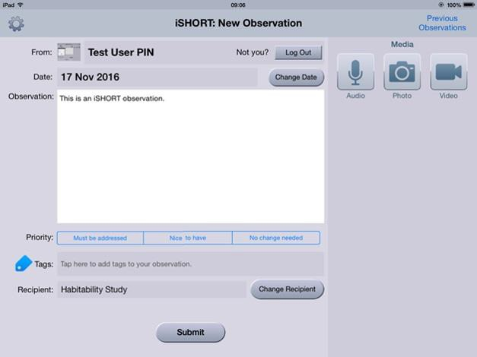
Figure 2. Screenshot from iSHORT

Users log into the iSHORT with an existing or new user name, with or without creating a 4-digit PIN. Reports are pre-populated with the current date and time, but users can adjust the date and time to report events that happened in the past. Participants can also assign a priority level to the observation: must be addressed, “nice to have”, or no change required. In addition, users can select tags to identify relevant human factors and habitability topics of interest that relate to the observation. The tags can also be used to remind users of the kind of expected entries. Users can enter text using the iPad’s software keyboard, and they can capture photos, video, and audio within the application as well as access photos and videos stored on the iPad.

In 2016, the ISS Habitability team developed iQ&A, a stand-alone application with capabilities that were previously included in the iSHORT. The iQ&A tool is simpler and easier to use than the iSHORT and still includes iPad’s multimedia functions: questionnaires can be created with a variety of input methods (free response, radio buttons, checkboxes, etc.), and users can attach video, photographs, text, or audio files (see Figure 3). Because iQ&A was implemented after the start of this study, three participants completed all surveys using the iSHORT, one participant used iSHORT for the early part of the mission and iQ&A at a later phase of the mission, and the remaining two participants used iQ&A for all surveys.

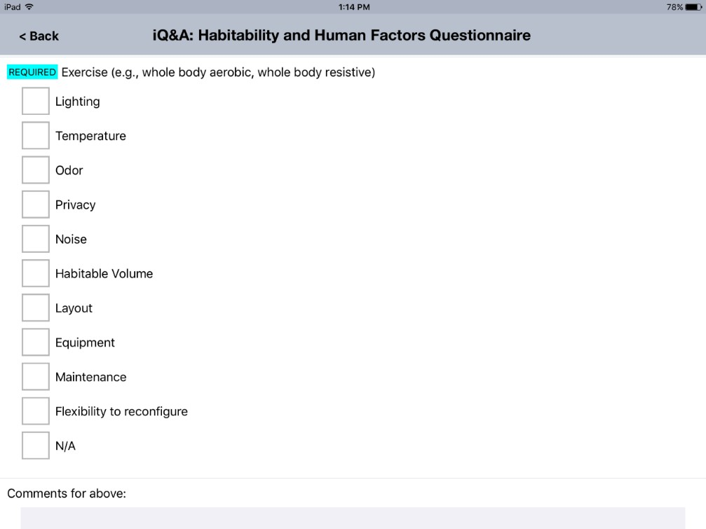

Figure 3. Screenshot of iQ&A survey

Observations and surveys were submitted wirelessly to a local server when the user tapped a “submit” button within the applications. Users could view previously submitted observations as well as receive feedback that each entry has synchronized with the data server.

Participants
Six U.S. astronauts participated in the study; one astronaut’s ISS mission lasted one year, and the remaining five astronauts participated in ISS missions lasting approximately 6 months. International Space Station Medical Project (ISSMP) personnel acted as an interface for the ISS Habitability team to recruit and consent participants for this study. There were no inclusion or exclusion criteria for participation in the study.

Facilities
All data was collected on board the ISS. During some data collection sessions, the astronaut was required to capture video in specific areas of ISS (e.g., crew quarters, hygiene compartment), but unless otherwise specified the location of data collection within ISS was at the participant’s discretion.

Procedures and Timeline
Participants of the ISS Habitability study were asked to watch an overview video (serving as the only training for the study), capture data using the iSHORT or iQ&A tool, and participate in three principle investigator (PI) conferences. No activities were required before or after the mission. The method and frequency of data collections are summarized in Table 4 and additional detail is given in the sections below.

Table 4. ISS Habitability activities

Method/Tool | Frequency | Description
Overview video | Once per mission | Crewmembers were scheduled to view an introductory video that described the use of the applications and the type of data being requested.
Human Factors and Habitability Observation (iSHORT) | Approximately once every two weeks | Crewmembers were scheduled to use iSHORT to document human factors and habitability observations, with the tool available for additional use as needed.
Walk-through videos (iSHORT) | Approximately once per month | Crewmembers were scheduled to use iSHORT to provide a guided tour of an area of the habitat to an audience of human factors engineers.
Task-based videos/Narrated Task videos (iSHORT) | Approximately once per month | Crewmembers were scheduled to use iSHORT to talk- aloud throughout the performance of pre-selected tasks to provide insight to human factors engineers.
Habitability and human factors questionnaire (iQ&A) | Three times during the mission | Crewmembers were scheduled to use iQ&A to complete a questionnaire addressing a diverse set of habitability and human factors concerns similar to topics typically covered during post-mission debriefs, and also including behavioral health questions.
PI conference | Three times during the mission | Crewmembers were scheduled to participate in a real- time conference with the PI. The conference consisted of investigators asking human factors/habitability questions based on the responses to the questionnaire and previous iSHORT-based data collected.

Overview Video
Participants were scheduled to view approximately 15 minutes of reference videos intended to familiarize them with the following topics:

Use of iSHORT and iQ&A
Overview of Habitability
Observation sessions (capturing an observation with iSHORT)
Walk-through Videos
Task-based Videos
Questionnaires using iQ&A and PI Conferences

This video training approach was validated during HERA Campaign 1 Mission 1. Screenshots from the reference videos are provided in Figure 4.

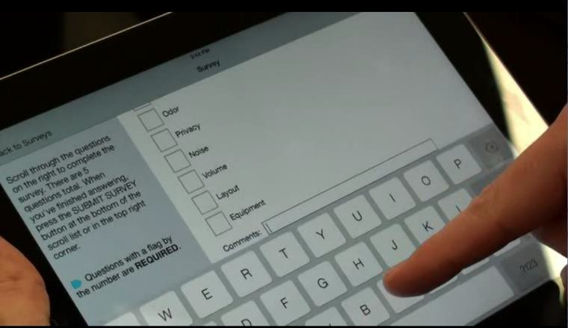

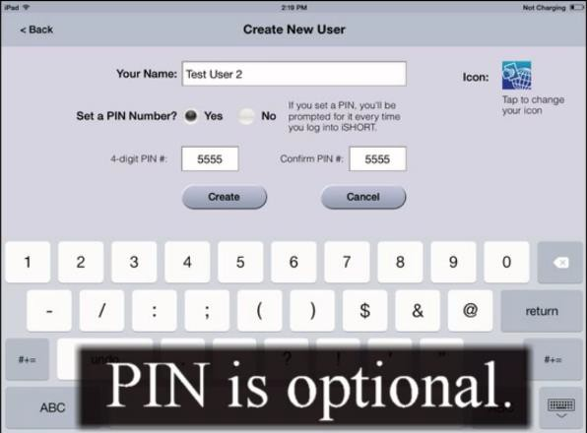
Figure 4. Screenshots from study training videos.

Human Factors and Habitability Observations
At scheduled times throughout the mission, participants used iSHORT to collect observations about the living and working environment of their choosing. They were instructed by the reference video to select a topic of interest to habitability and human factors engineers and to document positive or negative details using text, audio, photo, and/or video. The first study participant indicated that as the study continued it became difficult to think of new observation topics so prompts were then included to provide guidance. Participants were prompted to select a topic for observation, but they were under no obligation to follow the prompt. For example: “Topics may include EVA preparation activities such as tools, volume of work area, etc.” In addition to scheduled activities, participants were informed that iSHORT is available for use at any time.

Human Factors and Habitability Observations were scheduled approximately every other week. Each Observation was scheduled for up to 10 minutes of crew time.

Walk-Through Videos
Participants performed walk-through tours of the habitat at scheduled times using iSHORT to capture video data. The topics of these tours were assigned by the investigation team. Participants provided an overview of the assigned area and its hardware, capturing positive and negative aspects while they explained the function of the area.

Walk-through videos were scheduled approximately once a month. Each video was scheduled for up to 15 minutes of crew time.

Narrated Task Videos
The investigation team assigned specific tasks that the participant captured by video at scheduled times.

The astronaut narrated the task, explaining what they are doing and why, pointing out anything of interest to habitability and human factors engineers.

Narrated Task videos were scheduled approximately once a month. Each session was scheduled for up to 15 minutes of crew time, in the form of additional time added to the existing task duration.

Habitability and Human Factors Questionnaires
Participants completed the Habitability and Human Factors Questionnaires at three scheduled times early, mid and late into mission. Each session took approximately 20 minutes. The questionnaire consisted of two sections: a list of 14 volume-driving mission critical tasks with check boxes to select from 10 possible habitability and human factors that potentially needed improvement (example shown in figure 3); and a Likert scale to rate the overall vehicle habitability in terms of privacy, habitable volume, and layout. The volume-driving critical tasks listed in the questionnaire were exercise, whole body hygiene, waste collection and management, private personal activities, sleep, food preparation, group meet and eat, recreation, suit don/doff stowage and maintenance, radiation shelter, Display &Control console operations, mission-specific on-board research, crew health/medical, and stowage. Questionnaires were scheduled for early, middle, and late in the mission for both 1-year and 6-month duration missions. Each session was scheduled for up to 20 minutes of crew time.

For the list of volume-driving tasks, participants were instructed to check a box for any of the factors that needed improvement from a habitability point of view, or check "N/A" if none of these factors needed improvement. Each task presented the same list of factors.

PI Conference
Each participant convened with the investigation team in a private setting after they had completed each habitability and human factors questionnaire. Each session was scheduled for up to 20 minutes of crew time. The investigative team used questionnaire results and additional information captured in the iSHORT to develop a tailored set of questions for each cPI Conference. The investigation team communicated with the participant using 2-way voice and 1-way video (enabling the participant to visually demonstrate postures or tasks). The standard PI conference questions are contained in Appendix B – PI Conference Questions.

PI Conferences were scheduled to follow the early, middle, and late questionnaires for both 1-year and 6- month duration missions.

Data Analysis

iSHORT Data
The primary data of interest for this study were the iSHORT observations, narrated task videos, and walk-through videos, henceforth referred to as iSHORT-based data. A content analysis method (Stemler, 2001) was employed, following a similar method employed by Stuster (2010, 2016). A set of codes were sorted into were defined belonging seven primary categories. A summary of the categories and codes is given in Table 5. The full list of codes and their definitions is given in Appendix C – ISS Codes and Definitions.

These codes were selected from the list of tags available in the iSHORT app, which were developed based on results from previous studies of human factors and habitability (Mount, 2002). In addition to codes in the seven major categories, the research team coded for a discussion of location within the habitat, and identified tone (positive, negative, or neutral) of each sentence. The outcomes category contained outcome measures such as effectiveness, efficiency, and intuitiveness that are of interest to human factors and habitability professionals The Study category captures comments referring to the study itself, specifically with regard to the prompts, use of data, the use of the iPad, and impact on activity performance.

Table 5. List of primary categories and examples of codes used for analysis.

Primary Category | Number of Codes | Codes
Activities | 14 | Sleep, Exercise, Recreation, Stowage, Food, Hygiene, Trash, Translation, Housekeeping, Maintenance, Science, Health and medical, Emergencies (non-medical), Public Affairs Office (PAO)
Habitat Environment | 11 | Lighting, Vibration, Temperature, Air quality, Odor, Privacy, Noise, Gravity, Volume, Layout, Aesthetics
Equipment | 4 | Hardware, Software, Spacesuits, Improvisation/modification
Operations | 6 | Timelines, Training, Labels, Procedures, Safety, Improvisation/modification
Group Interactions | 3 | Group structure, Group behaviors, Group culture and language
Outcomes | 15 | Satisfaction, Effectiveness, Efficiency, Consistency, Ease of use, Convenience, Intuitiveness, Comfort, Fit, Interface design, Physical workload, Mental workload, Fatigue, Stress, Suggestions for improvements
Study | 4 | Prompts, Data use, iPad, Activity performance

Two coders independently reviewed the entire set of iSHORT-based data. Each data point (consisting of a transcript of the observation, narrated task, or walk-through video) was assigned a primary code. After they assigned the primary code the coders reviewed the rest of the transcript on a sentence-by-sentence basis and assigned additional codes that applied to the sentence. The coders identified the tone (positive, negative, or neutral) that best characterized the sentence. The codes assigned by each coder were compared, and a third coder reviewed any disagreement in assignments. The cause of the majority of disagreements was simple omission, and the third coder was generally able to easily resolve any conflicts. In cases of more complex disagreements, all three coders convened to discuss the coding. After this process, the resulting data set was composed of a set of codes that all three human factors specialists agreed on.

The frequency of use of each code, category, and tone was examined at a high level, and then in the context of mission timeline (early, middle, and late). A co-occurrence analysis was conducted in which the most frequently used codes were further examined to determine their association with any other codes (e.g., which other codes are most associated with “efficiency”). This analysis helped the researchers to provide depth and context to the recommendations and findings they derived from the data.

Questionnaires and PI Conferences
The Human Factors and Habitability Questionnaires were primarily used to guide the PI Conferences. The research team also investigated changes in subjective ratings across the three different data collection time points. The PI Conferences were used to provide context to the iSHORT-based data and provide the participants with feedback. As such, these data were used qualitatively in addition to the iSHORT-based data to derive general recommendations for habitat design and human factors for future missions.

Results
Data from participants of five six month missions and a one year mission are presented below. It should be noted that due to data privacy concerns associated with presenting results for less than five participants, results and discussion are kept at are aggregated with regard to the 1-year mission participant. Mission duration for the standard duration participants was approximately 6 months, with some variability between participants.

Data Collection Rates
The total number of completed sessions is provided in Table 6. Note that some observations contained multiple files. Observations were sorted into media type, to characterize participants’ use of the iSHORT application. The average video length was approximately 4 minutes. The total combined length of video captured by all the participants was approximately 15 hours.

Table 6. Number of data collection sessions completed.

Data Type | Total
Human Factors and Habitability Observations | 105
Text | 15
Video | 114
Audio | 26
Narrated Task Videos | 37
Walk-through Videos | 36
Questionnaires | 18
PI Conferences | 18

Habitability and Human Factors Observations
The Observations submitted consisted of all three primary reporting methods: text, audio, and video (details provided in Table 7). While all three reporting methods were regularly used, it should be noted that most participants seemed to prefer using one method over the others (in bold for each participant), and this preference varied for participants. Because the participants were asked to perform the narrated task and walk-through activities using video, Table 7 provides the breakdown of observations by media type and participant. Occasionally, participants used multiple media types to record one observation (e.g., 2 audio files and 1 video file). Each file was counted separately in the table even if it refers to the same observation. None of the participants elected to attach photos to their observations. Overall, video emerged as the preferred method of reporting across participants, with four of the six preferring it over text or audio. Note that the participants are not listed in chronological order, for the sake of de-identification.

Table 7. Habitability and human factors Observation media used. Each participant’s preferred method is highlighted in bold.

Media used | Participant A | Participant B | Participant C | Participant D | Participant E | Participant F
Text | 0.0% | 13.3% | 4.0% | 4.0% | 0.0% | 84.6%
Audio | 9.5% | 73.3% | 0.0% | 0.0% | 23.2% | 0.0%
Video | 90.5% | 13.3% | 96.0% | 96.0% | 76.8% | 15.4%

For Observation activities, the participants were instructed to select a habitability and human factors topic of their choice on which to report. They were free to follow the prompt provided or select a different topic. Overall, participants elected to follow the prompt approximately 50% of the time, with some variability in preference seen between participants (see Table 8).

Table 8. Frequency of participants' use of prompts.

Followed prompt? | Participant A | Participant B | Participant C | Participant D | Participant E | Participant F
Yes | 23.8% | 57.1% | 56.0% | 66.7% | 53.3% | 23.1%
No | 76.2% | 42.9% | 44.0% | 33.3% | 46.7% | 76.9%

Throughout the study, the participants elected to report on a wide variety of topics, with some Observations encompassing more than one topic. While iSHORT provided tags intended to serve as memory joggers, there is no feedback regarding whether the participants took advantage of the tags for this purpose. Based on analog testing, while some users find the tags to be helpful, others do not use them as memory joggers. In general, participants did not attach tags or select priority levels for their submissions.

Narrated Task Videos
As previously discussed, Narrated Task videos were scheduled with instructions for the participant to provide a “talk aloud” narrative while completing a task already on the timeline. The task scheduled for

each video was specified in the crew schedule. Note that some tasks and associated videos were performed by multiple participants (at different times) while some were performed by only one participant. The tasks captured include:

    - Food preparation activities
    - Exercise equipment setup and use
    - Various payloads setup
    - Blood collection process
    - Housekeeping activities
    - Mouse Habitat Unit removal
    - Emergency OBT sim drill
    - Dragon Transfer ops

Walk-through Videos
Walk-through videos were scheduled with instructions for the participant to provide a tour of an area or task for human factors and habitability experts. The topic for each video was provided in the crew schedule. Some of the areas and tasks captured were:

    - Hygiene areas
    - Translation path from Cupola to Permanent Multipurpose Module (PMM)
    - US Airlock
    - Robotic Work Station in Cupola
    - Waste and Hygiene Compartment (WHC)
    - Dining area
    - Windows
    - Crew Quarters

Combined iSHORT-based data
The primary analysis of this study was based on the codes assigned as discussed in the Data Analysis section. The following sections outline the analysis by specific categories and codes, and by tone, taking into consideration mission phase.

Categories and codes used
With regard to the seven primary categories, the Outcomes category was used most frequently, followed by Activities, Equipment, and Habitat Environment. The Location, Operations, Group Interactions, and Study categories were used far less often (Figure 5). The fact that the Outcomes category was used most often indicates that the participants understood the goals of the study and were able to self-report observations that are valuable to human factors and habitability professionals. This finding adds evidence that given proper training people are able to report on human factors issues without the direct support of a professional.

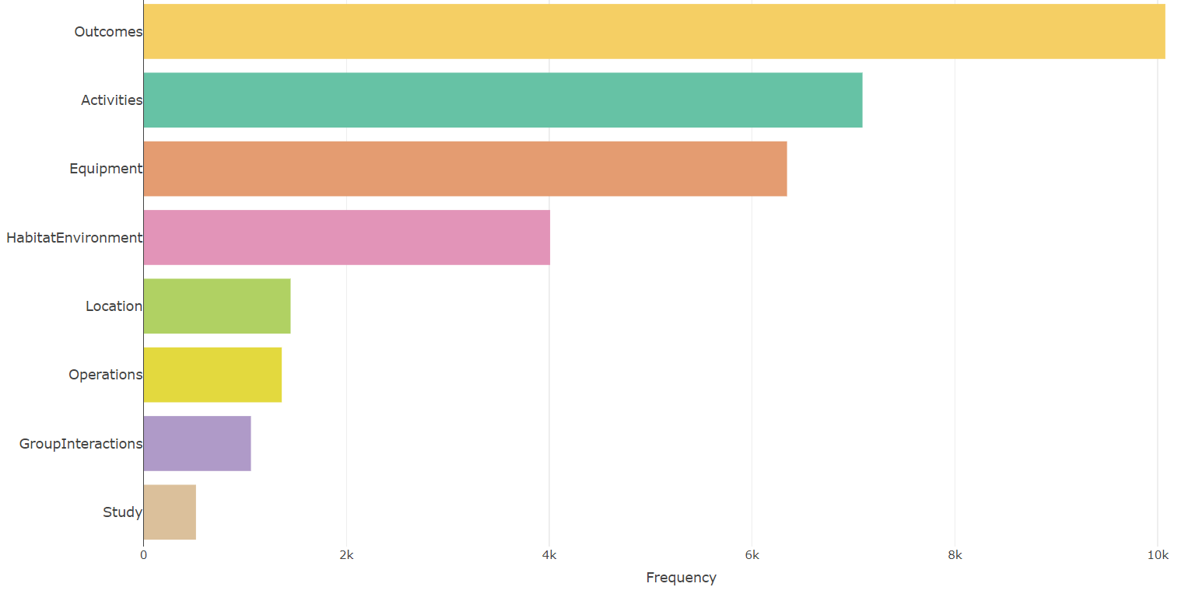

Figure 5. Major category frequency.

The data was also examined at a deeper level, with consideration of each individual code within a primary category. As can be clearly seen in Figure 6, the Hardware code within the Equipment category was used most often, and is the reason for the Equipment category being the third most used primary category. This is likely due to participants often referencing specific pieces of hardware while discussing a variety of topics. For example, when discussing exercise, participants may refer to the Advanced Resistive Exercise Device (ARED), or its subcomponent, and the sentence would be tagged with the Hardware code alongside the Exercise code. This resulted in the Hardware category being used extremely frequently. Within the Outcomes category, the three most often used codes were Interface Design, Effectiveness, and Satisfaction, while the three most often discussed activities were Stowage, Exercise, and Food.

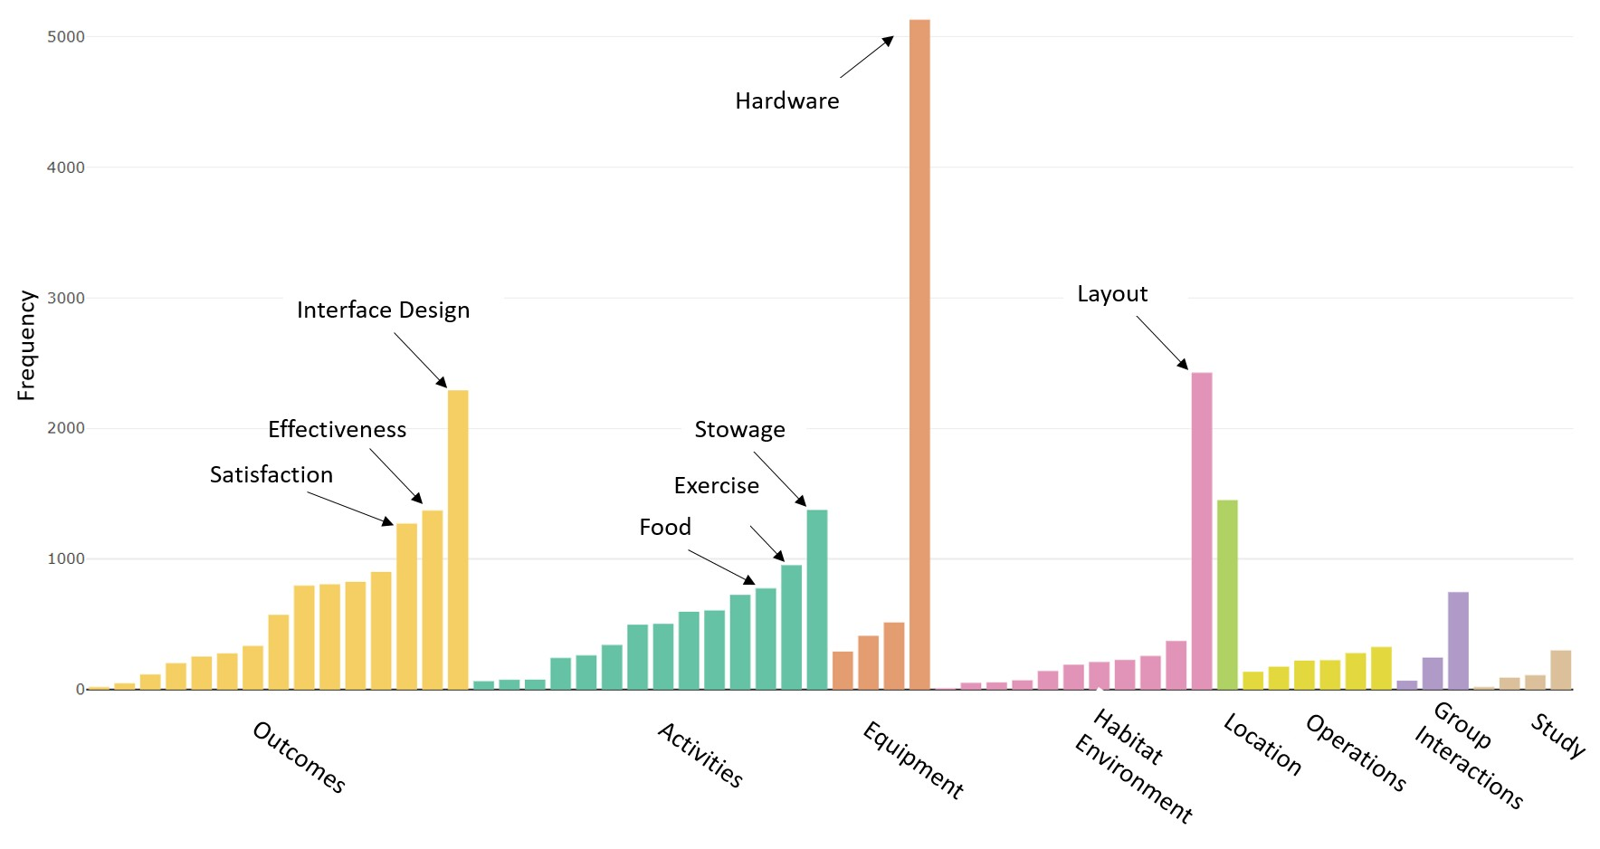

Figure 6. Individual code frequency.

The top 20 most used codes accounted for approximately three quarters (78%) of all codes used and are presented in Table 9.

Table 9. Most frequently used codes and major categories.

Rank | Code | Major Category | Total Number of Times Used | Cumulative Percent
1 | Hardware | Equipment | 5129 | 16.84
2 | Layout | Habitat Environment | 2426 | 24.81
3 | Interface design | Outcomes | 2291 | 32.33
4 | Stowage | Activities | 1375 | 36.84
5 | Effectiveness | Outcomes | 1371 | 41.34
6 | Satisfaction | Outcomes | 1271 | 45.52
7 | Exercise | Activities | 952 | 48.64
8 | Ease of use | Outcomes | 901 | 51.60
9 | Convenience | Outcomes | 825 | 54.31
10 | Consistency | Outcomes | 806 | 56.96
11 | Suggestions for improvements | Outcomes | 796 | 59.57
12 | Food | Activities | 775 | 62.11
13 | Group behaviors | Group Interactions | 746 | 64.56
14 | Science | Activities | 725 | 66.94
15 | Maintenance | Activities | 606 | 68.93
16 | Health and medical | Activities | 596 | 70.89
17 | Efficiency | Outcomes | 572 | 72.77

18 | Software | Equipment | 514 | 74.46
19 | Hygiene | Activities | 503 | 76.11
20 | Housekeeping | Activities | 497 | 77.74

Of the top 10 most commonly used codes, six are of the major category “Outcomes”: Interface design, Effectiveness, Satisfaction, Ease of use, Convenience, and Consistency. The next few sections investigate these more closely, and derive general recommendations for ISS and future vehicle designs based on the coded data. Overall, the Layout code was one of the most frequently co-occurring codes with all Outcomes under consideration, indicating that issues with layout have far reaching consequences and impact various aspects of human factors and habitability.

Interface design
The interface design code was used a total of 2,291 individual times. The ten other codes that co-occurred most often with interface design are presented in Table 10. With regard to tone, 42% of comments were neutral, 37% negative, and 24% were positive.

Table 10. Ten most frequently co-occurring codes with interface design.

Code | Major category | Number of co- occurrences | Percent of co- occurrence
Hardware | Equipment | 1859 | 81.14
Layout | Habitat Environment | 564 | 24.62
Effectiveness | Outcomes | 438 | 19.12
Ease of use | Outcomes | 417 | 18.20
Stowage | Activities | 405 | 17.68
Suggestions for improvements | Outcomes | 385 | 16.80
Satisfaction | Outcomes | 373 | 16.28
Exercise | Activities | 346 | 15.10
Software | Equipment | 256 | 11.17
Convenience | Outcomes | 252 | 11.00

From both this table and the tone breakdown, it can be inferred that issues with interface design impact the participant’s ability to perform their tasks (effectiveness), and that there may also be issues with ease of use, satisfaction, and convenience. The interface design of both hardware and software was discussed, and the most commonly referenced activities with regard to interface design were stowage and exercise.

Given the results of the co-occurrence analysis, improvements made to interface design could result in increased effectiveness, ease of use, satisfaction, and convenience, all of which may also result in time savings while crew is performing specific tasks. Improvements to interface design should be focused on stowage and exercise systems on board the ISS.

Effectiveness
Effectiveness was used to indicate instances in which the participant commented about the quality of their task performance, including any errors committed. The Effectiveness code was used 1,371 times in the data set. Approximately 51% of the instances were coded as Negative, 36% as Positive, and 19% as Neutral. The ten most frequently co-occurring codes are listed in Table 11. Note that both Interface Design and Effectiveness were associated with Hardware, Layout, Satisfaction, Stowage, Ease of Use, Convenience, and Suggestions for improvements. This similarity is likely due to the close association between Interface design and Effectiveness. Interestingly, effectiveness was closely associated with Science activities and Consistency, whereas Interface design was not. Given these associations, improvements made to the interface design of hardware and software would likely affect effectiveness and all of the other closely associated concepts. However special consideration should be given to science with regard to effectiveness. The consistency of systems (e.g., differences between ground and flight designs) appears to also have a close relationship with effectiveness. Interestingly, there does not seem to be a strong association between efficiency and effectiveness, two concepts that are often discussed together. This data adds evidence that these are two separate constructs that must be considered individually.

Table 11. Ten most frequently co-occurring codes with effectiveness.

Code | Major category | Number of co- occurrences | Percent of co- occurrence
Hardware | Equipment | 1000 | 72.94
Layout | Habitat Environment | 499 | 36.40
Interface design | Outcomes | 438 | 31.95
Satisfaction | Outcomes | 314 | 22.90
Stowage | Activities | 313 | 22.83
Ease of use | Outcomes | 207 | 15.10
Convenience | Outcomes | 178 | 12.98
Consistency | Outcomes | 158 | 11.52
Science | Activities | 150 | 10.94
Suggestions for improvements | Outcomes | 150 | 10.94

Satisfaction
The Satisfaction code was used to indicate crewmember like and dislike of equipment, operations, activities, and environment. The Satisfaction code was used 1,271 times, with approximately 59% positive, 35% negative, and 9% neutral. The stark difference between the tone distribution of this code, other codes, and the entire data set, is reasonable considering the satisfaction code was used with sentences that indicated like or dislike, which are likely to be emotionally charged, leading to far less instances of Neutral tone. The top ten codes that co-occurred with Satisfaction are listed in Table 12.

Table 12.Ten most frequently co-occurring codes with Satisfaction.

Code | Major category | Number of co- occurrences | Percent of co- occurrence
Hardware | Equipment | 787 | 61.92
Layout | Habitat Environment | 436 | 34.30
Interface design | Outcomes | 373 | 29.35
Effectiveness | Outcomes | 314 | 24.70
Stowage | Activities | 225 | 17.70
Suggestions for improvements | Outcomes | 142 | 11.17
Exercise | Activities | 140 | 11.01
Group behaviors | Group Interactions | 138 | 10.86
Consistency | Outcomes | 136 | 10.70
Convenience | Outcomes | 131 | 10.31

Interestingly, Satisfaction was one of only two codes from the Outcomes category to show a relatively sizeable relationship with Group behaviors. The majority of sentences coded with both the Satisfaction and Group behaviors codes were positive (62%) and approximately 38% coded as negative (7% neutral). This relationship demonstrates the importance of coding for concepts related to well-being, as they may reveal patterns that would not be apparent if the data is only coded for concepts that may directly impact or speak to task performance.

Ease of use
Ease of use was primarily used to capture comments about usability. The code was used a total of 901 times. Approximately 52% of the coded sentences were negative, 41% positive, and 12% neutral. The distribution of the top ten most commonly used codes are listed in Table 13.

Table 13. Ten most frequently co-occurring codes with Ease of use.

Code | Major category | Number of co- occurrences | Percent of co- occurrence
Hardware | Equipment | 643 | 71.37
Interface design | Outcomes | 417 | 46.28
Layout | Habitat Environment | 277 | 30.74
Convenience | Outcomes | 254 | 28.19
Stowage | Activities | 240 | 26.64
Effectiveness | Outcomes | 207 | 22.97
Satisfaction | Outcomes | 127 | 14.10
Efficiency | Outcomes | 123 | 13.65
Suggestions for improvements | Outcomes | 116 | 12.87
Intuitiveness | Outcomes | 114 | 12.65

Notably, Effectiveness, Efficiency, intuitiveness, and convenience, which can all contribute to usability, are all related to the Ease of use code. These associations demonstrate the complex relationships among different aspects of usability, as well as some of the consequences of poor usability. Interestingly Stowage is the only activity highlighted as one of the top ten most frequently co-occurring codes with Ease of use.

Convenience
Convenience was used 825 times in the data set. Approximately 45% of uses were negative, 39% positive, and 20% neutral. The top ten most frequently co-occurring codes are listed in Table 14.

Table 14. Ten most frequently co-occurring codes with Convenience.

Code | Major category | Number of co- occurrences | Percent of co- occurrence
Hardware | Equipment | 647 | 78.42
Layout | Habitat Environment | 464 | 56.24
Stowage | Activities | 307 | 37.21
Ease of use | Outcomes | 254 | 30.79
Interface design | Outcomes | 252 | 30.55
Efficiency | Outcomes | 196 | 23.76
Effectiveness | Outcomes | 178 | 21.58
Satisfaction | Outcomes | 131 | 15.88
Suggestions for improvements | Outcomes | 130 | 15.76
Food | Activities | 92 | 11.15

While all other Outcome codes discussed showed a relationship with Layout, this association is especially strong with regard to Convenience, with over 50% of sentences coded with Convenience also being coded with Layout. Given this association, it is likely that improvements made to layout would result in improved convenience, this may be especially true for stowage and food-related activities, as these two were the activities most closely associated with convenience.

Consistency
The Consistency code was used to mark comments having to do with the consistency of systems and operations, e.g., differences between training on the ground and flight hardware, expected functionality compared to actual. Approximately 43% of comments coded with the consistency code were negative, 36% were neutral, and 26% were positive. The top ten most frequently co-occurring codes with consistency are listed in Table 15.

Table 15. Ten most frequently co-occurring codes with Consistency.

Code | Major category | Number of co- occurrences | Percent of co- occurrence
Hardware | Equipment | 533 | 66.13

Layout | Habitat Environment | 258 | 32.01
Interface design | Outcomes | 238 | 29.53
Effectiveness | Outcomes | 158 | 19.60
Stowage | Activities | 146 | 18.11
Satisfaction | Outcomes | 136 | 16.87
Suggestions for improvements | Outcomes | 99 | 12.28
Group behaviors | Group Interactions | 94 | 11.66
Efficiency | Outcomes | 93 | 11.54
Exercise | Activities | 90 | 11.17

Along with Satisfaction, Consistency is the only Outcomes code to show a relationship with group behaviors. Many of these comments were related to handover and transitioning between the old and new crew, and differences between how various crewmembers perform tasks. Consistency was also closely related to Hardware and Interface Design, indicating crewmembers frequently discussed similarity among different interfaces.

Analysis of tone
As mentioned in previous sections, the tone of each sentence was categorized as positive, negative, or neutral. Occasionally, both positive and negative sentiment was apparent in a single sentence, for example: “The scratch pane only allows small access for the camera but the window itself is nice and large.” In these cases, the sentence was coded as both positive and negative, in an effort to capture both sentiments. Out of over 7600 coded sentences, only 164 were coded as both positive and negative. In general, approximately 44% of comments were neutral, 32% were negative, and 24% were positive (Figure 7). This distribution did not vary much by mission quarter (Figure 8).
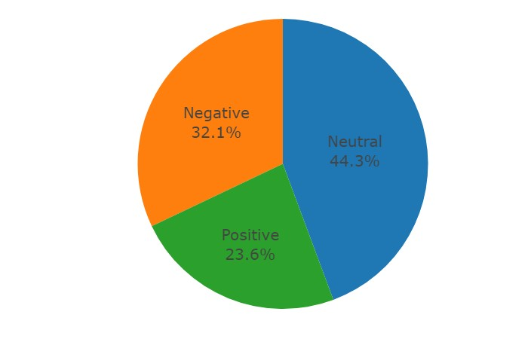

Figure 7. Percentage distribution of tone.

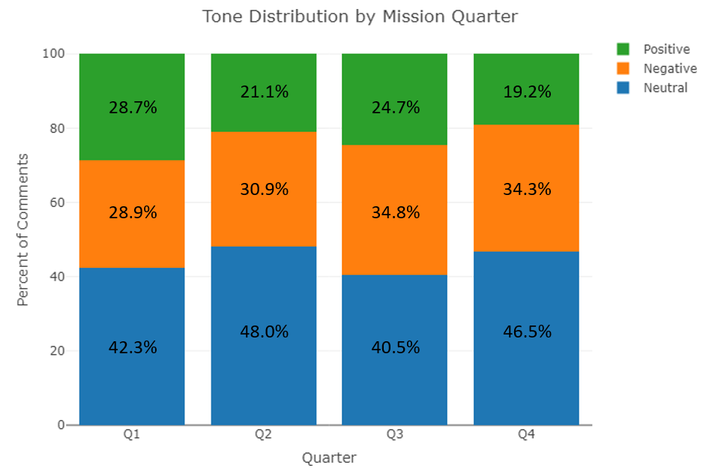

Figure 8. Distribution of tone by mission quarter

The large portion of sentences coded as neutral is likely a result of the participants taking time to describe the activities or equipment on which they were commenting. For example, this sentence about the food warmer describing the interface: “You get a red light and every 10 minutes you get one, two, three, four of these lights to come on and then the thing will time out.” The presence of both positively and negatively coded sentences indicates that the participants used the iSHORT tool to report on the characteristics of ISS and their missions that they dislike, as well as those they liked. This is of special interest for future mission and vehicle design, since we would like to capture the items needing improvement (e.g., about packaging “so when you're doing something, you got to open up every bag, every bubble wrap bag, to find the specific part you need.”), as well as those that are working well (e.g., about stowage “This style is the Russian pocket and I also like those again because you can see through them.”).

Tone was further analyzed by calculating Stuster’s (2010, 2016) Net Positivity/Negativity Index (NPN) for each participant by mission quarter. The proportion of negative comments was subtracted from the proportion of positive comments. As such, positive values indicate a greater number of positive comments for the specific participant and mission quarter while negative values indicate a greater number of negative comments. Overall, the participants did not have a consistent relationship between NPN and mission quarter (Figure 9).

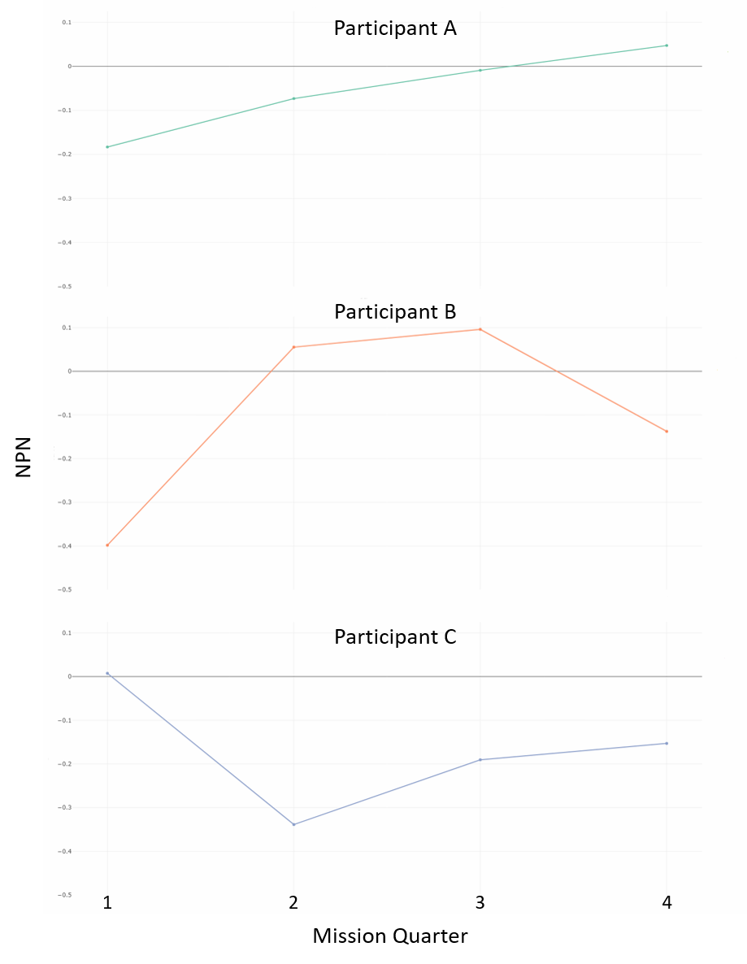

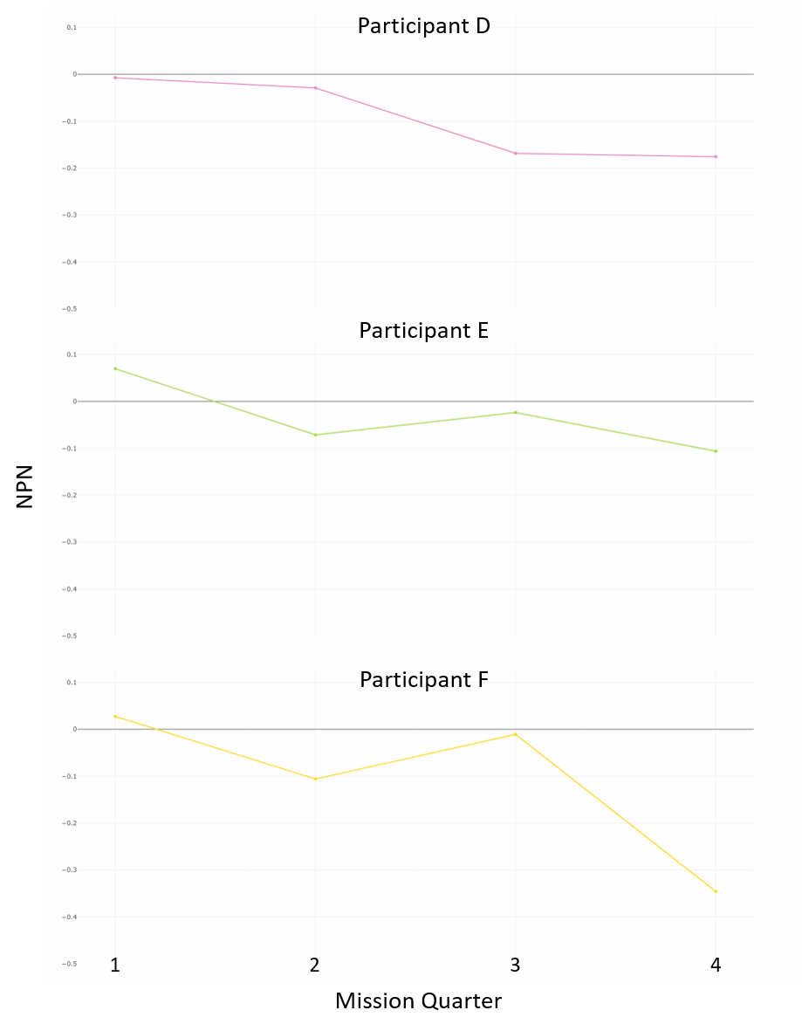

Figure 9. NPN by participant and mission quarter.

As was seen in the aggregate results, tone was overall negative in nature across participants and mission quarter. No consistent pattern could be discerned across participants, nor does there appear to be a “third quarter effect.” Comments by participant A were consistently more positive as their mission progressed.

Participants E and F demonstrated a similar pattern, with a positive “spike” during their third quarter while generally presenting with increasingly negative comments. Participant D presented with increasingly negative comment as mission progressed. Participant B presented with a positive NPN for the middle part of their mission and negative NPN for the first and last quarter. Finally, participant C presented with a sharp negative skew in mission quarter 2, followed by a relative increase in quarters 3 and 4. While there does appear to be significant variability among our participants, with a larger sample size it may be possible to detect a more consistent pattern.

Location
Of the 7,671 number of sentences that made up the entire dataset, 1,450 (approximately 20%) were assigned the code of “Location.” This code was assigned when the participant discussed a specific location in the habitat. Since for Walk-through and Narrated Task videos participants were asked to discuss specific areas and activities in specific areas, the analysis of location below includes data from Observations only.

The Observations from each participant were reviewed, and the number of Observations in which participants discussed activities or human factors concerns within a specific volume (e.g., hygiene in the PMM) were tallied. If the participant did not refer to the specific location during the Observation (e.g., a discussion about the food warmer interface), the Observation was not counted as a specific module or area. In cases where the participant discussed more than one location in the same Observation, the Observation was counted multiple times. Table 16 lists the number of Observations associated with each location.

Table 16. Number of Observations about specific locations.

Location | Times mentioned
Node 1 | 10
PMM | 10
U.S. Lab | 7
JEM | 7
Crew Quarters | 6
Columbus | 6
WHC | 5
Node 2 | 4
Node 3 | 3
Cupola | 3
Airlock | 3
JLP | 2
Russian segment | 2
BEAM | 1
Dragon | 1
Soyuz | 1
HTV | 1

The number of times participants chose to discuss a specific location likely signifies its importance. Node 1 includes the food preparation and consumption facilities. Given that “Food” was amongst the most commonly discussed activities, it is reasonable that Node 1 was one of the most frequently discussed locations. The Permanent Multipurpose Module (PMM) serves two primary activities on board the ISS today – stowage and hygiene. Initially designed for stowage, crewmembers additionally use the PMM as an improvised hygiene area. Note that the two most commonly discussed areas, Node 1 and PMM, are the locations of basic habitability functions (food and hygiene). This serves to highlight the importance of having a specific place for crewmembers to perform these activities. The next most frequently discussed areas, the Japanese Experiment Module (JEM) and U.S. Lab, likely reflect the participants’ emphasis on their day-to-day work activities and time they spend in these modules. The same is likely true for the Columbus module. The Crew Quarters (CQ) were also mentioned with regular frequency. It is important to note that these references to the CQ are above and beyond specific Walk-through requests about the CQ, indicating its perceived importance by the crewmembers.

The top most frequently referenced areas on ISS represent two primary functions – habitability and science. It is likely that crewmembers place great importance on these functions and therefore discuss the locations of these activities in great depth. Future vehicles should design habitability and science areas with great care, as these appear to be areas of specific concern for the crewmembers. Future studies focused on quantifying time spent in each of these areas will further these findings and may provide more concrete evidence as to the importance of these specific locations.

Habitability and Human Factors Questionnaire
The results of this questionnaire were primarily used to guide questions administered during the subsequent PI Conference. Although the option to respond using media (photos, video, or audio) was available, none of the participants elected to respond using these modalities.

While the primary purpose of the questionnaire was to aid in in the development of the PI Conference questions, a number of interesting trends emerged from an examination of participants’ responses to the questionnaires. Whole body hygiene emerged as the category marked most often as needing improvement across the factors considered. Within this category, layout and privacy were mentioned most often. From comments given within the questionnaire and follow-up questions asked at the PI Conferences, it was determined that this finding is likely due to the lack of a dedicated volume for hygiene. Exercise was the second highest category that emerged as needing improvements, with noise being the factor mentioned most often. This is likely due to the noise produced by the exercise machines, which required the participants to wear earplugs while exercising. The frequencies of all areas and the categories needing improvement are listed in Appendix D – Questionnaire Results.

In addition to responding to open-ended questions, participants rated their overall satisfaction (1- completely unacceptable to 5-completely acceptable) with privacy, habitable volume, and layout in each questionnaire. The overall mean ratings were 4.1, 4.3, and 3.8, respectively. The nparLD R package developed by Noguchi et al. (2012) was used to explore whether the participants’ ratings changed depending on when the questionnaire was administered (early, middle, or late in their mission). This non- parametric approach was selected to accommodate the repeated measures Likert-scale data. The results

of the analysis showed no statistically significant difference among the three questionnaire ratings for any of three concepts explored, suggesting self-rated satisfaction with these concepts did not vary as a function of time spent on ISS. Qualitatively, the ratings participants provided on the questionnaires mirror the responses from the iSHORT-based data, where layout was the least satisfactory of the three aspects considered and was one of the most commonly co-occurring codes with the Outcomes considered in the previous few sections.

PI Conferences
Upon receiving results of the Habitability and Human Factors Questionnaire, the investigative team convened to tailor a set of questions for the PI Conference. The base list of questions, shown in Appendix B – PI Conference Questions, was expanded upon and customized to reflect specific topics addressed by the participant prior to the PI Conference through observations, Narrated Task video, Walk-through video, and the questionnaire. Tailored questions included requests for more details pertaining to Walk-through and Narrated Task videos, observations, and problem areas indicated in the questionnaire. Feedback from the PI conferences was used alongside the iSHORT-based data to develop general recommendations.

Interpretation and General Recommendations
Based on the data from this study, a number of general recommendations can be made for future vehicles and ISS systems. These are primarily derived from the iSHORT-based data but are also supported by responses to the surveys and comments made in the PI conferences. To derive these recommendations, the team examined the original transcript data focusing on the codes that emerged as most frequently used in the dataset. Some supporting quotations from the data are provided for each recommendation. While many of the recommendations below are not new, it is clear from the data collected during the study that these are not yet being fully implemented.

In addition to general recommendations, the team reviewed existing standards and guidelines in order to make specific suggestions for modification. NASA Standard 3001 Volume 2: Human Factors, Habitability, and Environmental Health defines standards from which all programs derive specific requirements. The Human Integration Design Handbook (HIDH) serves as a companion to 3001 to aid in the interpretation of standards. It is important to note that 3001 was baselined in 2011, and ISS was not held to this standards document. Human factors requirements for ISS are mostly defined in the International Space Station Flight Crew Integration Standard, SSP 50005. However given the importance of NASA-STD-3001 to future programs, lessons learned from ISS Habitability can be used to influence this document in order to ensure that human factors and habitability standards support the crew and crew tasks in future vehicles. NASA Standard 3001 is currently undergoing revision. The recommendations made in this report are based on the currently approved version of the document, revision A, from 2015. In all cases, revisions to HIDH should accompany those made to the standard, and evidence from this report incorporated.

8.8.1 Increase the use of wireless technology
The current reliance on wired technology presents the crew with challenges of cable management and the inconvenience and difficulty of relocating items. Figure 10 shows an example of cables aboard the ISS. While there are other design solutions that would contribute to better cable management, such as running cables behind stowage/rack systems, designers should additionally investigate new wireless

technology. Items that are expected to be relocated frequently, such as cameras and communication devices, would especially benefit from a wireless implementation.
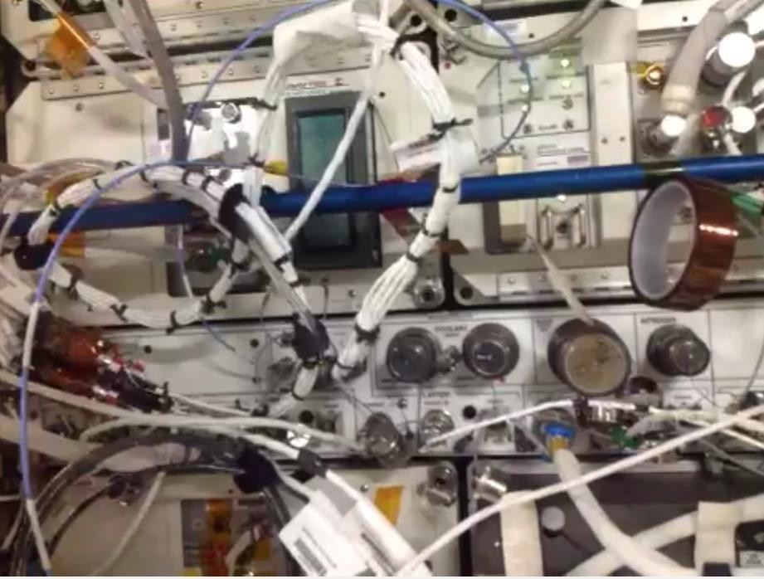
Figure 10. An example of cables aboard ISS.

Some of the specific comments made that support this recommendation are:

“We have all over station a bunch of rack front cabling which actually is a mess […] it actually really gets in the way.”

“You needed one cable and then a little transformer kind of box and then another cable and also two ends of that assembly needed to go to different places and it had you select parameters for each cable line one at a time and then you had to go find this end and connect it up and then you go find this end and connect it to this little transformer box […] It was a cable nightmare.”

“Here's an example of what I've spoken before about that can be improved and that's cable management […] it becomes time consuming in order to reconfigure hardware because of all the cables”

“There are cables all over the place, cables on cameras, cables on monitors, power cables, cables going into laptops, cables on racks. They are snag hazards, they are messy. […] managing these things is a huge problem, time sync. There's cables […] to and from power supplies of all different kinds and colors. They are absolutely all over the place. There needs to be a better way to deal with these and I don't know what that way is. Maybe wireless. A lot of wireless transmission of data, and I don't know, but it's definitely a habitability issue.”

“[…] because every investigation wants [the camera] looking at a different rack, we have to move everything around all the time. […] So we end up with this huge mess of cables, and we're having to move them every single time we need to change camera position. It really can get in the way.”

Currently, two standards in NASA-STD-3001 specifically refer to cable management: 9.6.1 Cable Management [V2 9034], which requires the system to manage cables to prevent interference with crew operations and safety, and 9.6.2 Cable Identification [V2 9035], which requires unique identifiers for all maintainable cables, wires, and hoses. While these are two critical standards for cable management, the concept of cable management via decreasing the number of physical cables by increasing wireless technology is not represented. The team therefore suggests the following modification (in bold) to the rationale of V2 9034:

9.6.1 Cable Management [V2 9034]

The system shall manage cable, wire, and hose location, protection, routing, and retention to prevent physical interference with crew operations and safety.

Rationale: Designers are to define areas of activity and route fixed lines and cables so that they are both protected and also do not interfere with these activities. Also, system designers are to focus on non-fixed lines and cables that may be unstowed or moved for a specific task or temporary rearrangement. While the rerouted cable or line may accommodate a specific need, the routing path may interfere with other, non-related activities. Designers are to identify potential uses for lines and cables and ensure the start points, end points, and cable and line routes in between accommodate all crew activities. Additionally, designers should consider wireless implementation for activities such as communication and video recording. Wireless solutions will decrease issues seen with cable management as well as have the potential to increase convenience of relocation and usability of hardware.

Additional information regarding candidates for wireless solutions (e.g., cameras and communication devices) should be included in chapter 9 of the HIDH.

8.8.2 Design stowage systems for efficiency and function
Stowage systems should take into account the specific tasks that are expected to be performed and the location in the habitat where the tasks are expected to take place. For tasks that are performed frequently and/or for emergency tasks, time to stow and unstow materials may delay response and add frustration to the crew. Certain pieces of hardware should therefore be considered for temporary or permanent stowage near the activity site. Different forms of stowage (e.g., clear and opaque bags, a variety of sizes, compartments, and clasps) should be developed, and some control should be given to the crew. For example, within their individual crew quarters, individual crewmembers may have different stowage requirements and preferences, and these should be accommodate to the extent possible. Finally, stowage

systems (lockers, Cargo Transfer Bags (CTBs), etc.) should be designed to be easily accessible with microgravity operations in mind. Comments related to this recommendation include:

“The PMM is particularly difficult with bulky long term stowage mixed with daily operational stowage.”

“[…] our safety equipment is right up here right above the toilet. So it's pretty handy if you ever needed it in case of a leak.”

“This is on the starboard side overhead and we can see the crew has created a bungee jail here and we stow all of our exercise equipment here. This is great to stow your equipment here because it can dry out.”

“I had to go into the panel, pull it off, do some quarter turn fasteners and kind of get the panel out of the way before I could slide it out. Then it's got some somewhat intuitive handles here to pull it out. And then before you can get access, you actually have to open this hard lid here. So that makes it pretty difficult to access inside. And then, the most challenging part, and I don't want to open it too far here, is that once you do that, nothing inside is secured by anything.”

“And here's our tool drawer. It's easy to access. These are easy to pull out and the foam is well designed to hold all of these tools (Figure 16). […] it's well organized and you can find things easily and it's a great place to access. It's not underneath the table or hidden by any work volume.”

“A lot of these payload containers have this lip on them. And so in order to actually open this up, you know, you have to demate all these connections but you have to be able to open this up greater than 90 degrees in order to slide this payload out. And that means that everything down here also has to be out of the way. It's actually quite inconvenient when you're pulling payloads in and out of a rack when the lip requires the door has to be open greater than 90 degrees (Figure 11).”

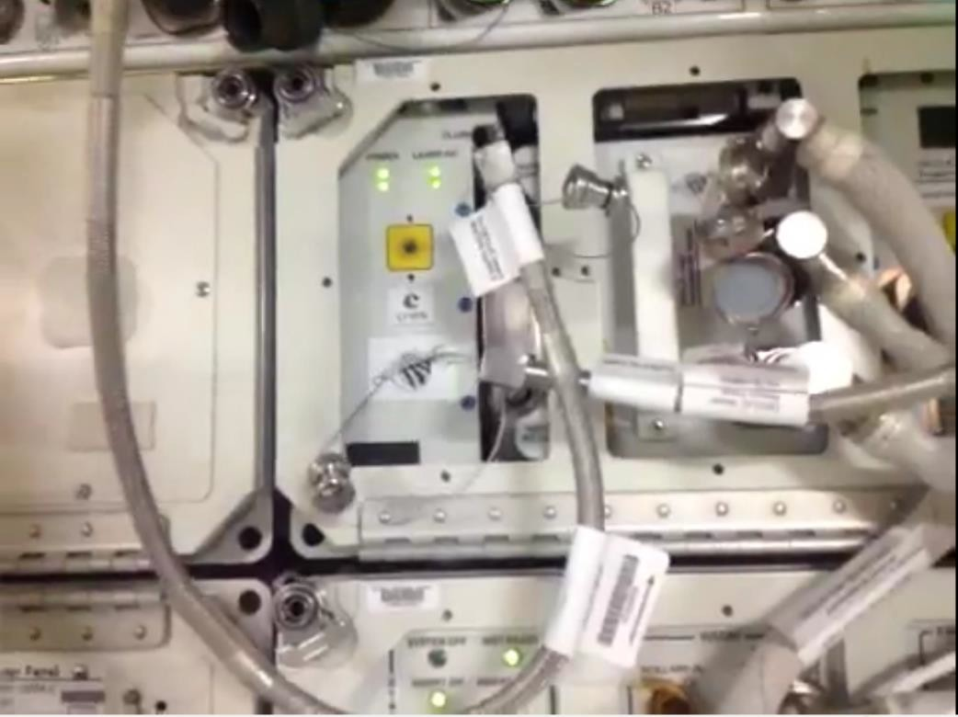

Figure 11. Screenshot from a video showing the "lip" over payload containers. In order to access the container a user needs to demate the connections and open the "lip."

Section 7.6 of the 3001 document addresses stowage. The rationale of 7.6.1.1 Stowage Provisions [V2 7050] can be edited to capture allowing for multiple stowage options:

7.6.1.1 Stowage Provisions [V2 7050]

The system shall provide for the stowage of hardware and supplies, to include location, restraint, and protection for these items.

Rationale: Some stowed items are removed from stowage, used, and then returned to the provided provisions/location. Other items are temporarily removed from stowage, relocated to another use location, and much later stowed. Different stowage methods are appropriate for different items. A variety of stowage options should be considered and provided to the crew, with some level of crew discretion allowed.

While a standard exists to prevent interference of stowage with crew operations, there is no standard about facilitating crew activities. Modifying 7.6.1.4 Stowage Interference [V2 7053] would capture both of these issues:

7.6.1.4 Stowage Arrangement Interference [V2 7053]

The system shall provide defined stowage locations that facilitate crew activities and do not interfere with crew operations.

Rationale: Having defined stowage locations supports efficient operations and helps prevent the stowage system from interfering with operations, such as translation and vehicle control. Care is to be

taken when designing the stowage system so that clear translation can occur in the event of an emergency. To maintain a high level of efficiency in crew operations, it is important to locate items within easy reach of their point of consumption. Opportunities for temporary stowage of specific hardware need to be provided to the crew in order to facilitate operations.

Finally, as can be gathered from the comments above, usability and interface design of stowage solutions need to be considered in future vehicles. Usability is addressed by section 10.1.1. However, in the front matter to chapter 10, Crew Interfaces, interfaces are defined as those “through which static and dynamic information is exchanged between the crew and the system.” This definition appears to imply usability is therefore limited to display and controls related to informatics. Usability should be applied to all crew interfaces (including stowage interfaces), and therefore the recommendation of this team is to either expand the definition of crew interfaces as it is in chapter 10, or move the usability standards (specifically 10.1.1.1 Usability Acceptance Criteria [V2 10001], 10.1.1.2 Crew Interface Provision [V2 10002], and 10.1.1.3 Provision of Usable Interfaces [V2 10003]) to another section.
Alternatively, a usability standard could be added to chapter 9, Hardware and Equipment.

8.8.3 Give additional thought to the placement and design of handrails and restraint systems
A number of participants discussed the lack of restraints specifically in the Cupola, but these comments highlight an important aspect of microgravity operations. The location/layout and the design of mobility aids need to be considered in future vehicle designs. Mobility and stability aids should be located in strategic locations based on the tasks astronauts are expected to perform and translation paths. In addition, in locations where the crew is expected to spend a considerable portion of time, padding on restraints should be provided to increase crew comfort. An example of a padded restraint made by the crew is presented in Figure 12. The crewmembers wrapped a piece of foam around a standard handrail to increase comfort while dining.
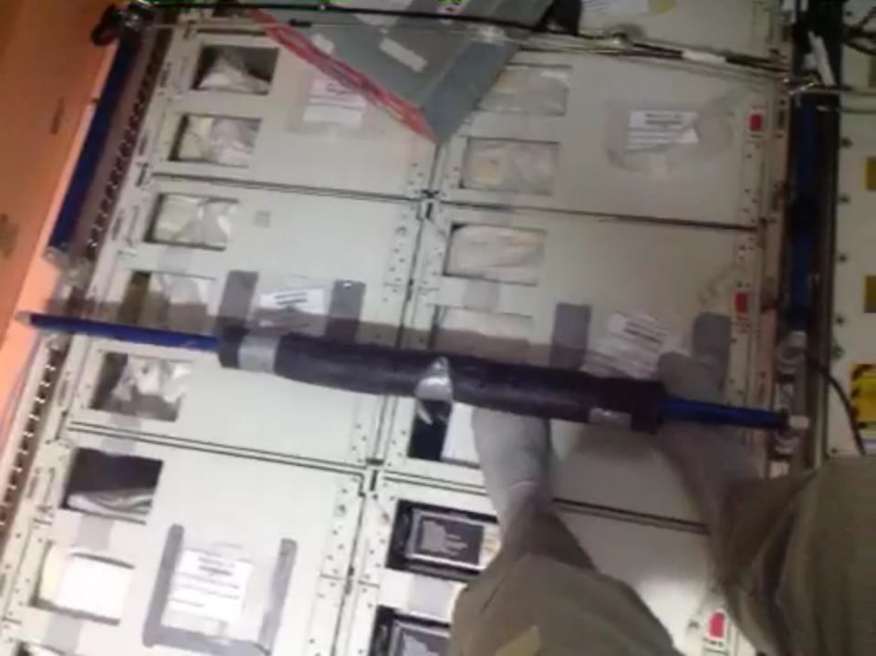
Figure 12. Crewmembers modified this restraint in the dining area to increase comfort.

Some of the comments related to mobility aids include:

“But the Cupola is lacking any preplanned foot restraints or anything to help […] This is probably the best place to put your feet, and the M1 operator just hooks feet into there and that gives a fairly stable position. And also can lock knees in against that metal bar and maybe this metal cable there. And by doing that you kind of get into a good stable body position. But that's obviously not a design. That's just improvisation.”

“The other thing about this is it would be good if there was better ways to restrain your body. As you're poking your head in this window, […] you wind up putting your feet in some holes that are on the lockers outside up here. […] It would be better if there were, like, maybe some foot restraints on the outside here.”

“We manage to find good foot restraints for the Robotic workstation, but it's sort of improvised. We use our feet in the hatchway opening like this [Figure 13].”
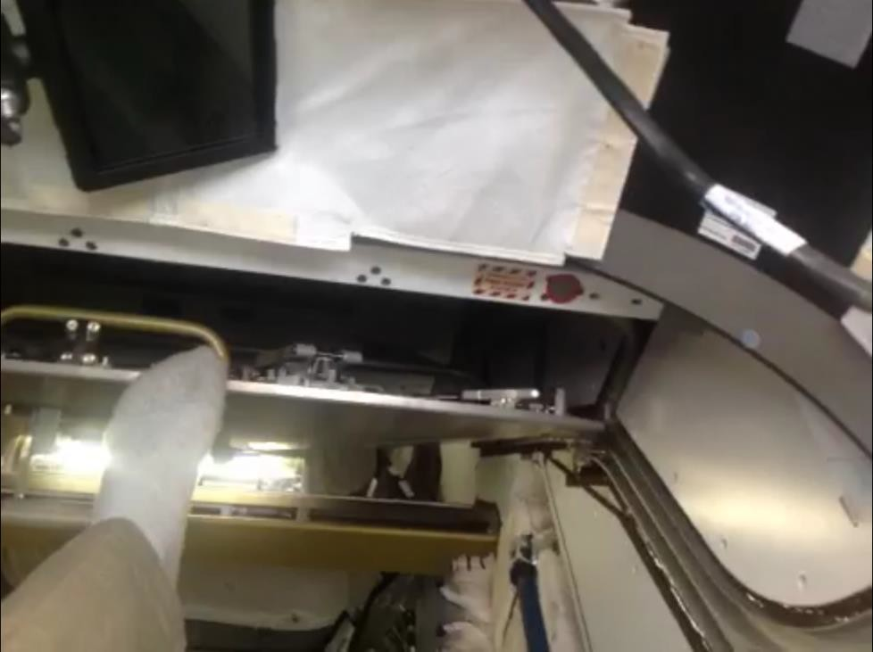
Figure 13. Improvised foot restraint in the Cupola. The crewmember is demonstrating using the hatch opening for stabilization.

“If we had more handrails, I think it would be better. The airlock, this handrail on the right-hand side I used as EV-1 when I'm opening the hatch and it's actually kind of far away from me. So if I were redoing it, I would move it down just a little bit closer on both the right and the left to make it a little easier for the EV-1 crewmember who is opening this hatch to have some place to hang onto.”

“[…] you know, we add towels and tape to make it a little bit softer on your feet.”

“When you're sitting in these adjustable foot rails, you can just control your body. This is like the best way to do maintenance. You can move around. You can rotate your entire body 180 degrees and flip from one surface to another just by using your toes and your feet and controlling your motion.”

Section 8.5 Restraints and Mobility Aids in 3001 contains a number of standards for the provision and design of restraints. Minor modifications to existing standards may result in better restraint system implementations in future vehicles:

8.5.1 Crew Restraint Provision [V2 8033]
Crew restraints shall be provided to assist in the maintaining of body position and location to support task performance in reduced gravity conditions or during high accelerations.

Rationale: Maintaining a static position and orientation at a workstation is necessary to ensure that controls can be activated without motion being imparted to the crewmember. Without gravity to hold an individual onto a standing or sitting surface, the body floats or moves in the opposite direction of an applied force. The cognitive and physical work required to maintain body position during a task can interfere with the task performance. Activities that use both hands are not to require handholds to maintain position at a workstation but may require restraints such as foot loops, straps, or harnesses. Restraint location, design, and provision should take into consideration the required tasks (including length of task performance) and the anthropometric range of the potential crewmembers as defined in

4.1.3 Population Definition [V2 4003]. A task analysis can help with the determination of the location and type of restraints needed.

8.5.2 Crew Restraint Design [V2 8034]

Crew restraints shall be designed to accommodate the crewmember for the duration of the task.

Rationale: Crew restraints provide for operator stability. Where it is critical that a workstation operator remain stable for task performance, e.g., view through an eyepiece, operate a keyboard, or repair a circuit, foot restraints and other ad hoc positioning techniques may be sufficient. However, tasks that require a stabilized crewmember to maintain position for long periods of time, e.g., 1 hour of continuous use or longer, require a restraining system designed with task duration, stability, and training to operate in mind. In these cases of prolonged restraint use, the design should also consider crew comfort (e.g., padding).

Increase the integration of software and hardware for tasks that are expected to be performed regularly
Having an integrated system decreases setup time and frustration. This is especially true for tasks that are expected to be performed regularly, such as exercise. Having to configure more than one set of hardware and software components increase the amount of time the crewmember has to spend on setup and can also affect crewmember satisfaction and frustration. A detailed task analysis will aid future designers in

selecting specific systems for increased integration. Some of the comments related to system integration include:

“Also, this thing, the heart rate sensor, I don't know why this can't just be built right into the treadmill here like this, why it has to be this thing that moves around all over the place and gets in your way.”

“There's these other features that have never really been incorporated where you could look at the load on that screen as we went through the routine and advance the buttons for how much you lifted. That would actually be a really nice thing to be able to implement […] We'd save a little bit of time if we had integrated these.”

“It [Cycle Ergometer with Vibration Isolation and Stabilization (CEVIS)] receives the data through this improvised, not really improvised, but an additional Bluetooth device which doesn't have great reception. So oftentimes the heart rate data is not accurate.”

“I think we could figure out a way for the PDF in what we're doing to be much more digitally synched and not rely on the human to remember to cross out the date and look at — consolidate seven pieces of information and look for the tiny barcodes printed on it.”

“It would be great if you had something like this that was high definition and controlled […] versus a big bulky camera that gets in the way and has these very difficult cables to deal with all the time. We have to hook up the mike and the transmitter for the wireless mike. It would be nice if all this stuff was kind of all self-contained, built in and you didn't have to have this set-up”

This recommendation touches upon the general guiding principle of Human-System Integration (HSI). NASA’s Human Systems Integration Practitioner’s Guide defines HSI as “a system engineering discipline that applies knowledge of human capabilities and limitations throughout the design, implementation, and operation of hardware and software” (pg. 1-1). Since the focus of the entire NASA-STD-3001 Volume 2 is HSI, this guiding principle should be driving all mission and vehicle design. It is therefore the recommendation of the research team for future vehicle and mission designers to consult the HSI Practitioner Guide and solicit the help of HSI specialists early in the development cycle to ensure an HSI focused final product.

Provide highly usable interfaces for hardware and software that are intended to be reconfigured to support crewmember use
Reconfigurability is generally a desired trait for areas and hardware in a constrained volume environment such as ISS and to an even greater degree for future missions. However, the interface design of these reconfigurable items must be considered. Poorly designed reconfigurable interfaces may lead to the crewmembers’ choosing not to alter the configuration of a device, which could in turn lead to issues with convenience and habitable volume. Some comments related to the interface design of reconfigurable items include:

“[about foot restraints] We can install one, but it's actually more trouble than it's worth.”

“But also over time these work stations have been set up so that they're currently installed and they can be moved up and down and they just become a very convenient place especially for complex maintenance […]”

“[about CEVIS software] I normally use manual mode because I've had difficulty in the past changing the load […] Yeah, if I hit exit, it's going to turn off. So I really can't change between protocols.”

“The table also folds out […] That's a pretty neat design […] It just folds out like that, and then it locks into position quite simply with these locks here.”

“What I do before I get ready to do the [Microgravity Science Glovebox] MSG is actually grab a foot restraint. Those are usually close by. These are a little bit of a weird — this is a human factors issue because I have been up here for months and I always have to just think about this a little bit. […] which means it's not intuitive. First you go to unlock. Then there's a little tab down here and you push the tab away from you and it unlocks. […] Push the tab back in, push this to locked.”

Section 10.1.1 of 3001 defines a number of standards related to usability. Of particular interest to this recommendation is 10.1.1.1 Usability Acceptance Criteria [V2 10001]. The proposed modification to the rationale highlights the importance of usability for reconfigurable systems:

10.1.1.1 Usability Acceptance Criteria [V2 10001]

Each program shall define usability acceptance criteria for crew interfaces.

Rationale: Usable crew interfaces allow users to achieve task goals efficiently, effectively, and with satisfaction. Efficiency, effectiveness, and satisfaction are the three major components of usability; therefore, acceptance criteria for all three should be defined by every program. Effective crew interfaces allow users to achieve specified tasks with accuracy and completeness. Efficient crew interfaces allow users to expend appropriate amounts of resources, e.g., time, workload, to achieve the effectiveness necessary in a specified context of use. Users are satisfied with a crew interface if they are willing to use a crew interface and have positive subjective responses and attitudes toward the crew interface. Highly usable interfaces are especially important with regard to systems that are designed to be reconfigurable. Programs should consider different usability criteria for reconfigurable devices.

Note that this recommended edit assumes a wider definition of Crew Interfaces or expanded scope of the usability standards as proposed in section 8.8.2.

8.8.6 Design systems for consistency
Similar systems should be operable in a similar manner. Related systems should have similar interfaces, and flight hardware and software should be designed to be as close as possible to the ground systems with which the crew trains. Poor consistency across systems and differences between flight and ground training hardware and software can lead to issues with effective task performance (i.e., errors) and increased time to perform tasks. Some comments related to this recommendation include:

“This is the forward light switch in Columbus with on and off with "on" in the upper most position and we have the off light switch over here with "off" in the up position and "on" in the down position. So even within one module, we have nonstandard light switches [Figure 14].”
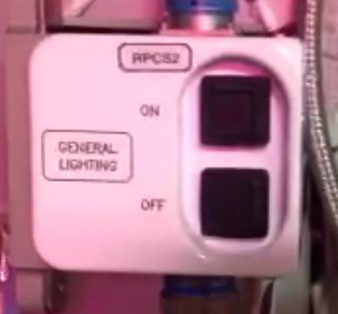
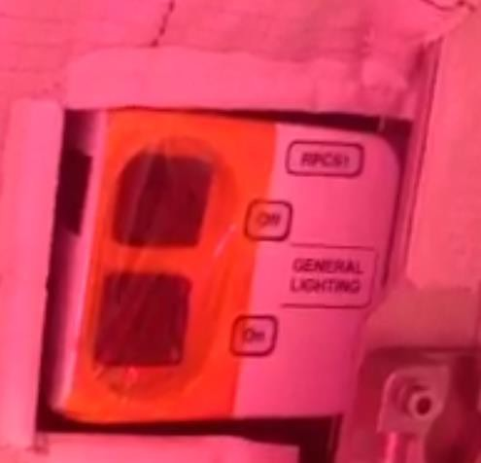

Figure 14. Two light switches in the same module with inconsistent interfaces.

“[…] the stationary bike [hardware] is pretty nominal in terms of human interface, what you'd expect”

“[About the WHC] The Building 9 mockup is actually very high fidelity. So if you want to see what this looks like in real life, I would suggest go to Building 9 and take a look at it because that one almost exactly resembles this mockup. It's one of the few pieces of space flight hardware that we have on the ground that is almost exactly like the real one.”

“The other thing for consideration is to the extent that we can make the interfaces as similar as possible. So every time you have a different socket head that you have to change out, a different hex head, a different socket size, you got to go in the tool drawer and pick a different socket and that adds times to the activity. […] And if we have interfaces that are all using the same screw or socket or fixture, that will make it a lot easier and a lot more efficient.”

10.1.3.6 Consistent Displays and Controls [V2 10010] in NASA-STD-3001 requires consistent crew interfaces. However the standard is currently limited to “within and across spacecraft.” The proposed wording below also includes consistency between flight and training interfaces:

10.1.3.6 Consistent Displays and Controls [V2 10010]

Crew interfaces shall use consistent control and display layout within and across spacecraft, and between training and flight.

Rationale: The intent of this requirement is to ensure as much consistency of display and controls as possible across a spacecraft and between training and operations. Consistent layouts make crew

interfaces easy to learn and use, because learning does not have to occur when new displays or controls are encountered within or across the spacecraft.

    - Provide a dedicated volume for hygiene operations that is separate from toilet operations Using the same volume for both toilet and personal hygiene operations is not feasible. Aside from issues of cleanliness, using the toilet volume for hygiene prevents other crewmembers from using the toilet at the same time. Ideally, a dedicated private space for personal hygiene should be provided, with a full length mirror to allow for body inspection, and a separate hygiene station provided for each crewmember to stow their personal items. Currently on ISS, crewmembers have several improvised spaces for hygiene operations, and do not use the toilet volume for hygiene operations. Some comments in support of this conclusion include:

“There's been some discussion about using this WHC for changing clothes. Imagine changing clothes in a urinal at an airport. That's sort of what it's like, only probably with more levels of inconvenience.”

“We've also used the PMM and you can see the PMM is very, very crowded but we have a translation path here into a center little volume that's still clear (Figure 15).”
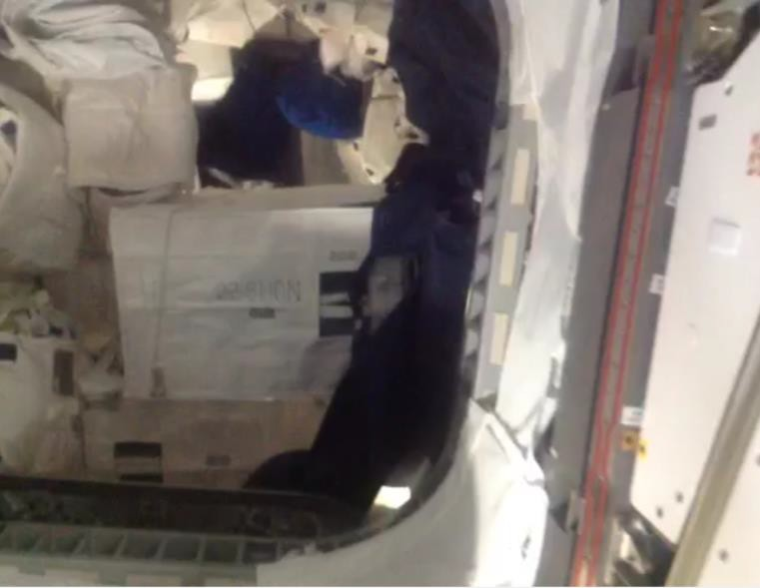

Figure 15. Screenshot from video showing translation path to improvised hygiene area in the PMM.

“It would be much better, of course, if we had a designated place, one per crewmember, to be able to perform all of these functions that would complement the WHC not be combined with the WHC because the combination just doesn't work out practically.”

“You know, the issue with using this for hygiene like brushing your teeth and washing, it's very close quarters to your toilet. It would kind of be like doing that type of activity in a port-a-john like one of those blue toilets, not very nice.”

“A lot of people have issues with the idea of using the toilet as a hygiene station but actually the practicality of it is that it would close out the toilet for access for other people for long periods time, you know, 15 or 20 minutes at a time while somebody is cleaning up.”

Currently, no standard exists that requires separate volumes for hygiene and toilet operations. Two standards exist that require privacy for the performance of these activities (7.2.1.2 Body Cleansing Privacy [V2 7017], and 7.3.1.3 Body Waste Management Privacy [V2 7022]), and two others exist that generally discuss layout (8.2.1.1 Functional Arrangement [V2 8005], and 8.2.1.2 Interference [V2 8006]). Given the evidence gathered in this study about the practicality of conducting hygiene activities in the same volume as toilet operations, a new standard is proposed:

8.2.1.X Body waste management and personal hygiene locations [V2 XXXX]

For missions greater than 30 days, the system shall provide separate dedicated volumes for body waste management and personal hygiene.
Rationale: Evidence from ISS suggests that locating personal hygiene (e.g., body cleansing, personal grooming) in the same volume as body waste management is impractical and disliked by the crew. Conducting personal hygiene in the WHC limits its use by other crewmembers. Additionally, due to the effects of microgravity, the WHC volume may not be sufficiently clean to support hygiene activities. ISS crewmembers improvise spaces aboard station to conduct personal hygiene that are separate from the WHC volume, which may lead to issues with space utilization and microbial growth due to water liberation. A dedicated space for personal hygiene with appropriate surfaces that limit microbial growth needs to be provided in future vehicles.

Ensure labels are clear, visible, and accessible from multiple viewing angles
Unclear or inaccessible labels can lead to errors, safety concerns, and inefficiencies in task completion. When designing labels, system and payload designers should consider the content that is important to the crewmember performing the task, microgravity effects (e.g., viewing angles), and how packaging may impact the label. Use of colors in labels especially for safety critical tasks should be considered in accordance with standards.

“If you can keep away from complicated alphanumeric codes and go to plain English or plain language names of parts, that helps a lot as well.”

“Here's some examples of some nice sized labels for the water mist PFE, portable fire extinguisher and portable breathing apparatus. I like them because of their size, their color their priority. Being red for emergency, I think, is important.”

“There's three panels. […All] of them have "ACY," "control" and "panel" in them. So they're all named the ACY control panel. They're differentiated by ACY fan control panel, ACY hydraulic interface control panel and ACY control panel.”

“[…] one CTB on the […] that just departed on Monday had the wrong CTB in it and we threw away a centrifuge — or a CTB 2.0 labeled 3005 was thrown away instead of a 3.0 labeled 3005

[…] You know, that commonality in naming and sizes. So maybe relabeling different sizes to start with a different number maybe or something to start with so they will all be maybe a little bit more distinguishable on the front end as well as the back end. That might be helpful.”

“And it's just very confusing when you look at it, and it's all labeled in Russian.”

“The only thing that that needs a little bit of improvement is that these labels fall off and they should be in bigger font so you can easily identify the tools (Figure 16).”
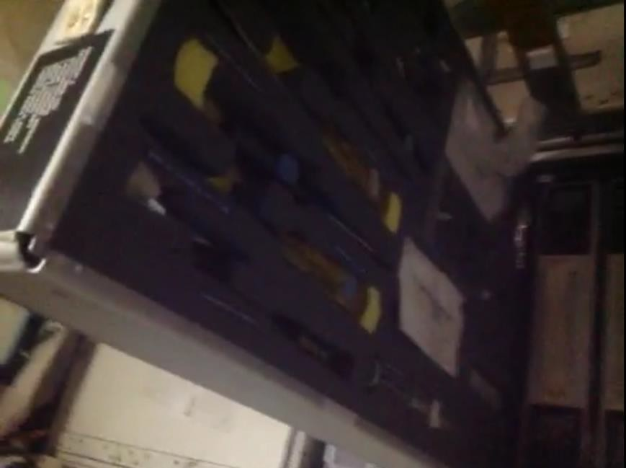

Figure 16. Screenshot from video showing the tool box. The red arrow is pointing at a label.

Section 10.3.5 of NASA-STD-3001 is dedicated to a number of standards about labels – label provision, label standardization, label display standards, label display standards, label location, label categories, label distinction, and label font height. However, no standard exists in that section discussing label content. A new standard is proposed to address this gap:

10.3.5.X Label Content [V2 XXXX]

Labels shall contain and be limited to the information that is needed for the crewmember to identify the object and perform all associated tasks in an effective and efficient manner.

Rationale: Too much, too little, or irrelevant information on labels increases visual clutter and may lead to increased frustration, task completion times, and errors. Labels should be clear, visible, and easily interpretable for the crewmember to identify the object and complete the associated task. In addition, labels should be provided in the official language(s) of the operating vehicle. Excessive similarity among labels should be avoided in accordance with 10.3.5.6 Label Distinction [V2 10065].

    - Provide windows as resource for crewmember recreation as well as specific operational tasks One of the primary forms of crewmember recreation aboard the ISS is Earth observation. Earth viewing and photography is also a timelined task and part of the Crew Earth Observation (CEO) payload, and windows are also used during robotic and vehicle inspection operations. As much as the crew appreciated the windows for their benefits for psychological health and their utility, they also commented about the quality of the scratch panes applied to the windows. These scratch panes limited the crewmembers’ ability to use the windows for photography. In future vehicles, windows should be coated with material that protects the window but does not affect its utility. Figure 17 is a screenshot from an iSHORT video showing a scratch pane.
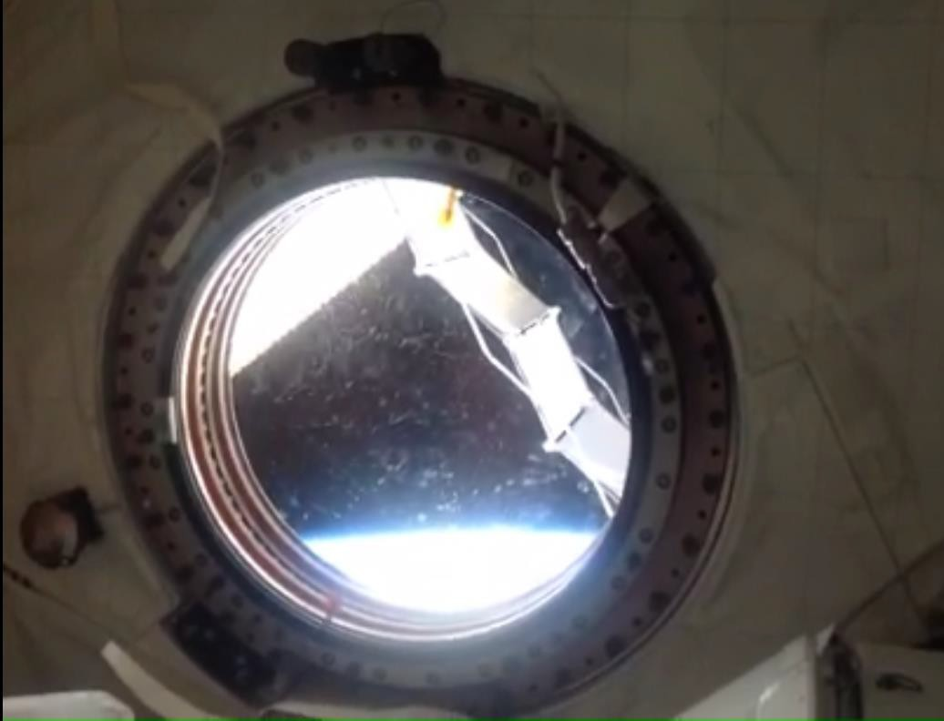

Figure 17. A screenshot from a video showing a scratch pane on an ISS window.

Some comments related to this recommendation include:

“This is another good window, though, from the standpoint of being able to inspect the vehicle. It's pretty cool to be able to open up the shade and confirm the condition of the vehicle and you can see some of the scratches as I move the camera a little bit […] I like these windows quite a bit.”

“The irony of having these scratch panes is that the scratch panes are to protect the windows so that they're pristine for photography. But you can't take pristine photography because they're covered with scratches.”

“So window placement in future vehicles would be driven by what you're able to see through the window, of course, or what you potentially could see, want to see, whether it be a lunar surface, a planetary surface, the Earth in orbit, around the Earth, and approaching, departing vehicles, docked vehicles, and key elements of the external surface and equipment of the exploration vehicle.”

“I think if I were going on a long duration mission, it would be nice to have the windows. However, without the view of the Earth that's nearby, the effect of the window is going to be different.”

“[in the Cupola] we have out the window views which are available to us, which is nice for overall situational awareness.”

“[about JEM windows] The window quality here is not good enough for most photographs […] They are a nice view, but we can't leave them open generally. So they have to be closed which, you know, just means that you don't get to enjoy them.”

It is difficult to determine the potential impact of windows on behavioral health in future missions where the Earth is not visible. However, windows could still serve an integral part in vehicle inspection and potential scientific inquiry. It is therefore the conclusion of this study that windows or a satisfactory alternative should be provided in future vehicles even if the Earth or another planetary body is not visible for the purposes of vehicle inspection and science support. Future studies may investigate the use of virtual windows and/or virtual reality and their effect on behavioral health. NASA-STD-3001 section 8.6 contains a number of standards regarding window provision and light blocking. A modification to the rationale of V2 8043 is proposed to address issues of window quality (stemming from comments about the scratch panes), and a title change is proposed to clarify the intent of the standard:

8.6.1.1 Window Provision Visibility [V2 8043]

The system shall provide windows on all spacecraft that provide the unobstructed fields of view necessary to support expected crew tasks.

Rationale: Windows provide direct, non-electronic, through-the-hull viewing and are essential to mission safety and success, as well as to maintaining crew psychological and physical health and safety. They support crew photography (a primary on-and-off duty activity of onboard crews), provide SA of the external environment, are essential for piloting and robotic operations, and permit safe viewing through hatches. Note that scratch panes on ISS windows limit their utility for photography. Scratch panes and other safety features of windows in future vehicles should not interfere with crew tasks. Windows also permit stellar navigation, vehicle anomaly detection and inspection, and environmental and scientific observations. Windows do not have the failure modes associated with cameras and display systems that may not be operable during emergencies when most needed.

8.8.10 Provide crewmembers with the ability to control and modify environmental factors Crewmember individual preference for environmental factors such as temperature, lighting, and ventilation vary, and should be adjustable by crew. Within individual private quarters, these environmental factors should be easily controllable by each individual crewmember. Currently on ISS, MCC controls the temperature. Crewmembers may call down to MCC and request a temperature adjustment, but all crew quarters are adjusted to the same temperature. Given how widely individual

preferences vary, this results in situations where some crewmembers are uncomfortable. In future vehicles, individual crewmembers should have control over environmental factors with each crewmember controlling their own individual crew quarter. Additionally, a SmartHab system that customizes environmental conditions automatically based on individual crewmembers’ preferences may improve habitability. Some comments related to this recommendation include:

“[about improvements to crew quarters] to be able to vary the ventilation a little bit more, particularly without increasing the noise […] it certainly would have been nice if we had the ability to control temperature a little bit within the crew quarters in addition to the ventilation and then, of course, keeping the heat down.”

“The other thing that I noticed is that the temperature in the crew quarters is set to do whatever the module is set. So that means that everybody has to be at the same temperature. For me that's been pretty tough because I definitely like to be warmer than my crewmates. So I end up wearing two or three pairs of clothes and a ski cap to bed.”

“The temperature onboard the ISS, the ground can modify it if we ask them to but you have to work among your crew to determine what the best temperature is for the crew. [Other crewmembers] tend to be little warm, and I tend to be little cold. So we call that a compromise. I am usually wearing long pants socks and a couple of shirts or a sweatshirt with a shirt. And [other crewmembers] are in long pants and short sleeved T-shirts.”

“Ventilation here, we've got three position speed for the fan. So we got high, medium and low. I find the high to be a little bit too loud for sleeping at night, the low is inadequate ventilation. So the medium becomes a compromise. I would love to be at high, but I don't like - I don't want to tolerate the noise or I can't tolerate the noise.”

“You can see they used a regular GLA [General Luminaire Assembly] for lighting here when they designed these crew quarters, which is not optimum because it's just the light glaring you in the face. So I immediately put this shade here.”

In 3001 V2 Revision A, this recommendation is partially addressed (in crew quarters only) by the following standard:

7.9.3 Environmental Control [V2 7072]

For individual private quarters, the system shall provide the crew control of lighting, noise, ventilation, and temperature.

Rationale: Sleeping and working areas may overlap, and the crew is to be able to adjust the environment according to function. Level of individual control is defined by the mission duration in accordance with section 7.9.2, Private Quarters [V2 7071], in this Standard.

However, given recent discussion about the necessity of providing crew quarters for all missions greater than 30 days (as required by 7.9.2 Private Quarters [V2 7071]), this standard is slated for deletion in the upcoming Revision B. An alternative standard is therefore proposed:

7.X.X General Environmental Control [V2 XXXX]
The system shall provide the crew with direct control of environmental factors such as lighting, noise, ventilation, and temperature.

Rationale: Control of the environment is essential for crew comfort and task performance. The crew should be able to directly control (i.e., without ground involvement) environmental factors such as lighting, noise, ventilation, and temperature. In individual crew quarters, individual control is recommended to accommodate different crew preferences.

8.8.11 Ensure the trash management systems sufficiently control odor
While participants had generally positive comments regarding trash and odor control, the current trash management approach requires stowage until a visiting vehicle departs, in order to dispose of it on the vehicle. Depending on the frequency of visiting vehicles, the trash may be stowed for long periods of time. In these cases, there may be issues with odor and the stowage volume not being useable for the duration. In future vehicles with no resupply ability, a trash system should be developed that minimizes odor and impacts to habitable volume. Comments related to the trash system include:

“But overall, the system works really well. I haven't noticed any leaking from these bags and they seem to seal odor pretty well.”

“[…] the PMM is going to be just packed with our trash and, of course, it does get a little fragrant in here from the trash as well. After a month or two you start smelling it pretty good.”

“So something about this full would be a wet trash bag that would then go in a vehicle back down. And these do have a little bit of an odor after a few months. So it's good to get them down the soonest we can.”

“We've been here just over a month and one of the things I've noticed, and I was a little surprised by, was the fact that PMM, where we stow in the end cone where we stow our trash is actually starting to smell. They just had a cargo vehicle leave before we arrived. So they cleared all the trash. So that means in one month we're starting to get smell already”

“I've heard other crews talk about the fact when KTO […] was not sealed appropriately and it stunk up the whole station. So I could easily see how that happened. You need to make sure that everything is very tightly sealed for trash management and having better ways, better odor control, and more effective ways of holding and maintaining trash so it doesn't get smelly is obviously very, very important for long duration missions.”

“The worst trash I guess that we worry the most about is the wet trash. So we have the KTOs from the toilet which even though they're pretty well contained after they're full, they have a nice seal around the lid, they do tend to smell after a few months a little bit, not horrible but they do.”

The standard most relevant to this recommendation is 7.8.2 Trash Odor Control [V2 7068]. A suggested modification to the standard’s rationale is proposed to accommodate missions with limited resupply capabilities:

7.8.2 Trash Odor Control [V2 7067]

The trash management system shall provide odor control of trash.

Rationale: Uncontrolled odors can have an adverse effect on crew performance and can exacerbate pre- existing symptoms of SAS. On ISS, trash is regularly disposed of on visiting vehicles. In future missions with limited resupply and disposal capabilities, the trash management system will need to be designed to minimize odors over the entire duration of the mission.

Design packaging to facilitate activities and reduce trash generation
Complex or inefficient packaging or stowage of material adds time and frustration to task performance, and excess packaging becomes trash and occupies valuable volume. A task analysis can be used to determine the most efficient way to package material based on the tasks to be performed. Alternatives to standard packaging materials could also be examined, such as reusable or degradable materials. Comments related to packaging and trash include:

“The amount of trash that we generate is very significant. Some of the primary sources of trash are packing material for items that are launched, ziplocks and other types of bags for stowing hardware and equipment, and food packaging. […] Instead of foam for protecting launched equipment, perhaps inflatable bags could be used that could then be deflated on board. Some equipment is triple bagged, so reducing this to one bag would reduce trash. Lastly, food portion sizes for rehydratable foods could be increased so that 2 or 3 packages wouldn't have to be used for one meal.”

“If you have to go to multiple places to get different parts to put everything together and reading a lot of numbers and a lot of ops nomenclature that is not intuitive, it can add a lot of overhead and complexity to putting something together. If it's packaged so that it logically and operationally comes out of the pack and each piece that you need is the next thing that comes out of the pack and it's all collocated, or mostly collocated, adds a lot of efficiency to it”

“[…] kits should take full advantage of using friction fit for stowing items and organize items inline with the setup/disassembly procedures. I had a task yesterday to disassemble an experiment with

a couple dozen cables, each of which was stowed in its own ziplock bag and spread over four CTBs.”

“We produce a tremendous amount of trash related to food. Two of the reasons are because several food items are double bagged and the portion sizes are very small. The rehydratable meat packages, for example, are so small that it takes 3 or 4 packages to make even a normal sized entrée. This produces a lot of trash and takes additional time to prepare.”

“But the main kit came in a kit self-contained, logically unpacked, logically put together, especially after doing it one time.”

There is currently no standard that discusses packaging efficiency. A new standard is proposed:

9.x.x Packing Efficiency

Hardware shall be packaged to maximize crew efficiency and minimize trash generation.

Rationale: Excessive or inefficient packaging increase the time crew take to perform the task. Designers should consider steps necessary to unpack material and how they may impact task performance. Excessive packing material may also become trash and add volume to a vehicle with potentially low volume.

Ensure surfaces in areas that are likely to get dirty are easily cleanable and accessible
Surface cleanability is important for both physical and behavioral health. Contaminants such as fungi and bacteria could lead to unhealthy conditions, and dirty surfaces can impact crew comfort and well-being. All interior surfaces should be constructed out of easily cleanable material, but this is especially important in areas that are likely to get dirty (e.g., in the galley and waste and hygiene compartment, see Figure 18). Additionally, air filters and other areas that collect dust and need to be cleaned regularly should be easily accessible without the use of tools.
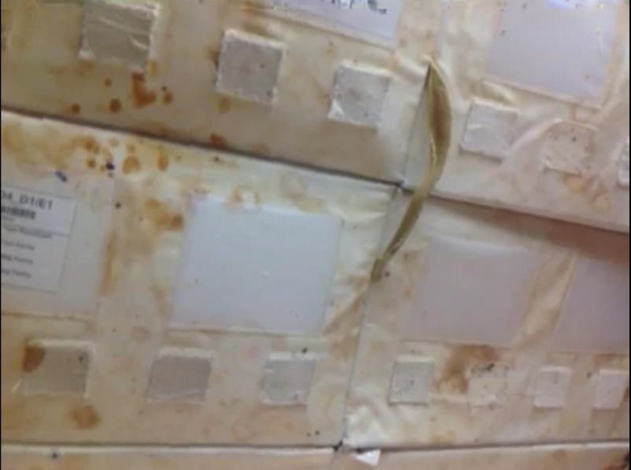

Figure 18. Surface showing dirt accumulation in dining area.

“[…] any places that has the potential to collect dust and dirt, and crew quarters as well collect skin particles, hair and spills like food spills, drink spills, that kind of thing […] needs to be designed to be maintainable. And that's getting access to the fans, getting access to the ducts, easy access, and using fasteners that are designed for multiple cycles. And the current crew quarters was not designed for maintenance in the ducting, cleaning out the ducting. So access to the ducting takes quite a bit of work.”

“Surfaces should also be without grooves or surface changes to ease cleaning. Even better would be surfaces that wouldn't allow particles to attach to it. Vents could also be designed such that it was not necessary to use tools to access them for cleaning.”

“In Node 2 we end up spending quite a bit of time cleaning the walls, the ceilings and the floor because of just drops of food floating away […] If we had these stowage bags with some sort of cleanable material or stain resistant material, it would be much better.”

“And this is the PMM, and I would say it's relatively difficult to clean this area because there are particular places where the dust accumulates, per se. We have all these cloth surfaces. And so we could wipe down the handrails with disinfectant wipes, but the rest of it becomes more difficult to clean.”

“If I were going to make the fabrics again, I would definitely try to make fabrics that were more stain resistant than these are. They get dirty.”

“…that is the easiest grill to clean on the space station. All grills should be designed like this grill. I love it. It's my favorite grill (Figure 19). [… About another grill design] And so for design we need to think about the ducting that goes into an area with high airflow, make that easy to clean. We're digging deep into the bowels of the space station here to get it clean (Figure 20). I've already gone through a panel. I've gotten out a tool and compare the complexity of this task to this previous task up here where the filter is mounted flush.”

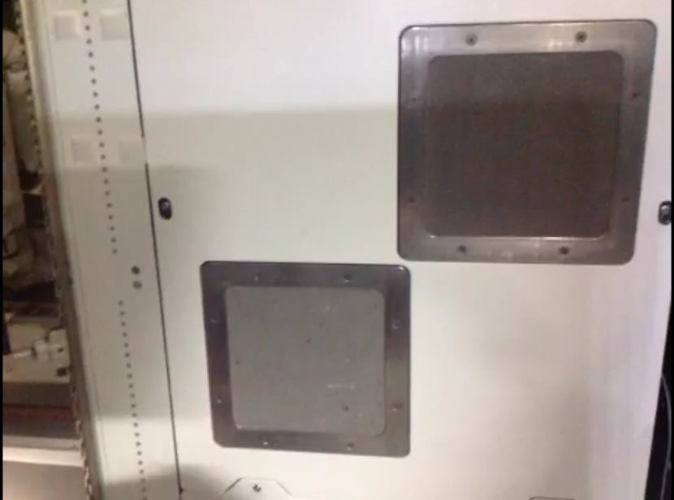

Figure 19. Screenshot from video showing good grill design. These grills are highly visible and easy to access and clean.
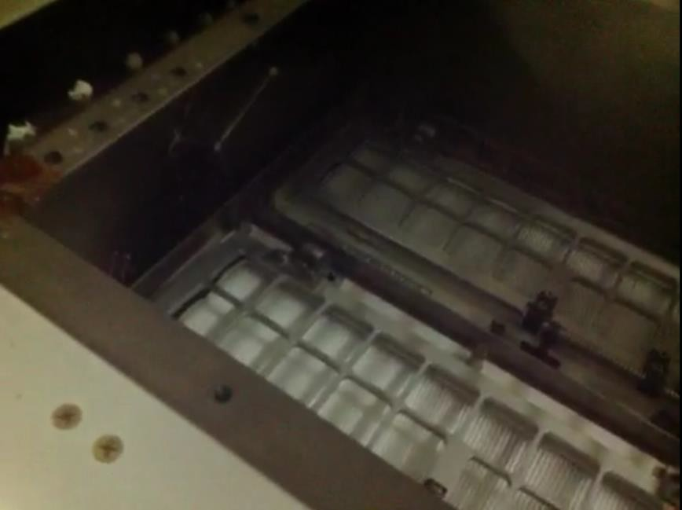

Figure 20. Screenshot from video showing poor grill design. This grill is hard to access for cleaning and requires using tools.

The most relevant standards in 3001 are 7.11.1 Accessibility for Cleaning [V2 7079] and 7.11.4 Surface Material Cleaning [V2 7082]. The following modifications capture our recommendation:

7.11.1 Accessibility for Cleaning [V2 7079]

The system shall allow crewmembers to Sufficient volume shall be provided to access areas that need to be cleaned and perform housekeeping activities.

Rationale: Access to areas that need to be cleaned includes physical access (e.g., panels and covers can be easily removed) and the provision of sufficient volume for cleaning activities and associated hardware. The full size range of personnel with appropriate cleaning tools and equipment is to be able to access all areas for routine cleaning. Areas such as vents that need to be cleaned regularly need to be easily accessible. Complex access procedures (e.g., disassembling panels, disconnecting alarms) add time and frustration to task performance. Fixed equipment should not to have to be unsecured and moved for routine cleaning. Inaccessible areas are to be closed off to prevent the accumulation of trash and dirt.

7.11.4 Surface Material Cleaning [V2 7082]

The system shall be designed with surface materials that can be easily cleaned and sanitized using planned cleaning methods.

Rationale: Program requirements are to be established so that surface materials, such as highly textured materials, are assessed for this feature. Materials in areas prone to dirt accumulation (e.g., galley) should be given special consideration with regard to material selection.

8.9 Additional uses for the data and tools
The data collected as part of this study is of high value to ISS operations personnel. While the research team focused on lessons learned aboard ISS to develop recommendations for future vehicles, trainers and operational team members will likely be interested in the content as it relates to every day ISS habitability. As part of this investigation, the study team developed a data release process that allowed us to share this valuable data with a variety of stakeholders, including crew trainers and other researchers. It is the sincere hope of the study team that this data continue to be available to members outside of the study team, via a mechanism such as the Life Sciences Data Archive (LSDA).

The study also saw instances of crew-to-crew data releases. One crewmember, upon realizing there would be a short handover period with the next ISS crew, requested that their data be made available to members of the next crew to act as training videos to compensate for the short handover. Another crewmember requested that a specific observation be made available to specific crewmembers scheduled for an upcoming mission. These instances of crew-to-crew data sharing demonstrate the value the crewmembers themselves placed on the data.

Additionally, data from the study was integrated into crewmembers’ postflight debriefs. The individual crewmembers’ responses from the study were inserted into the debrief question printout and served as memory joggers for the crewmember to use to answer the debrief questions.

In addition to the actual data collected by the study, the iSHORT and iQ&A tools are valuable for the conduction of tests and evaluations, additional research, and as general feedback mechanisms. These tools have been used by the Gateway habitat design and evaluation team and the Orion Human Engineering team to collect feedback during their evaluations and on a recent MarsRATs simulation. Both

tools will be available for free on the Apple App Store and the research team is encouraging anyone who may have a potential use for the tools to do so.

Lessons Learned
The major lesson learned pertaining to operations is related to a software technical issue that occurred on orbit. iSHORT was the first iPad application custom-developed for use on International Space Station, so certification processes and software logistical concerns included many unknowns. Following the completion of the first 4 data collection sessions of the first participant, the version of iSHORT deployed on ISS was disabled due to an expired Enterprise certificate. The team worked to complete and certify a new build of the application with a new expiration date, but iSHORT was unusable until the application was redeployed via an ISS onboard Web server. Following this experience, the team ensured that software builds were made with licenses that allowed for the maximum time of use (up to 1 year from the build) and closely tracked these dates. New versions of iSHORT and iQ&A were deployed regularly, in order to allow for the new version to be available on ISS prior to expiration of the previous versions, alongside the LS1 server script written by our developer.

Feedback during an observation from the first participant in the study stated that the request to find any human factors or habitability issues to document for an iSHORT observation is too open-ended after the major issues are exhausted. In order to avoid scheduling observations for participants who do not have anything to report, the team has worked with ISSMP to provide prompts to participants for each observation following this comment from the first participant. Prompts included reminders of recent timelined events that would be expected to impact habitability and human factors as well as specific topics that were of interest, while still allowing the participant to provide open-ended responses for any topic of their choosing.

Finally, during Narrated Tasks, participants sometimes found it difficult to complete the activity while holding the iPad. If future studies would like to include these data collection methods, a mount for the iPad is recommended that allows participants to complete the task without interference from the iPad.

Conclusion
This study revolved around two primary aims. The first aim, to characterize human factors and habitability aboard ISS, was fully achieved by the study. Details about habitability and human factors during a long duration microgravity exposure were documented, and the relationship between environmental factors and performance were analyzed and used to derive recommendations for future missions and vehicle design (Aim 1a). The effect of mission length on human factors reporting by crewmember were examined by looking at mission breakdown by phase, and did not appear to have a consistent pattern (Aim 1b). However, it is important to note that only 1 of the 6 crewmembers who participated in the study was a 1- year mission crewmember. In future studies, the potential effect of variable mission length should be examined with additional participants. Aim 1c, examine the cost versus benefit of implementing the use of near-real time tools for collecting feedback, was addressed by the feasibility and success of

implementing the data collection tools. Further evidence of the usefulness of this type of data is provided by the extended use of the data and tools described in section 8.9.

The second aim, to characterize the utilization of space on ISS, was partially addressed by examining specific locations about which participants submitted observations. The subcomponents of the aim assumed the use of tools that were in development at the time the proposal was written, which were unfortunately not sufficiently developed. A future study focusing on achieving aim 2 should include the development/refinement of existing tools in order to fully address these important questions.

In general, the study participants provided thoroughly detailed and insightful feedback for all data collection types. The participants had a good understanding of the types of details that will be of interest to habitability and human factors experts, and have provided a wealth of information relevant for the design of future space vehicles and habitats. Providing an opportunity for participants to capture observations while on-orbit allowed them to give demonstrations and discuss details that are fresh on their mind. Ideally, this type of near real-time reporting of human factors and habitability concerns should continue as part of regular operations on ISS and in future programs, potentially as an integrated part of the Crew Notes functionality. This data will be of outstanding value not only to human factors researchers and vehicle designers, but to the greater operational community as well.

Acknowledgments
We would like to thank the multitude of people who contributed to this work and made this study a success: Alonso Fuentes, Grace Boothe, Jerri Stephenson, Katie Vasser, Kira Materjek, Lauren Landon, Natalia Russi-Vigoya, Peggy Delany, Pete Roma, Ron Archer, Tom Williams, Sandra Whitmire, Susan Schuh, and Vicky Byrne.

References
Abercromby, A. F. J., Gernhardt, M. L., & Litaker, H. (2010). Desert Research and Technology Studies (DRATS) 2008: Evaluation of Small Pressurized Rover and Unpressurized Rover Prototype Vehicles in a Lunar Analog Environment. (NASA/TP-2010-216136).
American Bureau of Shipping. (2001). Guide for Crew Habitability on Ships. Houston, TX. Beaubien, J. M., & Baker, D. P. (2002). A review of selected aviation Human Factors taxonomies,
accident/incident reporting systems, and data reporting tools. International Journal of Applied Aviation Studies, 2(2), 11-36.
Bellcomm, I. (1970). Tektite II Behavioral Observer Handbook. (NASA-CR-126699). National Aeronautics and Space Administration.
Binsted, K., Kobrick, R. L., Griofa, M., Bishop, S., & Lapierre, J. (2010). Human factors research as part of a Mars exploration analogue mission on Devon Island. Planetary and Space Science, 58(7-8), 994-1006.
Bond, R. L. (1973). Habitability/Crew Quarters- Experiment M487 Skylab Medical Experiments Altitude Test (SMEAT). Houston, TX: BioTechnology, Inc.
Celentano, J. T., Amorelli, D., & Freeman, G. G. (1963, May 2, 1963). Establishing a Habitability Index for Space Stations and Planetary Bases. Paper presented at the AIAA/ASMA Manned Space Laboratory Conference, Los Angeles, CA.
Clancey, W. J. (2001). Field science ethnography: Methods for systematic observation on an expedition.
Field Methods, 13(3), 223 - 243.
Clancey, W. J., Lee, P., Cockell, C. S., Braham, S., & Shafto, M. (2006). To the North Coast of Devon: Collaborative navigation while exploring unfamiliar terrain. In J. Clarke (Ed.), Mars Analog Research (Vol. 111, pp. 197-226). San Diego: Univelt, Inc.
Connors, M. M., Harrison, A. A., & Atkins, F. R. (1985). Living Aloft: Human Requirements for Extended Spaceflight. (NASA-SP-483). Retrieved from https://www2.sti.nasa.gov/Webtop/ws/asdb/ul/web/ImageDisplay/1985024459.pdf?&docid=1 985024459&type=pdf&daa=.
Fraser, T. M. (1968). The Intangibles of Habitability During Long Duration Space Missions. (NASA CR- 1084). Washington, D.C. Retrieved from http://ntrs.nasa.gov/archive/nasa/casi.ntrs.nasa.gov/19680017230_1968017230.pdf.
Harrison, A. A., & Connors, M. M. (1990). Human factors in spacecraft design. Journal of Spacecraft and Rockets, 27(5), 478-481.
Helmreich, R. (1971). Human Reactions to Psychological Stress: The Tektite II Human Behavior Program
(Technical Report No. 14). Retrieved from
Johnson, C. C. (1975). Skylab experiment M487: Habitability/Crew quarters. (TM X-59136). Houston: Johnson Space Center.
Keeton, K. E., Schmidt, L. L., Slack, K. J., & Malka, A. A. (2012). The Rocket Science of Teams. Industrial and Organizational Psychology, 5(1), 32-35.
Lane, H. W., & Feeback, D. L. (2002). Habitability and Environmental Factors: The Future of Closed- Environment Tests. In H. W. Lane, R. L. Sauer, & D. L. Feeback (Eds.), Isolation: NASA Experiments in Closed-Environment Living (pp. 419-432). San Diego, CA: American Astronautical Society.
Litaker, H., Thompson, S. G., & Howard, R. (2009, October 19 - 23, 2009). A Comparison of the Unpressurized Rover and Small Pressurized Rover During a Desert Field Evaluation. Paper presented at the Human Factors and Ergonomics Society 53rd Annual Meeting, San Antonio, TX.
Miller, J. W., & Koblick, I. G. (1984). Living and Working in the Sea. New York: Van Nostrand Reinhold Company.

Miller, J. W., VanDerwalker, J. G., & Waller, R. A. (1971). Tektite 2: Scientists in the Sea. Washington, D.C. Mount, F. E. (2002). Habitability: An Evaluation. In H. W. Lane, R. L. Sauer, & D. L. Feeback (Eds.),
Isolation: NASA Experiments in Closed-Environment Living (pp. 87-116). San Diego, CA: American Astronautical Society.
Mount, F. E., Adam, S., McKay, T., Whitmore, M., Merced-Moore, D., Holden, T., . . . Wolf, S. (1994).
Human Factors Assessments of the STS-57 SpaceHab-1 Mission. (NASA-TM-104802). Houston, TX Retrieved from http://naca.larc.nasa.gov/search.jsp?R=714752&id=9&as=false&or=false&qs=No%3D20%26Ns% 3DHarvestDate%257c1%26N%3D4294768892.
Mount, F. E., & Foley, T. (1999). Assessment of Human Factors. In C. F. Sawin, G. R. Taylor, & W. L. Smith (Eds.), Extended Duration Orbiter Medical Project: Final Report (NASA/SP-1999-534). Houston, TX: National Aeronautics and Space Administration.
Mount, F. E., Whitmore, M., & Stealey, S. L. (2003). Evaluation of Neutral Body Posture on Shuttle Mission STS-57 (SPACEHAB-1). (NASA/TM-2003-104805). Houston, TX.
NASA. (2014). Human Integration Design Handbook (HIDH) Rev 1.
NASA. (2015). NASA Space Flight Human-System Standard. Volume 2: Human Factors, Habitability, and Environmental Health Rev A.
Noguchi, K., Gel, Y. R., Brunner, E., & Konietschke, F. (2012). nparLD: an R software package for the nonparametric analysis of longitudinal data in factorial experiments. Journal of Statistical Software, 50(12).
Novak, J. B. (2000). Human engineering and habitability: the critical challenges for the International Space Station. Aviat Space Environ Med, 71(9 Suppl), A117-121.
Nowlis, D. P., Wortz, E. C., & Watters, H. (1972). Tektite II Habitability Research Program. (NASA-CR- 123496). Los Angeles, CA: National Aeronautics and Space Administration.
Pletser, V. (2010). A Mars Human Habitat: Recommendations on Crew Time Utilization, and Habitat Interfaces. Journal of Cosmology, 12, 3928-3945.
Romig, B. A., & Kosmo, J. J. (2011). Desert Research and Technology Studies (D-RATS) 2010 Mission Overview. Paper presented at the 42nd Lunar and Planetary Science Conference, The Woodlands, TX.
Stemler, S. (2001). An overview of content analysis. Practical assessment, research & evaluation, 7(17), 137-146.
Stuster, J. (1996). Bold endeavors. Annapolis, Md.: Naval Institute Press.
Stuster, J. (2000). Bold endeavors: behavioral lessons from polar and space exploration. Gravit Space Biol Bull, 13(2), 49-57.
Stuster, J. (2010). Behavioral Issues Associated with Long-Duration Space Expeditions: Review and Analysis of Astronaut Journals Experiment 01-E104 (Journals): Final Report. (NASA/TM-2010- 216130). Houston, TX.
Stuster, J. (2016). Behavioral Issues Associated With Long Duration Space Expeditions: Review and Analysis of Astronaut Journals Phase 2 Final Report.
Stuster, J., Bachelard, C., & Suedfeld, P. (1999). In the Wake of Astrolabe: Review and Analysis of Diaries Maintained by the Leaders and Physicians of French Remote Duty Stations. Retrieved from Santa Barbara, CA:
Tektite Underwater Habitat Museum. (n.d.). Retrieved from http://www.islands.org/Tektite/index.htm Vallance, S. (2001). NASA/JSC Operational Habitability Team: Antarctic 2000 Human Factors and
Habitability Case Study. Final Data Report.
Whitmore, M., Adolf, J. A., & Woolford, B. J. (2000). Habitability research priorities for the International Space Station and beyond. Aviat Space Environ Med, 71(9 Suppl), A122-125.

Whitmore, M., & Chmielewski, C. E. (1998). Overview of glovebox/restraint systems ergonomic evaluations: Findings and recommendations. Houston: Johnson Space Center.
Whitmore, M., McQuilkin, M. L., & Woolford, B. J. (1998). Habitability and performance issues for long duration space flights. Hum Perf Extrem Environ, 3(1), 64-74.
Whitmore, M., & Mount, F. (1995). Microgravity maintenance workstation development. International Journal of Industrial Ergonomics, 15, 189-197.
Whitmore, M., Paige, D., Chung, P., Gieske, A., & Blume, J. (2004). Habitat Utilization Assessment.
National Aeronautics and Space Administration.

Appendix A – NEK Habitability

Introduction and Specific Aims
In November 2017, a seventeen-day mission took place in the Russian NEK analog in Moscow. This roughly two-week mission was considered a “shake-down mission” to assess the feasibility of conducting HRP research in the analog. A modified ISS Habitability protocol was implemented alongside a number of other HRP projects to address two specific aims:

Aim 1: Test the feasibility of conducting a habitat and human factors evaluation using a protocol similar to ISS Habitability in the NEK analog facility.

Aim 2: Define advantages and disadvantages of using the NEK facility as a long-duration isolation and confinement analog (i.e., the fidelity of the habitat).

Methods

Participants
Six participants took part in the NEK mission and participated in the NEK Habitability evaluation. All six participants were Russian speakers.

Procedures
The initial proposal aimed to implement a similar experimental protocol as was used in the ISS Habitability study, including the three iSHORT-based data collection methods, questionnaires using iQ&A, and PI Conferences. However, due to several constraints with the capabilities of NEK (i.e., no real-time communication or near-real-time data transfer), the protocol was limited to iSHORT-based data collection only. The frequency of each type of data collection method is listed in (Table 17).

Table 17. NEK Habitability activities.

Method | Frequency | Description
Human Factors and Habitability Observation | Approximately once a week | Crewmembers were scheduled to use iSHORT to document human factors and habitability observations, with the tool available for additional use as needed.
Walk-through Video | Once per mission | Crewmembers were scheduled to use iSHORT to provide a guided tour of the habitat to an audience of human factors engineers.
Task-based videos/Narrated Task videos | Once per mission | Crewmembers were scheduled to use iSHORT to talk-aloud throughout the performance of a task to provide insight to human factors engineers.

The timeline for the mission did not allow participants to report completed tasks, and thus did not allow the experimenter to track whether or not a specific activity was completed.

Tools
Given the communication limitations imposed by the analog, only iSHORT was made available to the participants. Although the primary language of the mission was Russian, the iSHORT tool was not translated.

Training
The experimenter provided a training packet to ISSMP that included information on how to use iSHORT, the data collection types, and the type of information of interest to human factors practitioners. An ISSMP representative conducted the training with the participants in Russia.

Data analysis
The data analysis followed a similar coding scheme to the ISS Habitability analysis (see Appendix E – NEK Codes and Definitions). The same three human factors specialist that coded the ISS Habitability dataset followed the same process to code this dataset. A few noteworthy modifications were made to the coding scheme:

- Given that one of the primary goals of this short study was to examine the feasibility of conducting a study at the Russian analog, it was important to categorize the quality of the data. Each data point (by individual video, audio, or text) was categorized as Low, Medium, or High Relevancy. High relevancy was specifically defined as being at the same level as data collected during the ISS Habitability study. It is important to note that the relevancy category was assigned at the level of the entire file, and so even if only a handful of sentences in a file were of high relevance, the entire submission was marked as highly relevant.
- Given that the second aim of the study was to assess analog fidelity, an additional Outcome code was added – Habitat Fidelity.
- Alternative App Use was added as a code under the Study category to capture instances in which the participants used the app for a purpose other than reporting on a human factors and habitability issue (e.g., sending a message to the analog coordinator).

Results

Data collection rates and overview
Following the end of the mission, the data files were electronically transferred to the research team. A total of 54 zipped data files were delivered, comprised of 13 audio files, 77 video files, 78 photos, and 4 text files. Given the schedule of activities and the number of participants, a total of 30 files were expected. The total media (video and audio) length was approximately 1.5 hours, with an average of approximately 1 minute per file. The majority of the data was in Russian, and it was necessary to have it translated prior to performing any analyses or verifying data quality.

In a conversation with a flight analogs representative, it was revealed that the participants used the iSHORT tool to perform an unrelated activity. This activity required the participants to film themselves and take photos during the performance, and used the iSHORT tool to do so. These 3 files, consisting of 36 photos and 11 videos, were excluded from analysis.

It was difficult to determine authorship of many of the responses, since many were made in groups (e.g., the whole crew sitting around the table discussing the same topic), and some appeared to have selected the wrong user name. Therefore, all data points were pooled together to create Table 18. Additionally, since participants did not report in real-time which activities they performed, it was difficult to determine which files belonged to which category (i.e., Observation, Walk-through, Narrated Task, or Bonus). The file types were assigned to each file after the study was completed, based on the Excel mission schedule and the time stamp of the files. That is, if a file was submitted on a specific date a Narrated Task was scheduled, that file was marked as a Narrated Task.

Table 18. Expected vs. received data.

Data collection type | Number expected | Number received
Observation | 18 | 15
Walk-through | 6 | 5*
Narrated Task | 6 | 4
Bonus | 0 | 24
Other Task | 0 | 3
Blank | 0 | 1
Total | 30 | 52
*The total number of files received for Walk-throughs was 7, but two are considered to be continuations of other files.

Interestingly, while not all of the scheduled data collection sessions were completed, the participants chose to make use of the iSHORT application at unscheduled times to a great degree. These “bonus” observations were not always reports of human factors and habitability concerns. They included activities such as sending a message to the study coordinator about an activity, and general communication.

Data relevancy
Out of a total of 83 files (text, audio, and video), approximately 76% were rated as highly relevant, 12% as medium, and 12% as low (Table 19).

Table 19. Relevancy of NEK data files.

Relevancy | Number of files (Percentage)
High | 63 (76%)
Medium | 10 (12%)
Low | 10 (12%)

These results indicate an overall understanding of the goals of the study, although it is noteworthy that nearly a quarter of the data was considered to be of lower quality than the ISS Habitability data. As mentioned earlier in the write up, the NEK Habitability participants used the iSHORT application for purposes other than reporting on human factors and habitability concerns, which may contribute to the lower relevancy.

Categories and codes used
The frequency of primary categories is presented in Figure 21. As in the ISS Habitability study, the Outcomes category was the most frequently used primary category.
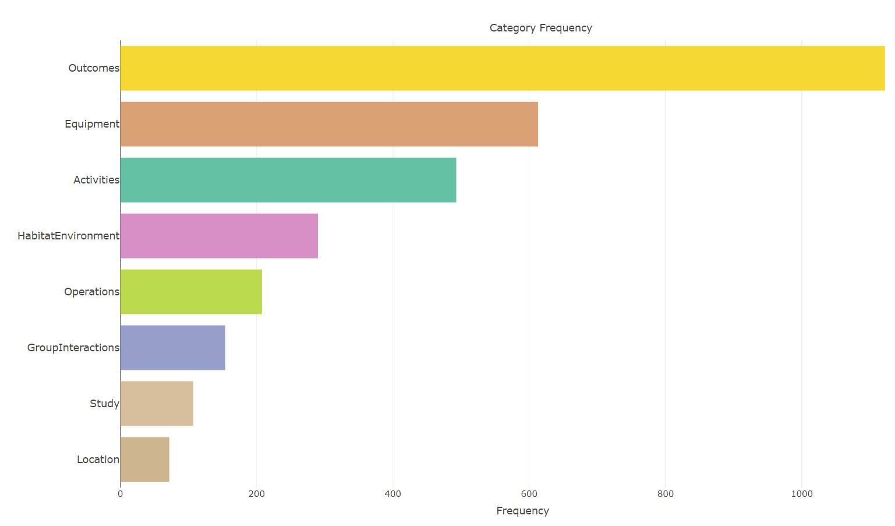
Figure 21. NEK major category frequency.

With regard to the individual codes used, the data show some striking similarities and differences between the two data sets (Figure 22). The most commonly used codes in the outcome category, Interface Design, Effectiveness, Consistency, and Satisfaction, are quite similar to the ISS Habitability data set (Interface Design, Effectiveness, Satisfaction, and Ease of Use).

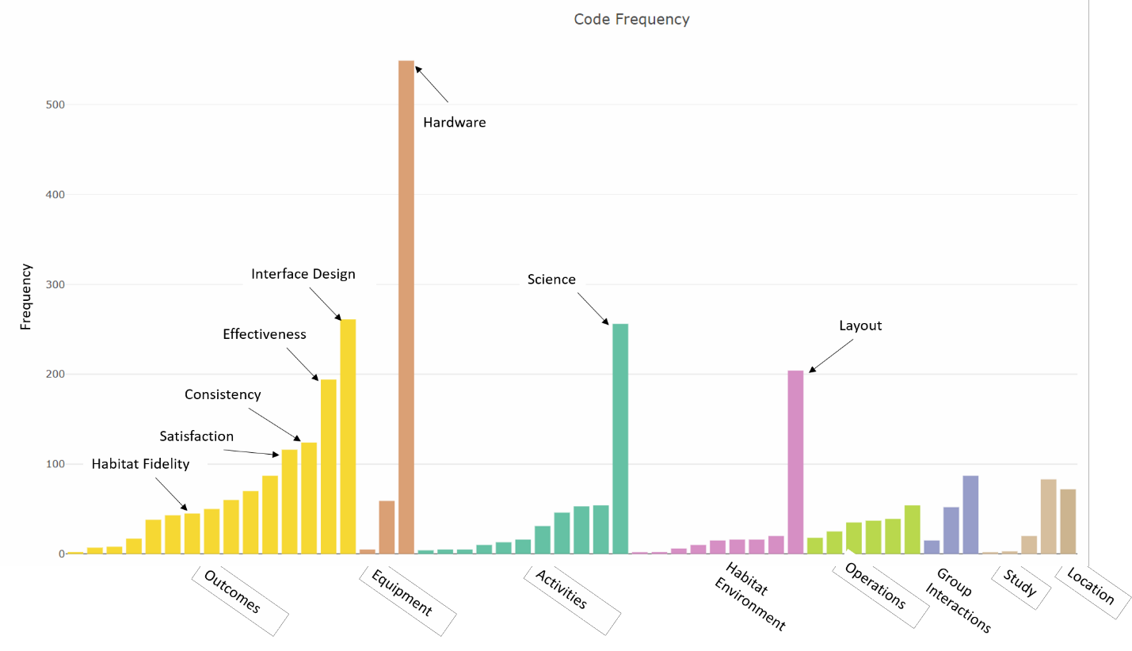

Figure 22. NEK individual code frequency.

Hardware is again highlighted as the most frequently used individual code, most likely due to a similar tendency by the NEK participants to discuss an item with which they are interacting. In contrast to the ISS Habitability data, the participants in the NEK study discussed Science as the most frequent activity. This is likely due to their tendency to discuss the various experiments in which they participated. Interestingly, comments relating to habitat fidelity were relatively few in number.

Analysis of tone
The tone breakdown of the comments for the NEK participants showed a similar pattern to that seen in the ISS data set (Figure 23). The majority of the comments (40.6%) were neutral, followed by negative (37.3%), and then positive (22%). Since the mission was only seventeen days in length, no analysis was conducted with respect to the length of isolation (i.e., mission phase). Additionally, given the difficulty in identifying one specific author for the observations, it was not possible to examine tone by individuals as was done for the ISS Habitability dataset.

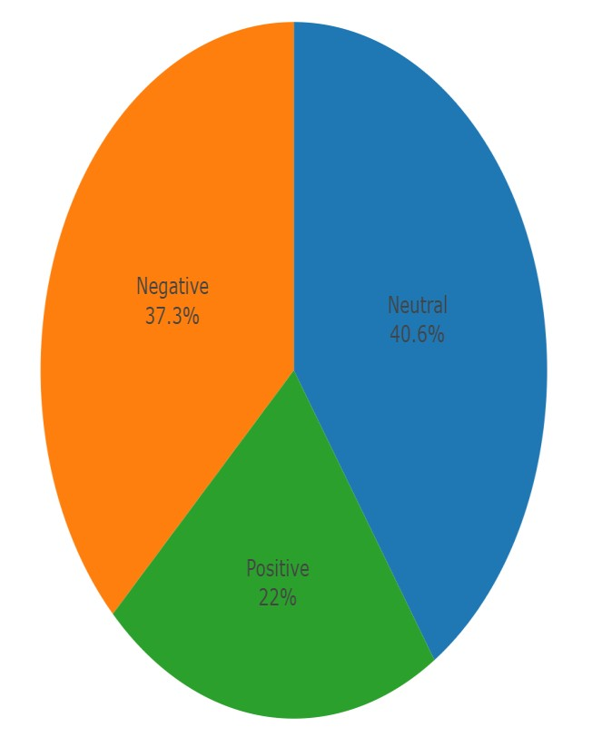

Figure 23. Percentage distribution of tone for NEK.

Data collection types
It appeared that participants had a good understanding of the observation and Walk-through activities and provided useful information. With regard to the Narrated Tasks, participants appeared to treat them like observations, discussing general concerns with hardware and tasks. This misunderstanding is likely due to the lack of real time communication capability. During the ISS Habitability study, the investigators were able to choose specific tasks for the narration, whereas in this study, this was not possible.

Recommendations
Recommendations for study implementation and habitat capabilities addressing Aim 1 are listed in the next section. This section focuses on recommendations derived from the data collected to address Aim 2 to the degree possible given the limitations on the experimental protocol.

Increase the comfort, usability, and robustness of experimental hardware.
Many comments were made by participants regarding the comfort of wearable devices, specifically the sociometric badge and the heart rate monitoring device. The heart-rate monitor was not comfortable for long term wear (Figure 24). This is demonstrated by a conversation among three crewmembers:

“Crewmember 1: If it is a loose fit, it falls off, but if it is on very tight, then it starts to annoy/(irritate) you…
Crewmember 2: Yes, in other words, I have to constantly lift it up in front to keep it on, and from behind on my back it is constantly falling off, so I go all day long by lifting it up, well, plus, that physical discomfort from this belt.
Crewmember 3: I have been itching all day long. Well, not all day long, but after a day & a half, it began to itch badly. However, maybe it is due to the fact that we do not shower, of course.”

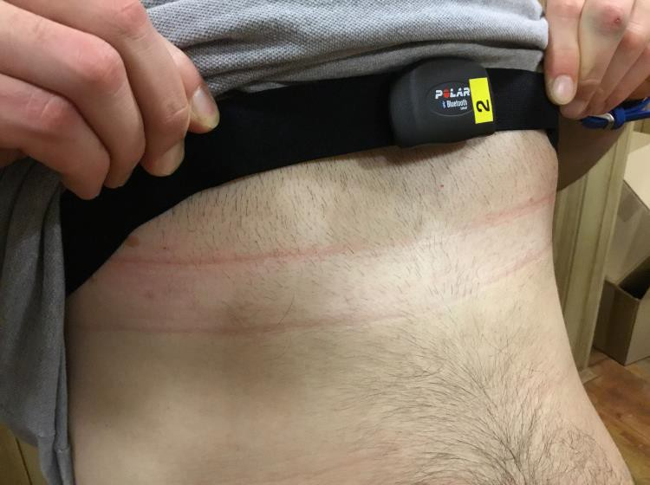
Figure 24. NEK crewmember showing marks left by the heart rate monitor.

The usability of the acoustic monitor was discussed by a number of participants, and issues with it are demonstrated by the following comment:

“Our crew members say that it’s inconvenient, the work with this device is not efficiently organized. I mean, what the steps are to switch it on? The following steps need to be taken: push the Rec button and control the monitor while holding the blue button. CLEAR comes up, we let it go – that’s it, we cleared its memory. At first, when we were sending data from our containment to Earth, so to say, one of the first mistakes we made […] was not clearing the memory of their sound level meter. […] This is the first step. The second step is to select the recording level: thirty- eight – eighty. […] Then we have to select “slow” instead of “fast”. […] To start recording we need to push the Rec button and make sure the Rec is on. As soon as we wake up, we need to stop the recording by pushing the Rec button again. Now we would have the following issue. Some of us just turned it off by pushing the blue button without stopping Rec. […] only after pushing the Rec button again, that is after stopping the recording, we can push the blue button, and the sound level meter will start to count down till it switches off. So, here are the steps: turn on - one, two, fast-slow - three, push Rec - four, wake up – push Rec: five, and turn off – six. Six steps. It turned out that some of us found it hard to remember.”

The robustness of experimental equipment was mentioned with regard to two specific devices, the sociometric badge and heart rate monitor. The badge had issues where it broke (Figure 25), and the heart rate monitor appeared to not record data correctly (e.g., extreme fluctuation in reported heart rate with no change in physical activity). Some of the participants suggested that there may be an interaction between the two devices, since the badge was worn around the participants’ necks and the heart rate band around their chest.

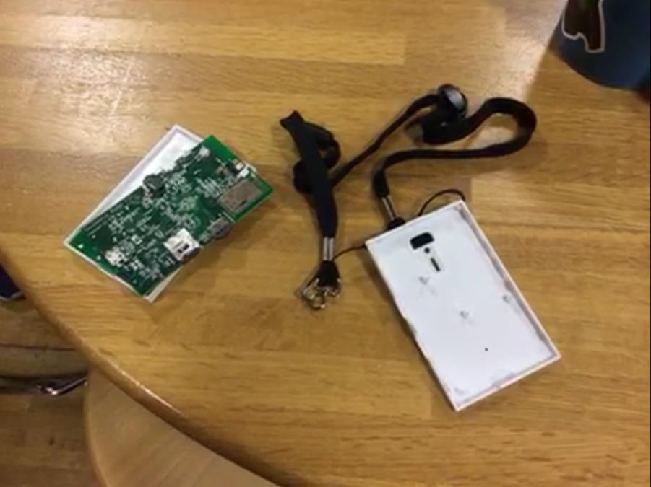

Figure 25. Screenshot from video showing broken badge.

Taken together, comments regarding the comfort, usability, and robustness of different pieces of hardware made up a large portion of observations. Hardware to be deployed in flight undergoes rigorous testing, and hardware deployed in analogs should also be tested for these issues to increase the fidelity of the analog.

Provide experimental material in the primary language of the mission
This recommendation stems from both the implementation of the current study and a comment made by one of the participants. Not having experimental material in Russian caused confusion and potentially impacted data quality:

“Naturally, because of the linguistic differences and the language being foreign to us, we seem to not always correctly understand what you mean. For example, I have such a vocabulary, which we, of course, know by heart already. […] Such words as tense, angry, worn out, unhappy, lively, and even irritated, angry. It seems to me these are emotional shades translated to me by the Russian dictionary. What did you mean by it? well, I hope we get it right. […] what do you mean by “love and affection”? We discussed this issue for a long time and decided to give a neutral answer, because what is meant by “love and affection”? Just caring about each other, or some kind of friendly love or something more? So, that was not very clear to us, at least to me.”

While this is only one observation, it appears to reflect a sentiment shared by the rest of the crew (i.e., the crew “discussed this issue for a long time”). It is very important to the validity of the data collected using psychological scales that the language in the scale is translated and understood correctly. It is therefore the recommendation of this study that validated scales in the primary language of the mission be used.

Provide flight-like software support tools
On ISS today and in future exploration missions, the crew rely on software tools to facilitate their daily activities (e.g., OPTIMIS or Playbook for schedules, International Procedure Viewer (IPV) for procedures). From the data collected during this investigation, it appeared that the NEK crew relied heavily on paper- based or static (e.g., PDFs, notebooks) tools for the duration of the mission (Figure 26). It is recommended that software-based tools be provided to participants in the NEK analog to increase the fidelity of the habitat. In addition to increasing fidelity, this would provide an excellent opportunity to researchers interested in investigating software tools for long-duration exploration missions.
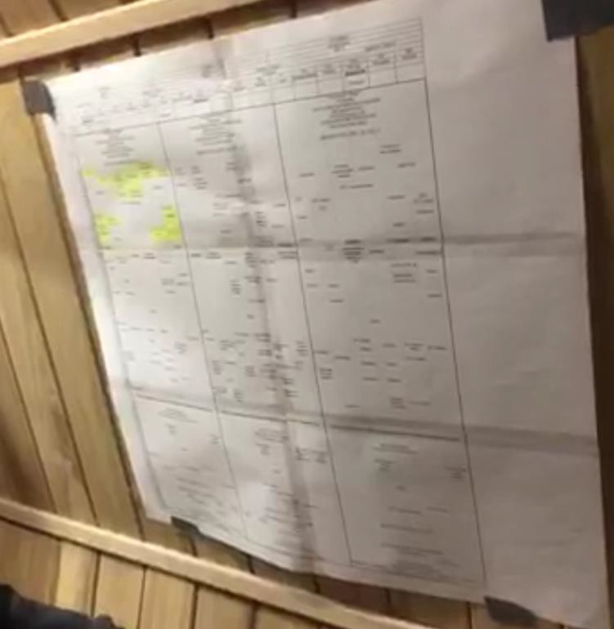
Figure 26. Screenshot from a video showing the crew's schedule affixed to a wall.

13.4 Conclusions and Lessons Learned
The two primary aims of the short NEK Habitability study were to 1) investigate the feasibility of conducting the study in the analog, and 2) investigate the fidelity of the habitat itself. While the study was implemented and data received, it was with significant modifications to the protocol (aim 1) which influenced our ability to address aim 2. The questionnaire and PI Conference could not be administered, which would have allowed us to examine the responses, and ask specific questions directed at assessing habitat fidelity (aim 2). Some recommendations relating to habitat fidelity are listed in the section above. Specific limitations imposed by the NEK analog and their impact on the study are listed in Table 20. The primary limitations were the lack of real-time communication and data transfer (including the ability to monitor whether tasks were completed) and the lack of integrated translation support for Russian language data points.

Table 20. Limitations, impacts, and recommendations

Limitation | Impact on study | Recommendations for future NEK missions
No data available until after the mission | - Could not conduct PI Conference  - Could not determine data quality (and intervene if necessary) | Include near-real-time data downlink and transfer capability
No possibility of contact between participants and PI during the mission | - Participants who were confused by the activities could not reach out to the PI for clarification  - Could not conduct PI Conference | Include a method of communication between the PI and the participants
The primary language of the mission was Russian | Given that the majority of the data received was in Russian, additional time and cost was associated with the translation of the data | Include a streamlined workflow for data translation that would minimize the effect on schedule

In general, data collected in the NEK was highly relevant and comparable to the data collected during the ISS Habitability study. The participants in the NEK mission appeared to be motivated and provided data similar to that provided by the astronauts on board the ISS in both tone and content. Overall, with some modifications to the analog and analog capabilities, the conclusion of this investigation is that HRP studies could be successfully implemented and conducted in the NEK analog.

Appendix B – PI Conference Questions

Note that these questions serve as a starting point. Questions are modified based on inputs received via iSHORT and questionnaires during the mission, adding/removing/modifying questions to fit within a 15-minute conference.

Habitability & Human Factors optimizes the quality of the crew’s working and living environment by improving operational habitability as it relates to increased crew productivity and well-being.

Our overall goal is to identify aspects of the mission, environment, or hardware that should be changed to better suit the human user and thereby reduce errors, irritation, and delays, and improve efficiency and degree of mission success.

U6-1 Have you experienced any issues with the overall design of the habitat? General Topology/Layout/Co-location of items?

U6-2 Were there any areas of the habitat that you found to be particularly well designed?

U6-3 Did you feel that you had adequate volume to perform your tasks? Did you feel that you had adequate volume from a psychological standpoint?

U6-4 Did you encounter any challenges with having the right level of privacy ()?

U6-5 How would you describe the size and layout of your dedicated sleep station, for both sleeping and conducting your own activities during down time? Do you have any additional suggestions for future vehicles related to the provision and design of dedicated sleep stations?

U6-6 Please indicate the top two (2) habitability and human factors issues you experienced (e.g., what improvements/changes could have been made from a Habitability/HF perspective?)

U6-7 Do you have any additional suggestions you would like to make for future exploration programs regarding human centered design, habitability, level of autonomy, planning considerations, crew comfort (specific smells, wall color, home/Earth amenities)?

Appendix C – ISS Codes and Definitions

Activities
Sleep – discussions of sleep areas (CQ), sleep-related items (e.g., sleeping bags, ear plugs), ability to fall asleep, quality of sleep, sleep disturbance (noise, light etc.), circadian rhythms | Hygiene – discussion of WHC activities, personal hygiene, hygiene items (e.g., towels), hygiene locations | Science – activities related to science (e.g., glovebox operations)
Exercise – discussions of exercise needs, specific equipment (ARED, CEVIS etc.) | Trash – discussion of trash generation, storage, types of trash | Health and medical – activities related to health and medical (e.g., blood draws, private medical conference, medical emergencies)
Recreation – discussion of free time, any activity that is specifically for crew enjoyment, individual recreation vs group recreation | Translation – discussion of mobility aids, translation paths, hindrances to translation paths, learning to translate | Emergencies (non-medical) – emergency activities that are unrelated to medical (e.g., fire, depress, toxic exposure, simulations)
Stowage – discussion of location, types, needs | Housekeeping – discussion of cleaning activities, items used for these activities (e.g., vacuum), frequency | PAO – activities related to public affairs; can include demonstrations, youtube videos, social media, any interactions with education system, camera/voice setup.
Food– discussion of location, quality of food or drinks, types/variety of food or drinks, steps necessary for food prep, food they miss | Maintenance – discussion of hardware maintenance, tools, volume, frequency
Habitat Environment
Lighting – discuss types of lighting, location, needs | Odor – location, specific equipment/materials, mitigation strategies | Volume – sufficient, needed, effects on volume needs, impacts of volume on activities, bumping into something or someone
Vibration – discuss effects on activities, locations | Privacy – visual, audio, olfactory privacy | Layout – effect on task performance, location of hardware/activities within node and in general, co-location of items and activities
Temperature – effects on activities, locations, control | Noise – from hardware, in specific locations, effects on activities | Aesthetics – styles and tastes, “looks nice/doesn’t look nice”, “messy”
Air Quality – CO2 level, particulates, allergens, dust | Gravity – differences from ground activities due to gravity
Equipment
Hardware – specific pieces of equipment, includes cables, cameras, computers, clothing, racks and lockers | Software – including iPad apps | Spacesuits – including airlock
Improvisation/modification (equipment) – changing hardware or software setup from original configuration, temporary fixes for broken items, add label for clarification
Operations

Timelines – scheduling, software, shifting | Labels – quality, location, language, absence of | Safety – includes cautions, warning – design, frequency
Training – differences between ground and flight, time between training and flight, training new crewmembers, onboard just-in-time payload training, simulations | Procedures – quality, use, software | Improvisation/modification (operations) – changing procedures, modifications from training
Group Interactions
Group structure – command structure, team role (commander, engineer etc.), independent vs team task | Group behaviors – leadership/followership, communication delivery, information exchange, supporting/backup behaviors, problem solving (detection, prioritization, risk assessment), coordination (timing and synchronization of actions), adaptability, conflict management, cohesion, trust, safety, etc. | Group culture and language – language differences, language in transcript, fluency, native vs non-native, cultural background, space agency affiliation
Considerations
Satisfaction – with item discussed and in general (like/dislike, good/bad, nice/not nice), also criticality/importance | Convenience – location/access | Physical workload – how physically demanding a task is, consideration of force and torque, muscle exertion
Effectiveness – influences on quality of task performance | Intuitiveness – ease of learning | Mental workload – how mentally demanding a task is, spare capacity for performing other tasks concurrently, focus/vigilance/attention
Efficiency – influences on time to perform task (fast/slow) | Comfort – physical and emotional | Fatigue – tired, weariness, lethargy
Consistency – expected vs actual, across location, time and systems; ground (training) vs flight (operations) | Fit – physical fit of a device to a person; ergonomics | Stress – state of mental strain due to adversity, anxiety
Ease of use – usability, error prevention | Interface design – comments about software and hardware interfaces, layout and organization | Suggestions for improvements
Study (Hab Study Specific)
Prompts – quality, following or not following (specific comment), clarity | Data use – requests for data sharing, data privacy concerns | iPad – discussion of iPad capabilities/appropriateness for study
Activity performance – differences from required activity, suggestions for improvements
Location – comments specifically about the location (not just off-hand comments)
General Location – comments about general locations of items and/or activities
Tone* Always mark
Positive | Negative | Neutral
Note
Note – indicates that a note was made in the excel file and should be reviewed
Filler
Filler – If there are filler words or sentences, or incomplete thoughts, mark them with the primary category “Filler”

Appendix D – Questionnaire Results
Area | Number of times area was marked | Category | Number of times category was marked as needing improvement
Whole Body Hygiene | 66 | Layout | 13
Whole Body Hygiene | 66 | Privacy | 12
Whole Body Hygiene | 66 | Lighting | 11
Whole Body Hygiene | 66 | Temperature | 10
Whole Body Hygiene | 66 | Habitable Volume | 8
Whole Body Hygiene | 66 | Odor | 5
Whole Body Hygiene | 66 | Equipment | 3
Whole Body Hygiene | 66 | Flexibility to reconfigure | 2
Whole Body Hygiene | 66 | Noise | 1
Whole Body Hygiene | 66 | Maintenance | 1
Exercise | 39 | Noise | 13
Exercise | 39 | Layout | 6
Exercise | 39 | Odor | 5
Exercise | 39 | Lighting | 4
Exercise | 39 | Temperature | 4
Exercise | 39 | Privacy | 2
Exercise | 39 | Habitable Volume | 2
Exercise | 39 | Equipment | 1
Exercise | 39 | Maintenance | 1
Exercise | 39 | Flexibility to reconfigure | 1
Sleep | 34 | Temperature | 10
Sleep | 34 | Noise | 10
Sleep | 34 | Lighting | 7
Sleep | 34 | Layout | 3
Sleep | 34 | Privacy | 2
Sleep | 34 | Habitable Volume | 1
Sleep | 34 | Equipment | 1
Sleep | 34 | Odor | 0
Sleep | 34 | Maintenance | 0
Sleep | 34 | Flexibility to reconfigure | 0
Stowage | 34 | Layout | 8
Stowage | 34 | Habitable Volume | 7
Stowage | 34 | Equipment | 7

 |  | Lighting | 6
 |  | Odor | 3
 |  | Temperature | 2
 |  | Noise | 1
 |  | Privacy | 0
 |  | Maintenance | 0
 |  | Flexibility to reconfigure | 0
Private Personal Activities | 33 | Lighting | 7
Private Personal Activities | 33 | Noise | 7
Private Personal Activities | 33 | Temperature | 6
Private Personal Activities | 33 | Privacy | 4
Private Personal Activities | 33 | Habitable Volume | 3
Private Personal Activities | 33 | Layout | 3
Private Personal Activities | 33 | Equipment | 2
Private Personal Activities | 33 | Flexibility to reconfigure | 1
Private Personal Activities | 33 | Odor | 0
Private Personal Activities | 33 | Maintenance | 0
Mission-Specific On-Board Research | 32 | Layout | 8
Mission-Specific On-Board Research | 32 | Lighting | 6
Mission-Specific On-Board Research | 32 | Noise | 5
Mission-Specific On-Board Research | 32 | Equipment | 5
Mission-Specific On-Board Research | 32 | Flexibility to reconfigure | 3
Mission-Specific On-Board Research | 32 | Temperature | 2
Mission-Specific On-Board Research | 32 | Habitable Volume | 2
Mission-Specific On-Board Research | 32 | Maintenance | 1
Mission-Specific On-Board Research | 32 | Odor | 0
Mission-Specific On-Board Research | 32 | Privacy | 0
Waste Collection and Management | 31 | Odor | 6
Waste Collection and Management | 31 | Privacy | 6
Waste Collection and Management | 31 | Noise | 6
Waste Collection and Management | 31 | Layout | 4
Waste Collection and Management | 31 | Habitable Volume | 3
Waste Collection and Management | 31 | Equipment | 3
Waste Collection and Management | 31 | Maintenance | 3
Waste Collection and Management | 31 | Lighting | 0
Waste Collection and Management | 31 | Temperature | 0
Waste Collection and Management | 31 | Flexibility to reconfigure | 0
Group Meet and Eat | 29 | Layout | 10

 |  | Lighting | 4
 |  | Equipment | 4
 |  | Noise | 3
 |  | Habitable Volume | 3
 |  | Odor | 2
 |  | Flexibility to reconfigure | 2
 |  | Privacy | 1
 |  | Temperature | 0
 |  | Maintenance | 0
Food Preparation | 27 | Layout | 11
Food Preparation | 27 | Equipment | 5
Food Preparation | 27 | Lighting | 3
Food Preparation | 27 | Habitable Volume | 3
Food Preparation | 27 | Odor | 2
Food Preparation | 27 | Noise | 2
Food Preparation | 27 | Flexibility to reconfigure | 1
Food Preparation | 27 | Temperature | 0
Food Preparation | 27 | Privacy | 0
Food Preparation | 27 | Maintenance | 0
Suit Don/Doff | 25 | Layout | 8
Suit Don/Doff | 25 | Habitable Volume | 6
Suit Don/Doff | 25 | Equipment | 5
Suit Don/Doff | 25 | Maintenance | 3
Suit Don/Doff | 25 | Lighting | 2
Suit Don/Doff | 25 | Noise | 1
Suit Don/Doff | 25 | Temperature | 0
Suit Don/Doff | 25 | Odor | 0
Suit Don/Doff | 25 | Privacy | 0
Suit Don/Doff | 25 | Flexibility to reconfigure | 0
Crew Health and Medical | 22 | Equipment | 8
Crew Health and Medical | 22 | Layout | 5
Crew Health and Medical | 22 | Noise | 4
Crew Health and Medical | 22 | Lighting | 3
Crew Health and Medical | 22 | Maintenance | 1
Crew Health and Medical | 22 | Flexibility to reconfigure | 1
Crew Health and Medical | 22 | Temperature | 0
Crew Health and Medical | 22 | Odor | 0
Crew Health and Medical | 22 | Privacy | 0

 |  | Habitable Volume | 0
D&C Console Operations | 19 | Layout | 5
D&C Console Operations | 19 | Equipment | 4
D&C Console Operations | 19 | Lighting | 3
D&C Console Operations | 19 | Flexibility to reconfigure | 3
D&C Console Operations | 19 | Noise | 2
D&C Console Operations | 19 | Maintenance | 2
D&C Console Operations | 19 | Temperature | 0
D&C Console Operations | 19 | Odor | 0
D&C Console Operations | 19 | Privacy | 0
D&C Console Operations | 19 | Habitable Volume | 0
Recreation | 19 | Layout | 5
Recreation | 19 | Equipment | 4
Recreation | 19 | Lighting | 3
Recreation | 19 | Noise | 2
Recreation | 19 | Habitable Volume | 2
Recreation | 19 | Flexibility to reconfigure | 2
Recreation | 19 | Privacy | 1
Recreation | 19 | Temperature | 0
Recreation | 19 | Odor | 0
Recreation | 19 | Maintenance | 0
Radiation Shelter | 4 | Flexibility to reconfigure | 2
Radiation Shelter | 4 | Habitable Volume | 1
Radiation Shelter | 4 | Equipment | 1
Radiation Shelter | 4 | Lighting | 0
Radiation Shelter | 4 | Temperature | 0
Radiation Shelter | 4 | Odor | 0
Radiation Shelter | 4 | Privacy | 0
Radiation Shelter | 4 | Noise | 0
Radiation Shelter | 4 | Layout | 0
Radiation Shelter | 4 | Maintenance | 0

Appendix E – NEK Codes and Definitions

Activities
Sleep – discussions of sleep areas (CQ), sleep-related items (e.g., sleeping bags, ear plugs), ability to fall asleep, quality of sleep, sleep disturbance (noise, light etc.), circadian rhythms | Hygiene – discussion of WHC activities, personal hygiene, hygiene items (e.g., towels), hygiene locations | Science – activities related to science (e.g., glovebox operations)
Exercise – discussions of exercise needs, specific equipment (ARED, CEVIS etc.) | Trash – discussion of trash generation, storage, types of trash | Health and medical – activities related to health and medical (e.g., blood draws, private medical conference, medical emergencies)
Recreation – discussion of free time, any activity that is specifically for crew enjoyment, individual recreation vs group recreation | Translation – discussion of mobility aids, translation paths, hindrances to translation paths, learning to translate | Emergencies (non-medical) – emergency activities that are unrelated to medical (e.g., fire, depress, toxic exposure, simulations)
Stowage – discussion of location, types, needs | Housekeeping – discussion of cleaning activities, items used for these activities (e.g., vacuum), frequency | PAO – activities related to public affairs; can include demonstrations, youtube videos, social media, any interactions with education system, camera/voice setup.
Food– discussion of location, quality of food or drinks, types/variety of food or drinks, steps necessary for food prep, food they miss | Maintenance – discussion of hardware maintenance, tools, volume, frequency, day to day operational activities (checking system health)
Habitat Environment
Lighting – discuss types of lighting, location, needs | Odor – location, specific equipment/materials, mitigation strategies | Volume – sufficient, needed, effects on volume needs, impacts of volume on activities, bumping into something or someone
Vibration – discuss effects on activities, locations | Privacy – visual, audio, olfactory privacy | Layout – effect on task performance, location of hardware/activities within node and in general, co-location of items and activities
Temperature – effects on activities, locations, control | Noise – from hardware, in specific locations, effects on activities | Aesthetics – styles and tastes, “looks nice/doesn’t look nice”, “messy”
Air Quality – CO2 level, particulates, allergens, dust | Control – personalization, individual control over environment
Equipment
Hardware – specific pieces of equipment, includes cables, cameras, computers, clothing, racks and lockers; only use if not covered by other codes (e.g., exercise for ARED, stowage for bags) | Software – including iPad apps | Spacesuits – including airlock
Supplies – discussion of inventory, resupply, consumables (e.g., water, paper towels)
Operations
Timelines – scheduling, software, shifting | Labels – quality, location, language, absence of | Safety – includes cautions, warning – design, frequency

Training – differences between ground and flight, time between training and flight, training new crewmembers, onboard just-in-time payload training, simulations | Procedures – quality, use, software | Improvisation/modification – changing procedures, modifications from training, changing hardware or software setup from original configuration, temporary fixes for broken items, add label for clarification.
Group Interactions
Group structure – command structure, team role (commander, engineer etc.), independent vs team task, communication with MCC. | Group behaviors – leadership/followership, communication delivery, information exchange, supporting/backup behaviors, problem solving (detection, prioritization, risk assessment), coordination (timing and synchronization of actions), adaptability, conflict management, cohesion, trust, safety, etc. | Group culture and language – language differences, language in transcript, fluency, native vs non-native, cultural background, space agency affiliation.
Outcomes
Satisfaction – with item discussed and in general (like/dislike, good/bad, nice/not nice) | Convenience – location/access | Physical workload – how physically demanding a task is, consideration of force and torque, muscle exertion.
Effectiveness – influences on quality of task performance | Intuitiveness – ease of learning | Mental workload – how mentally demanding a task is, spare capacity for performing other tasks concurrently, focus/vigilance/attention
Efficiency – influences on time to perform task (fast/slow) | Comfort – physical and emotional | Fatigue – tired, weariness, lethargy
Consistency – expected vs actual, across location, time and systems; ground (training) vs flight (operations) | Fit – physical fit of a device to a person; ergonomics | Stress – state of mental strain due to adversity, anxiety
Ease of use – usability, error prevention | Interface design – comments about software and hardware interfaces, layout and organization | Suggestions for improvements – improvements to habitat or future missions, discussion of importance or criticality.
Habitat fidelity – comments related to accuracy of the simulated habitat compared to a real space vehicle and mission (e.g., gravity, volume/layout, differences or similarities in operations)
Study (Hab Study Specific)
Prompts – quality, following or not following (specific comment), clarity | Data use – requests for data sharing, data privacy concerns | iPad – discussion of iPad capabilities/appropriateness for study
Activity performance – differences from required activity, suggestions for improvements | Alternative app use – using the app for another purpose (e.g., sending messages to people or about other studies, as a crew note), other than the requested observation, walk through, or Narrated Task.
Location – comments specifically about the location (not just off-hand comments)
General Location – comments about general locations of items and/or activities
Tone* Always mark
Positive | Negative | Neutral
Filler
Filler – If there are filler words or sentences, or incomplete thoughts, mark them with the primary category “Filler”

Relevancy – coded at the entire observation level (same as primary category)
Low – did not appear to discuss HF/Habitability concerns; did not follow instructions for data collection type (walk through, Narrated Task) | Medium – discussed HF/Habitability concern at a high level, not very thoroughly, partially useful | High – competently and thoroughly discussed HF/Habitability issues. Data is useful. At the same level as ISS Hab data

Appendix F – Acronyms

ARED | Advanced Resistive Exercise Device
AVIMA | Automatic Video-based Motion Analysis
CEO | Crew Earth Observation
CEVIS | Cycle Ergometer with Vibration Isolation and Stabilization
CQ | Crew Quarters
CTB | Cargo Transfer Bag
HFBP | Human Factors and Behavioral Performance
HIDH | Human Integration Design Handbook
HRP | Human Research Program
HSI | Human-System Integration
IPV | International Procedure Viewer
iQ&A | iQuestion and Answer
IRB | Institutional Review Board
iSHORT | Space Habitability Observation Reporting Tool
ISS | International Space Station
ISSMP | International Space Station Medical Project
JEM | Japanese Experiment Module
JSC | Johnson Space Center
LSDA | Life Sciences Data Archive
MCC | Mission Control Center
MSG | Microgravity Science Glovebox
NEEMO | NASA Extreme Environment Mission Operations
NHV | Net Habitable Volume
NPN | Net Positivity/Negativity Index
OPTIMIS | Operations Planning Timeline Integration System
PAO | Public Affairs Office
PMM | Permanent Multipurpose Module
RFID | Radio-Frequency Identification
SBIR | Small Business Innovation Research
SOIRT | Space Operations Incident Reporting Tool
WHC | Waste and Hygiene Compartment

