Swamp Works Regolith Compaction Technologies. E. A. Bell¹, B. Kemmerer², M. A. Gudino³, B. Burdess⁴, N. J. Gelino⁵, A. M. St John⁶, E. Skirde⁷, D. E. Essumang⁸, P. Flowers⁹, V. Rao-Aourpally¹⁰
¹Swamp Works, NE-L6, Laboratories, Development, and Testing Division, Kennedy Space Center, National Aeronautics & Space Administration (NASA), Mailstop NE-L6, KSC, FL. 32899, evan.a.bell@nasa.gov, ²Swamp Works, NE-L6, Laboratories, Development, and Testing Division, Kennedy Space Center, National Aeronautics & Space Administration (NASA), Mailstop NE-L6, KSC, FL. 32899, beverly.kemmerer@nasa.gov, ³Swamp Works, NE-L6, Laboratories, Development, and Testing Division, Kennedy Space Center, National Aeronautics & Space Administration (NASA), Mailstop NE-L6, KSC, FL. 32899, marco.a.gudino@nasa.gov, ⁴Swamp Works, NE-C6, Commercial Systems Division, Kennedy Space Center, National Aeronautics & Space Administration (NASA), Mailstop NE-C6, KSC, FL. 32899, benjamin.h.burdess@nasa.gov, ⁵Swamp Works, , NE-L6, Laboratories, Development, and Testing Division, Kennedy Space Center, National Aeronautics & Space Administration (NASA), Mailstop NE-L6, KSC, FL. 32899, nathan.j.gelino@nasa.gov, ⁶Swamp Works, Astrion, Kennedy Space Center, NASA, Mailstop LASSO-13, KSC, FL. 32899, aidan.m.stjohn@nasa.gov, ⁷Swamp Works, NE-L6, Laboratories, Development, and Testing Division, Kennedy Space Center, National Aeronautics & Space Administration (NASA), Mailstop NE-L6, KSC, FL. 32899, elise.skirde@nasa.gov, ⁸Swamp Works, National Aeronautics & Space Administration (NASA), Mailstop NE-TI, KSC, FL. 32899, deborah.essumang@nasa.gov, ⁹Redwire, 8226 Phillips Hwy, Suite 101, Jacksonville, FL, 322056, patrick.flowers@redwirespace.com, ¹⁰Redwire, 8226 Phillips Hwy, Suite 101, Jacksonville, FL, 322056, vineel.rao-aourpally@redwirespace.com.

Introduction: While the level of compaction below the lunar surface increases quickly after only a few cm of depth, in many cases during a construction mission there will be a need to excavate and transport regolith to a new location for cut-and-fill or horizontal construction of structures such as berms. In these cases to achieve high levels of bulk density, compaction must be performed. Additionally, in some cases surface technologies such as systems that sinter/melt the surface may desire the maximum possible compaction at the surface to improve melting/heating performance and the final material strength properties.
Kennedy Space Center’s (KSC) Swamp Works has developed two means of compaction, lunar and martian compaction. Planetary Autonomous Compaction Technology (PACT) which is part of the Multifunction End Effector for Regolith Compaction Acquisition and Transfer (MEERCAT [1]) robotic arm end effector system’s capabilities and the Site Preparation Tooling for Operations on Mobility Platforms (STOMP [2]) vibratory roller compactor. PACT on MEERCAT has been demonstrated to a TRL 5 and STOMP to a TRL 4 in ambient testing.
The results of PACT on MEERCAT and STOMP testing will be shared with results for various simulants including BP-1, ICN-LHT-1G (aka CSM-LHT-1G), RDW-LHT-1GH (a simulant developed for the Mason Tipping Point to match characteristics of ICN-LHT-1G), and Exolith LHS-1E. This will also include discussions on methods used to verify relative density before and after compaction and means to verify density effects below depth. To calculate relative density, maximum and minimum densities for simulants were taken from literature [3] [4] [5] and additional lab testing (publication in work).
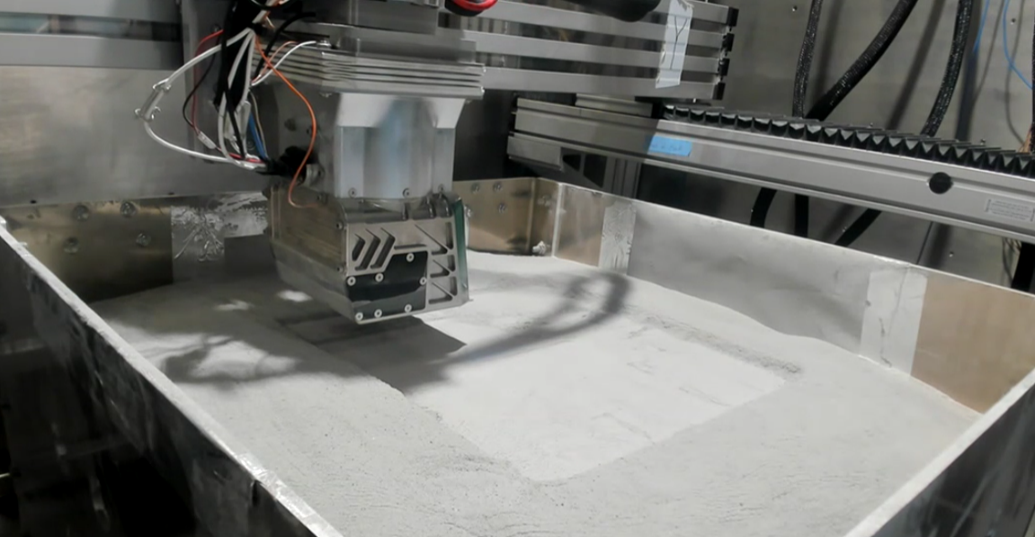
Figure 1. TRL 5 PACT performing vibratory plate compaction on an area of 300 x 305 mm.
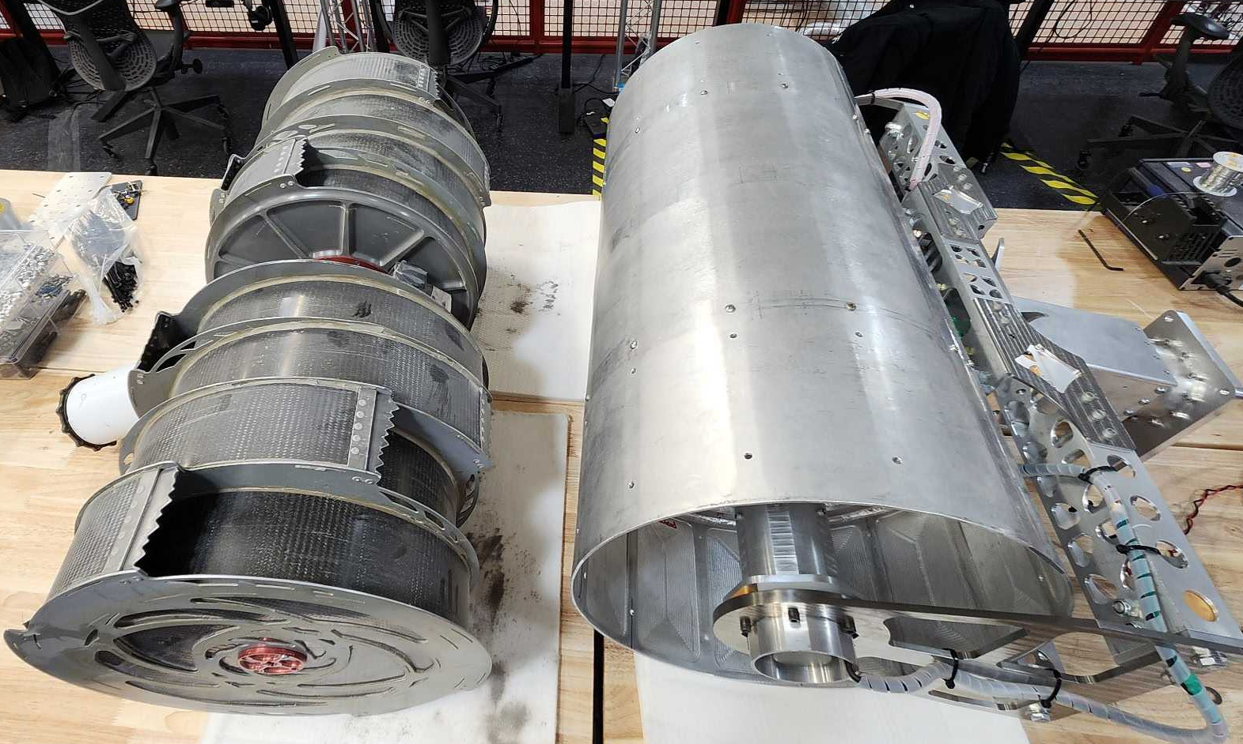
Figure 2. RASSOR excavator bucket drum (left) and TRL 4 STOMP vibratory roller compactor (right).
PACT Testing Results: During in-vacuum testing of PACT using a tamping method of compaction on low-density prepared ICN-LHT-1G, the results showed a final compaction of 86 to 122 Percent Relative Density (%RD). Bulk density was estimated using a pocket penetrometer correlated through lab testing and core samples. It is noted that core samples generally read a lower bulk density value compared to the pocket penetrometer.
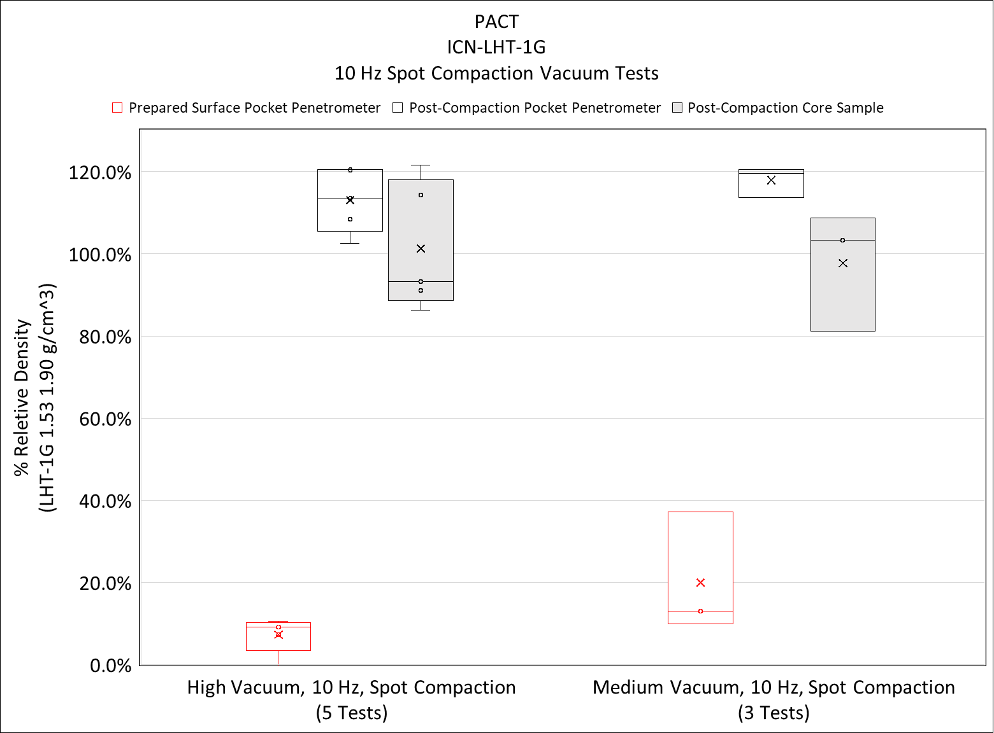
Figure 3. Pre and post compaction with PACT results in terms of %RD.
Additionally, a correlation between pressure and sinkage using PACT’s compaction plate on various regolith simulant densities was generated to estimate the compacted state in vacuum using PACT. The results of this testing verify that compaction levels are at or exceed 80 %RD. RDW-LHT-1GH simulant showed substantially different sinkage at the same pressure as ICN-LHT-1G. This highlights the need for developing material properties in-situ on the lunar surface rather than rely on simulants terrestrially.

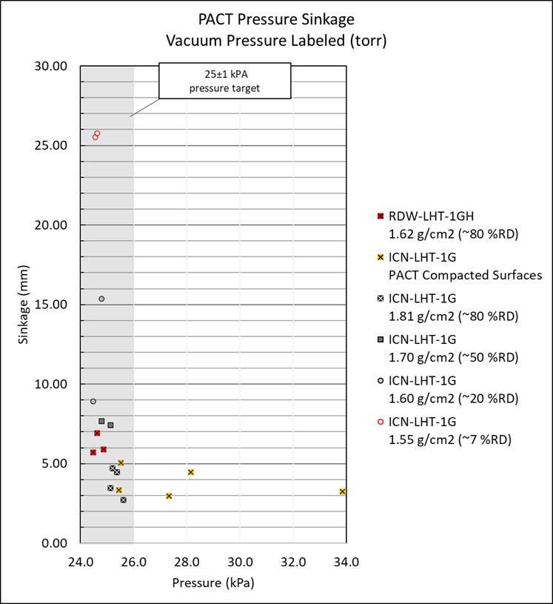
Figure 4. PACT sinkage achieved for ~25 kPa of surface bearing pressure. Tests done in pre-prepared bins at a set density and PACT compacted bins. PACT compacted surfaces achieve similar sinkages as that of 80 %RD ICN-LHT-1G or in some cases high pressures at the same amount of sinkage.
STOMP Results: STOMP ambient testing in BP-1 showed similarly high final compaction densities; 85%RD after 5 passes and exceeding 100%RD after 10 passes with STOMP. Measurements beyond 100%RD were limited due to the correlation of pocket penetrometer results to bulk density in BP-1 available to the team.
Cone penetrometer results show that the compaction effected the regolith simulant down to the limit of the cone penetrometer’s reading range (~20 cm)

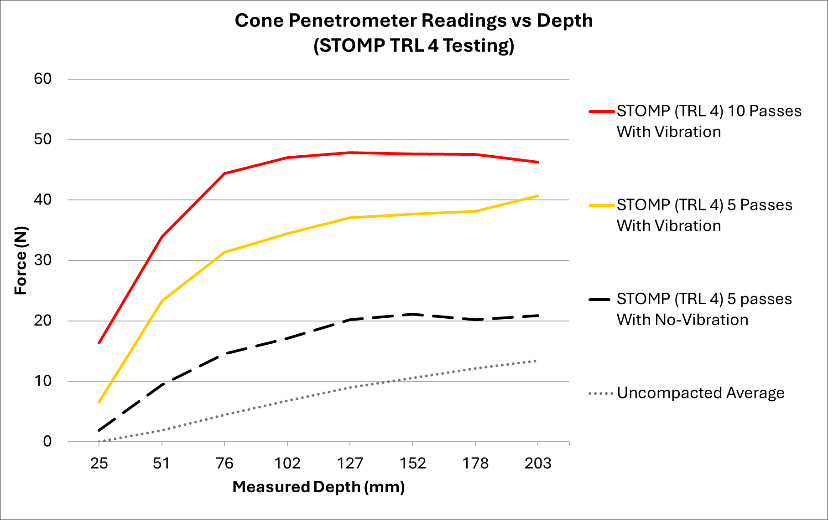
Figure 5. Cone penetrometer measurements below surface during STOMP testing in BP-1. Results show compaction effect down to 20 cm.
References: [1] Bell, Eduardo, et al ntrs.nasa.gov/citations/20240004381 [2] Gudino, Marco, et al https://ntrs.nasa.gov/citations/20250005532 [3] Slabic, Ane, et al. https://ntrs.nasa.gov/citations/20240011783 [4] Suescun-Florez, Eduardo, et al. (2015) J. Aero. Eng., 28.5, 04014124. [5] Long-Fox, Jared M., et al. (2023) Adv. Space Res., 71.12, 5400-5412.

