A comparison of Finite element Model transition methods for Launch Vehicle flex simulation
(Preprint) AAS XX-XXX
Wei Wu
For large launch vehicles, it is necessary to simulate the structural dynamics response in flight. Due to the fuel depletion, in practice, a finite set of Finite Element Models (FEMs) for various propellant levels are created and used for time domain flight simulation due to computational constraints. This creates the problem of transition between two FEMs. To gain insight into the problem, a kinetic constraint posed by two different finite element models at the transition time is derived. Based on this result, this paper analyses and compares three existing transition methods using a free-free beam example. First, results from these methods are compared to the response of the beam with continuous varying mass, so the true performance of each method can be evaluated. FEMs including the same and different set of modes are also simulated. Both the initial conditions and the forced response are considered. As the outcome of this simulation study, the recent method proposed in a previous paper is shown to be the best candidate for FEM transitions for simulation purposes by accounting for the kinetic consistency following the transition in addition to the kinematic continuity at the transition time in other methods.

I. Introduction
Large or light space structures such as a launch vehicle may have significant flexible motion during flight to which the flight control system will sense and react. Thus, it becomes important to understand the flex and control interaction. Mass and stiffness of launch vehicles vary during flight with propellant consumption, causing the shift of mode frequencies and mode shapes of the structure throughout flight. This significantly impacts flight control design through the flex and control interaction, e.g. the controller gains are usually scheduled to stabilize the changing structural dynamics. To verify the flight control design, it is necessary to model flexible body dynamics in simulation environments as accurately as possible.
Although the change in the structure of the vehicle is continuous, it is currently not feasible to continuously switch FEMs. First, it is costly to develop FEMs. Second, it is very time consuming to include a large set of FEMs in a time domain simulation due to computational constraints, especially for Monte Carlo simulations. In the current practice, a finite set of FEMs based on propellant levels, i.e. mass, are developed and used for simulation. Due to a finite number of FEMs, there is a noticeable change in the mass and the stiffness of the structure in one time step when the simulation transitions between two FEMs. In addition, computational limitations introduce a need to truncate the number of modes to decrease simulation run time. An inconsistent set of modes between two adjacent FEM models can also result in large changes in energy carried by modes across the transition. These issues motivated the research of methods ^{1,2,5} addressing a smooth transition in both the modal and physical states of the vehicle when switching from one FEM to the next.
In the past, two approaches ^{1,2} have been proposed to solve this problem. These previous approaches generally exhibit problematic transient behavior that dies out over time but is not representative of the true elastic structural response. Another recent approach ⁵ presented an improved solution by incorporating a kinetic constraint. In this paper, that approach will be referred to as the Kinetics Consistent Transition (KCT) method. This paper developed a kinetic constraint describing the difference in kinematic variables at the transition. The constraint indicates the unavoidable discontinuity in kinematic variables, and it also provides insights for balancing the discontinuity at the transition and the unwanted transient following the transition. As a follow up to KCT, using the same beam example, all three methods are compared to the physical response of the beam with a time-varying mass, which is a new baseline of comparison for these three methods. In addition to the somewhat exaggerated case of removing the first bending mode in the second FEM ³, simulation results are shown from the more common case of having the same set of modes in both FEMs in both the unforced and the forced responses are simulated. The results present evidence for choosing the most suitable transition method for flex simulation in launch vehicle design and verification.
The paper is organized as follows. In section 2, the FEM transition problem in simulation is discussed, a kinetic constraint at the transition time instant is derived which dictates the transient behavior after the transition. Section 3 presents and discusses the existing transition methods. Section 4 shows simulation results for a free-free beam used to test the three transition methods for both unforced and forced responses using either the same set of FEM modes or a different set of FEM modes. The best transition method is identified based on the simulation outcomes for all test cases. Final conclusions are given in section 5.

2. FEM TRANSITION
The elastic structural dynamic model is reviewed first, then the nature of the FEM transition problem is discussed and a constraint governing the transition is derived.
The vibration of an elastic vehicle structure is described by the undamped (damping will be added later via modal damping), linear, second order dynamics model:
$$\begin{aligned}M\ddot{x}+Kx=f \#\left(2.1\right)\end{aligned}$$
where $x$ and $\ddot{x}$ are vectors of the physical nodal displacement and acceleration of a FEM, respectively, $M$ is the mass matrix, $K$ is the stiffness matrix, $f$ is a vector of external forces exciting the structure. This system of equations is then expressed in generalized coordinates $η$ using mode shapes from the FEM. This transformation produces a set of decoupled equations of motion for each mode, which simplifies the analysis for Guidance, Navigation, and Control (GN&C) design. The transformation to generalized coordinates is as follows:
$$\begin{aligned}η=Φx \#\left(2.2\right)\end{aligned}$$
$$\begin{aligned}\ddot{η}=Φ\ddot{x}\#\left(2.3\right)\end{aligned}$$
where $Φ$ represents a mass-normalized matrix of mode shapes (eigenvectors), which may be a reduced set due to mode truncation, and $η$ is the generalized displacement. Transforming the system of equations to the modal space gives:
$$\begin{aligned}MΦ\ddot{η}+KΦη=f \#\left(2.4\right)\end{aligned}$$
Multiplying the system of equations by the transpose of the mode shape matrix gives:
$$\begin{aligned}Φ^{T}MΦ\ddot{η}+Φ^{T}KΦη=Φ^{T}f \#\left(2.5\right)\end{aligned}$$
Because the mode shapes are normalized such that they are orthonormal with respect to the mass matrix, the mass and stiffness matrices become conveniently diagonalized such that:
$$\begin{aligned}Φ^{T}MΦ=I \#\left(2.6\right)\end{aligned}$$
$$\begin{aligned}Φ^{T}KΦ=\tilde{K}=diag\left(ω_{n}^{2}\right) \#\left(2.7\right)\end{aligned}$$
where each $ω_{n}$ represents the natural frequency of each mode of the system. Usually, the damping associated with structural modes is added by assuming a viscous damping. This results in a diagonal damping matrix $\tilde{C}$:
$$\begin{aligned}\tilde{C}=diag\left(2ζω_{n}\right)\#\left(2.8\right)\end{aligned}$$
By combining these equations, the equation of motion for the elastic system in generalized displacements becomes:
$$\begin{aligned}I\ddot{η}+\tilde{C}\dot{η}+\tilde{K}η=Φ^{T}f \#\left(2.9\right)\end{aligned}$$
Now consider a structure with time varying mass and stiffness and a finite set of FEMs representing the varying structure at discrete set of times. It is apparent that each FEM represents a different structure. At the FEM transition time instant, two equations must hold for continuity
$$M_{1}\ddot{x}+C_{1}\dot{x}+K_{1}x= f (2.10)$$
$$M_{2}\ddot{x}+C_{2}\dot{x}+K_{2}x=f \left(2.11\right)$$
There is a discontinuity in the kinematic variables, since no displacement and its first and second derivatives can simultaneously satisfy both equations. The displacement in the real structural vibration, however, is continuous due to the continuous variation of physical properties. Thus, a finite approximation of a continuous variation in the structure creates inconsistency in the displacement and velocity across the transition in simulation. It is desired to keep the displacement and velocity continuous to avoid an unwanted flex response and a subsequent reaction from the flight control system, which will interpret the sudden change in motion as the effect of some external disturbance. Previous algorithms force the displacement and velocity to be the same across the transition ^{1,2}. However, this introduces a disturbance in the acceleration after the transition based on equations 2.10 and 2.11, which consequently introduce a transient perturbation in the velocity and the displacement at the next simulation time step. This strategy maintains the same displacement and velocity at the time of transition but causes a period of fictitious transient right after the transition.
Recognizing there is no simultaneous solution for equations 2.10 and 2.11, consider at the time of transition, in reality,
$$M_{1}{\ddot{x}}_{1}+C_{1}{\dot{x}}_{1}+K_{1}x_{1}=f \left(2.12\right)$$
$$M_{2}{\ddot{x}}_{2}+C_{2}{\dot{x}}_{2}+K_{2}x_{2}=f \left(2.13\right)$$
Subtracting (2.12) from (2.13) gives
$$M_{2}∆\ddot{x}+C_{2}∆\dot{x}+K_{2}∆x=-∆M{\ddot{x}}_{1}-∆C{\dot{x}}_{1}-∆Kx_{1} \left(2.14\right)$$
Where $∆x=x_{2}-x_{1}$, $∆\dot{x}={\dot{x}}_{2}-{\dot{x}}_{1}$, $∆\ddot{x}={\ddot{x}}_{2}-{\ddot{x}}_{1}$, $∆M=M_{2}-M_{1}$, $∆C=C_{2}-C_{1}$, and $∆K=K_{2}-K_{1}$. The right-hand side of equation 2.14 is known and determines the amount of discontinuity at the transition, the left-hand side has three unknowns $∆x$, $∆\dot{x}$, and $∆\ddot{x}$. So, there is no unique solution for the three unknowns. A transition method gives one solution to this equation based on a chosen objective. A good transition method shall give a solution of $x_{2}$ and ${\dot{x}}_{2}$ such that there is no sudden transient deviation from the dynamic response before the transition after the transition.
Note that if $∆x=∆\dot{x}=0$ is the objective, then $∆\ddot{x}$ is large, which leads to a large change in ${\dot{x}}_{2}$ at the first integration step after the transition and this consequently leading to a large change in $x_{2}$ at the second integration step. Thus, a transient occurs.

3. FEM TRANSITION METHODS
  - The LSQI Method¹
The Quadratic Inequality constrained Least Squares (LSQI) method is a least squares problem that aims to minimize the difference in physical displacements and velocities across the FEM transition constrained by the energy in the elastic system. The least squares formulation for the transition between the k^{th} FEM and (k+1)^{th} FEM is given by the below equations
$$\begin{aligned}\min{η_{k+1}}{\left|Φ_{k+1}η_{k+1}-x_{k}\right|}_{2}^{2} \#\left(3.1.1\right)\end{aligned}$$
$$\begin{aligned}\min{{\dot{η}}_{k+1}}{\left|Φ_{k+1}{\dot{η}}_{k+1}-{\dot{x}}_{k}\right|}_{2}^{2} \#\left(3.1.2\right)\end{aligned}$$
The generalized displacement objective is constrained by the potential energy (U), and the generalized velocity objective is constrained by the kinetic energy (T). The energy constraints are written in quadratic form as follows:
$$\begin{aligned}T=\frac{1}{2}{\dot{η}}^{T}I\dot{η}=\frac{1}{2}{\dot{η}}^{T}\dot{η} \#\left(3.1.3\right)\end{aligned}$$
$$\begin{aligned}U=\frac{1}{2}η^{T}\tilde{K}η \#\left(3.1.4\right)\end{aligned}$$
The quadratic inequality constraint on energy compares the energy carried by the elastic modes before the transition to after and ensures that FEM transition does not introduce energy into the system.
The LSQI method is shown below, where a least squares objective function independently minimizes the physical displacements and velocities across the FEM transition constrained by the potential and kinetic energy in the system, respectively.
$$\begin{aligned}\min{η_{k+1}}{\left|Φ_{k+1}η_{k+1}-x_{k}\right|}_{2}^{2} ; s.t. {\left|η_{k+1}^{T}{\tilde{K}}_{k+1}η_{k+1}\right|}_{2}^{2}≤ {\left|η_{k}^{T}{\tilde{K}}_{k}η_{k}\right|}_{2}^{2} \#\left(3.1.5\right)\end{aligned}$$
$$\begin{aligned}\min{{\dot{η}}_{k+1}}{\left|Φ_{k+1}{\dot{η}}_{k+1}-{\dot{x}}_{k}\right|}_{2}^{2} ; s.t. {\left|{\dot{η}}_{k+1}^{T}{\tilde{M}}_{k+1}{\dot{η}}_{k+1}\right|}_{2}^{2}≤ {\left|{\dot{η}}_{k}^{T}{\tilde{M}}_{k}{\dot{η}}_{k}\right|}_{2}^{2} \#\left(3.1.6\right)\end{aligned}$$
Note that for launch vehicles with a continuous decrement in mass due to propellant consumption, the inequality constraints on energies are normally not active in an LSQI solution. While the inequality constraints prevent energy increase at the instant of transition, the LSQI solution may inadvertently remove the energy from the structure. However, in a physical system, the energy will remain constant at the virtual FEM transition time point. Simulations showed transients “ring” immediately following a transition² using this method.
Also note that LSQI solves the modal displacements and the modal velocities separately in two optimization problems. This is not optimal, since the displacements and velocities are inherently related. Individual optimality in the displacement and the velocity may not be dynamically optimal for the transition problem.
3.2 The Direct Shape Matching Method²
The original LSQI method saw transient behavior in the energy carried in the elastic system after transitioning between FEMs. This was due to the validity of the energy constraint being sensitive to the number of retained modes in the elastic model². Additionally, the original LSQI formulation did not include consideration for the homogeneous and particular solutions to the displacement. These issues of the LSQI method were treated by addressing the solution to the steady-state displacement independently. This approach is called Direct Shape Matching (DSM), as the generalized displacement following the transition is directly mapped to the equilibrium displacement². The steady-state displacement for the current FEM can be computed as a function of the stiffness ($\tilde{K}$) and the generalized force ($Φ^{T}f$).
$$\begin{aligned}{η_{ss}}_{k}={\tilde{K}}_{k}^{-1}\left(Φ_{k}^{T}f_{k}\right)\#\left(3.2.1\right)\end{aligned}$$
The homogenous displacement is then computed from the known generalized displacement and the steady-state displacement.
$$\begin{aligned}η_{h_{k}}=η_{k}-{η_{ss}}_{k} \#\left(3.2.2\right)\end{aligned}$$
The homogenous displacement is then used to constrain the potential energy in the least squares formulation. The updated LSQI-DSM formulation to solve an optimal generalized displacement across a FEM transition becomes:
$\begin{aligned}\operatorname{Min}{{η_{h}}_{k+1}}{\left|Φ_{k+1}{η_{h}}_{k+1}-x_{ssk}\right|}_{2}^{2} ; s.t. {\left|{η_{h}}_{k+1}^{T}{\tilde{K}}_{k+1}{η_{h}}_{k+1}\right|}_{2}^{2}≤ {\left|{η_{h}}_{k}^{T}{\tilde{K}}_{k}{η_{h}}_{k}\right|}_{2}^{2} \#\left(3.2.3\right)\end{aligned}$
$$η_{ss_{k+1}}={\tilde{K}}_{k+1}^{-1}(Φ_{k+1}^{T}f_{k})$$
$$η_{k+1}={η_{h}}_{k+1}+{η_{ss}}_{k+1}$$
This updated formulation provided benefits in smoothing transitions of FEMs in simulation. However, it introduced a new issue of the discontinuity of physical displacements immediately following a transition. This new issue motivated the improvements to kinetic consistency across FEM transitions provided by the next method.
Note that the DSM method focuses on constant energy across a transition. It assumes that the potential energy is much larger than the kinetic energy for a launch vehicle and breaks the solution to a forced response solution and a homogenous solution. The forced response is solved directly based on the applied force and the system stiffness, and the homogenous solution is solved using least squares like LSQI. However, it is hard to understand how the total energy is conserved across a transition without using the total energy as an equality constraint in the formulation.
  - The KCT Method ⁵
This method was called Weighted Quadratically Constrained Least Squares (WLSQI) in reference 5. Since the method aims to maintain the kinetic consistency across transitions, it is renamed in this paper to stress its main feature. An improved method arose from cases in which LSQI provided a solution that resulted in a large amplitude transient in simulation at the model transition. Two issues with the LSQI method were identified⁵:
- While LSQI will attempt to minimize the difference between physical states of each node, the constrained solution allows for discrete differences in displacement states when transitioning from one FEM to another. This is problematic if this occurs at a sensor location that is used for control system feedback, as that sensor will experience a sudden, drastic change in state across a single time step.
- LSQI ignores the acceleration of nodes in the elastic model. A lack of kinetic consistency in physical states across FEM transitions leads to unrealistic oscillatory behavior after the transition.
To resolve the first issue, the KCT/WLSQI includes a weight matrix that heavily penalizes position differences at specified FEM nodes on the vehicle. This ensures that even if there are discrete changes in physical states across the model transition, the physical states at the specified nodes are equal. This removes simulation transient behavior “sensed” by the sensors, e.g., a discrete jump in physical position. In this paper, the weight matrix will not be included to focus on the main topic of dynamics.
The second issue with the LSQI solution occurs due to the lack of a constraint on the acceleration states. KCT corrects this issue by solving for the generalized position and velocity flex states simultaneously with an additional constraint on the acceleration. From equations 2.10 and 2.11 the structure dynamics after the transition is different from before. To prevent a transient jump in the displacement and velocity following a transition due to the sudden change of the structural dynamics, a smooth transition in the acceleration is required. Otherwise, a sudden jump in the acceleration at the transition consequentially leads to large transients in the velocity and the displacement following the transition. Acceleration is solved using the equation of motion in terms of the displacement and velocity, so the constraint is included in the objective function. The acceleration constraint follows from the equation of motion for the elastic body by assuming that the acceleration after the FEM transition is equivalent to the acceleration before, as is desired.
$$\begin{aligned}{\ddot{x}}_{k}=Φ_{k}{\ddot{η}}_{k}=Φ_{k}Φ_{k}^{T}f-{\tilde{K}}_{k}{Φ_{k}η}_{k}-{\tilde{C}}_{k}Φ_{k}{\dot{η}}_{k}\#\left(3.3.1\right)\end{aligned}$$
$$\begin{aligned}{\ddot{x}}_{k+1}=Φ_{k+1}{\ddot{η}}_{k+1}=Φ_{k+1}Φ_{k+1}^{T}f-{\tilde{K}}_{k+1}{Φ_{k+1}η}_{k+1}-{\tilde{C}}_{k+1}Φ_{k+1}{\dot{η}}_{k+1}\#\left(3.3.2\right)\end{aligned}$$
$$\begin{aligned}{\ddot{x}}_{k}= {\ddot{x}}_{k+1} \#\left(3.3.3\right)\end{aligned}$$
$f$ represents the external force on the structure, and $\tilde{C}$ is a diagonal matrix of damping coefficients. Combining equations, the constraint on acceleration, expressed in modal displacement and the modal velocity, is defined as:
$$\begin{aligned}-Φ_{k+1}{\tilde{K}}_{k+1}η_{k+1}-Φ_{k+1}{\tilde{C}}_{k+1}{\dot{η}}_{k+1}={\ddot{x}}_{k}-Φ_{k+1}Φ_{k+1}^{T}f \#\left(3.3.4\right)\end{aligned}$$
Note that the generalized force ($f$) is assumed to be constant across the FEM transition. This acceleration constraint improves kinetic consistency of the elastic body across FEM transitions. The KCT method including the acceleration constraint is formulated as:
$$\begin{aligned}\min{η,\dot{η}}{\left|\left[\begin{matrix}Φ_{k+1} & 0 \\ 0 & Φ_{k+1} \\ -Φ_{k+1}{\tilde{K}}_{k+1} & -Φ_{k+1}{\tilde{C}}_{k+1}\end{matrix}\right]\left[\begin{matrix}{η_{h}}_{k+1} \\ {{\dot{η}}_{h}}_{k+1}\end{matrix}\right]-\left[\begin{matrix}x_{k} \\ {\dot{x}}_{k} \\ {\ddot{x}}_{k}-Φ_{k+1}Φ_{k+1}^{T}f\end{matrix}\right]\right|}_{}^{2} \#\left(3.3.5\right)\end{aligned}$$
$$s.t. {\left|{\left[\begin{matrix}η_{k+1} \\ {\dot{η}}_{k+1}\end{matrix}\right]}^{T}\left[\begin{matrix}{\tilde{K}}_{k+1} & 0 \\ 0 & {\tilde{M}}_{k+1}\end{matrix}\right]\left[\begin{matrix}η_{k+1} \\ {\dot{η}}_{k+1}\end{matrix}\right]\right|}_{2}^{2}≤ {\left|{\left[\begin{matrix}η_{k} \\ {\dot{η}}_{k}\end{matrix}\right]}^{T}\left[\begin{matrix}{\tilde{K}}_{k} & 0 \\ 0 & {\tilde{M}}_{k}\end{matrix}\right]\left[\begin{matrix}η_{k} \\ {\dot{η}}_{k}\end{matrix}\right]\right|}_{2}^{2}$$

4. SIMULATION STUDY
  - Simulation Setup
A standalone simulation environment was developed for testing transition methods on flexible body dynamics isolated from all other vehicle dynamics. A parametric FEM of a 3D free-free Timoshenko beam was used for this study ³ by considering only the vertical deformation and the rotation in the vertical plane (the pitch angle and rate), with the original cantilever boundary condition modified to represent a launch vehicle. The beam is divided into forty elements with forty-one nodes. To represent the FEM transitions seen in launch vehicle simulations, two FEMs were generated with the second model having 85% of the density of the first. The first FEM was used to generate continuous dynamics under a constant vertical step input force of 100 Newtons applied at the right end of the beam at the initial time. At around five seconds in the simulation, the beam model transitions to the second FEM with the same applied force, using different methods discussed in section 2. Then, the simulation continues the continuous dynamics. To validate and compare responses from various FEM transition methods, the response of the beam with continuously changing density is first generated. To simulate the true response for this case, a FEM model is created for each time step with a small, fixed time interval. By continually transitioning between FEMs at a high rate in the simulation, the dynamics of the time varying beam is approximated, and the simulated response closely represents the true response.
Several test cases were investigated. They include 1) unforced response; 2) forced response; 3) FEMs with the same number and sequence of modes; and 4) FEMs with the same number but different sequence of modes.
  - Simulation Results
Case 1: Unforced Response
The initial condition response under continuously varying mass was simulated. Every 0.1 second, the current FEM was replaced by the next one through the entire simulation. This gives a response close to the one of a beam with varying mass. The mass of the beam was linearly reduced from the initial value to 70% of the initial value at the end of the simulation. The pitch angular rate, $q$, at node number 8 of the beam, is shown in Figure 1, where each red line indicates a FEM transition at each time instant. This result is used for validating the result of each transition method under the same initial condition.
Consider now a transition between two FEMs at the middle time point of the simulation. The second FEM’s mass is 85% of the first. Both FEMs have the first seven modes after mode truncation. Results using LSQI, DSM, and KCT for transition are shown in Figures 2(a), 2(b), and 2(c) respectively. LSQI and DSM produced a different response with smaller magnitude after the transition, not consistent with the first FEM response, while KCT maintained the dynamics after the transition compared to the real beam response. Note that LSQI and DSM gave an identical result in this case since there is no external force/moment. 2(d) shows the coplot of beam free responses from different methods where the legend “Continuous” denotes FEM transition every 0.1 second, demonstrating the effectiveness of KCT compared to LSQI and DSM.

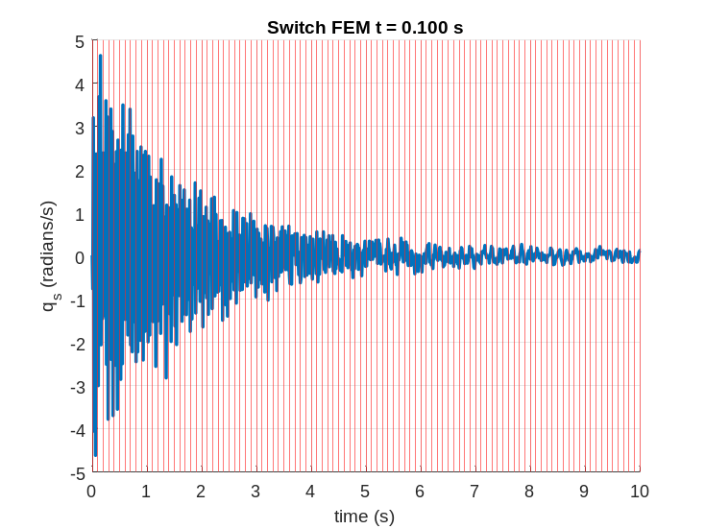

Figure 1: Beam with a continuously decreasing mass
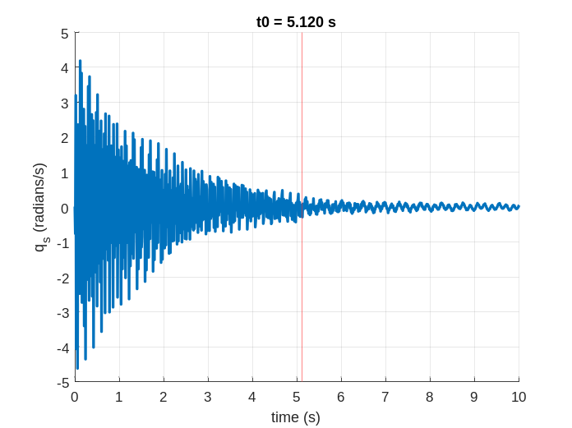
- LSQI
- DSM
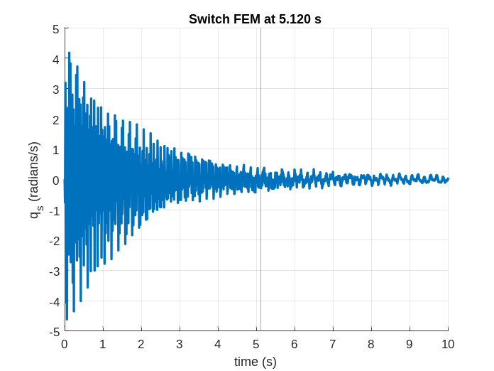
- KCT
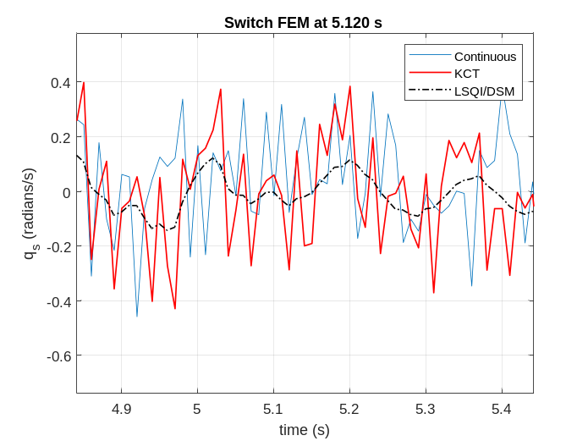
- Coplot of beam responses
Figure 2: Initial condition response with LSQI, DSM, and KCT FEM transition

Case 2: Forced response with same modes

A constant force of 100 Newton was applied at the right end of the beam initially at rest in this case. The two FEMs have the first seven modes after mode truncation with a transition between the FEMs at 5.120 seconds. LSQI and DSM both gave an unreal response following the transition with a slightly slower decay rate compared to the response with the first FEM. LSQI and DSM solution are almost identical in this case with the maximum difference around 1.3e-7 rad/sec at the time of transition. LSQI result is shown in Figure 3(a). KCT maintained dynamics consistent with the real forced response, shown in Figure 3(b). Figure 3(c) compares the LSQI and KCT solution.

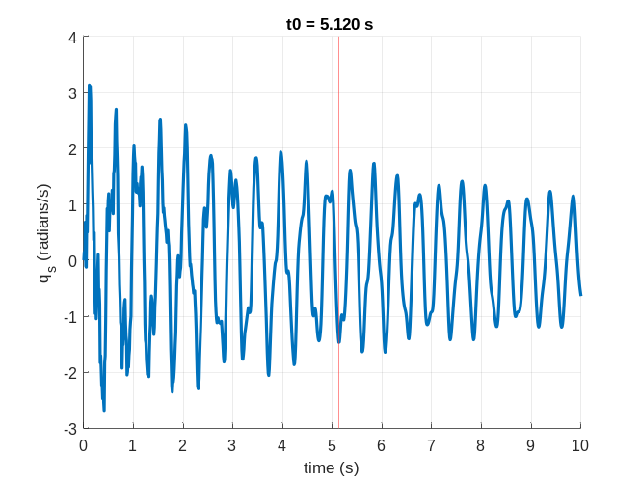
- LSQI

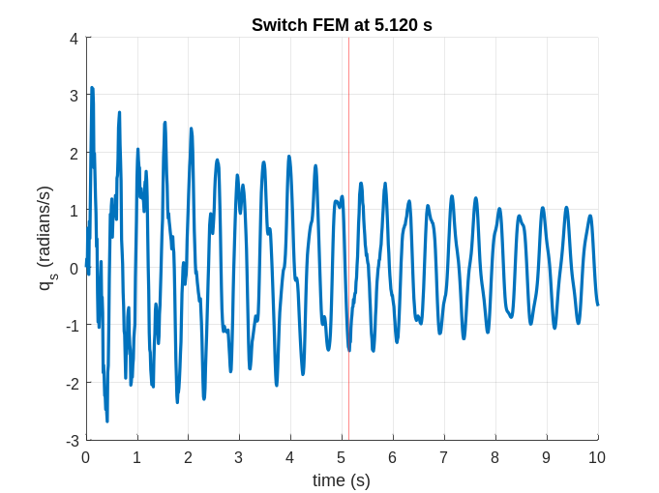
- KCT
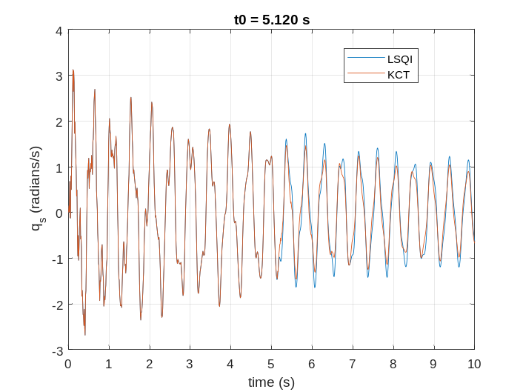
- LSQI vs. KCT
Figure 3: Forced response with same FEM modes

Case 3: Forced response with different modes
The motivating case of varying mode sets between two adjacent FEMs is examined, with the first FEM containing a low frequency mode that does not exist in the second FEM. Note that the results shown demonstrate an extreme case of removing the dominant first bending mode to exacerbate this situation. The first FEM had the first seven modes, and the second FEM had the second to the eighth modes. Results for this case are shown in Figure 4. Based on these results, it is evident that LSQI and DSM failed to initialize the second FEM to produce a consistent physical response. A fictious transient effect is introduced at the transition, exciting higher frequency modes. KCT was able to closely maintain the dynamics across the transition, producing a better response after the transition.
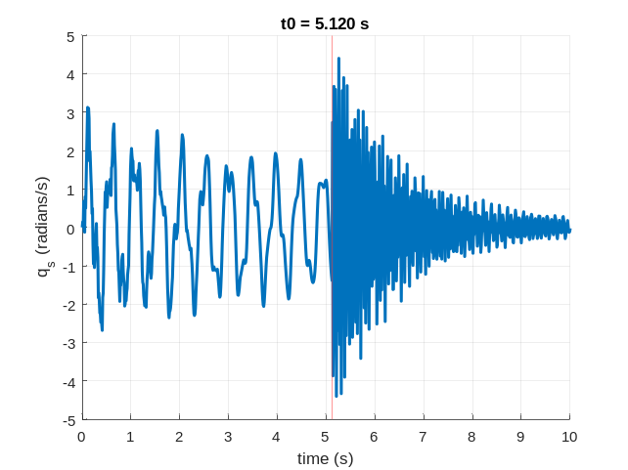
- LSQI
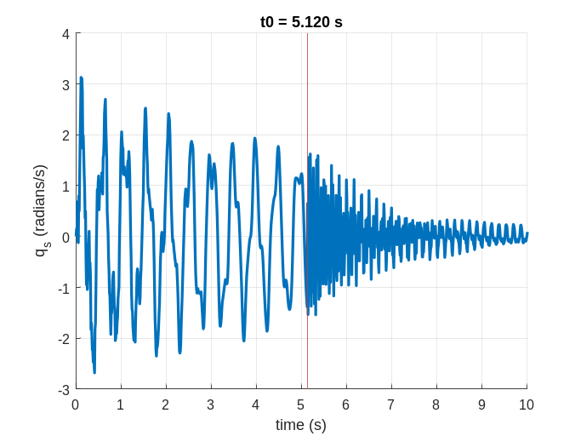
- DSM
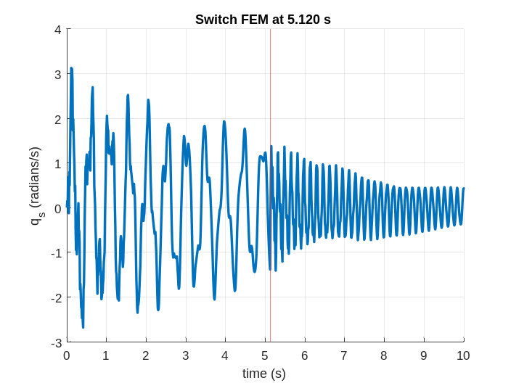
- KCT
Figure 4: Forced response with different FEM modes
The simulation study in this section showed that the KCT method for this simple beam case is the best method examined for consistent dynamic transitions between FEMs. The KCT formulation was implemented using the MATLAB® 2023b fmincon constrained optimization function with both the interior-point algorithm and the sequential quadratic programming (SQP) algorithm. The two algorithms produced identical results in all cases. The inequality energy constraints were found inactive for all simulated cases.

5. Conclusions
When using a finite set of FEM models to represent a continuous changing vehicle structure in flight simulation due to computational constraints, it is unavoidable to introduce a discontinuity in dynamics at the time of a FEM transition. The nature of the transition issue was discussed in this paper, and it helps conceive good transition methods. Three existing transition methods were compared through simulations of a free-free beam. The results showed that LSQI and DSM currently used in some launch vehicle simulations generate transients or unrealistic dynamic responses after the transition while the KCT method are capable of maintaining the kinetic consistency across FEM transitions in all simulated cases by constraining the solution based on the nature of the deviation in the structural dynamics/FEMs in a transition. If a further transition method development is desired, a constrained optimization problem minimizing the total error between the predicted response from the first FEM over a short time interval after the transition and the response of the second FEM in the same time interval can be setup to find the best initial values of the modal displacement and velocity for the second FEM at a transition.
References
1 J. Orr, “Elastic Model Transitions Using Quadratic Inequality Constrained Least Squares,” AIAA Atmospheric Flight Mechanics Conference, Toronto, CA, 2010. AIAA-2010-7642.
2 R. Jurenko, J. Bush, and J. Ottander, “Elastic Model Transitions: A Hybrid Approach Utilizing Quadratic Inequality Constrained Least Squares (LSQI) And Direct Shape Mapping (DSM),” AAS, 2013, AAS 14-304
³ H. Panzer, J. Hubele et al., “Generating a Parametric Finite Element Model of a 3D Cantilever Timoshenko Beam Using Matlab,” Technical reports on Automatic Control, vol. TRAC-4, Institute of Automatic Control, Technische Universit¨at M¨unchen, 2009
⁴ Chan, Tony F., Olkin, J.A., and Cooley, D.W., “Solving Quadratically Constrained Least Squares Using Black Box Solver,” BIT, vol. 32, no. 3, Sept. 1992, pp. 481–494, https://doi.org/10.1007/bf02074882.
⁵ Ganiban, J., and Wu, W. “Improving Kinetic Consistency Across Elastic Model Transitions with Quadratic Inequality Constrained Weighted Least Squares (WLSQI),” AAS/AIAA, Space Flight Mechanic Conference, January 19-23, 2025.
⁶ Clough, Ray W., and Penzien, Joseph, Dynamics of Structures, 2nd ed. (revised), Computers and Structures, Incorporated, 2003.

GN&C Associate Tech Fellow, EV41, Amentum [ESSCA], Marshall Space Flight Center, Huntsville AL 35812

