Hidden in plain sight: a new Main Belt population of aqueously altered and thermally metamorphosed asteroids.

Authors: Maggie McAdam¹, Jessie Dotson¹, Darby Dyar²
¹NASA Ames Research Center
² Planetary Science Institute

Abstract:

C-complex low albedo asteroids are understood to be related to aqueously altered carbonaceous chondrite meteorites. However, in recent years, a new subgroup of aqueously altered meteorites that have experienced significant heating after their initial interactions with water has been extensively studied. It remains unclear where the aqueously altered and heated parent bodies are located in the asteroid belt. To address this question, we reanalyzed the original dataset that defined the Bus-DeMeo spectral taxonomy of asteroids (DeMeo et al., 2009) using a machine learning approach trained with near-infrared archival meteorite spectra. Results show that ~50% of the C-complex asteroids first identified in the Bus-DeMeo asteroid spectral taxonomy are aqueously altered and heated. Though Ryugu has been shown to also have experienced both of these processes, this is the first evidence of a population of aqueously altered and thermally metamorphosed asteroids in the Main Asteroid Belt. Based on the expected velocity and frequency of impacts in the main belt population, we conclude that impacts are the most likely heat source driving thermal metamorphism we identify. Moreover, these aqueously altered and thermally metamorphosed asteroids may represent a primordial population of low-albedo material that formed in situ in the inner solar system. If these asteroids formed in place, rather than being brought in from the outer solar system during giant planet migration, they would have experienced more frequent and higher velocity impacts, resulting in their distinct mineralogy.

Introduction:

Carbonaceous chondrites with both aqueous alteration and subsequent thermal metamorphism have been known in meteorite collections for approximately 40 years. The first samples were collected in Antarctica in the late 1970s and early 1980s (Ikeda, 1992 & Akai, 1990). In the more than four decades since the first grouplet was discovered, more than 50 meteorites with the characteristic signs of both aqueous alteration and thermal metamorphism have been identified in systematic studies (e.g., Tonui et al., 2014; King et al., 2021, Suttle et al., 2023, Quirico et al., 2018).

Within the population of aqueously altered and heated meteorites, recent studies suggest that there are likely two subgroups (Schrader et al., 2025; Ebihara et al., 2025; Suttle et al., 2023). One group has precursor materials similar to CIs, with nearly all accreted silicates converted to phyllosilicates and other secondary phases during a period of parent body aqueous alteration prior to heating. The other group’s precursor materials are likely similar to the CMs, but with less complete aqueous alteration. Despite the complexity of these meteorites and the ongoing research regarding their provenances, they are broadly grouped together for the purposes of this present study. We refer to these meteorites herein as CY meteorites for brevity, although this is not an official meteorite subgroup designation.

There are two hypotheses for the heat source that drove thermal metamorphism for these meteorite parent body(s). Ubiquitous on airless bodies, impacts would locally heat the parent asteroid, causing dehydration of the phyllosilicates and in some cases enough extensive heating to cause recrystallization of secondary silicates (e.g., Quirico et al., 2018 & Suttle et al., 2023). The second hypothesis is that the heat source comes from solar radiation. Solar radiation may cause heating effects on the upper few centimeters of an asteroid’s surface, driving the thermal metamorphism seen in CYs (e.g., Suttle et al., 2-23-Jenkins, 2024).

King et al. (2021) identify Ryugu as a potential CY parent body based upon the relatively short cosmic ray ages of the CYs in their study and the similarities between Ryugu’s spectrum and the spectra of CYs. Both Schrader et al. (2025) and Ebihara et al. (2025) assert, in contrast, that there are at least two parent asteroids representing different precursor materials. Samples returned from small low-albedo asteroids like Ryugu and Bennu will provide critical insights on the solar radiation-driven heating, thermal stresses on the surfaces of near-Earth objects, and the mineralogical effects of these processes on asteroids. In addition to the key ongoing work on returned samples, it is also necessary to contextualize Ryugu and Bennu in relation to other asteroids, especially in the Main Asteroid Belt where they likely originated.

In this work, a supervised machine learning approach trained on archival meteorite spectroscopy from RELAB is used to classify asteroids in the context of meteorite spectra, including this new and growing group of CY meteorites. Using this tool, we investigate the C-complex asteroids from the Bus-DeMeo asteroid taxonomy scheme and find many CY-like asteroids.

Asteroid Classification on the basis of spectroscopy

Asteroid taxonomy has evolved over the past few decades as methods, technology, and data acquisition have improved (McCord et al., 1970; Chapman et al., 1975; Tholen, 1984; Bell, 1989). Most used in this evolving field has been the Bus-DeMeo spectral classification of asteroids (Bus et al., 2002a, Bus et al., 2002b; DeMeo et al., 2009; DeMeo and Carey, 2014) that uses spectral slope and principle component analysis to group asteroids based on spectral similarity. The taxonomy is based on 371 asteroid’s near-infrared spectra obtained over ~10 years by the Infrared Telescope Facility (DeMeo et al., 2020). The Bus-DeMeo framework uses an algorithm based on cluster analysis to group samples but frequently requires visual inspection to determine classification (e.g., Burbine et al., 2024). Around 40% of classifications in one work require specialized expertise to determine taxonomic group.

Other researchers have worked to connect meteorite groups to these asteroid spectral groups. Dyar et al. (2023) selected, prepared, and acquired spectra to fill in representative meteorite classes to augment what was already available in RELAB, creating a training set with 1422 spectra. They then used the meteorite training set of near-infrared (0.7 – 2.5-µm) spectra to test multiple machine learning classifiers and apply the resultant taxonomy to group asteroids using their spectra over the same wavelength range. Their new classification tool thus relies on the known mineralogy-based classification of meteorites. Dyar et al. (2023) split the meteorites into eight different classes based on the meteorite bulk mineralogy (e.g., 2023, Table 1), and found that the best approach was a logistic regression classifier. This work leverages their approach and uses the SciKitLearn in-built logistic regression as the classifier. Subsequent workers have followed this approach using the same data sets (Dyar et al., 2023, Nath et al., 2025).

Methodology

We use the framework from Dyar et al. (2023) as a starting point. Three changes from their original work were undertaken to improve the overall accuracy and to reflect the ongoing meteoritic research relevant to low-albedo asteroids. These modifications include adding more RELAB data that have been publicly archived since the Dyar et al. (2023) database was created (circa 2020), balancing the training data to improve overall accuracy of the classifier, and creating two new classification groups in the training dataset.

We expanded the original 1422 spectra training dataset to 2044 spectra from the RELAB database archived at the Planetary Data System Geoscience Node (https://pds-speclib.rsl.wustl.edu/), an increase of ~30%. These new spectra are from all classification groups. We also changed the classification scheme for the entire data set slightly.

Based on the ongoing research into CY meteorites, sample lists of aqueously altered and thermally metamorphosed meteorites from the literature were cross-referenced with the RELAB database. Ninety spectra of CY meteorites were then identified in the RELAB database. This group is smaller than other classification groups that have 200 or more spectra (e.g., the ordinary chondrite group with >700 spectra, HEDs with >400 spectra and the aqueously altered carbonaceous chondrites with >300 spectra). However, it is far from the smallest group. There are only ~30 iron meteorites in the RELAB dataset because it is nearly impossible to create regolith-like aliquots of metal meteorites. Additionally, another new classification group included in this study is the primitive carbonaceous chondrites, of which we have identified 17 spectra.

Primitive carbonaceous chondrites are characterized by significant proportions of amorphous materials (e.g., McAdam et al., 2018), high pre-solar grains, and highly unequilibrated mineral assemblages (e.g., Kimura et al., 2024). All of these lines of evidence suggest that these meteorites have experienced virtually no parent body processing since the time of accretion. Furthermore, the amorphous silicates observed in these samples are hypothesized to have condensed directly from the pre-solar nebula and represent some of the most pristine samples of the earliest solids formed in the solar system (Keller et al., 2011, Messenger et al., 2015). Additionally, these meteorites have distinct near-infrared spectral signatures (Bates et al., 2021, Cloutis et al., 2021), so they can be grouped together for the purposes of our spectral meteorite classification tool.

Prior to balancing and training the classifier, we removed 20% of the meteorite spectra to serve as a test dataset. We stratified the unnormalized data at 1.25-µm and set aside every 5th spectrum in a given class. The only exception to this was the primitive carbonaceous chondrites class with only 17 spectral samples. We hand-selected three of these for the test dataset to ensure they were representative of the classification group.

To address the issue of imbalanced classes in the training data, a balancing strategy was used to ensure that each classification group has roughly the same number of spectra within it. This improves the accuracy of the approach, ensuring that the large groups do not wash out the smaller groups. Depending on the number of meteorite spectra in a training classification group, we over- or under-sample the group’s spectra to generate a suite of ~105 spectra in each class. The small groups were oversampled using a synthetic minority oversampling technique (from SciKitLearn). A Near Miss approach was used to under-sample the large groups (NearMiss version 2 from SciKitLearn). Through this process, the new balanced classes were forced to have equal representation from the meteorite chemical subgroups that make up each classification group in the training data. Please see the Supplemental Materials for more information.

Each meteorite classification group consists of up to four meteorite chemical groups. Chemical groups are defined based on petrographic and geochemical analyses of meteorites (e.g., Weisberg et al., 2006). Bulk composition, characteristics of components (e.g., average chondrule size) and oxygen isotopes among many other factors are used to classify meteorites into groups. Dyar et al. (2023) created classification groups in the training data based on mineralogical and textural characteristics of the meteorites. For example, in the Dyar et al. (2023) grouping, both high iron enstatite chondrites (EH) and low-iron enstatite chondrites (EL) meteorites are included in a training data classification group along with Aubrite meteorites. Aubrites are also primarily composed of enstatite, but they are achondrites and therefore lack chondrules like the EH and EL groups. All these chemical groups have high abundances of enstatite and thus have comparable spectral characteristics.

In some cases, there can be more representation from one meteorite chemical subgroup within the training data classification group (e.g., many more CM spectra than CR spectra). We force the balanced datasets to equally sample from the different chemical subgroups within the classification group to ensure that all of the variations are captured. In the hydrated carbonaceous chondrite group, this required over-sampling the CRs and under-sampling CMs to generate the balanced class (see Supplemental Materials).

Using the remaining 80% of the meteorite spectra, we created 30 balanced training datasets, tuning their hyperparameters using a cross-validation approach. The training data are normalized to unity at 1-μm. We used those balanced training datasets and their C parameters to train a logistic regression classifier and classify the test data. We limit the number of iterations for the logistic regression to 1500 to avoid overfitting. The accuracy of each classification group was recorded.

To select the most robust balanced training dataset, we evaluated the accuracies of each classification group in the test data. Because this work is primarily concerned with understanding low-albedo asteroids, we selected a balanced training dataset that has high accuracy for the low-albedo classification groups (aqueously altered carbonaceous chondrites, irons, CYs and primitive carbonaceous chondrites group which we abbreviate as CP). The balanced training dataset we selected is included in the supplementary material. This training dataset uses a C parameter of 64 which is relatively small, indicating that the logistic regression does not require much tuning.

Using this modified classification tool and the specific balanced training dataset described above, we reanalyze the original asteroid spectra that comprise the Bus-DeMeo asteroid spectral taxonomy. In this paper, we limit the discussion to the low-albedo asteroids in the C-complex (49 asteroids). A full discussion of the reclassification of the Bus-DeMeo spectral taxonomy dataset will be presented in a forthcoming paper that is currently in preparation.

Table 1: Asteroids Predicted Meteorite Group
Asteroid | Bus-DeMeo Type | Predicted Meteorite Group | Asteroid | Bus-DeMeo Type | Predicted Meteorite Group
1 Ceres | C | CY | 106 Dione | Cgh | Hydrated CCs
2 Pallas | B | CY | 111 Ate | Ch | CY
10 Hygiea | C | CY | 128 Nemesis | C | CY
13 Egeria | Ch | EH/EL/Aub | 130 Elektra | Ch | Hydrated CCs
19 Fortuna | Ch | Irons | 147 Protogeneia | C | Irons
24 Themis ) | C | CY | 150 Nuwa | C | CY
34 Circe | Ch | Irons | 175 Andromache | Cg | CY
38 Leda | Cgh | Hydrated CCs | 191 Kolga | Cb | Irons
41 Daphne | Ch | H/L/LL/Ure | 205 Martha | Ch | Hydrated CCs
48 Doris | Ch | CY | 210 Isabella | Cb | CY
49 Pales | Ch | Hydrated CCs | 214 Aschera | Cgh | Hydrated CCs
50 Virginia | Ch | Irons | 266 Aline | Ch | CY
51 Nemausa | Cgh | Hydrated CCs | 345 Tercidina | Ch | CY
52 Europa | C | CY | 444 Gyptis | C | CY
54 Alexandra | Cgh | Hydrated CCs | 688 Melanie | C | CY
58 Concordia | Ch | Hydrated CCs | 706 Hirundo | Cgh | Hydrated CCs
66 Maja | Ch | CY | 776 Berbericia | Cgh | Hydrated CCs
70 Panopaea | Cgh | Hydrated CCs | 785 Zwetana | Cb | Irons
76 Freia | C | CY | 1300 Marcelle | Cgh | Hydrated CCs
78 Diana | Ch | CY | 1508 Kemi | B | CY
84 Klio | Ch | Hydrated CCs | 2099 Opik | Ch | Irons
85 Io | C | CY | 2378 Pannekoek | Cgh | Hydrated CCs
90 Antiope | C | CY | 3200 Phaethon | B | CY
93 Minerva | C | CY | 6411 Tamaga | B | Hydrated CCs
105 Artemis | Ch | CY

Meteorite-asteroid connections

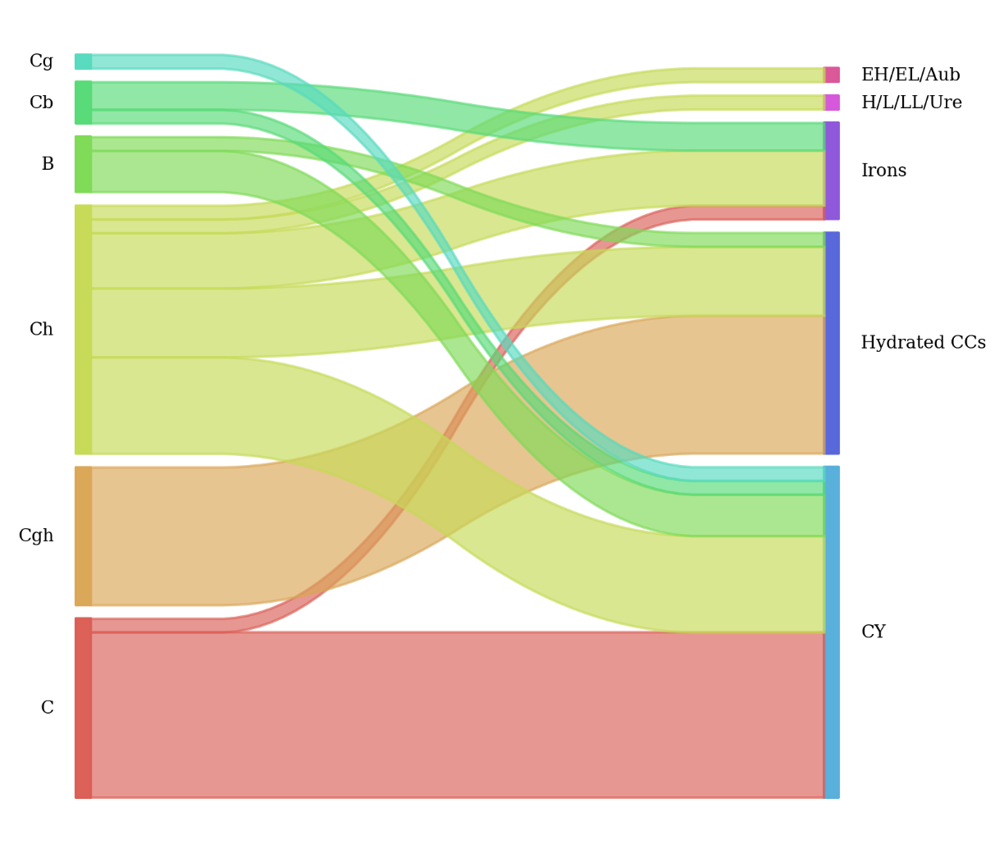
Asteroid classifications from the spectral mapping tool are listed in Table 1. Of the 49 low-albedo asteroids in the original dataset, 24 are classified as CY-like, 16 are classified as hydrated carbonaceous chondrite-like (hydrated CCs) and 7 are classified as Iron-like. The remaining two asteroids, (41) Daphne and (13) Egeria, are classified with ordinary chondrites and enstatite chondrites/aubrites respectively. These results are captured in Figure 1, which is a Sankey diagram of the Bus-DeMeo spectral classifications flowing to the spectral meteorite mapping tool results.
Figure 1: Sankey diagram of low-albedo asteroids from the original Bus-DeMeo classification scheme. ~49% (24/49) of these asteroids classify as CY-like asteroids, indicating the presence of aqueous alteration and thermal metamorphism.

A significant fraction of the low-albedo asteroids (49%) in this dataset have experienced both aqueous alteration and thermal metamorphism. There is no apparent relationship between bulk mineralogy and perihelion distance (Figure 2), which suggests that solar radiation is not playing a significant role as the heat source for these asteroids. Impacts are more likely to be the heat source for the observed thermal metamorphism.

There are also no apparent relationships among the resultant classification versus bulk mineralogy, orbital eccentricity, or inclination (Figure 3, left). Size also does not seem to be related to bulk mineralogy (Figure 3, right).

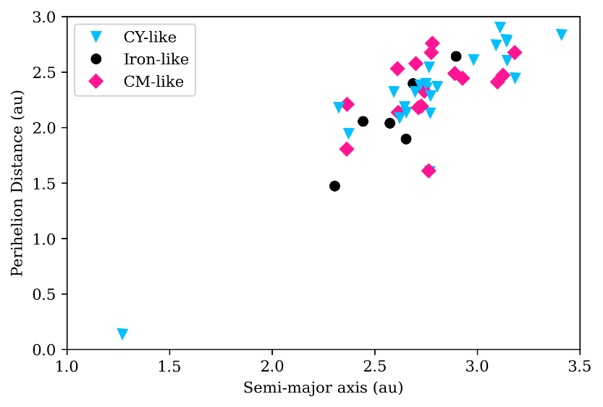
Figure 2: Semi-major axis vs. perihelion distance for the 49 Bus-DeMeo low-albedo asteroids. CY-like, hydrated C-like and Iron-like asteroids are indistinguishable from each other and neither group indicates a preference for perihelion distance.

Implications:

Results of this work indicate that a significant fraction of low-albedo main-belt asteroids have experienced both aqueous alteration and thermal processing. Asteroids with these complex histories have been hiding in plain sight all along. Our machine learning approach, rooted in laboratory measurements of meteorites, allows them to be identified as such for the first time.

Impact heating is the most likely driver of the thermal metamorphism observed on the CY-like asteroids. As shown in Figure 2, the CY-like asteroids do not have especially small perihelion distances nor is there a relationship with CY-like asteroids and semi-major axis (Figure 2 and Figure 3, right). While solar radiation may also drive thermal processing to near-Earth asteroids, this work indicates that there is a large population of asteroids that experienced impact driven heating in the Main Belt.

The current paradigm in planetary science is that low-albedo asteroids were likely brought into the inner solar system during giant planet migration (Walsh et al., 2011). Low-albedo asteroids are thought to be more primordial than higher albedo inner main belt asteroids, which tend to be in the S-complex and do not seem to have formed with significant coaccreted water. The results of this analysis suggest that there is a subpopulation of low-albedo material that experienced a more extensive impact history. Impacts in the inner solar system are more frequent and occur at higher velocities compared to the outer solar system.

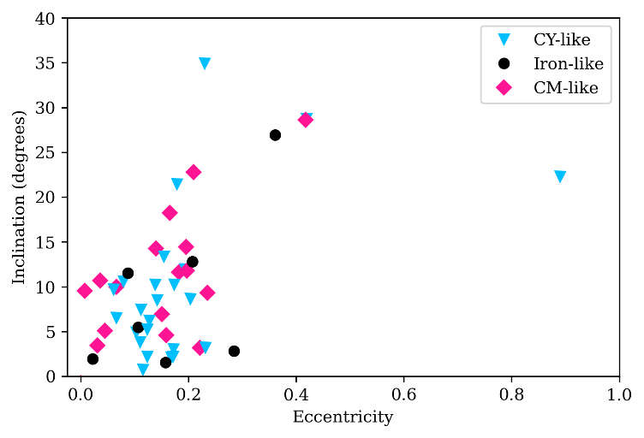
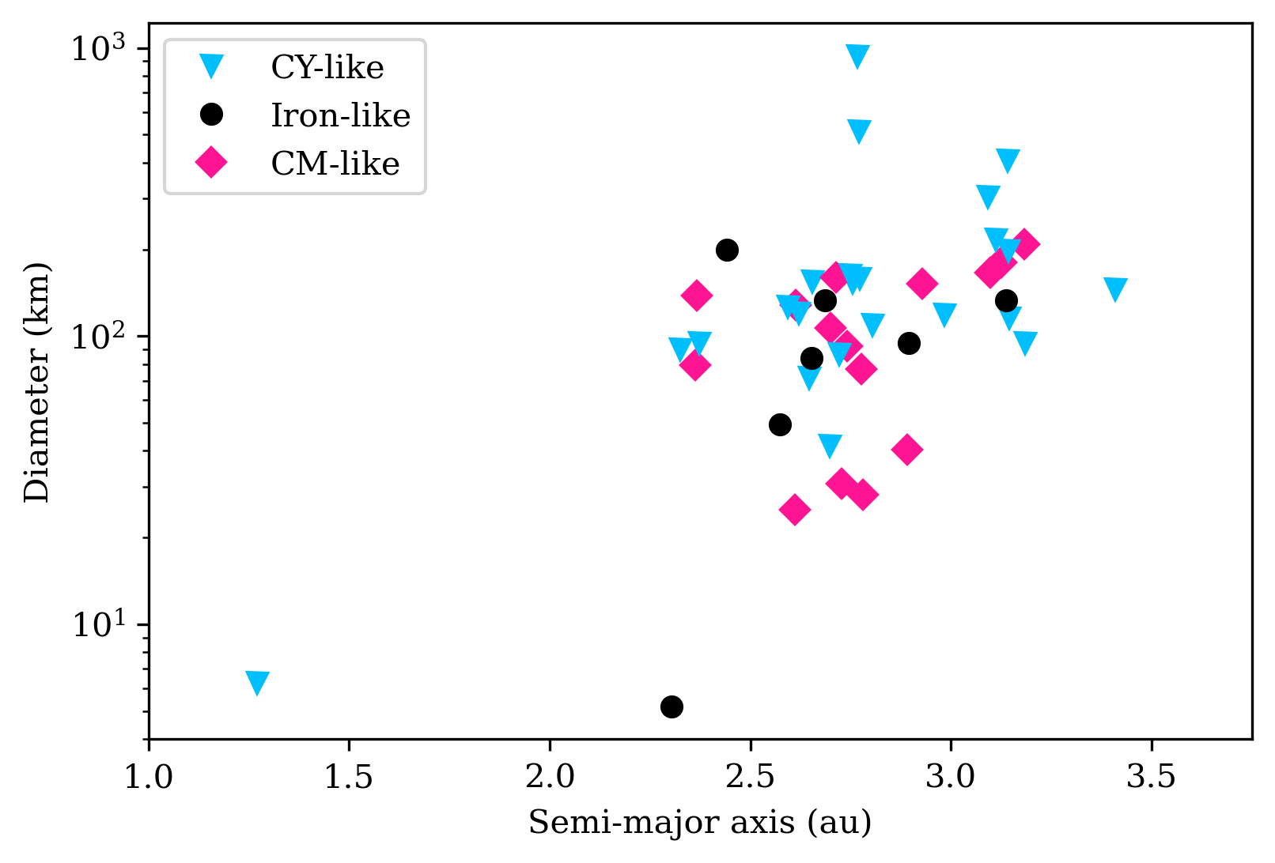
These results imply that there is a large subpopulation of aqueously altered and thermally metamorphosed asteroids in the main belt. They may represent a primordial population of low-albedo material that formed in situ rather than being brought into the inner solar system during giant planet migration. Asteroids that formed in situ would have experienced a larger number of impacts and impacts with higher velocity than in the outer solar system, where collisions are far more infrequent and occur at lower speeds. CY-like asteroids may therefore represent remnant disk material that survived giant planet migration.
Figure 3: (left) low-albedo asteroids orbital eccentricity vs. inclination. There are no apparent correlations between these orbital parameters and composition. (Right) semi-major axis vs diameter (y-axis is on a logarithmic scale). There are no apparent relationships between composition and asteroid size or location in the asteroid belt.

Conclusions:

A machine learning approach first published by Dyar et al., (2023) was used to classify the low-albedo C-complex asteroids as identified in (DeMeo et al., 2009). We modified the Dyar et al. (2023) approach to add more training data, and included two new training classifications to the training dataset, and balancing the training data to improve accuracy. Using this machine learning tool, it can be seen that ~49% of the low-albedo C-complex asteroids are spectrally consistent with aqueously altered and thermally metamorphosed meteorites. For the first time, a large population of asteroids is identified that have experienced both processes. The fact that so many CY-like asteroids (those with aqueous alteration and thermal metamorphism) are identified and the lack of correlation between perihelion distance and semi-major axis indicates that impacts are the most likely heating source for these asteroids. Solar radiation may also be affecting near-Earth asteroids but impacts seem to be a significant heat source for the numerous Main Belt objects in this study. These newly discovered CY-like asteroids may represent a population of low-albedo asteroids that formed in situ in the inner solar system. Low-albedo asteroids are hypothesized to have formed in the outer disk and were later implanted during giant planet migration. We suggest that the low-albedo asteroids that are spectrally consistent with hydrated carbonaceous chondrites (rather than CYs) may have experienced this orbital evolution. However, CY-like asteroids seem to have experienced more impacts than those objects. Inner solar system impacts are more frequent and occur at higher relative velocities which could be the source of the extensive thermal processing on these CY-like asteroids.
Acknowledgements
We thank all the authors on Dyar et al., 2023, for their efforts and discussions at DarbyFest (2025), especially Squid and Tom Burbine.
This research was funded by the Asteroid Threat Awareness Program.

Availability Statement:
The balanced training dataset and full table results and asteroid characteristics will be published on Zenodo after article is accepted.
The 371 asteroid spectra that comprise the basis of the Bus-DeMeo spectral taxonomy can be found here: DeMeo, F., Binzel, R.P., Slivan, S.M., and Bus, S.J. (2020). Bus-DeMeo Asteroid Taxonomy V1.0. urn:nasa:pds:ast.bus-demeo.taxonomy::1.0. NASA Planetary Data System; https://doi.org/10.26033/089p-c283.
The software to create the balanced dataset and classify spectra can be found [we are finalizing the release of the software]

References

Akai, J., 1990. Mineralogical evidence of heating events in Antarctic carbonaceous chondrites, Y-86720 and Y-82162. In Proceedings of the NIPR Symposium on Antarctic Meteorites (Vol. 3, pp. 55-68). National Institute of Polar Research.
Bates, H.C., Donaldson Hanna, K.L., King, A.J., Bowles, N.E. and Russell, S.S., 2021. A spectral investigation of aqueously and thermally altered CM, CM‐An, and CY chondrites under simulated asteroid conditions for comparison with OSIRIS‐Rex and Hayabusa2 observations. Journal of Geophysical Research: Planets, 126(7), p.e2021JE006827.
Bell, J.F., 1989. Asteroids II, University of Arizona Press, pp. 921-944.
Burbine, T.H., Khanani, I., Kumawat, D., Hussain, A., Wallace, S.M. and Dyar, M.D., 2024. Testing the Bus–DeMeo Asteroid Taxonomy Using Meteorite Spectra. The Planetary Science Journal, 5(9), p.194.
Bus, S.J. and Binzel, R.P., 2002a. Phase I of the small main-belt asteroid spectroscopic survey: A feature-based taxonomy. Icarus 158, 146-177. https://doi.org/10.1006/icar.2002.6856
Bus, S.J. and Binzel, R.P., 2002b. Phase II of the small main-belt asteroid spectroscopic survey: The observations. Icarus 158, 106-145. https://doi.org/10.1006/icar.2002.6857
Chapman, C.R., Morrison, D., Zellner, M., 1975. Surface properties of asteroids : A synthesis of polarimetry, radiometry, and spectrophotometry. Icarus 25, 104-130. https://doi.org/10.1016/0019-1035(75)90191-8.
Cloutis, E.A., Hudon, P., Hiroi, T. and Gaffey, M.J., 2012. Spectral reflectance properties of carbonaceous chondrites 4: Aqueously altered and thermally metamorphosed meteorites. Icarus, 220(2), pp.586-617.
DeMeo, F., Binzel, R.P., Slivan, S.M., and Bus, S.J. (2020). Bus-DeMeo Asteroid Taxonomy V1.0. urn:nasa:pds:ast.bus-demeo.taxonomy::1.0. NASA Planetary Data System; https://doi.org/10.26033/089p-c283.
DeMeo, F.E., Binzel, R.P., Slivan, S.M., Bus, S.J., 2009. An extension of the Bus asteroid taxonomy into the near-infrared. Icarus 202, 160-180. https://doi.org/10.1016/j.icarus.2009.02.005
DeMeo, F.E., Carry, B., 2014. Solar System evolution from compositional mapping of the asteroid belt. Nature, 505, 629–634. https://doi.org/10.1038/nature12908.
Dyar, M.D., Wallace, S.M., Burbine, T.H. and Sheldon, D.R., 2023. A machine learning classification of meteorite spectra applied to understanding asteroids. Icarus, 406, p.115718.
Ebihara, M., Shirai, N., Osawa, T. and Yamaguchi, A., 2025. Chemical characteristics of the Yamato-type (CY) carbonaceous chondrites. Geochimica et Cosmochimica Acta, 389, pp.200-210.
Ikeda, Y., 1992. An overview of the research consortium," Antarctic carbonaceous chondrites with CI affinities, Yamato-86720, Yamato-82162, andBelgica-7904. In Proceedings of the NIPR Symposium on Antarctic Meteorites (Vol. 5, pp. 49-73). National Institute of Polar Research.
Jenkins, L.E., 2024. Physical and chemical alteration of material from C-Complex asteroids (Doctoral dissertation, University of Glasgow).
Keller, L. P., Messenger, S. (2011) On the origins of GEMS grains. Geochimica et Cosmochemica Acta, 75, 5336-5365.
Kimura, M., Weisberg, M.K. and Yamaguchi, A., 2024. Subtype 3.0 chondrites: Petrologic classification criteria. Meteoritics & Planetary Science, 59(4), pp.858-877.
King, A.J., Schofield, P.F. and Russell, S.S., 2021. Thermal alteration of CM carbonaceous chondrites: Mineralogical changes and metamorphic temperatures. Geochimica et Cosmochimica Acta, 298, pp.167-190.
McAdam, M.M., Sunshine, J.M., Howard, K.T., Alexander, C.M., McCoy, T.J. and Bus, S.J., 2018. Spectral evidence for amorphous silicates in least-processed CO meteorites and their parent bodies. Icarus, 306, pp.32-49.
McCord, T.B., Adams, J.B., Johnson, T.V., 1970. Asteroid Vesta: Spectral reflectivity and compositional implications. Science 168, 1445–1447. https://doi.org/10.1126
Messenger, S., Nakamura-Messenger, K., Keller, L. P., Clemett, S. J. (2015) Report: Pristine stratospheric collection of interplanetary dust on an oil-free polyurethane foam substrate. Meteoritics and Planetary Science, 50, N. 8, 1468-1485.
Nath, R., Mali, S., K, D., Panwar, N., Verma, A.J., Kumar, A., Mahajan, R.R., Basu Sarbadhikari, A., Varela, M.E., Ehgamberdiev, S.A. and Kapadia, T., 2025. Classifying meteorites with MetNet: A deep learning approach using reflectance spectroscopy. Meteoritics & Planetary Science, 60(5), pp.1063-1072.
Quirico, E., Bonal, L., Beck, P., Alexander, C.D., Yabuta, H., Nakamura, T., Nakato, A., Flandinet, L., Montagnac, G., Schmitt-Kopplin, P. and Herd, C.D.K., 2018. Prevalence and nature of heating processes in CM and C2-ungrouped chondrites as revealed by insoluble organic matter. Geochimica et Cosmochimica Acta, 241, pp.17-37.
Schrader, D.L., Torrano, Z.A., Foustoukos, D.I., Alexander, C.M.D., Render, J. and Brennecka, G.A., 2025. Reassessing the proposed “CY chondrites”: Evidence for multiple meteorite types and parent bodies from Cr-Ti-HCN isotopes and bulk elemental compositions. Geochimica et Cosmochimica Acta, 390, pp.24-37.
Suttle, M.D., King, A.J., Harrison, C.S., Chan, Q.H.S., Greshake, A., Bartoschewitz, R., Tomkins, A.G., Salge, T., Schofield, P.F. and Russell, S.S., 2023. The mineralogy and alteration history of the Yamato-type (CY) carbonaceous chondrites. Geochimica et Cosmochimica Acta, 361, pp.245-264.
Suttle, M.D., King, A.J., Harrison, C.S., Chan, Q.H.S., Greshake, A., Bartoschewitz, R., Tomkins, A.G., Salge, T., Schofield, P.F. and Russell, S.S., 2023. The mineralogy and alteration history of the Yamato-type (CY) carbonaceous chondrites. Geochimica et Cosmochimica Acta, 361, pp.245-264.
Tholen, D.J., 1984. Asteroid taxonomy from cluster analysis of photometry. PhD Thesis, University of Arizona, 166 pp.
Tonui, E., Zolensky, M., Hiroi, T., Nakamura, T., Lipschutz, M.E., Wang, M.S. and Okudaira, K., 2014. Petrographic, chemical and spectroscopic evidence for thermal metamorphism in carbonaceous chondrites I: CI and CM chondrites. Geochimica et Cosmochimica Acta, 126, pp.284-306.
Walsh, K.J., Morbidelli, A., Raymond, S.N., O'Brien, D.P. and Mandell, A.M., 2011. A low mass for Mars from Jupiter’s early gas-driven migration. Nature, 475(7355), pp.206-209.
Weisberg, M.K., McCoy, T.J. and Krot, A.N., 2006. Systematics and evaluation of meteorite classification. Meteorites and the early solar system II, 19, pp.19-52.
Supplemental Material

CY Meteorite Spectral Properties

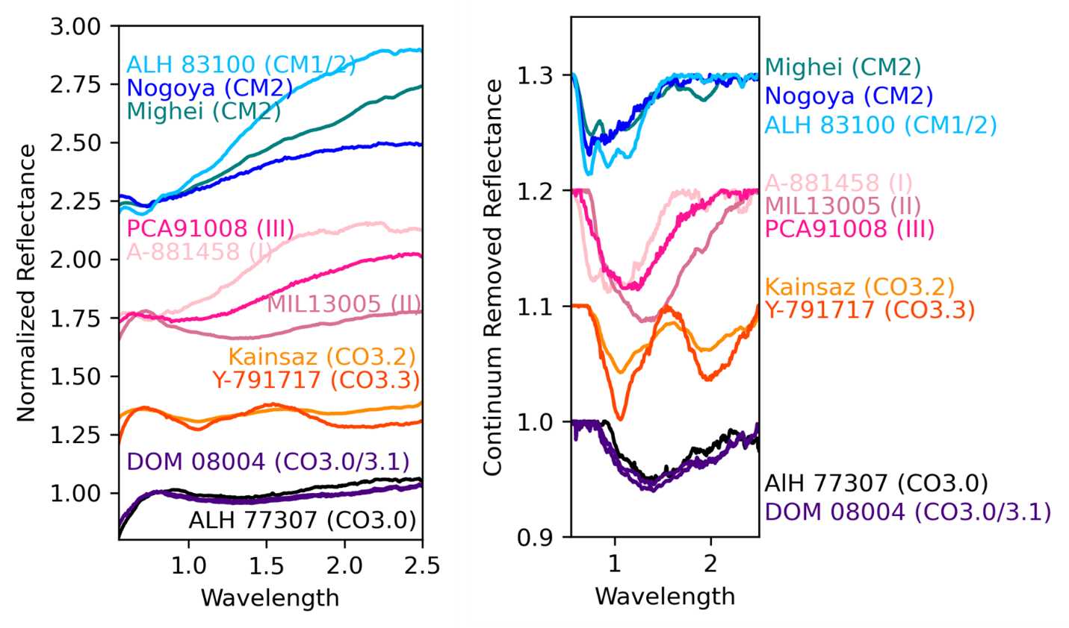
Since the early 1980s, around 55 unique meteorites with aqueously alteration and heating have been identified (based on the authors’ literature review). Previous spectral studies have investigated a small fraction of these samples (e.g., Bates et al., 2021, Cloutis et al., 2012). Bates et al., (2023) investigated the 3-µm region and the mid-infrared. Cloutis et al., (2012) found that aqueously altered and heated carbonaceous chondrites are diverse in the near-infrared.
Figure 1: Example spectra of different carbonaceous chondrite groups. (Left) Normalized and offset near-infrared spectra, (Right) continuum removed near-infrared spectra. Top spectra in blue are CM representatives. The type member (Mighei), Nagoya (an unusual CM) and ALH 83100 (an Antarctic find) are typical CM spectra. CMs can have variable red slopes and typically a 0.7-𝜇m feature. Pink spectra show three CY meteorites. A-881458 is a mildly heated (stage 1) CY, MIL13005 is a moderately heated (stage II) and PCA 91008 is extensively heated (stage III). These samples show the characteristic 1.2-𝜇m feature. They can also have variable slopes. Kainsaz and Y-791717 are both anhydrous carbonaceous chondrites in the CO group. Though only mildly heated, they show characteristic olive and pyroxene bands reflecting their anhydrous, mafic mineralogy. At the bottom, two primitive carbonaceous chondrites are shown (ALH 77307 and DOM 08004). These meteorites have abundant amorphous silicates which condensed directly from the solar nebula and have remained largely unchanged since. They have a characteristic 1.4-𝜇m feature.

Approximately 26 of the 55 samples were measured by RELAB in the near-infrared. We have ~90 spectra of CY meteorites. Frequently, it appears these samples were characterized because they were unusual and were included in other studies of aqueously altered meteorites. Now however, we can comprehensively investigate the near-infrared properties of CY meteorites because there is a significant number of samples in the archive.

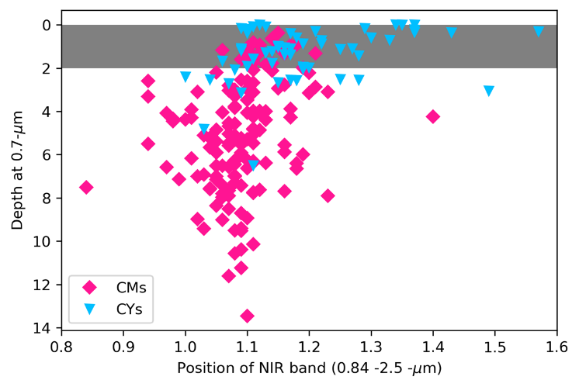
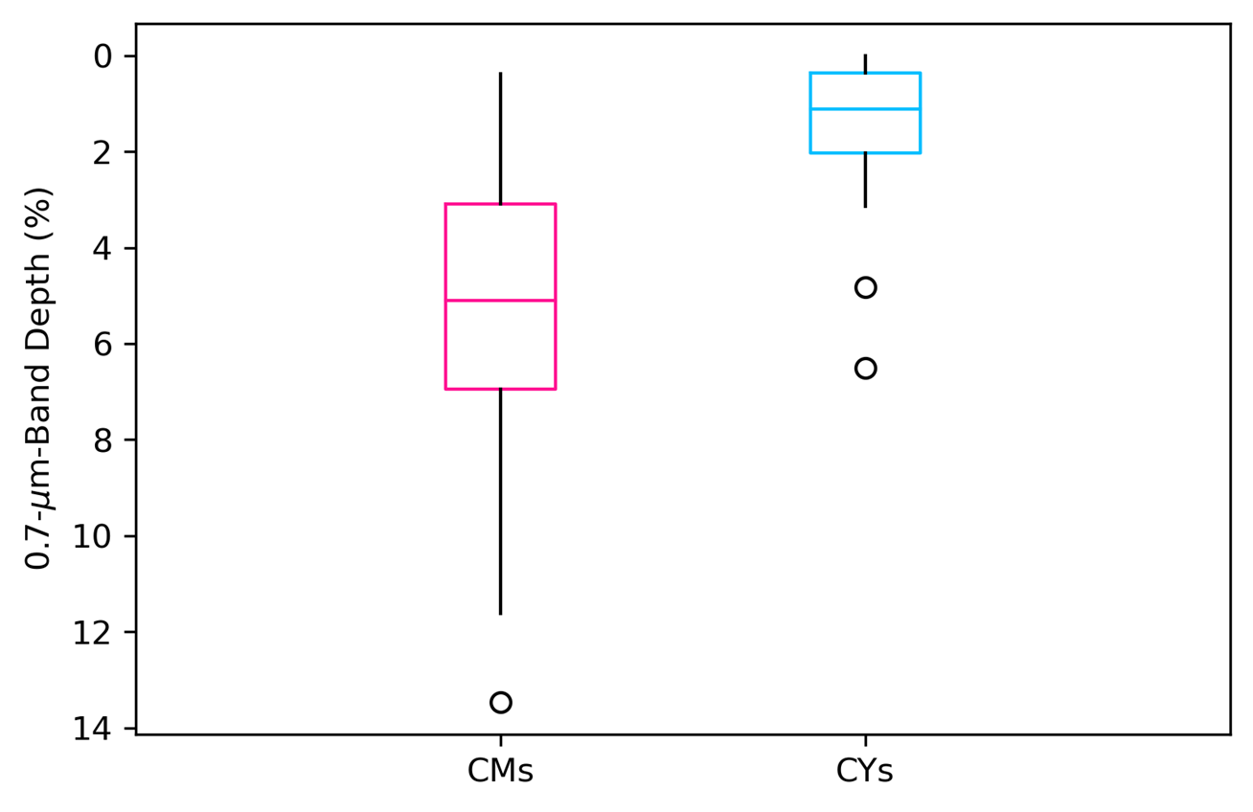
Figure 1 shows several representative spectra of CMs, CYs, primitive carbonaceous chondrites and anhydrous carbonaceous chondrites. The characteristic near-infrared feature of CMs is the 0.7-𝛍m charge transfer band (Figure 2). We find that 86% of CMs (127 of 148 spectra) have this feature with an average depth of 5.5%. CY meteorites typically do not have the 0.7-𝛍m feature. We find that 77 of 90 the CYs in the dataset have a band depth at 0.7-𝛍m of <2% which we consider to be featureless. On average, CYs have a band depth of 1.5% at 0.7-𝛍m. (Figure 3). We conclude that the 0.7-µm charge transfer band is characteristic of meteorites that have only experienced aqueous alteration or very mild thermal metamorphism (e.g., stage I). This is consistent with the result of (28) who found that the 0.7-µm band was most prominent in the least-heated samples and the depth of this band decreases with increasing heating.
Figure 2: (left) The 0.7-𝜇m band depth for CM and CY meteorites. (right) Box plot of 0.7-𝜇m band depths for CM and CY meteorites. (Left). Here, the band depth at 0.7-𝜇m is plotted against the position of the near-infrared band. The 0.7-𝜇m band is calculated using continuum removed data. Using the continuum removed data, we fit a 4th order polynomial to the near-infrared region (0.82-2.5-𝜇m) and calculate the depth of the near-infrared band at the minimum of the polynomial function. 127 of the 148 CM spectra (86%) have a 0.7-𝜇m band. On average, the 0.7-𝜇m band is 5.12% (standard deviation of 2.62%). CYs in contrast have an average band depth of 1.36% (standard deviation of 1.22%). Only 13 of the 90 spectra exhibit a 0.7-𝜇m with a band depth greater than 2%. We consider any band depths of <2% to be featureless. CYs largely do not exhibit 0.7-µm features.

CY meteorites commonly exhibit a broad, weak 1.2-𝛍m feature that can be seen using a convex-hull continuum removal (Figure 1 right). Fitting the near-infrared features of CMs, CYs and primitive carbonaceous chondrites with a 4th order polynomial allows us to determine the band center and depth (Figure 3). The heating process dehydroxylates the phyllosilicates produced during aqueous alteration, leaving behind poorly ordered amorphous phases. Though they have a different formation mechanism, the amorphous silicates in CY meteorites can produce similar spectral features to the primitive carbonaceous chondrites. There is some overlap between CYs and primitive carbonaceous chondrites. However, CYs typically have bands intermediate between hydrated carbonaceous chondrites and primitive carbonaceous chondrites (CPs).

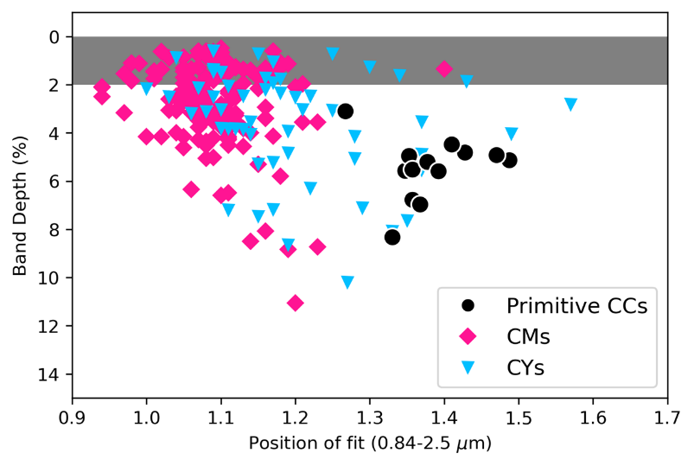
In summary, CY meteorites are spectrally distinct from aqueously altered meteorites, primitive carbonaceous chondrites, and anhydrous carbonaceous chondrites. This is the first comprehensive investigation of CY meteorite spectra which was enabled by archived data.
Figure 3: CM, CY and primitive carbonaceous chondrite band position and depth of the near-infrared features. Here we take the continuum removed near-infrared feature (0.82-2.5-𝜇m), fit with a 4th order polynomial and determine the position of the minimum and depth of the feature by subtracting the value of the spectrum at the minimum from unity. The results show that CMs are distinct from primitive carbonaceous chondrites which have a 1.4-𝜇m feature of ~3-8% depth. CYs are intermediate between the two groups. The heating process dehydroxylated the phyllosilicates leaving behind amorphous silicates. Though the formation of amorphous silicates is distinct for primitive carbonaceous chondrites, the spectral features can be similar.

Balancing Training Data

Figure 4 shows an illustration of the training data. Each classification group in the training data set has 1-4 chemical groups of meteorites included. They are grouped based on their textural and mineralogical similarities. Figure 4 shows how the different classification groups can have wildly different numbers of spectra. We force the training dataset to have ~105 spectra per classification group and also to equally sample from each of the chemical groups. The right side of Figure 3 illustrates this. Table1 below describes the meteorite chemical groups and the number of spectra from each group in the raw dataset. Table 2 describes the spectral similarities of each classification group.

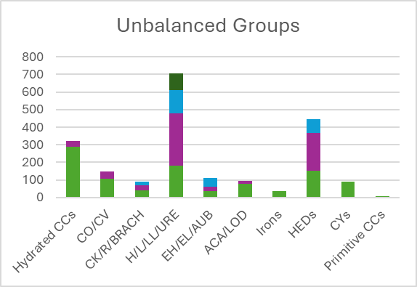
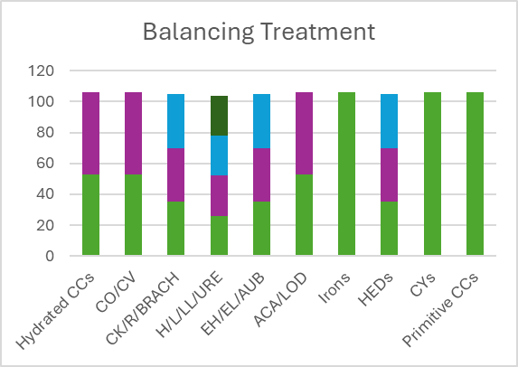
Figure 4: Schematic representation of balancing treatment. The training dataset from RELAB is highly unbalanced (top). Ordinary chondrites (H/L/LL) have been measured with much greater frequency than primitive carbonaceous chondrites or irons primarily because there are many more ordinary chondrites to measure. The training data are grouped based on primary mineralogy and spectral similarity. Then each group is over/under sampled to create a balanced dataset. Each meteorite chemical type is also balanced such that the balanced groups have equal representation from all of the meteorite chemical types. This is represented in the bottom figure. Table 1 contains the number of spectra from each meteorite group.
Table 1: Meteorite Group Mineralogy Descriptions (modified from [22]):
Types | number of spectra | major mineral components
CMs | 288 | Fe-Mg serpentines, clumps of tochilinite/cronstedtite, sulfides, magnetite. Chondrules contain olivine, low-Ca clinopyroxene, and isotropic glassy mesostases.
CR | 33 | Olivine, low-Ca pyroxene, metallic FeNi, troilite, FeNi sulfides, FeMg serpentines, and magnetite.
CO | 41 | Olivine, low Ca-pyroxene and pigeonite, feldspathic glass, metallic FeNi, and minor sulfides, and CAIs
CV | 107 | Olivine, low-Ca pyroxene, glass, metallic FeNi, troilite, anorthite, and CAIs
CK | 40 | Olivine, low-Ca pyroxene, anorthite, diopside, fassaite, magnetite, pentlandite, and CAIs
R | 29 | Abundant olivine, less abundant in low-Ca pyroxene. Can also contain pigeonite, augite, diopside, albite or oligoclase, and spinel
Brachinites | 22 | Olivine-dominated, Ca-pyroxene, chromite, plagioclase, Fe-sulfides
H | 181 | olivine, low-Ca pyroxene, pigeonite, FeNi metal, troilite. Olivine much more abundant than pyroxenes. FeNi metal less abundant than L chondrites.
L | 297 | olivine, low-Ca pyroxene, pigeonite, FeNi metal, troilite. Olivine much more abundant than pyroxenes. FeNi metal less abundant than L chondrites.
LL | 134 | olivine, low-Ca pyroxene, pigeonite, FeNi metal, troilite. Olivine much more abundant than pyroxenes. FeNi metal less abundant than L chondrites.
Urelites | 96 | Low-Ca pyroxene, forsterite, calcic pyroxene, plagioclase, FeNi metal, sulfides
EH | 36 | Low-Ca pyroxene, forsterite, calcic pyroxene, plagioclase, FeNi metal, sulfides
EL | 26 | Low-Ca pyroxene, forsterite, calcic pyroxene, plagioclase, FeNi metal, sulfides
Aubrites | 48 | Enstatite-dominated, albite, diopside, forsterite, sulfides
Acapulcoites | 78 | Orthopyroxene, olivine, Cr-diopside, sodic plagioclase, FeNi metal, troilite.
Lodranites | 17 | Orthopyroxene, olivine, Cr-diopside, sodic plagioclase, FeNi metal, troilite. Coarser grained than acapulcoites.
IAB/IIAB | 28 | FeNi metal, tetrataenite, troilite, daubréelite, schreibersite
Howardites | 150 | Polymict breccias composed predominantly of eucritic and diogenitic clasts.
Eucrites | 215 | Igneous volcanic monomict rocks rich in pyroxene (pigeonite) and calcic plagioclase
Diogenites | 81 | Orthopyroxenite monomict rocks with <10% plagioclase and minor chromite, olivine, silica, pigeonite, and augite.
CY | 90 | Fe-Mg serpentines, amorphous phases, sometimes secondary olivines if heating is extensive enough
CO 3.0s | 17 | Amorphous silicates, olivine, low Ca-pyroxene and pigeonite, feldspathic glass, metallic FeNi, and minor sulfides, and CAIs

Table 2: Spectral Descriptions of Groups (modified from [21])
Group | spectral similarity
Hydrated carbonaceous chondrites (CM, CR) | relatively featureless spectra lacking major olivine and pyroxene features.
CO/CV | Relatively weak absorptions due to olivine and pyroxene
CK/R/Brach | Olivine, low Ca-pyroxene and pigeonite, feldspathic glass, metallic FeNi, and minor sulfides, and CAIs
H/L/LL/Ure | Absorption features due to olivine and pyroxene representing a continuum between varying amounts of olivine and pyroxene
EH/EL/Aub | Absorption features due to olivine and pyroxene representing a continuum between varying amounts of olivine and pyroxene
ACA/LOD | Orthopyroxene-dominated spectra
Irons | Featureless, slightly red spectra due to the abundance of FeNi and absence of silicates
HEDs | Continuous range of absorption features due to varying amounts of pyroxene
CYs | Weak feature centered at 1.2-microns. Absence of 0.7-micron charge transfer band.
Primitive carbonaceous chondrites | Weak feature centered at ~1.4 microns with 3-8% depth.

