A Simplified Model of VIPER Thermal Management System. Part I: Loop Heat Pipe
Ezequiel F. Medici
S&K Global Solutions, Houston, TX, 77058
Jodi C. Turk, and Elijah R. Stewart
NASA Marshall Space Flight Center, Huntsville, AL, 35812
Tim Page
Amentum Space Exploration Division, Huntsville, AL, 35812
Zane W. Mittag, Juan M. Barragan, Angel Alvarez-Hernandez
NASA Johnson Space Center, Houston, TX, 77058
NASA’s Volatiles Investigating Polar Exploration Rover (VIPER) uses a combination of loop heat pipes (LHPs) and heaters as the primary hardware to modulate the temperature of the electronic boxes and payloads instruments. LHPs have been designed and instrumented to be capable of passive and active shutdown. The goal of the passive shutdown, using a thermal control valve (TCV) to limit the flow of the working fluid, is to preserve thermal energy and avoid unnecessary heat leaks during lunar night. The goal of the active shutdown on the other hand, is to forcefully increase the vehicle internal temperature to bakeout the payload instruments. Several numerical modeling tools are available to analyze LHP performance under the complex set of operational requirements and environments levied on the VIPER Thermal Management System (TMS). Yet, while those numerical modeling tools are capable of detailed performance analysis, they tend to take large computational resources and long computational time. In this paper, a model of a single LHP developed based on control volume approach is presented. By using the control volume approach, the complex geometry of the LHP, and the components attached to it, are reduced to thermal lump capacitances, thus reducing the computation effort. This paper also describes the effort to correlate the proposed LHP model using thermal vacuum (TVAC) test data.

Acronyms and Nomenclature

A = area [m²]
c = heat capacity [J/(kgK)]
β = mass transport coefficient
CAD = computer aided drawing
CC = compensation chamber
CCHP = constant conductance heat pipe
CV = control volume
ε = emissivity
$ε^{*}$ = effective emissivity
E = energy stored in a control volume [W]
g = gravity [m/s²]
G = effective thermal conductance [W/K]
K = thermal conductance [W/(mK)]
k = permeability [m²]
EDU = engineering design unit
h = specific enthalpy [J/kg]
H = height [m]
L = length [m]
LHP = loop heat pipe
m = mass [kg]
$\dot{m}$ = mass flow rate [kg/s]
MLI = multi-layer insulation
NIST = National Institute of Standards and Technology
φ = TCV opening function
P = pressure [Pa]
PID = proportional integral derivative
Q = heat flow [W]
ρ = density [kg/m³]
σ = Stefan–Boltzmann constant [W/(m²K⁴)]
t = time [s]
T = Temperature [°C]
TC = thermocouple
TCV = thermal control valve
TMS = thermal management system
TVAC = thermal vacuum
μ = dynamic viscosity [m²/s]
VIPER = volatiles investigating polar exploration rover

Introduction
L
oop heat pipes are a proven reliable technology to effectively transport heat from a heat source to a heat sink¹. Generally, LHP’s functionality consists of boiling a working fluid at the heat source (the evaporator) and condensing it at the heat sink (the condenser), thus effectively transporting heat from one area to another. The evaporator is composed of a few layers of porous materials, called wicks, to enhance the boiling of the working fluid. Once the evaporated working fluid leaves the evaporator, it is transported to the condenser through a tube, called the vapor line. The condensed working liquid then returns to the evaporator through a different tube called the liquid line, making a closed loop system. There is also a reservoir of working fluid, called the compensation chamber (CC) that feeds (or removes) liquid working fluid to/from the evaporator.
Due to their versatile design and performance, LHPs have been proven practical in the aerospace industry^{1,2}, including the VIPER mission³. The VIPER rover utilizes four LHPs to remove waste electronic heat and maintain components within their narrow range of operating temperatures. The rover will also occasionally be exposed to extreme cold environments throughout the mission, like lunar permanent shadow regions and lunar nights⁵. During the cold segments of the mission, the LHPs should be capable of modulating the amount of heat transported out of the vehicle and reduce heat flow to a minimum. To accomplish minimum heat flow, every LHP was designed with a thermal control valve (TCV) that passively interrupts the flow of the working fluid from the evaporator to the condenser when the temperature drops below a certain threshold. The VIPER mission also requires bakeout for its payload instruments while in transit to the moon. To achieve bakeout temperatures, the four CC on each LHP are instrumented with a heater. Once the heater is activated, the CC temperature increases above the evaporator temperature, eventually interrupting the flow of working fluid which increases the internal temperature of the vehicle. Another requirement of VIPER LHPs is the capability to startup post lunar night.
Modeling and characterization of the LHP is essential for the mission success. While many thermal computational tools are available to model LHP performance under the previously mentioned requirements, like Thermal Desktop®, they tend to be computably costly to run when merged with the complete vehicle thermal model. While that might not be the major limiting factor when analyzing performance on a given segment of the mission where a high degree of fidelity is needed, this does become an issue when performance analysis is needed in short notice or real time simulations, like those dedicated to training the rover operators, where fidelity is sacrificed to expediate results. Alternatively, as described in this paper, an LHP model can be developed by simplifying its geometry and the complexities of two-phase flow using a control volume approach. The LHP can be reduced to just four thermal lump capacitance nodes, making it suitable for real time analysis. However, the model needs to be correlated; given the simplicity of the proposed LHP model, only a limited number of parameters can be adjusted to correlate the model, which reduces the correlation effort compared with correlating a full LHP model. To that end, several engineering design unit thermal vacuum (TVAC) tests have been carried out to characterize the LHP performance, anchor the design, and offer hands-on training for the mission thermal console personnel. Of special interest, has been the performance of single LHP at different thermal loads, environments, and instrumentations operating in a lunar-like environment, as described by Medici et. al⁵. That TVAC test data has been used to correlate the LHP model. The steps followed in the correlation process are also described in this paper.
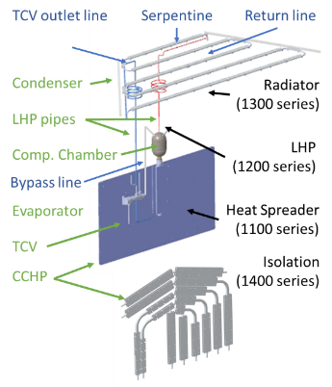
Figure 1. Schematic representation of the thermal management system subcomponent.

Model Description
The thermal management system (TMS) under study consists of a heat spreader, an LHP, and a face sheet radiator, Figure 1. The heat spreader is made of two aluminum face sheets encompassing a series of constant conductance heat pipes (CCHPs) which assist the heat transport. These CCHPs and their effect on heat transport are not modeled. The LHP consists of an evaporator, a TCV, a CC and a serpentine condenser. The serpentine condenser and the radiator face sheet are modeled as a single unit. A ¼” stainless steel tube, identified as the vapor line, connects the lower end of the evaporator to the TCV and the TCV to the serpentine condenser. Another ¼” stainless steel tube, identified as the liquid line, connects the serpentine condenser to the CC. The liquid and vapor lines allow the flow of working fluid, in this case propylene, to move through the system in a closed loop. The liquid and vapor lines are not modeled as physical entities, but the heat transported through them is modeled as a physical entity. A distinction must be made here between forward and reverse LHP flow working modes. While under nominal conditions, the LHP should operate in forward flow mode, meaning that the propylene vapor leaves the evaporator vapor plenum through the vapor line and passes through the TCV. Depending on temperature, the TCV can partially or fully divert the vapor flow into the CC and the radiator. The propylene condenses at the radiator, returning in liquid state to the evaporator through the liquid line. In reverse flow, the propylene liquid leaves the evaporator through the liquid line, forcing either the LHP to work in reverse or thermosyphon within the liquid line.
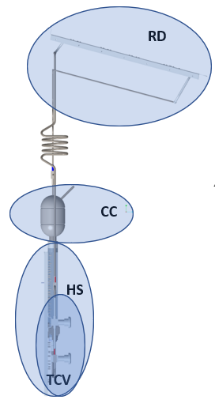
Figure 2. schematic representation of the LHP subcomponent and their control volumes. Notice that in this side view of the LHP the TCV-CV and the HS-CV seem to overlap which is not the case.
The control volume modeling approach was used to simulate the LHP performance under a broad range of thermal loads, thermal environments, and gravitational fields. In the control volume approach, the main LHP subcomponents were modeled as independent thermofluidic units capable of exchanging mass and energy between themselves and the surroundings as well as storing energy within their volume. The LHP model consisted of four control volumes (CV) as indicated in Figure 2:
#1: heat spreader and evaporator assembly CV, labeled as HS.
#2: compensation chamber CV, labeled as CC.
#3: radiator CV, labeled as RD.
#4: thermal control valve CV, labeled TCV.

Heat Spreader and Evaporator Assembly Control Volume
The HS-CV contains the mass of the heat spreader and evaporator, and energy stored within this control volume, $E_{HS}$, is modeled as lump capacitance.
$$\begin{aligned}E_{HS}=m_{HS}c_{A}\frac{dT_{HS}}{dt}\#\left(1\right)\end{aligned}$$
where $m_{HS}$ is the combined mass of the heat spreader and evaporator, $c_{A}$is the aluminum heat capacity, $T_{HS}$ is the HS-CV temperature, and $t$ is the time. The HS-CV can also exchange heat with the CC-CV by conduction through CC-evaporator collar, $Q_{HS-CC}$, and with the TCV-CV by conduction through the seat of the TCV, $Q_{HS_TCV}$, Figure 3, which are modeled as single conductors:
$$\begin{aligned}Q_{HS-CC}=G_{CC}\left(T_{HS}-T_{CC}\right)=\frac{{(K}_{SS}+K_{AL})A_{C}}{2L_{C}}\left(T_{HS}-T_{CC}\right) \#\left(2\right)\end{aligned}$$
$$\begin{aligned}Q_{HS-TCV}=G_{TCV}\left(T_{HS}-T_{TCV}\right) \#\left(3\right)\end{aligned}$$
where $A_{C}$ and $L_{C}$are the area and length of the collar, $K_{SS}$ and $K_{AL}$are thermal conductivities of stainless steel and aluminum, $G_{CC}$is the evaporator to CC effective conductance, and $G_{TCV}$is the heat spreader to TCV effective conductance, empirically modeled as a 0.5 W/°C when the LHP is in forward flow and 0.05 W/°C when the LHP is in reverse flow. The HS-CV can also receive external energy in the form of heat through heaters or electronic waste heat from components located on the heat spreader face sheet, $Q_{HS}$. The HS-CV can also transfer heat to the radiator as vapor flows through the vapor line when the LHP is in forward flow mode or through the liquid line when the LHP is reverse flow mode, $Q_{HS-RD}$. For modeling simplification purposes, when the LHP is in forward flow, ${\left.Q_{HS-RD}\right|}_{F}$ is equal to maximum heat that can be transported between the evaporator and radiator. Thermodynamically, that transported heat can’t exceed the maximum heat capable of being dissipated at the radiator through radiation to the sky. That theoretical maximum heat is reached when the radiator temperature is equal to the evaporator temperature. In practice, that maximum heat is even smaller due to two phase flow transport limitations. For modeling purposes, those limitations are captured as an effective transport coefficient $β_{T}$.
$$\begin{aligned}{\left.Q_{HS-RD}\right|}_{forward}=φ_{TCV}β_{T}\left[σε_{RD}A_{RD}\left(T_{HS}^{4}-T_{Sky}^{4}\right)-Q_{RD}\right] \#\left(4\right)\end{aligned}$$
where $σ$ is Stefan–Boltzmann constant, $ε_{RD}$ is radiator effective emissivity, $A_{RD}$ is radiator effective area, $T_{sky}$ is the temperature of deep sky, $Q_{RD}$ is the radiator heaters thermal load, and $φ_{TCV}$ is a function ranging from 0 to 1 that dictates how much flow the TCV is allowing to flow though the LHP.
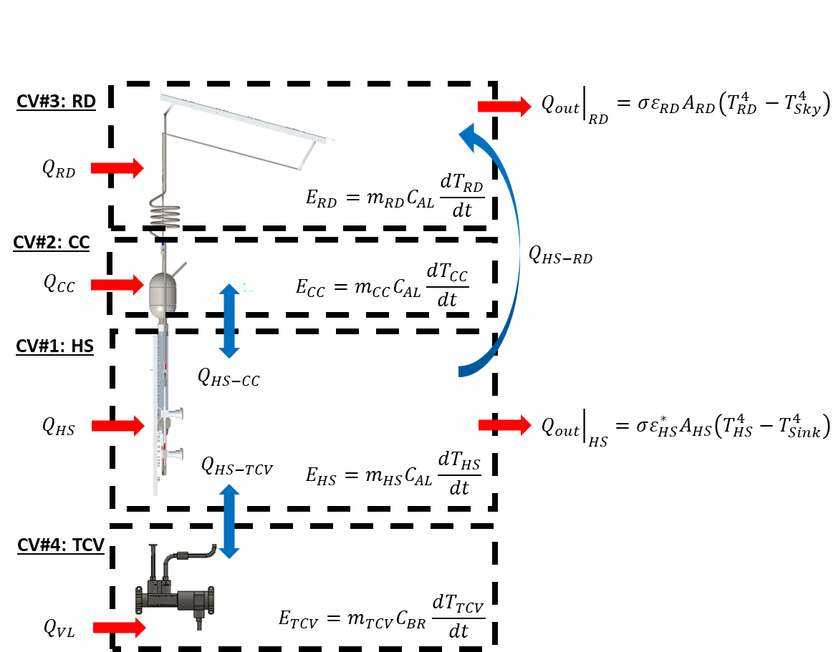
Figure 3: Control volume discretization of the LHP model indicating the heat fluxes between control volumes, energy exchange with the environment, energy stored internally, and energy input in the form of heat.
The mass flow rate of propylene through the LHP, ${\dot{m}}_{LHP}$, while in forward flow, is calculated as follows:
$$\begin{aligned}{\left.{\dot{m}}_{LHP}\right|}_{F}=\frac{{\left.Q_{HS-RD}\right|}_{F}}{h_{fg}} \#\left(5\right)\end{aligned}$$
where, $h_{fg}$is the specify enthalpy of propylene at $T_{HS}$ temperature. On the contrary, when the LHP is in reverse flow mode, ${\left.Q_{HS-RD}\right|}_{R}$ is driven by the buoyancy pressure, $∆P$, along the liquid line:
$$\begin{aligned}∆P=g\left(ρ_{HS}-ρ_{RD}\right)H \#\left(6\right)\end{aligned}$$
where, $g$ is the gravity, $ρ_{HS}$ and $ρ_{RD}$ are the density of liquid propylene at evaporator and radiator temperatures, and $H⁡$is the height difference between the evaporator and the radiator. The flow induced by this pressure gradient is restricted by the reverse flow passing through the evaporator wick, which can be modeled as Darcy flow. Therefore, the mass flow rate of propylene in reverse flow becomes:
$$\begin{aligned}{\left.{\dot{m}}_{LHP}\right|}_{R}=ρ_{HS}A_{p}\frac{k_{w}∆P}{μL_{w}} \#\left(7\right)\end{aligned}$$
where, $A_{p}$ is the cross-sectional area of the liquid tubing, $k_{w}$ is the wick permeability, $μ$ viscosity of the liquid propylene, and $L_{w}$is the effective length of the wick. This mass flow rate of propylene carries a sensible heat to the radiator in the form of:
$$\begin{aligned}{\left.Q_{HS-RD}\right|}_{R}={\left.{\dot{m}}_{LHP}\right|}_{R}c_{P}\left(T_{HS}-T_{RD}\right) \#\left(8\right)\end{aligned}$$
where, $c_{P}$ is the propylene heat capacity and $T_{RD}$ is the temperature of the RD-CV.
This CV can also exchange radiative heat to the environment primordial through the surface of the heat spreader, which is covered with multi-layer insulation (MLI), ${\left.Q_{out}\right|}_{HS}$:
$$\begin{aligned}{\left.Q_{out}\right|}_{HS}=σε_{HS}^{*}A_{HS}\left(T_{HS}^{4}-T_{Sink}^{4}\right) \#\left(9\right)\end{aligned}⁡$$
where, $A_{HS}$ is the area of the heat spreader (this area should include both sides of the heat spreader) and $T_{sink}$ is the temperature of the surrounding environment. The effect of the MLI in the heat transfer rate is captured in the effective MLI emissivity $ε_{HS}^{*}$.

Compensation Chamber Control Volume
The CC-CV contains the mass of the compensation chamber, and it can only exchange heat with the HS-CV by conduction through CC-evaporator collar, $Q_{HS-CC}$, described earlier, Figure 3 Left. The CC-CV can also receive external energy in the form of heat through heaters located on the external surface of the CC, ${\left.Q_{in}\right|}_{CC}$. The energy stored within the CC-CV control volume, $E_{CC}$, is modeled as lump capacitance:
$$\begin{aligned}E_{CC}=m_{CC}c_{A}\frac{dT_{CC}}{dt} \#\left(10\right)\end{aligned}$$
where $m_{CC}$ is the mass of CC, and $T_{CC}$ is the CC-CV temperature. The heat exchange between the CC and the radiator through the LHP liquid line is neglected.

Radiator Control Volume
The RD-CV contains the mass of the radiator face sheet and the condenser serpentine, and it can receive heat from the LHP evaporator through the vapor or liquid lines depending on the LHP being in forward or reverse flow modes, $Q_{HS-RD}$ , described earlier, Figure 3 Left. The energy stored within this control volume, $E_{RD}$, is modeled as lump capacitance:
$$\begin{aligned}E_{RD}=m_{RD}c_{A}\frac{dT_{RD}}{dt} \#\left(11\right)\end{aligned}$$
where $m_{RD}$ is the mass of radiator assembly, and $T_{RD}$ is the RD-CV temperature. This CV can also exchange radiative heat to the environment (sky) through its top surface, ${\left.Q_{out}\right|}_{RD},$ while the heat leak through its bottom surface covered with MLI is ignored:
$$\begin{aligned}{\left.Q_{out}\right|}_{RD}=σε_{RD}^{}A_{RD}\left(T_{RD}^{4}-T_{Sky}^{4}\right) \#\left(12\right)\end{aligned}$$
where, $ε_{RD}^{}$ is the radiator effective emissivity and $A_{RD}$ is the area of the radiator. The RD-CV can also receive external energy in the form of heat through heaters located on its bottom surface, $Q_{RD}$.

Thermal Control Valve Control Volume
The TCV-CV contains the mass of the TCV, and it can only exchange heat with the HS-CV by conduction through the seat of the TCV, $Q_{HS_TCV}$, described earlier, Figure 3 Left. The energy stored within this control volume, $E_{TCV}$, is modeled as lump capacitance:
$$\begin{aligned}E_{TCV}=m_{TCV}c_{B}\frac{dT_{TCV}}{dt} \#\left(13\right)\end{aligned}$$
where $m_{TCV}$ is the mass of the TCV, $c_{B}$is the brass heat capacity, $T_{TCV}$ is the TCV-CV temperature.

Single LHP Model System of Equations
By solving the energy balance around each CV in the form of energy stored = energy in - energy out, using the heat fluxes defined per control volume, results in a system of four coupled differential equations:
$$\begin{aligned}\frac{dT_{HS}}{dt}=\frac{Q_{HS}}{m_{HS}c_{A}}-\frac{G_{CC}}{m_{HS}c_{A}}\left(T_{HS}-T_{CC}\right)-\frac{G_{TCV}}{m_{HS}c_{A}}\left(T_{HS}-T_{TCV}\right)-\frac{Q_{HS-RD}}{m_{HS}c_{A}}-\frac{σε_{HS}^{*}A_{HS}}{m_{HS}c_{A}}\left(T_{HS}^{4}-T_{Sink}^{4}\right) \#\left(14\right)\end{aligned}$$
$$\begin{aligned}\frac{dT_{CC}}{dt}=\frac{Q_{CC}}{m_{CC}c_{A}}+\frac{G_{CC}}{m_{CC}c_{A}}\left(T_{HS}-T_{CC}\right) \#\left(15\right)\end{aligned}$$
$$\begin{aligned}\frac{dT_{RD}}{dt}=\frac{Q_{RD}}{m_{RD}c_{A}}+\frac{Q_{HS-RD}}{m_{RD}c_{A}}-\frac{σε_{RD}^{}A_{RD}}{m_{RD}c_{A}}\left(T_{RD}^{4}-T_{Sky}^{4}\right) \#\left(16\right)\end{aligned}$$
$\begin{aligned}\frac{dT_{TCV}}{dt}=\frac{G_{TCV}}{m_{TCV}c_{B}}\left(T_{HS}-T_{TCV}\right)\#\left(17\right)\end{aligned}$
This system of equations was implemented in Octave and solved using Runge-Kutta 2-3. The geometrical design parameters were taken from the vehicle computer aided drawing (CAD) assembly and the material properties for propelyne and ammonia working fluids were taken from the National Institute of Standards and Technology (NIST) ThermoData Engine online database.

VIPER’s Single LHP Model Correlation
To correlate the single LHP model, test data from VIPER’s single LHP thermal vacuum (TVAC) test was used. For more details on the test configuration and data analysis please refer to E. F. Medici et all⁵. In summary, the TVAC test consisted of four main test segments: cold survival, LHP startup, steady operations, and LHP hot shutdown. During cold survival, the heat spreader-evaporator assembly was maintained at -22.2°C using the heaters located on the heat spreader itself. The heater power was modulated using a proportional-integral-derivative (PID) control system. The resulting power needed to maintain the heat spreader at -22.2°C was 10.6 W while radiator surface temperature was at -145.8°C and the sink temperature as measured on the vacuum chamber shroud was -148°C. It is worth noticing that during cold survival, the LHP was in reverse flow mode as described earlier. To match both quantities, the radiator temperature and the cold survival power, the MLI effective emissivity, $ε_{HS}^{*}$, and the radiator emissivity $ε_{RD}^{}$ were adjusted until the model predicted 10.5 W heat dissipation. The resulting modeling values for $ε_{HS}^{*}$, $ε_{RD}^{}$ were 0.04 and 0.9 while the predicted radiator temperature was -141.5°C. Figure 4 shows the good agreement between the measured and the predicted transient temperature profile from operational to survival at the radiator and evaporator after adjusting $ε_{HS}^{*}$ and $ε_{RD}^{}$.
Within the steady state test segment, an additional test was performed at a higher thermal load, 200 W, to drive the TCV above its fully open, $φ_{TCV}=1$, temperature set point and analyze the performance. Temperature data from this segment was used to determine the transport limitation coefficient $β_{T}$. The resulting modeling value for $β_{T}$ that generated acceptable radiator and evaporator temperature profiles was 0.9. The transient temperature comparison between test data and modeling prediction is shown Figure 5.

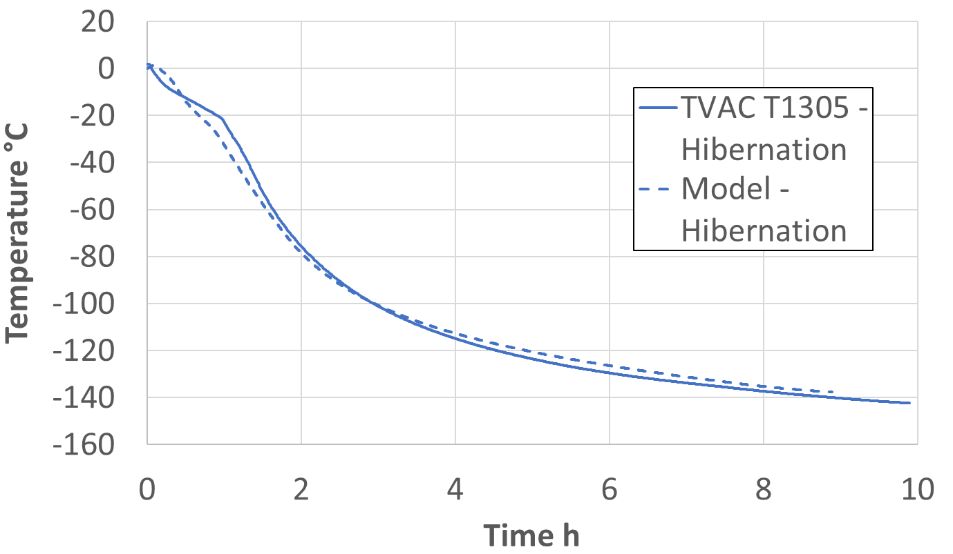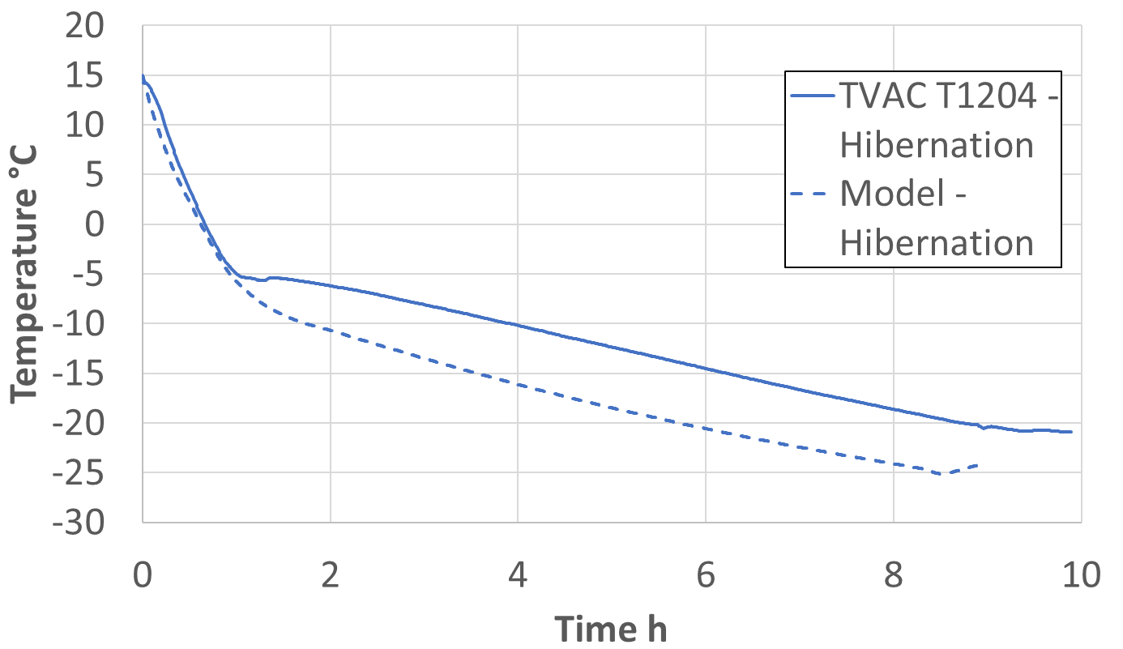
Figure 4. Measured (solid lines) and predicted (dashed lines) transient temperature profile from operational to survival at the radiator (Left) and evaporator (Right). The vacuum chamber sink temperature was -148°C.
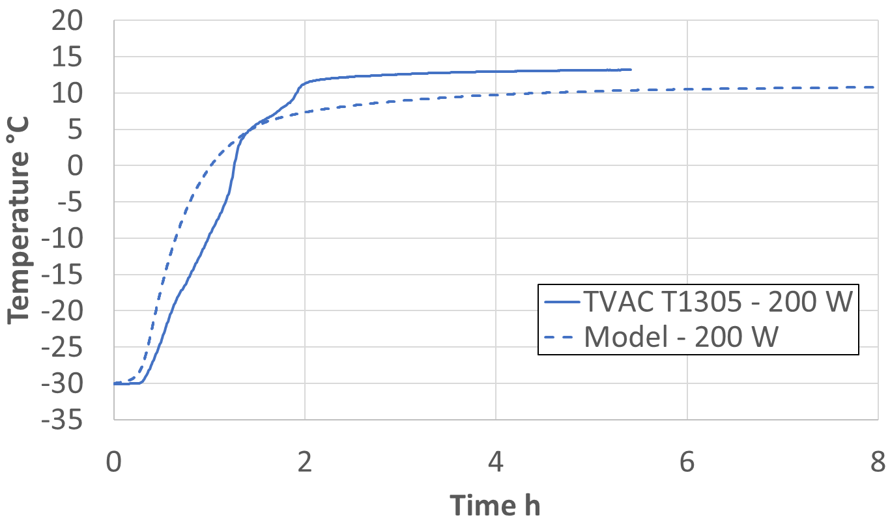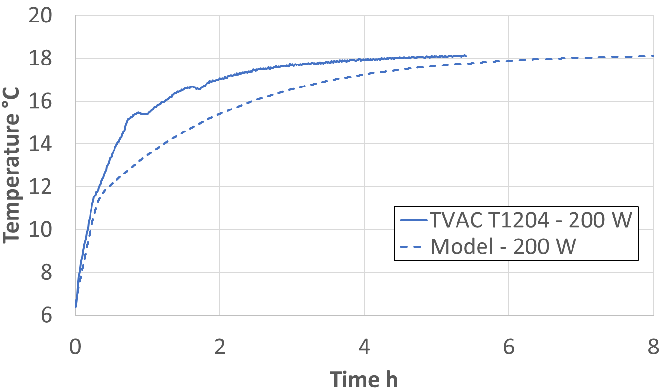
Figure 5: Measured (solid lines) versus modeled (dashed lines) transient temperature profile at 200 W steady state. Left: Radiator temperatures. Right: Evaporator temperatures.

The next step in model correlation was to use steady operational temperature and power data to determine the TCV opening profile, $φ_{TCV}$, as a function of its body temperature, which is known to be non-linear. The TCV is partially open when its temperature is between -10°C and 10°C. Data from four steady operational tests performed at 40 W, 60 W, 80 W and 110W thermal loads applied to the heat spreader-evaporator assembly were used for this model correlation. Figure 7 shows the measured transient temperature profile at the evaporator, and at the radiator surface, as well as the final transient temperature profiles predicted by the LHP model under the same thermal loads. The acceptable level of agreement between test and modeled temperature profiles, was achieved by optimizing the TCV opening/closing function, $φ_{TCV}$, shown in Figure 6.
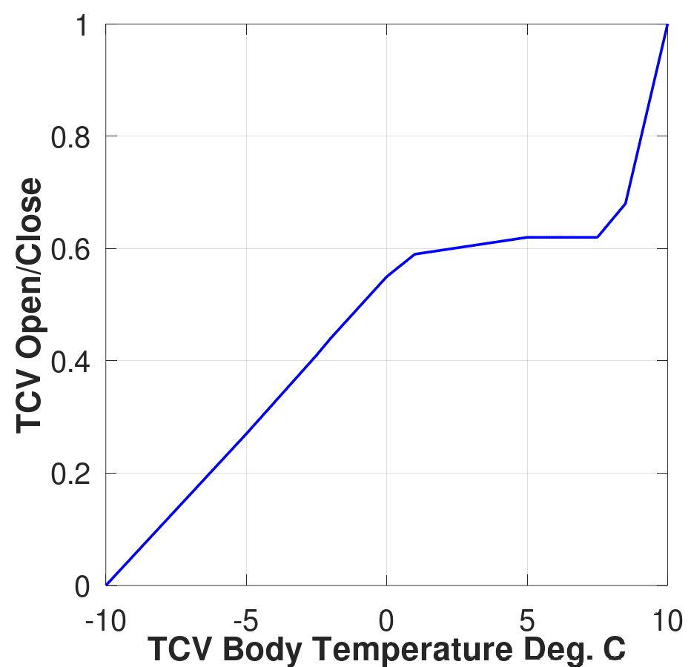
Figure 6: TCV opening/closing as a function of its body temperature.
Once $ε_{HS}^{*}$, $ε_{RD}^{}$, $φ_{TCV}$, and $β_{T}$ were correlated to match the test data, no other parameter needed tuning or correlation. The correlation effort was then focused on comparing the model predictions against other steady state cases tested to evaluate the model capabilities. Of particular interest during testing was the effect of the sink temperature on the LHP performance. During testing it was found changing the sink temperature for the radiator was not feasible. The chamber shroud only provided the coldest sink temperature (LN2 temperature). Therefore, an alternative method to test this LHP performance was envisioned by imposing a thermal load to the radiator surface through the attached Kapton heaters. Although not ideal, it was a practical solution to meet the test objectives. The thermal load was calculated to provide a radiator surface temperature equivalent to the sink temperatures of -30°C and -55°C. Those radiator thermal loads were 106 W and 64 W, respectively. Three tests were conducted to investigate the effect of the sink temperature using the following thermal loads configuration:
- 110 W on the heat spreader, 106 W on the radiator,
- 110 W on the heat spreader, 64 W on the radiator, and
- 80 W on the heat spreader. 64 W on the radiator.

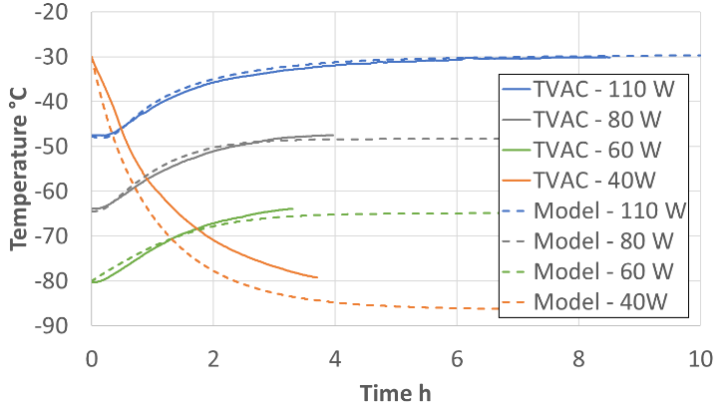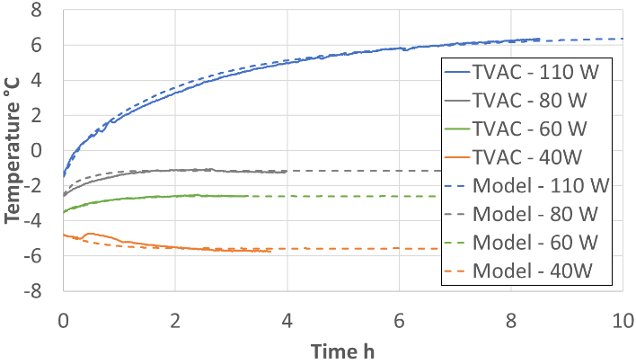
Figure 7: Measured (solid lines) versus modeled (dashed lines) transient temperature profile at steady state for 110 W, 80 W, 60 W, and 40 W applied heat. Left: Radiator temperatures. Right: Evaporator temperatures.

The radiator and evaporator temperature profiles for each of these tests are shown in Figure 8, Figure 9, and Figure 10, respectively. To model these tests, the model was configured imposing the same heat spreader thermal load used during testing and the desired/targeted radiator sink temperature. The radiator sink temperature was the preferred modeling choice over imposing a thermal load on the radiator volume. The reasoning is because in the model, which is a lump thermal capacitance, that radiator thermal load would be directly applied to the fluid in the serpentine lines, making the LHP condenser unrealistically hotter than in the test. Figures 8, 9, and 10 show the test measurements and modeling predictions. The largest discrepancy testing and modeling predictions can be found for the 110 W on the heat spreader and 64 W on the radiator case where the model predicted a partial flow throttling through the TCV, Figure 9. The partially throttled flow with a hot radiator is difficult to predict with precision since part of the vapor is diverted back into the CC through the bypass line at a rate that is not necessarily proportional to the TCV opening/closing. The model does not include the effect of the vapor being diverted through the bypass line and it has only been calibrated for the cold radiator surface, Figure 7.

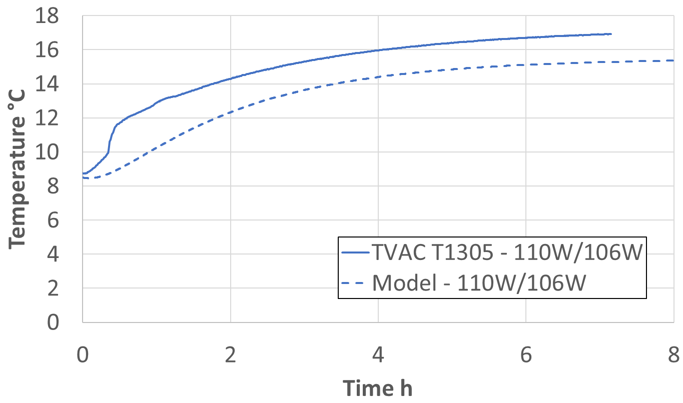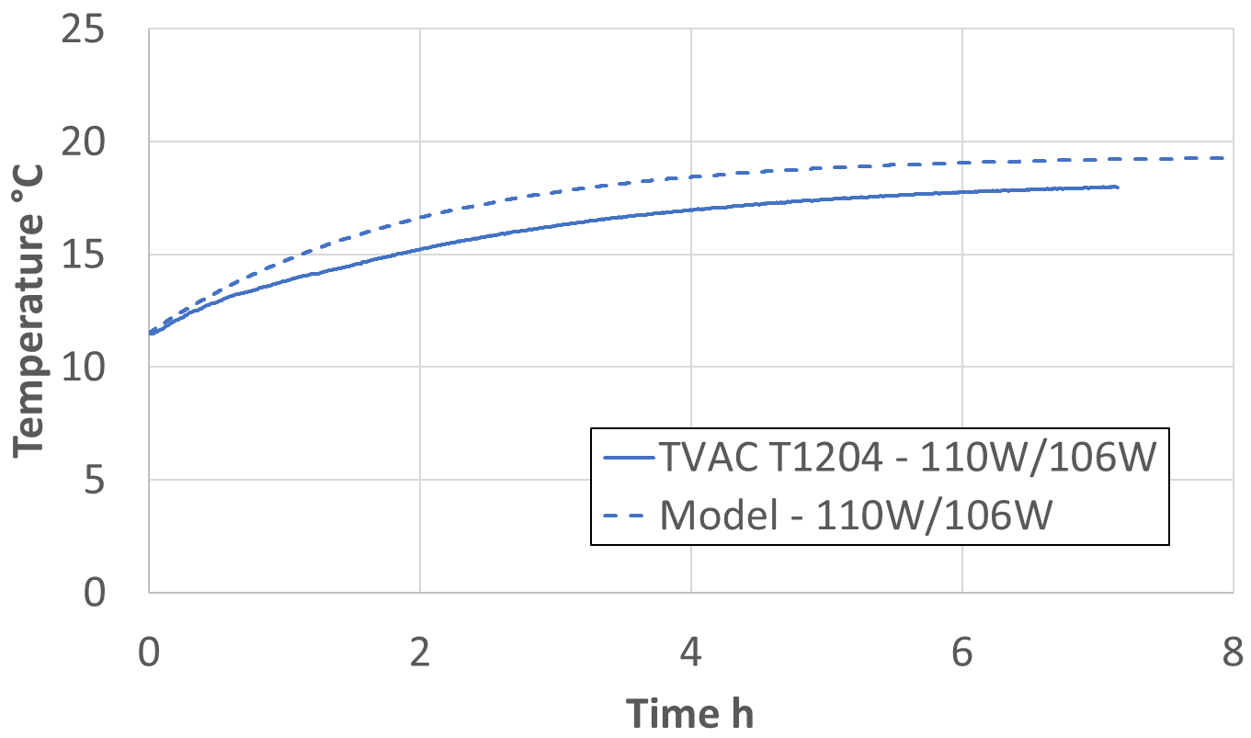
Figure 8: Measured (solid lines) versus modeled (dashed lines) transient temperature profile at steady state for 110 W on the heat spreader and 106 W on the radiator. LHP model has no thermal load on the radiator, but the sink temperature was changed to -30°C. Left: Radiator temperatures. Right: Evaporator temperatures.

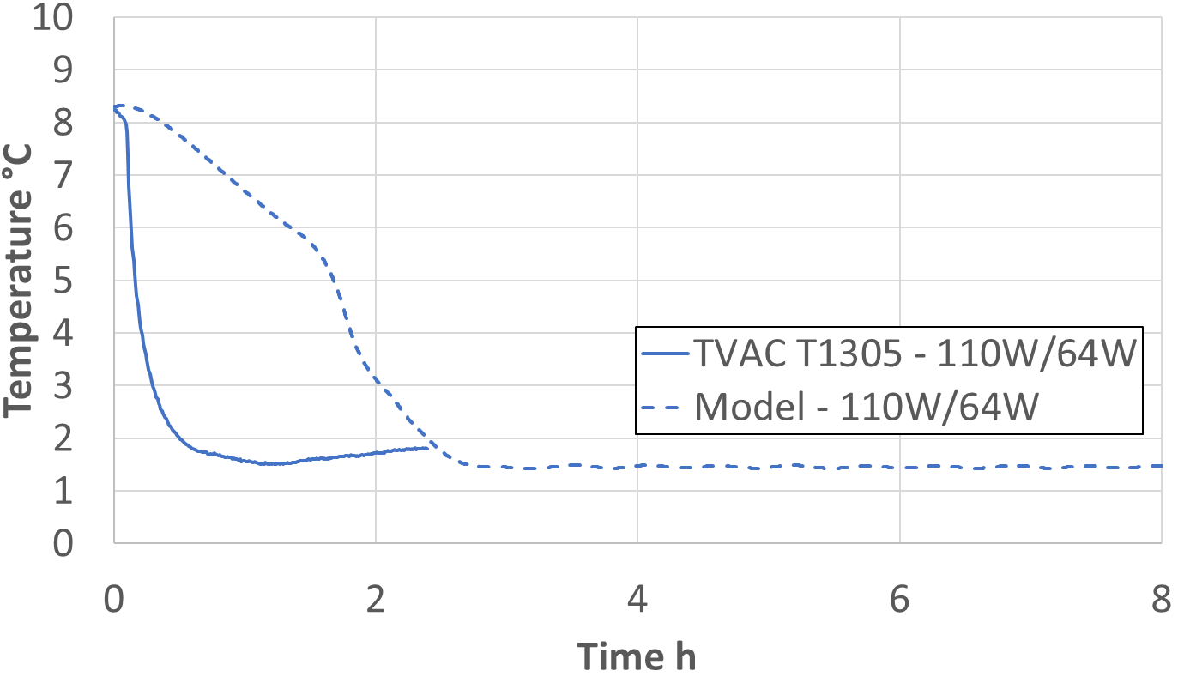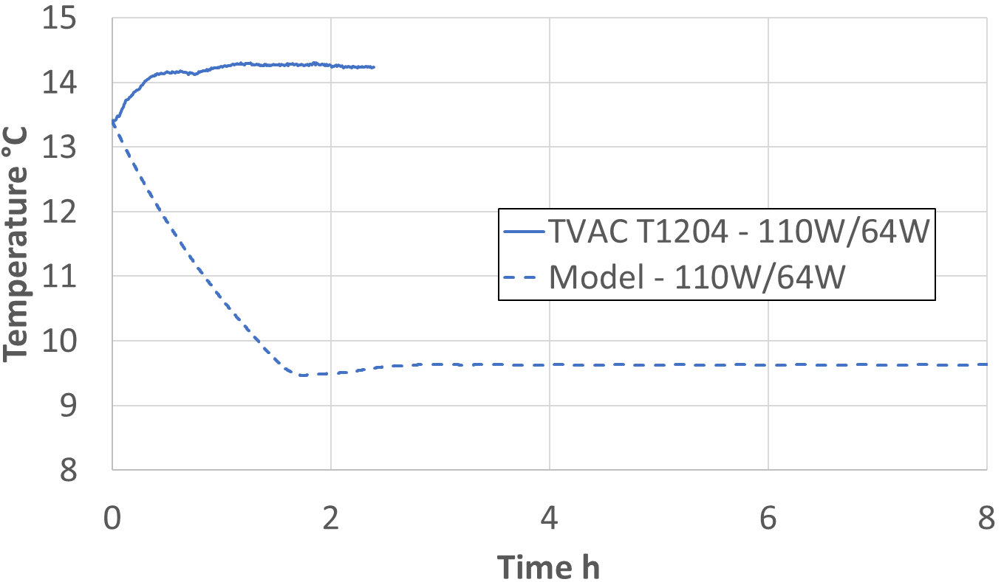
Figure 9 Measured (solid lines) versus modeled (dashed lines) transient temperature profile at steady state for 110 W on the heat spreader and 64 W on the radiator. LHP model has no thermal load on the radiator, but the sink temperature was changed to -55°C. Left: Radiator temperatures. Right: Evaporator temperatures.

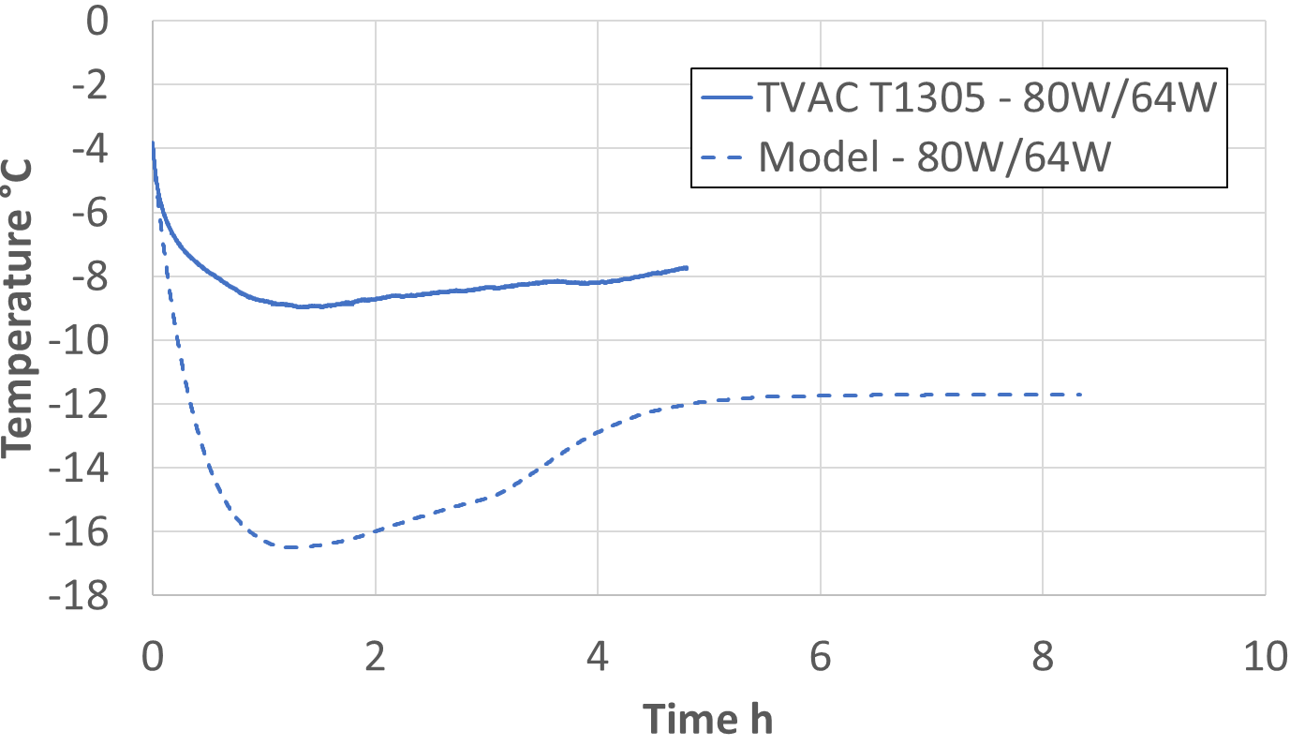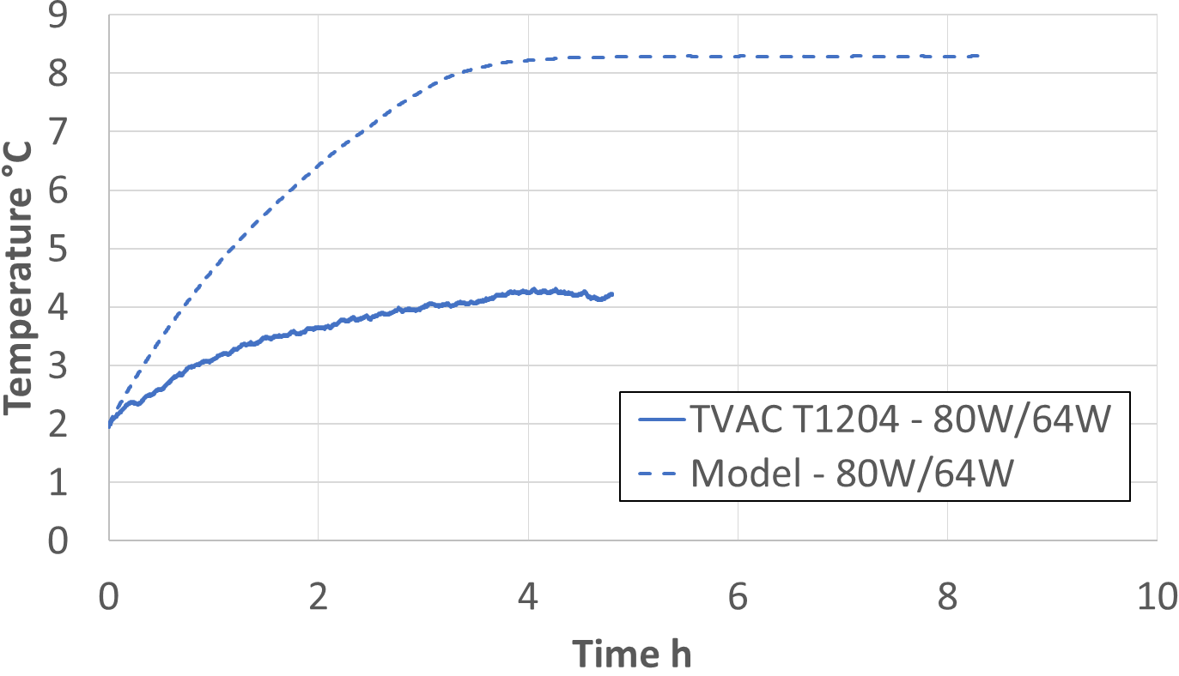
Figure 10: Measured (solid lines) versus modeled (dashed lines) transient temperature profile at steady state for 80 W on the heat spreader and 64 W on the radiator. LHP model has no thermal load on the radiator, but the sink temperature was changed to -55°C. Left: Radiator temperatures. Right: Evaporator temperatures.

From the steady state temperatures reached at the end of each transient segment, the error between the measured and predicted temperatures for each CV as well as cumulative error for every test segment were calculated, as shown in Table 1. Each test segment has a different heat spreader and radiator power configuration, as listed in columns 1 and 2. While a good agreement was obtained between the measured and predicted temperatures, few cases exhibit error larger than 5: the radiator temperature when 40 W was applied to the heat spreader and the cumulative error for the cases with 64 W applied to the radiators. For the case where 40 W was applied to the heat spreader, the TCV temperature is at the coldest operational steady state temperature observed, -5.47°C, outside of hibernation. The low TCV temperature throttles the flow working fluid, perhaps slightly more severely in the model than in the test paper, resulting in less heat being dissipated at the radiator and therefore reducing its temperature. For cases where 64 W were applied to the radiator, the TCV temperature is on the borderline line of being fully open. A small TCV temperature change can result in a significant change on the flow of working fluid sent to the radiator, or through the bypass line to the compensation chamber, and therefore on the temperatures across the system.

Table 1: Summary of the delta temperature error for ten steady state test segments. Every test segment was driven by a different heat spread and radiator power configuration. Highlighted in red are errors larger than 5.

Two more performance cases were also tested and modeled: LHP startup⁶ and hot LHP shutdown¹. The objective of the LHP startup was to bring the TMS from cold survival into a stable operational temperature. During cold survival, the LHP was in reverse flow mode, identified as when the liquid line was warm, and the vapor was cold, Figure 11 Left. A heating choreography was used to bring the heat spreader and evaporator assembly to operational temperature and the TCV temperature to a point where the LHP started to flow in forward flow. The heating choreography involved three heaters of 42 W, 37.5 W and 41 W powered on simultaneously, and powered off sequentially. The 42 W heater was powered off when the reference heat spreader thermocouple reached -10°C, at approximately 0.5h, and the 37.5 W heater was powered off when that thermocouple reached 0°C at approximately 1.5h. The 41 W heater remained on throughout the duration of the LHP startup. The startup was considered completed when the LHP started to flow in forward flow mode, meaning the liquid line became cold and the vapor line became warm. This temperature transitions happened rather quick (within minutes) once the TCV become fully open (above 10°C), at approximately 5.3h, as shown Figure 11. In a modeling effort to capture the essence of this behavior, only the propylene flow was modeled, not the liquid and vapor lines temperatures. The flow inversion, imposed based on the temperature of the TCV alone, set to 12.5°C, triggered a sudden radiator temperature increase and evaporator temperature decreases. The temperature change in the radiator and evaporator matched both the test measurements and the modeling predictions. However, the exact timing of the LHP flow reversal did not match perfectly since it is difficult to predict exactly when the TCV will actually open in a simplified model.

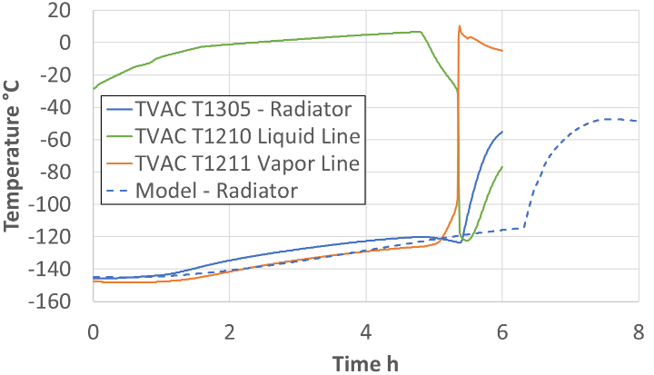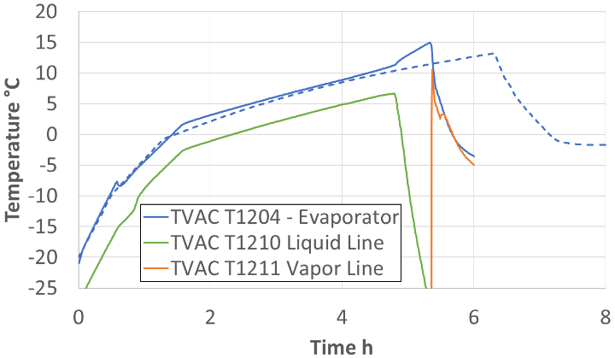
Figure 11: Measured (solid lines) versus modeled (dashed lines) transient temperature profile during LHP startup. Left: Radiator temperature. Right: Evaporator temperature.

The objective of the hot LHP shutdown, on the other hand, is to reduce the LHP heat transport capability by limiting the flow of propylene to the radiator. This was done by applying heat to the compensation chamber. As shown in Figure 12, the hot LHP shutdown started when 36 W were applied to the CC with on/off temperature setpoints of 45°C /50°C, 45 W were applied to the heat spreader with on/off temperature setpoints of 35°C /40°C; and an additional 55 W was continuously applied to the heat spreader throughout the duration of the hot shutdown test segment. The initial temperature condition for the heat spreader, evaporator, and TCV assembly was approximately 0°C and the LHP was operating in forward flow. This implies that the TCV was partially open at the beginning of the segment. Since the TCV was partially open, the heat applied to the surface of the CC will vaporize the liquid propylene stored in the CC. The propylene vapor will then leave the CC through the bypass vapor line, circulating through the TCV, and eventually reaching the condenser serpentine. While this happened, the CC was warming up at the same rate as the evaporator and heat spreader assembly. However, once the TCV reached its fully open temperature, at approximately 1.7h, the TCV bypass line became isolated, preventing the vapor from leaving the CC. This in turn triggered a sudden pressure and temperature increase on the CC, Figure 12 Right. This sudden temperature increase was followed by the LHP reversing its flow direction and cooling off the TCV while the heat spreader assembly continued to increase in temperature, now at an even higher rate, effectively shutting down the LHP. The LHP shutdown and flow reversal can be also observed in Figure 12 Left, with the inversion of the liquid and vapor line temperatures.
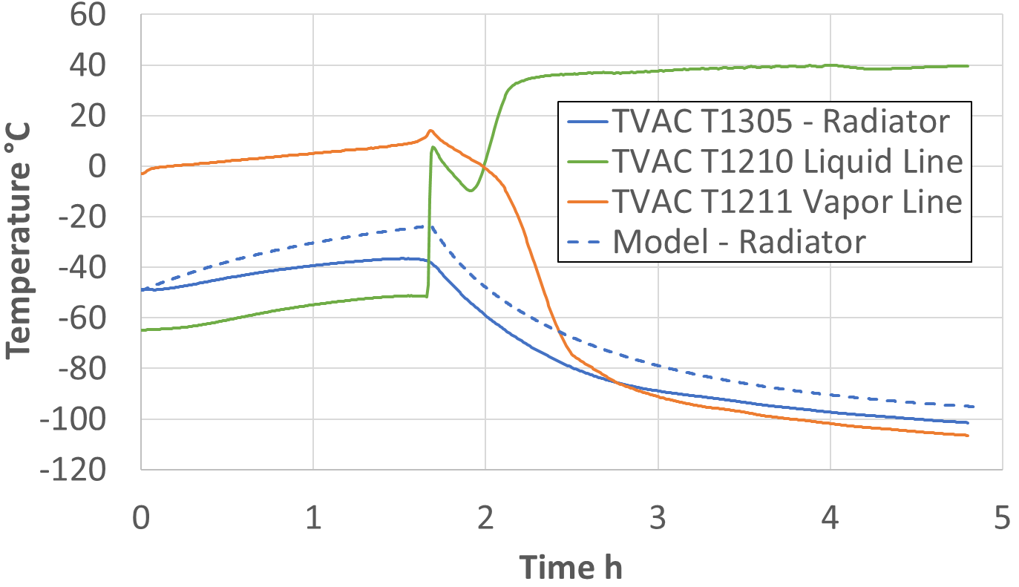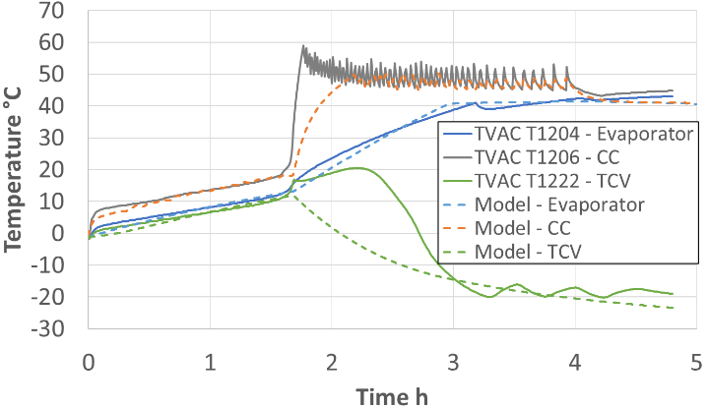
Figure 12: measured (solid lines) versus modeled (dashed lines) transient temperature profile during LHP hot shutdown. Left: radiator, liquid, and vapor lines temperatures. Right: evaporator, CC, and TCV temperatures.

The LHP hot shut down was modeled by imposing a high (5x) CC to evaporator conductance, $G_{CC}$, to capture the heat leak associated to the vapor leaving the CC through the bypass line until the TCV reaches its fully open temperature of 12.5°C. Once the TCV reaches its fully open temperature, $G_{CC}$ is set back to is its nominal value, triggering a sharp temperature increase in the CC, similar to the temperature increase observed in the test. At this point, if the temperature of the CC is larger than the rest of the assembly, the LHP is forced to operate in reverse flow mode. This sudden decrease in thermal energy dissipation from the LHP causes an increase in the warmup ratio of the evaporator and heat spreader assembly. The LHP reverse flow also causes a heat leak from the TCV that starts to cool down at a rate ~1 W. The modeling followed the same heating sequence used during the testing. By imposing these conditions and the same heating sequence used during testing, a good agreement was found between the temperatures from test measurement and from modeling, Figure 12.

Conclusions
The numerical model described in this paper was based on the control volume approach. This approach allowed simplification of the geometry of the LHP and the components attached to the heat spreader as well as modeling the complex two-phase flow taking place at the evaporator, CC and radiator. The result was equivalent to a four-node network model. This simplification significantly reduced the computation cost and time needed to perform a simulation when compared to standard analysis thermal modeling tools. This is a desirable quality for use in quick performance assessments, and real time simulations, especially those dedicated to console operator training. Yet, a clear disadvantage is the spatial (and not necessarily temporal) resolution of the model which is limited to only four lump capacitance nodes.
Through a correlation effort, the numerical model described in this paper was demonstrated to be capable of capturing the bulk transient and steady temperatures LHP response under a broad range of thermal load. Another advantage of this model is that a very small number of parameters needed to be correlated, also significantly reducing the correlation time effort. It was also demonstrated that by adding ad-hoc logic, it was also capable of capturing the LHP shutdown through the TCV, LHP startup, and LHP hot shutdown.

Acknowledgments
Any opinions, findings, and conclusions or recommendations expressed in this paper are those of the authors and do not necessarily reflect the views of the National Aeronautics and Space Administration (NASA).

References
[1] Ku, J., (1999). Operating characteristics of loop heat pipes. SAE transactions, 503-519.
[2] Launay S., Sartre V., and Bonjour J., (2007). Parametric analysis of loop heat pipe operation: a literature review. International Journal of Thermal Sciences, 46(7), 621-636.
[3] Smay J., Hughes J., Spangler R., Tarau C., and Alvarez-Hernandez A. R., (2024). Volatiles Investigating Polar Exploration Rover (VIPER) Thermal Management System (TMS) Design, Development, and Testing. International Conference on Environmental Systems. No. ICES-2024-72
[4] Colaprete, A., (2021). Volatiles investigating polar exploration rover (VIPER).
[5] Médici E. F., Turk J. C., Stewart E. R., Page T., Dobarco-Otero J., Quintanilla G., Slusser T. B., Mittag Z. W., Barragan J. M., Alvarez-Hernandez A. R., Bugby D. C., Hughes J., Smay J., Tarau C., (2026). Simulated Lunar Gravity Testing of VIPER Loop Heat Pipe Architecture. International Conference on Environmental Systems. No. ICES-2026-486
[6] Ku J., (2016). Loop heat pipe startup behaviors. International Conference on Environmental Systems. No. ICES-2016-24.

Thermal Engineer, S&K Global Solutions, Houston TX 77058.
AST Heat Transfer, NASA Marshall Space Flight Center, Huntsville, AL 35812.
AST Heat Transfer, NASA Marshall Space Flight Center, Huntsville, AL 35812.
Thermal Engineer, NASA Marshall Space Flight Center, Huntsville, AL 35812.
Thermal Control System Project Manager, NASA Johnson Space Center, Houston TX 77058.
VIPER Cross Cutting Integration Manager, NASA Johnson Space Center, Houston TX 77058.
JSC Passive Thermal Technical Discipline Lead, NASA Johnson Space Center, Houston TX 77058.

