A Simplified Model of VIPER Thermal Management System. Part II: Integrated Vehicle
Ezequiel F. Medici
S&K Global Solutions, Houston, TX, 77058
Jodi C. Turk, and Elijah R. Stewart
NASA Marshall Space Flight Center, Huntsville, AL, 35812
Tim Page
Amentum Space Exploration Division, Huntsville, AL, 35812
Zane W. Mittag, Juan M. Barragan, Angel Alvarez-Hernandez
NASA Johnson Space Center, Houston, TX, 77058
NASA’s Volatiles Investigating Polar Exploration Rover (VIPER) thermal management system (TMS) relies on four loop heat pipes (LHPs) to transport electronic waste heat to the vehicle cooling radiative surface and avoid overheating. The TMS has also ten constant conductance heat pipes (CCHPs) dedicated to balance the thermal load within the internal environment where the avionics boxes are mounted, also called warm electronic box (WEB), and to transport the heat from two of the science payload instruments. The TMS also uses two thermal straps to thermally link the batteries to the WEB. These thermal components, in addition to heaters, thermostat, multi-layer insulation (MLIs), and isolators forms the core of the VIPER TMS. The complex heat transport balance managed by the TMS is challenging to characterize and model. The more fidelity and granularity of a model, the more costly the computational resources needed and the longer the simulation and modeling time. When the priority is to provide quick but reliable assessments of the thermal performance or real time thermal feedback for training of console operators, simplified modeling tools are needed. To satisfy that need, this paper describes the effort to develop and correlate a model of VIPER TMS based on control volume approach. The correlation effort in particular focuses on hibernation, cold thermal balance, and hot thermal balance data from the integrated vehicle thermal vacuum (TVAC) test. Thus, the correlated model captures the heat leaks during hibernations and the performance at two extremes, bounding, operating scenarios.

Acronyms and Nomenclature

A = area [m²]
c = heat capacity [J/(kgK)]
CAD = computer aided drawing
CC = compensation chamber
CCHP = constant conductance heat pipe
CV = control volume
$ε^{*}$ = effective emissivity
G = effective thermal conductance [W/K]
k = permeability [m²]
LHP = loop heat pipe
m = mass [kg]
MLI = multi-layer insulation
MSOLO = Mass Spectrometer Observing Lunar Operations
NIRVSS = Near Infrared Volatiles Spectrometer System
NIST = National Institute of Standards and Technology
ODE = ordinary differential equation
PID = proportional integral derivative
Q = heat flow [W]
σ = Stefan–Boltzmann constant [W/(m²K⁴)]
t = time [s]
T = Temperature [°C]
TC = thermocouple
TCV = thermal control valve
TMS = thermal management system
TVAC = thermal vacuum
VIPER = volatiles investigating polar exploration rover

Introduction
T
he core of the VIPER thermal management system (TMS) consists of four heat spreaders panels and four loop heat pipe assemblies, one per quarter of the vehicle, filled with propylene. When the four heat spreaders are integrated, they resemble a box, called warm electronic box, WEB, Figure 1, items 1 to 8. The purpose of heat spreaders and LHP assemblies are to collect electronic waste heat and transport it to the radiators where it dissipates to the sky. Thus, every LHP evaporator is mounted on the heat spreader while the condenser is mounted on the radiator. Also, every LHP is instrumented with a thermal control valve (TCV) that would stop the flow working fluid and minimize the heat leaks during lunar nights or cold environments. Medici et al.¹ described in more detail the working principle and performance of a single VIPER LHP under lunar-like environment. Briefly, there are two states on which the LHP can operate, forward or reverse flow. In forward flow, the LHP working fluid cycle works as intended, liquid working fluid is evaporated at the evaporator grooves, which is collected at the vapor plenum and flows into the condenser though the vapor line. At the condenser, it condenses back into liquid state and returns to the evaporator though the liquid line. A noticeable characteristic of this flow is that the vapor line temperature is significantly higher than the liquid line temperature. On the other hand, in reverse flow, liquid working fluid is also evaporated at the evaporator but, by trying to flow in the opposite direction, it becomes highly restricted making the LHP heat transport capacity very ineffective. Nonetheless, enough heat can be transported out the WEB through this path that it must be considered as one more heat leak, especially in cold environments where the objective is to save thermal energy.
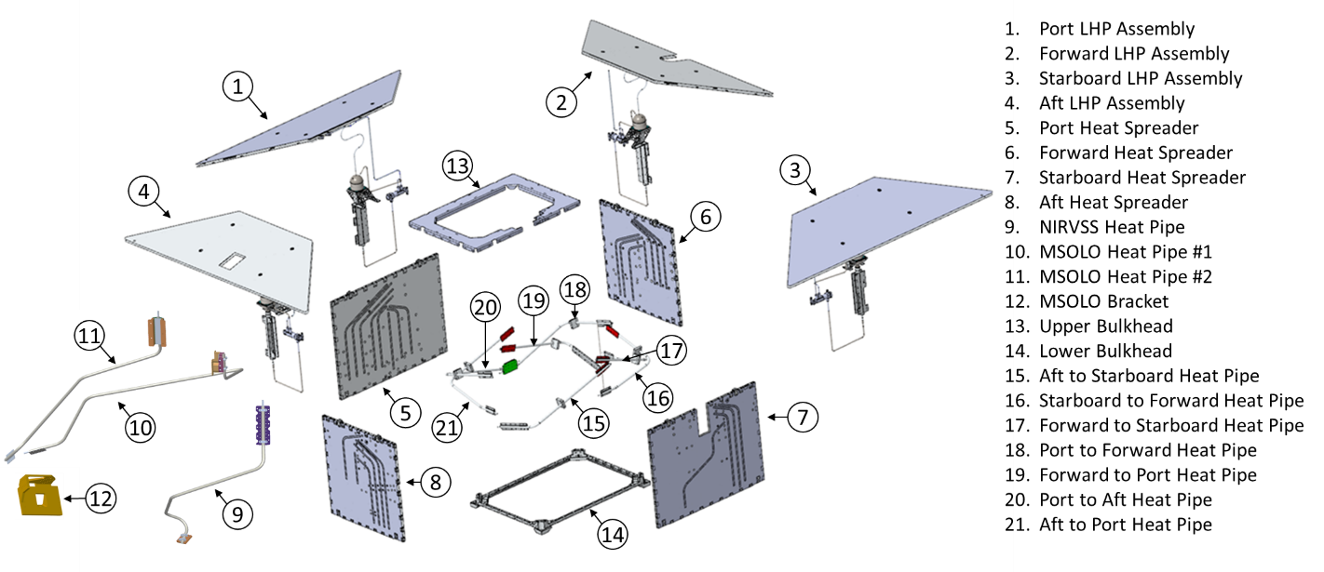Figure 1: VIPER thermal management system exploded view.
There are also seven crossing constant conductance heat pipes, xCCHPs, filled with ammonia interconnecting each quarter of the WEB. The purpose of these CCHPs is to better distribute the thermal loads and add a layer of redundancy in the case of an LHP failure and they are mounted either on the LHP evaporator or at the heat spreader panel. Also, since the heat pipes are oriented at 15 degrees from an imaginary horizontal line, they can only transport heat in one direction, from the bottom up. To ensure that heat can be transported back and forth between each quarter of the WEB, the xCCHPs are arranged in a crisscross configuration as shown in Figure 1, items 15 to 21. Additionally, the VIPER TMS has three more ammonia filled CCHPs and two thermal straps. One CCHP provides a thermal link from the NIRVSS payload instrument to the aft LHP evaporator, Figure 1, item 9. The other two CCHPs provide a thermal link from the MSOLO payload instrument to the forward and starboard LHPs evaporators, Figure 1, items 10 and 11. The two thermal straps provide a thermal link between the batteries, one from the aft battery and the aft heat spreader and one from the forward battery and the forward heat spreader. A full description of the VIPER TMS was summarized by Smay et al.².
To analyze the dynamics of the described VIPER TMS several commercially available and in-house modeling tools are used. As stated in part I of this paper³, the objective behind the development of the model described in this paper is to have an analysis tool that could provide a low spatial fidelity but rapid thermal assessments of the VIPER TMS when compared against high fidelity, commercially available thermal simulation software. The rapid assessment characteristic of the model has the purpose of optimizing parametric analysis by eliminating unwanted or undesirable scenarios before executing a high-fidelity model, provide a general depiction of the vehicle thermal status in the case of an anomaly, and provide real time thermal telemetry to train operators. To achieve the rapid assessment aspect of this in-house model, control volume approach was used to reduce the number of thermal nodes. While part I of this paper describes the model and the correlation effort of a single VIPER LHP, part II describes how the single LHP model was expanded to capture the most relevant VIPER TMS components and how it was correlated using the rover TVAC test data.

Model Description
To model the thermal response of VIPER’s four heat spreaders, their attached electronic boxes, and their LHPs, a single heat spreader-LHP model is executed four times, every time with different parameters representing each quarter of the vehicle. The single heat spreader-LHP assembly model is described by Medici et al.³. The model is based on the control volume, CV, approach where the main subcomponents are modeled as thermal lump capacitances. There are four control volumes per every LHP submodel: the first CV includes the heat spreader, LHP evaporator, and electronic boxes, the second CV contains the compensation chamber, the third CV contains the radiator, and the fourth CV contains the TCV. These CVs can store energy in the form of heat and exchange energy between themselves and the environment through conduction and radiation. The energy balance at each control volume is mathematically represented by an ordinary differential equation, ODE. Thus, the energy balance for a single heat spreader-LHP assembly, results in a system of four coupled ODEs.
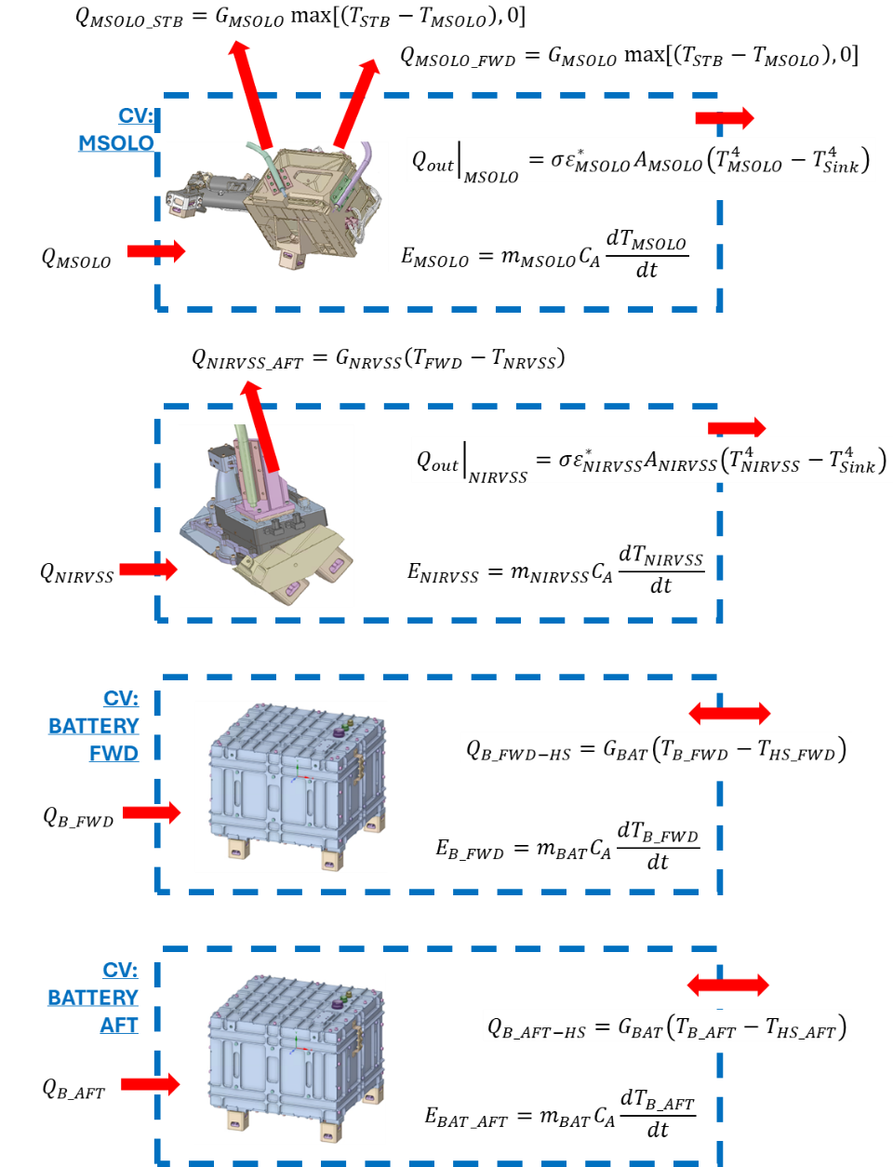
Figure 2: Control volume discretization of the payloads and batteries model indicating the heat fluxes between control volumes, energy exchange with the environment, energy stored internally, and energy input in the form of heat.
Additionally, VIPER’s TMS includes two batteries and two payload instruments, NIRVSS and MSOLO that reside outside the WEB thermal environment. These four components are also modeled as thermal lump capacitances with known masses, internal heat generation, and overall specific heat. Each of these thermal lump capacitances can also exchange energy with the WEB and the environment through the payload instrument CCHPs and the thermal straps. Schematic representations of the payload instruments and batteries CVs are shown in Figure 2.
To solve the energy balance for the whole VIPER TMS, 20 coupled ODEs are needed: the four ODEs per heat spreader-LHP assembly model presented by Medici et al.³, 16 ODEs, and four more ODEs, one per battery and one per payload instrument. Figure 3 right shows a schematic presentation of the modeled VIPER TMS where heat spreaders are represented in light brown boxes, radiators in light blue, batteries in green, and payloads in dark brown while the red arrows represent any form of heat conduction through CCHPs, LHP, or thermal straps.
To formulate the four additional ODEs associated to the batteries and payloads CVs, the energy storage rate, and the heat transfer rate in and out of their CVs needs to be defined, Figure 2. The energy stored within each payload and battery CVs, $E_{B_FWD}$, $E_{B_AFT}$, $E_{NIRVSS}$, and $E_{MSOLO}$ can be expressed as:
$$\begin{aligned}E_{B_{FWD}}=m_{B}c_{A}\frac{dT_{B_{FWD}}}{dt} \#\left(1\right)\end{aligned}$$
$$\begin{aligned}E_{B_{AFT}}=m_{B}c_{A}\frac{dT_{B_{AFT}}}{dt} \#\left(2\right)\end{aligned}$$
$$\begin{aligned}E_{NIRVSS}=m_{NIRVSS}c_{A}\frac{dT_{NIRVSS}}{dt} \#\left(3\right)\end{aligned}$$
$$\begin{aligned}E_{MSOLO}=m_{MSOLO}c_{A}\frac{dT_{MSOLO}}{dt} \#\left(4\right)\end{aligned}$$
where $m_{B_FWD}$, $m_{B_AFT}$, $m_{NIRVSS}$, and $m_{MSOLO}$ are the masses of batteries and payload instruments, $c_{A}$is the aluminum heat capacity, and $T_{B_FWD}$, $T_{B_AFT}$, $T_{NIRVSS}$, and $T_{MSOLO}$ are the batteries, NIRVSS, and MSOLO payload instruments CV temperatures. Radiative heat between the batteries and their environment is neglected since they are covered by MLI blankets.
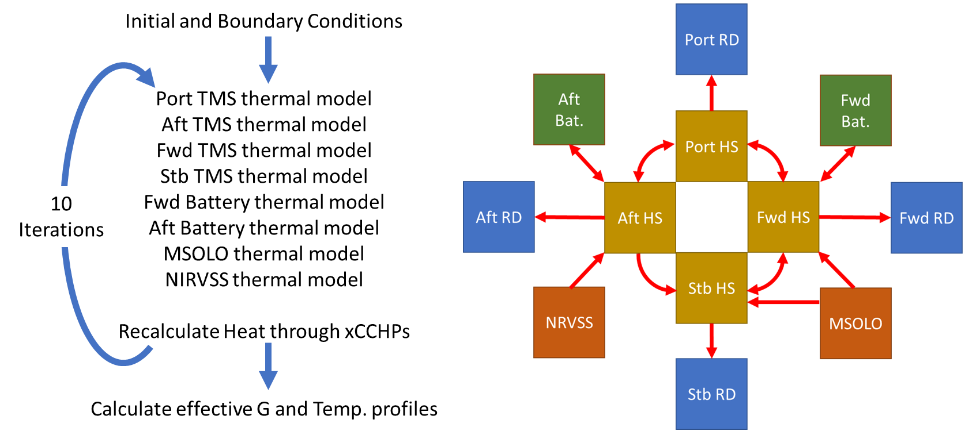
Figure 3: Left: logic used to solve the VIPER thermal management system model using the single LHP model on its core. Right: schematic representation of the VIPER thermal management system model, where the color coder blocks represent the following components: blue blocks the radiators, green blocks the batteries, orange blocks the payloads instruments, and brown blocks the heat spreaders. The red arrows indicate the direction heat can flow between the components.
In addition to stored thermal energy, the batteries can also exchange heat back and forth with the heat spreader though the battery thermal straps as:
$$\begin{aligned}Q_{B_{FWD-HS}}=G_{BAT}\left(T_{B_{FWD}}-T_{HS_{FWD}}\right) \#\left(5\right)\end{aligned}$$
$$\begin{aligned}Q_{B_{AFT-HS}}=G_{BAT}\left(T_{B_{FWD}}-T_{HS_{AFT}}\right) \#\left(6\right)\end{aligned}$$
where $G_{BAT}$ is the battery thermal strap effective thermal conductance and $T_{HS_FWD}$ and $T_{HS_AFT}$, are the forward and aft heat spreader and LHP evaporator assemblies CV temperatures. The batteries thermal strap effective thermal conductance was obtained from the manufacturer specifications, $G_{BAT}=0.05$ [W/K]. The payload instruments CVs, on the other hand, can only send heat to the heat spreader CVs through CCHPs, $Q_{MSOLO-STB}$, $Q_{MSOLO-FWD}$, and $Q_{NIRVSS-AFT}$:
$$\begin{aligned}Q_{MSOLO-STB}=G_{MSOLO}max\left[\left(T_{MSOLO}-T_{HS_{STB}}\right),0\right] \#\left(7\right)\end{aligned}⁡$$
$$\begin{aligned}Q_{MSOLO-FWD}=G_{MSOLO}max\left[\left(T_{MSOLO}-T_{HS_{FWD}}\right),0\right] \#\left(8\right)\end{aligned}$$
$$\begin{aligned}Q_{NIRVSS-AFT}=G_{NIRVSS}max\left[\left(T_{NIRVSS}-T_{HS_{AFT}}\right),0\right] \#\left(9\right)\end{aligned}$$
where $G_{MSOLO}$and $G_{NIRVSS}$ are the CCHPs effective conductance, and $T_{HS_STB}$ is the starboard heat spreader and LHP evaporator assembly CV temperature. These payload instrument CVs can also exchange radiative heat to the environment through their surroundings, ${\left.Q_{out}\right|}_{MSOLO}$ and ${\left.Q_{out}\right|}_{NIRVSS}$:
$$\begin{aligned}{\left.Q_{out}\right|}_{MSOLO}=σε_{MSOLO}^{*}A_{MSOLO}\left(T_{MSOLO}^{4}-T_{S}^{4}\right) \#\left(10\right)\end{aligned}⁡$$
$$\begin{aligned}{\left.Q_{out}\right|}_{NIRVSS}=σε_{NIRVSS}^{*}A_{NIRVSS}\left(T_{NIRVSS}^{4}-T_{S}^{4}\right) \#\left(11\right)\end{aligned}⁡$$
where, $ε_{MSOLO}^{*}$ and , $ε_{NIRVSS}^{*}$ are the payload instruments’ multi-layer insulation (MLI) effective emissivity, $A_{MSOLO}$ and $A_{NIRVSS}$ are the payload instruments’ surface area, $σ$ is Stefan–Boltzmann constant, and $T_{s}$ is the temperature of surroundings. These CVs can also receive external energy in the form of heat through heaters or internal dissipation when powered on, $Q_{B_AFT}$, $Q_{B_AFT}$, $Q_{MSOLO}$, and $Q_{NIRVSS}$.
Solving the energy balance around each payload instrument and battery CV in the form of energy stored = energy in - energy out using the heat fluxes defined per CV described earlier, results in a system of four coupled ODEs:
$$\begin{aligned}\frac{dT_{B_{FWD}}}{dt}=\frac{Q_{B_{FWD}}}{m_{B}c_{A}}-\frac{G_{BAT}}{m_{B}c_{A}}\left(T_{B_{FWD}}-T_{HS_{FWD}}\right) \#\left(12\right)\end{aligned}$$
$$\begin{aligned}\frac{dT_{B_{AFT}}}{dt}=\frac{Q_{B_{AFT}}}{m_{B}c_{A}}-\frac{G_{BAT}}{m_{B}c_{A}}\left(T_{B_{AFT}}-T_{HS_{AFT}}\right) \#\left(13\right)\end{aligned}$$
$$\begin{aligned}\frac{dT_{MSOLO}}{dt}=\frac{Q_{MSOLO}}{m_{MSOLO}c_{A}}-\frac{G_{MSOLO}}{m_{MSOLO}c_{A}}max\left[\left(T_{MSOLO}-T_{HS_{STB}}\right),0\right]-\frac{G_{MSOLO}}{m_{MSOLO}c_{A}}max\left[\left(T_{MSOLO}-T_{HS_{FWD}}\right),0\right] \\ -\frac{σε_{MSOLO}^{*}A_{MSOLO}}{m_{MSOLO}c_{AL}}\left(T_{MSOLO}^{4}-T_{S}^{4}\right) \#\left(14\right)\end{aligned}$$
$$\begin{aligned}\frac{dT_{NIRVS}}{dt}=\frac{Q_{NIRVSS}}{m_{NIRVSS}c_{A}}-\frac{G_{NIRVSS}}{m_{NIRVS}c_{A}}max\left[\left(T_{NIRVSS}-T_{HS_{AFT}}\right),0\right]-\frac{σε_{NIRVSS}^{*}A_{NIRVSS}}{m_{NIRVSS}c_{A}}\left(T_{NIRVSS}^{4}-T_{S}^{4}\right) \#\left(15\right)\end{aligned}$$
In principle, it is possible to directly solve all 20 coupled OEDs representing VIPER’s TMS. However, in practice, in addition to all the described heat and energy transport, there is also the heat transported by the xCCHPs thermally connecting each quarter of the WEB and the thermosyphons. Although the xCCHPs and the thermosyphons conductances could be known, the amount of heat conducted through them is unknown as it depends on their evaporator and condenser temperatures which in turn depends on the heat spreader-LHP evaporator assembly CV and payloads CV temperature. Since those temperatures are not known before-hand, this implies that heat transported through the xCCHPs and the thermosyphons and therefore the energy balance at each assemblies’ CV is not known. To overcome this modeling obstacle, an iterative solution scheme is proposed. First, initial CVs temperature are set, along with the required boundary conditions. Then, assuming no heat transport through the xCHHPs and the thermosyphons, the first run on the single LHP model per every quarter of the vehicle, the batteries thermal model, and the payload instruments thermal model are executed. The iteration then continues by assessing the spreader-evaporator assemblies’ CV temperature and calculating the heat transport through the xCCHPs and the thermosyphons. The new iteration starts by imposing the calculated heat transport through the xCCHPs and the cycle repeats, Figure 3 Left. Since the iterative method has been implemented to assess the heat carried by the xCCHPs and thermosyphons, which do not change significantly between the time steps once the model has been initialized due to rather larger vehicle thermal inertia. By trial and error, it was found that the system of ODEs converges after ten iterations without the need of an adaptive convergency criteria. The iterations and the individual thermal models were implemented in Octave and solved using Runge-Kutta 2-3. The geometrical design parameters were taken from the vehicle computer aided drawing (CAD) assembly and the material properties for propelyne and ammonia working fluids were taken from the National Institute of Standards and Technology (NIST) ThermoData Engine online database.

Model Correlation
The single LHP model, used to model each of the VIPER LHPs, was correlated using test data from the VIPER’s LHP TVAC test. For more details on the test configuration and data analysis please refer to E. F. Medici et al.¹ and for the model description and correlations please refer to E. F. Medici et al⁴. The integrated VIPER TMS model described in this paper, however, is correlated using data from the integrated vehicle TVAC test. Given that the LHP model was already correlated, the correlations effort for the integrated vehicle model was aimed at correlating the performance of the xCCHPs interconnecting the WEB, the CCHPs providing a thermal link to the payloads, and the overall heat leaks. Also, since the single LHP TVAC test was performed in a lunar-like environment where the effective gravitational component was 1/6 of the Earth gravity while at the integrated vehicle TVAC was performed in 1g environment, the TCVs performance needed to be reassessed.
The integrated TVAC test consisted of several segments and three were specifically allocated for thermal correlation purposes: hot thermal balance, cold thermal balance, and hibernation. To assist the hot thermal balance and provide a hot thermal environment representative of the Sun impinging on the corner of the vehicle, a heat enclosure that surrounded the vehicle was used. The heat enclosure provided an environment where the temperature seen by the radiators were those specified in Table 1. During cold thermal balance, on the other hand, the enclosure provided an obstructed view from the VIPER’s radiators to chamber shroud, affecting the sink temperature even with all the enclosure heaters powered off. The effective cold thermal balance sink temperatures are also listed in Table 1.
Table 1: Radiator sink temperatures provided by the enclosure during hot and cold thermal balance.
The first step on the model correlation was the calculations of the heat leaks during hibernation where thermostatically controlled heaters maintained components at survival temperature. Heat leaks were primarily due to radiation and conduction through MLI blankets and isolators as well as from the LHP flowing in reverse. While on the single LHP TVAC test there was a non-negligible amount heat leak through the heat spreader MLI at the integrated vehicle level, the heat leak from the WEB MLI has been reduced significantly due to the several additional layers of MLI and components separating it from the external environment. This is not the case for the payload instruments, MSOLO and NIRVSS, since their MLI does not completely cover them, leaving them partially exposed to the environment. From the hibernation correlation effort, it was found that the effective emissivity of the WEB and payload instruments MLI to be $ε_{HS}^{*}=0.01$, $ε_{MSOLO}^{*}=0.03$, and $ε_{NIRVSS}^{*}=0.03$ while the maximum LHP heat leak in reverse flow was capped at 12.5 W. These effective emissivities were obtained by trial and error until the predicted power dissipated by the heat spreaders and payload instruments’ survival heaters matched the estimated values. During hibernation, there was no power or thermal telemetry available, or recorded; as the vehicle computer went into low power dissipation mode. Therefore, the only strategy available to determine the heaters’ duty cycle and components’ temperature was based on the readings from thermocouples (TCs) that were not wired directly to the vehicle computer. Those thermocouples were connected to an external data acquisition system. The only exception to this method of estimating the heater duty cycle was for the batteries, which have no TCs near the heaters. Therefore, the duty cycle of the battery heaters was calculated through analysis post-TVAC test. The final predicted versus estimated power dissipated by the survival heaters are shown in Table 2.
Table 2: Measured and predicted heater power dissipations during cold thermal balance and hibernation. Aft and forward batteries heaters dissipation were estimated through analysis post integrated vehicle TVAC test. The remaining heater dissipations were obtained by estimating the heaters’ duty cycle from thermocouples located near the heaters.
After correlating the model to capture the heat leaks during hibernation, the correlation effort was centered on the performance of the TCVs under the full effect of the Earth’s gravity (the single LHP TVAC test was performed under the partial effect of the gravity, representative of the moon environment) and the WEB xCCHPs performance. Since the objective of correlation is centered on the steady state, not the transient, a uniform WEB initial temperature condition was set assuming the average temperature value of four heat spreaders. The assessment of the TCV performance was done using data from the cold thermal balance data. During the cold thermal balance, the port and forward LHPs were operating in forward flow while the aft and starboard LHP remained in reverse flow. Throughout the cold thermal balance, MSOLO and NIRVSS payload instruments were powered off and the only avionics powered on were the IAU on the port heat spreader (~50 W) and the transceiver on the aft heat spreader (~10 W). Since there was not a significant amount of electronic waste heat during cold thermal balance, to maintain the WEB and payload instruments within operational temperature, the port and aft heat spreader heaters provided 8.7 W and 28.9 W while the forward and starboard heat spreaders heaters never reached their on-temperature set points. MSOLO and NIRVSS heaters provided 2.7 W and 0.7 W respectively. During cold thermal balance the payload instruments CCHPs were considered inactive with a conductance of zero.
Again, by trial and error, the best modeling predictions of the cold thermal balance were obtained assuming a TCV opening/closing function linearly actuated by its body temperature. This was different from the single LHP TVAC test under moon-like environment where the TCV opening/closing function resembled an s-shape curve. In the modeling simulations, only the aft heat spreader heater reached the on/off temperature set points providing 15.1 W while MSOLO and NIRVSS heaters provided 5.3 W and 1.5 W respectively. The battery heaters did not reach the on-temperature set point during testing or in the modeling. The full comparison between the predicted versus measured temperatures at the radiators, heat spreaders, payload instruments, and batteries for the cold thermal balances are shown in Figure 4 and Figure 5, and the heater power dissipation per thermal zone are shown in Table 2. The lower predicted heat dissipated at the WEB, as captured by the duty cycle of the heaters located on the port and aft heat spreaders, could be attributed to the forward and starboard heat spreader temperature stabilizing at a colder temperature in the model when compared to the TVAC data, resulting in an overall lower heat leak. This effect, in turn, could be caused by the selected opening/closing function of the TCV. The WEB xCCHPs conductance was estimated to be $G_{HP}$ of 1.5 [W/K].
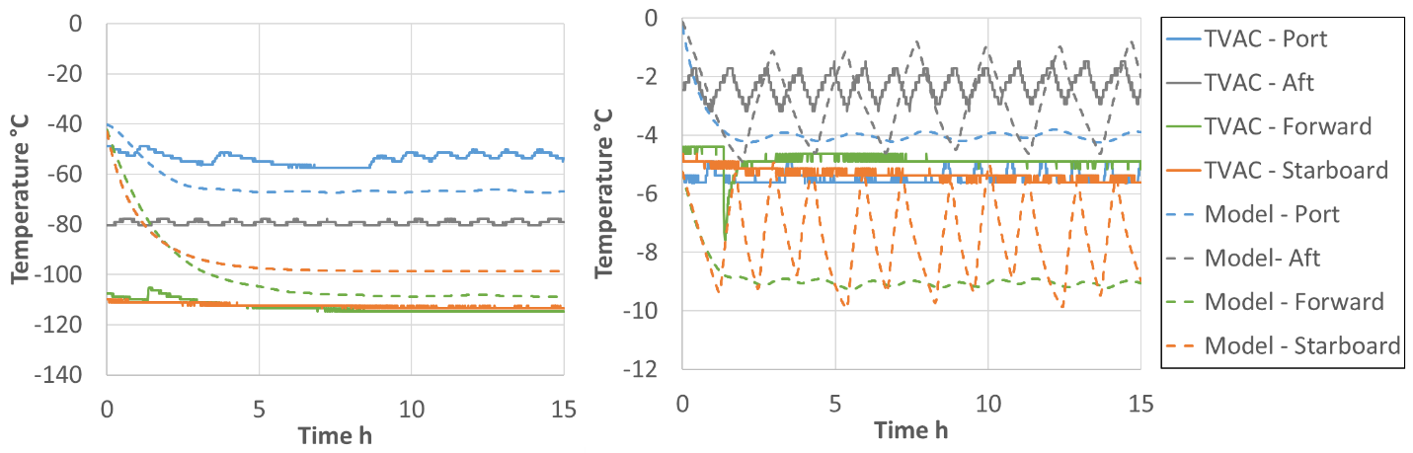
Figure 4: Measured (solid lines) versus modeled (dashed lies) transient temperature profile during cold thermal balance. Left: radiators. Right: evaporators.

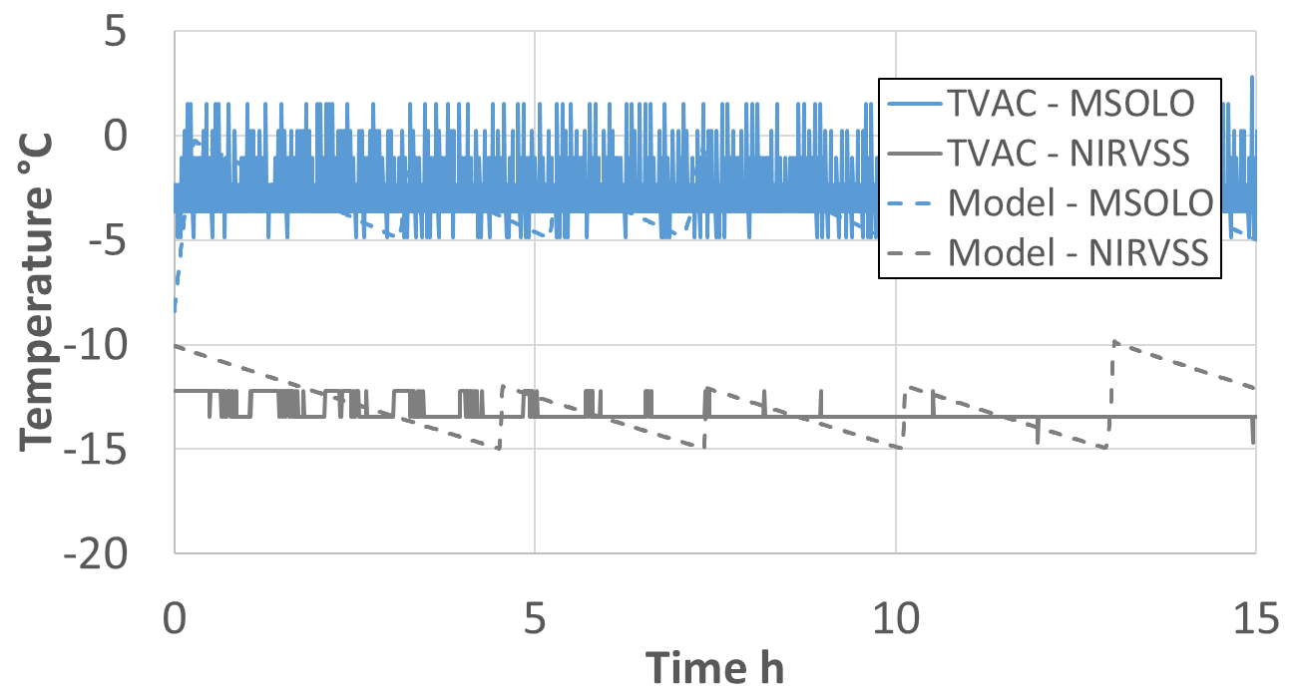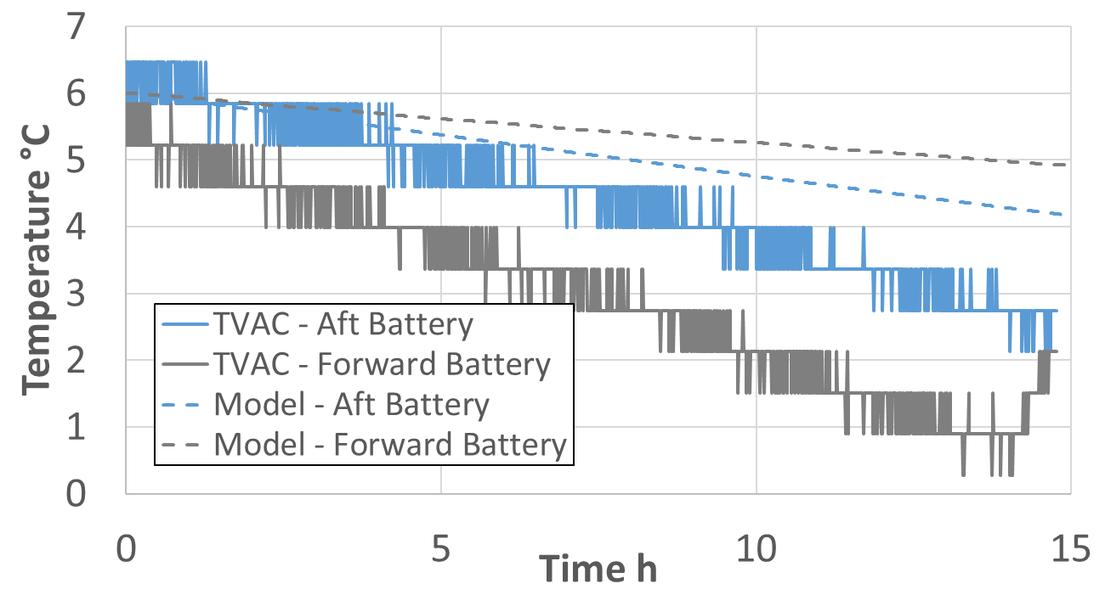
Figure 5: Measured (solid lines) versus modeled (dashed lies) transient temperature profile during cold thermal balance. Left: MSOLO and NIRVSS. Right: batteries.
During hot thermal balance, the enclosure heaters were powered on providing the radiators sink temperature listed in Table 1. In addition to the heat enclosure, every heat spreader had the following waste heat from electronic boxes:
- Port heat spreader, ~80 W.
- Aft heat spreader, ~84 W.
- Forward heat spreader ~60 W.
- Starboard heat spreader ~12.5 W.
- Payload instruments: MSOLO ~42 W and NIRVSS Bracket ~21W.
To dissipate the heat, the port and starboard LHPs were operating in forward flow while the forward and aft LHPs were operating in reverse flow. The steady state hot thermal balance temperatures were used to characterize the xCCHPs, payloads CCHPs, and LHPs thermal performance at high thermal loads. In the case of the CCHPs, the thermal conductance was adjusted to match the measured temperature profiles at the WEB, and MSOLO and NIRVSS payloads instrument. The best correlation between the predicted and measured temperatures was obtained for CCHPs thermal conductance of $G_{MSOLO}$, $G_{NIRVSS}$, and $G_{HP}$ of 1.5 [W/K]. The comparison between the predicted versus measured temperatures at the radiators, heat spreaders, payloads, and batteries for the hot thermal balances are shown in Figure 6, and Figure 7.

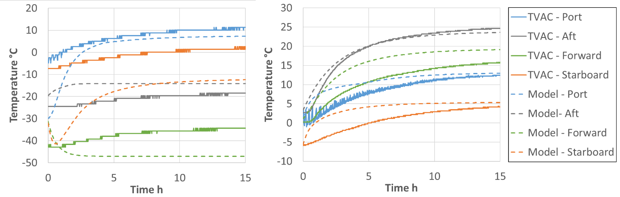
Figure 6: Measured (solid lines) versus modeled (dashed lies) transient temperature profile during hot thermal balance. Left: radiators. Right: evaporators.
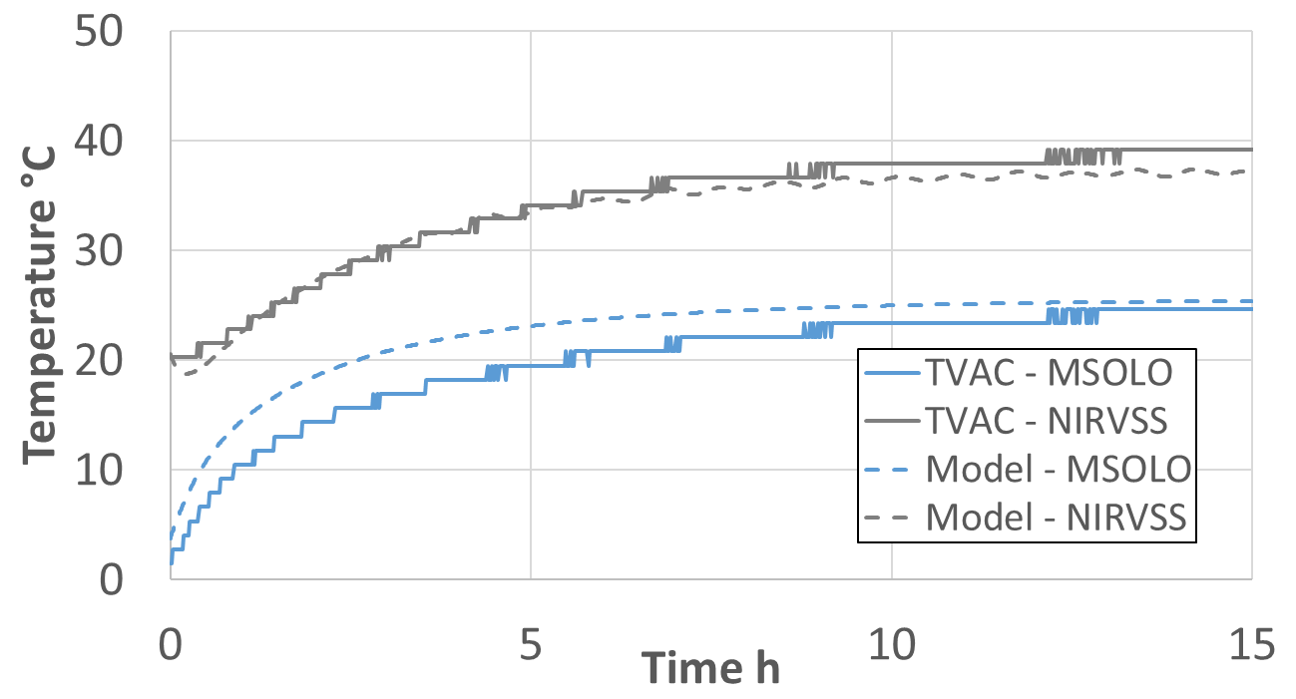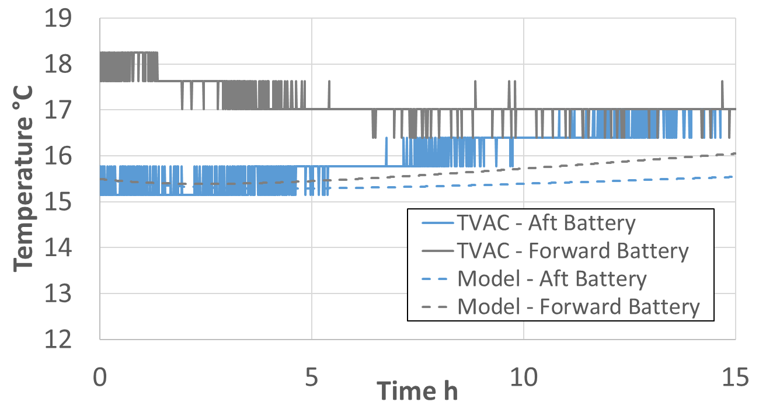
Figure 7: Measured (solid lines) versus modeled (dashed lies) transient temperature profile during hot thermal balance. Left: MSOLO and NIRVSS. Right: batteries.
From the steady state temperatures reached at the end of hot thermal balance, cold thermal balance, and hibernation test segments, the error between the measured and predicted temperatures for each CV were calculated, Table 3. While a good agreement was obtained between the measured and predicted temperatures, few cases exhibited large errors, highlighted in red in Table 3, that are worth discussing. Those cases can be grouped as follows:
- Port, aft, and starboard radiators during cold thermal balance test segments. During cold thermal balance, two of the LHPs were operating in reverse flow and two LHPs were operating in forward flow causing an uneven heat dissipation between radiators. In the vehicle, there are aluminum brackets connecting the edges of radiators allowing some amount of dissipated heat to be shared between the radiators. That heat sharing capacity is not captured on the thermal model, resulting in larger temperature gradient predictions.
- Aft TCV temperature during cold thermal balance test segment. The aft LHP was operating in reverse flow, however the TCV body temperature was hovering around the fully closed temperature of -10°C. On the contrary, the thermal model predicted a fully closed TCV driving its body temperature even further cold, like in hibernation.
- Port and starboard radiators during hibernation test segments. Again, the fact the model does not capture the heat dissipation being shared between the radiators is causing larger temperature gradient predictions.
- Forward and starboard radiators during hot thermal balance test segment. These discrepancies between the testing and modeling are again due to the missing aluminum brackets connecting the edges of radiators on the model.
- Batteries during hibernation. During hibernation, the only available battery thermocouples were mounted either on the batteries case or the batteries MLI, none of which are presentative of the batteries’ average body temperature.
Table 3: Summary of the temperature error for hot thermal balance, cold thermal balance, and hibernation test segments. Cases with large errors are highlighted in red.

Conclusions
The numerical model described in this paper captures the key components of VIPER’s TMS. Those are the four heat spreaders with the masses of the avionics boxes, four radiators, four LHPs to conduct the heat from the heat spreaders to the radiators, seven xCCHPs to balance the heat between heat spreaders, two payload instruments with their three CCHPs, and two batteries with their thermal straps. The heat spreaders with the avionics boxes, the LHPs, and the radiators were modeled following an earlier single LHP modeling approach, which was based on the control volume simplification method. The payload instruments and the batteries are modeled as thermal lump capacitances. Yet, since the amount of heat transported by the xCCHPs between heat spreaders are unknown, an iterative solution scheme was needed to overcome this modeling challenge. Despite the need for an iterative solution scheme, the collection of simplifications described in this paper allowed for a computationally efficient model able to provide thermal predictions in very short time. This is a needed quality of any modeling tool used for quick assessments and for flight console operator training where almost real time feedback is required. However, fidelity is lost on the spatial temperature distribution which are just averages for any given thermal region.
The proposed VIPER TMS numerical model was correlated using integrated vehicle TVAC test data. The model was correlated using three different segments of the TVAC: hibernation, cold thermal balance, and hot thermal balance. By doing so, the model can capture the three most extreme conditions expected on vehicle, bounding most other mission operation scenarios. Through the correlation effort, the model was calibrated to capture the heat leaks, TCV performance in 1g, and the thermal conductance of the CCHPs.
While the reason for discrepancy between model and the test data has been identified, some of the discrepancies are intrinsic the model itself (for example, uncertainty on the sink temperatures) while others could be address in future, more refine, versions of the model (for example heat shared between the radiators).

Acknowledgments
Any opinions, findings, and conclusions or recommendations expressed in this paper are those of the authors and do not necessarily reflect the views of the National Aeronautics and Space Administration (NASA).

References
[1] Médici E. F., Turk J. C., Stewart E. R., Page T., Dobarco-Otero J., Quintanilla G., Slusser T. B., Mittag Z. W., Barragan J. M., Alvarez-Hernandez A. R., Bugby D. C., Hughes J., Smay J., Tarau C., “Simulated Lunar Gravity Testing of VIPER Loop Heat Pipe”, 56th International Conference on Environmental Systems. San Juan, Puerto Rico, 2026.
[2] Smay J., Hughes J., Spangler R., Tarau C., and Alvarez-Hernandez A. R., “Volatiles Investigating Polar Exploration Rover (VIPER) Thermal Management System (TMS) Design, Development, and Testing,” 53rd International Conference on Environmental Systems, Louisville, KY, 2024.
[3] Médici E. F., Turk J. C., Stewart E. R., Page T., Mittag Z. W., Barragan J. M., and Alvarez-Hernandez A. R., “A Simplified Model of VIPER Thermal Management System. Part I: Loop Heat Pipe”, 56th International Conference on Environmental Systems. San Juan, PR, 2026.

Thermal Engineer, S&K Global Solutions, Houston TX 77058.
AST Heat Transfer, NASA Marshall Space Flight Center, Huntsville, AL 35812.
AST Heat Transfer, NASA Marshall Space Flight Center, Huntsville, AL 35812.
Thermal Engineer, NASA Marshall Space Flight Center, Huntsville, AL 35812.
Thermal Control System Project Manager, NASA Johnson Space Center, Houston TX 77058.
VIPER Cross Cutting Integration Manager, NASA Johnson Space Center, Houston TX 77058.
JSC Passive Thermal Technical Discipline Lead, NASA Johnson Space Center, Houston TX 77058.

