Design of an AI Trash Sorting Machine For Use On The Moon and Mars
Steven Sepka, Justine Richardson, and Lance Delzeit
NASA Ames Research Center, Moffett Field, CA, 94035 USA
Ray Pitts
NASA Kennedy Space Center, Merritt Island, FL, 32899 USA
Jennifer Jones
NASA Marshall Space Flight Center, Huntsville, AL, 35812 USA
and
Greg S. Pace, Serena Trieu, and Janine Young
Amentum Services Inc, Chantilly, VA 20151 USA
As NASA prepares for Mars colonization, resource conservation will be critical for survival. Artificial Intelligence (AI) powered waste sorting technologies, already emerging on Earth, offer promising solutions for recycling and material recovery. These systems use advanced sensors and machine learning algorithms to identify and separate materials with remarkable accuracy. On Mars, where every item has significant value, efficient recycling will be essential to reduce resupply needs and support closed-loop life support systems. This paper explores how terrestrial AI-based trash sorting technologies can be adapted for Martian conditions, focusing on challenges such as the harsh surface environment, minimizing system mass, power, volume, and estimating waste composition. Addressing these issues will be key to enabling sustainable operations on the Red Planet.

Acronyms and Nomenclature
AI = Artificial Intelligence
CM = Crew Member
d = lunar day
ESM = Equivalent System Mass
FE = Foundational Exploration
GCR = Galactic Cosmic Radiation
HLR = Human Lunar Return
ICSD = Increased Crew Size and Duration
ISC = Increased Science Capability
M2M = Moon to Mars
mGy = Milligray
ML = Machine Learning
MSL = Mars Science Laboratory
PnP = Pick and Place
RAD = Radiation Assessment Detector
RTMDet = Real-Time Models For Object Detection
SLE = Sustained Lunar Evolution
YOLO = You Only Look Once

Introduction
A
rtificial intelligence (AI) refers to the ability of computers to simulate human thought and perform tasks in real-world environments. Machine learning (ML), a subset of AI, encompasses the technologies and algorithms that enable systems to identify patterns, make decisions, and improve performance through experience and data. An AI system typically combines ML with robotics and automated processes, and is generally designed to operate autonomously or with minimal human intervention.
The adoption of AI in terrestrial trash-sorting systems is accelerating as municipalities seek to reduce landfill use and improve recycling efficiency. For instance, AMP™[1] has expanded on a two-year pilot project in Portsmouth, VA, where its system processes up to 150 tons of locally sourced municipal solid waste daily. ZenRobotics®, a division of Terex Corporation, has been a pioneer in AI-powered sorting for over 15 years and now operates globally. Its Fast Picker® [2] achieves up to 80 picks per minute, making it well-suited for lightweight materials such as packaging waste and dry mixed recyclables. In contrast, Machinex Industries Inc. offers the SamurAI® Optima™ robot [3], designed for smaller-volume environments. Mounted directly on the conveyor, it can be installed within a single day and delivers up to 70 picks per minute with approximately 95% accuracy in targeted product recognition. These innovations highlight a trend toward faster, more precise, and easily deployable solutions, signaling a future where fully automated waste management systems become standard practice.
Developing an AI-based trash-sorting robot for use on Mars presents unique challenges. This paper explores the potential benefits of leveraging an AI sorting mechanism to enable recycling for Martian missions and examines the technical hurdles that must be overcome to implement such a system.

Economics

Mars
For sustained operations on Mars, one of the most important reasons for sorting the trash is the value of these items for recycling. It is difficult to evaluate their worth due to the number of uncertainties associated with any Mars mission. However, one way to estimate it is using previous uncrewed missions. For example, the Mars Perseverance Rover[4] landed on Mars on February 18, 2021 with a mass of 1,025 kg. The rover is expected to cost $2.7 billion dollars [5] in total, of which $2.2 billion was for spacecraft development, $243 million for launch services, and about $300 million for operations and scientific analysis. This corresponds to a cost of $237,073/kg for the landed mass using the launch services budget. For a crewed mission the costs will be higher. Landed mass is the total mass of the spaceship at landing including its cargo. One scientist estimates that in just fuel expenses[6] it will cost $1M/lbm of cargo. Additionally, a mass-cost analysis does not consider available cargo volume on the spaceship, which will always be minimal. The ability to recycle materials on Mars will have a major beneficial impact for sustained Martian presence. If the mass, power, volume and crew time can be kept to a minimum, recycling should always be worthwhile.

Lunar
Flying from Earth to the moon is also expensive. For chemical rockets[7] it costs $1M to $1.2M to fly a single kilogram from Earth to the Moon. For missions to low Earth orbit there are many reports indicating launch costs have decreased[8][9]. However, a recent study [10] has found that although the privatization of making spacecraft has resulted in reduced costs, NASA is charged a premium for launch operations.

Environment
Whether intended for use on the Moon or Mars, the sorting robot will ideally operate inside the habitat. These habitats are expected to maintain an environment similar to Earth's atmosphere, with a cabin pressure of 101.3 kPa (14.7 psi) and an oxygen concentration of 21% by volume. However, the environment could also be at a reduced pressure of 10.2 psi combined with an increased oxygen concentration of 26.5%, similar to those being discussed for exploration missions and used on the Shuttle [11]. This enhanced oxygen environment introduces a greater fire hazard, so material selection must account for this risk.
If the sorting robot is instead used or stored on the lunar or Martian surface, these extreme environments pose significant challenges. The goal is for a trash-sorting robot to survive for 20 years or more on the surface of Mars if kept inside a pressurized habitat. For reference, the environmental conditions on Mars and the Moon are summarized in Table 1.

Table 1. Lunar and Martian Environmental Conditions
 | Martian Surface | Lunar Surface | Inside a Pressurized Habitat
Gravity | 3.73 m/s² | 1.625 m/s² | Same as external surface
Atmospheric pressure | 636 Pa | 0.3 nPa | 57.2 kPa
Temperature range | -153°C to 20°C | -223°C to -23°C | 18°C to 27°C
Atmospheric composition | 95% CO₂, 2.7% N₂, 1.6% Ar, and trace amounts of O₂, CO, and water vapor | N/A | ~34% O₂, 66% N₂, and water vapor
Radiation | 40-50 times Earth | ~200 times Earth | To be determined
Soil composition issues for machinery | Regolith contains perchlorates, and dust particles | Electrically charged, sharp, and irregular dust particles | N/A

Radiation levels on Mars are significantly higher than on Earth due to the planet's lack of a global magnetic field and a thin atmosphere, which offer minimal protection from cosmic rays and solar particles. The radiation dose rate [12] for MSL/RAD was 0.21–0.31 mGy/d (Martian day), which is about 40-50 times the daily amount on Earth[13].
Galactic cosmic radiation (GCR) can affect metals by creating crystal lattice defects resulting in decreased density, reduced toughness, and makes the metal more brittle despite a potential increase in hardness. While metals are generally more resistant to radiation damage compared to other materials, these changes in mechanical properties can degrade their performance over time in a space environment [14].

Waste Generated
A growing body of work is being established in the literature regarding the anticipated waste stream for future crewed exploration missions.[15][16]. The reported waste models leverage existing datasets of waste generation rates and materials realized onboard the International Space Station. Common crew-related trash items include food packaging, used clothing, containment bags (e.g., cargo transfer bags, plastic recloseable bags, etc.), hygiene items, and metallic structures. Table 2 shows a list of crew-related trash items on ISS that are expected on future missions.
A previous study [17] was performed assessing the value of using advanced trash management capabilities to both mitigate the waste footprint on planetary bodies and to generate value-added products within the lunar segments of NASA’s Moon to Mars (M2M) Architecture [18]. A lunar waste resource estimate was generated and is shown in Figure 1. This figure showcases estimates of various waste resources for lunar missions from short stay, small crew missions (7 days on lunar surface; crew of 4) to longer duration and larger crews (365 days on lunar surface; crew of 8). Although this figure centralizes on the lunar campaign, similar waste items are assumed to be prevalent for a future mission to Mars. Accordingly, various waste resources may be of high utility to a Mars mission, including polymers, textiles, biologics, and metallics. If the use of one particular waste stream is desired, effective sorting and separation, with minimal crew intervention, is required.

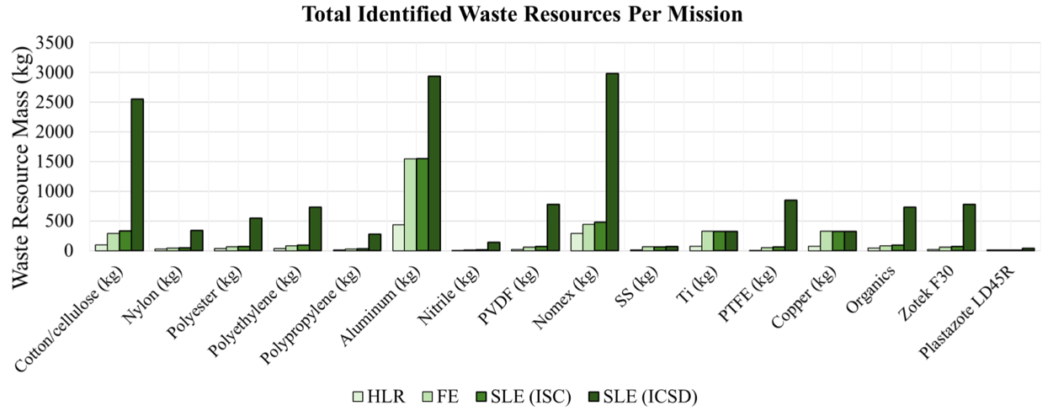
Figure 1. Potential resources in the waste stream. Estimates were generated for the lunar segments of the Moon to Mars Architecture. These values are total estimates for Human Lunar Return (HLR), Foundational Exploration (FE), and two reference missions for Sustained Lunar Evolution (SLE): Increased Science Capability (ISC) and Increased Crew Size and Duration (ICSD). Please refer to the publication [18] for more details

Table 2. Examples of Crew Trash Items
Trash Component | Trash Component | Trash Component
Athletic Running Shoe | Cotton T-shirts | Beef Patty
Shorts | Towels | Scrambled Eggs
Socks | Wet Wipes | Beef Franks
Leather Belt Buckle | Dry Lab. Chem Wipes | Macaroni
Exercise Shirt | Disinfectant Wipes | Tortilla
Thermal Protective Glove | Nitrile Gloves | Rice Pilaf
Electric Shaver | Shampoo On Towels | Sweet And Sour Chicken
Adjustable Tether | Toothpaste On Towels | Cream Spinach
Mini Flashlight | Polyethylene Terephthalate (PET) Plastic | Orange-Pineapple Drink
Flashlight Nylon Belt Holster | Chewing Gum | Apple Cider Drink
Mechanical Pencil | Deodorant | Pineapple Drink
Binder Clips | Computer Paper | Dried Apricots
Rubber Bands | Duct Tape | Peaches
HEPA Filter (Vacuum Filter) | Polyimide Tape | Macadamia Nuts
Vacuum Bags | Hook And Loop Backing | Strawberries
Open End Wrench | Bite Size pouch | Vanilla Pudding
Scientific Calculator | Thermo pouch | Reclosable Plastic Bag
Magnetic Strip Assembly | Beverage Pouch | Bubble Wrap
Nylon Brush | Septum | Syringes
Oxygen Sensor | Septum Adapter | Bandages
pH Strips | Rehydrateable Pouch | Bulk overwrap bag (BOB)
Dessicant | Overwrap, White

Equivalent System Mass
There are many factors that go into the design of an AI sorting robot. Examples include the conveyor belt dimensions, conveyor belt speed, conveyor motor power, reliability, overall system size, robot arm mounting, robot arm reach, sorting bin locations, and having a trash dispenser designed for low gravity environments. When making these design choices Equivalent System Mass (ESM) should always be kept in mind.
ESM is used in advanced life support system trade studies as a transportation cost parameter. Because the cost to transport payload is proportional to the mass of the payload, a mass-based method such as ESM can estimate relative launch costs. Trade studies are used to identify which of several options (that meet all requirements) are most likely to have the lowest cost. ESM values are calculated by the sum of the life support system mass, and by using conversion factors, values from the pressurized volume, power generation, cooling, and crewtime. The calculation of ESM values is shown in Eq. 1 below.
ESM should not be the only metric considered in a trade study. As a cost metric, ESM does not include reliability, safety, and performance differences between trade study options. To apply ESM appropriately, the trade study options must meet some common prerequisites, and some characteristics might require comparison by other means. However, a low ESM will help mission planners justify launch costs.

ESM = M + (V*Veq) + (P*Peq)+ (C*Ceq)+ (CT*D*CTeq) (1)

ESM = the equivalent system mass value of the system of interest [kg]
M = the total mass of the system [kg]
V = the volume of system [m3]
Veq = the mass equivalency factor for the volume [kg/m3]
P = the power requirement of the system [kWe]
Peq = the mass equivalency factor for the power generation [kg/kWe]
C = the cooling requirement of the system [kWth]
Ceq = the mass equivalency factor for cooling [kg/kWth]
CT = the total crewtime requirement of the system[CM-Wy]
D = the duration of the mission segment of interest [y]
CTeq = the mass equivalency factor for the crewtime support [kg/CM-h]

Trash Sorting Systems
The field of AI robots using vision has grown rapidly. To construct an AI robot for use on Mars a good starting point is with what’s being commercially developed. This section discusses some of the key components for developing an AI robot.

Overview
Automatic sorting systems use advanced image recognition algorithms to analyze visual data and identify different waste materials with high precision, enabling efficient material sorting. There are two free, open-source machine learning (ML) programs that have extensive use within the AI community. They are TensorFlow® and PyTorch®. These frameworks are designed to facilitate the creation, training, and deployment of ML models by comparison of scanned items to those in memory. These ML models have been used to create state-of-the-art object identification algorthims such as You Only Look Once (YOLO) [19] or Real-Time Models for Object Detection (RTMDet) [20]. In addition to ordinary visual wavelength cameras, hyperspectral cameras using an expanded wavelength spectrum are also used to capture images of the items [21].
Trash sorting is difficult due to the large number of features and the heterogeneous nature of waste materials. The main features of the recognition object are their shape, color, texture, and spatial relationships of the image [22]. Spatial relationships of an image describe the position, size, depth, and orientation of objects. Analyzing each image from different perspectives contains a considerable amount of information, therefore in order to improve accuracy it is necessary to classify and divide the features of the image. Training efficiency improves as more discrimination criteria become available. Over 90% accuracy in waste item identification has been demonstrated [23]. However, technical barriers still exist such as waste stacking on the sorting line, multiple objects coming into contact with each other, and objects with similar characteristics being mixed [24].
Robot arms are used commercially and have shown success. These arms are often called manipulators due to the arm's ability to perform tasks by grasping, moving, and manipulating objects much like a human arm. Manipulators are highly precise and versatile when used for material handling such as pick-and-place (PnP) processes that select objects and physically transfer them to the appropriate material bin. Instead of grasping objects, robot sorting systems can also use suction at the arm’s end to secure the items. For exposed surface applications on Mars or the moon, excessive dust exposure would make suction impractical due to potential clogging. Other sorting methods such as using blowing [25] to move items have been used. Recently a finger-like gripper was fully integrated into a 4-degree-of-freedom robot structure [26].
Commercially available robot arms with vision systems has grown rapidly. Some examples are Kinova® Inc. Gen3 [27], FANUC Corp.’s LR Mate series [28], and Hiwonder® JetArm [29] robots. These robots can respond to voice commands and have demonstrated the ability to easily sort objects based on shape or color. They would need to be trained to recognize the trash items found in Table 2.
There are open-souce datasets of trash images. Implementing a rich data set that consists of many recyclable waste images is an important step in creating a categorization module for machine learning. To the best of our knowledge there are only two open source data sets, namely, TrashNet [30] and Taco [31], that are available for public use.

Typical AI Imaging System Components

Camera:
The camera captures an image of the trash as raw data for the AI detection model. The image is digitized.

Image Processing:
The image may need to be resized to reduce computational load, manage memory, and standardize input dimensions for machine learning models. To reduce complexity, the color scale may be converted to grayscale. A Gaussian blur or median filter is often used to remove unwanted noise. Another technique is to normalize pixel values, for example between values of 0 and 1, to help ensure stable training and inference.

Detection Model:
AI software models like YOLO or RTMDet are easy to implement, fast, and accurate. They are designed to make product identification in real-time. All AI models will require training data. This helps insure that AI learns what each product looks like. Training data often labels the images and has boxes drawn around the items.

Inverse Kinematic Calculations
An imaging system uses inverse kinematic calculations to determine the joint angles and motor positions required to place the grabber at a specific spatial coordinate to pick up an item. This task becomes even more challenging when the target is on a moving conveyor belt, as the system must identify the recycled item and position the grabber within the limited time the item remains in view.

Typical Conveyor System
The crew generates approximately 1.1 kg of trash per crew member per day [15][16]. Consequently, the conveyor system required for daily operations can be relatively compact. Commercially available conveyor systems are typically constructed from aluminum or steel, measuring about 1.8 m (6 ft) in length with a belt width of approximately 20.3 cm (8 in.). For the trash dispenser, the design must ensure an evenly distributed array of items while minimizing overlap. Operating in a microgravity environment introduces unique challenges; therefore, a variable-sized opening may be necessary. This opening’s size would be optimized in situ, potentially using an imaging system to monitor and detect clogging. It is hoped an even smaller conveyor systems will be developed.

In-Space Manufacturing
In-Space Manufacturing (ISM) utilizes welding, additive manufacturing, formative manufacturing and/or subtractive manufacturing for on-demand part or infrastructure production in space and on non-terrestrial surfaces. Materials suitable for ISM include metals, plastics, and ceramics. Manufactured items could be used for a wide range of applications including tall towers, habitats, tiles for radiation or dust protection, chairs, spoons, chess pieces or luxury items for crew mental health, replacement parts/spares for critical equipment or known consumables, electronic sensors, and devices for power generation or storage. As a result, ISM is vital for NASA’s sustained space presence by supporting mission flexibility, on-site device creation, and reducing the amount of needed spare parts initially carried on a mission.
With longer duration exploration missions and a sustained presence on the Moon or Mars, the incorporation of both In-Space Manufacturing (ISM) and in-space recycling could provide necessary resources to support and complement mission needs. ISM and recycling technologies should be developed in parallel as the two capabilities naturally complement each other. The utilization of recycled feedstocks for ISM greatly reduces the mass of feedstock that must be launched. In turn, the availability of ISM technologies increases the viability of recycling by providing a method to turn recycled feedstock into new necessary parts or structures manufactured on non-terrestrial surfaces.
An additional key component of in-space manufacturing is the inspection and certification of produced items so that they could be used with confidence for an intended application. Sorting technologies could be a piece of that process by ensuring a baseline quality in the recycled feedstock material.

Conclusion
The ability to recycle waste in space offers substantial savings in both cost and logistics, while also reducing the accumulation of discarded material on planetary surfaces. Effective waste sorting further enhances this capability by generating high‑quality feedstock for recycling and in‑space manufacturing. This paper has outlined many of the design challenges associated with implementing such systems for lunar and Martian missions. Developing robust waste‑sorting capabilities for planetary surfaces will also yield terrestrial benefits, enabling compact, low‑power, easily assembled recycling systems that maintain high sorting accuracy and long operational lifetimes.

Appendix

Table A1. Average compositions of the Martian crust, soil, and dust [j].
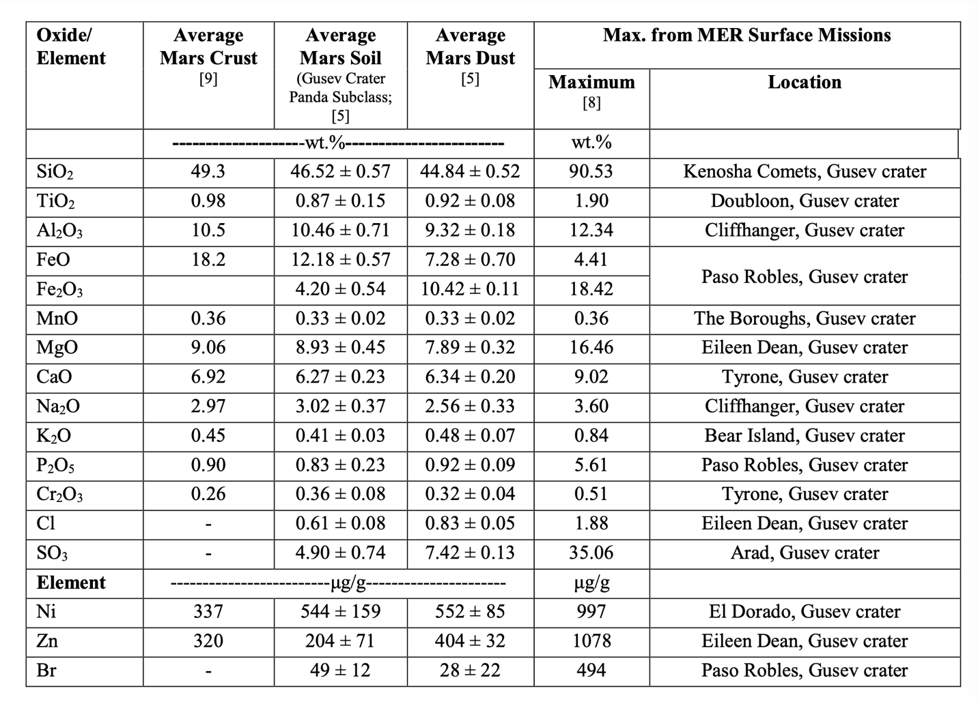

Acknowledgments
This study was performed with the support of personnel within various NASA organizations, including the ESDMD Mars Campaign Office Logistics Reduction Project and STMD ISRU.

References
[1] AMP™ (Nov 21, 2025) "AI Takes Out the Trash: Largest U.S. Recycling Project to Extend Landfill Life for Virginia Residents" [Press release]. https://ampsortation.com/articles/largest-us-recycling-project-spsa
[2] https://www.terex.com/zenrobotics/robots/fast-picker
[3] https://www.machinexrecycling.com/sorting/equipment/samurai-sorting-robot/
[4] California Institute of Technology Jet Propulsion Laboratory, “Mars 2020 Perseverance Launch Press Kit” https://www.jpl.nasa.gov/news/press_kits/mars_2020/launch/mission/spacecraft/perseverance_rover/
[5] The Planetary Society, “Cost of Perseverance” https://www.planetary.org/space-policy/cost-of-perseverance
[6] Patel, P., "For NASA’s mission to Mars, how much do materials need to improve?" Chemical And Engineering News Volume 101, Issue 20 https://cen.acs.org/materials/NASAs-mission-Mars-much-materials/101/i20
[7]Hollingham, R., "Leave only moonprints: Nasa's lunar recycling ambitions" British Broadcast Corporation (BBC) 7 December 2024 https://www.bbc.com/future/article/20241206-leave-only-moonprints-nasas-lunar-recycling-ambitions
[8] Adilov, N., Alexander, P., Cunningham, B., and Albertson, N.,. (2024). “An Analysis of Launch Cost Reductions for Low Earth Orbit Satellites” (accepted for publication, Economics Bulletin, 2022). Economics Bulletin.
[9] Jones, H., “The Future Impact of Much Lower Launch Cost” 48th International Conference on Environmental Systems, 8-12 July 2018, Albuquerque, New Mexico, ICES-2018-58
[10] Kim, M.J., "Counting stars and costs: An empirical examination of space launch cost trend at NASA" Acta Astronautica, Volume 232, 2025, Pages 633-639, ISSN 0094-5765, https://doi.org/10.1016/j.actaastro.2025.04.011
[11] Lange, K., Perka, A., Duffield, B., and Jeng, F. (2005). “Bounding the Spacecraft Atmosphere Design Space for Future Exploration Missions.” NASA/CR—2005–213689 https://ntrs.nasa.gov/api/citations/20050185597/downloads/20050185597.pdf
[12] Ehresmann, B., Zeitlin C., Hassler D.M., Guo J., Wimmer-Schweingruber R.F., Berger, T., Matthiä, D., Reitz G., “The Martian surface radiation environment at solar minimum measured with MSL/RAD,” Icarus, Volume 393, 2023, Table 1, 115035, ISSN 0019-1035, https://doi.org/10.1016/j.icarus.2022.115035.
[13] Hassler, D.M., et al., "Mars’ Surface Radiation Environment Measured with the Mars Science Laboratory’s Curiosity Rover" Science 343, 1244797(2014) DOI:10.1126/science.1244797
[14] Abd El-Hameed, A. M. (2022). Radiation effects on composite materials used in space systems: a review. NRIAG Journal of Astronomy and Geophysics, 11(1), 313–324. https://doi.org/10.1080/20909977.2022.2079902
[15] Richardson, T.-M. J. et al., “The Trash Compaction Processing System (TCPS) Technology Demonstrations Science Objectives and Requirement Definitions,” Jul. 2023, Accessed: Apr. 22, 2025. [Online]. Available: https://hdl.handle.net/2346/94644
[16] R. Pitts, J. A. Olson, M. Benson, M. Kelley, C. A. Richardson-Gongora, and A. J. Meier, “Development of a Predictive Model for In-Situ Resource Utilization of Space Exploration Waste,” in ASCEND 2023, American Institute of Aeronautics and Astronautics. doi: 10.2514/6.2023-4659
[17] Anthony, S. M. and Hintze, P. E. “Trash-to-Gas: Determining the Ideal Technology for Converting Space Trash into Useful Products,” presented at the International Conference on Environmental Systems, Tucson, AZ, Jul. 2014.
[18] Pitts, R. P., Alvarez, V. R. Ewert, M. K. and Spader, A. M. “Advanced Waste Management Strategic Analysis: Human Lunar Return to Sustained Lunar Evolution,” Jul. 2025, Accessed: Aug. 12, 2025. [Online]. Available: https://hdl.handle.net/2346/102765
[19] Joseph Redmon, J., Divvala, S., Girshick, R., Farhadi, A., "You Only Look Once: Unified, Real-Time Object Detection" University of Washington https://arxiv.org/pdf/1506.02640
[20] Lyu, C., Zhang, W., Huang, H., Zhou, Y., Wang, Y., Liu, Y., Zhang, S., and Chen, K., Shanghai AI Laboratory "RTMDet: An Empirical Study of Designing Real-Time Object Detectors" https://arxiv.org/abs/2212.07784?ref=blog.roboflow.com
[21] Moore, A., “AI-Powered Waste Management System to Revolutionize Recycling,” Forest Biomaterials Research, North Carolina State University, College of Natural Resources News, November 9, 2023.
[22] Li, D., Li, M., & Bitto, A. K. (2024). Exploring Artificial Intelligence-driven Image Recognition Technology. Journal of Computer Technology and Software, 3(1), 22–25. Retrieved from https://www.ashpress.org/index.php/jcts/article/view/22
[23] Fahmi, F., and Lubis, B. P., "Identification and Sorting of Waste using Artificial Intelligence Based on Convolutional Neural Network" 2022 6th International Conference on Electrical, Telecommunication and Computer Engineering (ELTICOM), ©2022 IEEE, DOI: 10.1109/ELTICOM57747.2022.10038044
[22] Cheng, T.; Kojima, D.; Hu, H.; Onoda, H.; Pandyaswargo, A.H. "Optimizing Waste Sorting for Sustainability: An AI-Powered Robotic Solution for Beverage Container Recycling." Sustainability 2024, 16, 10155. https://doi.org/10.3390/su162310155
[25] Koskinopoulou, M., Raptopoulos, F., Papadopoulos, G., Mavrakis, N., and Maniadakis, M., "Robotic Waste Sorting Technology" IEEE Robotics & Automation Magazine • June 2021 p50
[26] Leveziel M, Laurent GJ, Haouas W, Gauthier M, Dahmouche R (2022) A 4-DoF parallel robot with a built-in gripper for waste sorting. Robot Autom Lett 7:9834–9841. https:// doi. org/ 10. 1109/ LRA. 2022. 31925 82
[27] online https://www.kinovarobotics.com/product/gen3-robots
[28] online https://www.fanucamerica.com/products/robots/series/lr-mate
[29] online https://www.hiwonder.com/products/jetarm?variant=41317227888727
[30] online https://github.com/garythung/trashnet
[31] online http://tacodataset.org

Physical Scientist, Bioengineering Branch, MS 239-131, NASA Ames Research Center Moffett Field, CA 94035.
Research Physical Scientist, ARC-Bioengineering Branch, Mail Stop 239-15, Moffett Field, CA 94035.
Physical Scientist, Bioengineering Branch, NASA ARC N239-15, Moffett Field, CA 94035.
MCO Logistics Reduction TtG Lead, Exploration Systems and Development Office/ Mail Stop UBE00.
NASA Marshall Space Flight Center, Huntsville, AL 35812, United States of America.
Bastion Technologies Inc, Houston, TX, 77058.
Bastion Technologies Inc, Houston, TX, 77058.
Bastion Technologies Inc, Houston, TX, 77058.

