SSC26-I-06

ACS3 Results and Lesson Learned

Philip Shih
NASA Ames Research Center
Mail Stop 213-2 Moffett Field, CA 94035; 650-880-0128
philip.c.shih@nasa.gov

Olive Stohlman
NASA Langley Research Center
4 West Taylor Street, Mail Stop 230 Hampton, VA 23681; 757-864-8896
olive.r.stohlman@nasa.gov

Ivan Bertaska
NASA Marshall Space Flight Center
Room 4301, Bldg 4600, Huntsville, AL 35812; 256-544-1438
ivan.r.bertaska@nasa.gov

Andres Dono Perez
Astrion/NASA Ames Research Center
Moffett Field, CA 94035-1000; 650-604-2025
andres.donoperez@nasa.gov

ABSTRACT
ACS3 (Advanced Composite Solar Sail System) was a technology demonstration mission for the National Aeronautics and Space Administration¹, to demonstrate the deployment of a solar sail of size 80m² from a new NASA-developed compact deployable composite boom² packaged in a 12U CubeSat. The extended objective of the mission was to perform attitude control and orbit maneuvering. ACS3 was successfully launched on 24 April 2024 local time via Rocket Lab Electron launch vehicle from Rocket Lab Launch Complex 1B in Mahia, New Zealand. Following four months of commissioning operations, the solar sail was deployed on 28 August 2024, achieving the primary objective of the mission. There were challenges throughout all phases of the mission. The first part of this paper will discuss the result of the demonstration and the technical challenges encountered during the mission. The second part of the paper focuses what has been learned regarding the development and execution of a solar sail mission. Based on the results of the mission, this paper will also provide some recommendations for future solar sail SmallSat or CubeSat missions.

introduction
Advanced Composite Solar Sail System (ACS3) was a mission to demonstrate the deployment of a solar sail with area of about 80 m² from a compact composite boom deployer packaged in a 12U CubeSat. Prior to ACS3, other solar sail mission concepts demonstrated deploying or planned to deploy solar sails using either metallic booms or spin-deployment techniques. Many deployable boom technologies exist, but few are suitable to SmallSats and CubeSats with limited volumes³. NASA has developed composite booms that can be packaged compactly for small spacecrafts to address the issues of other boom technologies.
The main objectives of the ACS3 mission were to successfully deploy the solar sail using the composite booms and acquire images of the fully-deployed solar sail in Low Earth Orbit (LEO). In addition to the primary objectives, the mission hoped to achieve controlled solar sailing with pointing, orbit raising and lowering as extended goals.
This paper will first give a high-level description of the spacecraft, the payload, and the Sail and Boom System. It will be followed by an overview of the mission operation result with additional details in the area of the ADCS, Solar Sail Shape and flight dynamics. Finally, the paper discusses lessons learned and offers recommendations for future solar sail mission.

Sail Boom Subsystem
The main payload of the ACS3 mission is the Sail Boom Subsystem (SBS) housed in a 12U spacecraft, developed at the NASA Langley Research Center (LaRC). It was controlled by the payload Avionics Subsystem (AS) developed at NASA Ames Research Center (ARC).
Figure 1 shows an overhead view of the ground full deployment of the solar sail. The sail membrane quadrants are metallized Polyethylene Naphthalate (PEN) thin films of 2-2.5 µm (including metallization). One side of the sail was coated with aluminum to reflect sunlight and the other side was coated with chromium to enhance thermal emissivity³. Tip-to-tip distance between adjacent booms is 9.9 m. Total deployed area is about 80 m².
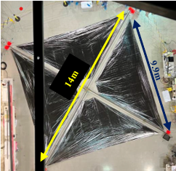
Figure 1: Sail Ground Full Deployment (The image is obstructed by laboratory ceiling structure)

The booms used in ACS3 were developed over a series of studies and collaborations, including the NASA Space Technology Mission Directorate (STMD) Deployable Composite Boom Project (DCB). It was a project of collaboration between the German Aerospace Center (DLR) and NASA Langely Research Center to develop compact deployable technology for future small spacecraft missions. The booms were collapsible tabular mast (CTM) composite booms with typical shape as shown in figure 2.
The booms design was optimized for minimum coiling diameter and high deployed stiffness. The SBS used a tape-spool deployment mechanism similar in concept to that created by DLR for DeorbitSail⁴.

The Spacecraft
The spacecraft in ACS3 is a 12U CubeSat form factor, which simplified the engineering of the spacecraft bus. Instead of a 6U, a 12U bus has a larger volume available for the use of of higher stiffness composite boom laminates. The spacecraft has three major assemblies, as shown in Figure 3: the spacecraft bus which houses the common components of a CubeSat and the payload avionics subsystem, the Sail Boom Subsystem (SBS), and the “-Z” plate, which carries the UHF and S-band antennas.

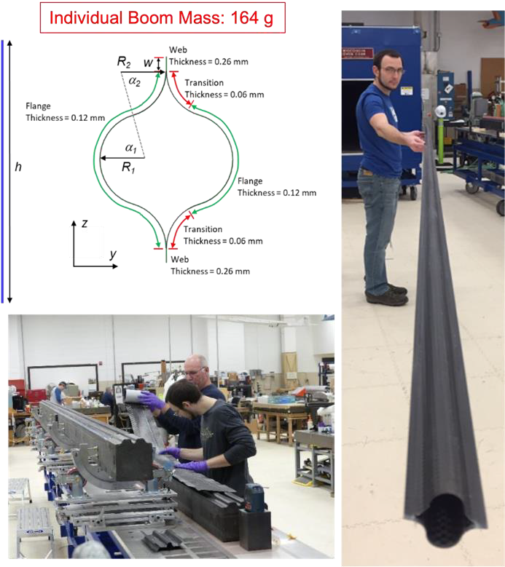
Figure 2: DCB Design and Fabrication

The payload avionics subsystem controls the sail deployment drive motors and acquires images of the sail via the four quadrant cameras. Deployed sail images were taken throughout phases of the mission operation.
Some of the representative properties of the complete spacecraft are summaried in Table 1.
Table 1: Representative Properties for ACS3
Properties | Value | Units
Total spacecraft mass, including sail | 16 | kg
Bus mass | 8.3 | kg
Sail-Boom Subsystem (SBS) mass | 7.7 | kg
Boom mass, each | 0.164 | kg
Sail quadrant area, each | 20 | m²
Sail quadrant mass, each | 0.085 | Kg
Sail membrane thickness, including metallization | ~2 – 2.5 | μm
Effective characteristic acceleration at 1.0 AU, a_{c} | 0.045 | mm/s²
Effective Lightness Number, $β$ | 0.0077 | -

ACS3 Mission OPERATION OVERVIEW
ACS3 was successfully launched on 24 April 2024 10:33am NZST, on the Rocket Lab Electron launch vehicle rideshare mission “Beginning of the Swarm” as the secondary payload. It was deployed about 105 minutes after the liftoff. The spacecraft was deposited in a 1008 km x 985 km, 97.4º inclination orbit. In the beginning of the commissioning phase, the ground station had to overcome technical issues in establishing
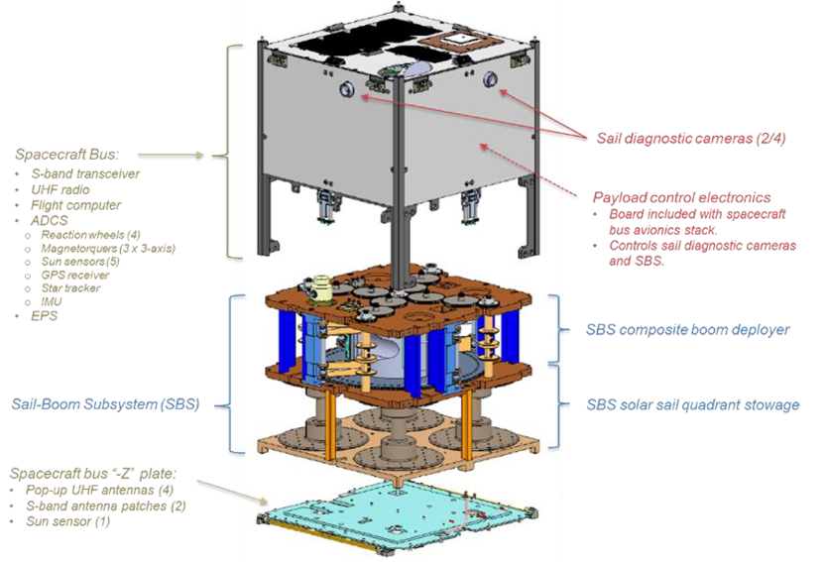
stable communication link with the spacecraft. After four months of commissioning, the solar sail was fully
Figure 3: Spacecraft Major Assembliess and Subsystems. Solar Panels, Sail Membrane and Booms have been omitted for clarity

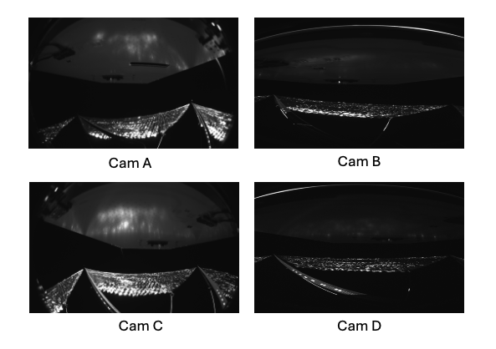
deployed after some technical issues with the pin-puller firing device. Full deployment was evidenced in acquired images from the high-definition cameras each of the quadrant (Figure 4). Mark up illustrates the sail and boom structure on the camera image can be seen in figure 5.
Figure 4: Images of the Sail Quadrants from the Quadrant Cameras after the deployment
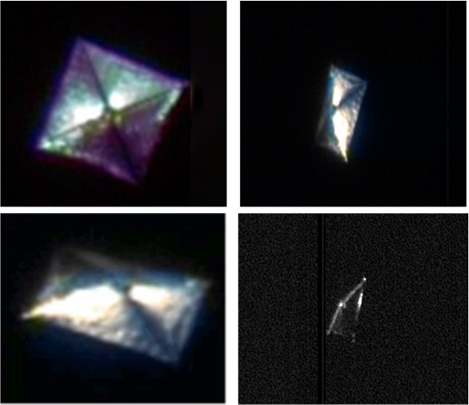
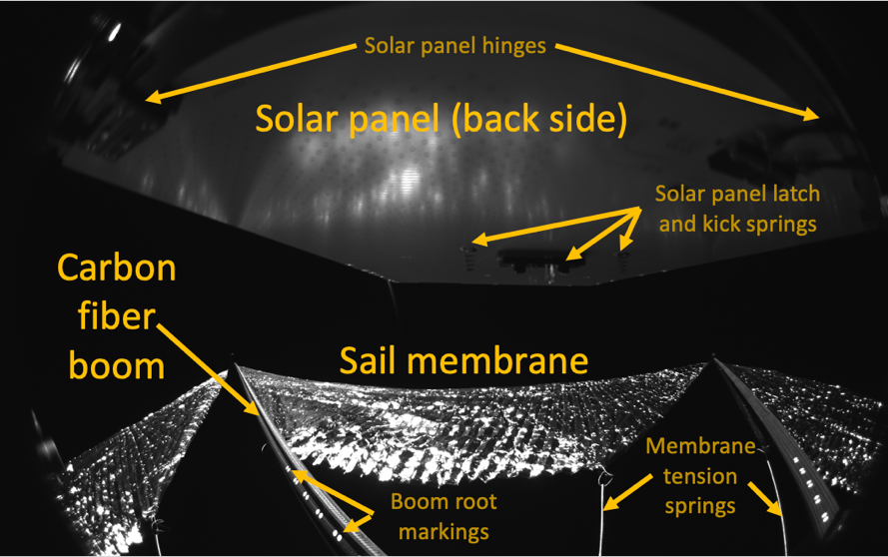
After detailed analysis of the images, it was found that there was a bend and rotation near the root of one of the booms. This indicated a deviation from the idea sail shape that would affect the torques acting on the spacecraft. The booms were clocked by close to 45º and swept aft by 1 to 2 meters, making the overall sail shape more pyramidal and less planar. This was confirmed in another set of images captured by Vantor (formerly Maxar) as shown in figure 6.
Figure 6: Worldview-2 images of ACS3 taken on 11Sep 2024 (Courtesy Vantor)
Figure 5: Mark Up of Sail and Boom Structure
During a controlled pointing experiment on 20 Sep 2024, the spacecraft encountered an anomaly after changing configuration of the reaction wheel and ADCS parameters. As the spacecraft was tumbling at greater than anticipated rates, the reaction wheels were saturated and driven to maximum speed which drained the battery to a very low level in a very short time. Due to the deformation in the sail, the spacecraft encountered a relatively large roll torque that steadily increased the z-axis rates. The battery level was able to be brought back to the operational level, but the spacecraft was oriented in a flat spin with the solar panels pointing away from the sun. The spacecraft appeared to be in an inertial pointing state stabilized by a steadily increasing spin rate on the z-axis.
The power availability was serious degraded, mostly from the Earth’s albedo. The availability of the power constrained the use of magnetorquers to detumble the spacecraft, which was crucial to control the spacecraft’s attitude. More analysis of this anomaly will be discussed in the later section on the Attitude Determination and Control System (ADCS) section.
The mission operation team kept the spacecraft operational under a power management scheme to keep radio contact and continue the detumble operation. However, by the end of January 2025, the battery power level dropped to a very low level again, this time due to the seasonal variation in Earth’s albedo. The ground station lost contact with the spacecraft completely. The spacecraft also shut down the UHF radio to prevent the battery from being completely draining to an unrecoverable state. After about two and a half months, the ground station resumed consistent radio contact with the spacecraft as the battery power was charged back to the operational level due to increase of the earth’s albedo level.
Over the subsequent two months, the spacecraft was predicted to acquire more solar power due to the Sun ephemeris; however, the spacecraft’s attitude during this period prevented it from capturing more solar power. From the available ADCS telemetry, the spacecraft -z side still faced the Sun in June 2025 as in Jan 2025. The solar panel was still pointing away from the sun, due to a confluence of the gravity gradient torque, gyroscopic stabilization about the sail plane, and additional damping the sail structure. This is elaborated in the ADCS section. The detumble operation continued. The RSS rotational rate has been reduced to about 5-6 deg/s, but it never reached the required value for orbital maneuver operations. The project decided not to attempt pointing or any orbital maneuvering so as not to risk of losing radio contact with the spacecraft before decommissioning. The mission operation ended on March 27, 2026 with spacecraft decommissioning.

SAIL SHAPE ANALYSIS
The shape of the solar sail was one of the most important aspects in the ACS3 mission or other solar sail mission. If the sail was not fully deployed or the shape changed unexpectedly, it could create unexpected or off-nominal condition for the spacecraft. The mission had planned to periodically acquire images of the sail to monitor its health and shape.

Solar Sail Overview
As mentioned previously, the sail membrane was a thin film of metallized PEN with thickness of 2-2.5 $μ$m. PEN was chosen over material such as CP-1 (thin film polyimide) because of the cost constraints and its durability for a short mission (the original planned mission duration was 6 months). Each quadrant weighed about 85g with support hardware as shown in Figure 8.
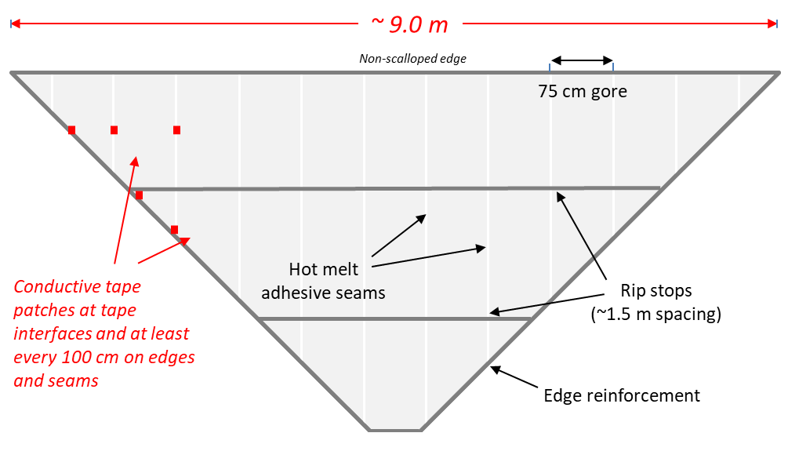
Figure 7: Quadrant Mass (w/hardware) ~85g

The following figure shows the folding scheme of each quadrant of the sail.
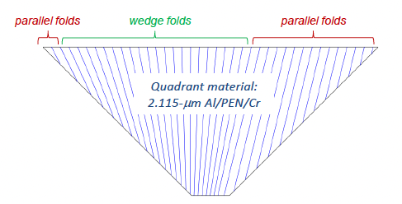
Figure 8: Folding Scheme of Sail Quadrant

On-Orbit Images
The sail was deployed on Aug 28, 2024. From the post-deployed images of the sail, the boom centered at Camera A buckled near its root. In Figure 9, the boom buckle area is clearly seen near the bottom-center of the images, but no cracks or delamination are visible.
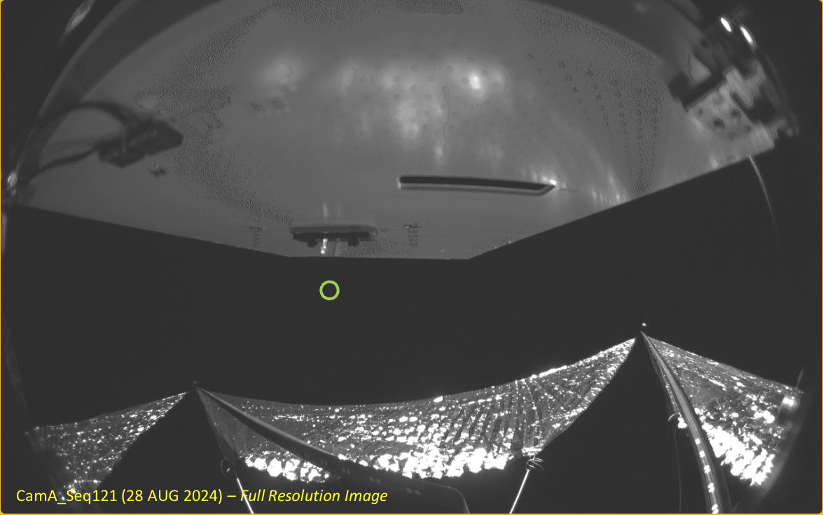
Figure 9: Camera A, sequence 121 at the end of deployment 28 Aug 2024

Comparing the ground-based and on-orbit images, it is clear that the final deployed shape was rotated about 45º away from its nominal shape. Several candidate causes for this anomaly are being investigated.
The four cameras on the spacecraft provided a complete view of the deployed sail. As each lends field of view is larger than 90 degrees, they have substantial overlap. Using the manufacturer’s len distortion function, the lens’ fisheye distortion can be converted to recetilinear projection. The ground test images can be re-projected to validate that lens distortion straight lines become straight. By projecting known position points onto the flight images and comparing with the theoretical position of a quadrant or boom, a reasonable estimate of the sail shape can be made.
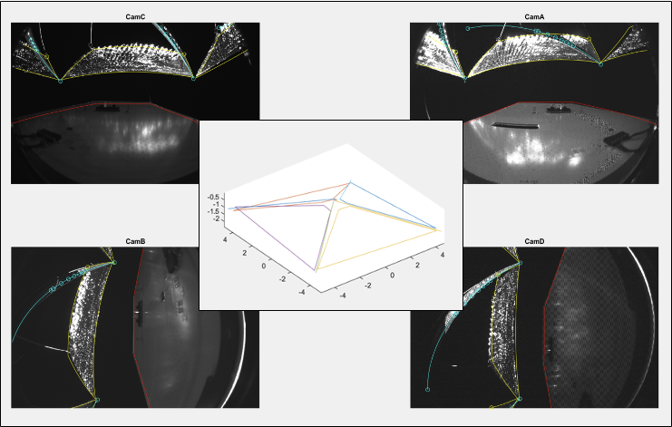
Figure 10: Image sequence 122, taken on 28 Aug 2024

Image sequence in Figure 10, taken post-deployment on 28 Aug 2024, showed a pyramidal shape. Another image sequence, taken on 17 December 2024, is shown in figure Figure 11.
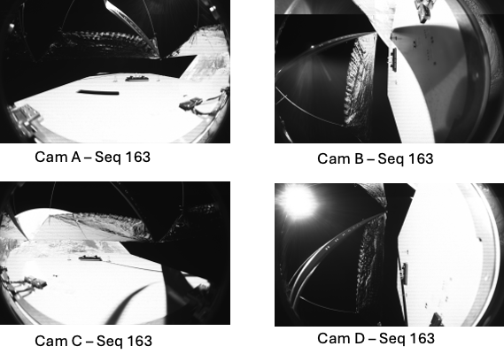
Figure 11: Image Sequence 163, taken on 17 Dec 2024

In Figure 12, image sequence 122 is overlaid onto the image sequence 163. It is found that the sail was flatter in image sequence 163 than image sequence 122.
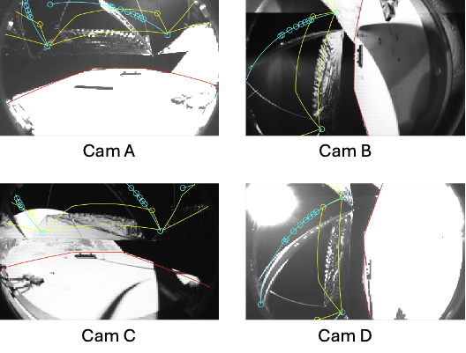
Figure 12: Image 122 overlaid on Image 163

Figure 13 shows the apparent quadrant positions of image series 122 and 163. Image series 163 has rotated from series 122 a little bit.
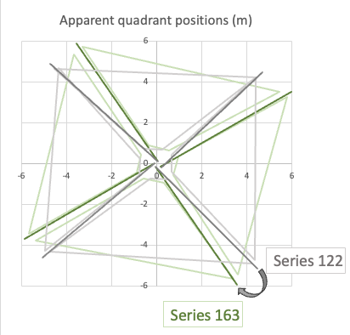
Figure 13: Apparent quadrant positions of Image 122 and 163

From Figure 14, the sail became flatter between September 2024 and December 2024. In the subsequent images acquired in September 2025 and late 2025, the sail continued to become flatter.
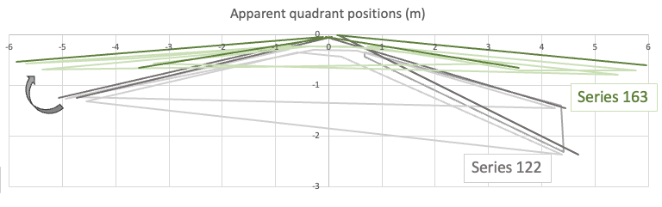
Figure 14: Apparent quadrant positions from the side

These observation raised the question of wether the change of the solar sail shape was related to the spacecraft rotational rate. For a simple flat spin, a higher spin rate is expected to flatten the sail shape through centrifugal force. In Figure 15, the boom tip position is measured in terms of pixel in the acquired image thumbnail.
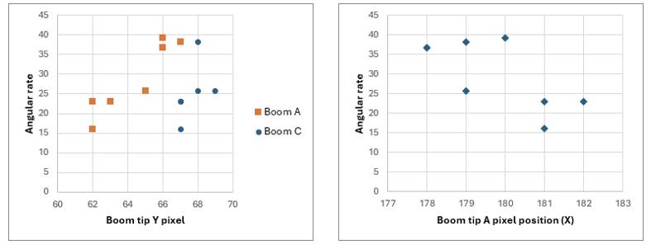
Figure 15: Boom tips position vs Angular rate (deg/s), showing no strong trend.

Due to the small number of images able to be downlinked from the spacecraft, there was not sufficient evidence to identify a relationship between the sail shape and the body rate. Although there is a suggestion of a relationship, there is not enough image data corrected to to a known angular rate.
Sail Degradation
Degradation of the sail is another aspect that got attention by the community. As the sail was built by lower cost material which does not have a long lifetime as compared with other material, it is interesting to see how the sail degrades throughout the mission. The degradation may cause instability of the spacecraft attitude and disturbance torques. On the image downlinked on 18 Dec 2024, some holes were seen as shown in Figure 16.
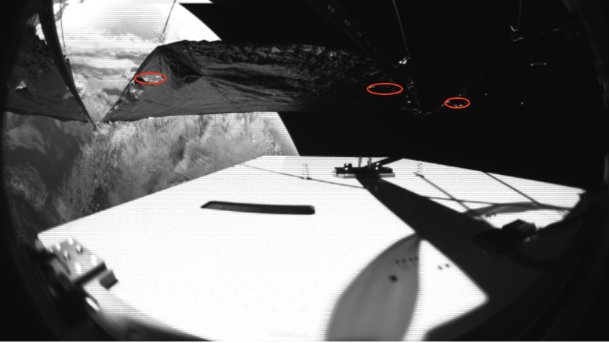
Figure 16: Degradation on the sail

It was expected that there would be some tears or holes, and maybe a seam failure on the sail. The sail was not designed for a mission longer than a year and not for any significant direct sun exposure on the backside, and continuous exposure exceeded thermal and UV design parameters for the sail and bonding materials. In the last high-definition image acquired in early March 2026 (as shown in Figure 17 below), the holes did not become larger and the overall structure of the sail quadrant from camera A did not have any visible change.

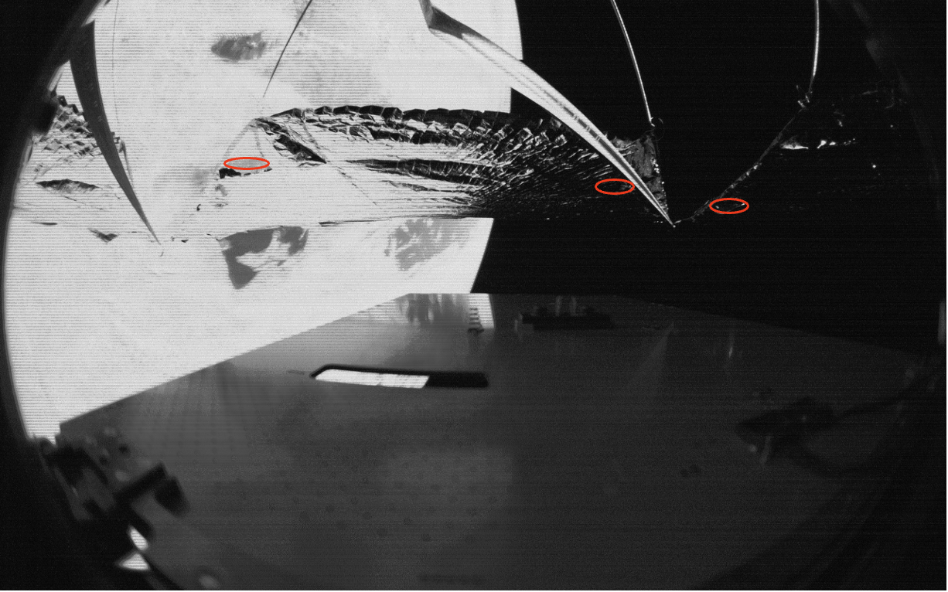
Figure 17: Degradation in the Last Acquired Image

After two years in orbit, besides a few holes seen in one of the quadrants, there is no sign of structural deterioration. Sail quadrants are expected to maintain physical cohesion due to ripstops. No detachments or separations of sail materials are anticipated in the near future. There will be minimal degradation and atomic oxygen erosion of composite boom expected as the spacecraft orbit decays to a lower attitude. Whie the exact progression of sail deterioration is unknown, the sail fabric will tear and produce more holes before the spacecraft re-enters the Earth’s atmosphere and is destroyed by heat.

ATTITUDE DETERMINATION AND CONTROL SYSTEM (ADCS)
ADCS Overview
ACS3 was equipped with standard set of ADCS sensors and effectors for three-axis pointing control, as supplied by the bus provider. These included an Inertial Measurement Unit (IMU), gyroscopes, magnetometers, sun sensors, star tracker, three-axis magnetorquers, and a four reactions wheels. Attitude determination could be achieved either with fine resolution, with inclusion of the star tracker, or coarse resolution with exclusive use of the sun sensors and magnetometers. Pointing control was achieved with the use of all four reaction wheels. Magnetorquers were used exclusively for reaction wheel momentum management and detumbling. A figure of the ADCS component location within the 12U is displayed in figure 18.
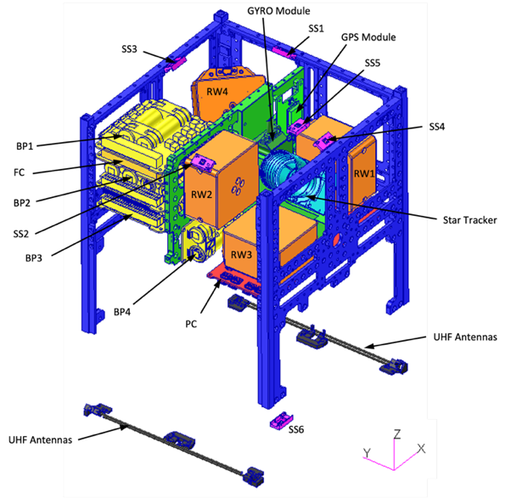
Figure 18: ADCS Components

The 12U bus offered multiple control modes to complete the ACS3 mission. The two of interest in this publication are pointing control and detumbling. For the former, reaction wheels are used for fine attitude adjustment and can track specified target attitude profiles. For the latter, estimates of the rate of change of the magnetic field vector are used to phase the magnetorquers appropriately to reduce spacecraft body rates. Typically, this control method is used to detumble the spacecraft after deployment or to bring the spacecraft to a safe state after off-nominal loss of control.

ADCS Challenges
A key challenge for ACS3 was the use of a conventional ADCS, employed in the bus providers’ fleet of standardized spacecraft. These satellites were relatively small with compact deployed appendages, such as solar panels. They exhibit significantly smaller inertias, less impactful flexible body dynamics, and smaller solar radiation pressure (SRP) and gravity gradient disturbance torques when compared to ACS3 in its deployed state. These effects were somewhat mitigated by increasing the size of the magnetic torque rods used for momentum management, allowing for greater control efficacy to desaturate the reaction wheels in the presence of larger disturbances. However, control over the flexible body remained a challenge as typical safeguards to prevent control-structure interaction were omitted in the design, as these are not a risk for a traditional CubeSat mission. Prior to flight, an alternative ADCS design was incorporated that featured sufficient protection between the controller and the flexible body by reducing the open-loop gain in the “roll” axis, or the axis orthogonal to the solar sail plane. A natural consequence was the reduction in time domain performance. However, performance was deemed admissible because the orbital raising and lowering maneuvers required only thrust vector positioning, and there was inconsequential projection of the thrust vector into the roll axis, i.e., the in-plane rotation of the sail would not appreciably alter the thrust vector.
During the mission operation, several challenges arose that required workarounds.
Due to an unknown issue, the star tracker was unable to determine an attitude solution. Instead, a coarse attitude determination algorithm was used based on inputs from the sun sensors and magnetorquers The attitude was also propagated using rate estimates from the gyroscopes at a higher rate. Post-flight simulations determined that the reduction in pointing accuracy did not appreciably alter the viability of orbital raising and lowering maneuvers.
As mentioned in the mission overview, the sail suffered an off-nominal deployment where one boom was canted, roughtly, one meter out-of-plane as compared to the other three booms. This led to significantly greater SRP torques than initially predicated – up to an order of magnitude larger – that manifested predominantly about the roll axis. This would heavily influence the post-deployment spacecraft dynamics as described below.
On 20 September, 2024, the reaction wheels saturated during a controlled pointing experiment. Although previous controlled pointing experiments experienced a similar fault and the spacecraft successfully recovered, the resultant attitude of the spacecraft was disadvantageous in two ways. First, the resultant solar incidence angle yielded a constant torque about the roll axis, causing the spacecraft rates to accelerate and enter a gyroscopic, semi-stable spin in the z-axis. This was exacerbated by the off-nominal deployment of the sail which increased the roll torques by an order of magnitude. Second, the solar arrays were oriented away from the Sun, relying solely on Earth’s albedo for power generation. This power constraint limited the efficacy of the detumble controller, given the significant power draw of the magnetorquers. In response, non-critical spacecraft components were immediately powered down to maximize the power available for detumble operations.
Although the spin axis of an idealized, gyroscopically stable rigid body is inertially constrained, natural damping in physically realizable structures will serve as a source of energy dissipation, causing a drift of that spin axis. The large, gossamer solar sail is theorized to have greater damping than common spacecraft, leading to a relatively large energy dissipation mechanism. This resulted in ACS3 achieving an equilibrium state relative to the orbital reference frame, i.e., the ACS3 attitude was “locked” to the orbital frame. As the SSO precessed, so did the attitude. This condition is known as Thomson’s equilibrium point, where gravity gradient and gyroscopic torques lead to a spacecraft orientation where the major axis of inertia (i.e., “spin” axis) is perpendicular to the orbital plane. ACS3 was slightly offset from this condition due to asymmetries in the inertia tensor and a significant SRP torque that was on the same order of magnitude as the gravity gradient torques. The ultimate result of this condition was, even though the SSO precessed by a full 180˚, the spacecraft attitude rotated along with it, such that the solar panels continued pointing away from the sun.
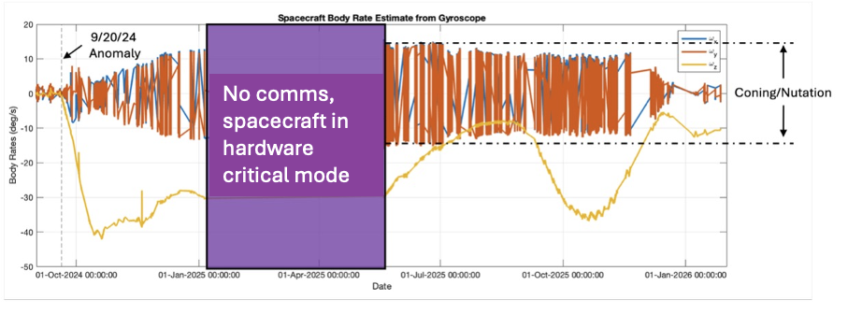
Figure 19 displays the spacecraft body rates, as measured from the gyroscope, from the anomalous event through the end of the mission. One can see that the efficacy of detumbling varied due to the differences in the sun-earth-probe geometry and spacecraft orientation. In addition to the drift in the rotational axis of the spacecraft, the natural precession of the orbit varied the albedo illumination the solar panels were exposed to. In turn, some seasons featured greater detumbling efficacy than others.
Figure 19: ACS3 Body Rates from Anomalous Event through the End of Mission

TRAJECTORY PREDICTION
The ACS3 flight dynamics (FD) team produced orbit determination during the first three months of the mission, while the ground team started to receive valid GPS data up until the sail deployment date. During this time frame, the GPS receiver did not acquire consistent data with periodic cadence due to various issues such as the connectivity with the S-band antenna and the ground station, and the absence of a measurement lock in various instances. However, there was a valid amount of measurement data that was processed by the Flight Dynamics System (FDS) at NASA Ames. These files showed sufficient quality to run Initial Orbit Determination (IOD) and subsequently use a sequential Kalman filter and a smooth process to generate updated ephemeris files as the mission progressed in the initial 1000 km near circular Sun-Synchronous Orbit (SSO).
The FD team at Ames produced regular ephemeris with the DFS as new data was received. Once the sail deployment occurred, a last ephemeris file was produced that covered all the measurements since commissioning up to that point in time. Figure 20 and Figure 21 show the residuals and the position uncertainty respectively, corresponding to that timeframe: The FDS propagator consisted of EMG2008 gravity model with 50x50 harmonics, a NRLMSISE00 atmospheric model, a Solar Radiation Pressure (SRP) plate model, and with third body gravity effects from the Moon and the Sun. The propagator includes daily updated data such as solar weather coefficients and estimates of the ballistic coefficient based on the solution obtained by the orbit determination. Therefore, the initial state and updated coefficients are used to start the orbit propagation for a total of seven days, for NASA Conjunction Assessment Risk Analysis (CARA) screening purposes and to generate meaningful data for the mission and the ground system. A new ephemeris with also covariance of uncertainty propagation is then generated and provided to the mission and to CARA in the CCSD v2.0 format. In addition, TLEs were also generated for the ground station facility at Santa Clara University, Santa Clara, CA. The process occurred daily, and each ephemeris is accompanied by a complete report with report with results regarding the change in orbital elements, ground pass schedules, Azimuth-Elevaton-Range (AER) reports, and any other relevant data for the mission such as eclipse times for power budget planning.
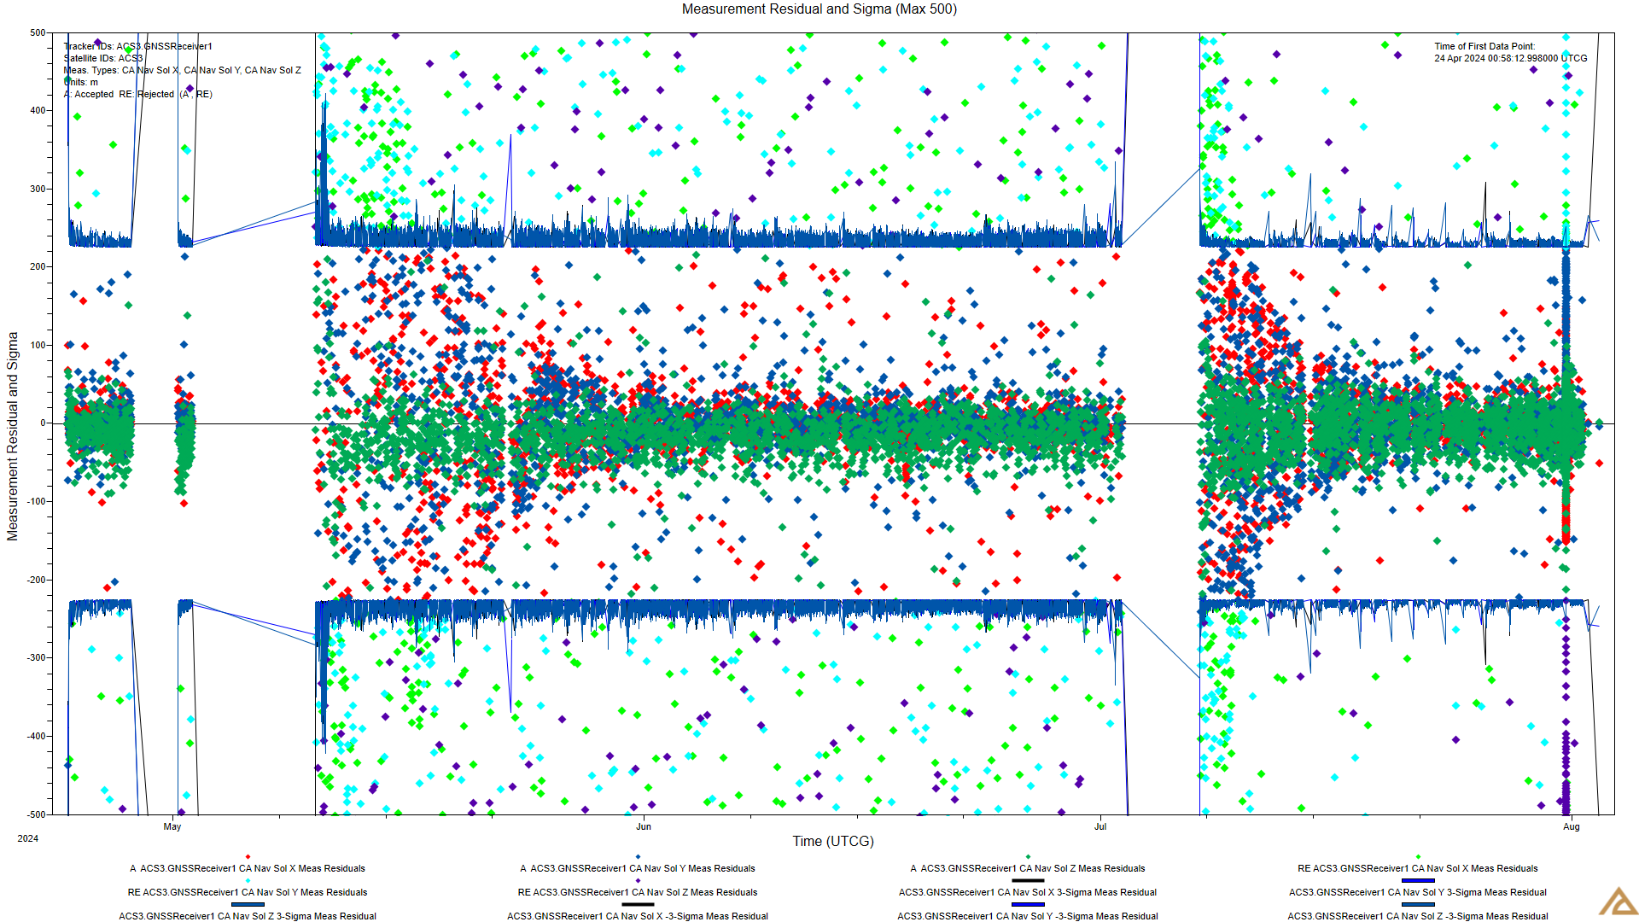
Figure 20: Measurement Residuals from Commissioning up until Sail Deployment

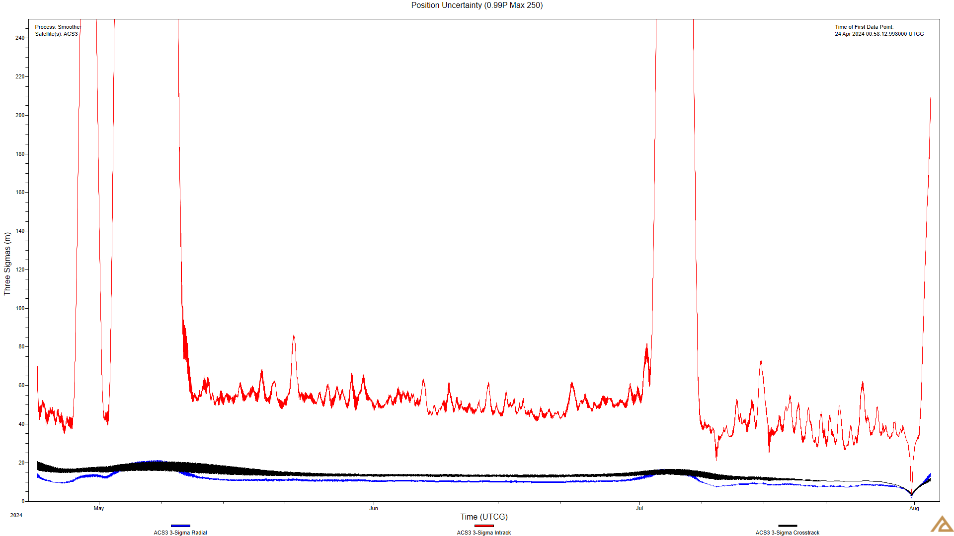
Figure 21: Position Uncertainty observed with GPS data from commissioning up until sail deployment

Upon sail deployment, the mission stopped receiving GPS data at the necessary cadence to address the change in delta-V caused by the newly deployed surface, both because of the increased drag force and solar radiation pressure. The sail deployment also caused issues with the ADCS and power systems, that disabled the capability to send telemetry for a time span of a few months. No more valid GPS data was received for the remainder of the mission.
The FD team kept monitoring the spacecraft orbit propagation by analyzing the Vector Covariance Message (VCM) , provided by the NASA CARA team. These files were presented daily, and they represented the most accurate orbit representation available. The file started to be received in November 2024 up until the mission was decommissioned in March 2026.
The files included updated state vectors and estimates of the ballistic and SRP coefficients. The team gathered that data and propagated the orbit with the high-fidelity propagator explained above for a short time span, since the high-speed spacecraft rotation induced large uncertainties that could not be predicted accurately. The initial approach included the study of an older VCM with the goal of matching the next one in the orbital elements. This initial analysis was useful to test the method of using a combination of the BC and SRP models to try to match a later VCM. We used the mean elements to get an approximate match in the eccentricity and the semi-major axis. It is important to note that these were just an estimation of the average values and with a simple method, rather than an exhaustive analysis with fitting techniques or filters. This method was useful for short time spans, as the mean semimajor-axis, eccentricity and inclinations could be matched to get a representative orbit that had a higher accuracy than the TLE. However, these analyses were not suitable for long-term propagation and lifetime predictions, since the spacecraft rotation induced changes in the SRP and Drag force assumptions, that altered the evolution of those same orbital elements. We observed that SRP was inducing eccentricity changes that were difficult to predict, especially in long time spans. Therefore, the mission studied and monitored the orbit propagation in time intervals of a week or less, depending on how those coefficients changed over time. To represent these changes, the team gathered the historical data corresponding to the estimated Cr and Cd coefficients, as shown in Figure 22.
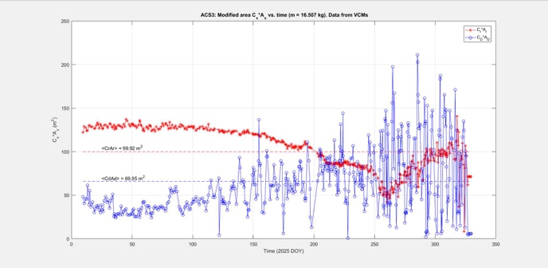
Figure 22: Evolution of the Cr*A and Cd*A values as captured in each VCM

Futher work includes the study of the spacecraft attitude and sail dynamics, as captured in this paper, to obtain a more accurate representation of the expose surfaces to SRP and drag, so the model can be reconstructed to more accurately predict the long term behavior of the orbit propagation.
LESSON LEARNED
This section discusses some of the main lessons learned from the mission.
ADCS
The ACS3 mission provided significant insights into spacecraft dynamics and attitude control. The key lessons learned from these observations are summarized below.
- A camera system providing full visibility of the solar sail proved invaluable for characterizing off-nominal deployments and updating dynamic models to account for the observed structural deformation.
- Flexible-body attenuation filters should be designed with roll-off frequencies prior to the first fundamental structural mode, rather than solely targeting rotational modes. In-flight data revealed that theoretically “purely translational” modes coupled into rotational degrees of freedom due to asymmetries in the deployed sail shape.
- Testing star trackers with optically emulated star fields is frequently relegated to vendor-level component checkouts. However, component-level tests cannot verify full ADCS functionality. To ensure system-level reliability, hardware-in-the-loop testing with emulated star fields should be integrated at the subsystem level whenever feasible.
- The interaction between SRP and gravity-gradient torques induced a semi-stable equilibrium that drove the spacecraft into an anti-sunward orientation. Standard ADCS simulation suites often fail to predict this behavior because they neglect long-term dissipative effects, such as elastic body deformations, focusing instead on short control timescales. Future LEO sail missions must incorporate these coupled environmental and dissipative effects into long-term behavioral models to protect for a similar failure mode.
- A lack of comprehensive off-nominal simulations obscured potential attitude risks prior to bus delivery. Scenarios such as the semi-stable anti-sunward behavior was not modeled. Conducting a broader suite of off-nominal simulations earlier in the project lifecycle would have allowed the project to identify these risks and develop more robust, experimental controlled-pointing strategies.

Solar Sail
The central part of ACS3 mission was to deploy the solar sail using the composite boom deployer. Lessons learned from developing the sail boom subsystem are summarized as below:
- It was desirable to have a high-fidelity full deployment test to verify the deployment mechanism functionality and control electronics. However, ACS3 was constrained to testing coupled deployment dynamics of booms and mechanisms at ambient temperatures and nominal gravity condition using simulated sails (springs, lanyards, and strings). Full deployment in TVAC wasn’t performed because of the chamber size limitation. Full deployment testing was performed on a flat floor with offloading at two stations along each boom only. Gravity offloading in the plane of the sail appeared to work well, but out-of-plane motion and boom rotation were always constrained by the gravity offloading system. The gravity could have stabilized sail deployment paths and even helped elements like springs and lanyards avoid snags or fouling. Future solar sail project could test the partial deployment of the sail with a gravity offloader that does not constrain 3-D motion, to bridget the gap between the earth-based development and operational performance in space. For future mission with a larger sail area, the problem will only get more challenging at larger scales.
- In the ACS3 project, there was an order of magnitude differences between predicted and flight performance. Cameras were key in determining the sail shape. Some coordination efforts were needed to get images from other satellite assets in capturing images and required a close satellite to take pictures. Telemetry indicated rotation rate of the spacecraft heavily influenced the sail shape itself, and consequently, the SRP torques. Sail shape is difficult to determine by analysis and almost impossible to bound on Earth. Even if the ACS3 SBS had deployed nominally, there was substantial shape uncertainty. This creates large unknowns for the sail shape and the SRP based disturbance torques along the thrust modeling. For most of the NASA’s solar sail missions, the change of sail shape only affects off-nominal scenarios where the solar sail is unintentionally put into a “fast” (> 0.1 deg/s) rotation. However, it is applicable to ICARUS-type solar sail missions, which rely on gyroscopic stiffening to flatten the sail. For such mission, it is recommended to include the gyroscopic stiffening in the flex model. Certain multi-body tools (e.g. DARTS) can represent the effect.
- ACS3 diagnostics cameras were able to provide accurate insight towards the shape of the sail following the deployment. However, the limitations of the tools and communication links presented challenges to close the problem. A better camera system or improved placement as well as improved communication system on the spacecraft could provide more information to help modeling the sail shape in addition to the simulation tools.

Electrical Power System (EPS) Design
Designing the electrical power system (EPS) for a CubeSat mission is inherently challenging due to strict cost and size constraints. Solar panels and rechargeable batteries form the core of the EPS, but for missions that incorporate a solar sail, the placement of the solar panels become more complex because the sail can obstruct direct sunlight.
- For the ACS3 mission, the detumble operation was constrained by the limited power available to the magnetorquers, particularly when the spacecraft’s solar panel faced away from the sun. The solar panel configuration of the spacecraft limited itself to receive direct solar charging on one-side only. As mentioned in the previous sections, the solar panel was charged only from the Earth’s albedo after the spacecraft pointed the solar panel away from the sun. Solar sail egress limited options for body panels and custom dual face panels would require a costly and schedule prohibitive development effort for a low-cost technology demonstration effort.
- Power is life. Reliable power generation at all sun attitude is important. If there is a payload as large as a solar sail in ACS3 mission, the mission needs to consider options of generating power on multiple sides of the spacecraft, a gimbaled solar panel array to ensure power generation. If the project is allowed, considered placing thin-film solar cells on the solar sail for power generation. This approach has been proved successful in some prior solar sail missions.

Analysis of the Power Generation per Orbit
- As mentioned in the mission overview section, the spacecraft could charge its batteries only from Earth’s albedo as the spacecraft was in anti-sunward orientation in the latter half of the mission operation. The solar panel of the spacecraft only faced to the +z side which limited its capability of charging. There was no analysis of power generation per orbit from the orbital mechanics perspective in the early stages of the project which could have resulted in making incorrect decision about the power need.
- Projects using a solar panel with a solar sail should have a thorough analysis of the orbit geometry to generate power per orbit. Such analysis could also help identifying where to place the solar panel on the spacecraft.

Communication Limitation
Even though communication technology in SmallSat mission is pretty mature nowadays, design of communication subsystem for a cost-effective SmallSat mission could still face unexpected challenges as seen in this mission.
- When the ACS3 mission was applying the spectrum license to operate, the local chapter of Society of Broadcast Engineer (SBE) expressed concerned that the intended frequency use for S-band link may interfere with the local TV breaking news microwave links due to the proximity of the ground station to the receiver tower of the TV station. After negotiation the mission was limited to using its S-band link only when the spacecraft was above certain elevation from the horizon. This caused significantly reduced S-band transmission pass times and data throughout. If a CONUS ground station used is near an urban area, engage with the local Society of Broadcast Engineer and other frequency spectrum authorities as early as possible once the frequency is designed. As found in this project, local spectrum authorities could cause delay in spectrum license or delay the radio frequency authorization approval process which could result in launch schedule delay.
- ACS3 mission operation encountered challenges in communication link between the spacecraft and the ground station. The spacecraft has only one directional antenna for data transmission and UHF antenna array for transmitting beacons. After the anomalous event on 20 Sep 2024, the spacecraft was unable to point the S-band antenna to the ground station which resulted in an unreliable S-band communication link and less than planned telemetry data volume from the spacecraft. Due to the limitation of S-band link, the mission was forced to rely on the lower data rate UHF link for beacons and status updates. The single directional antenna for primary communication link required good attitude knowledge and control to establish a reliable link, which was absent. The communicaton system on a spacecraft should provide 4$π$ steradian coverage for critical communication link. Future solar sail mission should consider antennas on both +z and -z side.
- If schedule and budget allows, a mission should have a plan for multiple ground station locations to provide additional coverage for critical mission operation and a backup station if one of the ground stations is not operational. For ACS3, the only ground station was located in San Francisco Bay Area. The S-band antenna was frequently offline due to wind events and severe winter storm. The antenna needed to be strapped down during high wind conditions to protect it from wind damage.

Complexity Does not Scale
Smaller is not necessarily easier or cheaper for a solar sail mission. It is particularly true if deployable or miniature mechanisms are required. For ACS3, the 12U volume constraints, not mass, drove almost every design decision across the deployer and avionics subsystem. The tight packaging created significant challenges for subsystem integration and wiring harness routing. During integration and test, a motor temperature sensor wire was pinched between the motor and the attachment plate, shorting the sensor on the motor causing the avionics board to stop functioning as the power rail used was turned off by the EPS. Correcting the issue requiring disassembling multiple spacecraft side panels resulting in schedule impacts. The problem in ACS3 design choice would have been reduced at a larger scale, where components and the deployment mechanism could have more physical margin. Testing and troubleshooting of problems would have less contrained by limited access. Although the spacecraft is lighter, the solar sail packaging becomes more challenging as scale decreases, increasing risk and complexity of both stowage and deployment. For future solar sail missions, spacecraft form factor deserves careful early-stage trade analysis to balance size, packaging, subsystem accessibility, and operational risk.

CONCLUSION
Even though the project has encountered challenges throughout the phases of mission operation, it successfully completed the primary objective – to deploy the solar sail using a composite boom deployer on a 12U CubeSat. It provided many valuable lessons for the future solar sail mission.
There is a need for improving long-term ADCS simulation to include the interaction of environmental and dissipative effects which are often neglected. Simulating off-nominal spacecraft behavior is also recommended in earlier project lifecycle to allow early identification of the risks and mitigation planning.
Solar Sail shape modeling and on-orbit shape determination was a challenge in ACS3 mission due to difficulties in obtaining pictures of whole sail shape on-orbit. Placement of cameras to capture the image of the sail shape also needs careful consideration.
The ACS3 mission was a collaborative effort involving multiple NASA centers, government agencies, industry partners and academia. This mission also demonstrates the value of cross-organizational collaboration in advancing space technology for future missions.
ACKNOWLEDGMENTS
The authors wishes to give special thanks to Dr. William Keats Wilkie, who retired recently from NASA after 40 years of services, for his instrumental role and invaluable contribution to the ACS3 project and mission operation. Also, we would like to dedicate this project to the late mission system engineer, Alan Rhodes, who guided the I&T and the commissioning phase of the mission operation. His dedication and commitment were vital to the project when the team was tackling the challenges. Also, thanks to the following (with their current affiliations) for their dedication and contribution to the mission operation: Rudolph Aquilina (NASA ARC), Benjamin Diedrich (ESSCA/NASA MSFC), Darin Foreman (NASA ARC), David Kunkee (Aerospace Corp), Don Beddell (ASRC), Dongmeng Li (NASA ARC), Andrew Heaton (NASA MSFC), Jerry Warren (NASA LaRC), Jin Ho Kang (NASA LaRC), John Inness (NASA MSFC), Juan Fernandez (NASA LaRC), Justin Hopkins (NASA ARC), Mark Allard (NASA ARC), Paul Kim (Aerospace Corp – Retired), Prajit Saravanan (MEI/Astrion), Scott Miller (NASA ARC), Theodore Hendriks (MEI/Astrion), William Hunt (ASRC), William Notley (NASA ARC), Winston Czakon (NASA ARC – Retired), Christopher Kitts (SCU RSL), Michael Neumann (SCU RSL), Divya Bengali (SCU RSL), Jack Ninteman (SCU RSL), Jenny Huynh (SCU RSL), Katie Ott (SCU RSL), Quinn Bates (SCU RSL), Paul Frey (NanoAvionics), Mindaugas Kazanavičius (NanoAvionics), Augustinas Stankevičius (NanoAvionics), Mario Marano (NanoAvionics), Giovanni Minelli (NPS MC3), Roberto Carlino (E-Space), Scot Tomer (Loft), Thomas Heckman (Applied Materials), Logan Anderson (University of Minnesota).
Special thanks are given to the following organizations that provided support to the mission operations of the project: NASA CARA (Conjunction Assessment Risk Analysis), NASA RTMD SSDS (Small Satellites and Distributed Systems), Santa Clara University Robotics System Laboratory (SCU RSL), Naval Postgraduate School Mobile CubeSat Command Control (NPS MC3), Monterey CA.

References
- What is the Advanced Composite Solar Sail System? https://www/nasa.gov/smallspacecraft/what-is-acs3/
- Deployable Composite Booms https://www.nasa.gov/directorates/spacetech/game_changing_development/projects/dcb
- Keats Wilkie, “The NASA Advanced Composite Solar Sail System (ACS3) Flight Demonstration: A Technology Pathfinder for Practical SmallSat Solar Sailing” SSC21-II-10, 35th Annual Small Satellite Conference.
- Hillebrandt, Martin, et al. "Deployment testing of the de-orbit sail flight hardware." 2nd AIAA Spacecraft Structures Conference. 2015. Wyatt, C.L., Radiometric Calibration: Theory and Methods, Academic Press, New York, 1978. https://arc.aiaa.org/doi/pdf/10.2514/6.2015-0434

