Artemis CubeSats Help Advance Exploration of the Moon, Mars, and Beyond
Russell Lane, David Beaman, Courtney Ryals, David Hitt
NASA, Marshall Space Flight Center: SLS Payload Integration Office
NASA, MSFC; 256.544.0847
william.r.lane@nasa.gov

ABSTRACT
On April 1, NASA launched the Artemis II mission – the first crewed mission of the Artemis campaign. The nine-day lunar flyby launched on the agency’s SLS (Space Launch System) rocket and had four astronauts test the Orion spacecraft in high Earth orbit and in deep space. Four 12U CubeSats also launched on the mission, housed within the SLS’s Orion stage adapter (OSA). The spacecraft were deployed approximately five-and-a-half hours into the flight, following Orion separation and departure from SLS, as the SLS interim cryogenic propulsion stage (ICPS) and the attached OSA were in a high Earth orbit on an atmospheric disposal trajectory. All four CubeSats were successfully deployed from the launch vehicle. Deployment statuses of the spacecraft, along with updates about the SLS rocket and Artemis missions, are reported in this paper. The paper will also discuss opportunities for CubeSat payloads on future Artemis missions.
Artemis II
At 6:35 p.m. EDT, the Artemis II mission launched from NASA’s Kennedy Space Center in Florida. The SLS rocket propelled the Orion spacecraft and its four astronauts – NASA’s Reid Wiseman, Victor Glover, and Christina Koch and CSA ‘s (Canadian Space Agency) Jeremy Hansen – off Earth’s surface and into space (Figure 1).
The four became the first astronauts to travel to the Moon in more than half a century. During their nearly 10-day mission, the crew completed a record-setting lunar flyby, taking them 252,756 miles at their farthest distance from Earth and 4,067 miles above the lunar surface at their closest approach.
As they flew over the Moon’s far side, the crew photographed and described terrain features including impact craters, ancient lava flows, and surface cracks and ridges formed as the Moon slowly evolved over time. They also noted differences in color, brightness and texture, which provide clues that help scientists understand the composition and history of the lunar surface. The crew witnessed an “Earthset” — the moment Earth dropped below the lunar horizon — as Orion traveled behind the Moon and an “Earthrise” as the spacecraft emerged from the opposite edge of the Moon.
As the lunar observation period ended, the crew witnessed a nearly hour-long solar eclipse as the spacecraft, the Moon and the Sun aligned. With a view of a mostly darkened Moon, the crew analyzed the solar corona — the Sun’s outermost atmosphere — as it appeared around the Moon’s edge.
Artemis II splashed down at 8:07 p.m. April 10 in the Pacific Ocean off the coast of San Diego.
Along with the four astronauts, the mission carried another four flyers aboard SLS’s Orion stage adapter (OSA) – 12U CubeSats developed by four of NASA’s international partners who are also signees of the Artemis Accords (Figure 2).
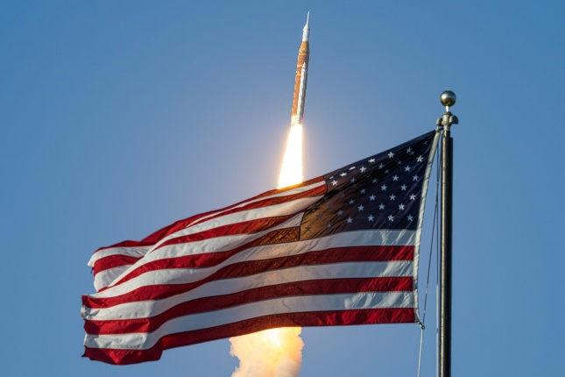
Figure 1. The Artemis II mission launched April 1 at 6:35 p.m. EDT.
SLS is the most capable operational rocket in the world and the only vehicle capable of launching astronauts to the Moon in a single launch. The Block 1 crew configuration, featuring an interim cryogenic propulsion stage (ICPS), can send 59,000 lbs. (27 metric tons) to the Moon in a single launch.
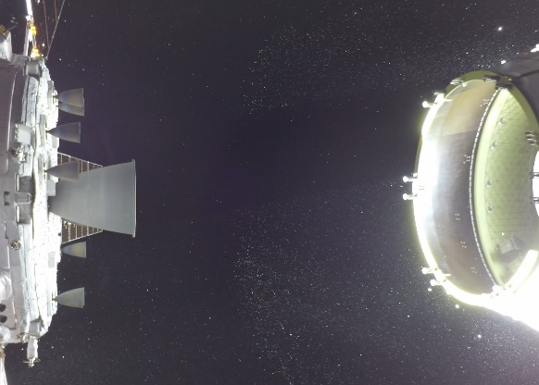
Figure 2: The Atenea and SHMS CubeSats are seen in the lower portion of the OSA in the right side of the image following Orion spacecraft separation.
When possible, NASA makes remaining mass margins available to launch CubeSats. The secondary payloads conduct science and technology investigations that address gaps the community needs to solve for a sustained crewed presence on the Moon and crewed missions to Mars.
On Artemis II, the four CubeSats flown were:
- ATENEA: Developed through a partnership with the Argentina National Space Activities Commission (CONAE), the spacecraft was designed to investigate radiation shielding, orbital design optimization, and long-range communications
- TACHELES: Developed through a partnership with the German Aerospace Center (DLR), the spacecraft was designed to demonstrate key in-space technologies, including electrical components, for future lunar logistics vehicles and operations
- Saudi HEO Magnetosphere Satellite (SHMS): Developed through a partnership with the Saudi Space Agency (SSA), the spacecraft was designed to measure various aspects of space weather such as radiation, solar X-rays, solar energy particles, and magnetic fields
- K-RadCube: Developed through a partnership with the Korea AeroSpace Administration (KASA), the spacecraft was designed to measure space radiation and its biological effect across the Van Allen radiation belts
The payloads were integrated into the OSA at NASA Kennedy in August and September 2025 before the OSA was added to the vehicle stack at the center’s Vehicle Assembly Building later that year (Figures 3-4). The CubeSats were encapsulated in a Secondary Payload Deployment System (SPDS) mounted within the OSA, consisting of Rocket Labs’ PSC containerized dispensers attached to vibration isolation units and attached via bracket to the interior wall of the adapter. The SPDS also includes an avionics unit that controls deployment of the CubeSats and connecting cabling. The SPDS is designed to accommodate up to 17 payloads in 6U or 12U dispensers; the number of payloads on each flight is informed by available performance in excess of primary mission requirements.
During Artemis II, the four spacecraft were deployed in one-minute intervals approximately five-and-a-half hours into the mission. At the time of the deployment, the Orion spacecraft had successfully separated from the ICPS upper stage, the astronauts had performed a series of piloting tests of the Orion, and the spacecraft had performed a separation burn to navigate away from the expended stage and attached adapter.
The satellites were deployed in high Earth orbit on an Earth atmospheric disposal trajectory. Three of the spacecraft were designed to execute propulsive maneuvers to boost their perigees, while one remained on the trajectory, maximizing its investigations until re-entry.
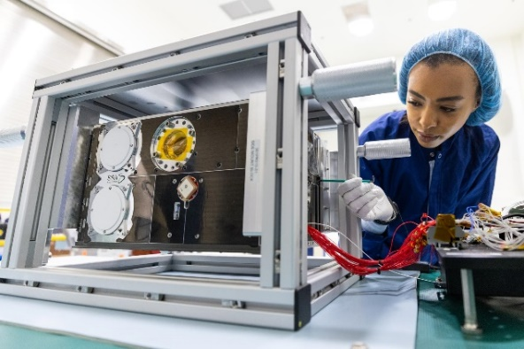
Figure 3: The SHMS CubeSat, developed through a partnership with the Saudi Space Agency, undergoes integration at NASA Kennedy.
All four CubeSats were successfully deployed from the OSA within the environments delivered to the payload developers. All four payloads transmitted data received by stations on the ground. NASA, respectfully, leaves the opportunity to report on the operational details of each CubeSat to their individual developers.
The four Artemis II CubeSats bring the total number of small satellites deployed by SLS on Artemis missions to 14, and the number of partner nations that have flown SLS CubeSats to six.
On Artemis I, an uncrewed test flight in which SLS launched Orion into a distant retrograde orbit around the Moon, SLS deployed 10 6U CubeSats, representing international partners in Italy and Japan, industry, academia, and NASA itself, and all had science and technology research missions designed to forward NASA’s future exploration goals.
After the SLS upper stage propelled Orion on a translunar injection burn to the Moon, the CubeSats were deployed into a heliocentric disposal orbit that passed near the Moon. BioSentinel, a NASA-developed payload designed to study deep-space radiation in order to better understand its effect on living beings, continues to transmit data years after its launch in November 2022.
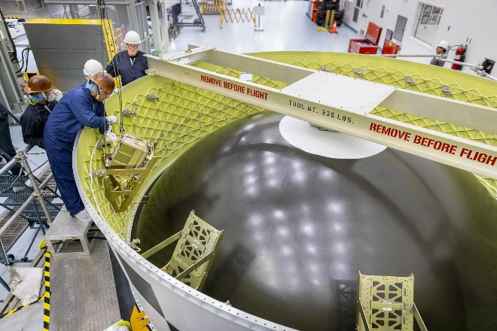
Figure 4: The K-RadCube spacecraft is lowered into the OSA at NASA Kennedy.
FUTURE MISSIONS
As NASA and our partners look ahead to the next Artemis missions, we are analyzing the opportunities to include secondary payloads. In May, NASA released a request for information (RFI) to U.S. and international partners to collect information on potential candidate CubeSats for the Artemis III, IV and V missions. While specific mission profiles are still being determined, NASA expects to accommodate 6U and 12U CubeSats that would deploy following the separation of the Orion spacecraft from the SLS in Earth orbit or on a heliocentric disposal trajectory. Opportunities may also exist for CubeSats deployed on a reentry trajectory from Earth orbit.
More than 60 responses were received, and SLS Payload Integration Office is analyzing the proposals and the mission parameters to determine potential future flight manifests.
Artemis III, targeted to launch in 2027, will be an Earth orbit rendezvous checkout of a crewed Orion spacecraft with one or both of the human landing systems that will ferry astronauts between lunar orbit and the lunar surface. The mission aims to buy down risk in advance of Artemis IV, which will be the first human landing since Apollo 17. Artemis IV and Artemis V, also a crewed lunar landing, are targeted for 2028.
The RFI also invited respondents to share concepts for CubeSats on future Artemis missions beyond Artemis V, as NASA develops a Moon Base to establishes a sustained human presence on the Moon. For more information on capabilities for future Artemis CubeSat payloads, contact nasa-slspayloads@mail.nasa.gov
ONE-STOP SHOP
SLS Payload Integration is a one-stop shop for secondary payloads launching on SLS. Once a CubeSat is selected for an SLS mission, the team facilitates the verification and coordination activities needed to ensure the spacecraft can safely fly on the selected mission. Using the resources of the SLS and NASA teams, Payload Integration also assists payload developers with challenges that arise in development or testing.
CONCLUSION
NASA and its industry, academic, and international partners are returning humans to the Moon to prepare for Mars. While SLS is responsible for launching the astronauts to the Moon, it also has the capability to launch CubeSats as secondary payloads. These payloads are able to investigate many scientific and technological challenges in deep space exploration. They also serve to engage additional partners and leverage the expertise and innovation of traditional and non-traditional space entities to further advance space exploration and the worldwide workforce to make the near impossible possible.

