Predicting Team Functioning in Long Term Space Missions using Acoustic and Linguistic Measures
Shrivatsa Mishra Caroline J. Wendt Sydney Begerowski
University of Colorado Boulder, USA University of Colorado Boulder, USA KBR, USA
shrivatsa.mishra@colorado.edu caroline.wendt@colorado.edu sydney.r.begerowski@nasa.gov
Suzanne Bell  NASA Johnson Space Center, USA  suzanne.t.bell@nasa.gov | Theodora Chaspari  University of Colorado Boulder, USA theodora.chaspari@colorado.edu

Abstract—Maintaining optimal team functioning is critical for long-duration space exploration missions, yet traditional monitoring methods, such as self-reports and wearable sensors, often impose operational burdens or suffer from bias. This paper investigates a non-intrusive speech-based artificial intelligence (AI) framework to predict degradations in team functioning using data from the Human Exploration Research Analog (HERA) of the U.S. National Aeronautics and Space Administration (NASA). Using acoustic features, linguistic descriptors, and semantic embeddings, we evaluate static non-linear and temporal machine learning models to predict both objective (task accuracy) and subjective (self-reported efficacy and cohesion) team functioning outcomes. Results indicate that temporal models outperform static approaches, with prediction of objective task accuracy in Team Interaction Battery (TIB) improving from near chance to 71%. Self-reported outcomes, including team efficacy and cohesion, are predicted more reliably than task performance, achieving balanced accuracies of up to 85.56% and 78.12%, respectively, and are found to be most strongly associated with acoustic features. In a second interdependent task, the MMSEV–EVA, accuracies of up to 78% are achieved using temporal models with acoustic features. Furthermore, incorporating just 1–2 days of team-specific historical data systematically improved performance, and acoustic markers from informal pre-task interactions provided modest predictive gains. Finally, while automated preprocessing yielded viable accuracy, human corrected data provided moderate performance gains, though transcription error rates did not significantly correlate with model performance. These findings highlight the potential of speech as a passive, high-fidelity monitoring tool for autonomous habitats.
Index Terms—Task performance, team cohesion, team efficacy, speech analysis, space exploration, temporal modeling

I. INTRODUCTION
Effective task-related communication and information sharing within teams are essential for sustaining both individual and collective behavioral health and performance in the uncertain and hazardous space environment [32]. The growing emphasis on deep space capabilities underscores the complex demands of long-duration exploration missions [13], which are characterized by isolation, confinement, and high operational intensity highlighting the critical importance of optimal team functioning [31].
Team functioning is a multi-level and dynamic process that involves the actions and interactions through which team members coordinate, cooperate, and collaborate [44]. Importantly, team functioning is inherently temporal, evolving over time through ongoing interactions [29], and is therefore more appropriately modeled using time-based approaches that capture these dynamics. Structured exchanges, such as task focused information sharing and semantic alignment, support the development of shared mental models and coordinated action [26, 21], whereas unstructured communication patterns capturing underlying cognitive, social, and affective dynamics provide insight into the team’s cognitive organization and social alignment [10, 12]. Critically, informal interactions occurring outside of focal tasks (e.g., pre-task discussions or casual exchanges) can reveal baseline coordination patterns, interpersonal alignment, and affective states that influence subsequent task performance, yet are often overlooked in traditional assessments of team functioning. Moreover, team functioning is inherently multidimensional, encompassing both subjective perceptions—such as team cohesion and efficacy—and objective outcomes, including task performance [42]. Yet, traditional methods for monitoring team functioning in crews often rely on intrusive self-reports or wearable sensors that measure member’s proximity to each other (i.e., proximity badges) [4] that are limited in capturing the richness of communication, may fail to fully capture the emergent time dependent states of team interaction, and impose participant burden [9].
Speech-based artificial intelligence (AI) systems offer a complementary and unobtrusive approach to modeling team functioning by leveraging naturally occurring speech interactions as a rich source of behavioral data [19, 14, 23]. Unlike traditional methods, speech-based models can capture both complex semantics (i.e., what is spoken) and nuanced pragmatics (i.e., how it is spoken), enabling fine-grained analysis of team dynamics and potentially early detection of performance degradation [47]. These systems can further operate continuously and passively, reducing participant burden while preserving ecological validity in complex, high stakes environments [38] providing a scalable framework for augmenting existing monitoring approaches and potentially support adaptive team interventions [53]. However, passive voice monitoring necessitates vital privacy trade-offs that must be navigated. Furthermore, real-world speech recordings, particularly those collected in space analog environments, are often characterized by variable recording conditions and channel distortions, which pose significant challenges for reliable feature extraction. Therefore, it is critical to examine the impact of pre-processing quality on downstream predictive performance.
Here, we examine a speech-based AI system to unobtrusively predict team functioning using data captured from team interactions in the Human Exploration Research Analog (HERA) Campaign 4 (C4) and Campaign 5 (C5) of the U.S. National Aeronautics and Space Administration (NASA). We investigate to what extent speech-based measures, encompassing acoustic parameters and linguistic content, can serve as reliable, minimally invasive markers of team functioning. Analysis was conducted on data from 9 teams (36 crew members, 11 female) on two types of interactions, including the Team Interaction Battery (TIB), which requires information sharing, conflict resolution, and leadership behaviors, and the multi-mission space exploration vehicle-extra vehicular activity (MMSEV-EVA), which is indicative of highly independent coordination and joint decision-making under constraints. Through this analysis, we aim to answer the following research questions:
(RQ1) To what extent can speech-based machine learning models reliably predict team functioning?
(RQ1a) How does modeling the temporal structure of conversational dynamics via time-based models improve predictive performance compared to static approaches?
(RQ2) What is the impact of incorporating team-specific data on the predictive performance of speech-based models of team functioning?
(RQ3) To what extent do informal, pre-task interactions contribute to improving predictions of team functioning in subsequent task-based interactions?
(RQ4) How do manual corrections to automatic speech preprocessing, including transcription, turn boundary detection, and speaker segmentation, affect model performance?
The contributions of this work are the following. First, we provide new empirical evidence identifying linguistic and acoustic features that are predictive of team functioning in high-fidelity space mission analogs. In contrast to prior work on automatic prediction of team functioning, which has largely focused on younger adults and student populations [52], we evaluate speech-based markers in a realistic, high-stakes operational setting, thereby showcasing ecological validity and relevance to real-world deployment. Second, we predict both subjective (i.e., self-reported cohesion and efficacy) and objective (i.e., task accuracy) measures of team functioning, which enables a more comprehensive understanding of how observable interaction patterns relate to both perceived and operational performance, addressing a common limitation in prior work that considers these dimensions in isolation. Third, we systematically examine the role of team-specific data and interaction context, including informal, pre-task discussions, in shaping model performance. Fourth, we provide practical insights into the impact of speech processing pipelines on model reliability by evaluating the effects of manual versus automatic pre-processing steps, including transcription, turn segmentation, and speaker diarization.

II. RELATED WORK

A. Team Functioning
Team functioning is a multidimensional construct encompassing the cognitive, affective, and behavioral processes that emerge as teams work toward shared goals [30, 45]. Unlike static team inputs, such as individual personality traits or demographic composition, team functioning represents dynamic ”emergent states” that evolve through continuous, reciprocal interaction among team members [29]. This emergent state is not merely the sum of individual attributes but are products of the team’s unique developmental trajectory within a specific context. Recent research emphasizes that team functioning is inherently temporal; it is shaped by episodic cycles of planning, action, and reflection [30]. Beyond these formal cycles, team functioning is heavily influenced by the continuous nature of both structured and unstructured interactions. Structured interactions, such as formal information sharing and semantic alignment, are essential for establishing shared mental models and ensuring task-relevant knowledge is mutually understood [26, 21]. Conversely, unstructured behavioral manifestations, such as the “who, when, and how” of communication, reveal the team’s underlying cognitive organization and social alignment [10, 12].
In high-stakes, high-reliability environments, such as the ones pertaining to healthcare, aviation, and long-duration spaceflight domains, effective functioning is characterized by high levels of psychological safety, the development of shared mental models, and the maintenance of closed-loop communication [43, 54]. Conversely, degradation in functioning often manifests as subtle communication breakdowns, reduced information exchange, or misalignment in goal prioritization, which can serve as early warning signs of performance degradation and team instability [37]. In isolated and confined environments, these interpersonal processes are further challenged by stressors such as social monotony and physical confinement, which can lead to rigid communication patterns and interpersonal friction [34]. These dynamics could be reflected in speech through patterns in turn-taking, information exchange, and prosody.
For a comprehensive evaluation of team functioning, it is essential to assess both team processes and outcomes. The first encompass the strategies, steps, and procedures used by the team to accomplish a task [42], while the latter focus on results, such as task accuracy. Team cohesion, defined as “the shared sense of attraction and commitment that motivates members to remain engaged and work together toward common goals,” [46] is an integral part of team processes, as cohesive teams are more likely to exhibit trust, open communication, and mutual support. In addition, a growing body of research highlights the role of team efficacy, defined as a team’s shared perception of its capability to successfully perform a specific task [2], as a key motivational driver of teamwork [1] and a factor influencing team outcomes [49]. Despite broad agreement on the importance of cohesion and efficacy in team assessment, their associations with performance tend to be stronger when performance is conceptualized as behavior rather than outcome [3], and these relationships vary depending on the level of conceptual and temporal alignment among measures [22]. This highlights the importance of incorporating outcome-based metrics, such as task accuracy, as complementary indicators of team functioning, particularly in high-stakes environments.

B. Speech as a Window into Team Dynamics
Speech serves as a behavioral conduit for team interaction, offering a continuous and data-rich stream for assessing cognitive and social states [35]. Research into speech-based markers generally distinguishes between: (1) the acoustic and prosodic properties of voice capturing how individuals speak; and (2) the linguistic content of the dialogue capturing what is said. Acoustic features are used to encode affective and physiological states such as arousal, stress, and engagement[18], on the other hand linguistic features reflect cognitive, social, and psychological processes, including attention, shared understanding, and role differentiation [7]. Together, these help reveal how teams coordinate in real time, linking micro-level communicative behaviors to macro-level team functioning outcomes.
1) Acoustic and Prosodic Markers: Acoustic markers are low-level physical properties of the speech signal, such as fundamental frequency (F₀), intensity, spectral energy, jitter, and shimmer, that reflect a speaker’s physiological and affective state [51]. These features are highly sensitive to cognitive load, arousal, and stress; for instance, increased tension typically raises pitch and intensity, while fatigue lowers them [18].
Prosodic markers refer to higher-level suprasegmental patterns, including rhythm, intonation, speech rate, and turn taking dynamics [6]. While acoustics describe signal properties, prosody captures interactional qualities like engagement, dominance, and social alignment[55]. Recent studies in high stakes environments, such as cardiac surgery and crisis teamwork, demonstrate that vocal stability and pitch variability are reliable indicators of communication quality and assertiveness [36, 25].
A critical mechanism in team coordination is acoustic prosodic entrainment, defined as the degree to which team members synchronize their vocal patterns [41]. Sustained entrainment fosters predictability and social rapport, serving as a key predictor of team cohesion and task accuracy [5]. In multi-party interactions, greater entrainment in pitch and intensity is associated with more balanced participation and lower levels of task conflict [33, 55]. Furthermore, entrainment is an emergent process sensitive to team composition; for example, teams with higher average agreeableness exhibit stronger vocal alignment, whereas high diversity in openness can weaken these bonds [40]. By capturing these moment-tomoment vocal adjustments, acoustic-prosodic markers provide a foundation for assessing collective entrainment and overall team stability.
2) Linguistic Markers: Linguistic markers capture what is said, including the lexical, semantic, and syntactic structures that reveal the cognitive, social, and psychological states of a team [27]. While acoustic markers describe the delivery, linguistic features provide a multidimensional view of how individuals express thought and social orientation, aligning with processes such as coordination and leadership.
Lexical markers involve specific word frequencies, often analyzed via the pre-defined lexicons such as the Linguistic Inquiry and Word Count (LIWC) tool [7]. These markers track stylistic shifts, such as the transition from “I” to “we” pronouns, which signals collective identity and shared responsibility [50]. High-performing teams often use more causal language (e.g., “because”) and fewer negative emotion terms, whereas a reliance on present-tense or purely affective words can correlate with poorer outcomes [15, 16].
Semantic markers capture meaning-based relationships using vector representations, such as Universal Sentence Encoder (USE) [11] embeddings or topic modeling. These features measure conceptual similarity and thematic coherence, providing a quantitative window into shared mental models [20]. Semantic alignment, referring to the convergence of shared vocabulary and conceptual framing, reflects how well a team’s mental models are synchronized [8]. Together, these linguistic markers allow for the automated detection of trust, cognitive load, and situational awareness through the dynamic interaction of speech content.

C. Temporal Modeling of Team Interaction
As team functioning is a dynamic process characterized by emergent states [44], temporal and sequential models that represent speech as a sequence of utterances can capture how behaviors such as turn-taking and coordination evolve across task phases [48]. These can potentially provide a more effective representation of team processes than static models. Common machine learning architectures include hidden Markov models (HMMs), long short-term memory (LSTM) networks, and transformers. For example, hierarchical LSTM frameworks have been used to integrate automated speech recognition (ASR) with semantic parsing to predict team-level communication effectiveness in real-world military exercises [48]. Similarly, theory-guided models combine Markov modeling with neural networks to predict conversational turn-taking sequences, linking temporal dynamics to individual personality traits like extraversion and emotional stability [39]. Furthermore, convolutional neural networks (CNNs) can analyze speech spectrograms in real-time to monitor team workload and performance, achieving nearly 70% accuracy by capturing sequential acoustic cues [47]. By explicitly modeling these longitudinal dependencies, temporal architectures provide a foundation for real-time assessment and adaptive feedback in high-stakes environments.

III. METHODOLOGY

A. Data Description and Pre-processing
The data were collected during the U.S. NASA’s HERA C4 (2017-2018) and C5 (2019-2020), which simulated a space expedition involving a geological exploration scenario for a mission to and from Mars’ moon, Phobos. C4 consisted of five missions/teams and C5 consisted of four missions/teams. Missions lasted 45 days with the exception of one crew that evacuated early due to a weather emergency. A total of 36 crew members (11 female), aged between 29 and 56, participated in this analog environment. All team members held at least a bachelor’s degree, and 11 had military backgrounds. Team interactions were recorded across multiple structured and unstructured tasks. For the purpose of this paper, we analyzed team interactions from the TIB and the MMSEV-EVA tasks.
The TIB was administered five times per mission (one time pre-mission, four times in-mission), lasting approximately 1.5 hours each session. It included a decision-making task requiring teams to collaboratively analyze distributed information to identify an optimal solution, as well as a relational task where members responded to questions about personal values and experiences. This dual-task approach provides a holistic view of team dynamics, capturing the interplay between technical problem-solving and interpersonal cohesion. TIB data were manually annotated for transcripts, turn start/end times, and speaker turn identity (ID). Team performance in the TIB decision-making task was coded by experts (i.e., “best”, “middle”, “worst”) and was used as a task measure in the TIB (Table I). The self-reported team efficacy and cohesion, administered after both the decision-making part and the relational part of the TIB task, were employed as a self reported team performance measure (Table I). We analyzed a total of 44 TIB tasks.
The MMSEV-EVA sessions, conducted 23 times in-mission and alternating with TIB sessions (i.e., either before or after the TIB session on a given day), involved task-specific interactions focused on operational performance. This task was a simulated extravehicular activity (EVA) in which crewmembers take a Multi-Mission Space Exploration Vehicle (MMSEV) to an asteroid and collect geological samples. We pre-processed audio data from the five MMSEV-EVA sessions that aligned with the days of the TIB task. MMSEV-EVA sessions lacked transcripts, speaker IDs, and turn timing data, therefore we used an automated algorithm as a first step followed by a manual correction by human coders. The automated pre-processing pipeline integrates OpenAI’s Whisper for transcription, CTC forced alignment for temporal correction, and MarbleNet [24] and TitaNet [28] for voice activity detection and speaker identification. Following this automated stage, human coders perform manual corrections using ELAN software to refine timestamps, revise transcripts for jargon, and verify speaker labels. This manual refinement process requires an average of 5.97 hours of labor to correct just one hour of transcript. Across the lexically matched turns in these manually corrected files, the system achieved an average Word Error Rate (WER) of 0.19. The percentage of objectives met during the MMSEVEVA task was used as a task measure of operationally relevant performance (Table I). We analyzed a total of 30 MMSEVEVA tasks.
In addition to the team interactions occurring within the MMSEV-EVA, we also pre-processed unstructured team discussions occurring immediately prior to these tasks to capture informal interactions and their potential impact on team functioning. These discussions had an average duration of 9.91 minutes. Audio data from these sessions were processed using the same pipeline as the MMSEV-EVA interactions. Although no explicit outcome measures were associated with these discussions, the resulting data were incorporated as supplementary training input, alongside MMSEV–EVA data, to examine the performance of these models in predicting team functioning during the MMSEV-EVA.

B. Speech-based Models of Team Functioning
We developed machine learning models to predict the team functioning outcomes of the TIB and MMSEV tasks (Table I), with all outcomes formulated as binary classification tasks, as continuous regression would suffer from severe overfitting and extreme sensitivity to sparse regions given the small sample size. For the TIB decision-making task, task accuracy was binarized into correct decisions (best or middle responses; N = 25) and incorrect decisions (worst responses; N = 19). For the decision-making and the relational parts of the TIB, self-reported team efficacy and cohesion were split into high and low groups (N = 17 per group) based on the sample median. For the MMSEV-EVA task, task accuracy was binarized using a 50% completion threshold (N = 9 for high accuracy; N = 21 for low accuracy).
Model inputs included three types of features: (1) acoustic features, consisting of the 88 voice parameters related to frequency, energy/amplitude, and spectral balance of the Geneva Minimalistic Acoustic Parameter Set (GeMAPS) [18] extracted using the OpenSMILE toolbox [17]; (2) lexicon based linguistic features, comprising 118 descriptors of linguistic, psychological, and cognitive processes derived from the LIWC dictionary [7]; and (3) linguistic embeddings, represented by 512-dimensional semantic and syntactic vectors extracted using the Universal Sentence Encoder [11]. Feature normalization was executed via session-level z-score standardization. To maintain task specificity in the TIB, models were trained exclusively on data corresponding to the target variable being predicted (i.e., either relational or decision-making performance). Given the presence of learning effects in the MMSEV–EVA task, whereby task accuracy improves over successive mission days [56], mission day was incorporated as an additional feature in the predictive models pertaining to the
MMSEV-EVA.
TABLE I
TEAM FUNCTIONING OUTCOMES OF THE TEAM INTERACTION BATTERY (TIB) AND THE MULTI-MISSION SPACE EXPLORATION VEHICLE-EXTRA VEHICULAR ACTIVITY (MMSEV-EVA) TASKS.
Task | Type of Measure | Description of Measure
MMSEV-EVA | Task measure | % Objectives met during the MMSEV-EVA (operationally-relevant performance, range: 1–100).
Task measure TIB decision-making performance (1: worst, 2: middle, 3: best), coded by experts.

TIB Self-reported efficacy Self-reported team efficacy score (“My team is confident in its ability to effectively complete tasks.”) on a 7-point Likert scale
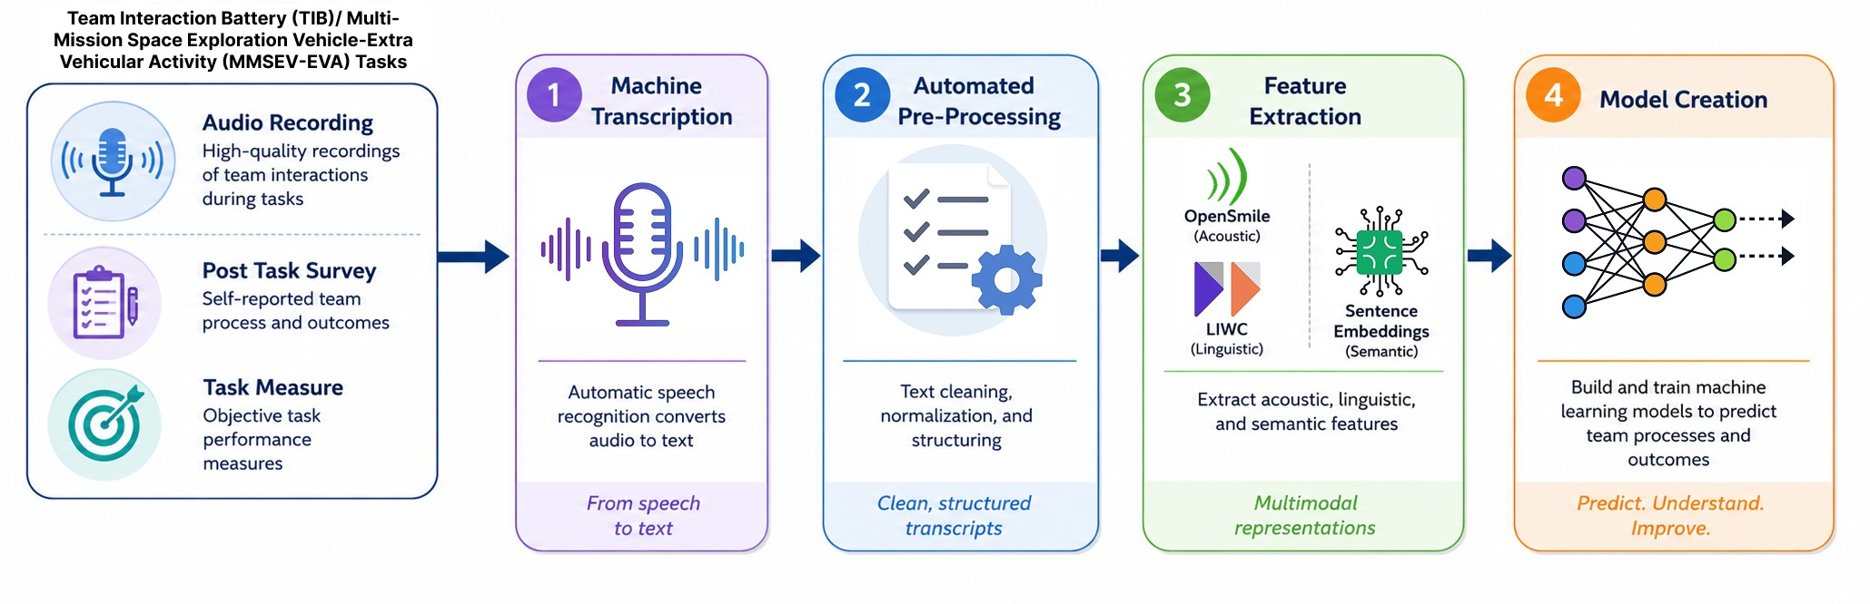
aggregated across all members.
Self-reported cohesion
Self-reported team cohesion score (“My team is cohesive.”) on a 7-point Likert scale aggregated across all members.
Fig. 1. Speech processing pipeline of the team interaction data.
These features were used to train both static and time-based classification models. A random forest was used as a static model that included 50 estimators with maximum depth each. An LSTM was used as a time-based model, which models the progression of speech patterns from individual turns within one day of the mission. Training models at the utterance/turn level using session-level outcomes sets up a weak-label structure with non-independent, correlated observations. To handle this, the LSTM processes the continuous chronological sequence of turns within a session. The unit of prediction at inference remains the session via voting aggregation, not individual turns. The LSTM had two layers with 16 and 8 units, respectively, and dropout regularization(p = 0.2). Experiments were conducted using a leave-one-day-out cross validation, where data from each day were held out for testing while the remaining days were used for training. All models were trained at the turn level, with each turn serving as an individual training instance. Similarly, predictions of team functioning were generated at the turn level for the test data. To obtain a session-level predictions, turn-level predictions were aggregated via majority voting, whereby the team functioning outcome for each session was determined by the most frequent prediction across session turns. This procedure was repeated as many times as the number of total days across all teams representing a team-dependent evaluation framework. To answer RQ1 and RQ1a, all models were evaluated using balanced accuracy (BA), which averages the recall obtained for each class to account for potential class imbalance.

C. Analytical Framework for Model Evaluation
To evaluate the impact of data context and pre-processing on model performance, we conducted a series of systematic experiments using the developed static and temporal architectures. To assess team-specific adaptation (RQ2), we incrementally added X prior mission days (where X ∈{0,1,2,3,4}) of a target team into the training set, comparing these to a baseline leave-one-team-out configuration (X = 0). To evaluate the predictive value of informal, pre-task interactions (RQ3), we integrated unstructured data from before the MMSEV-EVA sessions as supplementary training input for the MMSEV-EVA models to determine if informal ”chatter” serves as a predictive lead indicator for subsequent operational performance. Finally, to analyze the impact of transcription quality (RQ4), we compared the balanced accuracy of models trained on raw machine-generated transcripts against those trained on human corrected data, further analyzing the relationship between word error rate (WER) and the BA of the predictive model.

IV. RESULTS
This section presents the results of the speech-based models for predicting team functioning. We first compare the performance of static and temporal models (Section IV-A). We then examine the impact of incorporating team-specific data, including the extent of such data, on model performance (Section IV-B), as well as the effect of augmenting the models with data from informal interactions preceding the focal team task (Section IV-C). Finally, we evaluate the influence of manual corrections following automatic speech pre-processing on the predictive performance of the speech-based measures (Section IV-D).

A. Static and time-based models of team functioning
Results in the TIB demonstrate a clear distinction between predicting task accuracy and self-reported outcomes of team efficacy and cohesion (Figure 2). In the decision-making task, turn-level predictions for objective task accuracy with the static models performed near chance (BA ≈ 50%), but the time-based models improved the prediction of TIB task accuracy to approximately 71%. Model performance was substantially
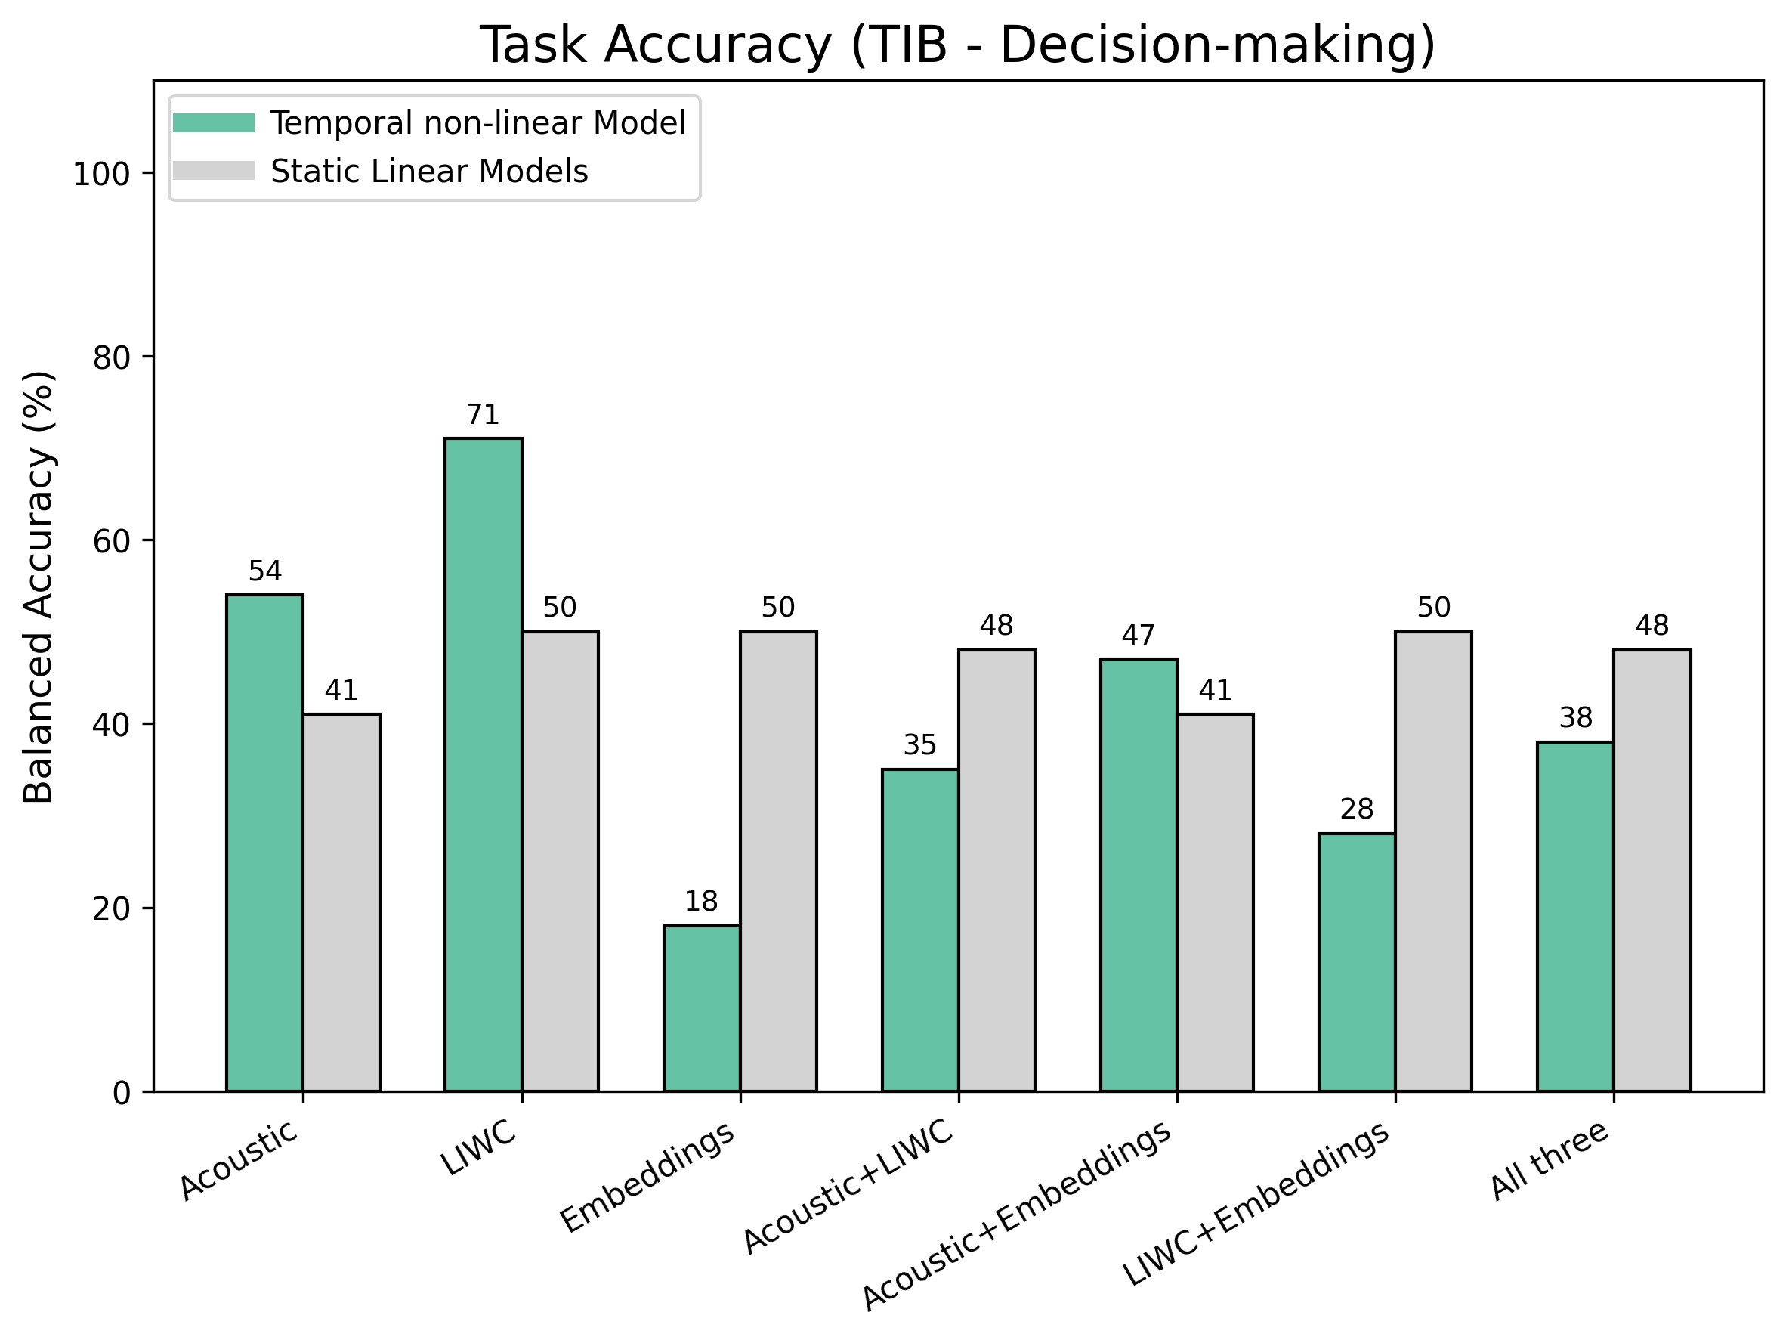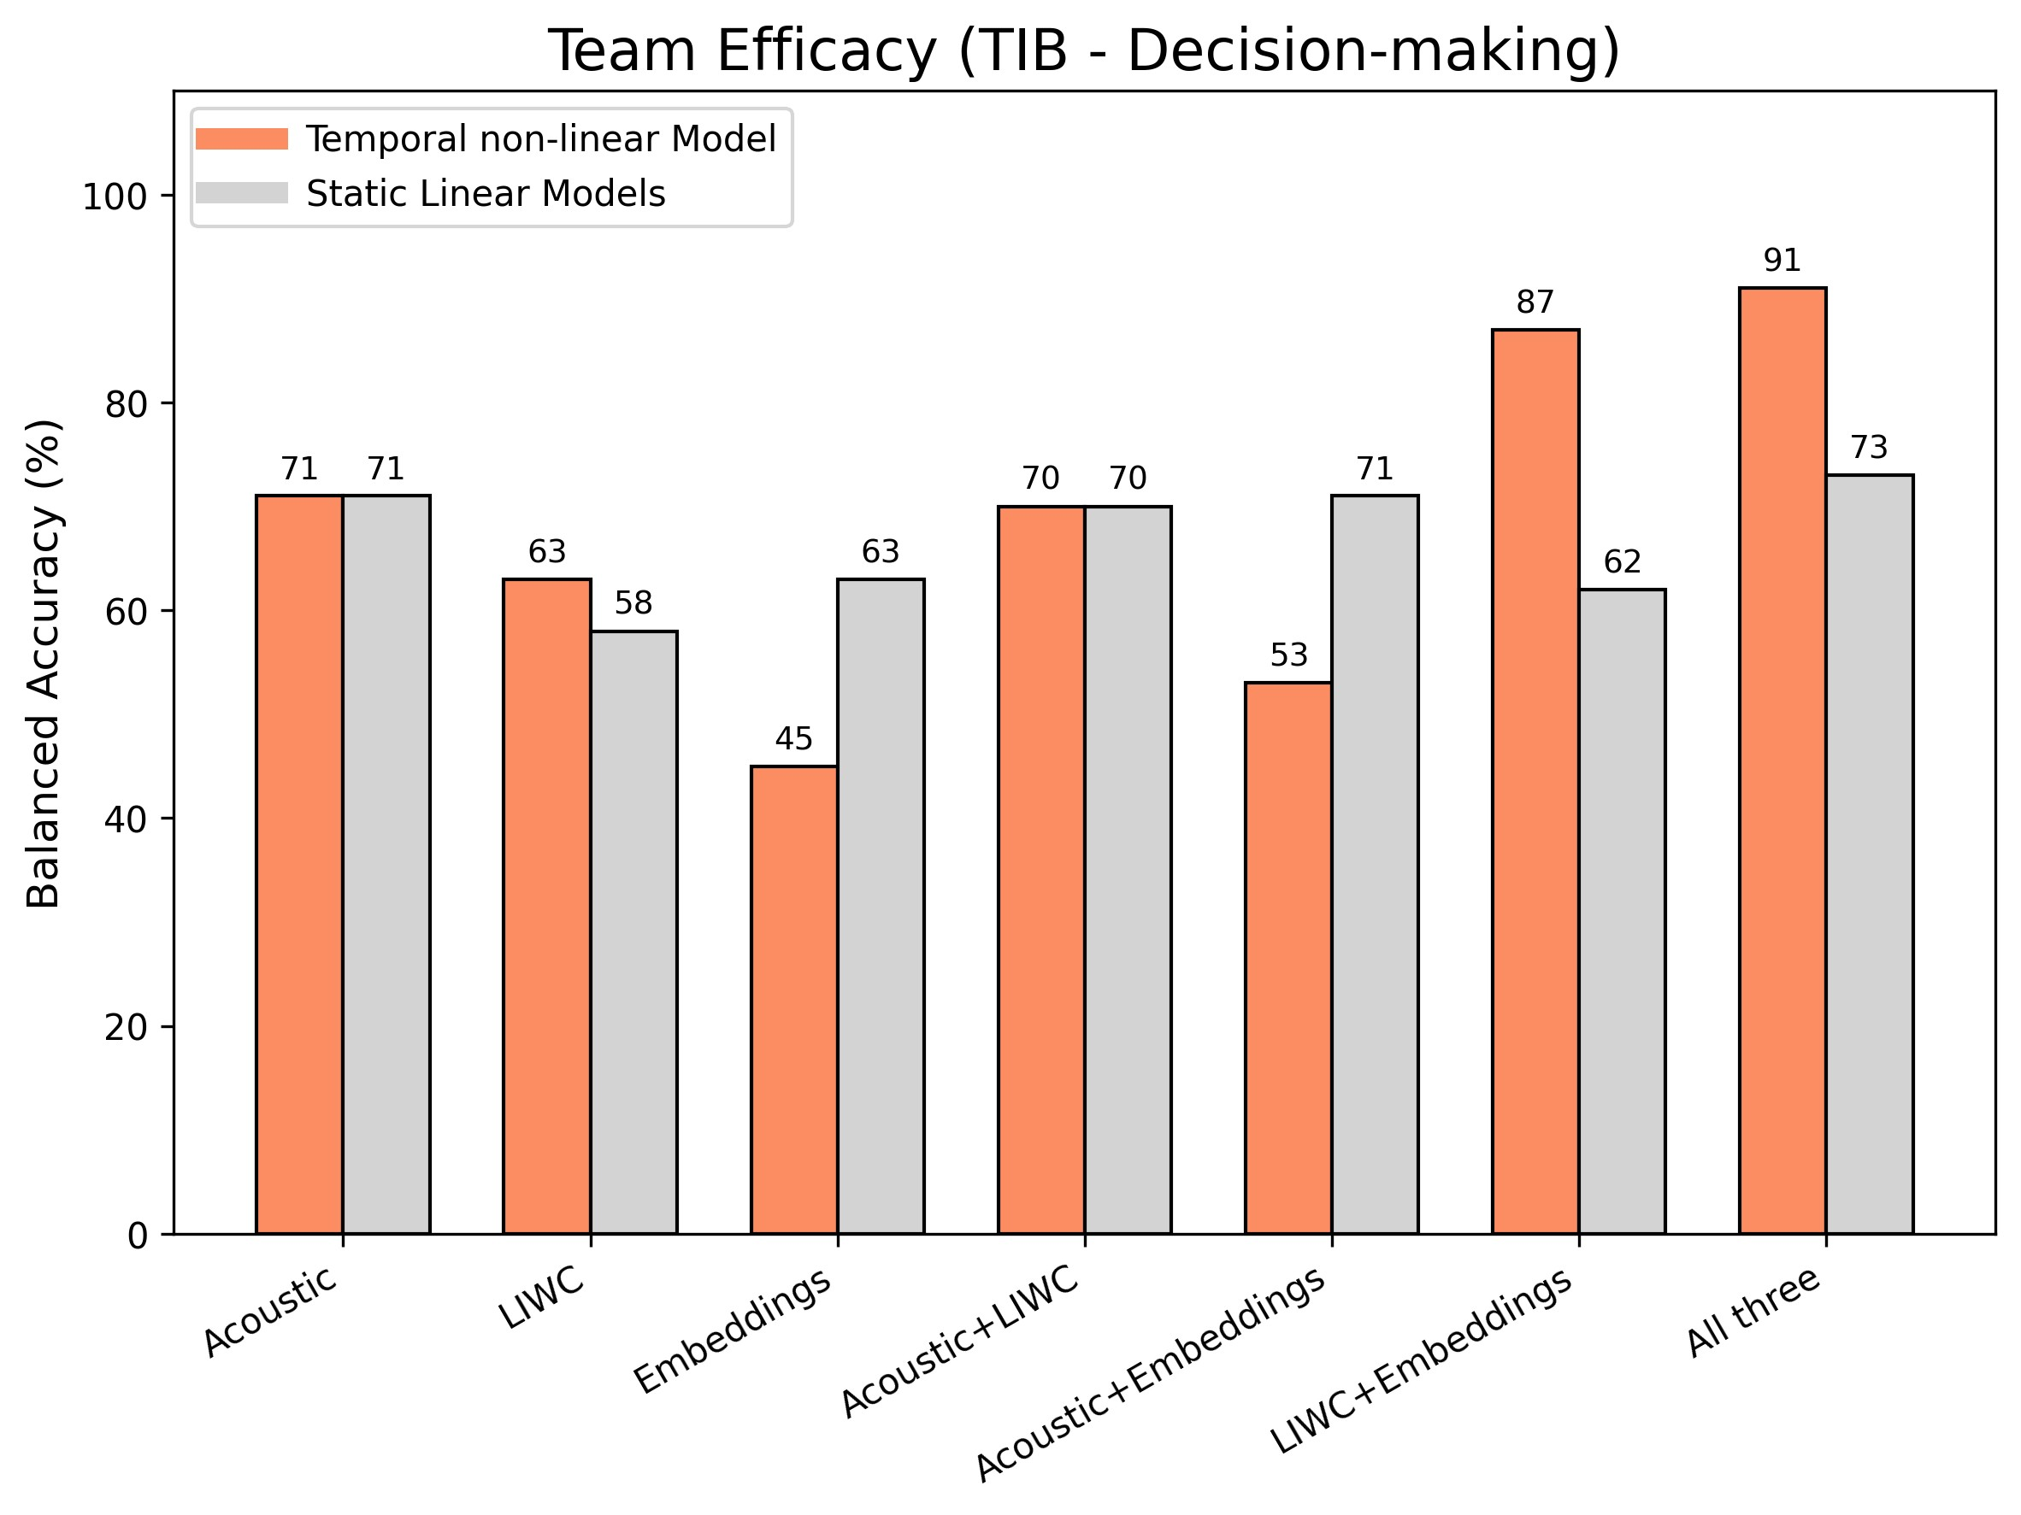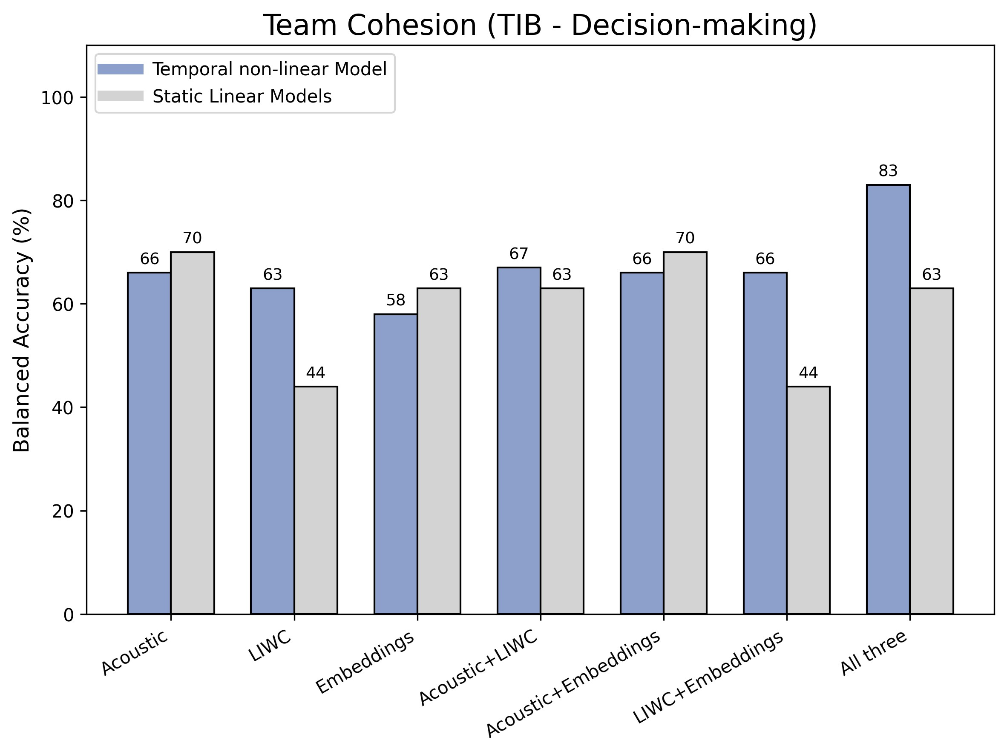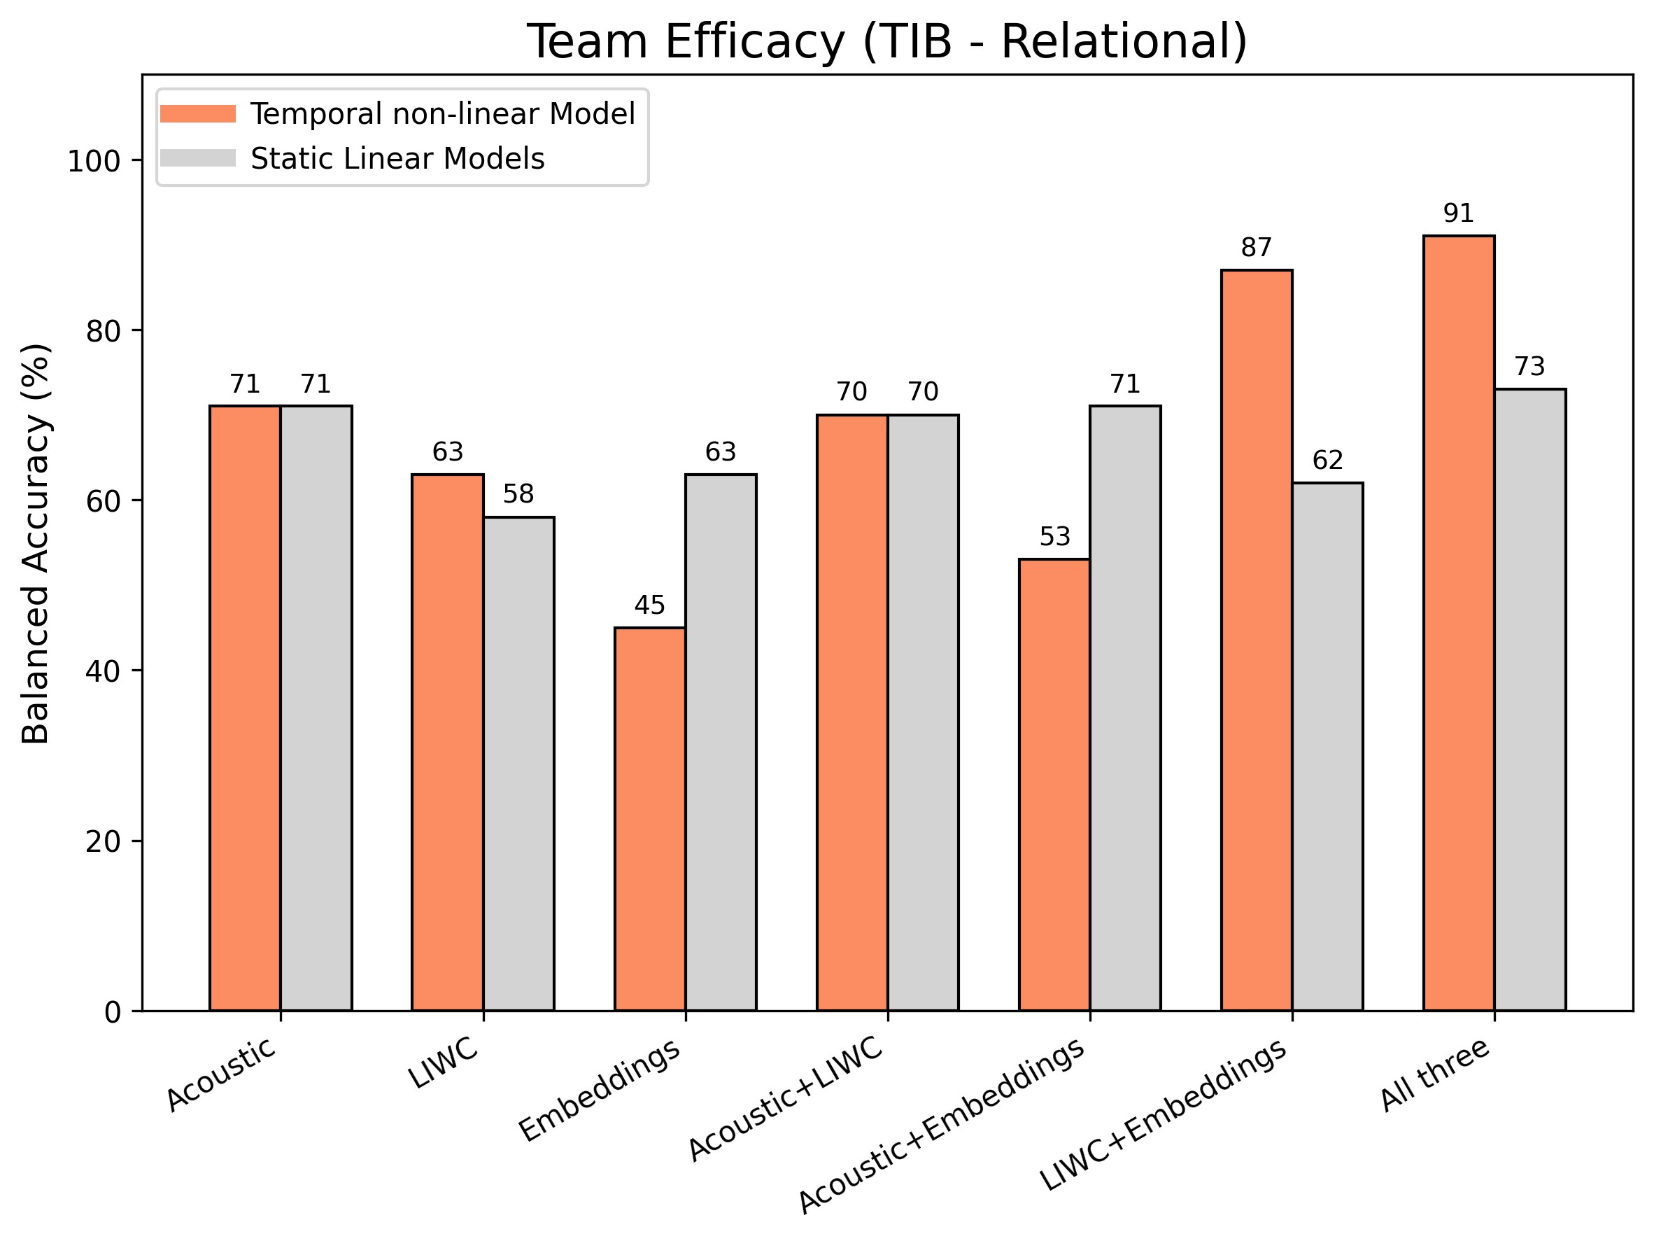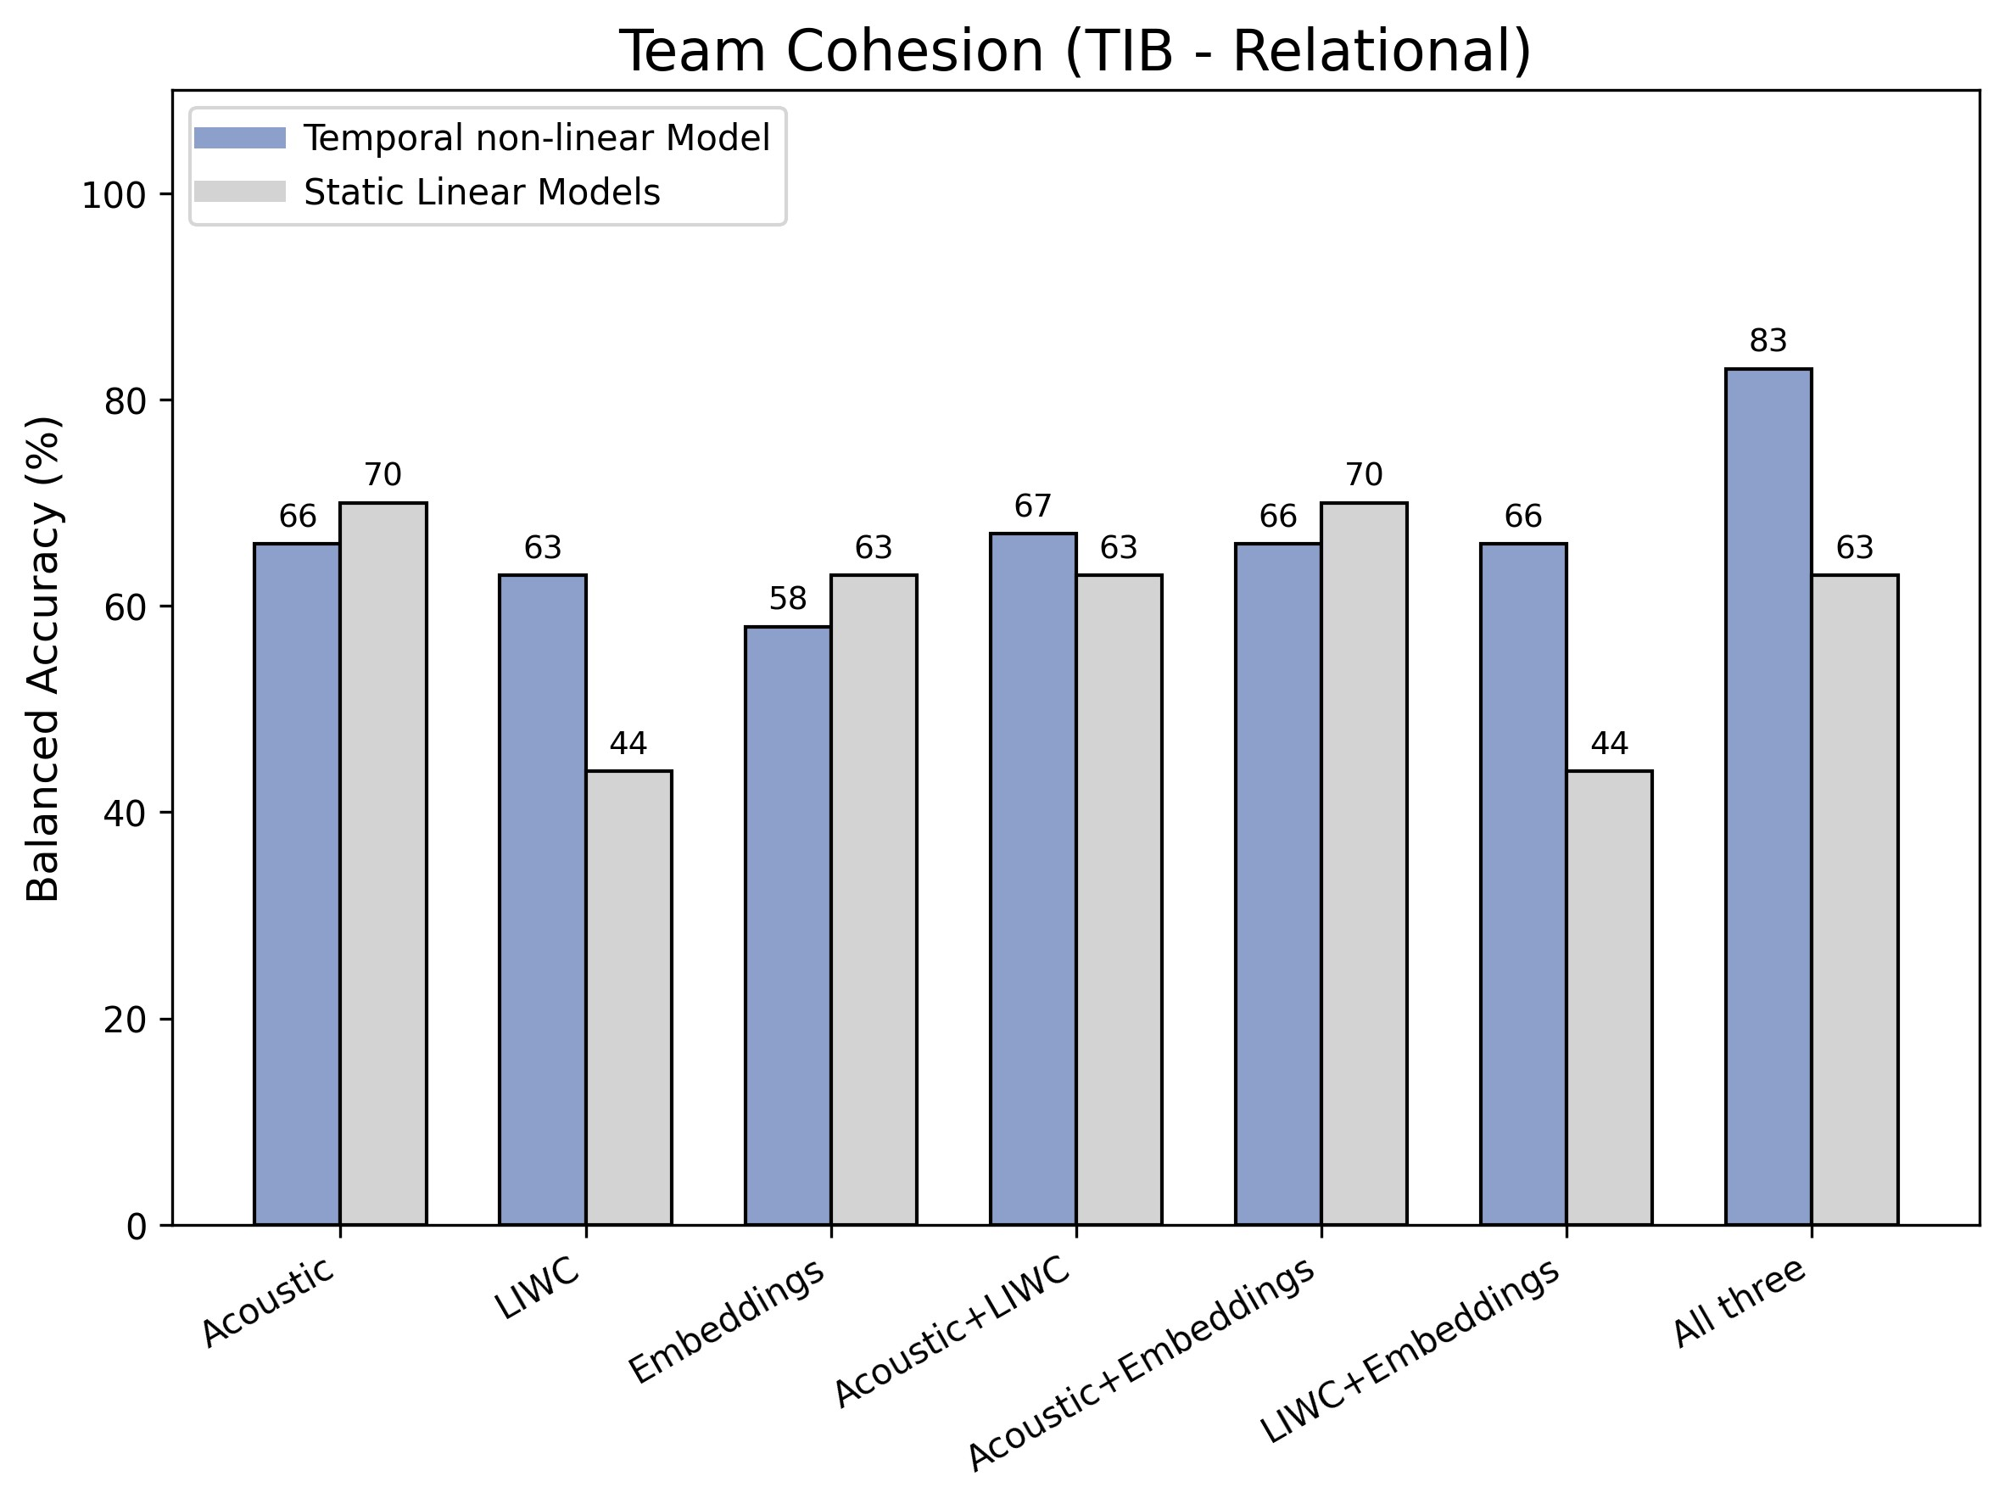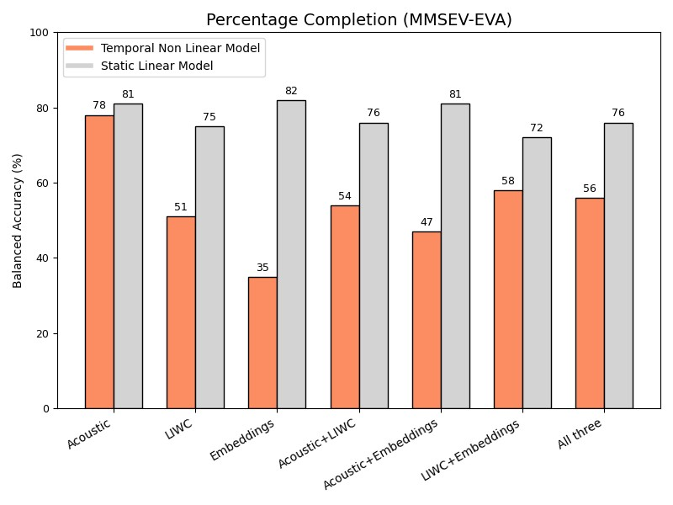
Fig. 2. Balanced accuracy of static (Random forest) and time-based (LSTM) models for predicting subjective and objective team functioning outcomes for the decision-making and the relational tasks of the TIB task, as well as the MMSEV-EVA, using leave-one-team-out cross-validation.
higher for self-reported team efficacy and cohesion, as compared to TIB task accuracy. In the relational task, majority voting achieved a BA of 85.56% for team efficacy and 78.12% for team cohesion. Acoustic features consistently emerged as the most predictive modality for these self reported outcomes. Results for the MMSEV-EVA task accuracy with static models utilizing language embeddings achieved a baseline accuracy of 60%. Temporal modeling with an LSTM (n = 2) reached 78% accuracy using acoustic features alone, while showing significantly worse performance with other features. To validate the significance of temporal modeling, we executed a shuffled-sequence baseline where the chronological order of conversational turns in the LSTM was randomized during testing. For the MMSEV-EVA task, randomizing turn order systematically degraded balanced accuracy across metrics, most notably dropping the top performance from 78% to 67%, with lower-performing targets reducing to baseline chance levels (e.g., dropping from 54% to 49%, and 52% to 43%).

B. Effect of Team-Specific Data on Model Performance
We evaluated whether the inclusion of historical interaction data from the target team in the training set enhances model performance. By incorporating earlier mission days from the same team, the models can learn interaction patterns and coordination dynamics unique to a specific team. Each team participated in a forty five-day mission, with the TIB task occurring five times; therefore, for a target team evaluation, the training set comprised data from all other teams plus X prior mission days of the target team, where X ∈ {0,1,2,3,4}. The models were subsequently tested on the remaining days
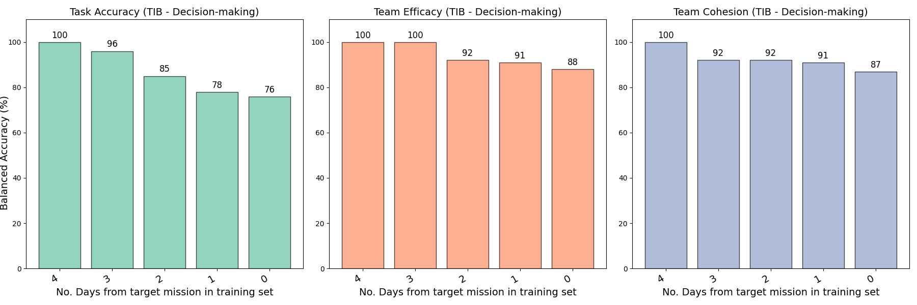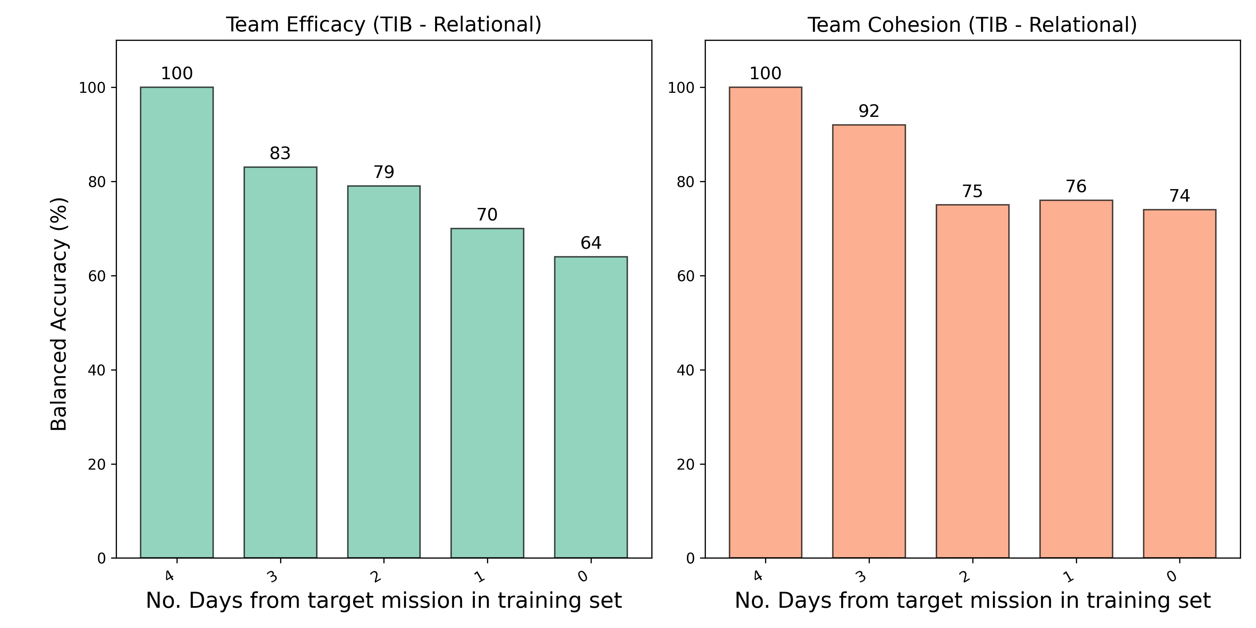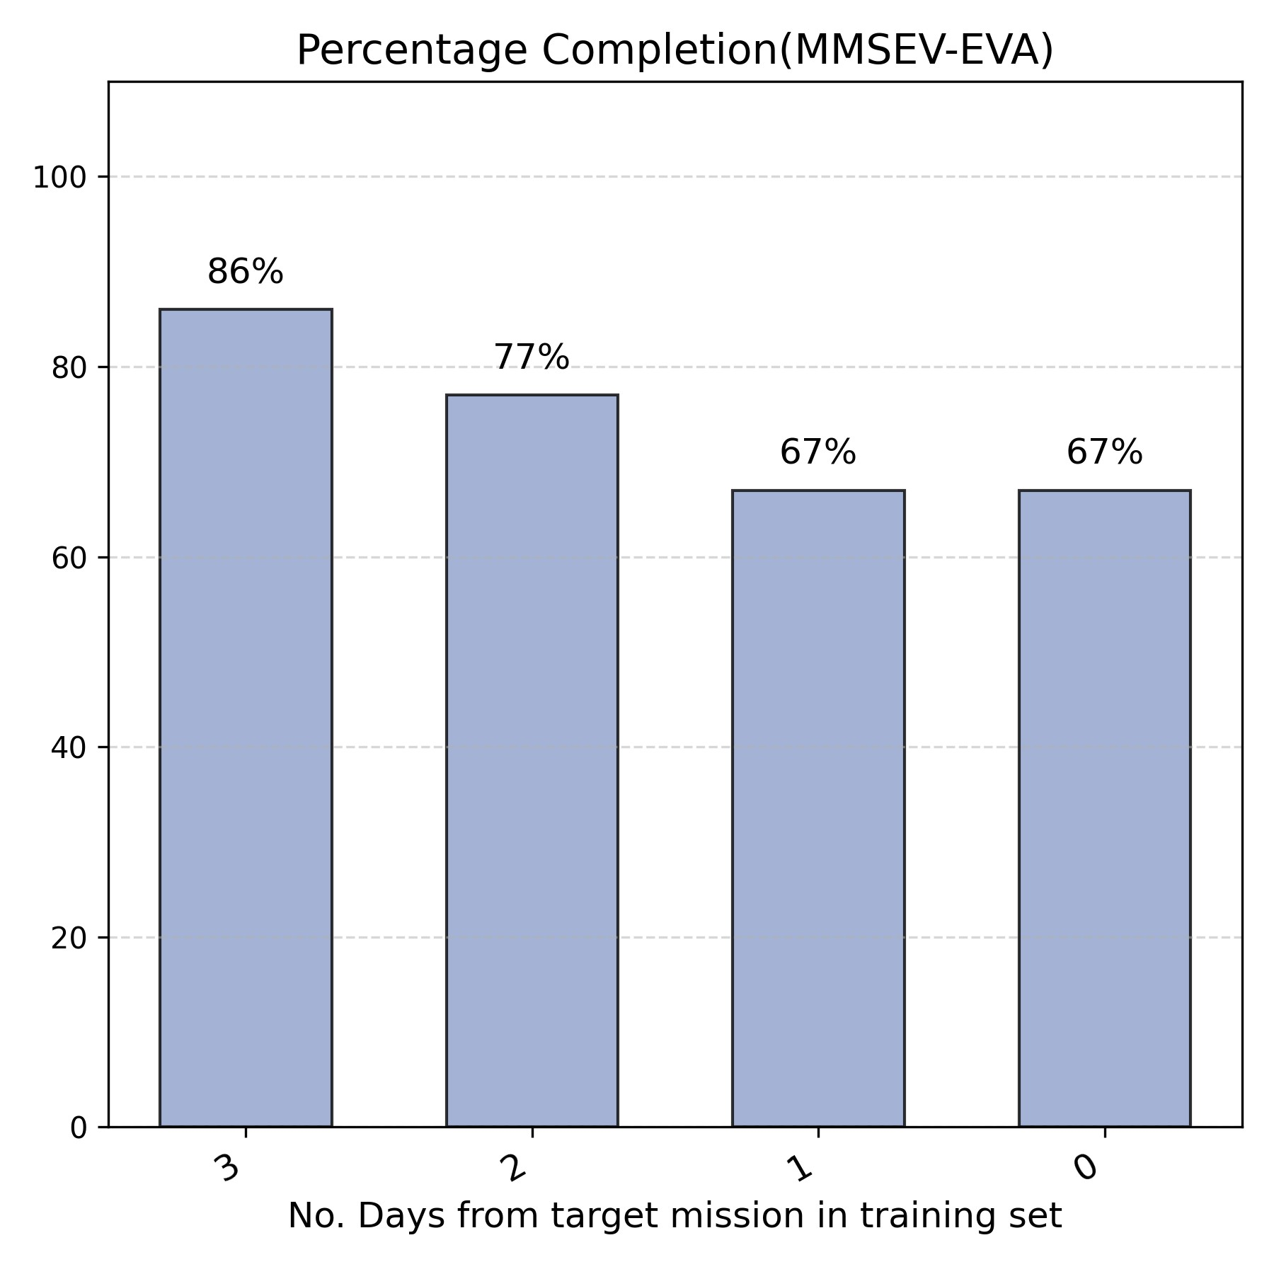
Fig. 3. Balanced accuracy (BA) of static models for predicting task accuracy, self-reported team efficacy, self-reported team cohesion and percentage completion during the TIB and the MMSEV-EVA task when including data from X prior days of the target team (where X ranges between 0 and 4) in the training set.
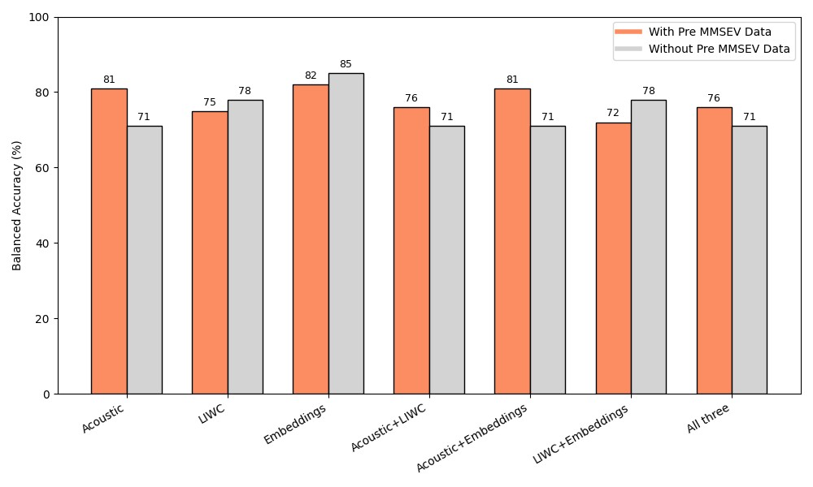
Fig. 4. Impact of informal discussions preceding the MMSEV-EVA task, referred to as ”Pre MMSEV Data,” on balanced accuracy (BA) for predicting percentage completion in the MMSEV-EVA task.
(X +1 through 5). The configuration with X = 0 denotes a leave-one-team-out cross-validation framework. All outcome measures for the TIB and the MMSEV-EVA tasks showed systematic improvements in BA with the inclusion of prior team-specific data (Figure 3). Notably, a performance boost was observed even with only a single day of prior interaction data (X = 1).

C. Effect of Pre-Task Data on Model Performance
Results for this indicated that the inclusion of pre-task data did not enhance performance when utilizing linguistic embeddings or LIWC features (Figure 4). This lack of improvement is consistent with the informal, non-technical nature of these discussions, which likely lacked the task specific vocabulary necessary to inform linguistic models. In contrast, a modest performance increase was observed when acoustic features were included. This suggests that while the content of pre-task chatter is operationally irrelevant, the acoustic-prosodic dynamics (e.g., vocal tension, engagement, and rhythmic entrainment) may provide a valuable baseline of the team’s emerging coordination state that linguistic content alone cannot reflect.

D. Effect of Audio Quality and Manually Corrected Speech Data on Model Performance
We evaluated model performance when trained on machine generated data compared to data that had been further cor-
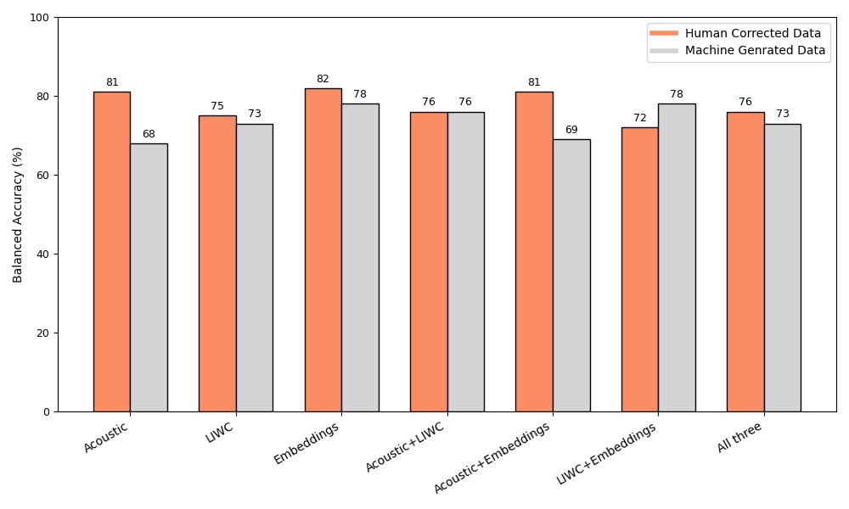
Fig. 5. Balanced accuracy (BA) for predicting percentage completion in the MMSEV-EVA task when extracting features from machine-generated data and human corrected data.
rected by human annotators. For the purpose of this analysis, we trained static models using a leave-one-day-out cross validation framework. Overall, models trained on human corrected data exhibited a modest improvement in performance, particularly when acoustic features were utilized (Figure 5). Upon comparing model performance with Word Error Rate (WER) in the transcription, we found no significant correlation between the WER and model accuracy for either the static or the LSTM models (r(55) = −0.08,p = 0.51). We categorized audio quality into low, medium, and high, based on an initial analysis of the machine generated audio. We compared the model’s balanced accuracy between low transcription quality sessions and medium/high transcription quality sessions using a t-test. Results further indicated that the model’s accuracy was significantly higher for the medium/high quality transcription group (0.74 (SD = 0.48)) compared to the low-quality transcription group (0.64 (SD = 0.36)) (t(63)=2.82, p = 0.006).

V. DISCUSSION
In addressing (RQ1), results indicate that while objective task performance remains difficult to predict (i.e., achieving 71% BA), likely due to the context-dependence of speech during active operations, speech-based models are more effective in capturing subjective dimensions of team functioning, such as team efficacy and cohesion (i.e., achieving BA of up to 85.56% and 78.12%, respectively). In answering (RQ1a), temporal models overall outperformed static architectures, achieving up to 91% balanced accuracy for team efficacy. This suggests that the longitudinal “rhythm” and cumulative trends in team interaction are more indicative of subjective team states than isolated communicative events. For long duration space missions, this highlights the importance of monitoring team functioning as a time-evolving state that is better captured through models that integrate cumulative trends in interaction over time rather than through static, single timepoint assessments.
In examining (RQ2), model performance improved significantly when even a small amount of historical data from the target team was incorporated into the training set. Specifically, adding just one to two days of team-specific data allowed the models to calibrate to the unique “vocal signatures” and communication norms of a specific crew. This finding is particularly relevant for deep-space exploration, where AI monitoring systems must be capable of adapting to the idiosyncratic communication styles of a small, isolated crew over months or years to maintain predictive reliability.
In our investigation of the predictive value of information pre-task interactions for answering (RQ3), we observed that acoustic features from unstructured conversational exchanges from pre-task MMSEV-EVA sessions provided a marginal boost in predicting subsequent operational performance in MMSEV-EVA tasks. This suggests that incorporating information from pre-task interactions may offer a more holistic view of emerging changes in team functioning. However, this finding should be further validated with additional data, particularly from safety critical events, where coordination and communication might manifest in unique ways.
Finally, in answering (RQ4), models trained on human refined transcripts yielded the highest BA. However, the performance of models using machine-generated text, that had an average WER of 0.19, remained robust enough for team functioning prediction. This suggests that while manual ”gold standard” data is ideal for research, fully automated, low latency speech processing can potentially serve as a viable path forward for real-time monitoring in environments where human intervention in data processing is not feasible, such as autonomous space habitats.

A. Limitations and Future Directions
Despite the promising results of this framework, several limitations remain that provide a roadmap for future development. First, the generalizability of our models is currently restricted to the HERA population; while these crews are highly screened to mirror astronaut profiles, further validation is needed across more diverse populations and extreme environments, such as the CHAPEA Mars analog or Antarctic research stations, to account for different cultural and organizational norms. Second, while our temporal LSTM architectures successfully captured longitudinal trends, this study did not leverage more advanced transformer-based models or large language models (LLMs). Future work should explore these architectures to better capture long-range semantic dependencies and nuanced pragmatic shifts in team dialogue. Additionally, the current system requires a brief ”calibration” period of 1–2 days to adapt to a new team’s specific vocal and linguistic signatures. To mitigate this initial drop in accuracy, we propose leveraging meta-learning and transfer learning across historical datasets to establish ”universal priors” of team coordination.

VI. CONCLUSION
This study validates the efficacy of speech-based machine learning as a high-fidelity, non-intrusive post-hoc outcome assessment tool for team functioning in extreme environments. Our results demonstrate that team functioning is a time evolving state that is better captured through models that integrate cumulative trends in interaction over time rather than through static, single-timepoint assessments. By capturing the underlying mechanism of interaction, these models achieved balanced accuracies of up to 91% for team efficacy and 84% for cohesion, proving that the dynamics of how a crew communicates are as vital as the content of what is said.

ETHICAL IMPACT STATEMENT

A. Research Ethics and Informed Consent
All data utilized in this study were collected from the NASA HERA missions under the oversight of the NASA
Institutional Review Board (IRB). Human participants (i.e., crew members) provided informed written consent prior to participation, explicitly agreeing to the collection of audio data and the use of their performance and psychological self-report data for research purposes. Participants were compensated by NASA for their time and participation in the mission according to standard government contractor or civil servant rates, which were determined independently of the findings of this specific AI study.

B. Potential Negative Impacts and Mitigation
The use of speech-based AI for continuous monitoring introduces risks related to the surveillance of crew members in isolated environments. There is a potential for such systems to be misused for punitive management or to influence future career prospects based on private interpersonal chatter. To mitigate this, we advocate for systems that prioritize on-edge processing and the use of aggregated team-level metrics rather than individual-level monitoring, ensuring that the primary goal remains mission safety and crew support rather than individual surveillance. While this study focuses on post-hoc analysis, the future application of real-time feedback loops could inadvertently deceive participants if the AI’s confidence levels are not transparent. We recommend that any mission support system include ”human-in-the-loop” verification to prevent the automation of incorrect interventions based on misclassified social cues.

C. Bias and Generalizability
The current models were trained on a specialized, highly screened population of NASA HERA crew members. This dataset has limited demographic diversity compared to the general population. Consequently, the linguistic and acoustic markers identified, such as those related to leadership or cohesion, may reflect the cultural and professional norms of Western aerospace environments. There is a risk that these models might exhibit bias or reduced accuracy when applied to non-native English speakers or crews from diverse cultural backgrounds (e.g., variations in prosodic entrainment norms). Furthermore, the models are highly sensitive to the specific high-stress context of simulated space exploration. A generic application of these models to other team environments (e.g., corporate offices) without recalibration could lead to inaccurate results.

ACKNOWLEDGMENT
This research was funded by the National Aeronautics and Space Administration (NASA) under #80NSSC25K7249 (PI: Chaspari; Co-PI: Bell), the data was collected under #NNX16AQ48G (PI: Bell).

REFERENCES
- Seyyed Babak Alavi and John McCormick. “Why do I think my team is capable? A study of some antecedents of team members’ personal collective efficacy beliefs”. In: Educational Psychology 38.9 (2018), pp. 1147– 1162.
- Albert Bandura. Self-efficacy: The exercise of control. Vol. 11. Freeman, 1997.
- Daniel J Beal et al. “Cohesion and performance in groups: a meta-analytic clarification of construct relations.” In: Journal of applied psychology 88.6 (2003), p. 989.
- Suzanne T Bell, Shanique G Brown, and Tyree Mitchell. “What we know about team dynamics for long-distance space missions: a systematic review of analog research”. In: Frontiers in psychology 10 (2019), p. 811.
- Stephanie A Borrie et al. “Syncing up for a good conversation: A clinically meaningful methodology for capturing conversational entrainment in the speech domain”. In: Journal of Speech, Language, and Hearing Research 62.2 (2019), pp. 283–296.
- Antonis Botinis, Bjorn Granstrom, and Bernd M¨ obius.¨ “Developments and paradigms in intonation research”. In: Speech communication 33.4 (2001), pp. 263–296.
- Ryan L Boyd et al. “The development and psychometric properties of LIWC-22”. In: Austin, TX: University of Texas at Austin 10.1-47 (2022), p. 6.
- Susan E Brennan and Herbert H Clark. “Conceptual pacts and lexical choice in conversation.” In: Journal of experimental psychology: Learning, memory, and cognition 22.6 (1996), p. 1482.
- Tom Buchanan. “Self-report measures of executive function problems correlate with personality, not performance-based executive function measures, in nonclinical samples.” In: Psychological assessment 28.4 (2016), p. 372.
- Janis A Cannon-Bowers and Eduardo Salas. “Reflections on shared cognition”. In: Journal of Organizational Behavior: The International Journal of Industrial, Occupational and Organizational Psychology and Behavior 22.2 (2001), pp. 195–202.
- Daniel Cer et al. “Universal sentence encoder for English”. In: Proceedings of the 2018 conference on empirical methods in natural language processing: system demonstrations. 2018, pp. 169–174.
- Nancy J Cooke and Jamie C Gorman. “Interaction based measures of cognitive systems”. In: Journal of cognitive engineering and decision making 3.1 (2009), pp. 27–46.
- Jason C Crusan, Douglas A Craig, and Nicole B Herrmann. “NASA’s deep space habitation strategy”. In: 2017 IEEE aerospace conference. IEEE. 2017, pp. 1–
11.
- Emily Doherty et al. “Using speech patterns to model the dimensions of teamness in human-agent teams”. In:
Proceedings of the 25th international conference on multimodal interaction. 2023, pp. 640–648.
- Mary T Dzindolet and Linda G Pierce. “Linguistic Analysis is Useful in Predicting Group Brainstorming Performance”. In: Proceedings of the Human Factors and Ergonomics Society Annual Meeting. Vol. 50. 17. SAGE Publications Sage CA: Los Angeles, CA. 2006, pp. 1784–1788.
- Mary T Dzindolet and Linda G Pierce. “Using linguistic analysis to identify high performing teams”. In: (2006).
- Florian Eyben, Martin Wollmer, and Bj¨ orn Schuller.¨ “Opensmile: the munich versatile and fast open-source audio feature extractor”. In: Proceedings of the 18th ACM international conference on Multimedia. 2010, pp. 1459–1462.
- Florian Eyben et al. “The Geneva minimalistic acoustic parameter set (GeMAPS) for voice research and affective computing”. In: IEEE transactions on affective computing 7.2 (2015), pp. 190–202.
- Ute Fischer, Lori McDonnell, and Judith Orasanu. “Linguistic correlates of team performance: Toward a tool for monitoring team functioning during space missions”. In: Aviation, space, and environmental medicine 78.5 (2007), B86–B95.
- Peter W Foltz et al. “Measuring situation awareness through automated communication analysis”. In: Macrocognition in teams. CRC Press, 2017, pp. 259– 275.
- James A Grand et al. “The dynamics of team cognition: A process-oriented theory of knowledge emergence in teams.” In: Journal of Applied Psychology 101.10 (2016), p. 1353.
- Rebecca Grossman et al. “The team cohesion performance relationship: A meta-analysis exploring measurement approaches and the changing team landscape”. In: Organizational Psychology Review 12.2 (2022), pp. 181–238.
- Swathi Jagannath et al. “A speech-based model for tracking the progression of activities in extreme action teamwork”. In: Proceedings of the ACM on Human Computer Interaction 6.CSCW1 (2022), pp. 1–26.
- Fei Jia, Somshubra Majumdar, and Boris Ginsburg. “Marblenet: Deep 1d time-channel separable convolutional neural network for voice activity detection”. In: ICASSP 2021-2021 IEEE International Conference on Acoustics, Speech and Signal Processing (ICASSP). IEEE. 2021, pp. 6818–6822.
- Sujinat Jitwiriyanont, Rattanasuwan Rawan, and Khuansiri Narajeenron. “Advancing Politeness and Assertive Communication Through Tone of Voice in Crisis Team Situations: Pre-Post Acoustic Analysis Study of Team and Strategies to Enhance Performance and Patient Safety (TeamSTEPPS) Virtual Simulation for Interprofessional Education in Health Care Undergraduate Students”. In: Journal of medical Internet research 27 (2025), e66988.
- Marta Juhasz. “Capturing team performance differences through communication based analyses of team cognition”. In: Periodica Polytechnica Social and Management Sciences (2010).
- Daniel Jurafsky and James H Martin. Speech and Language Processing: An Introduction to Natural Language Processing, Computational Linguistics, and Speech Recognition.
- Nithin Rao Koluguri, Taejin Park, and Boris Ginsburg. “Titanet: Neural model for speaker representation with 1d depth-wise separable convolutions and global context”. In: ICASSP 2022-2022 IEEE international conference on acoustics, speech and signal processing (ICASSP). IEEE. 2022, pp. 8102–8106.
- Steve WJ Kozlowski and Bradford S Bell. “Work groups and teams in organizations: Review update”. In: (2013).
- Steve WJ Kozlowski and Daniel R Ilgen. “Enhancing the effectiveness of work groups and teams”. In: Psychological science in the public interest 7.3 (2006), pp. 77–124.
- Lauren Blackwell Landon, Kelley J Slack, and Jamie D Barrett. “Teamwork and collaboration in long-duration space missions: Going to extremes.” In: American Psychologist 73.4 (2018), p. 563.
- Lindsay Larson et al. “Team performance in space crews: Houston, we have a teamwork problem”. In: Acta Astronautica 161 (2019), pp. 108–114.
- Diane Litman et al. “The teams corpus and entrainment in multi-party spoken dialogues”. In: Proceedings of the 2016 Conference on Empirical Methods in Natural Language Processing. 2016, pp. 1421–1431.
- Shreya Mane. “Psychological effects of isolation and confinement in space: Short note”. In: Int. J. All Res. Educ. Sci. Methods 13 (2025), pp. 814–820.
- Elizabeth A McGuier et al. “Team functioning and implementation of innovations in healthcare and human service settings: a systematic review protocol”. In: Systematic Reviews 10.1 (2021), p. 189.
- Shrivatsa Mishra et al. “Acoustic Patterns of Interprofessional Communication and Quality of Teamwork in the Cardiac Operating Theatre”. In: The Hamlyn Symposium on Medical Robotics: proceedings. Vol. 16. 2024, p. 103.
- Panagiotis Mitropoulos and Babak Memarian. “Team processes and safety of workers: Cognitive, affective, and behavioral processes of construction crews”. In: Journal of Construction Engineering and Management 138.10 (2012), pp. 1181–1191.
- Shrikanth Narayanan and Panayiotis G Georgiou. “Behavioral signal processing: Deriving human behavioral informatics from speech and language”. In: Proceedings of the IEEE 101.5 (2013), pp. 1203–1233.
- Lisa R O’Bryan et al. “ML-SPEAK: A theory-guided machine learning method for studying and predicting conversational turn-taking patterns”. In: Journal of Personality and Social Psychology (2025).
- Susannah BF Paletz et al. “Speaking similarly: team personality composition and acoustic-prosodic entrainment”. In: Small Group Research 54.6 (2023), pp. 860– 898.
- Martin J Pickering and Simon Garrod. “Toward a mechanistic psychology of dialogue”. In: Behavioral and brain sciences 27.2 (2004), pp. 169–190.
- Eduardo Salas and Janis A Cannon-Bowers. “Methods, tools, and strategies for team training”. In: Training for a rapidly changing workplace: Applications of psychological research. Ed. by M. A. Quinones and A.˜ Ehrenstein. American Psychological Association, 1997, pp. 249–279.
- Eduardo Salas, Ramon Rico, and Jonathan Passmore.´ “The psychology of teamwork and collaborative processes”. In: The wiley blackwell handbook of the psychology of team working and collaborative processes (2017), pp. 1–11.
- Eduardo Salas et al. “Communicating, coordinating, and cooperating when lives depend on it: tips for teamwork”. In: The Joint Commission Journal on Quality and Patient Safety 34.6 (2008), pp. 333–341.
- Eduardo Salas et al. “Does team training improve team performance? A meta-analysis”. In: Human factors 50.6 (2008), pp. 903–933.
- Eduardo Salas et al. “Measuring team cohesion: Observations from the science”. In: Human factors 57.3 (2015), pp. 365–374.
- Catherine Sandoval et al. “Real-time team performance and workload prediction from voice communications”. In: IEEE Access 10 (2022), pp. 78484–78492.
- Randall Spain et al. “Toward Computational Models of Team Effectiveness with Natural Language Processing.” In: TTW@ AIED. 2019, pp. 30–39.
- Kevin Tasa, Simon Taggar, and Gerard H Seijts. “The development of collective efficacy in teams: a multilevel and longitudinal perspective.” In: Journal of applied psychology 92.1 (2007), p. 17.
- Yla R Tausczik and James W Pennebaker. “The psychological meaning of words: LIWC and computerized text analysis methods”. In: Journal of language and social psychology 29.1 (2010), pp. 24–54.
- Manjul Tiwari. “Speech acoustics: How much science?” In: Journal of natural science, biology, and medicine 3.1 (2012), p. 24.
- Chaman Verma, Zoltan Ill´ es, and Veronika Stoffova.´ “Age group predictive models for the real time prediction of the university students using machine learning: Preliminary results”. In: 2019 IEEE International Conference on Electrical, Computer and Communication Technologies (ICECCT). IEEE. 2019, pp. 1–7.
- Sheila Simsarian Webber et al. “Team challenges: Is artificial intelligence the solution?” In: Business Horizons 62.6 (2019), pp. 741–750.
- Rafael Wespi et al. “Exploring objective measures for assessing team performance in healthcare: an inter-
view study”. In: Frontiers in psychology 14 (2023), p. 1232628.
- Mingzhi Yu, Diane J Litman, and Susannah Paletz. “Investigating the Relationship between Multi-Party
Linguistic Entrainment, Team Characteristics and the Perception of Team Social Outcomes.” In: FLAIRS. 2019, pp. 227–232.
- Lu Zhang and Yan Ma. “A study of the impact of project-based learning on student learning effects: A meta-analysis study”. In: Frontiers in psychology 14 (2023), p. 1202728.

