Scientific Highlights and Status of the Mars Science Laboratory Mission, Years 9 through 12

Ashwin R. Vasavada¹, Abigail A. Fraeman¹, John P. Grotzinger², J. Michael Battalio³, Jeff A. Berger⁴, Alex B. Bryk⁵, Joel M. Davis⁶, William E. Dietrich⁵, Olivier Gasnault⁷, John A. Grant⁸, Scott D. Guzewich⁹, Alexandra Holloway¹, Reidar Larsen¹, Jack Quade¹, Elizabeth B. Rampe¹⁰, Susanne P. Schwenzer¹¹, Allan H. Treiman¹², Benjamin M. Tutolo¹³, Amy J. Williams¹⁴
Corresponding author: ashwin.r.vasavada@jpl.nasa.gov ORCID: 0000-0003-2665-286X

¹Jet Propulsion Laboratory, California Institute of Technology, Pasadena, CA, USA
²Division of Geological and Planetary Sciences, California Institute of Technology, Pasadena, CA, USA
³Department of Earth and Planetary Sciences, Yale University, New Haven, CT, USA
⁴Jacobs – JETS, NASA Johnson Space Center, Houston, TX, USA
⁵Department of Earth & Planetary Science, University of California, Berkeley, CA, USA
⁶Department of Earth Science and Engineering, Imperial College London, London, UK
⁷Institut de Recherche en Astrophysique et Planétologie, Universite de Toulouse, Toulouse, France
⁸Smithsonian National Air and Space Museum, Center for Earth and Planetary Studies, Washington, DC, USA
⁹NASA Goddard Space Flight Center, Greenbelt, MD, USA
¹⁰NASA Johnson Space Center, Houston, TX, USA
¹¹AstrobiologyOU, School of Environment, Earth and Ecosystem Sciences, The Open University, Milton Keynes, UK
¹²Lunar and Planetary Institute, Universities Space Research Association, Houston, TX, USA
¹³Department of Earth, Energy, and Environment, University of Calgary, Calgary, AB, Canada
¹⁴Department of Geological Sciences, University of Florida, Gainesville, FL, USA

Abstract
We present the scientific highlights and status from years 9-12 of NASA’s Mars Science Laboratory mission, with its Curiosity rover. A thermochemolysis-based sample analysis revealed a variety of organic molecules preserved in clay mineral-rich lake/lake margin deposits of the Glen Torridon region. The stratigraphically higher clay-sulfate mineral transition on Aeolis Mons was found to be associated with a lithological change from lacustrine to dry aeolian depositional environments. Water intermittently returned to the surface after the increase in aridity, including during the deposition of wave ripple strata which indicate a climate capable of sustaining an ice-free lake in the early Hesperian. The overlying Mg sulfate-bearing unit has both poly- and monohydrated Mg sulfates and is also enriched in iron carbonate of a purity consistent with chemical sedimentation and therefore atmospheric sequestration. A channel-incised canyon within Gediz Vallis and distal alluvial deposits recorded numerous fluvial and debris flow events after the deposition, lithification, and erosion of the clay- and sulfate-bearing units. Bright clasts found in Gediz Vallis canyon are composed of native sulfur. The investigation of the modern atmosphere and environment focused on the influence of the crater and mountain topography and captured high-altitude noctilucent and iridescent clouds. Radiation monitoring now spans an 11-year solar cycle. Rover systems and science instruments remain capable of addressing mission scientific objectives. All ten scientific instruments continue to return high-value data despite degradation of the Chemistry and Camera instrument’s high-voltage system, loss of multispectral imaging capability, and loss of active neutron spectroscopy. The mission has mitigated the loss of redundant brakes on two arm joints, additional wheel wear, and highly reduced capability of the redundant flight computer. Efficiency improvements in rover energy utilization and operations staffing have allowed the mission team to maintain a high level of productivity despite declining rover power generation and funding.

Keywords: Mars, astrobiology, geology, habitability

Statements and declarations
Conflicts of interest/Competing interests: The authors have no relevant financial or non-financial interests to disclose.

Data Availability
Mars Science Laboratory data are publicly available at the NASA Planetary Data System (https://pds-geosciences.wustl.edu/missions/msl/)

Acknowledgments Credit for the success and accomplishments of the MSL mission belongs to all those who contributed to the design, development, testing, management, and ongoing operation of Curiosity and to the MSL Science Team and broader scientific community that have analyzed the data acquired on Mars. Kathya Zamora Garcia is the MSL Project Manager. We are grateful to Becky McCauley Rench, Dave Lavery, Nathan Barba, and Laura Ratliff at NASA Headquarters, as well as the Mars Program and Planetary leadership for their support of MSL in its extended missions. Elena Amador-French, Doug Archer, Anna Boettcher, Carrie Bridge, Jonathan Denison, Tex Kubacki, Daniel Lo, Charles Malespin, Amy McAdam, Nicky Relatores, Dave Vaniman, and Albert Yen reviewed parts of the manuscript. We sincerely appreciate the formal reviews by Janice Bishop and an anonymous colleague. Mastcam mosaics were processed by the Mastcam team at Malin Space Science Systems. Part of this research was carried out at the Jet Propulsion Laboratory, California Institute of Technology, under a contract with the National Aeronautics and Space Administration (80NM0018D0004). This paper is dedicated to the memory of our always curious and enthusiastic colleague, Horton Newsom.

© 2026. All rights reserved.

1 Introduction and Summary Findings
1.1 Scope of This Report
The Mars Science Laboratory (MSL) is a flagship mission within NASA’s Mars Exploration Program. The mission’s Curiosity rover was designed to conduct multidisciplinary observations across a local area and quantitatively assess past (and present, secondarily) habitability. We review the scientific contributions of the mission in Earth Years 9 through 12 (Y9-12) of Mars surface operations (Aug. 6, 2020, through Aug. 5, 2024; Sols 2845 through 4266) and summarize the mission’s performance and status. This paper is the third such overview: Vasavada et al. (2014) focused on the first 500 Sols on Mars while Vasavada (2022) covered launch, cruise, and surface operations through year 8. The mission’s overall scientific goals and strategy and its operations process are discussed in Vasavada (2022) and are not repeated here. Curiosity’s scientific payload is outlined in Table 1. Background information about the mission, spacecraft, payload, and landing site can be found in Grotzinger et al. (2012) and Lakdawalla (2018).
Over MSL’s prime mission (Aug. 2012 through Sept. 2014), its team documented an ancient habitable environment in the bedrock of Aeolis Palus, the plains in Gale crater surrounding the central mound of sedimentary rock, Aeolis Mons (known informally as Mount Sharp). During three extended missions (EM1, EM2 and EM3, through year 8), Curiosity climbed through and analyzed ~400 vertical meters of strata on lower Mount Sharp. Lithological, geochemical, and mineralogical analyses revealed long-lived ancient marginal rivers and lakes, multiple generations of subsurface fluids, and associated enrichments in phyllosilicates and other secondary phases. Evidence of past habitable environments was documented throughout: persistent liquid water, key chemical elements and nutrients required for life, diverse organic molecules, and sources of energy to fuel metabolism. In parallel the mission characterized aeolian processes, the meteorology and composition of the atmosphere, and the space radiation environment at Mars’ surface.
The Y9-12 timeframe reviewed here includes the latter two years of EM3 and the first two years of EM4. Near-infrared spectra of the additional ~450 vertical meters of strata explored in Y9-12 acquired by the Compact Reconnaissance Imaging Spectrometer for Mars onboard the Mars Reconnaissance Orbiter (MRO-CRISM) are challenging to interpret but permit confident detections of hydrated Mg sulfates at higher elevations. These detections motivated the hypothesis that the mineralogical transition from phyllosilicate- to Mg sulfate-bearing strata implies a major climate transition from wetter to drier conditions (e.g., Bibring et al. 2006; Milliken et al. 2010). The Y9-12 traverse (Figs. 1, 2) was chosen to take Curiosity through this transition into Mg sulfate-enriched strata and near landforms inferred to record flows of liquid water that postdate the hypothesized increase in aridity. The mission’s goals were to investigate these regions in situ, test the relevant hypotheses and interpretations, and understand whether habitable environments persisted through these changes in the ancient environment.
After a summary of key Y9-12 scientific findings below, Sects. 2-4 describe the results from the surface, the atmosphere, and space radiation environment. Sect. 5 describes the status of the rover and instruments. Sect. 6 updates mission operations and the performance achieved in this timeframe, and Sect. 7 previews future scientific investigations and the challenges of managing an aging rover. In Online Resource 1 (OR-1), we provide a detailed mission narrative to contextualize the results within the mission timeline, mission events, and strategic decisions made by the science and operations teams. OR-1 also includes traverse maps with placenames. OR-2 contains a list of drive distances and parking coordinates. An acronym list can be found in Table 2.
1.2 Summary of Scientific Highlights from Years 9-12
In Y9-12 Curiosity traversed 9.1 km and climbed ~450 m, more than doubling the mission’s total elevation change (Fig. 3). Along the traverse, the mast-mounted Chemistry and Camera instrument (ChemCam; Table 1) measured the composition of 1083 targets, and the arm-mounted Alpha Particle X-ray Spectrometer (APXS; Table 1) measured the composition of 605 targets. The team collected fifteen samples with the rover’s drill and analyzed them in the Chemistry and Mineralogy laboratory and the Sample Analysis at Mars laboratory (CheMin and SAM; Table 1). These measurements were accompanied by many thousands of images and continual readings by environmental sensors. At the end of year 12, Curiosity had in total traversed 32.4 km, gained ~850 m in elevation, and analyzed 48 samples.
The mission’s investigation of organic molecules has progressed significantly from first detecting simple chlorinated organics to inferring the potential precursors and origins of a diverse set of more complex molecules. These advances result from analytical procedures that have been refined in response to earlier findings and an improved understanding of the SAM analytical laboratory and Mars surface composition. Freissinet et al. (2025) identified long-chain (C₁₀-C₁₂) alkanes in a sample acquired early in the mission and proposed that the molecules were derived from carboxylic (fatty) acids preserved in the bedrock. This finding is from prior to Y9-12 but was published after the previous review (Vasavada 2022). Williams et al. (2026) detected over twenty aromatic organic molecules inferred to have been liberated from ancient organic macromolecular material by the thermochemolysis experiment performed in Glen Torridon (GT; Sect. 2.1). Both studies demonstrate that organic molecules accumulated in ancient lake/lake margin environments and were preserved for billions of years in clay mineral-rich sedimentary rock. Preservation occurred despite the diagenetic transformation of sediment into rock and exposure of the near-surface environment to ionizing radiation.
Curiosity’s geological findings continue to demonstrate the criticality of in situ, outcrop-scale observations to substantiate measurements and test hypotheses made from orbital datasets. The first-ever in situ investigation of a clay-sulfate transition (CST) on Mars (Sect. 2.2) confirmed its association with lithological changes from lacustrine to aeolian depositional environments. The inferred trend toward aridity was not monotonic, however, as there is evidence for periods of wet-dry cycling and a fluctuating water table that intermittently returned water to the surface. Clay minerals likely formed in situ in lacustrine settings, but the precipitation of Mg sulfate and other salts may have occurred during later diagenetic episodes.
Curiosity’s CheMin X-ray diffractometer detected crystalline Mg sulfate minerals for the first time in the Mg sulfate-bearing unit (MSBU), which is composed of dominantly aeolian, planar laminated and cross-stratified sediments (Sect. 2.3.1). Alternating beds hold either polyhydrated or monohydrated Mg sulfate minerals along with hydrated amorphous Mg sulfate and other salts (Sect. 2.3.2). A thin interval exposing wave ripple cross-lamination under thickly laminated sandstone is interpreted as evidence of a deepening lake (Sect. 2.3.3). The wind-generated wave ripples further indicate that the lake was ice free, providing an important paleoclimate marker. Most MSBU samples are also enriched in siderite (Fe carbonate) of a purity consistent with chemical sedimentation (Sect. 2.3.4). This carbonate deposit is the first substantial evidence of the “missing carbonate” that should have formed if ancient Mars had surface water in contact with a CO₂-rich atmosphere.
The incised canyon in Gediz Vallis and distal alluvial deposits (GV; Sect. 3) record numerous fluvial and debris flow events. These significant surface flows of water are relatively young, forming only after i) accumulation and lithification of the flat-lying strata of Mount Sharp, ii) wind-driven erosion inward from the crater rim that removed massive volumes of sedimentary rock, and iii) emplacement and lithification of an extensive dune field that covered the margins of the mountain, draping the older bedrock strata. Within GV Canyon, bright clasts exposed on a steep slope are formed of native sulfur (Sect. 3.5). This is the first detection of elemental (zero-valent) sulfur on Mars, a finding that remains to be understood.
Environmental monitoring in Y9-12 (Sect. 4) focused on how dynamics and atmospheric composition are affected by the rover’s location near the equator and on a mountain within a deep impact crater. Investigations have also shown that dust lifting in Gale occurs through both straight-line winds and vortices, with the dominant process changing as the rover climbed Mount Sharp (Sect. 4.1.3). The mission also captured the first observations of high-altitude, noctilucent and iridescent clouds (Sect. 4.1.5). Measurements of the space radiation environment at Mars’ surface (Sect. 4) hit a major milestone by completing an entire solar cycle and captured the largest dose rate of the mission during a solar particle event in May 2024 (Sect. 4.3).
2 Geology and Paleoenvironment: Mount Sharp Group
2.1 Glen Torridon (Murray and Carolyn Shoemaker Formations)
Glen Torridon (Figs. 1 and 2) is a roughly linear topographic depression associated with distinct and spatially cohesive absorptions in MRO-CRISM near-infrared spectra attributed to phyllosilicates (Milliken et al. 2010; Fig. 4). The area was referred to as the clay-bearing unit prior to Curiosity’s in situ exploration. Most of the mission’s investigation of GT occurred before year 9 (Bennett et al. 2023; Vasavada 2022). The search for organic molecules was a priority in GT, given that the phyllosilicate-enriched sedimentary rocks and fine-grained lacustrine mudstones such as those found in GT are favorable indicators both for habitability at the time of phyllosilicate formation and for subsequent preservation of organic molecules (Summons et al. 2011; Broz 2020). Nitrogen-, oxygen-, chlorine-, and sulfur-bearing organics and aromatics have been found in nearly all GT samples (Millan et al. 2022). These findings, and evidence for persistent near-neutral pH water during the formation of the GT strata, lead to an interpretation of the strata as preserving an ancient habitable environment (Bennett et al. 2023). Nitrogen availability may have been limited relative to other habitable regions documented by the mission (McAdam et al. 2022).
GT exposes the highest part of the Murray formation (fm) and the lowest part of the overlying Carolyn Shoemaker fm, the Knockfarril Hill member (mbr; Fig. 5). Year 9 included an extensive sampling campaign within the Knockfarril Hill mbr, which has two distinct facies: trough cross-stratified sandstone and interbedded sandstone and mudstone. It is interpreted to record deposition in fluvial, lake margin, and lake environments, with the different lithologies reflecting changes in sediment supply and/or base level (Fedo et al. 2022; Caravaca et al. 2022; Cardenas et al. 2022). The Carolyn Shoemaker fm encompasses a greater diversity of depositional settings and implies paleoenvironmental changes relative to the dominantly lacustrine Murray fm extending ~300 m below the base of the Carolyn Shoemaker fm. Bedrock exposed in upper GT also exhibits a wide range of diagenetic features involving multiple fluid episodes. Mn-rich nodular bedrock near the Mary Anning/Groken sampling site and nearby Fe-rich nodular bedrock are evidence of redox chemistry in interacting fluids (Gasda et al. 2022).
Early sampling of the Knockfarrill Hill mbr at Glen Etive (GE Fig. 5) found high abundances of Fe-rich dioctahedral smectite (up to 34 wt.% of the crystalline component; Bristow et al. 2021; Thorpe et al. 2022) and a variety of organic molecules (Millan et al. 2022), prompting the team to plan another, more extensive sampling campaign prior to leaving GT at the stratigraphically equivalent Mary Anning site (Fig. 5). SAM analyses of the sample drilled at Mary Anning 3 included both types of wet chemical processing capabilities: chemical derivatization with N-methyl‐N‐(tert‐butyldimethylsilyl) trifluoroacetamide and dimethylformamide (MTBSTFA and DMF) and the first thermochemolysis experiment on Mars, using tetramethylammonium hydroxide (TMAH) in methanol. These experiments are designed to convert polar organic compounds into derivatives detectable by SAM and to liberate refractory organic molecules from organic macromolecular material (Mahaffy et al. 2012).
Molecules identified in both evolved gas analysis (EGA) and gas chromatography-mass spectrometry (GC-MS) after TMAH processing include benzene, toluene, trimethyl and tetramethyl benzene, naphthalene, and methylnaphthalene (Williams et al. 2026). TMAH is a methylating reagent, and methylated single and two-ring aromatics might be derived from a macromolecular source that was cleaved and methylated. Additional organic molecules were detected only with GC-MS, including benzoic acid methyl ester and the sulfur-bearing benzothiophene, which adds to the inventory of sulfur-bearing organics detected at other sites in Gale (Eigenbrode et al. 2018; Millan et al. 2022). Analyses of the TMAH experiment identified over 20 aromatic and cyclic molecules with methyl and ester/carboxylic acid functional groups, and sulfur- and nitrogen-bearing organics. These results show that the detection of organic molecules is not confined to rocks that formed in low-energy lacustrine environments; higher-energy lake margin or fluvial environments also are capable of their accumulation and preservation.
2.2 Clay-Sulfate Transition (Carolyn Shoemaker and Mirador Formations)
Here, the clay-sulfate transition (CST; Figs. 1, 2, 4) refers to the ~200-m-thick section of the Mount Sharp group from the Mercou through Contigo mbrs of the Carolyn Shoemaker fm (Fig. 5), although it plausibly starts with the environmental changes recorded in the Knockfarril Hill and Glasgow mbrs in upper GT (Sect. 2.1). Near-infrared spectra of the CST from the MRO-CRISM lack strong absorption attributed to phyllosilicates in GT and exhibit weak and variable spectral absorption attributed to hydrated Mg sulfates (Fraeman et al. 2016; 2024; Sheppard et al. 2021).
The lithologies of the CST strata are described in detail in Meyer et al. (2024), Edgar et al. (2024), and Seeger and Grotzinger (2023). The stratigraphically lowest CST is characterized by broad exposures of bright bedrock with relatively high thermal inertias (i.e., well indurated). Curiosity approached one such exposure at Mont Mercou (Fig. 1), a mound with a 6-m tall cliff face. Near the base of this cliff, scour and drape features were present in a cross-bedded interval. The team interpreted these strata and others exposed in topographic benches in the underlying Glasgow mbr as recording river bars in an ancient alluvial and possibly shoreline setting (Cardenas et al. 2022). The overlying Pontours mbr is interpreted as recording lake margin environments, although extensive diagenetic overprinting makes it challenging to observe primary stratigraphy or determine grain size.
The Mirador fm, stratigraphically above the Carolyn Shoemaker fm, marks a major change to dominantly aeolian strata, hundreds of meters thick. Meyer et al. (2024) proposed that the base of the Mirador fm is an erosional unconformity. The lowest rocks of the Mirador fm are the low-angle cross-stratified sandstones of the Dunnideer mbr. The overlying Port Logan mbr is interpreted as preserving well-developed aeolian dunes. At the top of the CST, the Contigo mbr includes trough cross-stratified sandstone and lenses of thinly bedded, locally ripple cross-laminated sandstone, interpreted to record an aeolian dune field with local lacustrine/fluvial deposition in shallow interdune areas (Caravaca et al. 2025). The largest such lens is the Prow, which is ~18 m wide and 0.7 m thick. There the team observed symmetric ripples in sand-sized sediment interbedded with drapes of finer sediment. This assemblage is interpreted to have formed subaqueously in a combined flow (waves and current) environment (Gupta et al. 2023; Mondro et al. 2025a).
Diagenetic features such as cements, concretions, and veins are pervasive in the CST and are responsible for much of its observed chemical variability. The bulk chemical composition of bedrock in the CST is similar to the average composition of underlying Mount Sharp group strata except for a 35% increase in SO₃ and concomitant increases in Ca and Mg (Berger et al. 2025a). Covariations between Ca, Mg, and S suggest that Ca-sulfate is enriched relative to Mg-sulfate throughout most of the CST strata until the upper Contigo mbr (Sect. 2.3). Small (mm-scale) rounded concretions are compositionally indistinguishable from the surrounding rock. The compositions of cm-scale knobs are consistent with up to 15 wt.% enrichments in Mg sulfate. Ca-sulfate veins occur along with darker diagenetic features enriched in Fe, Fe+Cl (consistent with akageneite), or Na+Cl (consistent with halite). Halite is found throughout the CST and overlying MSBU in measurements of dark laminae, spherules, and fracture walls (Meslin et al. 2024). Curiosity’s neutron spectrometer found a slightly higher bulk water content (~1 wt.%) in both GT and the CST than in the lower units (Nikiforov et al. 2024).
Smectite clay minerals are found only at the base of the CST (18 and 12 wt.% of the crystalline component at the Nontron and Bardou sites, respectively) and are not present above the CheMin detection limit in samples drilled from progressively higher strata (Fig. 6; Rampe et al. 2023). Crystalline Fe oxides/oxyhydroxides and Ca sulfates are present throughout, but no crystalline Fe or Mg sulfates are detected. SAM evolved gas analyses show an increase in SO₂ released at temperatures consistent with the presence of X-ray amorphous Fe and Mg sulfates (Clark et al. 2024).
In summary, the first in situ investigation of a clay-sulfate mineralogical transition on Mars confirmed its association with changes in paleoenvironmental conditions recorded in primary sedimentary structures. Depositional settings broadly changed from lacustrine to alluvial river/shoreline to aeolian, reflecting the diminishing extent of lakes in an increasingly arid environment. The trend toward aridity was not monotonic but instead showed significant variability, given evidence for sustained wet-dry cycling at one lower-elevation interval of the CST (Rapin et al. 2023) and evidence for intermittent surface water at higher elevations. The clay minerals are consistent with in situ formation in the wet environments recorded in the lower lake and lake margin strata. However, the precipitation of sulfates and other salts appears to have occurred later in multiple postlithification diagenetic episodes and may be related to, but not strictly contemporaneous with, the paleoclimatic changes.
2.3 Mg Sulfate-Bearing Unit (Mirador Formation)
Curiosity first reached one of the areas where MRO-CRISM near-infrared spectra show strong absorption attributed to hydrated Mg sulfates (Fraeman et al. 2024; Sheppard et al. 2021) at Marker Band Valley (MBV; Figs. 1, 2, 4). The bulk Mg-sulfate abundance measured in situ increased sharply in the upper Contigo mbr rocks exposed there. The rover’s arrival initiated the team’s investigation of the several hundred-meter-thick MSBU delineated from orbital data, with its characteristic rounded hills, incised valleys, and packages of layers that vary in tonality and thickness. Here the MSBU is considered to start toward the upper part of the Contigo mbr of the Mirador fm, including the Canaima drill site. The ~210 vertical meters explored through year 12 are the lowest one-third of the thickness of the MSBU. MRO-CRISM observations of this unit are consistent with the presence of both mono- and polyhydrated Mg sulfates (Sheppard et al. 2021).
2.3.1 Depositional Environments
Roberts et al. (2026) studied a ~100 m stratigraphic section in MBV where the Contigo, Catrimani, Amapari, and Chenapau mbrs are exposed on the valley floor and surrounding buttes. They suggest that the succession of sedimentary facies and architectures reflects variations in sediment supply and water table elevation. Meter-scale cross-stratified sandstones in the Contigo mbr are interpreted to record a dry aeolian environment with ample sediment supply, resulting in the accumulation of sand from migrating simple dunes. Aeolian sand sheet deposits of the Catrimani mbr are interpreted to reflect a high water table that inhibited dune formation. The lacustrine Amapari mbr (Sect. 2.3.3) and dark lens-shaped units are consistent with fluvial erosion and infill in the Chenapau mbr record when the rising water table outpaced sediment accumulation.
Roberts et al. (2026) reported that variations between the light- and dark-toned bands in the Chenapau mbr, which give the MSBU its characteristic layered appearance, arose from changes in sediment availability, moisture content, wind energy, and depositional rate. Lighter beds record continuous, dry aeolian deposition while darker beds show evidence for intermittent deposition and adhesion structures. Higher intervals of the Chenapau mbr have scour-and-fill structures tens of meters in length and several meters deep that are interpreted as saucer-shaped aeolian ‘blowout’ structures indicating deflation by intense winds (Roberts et al. 2025).
Above MBV the steep walls of GV expose an additional ~100 m of MSBU strata, which were imaged in detail using the Mast Camera (Mastcam; Table 1) and ChemCam Remote Micro-Imager. Harris et al. (2024) interpreted some of these strata as lithified migrating dunes, and others as migrating sand sheets. The stratigraphy also exposes multiple erosional surfaces that could have formed from aeolian deflation, flooding, or dune migration. These erosional surfaces extend horizontally for 100s of meters and can be correlated laterally across significant distances, indicating regional erosional episodes during the construction of Mount Sharp.
2.3.2 Composition and Origin of Sulfates
Compositional measurements reveal Ca and Mg sulfates in MSBU strata, with Mg and Ca dominating in the light and dark layers, respectively (O’Connell-Cooper et al. 2024). The abundance of SO₃ is 120% greater than that in the underlying Mount Sharp group (Berger et al. 2025a) and covaries with the abundance of Mg. Correlated enrichments of Na and Cl are common in patches, coatings, thin platy layers, and veins (O’Connell-Cooper et al. 2025; Trussell et al. 2025). Hughes et al. (2024) described a hydrated Na-Mg-sulfate phase also associated with darker materials.
CheMin X-ray diffraction analysis of the Canaima sample (Fig. 6.) drilled from planar-laminated sandstone at the top of the Contigo mbr showed that it contained 2.3 wt.% of the crystalline polyhydrated Mg-sulfate mineral starkeyite (MgSO₄•4H₂O). This is the first identification of starkeyite on Mars (Chipera et al. 2023; Blake et al. 2024). The sample has ~22 wt.% Mg sulfate overall (crystalline + X-ray amorphous). Chipera et al. (2023) proposed that Mg sulfates formed in saturated brines from a crystalline precursor, either epsomite or meridianiite, which partially dehydrated to starkeyite and amorphous hydrated Mg sulfate as the Martian environment became more arid. Starkeyite and amorphous MgSO₄ are the expected phases for present-day summer conditions in Gale; slow kinetics prevent rehydration during more humid parts of the year.
The crystalline Mg sulfates in samples drilled from higher intervals of the MSBU are exclusively either starkeyite or the monohydrate kieserite (MgSO₄•H₂O) (Fig. 6; Blake et al. 2024). The presence of kieserite may require temperatures above 50°C to form from polyhydrated Mg sulfate (Chipera and Vaniman 2007). CheMin detected kieserite with less hydrated forms of calcium sulfate (bassanite and anhydrite) and starkeyite with gypsum.
The proportion of X-ray amorphous materials in drilled samples has gradually increased upsection from ~36 wt.% in GT to ~50 wt.% in the CST and ~58 wt.% at the base of the MSBU (Simpson et al. 2025; Fig. 6). Simpson et al. (2025) deconvolved X-ray diffraction patterns to separate silicate-rich and sulfate-rich amorphous components, the former of which could include X-ray amorphous clay minerals that fail to crystallize further or degrade under the environmental conditions experienced by strata above GT.
In summary, strata of the MSBU primarily record dry aeolian deposition, but some intervals record the influence of a near-surface water table, or in the case of the Amapari mbr, a transient lake. As with the CST, the trend toward aridification is neither simple nor monotonic. Furthermore, the timing of Mg sulfate enrichment relative to sediment accumulation in the MSBU and the origin of the sulfates are topics of continued study. The abundance of Mg sulfates and their occurrence over hundreds of meters of MSBU strata imply that remarkable volumes of water evaporated or sublimated to reach the 100-1000× concentrations necessary to saturate epsomite (Tosca et al. 2005). No bedded evaporites have been observed to date. Rapin et al. (2023) discussed primary evaporites associated with polygonal cracks in one area of the CST, but in most areas, the sulfates and other salts exist in pore spaces and in fractures, suggesting a late-stage diagenetic process.
Seeger and Grotzinger (2024) proposed several formation mechanisms for sulfates in the CST and MSBU that include i) downward infiltration of fluids from bedded evaporites deposited at higher stratigraphic levels to precipitate in pore spaces in older strata; ii) upward infiltration from deep groundwater brines; and iii) a downward wave of mineral precipitation as the groundwater table receded in response to the aridification of the Martian environment. Regardless of the timing of formation, the presence of highly soluble Mg-sulfates in the MSBU suggests negligible interactions with fluids post-Mg-sulfate deposition (Smith et al. 2022).
2.3.3 Amapari Marker Band
Curiosity’s traverse in the lower MSBU took it across a topographically, lithologically, and compositionally distinct set of strata which are exposed as a broad bench. This ‘marker band’ can be traced laterally but discontinuously in orbiter images for tens of kilometers around Mount Sharp as a dark, thin (< 3 m), erosionally resistant horizon (Milliken et al. 2010; Weitz et al. 2022) and could be related to similar marker bands and mantling units on Mount Sharp (Rudolph et al. 2024). Neither its process of formation nor its relationship to strata above or below it could be determined from orbit (Weitz et al. 2022). Hypotheses for the marker band’s origin ranged from whether it represents an endmember result of processes that formed the MSBU, or if it records an entirely different mode of sediment accumulation such as a volcanic eruption or impact.
Marker band outcrops along the traverse are referred to as the Amapari mbr of the Mirador fm or the Amapari Marker Band (AMB). The AMB comprises a ~0.5-m thick package of beds with variable resistance to erosion. Undulating, symmetrical forms in the lower beds with an average wavelength of 4.5 cm are interpreted as trains of wave oscillation ripples, formed when sediment was moved back and forth within shallow water (<2 m) by wind-induced surface gravity waves (Mondro et al. 2025a). Where bedding plane surfaces are exposed, ripple crests are observed, some with ‘tuning fork’ bifurcations (Fig. 7). The ripple unit is overlain by a thickly laminated unit, also interpreted as lacustrine. The stratigraphy of the AMB suggests increasing water depth during its deposition (Mondro et al. 2025b). Lateral correlations among the AMB outcrops in MBV are consistent with a transgressive depositional system associated with a lake with an extent of at least 2 km. Most significantly, the wind-driven wave ripples show that the lake was not ice-covered. This is evidence that Mars’ atmosphere was dense enough, and its climate warm enough, to sustain (at least seasonally) an uncovered lake in the early Hesperian when the AMB was deposited.
The elemental composition of the ripple unit is more basaltic and is highly enriched in transition metals (Fe, Mn, Zn) relative to other rocks in the Mount Sharp group (Gasda et al. 2026; Thompson et al. 2024b). Several attempts to drill into it were unsuccessful (Sect. 5.1.6). The thickly laminated unit transitions upward back into dominantly aeolian deposits and Mg-sulfate enrichment in the MSBU. However, measurements including those from the Tapo Caparo drill site (TC Fig. 5) in the thickly laminated unit show that the elemental, isotopic, and mineralogical compositions of the MSBU for at least ~150 m above the AMB remain distinct from those of the MSBU below (Thompson et al. 2024b; Burtt et al. 2024; Tutolo et al. 2025).
The processes responsible for the abrupt changes in the depositional environment and composition of the AMB are not fully understood (e.g., Gasda et al. 2026; Thompson et al. 2024b; Kite et al. 2025). The AMB may record the location of a chemical interface (redox and/or pH front) between surface and/or subsurface fluids. Kite et al. (2025) estimated that ~10,000 km³ of water flow (~1 km vertical column) would be required to transport the excess Fe, much greater than the volume of the lake.
2.3.4 Carbonate and Evidence of an Ancient Carbon Cycle
All four samples drilled from the Chenapau mbr over ~120 m of elevation contained 5-10 wt.% crystalline siderite (FeCO₃; Fig. 6). CheMin X-ray diffractometry and SAM evolved gas analyses showed that the siderite is nearly endmember (i.e., pure FeCO₃), which is consistent with its formation by chemical sedimentation (Tutolo et al. 2025). Carbonates detected by orbital and past landed missions and in Mars meteorites have been interpreted to form via alteration of basaltic minerals (Ehlmann et al. 2008), precipitation in a hydrothermal system (Morris et al. 2010), or via evaporitic concentration (Bridges et al. 2000; Boynton et al. 2009; Halevy et al. 2011). Tutolo et al. (2025) proposed that as Mars’ climate became colder and drier, chemical pathways emerged that favored a sequence of carbonate, Ca-sulfate, and Mg-sulfate mineral formation via evaporitic concentration. Isotopic data from the carbonate point towards intermittent surface water and extreme evaporation, both of which corroborate a wet-dry cycling interpretation (Burtt et al. 2024).
The inferred formation of siderite by chemical sedimentation is uniquely clear evidence for the hypothesized carbonate minerals expected from the interaction of an ancient, thicker CO₂ atmosphere with surface liquid water (e.g., Catling 1999), i.e., the so-called “missing carbonate”. If carbonate minerals accumulated and were preserved similarly in other layered sulfate units across Mars, they could represent the sequestration of a few tens of millibars of CO₂ from the atmosphere (Tutolo et al. 2025). Curiosity’s findings also imply that orbital near-infrared spectral detection of carbonate may be hindered if the carbonate is in sulfate-rich rocks (Sheppard et al. 2025). Finally, Tutolo et al. (2025) find evidence that some of the siderite in Curiosity’s samples had redissolved. This process releases CO₂ and partially closes an ancient carbon cycle that could have played a role in regulating climate.
2.4 Jau Crater Cluster
Curiosity’s traverse path above MBV was adjusted to inspect a group of at least 20 impact craters (diameters up to ~25 m), the Jau crater cluster (Fig. OR-8). Using orbiter images and rover orthomosaics, range maps, and derived digital terrain models, the team was able to constrain the limited degree of postimpact crater modification (Grant et al. 2025; Hoffman et al. 2024). The findings are most consistent with a primary, fragmenting meteorite impacting recently, at one to a few Ma, and certainly less than ~5 Ma.
3 Geology and Paleoenvironment: Siccar Point Group
At elevations associated with the MSBU, strata of the Mount Sharp group are dissected by broad, slope-aligned, wind-shaped valleys. One of these, Gediz Vallis, also holds the eroded remnants of a drainage system that transported water and sediment from a 125-km² catchment area downward several km to feed an alluvial fan near the base of Mount Sharp (Bryk et al. 2026). Curiosity ascended this drainage (Figs. 1 and 2), first allowing for the study of the highly eroded fan (lower Gediz Vallis Ridge, lower GVR) that was deposited on the Greenheugh Pediment. The traverse then paralleled a long, narrow ridge of debris (upper GVR) up to the mouth of GV and finally accessed deposits within a sinuous canyon running along the floor of GV.
The Siccar Point group (Fig. 5) comprises a set of sedimentary deposits that lie unconformably on the Mount Sharp group, including deposits in the sinuous canyon, in the upper and lower GVR (the Long Valley fm), and the capping unit of the Greenheugh Pediment (the Stimson fm). Stratigraphic relationships indicate that the Long Valley fm rocks are the youngest consolidated materials accessed by Curiosity, as they postdate the deposition, lithification, and erosion of the Stimson fm, which itself postdates the deposition, lithification, and erosion of the Mount Sharp group (Davis et al. 2025).
3.1 Greenheugh Pediment and Stimson Formation
Curiosity’s traverse enabled extensive remote observations of the northern and eastern margins of the Greenheugh Pediment as well as the erosionally resistant Stimson fm (Siccar Point group) which caps and preserves it (Fig. 8). After deposition and lithification of the Mount Sharp group, an extended period of wind abrasion swept back the deposit, leaving a topography close to its present form on the north-facing slopes of the mountain (Bryk et al. 2025; Watkins et al. 2022). This generated a gently inclined planar slope at the base of the mountain, i.e., a pediment. A large sand dune field developed in an arid environment (Banham et al. 2022) on the slope. This deposit (Stimson fm) was then lithified and subsequent wind abrasion cut through the deposit forming a planar surface approximately parallel to the underlying Mount Sharp group. The rover previously encountered the Stimson fm on the Emerson and Naukluft plateaus, at Murray buttes, and when it ascended the northern margin of the pediment. In Y9-12, Curiosity ascended the pediment for the second time at its southeastern margin, reaching areas (Fig. 8) that display its distinctive ‘washboard’ texture in orbiter images (Bryk et al. 2025).
Curiosity found multiple lines of evidence that aqueous fluids were involved in both the deposition and subsequent diagenesis of the Stimson fm, both at both the northern (Bedford et al. 2022; Dehouck et al. 2022; Rudolph et al. 2022; Sutter et al. 2022; Thompson et al. 2022) and eastern pediment margins (Bryk et al. 2025). Dietrich et al. (2022) proposed that soft-sediment deformation occurred at the base of the Stimson fm along a 90-m swath near Maria Gordon Notch (Fig. OR-4). Banham et al. (2024) described other soft sediment deformation structures that indicate subsurface fluid escape, freeze-thaw processes, or evaporite-induced deformation. Evidence of late-stage fluid diagenesis is observed widely along the contact, particularly in the underlying unit, and could have been controlled by rock permeability (Fraeman et al. 2020; Rudolph et al. 2022; Haber et al. 2025) and springs draining GV (Bryk et al. 2025).
3.2 Lower Gediz Vallis Ridge (Long Valley Formation)
The 2-km-long lower GVR was deposited on the Stimson fm, which itself rests atop the Siccar Point unconformity at the Greenheugh Pediment. Lower GVR is interpreted as the remnant central ridge of a highly eroded alluvial fan comprising material transported downslope through GV (Bryk et al. 2026). The fan may have radiated up to several kilometers beyond the remaining ridge, possibly related to accumulations of unconsolidated coarse sediments observed on the crater floor (Williams et al. 2018; Wiens et al. 2020). Long-range imaging of the cross-section of lower GVR during the rover’s southeastern ascent of the pediment (Fig. 8) revealed that the stratification within the GVR is less steeply inclined than the rough surface of the Greenheugh Pediment, as well as evidence for episodic deposition by debris flows and reworking by fluvial processes. Bryk et al. (2026) identified six depositional units, some of which include meter-sized boulders, and found that the ridge was constructed over thousands of successive runoff events as its depocenter propagated upslope. The prolonged episodic flows of water and sediment required to form the GVR deposits imply a major shift in the environment from arid conditions during the deposition of the aeolian Stimson fm and the basal GVR unit.
The mission’s investigation of lower GVR represents the first in situ study of a steep alluvial fan deposit on Mars, gathering a dataset that advances what has been learned from characterizing hundreds of fans from orbit. Curiosity’s field observations support the emerging realization that such fans were constructed in stages involving both fluvial and debris flow processes and requiring episodic surface liquid water in the catchment.
3.3 Upper Gediz Vallis Ridge (Long Valley Formation)
Curiosity’s uphill traverse parallel to the GVR included an in-situ investigation of the upper GVR at Bouboukas (Fig. 9). It records the upslope extent of the fan that covered the Greenheugh Pediment downslope and was deposited directly on the truncated Mount Sharp group strata. The upper GVR consists of loosely consolidated, very poorly sorted, lithified decimeter to meter-scale blocks of various colors and stratification. These materials are interpreted as sedimentary clasts from different source regions surrounded by fines, all transported by debris flows (Davis et al. 2023; Hughes et al. 2022). The compositions and textures of dark, resistant clasts suggest a source from a Stimson-fm-like deposit upslope (Thompson et al. 2024a). Wind erosion of the adjacent softer Mount Sharp group led to the deposit sitting as a distinct ridge above the adjacent bedrock (Figs. 1, 2, 9). Although the large clast sizes (cobbles and boulders) and very poor sorting of the clasts are consistent with deposition by debris flows, postdepositional winnowing has likely removed almost all the finer-grained fraction of the deposit, making identifying a matrix that would confirm the debris flow hypothesis challenging.
3.4 Gediz Vallis Canyon and Interior Materials
Curiosity’s traverse higher into GV brought it to a sinuous, shallow trough along the valley floor (Figs. 1, 2, 10). The 1-km long and 100-m-wide trough is interpreted as a bedrock canyon incised into the MSBU by a narrower channel, perhaps to 10 m depth or more (Dietrich et al. 2025). The canyon is filled with debris and much of it is buried. An outcrop exposure of a debris mound named Fascination Turret shows intensely fractured pale rock capped by isolated, broken darker boulders. The pale rocks are angular and at depth are densely packed, consistent with transport as granular flow in a rock avalanche (Dietrich et al. 2024). The Pinnacle Ridge and Echo Ridge mounds are similar. Discoloration along the rims of some clasts suggests that fluids permeated the debris after emplacement.
The upper GVR deposits onlap Fascination Turret (Dietrich et al. 2024), indicating that fan construction spanned or postdated rock avalanche deposition. After rock avalanche deposition, there was a period of erosion that cut away some of the rock avalanche leaving deposits in areas of concave banks along the canyon walls. Debris flow and fluvial processes likely drove this erosion enroute to downslope transport to the fan (Davis et al. 2026). The sulfur clasts described in Sect. 3.5 are found in one eroded gap. Subsequently, further mass flow deposits, possibly both rock avalanches and debris flows, buried the sulfur and other deposits. Erosion then resumed, creating a steep slope in the sulfur deposit (Dietrich et al. 2025). Debris flows and possibly river transport cut a channel to one side of the canyon and delivered the sediment that contributed to the GVR deposit downslope (Davis et al. 2026). In summary, the Long Valley fm here and downslope record alternating erosion and deposition events at the fan head as large volumes of sediment were delivered downslope, advancing the fan across the foot of Mount Sharp.
Unlike the surrounding MSBU, the Kings Canyon sample drilled from a large block within GV Canyon contains phyllosilicates (collapsed smectite; Fig. 6). The block was likely delivered from a unit upslope that records sustained interactions with liquid water, like the clay-bearing units in GT and lower on Mount Sharp (Rampe et al. 2025).
3.5 Native Sulfur and Whitebark Pass
Curiosity encountered a ~2100-m² field of decimeter-sized, atypically bright clasts along a slope in GV Canyon (Figs. 10 and 11). APXS and ChemCam analyses showed that the clasts are composed of pure native sulfur (S⁰), a mineral never before observed on Mars (VanBommel et al. 2026; Berger et al. 2025b; Forni et al. 2025). One clast crushed by the rover’s wheels exposed yellowish crystalline material (Fig. 11). Contextual observations and the brittle nature of the clasts suggest that they formed in place or with minimal transport in a depression along the canyon floor that cut into earlier rock avalanche debris (Dietrich et al. 2025; VanBommel et al. 2026).
The presence of elemental sulfur is unexpected given the narrow set of redox conditions linked to specific processes (e.g., volcanism, hydrothermalism, thermochemical sulfate reduction, microbial sulfate reduction) that lead to the formation of S⁰ on Earth and the lack of evidence for such processes occurring near the clasts or elsewhere in the rover’s field area. King et al. (2025) and VanBommel et al. (2026) suggest a novel low-temperature formation pathway, in which fluids (gaseous or liquid) originating at depth from degassing magma and/or H₂S-rich clathrates encounter near-surface water and are oxidized, leading to precipitation of S⁰. There remains insufficient evidence to determine how the elemental sulfur formed.
Nearby blocks of sedimentary rock have gray/purple and bright outer margins and surfaces with crystal molds after gypsum. These blocks, including the Whitebark Pass target, were studied for any relationship with the native sulfur clasts. Compositional measurements over the discolorations found a few wt.% excess sulfur after accounting for Mg and Ca sulfates, but otherwise, the blocks shared compositional and textural characteristics with other GV Canyon deposits. The Mammoth Lakes sample drilled from such a zoned block did not contain crystalline S⁰ (Figs. 6, 11).
4 Modern Atmosphere and Radiation Environment
In Y9-12 Curiosity entered its seventh Mars Year capturing hourly measurements of surface atmospheric pressure, ground and air temperature, relative humidity, and ultraviolet irradiance, as well as continuous measurements of high-energy radiation. These systematic measurements were complemented by daily to weekly observations of cloud properties and motions, atmospheric optical depth, and dust lifting processes, many utilizing the rover’s engineering cameras. Multiple instruments also periodically assessed the chemical and isotopic compositions of the atmosphere and enabled studies that infer relationships between composition and circulation.
Meteorological and climatological investigations capitalized on the mission’s extensive temporal record of observations and the rover’s traverse over a variety of surfaces and geographic settings within the local and crater topography. For example, Ruíz et al. (2025) show evidence for a nighttime “cold pool” within Gale resulting from the drainage of cooler air into a stable layer at the lowest altitudes. Curiosity now has traversed above where the pool forms and into regions where mixing with the free atmosphere has a greater influence on air temperature, circulation, and composition.
In Y9-12 reductions in the rover’s power output and the ground team’s operations schedule (Sects. 5.1.3 and 6.3) modified the dust and cloud imaging strategy (Hayes et al. 2024). The diurnal coverage of imaging has become sparser as more time is dedicated to battery recharging. However, the reduced ground operations schedule may occasionally result in an energy surplus when the next steps of arm, driving, or drilling activities must wait for a response from Earth. When this happens, the rover is intentionally kept awake longer to prevent the rover’s power system from charging the batteries when already near full charge (which degrades the batteries). The science team designed standardized atmospheric imaging sequences and inserted them into these time periods to improve coverage of cloud and dust phenomena without increasing planning complexity.
4.1 Meteorology and Climatology
4.1.1 New Inferences from the Atmospheric Pressure Record
Guzewich et al. (2021) identified the occurrence and diurnal and seasonal cycles of pressure waves with periods of tens of minutes to hours, finding a preference for early morning and evening, with the strongest waves occurring in southern spring and summer. They compared the longer-period waves to terrestrial gravity waves and suggested that the shorter-period (<1 h) waves resulted from slope-driven circulations within the crater.
Zurita-Zurita et al. (2022) used five Mars years of hourly pressure measurements to search for oscillations that were precursors of large dust storms that eventually reached Gale. They found signals in both thermal tides and baroclinic waves (large-scale atmospheric instabilities with frequencies of a few sols) that preceded increases in dust opacity, and they identified which patterns of wave period and/or phase correlated with each of the seasonal intervals during which dust storms frequently originate at different locations across Mars. These seasonally distinct pressure oscillations are long-range signals of both the circulation patterns that allow dust-lifting events to expand and the radiative effects of dust modifying the vertical temperature structure.
Curiosity’s pressure record also revealed a persistent deficit following the planet-encircling dust event in 2018/Mars Year 34 (de la Torre et al. 2024). Trends measured from Curiosity’s equatorial site implied that the northern seasonal ice cap began growing earlier than usual prior to the storm and lingered later into the spring. Both findings were confirmed by orbiter observations of the cap size and polar atmospheric temperatures.
4.1.2 Insights from Air Temperature Fluctuations
Mason et al. (2024) studied diurnal and seasonal trends in air temperature fluctuations in Curiosity, Phoenix, and Pathfinder measurements to compare how the near-surface atmospheric layer responds to the specific conditions and forcings at each site. The multimission data set provides greater insight into phenomena such as free and forced convection, frontal dust storms, and vortex activity than possible from a single mission.
4.1.3 Variation and Lifting of Atmospheric Dust
Five Mars Years of optical depth measurements obtained through direct solar imaging show the expected higher dust loading and annually repeatable maxima in southern spring and summer, clearer skies in fall and winter, as well as discrete dust events of various magnitudes (Lemmon et al. 2024a). They also showed that optical depth peaks in the morning during the dustier seasons in response to atmospheric thermal tides. Direct solar imaging is no longer possible with the Mastcam (Sect. 5.2.2), so the optical depth is derived from sky brightness (Lemmon et al. 2024b). Bischof et al. (2024) extended the analysis of line-of-sight (horizontal) dust extinction measurements, finding that dust loading is maximized around solar noon and lower in the morning and evening, consistent with local dust lifting as the source of extinction at low altitudes within the crater. In combination, the upward and horizontal dust observations show how the abundance and behavior of regional dust observed above the crater differ from those of dust within the crater.
Guzewich et al. (2023) exploited the varied seasons, surface types, and topographic settings experienced by Curiosity to observationally determine the controls on dust lifting. Over 1200 imaging sequences dedicated to dust lifting show preferential dust lifting on surfaces with saltating sand and reveal that the dominant lifting process is dust devils (convective vortices), with linear wind stress having an important but lesser role. Dust lifting primarily follows convection and therefore peaks diurnally at solar noon and seasonally in southern hemisphere spring and summer. This is consistent with the line-of-sight dust extinction measurements, which show a maximum around solar noon. Mason et al. (2025) further found an increase in vortex activity (inferred from pressure) with elevation, which is expected to enhance convection (Ordóñez-Etxeberria et al. 2020), and that the dust loading of vortices increased near sandy surfaces. The latter builds on the idea that such surfaces can enhance convection because of their lower thermal inertia and facilitate dust lifting from sand grain impacts. Removal of surface dust by sand saltation can also be inferred from Mars Hand-Lens Imager (MAHLI; Table 1) images of surface targets. Henley et al. (2025) found the least surface dust coverage near active aeolian dunes and during the windier southern spring and summer seasons.
Vicente-Retortillo et al. (2025) performed a combined analysis of dust abundance on the windows of the Rover Environmental Monitoring Station (REMS; Table 1) UV sensor, rover observations of atmospheric opacity and vortices inferred from pressure drops, and predictions of wind stress and dust devil activity from a mesoscale weather model. They found that dust accumulates during the aphelion season but is removed preferentially in the dustier season if vortex frequency and/or wind stress exceed threshold values. Wind stress was more important at lower elevations traversed on Mount Sharp, while vortex frequency was more important at higher elevations. After six Mars Years, the UV sensors still transmit 55% of the solar irradiance, suggesting that planning for long-term solar-powered surface missions should include an assessment of environmental conditions favorable for dust cleaning, such as those present at the lower elevations of Mount Sharp.
4.1.4 Water Vapor
The total column abundance of water vapor above Curiosity was retrieved from ChemCam passive spectroscopy of the sky. Its seasonal trend has a minimum of a few precipitable microns (pr-μm) near L_{s}=30-70° and reaches 10-20 pr-μm near L_{s}=150-200°, generally following seasonal profiles derived by MRO-CRISM (McConnochie et al. 2018; Khayat et al. 2022).
Curiosity also measures relative humidity (from which the volume mixing ratio, VMR, of water vapor may be derived) at 1.6 m above the ground with the REMS humidity sensor. From landing through Sol ~1800, VMR decreased overnight, consistent with adsorption of water vapor within a porous regolith (Savijärvi et al. 2019). After Sol ~1800, nighttime minimum temperature rose from about 190K to 195K and minimum VMR increased from about 15-17 to 50 ppmv, with less evidence of adsorption. These changes may be related to Curiosity ascending above the “cold pool” mentioned earlier (Ruíz et al. 2025). Hieta et al. (2025) recently updated the calibration of the REMS humidity sensor.
4.1.5 Noctilucent (Night-Shining) and Iridescent Clouds
Curiosity obtained the first images of iridescence (pearly lustrous colors) and scattering coronae (rings of color) in high-altitude clouds and hazes as they remained illuminated in the sky after the sun had set at the surface (Fig. 12; Lemmon et al. 2024c). Their iridescence arises from diffraction of sunlight through particles with a narrow size distribution (near 1 µm), with color dependent on the size and scattering angle. Cloud particle nucleation, growth, and sedimentation (falling due to gravity) can be inferred if, for example, colors vary spatially within regions with similar scattering angles. Lemmon et al. (2024c) also found post-sunset increases in sky brightness to be a consistent feature of the REMS UV data during early southern autumn in each Mars Year, including the years before Curiosity began acquiring images of the clouds. Furthermore, the temporal profile of UV sky brightness is best explained if the clouds are actively growing after sunset, consistent with the color analysis and with morphologies interpreted as fall streaks. At least two cloud populations were present, with altitude estimates ranging from approximately 40-80 km and arguments for both water ice and CO₂ compositions.
4.1.6 Aphelion Cloud Belt Properties
Hayes et al. (2024) extended the mission’s record of water-ice cloud opacity to five Mars Years by analyzing ~1200 new observations, demonstrating the highly repeatable characteristics of the Aphelion Cloud Belt (ACB) both diurnally, within the ACB season, and annually. Innanen et al. (2024; 2025) focused on constraining the single-scattering phase function and dominant ice-crystal geometry within the ACB from dedicated Navcam phase function sky surveys. The phase function is remarkably featureless, explaining the lack of angular scattering phenomena (e.g., haloes) observed from the surface and suggesting that ice crystals have irregular, rough shapes.
4.1.7 Five Mars Years of UV Measurements
The mission’s multiyear record of hourly UV irradiance is the first from the surface of Mars, revealing the magnitude of absorption by CO₂ and ozone and the significant and highly variable shielding by atmospheric dust (Viúdez-Moreiras et al. 2025). UV irradiance is a key driver of photochemistry and is a limiting constraint on surface habitability and the preservation of biosignatures. The dose of UV irradiance that affects biology is three orders of magnitude greater at Curiosity’s site than at the surface of present-day Earth (given Earth’s ozone layer) but may approximate the value during the Archean, when life originated on Earth.
4.1.8 Pathfinding a Meteorology Network
The use of multiple landed spacecraft as a meteorology network has long been proposed for Mars given the value of observing meteorological variables simultaneously over various length scales and locations to observe the time-varying fields of pressure, temperature, relative humidity, and winds. Battalio et al. (2022) examined wave activity in late northern spring, finding simultaneous detection of waves within Gale and Jezero (Perseverance rover site) craters in multiple variables. They were able to detect baroclinic waves (periods of 2.3 and 3.3 sols) as well as longer-period waves (8-25 sols) that may be barotropic (depth-independent) or annular (longitudinally symmetric) modes. The joint analyses of air temperature from multiple landed spacecraft (Sect. 4.1.2) also demonstrate the synergy of a network.
4.1.9 Winds Derived from Imaging of Aerosols Aloft
Sets of zenith-pointed images have been acquired regularly and have produced measurements of aerosol motion. Campbell and Moores (2025) associated easterly winds near aphelion with the advection of ACB water-ice clouds by the cross-equatorial Hadley circulation modeled during this season. Perihelion winds lack a clear pattern, consistent with expectations if the images are instead capturing chaotic dust motions driven by strong, planetary-scale waves during this season. InSight lander images also show easterly winds near aphelion (Lemmon et al. 2024d). The similar trends between the two geographically close spacecraft, despite their disparate local settings (e.g., deep crater vs. plains), support the idea that these measurements are sensitive to larger-scale circulations above the influence of local surface topography.
4.2 Variations in Chemical and Isotopic Composition
4.2.1 Oxygen Variability
Lo et al. (2024) explored potential drivers behind Curiosity’s discovery of an unexpected rise in O₂ over the first half of the Martian year relative to other noncondensable species and its subsequent decline. After various photochemical processes and interactions with surface and aeolian materials (e.g., oxychlorines, brines, peroxide, dust) are considered, the most promising explanation is a seasonal shift in the interchange between O₂ and surface oxychlorines, intermediated by seasonally evolving species such as O₃ and H₂O.
4.2.2 Isotopic Composition of CO₂
Multiple years of independent measurements by the SAM quadrupole mass spectrometer and tunable laser spectrometer showed enrichment of heavy isotopes in atmospheric CO₂ (Franz et al. 2021). In the southern spring and summer, ¹⁸O in CO₂ was further enriched relative to the annual baseline, preliminarily thought to reflect isotopic exchange between oxygen in CO₂ and water adsorbed in the near-surface layer (Franz et al. 2025).
4.2.3 Argon as a Tracer of Atmospheric Dynamics
Argon is a passive tracer of the condensation flow of the atmosphere. A uniquely long, two-decade record of measurements from the Curiosity and Opportunity Mars rovers shows a sharp, short-lived enrichment (~10% over 10° of L_{s}) in southern winter (VanBommel et al. 2024). The frequency of measurements was increased to precisely determine the timing of the transient increase at Gale. The timing differs between Curiosity and Opportunity observations, providing insights into planetary-scale atmospheric dynamics.
4.2.4 Atmospheric Methane
Recent efforts have focused on reconciling Curiosity’s near-surface, nighttime detections (Webster et al. 2018, 2021) with the nondetections from daytime ExoMars Trace Gas Orbiter (TGO) measurements sensitive to higher altitudes (Montmessin et al. 2021; Knutsen et al. 2021). The MSL science team previously determined that Curiosity’s background measurements are best explained by microseepage from the surface that is moderated by seasonal temperatures and/or winds (Moores et al. 2019a; Viúdez-Moreiras et al. 2020) and may be additionally influenced by barometric pumping (Ortiz et al. 2024) or rover disturbance of soil seals (Pavlov et al. 2024).
This methane release would be contained near the surface at night due to a combination of nocturnal inversion and convergent downslope winds, allowing methane to accumulate overnight (Moores et al. 2019b; Pla-Garcia et al. 2019). After dawn, however, the methane abundance should be greatly diluted by vertical mixing and divergent upslope flows. A recent night-day pair of experiments (Lo et al. 2025) repeated the earlier nondetection (Webster et al. 2021) shortly after dawn, confirming and better constraining the time of the dilution to the early morning hours. Even with the dilution, methane should eventually build up in the atmosphere and be detectable to TGO. Nondetection implies an unidentified process that rapidly destroys atmospheric methane or an improbable scenario in which microseepage occurs only near the rover (Viúdez-Moreiras et al. 2021a; 2021b).
4.3 Space Radiation Environment
Curiosity’s Radiation Assessment Detector (RAD; Table 1) has measured the energetic particle radiation environment at Mars’ surface continuously since 2012, spanning from before the maximum of Solar Cycle 24 through the solar minimum and across the maximum of Cycle 25. This record is critical for understanding how the broad spectrum of radiation from the sun and space and the hazard it poses for crewed missions are modulated by solar activity, the martian atmosphere, and the surface (Ehresmann et al. 2023; Guo et al. 2017). These surface-based measurements are unique and complement those from Mars’ orbit and elsewhere in the solar system, leading to RAD’s integration into NASA’s Heliophysics System Observatory. Primary funding for the RAD investigation comes from NASA’s Heliophysics Division in Y9-12.
Curiosity’s measurements of the radiation dose rate at Mars’ surface across varying levels of solar activity are critical for evaluating the risk, risk mitigation strategies, and timing of future missions with human explorers (Guo et al. 2021; Löwe et al. 2025). Human safety is impacted differently from long-term exposure to galactic cosmic rays and solar energetic particles and sudden, acute exposure during solar particle events (SPE). The RAD team found the unexpected result that while the overall radiation dose rate increased by 50% between the 2012 (weak) solar maximum and 2020 solar minimum, the dose equivalent rate, a value more directly related to human health risk, showed only a modest increase of 13% (Ehresmann et al. 2023).
During the stronger solar maximum of Cycle 25, RAD captured its lowest background dose rate levels of the mission as the sun attenuated the influence of galactic cosmic rays at Mars. The increased frequency and strength of SPE near solar maximum allowed the team to characterize their energy spectrum at the surface. An event on October 28, 2021, was the first “ground-level enhancement” observed on three bodies: Earth, Moon, and unexpectedly at Mars, since Mars had a longitudinal separation of 191° from Earth, opposite to the direction of the solar flare and coronal mass ejection (Guo et al. 2023). The dose rate from the mission’s largest SPE on May 20, 2024, was eight times greater (> 8000 μG/day) than any measured previously by RAD (Ehresmann et al., submitted). Mitrofanov et al. (2025) analyzed neutron emission generated in the surface and rover mass by this event using Curiosity’s Dynamic Albedo of Neutrons (DAN; Table 1) instrument and estimated an increase of ~40× over background at the peak.
The mission also continues to assess shielding of galactic cosmic rays by natural martian surface materials. Such measurements inform strategies for protecting astronauts from galactic cosmic rays and solar energetic particles using natural landforms and materials on either Mars or the Moon. Data acquired when a nearby butte blocked 20% of the sky showed a 7.5% decrease in biologically harmful secondary (neutral) particles as well as a 4% lower overall radiation dose (Ehresmann et al. 2021).
5 Rover and Instrument Status
Curiosity’s rover systems and instruments continued to successfully acquire the breadth of scientific measurements needed to address the mission’s habitability investigation in Y9-12. Environmental stresses and usage-driven thermal and mechanical wear impacted some systems, but the mission’s core robotic and scientific capabilities remain intact. All ten science instruments returned high-value scientific data. The following sections review changes in rover and instrument status that occurred after those reported in Vasavada (2022) and, along with Sect. 7.2, the actions taken to improve and extend the mission.
5.1 Rover Systems
5.1.1 Turret and Wrist Brake Solenoids
The actuator that rotates the turret on the rover’s arm experienced an open circuit on Sol 2892, resulting in the inability to release its brake. The arm’s wrist actuator experienced a similar issue on Sol 3304. The persistent failures were isolated to the brake solenoid hardware. Vibration and thermal cycling are suspected causes of failure, given the proximity of the actuators to the dynamic environment of the turret (e.g., drill percussion) and their thermal stresses on Mars, particularly when intensive daytime use of the actuators pushes temperatures beyond those driven by the Martian environment. Both failures were observed in the morning after sols of intensive use, suggesting that atypically large thermal cycles from the combination of environment and self-heating led to the failures, following years of mechanical and thermal stresses. On both the turret and the wrist, the backup solenoid is now prime and has been functioning nominally. Both the prime and backup solenoids may have experienced the degradation that led to the failures observed thus far.
The project implemented several operational changes to i) preserve the life of the remaining brake solenoids by reducing dynamics and thermal excursions and ii) mitigate the consequences of a complete loss of turret or wrist motion. Engineers redesigned commonly used arm motions (e.g., arm unstow) to reduce brake cycles. Activities that cause a large amount of actuator self-heating are constrained to the colder parts of the sol or are no longer permitted (e.g., rover self-portraits with MAHLI). Finally, use of drill percussion is capped at level two (of six) for drilling and removed entirely for some ancillary activities, particularly those using free-space percussion, i.e., without the arm loaded against the surface (e.g., emptying the drill bit assembly). Except when stowed, the arm is placed each evening in a pose that keeps the wrist and turret joints in positions that might still allow drill-based sampling if a failure in the remaining brake solenoids occurs overnight.
The most significant scientific impact, which comes from the limitation on drill percussion, is the inability to acquire sample material from more resistant (e.g., coarser-grained or more cemented) rocks (Sect. 5.1.6). Rocks enriched in clay and sulfate minerals, however, have been drilled successfully with rotary-only or percussive drilling at levels one or two. A moderate scientific impact arising from the mandatory overnight arm pose is that APXS integration is now limited to the evening rather than extending overnight. Finally, before the joint issues, emptying of the drill bit assembly resulted in a pile of drilled sample material for analysis by the mast- and arm-mounted instruments. Material in this pile was representative of that delivered to the laboratory instruments. Without this pile, context measurements for laboratory analyses are performed on the surface prior to drilling and on the tailings surrounding the drill hole.
5.1.2 Wheel Wear
Regular wheel inspections with MAHLI and Mastcam (every 1 km) showed that cracks, punctures, and broken grousers (treads) continued to accumulate, but at a rate that should not result in the loss of mobility over the rover’s expected life. At the end of year 8, two grousers were broken on the left middle wheel, and one was broken on the right middle wheel. In Y9-12, three more grousers broke on the left middle wheel (observed Sols 3079, 3369, and 3492), two broke on the left front wheel (observed Sols 3658 and 4312), and three more broke on the right middle wheel (observed Sols 3878, 4088, and 4088), resulting in a total of eleven. Based on ground testing, when fourteen grousers are broken on a single wheel, the team will consider more aggressive mitigations, including intentionally shedding part of the wheel skin to mitigate interference or hazards from sharp metal (Graser et al. 2020). Meanwhile the rate of wheel damage is minimized through strategic terrain assessment, careful daily path planning, traction control, and use of drive modes that allow for autonomous course correction (i.e., visual odometry) and hazard detection/avoidance. These strategies can result in shorter and slower drives than would otherwise be possible. However, a recent software update has improved the rate of visual odometry driving (Sect. 5.1.5).
5.1.3 Power System
The output of the rover’s Multi-Mission Radioisotope Thermoelectric Generator (MMRTG) continues to decline owing to plutonium decay and thermocouple degradation, as does the storage capacity and discharge/recharge rates of the rover’s batteries. Although these factors limited the energy available for science operations in Y9-12 (Fig. 13), sufficient energy remained available to support a cadence of remote science, contact science, and driving up to 3×/week if enabled by project funding (Sect. 6.3). Battery capacity remained sufficient for energy-intensive activities such as drilling and laboratory analyses.
In Y9-12 the project pursued several strategies to increase productivity and efficient use of the rover’s power system (Larsen et al. 2023). A more accurate battery model increased the usable battery capacity, while cell voltage balancing improved performance and life expectancy. Better modeling of the energy usage by rover and instrument activities (including electrical heating) has resulted in more productive plans. Operational changes based on mining rover telemetry and removing overmodeled durations of activities have reduced the energy load. The combined efforts have extended higher levels of scientific productivity farther into the future than previously thought possible.
5.1.4 Computer Status and Redundancy
In response to unsafe behavior of the A-side Rover Compute Element’s (RCE) non-volatile memory following anomalies in the prime mission and EM2, a version of flight software known as R-Hope was developed in EM3 specifically and only for RCE-A (Holloway et al. 2021). Project engineers identified a small chip on RCE-A (1.5% of the capacity of the previous flash memory) to house and run a version of flight software that could maintain essential rover systems, store telemetry for downlink, and execute sequencing and fault protection. R-Hope was installed on Sol 2963. Despite RCE-A no longer having operational NAND nonvolatile memory, R-Hope has made RCE-A capable of performing cross-string diagnostics in addition to keeping the rover safe indefinitely while the team recovers RCE-B in the case of an anomaly. Meanwhile, RCE-B remains fully functional.
5.1.5 Flight Software Update
Over Sols 3789 to 3792 (April 2023), the operations team uplinked and installed the sixth full update to Curiosity’s flight software (Holloway et al. 2023) since landing. Developed and tested between 2016 and 2022, Revision 13 (R13) fixed bugs, consolidated previous patches, reduced mission vulnerabilities, and added new high-payoff improvements to numerous rover and instrument systems. In addition, R13 was designed to make future patching more streamlined and safer. R13 included improvements to AEGIS (the software used for automated selection of ChemCam targets), instrument operation, data management, sequencing, patching, mobility/wheel wear reduction, power monitoring, heater commanding, fault protection, and rover arm and mobility operations. R13 also included a major new capability called visual odometry “thinking while driving” (Maimone et al. 2022), which allows the rover to process images for visual odometry while moving rather than while stopped between imaging steps, improving the rate of visual odometry driving by ~50%.
5.1.6 Sampling System
There were fifteen successful drill-based sampling campaigns, five unsuccessful drilling attempts (the same fraction as in the previous eight years), and no scooping attempts in Y9-12 (Table 3). The campaigns through Zechstein used the feed-extended, rotary-percussive drilling technique (Kinnett et al. 2022; Vasavada 2022). A smaller 30-mm target depth was used at Groken given the desire to sample nodules observed near the surface. After the arm brake solenoid failures (Sect. 5.1.1) the use of percussion was reduced. At Avanavero and onward, the team employed a revised drilling algorithm called rotary-weighted, feed-extended drilling which increased the time allocated to rotary-only drilling before engaging in percussion. In addition, the standard target depth was reduced from 40 to 35 mm, and the maximum allowable percussion level was capped at level two of six (Table 3).
The rotary-weighted drilling technique proved successful on most of the softer rocks just below and within the MSBU but was unable to penetrate the resistant rocks of the ripple unit of the AMB (Sect 2.3.3). The surface of the ripple unit is fractured into decimeter-scale plates that are resistant to drilling, unstable, and brittle. The ripple unit also has interleaved resistant and recessive laminations, frustrating the drill’s attempt to maintain its preload as it progressed. The four attempts made there failed to reach sampling depth due to a stall of the drill rotation motor (Amapari and Dinira), a shift or fracture of the target (Amapari 2), and a timeout due to low rate of penetration (Encanto). At Dinira, the drilling algorithm was revised to allow a 50% slower rate of penetration. Although this risked additional wear on the drill bit, project management, science, and engineering leads jointly assessed this to be less risky to mission goals than either increasing percussion beyond level two and potentially affecting the remaining arm brake solenoids or increasing the current used for drill rotation, potentially decreasing the life of that mechanism.
The drill also had mixed success at Mineral King on a darker, resistant layer of the MSBU. The first attempt stalled due to low rate of penetration. The achieved depth was sufficient (> 20 mm) to ingest some sample material, but after successful CheMin delivery and analysis, there was insufficient material for the SAM analysis. A second attempt failed to reach sampling depth. Sampling campaigns were successful at the softer Mammoth Lakes and Kings Canyon targets.
5.2 Science Instruments
5.2.1 ChemCam High Voltage Subsystem
On Sol 3007 the ChemCam instrument began exhibiting unexpected variations in the high voltage generated to trigger its laser when used at warmer temperatures. The suspected cause is a partial failure of a capacitor in the control loop (Mousset et al. 2023). The laser itself functions normally. The ChemCam team has restricted laser use to a single 5-point raster per sol at colder ambient temperatures to mitigate further degradation. The anomaly modestly reduces the rate of targets investigated with laser-induced breakdown spectroscopy, but each target is measured with half of the number of spots (5 instead of 10). Imaging and passive spectroscopy are unaffected.
5.2.2 Left Mastcam Filter Wheel
The left Mastcam filter wheel stalled between the clear and green filters while running a multispectral imaging sequence on Sol 3953, leaving a partially occluded view through the green filter. Initial recovery attempts moved the wheel toward the clear-filter position. The view through the clear filter is partially occluded (~42% pixels usable) and no further motion has been achieved. The cause of the failure was not immediately apparent, and subsequent tests and telemetry have not been able to rule out a mechanical issue with the motor, gearbox, or filter wheel mechanism or an electronic issue. A bearing failure internal to the motor is a possible root cause based on analysis of a life test unit driven to failure.
On Sol 4093, the Mastcam team resumed scientific use of the left camera and discontinued using the filter wheels on both cameras. With this restriction, color and stereo imaging remain possible, but narrow-band multispectral imaging and the use of the neutral density filters to derive atmospheric optical depth from direct solar imaging are not possible. The Mastcam team has developed new techniques and parameters to enable smooth mosaics and photometry with the left Mastcam and to derive optical depth from sky brightness observations (Lemmon et al. 2024b).
5.2.3 DAN Pulse Neutron Generator
Instrument telemetry from Sol 4014 and two subsequent attempts show that the DAN Pulse Neutron Generator (PNG) no longer generates the high voltage necessary to trigger pulses in the vacuum neutron tube. The DAN team suspects a loss of vacuum, and therefore electrical isolation, due to degradation of the internal tritium target. This failure mechanism was anticipated since the DAN PNG surpassed its design lifetime in 2013. DAN passive neutron spectroscopy is unaffected.
5.2.4 SAM Gas Chromatograph
On Sol 2849, gas chromatograph column four (GC4) within the SAM instrument suite showed restricted flow during a solid sample analysis, most likely due to accumulation of material in its injection trap. GC4, GC5, and GC6 have injection traps, which are useful for preconcentrating analytes and releasing them at once into the column, thereby improving the precision in the separation performed by the chromatograph. The other three columns lack traps since one column was intended for low molecular weight compounds (atmospheric species), and additionally, the traps can fail to transmit semi-volatile or heavy organic compounds (Mahaffy et al. 2012). Several unsuccessful attempts have been made to unclog GC4. The team commissioned and began to use GC2 instead. While the lack of an injection trap in GC2 makes the column much less susceptible to the clogging issue, it makes the chromatography data more challenging to interpret.
5.2.5 CheMin Sample Cell Status
The CheMin X-ray diffractometer was able to analyze a greater number of samples than the original number of pristine sample cells (27) by reusing the cells. Cell contents are dumped into an internal sump, and an analysis is run to verify the cleanliness of the emptied cell. Many cells are no longer reusable because their ports have become clogged or because the sample material has become immobile.
To improve the chances of reusing the remaining cells, the CheMin team has modified several of its procedures. Beginning at Pontours (Sol 3171), CheMin accepts only a single portion for each analysis, rather than two, unless the test portions are unusually small. The single portion mitigates against the cell and intake reservoir being overfull and thus clogging. Additional procedural changes made for Pontours and subsequent campaigns mitigate the chance that a sample might become compacted or cemented while sitting in its cell. These include delivering the sample as close to the analysis time as possible and dumping the sample after the first analysis, either immediately or after inspection of the data on Earth. If CheMin does not acquire a second or third analysis on a given sample, as was common earlier in the mission, phase detection limits and the uncertainties of phase abundances and unit cell parameters are all increased.
In year 13, CheMin reattempted to dump cells that had good grain motion during analysis but had not dumped successfully. Four of the twelve cells tested dumped well, while eight remained clogged. These four plus five remaining pristine cells leave nine sample cells useable (potentially more than once) for sample analyses after the Kings Canyon sampling campaign.
6 Science Planning, Mission Operations, and Mission Performance
6.1 A New Strategic Science Planning Process
After the 2022 Planetary Mission Senior Review (an independent review chartered by NASA prior to each mission extension), the NASA Science Mission Directorate (SMD) requested additional detail on the proposed MSL EM4 science objectives and strategies with a view to ensuring that they could be accomplished within the available resources and three-year timeframe. In response, the MSL science team created five campaign working groups involving ~100 scientists that spanned the themes and disciplines relevant for EM4. This process was a departure from the usual practice of standing up one campaign working group at a time as the rover approached and executed each multi-month science campaign. The need to respond to the SMD request covering all EM4 led to a fruitful six months during which the concurrent groups refined the campaigns and laid the groundwork for the detailed planning and execution phases to come later.
The strategic working groups focused on the Mg sulfate-bearing unit (Sect. 2.3), the GV system (Sect. 3.2-3.4), the boxwork unit (Sect. 7.1), and the modern environment (Sect. 4). A fifth group began thinking about higher regions of Mount Sharp to be reached in EM5 and beyond. Each working group began with the science investigations and traverse path as described in the EM4 proposal but was encouraged to reexamine and add detail to this initial plan, including any new objectives or rover waypoints. Project science leadership compiled a prioritized set of science measurements, sampling targets, and waypoints from each group into a “science floor” mission that fits within the expected EM4 time and resources based on a mission planning model. The full science team approved the refined EM4 plan in February 2023.
The results of the planning exercise helped project leaders monitor progress during EM4 and maximize science return when discoveries, anomalies, or external constraints required reworking the plan. The working groups also helped strengthen relationships across the diverse science team. The success of the multiple concurrent strategic science planning groups motivates a new strategic planning process the mission can use for future EMs.
6.2 Mission Operations Updates
6.2.1 Pandemic Response
The operations process, with its strategic, look-ahead, tactical, and supporting components, remains largely as described in Sect. 2 of Gildner et al. (2021) and in Vasavada (2022). The major exception was the abrupt transition to fully offsite operations that occurred in March 2020 during the COVID-19 outbreak. Although the operations process had accommodated the remote participation of the international science and instrument operations teams since shortly after landing in 2012, nearly all roles based at the Jet Propulsion Laboratory (JPL) were performed on site in dedicated facilities. Some of the reasons were technical, including the use of high-performance workstations (e.g., used by rover robotics engineers to simulate and visualize activities) and ensuring physical and cyber security. In-person operations also facilitate the numerous interactions between operations roles.
As with many organizations around the world, the pandemic forced a paradigm shift in MSL operations that led to adaptations and solutions not considered before. The project quickly modified operations processes for fully remote participation (Gildner et al. 2021) without impacting rover safety and with a modest impact on mission science and productivity, primarily a temporary reduction in plan complexity due to less-fluid communication and collaboration between team members. It is unlikely remote operations would have been possible only a few years earlier, without recent advances in network connectivity (e.g., Virtual Private Networks), home internet and Wi-Fi bandwidth, and messaging and web conferencing software, all of which were vital in its success. In summer of 2021, JPL began allowing employees to resume working on site and subsequently established a telework policy with several options for dividing workdays between on and off site. The project developed and permanently adopted a new hybrid operations process that allows for any operations role to be either on site or remote.
6.2.2 Telecom Challenges from Late Earthrise and Topography
From May-Nov. 2022 and from May-Dec. 2024, mission operations were impacted by late Earthrise times at Curiosity’s location. Curiosity receives command loads directly from Earth in mid-morning at Gale. The Sun-Earth-Mars geometry is such that Earth is typically visible in the sky at the desired uplink time. Every ~two years, however, Earthrise time reaches a local maximum, and the maxima were especially late in 2022 and 2024. The operations team designed a strategy that shifted the nominal 9:30 Local Mean Solar Time (LMST) uplink time in 15-minute increments, reaching as late as 10:45 LMST for several weeks in 2022. The late uplink impacted science return in two ways. The first was to shorten the time available for critical rover activities between uplink and the afternoon or evening relay orbiter overflights used for downlink. The second, more severe impact was to push instrument usage toward the warmer part of the diurnal cycle, when the APXS instrument experiences degraded data quality and the ChemCam instrument experiences instability in its high-voltage subsystem (Sect. 5.2.1). The use of these instruments was modified or reduced to ensure measurement quality and instrument safety.
In 2024, the latest uplink time required was 10:35 LMST. However, communications were further complicated by traversing through GV, where for some rover locations, the eastern valley wall caused an additional delay in Earth visibility. East and west valley walls also occluded transmissions to relay orbiters when at low elevations from the rover perspective. Careful assessment of terrain occlusions has reduced the number of mission interruptions through the hills and canyons of Mount Sharp (Wiederhold et al. 2023).
6.3 Mission Performance
A 7% funding reduction following a few years of level funding with no adjustment for inflation required the project to decrease the number of planning cycles from sixteen per month to fourteen at the start of EM3 (Oct. 2019). Funding levels were unexpectedly lower than the guidance received at the conclusion of the 2019 Planetary Mission Senior Review (which assessed EM3) and lower than required to make full use of the rover’s power source. Funding subsequently remained steady during years 9 through 11, each of which had fourteen planning cycles per month. In the weeks when the local times at Pasadena and Gale were aligned such that the results from the prior sol were available before the start of the planning shift for the next sol (“nominal sols”), operations occurred four days per week (M, T, W, F). During the other ~half of each 37-day cycle of local times (“restricted sols”), operations occurred three days per week (M, W, F).
In year 12, funding was reduced by ~10%, requiring the project to move to an operations schedule of twelve planning cycles per month, or three days per week during both nominal and restricted sol periods. This schedule underutilized both the rover’s power source and opportunities to command into nominal sols. Accounting for holidays and when communication was precluded during solar conjunction, Y9-12 had 162, 155, 162, and 141 planning cycles, respectively. During this timeframe, streamlined processes decreased the average duration of a planning shift from 8 to 7 hours.
The team executed 620 planning cycles over 1422 sols (44% of sols) in Y9-12. Drives occurred in 378 plans (61% of plans; 27% of sols). Plans covering thirty-two sols (2.25%) were completely lost, slightly better than in the previous eight years (2.5%). Nineteen sols were lost due to issues with the Deep Space Network (DSN), six due to terrain occluding the transmission path, three due to rover anomalies, two due to a standdown during JPL layoffs, one due to a command error, and one due to problems with planning tools and processes. The fractions attributed to DSN outages and terrain occlusions (the hills of the MSBU and GV) each were significantly greater than in previous years, while the fraction attributed to rover issues was much smaller. Significant parts of plans were lost on 103 additional sols (7.2%) because of, in decreasing order: instrument issues, rover mechanism issues, missing or delayed downlink data, avionics issues, insufficient mechanism heating, command errors, and rover instability during arm deployment.
7 Looking Ahead
7.1 Traverse Plans Beyond Year 12
Because thick sand deposits block further uphill progress within GV, as of early 2025 Curiosity was traversing westward laterally across Mount Sharp toward a broad slope-aligned valley parallel to GV where it will continue climbing. Given the discoveries within GV and orbital views of terrains in its upper reaches with diverse textures and spectral indications of hydration, the team is exploring whether to re-enter the valley later, from a higher elevation.
The primary motivation to head west, however, is to reach the easternmost extent of terrain characterized by low-relief, intersecting ridges that form a polygonal network at the decameter scale. The weblike patterns are observed from orbit laterally over 14 km within a narrow (~100 m) band of elevation. The ridge networks are hypothesized to be the erosional remnants of cemented fractures, similar to terrestrial boxwork (Siebach and Grotzinger 2014), implying significant groundwater fluxes within Mount Sharp hundreds of meters in elevation above the crater floor (Anderson and Bell 2010; Thomson et al. 2011). The mission will investigate what the ridges reveal about the timing and composition of subsurface fluids and examine whether the ridges record ancient subsurface habitable environments sustained by groundwater, including whether mineralization may have preserved organic molecules. A highlight for habitability assessment will be a set of SAM wet chemistry experiments that include the search for aliphatic carboxylic acids with the remaining sample cup available for thermochemolysis. The mission plans to reach the ridges no later than the start of EM5 (Oct. 2025) and study them for five months. (Note added in press: Curiosity investigated the ridges between July 2025 and March 2026.)
After investigating the ridges, Curiosity will traverse directly uphill and systematically assess changes in depositional environment and chemical, isotopic, and mineralogical composition over the next 320 vertical meters of the MSBU. The ascent will reveal whether characteristics observed lower in the MSBU persist, such as the dominantly aeolian depositional environment, intermittent influence of near-surface water, and presence of mono- and polyhydrated Mg sulfate, Ca sulfates, halite, and siderite (e.g., Sect. 2.3; Fig. 6). The upper MSBU may provide clues to the origin of the secondary minerals found throughout the MSBU, e.g., if evaporite beds are found.
Ascending through the MSBU will take Curiosity to what might be its peak elevation, over one vertical kilometer above its landing site, where a laterally extensive unconformity marks a major interruption in the construction of lower Mount Sharp (Fig 2; Malin and Edgett 2000; Anderson and Bell 2000). A yardang-forming unit (YU; Fig. 2) sits above the unconformity, covering an area of ~70 km² (Dromart et al. 2021). Its surface is characterized by elongated, sharp ridges interpreted as yardangs, i.e., formed by wind abrasion. The YU is distinct from other layers of the mountain in its pale color, weathering expression, and bedding orientation (Le Deit et al. 2013). MRO-CRISM observations of the YU lack spectral absorptions related to hydrated minerals and are consistent with a Martian dust-like composition (Milliken et al. 2010). The mission plans to reach the unconformity in the summer of 2028, assuming the mission is funded at the level proposed for EM5.
The team will investigate the depositional environment, composition, and diagenetic history of the YU. Its study is further motivated by a possible relationship to mantling units others have observed around Mars’ equator (e.g., Zimbelman and Griffin 2010) as well as by its rhythmic bedding, perhaps recording the influence of orbital oscillations (Milliken et al. 2010). More broadly, the team will seek to understand the changes in environment or climate that led to the hiatus in the construction of Mount Sharp and their implications for habitability. During a lateral traverse along the unconformity the team will look for erosional lag deposits, valley fills, paleosols and other evidence for weathering of the exposure surface, and exogenous materials. This traverse may also reveal how fluid flow was modified by the contact. EM6 (Oct. 2028) would begin while Curiosity is along this contact.
Although planning for a potential EM6 is not complete, an eastward traverse along the unconformity would place Curiosity above GV for a potential mission extension to explore bright and dark bedrock exposures with surface textures unlike any accessed to date in upper GV. These may be the source regions of dark and bright loose stones found frequently at lower elevations in GV without a clear provenance. The MSBU in upper GV also has spectral evidence of mineral hydration not present along the earlier traverse.
7.2 Rover and Instrument Capabilities in Future Years
The energy available from the rover’s power system (MMRTG output and battery performance) sets an upper limit on the scope and pace of rover and instrument activities. The project has gradually reduced its cadence of operations (i.e., number of operations shifts per week) in step with the decreasing capability of the power system or at a faster rate when necessitated by funding (Sect. 6.3). Because operations shifts on Earth are the primary driver of project costs, mission return and project cost value are jointly optimized when the funding level enables the project to send a new uplink plan as soon as the rover has recharged sufficiently after executing the previous plan and neither faster nor slower.
To predict the mission’s capabilities and determine the optimal operations pace in future years, the project analyzed two energy usage scenarios using a high-fidelity model of rover operations coupled with a model of the degrading power system. First, for how much longer can the power system sustain the most recent scope and pace of operations, e.g., mast- and arm-based science plus a drive 3×/week, continually week after week? While this scenario is a stress test of degrading MMRTG output and battery discharge/recharge rates, a second scenario is a stress test that also includes degrading battery storage capacity: For how much longer will activities such as drilling or SAM solid sample analyses, which use a large amount of energy within a short time, be possible before they exceed the storage capacity of the batteries? These scenarios were modeled in successive years and in both summer and winter to account for seasonal differences in electrical heating.
Results of the analyses conducted in late 2024 (Fig. 13) found that the rover’s power system can sustain both the 3×/week pace of operations and the energy-intensive activities throughout the EM5 timeframe (Oct. 2025 through Sept. 2028). A slower pace and/or reduced scope will subsequently be needed to allow additional recharge time, and some SAM experiments will need to be split across multiple sols. The ability to maintain these activities throughout EM5 was made possible by the improvements described in Sect. 5.1.3 (Larsen et al. 2023). The project’s Low Power Future Working Group continues to increase the energy efficiency of rover operations and extend the mission’s productivity further into the future. Two high-payoff initiatives are i) validating the safety of running more activities in parallel with communications windows and ii) allowing the rover to shut down as soon as sequenced activities complete rather than waiting for a preplanned (margined) duration, resulting in shorter rover “awake” times and corresponding energy savings.
Figure Captions
Fig. 1 Overview map of Curiosity’s traverse including the segment covered in this paper (labeled Start to End). Each circle is a stop of at least one night. Image credit: NASA/JPL-Caltech/U. of Arizona
Fig. 2 Oblique view of Curiosity’s traverse including the segment covered in this paper (labeled Start to End), which looks approximately south. Each circle is a stop of at least one night. Image credit: NASA/JPL-Caltech/U. of Arizona
Fig. 3 Summary chart of mission performance showing cumulative drive distance (solid line) and elevation (dotted line) as a function of sol and mission phase. After a sprint to reach Mount Sharp in the latter half of the 26-month Prime Mission, the pace of driving remained steady in the Extended Missions, with some intentional sprints, and gradually slowed as the pace of Earth operations decreased (particularly in EM4). The elevation trend shows an early descent into Yellowknife Bay, a direct climb up Mount Sharp to the Vera Rubin Ridge from mid-EM1 to mid-EM2, the Glen Torridon trough, and a steeper ascent to and through the Mg Sulfate-Bearing Unit. Orange triangles and blue dots mark the timings of successful scooping and drilling campaigns, respectively
Fig. 4 MRO High-Resolution Imaging Science Experiment (HiRISE) red-green-blue visible-wavelength color (panel A) and spectral characteristics (panels B and C) of the regions near Curiosity’s traverse (white line). Panel B shows spectral units derived from orbital spectroscopy coupled with geomorphic mapping. In Panel C, red, blue, and green colors show MRO-CRISM spectral summary parameters which map absorptions diagnostic of phyllosilicates (2.3 µm drop-off), high calcium pyroxene (HCP, broad absorption at 2.12 µm), and polyhydrated Mg sulfate (convexity at 2.29 µm due to 2.1 µm and 2.4 µm absorptions), respectively
Fig. 5 Cumulative stratigraphic column showing the vertical ordering of lithologic units encountered along Curiosity’s traverse. This two-dimensional representation was compiled from rover observations as it traversed both vertically and laterally. The width of segments in the lithology column indicates apparent resistance to erosion
Fig. 6 Crystalline mineral and amorphous phase abundances for each of the drilled samples in the CST, MSBU, and GV from CheMin. The background map is the same as Fig. 4B
Fig. 7 Upper surface of the ripple unit of the Amapari Marker Band imaged by Mastcam on Sol 3684. Image credit: NASA/JPL-Caltech/MSSS
Fig. 8 Lower Gediz Vallis Ridge and Greenheugh Pediment imaged by Mastcam on Sol 3422 (A) and by ChemCam Remote Micro-Imager on Sol 3401 (B). The stratification within the ridge is less steeply inclined than the rough surface of the Greenheugh Pediment. Image credit: (A) NASA/JPL-Caltech/MSSS, (B) NASA/JPL-Caltech/LANL/CNES/CNRS/IRAP/IAS
Fig. 9 Bouboukas site on upper Gediz Vallis Ridge (right) imaged by Mastcam on Sol 3923. The Mg sulfate-bearing unit is exposed below the dark ridge debris and on the layered Kukenán butte in the distance (left). Image credit: NASA/JPL-Caltech/MSSS
Fig. 10 Oblique rendering of Gediz Vallis Canyon constructed from orbital images and elevation data, looking east-southeast. The rover’s traverse is shown as a yellow line. The Mammoth Lakes (ML) and Kings Canyon (KC) drilling sites also are shown. Image credit: NASA/JPL-Caltech/UC Berkeley
Fig. 11 Field of bright stones in Gediz Vallis Canyon, imaged by Mastcam on Sol 4220. The inset shows the Convict Lake target, a stone broken by the rover’s wheels revealing fragments of yellowish crystalline material imaged by Mastcam on Sol 4208. The Mammoth Lakes (ML) drill hole is visible in the lower left. Image credit: NASA/JPL-Caltech/MSSS
Fig. 12 Iridescent noctilucent clouds imaged by Mastcam on Sol 3048. Image credit: NASA/JPL-Caltech/MSSS
Fig. 13 Rover power system output and energy load over the mission. Although the energy used for science operations (green, smoothed over 20 sols) is increasingly limited by the declining output of the MMRTG (blue), there is sufficient energy to support a 3×/week (12×/month) cadence of remote science, contact science, and driving, as well as energy-intensive activities through EM5

Online Resource 1 – Mars Science Laboratory Mission Narrative, Sols 2845-4266

Online Resource 2 – Rover Drive Distances and Parking Coordinates, Sols 2845-4266

References

Anderson RB, Bell III JF (2010) Geologic mapping and characterization of Gale Crater and implications for its potential as a Mars Science Laboratory landing site. Mars. https://doi.org/10.1555/mars.2010.0004

Banham SG, Gupta S, Rubin DM, Bedford CC, Edgar LA, Bryk AB, Dietrich WE, Fedo CM, Williams RM Caravaca G, et al (2022) Evidence for fluctuating wind in shaping an ancient martian dune field: The Stimson formation at the Greenheugh Pediment, Gale crater. J Geophys Res Planets. https://doi.org/10.1029/2021JE007023

Banham SG, Roberts AL, Gupta S, Davis JM, Thompson LM, Rubin DM, Paar G, Siebach KL, Dietrich WE, Fraeman AA, Vasavada AR (2024) Ice? Salt? Pressure? Sediment deformation structures as evidence of late-stage shallow groundwater in Gale crater, Mars. Geology. https://doi.org/10.1130/G51849.1

Battalio JM, Martínez G, Newman C, de la Torre Juarez M, Sánchez-Lavega A, Viúdez-Moreiras D (2022) Planetary waves traveling between Mars Science Laboratory and Mars 2020. Geophys Res Lett. https://doi.org/10.1029/2022GL100866

Bedford CC, Banham SG, Bridges JC, Forni O, Cousin A, Bowden D, Turner SMR, Wiens RC, Gasda PJ, Frydenvang J, et al (2022) An insight into ancient aeolian processes and post-Noachian aqueous alteration in Gale crater, Mars, using ChemCam geochemical data from the Greenheugh capping unit. J Geophys Res Planets. https://doi.org/10.1029/2021JE007100

Bennett KA, Fox VK, Bryk A, Dietrich W, Fedo C, Edgar L, Thorpe MT, Williams AJ, Wong GM, Dehouck E, et al (2023) The Curiosity rover’s exploration of Glen Torridon, Gale crater, Mars: An overview of the campaign and scientific results. J Geophys Res Planets. https://doi.org/10.1029/2022JE007185

Berger JA, Gellert R, O’Connell-Cooper CD, Thompson LM, VanBommel SJ, McCraig MA, Yen AS, Rampe EB, Clarke JV, Fraeman AA, et al (2025a) Elemental composition and isochemical characteristics of the clay-sulfate transition in Gale crater, Mars: APXS results from Mont Mercou to the Marker Band Valley. J Geophys Res Planets. https://doi.org/10.1029/2025JE009350

Berger JA, VanBommel SJ, King PL, Dietrich WE, Gellert R, Thompson LM, Yen AS, Kite ES, Vasavada AR, Clark JV, et al (2025b) Native sulfur discovered by Curiosity in Gediz Vallis, Gale crater, Mars: APXS results and interpretation. In: 56th Lunar Planet Sci Conf, p 1208

Bibring J-P, Langevin Y, Mustard JF, Poulet F, Arvidson R, Gendrin A, Gondet B, Mangold N, Pinet P, Forget F (2006) Global mineralogical and aqueous Mars history derived from OMEGA/Mars Express data. Science. https://doi.org/10.1126/science.1122659

Bischof G, Guzewich SD, Moores JE, Lemmon MT, Battalio JM, Hayes CW, Innanen AC, Smith CL (2024) Dust dynamics in Gale crater observed using the line-of-sight extinction through 3,663 sols of the Mars Science Laboratory mission. J Geophys Res Planets. https://doi.org/10.1029/2024JE008349

Blake D, Vaniman D, Achilles C, Anderson R, Bish D, Bristow T, Chen C, Chipera S, Crisp J, Des Marais D, et al (2012) Characterization and calibration of the CheMin mineralogical instrument on Mars Science Laboratory. Space Sci Rev. https://doi.org/10.1007/s11214-012-9905-1

Blake D, Tu V, Bristow T, Rampe E, Vaniman D, Chipera S, Sarrazin P, Morris R, Morrison S, Yen A, et al (2024) The Chemistry and Mineralogy (CheMin) X-ray diffractometer on the MSL Curiosity rover: A decade of mineralogy from Gale crater, Mars. Minerals. https://doi.org/10.3390/min14060568

Bridges JC, Hicks LJ, Treiman AH (2019) Carbonates on Mars. In: Filiberto J, Schwenzer SP (eds) Volatiles in the Martian Crust. Elsevier, Amsterdam, pp 89-118

Bristow TF, Grotzinger JP, Rampe EB, Cuadros J, Chipera SJ, Downs GW, Fedo CM, Frydenvang J, McAdam AC, Morris RV, et al (2021) Brine-driven destruction of clay minerals
in Gale crater, Mars. Science. https://doi.org/10.1126/science.abg5449

Broz AP (2020) Organic matter preservation in ancient soils of Earth and Mars. Life. https://doi.org/10.3390/life10070113

Bryk AB, Dietrich WE, Bennett KA, Fox VK, Fedo CM, Lamb MP, Kite ES, Thompson LM, Banham SG, Schieber J, et al (2025) Pediment formation and subsequent erosion in Gale crater: Clues to the climate history of Mars. Icarus. https://doi.org/10.1016/j.icarus.2024.116445

Bryk AB, Dietrich WE, Bennett KA, Fox VK, Fedo CM, Vasavada AR, Fraeman AA, Lamb MP, Le Mouélic S, Caravaca G, et al (2026) Curiosity meets the Gediz Vallis Ridge: Remnants of a late-stage debris-flow dominated fan in Gale Crater. Icarus. https://doi.org/10.1016/j.icarus.2026.117051

Burtt DG, Stern JC, Webster CR, Hofmann AE, Franz HB, Sutter B, Thorpe MT, Kite ES, Eigenbrode JL, Pavlov AA, et al (2024) Highly enriched carbon and oxygen isotopes in carbonate-derived CO₂ at Gale crater, Mars. PNAS. https://doi.org/10.1073/pnas.2321342121

Campbell CL, Moores JE (2025) Using imagery from the Mars Science Laboratory mission to understand wind properties of aerosols aloft. Planet Space Sci. https://doi.org/10.1016/j.pss.2025.106119

Caravaca G, Mangold N, Dehouck E, Schieber J, Zaugg L, Bryk AB, Fedo CM, Le Mouélic S, Le Deit L, Banham SB, et al (2022) From lake to river: Documenting an environmental transition across the Jura/Knockfarril Hill members boundary in the Glen Torridon region of Gale crater (Mars). J Geophys Res Planets. https://doi.org/10.1029/2021JE007093

Caravaca G, Gupta S, Rapin W, Schieber J, Le Deit L, Mangold N, Le Mouélic S, O’Connell-Cooper C, Mondro CA, Davis JM, et al (2025) Prow & Co.: Inside the fluvial lenses of Gale’s layered sulfate unit. In: 56th Lunar Planet Sci Conf, p 1389

Cardenas BT, Grotzinger JP, Lamb MP, Lewis KW, Fedo CM, Bryk AB, Dietrich WE, Stein N, Turner M, Caravaca G (2022) Barform deposits of the Carolyn Shoemaker formation, Gale crater, Mars. J Sedimentary Res. https://doi.org/10.2110/jsr.2022.032

Catling DC (1999) A chemical model for evaporites on early Mars: Possible sedimentary tracers of the early climate and implications for exploration. J Geophys Res Planets. https://doi.org/10.1029/1998JE001020

Chipera SJ, Vaniman DT (2007) Experimental stability of magnesium sulfate hydrates that may be present on Mars. Geochem Cosmochem Acta. https://doi.org/10.1016/j.gca.2006.07.044

Chipera SJ, Vaniman DT, Rampe EB, Bristow TF, Martínez G, Tu VM, Peretyazhko TS, Yen AS, Gellert R, Berger JA, et al (2023) Mineralogical investigation of Mg-sulfate at the Canaima drill site, Gale crater, Mars. J Geophys Res Planets. https://doi.org/10.1029/2023JE008041

Clark JV, Sutter B, McAdam AC, Lewis JMT, Franz H, Archer PD, Chou L, Eigenbrode J, Knudson C, Stern J, et al (2024) Environmental changes recorded in sedimentary rocks in the clay-sulfate transition region in Gale crater, Mars: Results from the Sample Analysis at Mars-Evolved Gas Analysis instrument onboard the Mars Science Laboratory Curiosity rover. J Geophys Res Planets. https://doi.org/10.1029/2024JE008587

Davis J, Dietrich W, Gupta S, Bryk A, Banham S, Wilson S, Hughes M, Thompson L,
Roberts A, Fedo C, et al (2023) The Gediz Vallis inverted channel: Evidence for late-stage flow in Gale crater, Mars? In: 54th Lunar Planet Sci Conf, p 1964

Davis JM, Gupta S, Grindrod PM, Banham SG, Rudolph A, Wilson SA, Grant JA, Williams RME, Kite ES, Roberts AL, Harris E, Paar G (2025) Late-stage aqueous activity at Gale crater, Mars, recorded by sediment fans eroded from Aeolis Mons. J Geophys Res Planets. https://doi.org/10.1029/2024JE008808

Davis JM, Wilson SA, Williams RME, Thompson LM, Paar G, Grant JA, Cowart A, Bryk AB, Gupta S, Banham SG, et al (2026) Late-stage debris flows eroded Aeolis Mons in Gediz Vallis, Gale crater, Mars. J Geophys Res Planets. Accepted.

de la Torre Juárez M, Piqueux S, Kass DM, Newman CE, Guzewich SD (2024) Pressure deficit in Gale crater and a larger northern polar cap after the MY34 global dust storm. J Geophys Res Planets. https://doi.org/10.1029/2023JE007810

Dehouck E, Cousin A, Mangold N, Frydenvang J, Gasnault O, Forni O, Rapin W, Gasta PJ, Caravaca G, David G, et al (2022) Bedrock geochemistry and alteration history of the clay-bearing Glen Torridon region of Gale crater, Mars. J Geophys Res Planets. https://doi.org/10.1029/2021JE007103

Dietrich WE, Bryk AB, Banham SG, Rubin DM, Thompson LM, Caravaca G, Williams RME (2022) Climate and diagenetic implications of possible soft sediment deformation of the basal aeolian Stimson sediments in Gale crater. In: 53rd Lunar Planet Sci Conf, p 1263

Dietrich WE, Bryk AB, Cowart A, Fedo C, Fau A, Gasnault O, Kite E, Wilson SA, Davis JM, Williams RME, et al (2024) First contact with a rock avalanche deposit on Mars. In: 10th Intl Conf on Mars, p 3101

Dietrich WE, VanBommel SJ, King PL, Berger JA, Gellert R, Thompson LM, Yen AS, Kite ES, Vasavada AR, Clark JV, et al (2025) Geomorphic setting of the native sulfur deposit in Gale crater, Mars. In: 56th Lunar Planet Sci Conf, p 1366

Dromart G, Le Deit L, Rapin W, Gasnault O, Le Mouélic S, Quantin-Nataf C, Mangold N, Rubin D, Lasue J, Maurice S, et al (2021) Deposition and erosion of a light-toned yardang-forming unit of Mt Sharp, Gale crater, Mars. Earth Planet Sci Lett. https://doi.org/10.1016/j.epsl.2020.116681

Edgar LA, Grotzinger J, Fedo C, Meyer M, Rapin W, Dietrich W, Bryk A, Gupta S, Roberts A, Banham S, et al (2024) Wet to dry depositional environments recorded in the clay-sulfate transition region in Gale crater, Mars: Overview and stratigraphic context for Curiosity’s exploration campaign. In: 55th Lunar Planet Sci Conf, p 1016

Edgett KS, Yingst RA, Ravine MA, Caplinger MA, Maki JN, Ghaemi FT, Schaffner JA, Bell III JF, Edwards LJ, Herkenhoff KE, et al (2012) Curiosity’s Mars Hand Lens Imager (MAHLI) investigation. Space Sci Rev. https://doi.org/10.1007/s11214-012-9910-4

Ehlmann BL, Mustard JF, Murchie SL, Poulet F, Bishop JL, Brown AJ, Calvin WM, Clark RN, Des Marais DJ, Milliken RE, et al (2008) Orbital identification of carbonate-bearing rocks on Mars. Science. https://doi.org/10.1126/science.1164759

Ehresmann B, Hassler DM, Zeitlin C, Guo J, Wimmer-Schweingruber RF, Khaksari S, Loeffler S (2021) Natural radiation shielding on Mars measured with the MSL/RAD Instrument. J Geophys Res Planets. https://doi.org/10.1029/2021JE006851

Ehresmann B, Zeitlin C, Hassler DM, Guo J, Wimmer-Schweingruber RF, Berger T, Matthiä D, Reitz G (2023) The Martian surface radiation environment at solar minimum measured with MSL/RAD. Icarus. https://doi.org/10.1016/j.icarus.2022.115035

Eigenbrode JL, Summons RE, Steele A, Freissinet C, Millan M, Navarro-González R, Sutter B, McAdam AC, Franz HB, Glavin DP, et al (2018) Organic matter preserved in 3-billion-year-old mudstones at Gale crater, Mars. Science. https://doi.org/10.1126/science.aas9185

Fedo CM, Bryk AB, Edgar LA, Bennett KA, Fox VK, Dietrich WE, Banham SG, Gupta S, Stack KM, Williams RME, et al (2022) Geology and stratigraphic correlation of the Murray and Carolyn Shoemaker formations across the Glen Torridon region, Gale crater, Mars. J Geophys Res Planets. https://doi.org/10.1029/2022JE007408

Forni O, Rapin W, Sklute EC, Gasda P, Loche M, Hughes EB, Schröder K, Rammelkamp K, Gasnault O, Lanza NL (2025) Elemental sulphur deposit and its related enrichments as viewed by ChemCam. In: 56th Lunar Planet Sci Conf, p 1476

Fraeman AA, Ehlmann BL, Arvidson RE, Edwards CS, Grotzinger JP, Milliken RE, Quinn DP, Rice MS (2016) The stratigraphy and evolution of lower Mount Sharp from spectral, morphological, and thermophysical orbital data sets. J Geophys Res Planets. https://doi.org/10.1002/2016jE005095

Fraeman AA, Edgar LA, Rampe EB, Thompson LM, Frydenvang J, Fedo CM, Catalano JG, Dietrich WE, Gabriel TSJ, Vasavada AR, et al (2020) Evidence for a diagenetic origin of Vera Rubin Ridge, Gale crater, Mars: Summary and synthesis of Curiosity’s exploration campaign. J Geophys Res Planets. https://doi.org/10.1029/2020JE006527

Fraeman AA, Arvidson RE, Hughes MN, Sheppard RY, Berger JA, Frydenvang J, Seeger C, Eng A, Meyer MJ, Rampe EB, Stack KM (2024) Mt. Sharp’s clay-sulfate transition: A regional perspective from integrated orbital and rover datasets. In: 10th Intl Conf on Mars, p 3159

Franz HB, Trainer MG, Atreya SK, Wong MH, Webster CR, Flesch GJ, Mahaffy PR, Malespin CA, McConnochie TH (2021) Assessing interannual variability in the chemical and isotopic composition of the Martian atmosphere. In: 52nd Lunar Planet Sci Conf, p 2012

Franz HB, Webster CR, Flesch GJ, Mahaffy PR, Raaen E, Kahre M, Prats B, Atreya SK, Burtt DG, House CH, et al (2025) The isotopic composition of martian atmospheric CO₂ at Gale crater during Mars Years 31-37. In: 56th Lunar Planet Sci Conf, p 2050

Freissinet C, Glavin DP, Archer Jr PD, Teinturier S, Buch A, Szopa C, Lewis JMT, Williams AJ, Navarro-Gonzalez R, Dworkin JP, et al (2025) Long-chain alkanes preserved in a Martian mudstone. PNAS. https://doi.org/10.1073/pnas.2420580122

Gasda PJ, Comellas J, Essunfeld A, Das D, Bryk AB, Dehouck E, Schwenzer SP, Crossey L, Herkenhoff K, Johnson JR, et al (2022) Overview of the morphology and chemistry of diagenetic features in the clay-rich Glen Torridon unit of Gale crater, Mars. J Geophys Res Planets. https://doi.org/10.1029/2021JE007097

Gasda PJ, Kite ES, Thompson LM, Mondro C, Dietrich WE, Weitz CM, Tutolo B, Farrand WH, Hausrath E, Cowart A, et al (2026) Amapari marker band metal enrichments: Potential mechanisms and implications for surface and subsurface water and weathering in Gale crater. J Geophys Res Planets. https://doi.org/10.1029/2025JE009153

Gellert R, Clark III BC, MSL and MER Science Teams (2015) In situ compositional measurements of rocks and soils with the Alpha Particle X-ray Spectrometer on NASA’s Mars rovers. Elements. https://doi.org/10.2113/gselements.11.1.39

Gildner M, Allbaugh AR, Mishkin A, Algermissen S, van Kirk M, Ellison D, Bridge C, Stough T, Stroupe A (2021) Commanding Curiosity from the couch: MSL remote operations, challenges, and path ahead. In: 2021 IEEE Aerospace Conference, pp 1-19. https://doi.org/10.1109/AERO50100.2021.9438370

Gómez-Elvira J, Armiens C, Castañer L, Domínguez M, Genzer M, Gómez F, Haberle R, Harri A-M, Jiménez V, Kahanpää H, et al (2012) REMS: the environmental sensor suite for the Mars Science Laboratory rover. Space Sci Rev. https://doi.org/10.1007/s11214-012-9921-1

Grant JA, Hoffman ME, Newsom HE, Kubacki T, Juarez C, Moore N, Wilson SA, Parker TJ (2025) Exploring the Jau crater cluster, Gale crater, Mars. J Geophys Res Planets. https://doi.org/10.1029/2024JE008763

Graser E, McGill S, Rankin A, Bielawiec A (2020) Rimmed wheel performance on the Mars Science Laboratory scarecrow rover. In: 2020 IEEE Aerospace Conference, pp 1-12. https://doi.org/10.1109/AERO47225.2020.9172666

Grotzinger JP, Crisp J, Vasavada AR, Anderson RC, Baker CJ, Barry R, Blake DF, Conrad P, Edgett KS, Ferdowsi B, et al (2012) Mars Science Laboratory mission and science investigation. Space Sci Rev. https://doi.org/10.1007/s11214-012-9892-2

Guo J, Li X, Zhang J, Dobynde MI, Wang Y, Xu Z, Berger T, Semkova J, Wimmer-Schweingruber RF, Hassler DM, Zeitlin C, Ehresmann B, Matthiä D, Zhuang B (2023) The first ground level enhancement seen on three planetary surfaces: Earth, Moon, and Mars. Geophys Res Lett. https://doi.org/10.1029/2023GL103069

Guo J, Zeitlin C, Wimmer-Schweingruber RF, Hassler DM, Ehresmann B, Rafkin S, Freiherr von Forstner JL, Khaksarighiri S, Liu W, Wang Y (2021) Radiation environment for future human exploration on the surface of Mars: the current understanding based on MSL/RAD dose measurements. Astron Astrophys Rev. https://doi.org/10.1007/s00159-021-00136-5

Guo J, Slaba TC, Zeitlin C, Wimmer-Schweingruber RF, Badavi FF, Böhm E, Böttcher S, Brinza DE, Ehresmann B, Hassler DM, Matthiä D, Rafkin S (2017) Dependence of the martian radiation environment on atmospheric depth: Modeling and measurement. J Geophys Res Planets. http://doi.org/10.1002/2016JE005206

Gupta S, Dietrich WE, Lewis KW, Kite ES, Mondro C, Schieber J, Weitz C, Bryk A, Edgar L, Fedo C, et al (2023) ‘High’ but not so dry on Aeolis Mons: Transient lake systems in Hesperian deserts in Gale crater. In: 54th Lunar Planet Sci Conf, p 2707

Guzewich SD, de la Torre Juárez M, Newman CE, Mason E, Smith MD, Miller N, Khayat ASJ, Kahanpää H, Viúdez-Moreiras D, Richardson MI (2021) Gravity wave observations by the Mars Science Laboratory REMS pressure sensor and comparison with mesoscale atmospheric modeling with MarsWRF. J Geophys Res Planets.
https://doi.org/10.1029/2021JE006907

Guzewich SD, Mason EL, Lemmon MT, Newman CE, Lewis KW (2023) Dust lifting observations with the Mars Science Laboratory navigation cameras. J Geophys Res Planets. https://doi.org/10.1029/2023JE007959

Haber JT, Horgan B, Rudolph A (2025) Widespread diagenesis at unconformities in Gale crater as inferred from the Curiosity rover and from orbit. J Geophys Res Planets. https://doi.org/10.1029/2024JE008304

Harris E, Davis JM, Gupta S, Dietrich WE, Banham S, Roberts AL, Rapin W, Gasnault O, Cowart A, Sheppard R, et al (2024) The sedimentology and stratigraphy of Texoli butte: Curiosity’s investigation into the sulfate-bearing unit of Mount Sharp, Gale crater, Mars. 10th Intl Conf on Mars, p 3121

Hassler DM, Zeitlin C, Wimmer-Schweingruber RF, Böttcher S, Martin C, Andrews J, Böhm E, Brinza DE, Bullock MA, Burmeister S, et al (2012) The Radiation Assessment Detector (RAD) investigation. Space Sci Rev. https://doi.org/10.1007/s11214-012-9913-1

Hayes CW, Kloos JL, Innanen AC, Campbell CL, Sapers HM, Moores JE (2024) Five Mars Years of cloud observations at Gale Crater: Opacities, variability, and ice crystal habits. Planet Sci J. https://doi.org/10.3847/PSJ/ad2202

Henley TLJ, Schmidt ME, Lewis KW, Moores J, Hayes C, Bray SL, Bradley NJ, Lee RE, Marincic IK, Turner KW, Guzewich SD, Newman CE, Bischof G, Viúdez-Moreiras D (2025) Surface dust coverages on rock targets in Gale crater: Influence of elevation, proximity to aeolian sand fields and seasonality. J Geophys Res Planets. https://doi.org/10.1029/2023JE008184

Hieta M, Jaakonaho L, Polkko J, Savijärvi H, Genzer M, Harri A-M, Lorek A, Garland S, de Vera J-P, Martínez G, et al. (2025) REMS-H revisited: Updated calibration and results of the humidity sensor of the MSL Curiosity. Space Sci Rev. https://doi.org/10.1007/s11214-025-01187-1

Hoffman ME, Newsom HE, Grant JA, Vasavada AR, Kah LC (2024) Quantitative analysis of the Jau crater cluster investigated by the Mars Curiosity rover. In: 55th Lunar Planet Sci Conf, p 2384

Holloway A, Byrne DJ, Peper N (2021) R-Hope: Development approach to extreme non-volatile memory reuse onboard the Curiosity rover. In: 2021 IEEE 8th International Conference on Space Mission Challenges for Information Technology, pp 7-13. https://doi.org/10.1109/SMC-IT51442.2021.00008

Holloway A, Denison J, Patel N, Maimone M, Rankin A (2023) Six years and 184 tickets: The vast scope of the Mars Science Laboratory's ultimate flight software release. In: 2023 IEEE Aerospace Conference, pp 1-12. https://doi.org/10.1109/AERO55745.2023.10115609

Hughes EB, Rivera-Hernández F, Rapin W, Johnson JR, Gasda P, Das D, Sklute E, Gasnault O, Lanza N, Kah LC, et al (2024) Hydrated Na-Mg-sulfate suggests warmer concentrated fluids infiltrated the sulfate unit, Gale crater, Mars. In: 55th Lunar Planet Sci Conf, p 2288

Hughes MN, Arvidson RE, Dietrich WE, Lamb MP, Catalano JG, Grotzinger JP, Bryk AB (2022) Canyon wall and floor debris deposits in Aeolis Mons, Mars. J Geophys Res Planets. https://doi.org/10.1029/2021JE006848

Innanen AC, Cooper BA, Hayes CW, Campbell CL, Kloos JL, Guzewich SD, Moores JE (2024) Three years of ACB phase function observations from the Mars Science Laboratory: Interannual and diurnal variability and constraints on ice crystal habit. Planet Sci J. https://doi.org/10.3847/PSJ/ad2990

Innanen AC, Hayes CW, Koch Nichol BE, Moores JE (2025) Four Mars Years of ACB phase function observations from the Mars Science Laboratory show low interannual and diurnal variability and suggest irregular water-ice crystal geometry. Icarus. https://doi.org/10.1016/j.icarus.2024.116437

Khayat ASJ, McConnochie TH, Smith MD (2022) The annual cycle of water vapor above Gale crater as retrieved by CRISM and compared to ChemCam passive sky spectroscopy. Icarus. https://doi.org/10.1016/j.icarus.2022.115136

King PL, VanBommel SJ, Berger JA, Dietrich WE, Franz HB, Thompson LM, Gellert R, Fraeman AA, Vasavada AR, Yen AS, et al (2025) Geochemical constraints on the origin of native sulfur in Gediz Vallis, Gale crater, Mars. In: 56th Lunar Planet Sci Conf, p 1949

Kinnett R, Green T, Klein D, Lin MR (2022) Remote diagnosis and operational response to an in-flight failure of the drill feed mechanism onboard the Mars Science Laboratory rover.
In: 46th Aero Mech Symp, p 309

Kite ES, Gasda P, Tino CJ, Weitz C, Thompson L, Tutolo BM, Mondro CA, Farrand WH, Gupta S, Schieber J, et al (2025) Hypotheses for the water and metal fluxes to the rippled Amapari Marker Band, Gale crater, Mars. Earth Planet Sci Lett. https://doi.org/10.1016/j.epsl.2025.119347

Knutsen EW, Villanueva GL, Liuzzi G, Crismani MMJ, Mumma MJ, Smith MD, Vandaele AC, Aoki S, Thomas IR, Daerden F, et al (2021) Comprehensive investigation of Mars methane and organics with ExoMars/NOMAD. Icarus. http://doi.org/10.1016/j.icarus.2020.114266

Lakdawalla E (2018) The Design and Engineering of Curiosity. Springer, Cham. https://doi.org/10.1007/978-3-319-68146-7

Larsen R, Herman J, Rink K, Wong A, Quade J, Wood E (2023) Preparing for a productive low power future on the Curiosity Mars rover. In: 2023 IEEE Aerospace Conference, pp 1-12. https://doi.org/10.1109/AERO55745.2023.10115900

Le Deit L, Hauber E, Fueten F, Pondrelli M, Pio Rossi A, Jaumann R (2013) Sequence of infilling events in Gale crater, Mars: Results from morphology, stratigraphy, and mineralogy. J Geophys Res Planets. https://doi.org/10.1002/2012JE004322

Lemmon MT, Guzewich SD, Battalio JM, Malin MC, Vicente-Retortillo A, Zorzano M-P, Martín-Torres J, Sullivan R, Maki JN, Smith MD, Bell III JF (2024a) The Mars Science Laboratory record of optical depth measurements via solar imaging. Icarus. https://doi.org/10.1016/j.icarus.2023.115821

Lemmon MT (2024b) Monitoring aerosol optical depth through sky imaging. In: 10th Intl Conf on Mars, p 3326

Lemmon MT, Vicente-Retortillo A, Guzewich SD, de la Torre Juárez M, Innanen AC, Campbell CL, Maki JN, Malin MC, Moores JE (2024c) Iridescence reveals the formation and growth of ice aerosols in martian noctilucent clouds. J Geophys Res Planets. https://doi.org/10.1029/2024GL111183

Lemmon MT, Campbell CL, Wolfe CA, Viúdez-Moreiras D, Lorenz RD, Maki JN, Moores J, Spiga A, Banfield D (2024d) Results from the InSight atmospheric imaging campaign. Icarus. https://doi.org/10.1016/j.icarus.2024.116248

Lo DY, Atreya SK, Wong MH, Trainer MG, Franz HB, McConnochie TH, Viúdez-Moreiras D, Mahaffy PR, Malespin CA (2024) Evaluating atmospheric and surface drivers for O₂ variations at Gale Crater as observed by MSL SAM. Planet Sci J. https://doi.org/10.3847/PSJ/ad251b

Lo DY, Atreya SK, Webster CR, Trainer MG, Franz HB, Wong MH, Mahaffy PR, McAdam AC, Malespin CA, Pla-Garcia J, et al (2025) New observations of martian atmospheric composition by MSL SAM. In: 56th Lunar Planet Sci Conf, p 1167

Löwe JL, Khaksarighiri S, Wimmer-Schweingruber RF, Hassler DM, Ehresmann B, Guo J, Reitz G, Berger T, Matthiä D, Zeitlin C, Löffler S (2025) Nowcasting solar energetic particle events for Mars missions. Space Weather. https://doi.org/10.1029/2025SW004372

Mahaffy PM, Webster CR, Cabane M, Conrad PC, Coll P, Atreya SK, Arvey R, Barciniak M,
Benna M, Bleacher L, et al (2012) The sample analysis at Mars investigation and instrument suite. Space Sci Rev. https://doi.org/10.1007/s11214-012-9879-z

Maimone M, Patel N, Sabel A, Holloway A, Rankin A (2022) Visual odometry thinking while driving for the Curiosity Mars rover's three-year test campaign: Impact of evolving constraints on verification and validation. In: 2022 IEEE Aerospace Conference, pp 1-10. https://doi.org/10.1109/AERO53065.2022.9843487

Malin MC, Edgett KS (2000) Sedimentary rocks of early Mars. Science. https://doi.org/10.1126/science.290.5498.1927

Malin MC, Ravine MA, Caplinger MA, Ghaemi FT, Schaffner JA, Maki JN, Bell III JF, Cameron JF, Dietrich WE, Edgett KS, et al (2017) The Mars Science Laboratory (MSL) mast cameras and descent imager: Investigation and instrument descriptions. Earth Space Sci. https://doi.org/10.1002/2016EA000252

Mason EL, Smith MD, Richardson MI, Guzewich SD (2024) Comparing atmospheric temperature fluctuations across landed missions. J Geophys Res Planets. https://doi.org/10.1029/2023JE007750

Mason EL, Guzewich SD, Edwards C, Vicente-Retortillo A, Viúdez-Moreiras D (2025) Comparing Navcam dust devil detections to transient daytime convective vortex signatures in REMS pressure and ultraviolet data. Icarus. https://doi.org/10.1016/j.icarus.2025.116726

Maurice S, Wiens RC, Saccoccio M, Barraclough B, Gasnault O, Forni O, Mangold N, Baratoux D, Bender S, Berger G, et al (2012) The ChemCam instrument suite on the Mars Science Laboratory (MSL) rover: science objectives and mast unit description. Space Sci Rev. https://doi.org/10.1007/s11214-012-9912-2

McAdam AC, Sutter B, Archer PD, Franz HB, Wong GM, Lewis JMT, Clark JV, Millan M, Williams AJ, Eigenbrode JL, Knudson CA, et al (2022) Evolved gas analyses of sedimentary rocks from the Glen Torridon clay-bearing unit, Gale crater, Mars: Results from the Mars Science Laboratory Sample Analysis at Mars instrument suite. J Geophys Res Planets. https://doi.org/10.1029/2022JE007179

McConnochie TH, Smith MD, Wolff MJ, Bender S, Lemmon M, Wiens RC, Maurice S, Gasnault O, Lasue J, Meslin P-Y, et al (2018) Retrieval of water vapor column abundance and aerosol properties from ChemCam passive sky spectroscopy. Icarus. https://doi.org/10.1016/j.icarus.2017.10.043

Meslin P-Y, Rapin W, Forni O, Cousin A, Gasnault O, Loche M, Dehouck E, Mangold N, Schröder S, Caravaca G, et al (2024) Overview of halite detections by ChemCam in Gale crater, Mars. In: 10th Intl Conf on Mars, p 3421

Meyer MJ, Milliken RE, Stack KM, Edgar LA, Rampe EB, Turner ML, Lewis KW, Kite ES, Caravaca G, Vasavada AR, et al (2024) Geological context and significance of the clay-sulfate transition region in Mount Sharp, Gale crater, Mars: An integrated assessment based on orbiter and rover data. GSA Bull. https://doi.org/10.1130/B37355.1

Millan M, Williams AJ, McAdam AC, Eigenbrode JL, Steele A, Freissinet C, Glavin DP, Szopa C, Buch A, Summons RE, et al (2022) Sedimentary organics in Glen Torridon, Gale crater, Mars: Results from the SAM instrument suite and supporting laboratory analyses. J Geophys Res Planets. https://doi.org/10.1029/2021JE007107

Milliken RE, Grotzinger JP, Thomson BJ (2010) Paleoclimate of Mars as captured by the stratigraphic record in Gale Crater. Geophys Res Lett. https://doi.org/10.1029/2009GL041870

Mitrofanov IG, Litvak ML, Varenikov AB, Barmakov YN, Behar A, Bobrovnitsky YI, Bogolubov EP, Boynton WV, Harshman K, Kan E, et al (2012) Dynamic Albedo of Neutrons (DAN) experiment onboard NASA’s Mars Science Laboratory. Space Sci Rev. https://doi.org/10.1007/s11214-012-9924-y

Mitrofanov I, Litvak M, Sanin A, Golovin D, Nikiforov S, Djachkova M, Anikin A, Lukyanov N, Semkova J, Matviichuk Y (2025) The solar particle event at Mars on 2024 May 20: neutron component of the radiation environment. Acta Astro. https://doi.org/10.1016/j.actaastro.2025.05.043

Mondro CA, Fedo CM, Grotzinger JP, Lamb MP, Gupta S, Dietrich WE, Banham S, Weitz CM, Gasda P, Edgar LA, et al (2025a) Wave ripples formed in ancient, ice-free lakes in Gale Crater, Mars. Sci Adv. https://doi.org/10.1126/sciadv.adr0010

Mondro CA, Grotzinger J, Fedo CM, Lamb MP, Gupta S, Dietrich WE, Banham S, Weitz C, Gasda P, Rubin D, et al (2025b) Depositional environment of the Amapari Marker Band: Rising water levels formed kilometer-scale lake in Gale crater, Mars. J Geophys Res Planets. https://doi.org/10.1029/2024JE008606

Montmessin F, Korablev OI, Trokhimovskiy A, Lefèvre F, Fedorova AA, Baggio L, Irbah A, Lacombe G, Olsen KS, Braude AS, et al (2021) A stringent upper limit of 20 pptv for methane on Mars and constraints on its dispersion outside Gale crater. Astron Astrophys. https://doi.org/10.1051/0004-6361/202140389

Moores JE, Gough RV, Martinez GM, Meslin P-Y, Smith CL, Atreya SK, Mahaffy PR, Newman CE, Webster CR (2019a) Methane seasonal cycle at Gale Crater on Mars consistent with regolith adsorption and diffusion. Nature Geosci. https://doi.org/10.1038/s41561-019-0313-y

Moores JE, King PL, Smith CL, Martinez GM, Newman CE, Guzewich SD, Meslin P-Y, Webster CR, Mahaffy PR, Atreya SK, Schuerger AC (2019b) The methane diurnal variation and microseepage flux at Gale crater, Mars as constrained by the ExoMars Trace Gas Orbiter and Curiosity observations. Geophys Res Lett. https://doi.org/10.1029/2019GL083800

Mousset V, Gasnault O, Lorigny E, Bouyssou M, Peret L, Fau A, Maurice S, Parot Y, Seran H, Bonnet JY, et al (2023) Report on the recovery of the ChemCam instrument onboard the Curiosity rover after a high voltage anomaly. In: 17th Intl Conf Space Ops, p 238

Nikiforov SY, Djachkova MV, Gellert R, Mitrofanov IG, Lisov DI, Litvak ML, Sanin AB, Vasavada AR (2024) Water and chlorine in the martian subsurface along the 27 km traverse of NASA’s Curiosity rover according to DAN measurements: 2. Results for distinct geological regions. J Geophys Res Planets. https://doi.org/10.1029/2022JE007731

O’Connell-Cooper CD, Thompson LM, Gellert R, Spray JG, McCraig MA, Berger J, Boyd NI, Knight A, VanBommel SJ, Yen A (2024) APXS geochemistry of the Chenapau member, Gale crater, Mars, and a comparison of lithologies above and below the Amapari Marker Band. In: 55th Lunar Planet Sci Conf, p 2382

O’Connell-Cooper CD, Spray JG, Gellert R, Thompson LM, Berger J, Boyd NI, Christian J, McCraig MA, VanBommel SJ, Yen A (2025) Salty Mars – Na enrichments associated with Cl, S, Mg, Ca in the layered sulfate unit, Gale crater, Mars: APXS identifications and implications. In: 56th Lunar Planet Sci Conf, p 2801

Ordóñez-Etxeberria I, Hueso R, Sánchez-Lavega A (2020) Strong increase in dust devil activity at Gale crater on the third year of the MSL mission and suppression during the 2018 Global Dust Storm. Icarus. https://doi.org/10.1016/j.icarus.2020.113814

Ortiz JP, Rajaram H, Stauffer PH, Lewis KW, Wiens RC, Harp DR (2024) Sub-diurnal methane variations on Mars driven by barometric pumping and planetary boundary layer evolution. J Geophys Res Planets. https://doi.org/10.1029/2023JE008043

Pavlov AA, Johnson J, Garcia-Sanchez R, Siguelnitzky A, Johnson C, Davis J, Guzewich S, Misra P (2024) Formation and stability of salty soil seals in Mars-like conditions. Implications for methane variability on Mars. J Geophys Res Planets. https://doi.org/10.1029/2023JE007841

Pla-Garcia J, Rafkin SCR, Karatekin Ö, Gloesener E (2019) Comparing MSL Curiosity rover TLS-SAM methane measurements with Mars Regional Atmospheric Modeling System atmospheric transport experiments. J Geophys Res Planets. https://doi.org/10.1029/2018JE005824

Rampe EB, Bristow TF, Blake DF, Chipera SJ, Vaniman DT, Achilles CN, Downs RT,
Ming DW, Morris RV, Morrison SM, et al (2023) Mineralogical evidence for environmental change in the clay-sulfate transition at Gale crater, Mars. In: 54th Lunar Planet Sci Conf, p 1554

Rampe EB, Bristow TF, Blake DF, Vaniman DT, Chipera SJ, Downs RT, Meusberger J, Ming DW, Morris RV, Morrison SM (2025) Mineralogy of Gediz Vallis from the Mars Science Laboratory CheMin instrument. In: 56nd Lunar Planet Sci Conf, p 2065

Rapin W, Dromart G, Clark BC, Schieber J, Kite ES, Kah LC, Thompson LM, Gasnault O, Lasue J, Meslin P-Y, Gasda PJ, Lanza NL (2023) Sustained wet-dry cycling on early Mars. Nature. https://doi.org/10.1038/s41586-023-06220-3

Roberts AL, Gupta S, Banham SG, Cowart A, Edgar LA, Rapin W, Dietrich WE, Davis JM, Kite ES, Caravaca G, et al (2025) Paleo-scours within the layered sulfate-bearing unit at Gale crater, Mars: Evidence for intense wind erosion. J Geophys Res Planets. https://doi.org/10.1029/2024JE008680

Roberts AL, Gupta S, Cowart A, Edgar LA, Rapin W, Dietrich WE, Kite E, Banham SG, Davis JM, Mondro CA, et al (2026) An aeolian depositional sequence shaped by near‐surface water at the base of the layered sulfate unit, Gale Crater, Mars. J Geophys Res Planets. https://doi.org/10.1029/2025JE009556

Rudolph A, Horgan B, Johnson J, Bennett K, Haber J, Bell III JF, Fox V, Jacob S, Maurice S, Rampe E, Rice M, Seeger C, Wiens R (2022) The distribution of clay minerals and their impact on diagenesis in Glen Torridon, Gale crater, Mars. J Geophys Res Planets. https://doi.org/10.1029/2021JE007098

Rudolph A, Horgan B, Bennett K, Weitz C, Sheppard R, Banham SG, Bryk AB, Kite E, Roberts A, Scuderi L (2024) An orbital comparison of a late mantling unit on Aeolis Mons with other erosion-resistant strata explored by MSL in Gale crater, Mars. J Geophys Res Planets. https://doi.org/10.1029/2023JE008242

Ruíz M, Sebastián-Martínez E, Rodríguez-Manfredi JA, Pla-García J, de la Torre Juarez M, Rafkin SCR (2025) Meteorological changes across Curiosity rover’s traverse using REMS measurements and comparisons between measurements and MRAMS model results. Remote Sens. https://doi.org/10.3390/rs17030368

Savijärvi H, McConnochie TH, Harri A-M, Paton M (2019) Water vapor mixing ratios and air temperatures for three martian years from Curiosity. Icarus. https://doi.org/10.1016/j.icarus.2019.03.020

Seeger CH, Grotzinger JP (2024) Diagenesis of the clay-sulfate stratigraphic transition, Mount Sharp Group, Gale crater, Mars. J Geophys Res Planets. http://doi.org/10.1029/2024JE008531

Sheppard RY, Milliken RE, Parente M, Itoh Y (2021) Updated perspectives and hypotheses on the mineralogy of lower Mt. Sharp, Mars, as seen from orbit. J Geophys Res Planets. https://doi.org/10.1029/2020JE006372

Sheppard RY, Loizeau D, Fraeman AA, Rampe EB, Pilorget C, Bibring J-P (2025) Mg-sulfate can spectrally obscure siderite: implications for martian surface carbonates. Front Astron Space Sci. https://doi.org/10.3389/fspas.2025.1549242

Siebach KL, Grotzinger JP (2014) Volumetric estimates of ancient water on Mount Sharp based on boxwork deposits, Gale Crater, Mars. J Geophys Res Planets. https://doi.org/10.1002/2013JE004508

Simpson SL, VanBommel SJ, Rampe EB, Bristow TF, Achilles C, Morrison S, Berger JA, Clark J, Tu V, Thorpe MT, et al (2025) X-ray amorphous materials in Gale crater, Mars: Observations, major trends and implications for paleoenvironmental conditions. In: 56th Lunar Planet Sci Conf, p 1578

Smith RJ, McLennan SM, Sutter B, Rampe EB, Dehouck E, Siebach KL, Horgan BHN, Sun V, McAdam A, Mangold N, et al (2022) X-ray amorphous sulfur-bearing phases in sedimentary rocks of Gale crater, Mars. J Geophys Res Planets. https://doi.org/10.1029/2021JE007128

Summons RE, Amend JP, Bish D, Buick R, Cody GD, Des Marais DJ, Dromart G, Eigenbrode JL, Knoll AH, Sumner DY (2011) Preservation of Martian organic and environmental records: Final report of the Mars biosignature working Group. Astrobiology. https://doi.org/10.1089/ast.2010.0506

Sutter B, McAdam AC, Wong GM, Clark JV, Archer PD, Franz HB, Gasda PJ, Ming DW, Yen A, Lewis JMT, et al (2022) Constraining alteration processes along the Siccar Point group unconformity, Gale crater, Mars: Results from the Sample Analysis at Mars instrument. J Geophys Res Planets. https://doi.org/10.1029/2022JE007387

Thompson LM, Spray JG, O’Connell-Cooper C, Berger JA, Yen A, Gellert R, Boyd N, McCraig MA, VanBommel SJ (2022) Alteration at the base of the Siccar Point unconformity and further evidence for an alkaline provenance at Gale crater: Exploration of the Mount Sharp group, Greenheugh Pediment cap rock contact with APXS. J Geophys Res Planets. https://doi.org/10.1029/2021JE007178

Thompson LM, Dietrich WE, Wilson SA, Davis JM, Grant JA, Williams RME, Berger JA, Boyd N, Gellert R, Knight AL, et al (2024a) APXS chemistry of upper Gediz Vallis Ridge blocks, Gale crater, Mars – the Greenheugh Pediment/Bradbury group connection. What does it all mean? In: 55th Lunar Planet Sci Conf, p 2470

Thompson LM, Spray JG, VanBommel SJ, O’Connell-Cooper CD, Berger JA, Gellert R, Vasavada AR, Gupta S, Yen AS, McCraig MA, Boyd NI (2024b) Amapari Marker Band, Gale crater, Mars: Event horizon with highest bedrock iron and zinc concentrations detected by Curiosity’s Alpha Particle X-Ray Spectrometer. Geophys Res Lett. https://doi.org/10.1029/2024GL111113

Thomson BJ, Bridges NT, Milliken R, Baldridge A, Hook SJ, Crowley JK, Marion GM, de Souza
Filho CR, Brown AJ, Weitz CM (2011) Constraints on the origin and evolution of the layered mound in Gale crater, Mars, using Mars Reconnaissance Orbiter data. Icarus. https://doi.org/10.1016/j.icarus.2011.05.002

Thorpe MT, Bristow TF, Rampe EB, Tosca NJ, Grotzinger JP, Bennett KA, Achilles CN, Blake DF, Chipera SJ, Downs G, et al (2022) Mars Science Laboratory CheMin data from the Glen Torridon region and the significance of lake-groundwater interactions in interpreting mineralogy and sedimentary history. J Geophys Res Planets. https://doi.org/10.1029/2021JE007099

Tosca NJ, McLennan SM, Clark BC, Grotzinger JP, Hurowitz JA, Knoll AH, Schröder C, Squyres SW (2005) Geochemical modeling of evaporation processes on Mars: Insight from the sedimentary record at Meridiani Planum. Earth Planet Sci Lett. https://doi.org/10.1016/j.epsl.2005.09.042

Trussell AR, Bell JF III, Farrand WH, Hughes EB, Eng AM, Kah LC, O’Connell-Cooper CD, Thompson LM, Gasda PJ, Manelski HT, et al (2025) Dark‐toned halite‐enriched veins above the Marker Band record a drying environment in Gale crater. J Geophys Res Planets. https://doi.org/10.1029/2025JE009244

Tutolo BM, Hausrath EM, Kite ES, Rampe EB, Bristow TF, Downs RT, Treiman A, Peretyazhko TS, Thorpe MT, Grotzinger JP, et al (2025) Carbonates identified by the Curiosity rover indicate a carbon cycle operated on ancient Mars. Science. https://doi.org/10.1126/science.ado9966

VanBommel SJ, Gellert R, Berger JA, Christian JR, Knight AL, McCraig MA, O’Connell-Cooper CD, Thompson LM, Yen AS, Boyd NI (2024) 4000 sols of atmospheric argon measurements in Gale crater by APXS. In: 55th Lunar Planet Sci Conf, p 1597

VanBommel SJ, Berger JA, King PL, Dietrich WE, Gellert R, Thompson LM, Vasavada AR, Bryk AB, Kite ES, Clark JV, et al (2026) A native sulfur deposit in Gale crater, Mars. Science. Accepted.

Vasavada AR, Grotzinger JP, Arvidson RE, Calef FJ, Crisp JA, Gupta S, Hurowitz J, Mangold N, Maurice S, Schmidt ME et al (2014) Overview of the Mars Science Laboratory mission: Bradbury Landing to Yellowknife Bay and beyond. J Geophys Res Planets. https://doi.org/10.1002/2014JE004622

Vasavada AR (2022) Mission overview and scientific contributions from the Mars Science Laboratory Curiosity rover after eight years of surface operations. Space Sci Rev. https://doi.org/10.1007/s11214-022-00882-7

Vicente-Retortillo A, Martinez GM, Newman CE, Lemmon MT, Johnson JR, Mason EL, Renno NO, Rodriguez-Manfredi JA (2025) Dust lifting and deposition over six Mars Years at Gale crater, from REMS observations and mesoscale simulations. J Geophys Res Planets. https://doi.org/10.1029/2024JE008888

Viúdez-Moreiras D, Arvidson RE, Gómez-Elvira J, Webster C, Newman CE, Mahaffy P, Vasavada AR (2020) Advective fluxes in the Martian regolith as a mechanism driving methane and other trace gas emissions to the atmosphere. Geophys Res Lett. https://doi.org/10.1029/2019GL085694

Viúdez-Moreiras D (2021a) A three-dimensional atmospheric dispersion model for Mars. Prog Earth Planet Sci. https://doi.org/10.1186/s40645-021-00445-4

Viúdez-Moreiras D, Richardson MI, Newman CE (2021b) Constraints on emission source locations of methane detected by Mars Science Laboratory. J Geophys Res Planets. https://doi.org/10.1029/2021JE006958

Viúdez-Moreiras D, Zorzano M-P, Lemmon MT, Fairén AG, Saiz-Lopez A, Smith MD (2025) Ultraviolet and biological effective dose observations at Gale crater, Mars. PNAS. https://doi.org/10.1073/pnas.2426611122

Watkins JA, Grotzinger JP, Stein NT, Banham SG, Gupta S, Rubin DM, Morgan KS, Edgett KS, Frydenvang J, Siebach KL et al (2022) Burian and exhumation of sedimentary rocks revealed by the base Stimson erosional unconformity, Gale crater, Mars. J Geophys Res Planets. http://doi.org/10.1029/2022JE007293

Webster, CR, Mahaffy PR, Atreya SK, Moores JE, Flesch GJ, Malespin C, McKay CP, Martinez G, Smith CL, Martin-Torres J, et al (2018) Background levels of methane in Mars’ atmosphere show strong seasonal variations. Science. https://doi.org/10.1126/science.aaq0131

Webster, CR, Mahaffy PR, Pla-Garcia J, Rafkin SCR, Moores JE, Atreya SK, Flesch GJ, Malespin CA, Teinturier SM, Kalucha H, et al (2021) Day-night differences in Mars methane suggest nighttime containment at Gale crater. Astron Astrophys. https://doi.org/10.1051/0004-6361/202040030

Weitz CM, Lewis KW, Bishop JL, Thomson BJ, Arvidson RE, Grant JA, Seelos KD, Ettenborough I (2022) Orbital observations of a marker horizon at Gale crater. J Geophys Res Planets. https://doi.org/10.1029/2022JE007211

Wiederhold E, Larsen R, Chandler L, Mukai R, Oij S, Dula W, Ellison D, Vasavada A (2023) Playing telephone through Martian rock: Assessing terrain occlusions to enhance telecom predictions. In: 2023 IEEE Aerospace Conference, pp 1-11. https://doi.org/10.1109/AERO55745.2023.10115628

Wiens RC, Maurice S, Barraclough B, Saccoccio M, Barkley WC, Bell III JF, Bender S, Bernardin J, Blaney D, Blank J, et al (2012) The ChemCam instrument suite on the Mars Science Laboratory (MSL) rover: body unit and combined system tests. Space Sci Rev. https://doi.org/10.1007/s11214-012-9902-4

Wiens RC, Edgett KS, Stack KM, Dietrich WE, Bryk AB, Mangold N, Bedford C, Gasda P, Fairén A, Thompson L, et al (2020) Origin and composition of three heterolithic boulder- and cobble-bearing deposits overlying the Murray and Stimson formations, Gale Crater, Mars. Icarus. https://doi.org/10.1016/j.icarus.2020.113897

Williams A, Eigenbrode JL, Millan M, Williams RH, Mcintosh O, Teinturier S, Roach J, Malespin C, McAdam AC, Mahaffy P, et al (2026) Diverse organic molecules on Mars revealed by the first SAM TMAH experiment. Nat Commun. https://doi.org/10.1038/s41467-026-70656-0

Williams RME, Malin MC, Stack KM, Rubin DM (2018) Assessment of Aeolis Palus stratigraphic relationships based on bench-forming strata in the Kylie and the Kimberley regions of Gale crater, Mars. Icarus. https://doi.org/10.1016/j.icarus.2018.02.028

Wilson SA, Williams RME, Thompson LM, Dietrich WE, Davis JM, Bryk AB, Cowart AC, Grant JA, Kite ES, Mondro C (2025) Curiosity’s Keyhole Wall campaign: Investigating the upper Gediz Vallis Ridge in Gale crater. In: 56nd Lunar Planet Sci Conf, p 1707

Zimbelman JR, Griffin LJ (2010) HiRISE images of yardangs and sinuous ridges in the lower member of the Medusae Fossae Formation, Mars. Icarus. https://doi.org/10.1016/j.icarus.2009.04.003

Zurita-Zurita S, de la Torre Juárez M, Newman CE, Viúdez-Moreiras D, Kahanpää HT, Harri A-M, Lemmon MT, Pla-García J, Rodríguez-Manfredi JA (2022) Mars surface pressure oscillations as precursors of large dust storms reaching Gale. J Geophys Res Planets. https://doi.org/10.1029/2021JE007005

Fig. 1
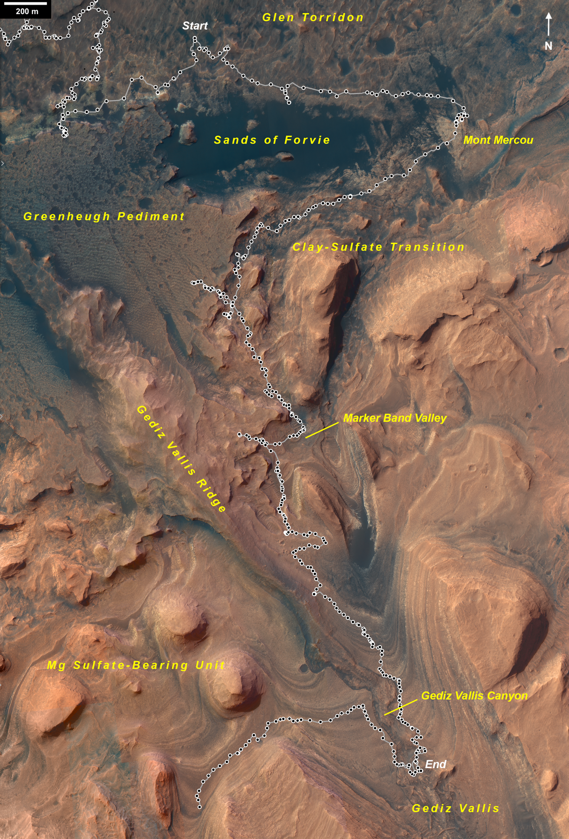
Fig. 2
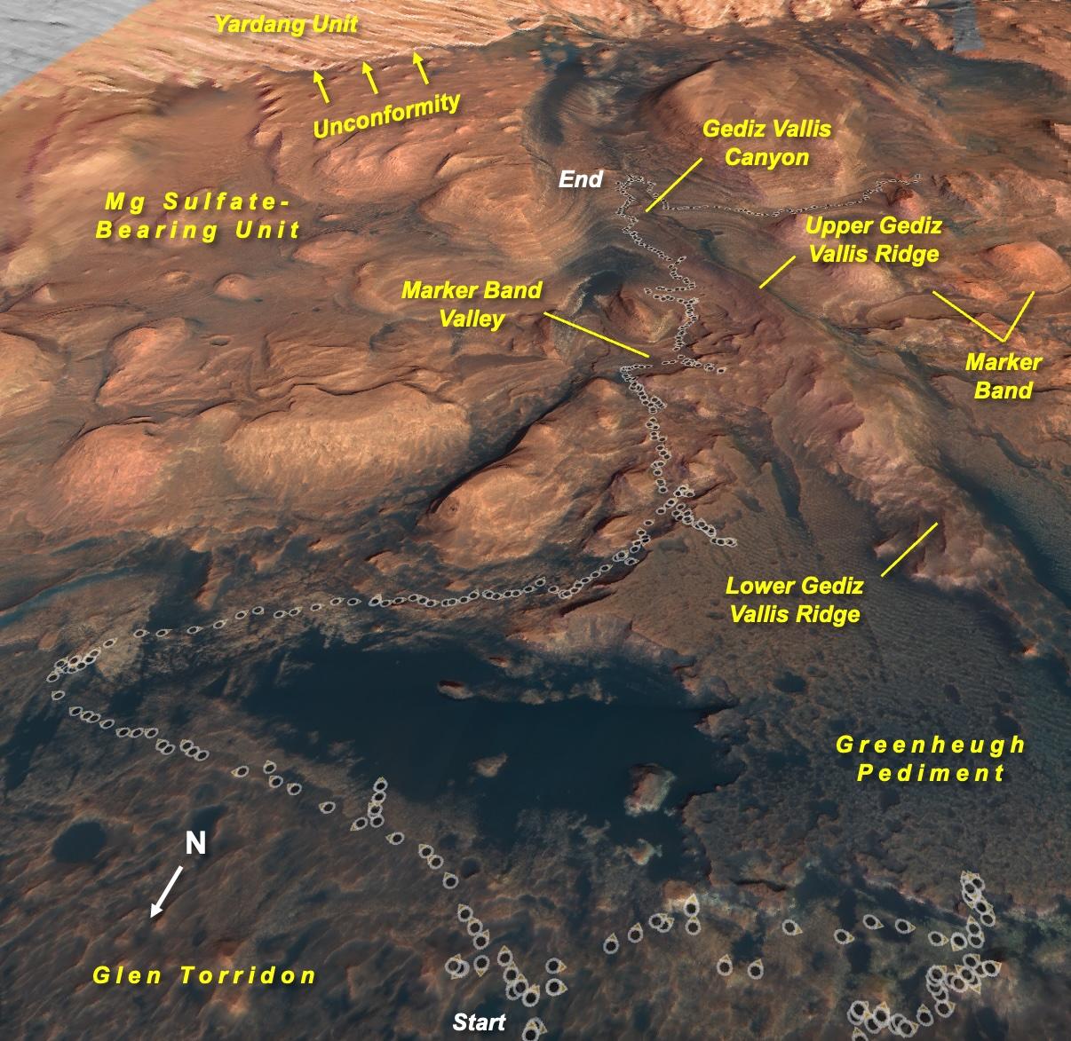

Fig. 3
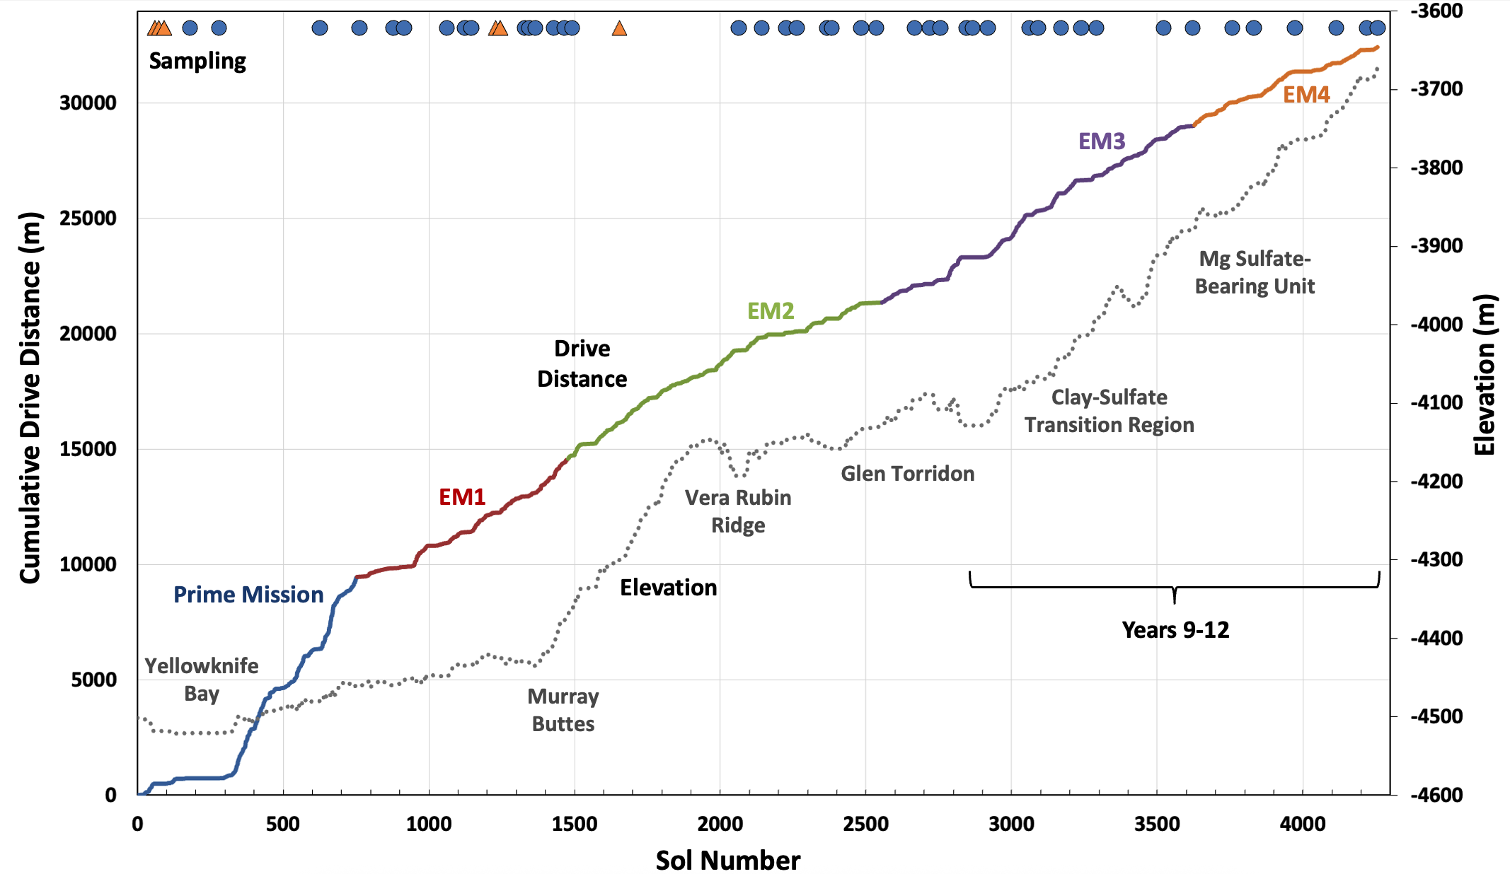

Fig. 4
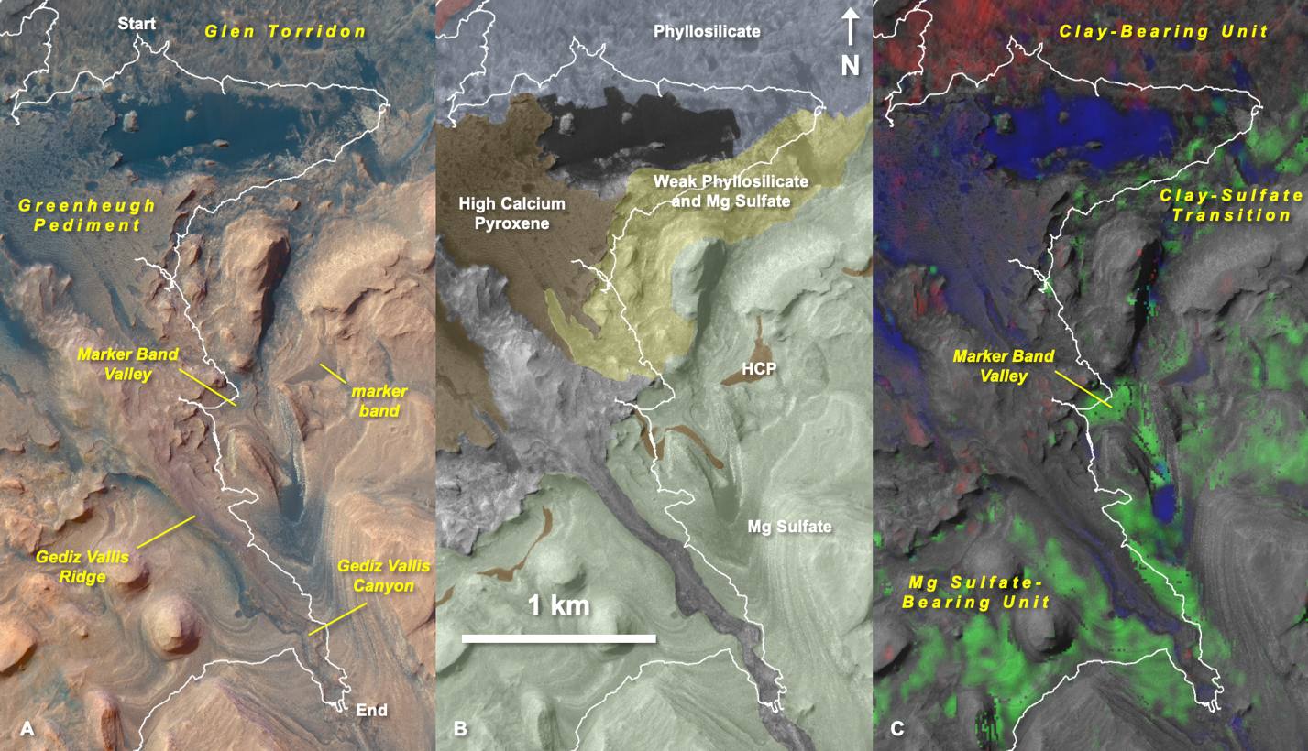

Fig. 5

Fig. 6
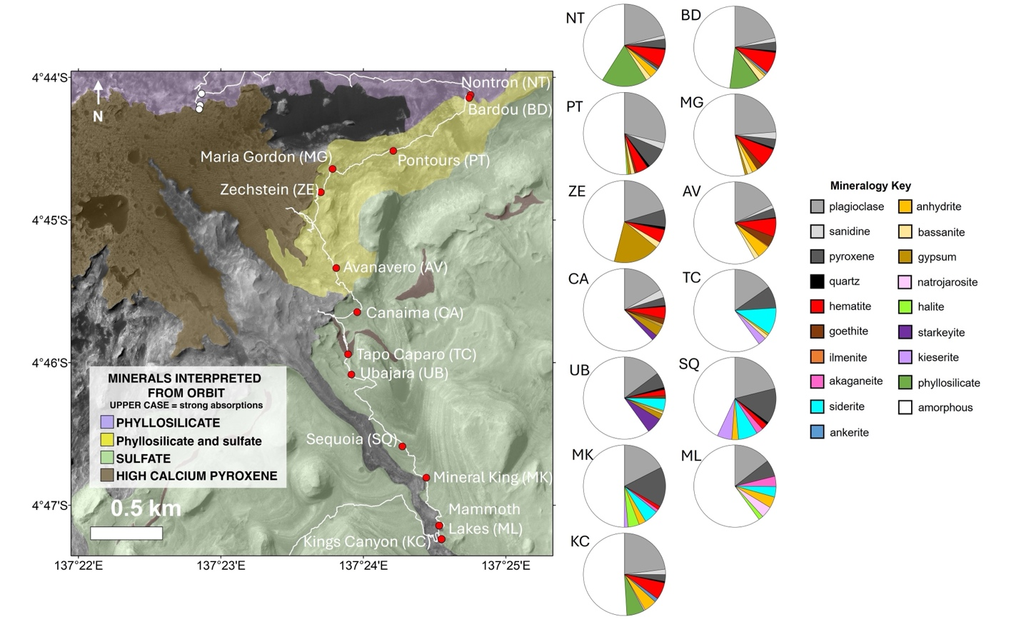
Fig. 7
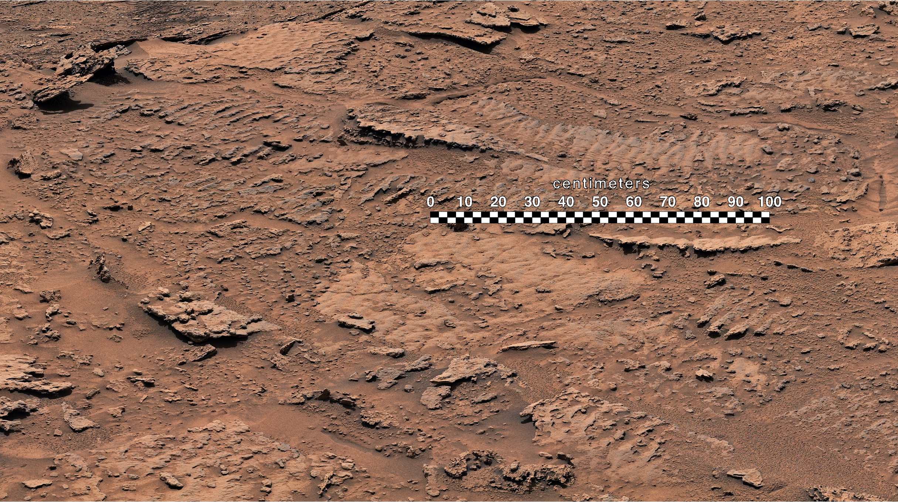
Fig. 8
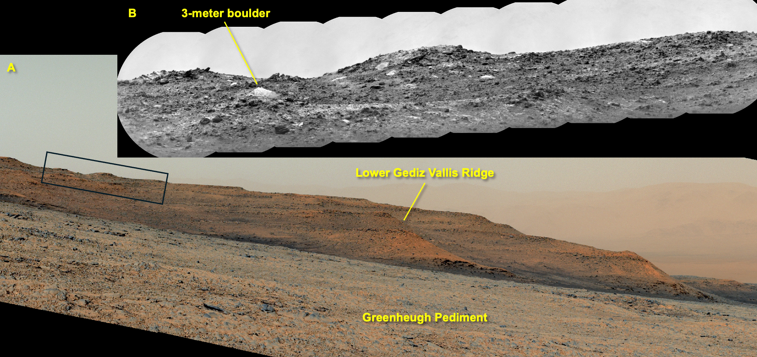

Fig. 9
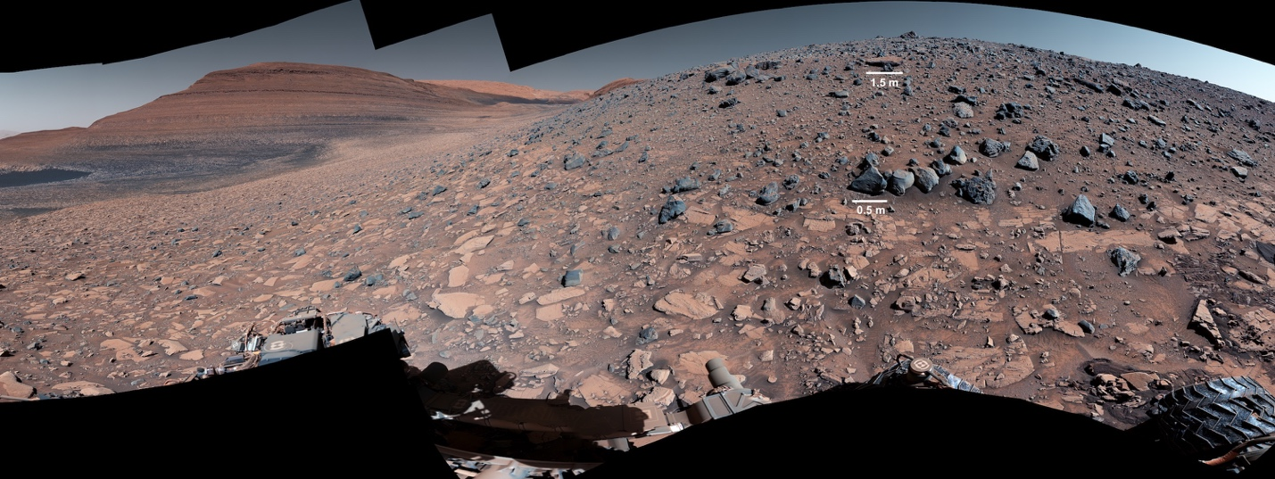

Fig. 10
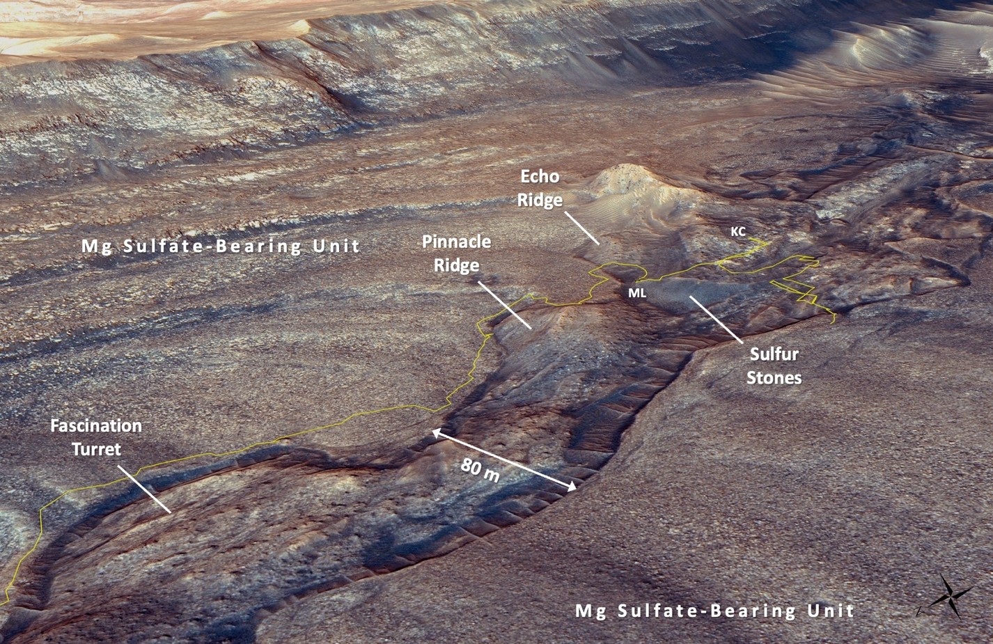
Fig. 11
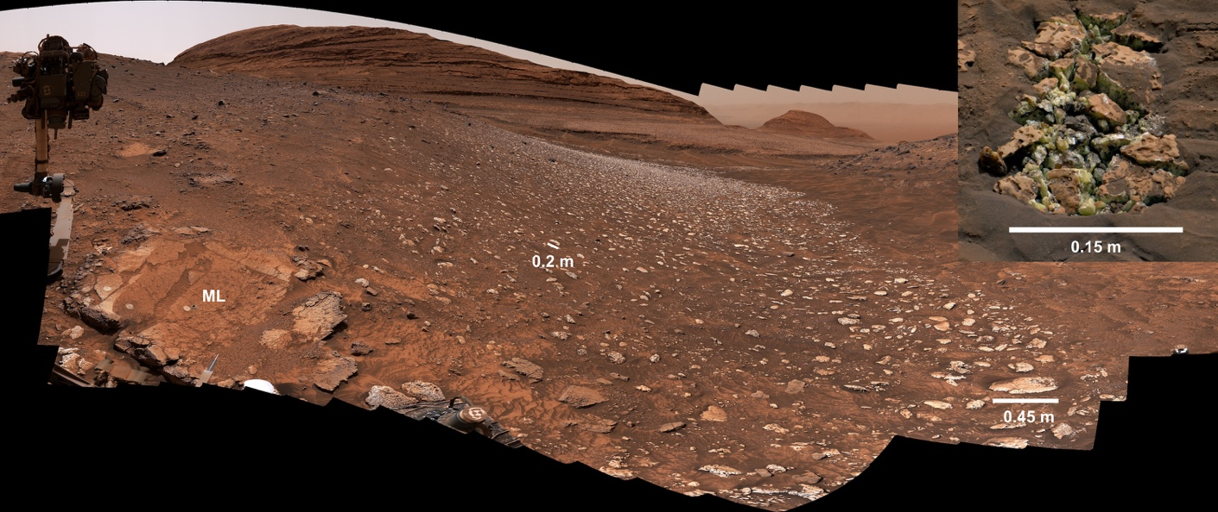
Fig. 12
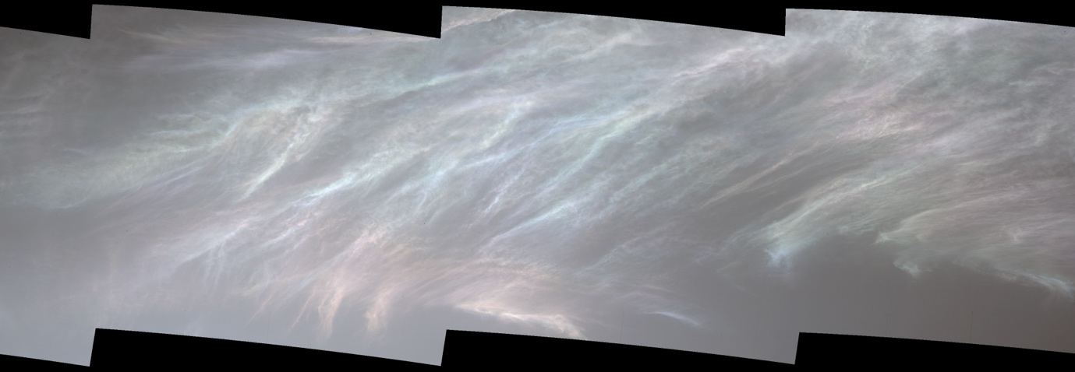

Fig. 13
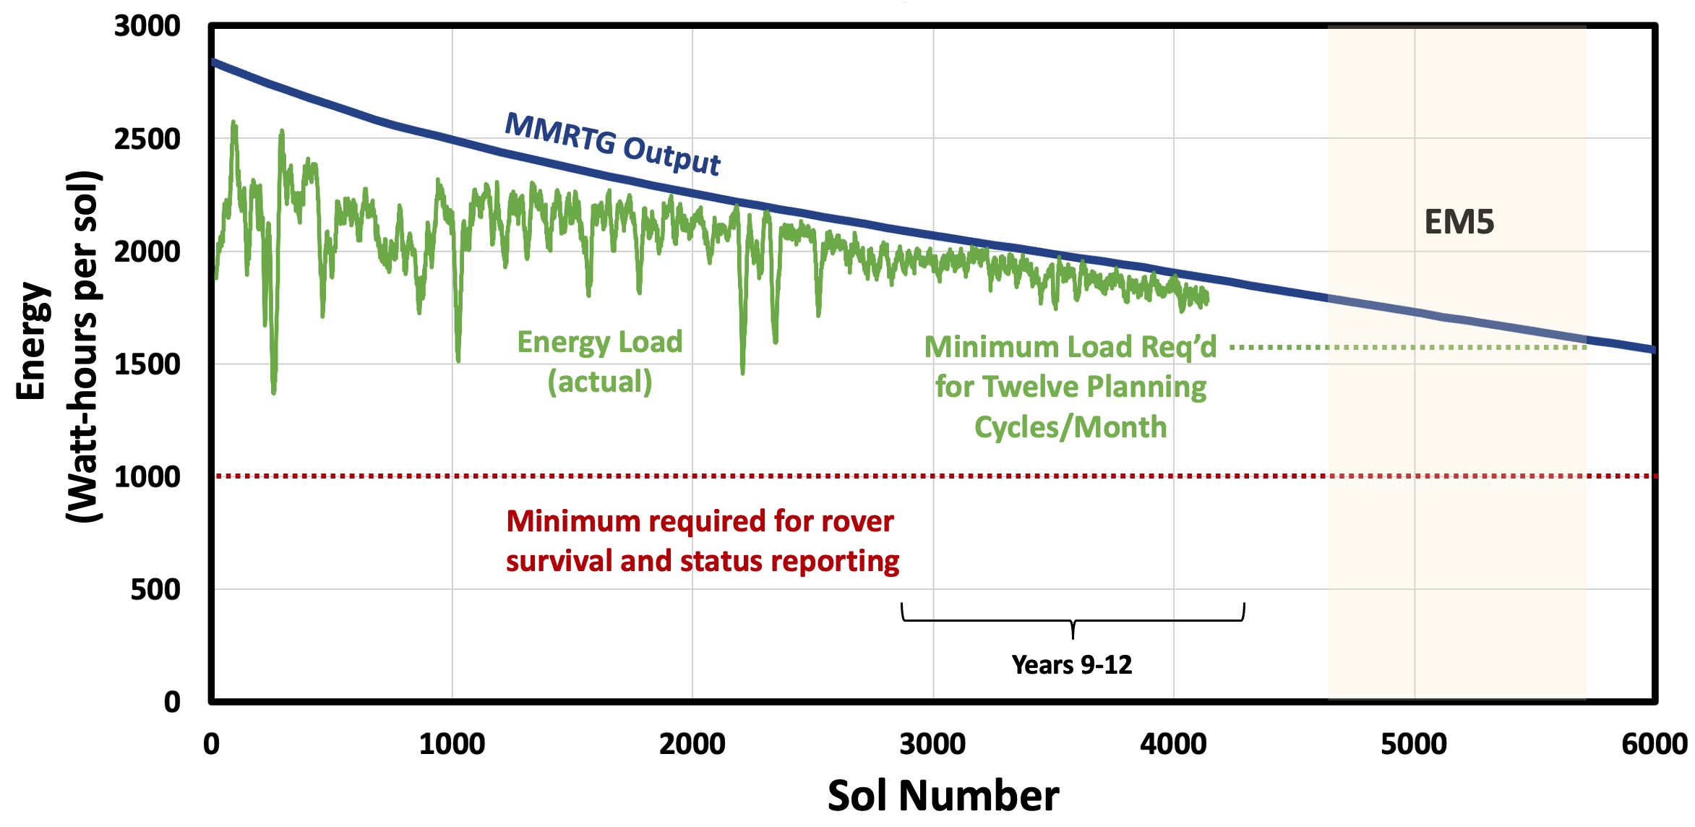

Table 1 Scientific instruments onboard the Curiosity rover
Instrument Name | Instrument Description | Reference
Remote science:
Mastcam (Mast Camera) | Multispectral science cameras | Malin et al. (2017)
ChemCam (Chemistry and Camera) | Laser-induced breakdown spectrometer and camera | Wiens et al. (2012), Maurice et al. (2012)
MARDI (Mars Descent Imager) | Nadir-viewing science camera | Malin et al. (2017)
Contact science (arm-mounted):
MAHLI (Mars Hand Lens Imager) | Science camera | Edgett et al. (2012)
APXS (Alpha Particle X-Ray Spectrometer) | X-ray spectrometer | Gellert et al. (2015)
Analytical laboratories:
CheMin (Chemistry and Mineralogy) | X-ray diffractometer | Blake et al. (2012)
SAM (Sample Analysis at Mars) | Mass spectrometer, gas chromatograph, tunable laser spectrometer suite | Mahaffy et al. (2012)
Environmental monitoring:
DAN (Dynamic Albedo of Neutrons) | Active neutron spectrometer | Mitrofanov et al. (2012)
RAD (Radiation Assessment Detector) | High-energy radiation detector | Hassler et al. (2012)
REMS (Rover Environmental Monitoring Station) | Meteorology station | Gómez-Elvira et al. (2012)

Table 2 Acronym list
ACB | Aphelion Cloud Belt
AMB | Amapari Marker Band
CRISM | Compact Reconnaissance Imaging Spectrometer for Mars
CST | Clay-Sulfate Transition
DSN | Deep Space Network
EGA | Evolved Gas Analysis
EM | Extended Mission
GC-MS | Gas Chromatography – Mass Spectrometry
GT | Glen Torridon
GV | Gediz Vallis
GVR | Gediz Vallis Ridge
HiRISE | High-Resolution Imaging Science Experiment
JPL | Jet Propulsion Laboratory
LMST | Local Mean Solar Time
MBV | Marker Band Valley
MMRTG | Multi-Mission Radioisotope Thermoelectric Generator
MRO | Mars Reconnaissance Orbiter
MSBU | Magnesium Sulfate-Bearing Unit
MSL | Mars Science Laboratory
NASA | National Aeronautics and Space Administration
PNG | Pulse Neutron Generator
RCE | Rover Compute Element
SMD | Science Mission Directorate
SPE | Solar Particle Event
TGO | ExoMars Trace Gas Orbiter
TMAH | Tetramethylammonium Hydroxide
UV | Ultraviolet
VMR | Volume Mixing Ratio
YU | Yardang-Forming Unit

Table 3 Sample collection attempts in Y9-12 and notes relevant for sample analyses. Attempts that failed to collect sample material are listed in parentheses
Target Name | Drill (Sol) | Achieved Depth (mm) | Target Depth (mm) | Max. Allowed Percussion
Mary Anning 3 | 2870 | 45.9 | 40 | 5
Groken | 2910 | 32.4 | 30 | 5
Nontron | 3056 | 44.3 | 40 | 5
Bardou | 3094 | 44.0 | 40 | 5
Pontours | 3170 | 45.5 | 40 | 5
Maria Gordon | 3229 | 46.1 | 40 | 5
Zechstein | 3289 | 43.8 | 40 | 5
Avanavero | 3512 | 40.2 | 35 | 2
Canaima | 3612 | 36.2 | 35 | 2
(Amapari) | 3676 | 8.5 | 35 | 2
(Amapari2) | 3680 | 17.7 | 35 | 2
(Encanto) | 3718 | 8.7 | 35 | 2
(Dinira) | 3742 | 8.0 | 30 | 2+
Tapo Caparo | 3752 | 39.1 | 35 | 2
Ubajara | 3823 | 35.2 | 35 | 2
Sequoia | 3980 | 39.2 | 35 | 2
Mineral King | 4107 | 24.5 | 35 | 2
(Mineral King 3) | 4125 | 11.2 | 35 | 2
Mammoth Lakes 2 | 4219 | 40.3 | 35 | 2
Kings Canyon | 4263 | 41.4 | 35 | 2

